MEMORANDUM OMB # 1850-0582 v. 28

DATE: July 15, 2021

TO: Robert Sivinski
Office of Information and Regulatory Affairs, Office of Management and Budget

FROM: Tara Lawley
Chief, Postsecondary Branch, Administrative Data Division, National Center for Education Statistics

THROUGH: Carrie Clarady, OMB Liaison, NCES

SUBJECT: Integrated Postsecondary Education Data System (IPEDS) 2020-21 through 2021-22 FAQ, Instruction, and Communications Package Summer 2021 Change Request (OMB# 1850-0582 v.28)

The Integrated Postsecondary Education Data System (IPEDS) is a web-based data collection system designed to collect basic data from all postsecondary institutions in the United States and the other jurisdictions. IPEDS enables the National Center for Education Statistics (NCES) to report on key dimensions of postsecondary education such as student enrollment, degrees and other awards earned, tuition and fees, average net price, student financial aid, graduation rates, revenues and expenditures, faculty salaries, staff employed, and information on academic libraries. The IPEDS web-based data collection system was implemented in 2000-01 and collects basic data from approximately 6,600 postsecondary institutions in the United States and the other jurisdictions that are eligible to participate in Title IV Federal financial aid programs. All Title IV institutions are required to respond to IPEDS (Section 490 of the Higher Education Amendments of 1992 (HEA, P.L. 102-325)). IPEDS allows other (non-title IV) institutions to participate on a voluntary basis. Approximately 200 institutions elect to respond. IPEDS data are available to the public through the IPEDS website.

IPEDS 2019-20 through 2021-22 annual data collection was approved by the Office of Management and Budget (OMB) in July 2019 (OMB# 1850-0582 v.24), with subsequent revisions approved in December 2019, April 2020, and July 2020 (OMB# 1850-0582 v.25-27).

This request is to make changes in IPEDS data collection materials so as to clarify online instructions; to update frequently asked questions and glossary terms; and to provide updated communications for the 2021-22 collection, indicating that there are no significant changes to the 2021-22 collection and removing coronavirus pandemic specific communications. This request does not introduce any changes to respondent burden or the cost to the federal government.

NCES regularly receives feedback from the IPEDS reporting community on areas that require clarification. Clarification changes will be made to the following IPEDS collections: Completions, 12-month Enrollment, Academic Libraries, Admissions, Outcome Measures, Fall Enrollment, Finance, Human Resources, and Student Financial Aid. Most clarifications provide greater detail to help institutions better understand what needs to be reported. Some changes relate to the clarifying of terminology around summer terms and provide more consistency across survey components. Another notable change is the removal of subcategories on the distance education question in Completions, which was not providing the expected utility. The other three collections (Graduation Rates, 200% Graduation Rates, and Institutional Characteristics) are unchanged with the exception of the update of dates throughout the documents.

The changes made to the IPEDS collection documents are listed in the table on the following pages. Changes to the communication materials are detailed in Attachment 1, beginning on p. 11 of this memo, and changes to the New Keyholder Handbook are detailed in Attachment 2, beginning on p. 18 of this memo.

Survey component/Other |  | Changed instruction/FAQ/screen (where applicable; additions in red, deletions with strikethrough, rewording in blue) | Change type (e.g., addition/ deletion/ rewording)
Completions (C) |  | Remove checkboxes from the Distance Education question (CIP Data screen) (p. 3):  Old screen:  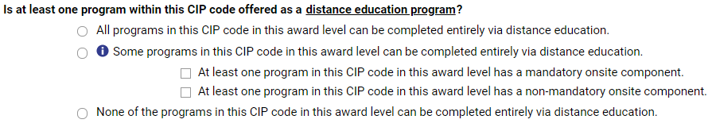  New screen:  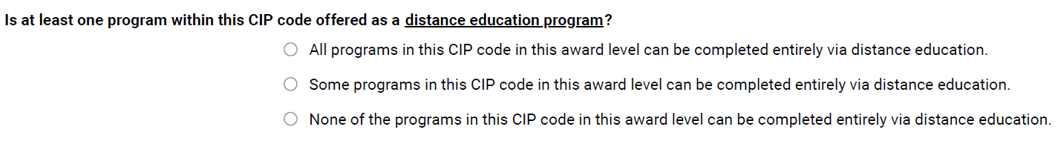 | Deletion on screen - subcategories removed as the detail provided was not useful
C |  | Remove checkbox language from Distance Education instructions under I. CIP Data Screens (p.12):  Distance Education  For each 6-digit CIP code and program level/length combination at your institution, please select one of the following three options (it is possible that one or more programs may be reported under the same CIP):  - All programs in the CIP can be completed entirely online.  - At least one program in the CIP can be completed entirely online. (please also indicate whether any of the online programs within the CIP has an onsite requirement).  - At least one program in the CIP has a mandatory onsite component  - At least one program in the CIP has a non-mandatory onsite component  - None of the programs in this CIP can be completed entirely online. | Deletion in instructions to match removal of checkboxes on screen
C |  | Add a note below the Distance Education instructions under I. CIP Data Screens (mirroring EF instructions) (p. 13):  NOTE: Requirements for coming to campus for orientation, testing, or academic support services do not exclude a program from being classified as exclusively distance education. Similarly, if instructional portions of the program are entirely online, but there is a requirement to complete a practicum, residency, or internship, the program is still considered entirely distance education. | Addition in instructions for clarity
C |  | Add the following FAQ to General FAQ section in C (p. 17 & p. 20):  Should I include credentials earned by dual enrolled high school students?  Yes, recognized postsecondary credentials earned by dual enrolled students prior to graduating high school should be included. | Addition to FAQ for clarity
C |  | Edited the following FAQ in General FAQ section in C (p. 17 & p. 20):  My institution has students for which gender is unknown does not align with the ‘Men’ and ‘Women’ categories in IPEDS (e.g., non-binary, unknown). Since there is no place to report other “gender unknown” categories on the IPEDS data collection screens, how should we report these individuals?  These individuals are still to be reported to IPEDS., even though their gender is unknown. It is up to the institution to decide how best to handle reporting individuals whose gender is unknown does not align with the ‘Men’ and ‘Women’ categories. However, a common method used is to allocate these students based on the known proportion of men to women. | Reworded FAQ to better align with current language around gender
12 Month Enrollment (E12) |  | Edited the following FAQ in General FAQ section in E12 (p. 45):  What is the difference between 12-month enrollment and Fall enrollment?  The 12-month Enrollment is a (E12) survey component collects an institution’s cumulative unduplicated headcount of enrollment over the full for the entire 12-month period beginning July 1 and ending June 30. In contrast, the Fall Enrollment is a (EF) survey component collects an institution’s “snapshot” enrollment count of students enrolled on a particular date in the fall. For academic reporters, EF enrollment counts reflect the institution’s official fall reporting date or October 15. For program reporters, EF enrollment counts reflect students enrolled during the period August 1 to October 31. The EF enrollment counts, for both academic reporters and program reporters, should be viewed as a subset of the larger E12 counts. The E12 survey component captures all unduplicated student enrollments, including fall-enrolled students (i.e., reported on the EF survey component) plus all other unduplicated student enrollments not captured on the EF survey component but that enrolled during the July 1 to June 30 time period. | Rewording and  addition to FAQ to provide more detail
E12 |  | Edited the following bullet point in the Instructions in E12 (p. 15):  Bullet #3 Under: “Full-time, non-degree/non-certificate-seeking full-time undergraduate students”  - If a student's attendance level (undergraduate or graduate) changes during the 12-month period, count the student at his/her highest level enrolled student’s attendance level as of entry to the institution for the first full term (i.e., typically the fall or spring terms for academic reporters). For example: If a student is an undergraduate in the fall and a graduate student in the spring, count the student as an undergraduate student. | Rewording in instructions to provide more clarity
E12 |  | Edited the following FAQ in General FAQ section in E12 (p. 24):  For students who start in the summer, the summer term is typically not considered a full term. and if summer is NOT a “full” term, pPlease use the following guidance:  - If a student starts in the summer of 2020 (prior to July 1), and they do NOT enroll in any additional terms in 2020-21, they are not to be included in the July 1, 2020 – June 30, 2021 E12 counts (as they would have been included in the prior E12 counts).  - If a student starts in the summer of 2020 (after July 1), and they do NOT enroll in any additional terms in 2020-21, they are still included in the 2020-21 E12 counts, at the attendance status (i.e., full-time or part-time) in which they were enrolled during the summer. [Moved this bullet #3 into the #2 position]  - If a student starts in the summer of 2020 (prior to July 1 OR after July 1), the summer term is not a “full term,” and the student continues enrollment beyond summer, either into the fall term or re-enrolls in the spring term, the institution should use the next “full” full term (e.g., Ffall or spring) to determine if the student is full-time or part-time, and the student should be included in the 2020-21 E12 counts. [Moved this bullet #2 into the #3 position] | Rewording/reorganization of FAQ answer to provide more detail
E12 |  | Edited the following FAQ in General FAQ section in E12 (p. 24):  FAQ # 6 How do I report students who enter my institution as non-degree/non-certificate-seeking students in the fall, but in the following spring term enroll as degree/certificate-seeking students?  Count these students as continuing degree/certificate-seeking because these students became degree/certificate-seeking at some point during the E12  period (July 1 – June 30) and had “prior postsecondary experience.”  Count these students as first-time degree/certificate-seeking if they were enrolled for credit at your institution in the fall prior to receipt of a high school  diploma (dual enrolled students).  NEW FAQ #9: How do I report students who changed attendance status (part-time to full-time or full-time to part-time) during the July 1-June 30 reporting period?  Report students based on their attendance status in their first full term enrolled (i.e., typically the fall or spring terms for academic reporter), even if that status changed during the 12-month period. | Replace FAQ # 6 with new FAQ that provides more relevant information.
E12 |  | Edited the following FAQ in Glossary section in E12 (p. 66):  Summer Term Session: A summer term session is typically not considered a full term shorter than a regular session and is not considered part of the academic year. It is not the third term of an institution operating on a trimester system or the fourth term of an institution operating on a quarter calendar system. The institution may have two or more sessions occurring in the summer term months. Some schools, such as vocational and beauty schools, have year-round classes with no separate summer term session. | Rewording to provide more consistent language
E12 |  | Edited the following FAQ in Unduplicated Count FAQ section in E12 (p. 25):  FAQ#2: How do I report a student who changes enrollment levels during the 12-month period? (4-year institutions only)  The enrollment level should be determined at the first “full” term during the 12-month reporting period at entry. For example, a student enrolled as an undergraduate in the fall and then as a graduate student in the spring should be reported as an undergraduate student on the 12-month Enrollment survey component. | Rewording to clarify
E12/Outcome Measures (OM) |  | Edited the following FAQ in Unduplicated Count FAQ section in E12 (pp. 44-46, 67-69, and 89-91):  FAQ: How can I ensure consistent reporting of degree/certificate-seeking undergraduates across EF, E12, and OM survey components?  - The Fall Enrollment (EF) survey component is a “snapshot” of the institution’s enrollment in the fall. The 12-month Enrollment (E12) survey component captures the institution’s total unduplicated headcount enrollment for an entire 12-month period (July 1 to June 30).  - EF enrollment counts are a subset of the E12 enrollment counts, as the E12 survey component captures students enrolled in the fall plus any other unduplicated students not captured in the EF survey component (e.g., students who first enroll in the spring term or enroll only in the summer term).  - Because the EF survey component is a subset of the E12 survey component, all student enrollment counts (total and by disaggregate) reported in the current year’s E12 survey component should be greater than or equal to the prior year’s EF survey component. Note that the prior year’s EF survey component matches the “data year” of the current year’s E12 survey because there is a greater “time lag” in reporting E12 data.  - Because the fall term is considered a full term for IPEDS reporting purposes, students enrolled in the fall term and captured in the EF survey component should retain their same enrollment statuses (e.g., part-time or full-time, first-time or non-first-time, degree/certificate-seeking or non-degree/non-certificate seeking, undergraduate or graduate) in the E12 survey component.  - For example, a full-time, first-time student reported on the EF survey would also be reported as a full-time, first-time student in the E12 survey. Similarly, a part-time, non-degree/non-certificate-seeking student reported in the EF survey component would retain those statuses in the E12 survey component.  - For both program reporters and academic reporters, student enrollment statuses as reported on the current-year EF survey should be retained for E12 reporting in the following data collection year when the data coverage periods align (i.e., you should not change students’ statuses between EF and E12 reporting).  - For students not reported on the EF survey component (i.e., not enrolled in the fall and therefore not captured), default to the student’s first full term at entry to determine enrollment statuses (typically spring in this scenario). If the student enrolls only in the summer and at no other time during the 12-month reporting period, then the summer term may be used to determine student statuses.  - While the E12 survey component captures unduplicated enrollment counts during the 12-month period of July 1 to June 30, the Outcome Measures (OM) survey component captures the 4-, 6-, and 8-year academic outcomes for the cohort of degree/certificate-seeking students during the same 12-month period. Like the E12 survey component, students’ statuses (i.e., first-time/non-first-time, Pell/Non-Pell, full-time/part-time) are determined by students’ first full term (i.e., fall or spring). | Addition to help institutions better understand connections between surveys
E12/OM (continued from previous page) |  | - Unlike the E12 survey component, the OM survey component captures only degree/certificate-seeking students. For this reason, students’ statuses for OM reporting purposes are determined in their first full term as a degree/certificate-seeking student. For example, students enter as non-degree/non-certificate-seeking students in the fall and in the following spring term enroll as degree/certificate-seeking students, these students would be reported as:  - In EF as non-degree/non-certificate-seeking students with the statuses (e.g., full-time/part-time) determined at their first full term (i.e., fall term).  - In E12 as non-degree/non-certificate-seeking students with the statuses (e.g., full-time/part-time) determined at their first full term (i.e., fall term). Note that students reported on both the EF and E12 survey components should be reported with the same enrollment statuses (i.e., they do not change).  - In OM as degree/certificate-seeking students with the statuses (i.e., first-time/non-first-time, Pell/non-Pell, full-time/part-time) determined at their first full term as degree/certificate-seeking students (i.e., spring term). Because the OM survey component is designed to capture academic outcomes for degree/certificate-seeking students, students who are non-degree/non-certificate-seeking in the fall (and reported as such for both EF and 12 survey components) but then become degree/certificate-seeking after the fall term should be reported for OM reporting purposes. Only in this scenario and only for OM reporting purposes should fall-enrolled students’ enrollment statuses then be determined from a non-fall term to align with when they became degree/certificate-seeking.  - Therefore, OM counts should be same or slightly greater than degree/certificate-seeking student counts reported in E12 because there is the potential for some students to enroll as non-degree/non-certificate-seeking in the fall term (and reported as such for EF and E12 survey components) but then change their enrollment to degree/certificate-seeking in the spring term (and thus need to be captured in the OM survey component). | Addition (continued from previous page)
E12 |  | FAQ 17) How do I report students who enter my institution as non-degree/non-certificate-seeking students in the fall, but in the following spring term enroll as degree/certificate-seeking students?  - Count these students as continuing degree/certificate-seeking because these students became degree/certificate-seeking at some point during the E12 period (July 1 – June 30) and had “prior postsecondary experience.”  - Count these students as first-time degree/certificate-seeking if they were enrolled for credit at your institution in the fall prior to receipt of a high school diploma (dual enrolled students). | Deletion; there is a new FAQ that better explains this as well as a dual enrolled FAQ. FAQs are renumbered as well.
E12 |  | Edited the following FAQ in Unduplicated Count FAQ section in E12 (pp. 22-25, 44-46, 67-69, and 88-90):  FAQ 4) My institution has students for which gender is unknown does not align with the ‘Men’ and ‘Women’ categories in IPEDS (e.g., non-binary, unknown). Since there is no place to report other “gender unknown” categories on the IPEDS data collection screens, how should we report these individuals?  These individuals are still to be reported to IPEDS, even though their gender is unknown. It is up to the institution to decide how best to handle reporting individuals whose gender is unknown does not align with the ‘Men’ and ‘Women’ categories. However, a common method used is to allocate these students with gender unknown based on the known proportion of men to women. | Rewording
E12 |  | Edited the following survey structure in E12 (pp. 4-6, 31-33):  Old Survey Screen: Revised survey screen:  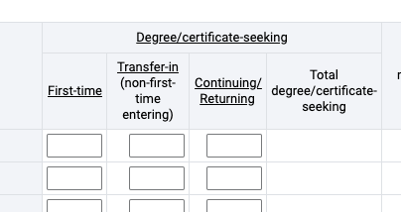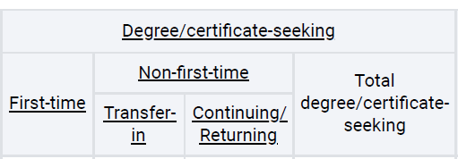 | Reorganizing – Non-first-time label applies to both transfer-in and continuing/returning students, so label moved above for clarity
Student Financial Aid (SFA) |  | New FAQ 6 (and renumbering FAQs #6-13 as #7-14) (p. 2, 20, 32, 36, 40, 42, 54, 66, 70, 74, 77, 93, 105, 109, 113, 116, 124, 137, 141, 145, 147, 151, 155, and 159)  When do I report financial aid awards for students who attend in the summer?  Report financial aid awarded for the [AY] academic year. If a student receives an award for a cross-over payment period, report the award in the academic year assigned by the financial aid office, which should be the same as the financial aid allocation or authorization year. This also applies if a student receives two Federal Pell Grant awards in the same academic year (i.e., Year-Round Pell). | Additional FAQ to explain reporting of students who attend in the summer
Outcome Measures (OM) |  | Replaced all references to “summer session” and “summer months” with “summer term” for consistency across survey components and global glossary. | Rewording
OM |  | Edited the following FAQ in FAQ section in Outcome Measures (p. 17)  FAQ 9) If we are reporting on a full-year cohort that enters between July 1 and June 30 (OM coverage cohort year), what happens if a student switches their attendance levels (e.g., full-time or part-time) during the OM coverage cohort year?  The attendance level is determined upon on the first full term at entry entering the institution. The student remains in the cohort even if there is a change in attendance levels in subsequent terms or years. | Rewording
OM |  | Edited the following FAQ in FAQ section in Outcome Measures (pp. 15 & 17)  FAQ 10) I have a group of degree-seeking undergraduate students who took a summer term session in 2013. However, the start date of the summer term session was prior to Outcome Measures coverage cohort year start date of July 1. In which cohort year should these students be reported?  For the 2013-14 cohort(s), institutions should include students who entered between July 1, 2013 - June 30, 2014.  For students who start in the summer, the summer term is typically not considered a full term. and if summer is NOT a "full" term, they should be treated based on guidance in the FAQs. Please use the following guidance: OM cohorts should be accurate based on a student's "normal" attendance intensity and not based on a partial summer term, which is not a full term.  - If a student starts in the summer of 2013 (prior to July 1), and they do NOT enroll in any additional terms in 2013-14, they are not to be included in the July 1, 2013 - June 30, 2014 cohort because they would have been included in the prior OM cohort year.  - If a student starts in the summer of 2013 (after July 1), and they do NOT enroll in any additional terms in 2013-14, they are still included in the 2013-14 cohort, at the enrollment level (full-time or part-time) in which they were enrolled during the summer. [Moved this bullet #3 into the #2 position]  - If a student starts in the summer of 2013 (prior to July 1 or OR after July 1), the summer term is not a "full term," and the student continues enrollment beyond summer, either into the fall term or re-enrolls in the spring term, the institution should use the next "full" full term (e.g., Ffall or spring) to determine if the student is full-time or part-time, and the student should be included in the 2013-14 cohort. [Moved this bullet #2 into the #3 position]  Please note: OM cohorts should be accurate based on a student's "normal" attendance intensity level (e.g., full-time or part-time) based on the first full term and not based on a partial summer term, which is not a full term. | Rewording and reorganizing for clarity
OM |  | FAQ 15) (Degree-seeking and Non-degree-seeking Students)  If I am an academic year reporter, how do I report students who enter my institution as non-degree/certificate-seeking students in the fall, but in the following spring term enroll as degree/certificate-seeking students?  Include these students in your OM cohort because these students became degree/certificate-seeking at some point during the full-year cohort of July 1, 2012 - June 30, 2013. | Deleted FAQ
Admissions (ADM) |  | Edited the following Data Reporting Reminder (p. 2)  Under “Data Reporting Reminders”:  - ADM is only applicable to first-time entering students; DO NOT include other students (i.e., transfer-in students) in the number of applicants, number of admits, and number (of admitted) that enrolled. | Rewording to add example
ADM |  | Added the following FAQ (pp. 11-12)  FAQ 11) How should I report admissions considerations if my institution has a “test-optional” admission policy?  If your institution has a test-optional admission policy (i.e., applicants for admission may decide whether to submit standardized test scores and they may be admitted with or without submitting such scores), select the “Considered but not required” option for the “SAT/ACT” consideration in Section 1 (Admissions Considerations). | Addition
ADM |  | Edited the following FAQ (pp. 11-12)  FAQ #10) New/clearer Answer  How do I treat students who enrolled in the summer prior to fall enrollment?  It depends on whether summer is a full and regular term. For academic reporters, if fall-enrolled students were first enrolled full-time during the prior summer term that began before June 30 AND the summer term IS considered a full and regular term, do NOT report these students in the ADM survey. If the summer is NOT a full and regular term, the students SHOULD be reported in ADM.  The ADM survey component collects enrollment counts for first-time students in the fall term, which consists mostly of recent high school graduates. Report first-time students, even if they have prior summer term enrollment preceding the fall term or prior dual enrollment while in high school, in the ADM survey component as they are considered first-time for IPEDS reporting purposes. Note that ADM enrollment counts should closely mirror the first-time enrollment counts captured in the Fall Enrollment (EF) survey component. | Rewording/ clearer answer to FAQ
ADM |  | Edited the following directions (p. 3)  Please select the option that best describes how your institution usesd any of the following data in its undergraduate selection process for the fall 2021 first-time student cohort. (If your institution changed its admissions considerations for the fall 2022 first-time student cohort, you may indicate such changes in the context box immediately following this section). | Addition to screen text, to provide more detailed information
ADM |  | Edited the following directions (p. 2)  The primary purpose of the IPEDS Admissions (ADM) component is to collect basic information about the undergraduate selection process for entering first-time, degree/certificate-seeking students in the fall term. This includes information about admissions considerations, admissions yields, and SAT and ACT test scores (if test scores are used in required for admissions decisions). The ADM survey component will be is collected only from institutions that do not have an open admissions policy for all or most entering first-time students, which is captured on the IC Header survey component. | Rewording instructions
ADM |  | Corrected incorrect acronym for Ability to Benefit from “ABT” to “ATB” | Correction
Human Resources (HR) |  | Edited the following directions (p. 9)  Add another bullet under ‘Who to Include in this Report’  - Graduate assistants are considered part-time employees and should be reported on the graduate assistant screen located in the part-time section of the survey. | Addition
Finance (F) |  | For degree-granting GASB and FASB reporting institutions only  Added separate context boxes under 4a and 4b | Addition, to allow institutions to provide specific context
F |  | For degree-granting GASB reporting institutions only  If your institution is a parent institution then the amounts reported should include  ALL of your child institutions. Include amounts for the institution’s GASB and FASB  component units.) | Addition, to more clearly specify.
F |  | For degree-granting FASB and for-profit reporting institutions only  FASB: 06 Plant-related debt (from Part A, line 03a)  For-profit: 06 Plant-related debt (from Part A, line 02a) | Deletion values cannot be preloaded
F |  | For degree- and non-degree-granting GASB reporting institutions only  This part is intended to report details about sources of discounts and allowances.  For each source on lines 01 – 05, enter the amount of the scholarships and fellowships source applied to (1) tuition and fees discounts and allowances and (2) auxiliary enterprises discounts and allowances. The amount of the source applied to total discounts and allowances will be automatically calculated for you in the 3rd column. Line 07 18 has been preloaded from data entered in Part E-1: Scholarships and Fellowships, line 08 for the 1st column "Tuition and fees discounts & allowances," line 09 for the 2nd column "Auxiliary enterprises discounts & allowances," and line 10 for the 3rd column "Total discounts & allowances." | Deletion and addition to clarify and provide appropriate ties to other parts of the survey component
F |  | For degree- and non-degree-granting FASB reporting institutions only  This part is intended to report details about sources of discounts and allowances.  For each source on lines 01 – 05, enter the amount of the scholarships and fellowships source applied to (1) tuition and fees discounts and allowances and (2) auxiliary enterprises discounts and allowances. The amount of the source applied to total discounts and allowances will be automatically calculated for you in the 3rd column. Line 07 18 has been preloaded from data entered in Part C-1: Scholarships and Fellowships, line 06 for the 1st column "Tuition and fees discounts & allowances," line 07 for the 2nd column "Auxiliary enterprises discounts & allowances," and line 08 for the 3rd column "Total discounts & allowances." | Deletion and addition to clarify and provide appropriate ties to other parts of the survey component
F |  | For degree-granting GASB reporting institutions only  Part N  01 – Enter the sum of the institution’s and GASB component unit's (if any) operating income/loss, net nonoperating revenues/expenses, and the institution’s FASB component unit’s (if any) change in unrestricted net assets (if applicable). Include nonoperating revenues and expenses from government appropriations, investment income and operating gifts, and interest on plant debt. Exclude plant and endowment gifts, capital appropriations, and investment gains/losses except for endowment payout and working capital investment gains/losses.  • For the FASB component unit, report the total change in unrestricted assets from the statement of activities. Also exclude the FASB component unit’s  investment gains/losses except for endowment payout and working capital investment gains/losses.  02 – Enter the sum of the institution’s and GASB component unit's (if any) operating revenues, nonoperating revenues, and the institution’s FASB component unit’s (if any) total unrestricted revenue (if applicable). Exclude investment gains/losses except for endowment payout and working capital investment gains/losses.  • For the FASB component unit, include total unrestricted revenues, gains and other support, including net assets released from restrictions. Also exclude the FASB component unit’s  investment gains/losses except for endowment payout and working capital investment gains/losses. | Deletion and Addition for clarity
F (continued from previous page) |  | 03 – Enter the sum of the institution’s and GASB component unit's (if any) change in net position and the institution’s FASB component unit’s (if any) change in net assets (if applicable), regardless of whether the net asset is expendable or nonexpendable, restricted or unrestricted.  04 – Enter the sum of the institution’s and GASB component unit's (if any) beginning of the year total net position and the institution’s FASB component unit’s (if any) beginning of the year’s total net assets (if applicable).  05 – Enter the sum of the institution’s expendable net assets and the institution’s GASB and FASB component units' expendable net assets (if applicable). Include all unrestricted and expendable restricted net assets. Exclude net assets to be invested in plant.  • For the FASB component unit, include all net assets without donor restriction and net assets with donor restriction – subject to time or purpose restriction. Exclude net investment in plant and net assets with donor restriction – subject to time or purpose restriction that will be invested in plant.  06 – Enter the sum of the institution’s plant-related debt and the institution’s GASB and FASB component units' plant related debt at par (i.e., face value or nominal value). Include all amounts borrowed for plant purposes from third parties and include all notes, bonds and capital leases payable, regardless  if the institution owes the obligation. Include current and long-term portions of plant related debt, debt of the institution’s affiliated foundations, partnerships, other special purpose entities, and amounts owed to a system or state-financing agency representing debt issued on the institution’s behalf.  07 – Enter the sum of the institution’s total expense and the institution’s GASB and FASB component units' total expense. Include all operating and nonoperating expenses. For both the institution and its FASB component units, exclude investment losses.
F |  | For degree-granting FASB reporting institutions only  Part I  06 – Enter the institution’s plant-related debt at par (i.e., face value or nominal value). has been carried forward from Part A, line 03a. Include the current and non-current portion of plant related debt that must be repaid (e.g., premiums, discounts, issuance costs, and asset retirement obligations are not included). | Deletion and Addition for clarity
F |  | For degree-granting for-profit reporting institutions only  Part G  06 – Enter the institution’s debt related to property, plant, and equipment at par (i.e., face value or nominal value) has been carried forward from Part A, line 02a. Include the current and non-current portion of plant related debt that must be repaid (e.g., premiums, discounts, issuance costs, and asset retirement obligations are not included). | Deletion and Addition for clarity
F |  | For all reporters  Update the last sentence of FAQ 4 to read: However, component unit information should still be included when reporting endowment net assets in Part H and for the data elements collected in Part N. | Addition for clarity
F |  | All reporters  How are Pension and OPEB information reported in Part M-1 and Part M-2 reflected in Part C-1 and Part C-2?  Pension and OPEB contributions should be reported across appropriate functional classifications on Part C-1. For example, fringe benefits, as part of the personnel compensation, are often associated with the Instruction expenses.  Pension and OPEB expenses, as recognized by GASB Statements #68 and #75, should be reported on Part C-1, Line 14 – Other functional expenses and deductions.  Both Pension and OPEB contribution plans and defined plans, as a result of the implementation of GASB Statements #68 and #75, should be reported on Part C-2, Line 19-3 – Benefits. | Addition to clarify Pension and OPEB reporting in Parts M-1 and M-2 and Parts C-1 and C-2
Academic Libraries (AL) | Instruction clarification for reporting Databases (p. 9):  Do include databases that only allow access to abstracts. Do not include discovery systems in the count of databases. Do not include "individual releases" such as annual updates of content or the migration of the user interface to the next vendor-release (i.e., interface version 3.0 replaces version 2.0) as separate databases.” |  |  | Addition, to clarify.
Fall Enrollment (EF) | Remove data reporting reminder related to coronavirus, as it is not applicable to this survey component and update required vs optional parts. (p. 2)  - Report data to accurately reflect the time period corresponding with the IPEDS survey component, even if such reporting is seemingly inconsistent with prior-year reporting. For example, if a summer term began later than usual due to Coronavirus Pandemic postponements, continue to report using the timeframes as defined in the IPEDS instructions. NCES expects that some data reported during the 2020-21 data collection year will vary from established prior trends due to the impacts of Coronavirus Pandemic. If an error edit is triggered even when submitting accurate data, please indicate in the corresponding context box or verbally to the Help Desk that the seemingly inconsistent data are accurate and reflect the effects of Coronavirus Pandemic.  - Part B, Enrollment of students by age, is optional required this year.  - Part C, Residence of first-time degree/certificate-seeking undergraduates, is required optional this year. |  |  | Deletion and rewording to reflect the current year requirements
EF | Update to reflect the odd year requirement of age reporting (as opposed to residence reporting required in even years) and remove all CIP enrollment screens (only collected in even years). |  |  | Rewording to reflect current year requirements
EF | Edited survey labels (pp. 4-5, 29-30  Old Survey Screen: Revised survey screen: |  |  | Reorganizing – Non-first-time label applies to both transfer-in and continuing/returning students, so label moved above for clarity
EF | Should I report fall-enrolled students as first-time if they were enrolled full-time during the prior summer term?  For academic reporters, if fall-enrolled students were first enrolled full-time during the prior summer term that began before June 30 (i.e., the end date for the Outcome Measures (OM) survey cohort year) AND the summer term is considered a full and regular term, do NOT report these students as first-time students on the Fall Enrollment (EF) survey. This will ensure that first-time students are reported in the same academic year in both the EF and OM surveys. |  |  | Deletion, FAQ is repetitive
EF | Edited the following FAQ (pp. 19, 23, 58, 61, 93, 97, 118 and 122):  My institution has students for which gender is unknown does not align with the ‘Men’ and ‘Women’ categories in IPEDS (e.g., non-binary, unknown). Since there is no place to report other “gender unknown” categories on the IPEDS data collection screens, how should we report these individuals?  These individuals are still to be reported to IPEDS., even though their gender is unknown. It is up to the institution to decide how best to handle reporting individuals whose gender is unknown does not align with the ‘Men’ and ‘Women’ categories. However, a common method used is to allocate these students based on the known proportion of men to women. |  |  | Reworded FAQ to better align with current language around gender

Attachment 1 – Changes to Communications Materials (Appendix B)

Global changes: Dates updated – “2020-21” globally replaced with “2021-22” and “2020” replaced with “2021”; dates for sending out emails and collection dates updated for the 2021-22 data collection

p. 3 (Overview) – text deleted to remove references to Coronavirus Pandemic reporting

Due to the coronavirus pandemic, some institutions were unable to complete their data submissions for the Spring 2020 collection period during the previous collection year (2019-20). For these institutions, NCES provided, on April 14, 2020, the following Guidance for Reporting Spring 2020 IPEDS Data:
For institutions that are unable to provide complete and accurate Spring 2020 data during the regular collection period, an additional reporting opportunity will be made available during the Fall of 2020. Using the Prior Year Revision System, institutions will be able to provide any missing Spring 2020 data.
The purpose of the coronavirus pandemic supplements to the Post-Collection Opening Communication Package includes all emailings and phone calls that RTI will implement to prompt the institutions needing to submit Spring 2020 data during the Fall 2020 data collection period. Exhibit 1 outlines the schedule of our planned communications. Exhibits 55 through 58 include the draft text for reminder emails and the phone script to be used when calling CEOs and keyholders of non-respondent institutions.
pp. 5-7 (from 2020-21 package) – Deleted supplemental coronavirus pandemic communications timeline

Fall 2020  Coronavirus pandemic supplement | Date | Correspondence Type | Scheduled Time | Recipient(s) | Communication Criteria
Fall 2020  Coronavirus pandemic supplement | Fall 2020  9/9/20 | Opening announcement Reminder | PYR Collection opening | Keyholders/  Coordinators | All Institutions Needing to Submit Spring 2020 Data
Fall 2020  Coronavirus pandemic supplement | 9/23/20 | Prompting email | 3 weeks prior to collection closing | Keyholders/  Coordinators | All Spring 2020 Data Not Yet Complete
Fall 2020  Coronavirus pandemic supplement | 10/7/20 | Prompting email | 1 week prior to collection closing | Keyholders/  Coordinators | All Spring 2020 Data Not Yet Complete
Fall 2020  Coronavirus pandemic supplement | 10/7/20 | Prompting phone call | 1 week prior to collection closing | Keyholders/  CEOs | All Spring 2020 Data Not Yet Complete

p. 9 (Exhibit 4 – Registration Letter to New Keyholders), p. 13 (Exhibit 6 – Registration Email to Keyholders), p. 17 (Exhibit 8 – Registration Email to Multi-Keyholders), pp. 21, 23 (Exhibit 10 – Registration Email to Coordinators), p. 27 (Exhibit 13 – New Keyholder Welcome Package/Email), & p. 33 (Exhibit 16 – Registration +3 Weeks Reminder Letter to CEOs) – text added

IMPORTANT NOTE: While Tthere are no significant changes to the survey forms for this collection year, Institutional Characteristics (IC), Completions (C), 12-Month Enrollment (E12), and Finance (F), and some minor changes to Academic Libraries (AL) as well as changes to the glossary and some there are several clarifications to instructions and FAQs. Please review these changes at https://surveys.nces.ed.gov/ipeds/ViewIPEDSChangesToTheCurrentYear.aspx before completing the survey components. Please also review the survey materials at https://surveys.nces.ed.gov/ipeds/VisIndex.aspx to view these changes.

p. 14 (Exhibit 6 – Registration Email to Keyholders), p. 18 (Exhibit 8 – Registration Email to Multi-Keyholders), and p. 23 (Exhibit 10 – Registration Email to Coordinators) – Text changed to update information about previously collected data

Data Availability for 2020-21 Collection:

Data submitted by institutions during the 2020-21 IPEDS Fall, Winter, and Spring collections are currently available, or will soon be available, through the IPEDS Use the Data tools (at the Collection level). Due to the impact of the coronavirus pandemic, the data for some institutions are not yet available, as they will be reporting Spring 2020 data during the Fall 2020 collection period. Additionally, we continue to update the College Navigator website with new data as they become available. These tools can be accessed from the IPEDS homepage at: http://nces.ed.gov/ipeds.

p. 13 (Exhibit 6 – Registration email to Keyholders), p. 17 (Exhibit 8 – Registration email to Multi-Keyholders), pp. 20, 23 (Exhibit 10 - Registration email to Coordinators) – Updated the URL for the data collection schedule

https://surveys.nces.ed.gov/ipeds/ViewContent.aspx?contentId=21 https://surveys.nces.ed.gov/ipeds/public/data-collection-schedule

p. 20 (Exhibit 10 – Registration Email to Coordinators) – text changed to update information about previously collected data.

Welcome! Once again, it is time to issue UserIDs/Passwords and prepare for the upcoming 2021-22 collection year. At this time, most of the data from the 2020-21 IPEDS web-based data collection are currently available through the IPEDS Data Tools (at the Collection level) and we are continuing to update the College Navigator website. However, due to the impact of the coronavirus pandemic, the data for some institutions are not yet available.

At the bottom of this email is a copy of what is being sent to the keyholders who were registered last year. Please take time to read it because it contains additional information that is NOT in your email. As you can see, we continue to emphasize compliance with the Title IV requirements. However, institutions impacted by the coronavirus pandemic will have the opportunity to report Spring 2020 data during the Fall 2020 collection period.

p. 30 (Exhibit 15 – Annual Update Emails to CEOs of IPEDS Institutions) – text added to inform CEOs of IPEDS data usage in College Scorecard (added as 3rd bullet in list); URL updated

- IPEDS data are used, in conjunction with other federal data sources, in the College Scorecard (https://collegescorecard.ed.gov/). This consumer tool provides information on colleges including average annual cost to attend, fields of study offered, earnings of graduates, and more.

p. 31 (Exhibit 15 – Annual Update Emails to CEOs of IPEDS Institutions) –URL updated

https://surveys.nces.ed.gov/ipeds/ViewContent.aspx?contentId=12
https://surveys.nces.ed.gov/ipeds/public/institutional-burden

p. 36 (Exhibit 18 – Fall Opening Announcement Email), p.38 (Exhibit 19 – One Last Chance Reminder Email to CEOs), p. 51 (Exhibit 28 – Fall Close -1 Week Reminder Email to Keyholder for “No Data Entered” or “All Required Surveys are Not Locked”), p. 54 (Exhibit 30 – Winter Registration Close -4 Weeks Reminder Letter to CEOs), p. 66 (Exhibit 38 – Winter Close -1 Week Reminder Email to Keyholder for “No Data Entered” or “All Required Surveys are Not Locked”), p. 81 (Exhibit 49 - Spring Close -1 Week Reminder Email to Keyholder for “No Data Entered” or “All Required Surveys are Not Locked”) – Updated amount of fine applicable for each violation

$58,328 $59,017

pp. 87-92 – Supplemental Coronavirus Pandemic communication materials (Exhibits 55-58) deleted:

Exhibit 55. Reminder to institutions to provide late Spring 2020 data via the PYR system (to be sent to Keyholders: CC: Coordinators)
Subject: IPEDS Spring 2020 Late Data Submission Due by October 14, 2020 - <UnitID>
September 9, 2020
Dear IPEDS Keyholder:
As explained in the This Week in IPEDS sent on April 14, 2020 (https://nces.ed.gov/ipeds/this-week-in-ipeds?date=2020-April-14&twid=260), IPEDS-reporting institutions that were unable to report (or finish reporting) Spring 2020 data, due to coronavirus pandemic disruptions, are being provided the opportunity to report the missing data during the Fall 2020 collection period, by using the Prior Year Revision (PYR) System.
Your institution is required to submit Spring 2020 IPEDS data. To report the data, log into the PYR (https://surveys.nces.ed.gov/IPEDS_py/) using your current 2020-21 UserID and password. Note that you must first register in the current collection system, if you have not already done so.
The late spring data must be entered, edited, and locked by the end of the Fall 2020 data collection. Use the "Am I Done" feature to ensure that you have completed all required surveys. The Fall PYR collection period runs September 9, 2020 – October 14, 2020.

All Spring 2020 survey components must be locked by midnight (pacific time) on October 14, 2020, in order to be considered a response. Failure to lock all required Spring 2020 survey components by October 14, 2020 will result in the institution being considered non-compliant for the 2019-20 collection year.

The importance of your institution's compliance with the IPEDS reporting responsibility cannot be overstated. As you know, responses to the IPEDS surveys are mandated for those institutions that participate or expect to participate in Title IV federal financial aid programs under Section 487(a)(17) of the Higher Education Act of 1965, as amended, (HEA), 20 U.S.C. §1094(a)(17) and the Department of Education's (Department) regulations at 34 C.F.R. §668.14(b)(19). As a condition of continued participation in the federal student aid programs, all institutions must complete, in a timely manner and to the satisfaction of the Secretary, all surveys conducted as a part of the Integrated Postsecondary Education Data System. According to the Office of Federal Student Aid (FSA), an institution's failure to complete and submit these surveys is a serious violation of its obligations under the HEA and the regulations, and appropriate action, including warnings, fines, and possible loss of eligibility for Title IV federal student financial aid programs, will be taken by that office.
If you have questions concerning accessing the system, or entering, editing, or locking your data, please contact the Help Desk at 1-877-225-2568, or ipedshelp@rti.org.

Please do not disregard this email! If you believe that you have received this message in error, please contact the Help Desk.

Best regards,

Tara Lawley
Program Director
Integrated Postsecondary Education Data System
National Center for Education Statistics

Exhibit 56. Close -3 Weeks Reminder Email (sent to Keyholders; CC: Coordinators)

Subject: Three Weeks Remaining to Provide Spring 2020 Late Data - <UnitID>
September 23, 2020
Dear IPEDS Keyholder:
As explained in the This Week in IPEDS sent on April 14, 2020 (https://nces.ed.gov/ipeds/this-week-in-ipeds?date=2020-April-14&twid=260), IPEDS-reporting institutions that were unable to report (or finish reporting) Spring 2020 data, due to coronavirus pandemic disruptions, are being provided the opportunity to report the missing data during the Fall 2020 collection period, by using the Prior Year Revision (PYR) System.
As of today, September 23, 2020, your institution has not yet locked the required Spring 2020 survey components in the PYR system.
To report the data, log into the PYR (https://surveys.nces.ed.gov/IPEDS_py/) using your current 2020-21 UserID and password. Note that you must first register in the current collection system, if you have not already done so.
The late spring data must be entered, edited, and locked by the end of the Fall data collection. Use the "Am I Done" feature to ensure that you have completed all required surveys. The Fall PYR collection period runs September 9, 2020 – October 14, 2020.

All Spring 2020 survey components must be locked by midnight (pacific time) on October 14, 2020, in order to be considered a response. Failure to lock all required Spring 2020 survey components by October 14, 2020 will result in the institution being considered non-compliant for the 2019-20 collection year.

The importance of your institution's compliance with the IPEDS reporting responsibility cannot be overstated. As you know, responses to the IPEDS surveys are mandated for those institutions that participate or expect to participate in Title IV federal financial aid programs under Section 487(a)(17) of the Higher Education Act of 1965, as amended, (HEA), 20 U.S.C. §1094(a)(17) and the Department of Education's (Department) regulations at 34 C.F.R. §668.14(b)(19). As a condition of continued participation in the federal student aid programs, all institutions must complete, in a timely manner and to the satisfaction of the Secretary, all surveys conducted as a part of the Integrated Postsecondary Education Data System. According to the Office of Federal Student Aid (FSA), an institution's failure to complete and submit these surveys is a serious violation of its obligations under the HEA and the regulations, and appropriate action, including warnings, fines, and possible loss of eligibility for Title IV federal student financial aid programs, will be taken by that office.
If you have questions concerning accessing the system, or entering, editing, or locking your data, please contact the Help Desk at 1-877-225-2568, or ipedshelp@rti.org.

Please do not disregard this email! If you believe that you have received this message in error, please contact the Help Desk. At this time, the help desk is beginning to call the Keyholders and Chief Executives to remind them of the deadline.

Best regards,

Tara Lawley
Program Director
Integrated Postsecondary Education Data System
National Center for Education Statistics

Exhibit 57. Close -1 Week Reminder Email (sent to Keyholders; CC: Coordinators)

Subject: One Week Remaining to Provide Spring 2020 Late Data - <UnitID>
October 7, 2020
Dear IPEDS Keyholder:
As of today, October 7, 2020, your institution has not yet locked the required Spring 2020 survey components in the PYR system.
As explained in the This Week in IPEDS sent on April 14, 2020 (https://nces.ed.gov/ipeds/this-week-in-ipeds?date=2020-April-14&twid=260), IPEDS-reporting institutions that were unable to report (or finish reporting) Spring 2020 data, due to coronavirus pandemic disruptions, are being provided the opportunity to report the missing data during the Fall 2020 collection period, by using the Prior Year Revision (PYR) System.
To report the data, log into the PYR (https://surveys.nces.ed.gov/IPEDS_py/) using your current 2020-21 UserID and password. Note that you must first register in the current collection system, if you have not already done so.
The late spring data must be entered, edited, and locked by the end of the Fall data collection. Use the "Am I Done" feature to ensure that you have completed all required surveys. The Fall PYR collection period is September 9, 2020 – October 14, 2020.

All Spring 2020 survey components must be locked by midnight (pacific time) on October 14, 2020, in order to be considered a response. Failure to lock all required Spring 2020 survey components by October 14, 2020 will result in the institution being considered non-compliant for the 2019-20 collection year.

The importance of your institution's compliance with the IPEDS reporting responsibility cannot be overstated. As you know, responses to the IPEDS surveys are mandated for those institutions that participate or expect to participate in Title IV federal financial aid programs under Section 487(a)(17) of the Higher Education Act of 1965, as amended, (HEA), 20 U.S.C. §1094(a)(17) and the Department of Education's (Department) regulations at 34 C.F.R. §668.14(b)(19). As a condition of continued participation in the federal student aid programs, all institutions must complete, in a timely manner and to the satisfaction of the Secretary, all surveys conducted as a part of the Integrated Postsecondary Education Data System. According to the Office of Federal Student Aid (FSA), an institution's failure to complete and submit these surveys is a serious violation of its obligations under the HEA and the regulations, and appropriate action, including warnings, fines, and possible loss of eligibility for Title IV federal student financial aid programs, will be taken by that office.
If you have questions concerning accessing the system, or entering, editing, or locking your data, please contact the Help Desk at 1-877-225-2568, or ipedshelp@rti.org.

Please do not disregard this email! If you believe that you have received this message in error, please contact the Help Desk. At this time, the help desk is beginning to call the Keyholders and Chief Executives to remind them of the deadline.

Best regards,

Tara Lawley
Program Director
Integrated Postsecondary Education Data System
National Center for Education Statistics

Exhibit 58. Close -1 Week Reminder Phone Call Script (Keyholders/CEOs)

Keyholder/CEO Calls to Registered

Title IV Institutions with Spring 2020 Surveys incomplete

Fall 2020 Collection Period

Guidelines and Script

In an effort to get the remaining Title IV schools to enter their late Spring 2020 IPEDS data, beginning October 7, 2020, we will be making calls to those schools that have not completed their required surveys (via the Prior Year Revision (PYR) System). These are institutions that were impacted by the coronavirus pandemic and did not report the Spring 2020 during the regular Spring 2020 collection period. Each of you will be getting a list of schools assigned to you in the Help Desk Application (HDA).

The goal of these calls is to remind the institution to complete data entry in the PYR as soon as possible and no later than October 14, 2020.

ALL calls must be thoroughly documented in the call log in the HDA.

Guidelines to follow for contacting keyholder and/or CEOs:

- Check Status of the school in the Prior Year Revision System (PYR) to determine if the school is still showing up having incomplete data for ONE OR MORE of the Enrollment, Human Resources, Finance, and/or Academic Libraries surveys.
- CHECK HDA COMMENTS THOROUGHLY to see if there is any reason for the school not making progress. If a valid reason is given, you do not need to call them (e.g. we are determining if they are still Title-IV eligible). However, enter a comment explaining that you reviewed the comments and explaining WHY you are not calling.
- When you call the school, you will ask to speak FIRST with the keyholder (KH). If the keyholder is no longer employed there, or is unavailable, then you will ask to speak with the CEO.
- The Keyholder name and phone number can be located in the HDA (contacts screen) or in the collection system (DCS) in the “user” screen,
- The CEO name and phone number are located in the DCS in the “Institution Identification” screen.
- Be sure to introduce yourself as being from the IPEDS helpdesk and state that you are following up regarding data entry for the IPEDS Spring 2020 data collection. An example script is shown below.
- The keyholder or CEO may give you a reason why they do not think they need to participate in IPEDS. There should, however, be VERY few acceptable reasons. If they try to give you such a reason, please keep good notes and CONTACT Project Staff.
- Although you will only be calling schools with Keyholders, you should note that there are also users called “coordinators” and they have a later deadline of October 28th. If someone tells you that their deadline is October 28th, seek help from a colleague to determine if the user is actually a coordinator.
- Keyholder UserIDs start with “P” or “88G.” Any other IDs (starting with a 2-digit number) are “coordinator” users.

Example script for contacting Keyholders and CEOs:

First, try to contact the Keyholder:

Hello, my name is ________, calling on behalf of the U.S. Department of Education concerning the IPEDS Spring 2020 Data Collection. May I speak with Dr./Mr./Ms. (Keyholder NAME)?

IF keyholder IS UNAVAILABLE:

May I leave a message for Dr./Mr./Ms. (NAME), or can you suggest a time at which I should call back? (Or if you have already made 2-3 call attempts:) Is there someone else I can talk to about the IPEDS Spring 2020 data collection?

LEAVE A MESSAGE THAT YOU CALLED AND ASK THAT THE Keyholder/CEO CALL THE IPEDS Help Desk (877-225-2568) OR SET AN APPOINTMENT TO CALL BACK.

IF Keyholder is available:

Hello Dr./Mr./Ms. (KH NAME), I am calling concerning the IPEDS Spring 2020 Data Collection. ***Please note that all calls from the Help Desk may be monitored for quality control purposes*** As of today, we see that you have not completed entering data using the Prior Year Revision system. We wanted to make sure you were aware of the October 14th deadline for reporting these late Spring 2020 data. Is there anything I can help you with to assure that you are able to meet this deadline?

(If “NO”): Please remember that the deadline is October 14th and that participation is mandatory for schools that participate in Title IV student financial aid programs. Thank you very much and have a nice day.

(If “YES”) Answer any questions they may have.

If keyholder is unavailable, try to contact the CEO.

Hello, my name is ________, calling for the U.S. Department of Education concerning the IPEDS Spring 2020 Data Collection. May I speak with Dr./Mr./Ms. (CEO NAME)?

IF CEO IS UNAVAILABLE:

May I leave a message for Dr./Mr./Ms. (NAME), or can you suggest a time at which I should call back? Or is there someone else I can talk to about the Spring 2020 data collection?

LEAVE A MESSAGE THAT YOU CALLED AND ASK THAT THE CEO CALL THE IPEDS HOTLINE (877-225-2568) OR SET AN APPOINTMENT TO CALL BACK.

IF CEO IS AVAILABLE:

Hello Dr./Mr./Ms. (CEO NAME), I am calling concerning the IPEDS Spring 2020 Data Collection. ****Please note that all calls from the Help Desk may be monitored for quality control purposes.**** As of today, we see that you have not completed entering data that must be submitted to be compliant for the 2019-20 IPEDS collection year. We wanted to make sure you are aware of the October 14th deadline. I tried contacting your keyholder, Dr/Mr./Ms. (KH Name), but was unable to reach him/her.

We would very much appreciate your help because the surveys must be completed by October 14th and they are mandatory for schools that participate in Title IV student financial aid programs.

Is there anything I can help you with to assure that you are able to meet the October 14th deadline?

(If “NO”): Then thank you very much for reminding your keyholder, and have a nice day.

(If “YES”) Answer any questions they may have.

*** A checkbox has been added in HDA. Once the script has been read, indicating that the call may be monitored for quality control purposes, the box should be checked, and this part of the script does not need to be read during future calls to the school.

IF CEO THINKS SCHOOL IS OUT OF SCOPE FOR IPEDS, OBTAIN REASON AND RECORD DETAILS. Contact Project Staff with this information.

Thank you very much for your time and cooperation.

Attachment 2 – Changes to New Keyholder Handbook (Appendix C)

Global changes: Dates updated – “2020-21” globally replaced with “2021-22” and “2020” replaced with “2021”; dates for sending out emails and collection dates updated for the 2021-22 data collection


p. 4 Removed image, dated image that needed to be removed

p. 11 Replaced 2020-21 schedule with 2021-22 schedule
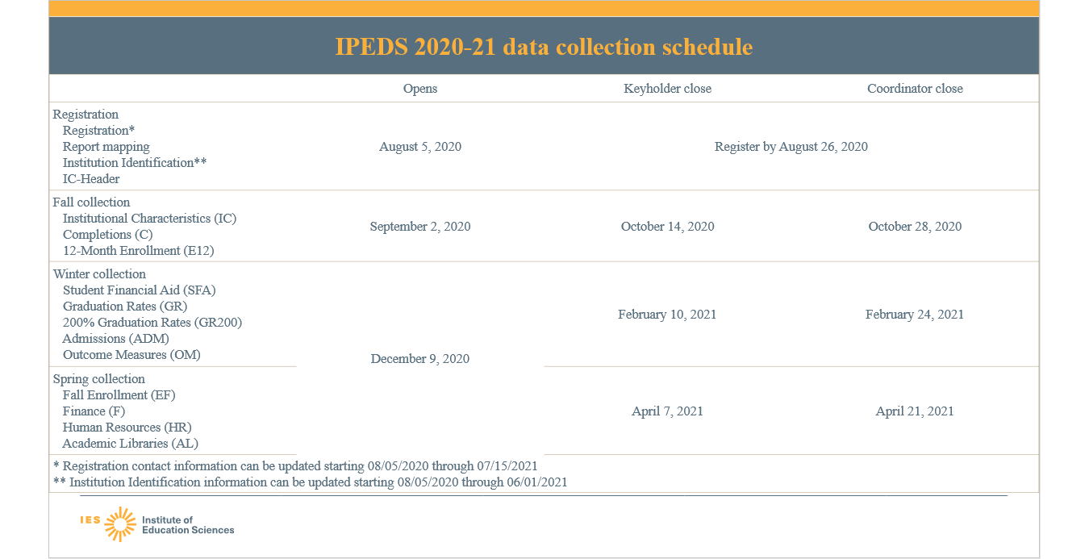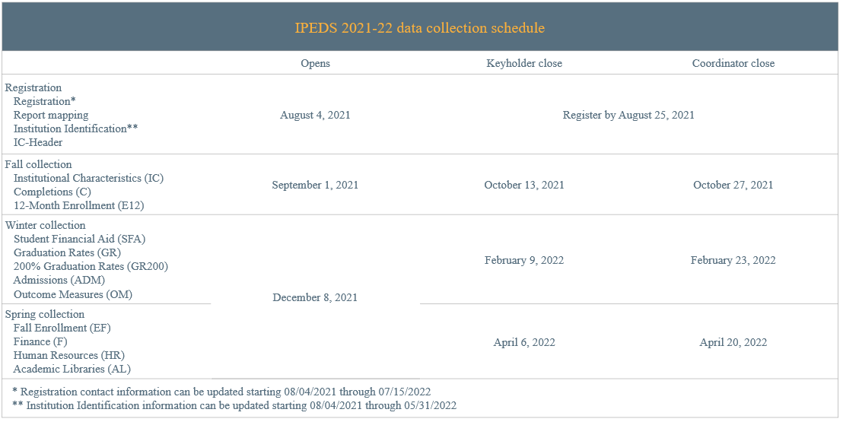

p. 14 replaced image from 2020-21 collection with image from 2021-22 collection
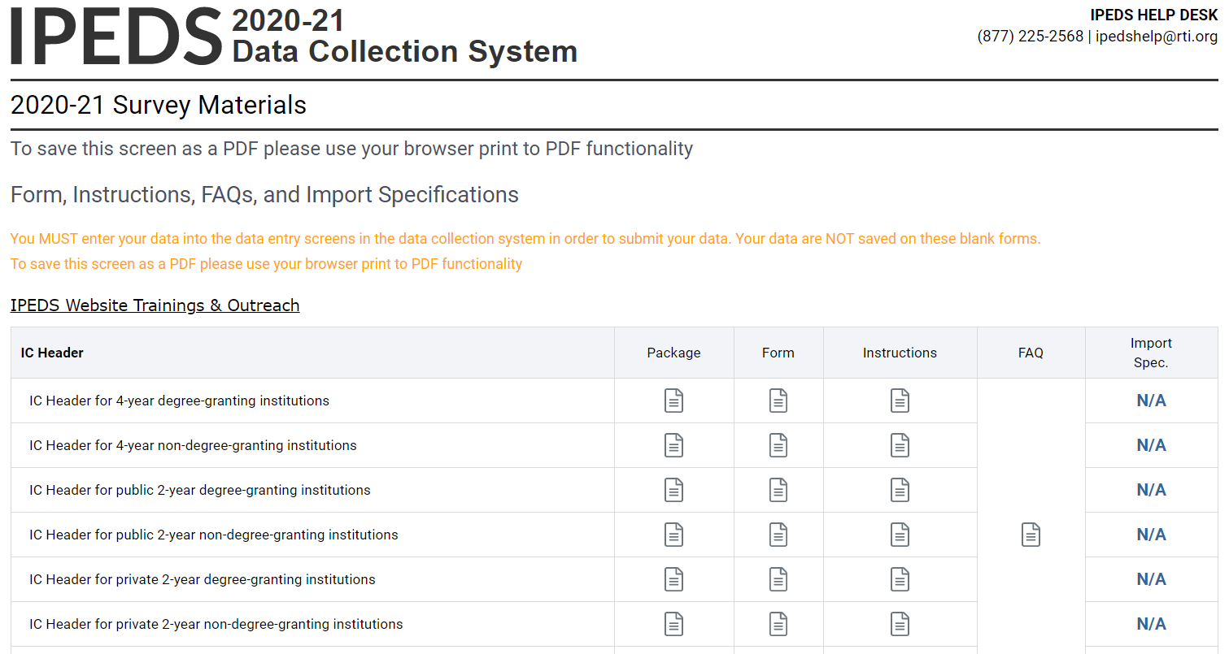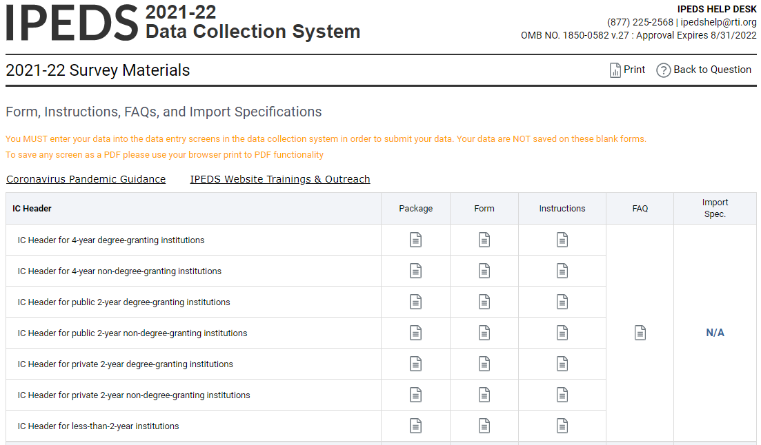

p. 15 replaced old glossary images with new glossary images
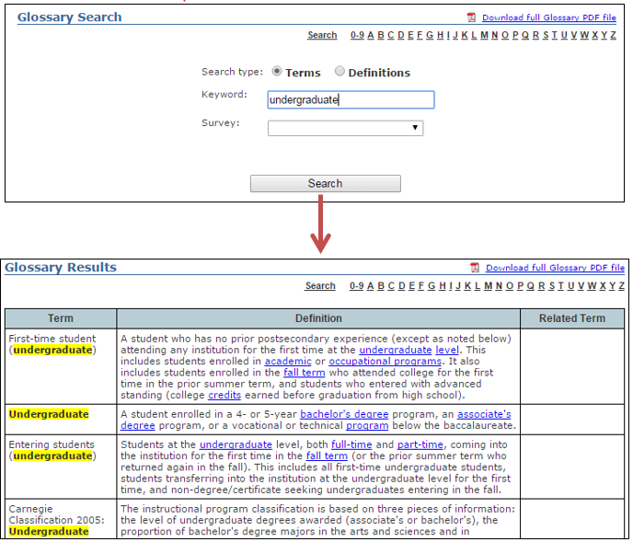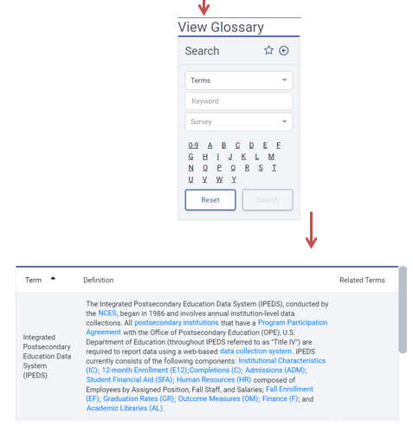

p. 21 replaced image from 2020-21 collection system with image from 2021-22 collection system
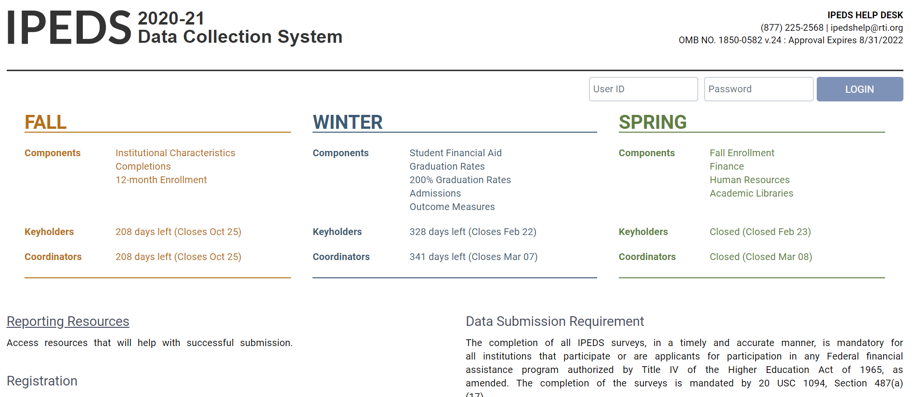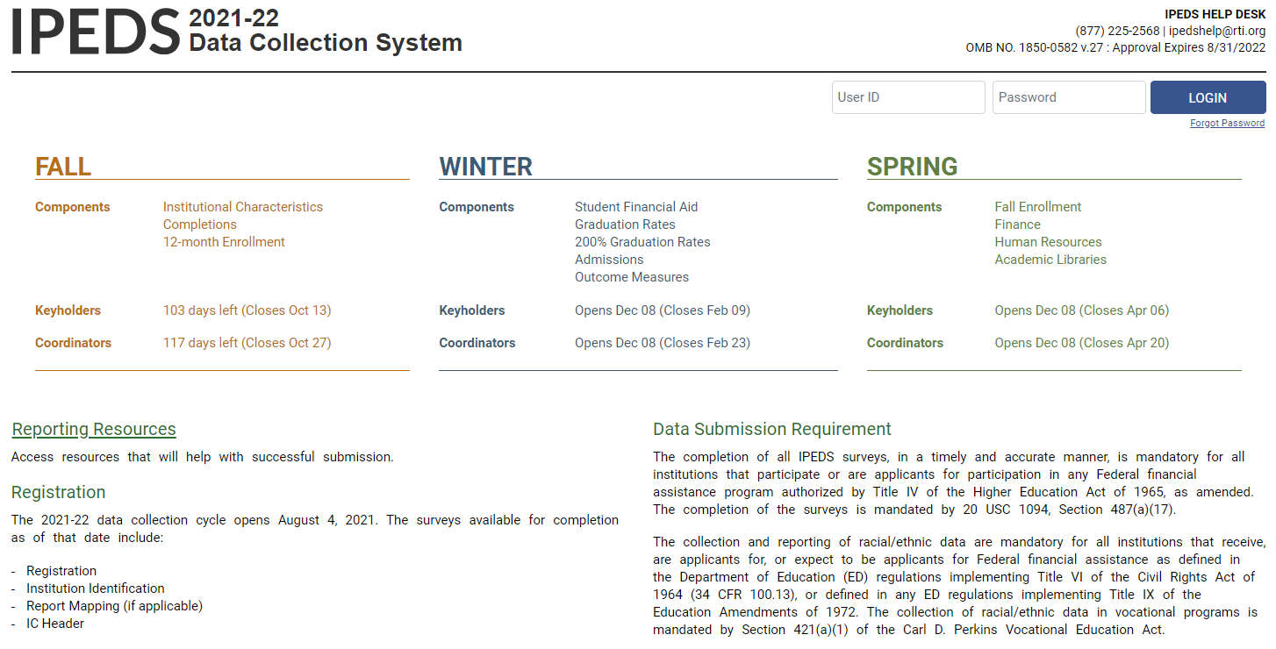

p. 22 removed note about message center, as it is no longer part of the collection system
The Message Center will tell you if you have new, unread messages.

p. 24 removed image from 2020-21 collection and replaced with image from 2021-22 collection
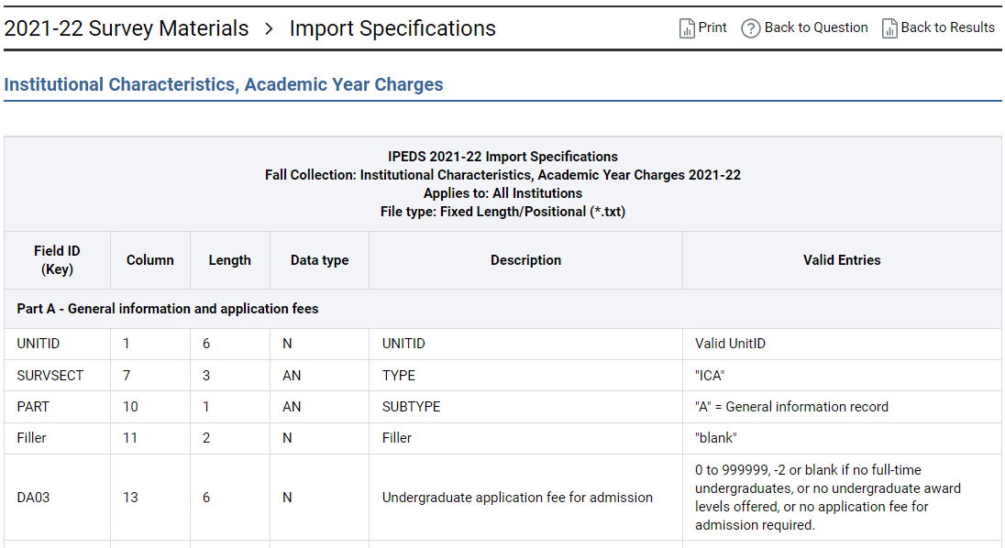
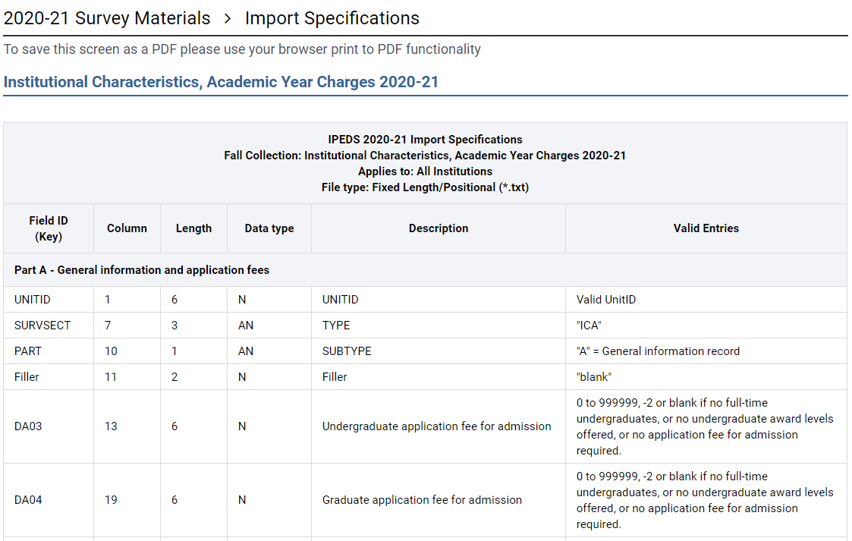

p. 30, 39 removed image from 2020-21 collection and replaced with image from 2021-22 collection
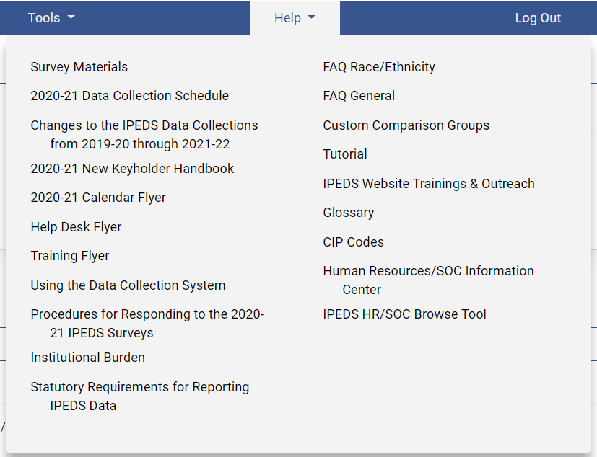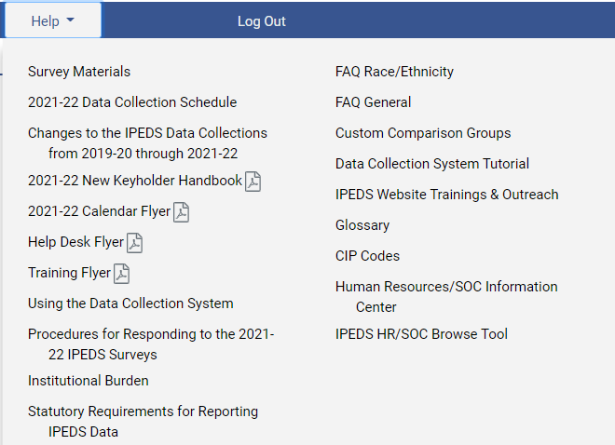

p. 40 replaced an older image from website with a newer image
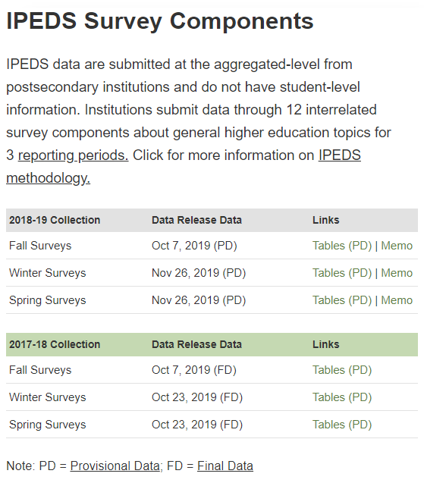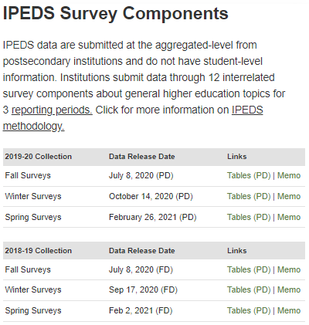

p. 43 replaced an older image from website with a newer image
