Methane Challenge Program
Implementation Plan

Partner Name |  |  | Current As Of (Date)

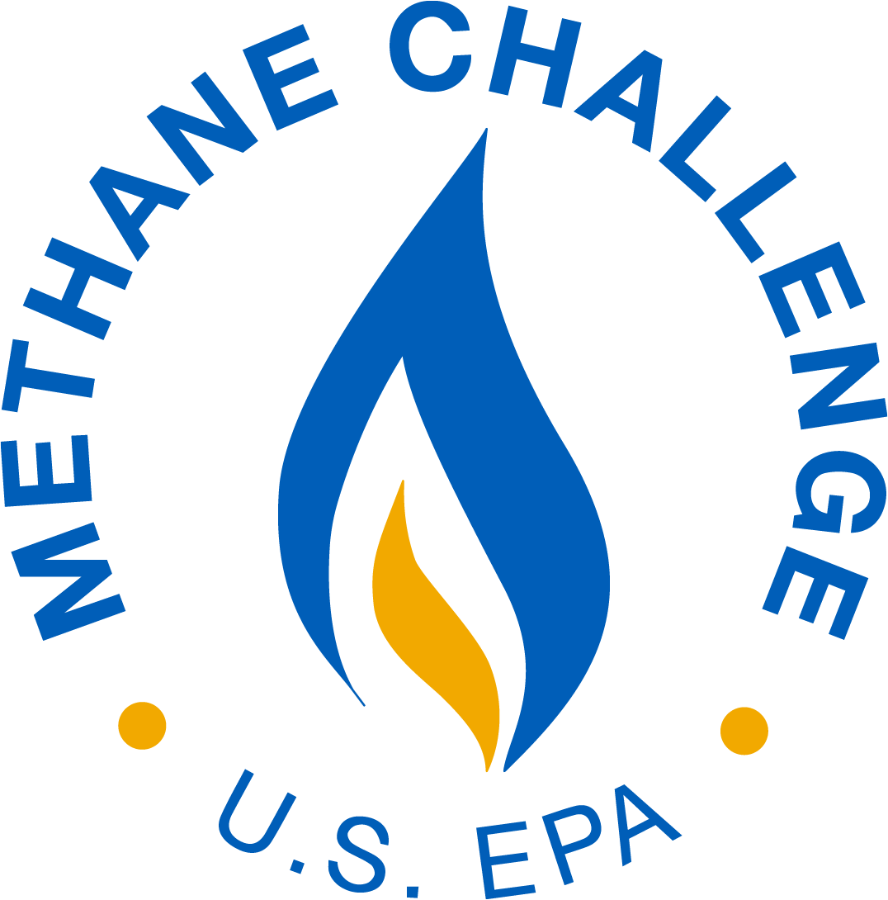

This collection of information is approved by OMB under the Paperwork Reduction Act, 44 U.S.C. 3501 et seq. (OMB Control No. 2060-0722). Responses to this collection of information are voluntary 42 USC 7403(g). An agency may not conduct or sponsor, and a person is not required to respond to, a collection of information unless it displays a currently valid OMB control number. The public reporting and recordkeeping burden for this collection of information is estimated to be 37 hours per response. Send comments on the Agency’s need for this information, the accuracy of the provided burden estimates and any suggested methods for minimizing respondent burden to the Regulatory Support Division Director, U.S. Environmental Protection Agency (2821T), 1200 Pennsylvania Ave., NW, Washington, D.C. 20460. Include the OMB control number in any correspondence. Do not send the completed form to this address.
Methane Challenge Commitments - BMP Commitment Option
Source |  | Start Date | Achievement Year
Onshore Production
 | Pneumatic Controllers
 | Equipment Leaks/Fugitive Emissions
 | Liquids Unloading
 | Pneumatic Pumps
 | Fixed Roof, Atmospheric Pressure Hydrocarbon Liquid Storage Tanks
 | Continuous Improvement Source (TBD)
 | Continuous Improvement Source (TBD)
Gathering and Boosting
 | Pneumatic Controllers
 | Equipment Leaks/Fugitive Emissions
 | Pneumatic Pumps
 | Fixed Roof, Atmospheric Pressure Hydrocarbon Liquid Storage Tanks
 | Reciprocating Compressors - Rod Packing Vent
 | Centrifugal Compressors - Venting
 | Continuous Improvement Source (TBD)
 | Continuous Improvement Source (TBD)
Natural Gas (NG) Processing
 | Reciprocating Compressors - Rod Packing Vent
 | Centrifugal Compressors - Venting
 | Continuous Improvement Source (TBD)
 | Continuous Improvement Source (TBD)
NG Transmission & Underground Storage
 | Reciprocating Compressors - Rod Packing Vent
 | Centrifugal Compressors - Venting
 | Equipment Leaks (Compressor Blowdown and Isolation Valves)
 | Transmission Pipeline Blowdowns between Compressor Stations (Commitment Rate: ; must be 50% or greater)
 | Pneumatic Controllers
 | Continuous Improvement Source (TBD)
 | Continuous Improvement Source (TBD)
NG Distribution
 | M&R Stations/City Gates
 | Mains – Cast Iron and Unprotected Steel (Commitment Rate: )
 | Services – Cast Iron and Unprotected Steel
 | Distribution Pipeline Blowdowns (Commitment Rate: ; must be 50% or greater)
 | Excavation Damages
 | Renewable Natural Gas
 | Continuous Improvement Source (TBD)
 | Continuous Improvement Source (TBD)

Methane Challenge Commitments - ONE Future Emissions Intensity Commitment Option
Segment: |  | Intensity Target: |  | Target Year:

Milestones/Timeframes for Meeting Commitments
Provide information on steps for achieving commitments such as anticipated rate of progress, key milestones, or other context (e.g., referencing work to be done during the next planned shutdown of a facility).

Additional Information/Context (optional)
Use this space, if desired, to provide other information about Program participation, such as plans for expanding Methane Challenge commitments, how historical actions informed Methane Challenge commitments, or other information on how the Program will be implemented.

Partners may delete unused rows within the table and may duplicate rows and add relevant details as needed (e.g., a corporate parent partner that has different commitments for each LDC can duplicate relevant rows to list the commitments for each LDC).

