Electronic Confidential Statement of Formula (eCSF) User Guide
Environmental Protection Agency
Office of Pesticide Programs

Electronic Confidential Statement of Formula (eCSF) User Guide
Environmental Protection Agency
Office of Pesticide Programs

Table of Contents
Table of Contents i
List of Exhibits ii
1 Introduction 1
1.1 Purpose 1
2 System Requirements 2
2.1 Supported Browsers 2
2.2 Screen Resolution 2
3 Live Application Support 3
4 eCSF General Functionalities 4
4.1 eCSF User Roles 4
4.2 Access the eCSF Application 4
4.3 Pesticide Submission Portal ‘Home’ Screen 6
4.4 Pesticide Submission Portal Header 7
4.5 eCSF Application Footer 8
4.6 Navigation Tree 10
4.7 Validation 11
5 Prepare a Confidential Statement of Formula (CSF) 14
5.1 eCSF ‘Home’ Screen 14
5.2 ‘Preliminary Questions’ Screen 14
5.3 ‘Product Properties’ Screen 18
5.4 ‘Box 2 – Producers and Product Repackaging Site’ Screen 22
5.5 ‘Box 11 – Manufacturing Sites & Component Suppliers’ Screen 31
5.6 ‘Components’ Screen 44
5.7 ‘Certification of Approving Official’ Screen 82
6 Including eCSF XML Files in a PSP Package Submission 85
7 Appendix A – Definitions, Acronyms, and Abbreviations 88
8 Appendix B – Admin Number Information 89
9 Appendix C –PDF Rendering Examples 91
9.1 Basic Formulation PDF Rendering 91
9.2 Alternate Formulation PDF Rendering 91
9.3 100% Repackaged Product PDF Rendering 91

List of Exhibits

Exhibit 4–1: CDX ‘Home’ Screen – Login 4

Exhibit 4–2: ‘MyCDX’ Screen – PSP Program Services 5

Exhibit 4–3: CDX ‘Application Profile Settings’ Pop–up 6

Exhibit 4–4: Pesticide Submission Portal – ‘Upload XML e–Submission Packages’ Option 7

Exhibit 4–5: Application Header 8

Exhibit 4–6: Application Footer ‘Preview XML’ Icon 8

Exhibit 4–7: Application Footer ‘Submit’ Icon 8

Exhibit 4–8: Application Footer ‘Save’ Icon 8

Exhibit 4–9: Application Footer ‘Validate’ Icon 8

Exhibit 4–10: Application Footer Provide Feedback 9

Exhibit 4–11: Application Footer Provide Feedback Pop-Up 9

Exhibit 4–9: Application Footer ‘CDX Links’ 9

Exhibit 4–13: PSP Navigation Tree 10

Exhibit 4–14: Pop-Up Validation Errors – ‘Add Site or Supplier’ Pop-Up 11

Exhibit 4–15: On-screen Validation Example 12

Exhibit 4–16: ‘Global Validation’ Pop–up 13

Exhibit 5–1: eCSF ‘Home’ Screen 14

Exhibit 5–2: ‘Preliminary Questions’ Screen – 100% Repack Product 17

Exhibit 5–3: ‘Preliminary Questions’ Screen – Non-repack Product 17

Exhibit 5–4: ‘Product Properties’ Screen 22

Exhibit 5–5: Box 2 – Producers 24

Exhibit 5–6: Box 2 – Product Repackaging Site 25

Exhibit 5–8: ‘Box 2 – Producers/Product Repackaging Site’ Screen – Initiate Manual Entry 26

Exhibit 5–8: ‘Add Producer’ Pop-Up 27

Exhibit 5–9: ‘Box 2 – Producers/Product Repackaging Site’ Screen – Entry Saved 27

Exhibit 5–10: ‘Box 2 – Producers/Product Repackaging Site’ Screen – Template Download 28

Exhibit 5–11: ‘Box 2 – Producers/Product Repackaging Site’ Screen – Initiate Template Upload 28

Exhibit 5–12: ‘Upload Template’ Pop-Up 29

Exhibit 5–13: ‘Box 2 – Producers/Product Repackaging Site’ Screen – Upload Complete 30

Exhibit 5–14: ‘Box 2’ PDF Rendering 30

Exhibit 5–15: ‘Box 2’ PDF Rendering of Addendum Page 31

Exhibit 5–16: ‘Box 2’ PDF Rendering of Addendum Page for Relabeling Facilities 31

Exhibit 5–17: ‘Box 11 – Manufacturing Sites & Component Suppliers’ Screen 33

Exhibit 5–18: ‘Box 11 – Manufacturing Sites & Component Suppliers’ Screen – Initiate Manual Entry 35

Exhibit 5–19: ‘Add Site or Supplier’ Pop-Up 35

Exhibit 5–20: ‘Box 11 – Manufacturing Sites & Component Suppliers’ Screen – Entry Complete 36

Exhibit 5–21: ‘Box 11 – Manufacturing Sites & Component Suppliers’ Screen – Template Download 37

Exhibit 5–22: ‘Box 11 – Manufacturing Sites & Component Suppliers’ Screen – Initiate Template Upload 37

Exhibit 5-23: ‘Upload Template’ Pop-Up 38

Exhibit 5-24: ‘Box 11 – Manufacturing Sites & Component Suppliers’ Screen – Upload Complete 38

Exhibit 5–25: ‘Box 11 – Manufacturing Sites & Component Suppliers’ Screen – Relate Component 40

Exhibit 5–26: ‘Box 11 – Manufacturing Sites & Component Suppliers’ Screen – View Existing Components 40

Exhibit 5–27: ‘Select Related Components’ Pop-Up 41

Exhibit 5–28: ‘Box 11 – Manufacturing Sites & Component Suppliers’ Screen – Component Relationship(s) Added 42

Exhibit 5–21: ‘Box 11 – Manufacturing Sites & Component Suppliers’ Screen – Relate Component 42

Exhibit 5–22: ‘Box 11 – Manufacturing Sites & Component Suppliers’ Screen – View Existing Components and Add New Component 43

Exhibit 5–23: ‘Select Related Components’ Pop-Up 43

Exhibit 5–24: ‘Box 11 – Manufacturing Sites & Component Suppliers’ Screen – Component Relationship Added 44

Exhibit 5–33: ‘Components’ Screen 46

Exhibit 5–34: ‘Add Component’ Pop-Up – Registered Active 50

Exhibit 5–35: ‘Add Component’ Pop-Up – Un–registered Active 51

Exhibit 5–36: ‘‘Add Component’ Pop-Up – Blended Active 52

Exhibit 5-37: ‘‘Add Component’ Pop-Up – Blended Active 56

Exhibit 5-38: ‘‘Add Component’ Pop-Up – Blended Active 58

Exhibit 5-39: ‘‘Add Component’ Pop-Up – Inert Component 59

Exhibit 5-40: ‘‘Add Component’ Pop-Up – Dye Component 61

Exhibit 5-41: ‘Add Component’ Pop-Up – Fragrance Component 64

Exhibit 5-42: ‘Add Component’ Pop-Up – Fertilizer Component 67

Exhibit 5-43: ‘Add Component’ Pop-Up – Water Soluble Component 69

Exhibit 5-44: ‘Add Component’ Pop-Up – Towelette Component 71

Exhibit 5-45: ‘Components’ Screen – Template Download 72

Exhibit 5-46: ‘Components’ Screen – Initiate Template Upload 72

Exhibit 5-47: ‘Upload Template’ Pop-Up 73

Exhibit 5-48: ‘Components’ Screen – Upload Complete 73

Exhibit 5-49: ‘Components’ Screen – Relate Site/Supplier 75

Exhibit 5-50: ‘Components’ Screen – View Existing Sites/Suppliers 75

Exhibit 5-51: ‘Select Related Sites/Suppliers’ Pop-Up 76

Exhibit 5-52: ‘Components’ Screen – Select Primary Site/Supplier 77

Exhibit 5-53: ‘Components’ Screen – Relate Site/Supplier 77

Exhibit 5-54: ‘Components’ Screen – View Existing Sites/Suppliers 78

Exhibit 5-55: ‘Select Related Sites/Suppliers’ Pop-Up 78

Exhibit 5–56: ‘Add Site or Supplier’ Pop-Up 79

Exhibit 5-57: ‘Components’ Screen – Select Primary Site/Supplier 79

Exhibit 5-58: Primary Site/Supplier Relationship PDF Rendering 80

Exhibit 5–9: Non–Primary Site/Supplier Relationship PDF Rendering 81

Exhibit 5–60: ‘Add Component’ Pop-Up – Chemical Identity Search 82

Exhibit 5–23: ‘Add Component’ Pop-Up – Chemical Identity Search Results 82

Exhibit 5–58: ‘Certification of Approving Official’ Screen 84

Exhibit 6–1: ‘Documents for the Application’ Screen – Upload eCSF File 86

Exhibit 6–1: ‘Documents for the Application’ Screen – Upload eCSF File 87

Exhibit 6–2: ‘Documents for the Application’ Screen – eCSF File Validation Error Report Link 88

Exhibit 6–20: eCSF File Validation Report 88

Exhibit 13–1 Admin Number Examples 91

Exhibit 13–2 File Symbol 91

Introduction
The United States Environmental Protection Agency (EPA) Office of Pesticide Programs (OPP) developed the Electronic Confidential Statement of Formula (eCSF) application to provide registrants an electronic option to create and submit ‘EPA Form 8570-4 – Confidential Statement of Formula’ (CSF) via the Pesticide Submission Portal (PSP) in the Central Data Exchange (CDX).
EPA designed ‘EPA Form 8570-4’ to capture a pesticide product’s complete chemical composition for use during registration evaluation under the Federal Insecticide, Fungicide, and Rodenticide Act (FIFRA). This form must be completed and submitted with each application for new registration of a pesticide product and application for amended registration, if the revision involves a formulation change.

Purpose
This document provides instructions on how to use the eCSF application to build eCSF Extensible Markup Language (XML) files for electronic submission to EPA via PSP. This includes field requirements, adding components, adding site and suppliers, uploading site and suppliers, relating site and suppliers to components and relating components to site and suppliers.
After reviewing this document, users will be able to:
- Access the eCSF application via CDX and PSP
- Upload and modify eCSF XML files
- Create, prepare, and save an eCSF XML file
- Submit an eCSF XML file via PSP

System Requirements
The following items are required to use the eCSF application:
- Internet access
- An e–mail account
- A vendor supported web browser with Java Script enabled and pop-up blockers disabled
- A vendor supported version of Adobe Acrobat Reader
- A CDX account with an active PSP Program Service role

Supported Browsers
For optimal performance, Google Chrome is recommended to access the eCSF application. However, vendor supported versions of the following browsers may also be used:
- Google Chrome
- Mozilla Firefox
- Microsoft Internet Explorer (IE) or Edge

Screen Resolution
Screen resolution should be set to 1024 x 768 or greater.

Live Application Support
Real–time application support is available by contacting the CDX Help Desk (CDXHD) using one of the following options:
- By Telephone:
Person–to–person telephone support is available from 8:00 am to 6:00 pm eastern standard time/eastern daylight time (EST/EDT). Call the CDXHD at its toll–free line, (888) 890–1995 or +1 (970) 494–5500 for international callers.
- By Email:
Send an email to helpdesk@epacdx.net with “Technical Support” in the ‘Subject’ line.
- By Chat:
Select the ‘Chat with the CDX Help Desk’ link on the CDX ‘Contact Us’ screen to generate a web form to enter information regarding a help request.
- By Contact Form:
Enter information in the text fields under the ‘Contact Form’ section of the CDX ‘Contact Us’ screen.

eCSF General Functionalities
This section describes general eCSF functionalities and includes the following topics:
- PSP roles for registrants
- Accessing eCSF from CDX/PSP
- Navigating the eCSF ‘Home’ screen
- The functions available in the navigation tree, application header, and application footer
- Validating eCSF XML file contents

eCSF User Roles
Registrants can access the eCSF application using two roles – Primary Submitter or Authorized Agent. There are no functionality differences between these roles within eCSF.
For more information about roles and CDX registration, please refer to the OPP CDX Pesticide Submission Portal Registration User Guide.

Access the eCSF Application
To access the eCSF application, first navigate to the CDX ‘Home’ screen.
Exhibit 4-1 shows a screen capture of the CDX ‘Home’ screen:
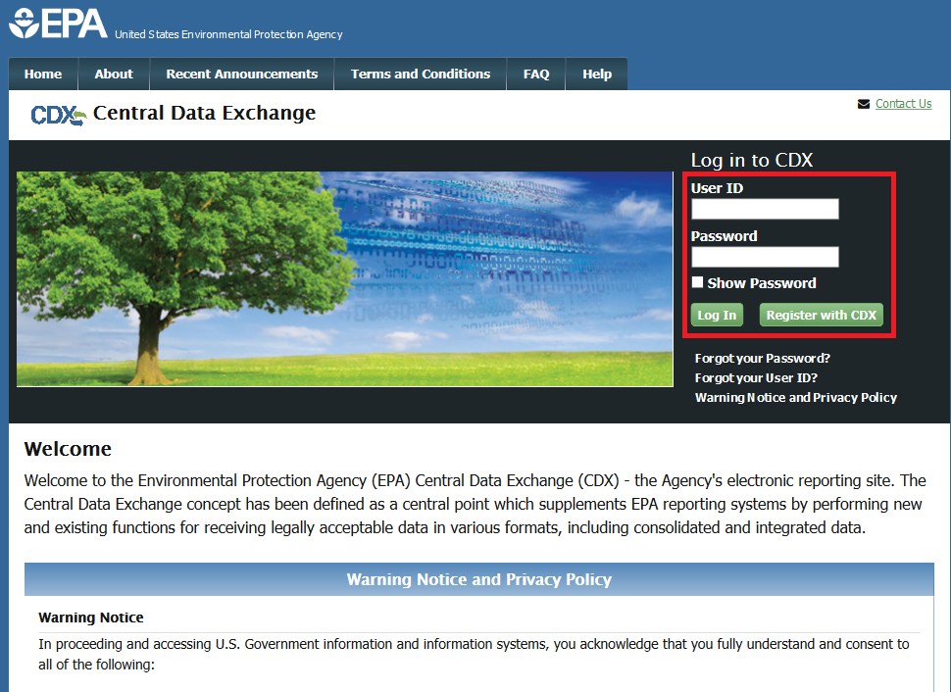
Exhibit 4-1: CDX ‘Home’ Screen – Login
Navigation: Enter valid values into the ‘User ID’ and ‘Password’ fields and select the ‘Log In’ button.
The ‘MyCDX’ screen displays once a user successfully logs into CDX. This screen contains a list of associated program services under the ‘Services’ header. If registered for the PSP program service, ‘PSP: Pesticide Submission Portal (Company Number Requests)’ will be listed. A program service’s status is visible by scrolling over the icons in the ‘Status’ column. Access the roles within a program service by selecting the blue, underlined link in the ‘Role’ column. The currently available registrant roles for PSP are ‘Primary Submitter’ and ‘Authorized Agent.’
Exhibit 4-2 shows a screen capture of the ‘My CDX’ screen:
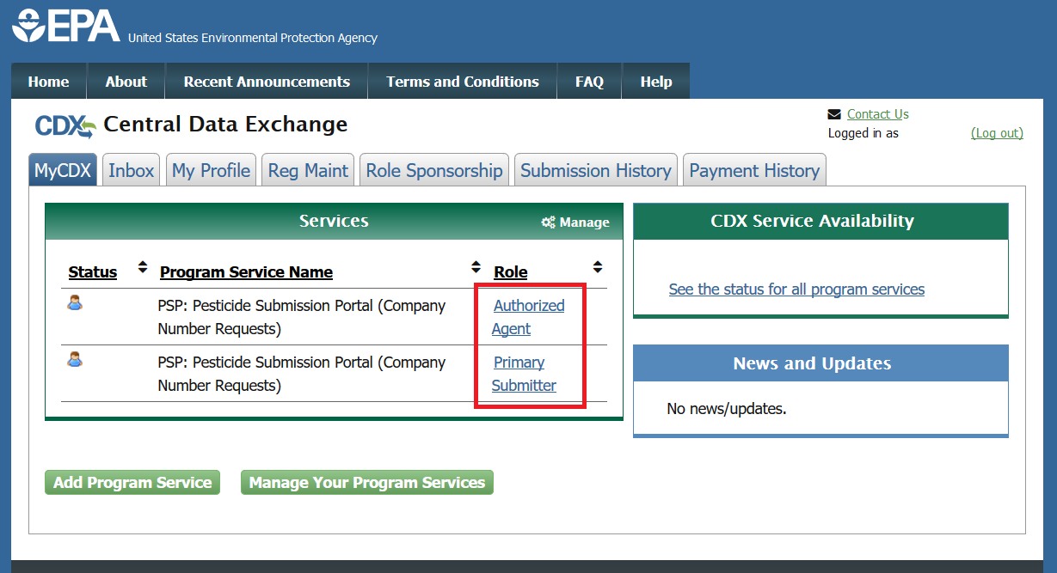
Exhibit 4-2: ‘MyCDX’ Screen – PSP Program Services
Navigation: Select a blue role link under the ‘Role’ column to enter PSP as the selected role.
When a role is associated with multiple organizations, selecting the role link on the ‘MyCDX’ screen generates the ‘Application Profile Settings’ pop-up. The user navigates directly into PSP when a role is associated with only one organization.

Exhibit 4-3 shows a screen capture of the ‘Application Profile Settings’ pop-up window:
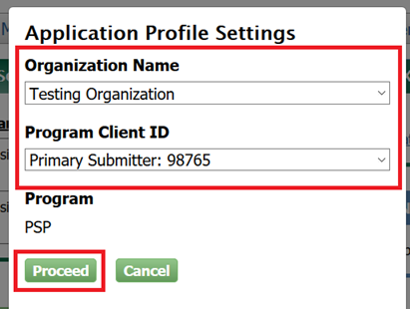
Exhibit 4-3: CDX ‘Application Profile Settings’ Pop–up
Navigation: Select an organization and company role/number and then select the ‘Proceed’ button to enter the PSP application.

Pesticide Submission Portal ‘Home’ Screen
The PSP ‘Home’ screen is the initial screen within PSP and it provides access to the various underlying PSP applications and functions available within the portal. The screen is separated into three panels:
- The ‘Submissions and Tools’ panel provides guided access to all submission applications and is logically divided into regulatory sections for ‘Registration Actions,’ Registration Review,’ ‘Reregistration,’ and ‘Pre–Submission Tools.’ Selecting these sections displays additional information for the options available under each regulatory section. For information on how to locate a specific submission type, navigate to the corresponding section of this user guide.
- The ‘PSP Alerts’ panel displays information pertinent to PSP including outage, maintenance, and OPP programmatic notifications.
- The ‘View Recent Packages’ panel displays the five (5) most recently modified registration packages for the user and organization displayed in the application header. Note that non–registration package submissions (e.g., DCI Responses) and registration packages for organizations other than the one displayed in the application header will not display.

Exhibit 4-4 shows a screen capture of how to navigate the PSP ‘Home’ screen to access the eCSF application:
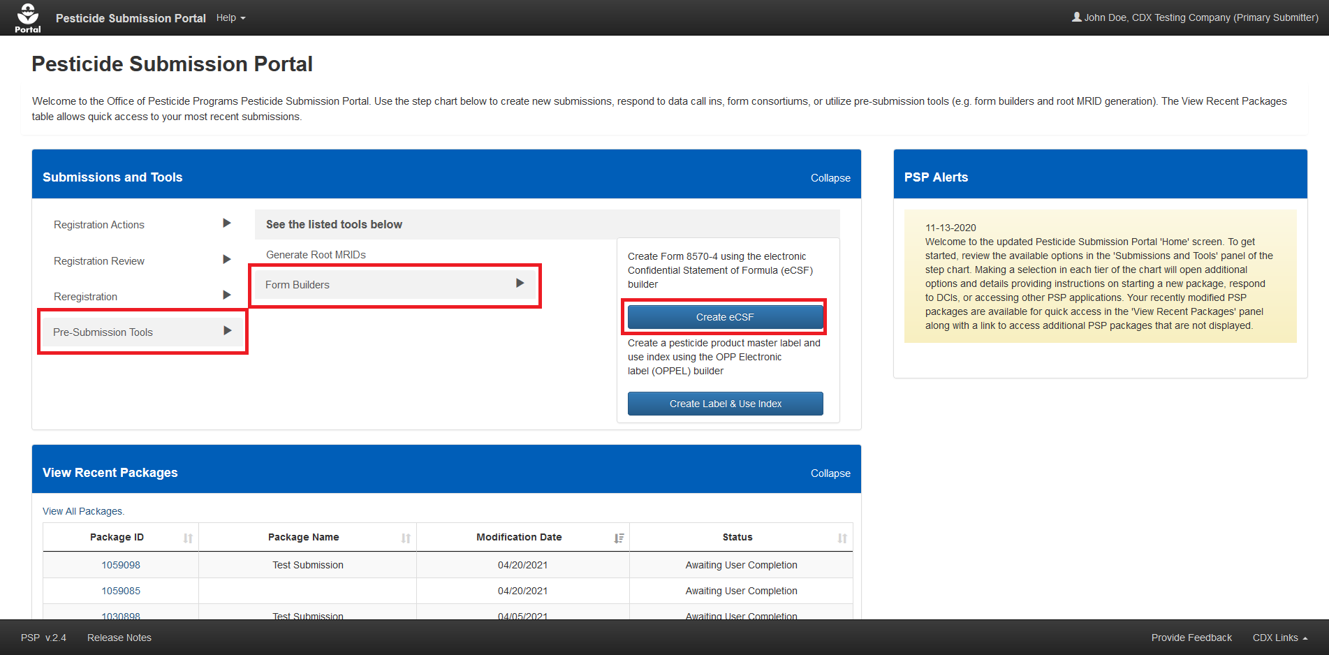
Exhibit 4-4: Pesticide Submission Portal – ‘Upload XML e–Submission Packages’ Option
Navigation: In the ‘Submissions and Tools’ panel, select the ‘Pre–Submission Tools’ option in the first column, next select the ‘Form Builders’ option in the second column, and finally select the ‘Create eCSF’ button.

Pesticide Submission Portal Header
The PSP header, first displayed on the PSP ‘Home’ screen, displays throughout all PSP applications, including the eCSF application, and contains the following useful navigation tools and information:
- The ‘Portal’ icon displayed on the left side of the header navigates the user to the PSP ‘Home’ screen from any of the PSP application screens when selected.
- Within the eCSF application, selecting the ‘Electronic Confidential Statement of Formula (eCSF) heading navigates the user to the eCSF ‘Home’ screen from any of the screens within the eCSF application.
- Selecting the ‘Help’ link displays application resources including user guides, answers to frequently asked questions, and contact information for the CDXHD.
- The logged in user’s name, organization, and role display as a link on the right side of the header to assist CDX users who have registered for multiple organizations and roles identify the role/organization combination with which they accessed PSP. Selecting the link will log the user out of both the application and CDX.

Exhibit 4-5 shows a screen capture of the PSP application header:
Exhibit 4-5: Application Header

eCSF Application Footer
The eCSF application footer displays throughout all application and dynamically presents the below functionalities based on the displayed screen:
- Preview XML: Select the ‘Preview XML’ icon to generate a pop-up displaying an in–progress XML representation of the current eCSF XML file.
Exhibit 4-6: Application Footer ‘Preview XML’ Icon
- Preview PDF: Select the ‘Preview PDF’ icon to generate a pop-up displaying an in–progress PDF rendering of EPA Form 8570-4 for the current eCSF XML file. Refer to Section 9 for examples of PDF renderings.
Exhibit 4-7: Application Footer ‘Submit’ Icon
- Save to local: Select the ‘Save to local’ icon to save the current, in–progress eCSF XML file to a local machine. The ‘Save to local’ function does not validate entered data.
Important: The eCSF application does not save eCSF XML files within PSP or the eCSF application. All work must be saved as an XML file to a local machine.
Exhibit 4-8: Application Footer ‘Save’ Icon
- Validate: Select the ‘Validate’ icon to check the current eCSF XML file for errors and generate a comprehensive report in a pop-up. Refer to Section 4.7.3 for additional information about global validation.
Exhibit 4-9: Application Footer ‘Validate’ Icon
- Provide Feedback: The feedback functionality allows users to share their eCSF application experience directly with the project team. Select the ‘Provide Feedback’ link to launch the feedback pop-up and provide application feedback.
Important: Contact the CDXHD for immediate assistance while working within PSP.
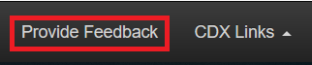
Exhibit 4-10: Application Footer Provide Feedback
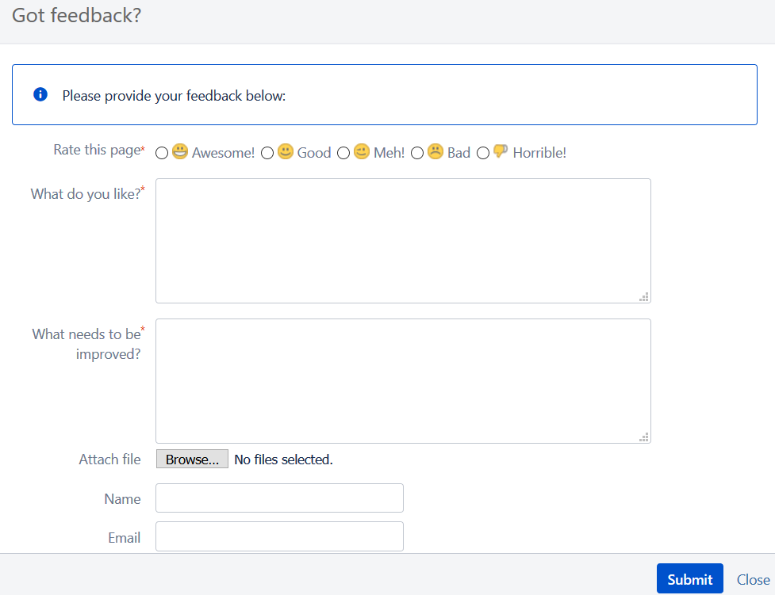
Exhibit 4-11: Application Footer Provide Feedback Pop-Up
- Help Links: The ‘CDX Links’ menu in the application footer provides convenient access to the following CDX resources:
- CDX ‘Home’ screen
- ‘MyCDX’ screen
- EPA Homepage
- CDX ‘Terms and Conditions’ screen
- CDX ‘Privacy and Security Notice’ screen
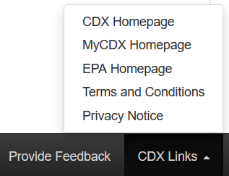
Exhibit 4-12: Application Footer ‘CDX Links’

Navigation Tree
The navigation tree is located on the left side of each screen within the eCSF application and allows a user to navigate between the various screens within a submission by selecting a screen title link.
All fields on the currently displayed screen must pass validation before a user can navigate to another screen. A user can by–pass on-screen validation by marking the screen for future review. When a user marks a screen for review, the navigation tree displays its title link text in red with an asterisk to indicate the screen does not pass validation and requires future attention. Refer to Section 4.7.2 for additional information about on-screen validation.
Exhibit 4-13 shows a screen capture of the navigation tree:
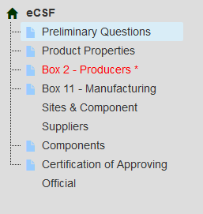
Exhibit 4-13: PSP Navigation Tree

Validation
To ensure that the data entered into an eCSF XML file are accurate and complete, the application applies a multi–part validation scheme that indicates errors while a user works on a submission and prevents a user from submitting incomplete or inaccurate files to EPA.

Pop-Up Window Validations
Many screens within the eCSF application utilize pop-up windows to facilitate data entry for an object (e.g., a component). These pop-ups follow a per field validation scheme that prevents data entered within the pop-up from being saved until a user clears all validation errors.
Exhibit 4-14 shows a screen capture of the ‘Add Site or Supplier’ pop-up with validation errors:
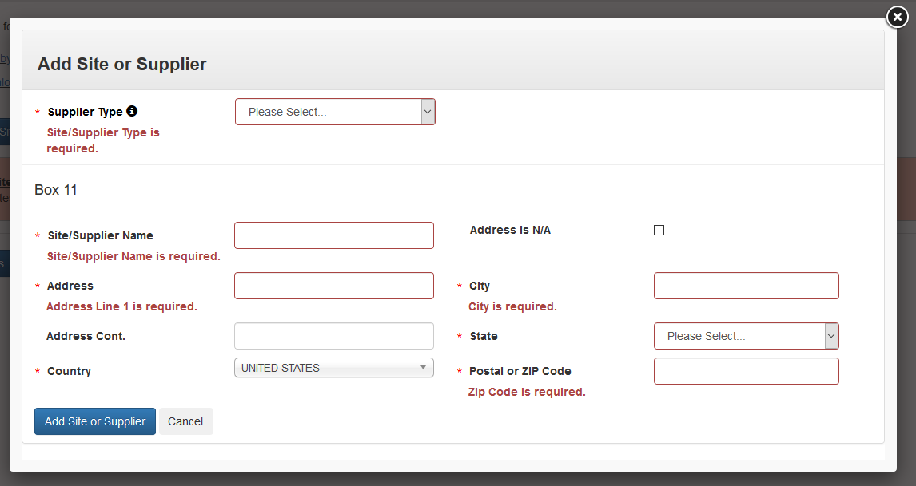
Exhibit 4-14: Pop-Up Validation Errors Example

On-screen Validations
The eCSF application performs data validation on the currently displayed screen whenever a user attempts to navigate away from the screen. If no validation errors are present, the application will perform the requested action. However, if validation errors are present, the application will display error messages on the screen and must be corrected prior to navigation. Note that some error messages can only be cleared by accessing the data entry pop-up for an object (e.g., a producer); in these cases the error messages provide direction to failed object.
To navigate away from a screen that contains validation errors without correcting them, select the ‘Mark for Registrant Review’ checkbox prior to performing a navigation action. A user must clear all errors and selected ‘Mark for Registrant Review’ checkboxes before they can certify or submit an eCSF XML file.
Exhibit 4-15 shows a screen capture of the ‘Box 2 – Producers’ screen with on-screen validation errors:
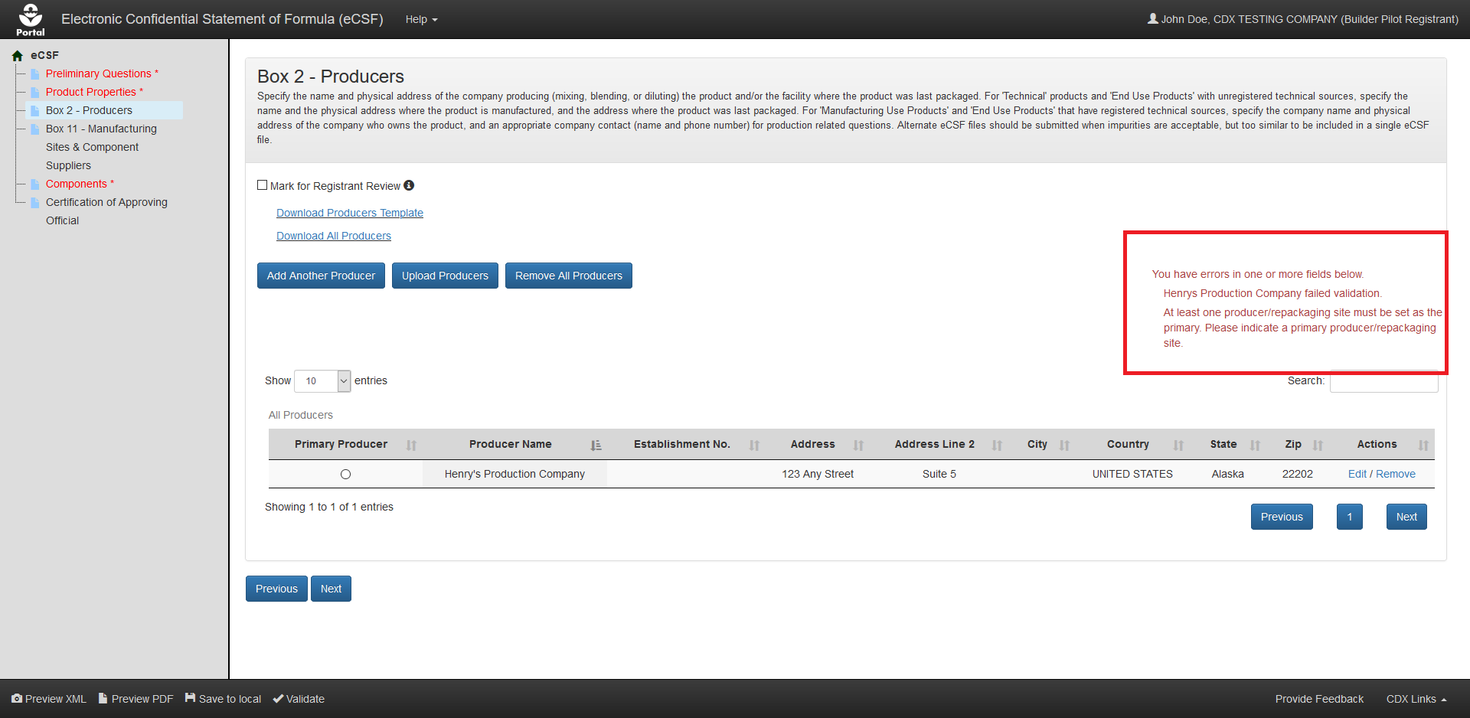
Exhibit 4-15: On-screen Validation Example

Global Validation
An eCSF user may perform a validation check on the entirety of an eCSF XML file at any time by selecting the ‘Validate’ icon in the application footer. Doing so will check each field within the submission for missing and/or invalid data as determined by the currently entered data.
The results of a global validation check display in a separate pop-up. Each validation error indicates the screen on which an error occurs as well as the specific error as a link to navigate to the screen to address the error. Once a user clears an error, the ‘Validate’ icon may be selected again to view an updated set of errors. A user must clear all errors before they can certify or submit an eCSF XML file.
Note: Add CDX must to a browser’s pop-up whitelist for global validation results to properly display.

Exhibit 4-16 shows a screen capture of the global validation pop-up:
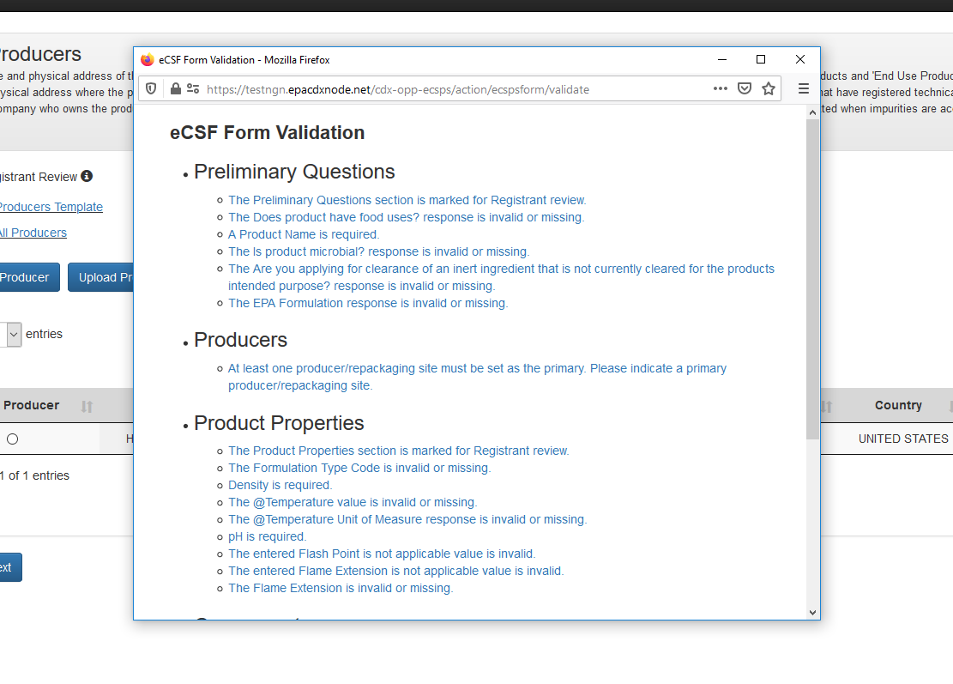
Exhibit 4-16: ‘Global Validation’ Pop-Up
Navigation: Select an error link in the ‘Global Validation’ pop-up to navigate to the location within the application where the selected error occurs.

Prepare a Confidential Statement of Formula (CSF)
This section describes how to prepare an ‘EPA Form 8570-4 – Confidential Statement of Formula’ file using the eCSF application. Upon completion, the eCSF application will produce an XML file, which a user can submit to EPA in lieu of a paper form.

eCSF ‘Home’ Screen
The eCSF ‘Home’ screen is the first screen within the eCSF application and is accessed by following the steps outlined in Section 4.2. From this screen, a user has the option to create a new eCSF XML file or upload a previously created file to make edits.
Exhibit 5-1 shows a screen capture of the eCSF ‘Home’ screen:
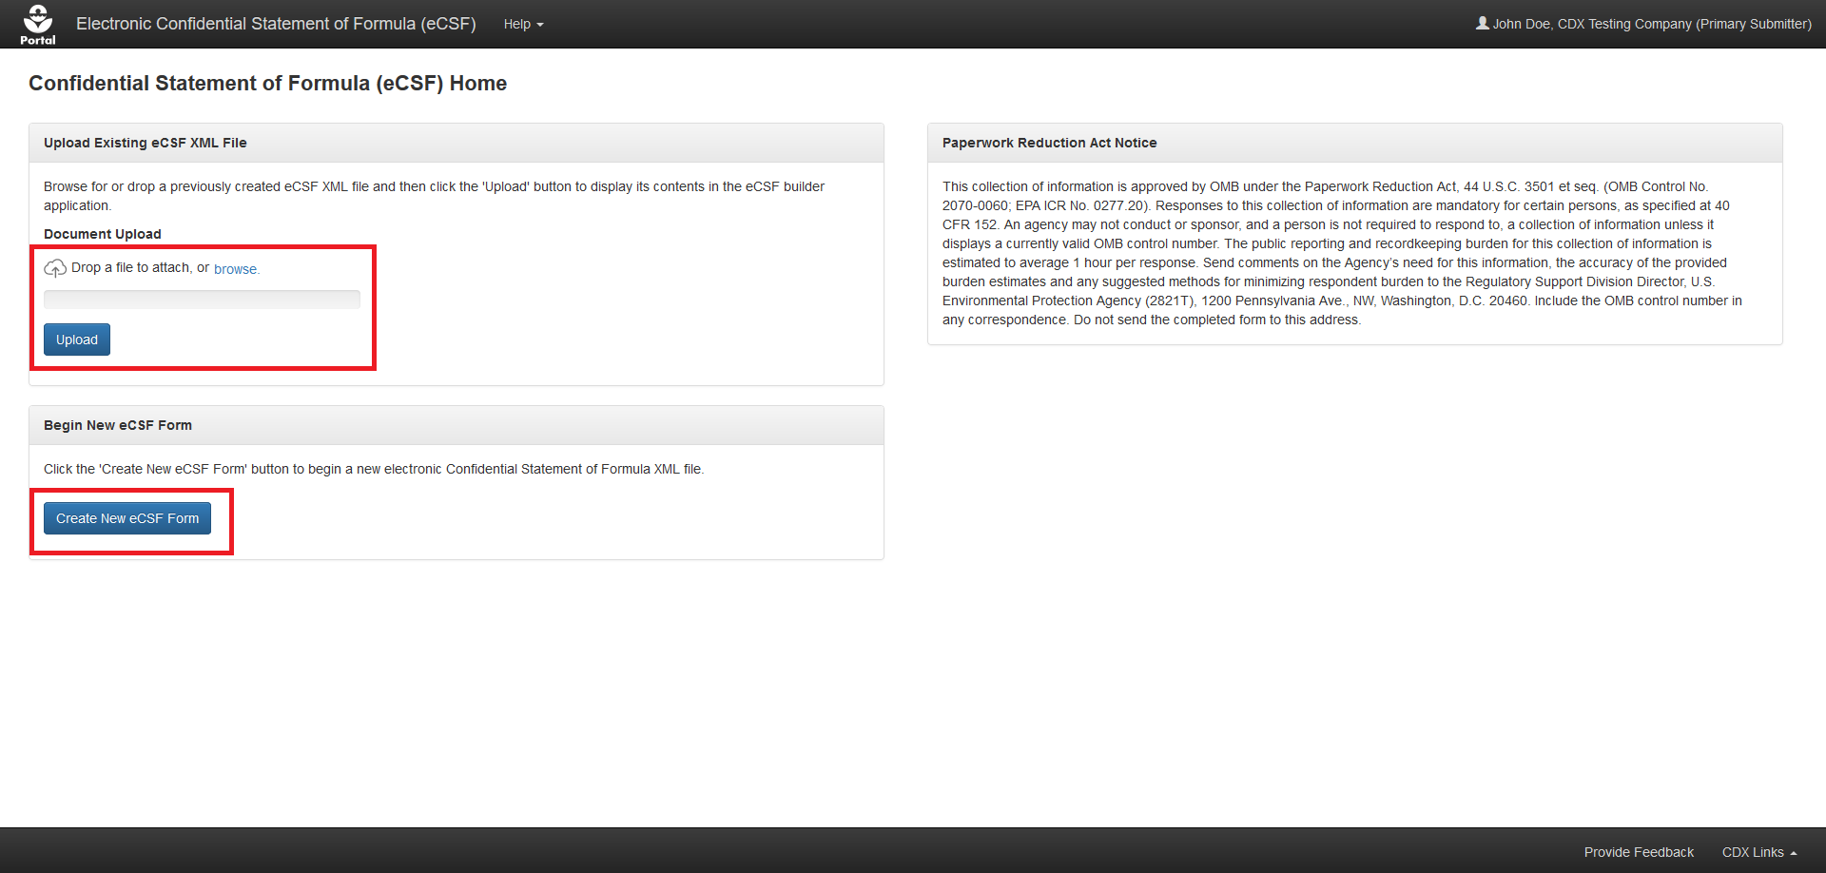
Exhibit 5-1: eCSF ‘Home’ Screen
Navigation: Select the ‘Create New eCSF Form’ to create a new eCSF XML file. Alternatively, upload an existing eCSF XML file and select the ‘Upload’ button to continue working on a previously created file.

‘Preliminary Questions’ Screen
The ‘Preliminary Questions’ screen captures basic information for a product.
Important: The responses provided on this screen dynamically update application validations and requirements on subsequent screens. Enter responses for all required fields on the ‘Preliminary Questions’ screen before navigating away from the screen to ensure the expected experience on subsequent screens.
The following fields display on the ‘Preliminary Questions’ screen:
- Mark for Registrant Review: Select this checkbox to bypass on-screen validation. When a screen has been marked for review, the navigation tree displays its title link text in red with an asterisk to indicate the screen does not pass validation and requires future attention. This field is optional.
- File Name: Enter the name that the eCSF XML file will have when a user saves it to their local machine. This field is pre–populated with a place holder name, but EPA recommends their preferred file naming convention of ‘[EPA Registration Number] _ [Basic/Alternate]_[Date Signed]’ (e.g., ‘98765–1_Basic_10102016’). This field is required.
- Box 1 – Name of Applicant/Registrant: Enter the name of the company that legally owns the product registration. The displayed information populates from the logged in user's CDX account and should be updated if it is inaccurate. This field is required.
- Box 1 – Address: Enter the mailing address for the company that legally owns the product registration. The displayed information populates from the logged in user's CDX account and should be updated if it is inaccurate. This field is required and may not be a PO Box.
- Box 1 – Address Cont.: Enter the continued mailing address for the company that legally owns the product registration. The displayed information populates from the logged in user's CDX account and should be updated if it is inaccurate. This field is optional.
- Box 1 – City: Enter the city for the mailing address for the company that legally owns the product registration. The displayed information populates from the logged in user's CDX account and should be updated if it is inaccurate. This field is required.
- Box 1 – State: Select the state for the mailing address for the company that legally owns the product registration. The displayed information populates from the logged in user's CDX account and should be updated if it is inaccurate. This field is required.
- Box 1 – Country: Enter the country for the mailing address for the company that legally owns the product registration. The displayed information populates from the logged in user's CDX account and should be updated if it is inaccurate. This field is required and must be ‘UNITED STATES.’
- Box 1 – ZIP Code: Enter the ZIP Code for the mailing address for the company that legally owns the product registration. The displayed information populates from the logged in user's CDX account and should be updated if it is inaccurate. This field is required and must be in either the ‘#####’ or ‘#####–####’ format.
- EPA Formulation – Box A: Select the formulation type for which the registration data requirements were reviewed by EPA. This field is required.
- Alternate Formulation Number: Enter an 'Alternate Formulation Number' for the formulation. This number should be a consecutively numbered integer up to five (5) digits (e.g., 1, 2, 3). To submit a new version of an Alternate Formulation, enter the 'Alternate Formulation Number' used in the corresponding, previously submitted version. This field is required when ‘EPA Formulation – Box A’ is ‘Alternate Formulation.’
- Is this product a 100% Repack?: Indicate whether the product is a 100% repackaging of another EPA registered product. Selecting ‘Yes’ for this field significantly reduces the number of required fields within the form and reduces the displayed screens to the ‘Preliminary Questions,’ ‘ Box 2 – Product Repackaging Site,’ and ‘Certification of Approving Official’ screens. This field is required.
- Registration Number for the Repackaged Product: Enter the registration number for the repackaged, EPA registered product. Once a user enters a number, the application will search current registration data to populate product data into the eCSF XML file and ensure that the entered number is accurate. This field is required.
- Company #: Displays the company number associated with the logged in user’s CDX account. This field is fixed and required.
- Reg. No./File Symbol – Box 4: Enter the full, EPA registration number or file symbol (e.g., ‘Company Number–Product Code’). Leave this field blank if EPA has not assigned a registration number to the product. If a user enters a valid registration number, the application will search current registration data to populate the ‘Product Name – Box 3’ field. This field is required for 100% repackaged products, but is otherwise optional.
- EPA Product Manager/Team Number – Box 5: If known, enter the EPA Product Manager number. This field is optional.
- Product Name – Box 3: Enter the product name as written on the application form and product label. If nothing is entered in ‘Reg. No./File Symbol – Box 4’ field the application will search current registration data to ensure that the entered value does not already exist for a product. This field is required.
- What is the Product Type?: Select a product type. This field is required. The following options are available for selection:
  - Technical
  - Manufacturing Use Product (previously known as Manufacturing Concentrate)
  - End Use Product (EP)
- Is this an Integrated Systems Product (ISP)?: Indicate whether the product is an integrated systems product. This field displays when the ‘Product Type’ is ‘Technical’ or ‘End Use Product (EP) and is required when displayed.
- Applying for Inert Clearance?: Indicate whether a clearance application is pending for any of the ‘Inert’ components within the eCSF XML file. Indicating that a user is also applying for food use clearance for a product allows ‘Inert’ components not cleared for food use to be added for products that have food uses. This field is required.
- Is product microbial?: Indicate whether the product has antimicrobial properties. This field is required.
- Does product have food uses?: Indicate whether the product has food uses. Note that the application does not allow ‘Inert’ components not cleared for food use in a food use product unless a user also indicates that an application for clearance is pending. This is a required field.
Exhibit 5-2 shows a screen capture of the ‘Preliminary Questions’ screen for a 100% repack product:
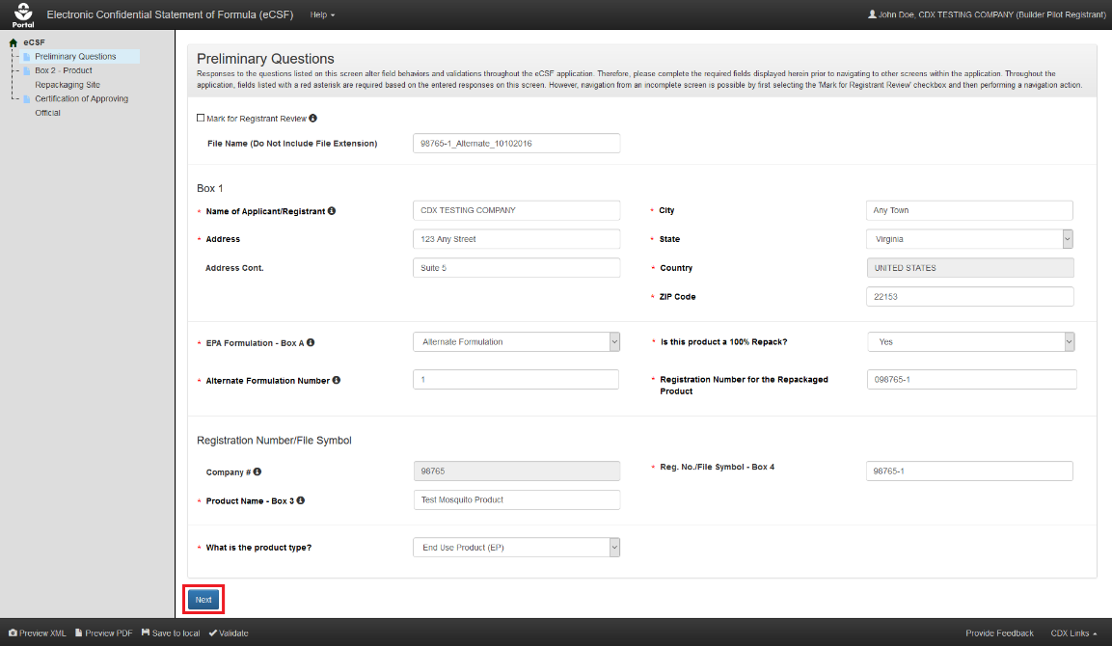
Exhibit 5-2: ‘Preliminary Questions’ Screen – 100% Repack Product
Navigation: Fill out all necessary fields and select the ‘Next’ button.
Exhibit 5-3 shows a screen capture of the ‘Preliminary Questions’ screen for a non-repack product:
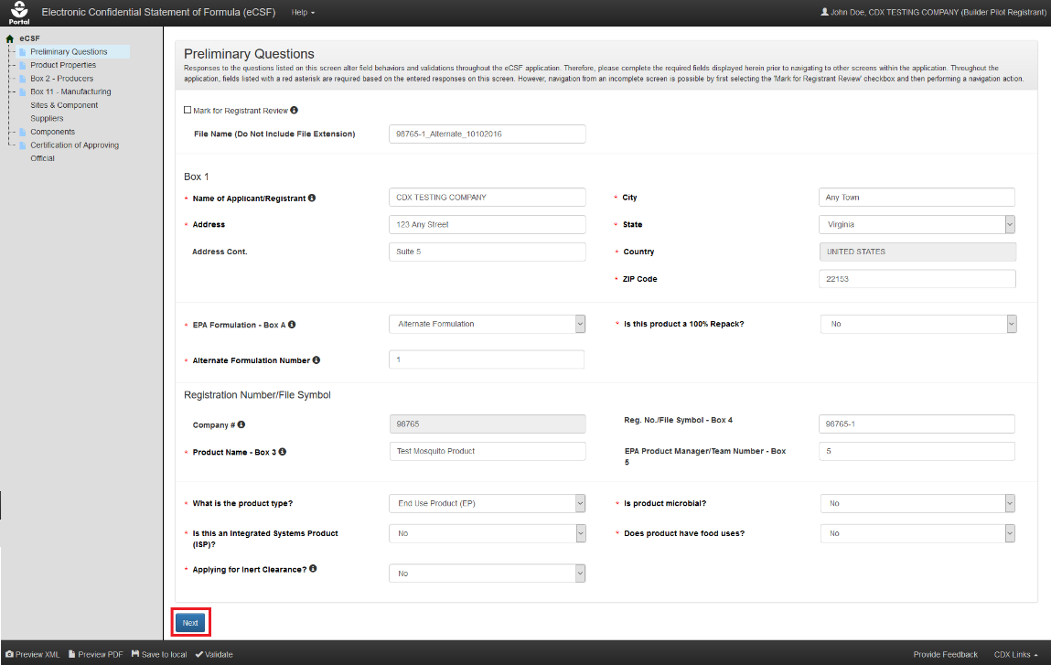
Exhibit 5-3: ‘Preliminary Questions’ Screen – Non-Repack Product
Navigation: Fill out all necessary fields and select the ‘Next’ button.

‘Product Properties’ Screen
The ‘Product Properties’ screen gathers data about a product’s physical properties. This screen does not display when ‘Is this product a 100% Repack?’ on the ‘Preliminary Questions’ screen is ‘Yes.’
Important: Similar to the ‘Preliminary Questions’ screen, responses provided on this screen dynamically update application validations and requirements on subsequent screens. Enter responses for all required fields on the ‘Product Properties’ screen before navigating away from the screen to ensure the expected experience on subsequent screens.
The following fields display on the ‘Product Properties’ screen:
- Mark for Registrant Review: Select this checkbox to bypass on-screen validation. When a screen has been marked for review, the navigation tree displays its title link text in red with an asterisk to indicate the screen does not pass validation and requires future attention. This field is optional.
- Formulation Type Code: Select the formulation type that best describes the product. A formulation type code must remain consistent throughout a product’s registration. ‘Technical' products should be described as either a 'Solid' or a 'Liquid'. This field is required. The following options are available for selection:
  - Solid
  - Liquid
  - Gas
  - Plant Incorporated Protectant
- Is this an impregnated material?: Indicate whether the product is an impregnated material. This field only displays when ‘Formulation Type Code’ is ‘Solid’ and is required when displayed.
- Material Type: Enter a material type for an impregnated material. This field only displays when ‘Formulation Type Code’ is ‘Solid’ and ‘Is this an impregnated material?’ is ‘Yes.’ This field is required when displayed.
- Weave Count: Enter a weave count. This field displays when ‘Formulation Type Code’ is ‘Solid, ’ ‘Is this an impregnated material?’ is ‘Yes,’ and ‘Is this a water soluble package?’ is ‘No;’ or when ‘Formulation Type Code’ is ‘Liquid,’ ‘Does this product contain substrate/towelette/wipe?’ is ‘Yes,’ and ‘Is this a water soluble package?’ is ‘No;’ This field is required when displayed.
- Weave Size: Enter a weave size. This field displays when ‘Formulation Type Code’ is ‘Solid, ’ ‘Is this an impregnated material?’ is ‘Yes,’ and ‘Is this a water soluble package?’ is ‘No;’ or when ‘Formulation Type Code’ is ‘Liquid,’ ‘Does this product contain substrate/towelette/wipe?’ is ‘Yes,’ and ‘Is this a water soluble package?’ is ‘No;’ This field is required when displayed.
- Is the product a pet collar?: Indicate whether the product is a pet collar. This field only displays when ‘Formulation Type Code’ is ‘Solid’ and ‘Is this an impregnated material?’ is ‘Yes.’ This field is optional.
- Is the product an ear tag?: Indicate whether the product is an ear tag. This field only displays when ‘Formulation Type Code’ is ‘Solid’ and ‘Is this an impregnated material?’ is ‘Yes.’ This field is optional.
- Plastic Type: Enter a plastic type for a pet collar or ear tag product. This field only displays when ‘Is the product a pet collar?’ and/or ‘Is the product an ear tag?’ is/are ‘Yes.’ This field is optional when displayed.
- Is the product under pressure?: Indicate whether the product is under pressure. Note that this does not apply to bag–on–valve products. This field only displays when ‘Formulation Type Code’ is ‘Liquid’ and is required when displayed.
- Is this a water soluble package?: Indicate whether the product’s packaging is water soluble. Additional fields display for products that are indicated as having water soluble packaging. This field only displays when ‘Formulation Type Code’ is ‘Solid’ or ‘Liquid’ and is required when displayed.
- Ink Type: Enter the ink type associated with the water soluble packaging. This field only displays when ‘Is this a water soluble package?’ is ‘Yes’ and is required when displayed.
- Film Type: Enter the film type associated with the water soluble packaging. This field only displays when ‘Is this a water soluble package?’ is ‘Yes’ and is required when displayed.
- Does this product contain substrate/towelette/wipe?: Indicate whether the product contains a substrate, towelette, or wipe. Note that products that have a substrate, towelette, or wipe cannot also have water soluble packaging. This field only displays when ‘Formulation Type Code’ is ‘Liquid’ and is required when displayed.
- Tissue Type: Indicate the tissue type for a ‘Plant Incorporated Protectant’ product. This field only displays when ‘Formulation Type Code’ is ‘Plant Incorporated Protectant’ and is optional when displayed. The following options are available for selection:
  - Whole Plant
  - Leaf
  - Kernel (Seed)
  - Root
  - Other
- Specify Other Tissue Type: Enter the tissue type when none of the options in the ‘Tissue Type’ field apply to the product. This field only displays when ‘Tissue Type’ is ‘Other’ and is optional when displayed.
- Viscosity: Enter a viscosity value, if necessary. This field is optional.
- Viscosity Units: Select a viscosity unit. Please select 'mPa(s)' for liquid MA and/or 'End Use Products'. This field is required when a ‘Viscosity’ value is present. The following options are available for selection:
  - mPa(s)
  - cP
  - St
  - cSt
- Box 7 – Is there a Density range?: Indicate whether the product has measured upper and lower density values. This field is required.
- Box 7 – Density: If the product does not have a density range, enter the density value. This field only displays when ‘Is there a Density range?’ is ‘No’ and is required when displayed.
- Box 7 – Lower Limit: If the product has a density range, enter the lower limit density value. This field only displays when ‘Is there a Density range?’ is ‘Yes’ and is required when displayed.
- Box 7 – Upper Limit: If the product has a density range, enter the upper limit density value. This field only displays when ‘Is there a Density range?’ is ‘Yes’ and is required when displayed.
- Box 7 – Density Unit: Select a density unit. EPA requires that the ‘Density Unit’ for liquid products be reported in ‘pounds per US gallon (ppg)’ and ' pounds per cubic foot(lb/ft^3)’ for other product types. The eCSF application converts this input into the appropriate unit when a user validates or renders the XML file. This field is required. The following options are available for selection:
  - kilograms per cubic meter (kg/m^3)
  - grams per cubic centimeter (g/cm^3)
  - kilograms per liter (kg/L)
  - grams per milliliter (g/mL)
  - pounds per cubic foot(lb/ft^3)
  - pounds per US gallon (ppg)
  - N/A (Specific Gravity)
- Box 7 – @Temperature: Enter the temperature at which the ‘pounds per US gallon (ppg)’ or bulk density was determined. This field is required.
- Box 7 – Temperature Unit: Select a unit for the ‘@Temperature’ value. This field is required. The following options are available for selection:
  - ℉
  - ℃
- Box 7 – Check if Density is N/A: Indicate whether a density measurement is not applicable for the product. This field only displays when ‘Formulation Type Code’ is ‘Plant Incorporated Protectant’ and is optional when displayed.
- Box 7 – Reason Density is N/A: Enter a reason why a density measure is not applicable for the product. This field only displays when ‘Check if Density is N/A’ is selected and is required when displayed.
- Box 8 – Is there a pH range?: Indicate whether the product has measured upper and lower pH values. This field is required.
- Box 8 – pH: If the product does not have a pH range, enter the pH value. This field only displays when ‘Is there a pH range?’ is ‘No’ and is required when displayed.
- Box 8 – Lower Limit: If the product has a pH range, enter the lower limit pH value. This field only displays when ‘Is there a pH range?’ is ‘Yes’ and is required when displayed.
- Box 8 – Upper Limit: If the product has a pH range, enter the upper limit pH value. This field only displays when ‘Is there a pH range?’ is ‘Yes’ and is required when displayed.
- Box 8 – Phase: Enter the phase at which the pH value(s) was measured. This field is optional. The following options are available for selection:
  - Neat
  - Dispersion
  - Emulsion
  - Solution
- Box 8 – Check if pH is N/A: Indicate whether a pH measurement is not applicable for the product. This field is optional
- Box 8 – Reason pH is N/A: Enter a reason why a pH measure is not applicable for the product. This field only displays when ‘Check if pH is N/A’ is selected and is required when displayed.
- Box 9 – Does Flash Point apply?: Indicate whether a flash point applies to the product. This field is required.
- Box 9 – Flash Point: Enter a flashpoint for combustible liquid MAs and 'End Use Products'. This field only displays when ‘Does Flash Point apply?’ is ‘Yes’ and is required when displayed.
- Box 9 – Temperature Unit: Select a unit for the ‘Flash Point’ value. This field only displays when ‘Does Flash Point apply?’ is ‘Yes’ and is required when displayed. The following options are available for selection:
  - ℉
  - ℃
- Box 9 – Reason Flash Point is N/A: Enter a reason for why a flash point is not applicable for the product. This field only displays when ‘Does Flash Point apply?’ is ‘No’ and is required when displayed.
- Box 9 – Does Flame Extension apply?: Indicate whether a flame extension applies to the product. This field is required.
- Box 9 – Flame Extension (Inches): Provide the flame extension for aerosol products as measured in inches. This field only displays when ‘Does Flame Extension apply?’ is ‘Yes’ and is required when displayed.
- Box 9 – Reason Flame Extension is N/A: Enter a reason for why a flame extension is not applicable for the product. This field only displays when ‘Does Flame Extension apply?’ is ‘No’ and is required when displayed.
Exhibit 5-4 shows a screen capture of the ‘Preliminary Questions’ screen for a non-repack product:
Exhibit 5-4: ‘Product Properties’ Screen
Navigation: Fill out all necessary fields and select the ‘Next’ button.

‘Box 2 – Producers and Product Repackaging Site’ Screen
The screen that populates ‘Box 2’ on ‘EPA Form 8570-4 – Confidential Statement of Formula’ (as well as associated addendum pages) displays as either ‘Box 2 – Producers’ for non-repackaged products or as ‘Box 2 – Product Repackaging Site’ for 100% repack products.
This screen allows a user to specify the name and physical address of the company producing (mixing, blending, or diluting) the product and/or the facility where the product was last packaged.
- For 'Technical' products and 'End Use Products' with unregistered technical sources, specify the name and the physical address where the product is manufactured, and the address where the product was last packaged.
- For 'Manufacturing Use Products' and 'End Use Products' that have registered technical sources, specify the company name and physical address of the company who owns the product, and an appropriate company contact (name and phone number) for production related questions.
Note: ‘Basic Formulation’ files may only have a single entry on this screen.
The following items display on the ‘Box 2 – Producers and Product Repackaging Site’ screen:
- Mark for Registrant Review: Select this checkbox to bypass on-screen validation. When a screen has been marked for review, the navigation tree displays its title link text in red with an asterisk to indicate the screen does not pass validation and requires future attention. This field is optional.
- Download Producers Template (link): Select this link to download the latest version of the ‘Producers’ template to a local machine.
- Download All Producers (link): Select this link to download a Microsoft Excel file containing all of the entries in the displayed table.
- On-screen Validation Errors: The application performs on-screen validations to ensure that underlying producer data is complete and accurate. Error messages display to the right of the screen’s action buttons and provide reference to specific producer entries that fail validation. When a generic error message displays, access the ‘Add Producer’ pop-up via the ‘Edit’ link in the ‘Actions’ column to view and resolve the specific error.
- Add Producer or Product Repackaging Site (button): Select this button to initiate the manual entry process. Refer to Section 5.4.1 for detailed instructions on how to manually enter a site or supplier.
- Upload Producers or Product Repackaging Sites (button): Select this button to initiate the bulk upload process. Refer to Section 5.4.2 for detailed instructions on how bulk producers.
- Delete Producers or Product Repackaging Sites (button): Select this button to remove all entries listed on the screen.
- Pagination: The pagination feature updates the table view to display 10, 25, 50, or 100 entries and displays the number of pages at the bottom right of the table.
- Search: The search function updates the table view to display only those entries for which the entered string is present.
- Primary Producer (table column): Indicate the entry that should display in ‘Box 2’ on the first page of the rendered PDF. This field is required.
- Producer Name (table column): Displays the organization name for the listed entry.
- Establishment Number (table column): Displays the establishment number for the listed entry.
- Address (table column): Displays the first address line for the listed entry.
- Address Line 2 (table column): Displays the second address line for the listed entry.
- City (table column): Displays the city for the listed entry.
- Country (table column): Displays the country for the listed entry.
- State (table column): Displays the state for the listed entry.
- Zip (table column): Displays the ZIP Code for the listed entry.
- Actions (table column): Select the ‘Edit’ link to launch the ‘Add Producer/Product Repackaging Site’ pop-up to make changes to the listed entry. Select the ‘Delete’ link to remove the entry from the eCSF XML file.
Exhibit 5-5 shows a screen capture of the ‘Box 2 – Producers’ screen:
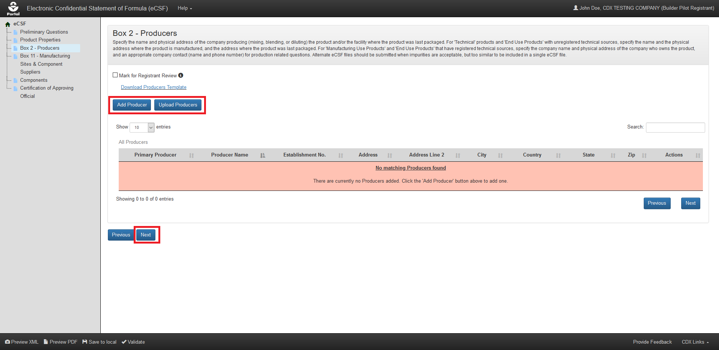
Exhibit 5-5: Box 2 – Producers
Navigation: To add producers, select the ‘Add Producer’ button to make a single entry or select the ‘Upload Producers’ button to upload a file containing multiple entries. Refer to Section 5.4.1 for information regarding manual entry and Section 5.4.2 for information regarding bulk upload. Select the ‘Next’ button to navigate away from the screen when all necessary ‘Box 2’ entries are complete.

Exhibit 5-6 shows a screen capture of the ‘Box 2 – Product Repackaging Site’ screen:
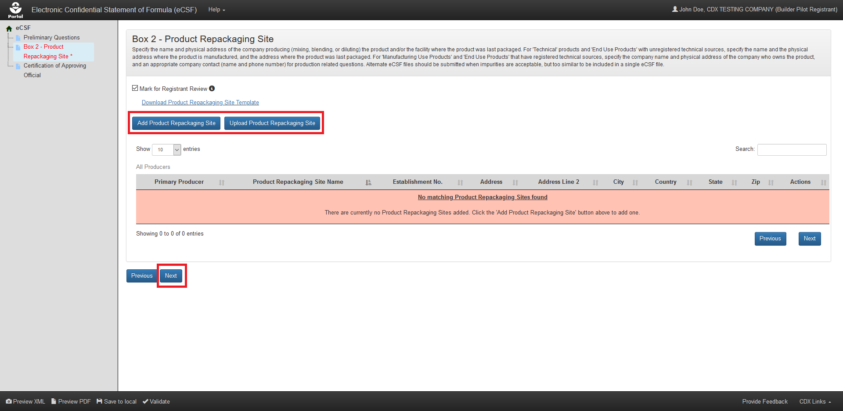
Exhibit 5-6: Box 2 – Product Repackaging Site
Navigation: To add product repackaging sites, select the ‘Add Product Repackaging Site’ button to single entry or select the ‘Upload Product Repackaging Site’ button to upload a file containing multiple entries. Refer to Section 5.4.1 for information regarding manual entry and Section 5.4.2 for information regarding bulk upload. Select the ‘Next’ button to navigate away from the screen when all necessary ‘Box 2’ entries are complete.

Manually Add a Producer/Repackaging Site
The ‘Add Producer/Repackaging Site’ pop-up allows a user to manually enter data to be rendered in ‘Box 2’ of ‘EPA Form 8570-4 – Confidential Statement of Formula’ and is accessed by selecting either the ‘Add Producer/Repackaging Site’ button or ‘Edit’ link on the ‘Box 2 – Producers and Product Repackaging Site’ screen.
The following fields display in the ‘Add Producer/Repackaging Site’ pop-up:
- Primary Producer: Indicate whether the producer/product repackaging site is the primary producer for the eCSF XML file. Selecting this checkbox and saving the pop-up will remove the primary producer designation from any other saved producer. The primary designation has no significance other than to indicate which entry displays on the first page of the PDF rendering. Refer to Section 5.4.3 for additional information about viewing ‘Box 2’ entries on a rendered PDF. This field is optional.
- Producer Name: Enter the company/organization name for the producer/product repackaging site. This field does not display when ‘What is the product type?' is 'End Use Product (EP)' on the 'Preliminary Questions' screen and all 'Active' components are registered. This field is required when displayed.
- Establishment Number: Enter the ‘EPA Establishment Number’ for the producer/product repackaging site. This field does not display when ‘What is the product type?' is 'End Use Product (EP)' on the 'Preliminary Questions' screen and all 'Active' components are registered. This field is required when 'What is the product type?' is 'Technical' and/or when 'Is this product a 100% Repack?' is 'Yes’ on the 'Preliminary Questions' screen. This field is optional in all other scenarios.
- Address: Enter the first address line for the producer/product repackaging site. This field does not display when ‘What is the product type?' is 'End Use Product (EP)' on the 'Preliminary Questions' screen and all 'Active' components are registered. This field is required when displayed.
- Address Cont.: Enter the second address line for the producer/product repackaging site. This field does not display when ‘What is the product type?' is 'End Use Product (EP)' on the 'Preliminary Questions' screen and all 'Active' components are registered. This field is required when displayed.
- City: Enter the city for the producer/product repackaging site. This field does not display when ‘What is the product type?' is 'End Use Product (EP)' on the 'Preliminary Questions' screen and all 'Active' components are registered. This field is required when displayed.
- State: Select the state for the producer/product repackaging site. This field does not display when ‘What is the product type?' is 'End Use Product (EP)' on the 'Preliminary Questions' screen and all 'Active' components are registered. This field is required when displayed.
- Postal or ZIP Code: Enter the Postal or ZIP Code for the producer/product repackaging site. This field does not display when ‘What is the product type?' is 'End Use Product (EP)' on the 'Preliminary Questions' screen and all 'Active' components are registered. This field is required when displayed.
- Country: Select the country for the producer/product repackaging site. This field does not display when ‘What is the product type?' is 'End Use Product (EP)' on the 'Preliminary Questions' screen and all 'Active' components are registered. This field is required when displayed.
- Contact Name: Enter a contact name for the producer/product repackaging site. Required when 'What is the product type?' is 'Manufacturing Use Product' or 'End Use Product' and/or when 'Is this product a 100% Repack?' is ‘Yes’ on the ‘Preliminary Questions’ screen. This field is optional in all other scenarios.
- Contact Title: Enter a contact title for the producer/product repackaging site. Required when 'What is the product type?' is 'Manufacturing Use Product' or 'End Use Product' and/or when 'Is this product a 100% Repack?' is ‘Yes’ on the ‘Preliminary Questions’ screen. This field is optional in all other scenarios.
- Phone Number: Enter a contact phone number for the producer/product repackaging site. Required when 'What is the product type?' is 'Manufacturing Use Product' or 'End Use Product' and/or when 'Is this product a 100% Repack?' is ‘Yes’ on the ‘Preliminary Questions’ screen. This field is optional in all other scenarios.
- Is this a relabeling only facility?: Indicate whether the product repackaging site is a relabeling only facility. This field only displays when ‘EPA Formulation – Box A’ is ‘Alternate Formulation’ on the ‘Preliminary Questions’ screen, ‘What is the product type?' is 'Technical’ on the ‘Preliminary Questions’ screen, and ‘Primary Producer’ is not selected. This field is required when displayed.
- Is CSF Approval Pending?: Indicate whether the CSF approval is pending. This field only displays when ‘EPA Formulation – Box A’ is ‘Alternate Formulation’ on the ‘Preliminary Questions’ screen, ‘What is the product type?' is 'Technical’ on the ‘Preliminary Questions’ screen, and ‘Primary Producer’ is not selected. This field is required when displayed.
- Date site first appeared on CSF: Enter or select the date on which the product repackaging site first appeared on a CSF for the product. This field only displays when ‘EPA Formulation – Box A’ is ‘Alternate Formulation’ on the ‘Preliminary Questions’ screen, ‘What is the product type?' is 'Technical’ on the ‘Preliminary Questions’ screen, and ‘Primary Producer’ is not selected. This field is required when displayed.
- Date of EPA letter approving the CSF: Enter or select the date of the EPA letter approving the CSF for the product. This field only displays when ‘EPA Formulation – Box A’ is ‘Alternate Formulation’ on the ‘Preliminary Questions’ screen, ‘What is the product type?' is 'Technical’ on the ‘Preliminary Questions’ screen, and ‘Primary Producer’ is not selected. This field displays as ‘Not Applicable’ when ‘Is CSF Approval Pending?’ is ‘Yes,’ but is otherwise required when displayed.
- Date of EPA review accepting the supporting data: Enter or select the date EPA accepted supporting data for the product. This field only displays when ‘EPA Formulation – Box A’ is ‘Alternate Formulation’ on the ‘Preliminary Questions’ screen, ‘What is the product type?' is 'Technical’ on the ‘Preliminary Questions’ screen, and ‘Primary Producer’ is not selected. This field displays as ‘Not Applicable’ when ‘Is CSF Approval Pending?’ is ‘Yes,’ but is otherwise required when displayed.
- Supporting Data MRID number(s): Enter the Master Record Identifier (MRID) number(s) for the documents that contain supporting data for the product repackaging site. This field only displays when ‘EPA Formulation – Box A’ is ‘Alternate Formulation’ on the ‘Preliminary Questions’ screen, ‘What is the product type?' is 'Technical’ on the ‘Preliminary Questions’ screen, and ‘Primary Producer’ is not selected. This field displays as ‘This is a relabeling only facility, no chemical reaction production or manufacturing.’ when ‘Is this a relabeling only facility?’ is ‘Yes,’ but is otherwise required when displayed.
Exhibit 5-7 shows a screen capture of how to initiate the manual entry process on the ‘Box 2 – Producers/Product Repackaging Site’ screen:
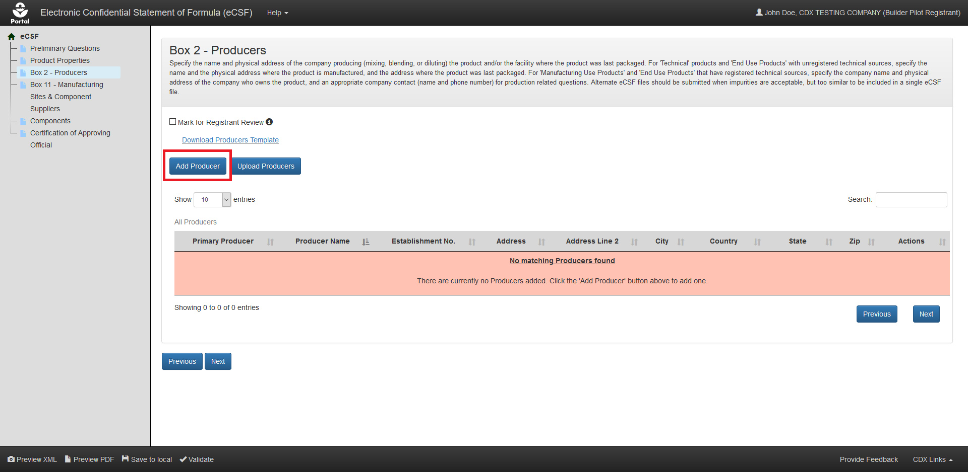
Exhibit 5-7: ‘Box 2 – Producers/Product Repackaging Site’ Screen – Initiate Manual Entry
Navigation: Select the ‘Add Producer’ button to launch the ‘Add Producer/Repackaging Site’ pop-up.
Exhibit 5-8 shows a screen capture of the ‘Add Producer’ pop-up:
Exhibit 5-8: ‘Add Producer’ Pop-Up
Navigation: Enter data in all required fields and select the ‘Save’ button.
Exhibit 5-9 shows a screen capture the ‘Box 2 – Producers/Product Repackaging Site’ screen following a successful manual entry:
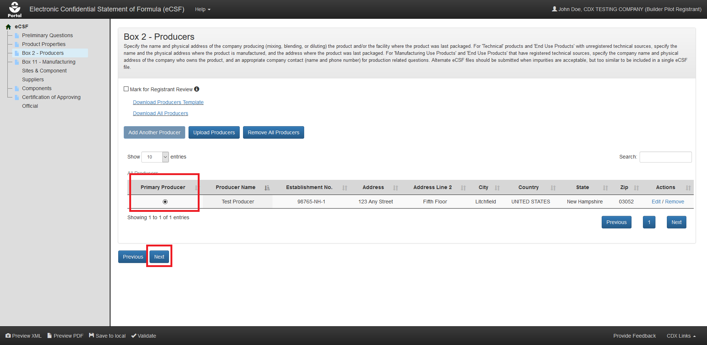
Exhibit 5-9: ‘Box 2 – Producers/Product Repackaging Site’ Screen – Entry Saved
Navigation: Select the radio button for the ‘Box 2’ entry that will display on the main section of ‘EPA Form 8570-4 – Confidential Statement of Formula’ (all other entries display on addendum pages) and select the ‘Next’ button to navigate to the next screen.

Bulk Upload a Producer or Repacking Site
The eCSF application allows a user to upload many ‘Box 2’ entries into an eCSF XML file using a Microsoft Excel spreadsheet template file. This allows for easy population of ‘Box 2’ entries when a registrant uses a regular set across products, eCSF XML files, etc. The application applies all applicable validations regardless of whether data is bulk uploaded or manually entered.
Note: The template file does occasionally change when application features are added or updated. All efforts to ensure backward compatibility are made, but a user should check that their template file matches the current template file prior to upload.
Exhibit 5-10 shows a screen capture of how to download the template file from the ‘Box 2 – Producers/Product Repackaging Site’ screen:
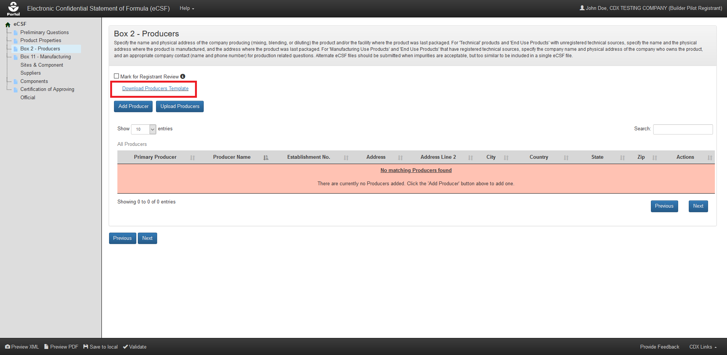
Exhibit 5-10: ‘Box 2 – Producers/Product Repackaging Site’ Screen – Template Download
Navigation: Select the ‘Download Producers Template’ link to save and work on template on a local machine.
Exhibit 5-11 shows a screen capture of how to initiate the bulk upload on the ‘Box 2 – Producers/Product Repackaging Site’ screen:
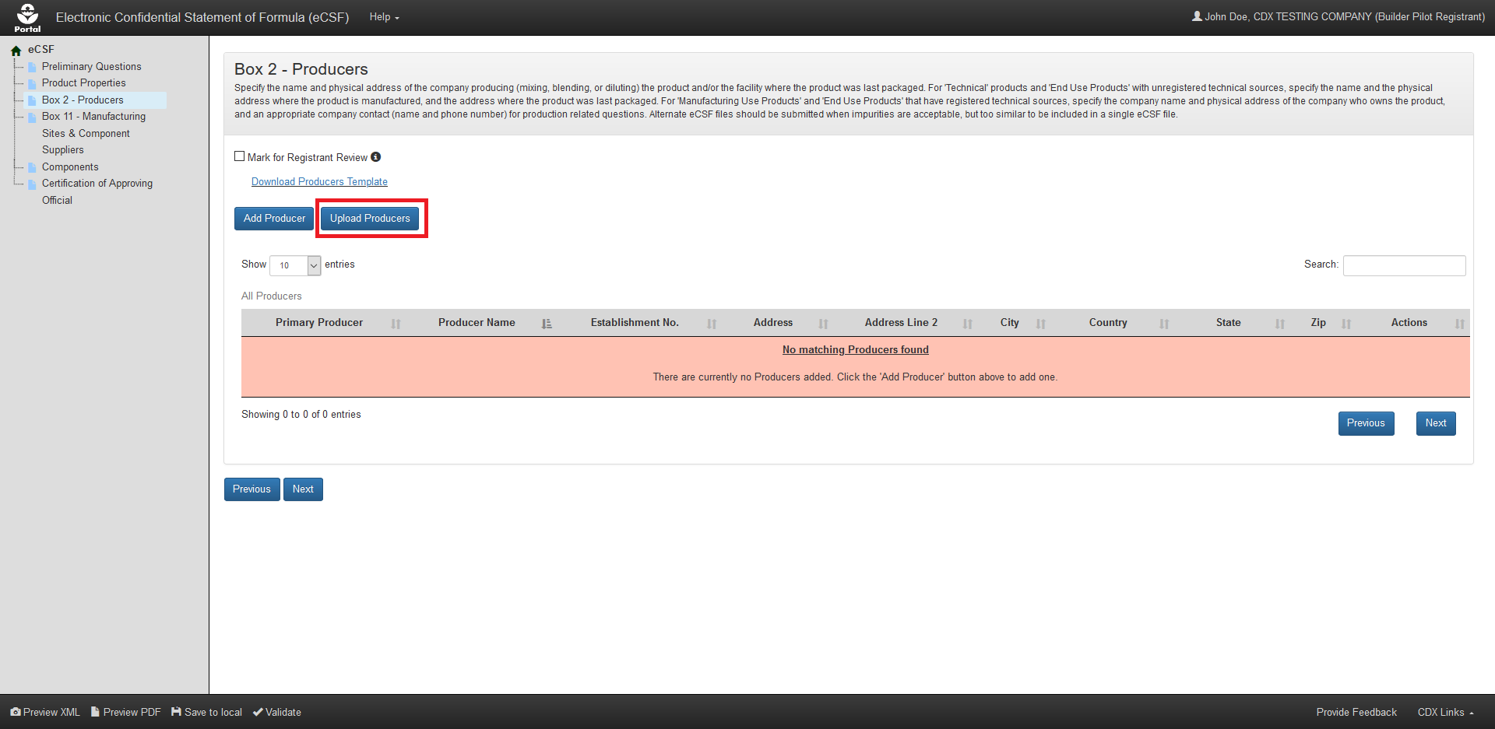
Exhibit 5-11: ‘Box 2 – Producers/Product Repackaging Site’ Screen – Initiate Template Upload
Navigation: Select the ‘Upload Producers Template’ button to launch the upload pop-up.
Exhibit 5-12 shows a screen capture of how to upload a ‘Box 2’ template in the pop-up:
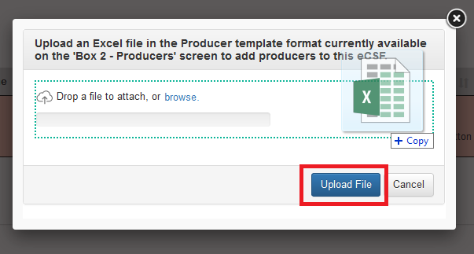
Exhibit 5-12: ‘Upload Template’ Pop-Up
Navigation: Select the ‘browse’ link to search the local machine for a file or drag and drop the file onto the pop-up to initiate upload. Next, wait for the file name to display (upload processing is incomplete until the file name displays) and then select the ‘Upload File’ button.
Exhibit 5-13 shows a screen capture the ‘Box 2 – Producers/Product Repackaging Site’ screen following a successful bulk upload:
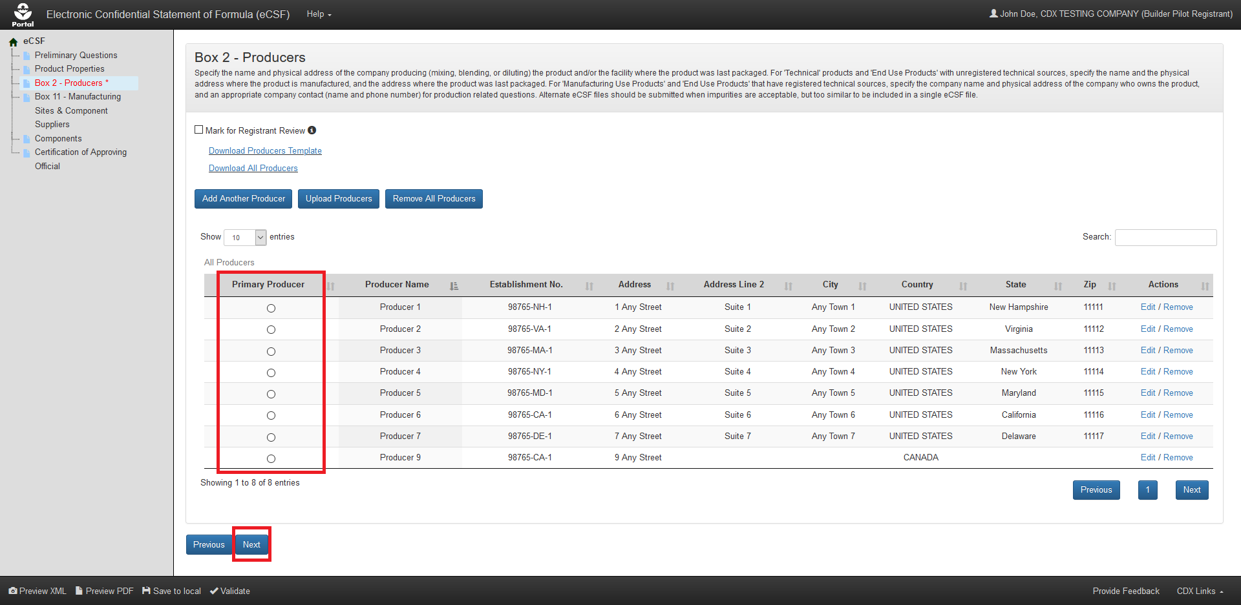
Exhibit 5-13: ‘Box 2 – Producers/Product Repackaging Site’ Screen – Upload Complete
Navigation: Select the radio button for the ‘Box 2’ entry that will display on the main section of ‘EPA Form 8570-4 – Confidential Statement of Formula’ (all other entries display on addendum pages) and then select the ‘Next’ button to navigate to the next screen.

View Box 2 Entries in Rendered PDF
The eCSF application allows multiple ‘Box 2’ entries in ‘Alternate Formulation’ eCSF XML files. When there are multiple entries for ‘Box 2,’ the entry identified as the primary on the ‘Box 2 – Producers/Product Repackaging Site’ screen will display on the first page of the rendered PDF file and it’s corresponding country will display in ‘Box 6.’ All other ‘Box 2’ entries display on addendum pages. The primary designation has no significance other than to indicate which entry displays on the first page.
Exhibit 5-14 shows the PDF rendering of a ‘Box 2’ entry marked as the primary:
Exhibit 5-14: ‘Box 2’ PDF Rendering
Exhibit 5-15 shows the PDF rendering of ‘Box 2’ entries onto an addendum page:
Exhibit 5-15: ‘Box 2’ PDF Rendering of Addendum Page
Exhibit 5-16 shows the PDF rendering of ‘Box 2’ entries for ‘Technical’ relabeling facilities onto an addendum page:
Exhibit 5-16: ‘Box 2’ PDF Rendering of Addendum Page for Relabeling Facilities

‘Box 11 – Manufacturing Sites & Component Suppliers’ Screen
The ‘Box 11 – Manufacturing Sites & Component Suppliers’ screen gathers data about the manufacturing sites and component suppliers for the components included in an eCSF XML file. The application renders these data in ‘Box 11’ on the main form or on addendum pages in specific situations.
Note: This screen does not display when ‘Is this product a 100% Repack?’ is ‘Yes’ and/or ‘What is the product type?’ is ‘Technical’ on the ‘Preliminary Questions’ screen.
The following items display on the ‘Box 11 – Manufacturing Sites & Component Suppliers’ screen:
- Mark for Registrant Review: Select this checkbox to by–pass on-screen validation. When a screen has been marked for review, the navigation tree displays its title link text in red with an asterisk to indicate the screen does not pass validation and requires future attention. This field is optional.
- View by Components (link): Select this link to navigate the application to the ‘Components’ screen.
- Download Sites & Suppliers Template (link): Select this link to download the latest version of the ‘Sites & Suppliers’ template to a local machine.
- Download All Sites & Suppliers (link): Select this link to download a Microsoft Excel file containing all of the entries in the displayed table.
- On-screen Validation Errors: The application performs on-screen validations to ensure that underlying site/supplier data is complete and accurate. Error messages display to the right of the screen’s action buttons and provide reference to specific site or supplier entries that fail validation. When a generic error message displays, access the ‘Add Site/Supplier’ pop-up via the ‘Edit’ link in the ‘Actions’ column to view and resolve the specific error.
- Add Site or Supplier (button): Select this button to initiate the manual site or supplier entry process. Refer to Section 5.5.1 for detailed instructions on how to manually enter a site or supplier.
- Upload Sites & Suppliers (button): Select this button to initiate the bulk upload process for sites and suppliers. Refer to Section 5.5.2 for detailed instructions on how bulk upload sites and suppliers.
- Delete All Sites & Suppliers (button): Select this button to remove all sites and suppliers listed on the screen. This will completely remove all sites and suppliers from the eCSF XML file and sever all component relationships.
- Table Filters: Select these tabs to update the table view to display all sites and suppliers, only manufacturing sites, or only component suppliers.
- Pagination: The pagination feature updates the table view to display 10, 25, 50, or 100 entries and displays the number of pages at the bottom right of the table.
- Search: The search function updates the table view to display only those entries for which the entered string is present.
- Relate Component (table column): Select the green ‘plus’ icon in this column to expand a table row to relate components to the selected entry. Refer to Section 5.5.3 for detailed instructions on relating manufacturing sites and component suppliers to components.
- Type (table column): Displays either ‘Manufacturing Site’ or ‘Component Supplier’ for the listed entry.
- Name (table column): Displays the organization name for the listed entry.
- Address (table column): Displays the first address line for the listed entry.
- City (table column): Displays the city for the listed entry.
- State (table column): Displays the state for the listed entry.
- Zip (table column): Displays the ZIP Code for the listed entry.
- Actions (table column): Select the ‘Edit’ link to launch the ‘Add Site or Supplier’ pop-up to make changes to the listed entry. Select the ‘Delete’ link to remove the entry from the eCSF XML and sever all associated component relationships.
Exhibit 5-17 shows a screen capture of the ‘Box 11 – Manufacturing Sites & Component Suppliers’ screen:
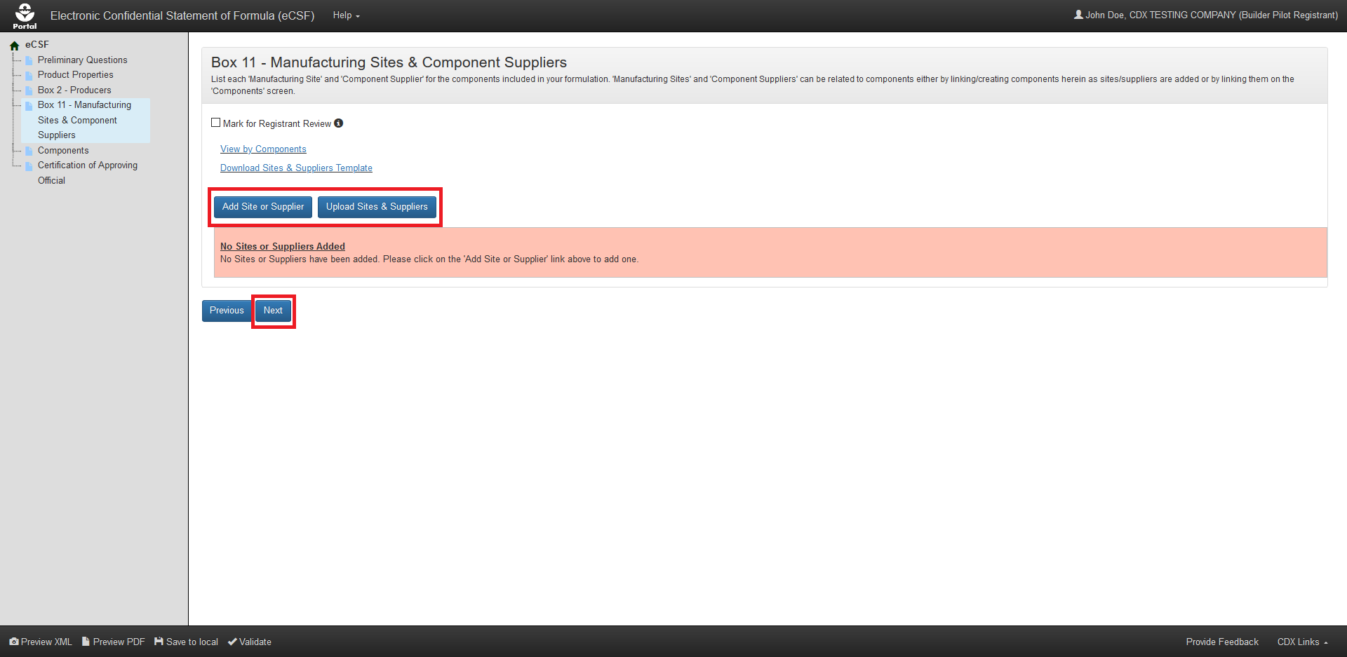
Exhibit 5-17: ‘Box 11 – Manufacturing Sites & Component Suppliers’ Screen
Navigation: To add manufacturing sites and component suppliers, select the ‘Add Site or Supplier’ button to make a single entry or select the ‘Upload Producers’ button to upload a file containing multiple entries. Refer to Section 5.5.1 for information regarding manual entry and Section 5.5.2 for information regarding bulk upload. Select the ‘Next’ button to navigate away from the screen when all necessary ‘Box 11’ entries are complete.

Manually Add a Manufacturing Site or Component Supplier
The ‘Add Site or Supplier’ pop-up allows a user to manually enter data to be rendered in ‘Box 11’ of ‘EPA Form 8570-4 – Confidential Statement of Formula’ and is accessed by selecting either the ‘Add Site or Supplier’ button or the ‘Edit’ link on the ‘Box 11 – Manufacturing Sites & Component Suppliers’ screen.
The following fields display in the ‘Add Site or Supplier’ pop-up:
- Supplier Type: Select 'Manufacturing Site' to identify the location at which an unregistered Active Ingredient is produced. Select 'Component Supplier' to identify the supplier of a purchased component, including registered Active Ingredients. This field is required. The following options are available for selection:
  - Manufacturing Site
  - Component Supplier
- Site/Supplier Name: Enter a name for the manufacturing site or component supplier. This field is required.
- Address: Enter the first address line for the manufacturing site or component supplier. This field displays when ‘Address N/A’ is not selected and is required when displayed.
- Address Cont.: Enter the second address line for the manufacturing site or component supplier. This field displays when ‘Address N/A’ is not selected and is optional when displayed.
- City: Enter the city for the manufacturing site or component supplier address. This field displays when ‘Address N/A’ is not selected and is required when displayed.
- State: Select the state for the manufacturing site or component supplier address. This field displays when ‘Address N/A’ is not selected and ‘Country’ is ‘United States’ and is required when displayed.
- Non–US Province: Enter the province for the manufacturing site or component supplier address. This field displays when ‘Address N/A’ is not selected and ‘Country’ is not ‘United States’ and is optional when displayed.
- Postal or ZIP Code: Enter the postal or ZIP Code for the manufacturing site or component supplier address. This field displays when ‘Address N/A’ is not selected and is required when ‘Country’ is ‘United States,’ but is optional when ‘Country’ is not ‘United States.’
- Country: Select the country for the manufacturing site or component supplier address. This field displays when ‘Address N/A’ is not selected and ‘Country’ is ‘United States’ and is required when displayed.
- Address is N/A: Check this box to indicate that an address is not applicable for the manufacturing site or component supplier. This field is optional.
- Reason Why Address is N/A: Enter a reason why an address is not applicable for the manufacturing site or component supplier. This field displays when ‘Address N/A’ is selected and is required when displayed.
Exhibit 5-18 shows a screen capture of how to initiate the manual entry process on the ‘Box 11 – Manufacturing Sites & Component Suppliers’ screen:
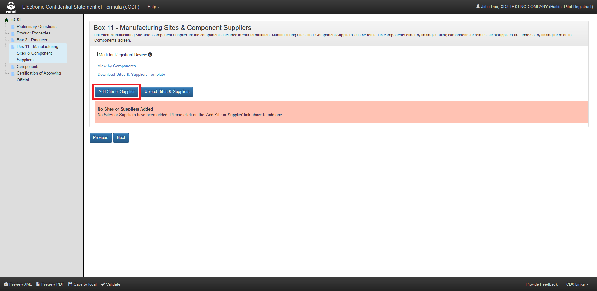
Exhibit 5-18: ‘Box 11 – Manufacturing Sites & Component Suppliers’ Screen – Initiate Manual Entry
Navigation: Select the ‘Add Site or Supplier’ button to launch the ‘Add Site or Supplier’ pop-up.
Exhibit 5-19 shows a screen capture of the ‘Add Site or Supplier’ pop-up:
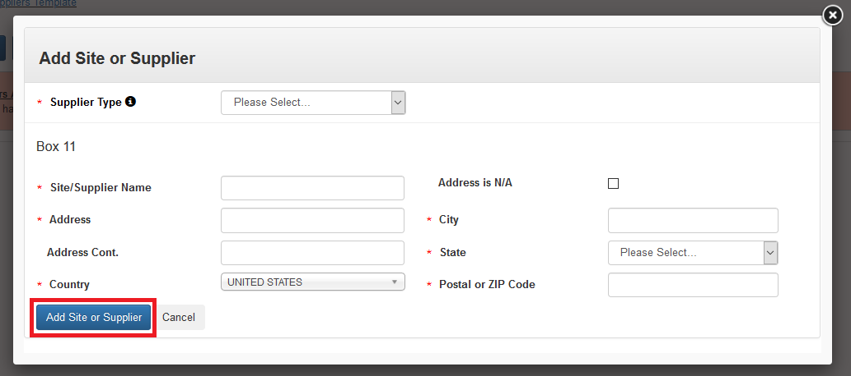
Exhibit 5-19: ‘Add Site or Supplier’ Pop-Up
Navigation: Enter data in all required fields and select the ‘Add Site or Supplier’ button.
Exhibit 5-20 shows a screen capture the ‘Box 11 – Manufacturing Sites & Component Suppliers’ screen following a successful manual entry:
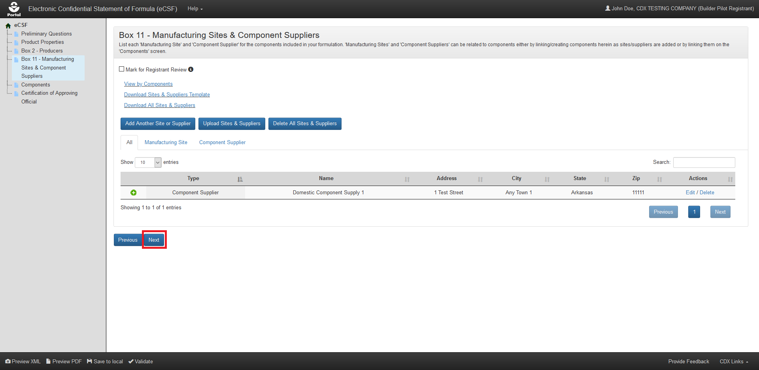
Exhibit 5-20: ‘Box 11 – Manufacturing Sites & Component Suppliers’ Screen – Entry Complete
Navigation: Select the ‘Next’ button to navigate away from the screen when all necessary ‘Box 11’ entries are complete.

Bulk Upload Manufacturing Sites and Component Suppliers
The eCSF application allows a user to upload many ‘Box 11’ entries into an eCSF XML file using a Microsoft Excel spreadsheet template file. This allows for easy population of ‘Box 11’ entries when a registrant uses a regular set across products, eCSF XML files, etc. The application applies all applicable validations regardless of whether data is bulk uploaded or manually entered.
Note: The template file does occasionally change when application features are added or updated. All efforts to ensure backward compatibility are made, but a user should check that their template file matches the current template file prior to upload.
Exhibit 5-21 shows a screen capture of how to download the bulk upload template file from the ‘Box 11 – Manufacturing Sites & Component Suppliers’ screen:
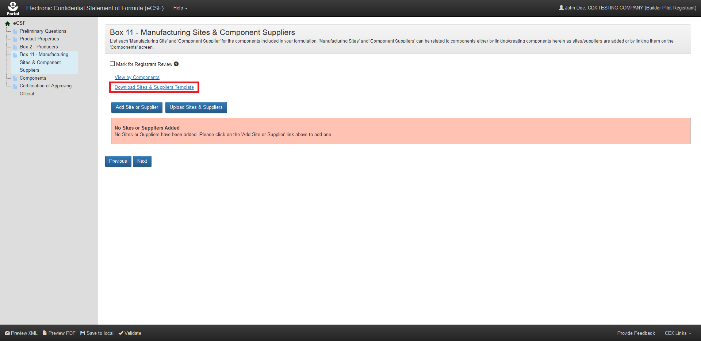
Exhibit 5-21: ‘Box 11 – Manufacturing Sites & Component Suppliers’ Screen – Template Download
Navigation: Select the ‘Download Sites & Suppliers Template’ link to save and work on the template on a local machine.
Exhibit 5-22 shows a screen capture of how to initiate the bulk upload on the ‘Box 11 – Manufacturing Sites & Component Suppliers’ screen:
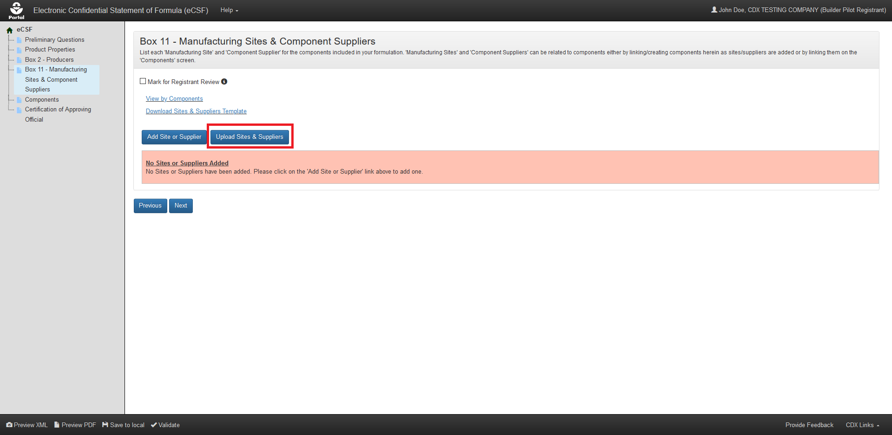
Exhibit 5-22: ‘Box 11 – Manufacturing Sites & Component Suppliers’ Screen – Initiate Template Upload
Navigation: Select the ‘Upload Sites & Suppliers Template’ button to launch the upload pop-up.
Exhibit 5-23 shows a screen capture of how to upload a ‘Box 11’ template in the pop-up:
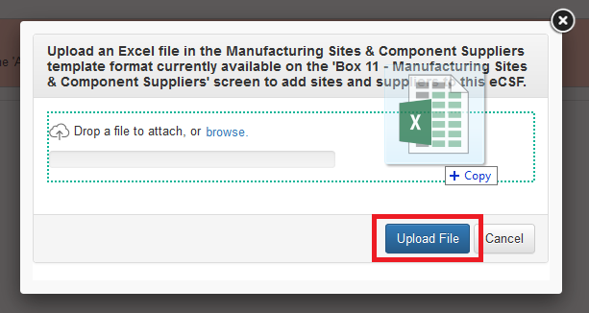
Exhibit 5-23: ‘Upload Template’ Pop-Up
Navigation: Select the ‘browse’ link to search the local machine for a file or drag and drop the file onto the pop-up to initiate upload. Next, wait for the file name to display (upload processing is incomplete until the file name displays) and then select the ‘Upload File’ button.
Exhibit 5-24 shows a screen capture the ‘Box 11 – Manufacturing Sites & Component Suppliers’ screen following a successful bulk upload:
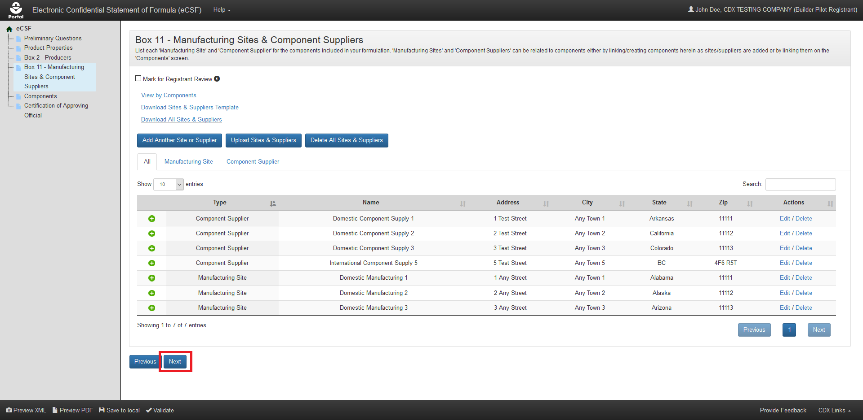
Exhibit 5-24: ‘Box 11 – Manufacturing Sites & Component Suppliers’ Screen – Upload Complete
Navigation: Select the ‘Next’ button to navigate away from the screen when all necessary ‘Box 11’ entries are complete.

Relate a Manufacturing Site or Component Supplier to Components
Generally, components within an eCSF XML file are required to have at least one manufacturing site and/or component supplier relationship. However, registrants should consider the following situations when linking components to manufacturing sites and component suppliers:
- Components in a basic formulation may only relate to a single site or supplier, which the application renders on the main form.
- When multiple component to site and supplier relationships exist in an alternate formulation, the application renders ‘Box 11’ data to addendum pages.
- The application enforces ‘Supplier Type’ to component rules via validations and disabled application functionality (e.g., registered Active components cannot be associated to manufacturing sites).
- Registrants cannot make component to manufacturing site and component supplier relationships using the bulk upload functionality.
- The application does not render orphaned manufacturing sites and component suppliers (i.e., entries that are not associated to any component) onto the form PDF. However, the application does maintain these entries in the eCSF XML file.

Create Site/Supplier Relationship for Existing Component(s)
Follow the below steps to create a relationship between a manufacturing site or component supplier and a component that already exists in an eCSF XML file.
Exhibit 5-25 shows a screen capture of how to initiate the process to relate a manufacturing site or component supplier to an existing component on the ‘Box 11 – Manufacturing Sites & Component Suppliers’ screen:
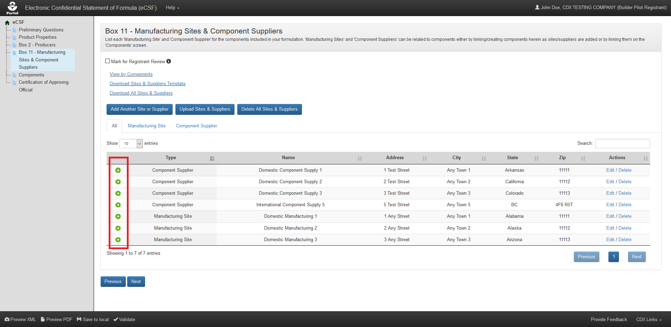
Exhibit 5-25: ‘Box 11 – Manufacturing Sites & Component Suppliers’ Screen – Relate Component
Navigation: Select the green ‘plus’ icon from the ‘Relate Components’ column for the entry that will be related.
Exhibit 5-26 shows a screen capture of how to view existing components to create a relationship on the ‘Box 11 – Manufacturing Sites & Component Suppliers’ screen:
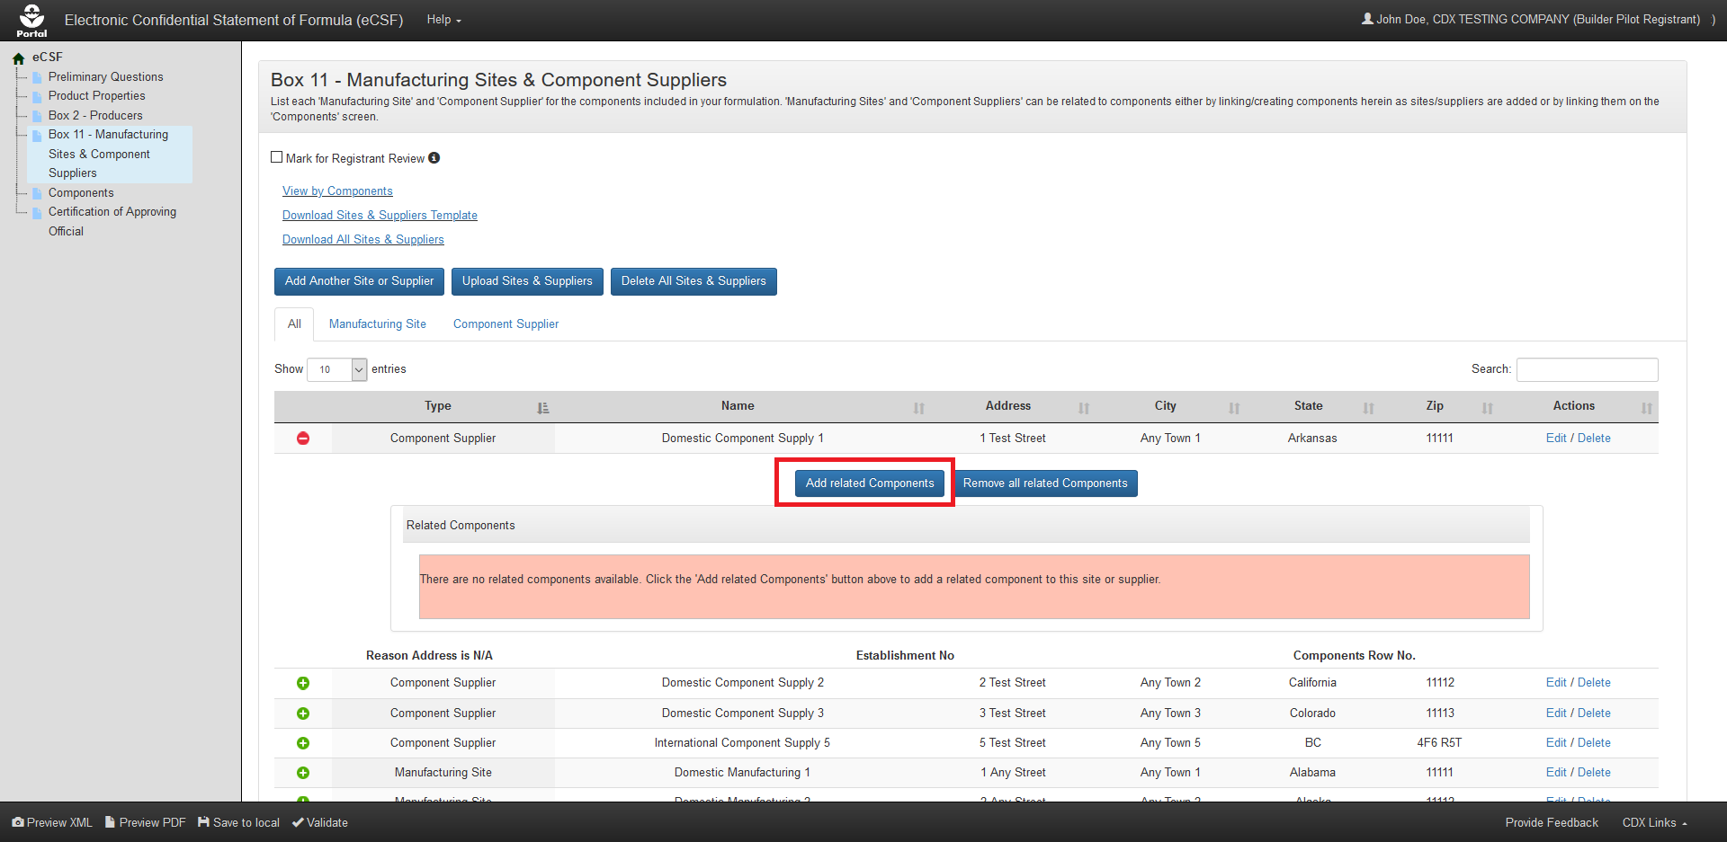
Exhibit 5-26: ‘Box 11 – Manufacturing Sites & Component Suppliers’ Screen – View Existing Components
Navigation: Select the ‘Add Related Components’ button to launch the ‘Select Related Components’ pop-up.
Exhibit 5-27 shows a screen capture of the ‘Select Related Components’ pop-up:
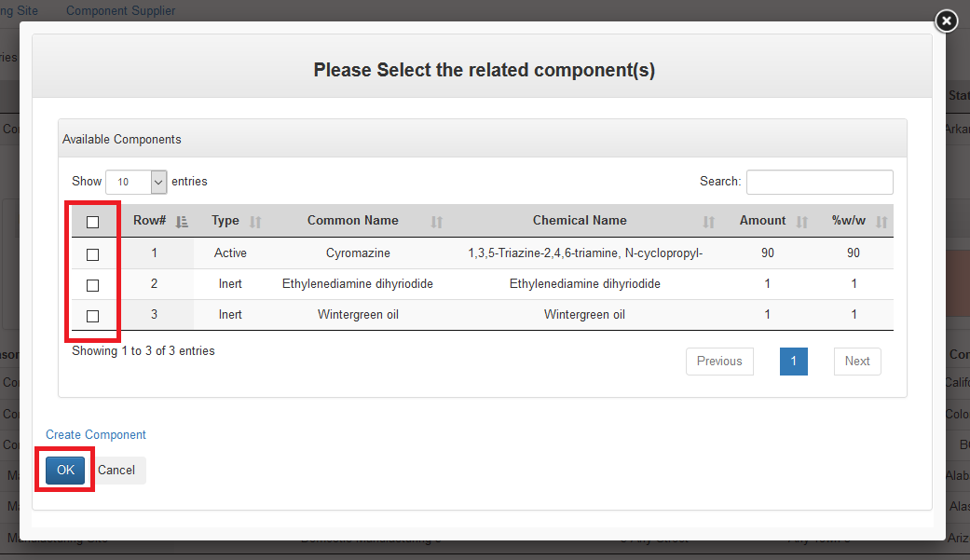
Exhibit 5-27: ‘Select Related Components’ Pop-Up
Navigation: Select the checkbox(es) for the component(s) that should be related to the listed a manufacturing site or component supplier and then select the ‘OK’ button.
Exhibit 5-28 shows a screen capture of the ‘Box 11 – Manufacturing Sites & Component Suppliers’ screen after component relationships have been successfully added:
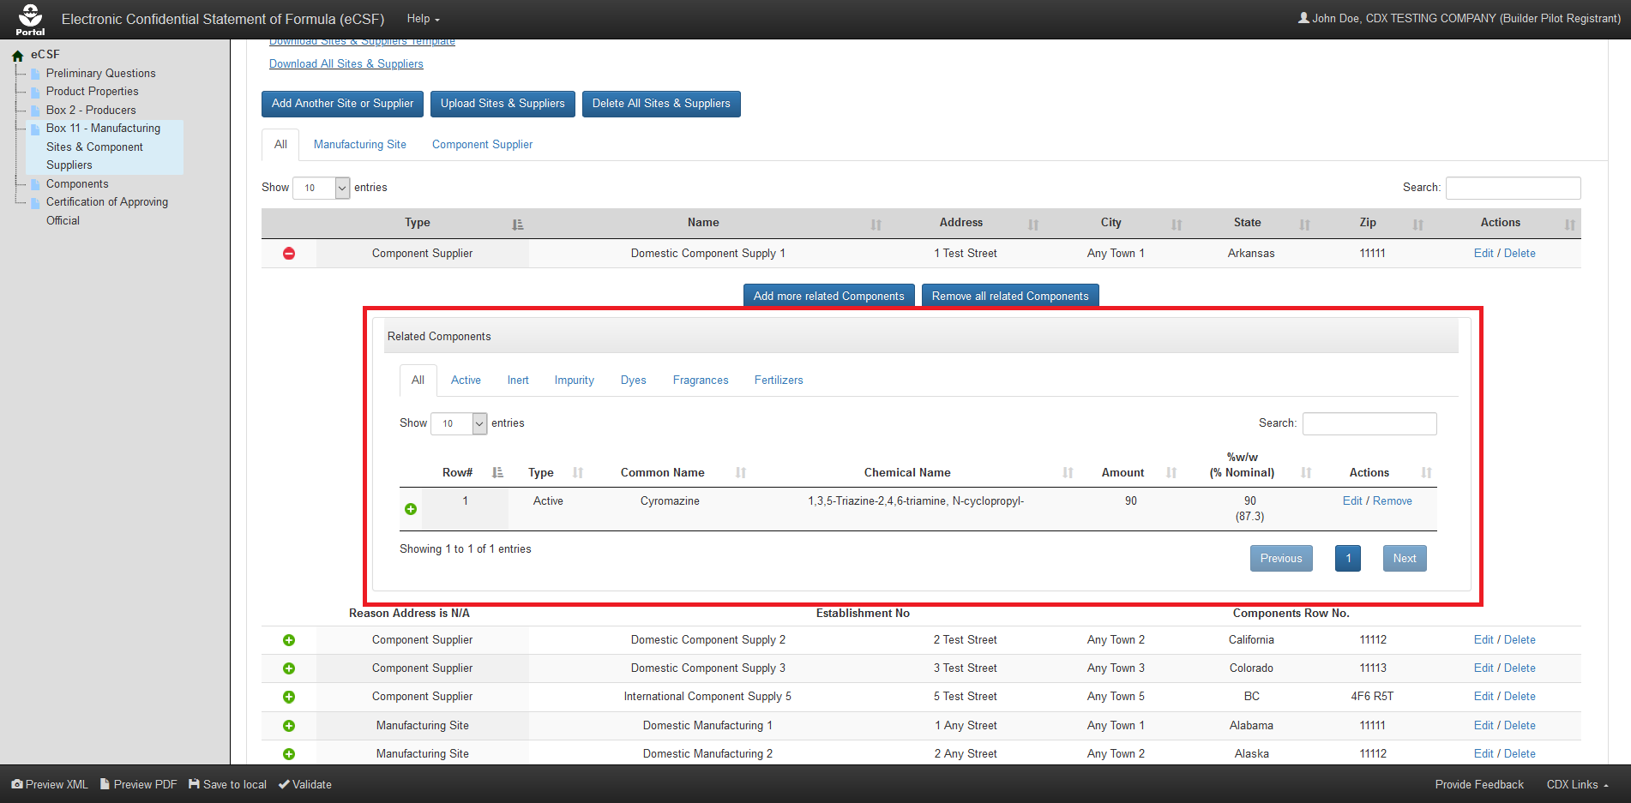
Exhibit 5-28: ‘Box 11 – Manufacturing Sites & Component Suppliers’ Screen – Component Relationship(s) Added

Create Site/Supplier Relationship for a New Component
It is highly recommended that registrants add components on the ‘Components’ screen to limit validation errors and ensure that component calculations are correct even though it is possible to create a new component on the ‘Box 11 – Manufacturing Sites & Component Suppliers’ screen. Follow the below steps to create a relationship between a manufacturing site or component supplier and a component that does not exist in the eCSF XML file.
Exhibit 5-29 shows a screen capture of how to initiate the process to relate a manufacturing site or component supplier to a new component on the ‘Box 11 – Manufacturing Sites & Component Suppliers’ screen:
Exhibit 5-29: ‘Box 11 – Manufacturing Sites & Component Suppliers’ Screen – Relate Component
Navigation: Select the green ‘plus’ icon from the ‘Relate Components’ column for the entry that will be related.
Exhibit 5-30 shows a screen capture of how to view existing components and enter a new component on the ‘Box 11 – Manufacturing Sites & Component Suppliers’ screen:
Exhibit 5-30: ‘Box 11 – Manufacturing Sites & Component Suppliers’ Screen – View Existing Components and Add New Component
Navigation: Select the ‘Add Related Components’ button to launch the ‘Select Related Components’ pop-up.
Exhibit 5-31 shows a screen capture of the ‘Select Related Components’ pop-up:
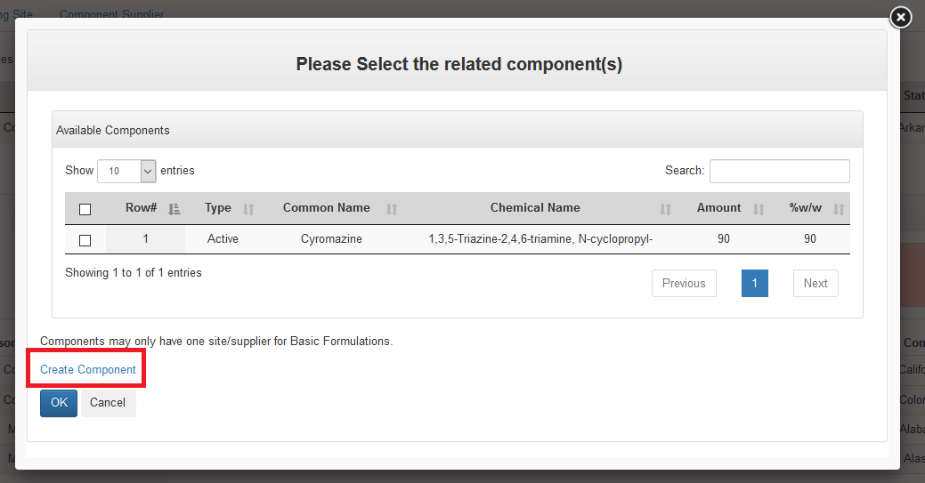
Exhibit 5-31: ‘Select Related Components’ Pop-Up
Navigation: Select the ‘Create Component’ link to launch the ‘Add Component’ pop-up. Please refer to Section 5.6.1 for detailed instructions on how to complete the ‘Add Components’ pop-up.
Exhibit 5-32 shows a screen capture of the ‘Box 11 – Manufacturing Sites & Component Suppliers’ screen after component relationships have been successfully added:
Exhibit 5-32: ‘Box 11 – Manufacturing Sites & Component Suppliers’ Screen – Component Relationship Added

‘Components’ Screen
The ‘Components’ screen captures data about the components that make up a product formulation. List each component as introduced into the formulation. For each identifiable ingredient present in a formulation, provide the Chemical Name, Trade Name(s), Registration Number, and Chemical Abstracts Registry Number (CASRN), as applicable.
Note: This screen does not display when ‘Is this product a 100% Repack?’ is ‘Yes’ on the ‘Preliminary Questions’ screen.
The following items display on the ‘Components’ screen:
- Mark for Registrant Review: Select this checkbox to by–pass on-screen validation. When a screen has been marked for review, the navigation tree displays its title link text in red with an asterisk to indicate the screen does not pass validation and requires future attention. This field is optional.
- View by Sites & Suppliers (link): Select this link to navigate the application to the ‘Box 11 – Manufacturing Sites & Component Suppliers’ screen.
- Download Components Template (link): Select this link to download the latest version of the ‘Components’ template to a local machine.
- Download All Components (link): Select this link to download a Microsoft Excel file containing all of the entries in the displayed table.
- On-screen Validation Errors: The application performs on-screen validations to ensure that both the totality of a formulation is accurate and that underlying component data is complete and accurate. Error messages display to the right of the screen’s action buttons and provide reference to specific component entries that fail validation. When a generic error message displays, access the ‘Add Component’ pop-up via the ‘Edit’ link in the ‘Actions’ column to view and resolve the specific error.
- Add Component (button): Select this button to initiate the manual component entry process. Refer to Section 5.6.1 for detailed instructions on how to manually enter a component.
- Upload Components (button): Select this button to initiate the bulk upload process for components. Refer to Section 5.6.2 for detailed instructions on how bulk upload components.
- Delete All Components (button): Select this button to remove all components listed on the screen. This will completely remove all components from an eCSF XML file and sever all site and supplier relationships.
- Table Filters: Select these tabs to update the table view to display all components or only a specific component type.
- Pagination: The pagination feature updates the table view to display 10, 25, 50, or 100 entries and displays the number of pages at the bottom right of the table.
- Search: The search function updates the table view to display only those entries for which the entered string is present.
- Relate Site/Supplier (table column): Select the green ‘plus’ icon in this column to expand a table row to relate sites and suppliers to the selected component entry. Refer to Section 5.6.3 for detailed instructions on relating components to manufacturing sites and component suppliers.
- Type (table column): Displays the component type for the listed entry.
- Common Name (table column): Displays the common name for the listed entry.
- Chemical Name (table column): Displays the chemical name for the listed entry.
- Amount (table column): Displays the entered amount for the listed entry.
- %w/w (Nominal) (table column): Displays the entered percent weight of total weight, as well as the calculated nominal value for the listed entry.
- Actions (table column): Select the ‘Edit’ link to launch the ‘Add Component’ pop-up to make changes to the listed entry. Select the ‘Delete’ link to remove the entry from the eCSF XML and sever all associated site and supplier relationships.
- Total Weight – Box 17: Displays a running total of all values entered in the ‘Amount’ column for each component entry.
- Total %w/w: Displays a running total of all values entered in the ‘%w/w (Nominal)’ column for each component entry. This must equal 100% for ‘End Use Products (EP)’ and ‘Manufacturing Use Product’. For ‘Technical’ products, this value must be between 98.5%–101.5%. The application does not apply a validation if the product is a ‘Plant Incorporated Protectant (PIP)’ product.
Exhibit 5–33 shows a screen capture of the ‘Components’ screen:
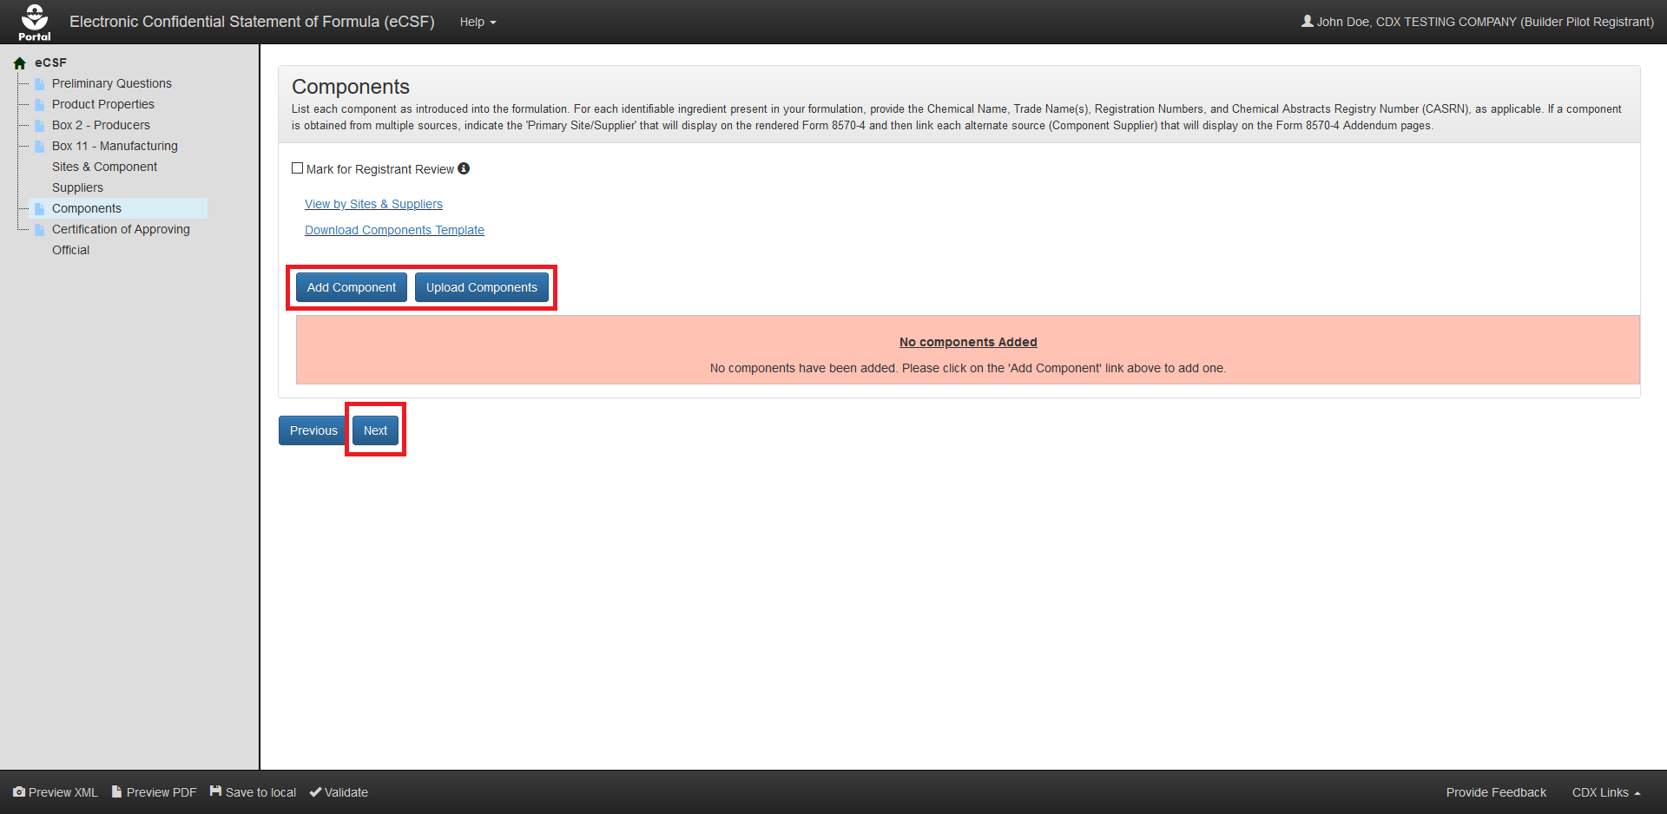
Exhibit 5–33: ‘Components’ Screen
Navigation: To add components, select the ‘Add Component’ button to make a single entry or select the ‘Upload Components’ button to upload a file containing multiple entries. Refer to Section 5.6.1 for information regarding manual entry and Section 5.6.2 for information regarding bulk upload. Select the ‘Next’ button to navigate away from the screen when all necessary entries are complete.

Manually Add a Component
The ‘Add Component’ pop-up allows a user to manually enter component data onto ‘EPA Form 8570-4 – Confidential Statement of Formula’ and is accessed by selecting either the ‘Add Component’ button or ‘Edit’ link on the ‘Components’ screen.
The following sub–sections detail the ‘Add Component’ pop-up for each component type available within the eCSF application.

Active Components
The following fields display in the ‘Add Component’ pop-up for an ‘Active’ component:
- Component Type: Select the component type to update the pop-up to display only those fields necessary for the selected component type. This field is required.
- Is this a registered active ingredient?: Indicate whether the ‘Active’ component is a registered ingredient. This field is required.
- Registration Number – Box 12: Enter the ‘EPA Registration Number’ for the ‘Active’ component. If the product is pending registration, enter the registration number if known. If EPA has not assigned a registration number, enter the submission number or 'Pending'. If the component is an unregistered formulation preservative or grandfathered technical, a registration number is not required. After a user enters a number and navigates away from the field, the application performs a search of current registered product data to validate the number’s validity and automatically populate certain fields within the pop-up. This field is required when ‘Is this a registered active ingredient?’ is ‘Yes.’
- Chemical Name – Box 10: Enter the component’s chemical name. The application will automatically populate this field with registered product data into a fixed field when a user indicates the component is a registered active ingredient and enters a valid number in the ‘Registration Number – Box 12’ field. This field is required.
- CASRN – Box 10: Enter the component’s Chemical Abstracts Service Registry Number (CASRN). The application will automatically populate this field with registered product data into a fixed field when a user indicates the component is a registered active ingredient and enters a valid number in the ‘Registration Number – Box 12’ field. This field is required for registered active ingredients and optional for unregistered active ingredients.
- Common Name (ISO Proposed or Accepted) – Box 10: Enter the component’s proposed or accepted ISO common name. The application will automatically populate this field with registered product data into a fixed field when a user indicates the component is a registered active ingredient and enters a valid number in the ‘Registration Number – Box 12’ field. This field is required for registered active ingredients and optional for unregistered active ingredients.
- IUPAC Name – Box 10: Enter the component’s International Union of Pure and Applied Chemistry (IUPAC) name. This field is optional.
- PC Code – Box 10: Enter the component’s PC Code. The application will automatically populate this field with registered product data when a user indicates the component is a registered active ingredient and enters a valid number in the ‘Registration Number – Box 12’ field. This field is optional.
- Override Chemical Name: Select this checkbox to enable the ‘Chemical Name – Box 10,’ ‘CASRN – Box 10,’ and ‘Common Name (ISO Proposed or Accepted) – Box 10’ fields for manual data entry when data has been automatically populated into fixed fields based on ‘EPA Registration Number’ or chemical identity searches. This field is optional.
- Reason for Chemical Name Override: Indicate a reason why changes to the automatically populated chemical identity fields are necessary. This field only displays when ‘Override Chemical Name’ is selected and is required when displayed.
- Trade Name – Box 10: Enter up to ten (10) brand names for the component. Select the ‘+ Add Trade Name’ button once the name is complete to save a ‘Trade Name to the ‘Add Component’ pop-up. The application will automatically populate this field with registered product data into a fixed field when a user indicates the component is a registered active ingredient and enters a valid number in the ‘Registration Number – Box 12’ field. This field is optional.
- Site/Supplier (for a Trade Name): The application pairs each saved ‘Trade Name’ to a ‘Site/Supplier’ drop-down menu that lists all the manufacturing sites and/or component suppliers related to the component. The first saved ‘Trade Name’ will automatically inherit a relationship with the component’s ‘Primary Site/Supplier’ to ensure the name renders on ‘EPA Form 8570-4.’ Subsequent ‘Trade Names’ may be associated to manufacturing sites and/or component suppliers other than the ‘Primary Site/Supplier’ and render onto addendum pages to ‘EPA Form 8570-4.’ Refer to Section 5.6.3.1 and Section 5.6.3.3 for information about how to set a ‘Primary Site/Supplier’ and how to view addendum pages, respectively.
- Consisting of (table for blended ‘Active Components’: When a user enters the EPA registration number for a blended ‘Active’ component, the ‘Consisting of’ table displays and populates with the chemical information for the component’s underlying chemicals. These values are directly tied to current registration data and cannot be changed.
- % Purity – Box 10: Enter the purity for the component. The application will automatically populate this field with registered product data into a fixed field when a user indicates the component is a registered active ingredient and enters a valid number in the ‘Registration Number – Box 12’ field. This field is required.
- Amount – Box 13a: Enter the amount of the component included in the formulation. This field is used in the calculations performed on the ‘Components’ screen. This field is required.
- % Weight / Total Weight – Box 13b: Enter the percent of the total composition the component comprises. The application sums this value with other components’ values to perform a validation on the ‘Components’ screen. This field is required.
- % Nominal – Box 13b: Enter the percent nominal value as captured on the product label. The application automatically calculates this value based on the values entered in the ‘% Purity – Box 10’ and ‘% Weight / Total Weight – Box 13b’ fields. This field is optional within the pop-up, but required to pass many on-screen validations.
- % Upper Certified Limit – Box 14a: Enter the 40 CFR 158.350 percent upper certified limit. The application automatically calculates this value based on the values entered in the ‘% Purity – Box 10’ and ‘% Weight / Total Weight – Box 13b’ fields. This field is optional.
- % Upper Certified Limit – Box 14a (Nominal): Enter the 40 CFR 158.350 percent upper certified limit for the nominal percentage. The application automatically calculates this value based on the values entered in the ‘% Purity – Box 10,’ ‘% Weight / Total Weight – Box 13b,’ and ‘% Nominal – Box 13b’ fields. This field is optional.
- % Lower Certified Limit – Box 14b: Enter the 40 CFR 158.350 percent lower certified limit. The application automatically calculates this value based on the values entered in the ‘% Purity – Box 10’ and ‘% Weight / Total Weight – Box 13b’ fields. This field is optional.
- % Lower Certified Limit – Box 14b (Nominal): Enter the 40 CFR 158.350 percent lower certified limit for the nominal percentage. The application automatically calculates this value based on the values entered in the ‘% Purity – Box 10,’ ‘% Weight / Total Weight – Box 13b,’ and ‘% Nominal – Box 13b’ fields. This field is optional.
- Request Wider Certified Limits: Select this checkbox to make manual changes to the calculated values in the ‘% Nominal – Box 13b,’ ‘% Upper Certified Limit – Box 14a,’ ‘% Upper Certified Limit – Box 14a (Nominal),’ ‘% Lower Certified Limit – Box 14b,’ or ‘% Lower Certified Limit – Box 14b (Nominal)’ fields. This field is optional.
- Justification for Wider Certified Limits: Indicate a reason why wider and/or changes certified limits are necessary. This field only displays when ‘Request Wider Certified Limits’ is selected and is required when displayed.
- Purpose in Formulation – Box 15: Select a purpose in formulation for the component. This value is fixed as ‘Active Ingredient’ for ‘Active’ components. This field is required.
- Is this component a Nanomaterial?: Indicate whether the component is a nanomaterial. This field is required.
- Culture Collection Deposit – Box 10: Enter the culture collection in which a ‘Microbial Pest Control Agent’ is deposited and the ‘Deposit Number.’ This field only displays when ‘Is product microbial?’ is ‘Yes’ on the ‘Preliminary Questions’ screen and is optional when displayed.
- Potency – Box 10: Enter the numerical value of the guarantee, expressed in terms of potency. This field only displays when ‘Is product microbial?’ is ‘Yes’ on the ‘Preliminary Questions’ screen and is optional when displayed.
- Viability – Box 10: Enter the numerical value of the guarantee, expressed in terms of viability. This field only displays when ‘Is product microbial?’ is ‘Yes’ on the ‘Preliminary Questions’ screen and is optional when displayed.
- % Upper Certified Limit – Expressed: Enter the percent upper certified limit expressed for the product. This field only displays when 'Formulation Type Code' is 'Liquid' and 'Does this product contain substrate/towelette/wipe? is 'Yes' on the 'Product Properties' screen and is required when displayed.
- % Lower Certified Limit – Expressed: Enter the percent lower certified limit expressed for the product. This field only displays when 'Formulation Type Code' is 'Liquid' and 'Does this product contain substrate/towelette/wipe? is 'Yes' on the 'Product Properties' screen and is required when displayed.
- % Nominal – Expressed: Enter the percent nominal expressed for the product. This field only displays when 'Formulation Type Code' is 'Liquid' and 'Does this product contain substrate/towelette/wipe? is 'Yes' on the 'Product Properties' screen and is required when displayed.
- Other Information: Enter additional information related to the component that is not captured in other fields. This field is optional.
Exhibit 5–34 shows a screen capture of the ‘Add Component’ pop-up for a registered ‘Active’ component:
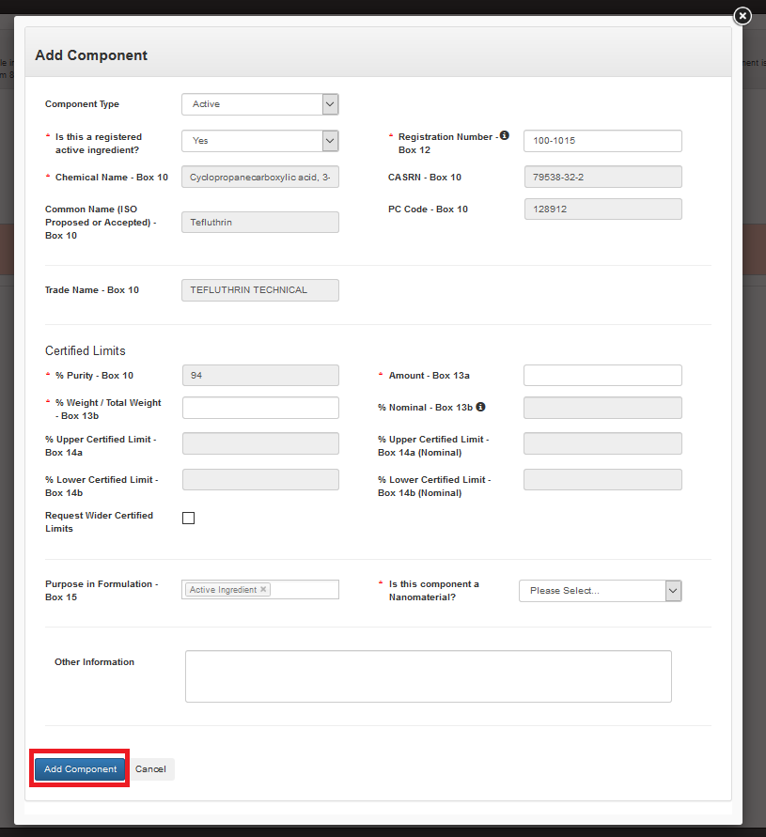
Exhibit 5–34: ‘Add Component’ Pop-Up – Registered Active
Navigation: Enter data in all required fields and select the ‘Add Component’ button.
Exhibit 5–35 shows a screen capture of the ‘Add Component’ pop-up for an unregistered ‘Active’ component:
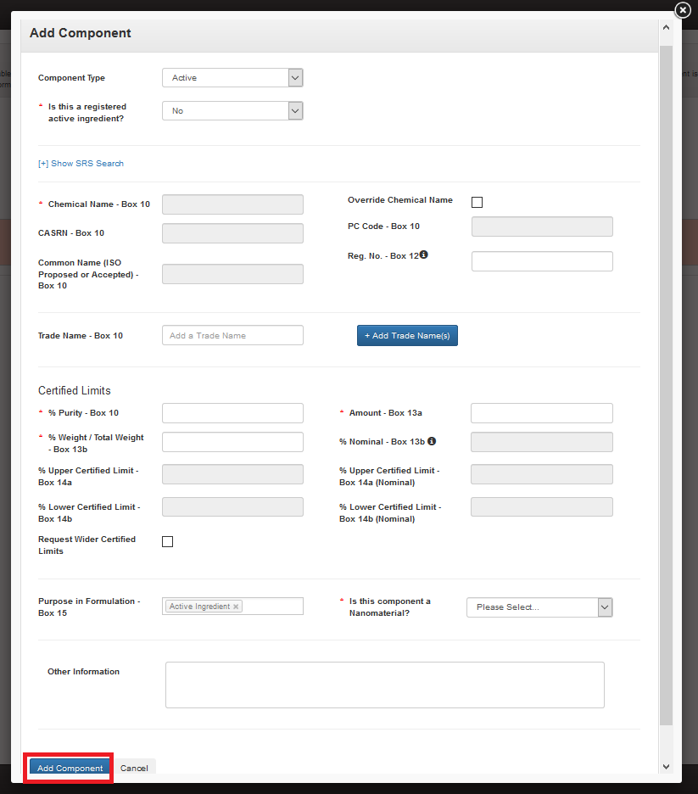
Exhibit 5–35: ‘Add Component’ Pop-Up – Un–registered Active
Navigation: Enter data in all required fields and select the ‘Add Component’ button.
Exhibit 5–36 shows a screen capture of the ‘Add Component’ pop-up for a registered, blended ‘Active’ component:
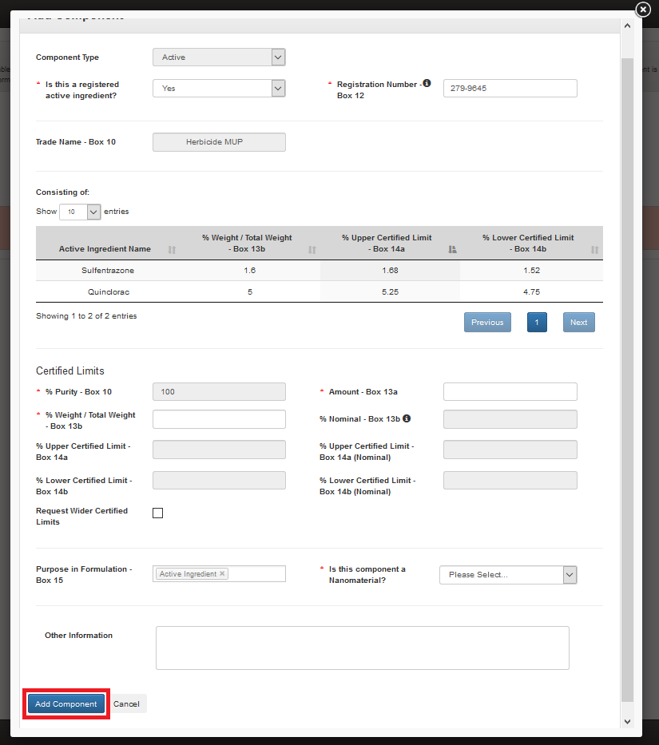
Exhibit 5–36: ‘Add Component’ Pop-Up – Blended Active
Navigation: Enter data in all required fields and select the ‘Add Component’ button.

Alternate Active Components
To add an alternate source for a registered active component select ‘Alternate Active’ from the ‘Component Type’ drop down and enter the registration number for the alternate source of the active ingredient. Note that all chemical identity and purity data must match between a parent active ingredient and alternate source for an active ingredient.
The following fields display in the ‘Add Component’ pop-up for an ‘Alternate Active’ component:
- Component Type: Select the component type to update the modal to display only those fields necessary for the selected component type. This field is required.
- Add Alternate Source for: Select the parent active ingredient for which this component is an alternate source. This field is required.
- Registration Number – Box 12: Enter the ‘EPA Registration Number’ for the ‘Alternate Active’ component. After a user enters a number and navigates away from the field, the application performs a search of current registered product data to validate the number’s validity and automatically populate certain fields within the pop-up. This field is required.
- Chemical Name – Box 10: Enter the component’s chemical name. The application will automatically populate this field with registered product data into a fixed field when a user indicates the component is a registered active ingredient and enters a valid number in the ‘Registration Number – Box 12’ field. This field is required and must match its parent active ingredient value.
- CASRN – Box 10: Enter the component’s Chemical Abstracts Service Registry Number (CASRN). The application will automatically populate this field with registered product data into a fixed field when a user indicates the component is a registered active ingredient and enters a valid number in the ‘Registration Number – Box 12’ field. This field is required and must match its parent active ingredient value.
- Common Name (ISO Proposed or Accepted) – Box 10: Enter the component’s proposed or accepted ISO common name. The application will automatically populate this field with registered product data into a fixed field when a user indicates the component is a registered active ingredient and enters a valid number in the ‘Registration Number – Box 12’ field. This field is required and must match its parent active ingredient value.
- IUPAC Name – Box 10: Enter the component’s IUPAC name. This field is optional.
- PC Code – Box 10: Enter the component’s PC Code. The application will automatically populate this field with registered product data when a user indicates the component is a registered active ingredient and enters a valid number in the ‘Registration Number – Box 12’ field. This field is optional.
- Override Chemical Name: Select this checkbox to enable the ‘Chemical Name – Box 10,’ ‘CASRN – Box 10,’ and ‘Common Name (ISO Proposed or Accepted) – Box 10’ fields for manual data entry when data has been automatically populated into fixed fields based on ‘EPA Registration Number’ or Substance Registry Services (SRS) searches. This field is optional.
- Reason for Chemical Name Override: Indicate a reason why changes to the automatically populated chemical identity fields are necessary. This field only displays when ‘Override Chemical Name’ is selected and is required when displayed.
- Trade Name – Box 10: Enter up to ten (10) brand names for the component. To save a ‘Trade Name to the ‘Add Component’ pop-up, select the ‘+ Add Trade Name’ button once the name is complete. The application will automatically populate this field with registered product data into a fixed field when a user indicates the component is a registered active ingredient and enters a valid number in the ‘Registration Number – Box 12’ field. This field is optional.
- Site/Supplier (for a Trade Name): The application pairs each saved ‘Trade Name’ to a ‘Site/Supplier’ drop-down menu that lists all the manufacturing sites and/or component suppliers related to the component. The first saved ‘Trade Name’ will automatically inherit a relationship with the component’s ‘Primary Site/Supplier’ to ensure the name renders on the main EPA Form 8570-4. Subsequent ‘Trade Names’ may be associated to manufacturing sites and/or component suppliers other than the ‘Primary Site/Supplier’ and render onto addendum pages to EPA Form 8570-4. Refer to Section 5.6.3.1 and Section Error! Reference source not found. for information about how to set a ‘Primary Site/Supplier’ and how to view addendum pages, respectively.
- % Purity – Box 10: Enter the purity for the component. The application will automatically populate this field with registered product data into a fixed field when a user indicates the component is a registered active ingredient and enters a valid number in the ‘Registration Number – Box 12’ field. This field is required and must match its parent active ingredient value.
- Amount – Box 13a: Enter the amount of the component included in the formulation. This field is used in the calculations performed on the ‘Components’ screen. This field is required.
- % Weight / Total Weight – Box 13b: Enter the percent of the total composition the component comprises. The application sums this value with other components’ values to perform a validation on the ‘Components’ screen. This field is required.
- % Nominal – Box 13b: Enter the percent nominal value as captured on the product label. The application automatically calculates this value based on the values entered in the ‘% Purity – Box 10’ and ‘% Weight / Total Weight – Box 13b’ fields. This field is optional within the pop-up, but required to pass many on-screen validations.
- % Upper Certified Limit – Box 14a: Enter the 40 CFR 158.350 percent upper certified limit. The application automatically calculates this value based on the values entered in the ‘% Purity – Box 10’ and ‘% Weight / Total Weight – Box 13b’ fields. This field is optional.
- % Upper Certified Limit – Box 14a (Nominal): Enter the 40 CFR 158.350 percent upper certified limit for the nominal percentage. The application automatically calculates this value based on the values entered in the ‘% Purity – Box 10,’ ‘% Weight / Total Weight – Box 13b,’ and ‘% Nominal – Box 13b’ fields. This field is optional.
- % Lower Certified Limit – Box 14b: Enter the 40 CFR 158.350 percent lower certified limit. The application automatically calculates this value based on the values entered in the ‘% Purity – Box 10’ and ‘% Weight / Total Weight – Box 13b’ fields. This field is optional.
- % Lower Certified Limit – Box 14b (Nominal): Enter the 40 CFR 158.350 percent lower certified limit for the nominal percentage. The application automatically calculates this value based on the values entered in the ‘% Purity – Box 10,’ ‘% Weight / Total Weight – Box 13b,’ and ‘% Nominal – Box 13b’ fields. This field is optional.
- Request Wider Certified Limits: Select this checkbox to make manual changes to the calculated values in the ‘% Nominal – Box 13b,’ ‘% Upper Certified Limit – Box 14a,’ ‘% Upper Certified Limit – Box 14a (Nominal),’ ‘% Lower Certified Limit – Box 14b,’ or ‘% Lower Certified Limit – Box 14b (Nominal)’ fields. This field is optional.
- Justification for Wider Certified Limits: Indicate a reason why wider and/or changes certified limits are necessary. This field only displays when ‘Request Wider Certified Limits’ is selected and is required when displayed.
- Purpose in Formulation – Box 15: Select a purpose in formulation for the component. This value is fixed as ‘Active Ingredient’ for ‘Active’ components. This field is required.
- Is this component a Nanomaterial?: Indicate whether the component is a nanomaterial. This field is required.
- Culture Collection Deposit – Box 10: Enter the culture collection in which a ‘Microbial Pest Control Agent’ is deposited and the ‘Deposit Number.’ This field only displays when ‘Is product microbial?’ is ‘Yes’ on the ‘Preliminary Questions’ screen and is optional when displayed.
- Potency – Box 10: Enter the numerical value of the guarantee, expressed in terms of potency. This field only displays when ‘Is product microbial?’ is ‘Yes’ on the ‘Preliminary Questions’ screen and is optional when displayed.
- Viability – Box 10: Enter the numerical value of the guarantee, expressed in terms of viability. This field only displays when ‘Is product microbial?’ is ‘Yes’ on the ‘Preliminary Questions’ screen and is optional when displayed.
- % Upper Certified Limit – Expressed: Enter the percent upper certified limit expressed for the product. This field only displays when 'Formulation Type Code' is 'Liquid' and 'Does this product contain substrate/towelette/wipe? is 'Yes' on the 'Product Properties' screen and is required when displayed.
- % Lower Certified Limit – Expressed: Enter the percent lower certified limit expressed for the product. This field only displays when 'Formulation Type Code' is 'Liquid' and 'Does this product contain substrate/towelette/wipe? is 'Yes' on the 'Product Properties' screen and is required when displayed.
- % Nominal – Expressed: Enter the percent nominal expressed for the product. This field only displays when 'Formulation Type Code' is 'Liquid' and 'Does this product contain substrate/towelette/wipe? is 'Yes' on the 'Product Properties' screen and is required when displayed.
- Other Information: Enter additional information related to the component that is not captured in other fields. This field is optional.
Exhibit 5-37 shows a screen capture of the ‘Add Component’ pop-up for an ‘Alternate Active’ component:
Exhibit 5-37: ‘‘Add Component’ Pop-Up – Blended Active
Navigation: Enter data in all required fields and select the ‘Add Component’ button.

Impurity Components
The application allows the inclusion of ‘Impurity’ components in ‘Technical’ and ‘Manufacturing Use Product’ formulations. Each ‘Technical’ product must have at least one (1) ‘Impurity’ component.
The following fields display in the ‘Add Component’ pop-up for an ‘Impurity’ component:
- Component Type: Select the component type to update the modal to display only those fields necessary for the selected component type. This field is required.
- Chemical Name – Box 10: Enter the component’s chemical name. This field is required.
- CASRN – Box 10: Enter the component’s CASRN. This field is optional.
- Common Name (ISO Proposed or Accepted) – Box 10: Enter the component’s proposed or accepted ISO common name. This field is optional.
- IUPAC Name – Box 10: Enter the component’s IUPAC name. This field is optional.
- Amount – Box 13a: Enter the amount of the component included in the formulation. This field is used in the calculations performed on the ‘Components’ screen. This field is optional.
- % Weight / Total Weight – Box 13b: Enter the percent of the total composition the component comprises. The application sums this value with other components’ values to perform a validation on the ‘Components’ screen. This field is optional.
- % Upper Certified Limit – Box 14a: Enter the 40 CFR 158.350 percent upper certified limit. The application automatically calculates this value based on the values entered in the ‘% Purity – Box 10’ and ‘% Weight / Total Weight – Box 13b’ fields. This field is required.
- Purpose in Formulation – Box 15: Select a purpose in formulation for the component. This value is fixed as ‘Impurity’ for ‘Impurity’ components. This field is required.
- Is this component a Nanomaterial?: Indicate whether the component is a nanomaterial. This field is required.
- Other Information: Enter additional information related to the component that is not captured in other fields. This field is optional.
Exhibit 5-38 shows a screen capture of the ‘Add Component’ pop-up for a registered, blended ‘Active’ component:
Exhibit 5-38: ‘‘Add Component’ Pop-Up – Blended Active
Navigation: Enter data in all required fields and select the ‘Add Component’ button.

Inert Components
Exhibit 5–36 shows a screen capture of the ‘Add Component’ pop-up for a registered, blended ‘Active’ component:
Exhibit 5-39: ‘‘Add Component’ Pop-Up – Inert Component
Navigation: Enter data in all required fields and select the ‘Add Component’ button.

Dye Components
The application allows the inclusion of ‘Dye’ components in ‘End Use Product’ and ‘Manufacturing Use Product’ formulations.
The following fields display in the ‘Add Component’ pop-up for a ‘Dye’ component:
- Component Type: Select the component type to update the modal to display only those fields necessary for the selected component type. This field is required.
- Chemical Name – Box 10: Enter the component’s chemical name. This field is required.
- CASRN – Box 10: Enter the component’s CASRN. This field is optional.
- Common Name (ISO Proposed or Accepted) – Box 10: Enter the component’s proposed or accepted ISO common name. This field is optional.
- IUPAC Name – Box 10: Enter the component’s IUPAC name. This field is optional.
- Trade Name – Box 10: Enter up to ten (10) unique brand names for the component. To save a ‘Trade Name to the ‘Add Component’ pop-up, select the ‘+ Add Trade Name’ button once the name is complete. This field is optional.
- Site/Supplier (for a Trade Name): The application pairs each saved ‘Trade Name’ to a ‘Site/Supplier’ drop-down menu that lists all the manufacturing sites and/or component suppliers related to the component. The first saved ‘Trade Name’ will automatically inherit a relationship with the component’s ‘Primary Site/Supplier’ to ensure the name renders on the main EPA Form 8570-4. Subsequent ‘Trade Names’ may be associated to manufacturing sites and/or component suppliers other than the ‘Primary Site/Supplier’ and render onto addendum pages to EPA Form 8570-4. Refer to Section 5.6.3.1 and Section Error! Reference source not found. for information about how to set a ‘Primary Site/Supplier’ and how to view addendum pages, respectively.
- % Purity – Box 10: Enter the purity for the component. This field is optional.
- Amount – Box 13a: Enter the amount of the component included in the formulation. This field is used in the calculations performed on the ‘Components’ screen. This field is required.
- % Weight / Total Weight – Box 13b: Enter the percent of the total composition the component comprises. The application sums this value with other components’ values to perform a validation on the ‘Components’ screen. This field is required.
- % Upper Certified Limit – Box 14a: Enter the 40 CFR 158.350 percent upper certified limit. The application automatically calculates this value based on the values entered in the ‘% Purity – Box 10’ and ‘% Weight / Total Weight – Box 13b’ fields. This field is optional.
- % Lower Certified Limit – Box 14b: Enter the 40 CFR 158.350 percent lower certified limit. The application automatically calculates this value based on the values entered in the ‘% Purity – Box 10’ and ‘% Weight / Total Weight – Box 13b’ fields. This field is optional.
- Request Wider Certified Limits: Select this checkbox to make manual changes to the calculated values in the ‘% Upper Certified Limit – Box 14a’ and ‘% Lower Certified Limit – Box 14b,’ fields. This field is optional.
- Justification for Wider Certified Limits: Indicate a reason why wider and/or changes certified limits are necessary. This field only displays when ‘Request Wider Certified Limits’ is selected and is required when displayed.
- Purpose in Formulation – Box 15: Select a purpose in formulation for the component. This value is fixed as ‘Dye/Coloring Agent/Colorant/Pigment’ for ‘Dye’ components. This field is optional.
- Is this component a Nanomaterial?: Indicate whether the component is a nanomaterial. This field is required.
- Other Information: Enter additional information related to the component that is not captured in other fields. This field is optional.
Exhibit 5-40 shows a screen capture of the ‘Add Component’ pop-up for a ‘Dye’ component:
Exhibit 5-40: ‘‘Add Component’ Pop-Up – Dye Component
Navigation: Enter data in all required fields and select the ‘Add Component’ button.

Fragrance Components
The application allows the inclusion of ‘Fragrance’ components in ‘End Use Product’ and ‘Manufacturing Use Product’ formulations.
The following fields display in the ‘Add Component’ pop-up for a ‘Fragrance’ component:
- Component Type: Select the component type to update the modal to display only those fields necessary for the selected component type. This field is required.
- Chemical Name – Box 10: Enter the component’s chemical name. This field is required.
- CASRN – Box 10: Enter the component’s CASRN. This field is optional.
- Common Name (ISO Proposed or Accepted) – Box 10: Enter the component’s proposed or accepted ISO common name. This field is optional.
- IUPAC Name – Box 10: Enter the component’s IUPAC name. This field is optional.
- Trade Name – Box 10: Enter up to ten (10) unique brand names for the component. To save a ‘Trade Name to the ‘Add Component’ pop-up, select the ‘+ Add Trade Name’ button once the name is complete. This field is optional.
- Site/Supplier (for a Trade Name): The application pairs each saved ‘Trade Name’ to a ‘Site/Supplier’ drop-down menu that lists all the manufacturing sites and/or component suppliers related to the component. The first saved ‘Trade Name’ will automatically inherit a relationship with the component’s ‘Primary Site/Supplier’ to ensure the name renders on the main EPA Form 8570-4. Subsequent ‘Trade Names’ may be associated to manufacturing sites and/or component suppliers other than the ‘Primary Site/Supplier’ and render onto addendum pages to EPA Form 8570-4. Refer to Section 5.6.3.1 and Section Error! Reference source not found. for information about how to set a ‘Primary Site/Supplier’ and how to view addendum pages, respectively.
- % Purity – Box 10: Enter the purity for the component. This field is optional.
- Amount – Box 13a: Enter the amount of the component included in the formulation. This field is used in the calculations performed on the ‘Components’ screen. This field is required.
- % Weight / Total Weight – Box 13b: Enter the percent of the total composition the component comprises. The application sums this value with other components’ values to perform a validation on the ‘Components’ screen. This field is required.
- % Nominal – Box 13b: Enter the percent nominal value as captured on the product label. The application automatically calculates this value based on the values entered in the ‘% Purity – Box 10’ and ‘% Weight / Total Weight – Box 13b’ fields. This field is optional within the pop-up, but required to pass many on-screen validations.
- % Upper Certified Limit – Box 14a: Enter the 40 CFR 158.350 percent upper certified limit. The application automatically calculates this value based on the values entered in the ‘% Purity – Box 10’ and ‘% Weight / Total Weight – Box 13b’ fields. This field is optional.
- % Upper Certified Limit – Box 14a (Nominal): Enter the 40 CFR 158.350 percent upper certified limit for the nominal percentage. The application automatically calculates this value based on the values entered in the ‘% Purity – Box 10,’ ‘% Weight / Total Weight – Box 13b,’ and ‘% Nominal – Box 13b’ fields. This field is optional.
- % Lower Certified Limit – Box 14b: Enter the 40 CFR 158.350 percent lower certified limit. The application automatically calculates this value based on the values entered in the ‘% Purity – Box 10’ and ‘% Weight / Total Weight – Box 13b’ fields. This field is optional.
- % Lower Certified Limit – Box 14b (Nominal): Enter the 40 CFR 158.350 percent lower certified limit for the nominal percentage. The application automatically calculates this value based on the values entered in the ‘% Purity – Box 10,’ ‘% Weight / Total Weight – Box 13b,’ and ‘% Nominal – Box 13b’ fields. This field is optional.
- Request Wider Certified Limits: Select this checkbox to make manual changes to the calculated values in the ‘% Nominal – Box 13b,’ ‘% Upper Certified Limit – Box 14a,’ ‘% Upper Certified Limit – Box 14a (Nominal),’ ‘% Lower Certified Limit – Box 14b,’ or ‘% Lower Certified Limit – Box 14b (Nominal)’ fields. This field is optional.
- Justification for Wider Certified Limits: Indicate a reason why wider and/or changes certified limits are necessary. This field only displays when ‘Request Wider Certified Limits’ is selected and is required when displayed.
- Purpose in Formulation – Box 15: Select a purpose in formulation for the component. This value is fixed as ‘Fragrance’ for ‘Fragrance’ components. This field is optional.
- Is this component a Nanomaterial?: Indicate whether the component is a nanomaterial. This field is required.
- Other Information: Enter additional information related to the component that is not captured in other fields. This field is optional.
Exhibit 5-41 shows a screen capture of the ‘Add Component’ pop-up for a ‘Fragrance’ component:
Exhibit 5-41: ‘Add Component’ Pop-Up – Fragrance Component
Navigation: Enter data in all required fields and select the ‘Add Component’ button.

Fertilizer Components
The application allows the inclusion of ‘Fertilizer’ components in ‘End Use Product’ and ‘Manufacturing Use Product’ formulations.
The following fields display in the ‘Add Component’ pop-up for a ‘Fertilizer’ component:
- Component Type: Select the component type to update the modal to display only those fields necessary for the selected component type. This field is required.
- Chemical Name – Box 10: Enter the component’s chemical name. This field is required.
- CASRN – Box 10: Enter the component’s CASRN. This field is optional.
- Common Name (ISO Proposed or Accepted) – Box 10: Enter the component’s proposed or accepted ISO common name. This field is optional.
- IUPAC Name – Box 10: Enter the component’s IUPAC name. This field is optional.
- Contains Nitrogen?: Indicate whether the ‘Fertilizer’ component contains nitrogen. This field is required.
- Maximum Nitrogen Percentage Tested – Box 10: Enter the maximum percent of nitrogen tested in the ‘Acute Eye Irritation’ guideline study, OPPTS 870.2400. This field only displays when ‘Contains Nitrogen?’ is ‘Yes’ and is required when displayed.
- Trade Name – Box 10: Enter up to ten (10) unique brand names for the component. To save a ‘Trade Name to the ‘Add Component’ pop-up, select the ‘+ Add Trade Name’ button once the name is complete. This field is optional.
- Site/Supplier (for a Trade Name): The application pairs each saved ‘Trade Name’ to a ‘Site/Supplier’ drop-down menu that lists all the manufacturing sites and/or component suppliers related to the component. The first saved ‘Trade Name’ will automatically inherit a relationship with the component’s ‘Primary Site/Supplier’ to ensure the name renders on the main EPA Form 8570-4. Subsequent ‘Trade Names’ may be associated to manufacturing sites and/or component suppliers other than the ‘Primary Site/Supplier’ and render onto addendum pages to EPA Form 8570-4. Refer to Section 5.6.3.1 and Section Error! Reference source not found. for information about how to set a ‘Primary Site/Supplier’ and how to view addendum pages, respectively.
- % Purity – Box 10: Enter the purity for the component. This field is optional.
- Amount – Box 13a: Enter the amount of the component included in the formulation. This field is used in the calculations performed on the ‘Components’ screen. This field is required.
- % Weight / Total Weight – Box 13b: Enter the percent of the total composition the component comprises. The application sums this value with other components’ values to perform a validation on the ‘Components’ screen. This field is required.
- % Nominal – Box 13b: Enter the percent nominal value as captured on the product label. The application automatically calculates this value based on the values entered in the ‘% Purity – Box 10’ and ‘% Weight / Total Weight – Box 13b’ fields. This field is optional within the pop-up, but required to pass many on-screen validations.
- % Upper Certified Limit – Box 14a: Enter the 40 CFR 158.350 percent upper certified limit. The application automatically calculates this value based on the values entered in the ‘% Purity – Box 10’ and ‘% Weight / Total Weight – Box 13b’ fields. This field is optional.
- % Upper Certified Limit – Box 14a (Nominal): Enter the 40 CFR 158.350 percent upper certified limit for the nominal percentage. The application automatically calculates this value based on the values entered in the ‘% Purity – Box 10,’ ‘% Weight / Total Weight – Box 13b,’ and ‘% Nominal – Box 13b’ fields. This field is optional.
- % Lower Certified Limit – Box 14b: Enter the 40 CFR 158.350 percent lower certified limit. The application automatically calculates this value based on the values entered in the ‘% Purity – Box 10’ and ‘% Weight / Total Weight – Box 13b’ fields. This field is optional.
- % Lower Certified Limit – Box 14b (Nominal): Enter the 40 CFR 158.350 percent lower certified limit for the nominal percentage. The application automatically calculates this value based on the values entered in the ‘% Purity – Box 10,’ ‘% Weight / Total Weight – Box 13b,’ and ‘% Nominal – Box 13b’ fields. This field is optional.
- Request Wider Certified Limits: Select this checkbox to make manual changes to the calculated values in the ‘% Nominal – Box 13b,’ ‘% Upper Certified Limit – Box 14a,’ ‘% Upper Certified Limit – Box 14a (Nominal),’ ‘% Lower Certified Limit – Box 14b,’ or ‘% Lower Certified Limit – Box 14b (Nominal)’ fields. This field is optional.
- Justification for Wider Certified Limits: Indicate a reason why wider and/or changes certified limits are necessary. This field only displays when ‘Request Wider Certified Limits’ is selected and is required when displayed.
- Purpose in Formulation – Box 15: Select a purpose in formulation for the component. This value is fixed as ‘Fertilizer’ for ‘Fertilizer’ components. This field is optional.
- Is this component a Nanomaterial?: Indicate whether the component is a nanomaterial. This field is required.
- Other Information: Enter additional information related to the component that is not captured in other fields. This field is optional.
Exhibit 5-42 shows a screen capture of the ‘Add Component’ pop-up for a ‘Fertilizer’ component:
Exhibit 5-42: ‘Add Component’ Pop-Up – Fertilizer Component
Navigation: Enter data in all required fields and select the ‘Add Component’ button.

Water Soluble Packaging Material and Ink Type Components
The application allows the inclusion of ‘Water Soluble Packaging Material’ and ‘Water Soluble Packaging Ink Type’ components when 'Is this a water soluble package?' is 'Yes' on the 'Product Properties' screen.
The following fields display in the ‘Add Component’ pop-up for a ‘Water Soluble Packaging Material’ or ‘Water Soluble Packaging Ink Type’ component:
- Component Type: Select the component type to update the modal to display only those fields necessary for the selected component type. This field is required.
- Chemical Name – Box 10: Enter the component’s chemical name. This field is required.
- CASRN – Box 10: Enter the component’s CASRN. This field is required.
- Common Name (ISO Proposed or Accepted) – Box 10: Enter the component’s proposed or accepted ISO common name. This field is required.
- IUPAC Name – Box 10: Enter the component’s IUPAC name. This field is optional.
- Trade Name – Box 10: Enter up to ten (10) unique brand names for the component. To save a ‘Trade Name to the ‘Add Component’ pop-up, select the ‘+ Add Trade Name’ button once the name is complete. This field is required.
- Site/Supplier (for a Trade Name): The application pairs each saved ‘Trade Name’ to a ‘Site/Supplier’ drop-down menu that lists all the manufacturing sites and/or component suppliers related to the component. The first saved ‘Trade Name’ will automatically inherit a relationship with the component’s ‘Primary Site/Supplier’ to ensure the name renders on the main EPA Form 8570-4. Subsequent ‘Trade Names’ may be associated to manufacturing sites and/or component suppliers other than the ‘Primary Site/Supplier’ and render onto addendum pages to EPA Form 8570-4. Refer to Section 5.6.3.1 and Section Error! Reference source not found. for information about how to set a ‘Primary Site/Supplier’ and how to view addendum pages, respectively.
- Purpose in Formulation – Box 15: Select a purpose in formulation for the component. This value is fixed as ‘Water Soluble Packaging’ for ‘Water Soluble Packaging Material’ components and ‘Water Soluble Packaging Ink Type’ for ‘Water Soluble Packaging Ink Type’ components. This field is optional.
Exhibit 5-43 shows a screen capture of the ‘Add Component’ pop-up for a ‘Water Soluble’ component:
Exhibit 5-43: ‘Add Component’ Pop-Up – Water Soluble Component
Navigation: Enter data in all required fields and select the ‘Add Component’ button.

Towelette Components
The application allows the inclusion of ‘Towelette’ components when 'Does this product contain substrate/towelette/wipe? is ‘Yes’ on the 'Product Properties' screen.
The following fields display in the ‘Add Component’ pop-up for a ‘Towelette’ component:
- Component Type: Select the component type to update the modal to display only those fields necessary for the selected component type. This field is required.
- Chemical Name – Box 10: Enter the component’s chemical name. This field is required.
- CASRN – Box 10: Enter the component’s CASRN. This field is required.
- Common Name (ISO Proposed or Accepted) – Box 10: Enter the component’s proposed or accepted ISO common name. This field is required.
- IUPAC Name – Box 10: Enter the component’s IUPAC name. This field is optional.
- Trade Name – Box 10: Enter up to ten (10) unique brand names for the component. To save a ‘Trade Name to the ‘Add Component’ pop-up, select the ‘+ Add Trade Name’ button once the name is complete. This field is required.
- Site/Supplier (for a Trade Name): The application pairs each saved ‘Trade Name’ to a ‘Site/Supplier’ drop-down menu that lists all the manufacturing sites and/or component suppliers related to the component. The first saved ‘Trade Name’ will automatically inherit a relationship with the component’s ‘Primary Site/Supplier’ to ensure the name renders on the main EPA Form 8570-4. Subsequent ‘Trade Names’ may be associated to manufacturing sites and/or component suppliers other than the ‘Primary Site/Supplier’ and render onto addendum pages to EPA Form 8570-4. Refer to Section 5.6.3.1 and Section Error! Reference source not found. for information about how to set a ‘Primary Site/Supplier’ and how to view addendum pages, respectively.
- Purpose in Formulation – Box 15: Select a purpose in formulation for the component. This value is fixed as ‘Towelette’ for ‘Towelette’ components. This field is optional.
Exhibit 5-44 shows a screen capture of the ‘Add Component’ pop-up for a ‘Towelette’ component:
Exhibit 5-44: ‘Add Component’ Pop-Up – Towelette Component
Navigation: Enter data in all required fields and select the ‘Add Component’ button.

Bulk Upload Components
The eCSF application allows a user to upload many component entries into an eCSF XML file using a Microsoft Excel spreadsheet template file. This allows for the easy population of component entries when a registrant uses a regular set across products, eCSF XML files, etc. The application applies all applicable validations regardless of whether component data is bulk uploaded or manually entered.
Note: The template file does occasionally change when application features are added or updated. All efforts to ensure backward compatibility are made, but a user should check that their template file matches the current template file prior to upload.
Exhibit 5-45 shows a screen capture of how to download the bulk upload template file from the ‘Components’ screen:
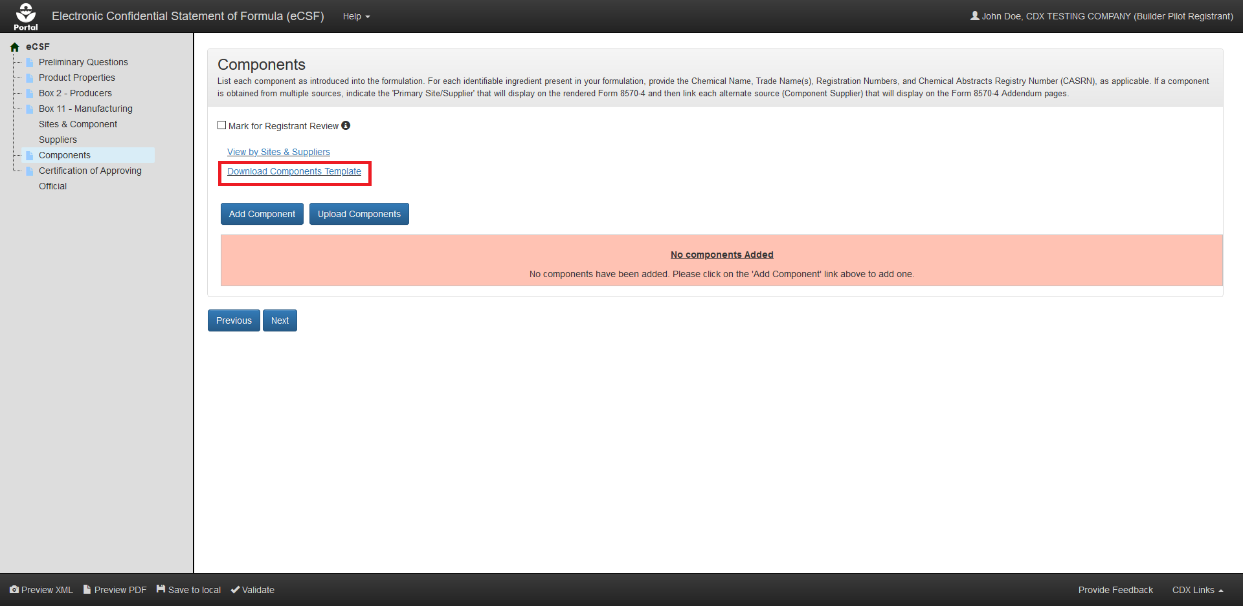
Exhibit 5-45: ‘Components’ Screen – Template Download
Navigation: Select the ‘Download Components Template’ link to save and work on the template on a local machine.
Exhibit 5-46 shows a screen capture of how to initiate the bulk upload on the ‘Components’ screen:
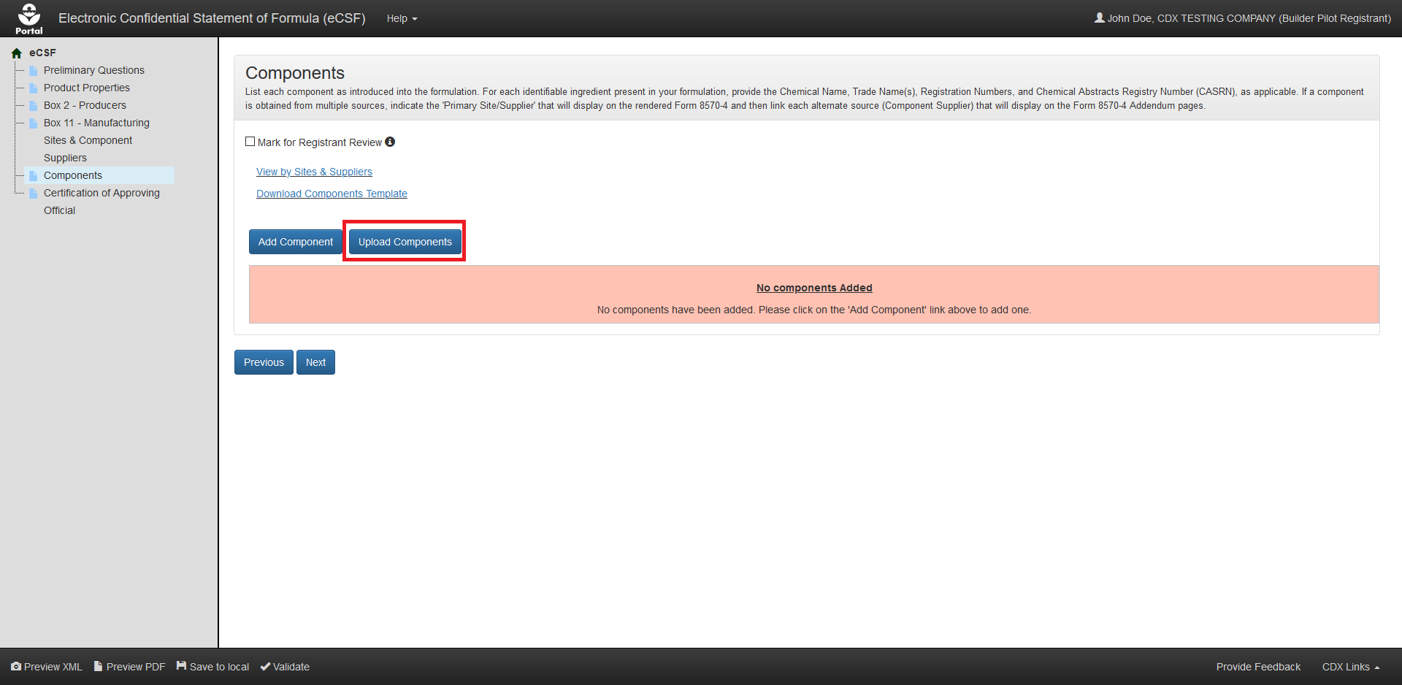
Exhibit 5-46: ‘Components’ Screen – Initiate Template Upload
Navigation: Select the ‘Upload Components Template’ button to launch the upload pop-up.
Exhibit 5-47 shows a screen capture of how to upload a ‘Components’ template in the pop-up:
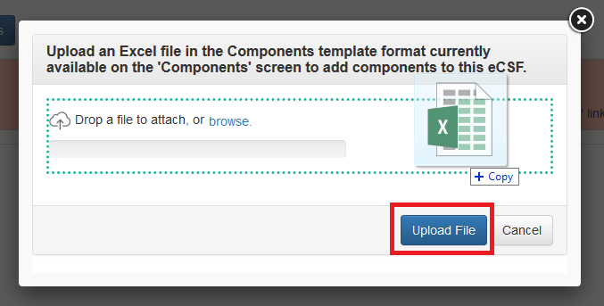
Exhibit 5-47: ‘Upload Template’ Pop-Up
Navigation: Select the ‘browse’ link to search the local machine for a file or drag and drop the file onto the pop-up to initiate upload. Next, wait for the file name to display (upload processing is incomplete until the file name displays) and then select the ‘Upload File’ button.
Exhibit 5-48 shows a screen capture the ‘Components’ screen following a successful bulk upload:
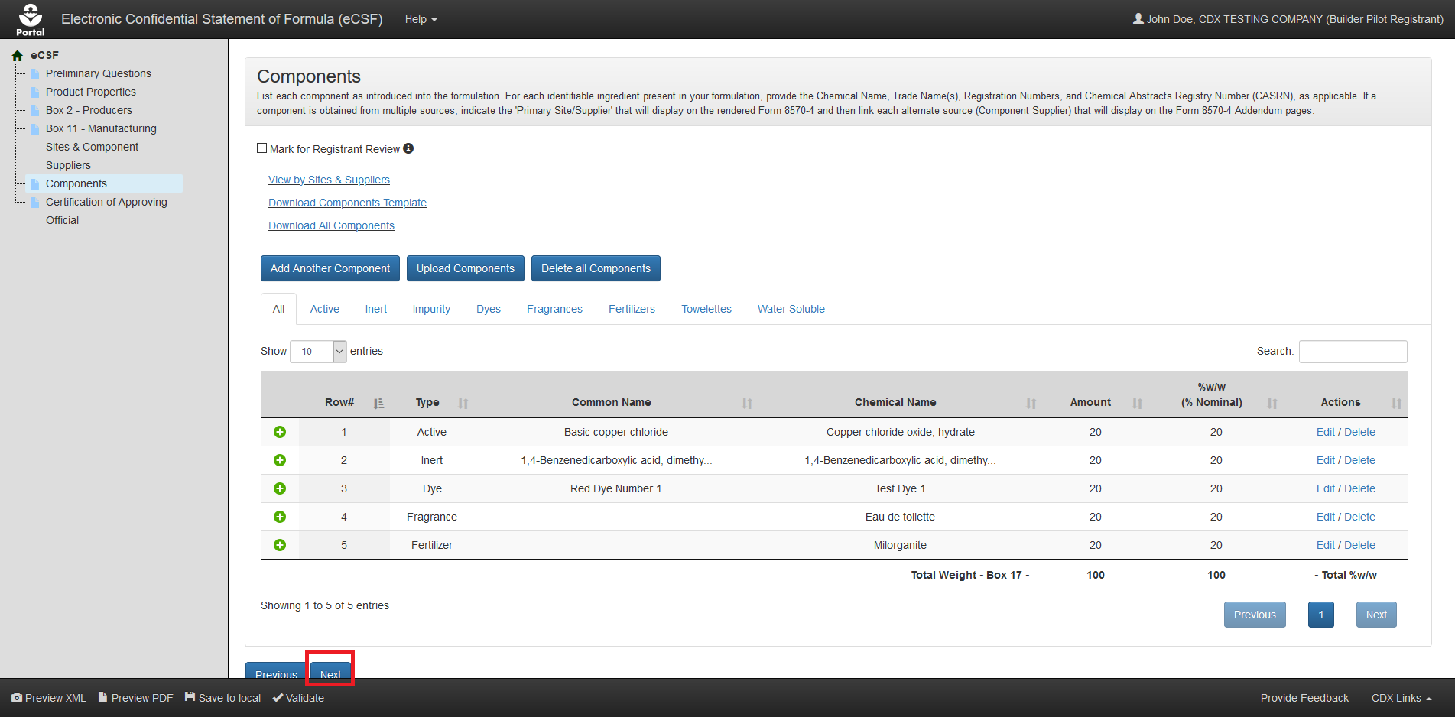
Exhibit 5-48: ‘Components’ Screen – Upload Complete
Navigation: Select the ‘Next’ button to navigate away from the screen when all necessary component entries are complete.

Relate a Manufacturing Site or Component Supplier to a Component
Generally, components within an eCSF XML file are required to have at least one manufacturing site and/or component supplier relationship. However, registrants should consider the following situations when linking components to manufacturing sites and component suppliers:
- Components in a basic formulation may only relate to a single site or supplier, which the application renders on the main form.
- When multiple component to site and supplier relationships exist in an alternate formulation, the application renders ‘Box 11’ data to addendum pages.
- The application enforces ‘Supplier Type’ to component rules via validations and disabled application functionality (e.g., registered Active components cannot be associated to manufacturing sites).
- Registrants cannot make component to manufacturing site and component supplier relationships using the bulk upload functionality.
- The application does not render orphaned manufacturing sites and component suppliers (i.e., entries that are not associated to any component) onto the form PDF rendering. However, the application does maintain these entries in the eCSF XML file.

Create Site/Supplier Relationship for Existing Site(s)/Supplier(s)
Follow the below steps to create a relationship between a component and a manufacturing site(s) or component supplier(s) that already exists in the eCSF XML file.
Exhibit 5-49 shows a screen capture of how to initiate the process to relate a component to an existing manufacturing site or component supplier on the ‘Components’ screen:
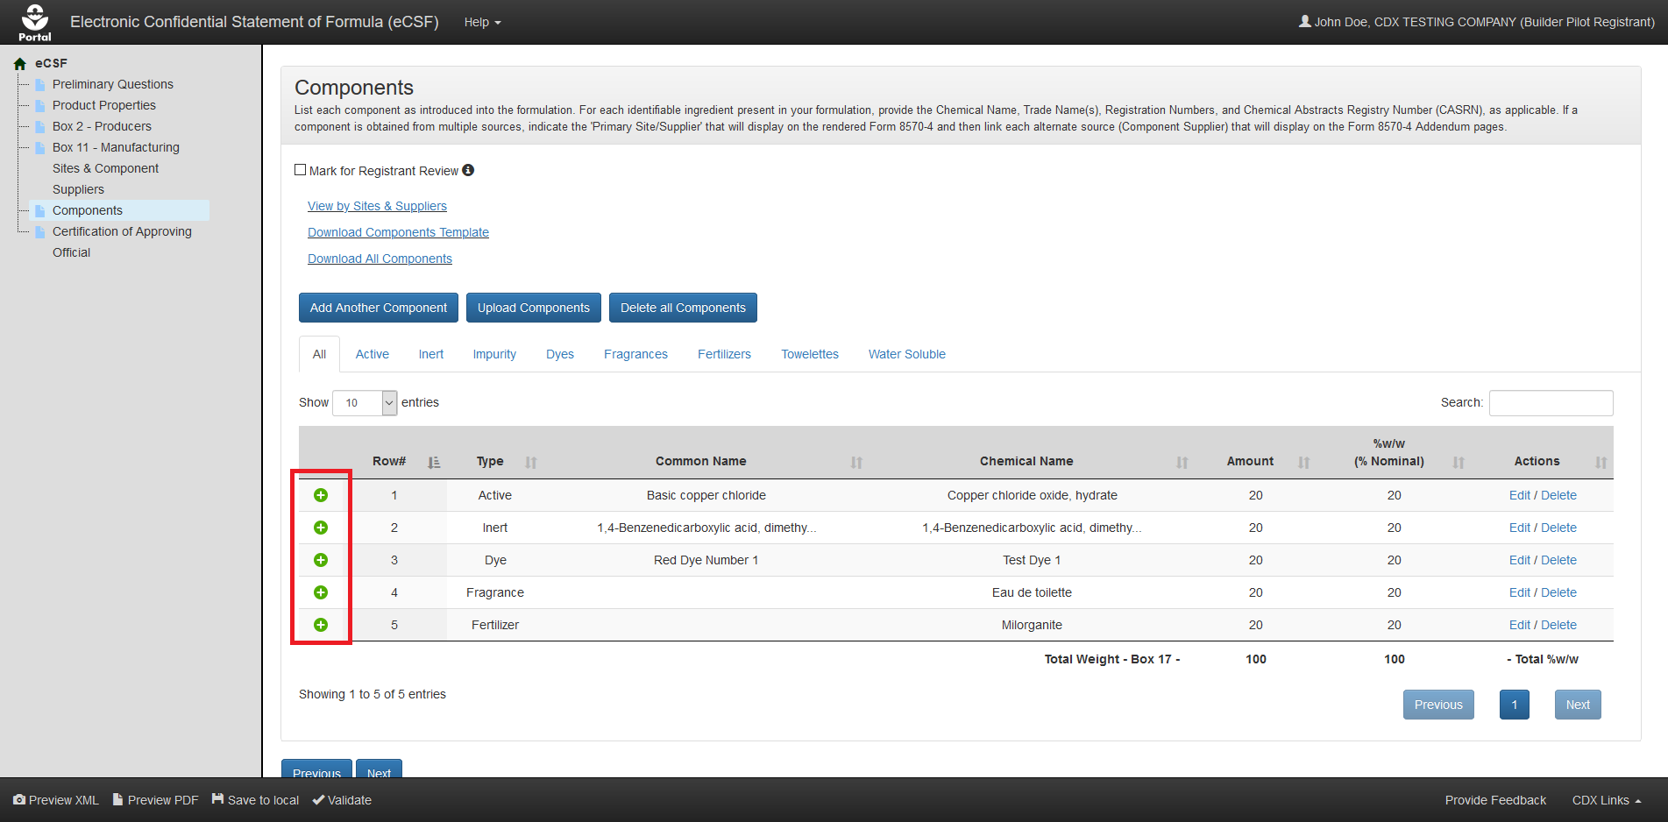
Exhibit 5-49: ‘Components’ Screen – Relate Site/Supplier
Navigation: Select the green ‘plus’ icon from the ‘Relate Site/Supplier’ column for the entry that will be related.
Exhibit 5-50 shows a screen capture of how to view existing manufacturing sites and component suppliers to create a relationship on the ‘Components’ screen:
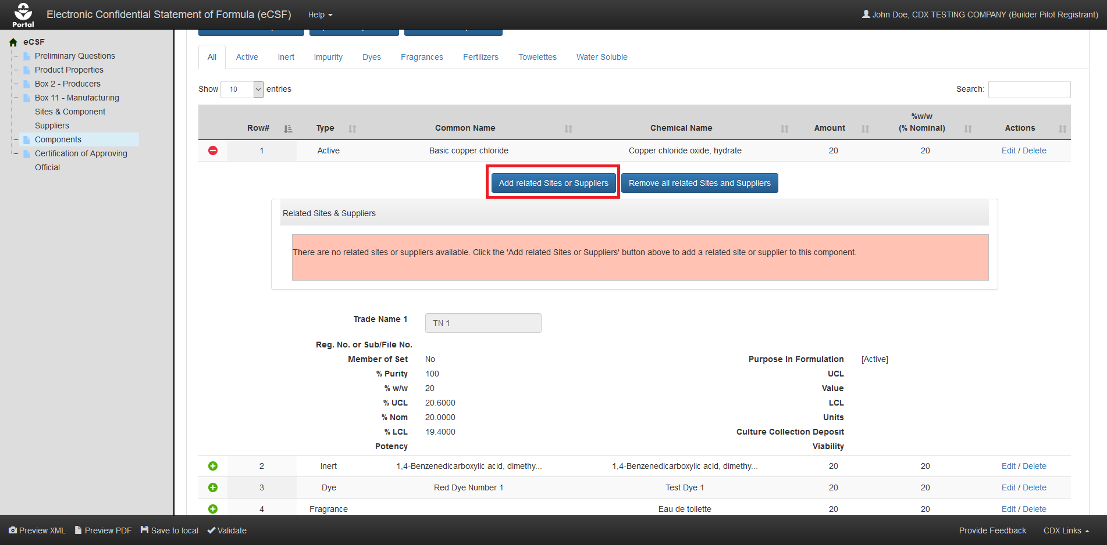
Exhibit 5-50: ‘Components’ Screen – View Existing Sites/Suppliers
Navigation: Select the ‘Add Related Sites/Suppliers’ button to launch the ‘Select Related Sites/Suppliers’ pop-up.
Exhibit 5-51 shows a screen capture of the ‘Select Related Sites/Suppliers’ pop-up:
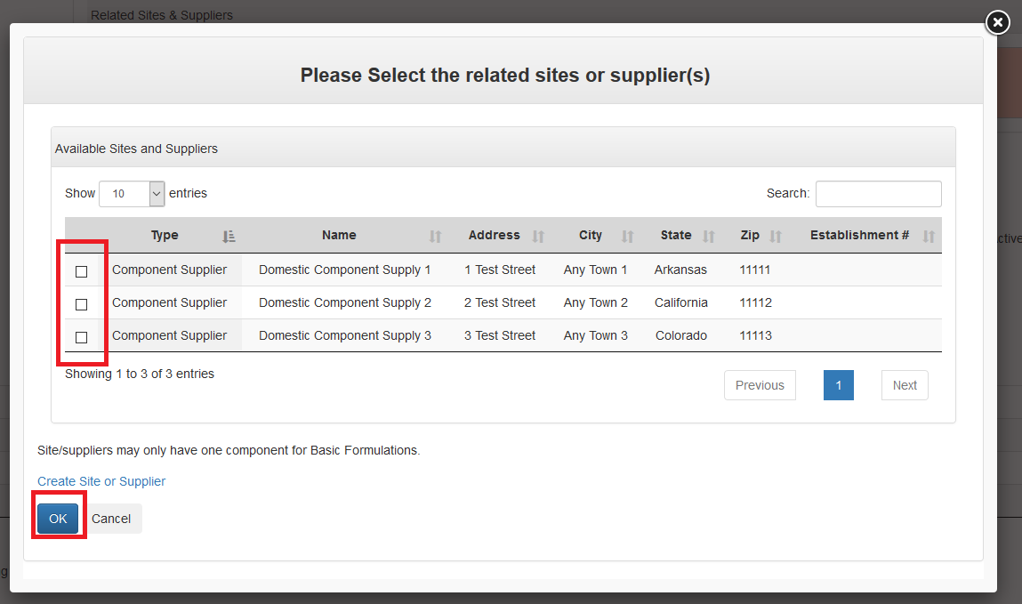
Exhibit 5-51: ‘Select Related Sites/Suppliers’ Pop-Up
Navigation: Select the checkbox(es) for the manufacturing site(s) and/or component supplier(s) that should be related to the listed component and then select the ‘OK’ button.
Exhibit 5-52 shows a screen capture of the ‘Components’ screen after manufacturing site or component supplier relationships have been successfully added:
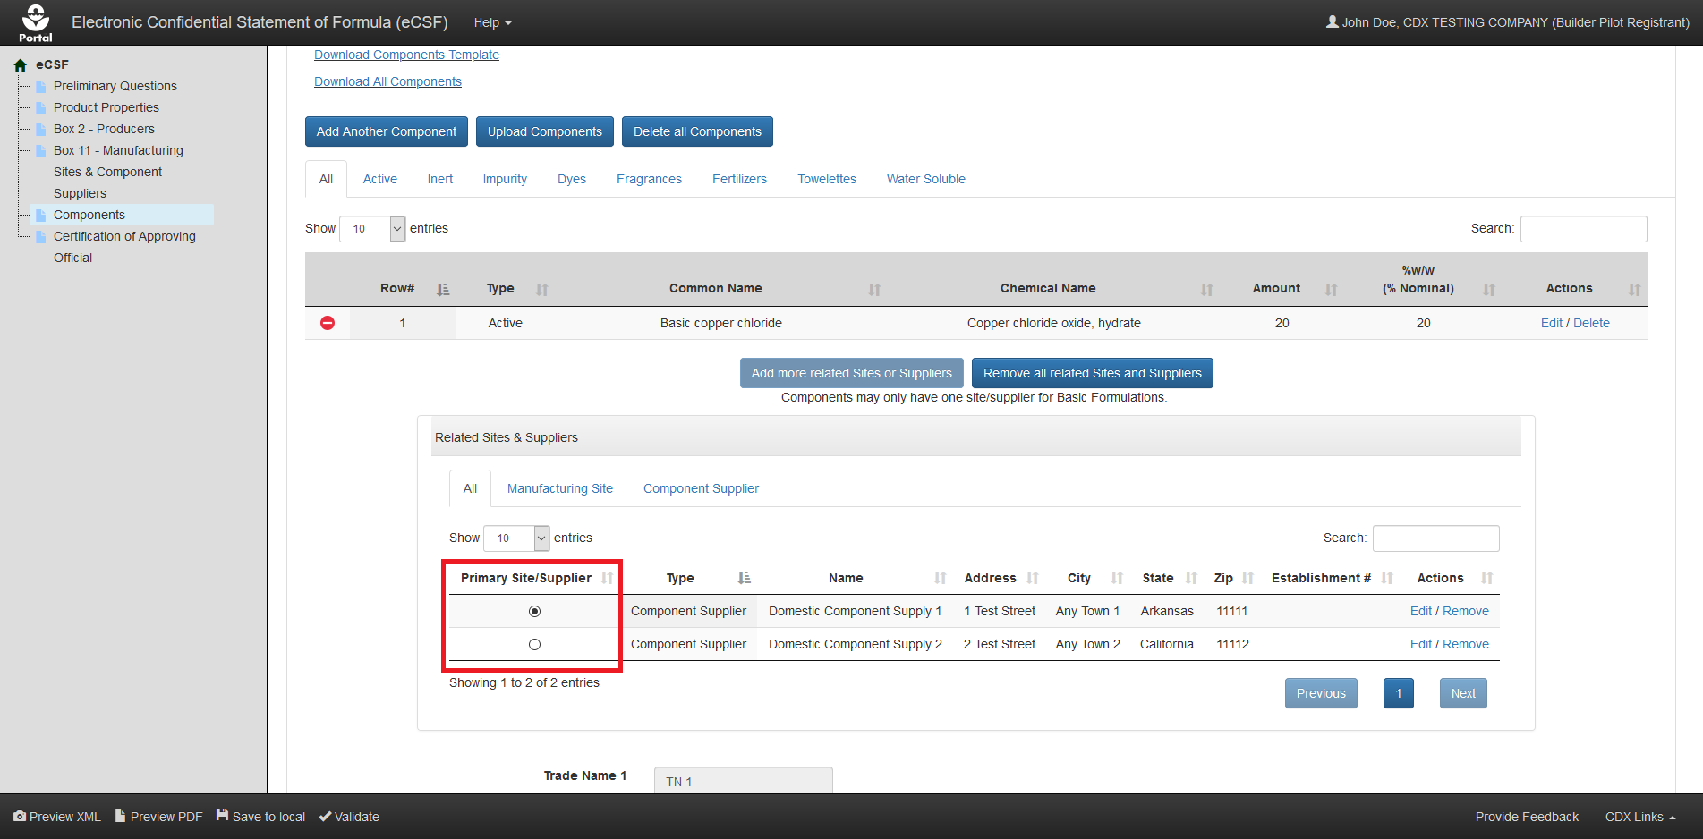
Exhibit 5-52: ‘Components’ Screen – Select Primary Site/Supplier
Navigation: Select the radio button in the ‘Primary Site/Supplier’ column for the entry that will display on the main section of ‘EPA Form 8570-4 – Confidential Statement of Formula’ (all other entries display on addendum pages).

Create Site/Supplier Relationship for a New Site/Supplier
Follow the below steps to create a relationship between a component and a manufacturing site or component supplier that does not yet exist in the eCSF XML file.
Exhibit 5-53 shows a screen capture of how to initiate the process to relate a component to a new manufacturing site or component supplier on the ‘Components’ screen:
Exhibit 5-53: ‘Components’ Screen – Relate Site/Supplier
Navigation: Select the green ‘plus’ icon from the ‘Relate Site/Supplier’ column for the entry that will be related.
Exhibit 5-54 shows a screen capture of how to view existing manufacturing sites and component suppliers on the ‘Components’ screen:
Exhibit 5-54: ‘Components’ Screen – View Existing Sites/Suppliers
Navigation: Select the ‘Add Related Sites/Suppliers’ button to launch the ‘Select Related Sites/Suppliers’ pop-up.
Exhibit 5-55 shows a screen capture of the ‘Select Related Sites/Suppliers’ pop-up:
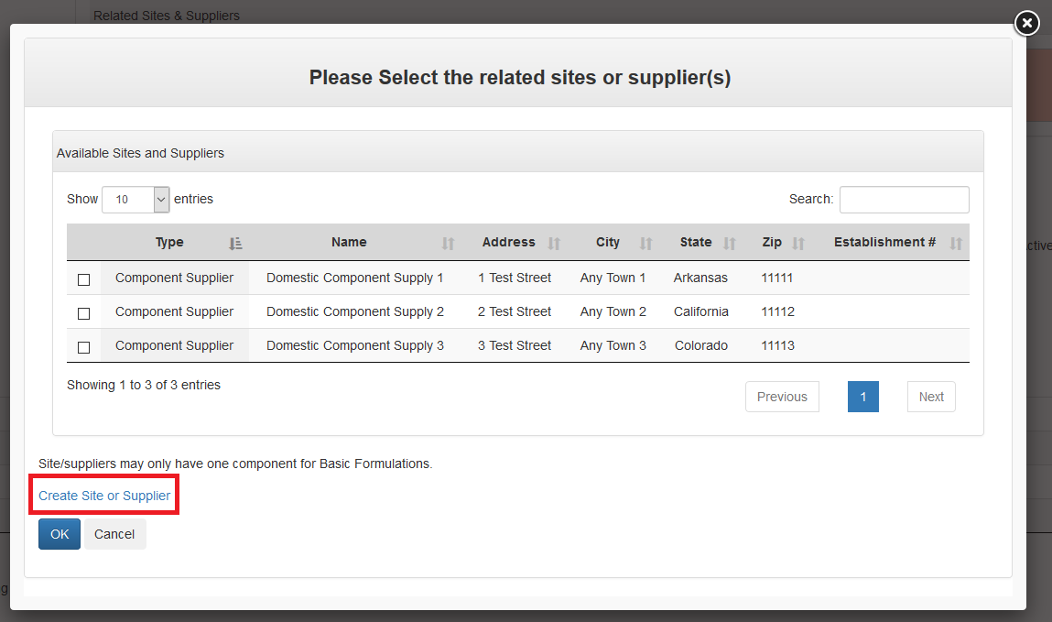
Exhibit 5-55: ‘Select Related Sites/Suppliers’ Pop-Up
Navigation: Select the ‘Create Site or Supplier’ link to access the ‘Add Site/Supplier’ pop-up.
Exhibit 5–56 shows a screen capture of the ‘Add Site or Supplier’ pop-up:
Exhibit 5–56: ‘Add Site or Supplier’ Pop-Up
Navigation: Enter data in all required fields and select the ‘Add Site or Supplier’ button. Refer to Section 5.5.1 for additional information on create sites and suppliers.
Exhibit 5-57 shows a screen capture of the ‘Components’ screen after component relationships have been successfully added:
Exhibit 5-57: ‘Components’ Screen – Select Primary Site/Supplier
Navigation: Select the radio button in the ‘Primary Site/Supplier’ column for the entry that will display on the main section of ‘EPA Form 8570-4 – Confidential Statement of Formula’ (all other entries display on addendum pages).

View Component to Site/Supplier Relationships in Rendered PDF
The eCSF application allows multiple component to manufacturing site or component supplier relationships in an alternate formulation. When there are multiple relationships, the entry identified as the primary on the ‘Components’ screen displays in ‘Box 11’ on the rendered PDF of ‘EPA Form 8570-4 – Confidential Statement of Formula.’ All other relationships and ‘Alternate Active’ components display on addendum pages. The primary designation has no significance other than to indicate which entry displays on the main form.
Exhibit 5-58 shows the PDF rendering of a component to primary site/supplier relationship:
Exhibit 5-58: Primary Site/Supplier Relationship PDF Rendering
Exhibit 5-59 shows the PDF rendering of a component to non–primary site/supplier relationship on an addendum page:
Exhibit 5-59: Non–Primary Site/Supplier Relationship PDF Rendering
Exhibit 5-60 shows the PDF rendering of an ‘Alternate Active’ component on an addendum page:
Exhibit 5-60: Non-Primary Site/Supplier Relationship PDF Rendering

Chemical Identity Searches
The eCSF application provides chemical identity searches for unregistered ‘Active’ components as well as ‘Inert’ components. Using the search functionality within the ‘Add Component’ pop-up ensures that chemical identities are correct and that chemical tags are properly applied (e.g., for commodity ‘Inert’ components).
When a user chooses to manually enter or alter a chemical identity search result, the application flags the component as having an overridden chemical name and a reason for the override becomes required.
Exhibit 5-61 shows a screen capture of the chemical identity search in the ‘Add Component’ pop-up:
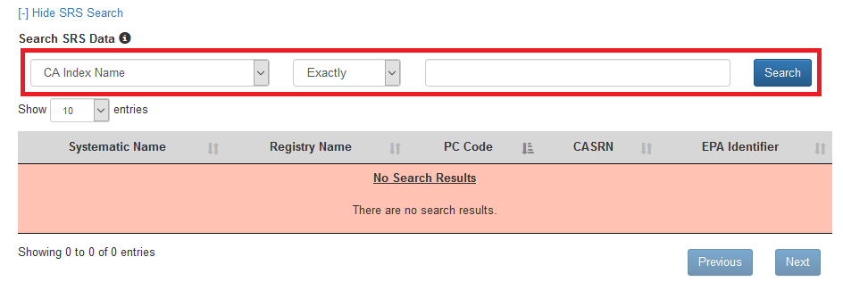
Exhibit 5-61: ‘Add Component’ Pop-Up – Chemical Identity Search
Navigation: Select a search criterion (e.g., ‘CASRN’) from the drop-down menu, select a search qualifier from the next drop-down menu (e.g., ‘Exactly’), enter a search term, and finally select the ‘Search’ button.
Exhibit 5-62 shows a screen capture of chemical identity search results in the ‘Add Component’ pop-up:
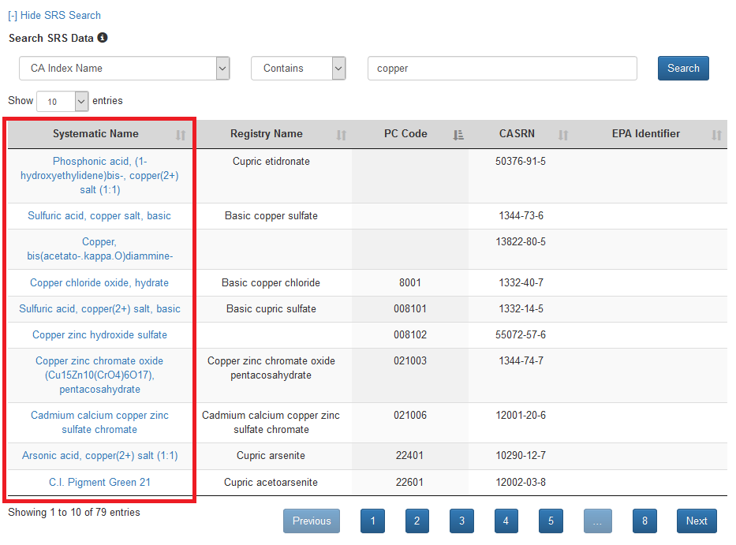
Exhibit 5-62: ‘Add Component’ Pop-Up – Chemical Identity Search Results
Navigation: Review the complete list of search results to identify the desired chemical. Update the display of the search results table by changing the number of displayed results and navigating through results pages as needed. After locating the desired chemical, select the link from the first column of the table to populate the selected chemical identity data into the ‘Add Component’ pop-up.

‘Certification of Approving Official’ Screen
The ‘Certification of Approving Official’ screen captures information for the Approving Official responsible for the contents of an eCSF file. EPA will contact the listed individual if any questions arise during the review of an eCSF file. A user can either populate contact information from their CDX account or manually complete the fields. The signature and certification block enables only after an entire eCSF file passes global validation. Refer to Section 4.7.3 for additional information about global validation.
The following fields display on the ‘Certification of Approving Official’ screen:
- Name – Box 16: Enter the name of the Approving Official certifying the submitted eCSF XML file. This ‘Approving Official’ represents the product’s applicant/registrant, but does not necessarily have to be the same individual submitting via PSP (e.g., a chemist could certify a form and an ‘Authorized Agent’ could submit via PSP). A user can populate this field from their CDX account by selecting the ‘Copy Information from CDX Profile’ link. This field is required.
- Position Title – Box 19: Enter the Approving Official’s title. This field is required.
- Address: Enter the first line of the Approving Official’s address. A user can populate this field from their CDX account by selecting the ‘Copy Information from CDX Profile’ link. This field is required.
- Address Cont.: Enter the second line of the Approving Official’s address. A user can populate this field from their CDX account by selecting the ‘Copy Information from CDX Profile’ link. This field is optional.
- City: Enter the city for the Approving Official’s address. A user can populate this field from their CDX account by selecting the ‘Copy Information from CDX Profile’ link. This field is required.
- State: Select the state for the Approving Official’s address. A user can populate this field from their CDX account by selecting the ‘Copy Information from CDX Profile’ link. This field is required.
- Country: Only a United States based Approving Official may certify an eCSF XML file and therefore this field is fixed as ‘United States.’
- Zip Code: Enter the ZIP Code for the Approving Official’s address. A user can populate this field from their CDX account by selecting the ‘Copy Information from CDX Profile’ link. This field is required.
- Phone Number: Enter the Approving Official’s phone number. A user can populate this field from their CDX account by selecting the ‘Copy Information from CDX Profile’ link. This field is required.
- Fax Number: Enter the Approving Official’s fax number. This field is optional.
- Email Address: Enter the Approving Official’s email address. A user can populate this field from their CDX account by selecting the ‘Copy Information from CDX Profile’ link. This field is required.
The following fields enable only after an eCSF passes global validation:
- I certify that all the information contained within this form is true and complete: Check this box to certify to the validity and accuracy of data contained in the eCSF XML file. This field is required.
- Signature – Box 18: Type the Approving Official’s signature. When included in a PSP package, this field is used in conjunction with PSP’s ‘CROMMER eSignature Widget’ to provide a valid electronic signature. This field is required.
- Date – Box 21: Provide the date on which the Authorized Official added their signature to an eCSF XML file. This field is required.
Exhibit 5-63 shows a screen capture of the ‘Certification of Approving Official’ screen:
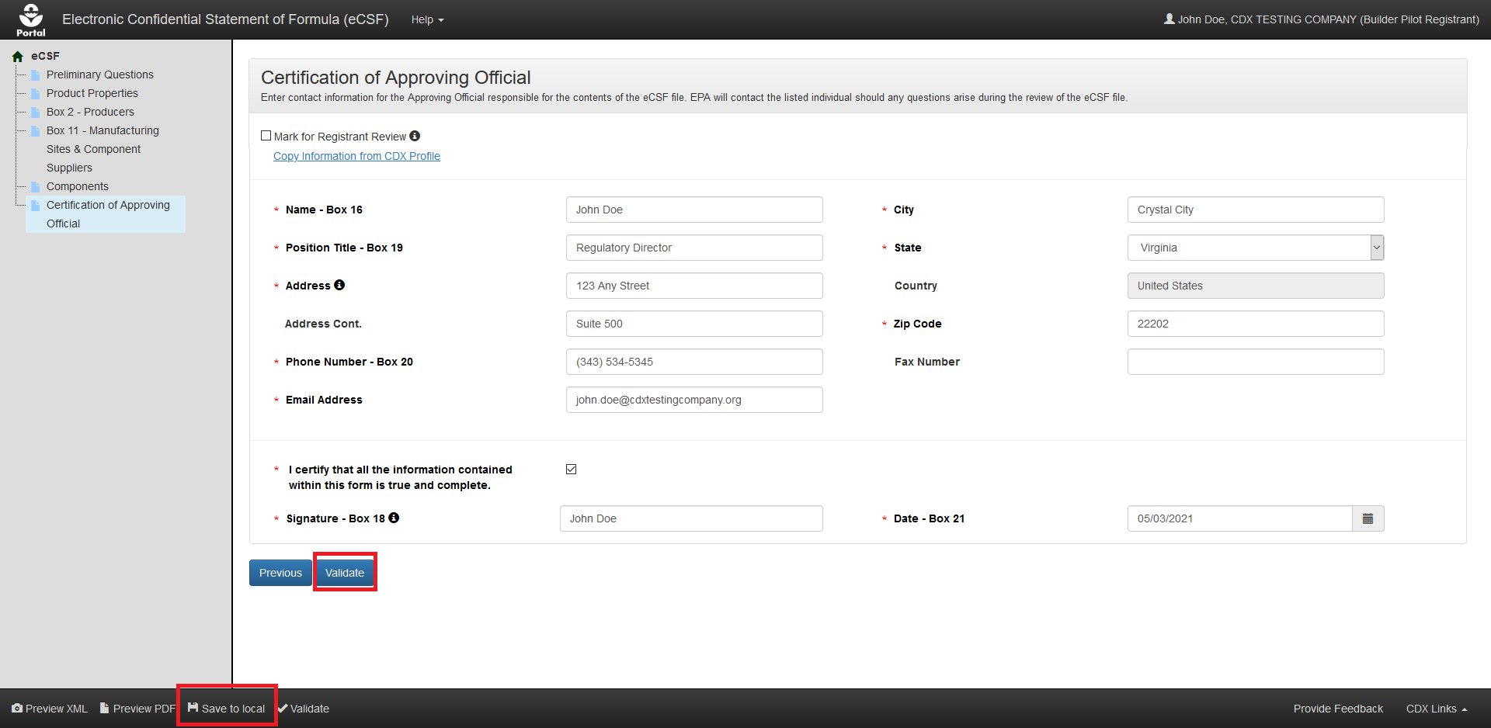
Exhibit 5-63: ‘Certification of Approving Official’ Screen
Navigation: Complete all required fields displayed on the screen, select the ‘Validate’ button to confirm that the entire eCSF XML file passes global validation, and finally select the ‘Save to local’ icon in the application footer to save the completed file to a local drive.

Including eCSF XML Files in a PSP Package Submission
The eCSF application allows a user to prepare electronic versions of ‘EPA Form 8570-4 – Confidential Statement of Formula’ for submission to EPA. Electronic submission provides efficiencies to both registrants and EPA reviewers due to faster file creation, review, and approval.
Note: The eCSF file type is available on the PSP ‘Documents for the Application’ screen for all application/regulatory types within a PSP registration package except for Distributor Products and Gold Seal Letter Requests.
Exhibit 6-1 shows a screen capture of how to upload an eCSF file on the ‘Documents for the Application’ screen:
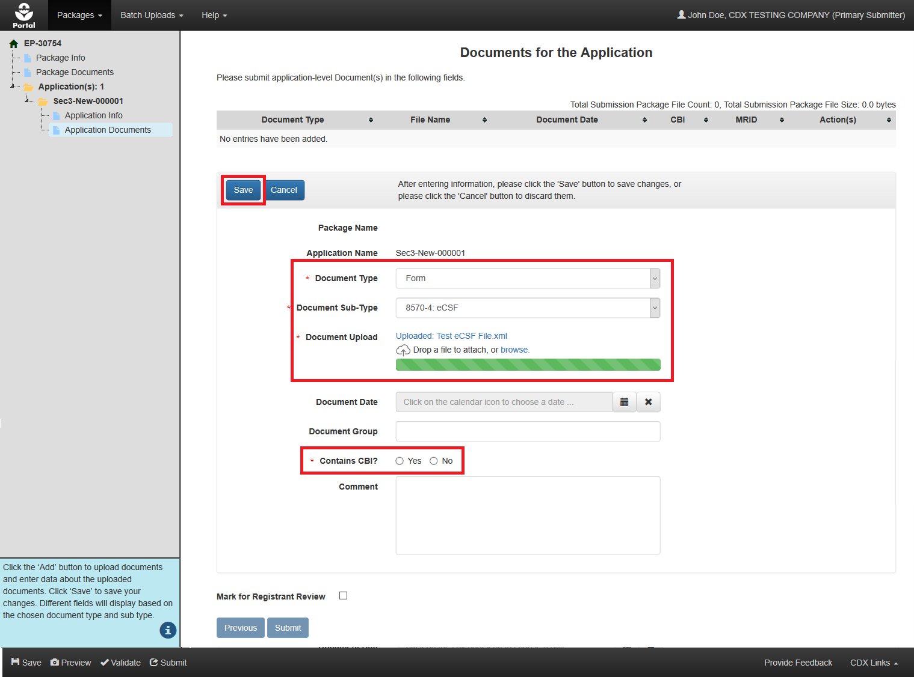
Exhibit 6-1: ‘Documents for the Application’ Screen – Upload eCSF File
Navigation: Select the ‘Add’ button (not pictured), select ‘Form’ from the ‘Document Type’ drop-down menu, select ‘8570-4: eCSF’ from the ‘Document Sub-Type’ drop-down menu, upload an eCSF XML file, indicate whether the eCSF file contains CBI, and finally select the ‘Save’ button to save the file to the application.
The application performs a validation check on the uploaded file when a user selects the ‘Save’ button. If the uploaded file is determined to not be in the correct eCSF format and/or contain validation errors, it will not save to the documents table and a corresponding error message will display.
Exhibit 6-2 shows a screen capture of a validation error message for an uploaded eCSF file:
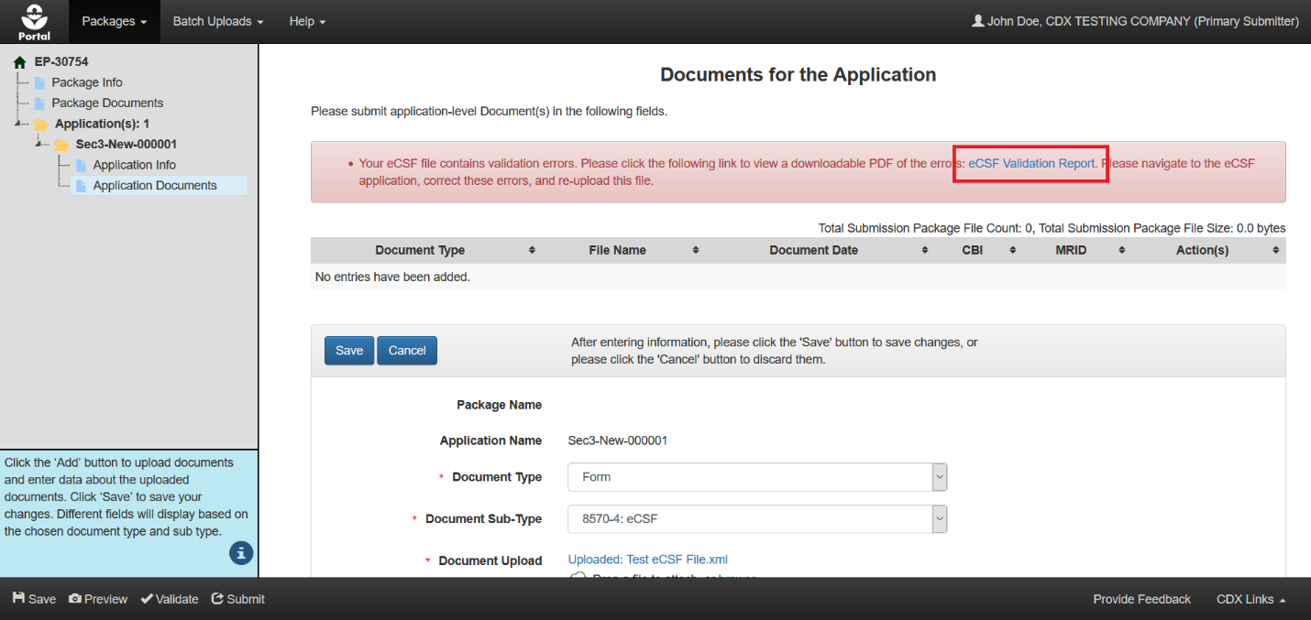
Exhibit 6-2: ‘Documents for the Application’ Screen – eCSF File Validation Error Report Link
Navigation: Select the ‘eCSF Validation Report’ link to access a report detailing the validation errors present within the uploaded eCSF file. A user cannot save an eCSF XML file to a package when it contains validation errors.
Exhibit 6-3 shows a screen capture of an eCSF Validation Report for an eCSF file:
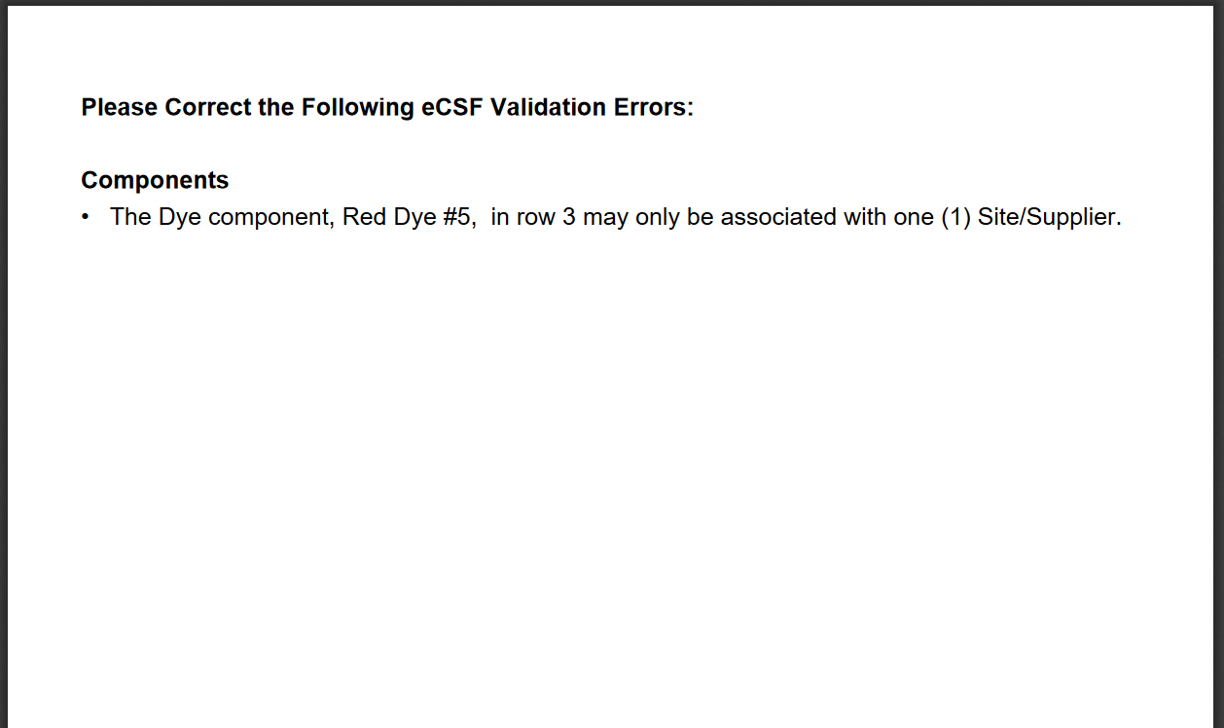
Exhibit 6-3: eCSF File Validation Report
Navigation: Correct all validation errors detailed in the report and then re-upload the file. Global validation in the eCSF application is the same as the validation applied in PSP; and it is therefore highly recommended that users upload a file that fails PSP validation into the eCSF application to correct errors. Refer to Section 4.7.3 for additional information about global validation.

Appendix A – Definitions, Acronyms, and Abbreviations
Acronym | Full Name
CASRN | Chemical Abstracts Registration Number
CBI | Confidential Business Information
CDX | Central Data Exchange
CDXHD | CDX Help Desk
CoR | Copy of Record
CRM | Chemical Review Manager
CROMERR | Cross–Media Electronic Reporting Regulation Security System
CSF | Confidential Statement of Formula
eCSF | Electronic Confidential Statement of Formula
EPA | United States Environmental Protection Agency
FIFRA | Federal Insecticide, Fungicide, and Rodenticide Act
IUPAC | International Union of Pure and Applied Chemistry
MRID | Master Record Identification Number
OPP | Office of Pesticide Programs
PDF | Portable Document Format
PRIA | Pesticide Registration Improvement Extension Act
PSP | Pesticide Submission Portal
SLN | Special Local Need
XML | Extensible Markup Language

Appendix B – Admin Number Information
Admin Number Information
The EPA Registration Number (Admin Number) is required on all pesticide products. The purpose of an Identification Number is to provide a unique product number for regular registrations, distributor registrations, Special Local Needs registrations, and Experimental Use Permits.
The EPA Registration Number indicates which company holds the registration for the pesticide product, and in which sequence the product was submitted to EPA by the company.
Refer to Exhibit 8-1 below for examples of Admin Numbers. Please note the following:
- CompanyNum = Company Number
- xxSEQxx = Sequence
- Seq = Sequence
- ParentRegNum means = Parent Regulatory Number
- EUP = Experimental Use Permit
- IN = Inert Ingredient Request
- PA = Pre-Application
Regulatory Action | Format | Examples
Product Registration – Section 3 | CompanyNum-xxSEQxx | - 55050-1  - 334-165  - 334-ANA (Temporary File Symbol before the product is registered, see Exhibit 13-2)
Distributor Product | ParentRegNum-CompanyNum | - 2155-40-12319  - 3862-140-13103
Experimental Use Permit - Section 5 | CompanyNum-EUP-xxSEQxx | - 44544-EUP-2  - 45054-EUP-1
Tolerance Petition | ParentRegNum-CompanyNum | - 3F1383  - 2G1214  - Possible 2nd characters: E,F,G,H,T - based on the Tolerance Petition type
Inert Ingredient Request | As given below 2nd character being E,F,G,H,T based on the tolerance petition type | - IN-10606  - IN-10559
Pre-Application | CompanyNumPASeq | - 2382PA1  - 54022PA16
Exhibit 8-1 Admin Number Examples
R | E | G | U | L | A | T | I | O | N
1 | 2 | 3 | 4 | 5 | 6 | 7 | 8 | 9 | 0
Exhibit 8-2 File Symbol

