Appraisal Ordering Acknowledgment
Verbiage will be added to the existing appraiser notification e-mail that will require the appraiser to select a link to Accept Assignment or Request Reassignment. Each link will take them to LGYHub where they will be required to enter information.
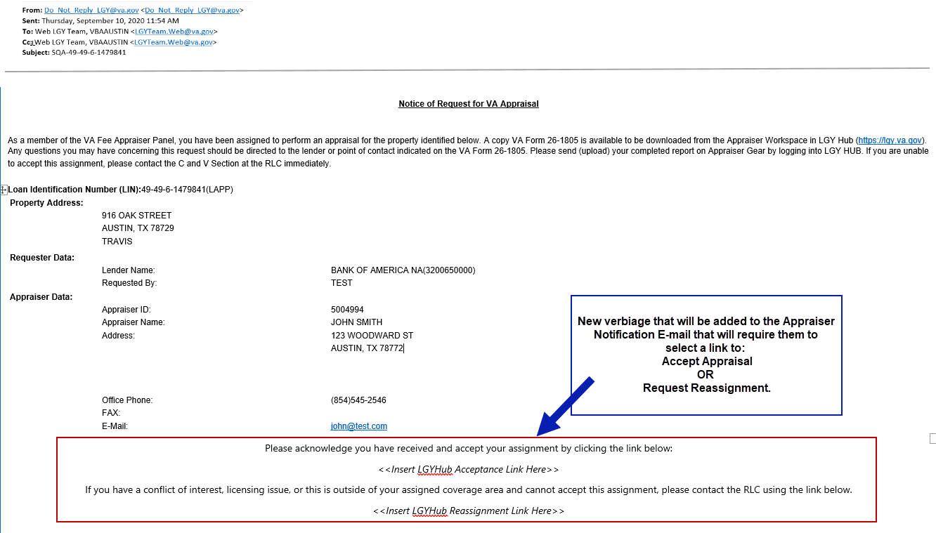
Appraiser acknowledges they have received their new assignment in LGY Hub.

Appraisal Reassignment
Appraiser requests a reassignment due to certain situations such as conflict of interest, national disaster, etc. Once the reassignment is approved, the assignment pending acceptance will be removed from the dashboard.
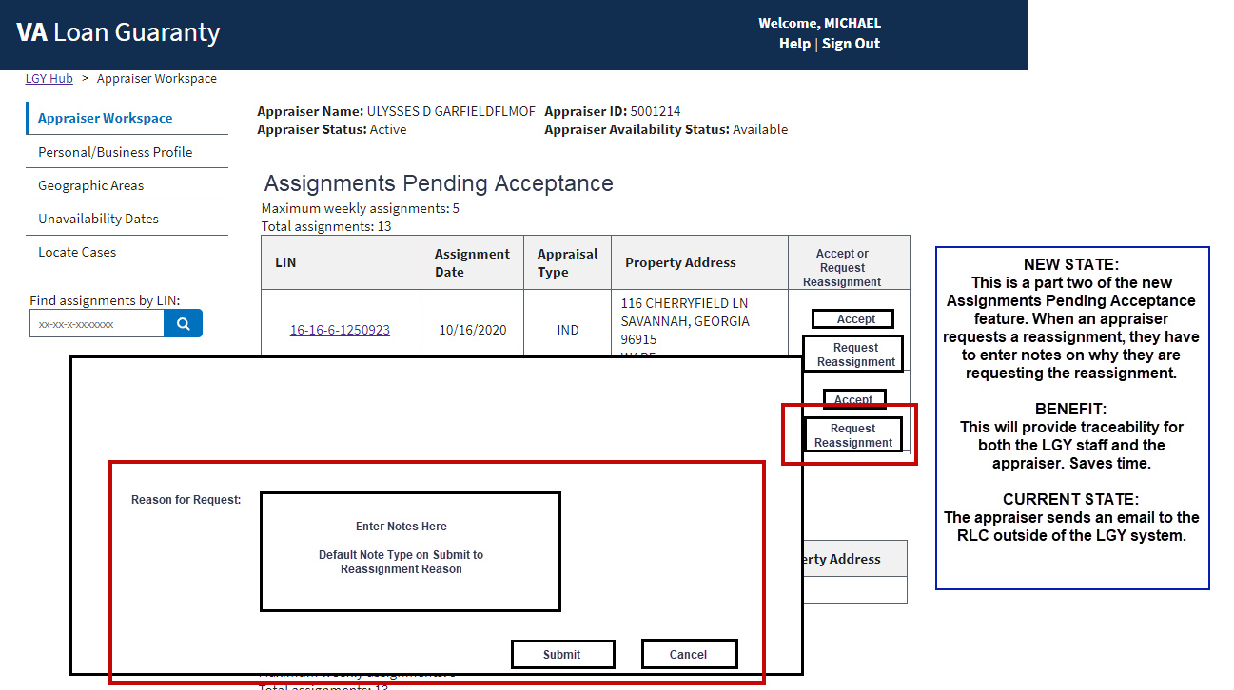
Appointment Scheduling
Appraiser informs LGY they have scheduled the appraisal via LGY.
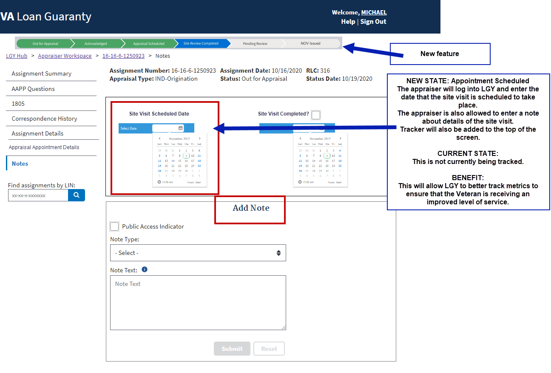

Appraiser informs LGY site visit is complete or not complete. Appraiser will be required to select a Note Type to explain reason for Review Not Complete.
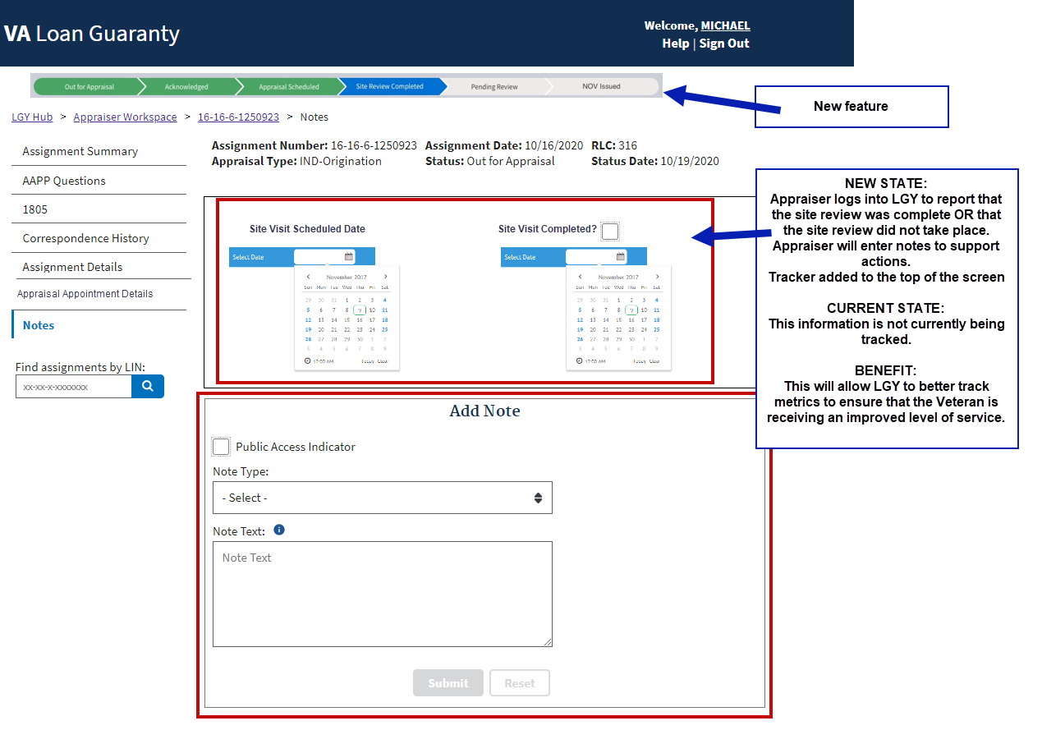
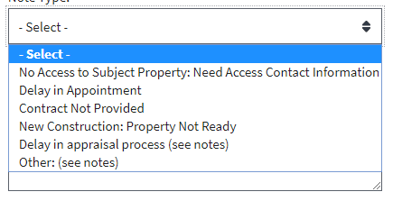

App

Appraisal Review Checklist
The lender and LGY will review the appraisal and complete a checklist in LGY to confirm the appraisal complies with VA’s minimum property requirements.
