ARMS 3 questionnaire changes for 2021

These differences are for corn rice and dairy questionnaires.
Section B: there is a specify crop box for “all other crops”
Section E and F are now combined into Section E
Section F is now Accounts Receivable
Section G is now Gov Payments
2c was rearranged. There are now only 4 sub-questions instead of 5
MPP was changed to DMC
Old
New
This question was removed from 2c and is now 2e.
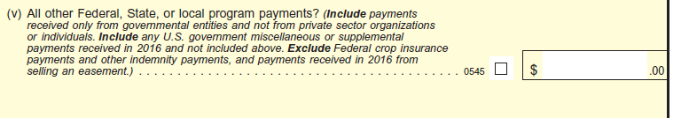

Added 2d and 2e is now a stand alone question.
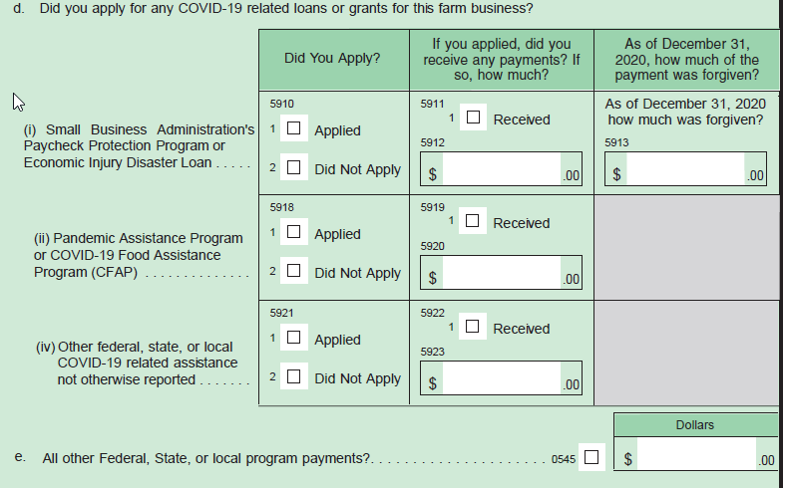
Also new to section G
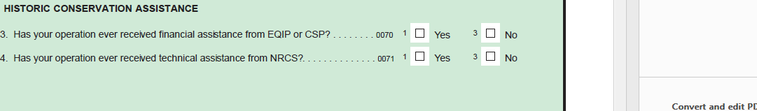
Operating and Capital Exp is now section H and no longer has columns for LL and contractor expenses
#17 is now it’s own question. It used to be a sub question of insurance. Please see difference

Old
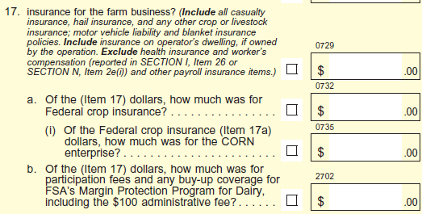
New
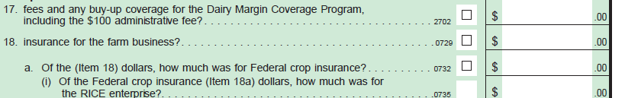
LL specific questions
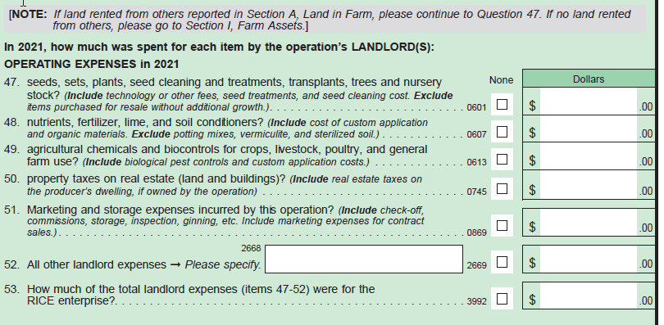
Farm Assets is now Section I

Debt is now Section J and the debt table is different.
Old debt table
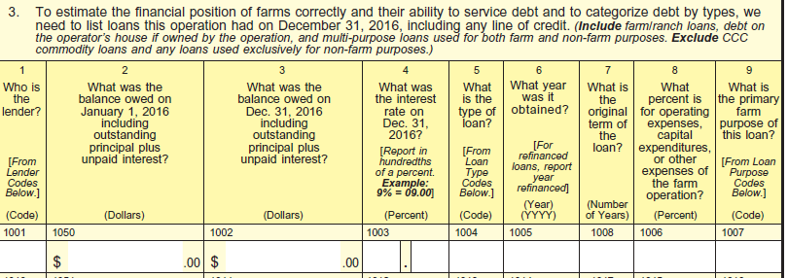
New debt table
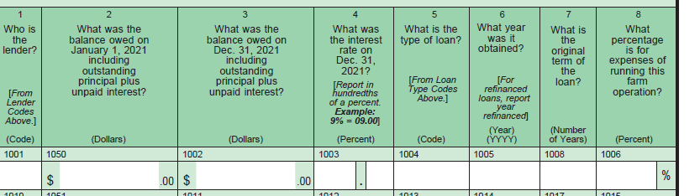

Old #5
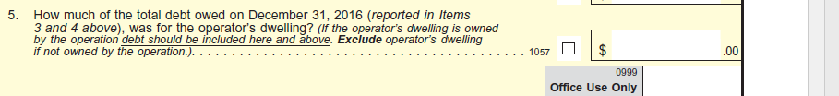
New #5
Old Section L has been divided. The first 6 questions in Section L are now their own section. In the new questionnaire they are in Section M Type of Organization.
Section L #7 has been removed and other questions in Section L are now part of Section K in the new questionnaire. Section K in the new questionnaire is called Personal Characteristics and Farm Management.
#9 in section L is now # 10 in Section K
Demographic questions asked in Section L are now asked in Section K for 4 people
Old
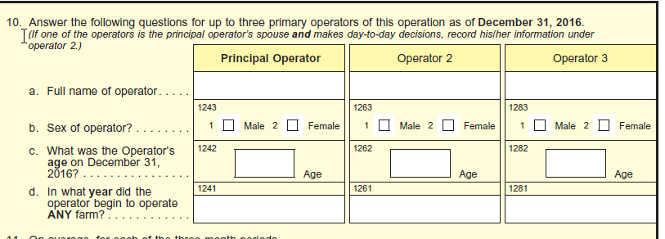
New
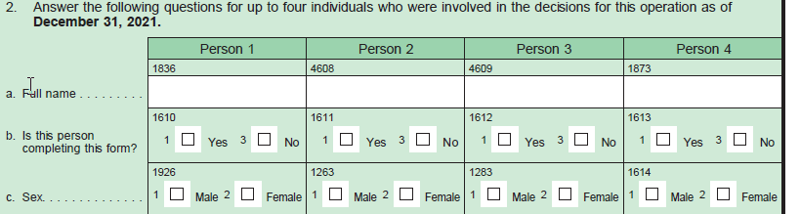
Section L 11 a-e is now in Section K
Section M questions are now in Section K and asked for 4 people.

Old
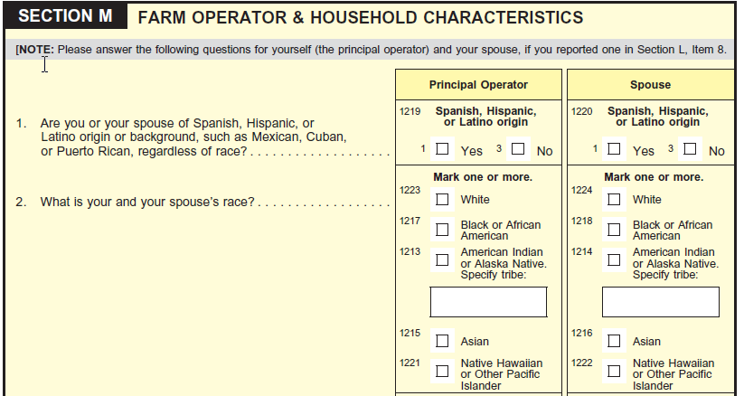
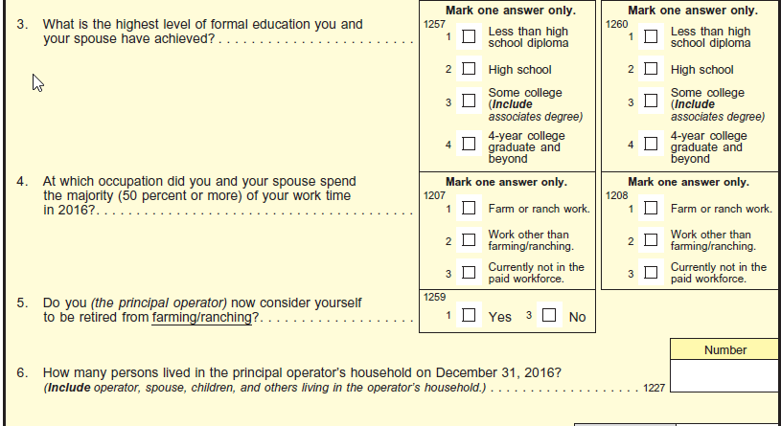

New
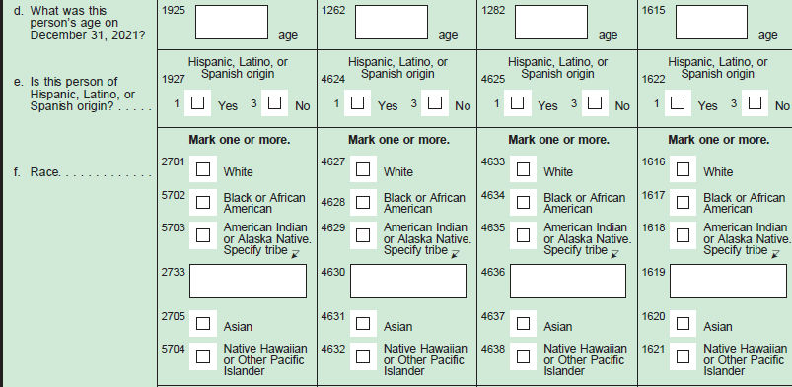
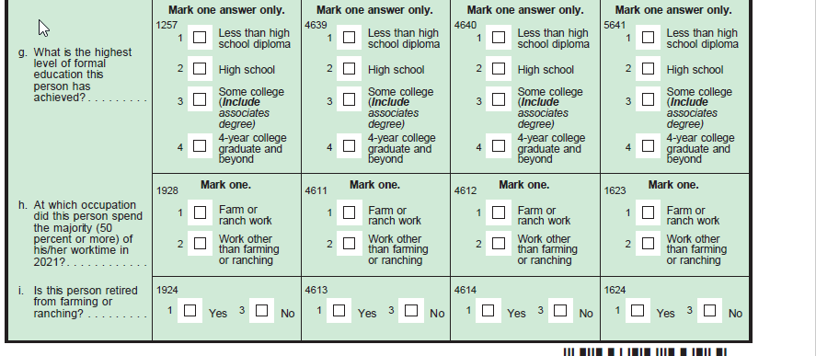
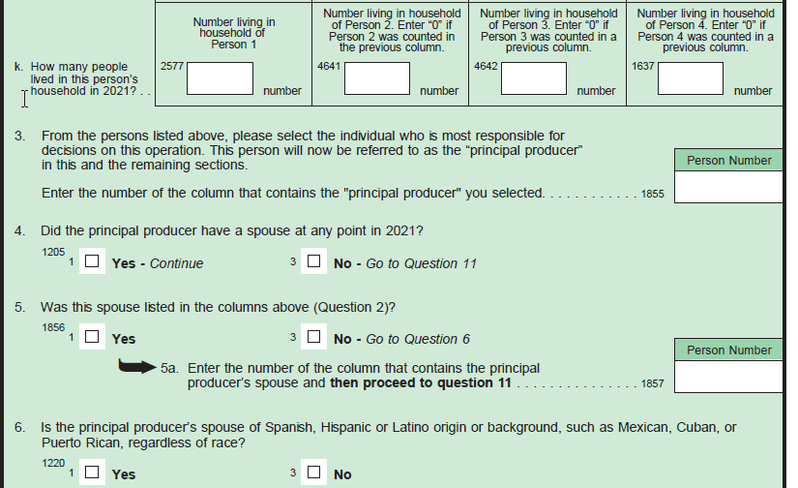
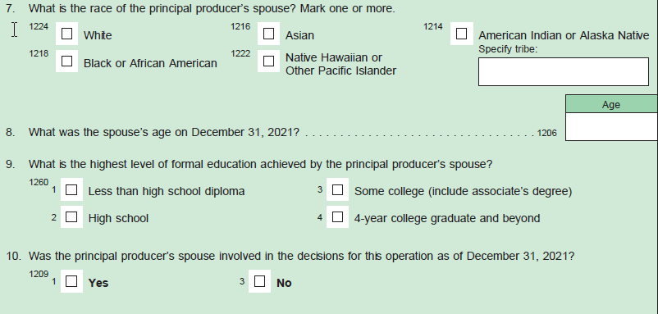

Also in new Section K
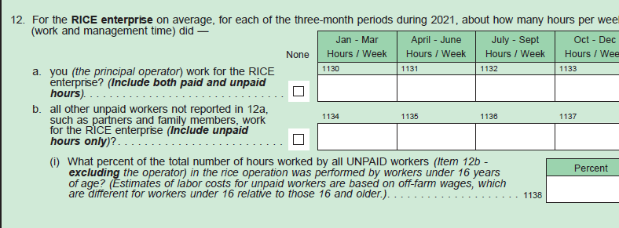
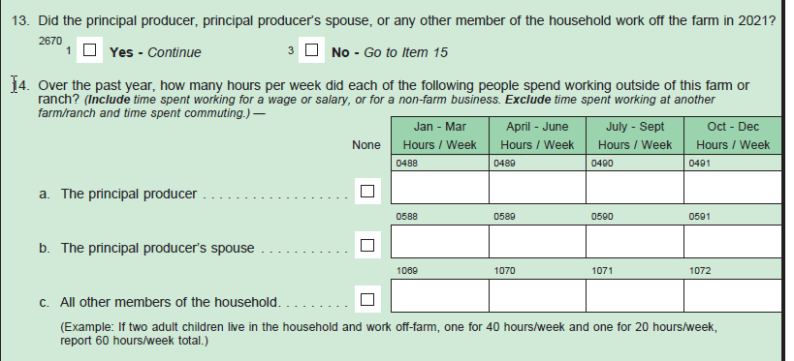
Section N is the same but it is Section L in the new questionnaire and there is a new question 1j

