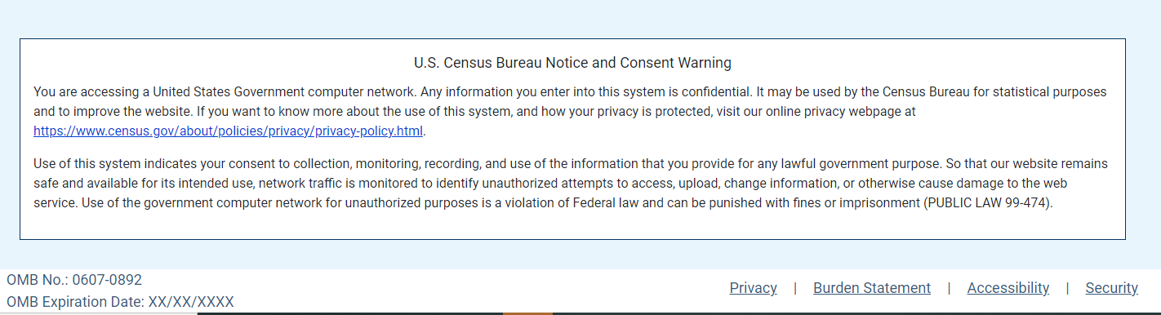
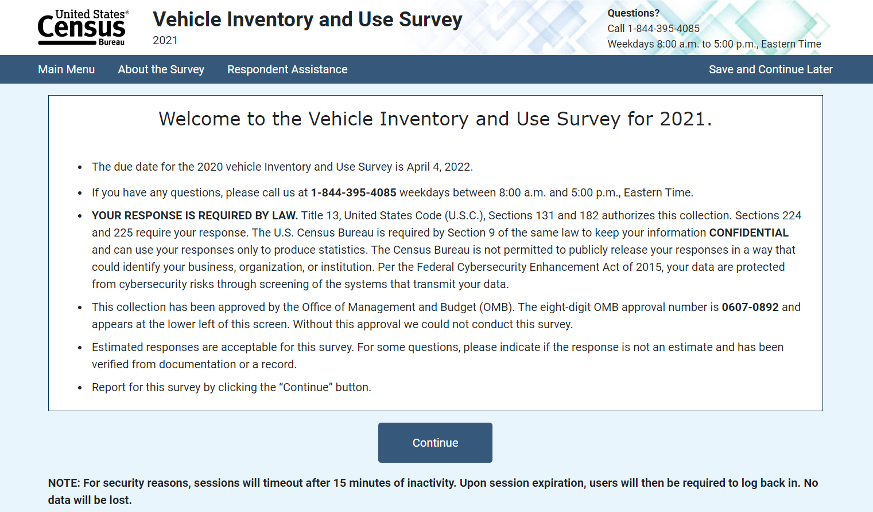

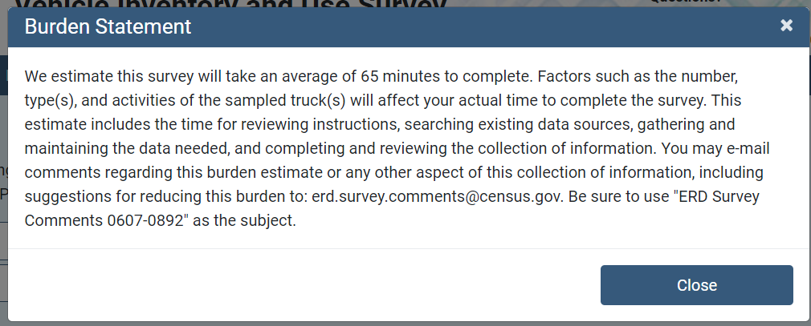

The Centurion instrument links to the About the Survey page. About the Vehicle Inventory and Use Survey (census.gov)
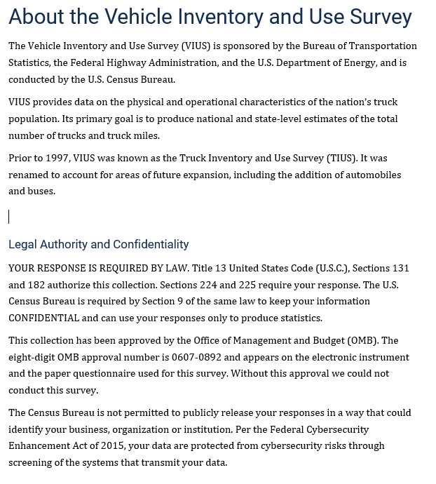

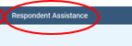

Information about OMB approval is shown on the Information for Respondents page linked from the Centurion instrument.
Information for Respondents (census.gov)

