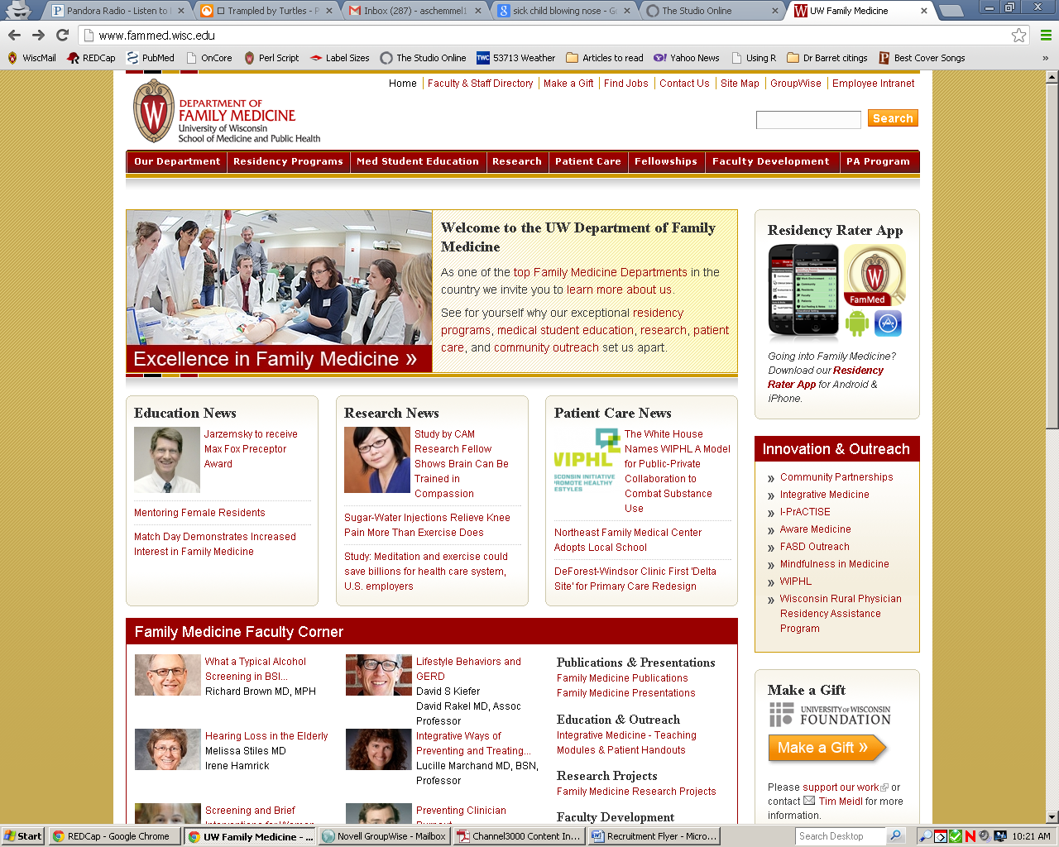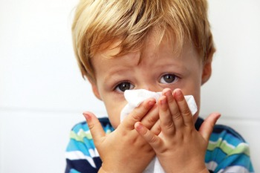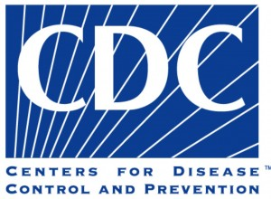

**CHILD SICK WITH COLD OR FLU THIS SCHOOL YEAR?**

Jonathan Temte, MD/PhD   
and Shari Barlow   
at the **UW Department of Family Medicine** are leading a cold study sponsored by the **Center for Disease Control (CDC)** focusing on children.

The study involves collecting nasal and throat samples from sick children (ages 4 – 19) in the Oregon School District during the 2013-2016 school years. These samples will be used to identify viruses circulating in the Oregon/Brooklyn community and provide an early warning for influenza and other diseases.

**Over the school year, if you think your child is coming down with a cold or flu, call us at 608-265-3164. We will come to your house for a quick visit to collect a simple nasal and throat sample and ask a few questions!**

**VISIT www.orchardstudy.org FOR INFORMATION!**