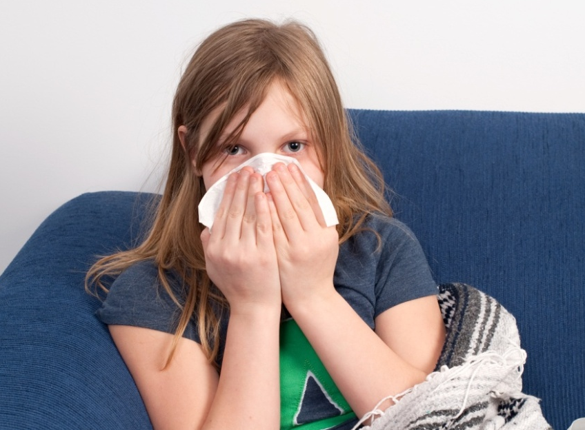
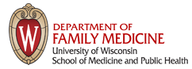
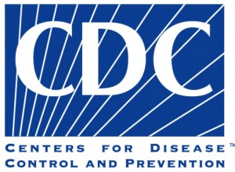
Children receive a $20 iTunes, Barnes and Noble or Firefly gift card for participating!
CHILD SICK WITH COLD OR FLU THIS SCHOOL YEAR?
Jonathan Temte, MD/PhD
and Shari Barlow
at the UW Department of Family Medicine are leading a cold study sponsored by the Center for Disease Control (CDC) focusing on children.
The study involves collecting nasal and throat samples from sick children (ages 4 – 19) in the Oregon School District during the 2013-2016 school years. These samples will be used to identify viruses circulating in the Oregon/Brooklyn community and provide an early warning for influenza and other diseases.
Over the school year, if you think your child is coming down with a cold or flu, call us at 608-265-3164. We will come to your house for a quick visit to collect a simple nasal and throat sample and ask a few questions!
VISIT www.orchardstudy.org FOR INFORMATION!

