Attachment 4

ALS Case Validation Questions (screenshots)

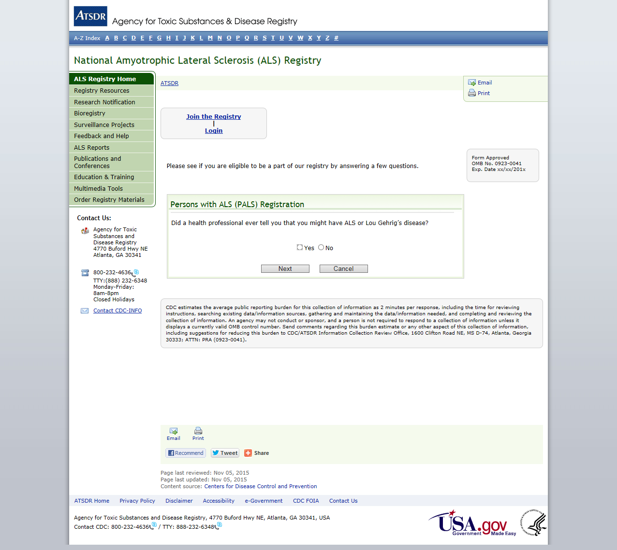

PALS Validation Question 1

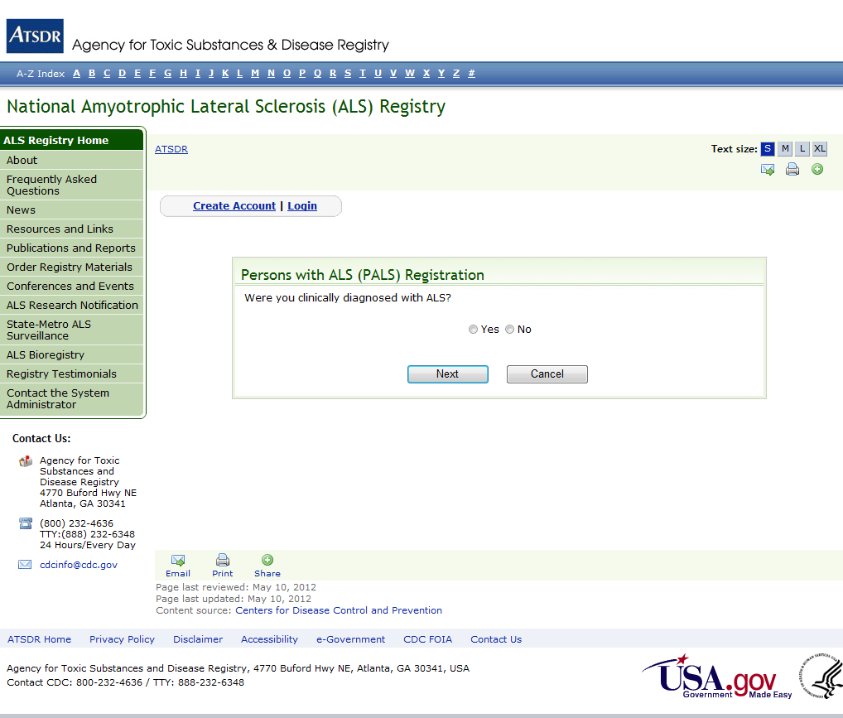

PALS Validation Question 2

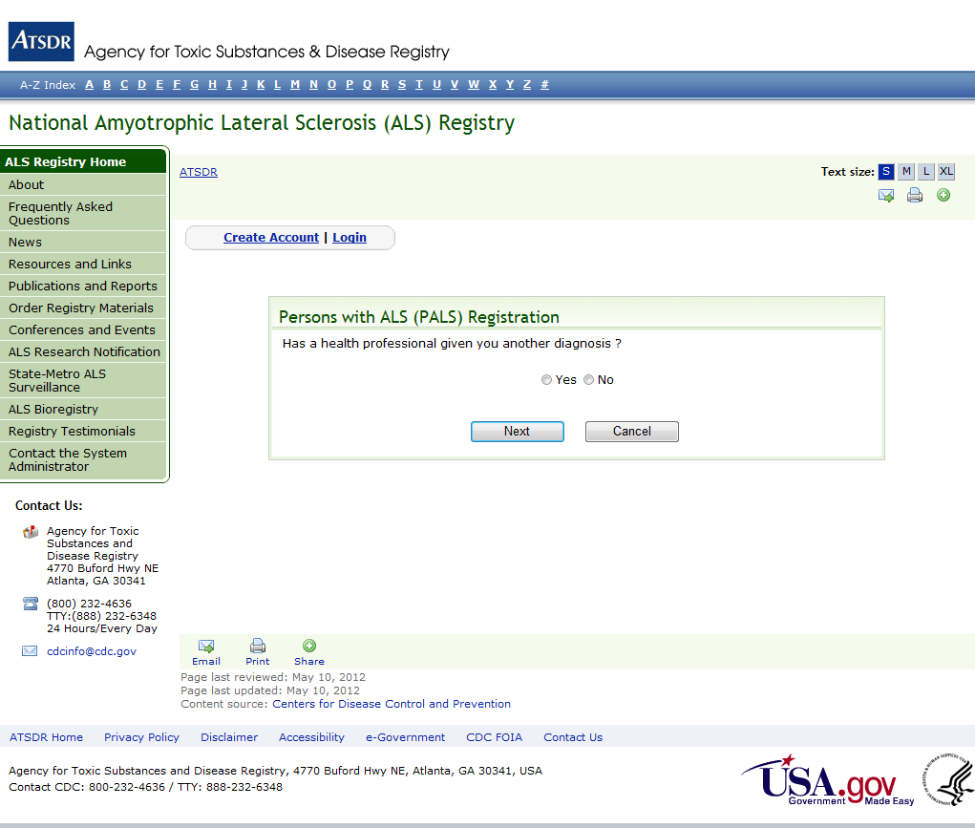

PALS Validation Question 3

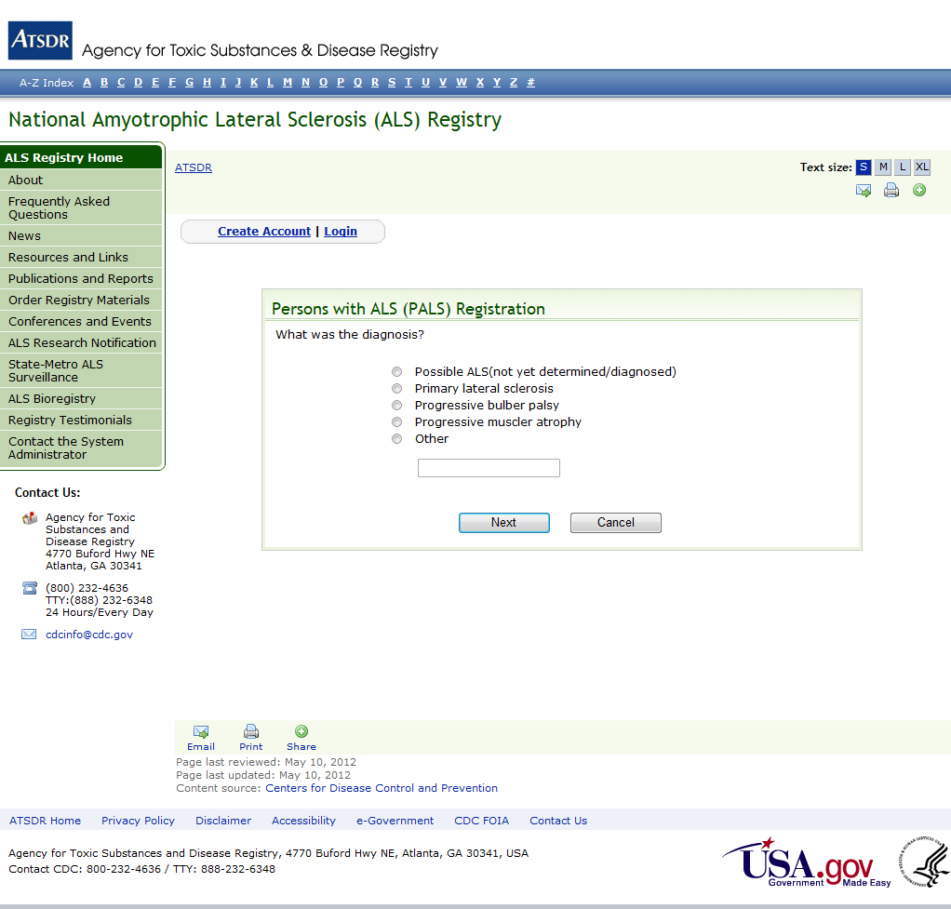

PALS Validation Question 4

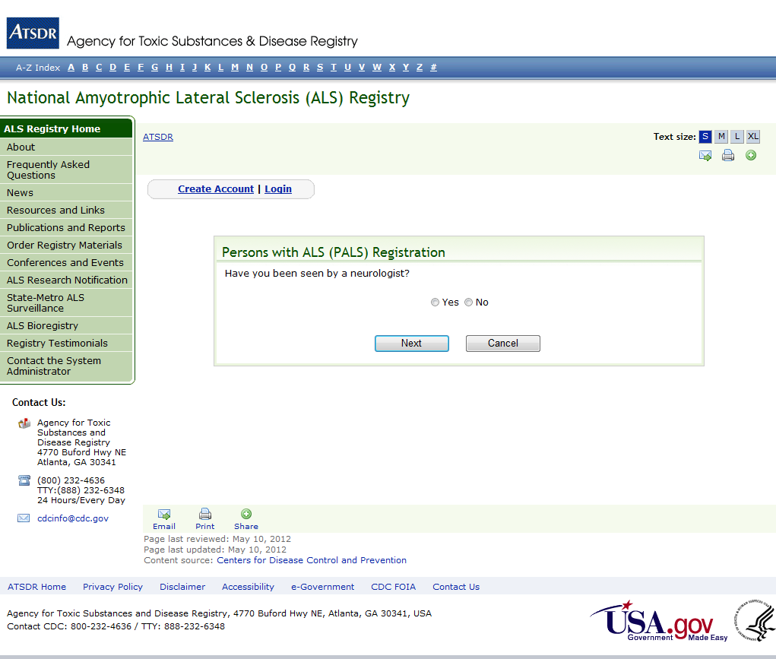

PALS Validation Question 5

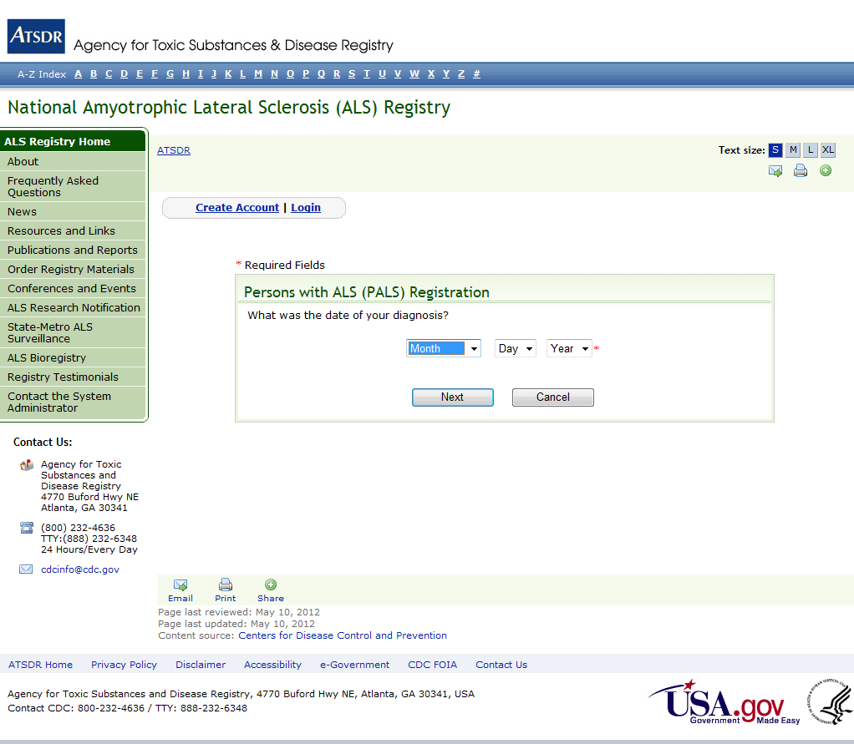

PALS Validation Question 6