Attachment 6
Approved Surveys (screenshots)
(16 Voluntary Survey Modules and Disease Progression Survey)
Figure 1: PALS Login Landing Page to Access Surveys 4
Figure 2: Select Survey to Take 5
Figure 3: General Instructions 6
Figure 4: Survey 1, Page 1 of 4 7
Figure 5: Survey 1, Page 2 of 4 8
Figure 6: Survey 1, Page 3 of 4 9
Figure 7: Survey 1, Page 4 of 4 10
Figure 8: Survey Taken Confirmation Page (Same for ALL Surveys) 11
Figure 9: Survey 2, Page 1 of 3 12
Figure 10: Survey 2, Page 2 of 3 13
Figure 11: Survey 2, Page 3 of 3 14
Figure 12: Survey 3, Page 1 of 2 15
Figure 13: Survey 3, Page 2 of 2 16
Figure 14: Survey 4, Page 1 of 3 17
Figure 15: Survey 4, Page 2 of 3 18
Figure 16: Survey 4, Page 3 of 3 19
Figure 17: Survey 5, Page 1 of 2 20
Figure 18: Survey 5, Page 2 of 2 21
Figure 19: Survey 6, Page 1 of 9 22
Figure 20: Survey 6, Page 2 of 9 23
Figure 21: Survey 6, Page 3 of 9 24
Figure 22: Survey 6, Page 4 of 9 25
Figure 23: Survey 6, Page 5 of 9 26
Figure 24: Survey 6, Page 6 of 9 27
Figure 25: Survey 6, Page 7 of 9 28
Figure 26: Survey 6, Page 8 of 9 29
Figure 27: Survey 6, Page 9 of 9 29
Figure 28: Disease Progression Survey, Page 1 of 8 30
Figure 29: Disease Progression Survey, Page 2 of 8 31
Figure 30: Disease Progression Survey, Page 3 of 8 32
Figure 31: Disease Progression Survey, Page 4 of 8 33
Figure 32: Disease Progression Survey, Page 5 of 8 34
Figure 33: Disease Progression Survey, Page 6 of 8 35
Figure 34: Disease Progression Survey, Page 7 of 8 36
Figure 35: Disease Progression Survey, Page 8 of 8 37
Figure 36: Survey 8, Page 1 of 2 38
Figure 37: Survey 8, Page 2 of 2 39
Figure 38: Survey 9, Page 1 of 11 40
Figure 39: Survey 9, Page 2 of 11 41
Figure 40: Survey 9, Page 3 of 11 42
Figure 41: Survey 9, Page 4 of 11 43
Figure 42: Survey 9, Page 5 of 11 44
Figure 43: Survey 9, Page 6 of 11 45
Figure 44: Survey 9, Page 7 of 11 46
Figure 45: Survey 9, Page 8 of 11 47
Figure 46: Survey 9, Page 9 of 11 48
Figure 47: Survey 9, Page 10 of 11 49
Figure 48: Survey 9, Page 11 of 11 50
Figure 49: Survey 10, Page 1 of 3 51
Figure 50: Survey 10, Page 2 of 3 52
Figure 51: Survey 10, Page 3 of 3 53
Figure 52: Survey 11, Page 1 of 9 54
Figure 53: Survey 11, Page 2 of 9 55
Figure 54: Survey 11, Page 3 of 9 56
Figure 55: Survey 11, Page 4 of 9 57
Figure 56: Survey 11, Page 5 of 9 58
Figure 57: Survey 11, Page 6 of 9 59
Figure 58: Survey 11, Page 7 of 9 60
Figure 59: Survey 11, Page 8 of 9 61
Figure 60: Survey 11, Page 9 of 9 62
Figure 61: Survey 12, Page 1 of 3 63
Figure 62: Survey 12, Page 2 of 3 64
Figure 63: Survey 12, Page 3 of 3 65
Figure 64: Survey 13, Page 1 of 4 66
Figure 65: Survey 13, Page 2 of 4 67
Figure 66: Survey 13, Page 3 of 4 68
Figure 67: Survey 13, Page 4 of 4 69
Figure 68: Survey 14, Page 1 of 7 70
Figure 69: Survey 14, Page 2 of 7 71
Figure 70: Survey 14, Page 3 of 7 72
Figure 71: Survey 14, Page 4 of 7 73
Figure 72: Survey 14, Page 5 of 7 74
Figure 73: Survey 14, Page 6 of 7 75
Figure 74: Survey 14, Page 7 of 7 76
Figure 75: Survey 15, Page 1 of 2 77
Figure 76: Survey 15, Page 2 of 2 78
Figure 77: Survey 16, Page 1 of 2 79
Figure 78: Survey 16, Page 2 of 2 80
Figure 79: Survey 17, Page 1 of 7 81
Figure 80: Survey 17, Page 2 of 7 82
Figure 81: Survey 17, Page 3 of 7 83
Figure 82: Survey 17, Page 4 of 7 84
Figure 83: Survey 17, Page 5 of 7 85
Figure 84: Survey 17, Page 6 of 7 86
Figure 85: Survey 17, Page 7 of 7 87

Please Note: OMB Burden Statement appears on the individual’s Survey Accounts page. Because participants can take surveys in any order, the OMB Burden Statement was placed on the one page that everyone has to view.

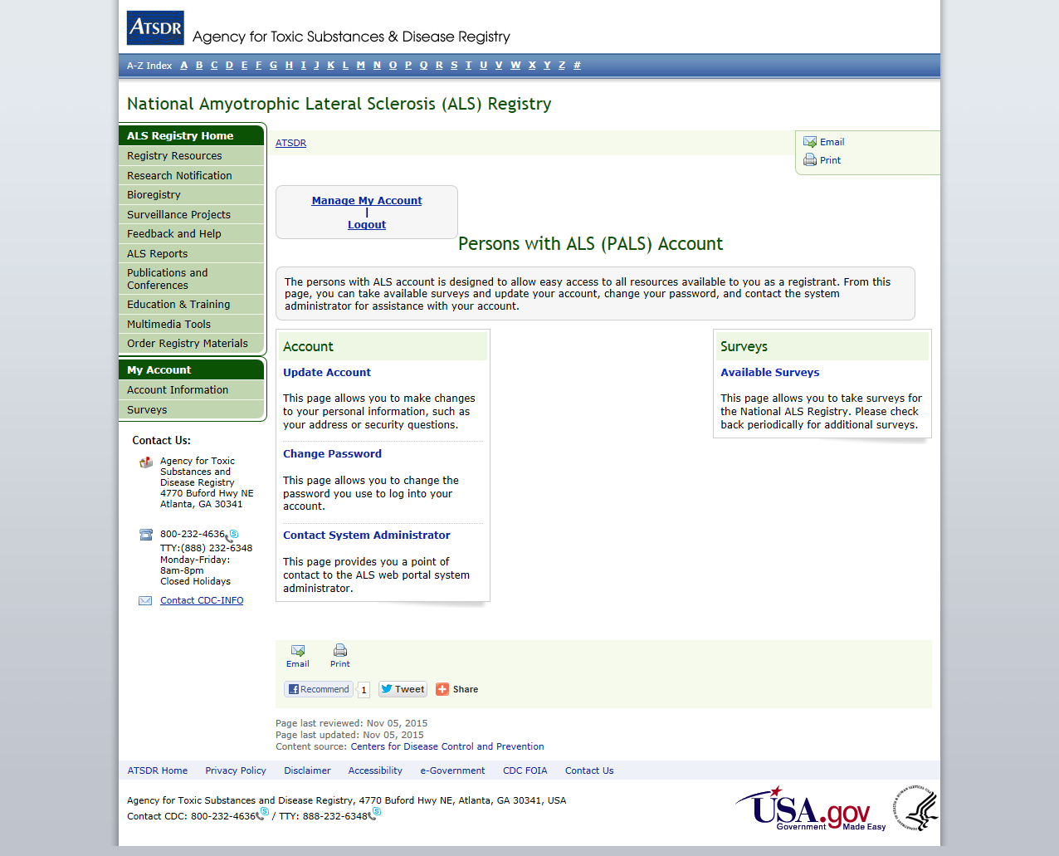
Figure 1: PALS Login Landing Page to Access Surveys

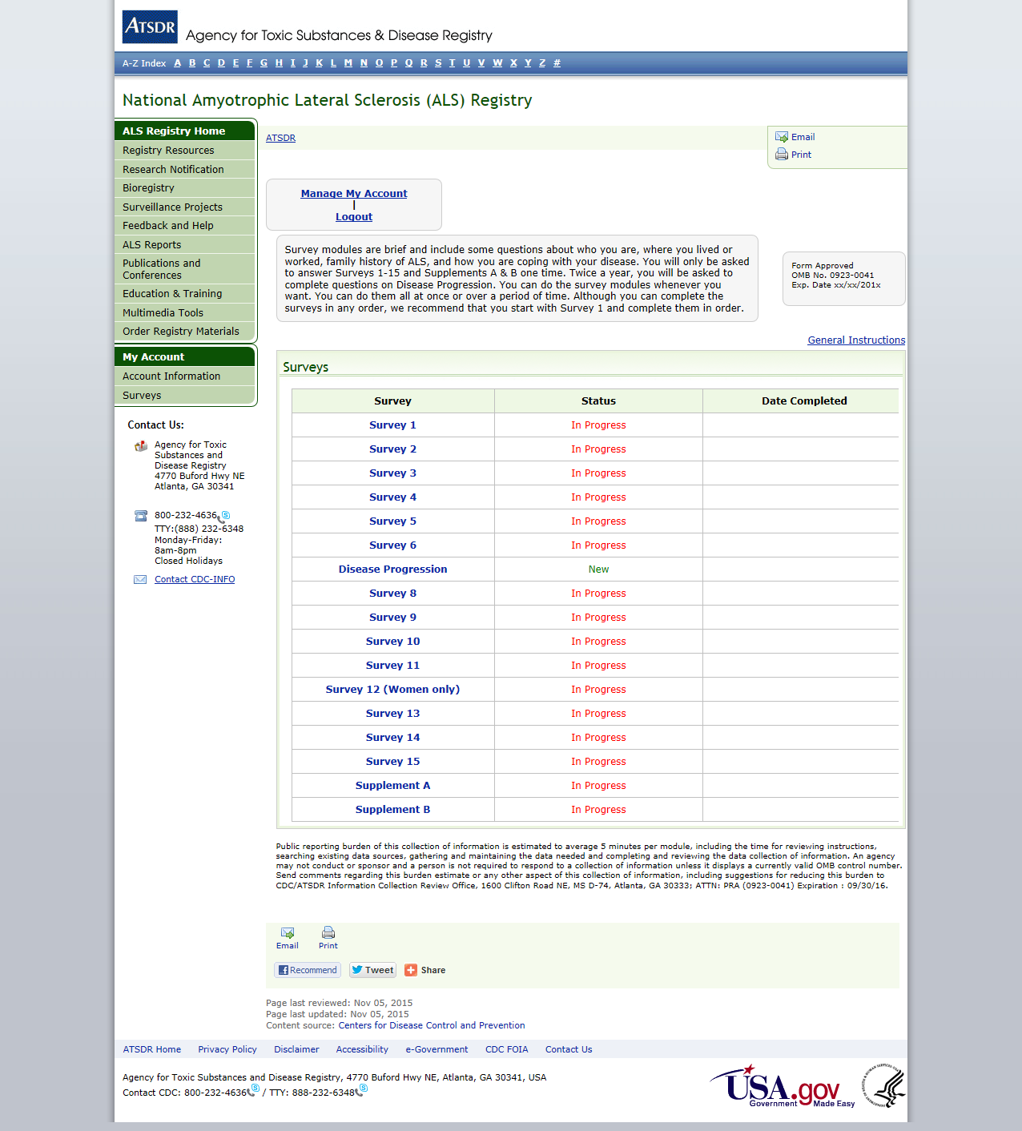

Figure 2: Select Survey to Take
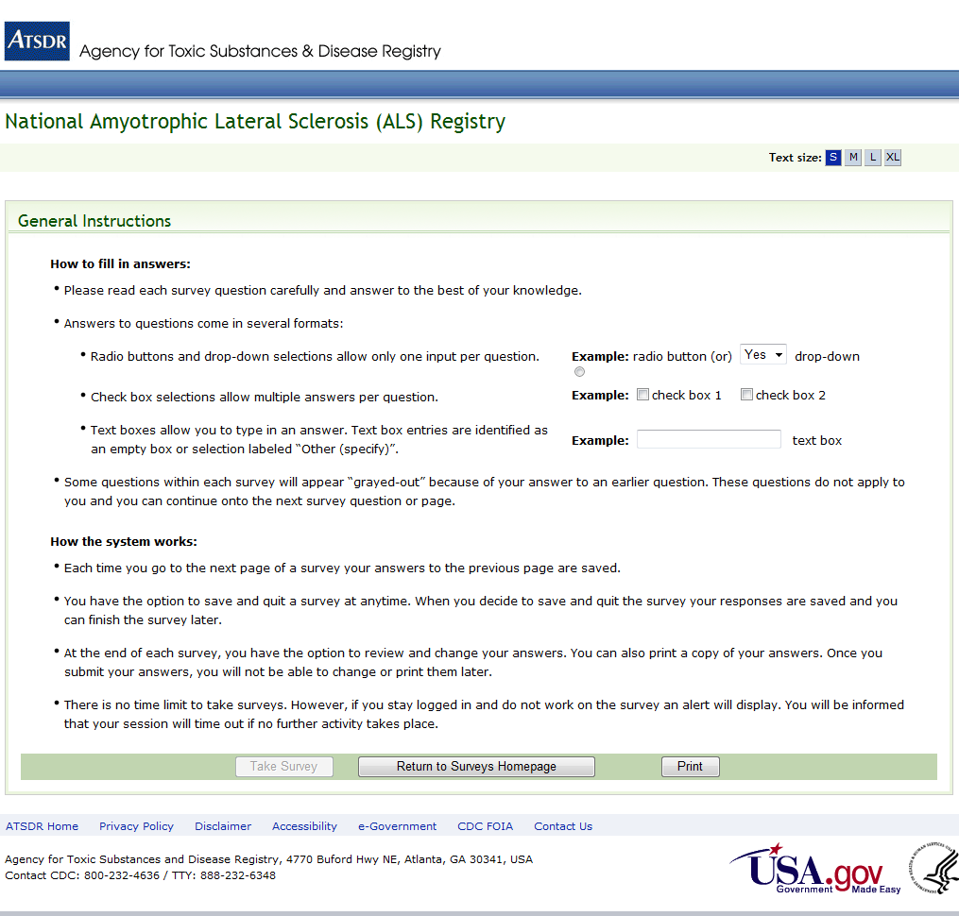
Figure 3: General Instructions
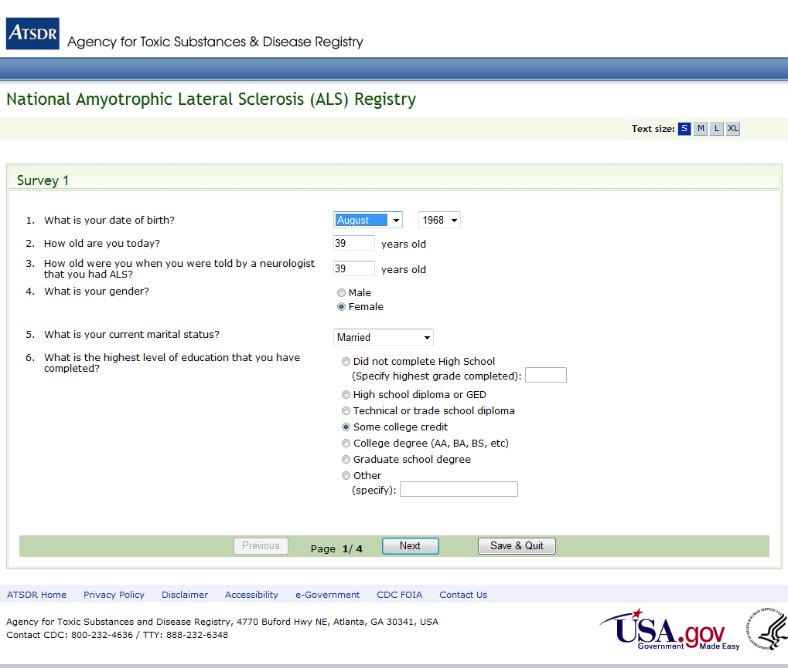
Figure 4: Survey 1, Page 1 of 4
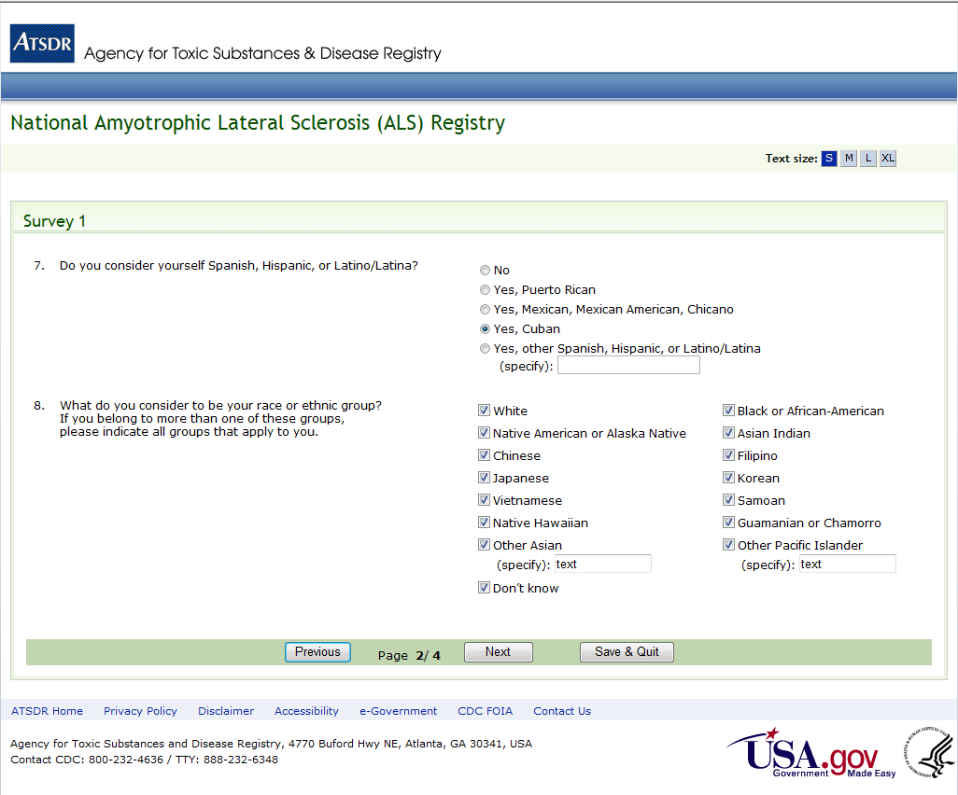
Figure 5: Survey 1, Page 2 of 4
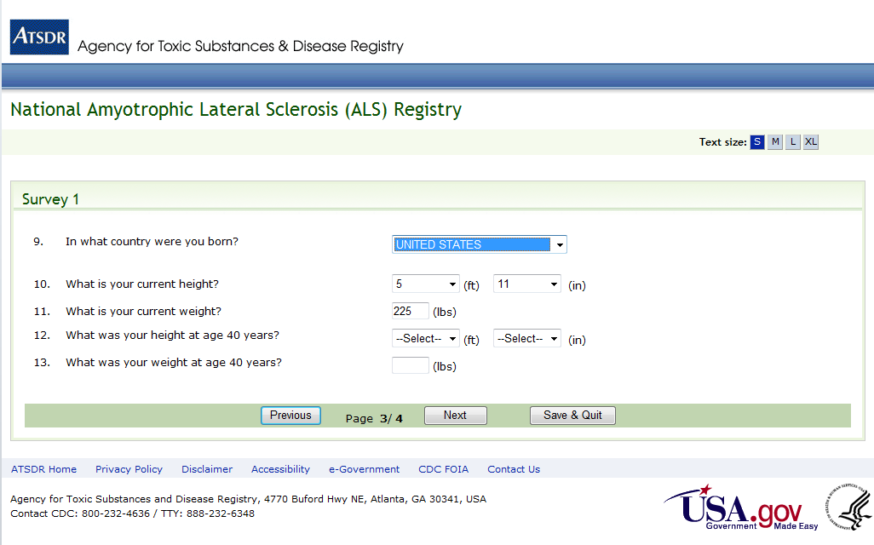
Figure 6: Survey 1, Page 3 of 4
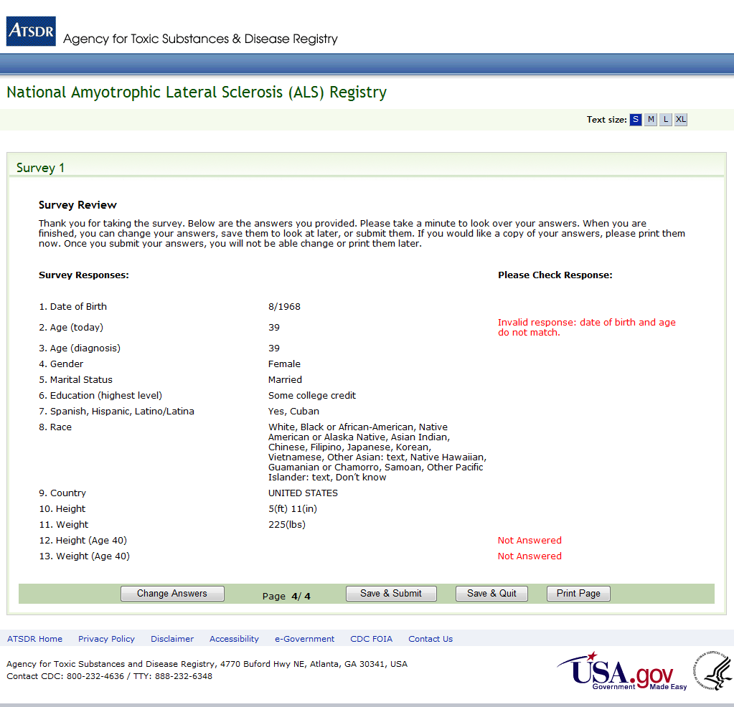
Figure 7: Survey 1, Page 4 of 4
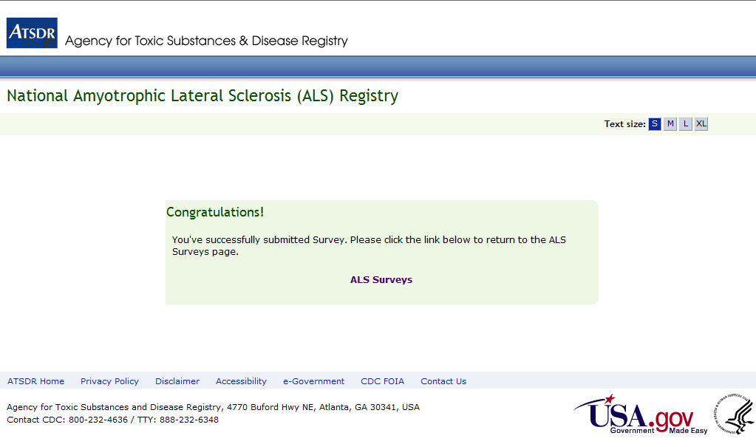
Figure 8: Survey Taken Confirmation Page (Same for ALL Surveys)
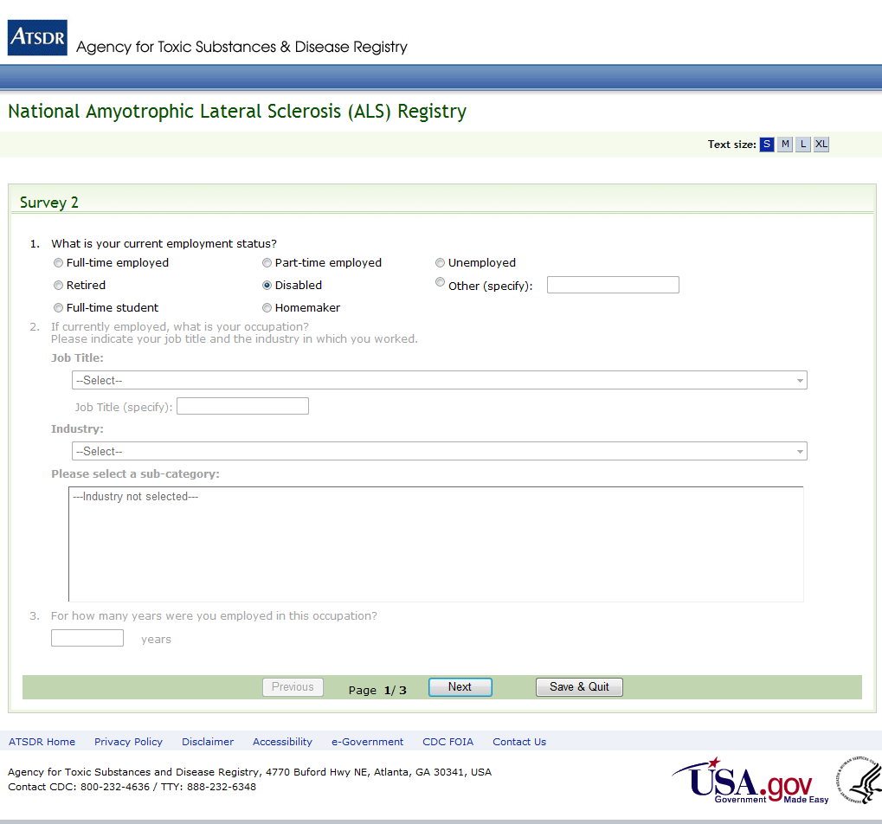
Figure 9: Survey 2, Page 1 of 3
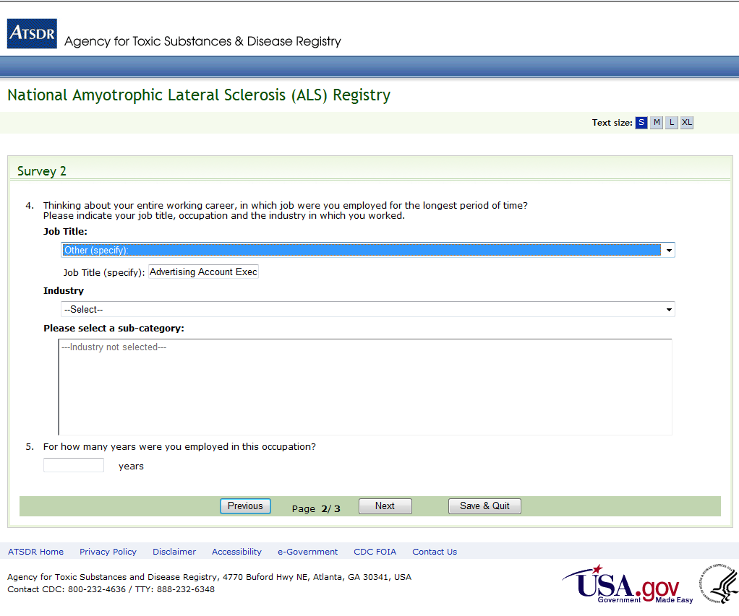
Figure 10: Survey 2, Page 2 of 3
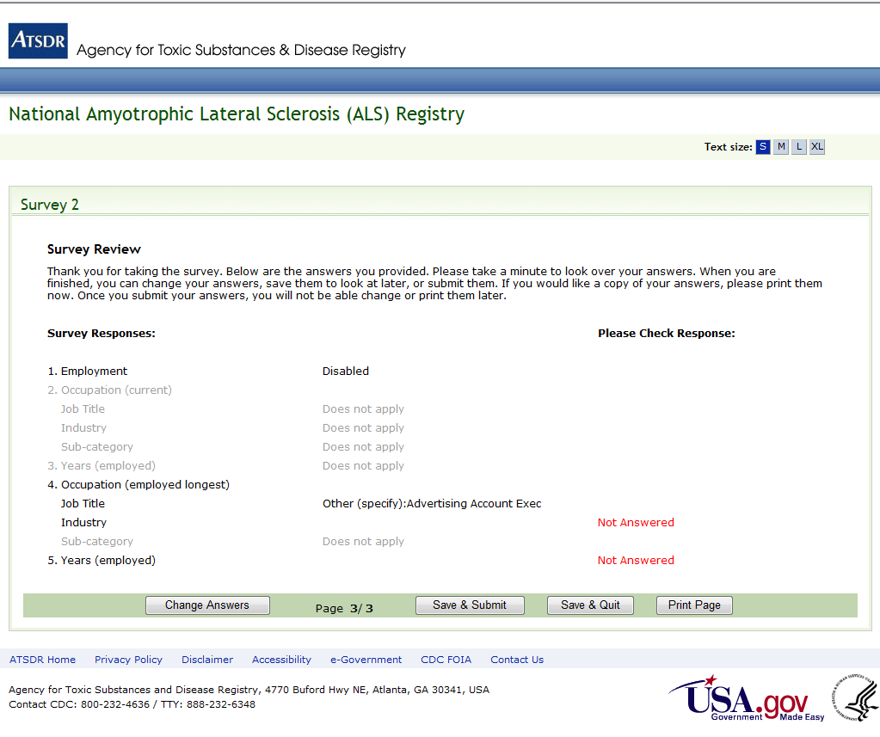
Figure 11: Survey 2, Page 3 of 3
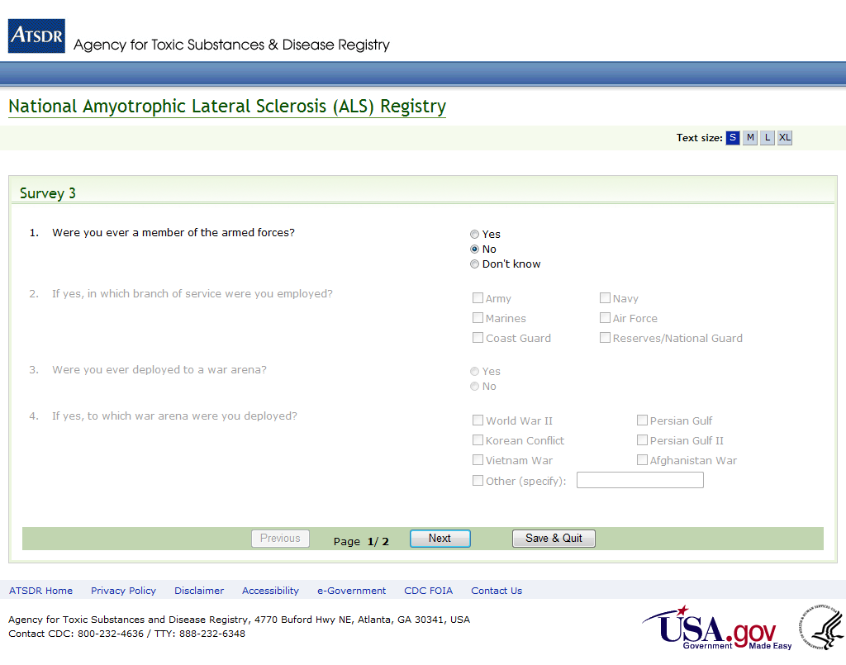
Figure 12: Survey 3, Page 1 of 2
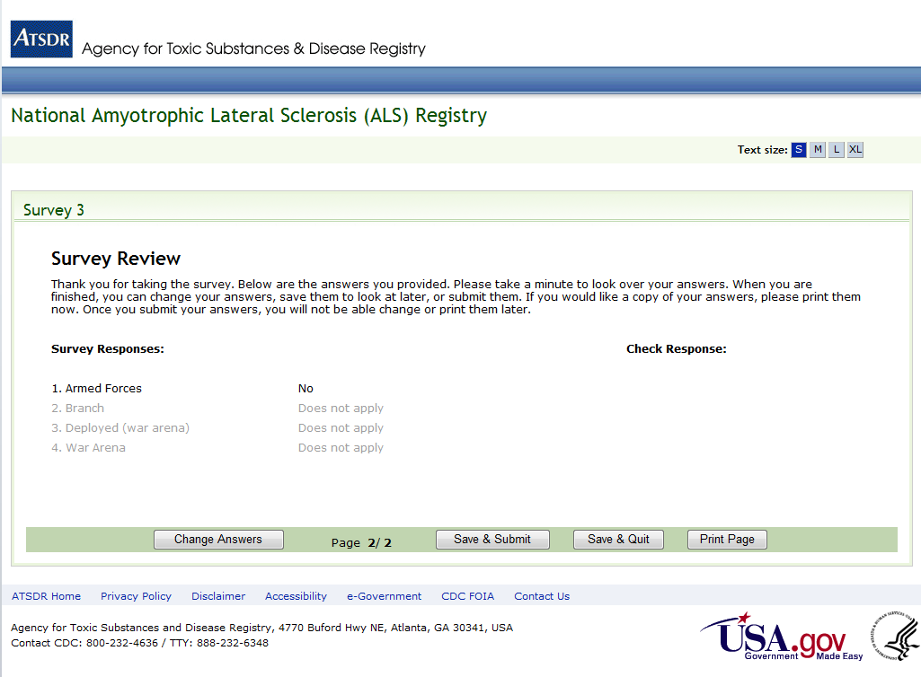
Figure 13: Survey 3, Page 2 of 2
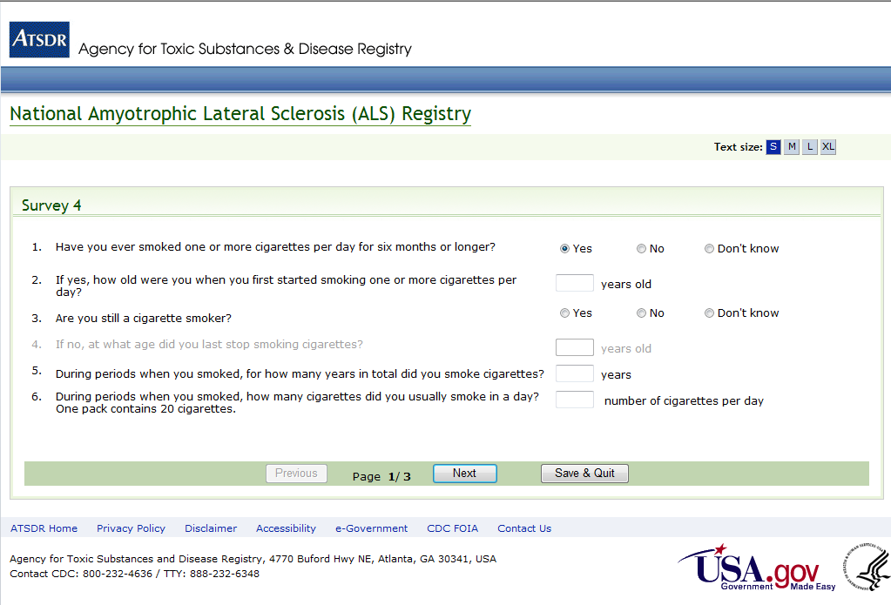
Figure 14: Survey 4, Page 1 of 3
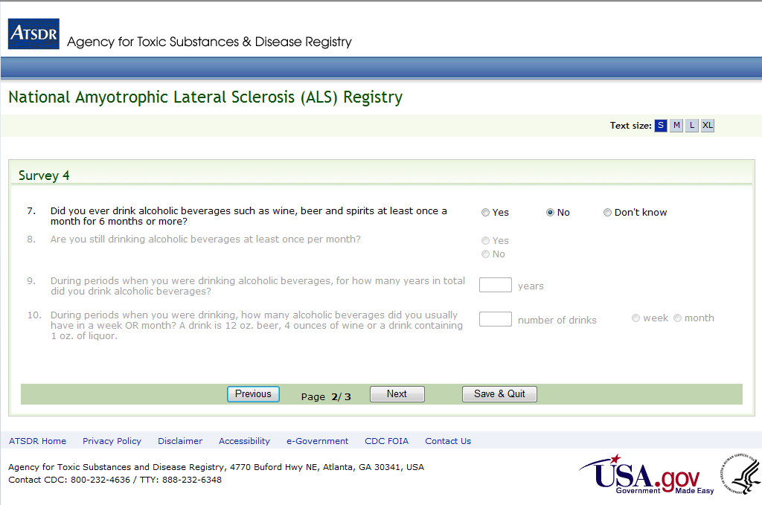
Figure 15: Survey 4, Page 2 of 3
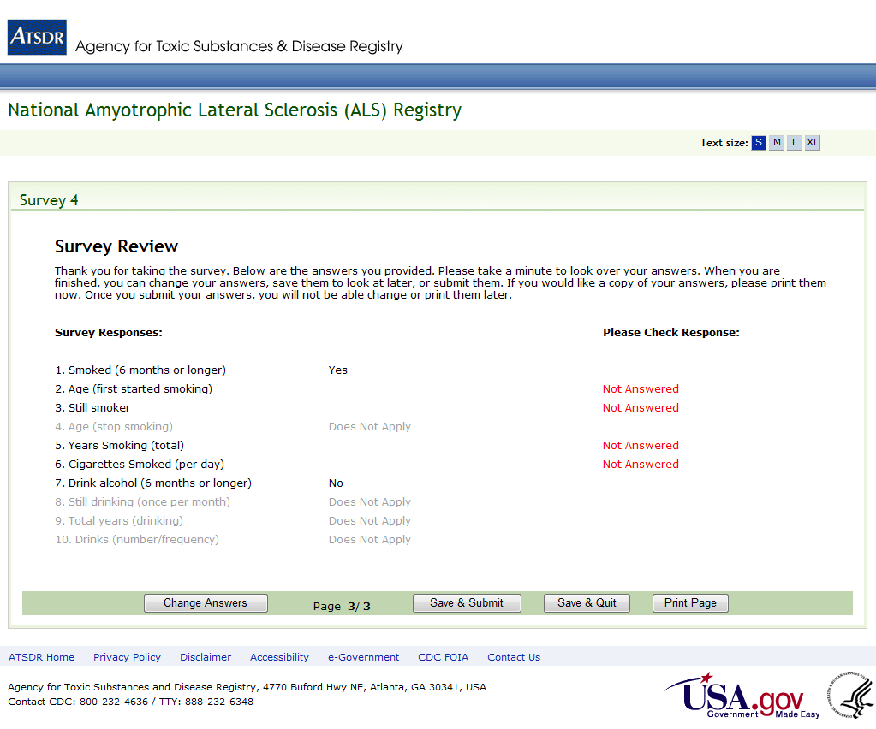
Figure 16: Survey 4, Page 3 of 3
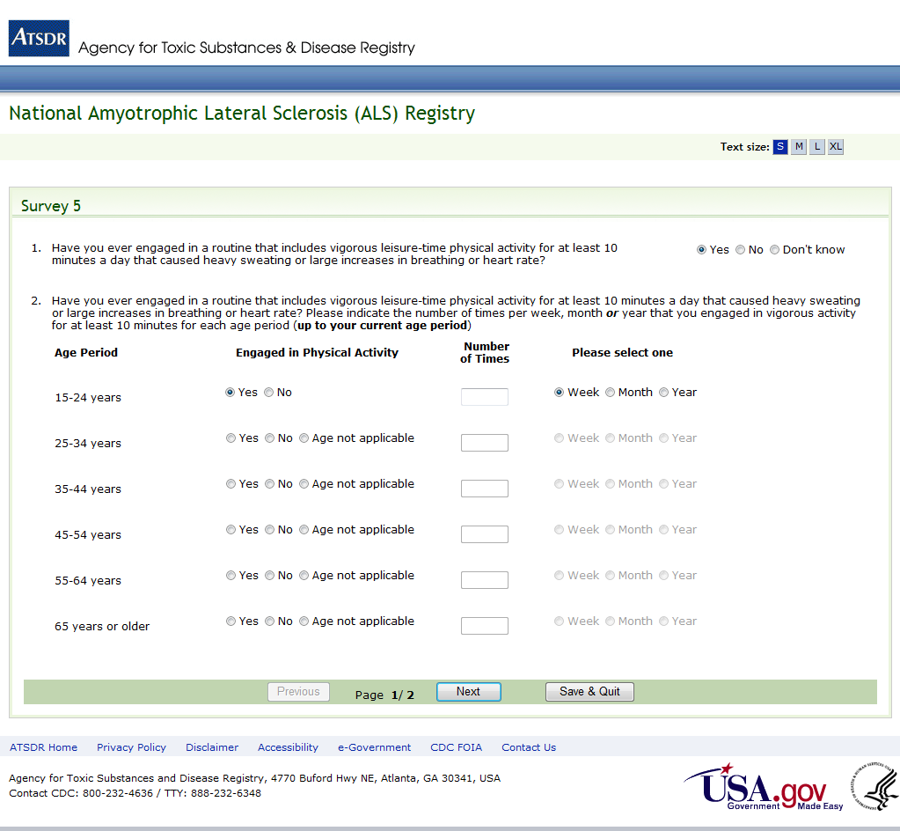
Figure 17: Survey 5, Page 1 of 2
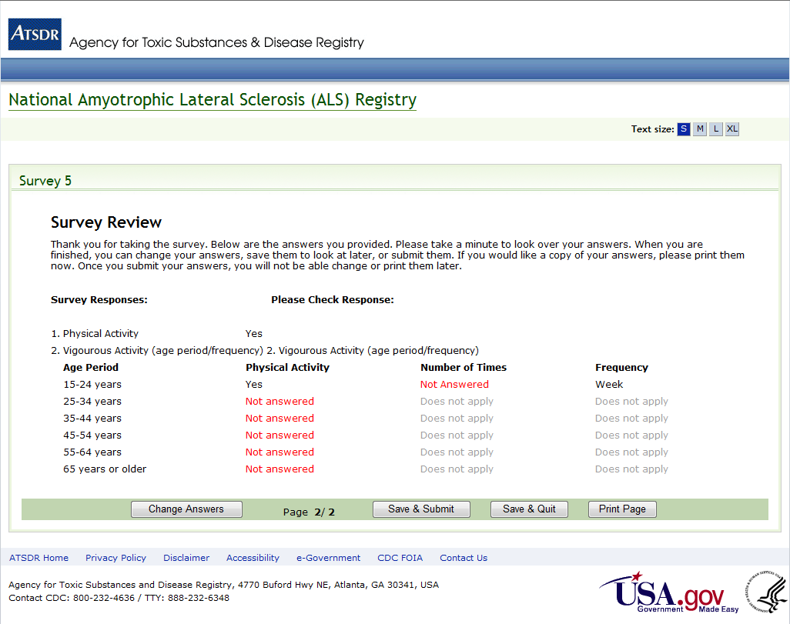
Figure 18: Survey 5, Page 2 of 2
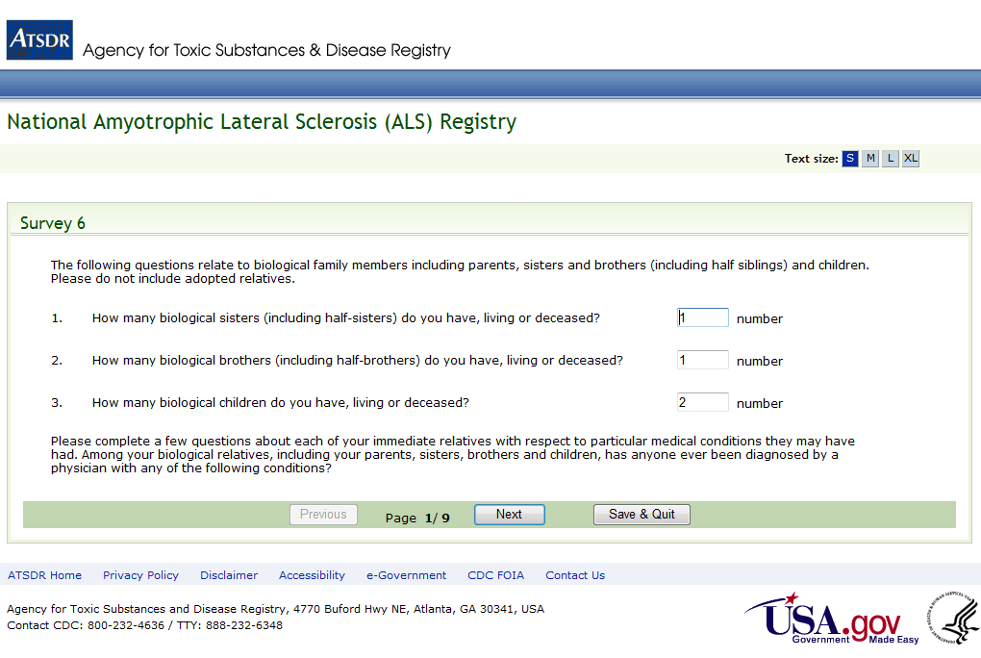
Figure 19: Survey 6, Page 1 of 9
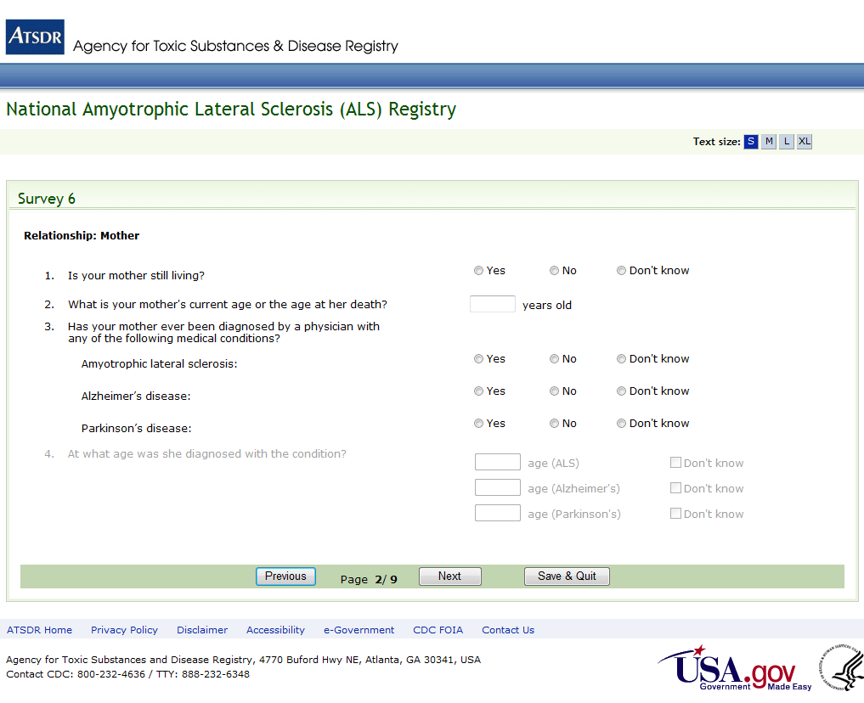
Figure 20: Survey 6, Page 2 of 9
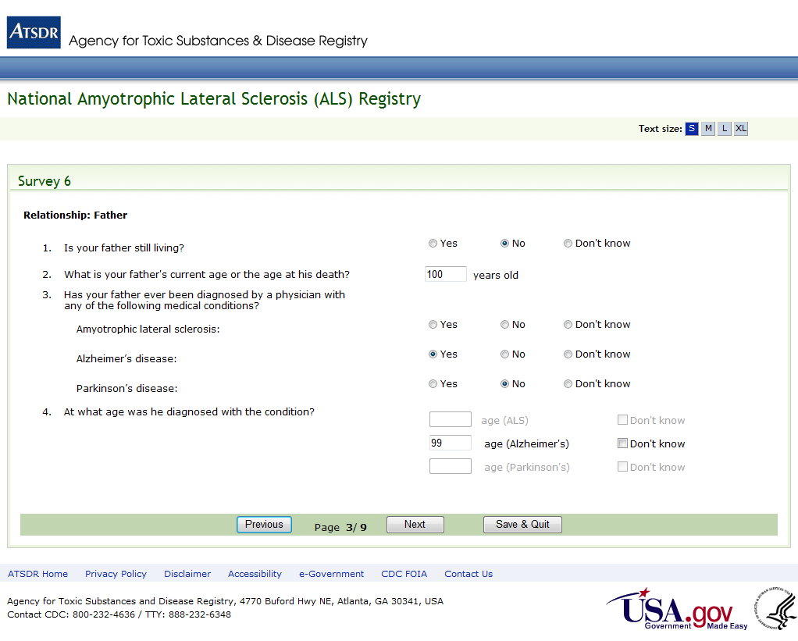
Figure 21: Survey 6, Page 3 of 9
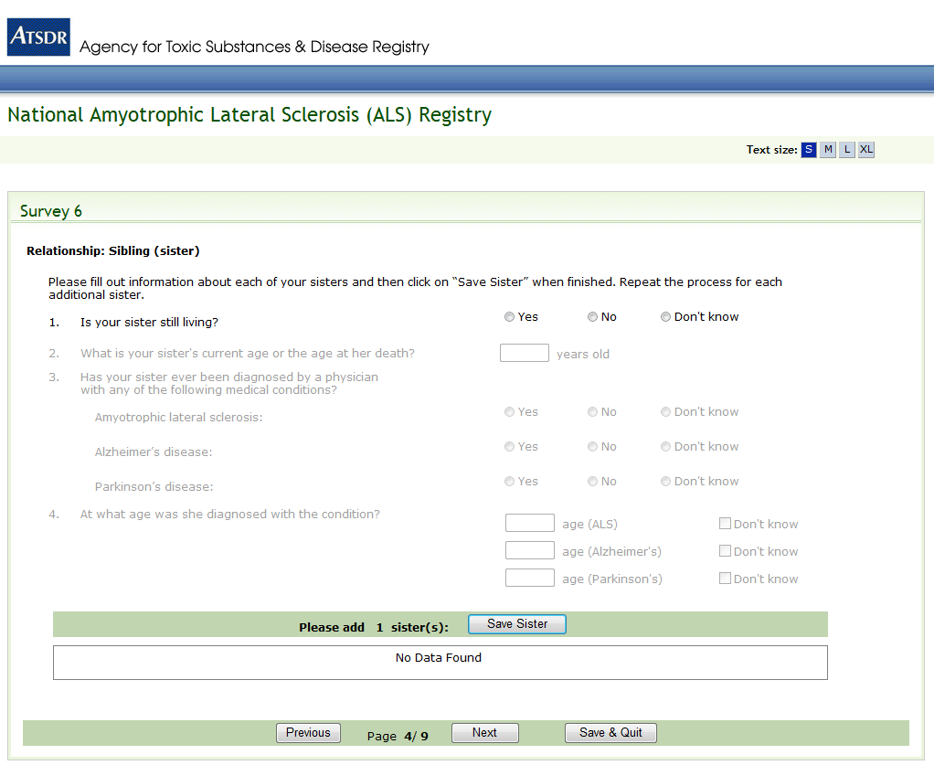
Figure 22: Survey 6, Page 4 of 9
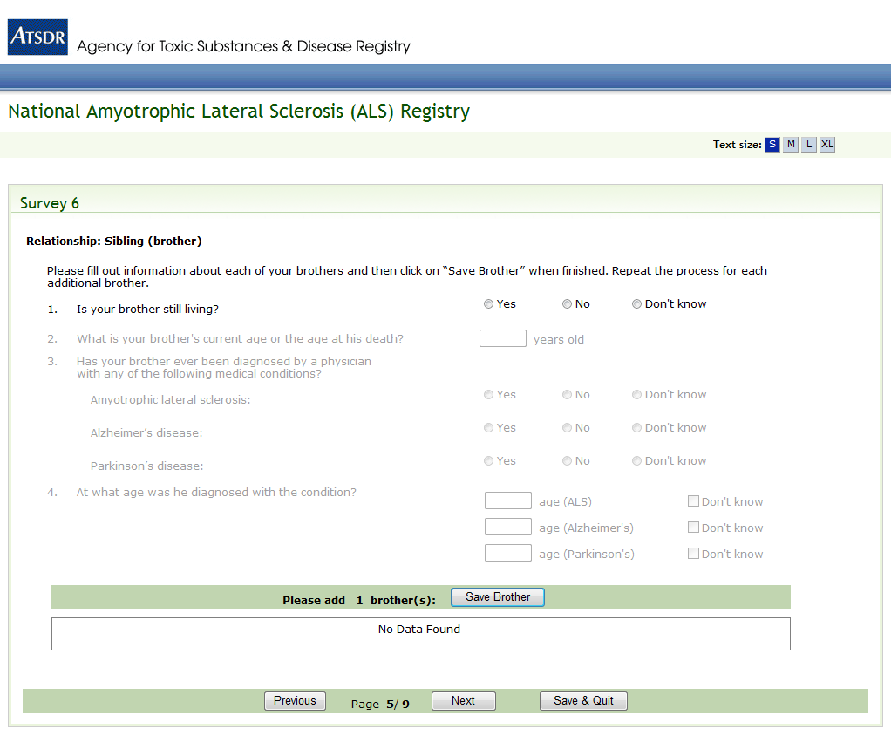
Figure 23: Survey 6, Page 5 of 9
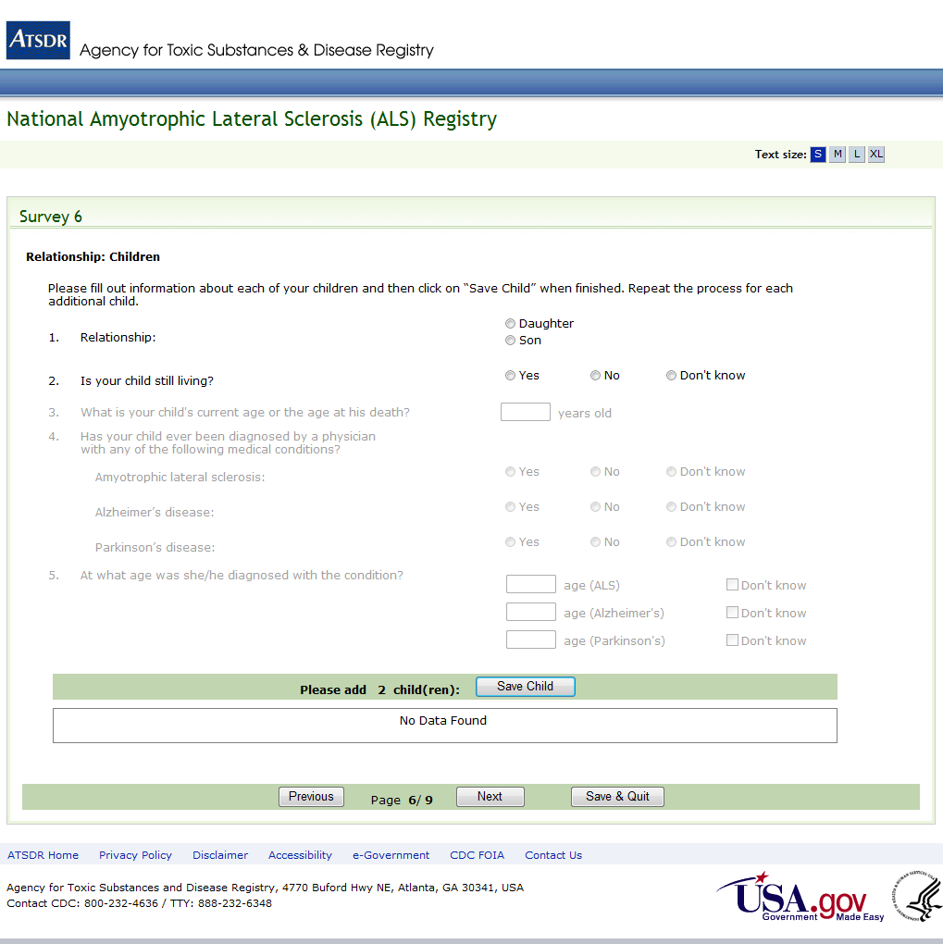
Figure 24: Survey 6, Page 6 of 9
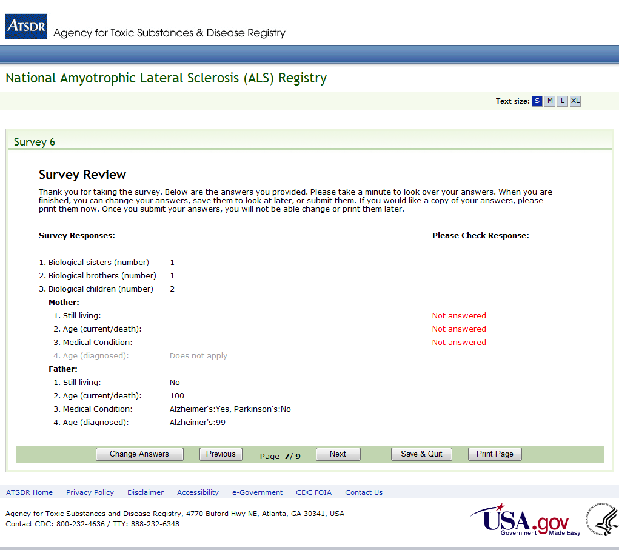
Figure 25: Survey 6, Page 7 of 9
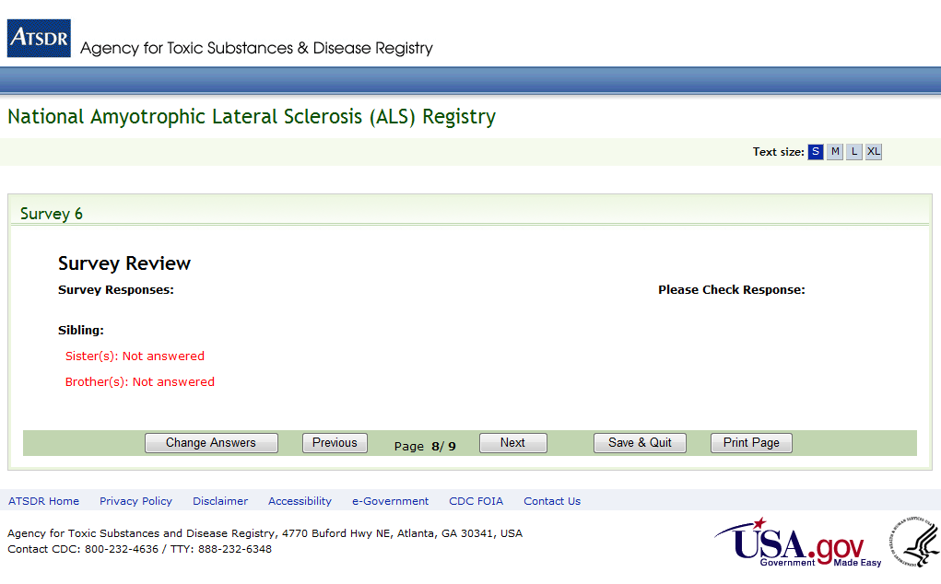
Figure 26: Survey 6, Page 8 of 9

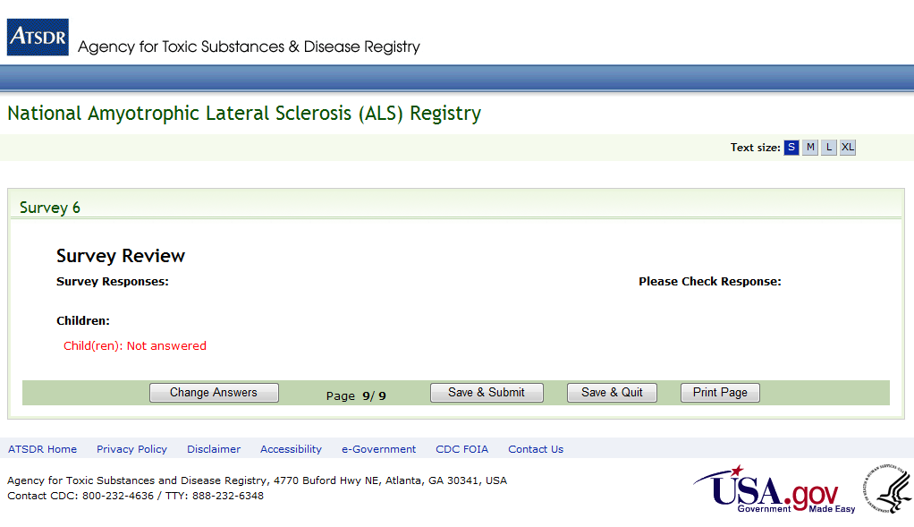
Figure 27: Survey 6, Page 9 of 9
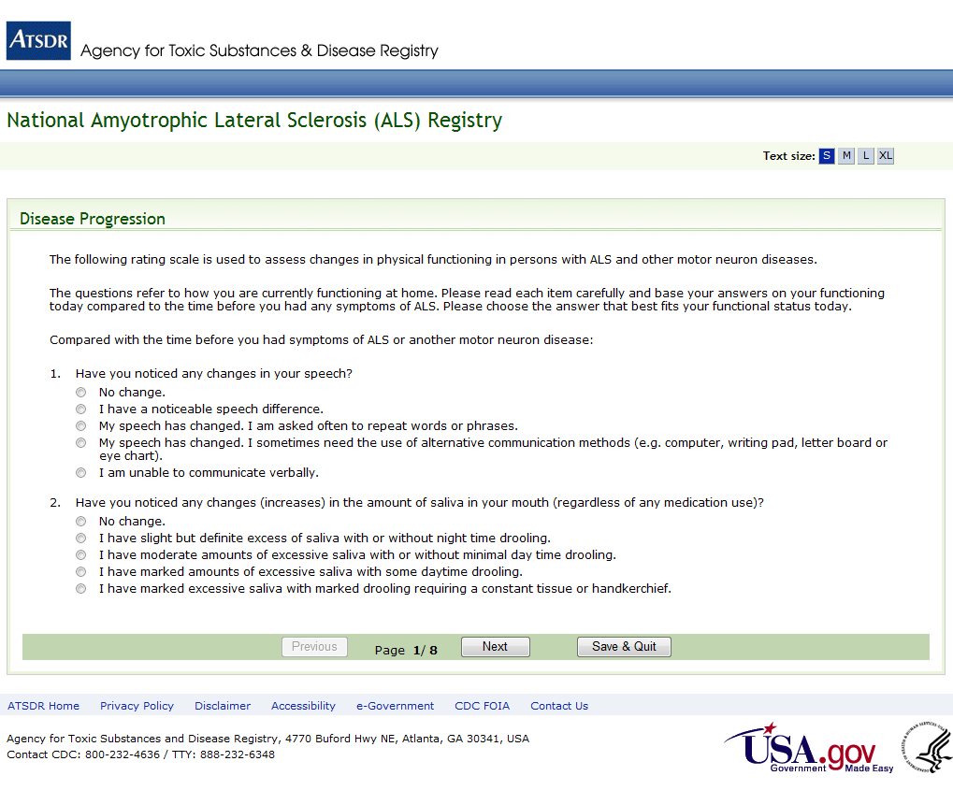
Figure 28: Disease Progression Survey, Page 1 of 8
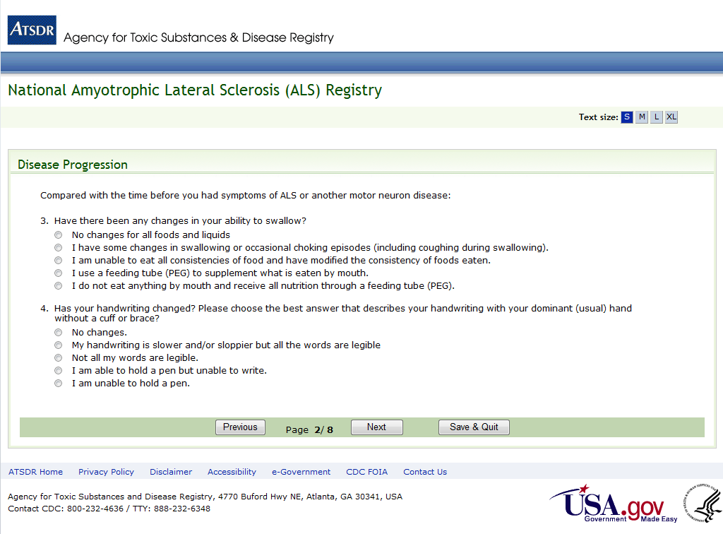
Figure 29: Disease Progression Survey, Page 2 of 8
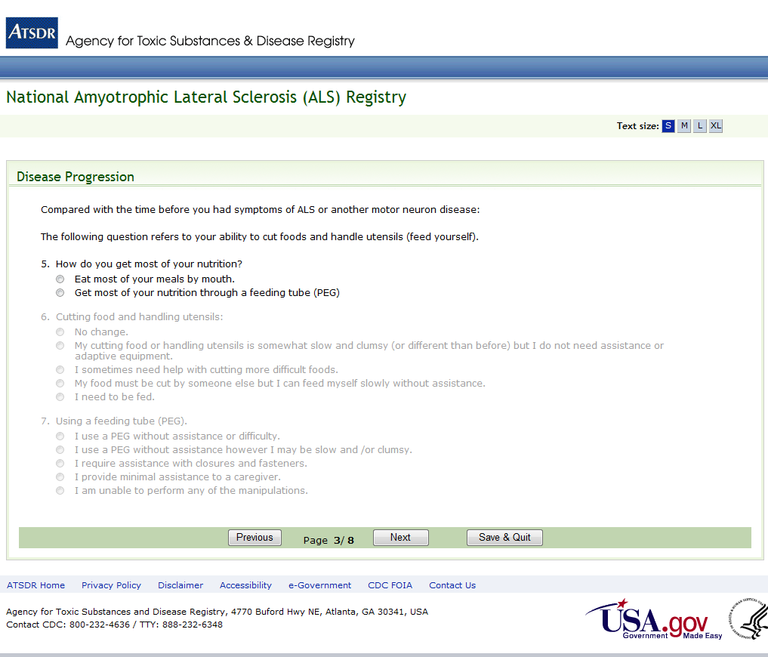
Figure 30: Disease Progression Survey, Page 3 of 8
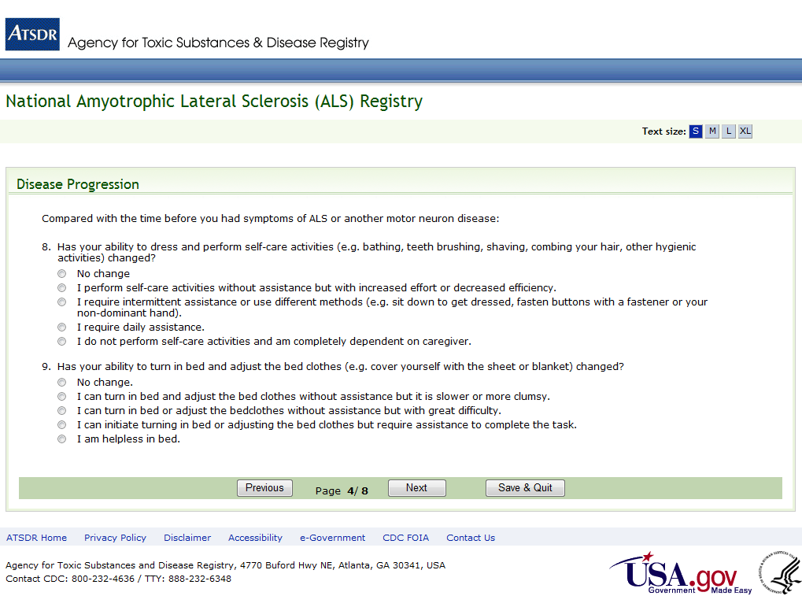
Figure 31: Disease Progression Survey, Page 4 of 8
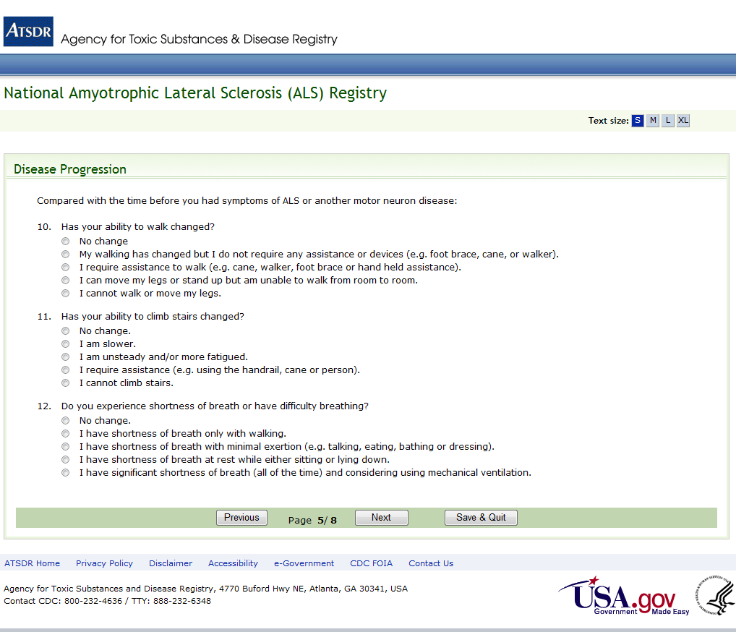
Figure 32: Disease Progression Survey, Page 5 of 8
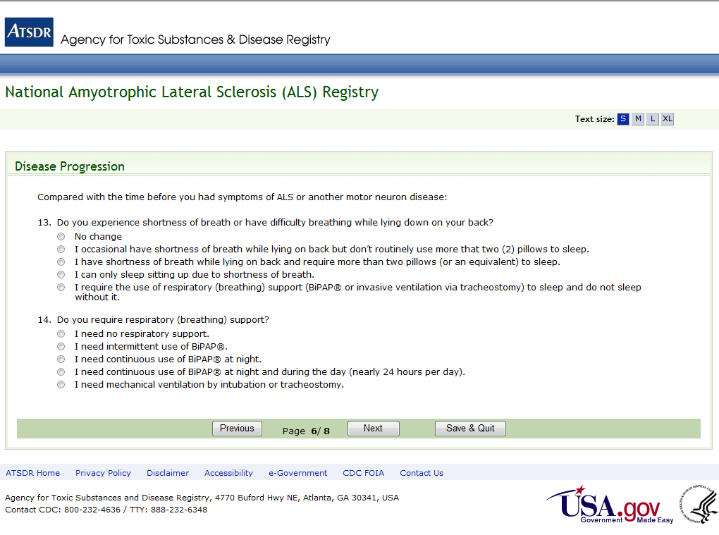
Figure 33: Disease Progression Survey, Page 6 of 8
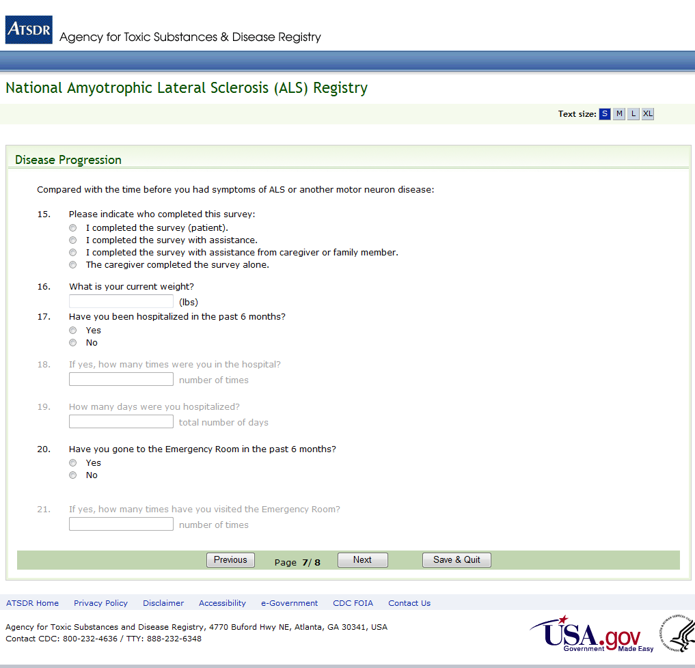

Figure 34: Disease Progression Survey, Page 7 of 8
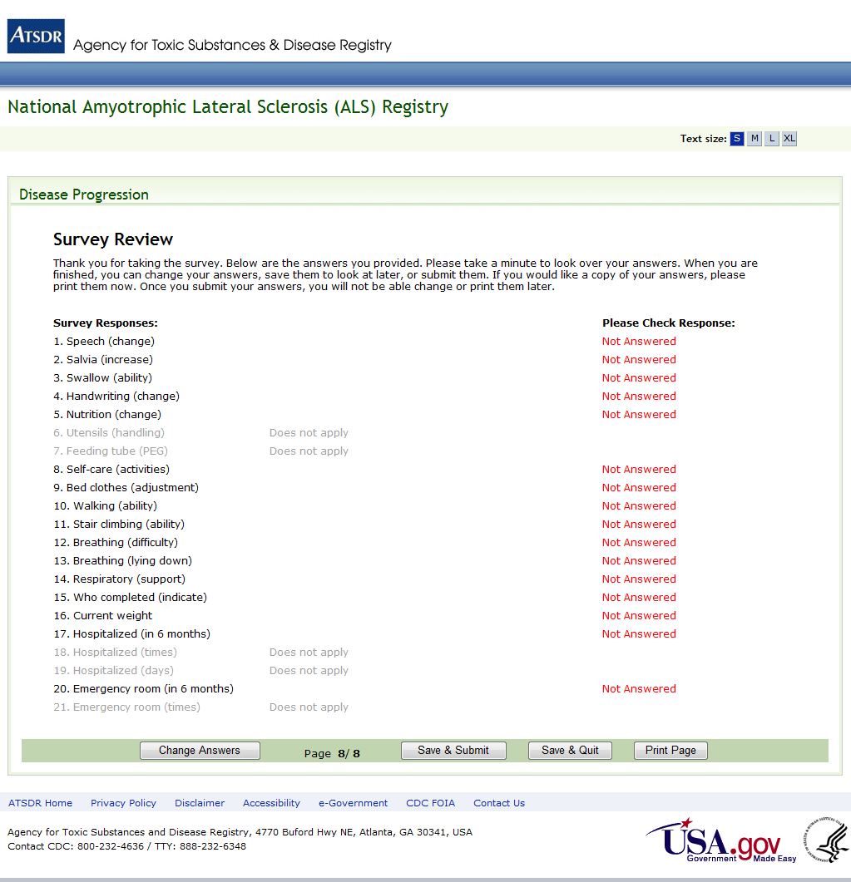

Figure 35: Disease Progression Survey, Page 8 of 8

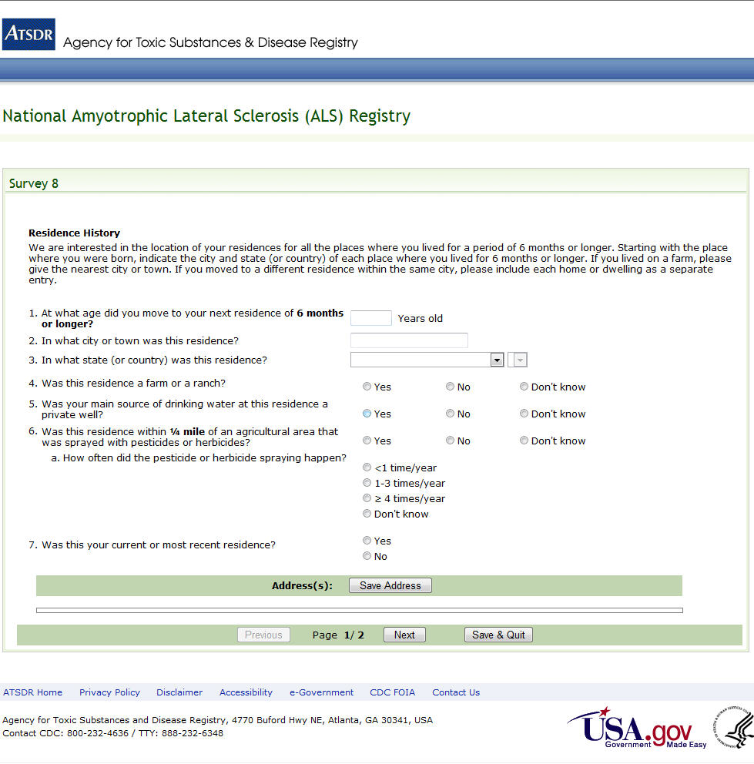

Figure 36: Survey 8, Page 1 of 2

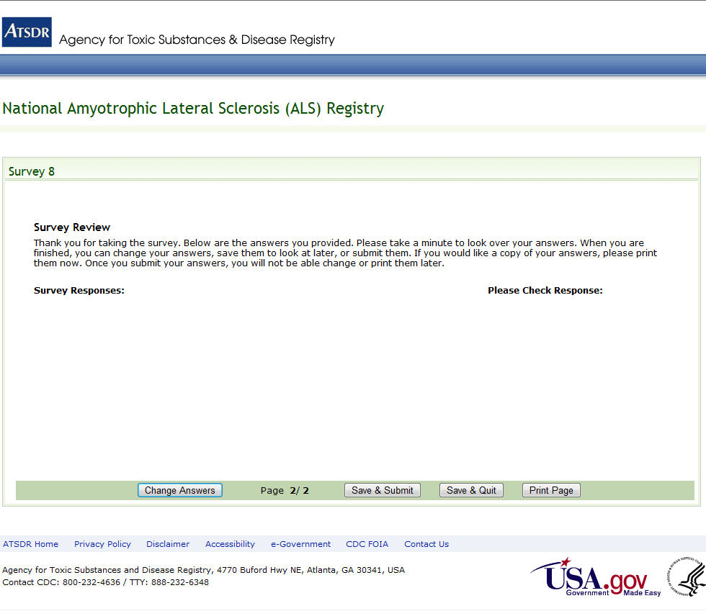
Figure 37: Survey 8, Page 2 of 2

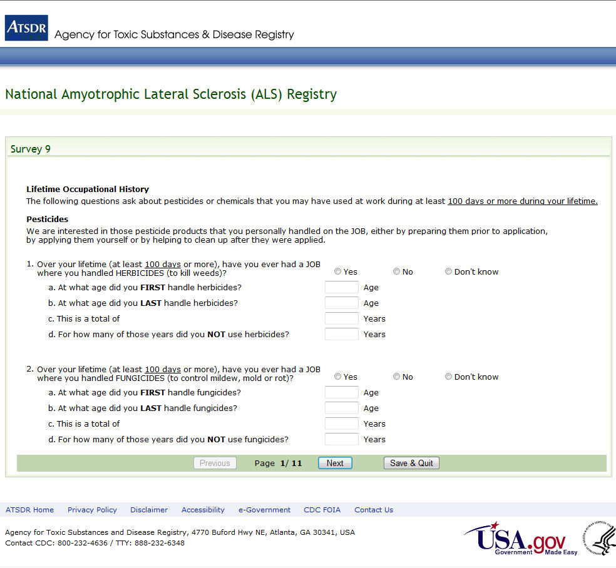
Figure 38: Survey 9, Page 1 of 11

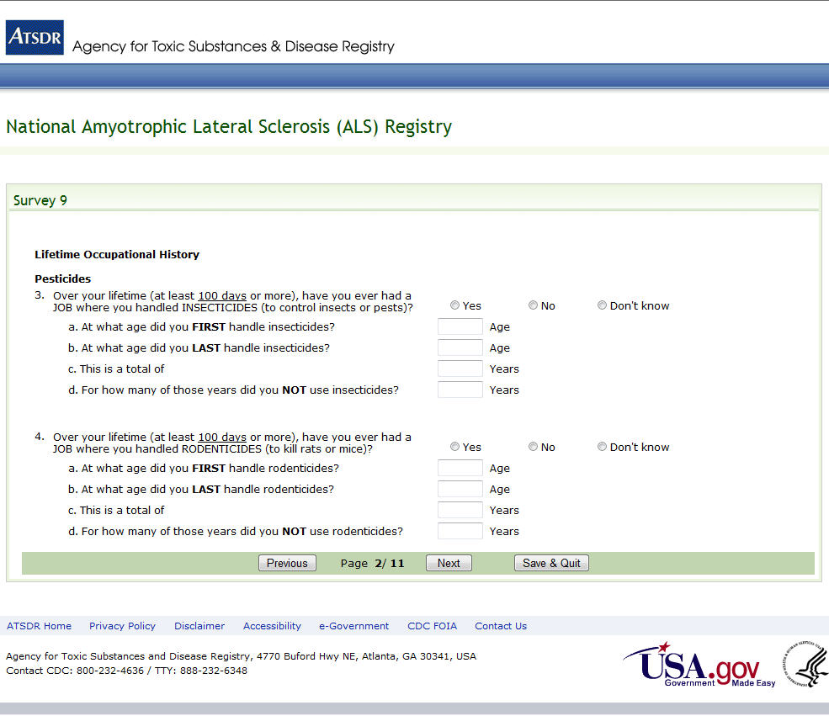
Figure 39: Survey 9, Page 2 of 11

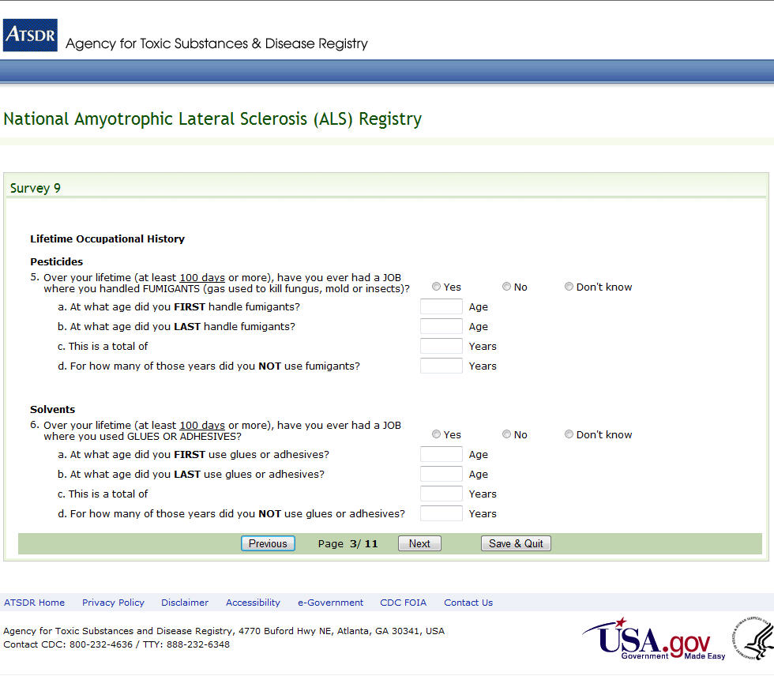
Figure 40: Survey 9, Page 3 of 11

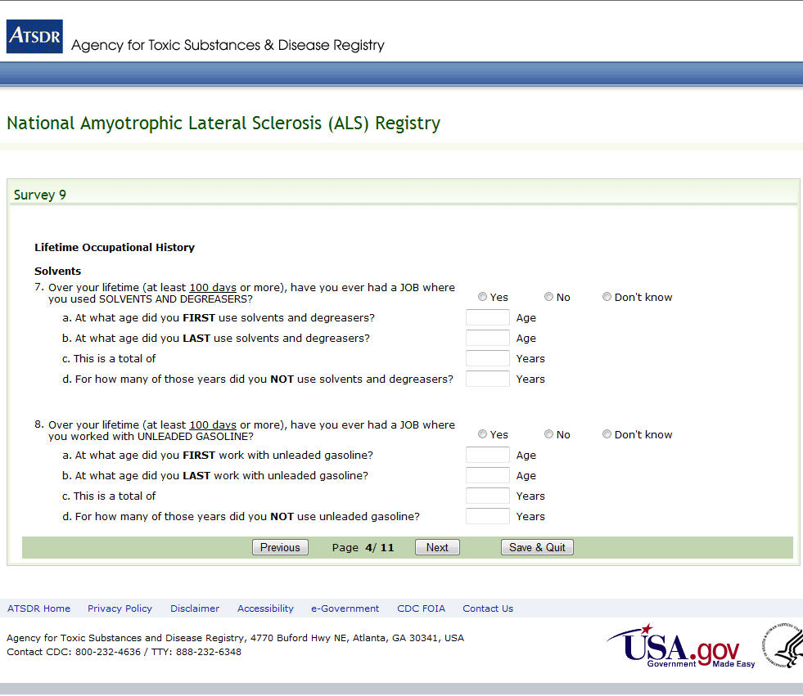
Figure 41: Survey 9, Page 4 of 11

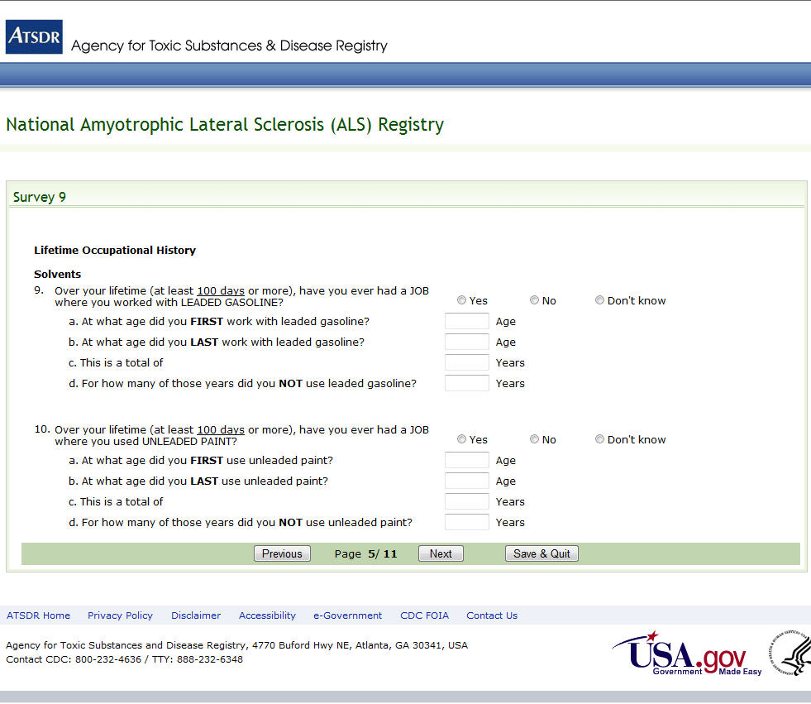
Figure 42: Survey 9, Page 5 of 11

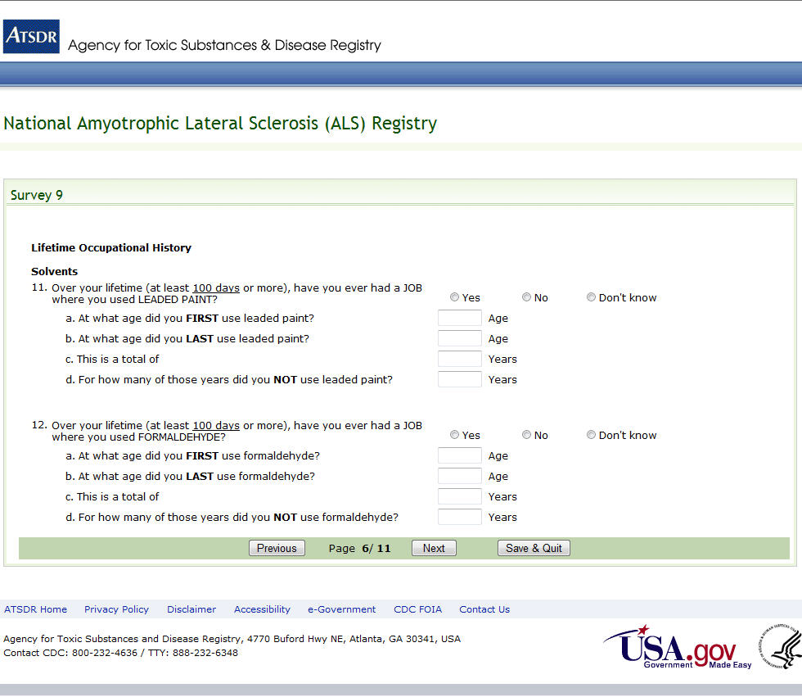
Figure 43: Survey 9, Page 6 of 11

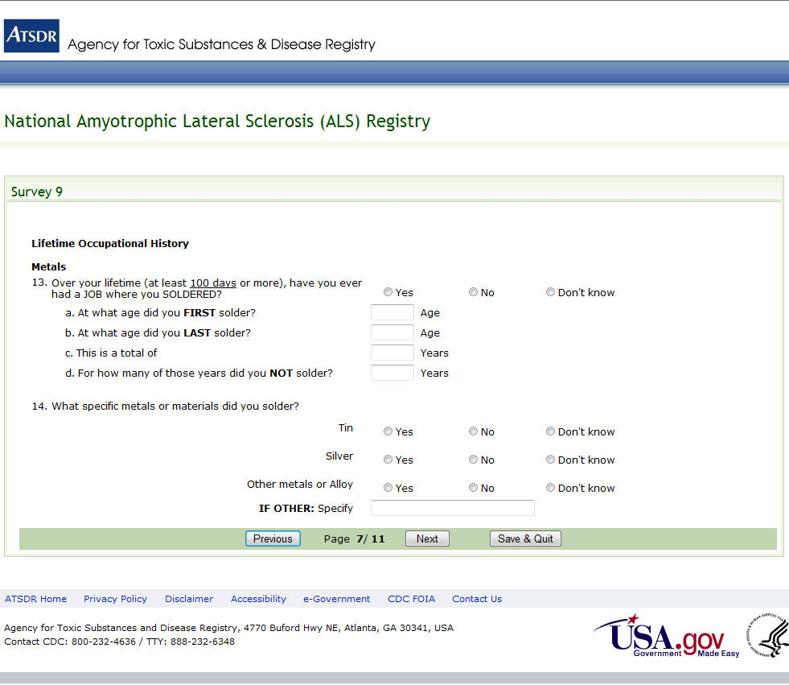
Figure 44: Survey 9, Page 7 of 11

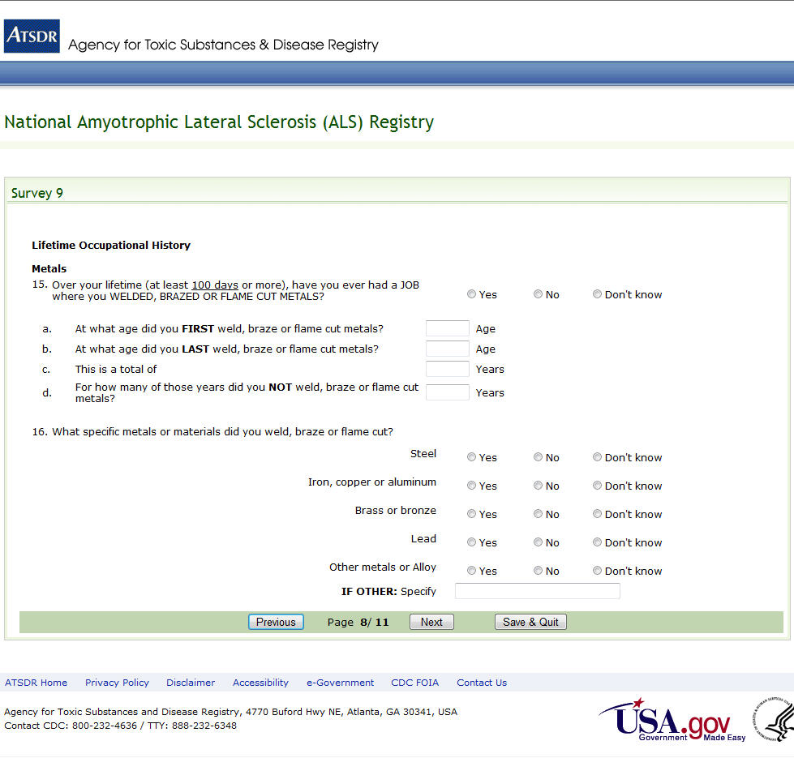
Figure 45: Survey 9, Page 8 of 11

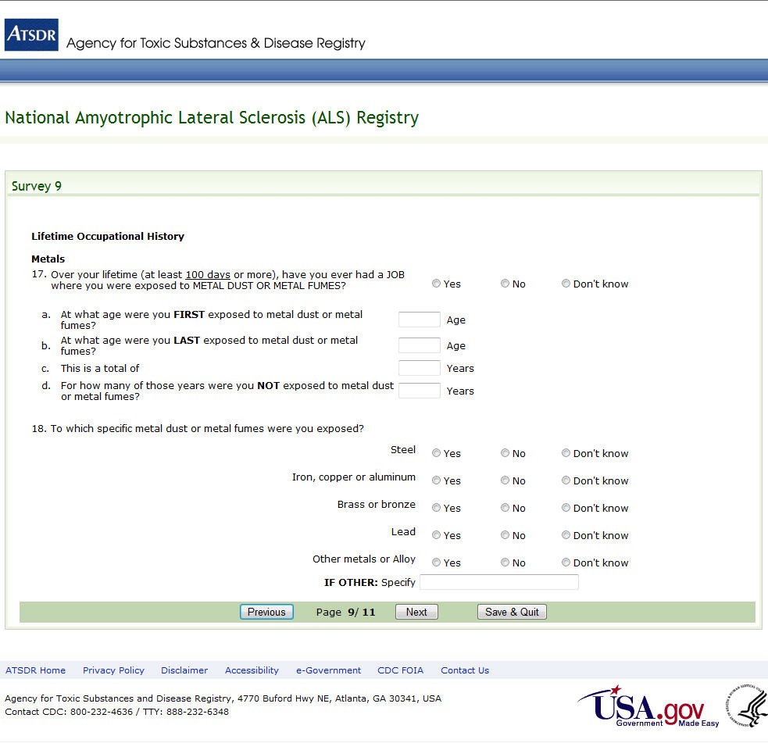Figure 46: Survey 9, Page 9 of 11

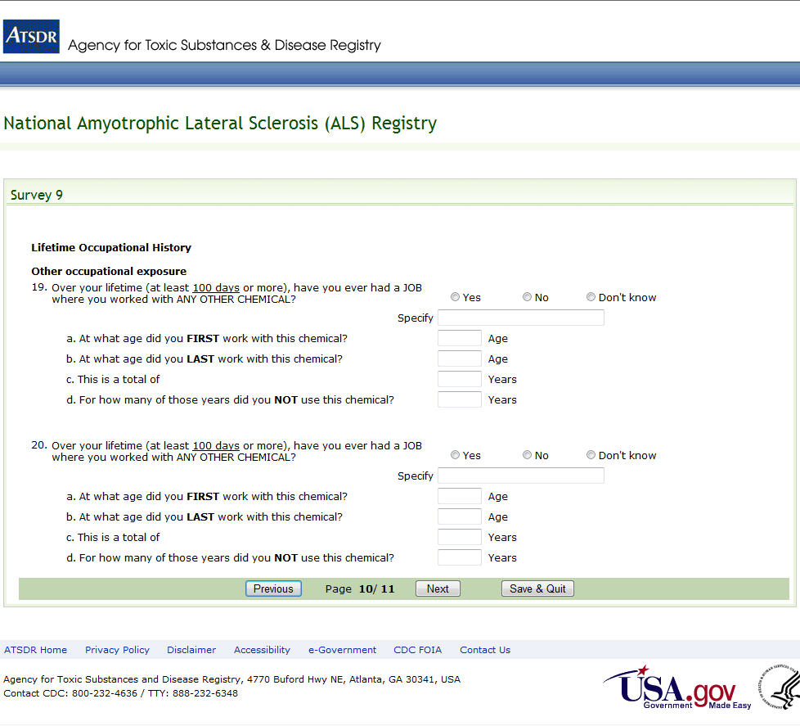Figure 47: Survey 9, Page 10 of 11

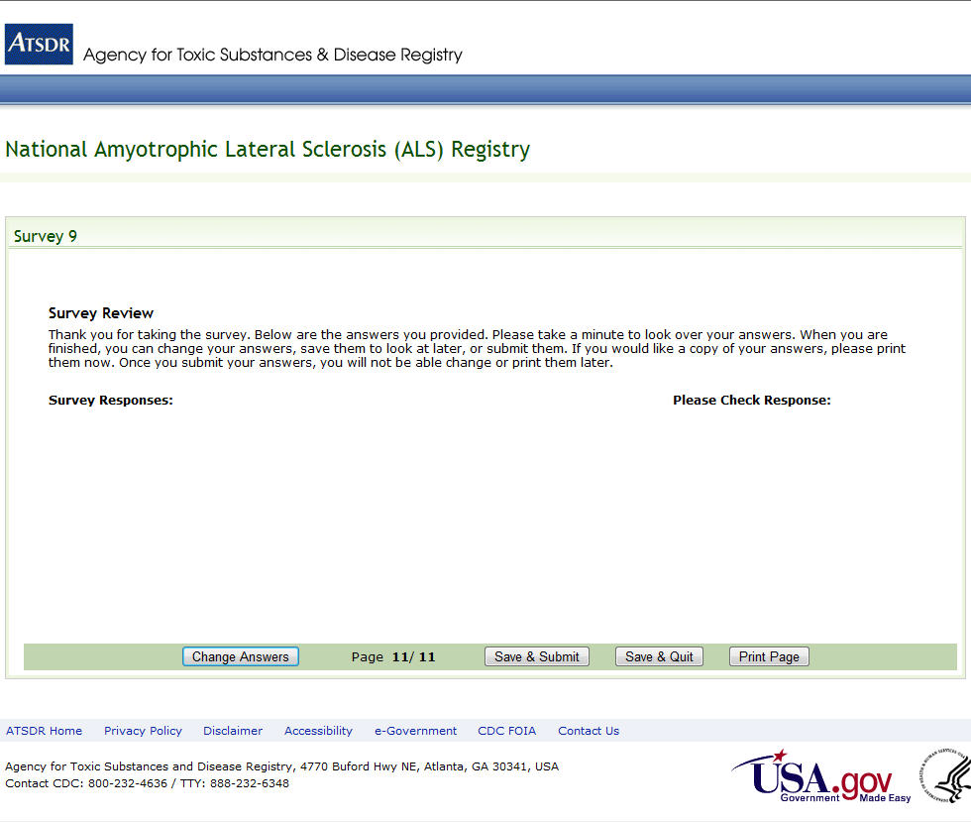Figure 48: Survey 9, Page 11 of 11

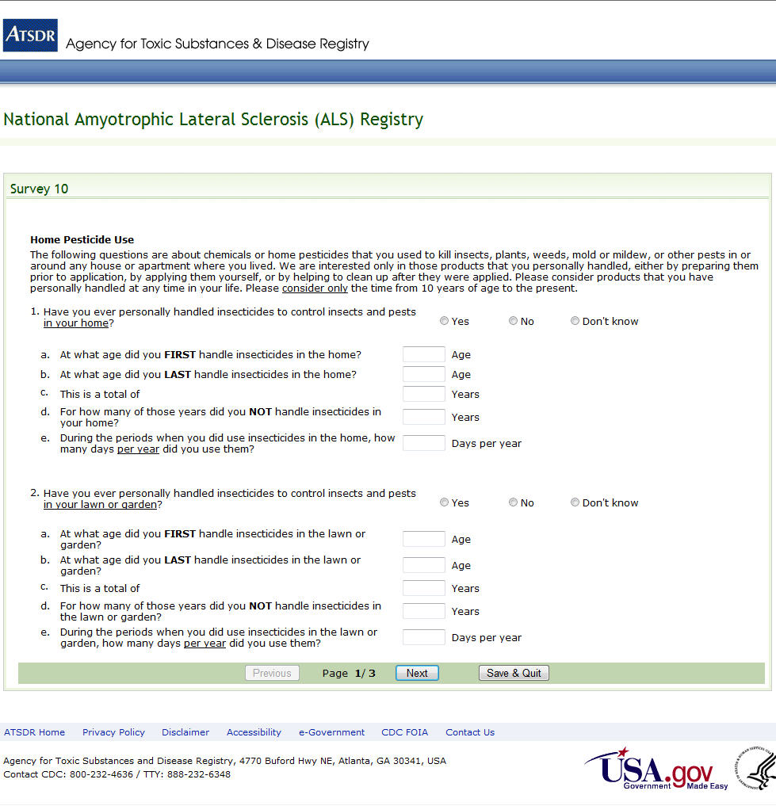Figure 49: Survey 10, Page 1 of 3

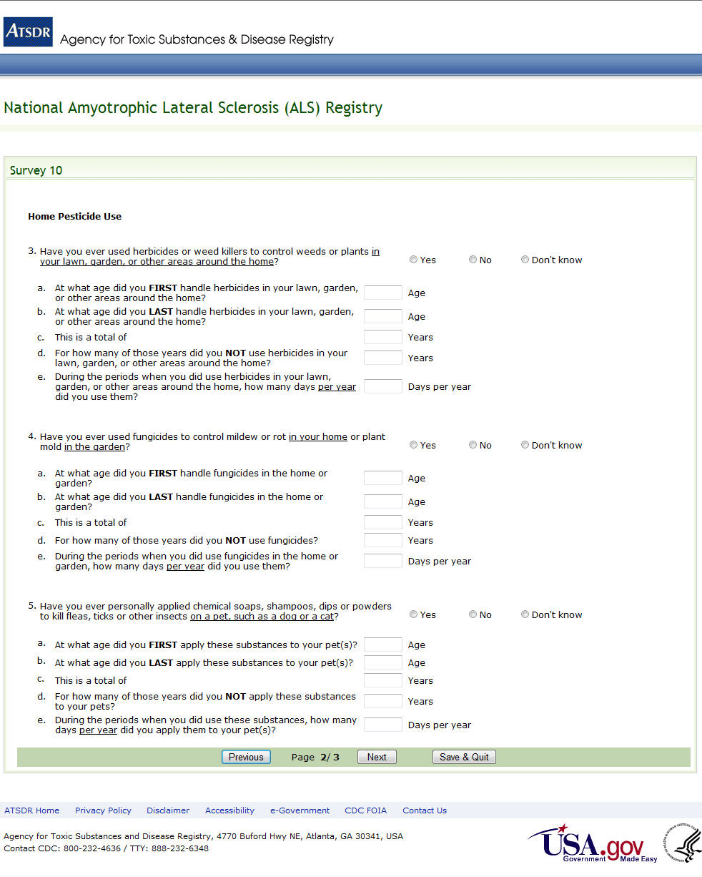Figure 50: Survey 10, Page 2 of 3

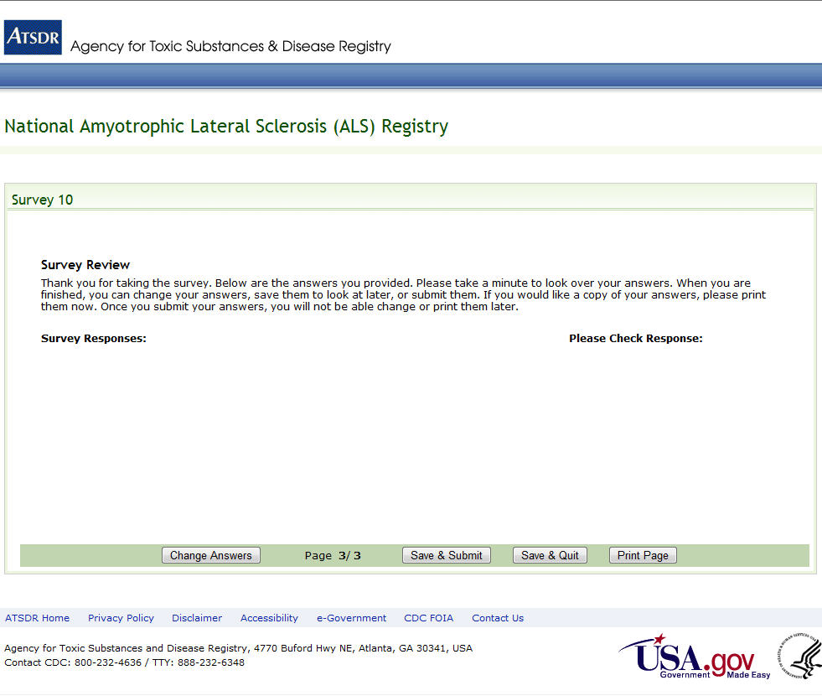Figure 51: Survey 10, Page 3 of 3

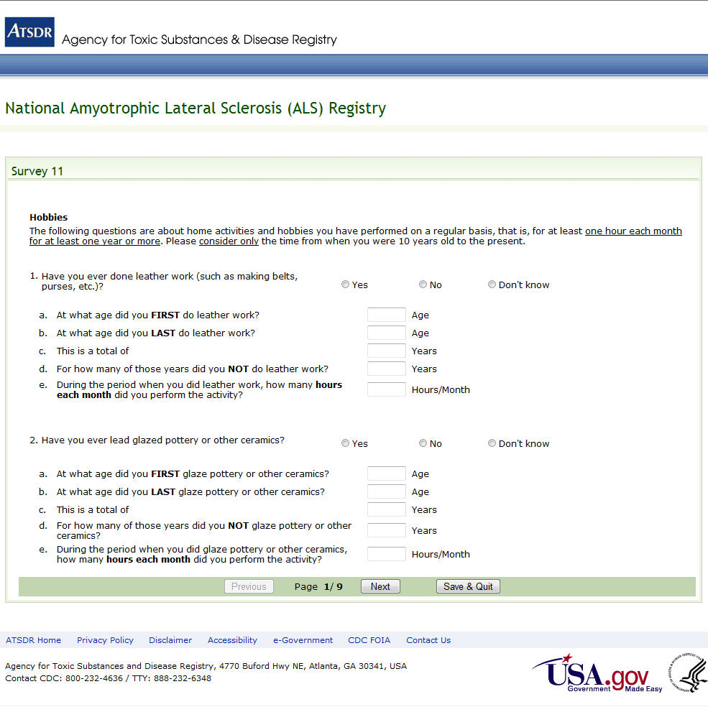Figure 52: Survey 11, Page 1 of 9

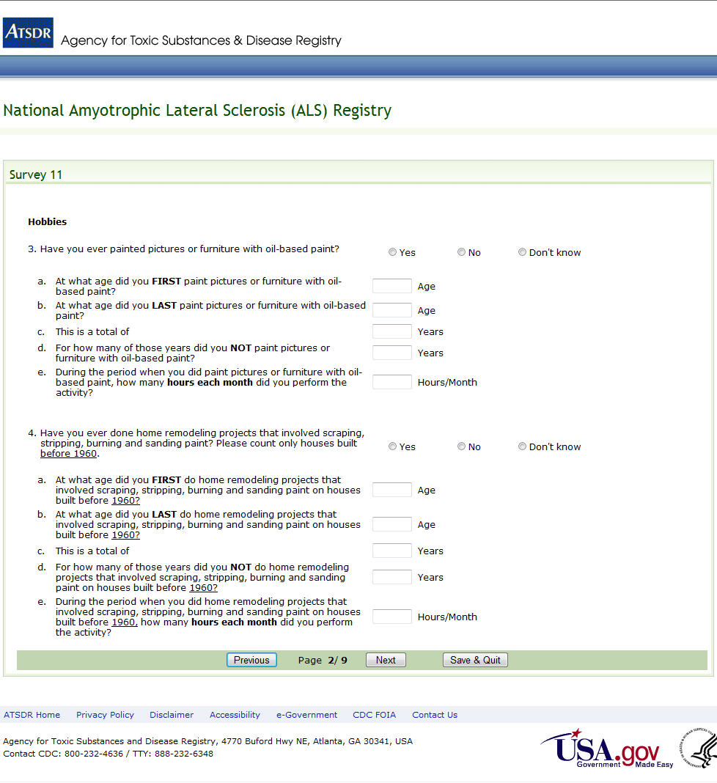Figure 53: Survey 11, Page 2 of 9

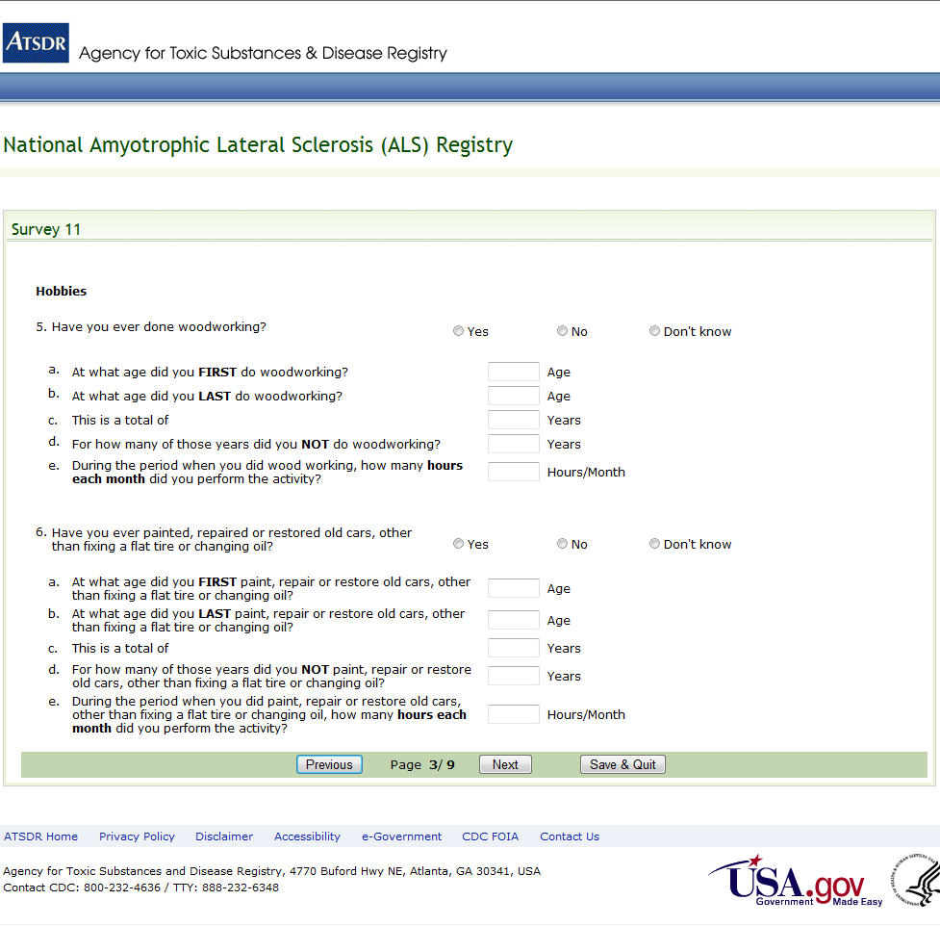Figure 54: Survey 11, Page 3 of 9

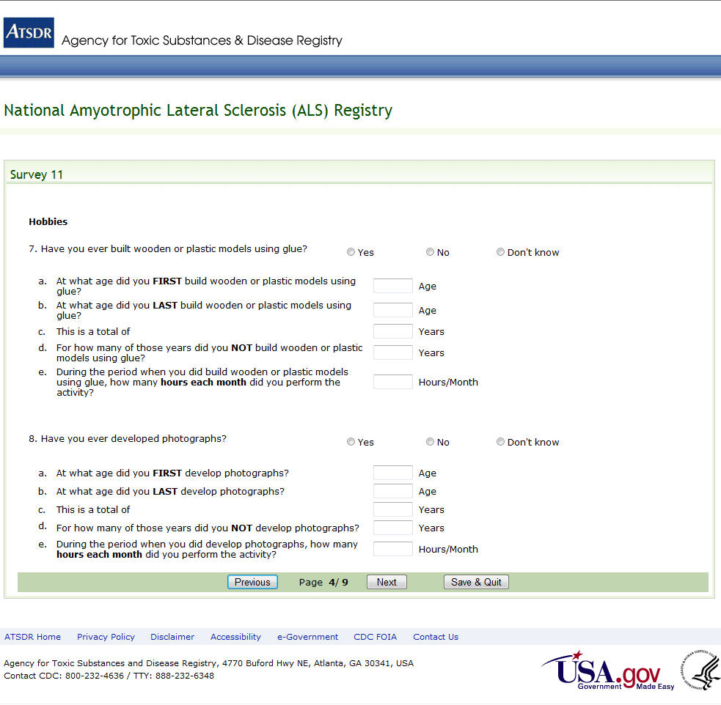Figure 55: Survey 11, Page 4 of 9

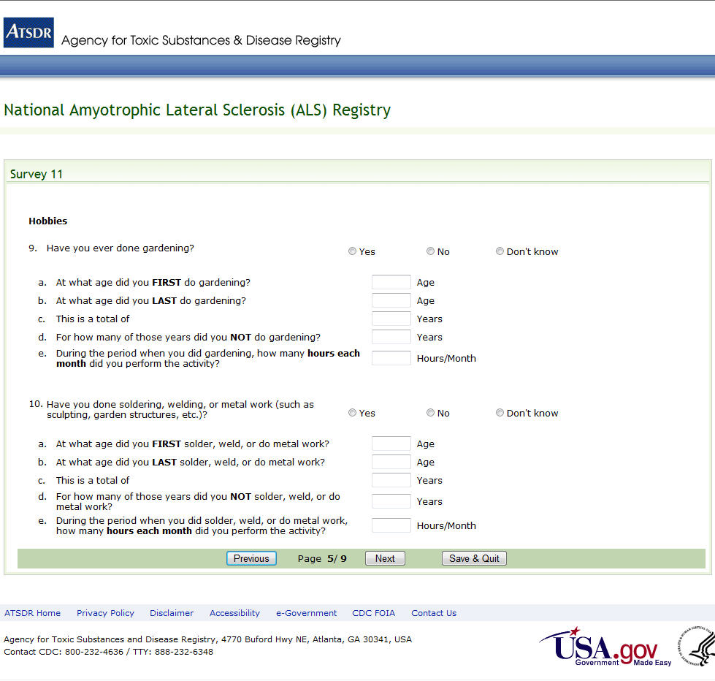Figure 56: Survey 11, Page 5 of 9

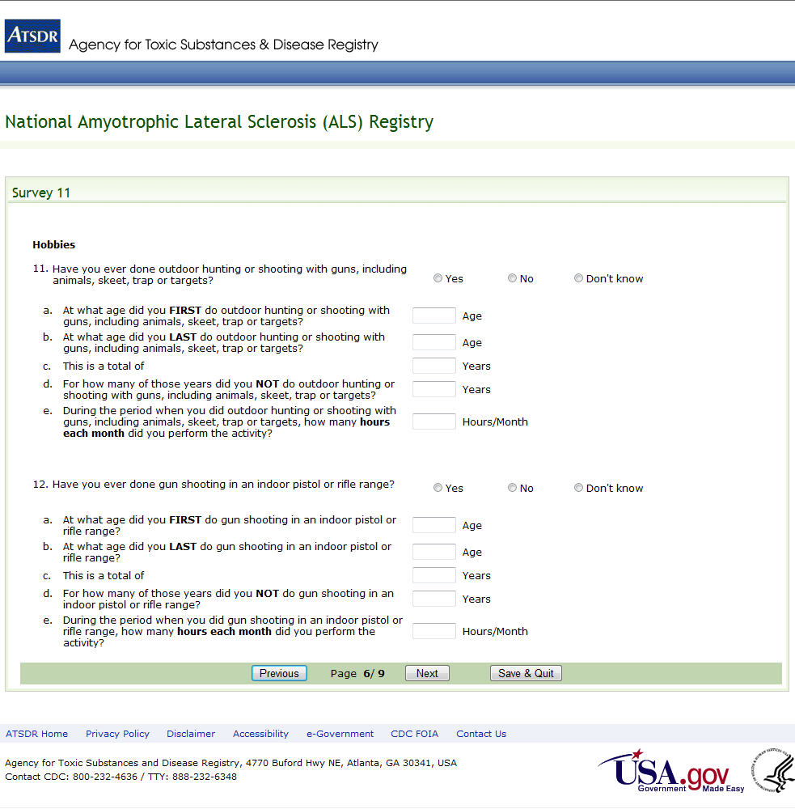Figure 57: Survey 11, Page 6 of 9

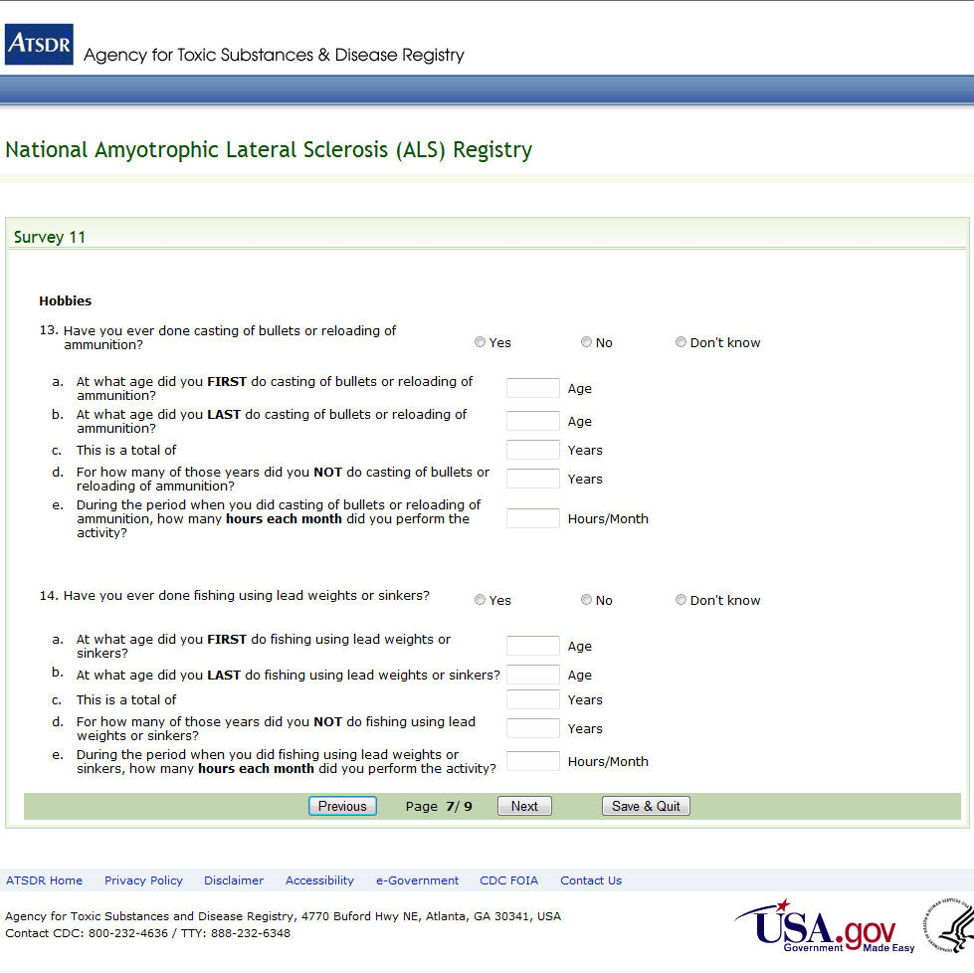
Figure 58: Survey 11, Page 7 of 9

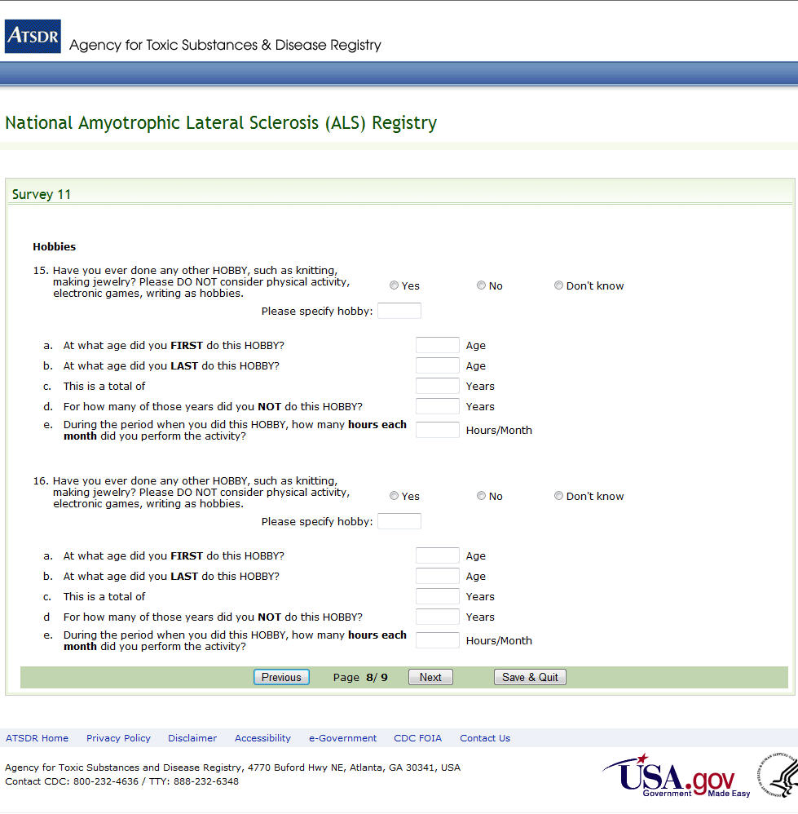Figure 59: Survey 11, Page 8 of 9

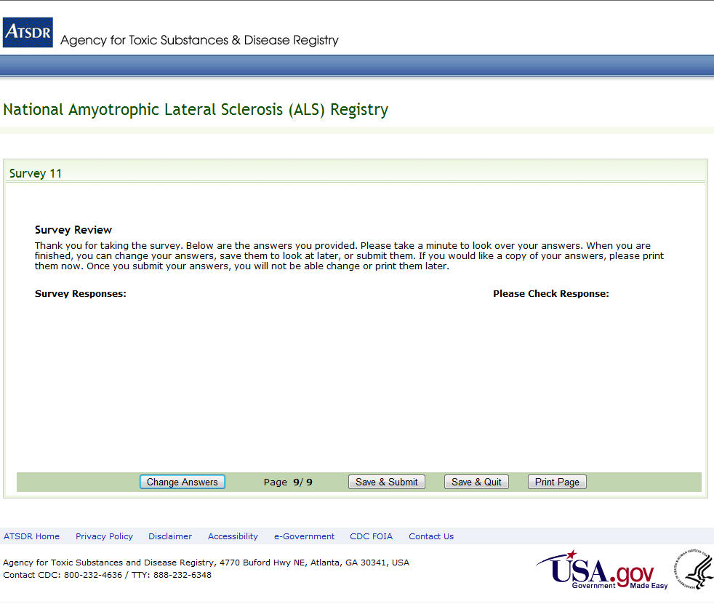Figure 60: Survey 11, Page 9 of 9

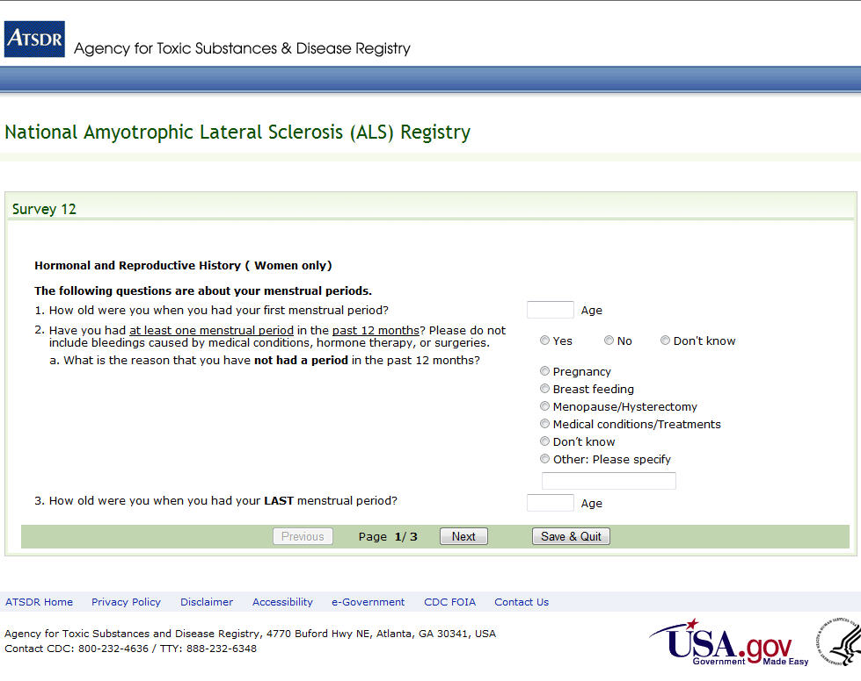Figure 61: Survey 12, Page 1 of 3

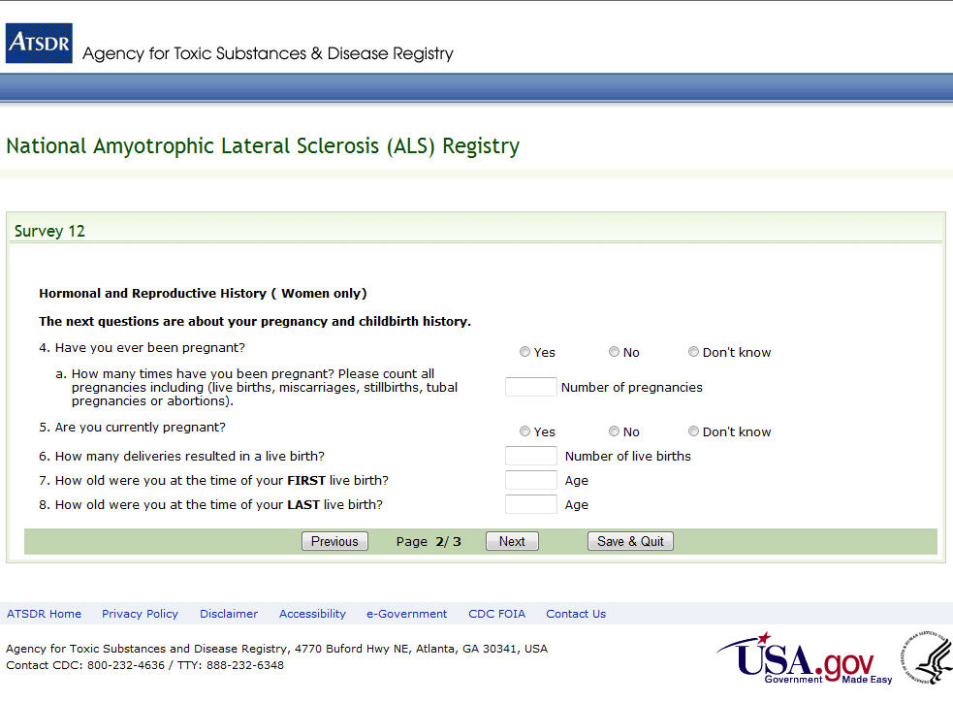Figure 62: Survey 12, Page 2 of 3

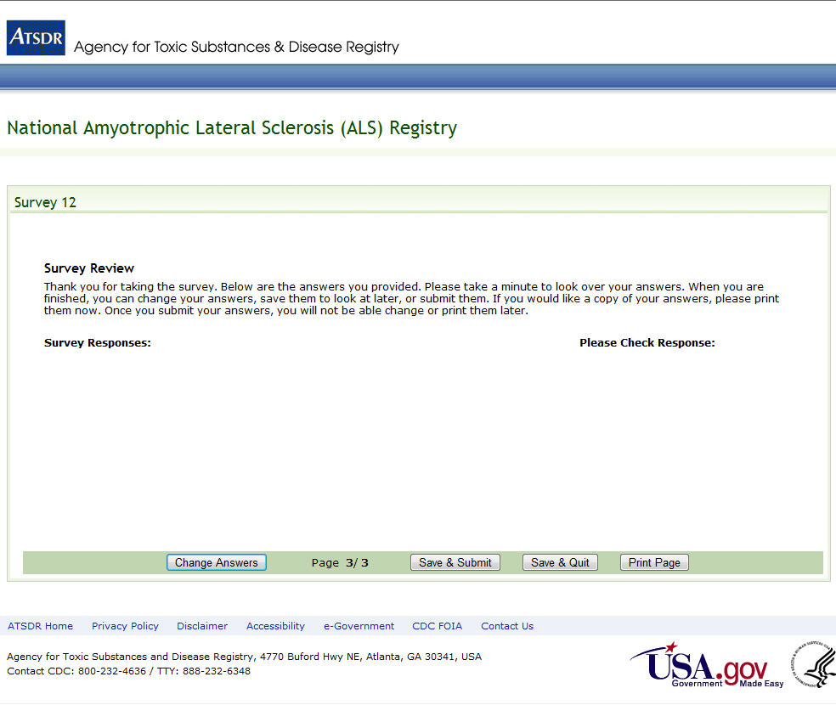Figure 63: Survey 12, Page 3 of 3

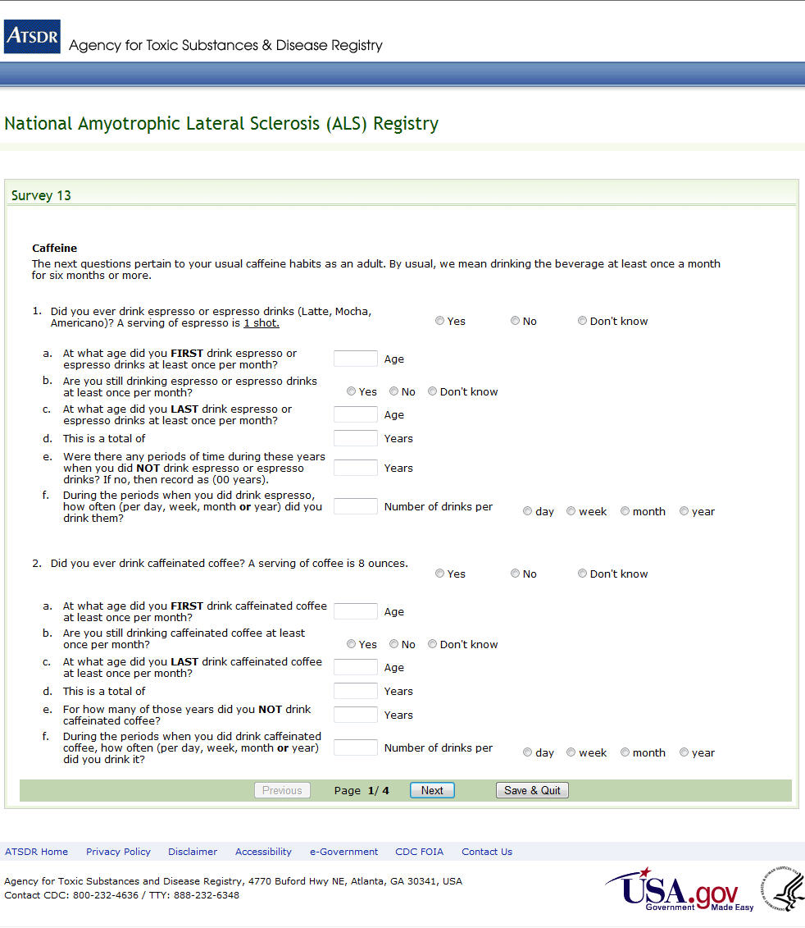Figure 64: Survey 13, Page 1 of 4

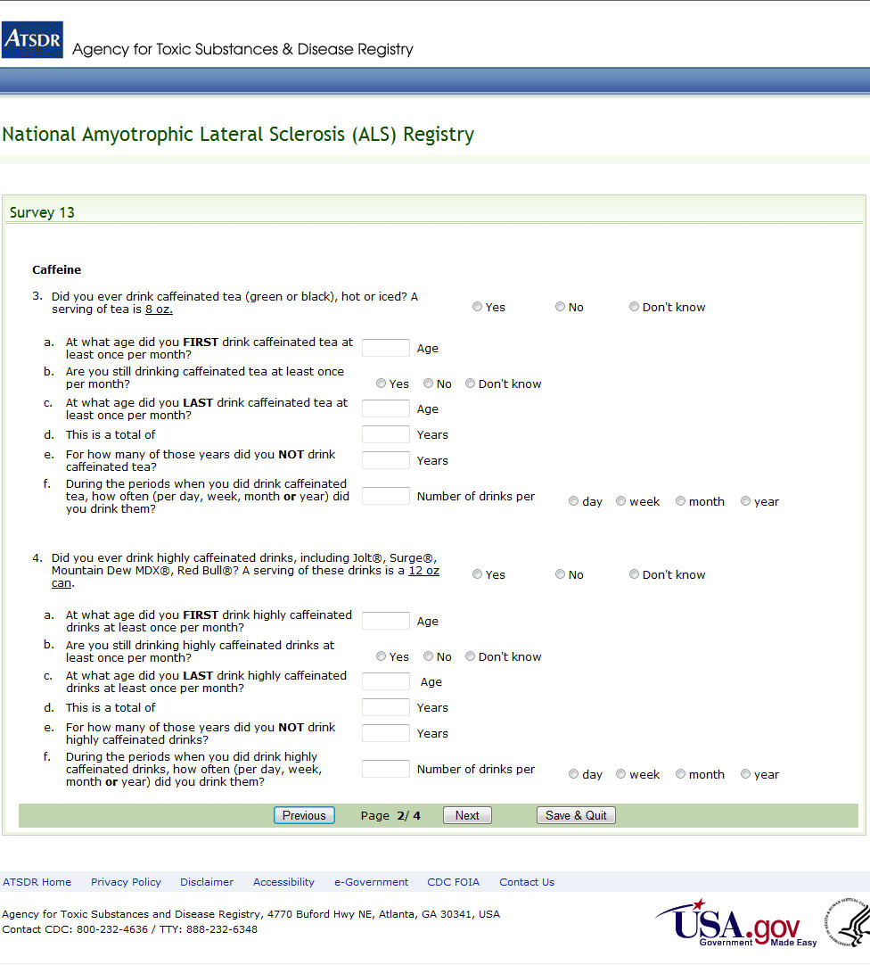Figure 65: Survey 13, Page 2 of 4

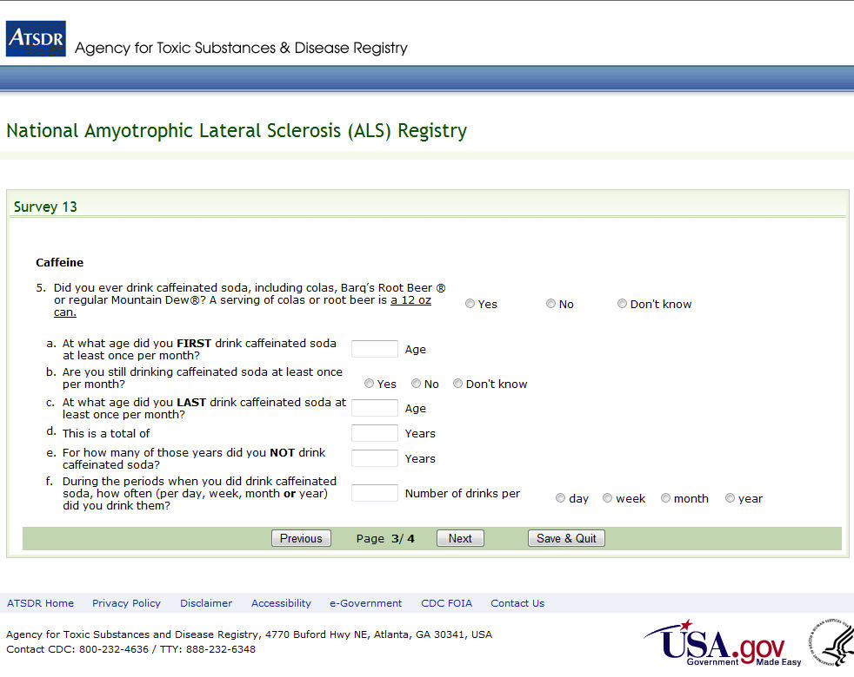Figure 66: Survey 13, Page 3 of 4

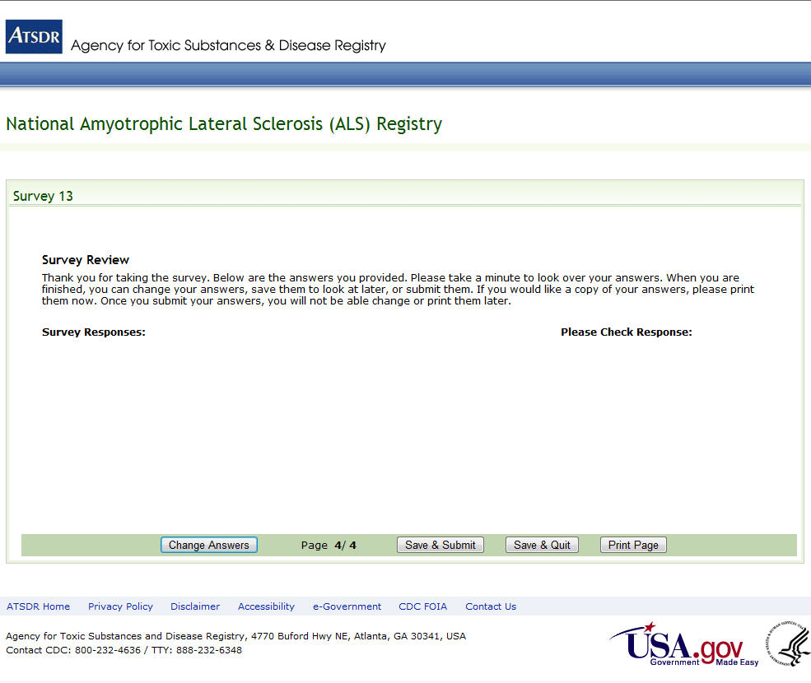
Figure 67: Survey 13, Page 4 of 4

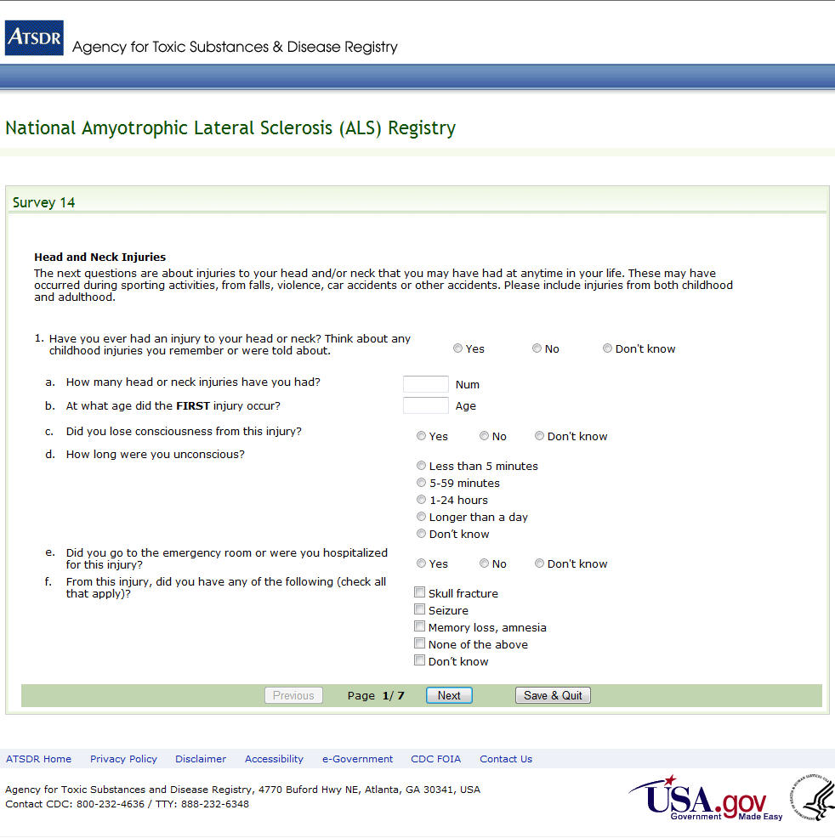
Figure 68: Survey 14, Page 1 of 7

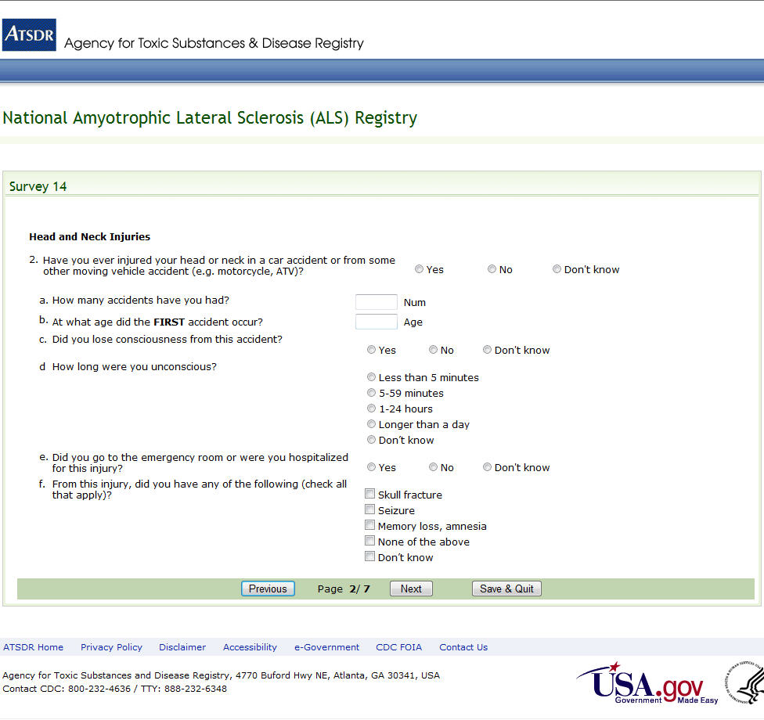Figure 69: Survey 14, Page 2 of 7

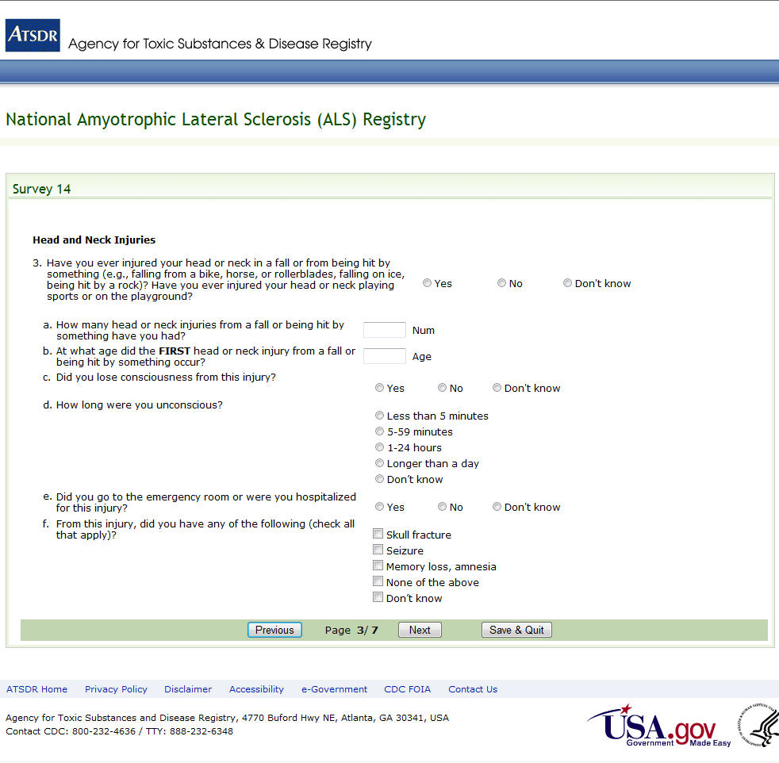Figure 70: Survey 14, Page 3 of 7

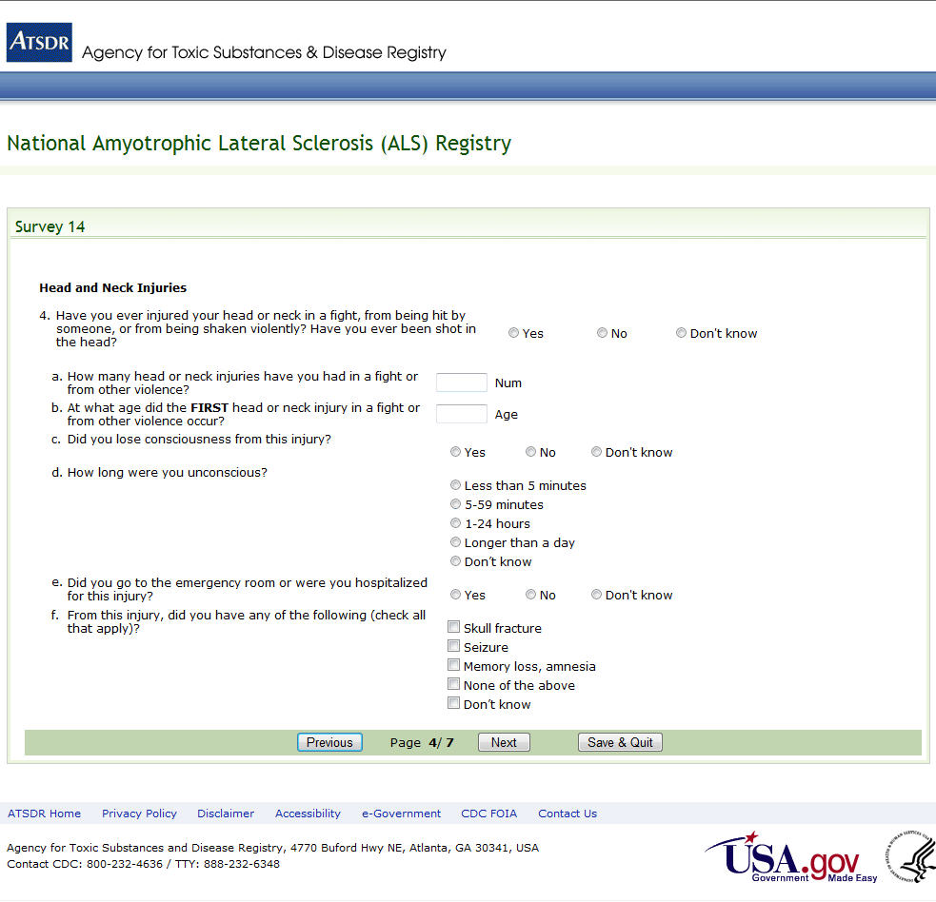Figure 71: Survey 14, Page 4 of 7

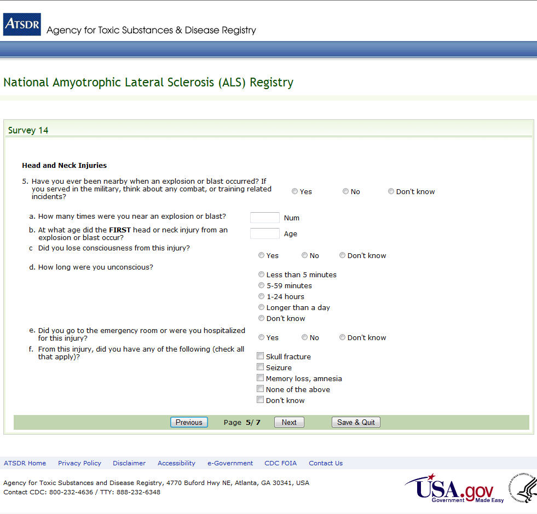Figure 72: Survey 14, Page 5 of 7

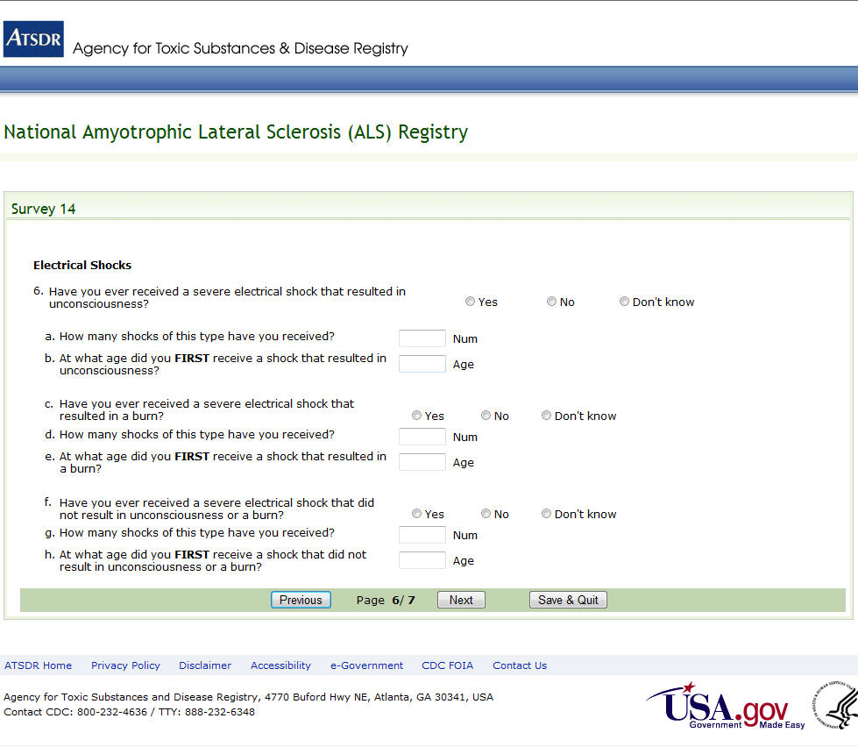Figure 73: Survey 14, Page 6 of 7

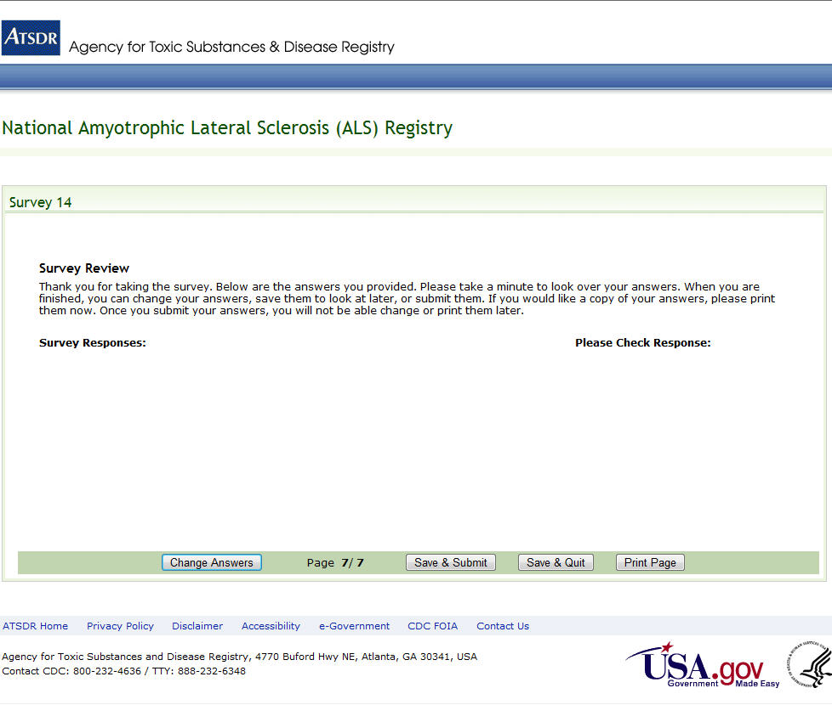Figure 74: Survey 14, Page 7 of 7

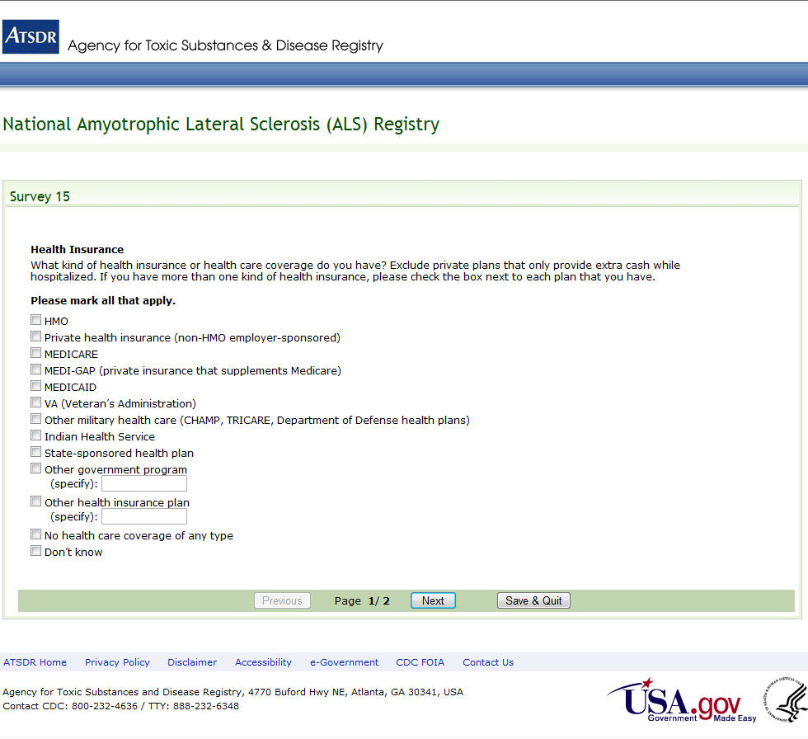Figure 75: Survey 15, Page 1 of 2

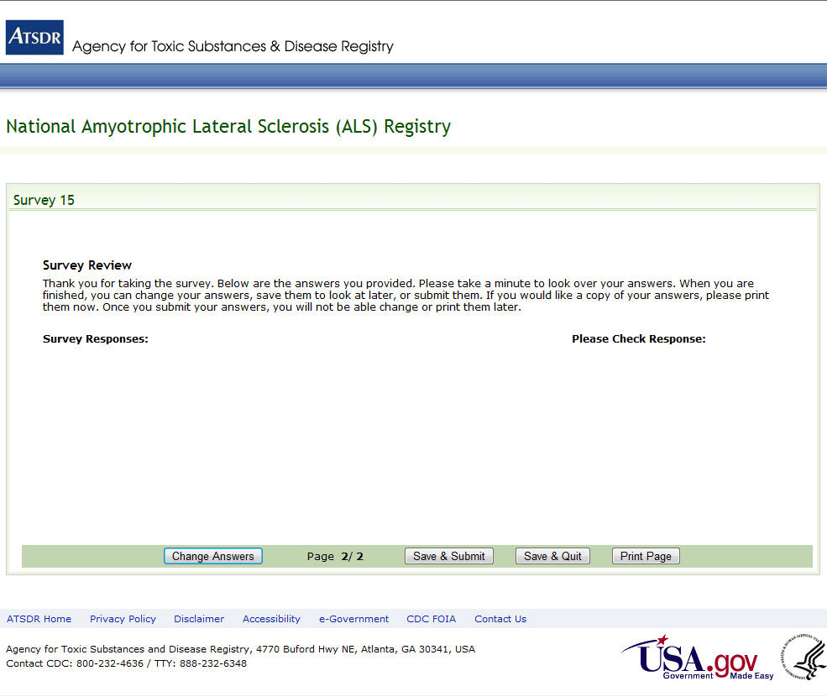Figure 76: Survey 15, Page 2 of 2

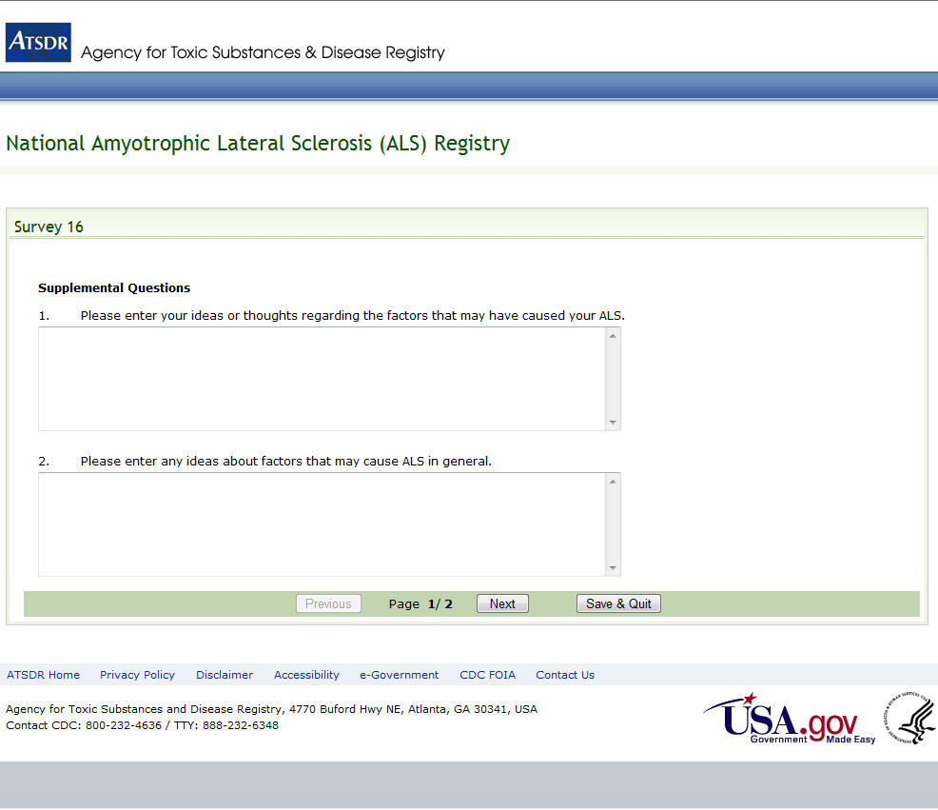Figure 77: Survey 16, Page 1 of 2

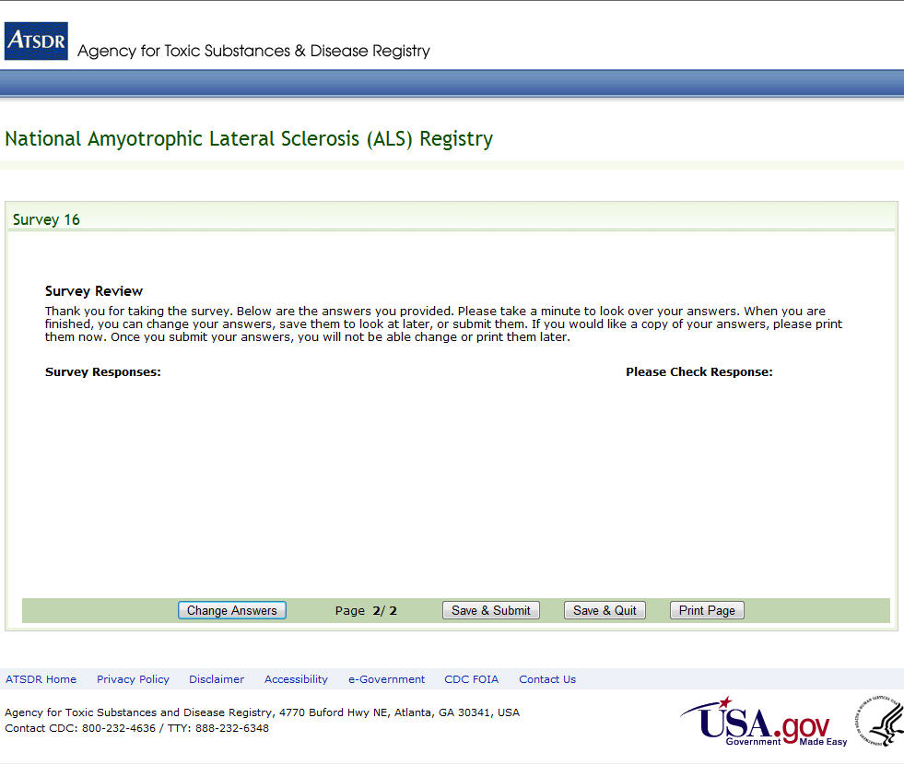Figure 78: Survey 16, Page 2 of 2

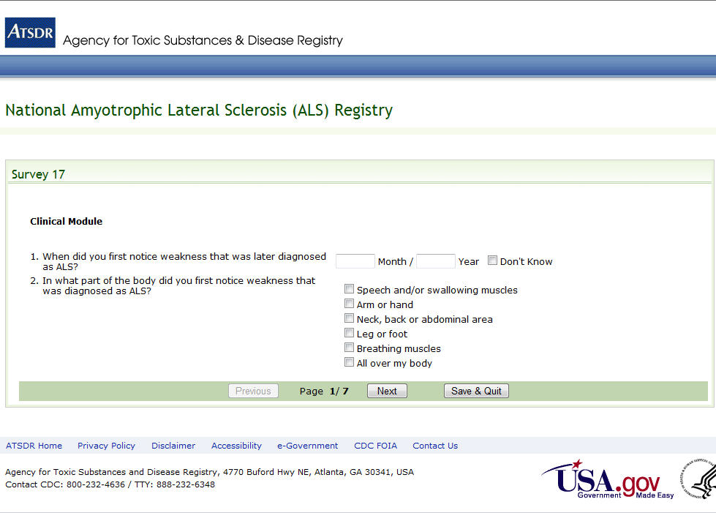
Figure 79: Survey 17, Page 1 of 7

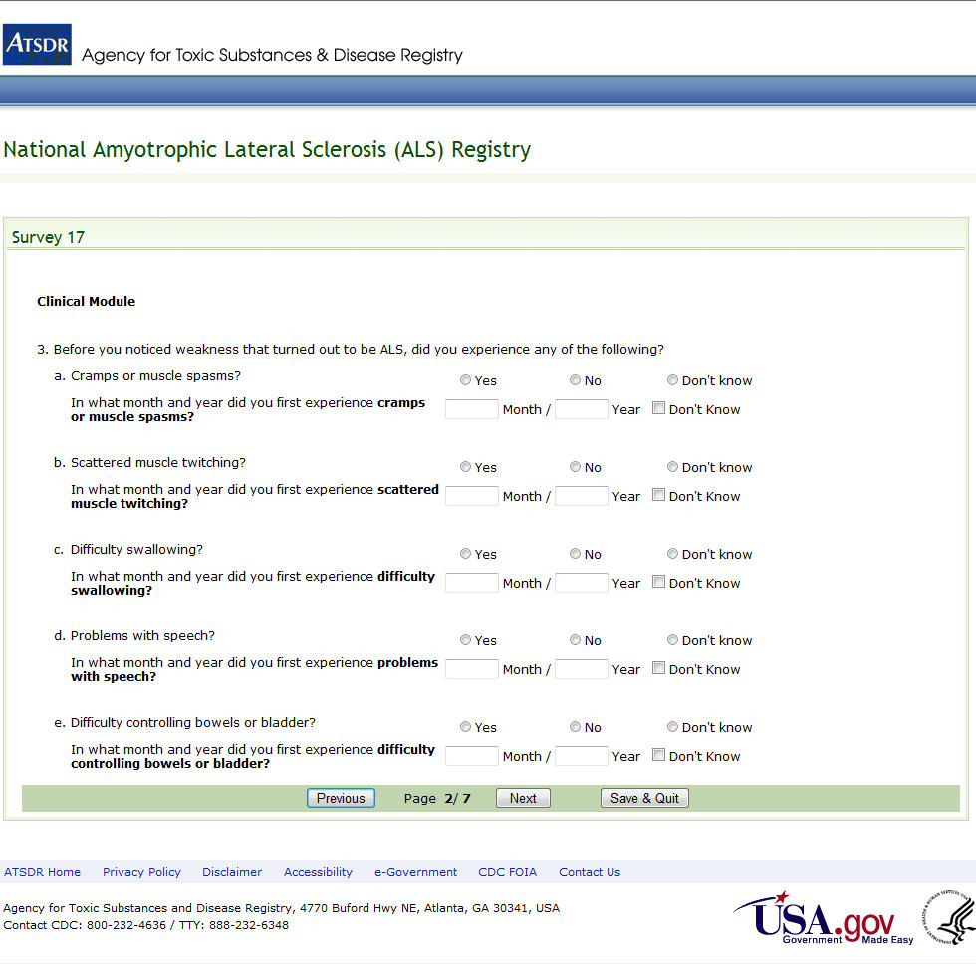Figure 80: Survey 17, Page 2 of 7

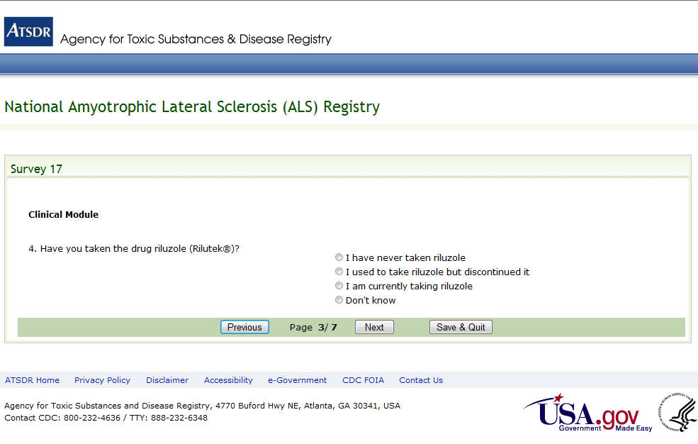
Figure 81: Survey 17, Page 3 of 7

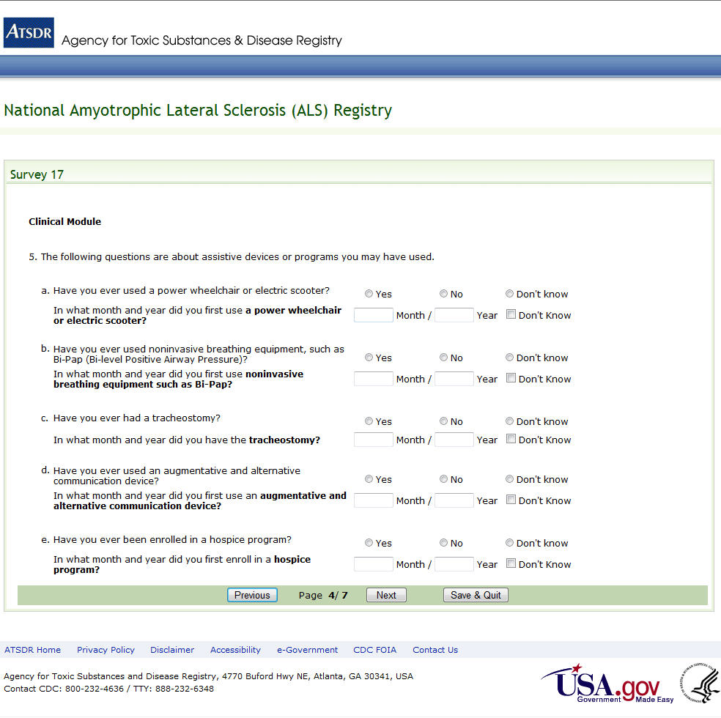
Figure 82: Survey 17, Page 4 of 7

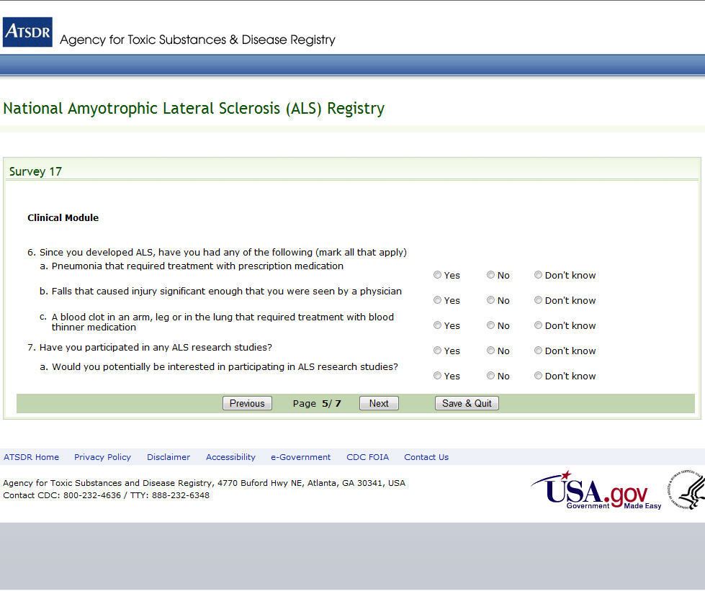
Figure 83: Survey 17, Page 5 of 7

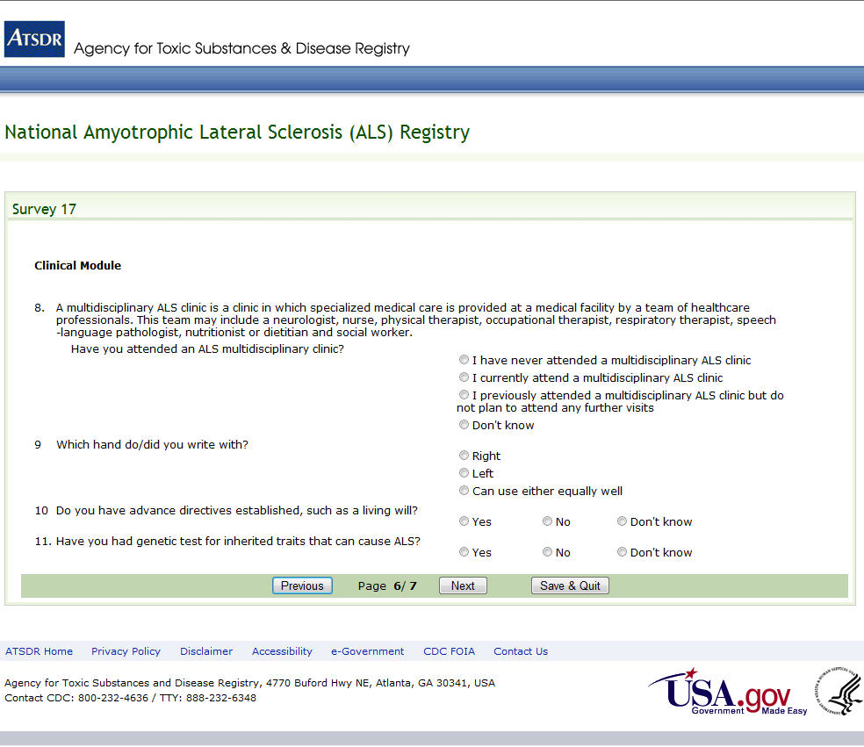
Figure 84: Survey 17, Page 6 of 7

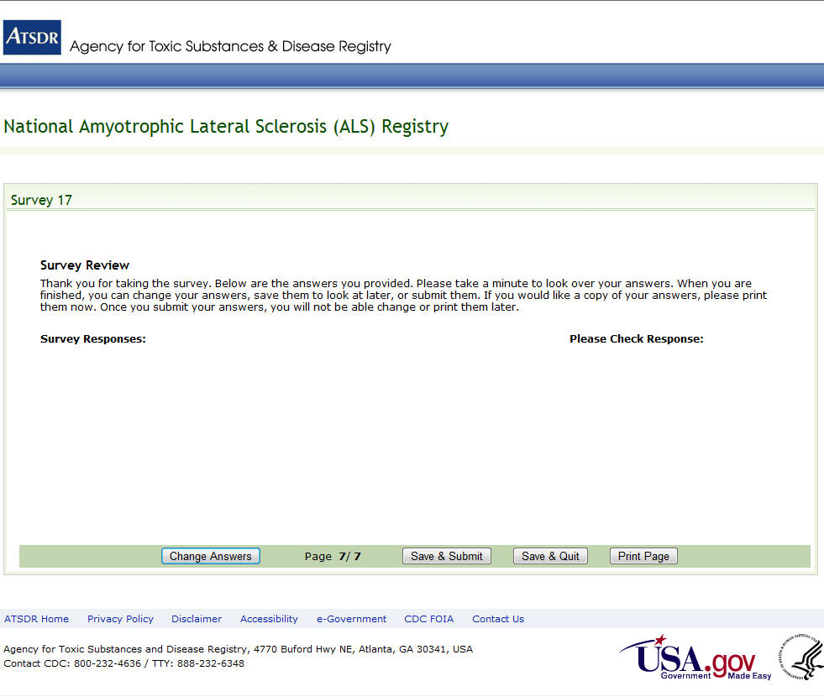Figure 85: Survey 17, Page 7 of 7

