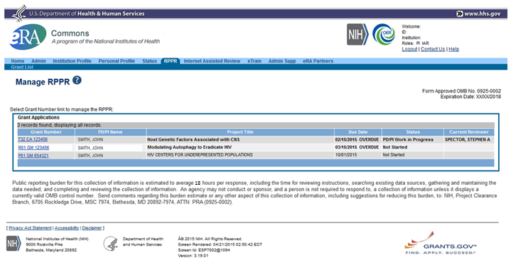
Expiration date: 02/28/2023

Section A – Cover Page
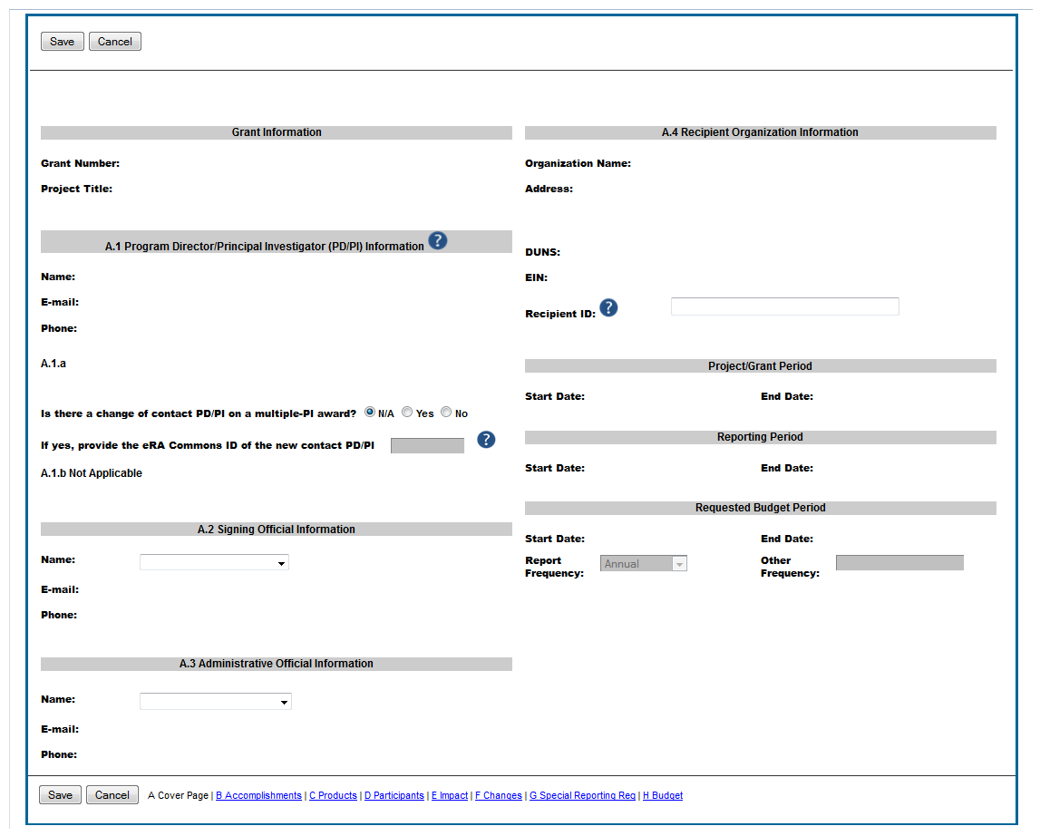
A.5 Notice of Award Authorized Official
Name:
Title:
Phone:
Email:

Section B – Accomplishments
B. Accomplishments (full screen)
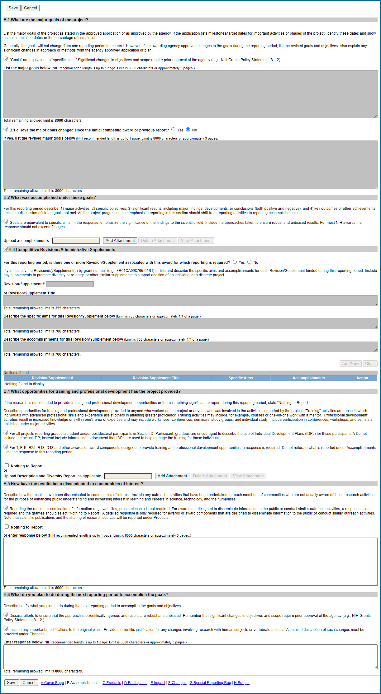
B1-2
B. Accomplishments (sections B1 – B4)
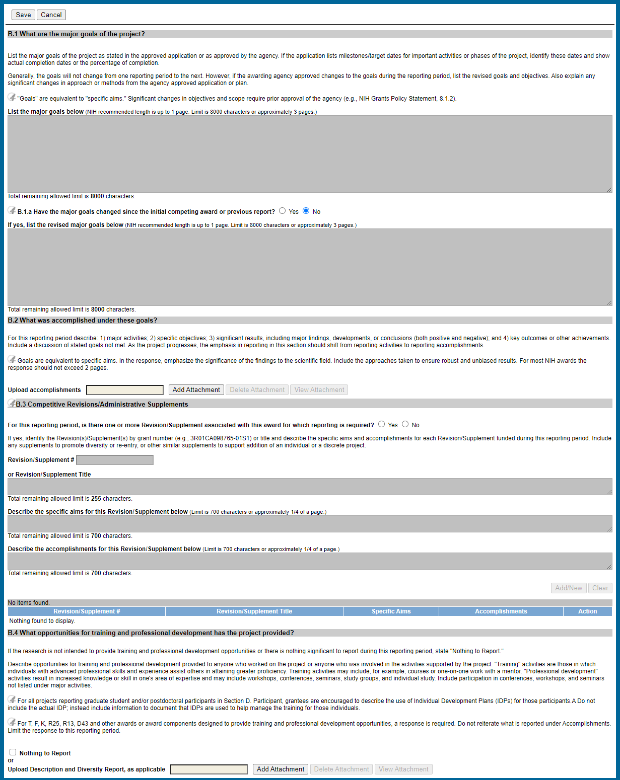
B3-4
B. Accomplishments (sections B3 – B4)
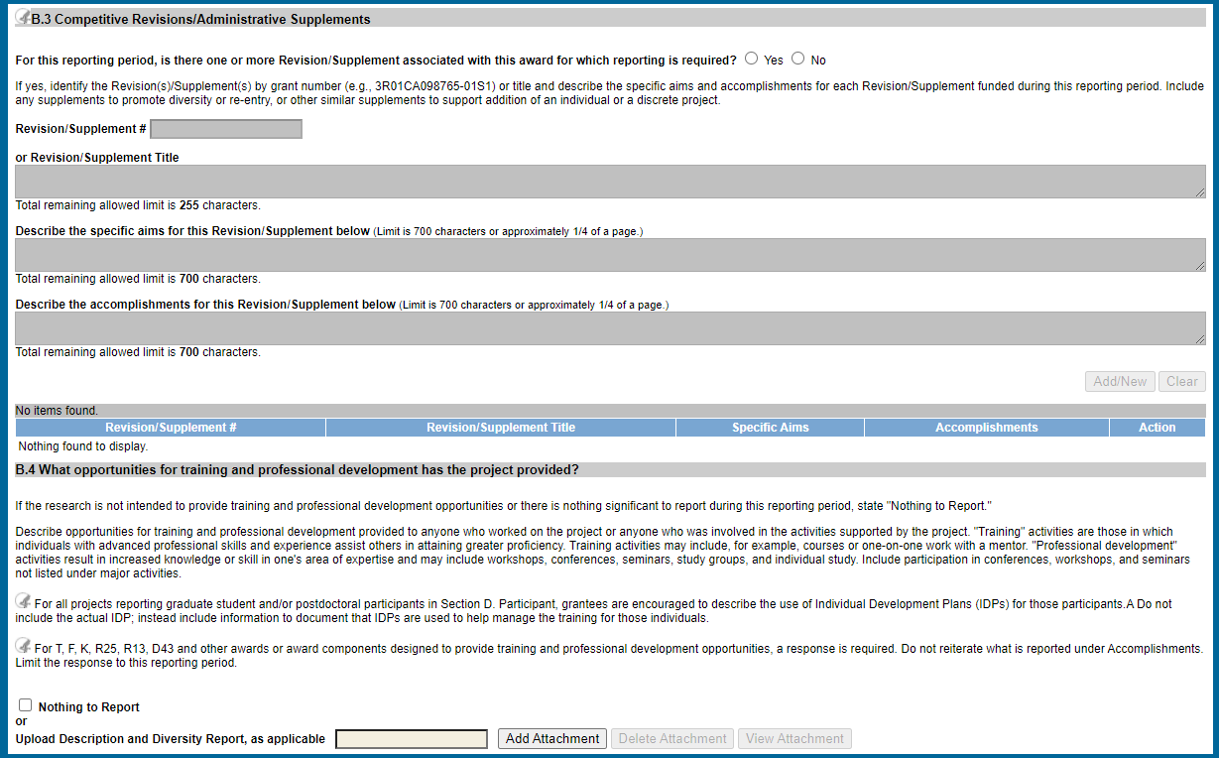
B5-6
B. Accomplishments (sections B5 – B6)
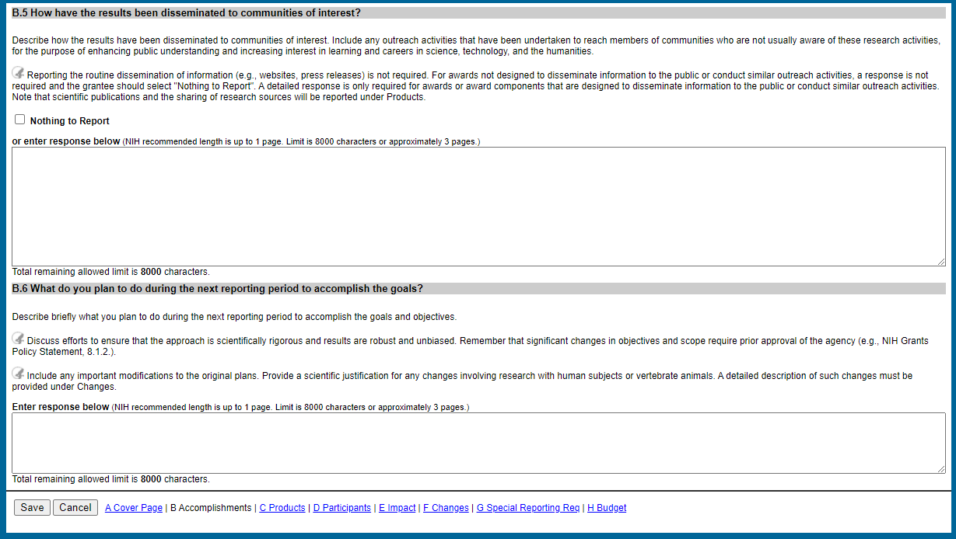
Section C – Products
C. Products (full screen)
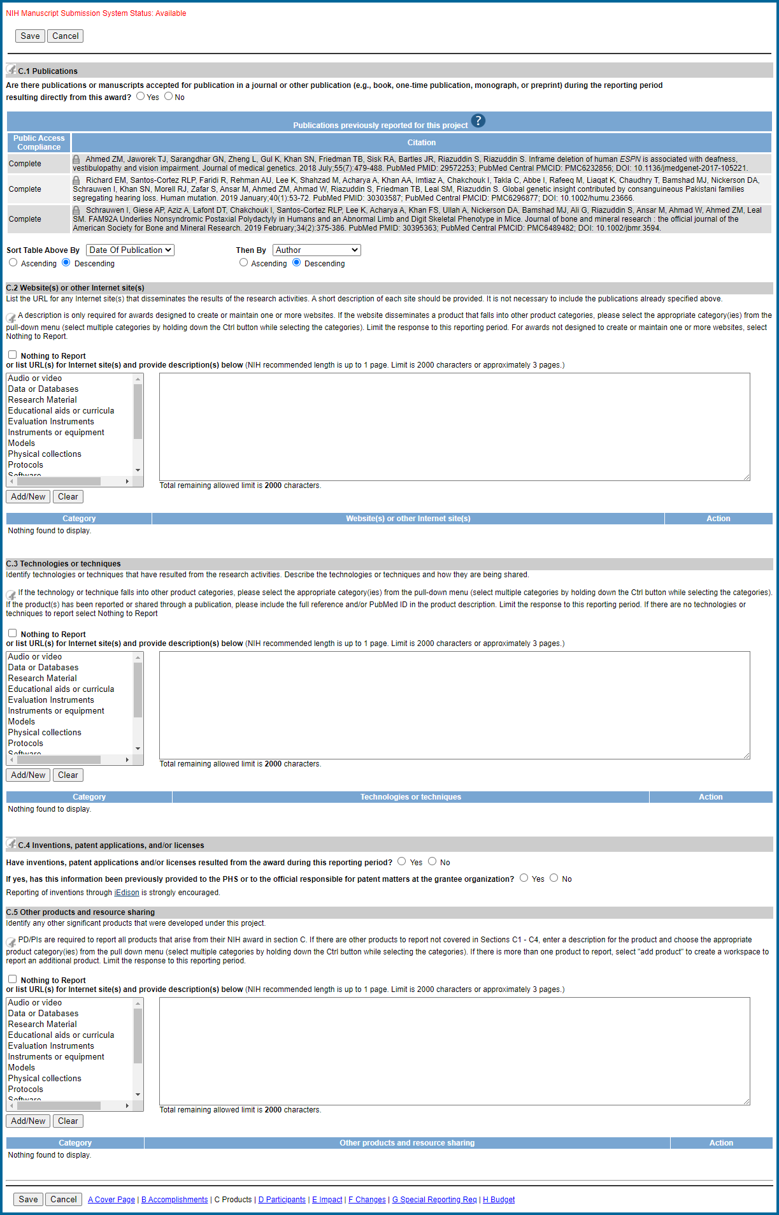
C1
C. Products (section C1)
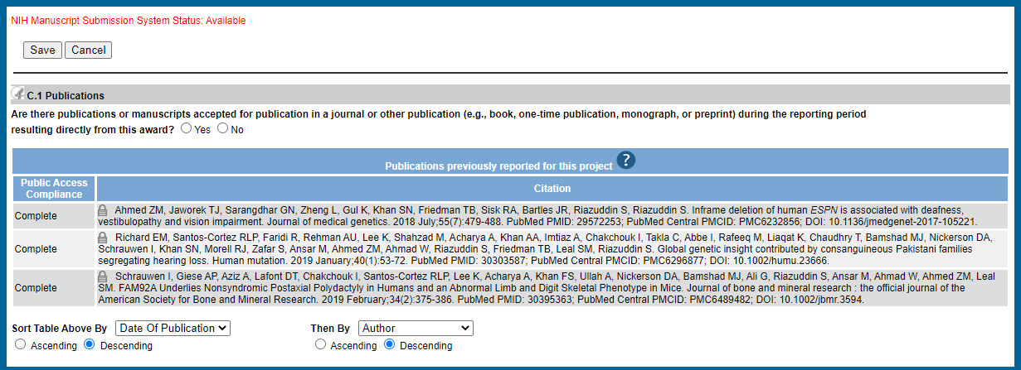
Proposed C2-5
C. Products (sections C2-C5)
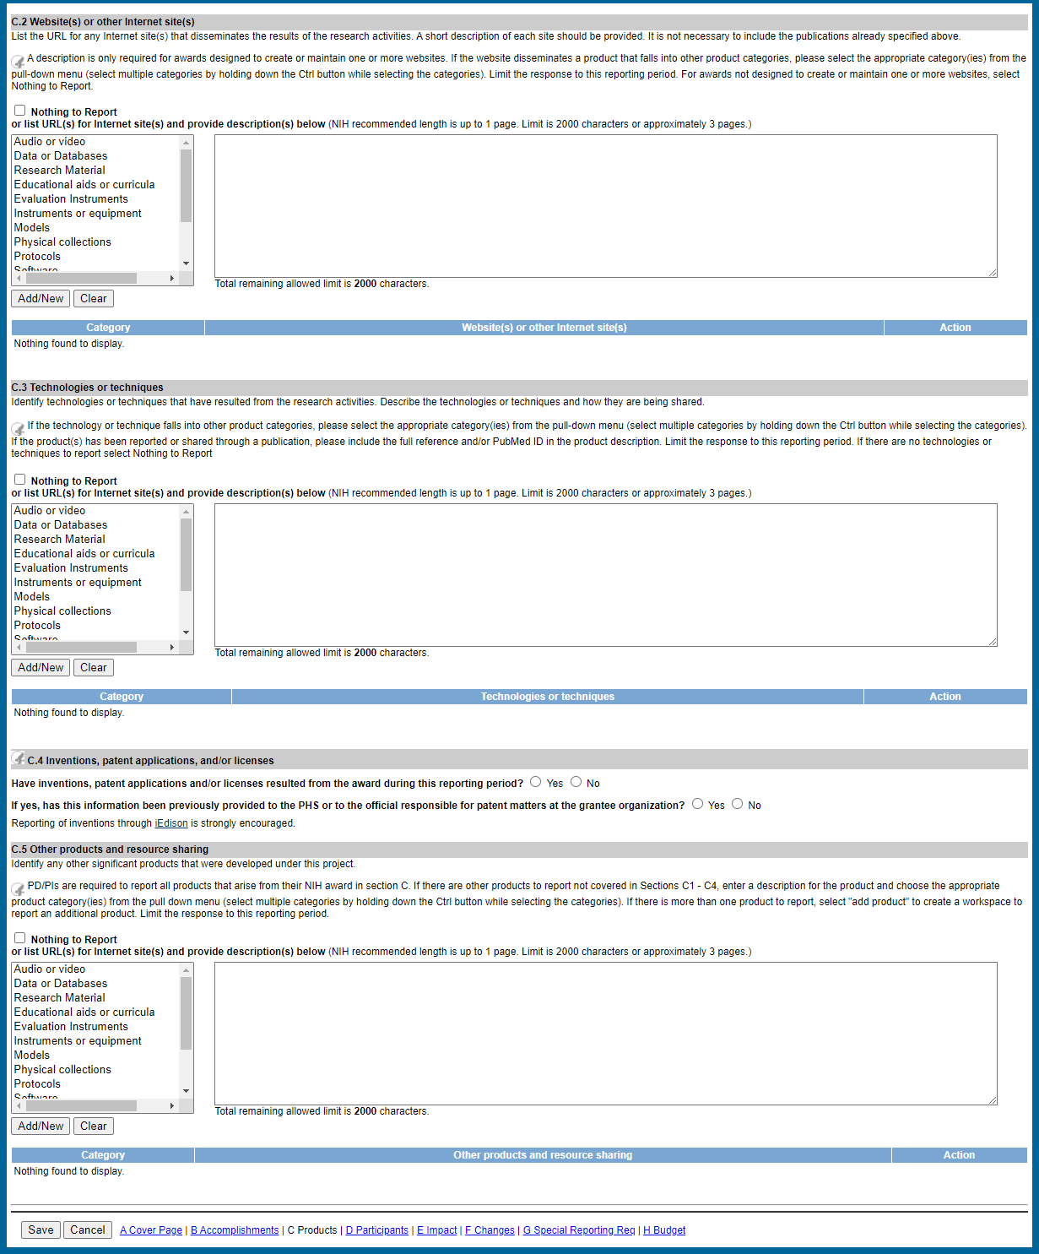
Section D – Participants
D. Participants (full screen)
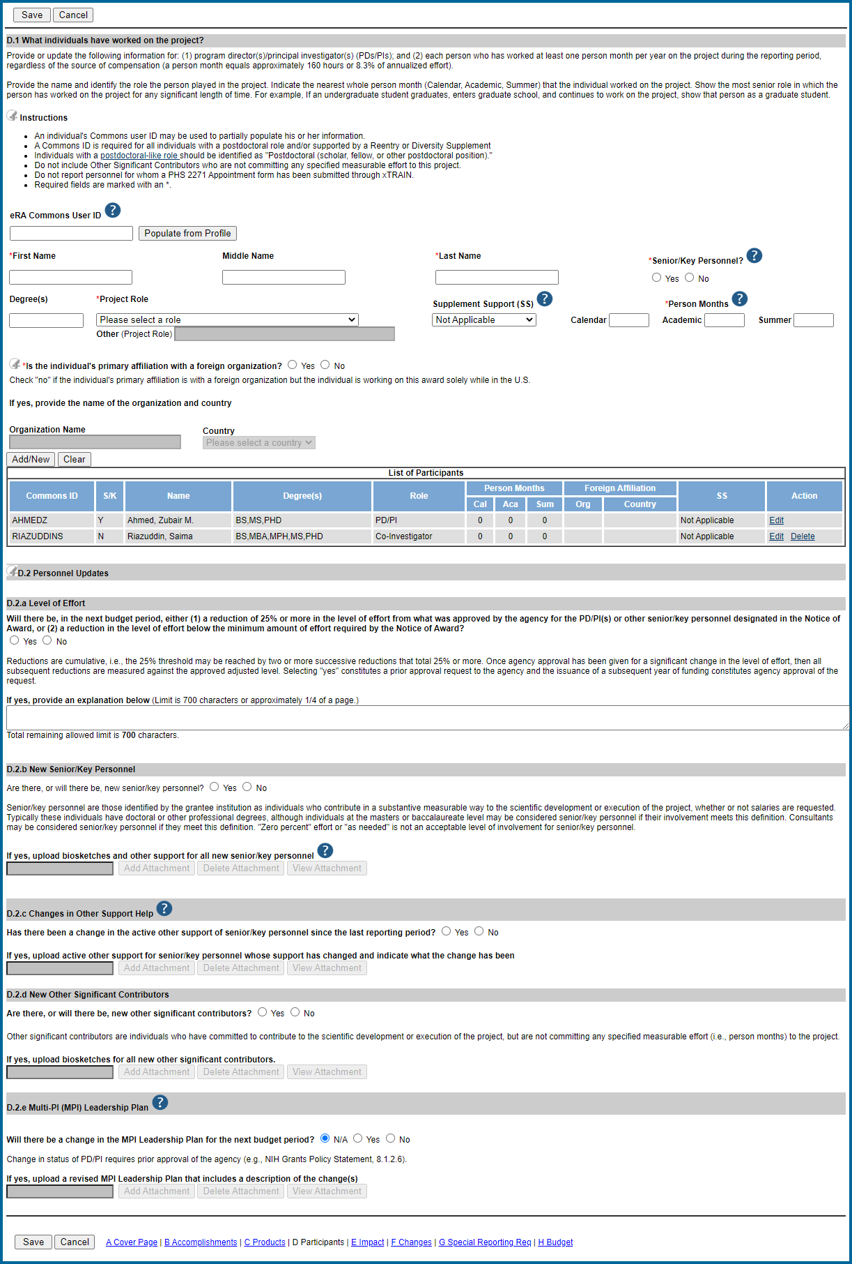
D1
D. Participants (section D1)
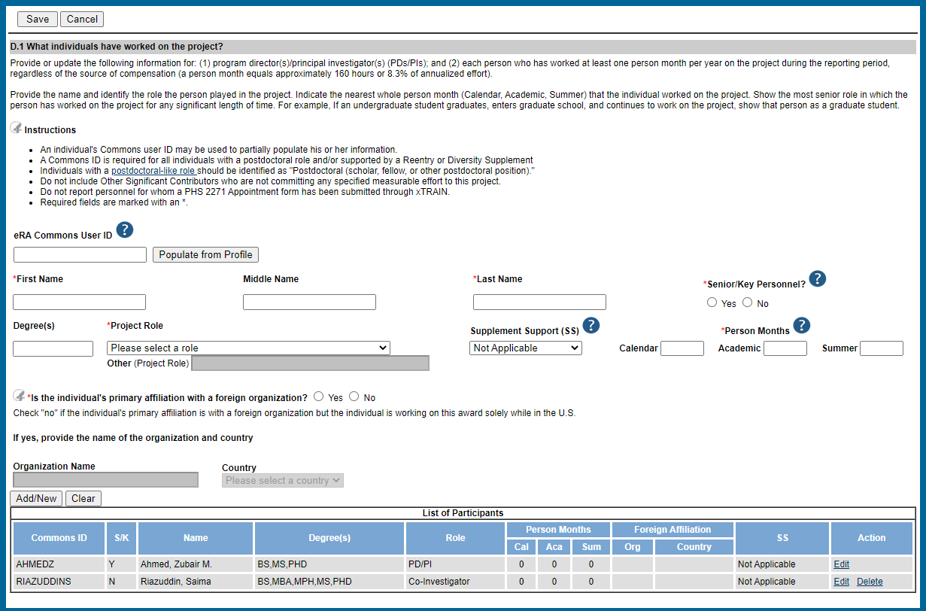
D2a-d
D. Participants (section D2, subsections a-d)
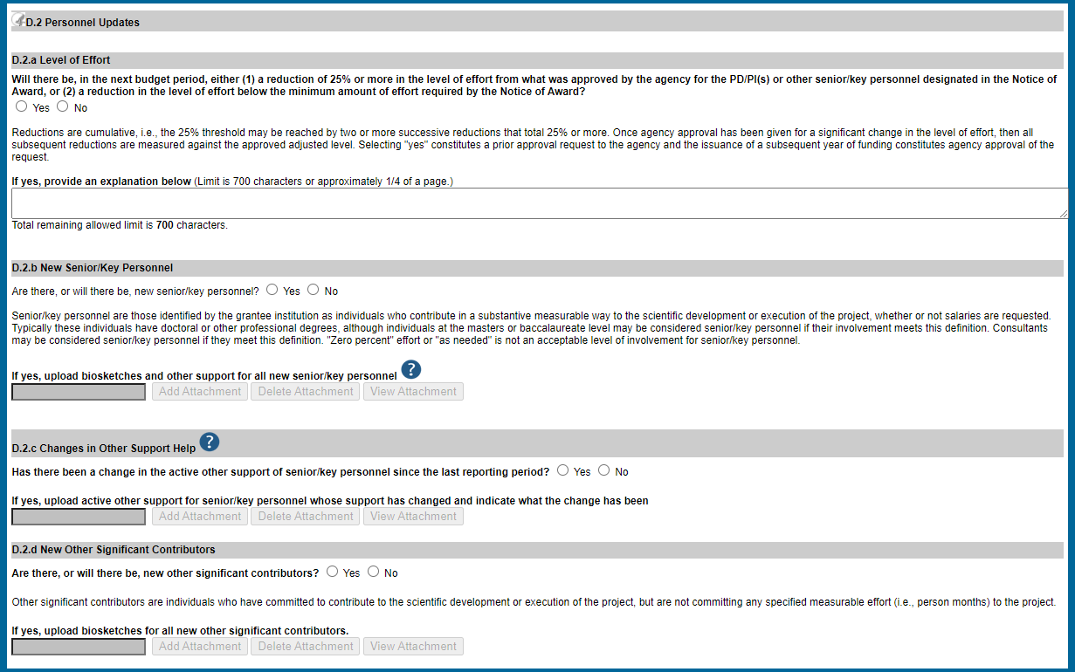
D2e
D. Participants (section D2, subsection e)
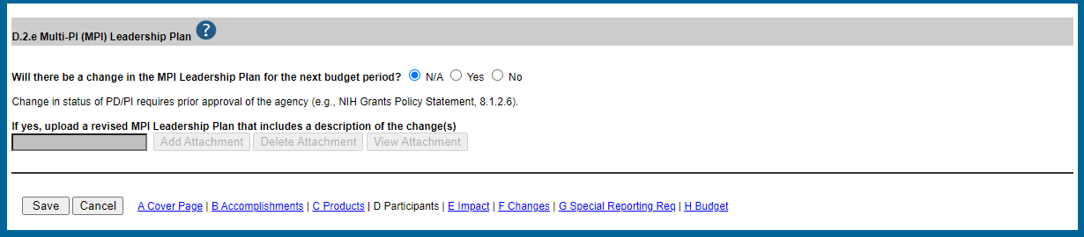
Section E - Impact
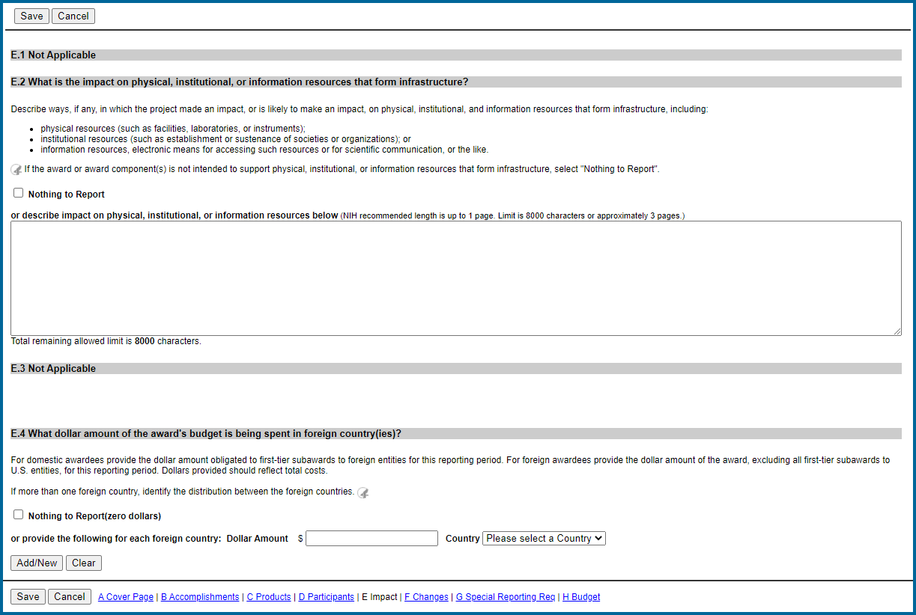
Section F - Changes
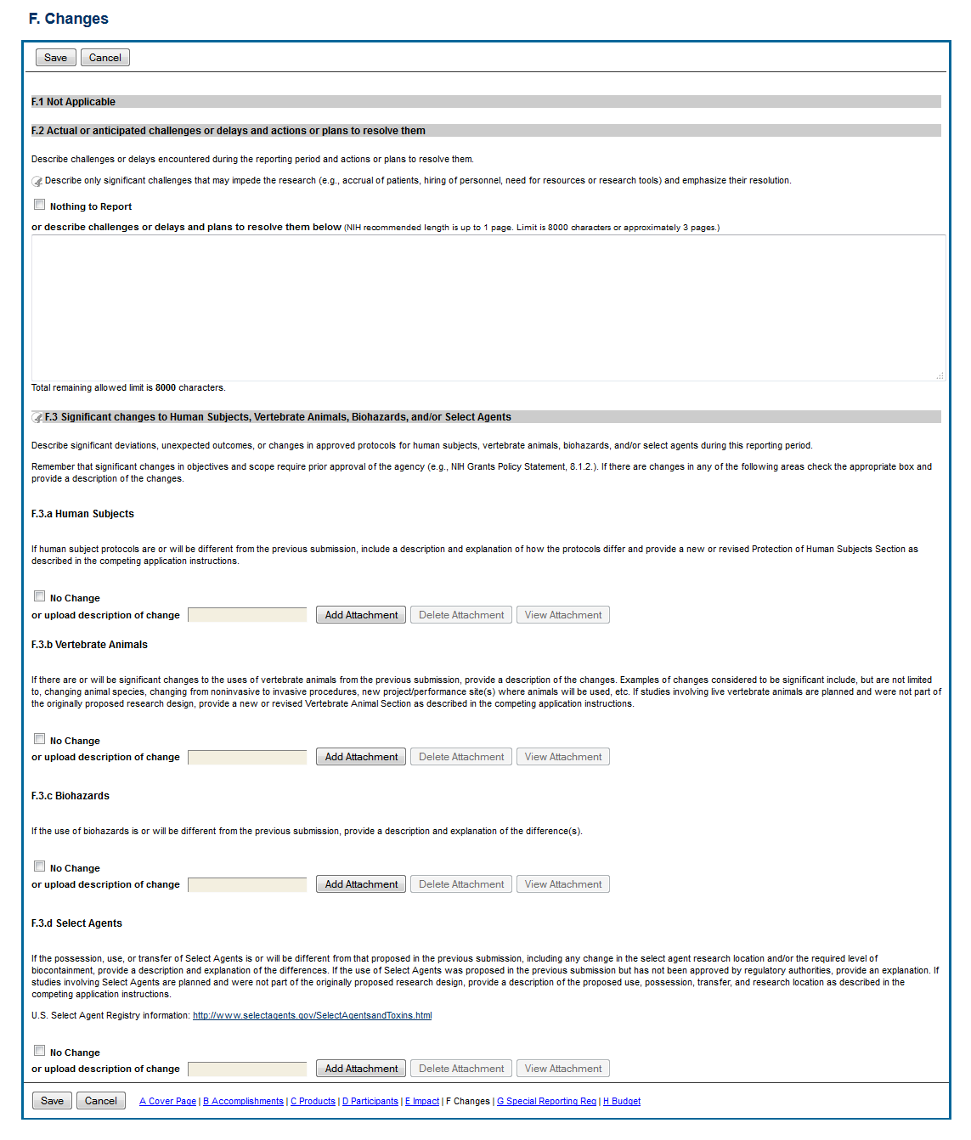
F1-2
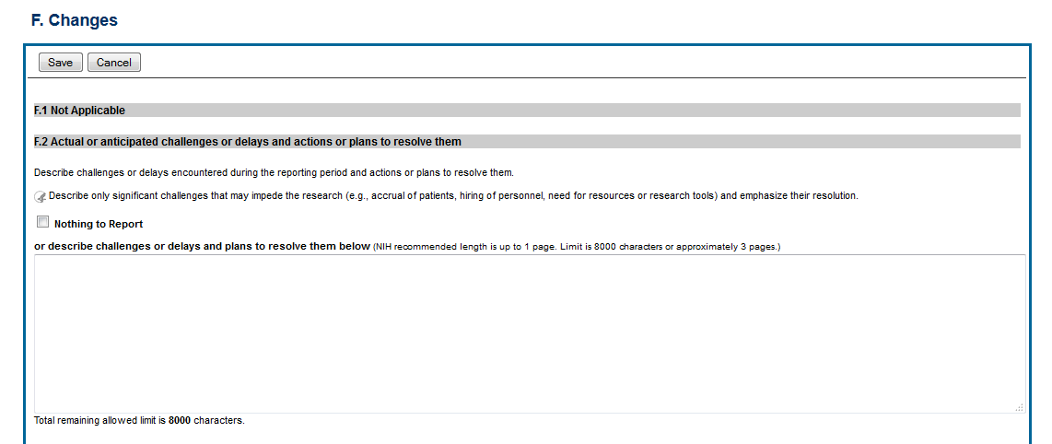
F3a-d

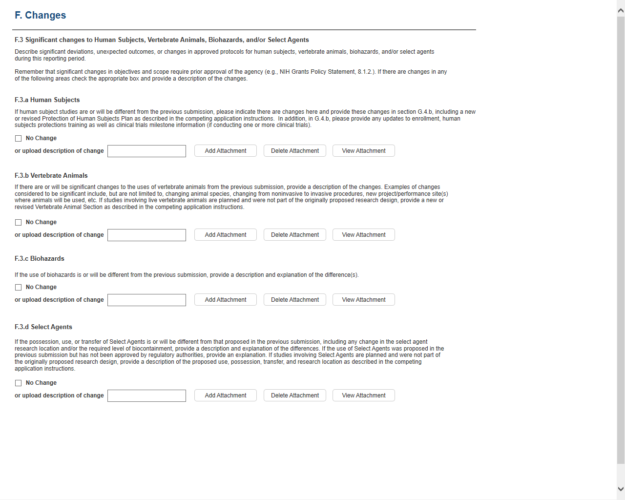
Section G – Special Reporting
G. Special Reporting (full screen)
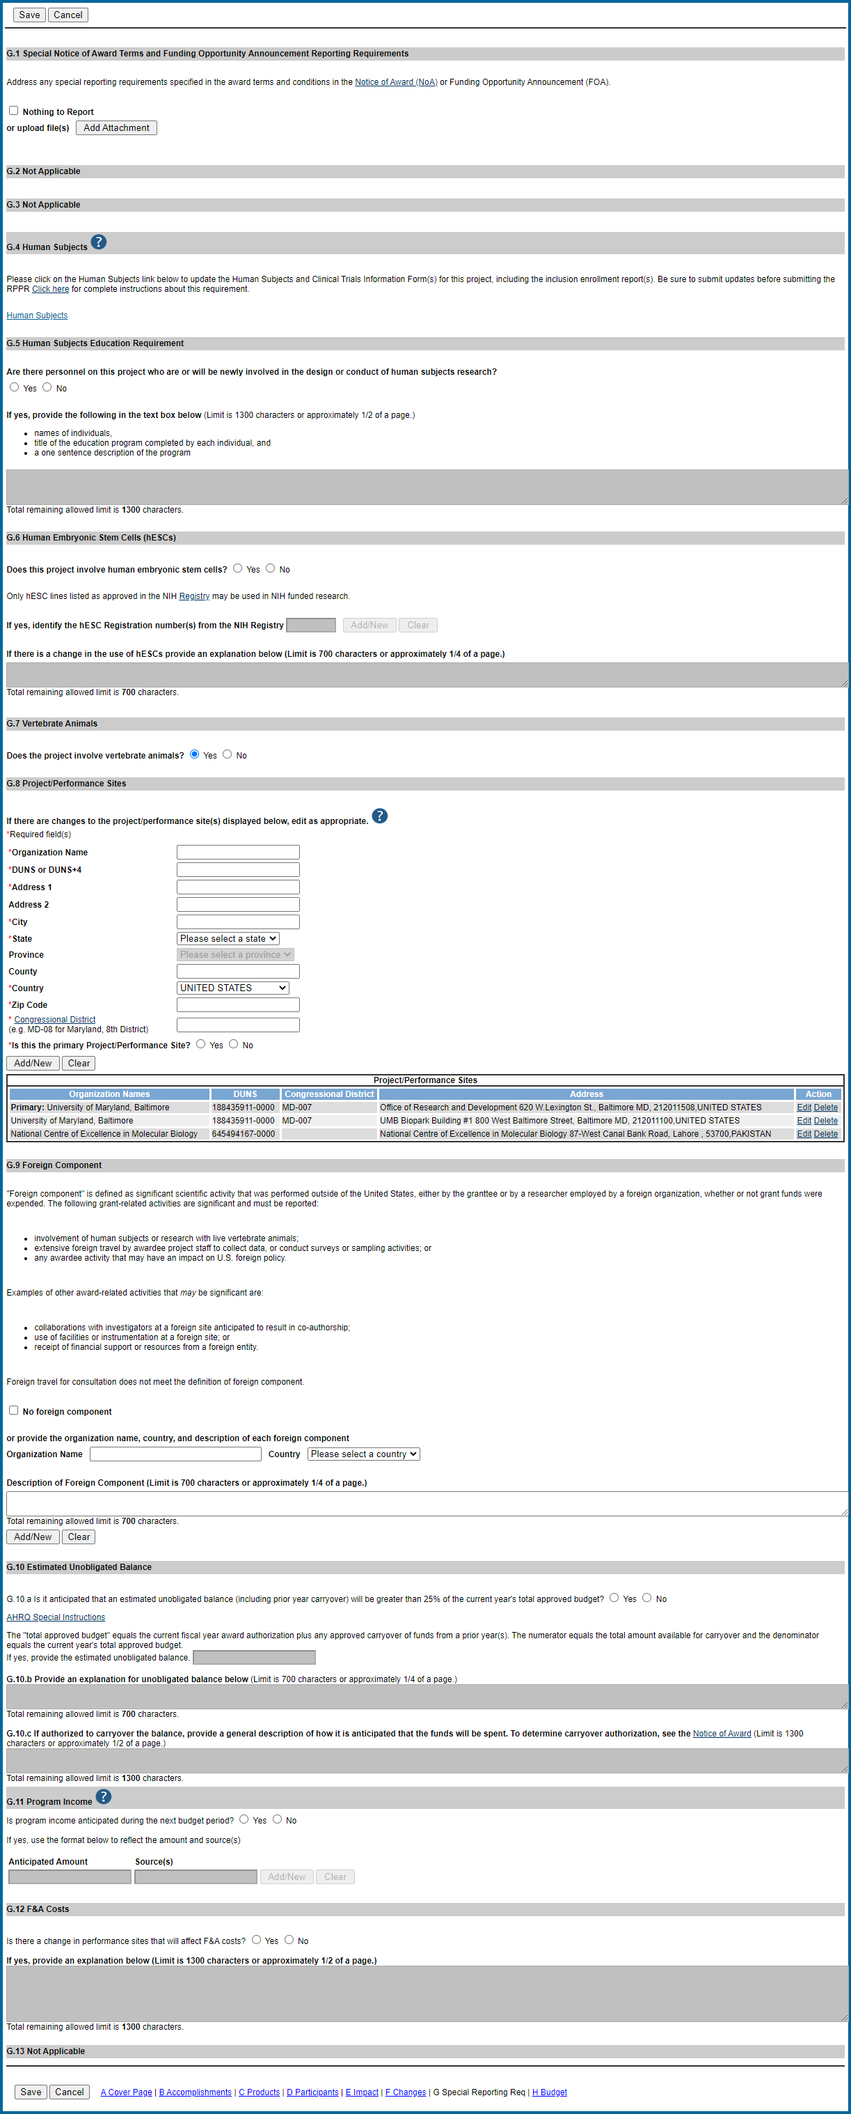
G1-3
G. Special Reporting (sections G1 – G3)
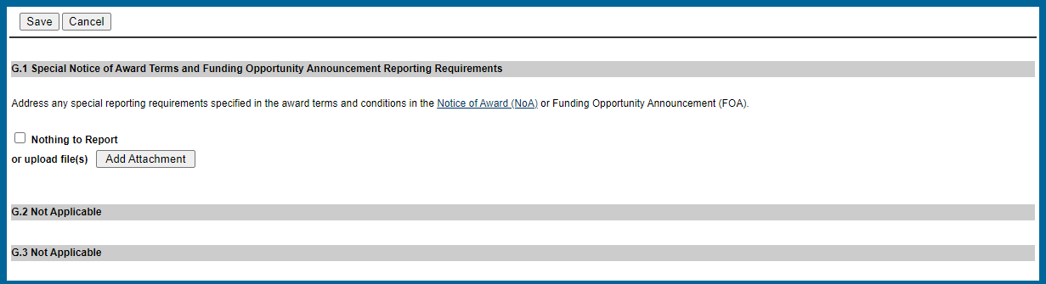

G4-5
G. Special Reporting (sections G4 – G5)
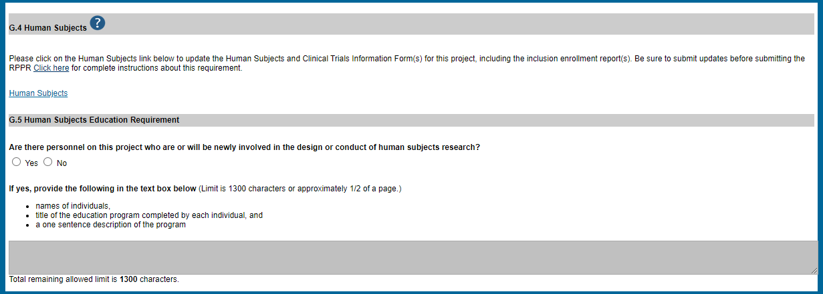
G6
G. Special Reporting (section G6)
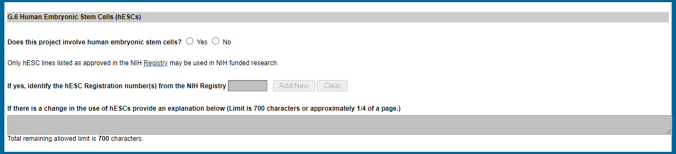
G7-8
G. Special Reporting (sections G7 – G8)
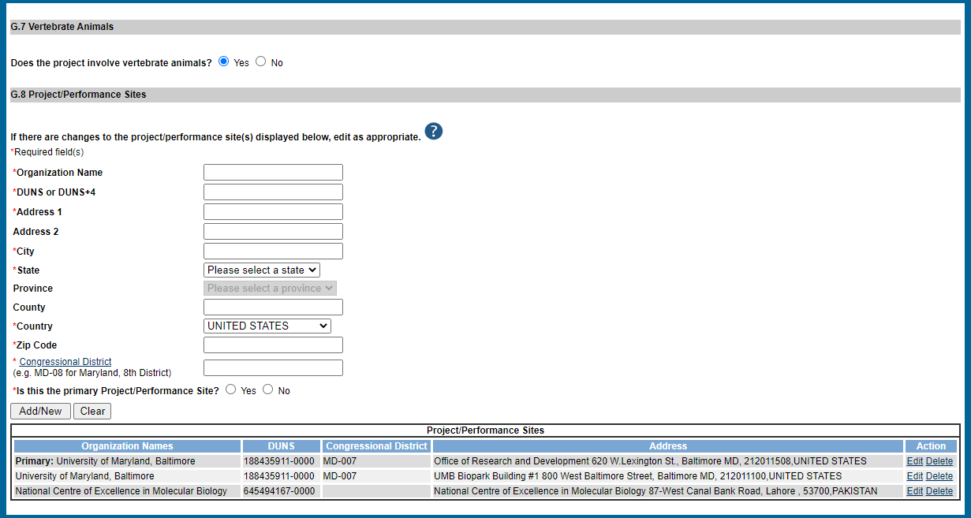
UEI
G9-10
G. Special Reporting (sections G9 – G10)
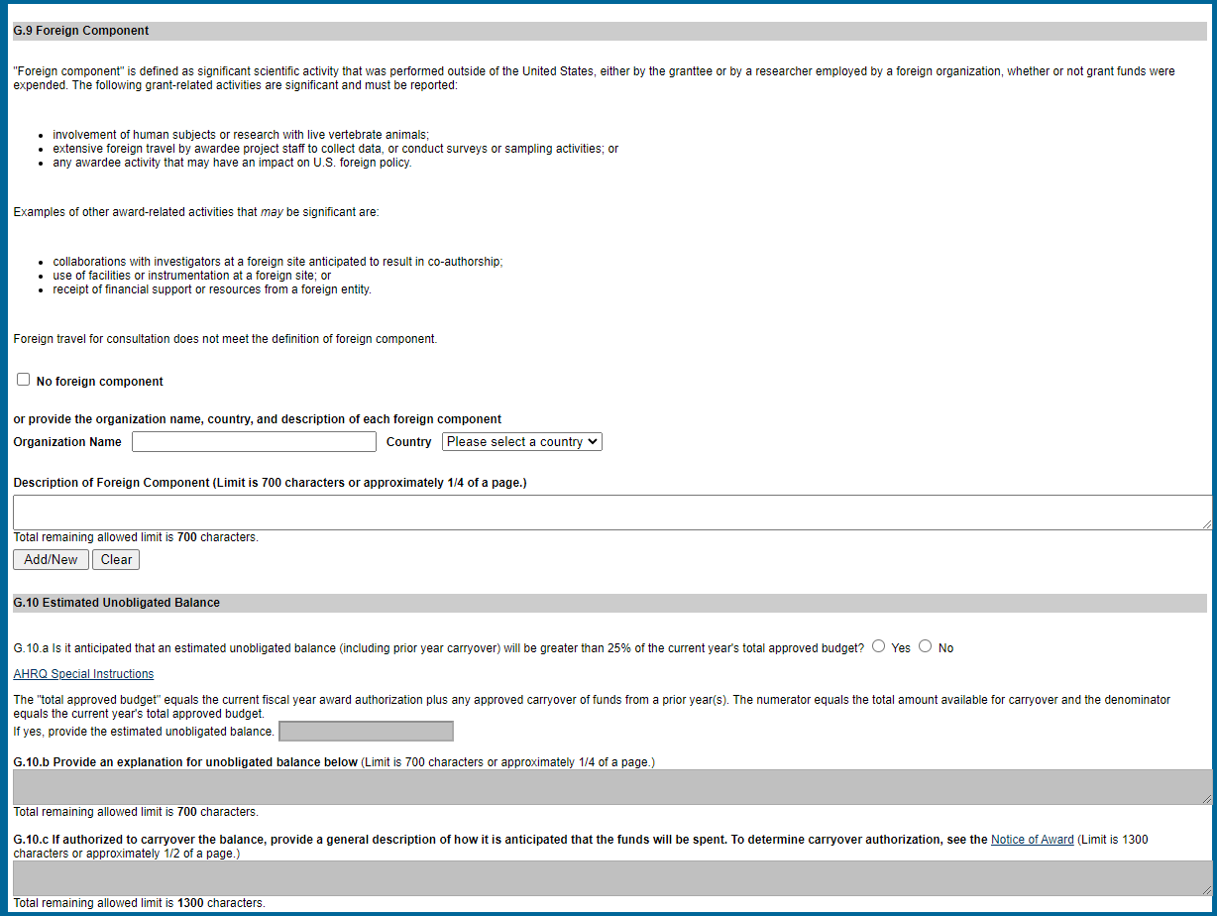
G11-G12
G. Special Reporting (sections G11 – G12)
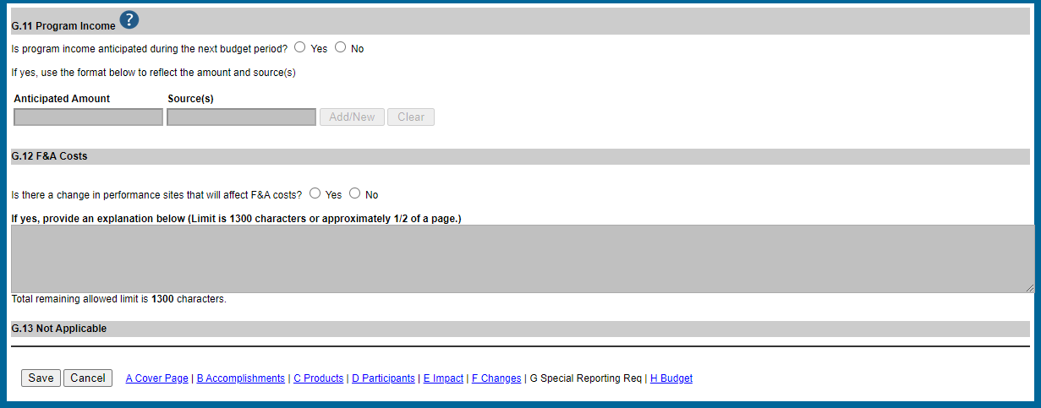
Section H - Budget
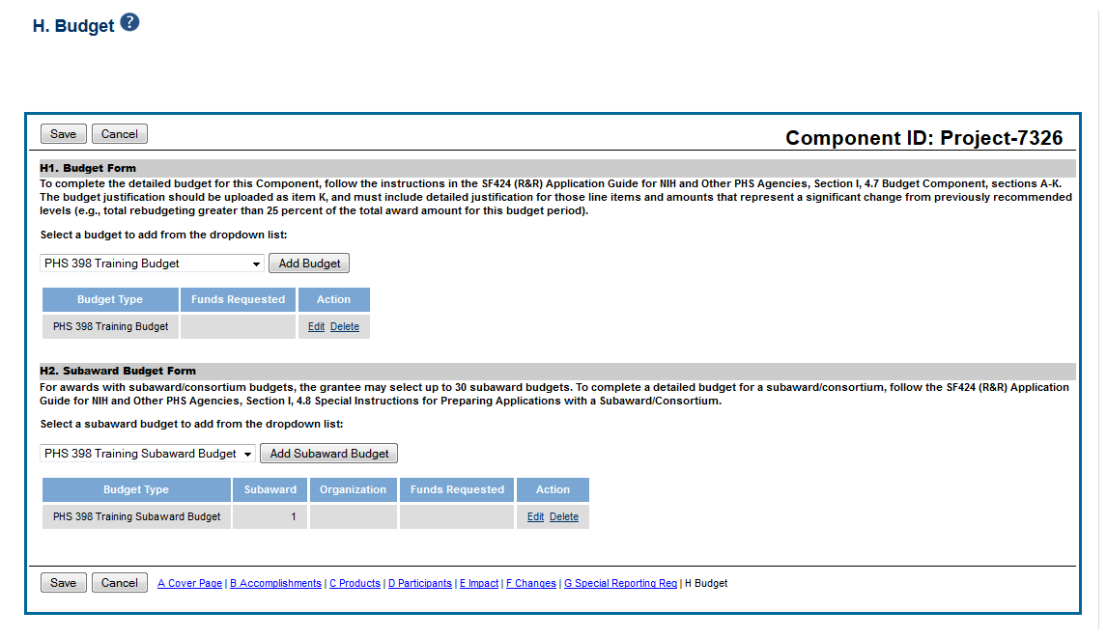

Section I - Outcomes
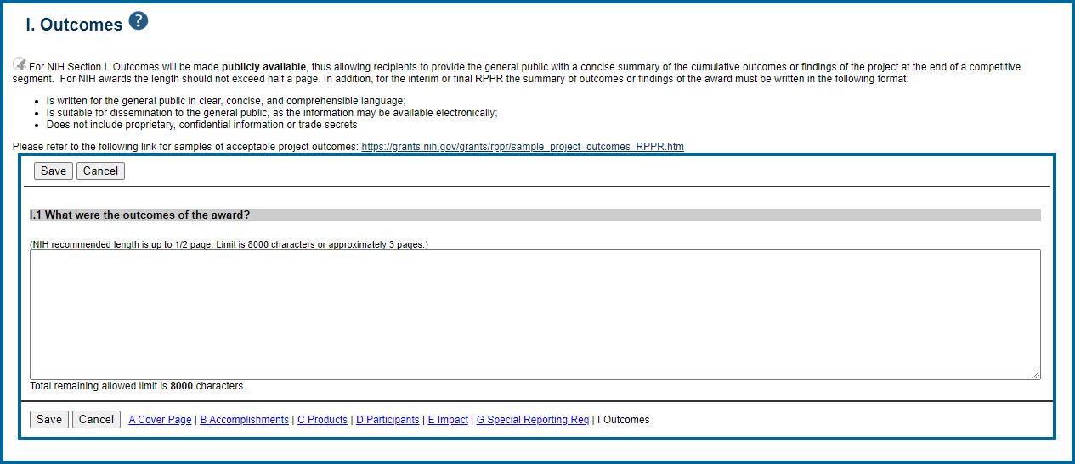
SF424 Budget
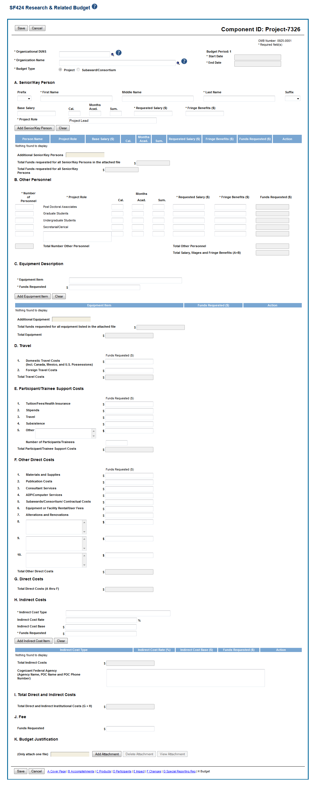
Organizational UEI
SF242 - A
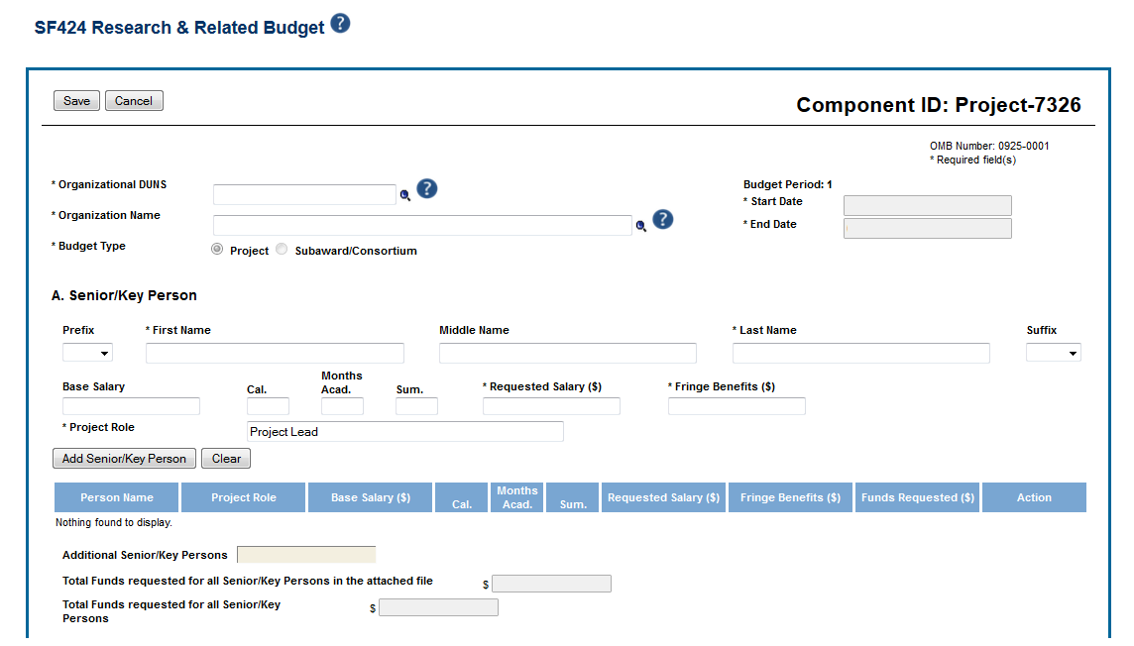
Organizational UEI
SF242 B-D
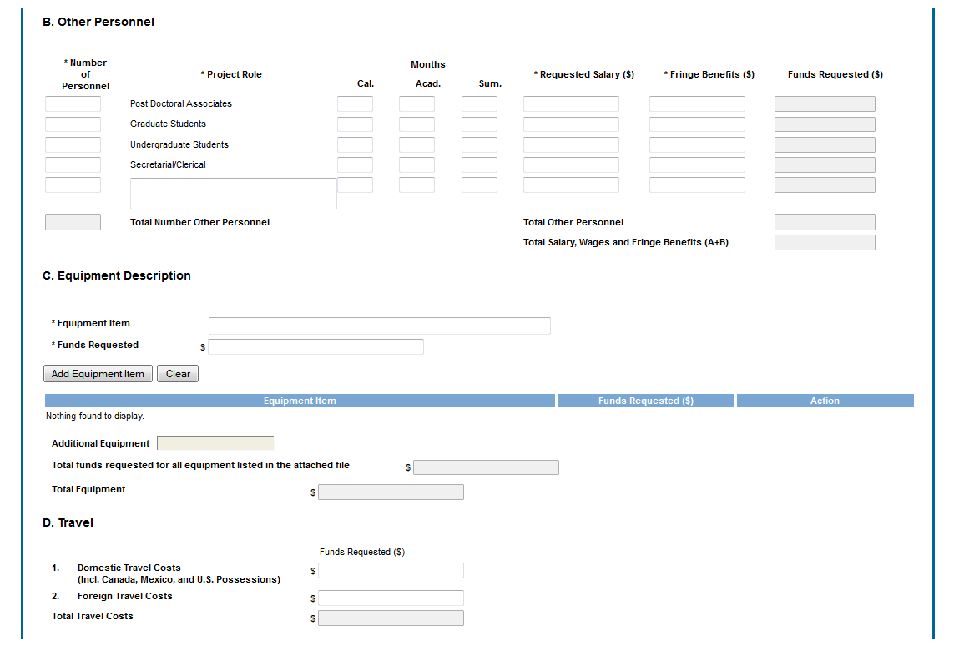
SF424 E-F
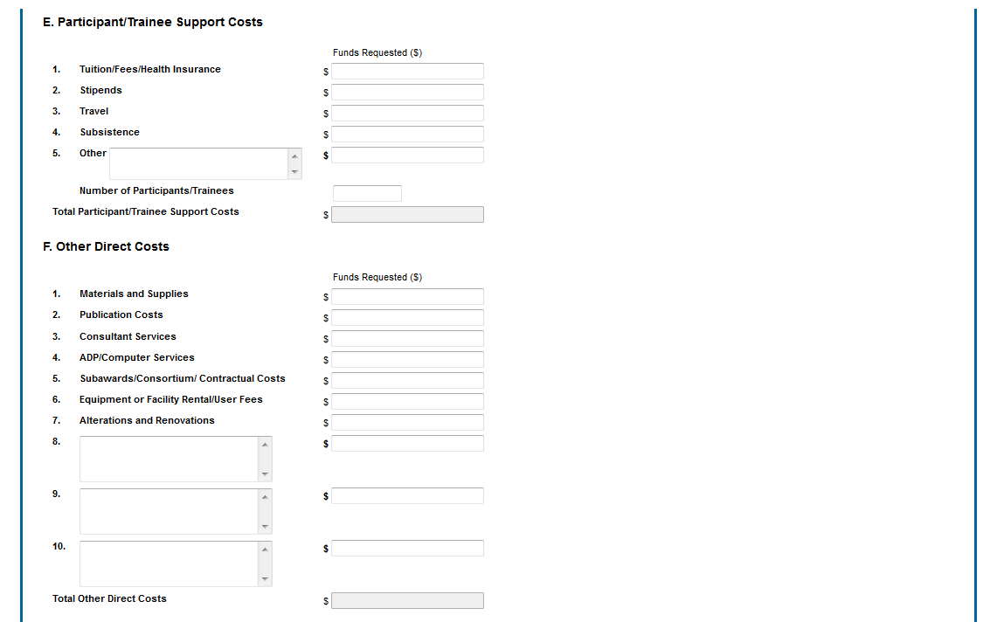
SF242 G-K
User Interface
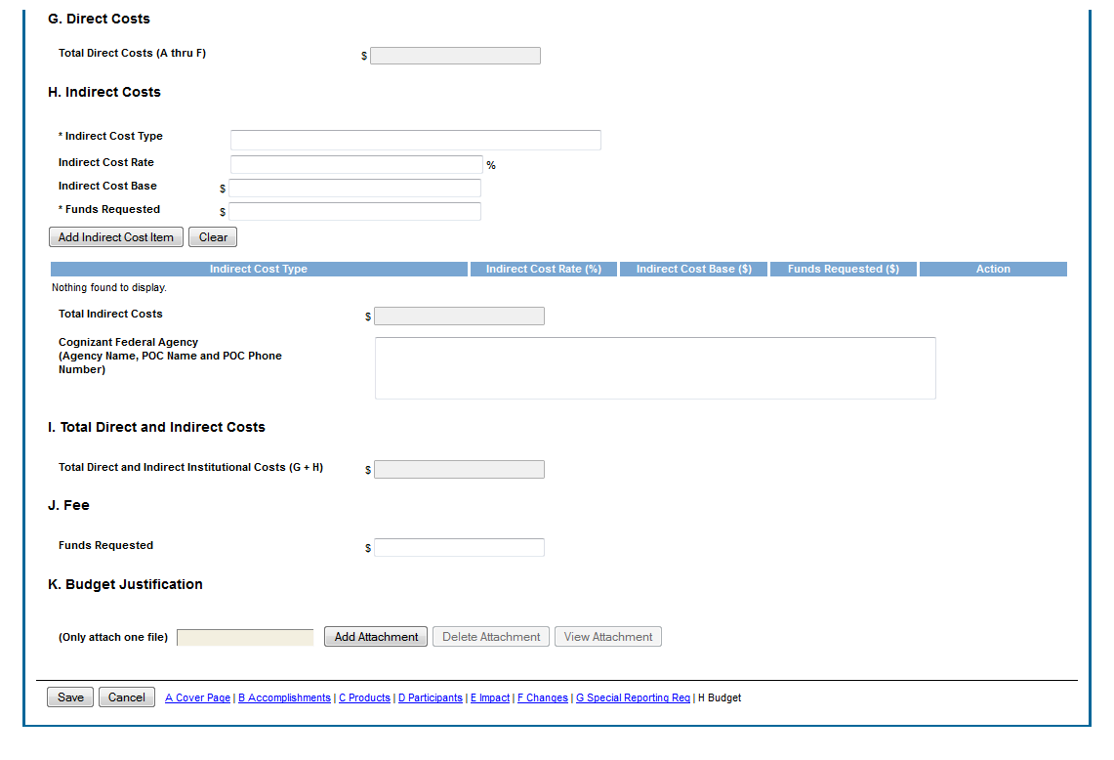
PHS398 Budget
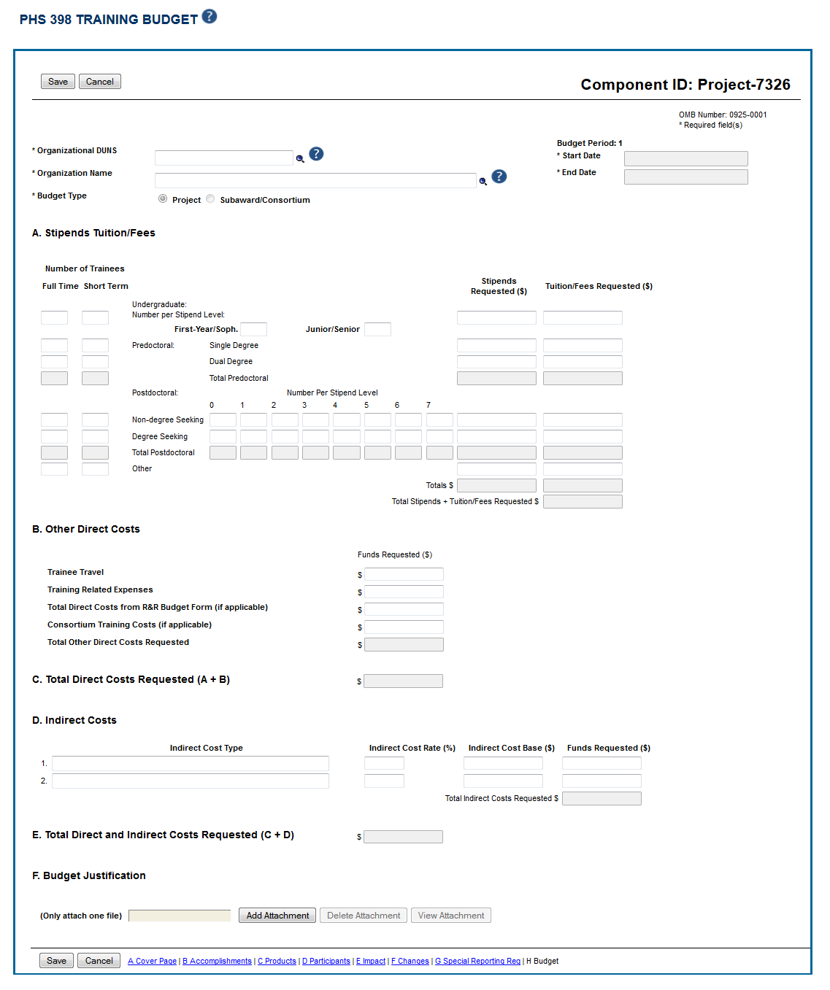
PHS398 - A
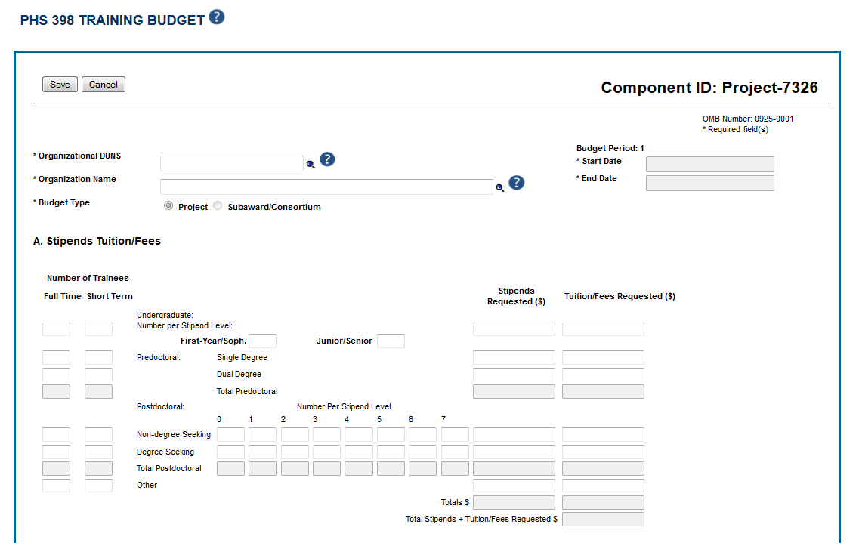
PHS398 - B
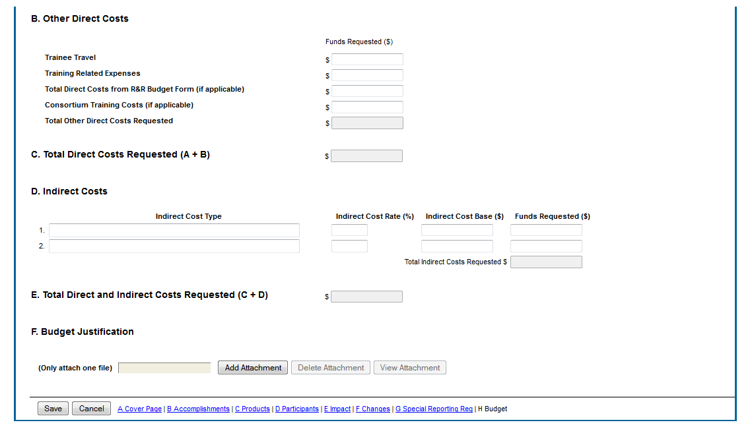
PHS398 Overall Budget
