Attachment 9
FCAS Vendor Portal Add/Edit User Accounts
OMB No.: 0925-XXXX
Expiration Date: XX/XX/XXXX
Collection of this information is authorized by The Public Health Service Act, Section 411 (42 USC 285a). Rights of participants are protected by The Privacy Act of 1974. Participation is voluntary, however in order for NCI Office of Acquisitions (OA) to provide access to the Vendor Portal for use in uploading deliverables and invoices and responding to and submitting requests to NCI OA, Vendor Portal registration is required. The information collected will be kept private to the extent provided by law. Names and other identifiers will not appear in any report other than what is utilized by NCI OA and program staff for routine day-to-day contract administration. Information provided will be combined for all participants and reported as summaries. You are being contacted by email to complete this Vendor Portal Registration form and a voluntary survey so that NCI can provide your Vendor Firm with Vendor Portal access and improve the website. The information you provide will be included in a Privacy Act system of records, and will be used and may be disclosed for the purposes and routine uses described and published in the following System of Records Notices (SORN): 09-25-0216 Administration: NIH Electronic Discovery and 09-25-0118 Contracts: Professional Services Contractors https://www.hhs.gov/foia/privacy/sorns/nih-sorns.html.

Public reporting burden for this collection of information is estimated to average 6 minutes per response, including the time for reviewing instructions, searching existing data sources, gathering and maintaining the data needed, and completing and reviewing the collection of information. An agency may not conduct or sponsor, and a person is not required to respond to, a collection of information unless it displays a currently valid OMB control number. Send comments regarding this burden estimate or any other aspect of this collection of information, including suggestions for reducing this burden to: NIH, Project Clearance Branch, 6705 Rockledge Drive, MSC 7974, Bethesda, MD 20892-7974, ATTN: PRA (0925-XXXX). Do not return the completed form to this address.

Creating New Vendor User Account:
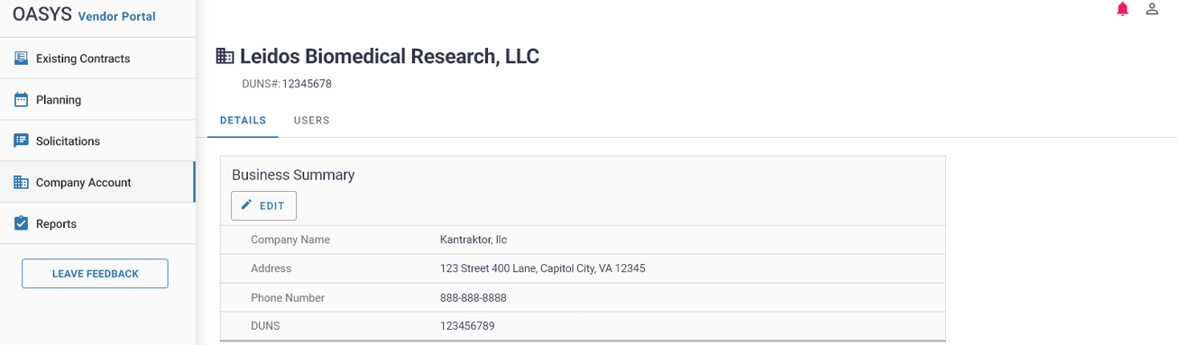
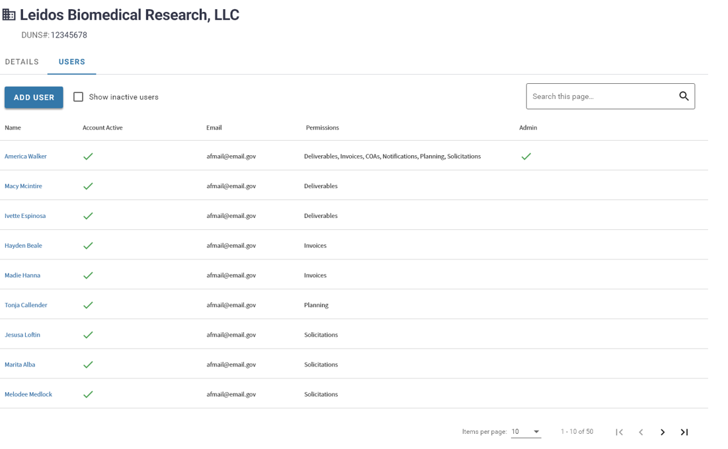
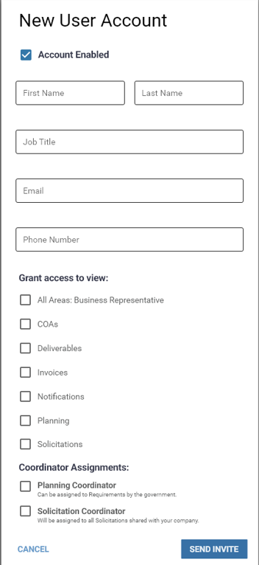

Editing Vendor User Account:
Double click on user’s name
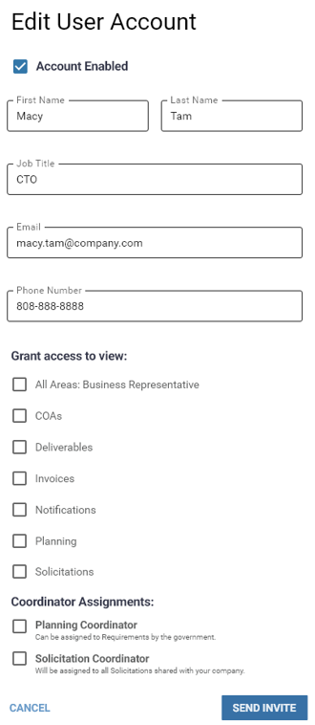

Edit Vendor Assigned Staff
