Attachment 3
OASYS/FCAS Email Invitation

Invitation to Submit Revised Proposal, Task Order Proposal or Blanket Purchase Agreement (BPA) Call Quote Email Invitation:
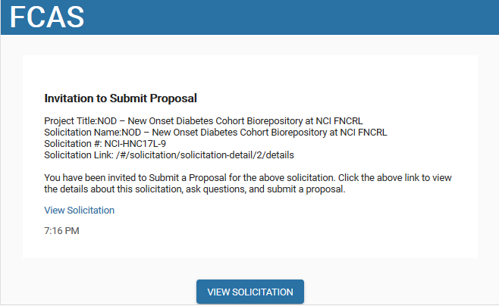

Request to Submit Revised Proposal:
