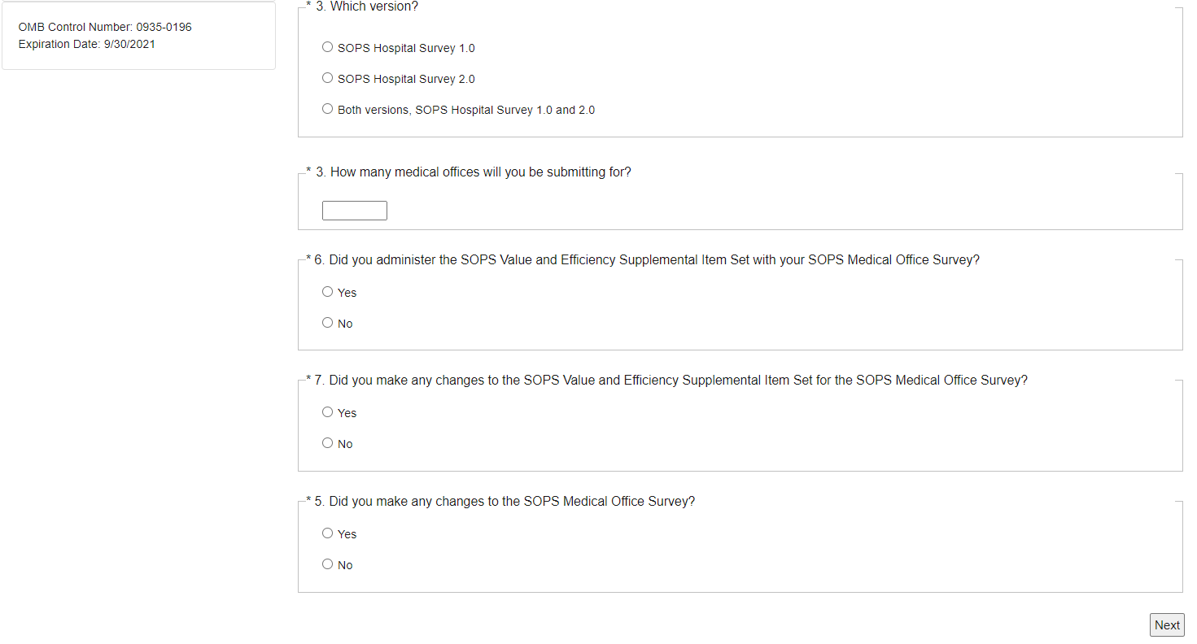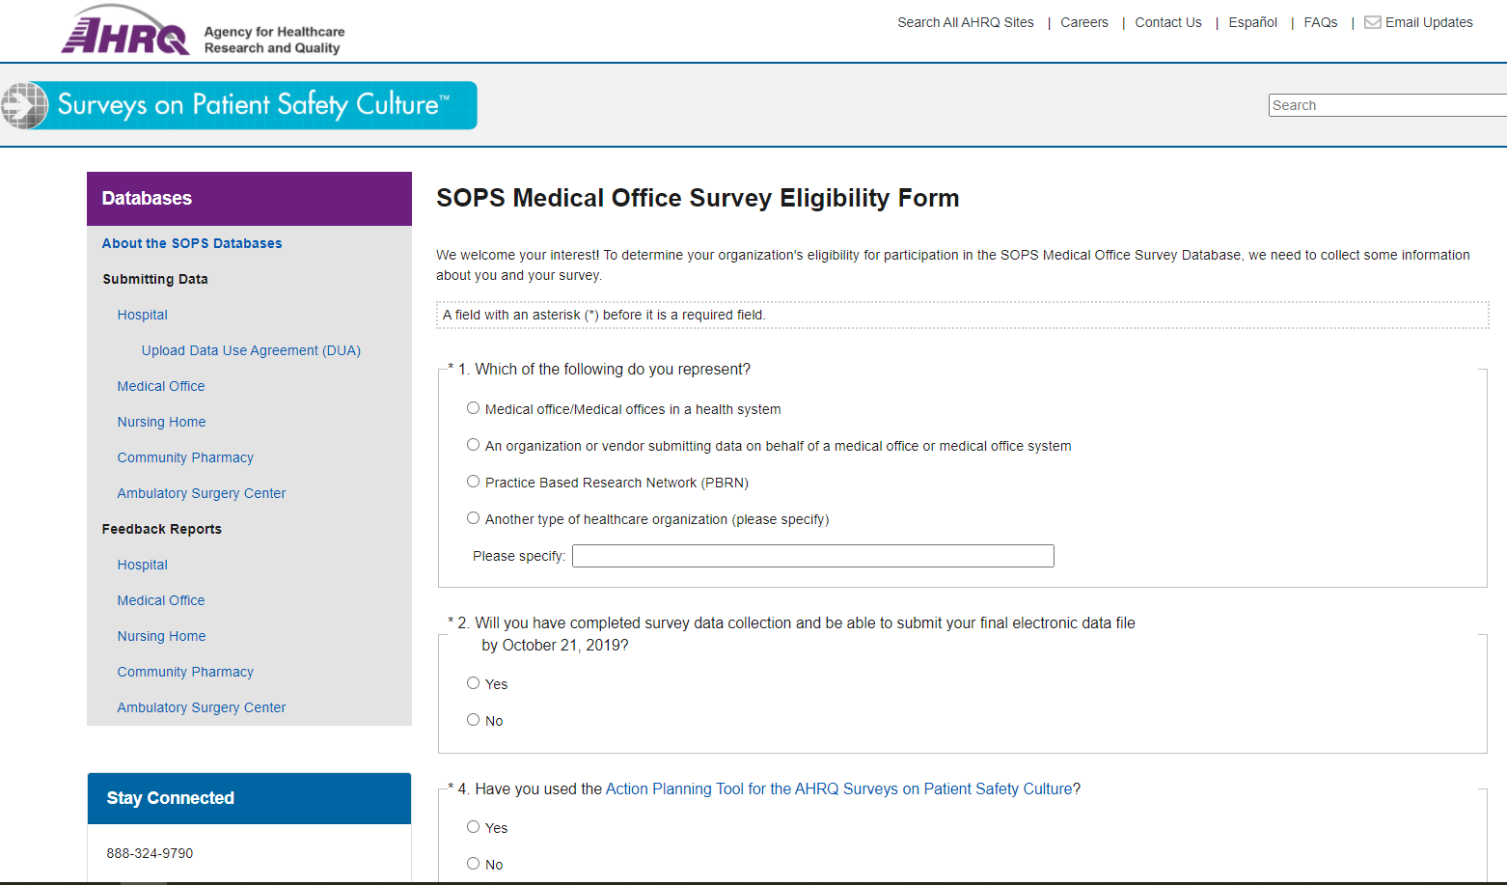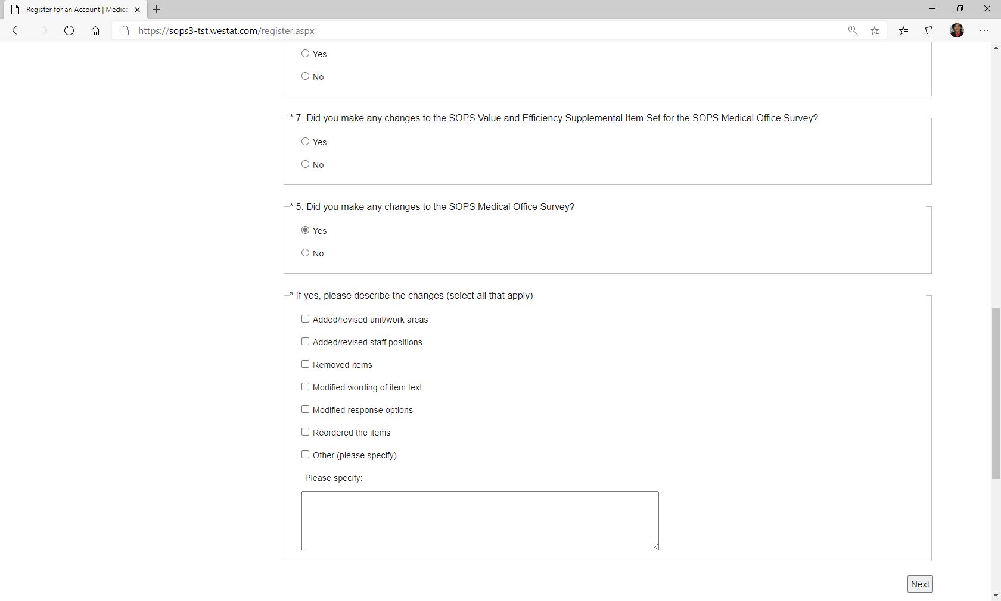

\*3. Have you used the Action Planning Tool for the AHRQ Surveys on Patient Safety Culture?

\*6. Did you make changes to the SOPS Value and Efficiency Supplemental Item Set for the SOPS Medical Office Survey?

\*7. Did you make any changes to the SOPS Medical Office Survey?

\*4. How many medical offices will you be submitting for?

\*5. Did you administer the SOPS Value and Efficiency Supplemental Item Set with your SOPS Medical Office Survey?

\*2. Will you have completed survey data collection and be able to submit your final electronic data file by October 20, 2021?

\*5. Did you administer the SOPS Value and Efficiency Supplemental Item Set with your SOPS Medical Office Survey?

\*4. How many medical offices will you be submitting for?

Public reporting burden for this collection of information is estimated to average 3 minutes per response, the estimated time required to complete the survey. An agency may not conduct or sponsor, and a person is not required to respond to, a collection of information unless it displays a currently valid OMB control number.  Send comments regarding this burden estimate or any other aspect of this collection of information, including suggestions for reducing this burden, to: AHRQ Reports Clearance Officer Attention: PRA, Paperwork Reduction Project (0935-XXXX) AHRQ, 540 Gaither Road, Room # 5036, Rockville, MD 20850.

