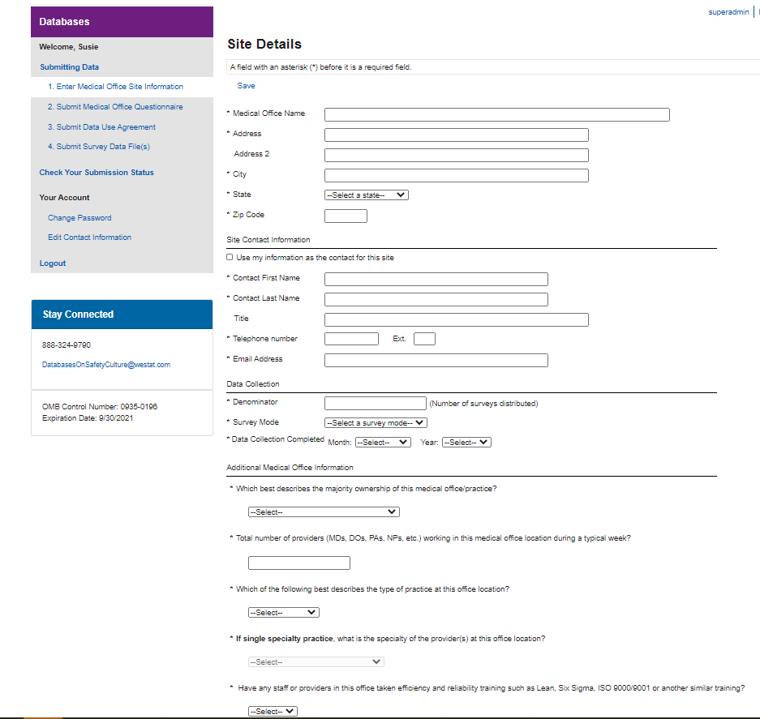

Public reporting burden for this collection of information is estimated to average 5 minutes per response, the estimated time required to complete the survey. An agency may not conduct or sponsor, and a person is not required to respond to, a collection of information unless it displays a currently valid OMB control number.  Send comments regarding this burden estimate or any other aspect of this collection of information, including suggestions for reducing this burden, to: AHRQ Reports Clearance Officer Attention: PRA, Paperwork Reduction Project (0935-XXXX) AHRQ, 540 Gaither Road, Room # 5036, Rockville, MD 20850.

Response options for Specialties (separated by semi-colons): Allergy/Immunology; Anesthesiology; Cardiology; Child & Adolescent Psychiatry; Dermatology; Diagnostic Radiology; Emergency Medicine; Endocrinology/ Metabolism; Family Practice/Family Medicine; Forensic Pathology; Gastroenterology; General Practice

Response options for Practice Type:

* Single specialty
* Multispecialty

Response options for Majority Ownership (separated by semicolon): Provider(s) and/or Physician(s); Hospital or Health System; University or Academic Medical Center; Community Health Center; Federal, state, or local government; Other

Response options for Survey Mode: (separated by semicolon): Paper; Web; Mixed mode (paper & web); Other