Figure 1: Submit Data Use Agreement (DUA) and Link DUA to Medical Office(s)
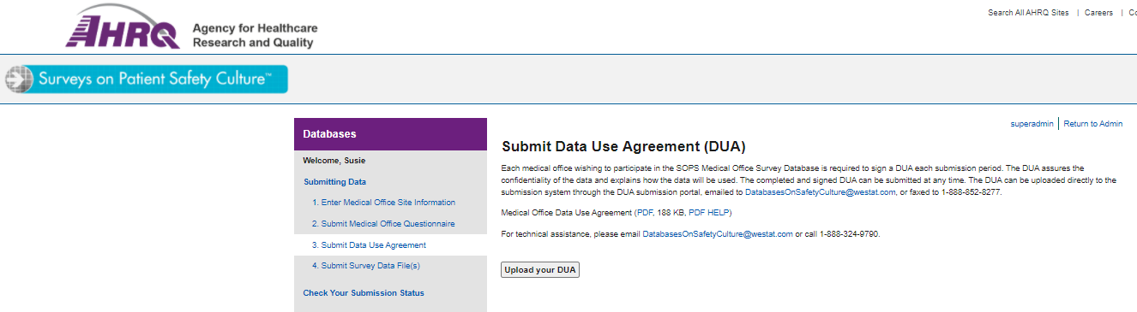

Figure 2: Submit Questionnaire and Link Questionnaire to Medical Office(s)
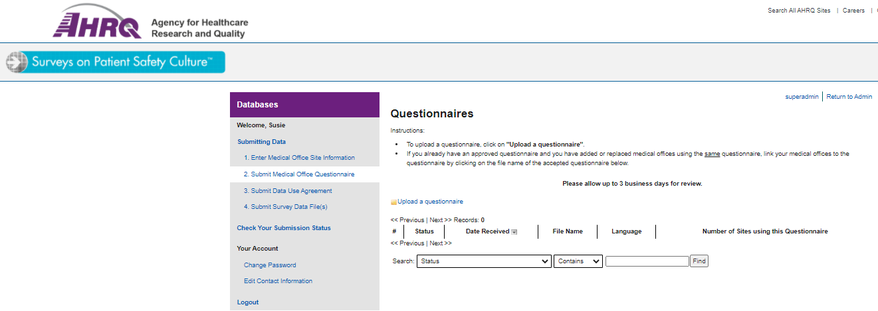

Figure 2: Submit Questionnaire and Link Questionnaire to Medical Office(s), continued
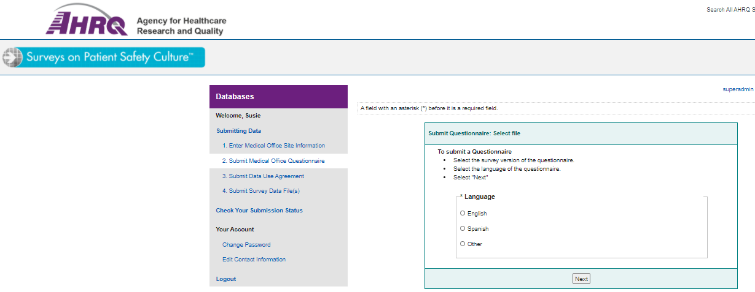

Figure 3: Upload Data for Each Participating Medical Office
