Department of Health & Human Services

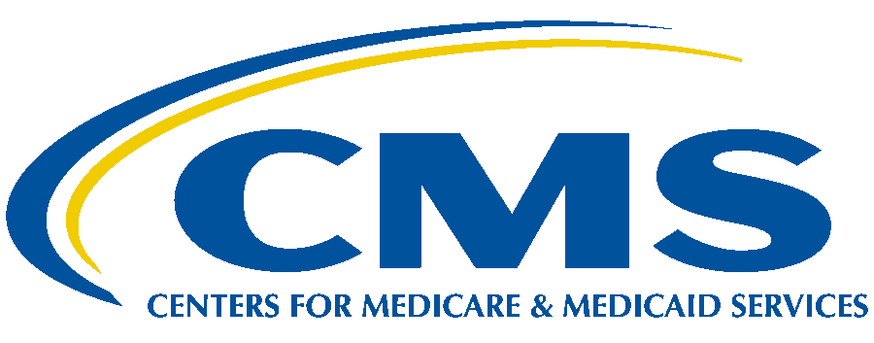

Centers for Medicare & Medicaid Services

7500 Security Boulevard

Baltimore, Maryland 21244-1850

# OFFICE OF THE ADMINISTRATOR

**DATE:** August 31, 2021

**TO:** Sharon Block

Acting Administrator

Office of Information and Regulatory Affairs

Office of Management and Budget

**FROM:** Chiquita Brooks-LaSure

Administrator

Centers for Medicare and Medicaid Services

Department of Health and Human Services

**SUBJECT**: Request for Emergency Clearance of the Paperwork Reduction Act Package for Requirement Related to Surprise Billing: Complaints Process for Surprise Medical Bills

**Emergency Justification**

The Centers for Medicare & Medicaid Services (CMS) is requesting that an information collection request for some provisions in the Consolidated Appropriations Act of 2021 (Appropriations Act) enacted on December 27, 2020, related to the No Surprises Act be processed in accordance with the implementing regulations of the Paperwork Reduction Act of 1995 (PRA) at 5 CFR 1320.13(a)(2)(i). We believe that public harm will result if the standard, non-emergency clearance procedures are followed. CMS is also requesting waiver of the notice requirement set forth in 5 CFR 1320.13(d).

Specifically, we are requesting emergency approval for the following information collection requirement (ICR): complaints process for surprise medical bills (45 CFR 149.150 and 149.450; 29 CFR 2510 & 2590). The cost-sharing and balance billing requirements on plans, issuers, health care providers, facilities, and providers of air ambulance services in the No Surprises Act apply for plan years (in the individual market, policy years) beginning on or after January 1, 2022. This ICR contains a critical protection for individuals to submit a complaint in respect to potential violations of balance billing requirements set forth in the No Surprises Act. It is in the public interest that individuals receive this protection under the No Surprises Act on the date on which those protections go into effect. Following the standard PRA process will not provide the Department of Health and Human Services (HHS), the Department of Labor (DOL), the Department of Treasury (collectively, “the Departments”), sufficient time to implement this new requirement.

**Background**

The No Surprises Act provides federal protections against surprise billing and limits out-of-network cost sharing under many of the circumstances in which surprise medical bills arise most frequently. The 2021 interim final regulations “Requirements Related to Surprise Billing; Part I” (86 FR 36872, 2021 interim final regulations) issued by the Departments implement provisions of the No Surprises Act that apply to group health plans, health insurance issuers offering group or individual health insurance coverage that provide protections against balance billing and out-of-network cost sharing with respect to emergency services, non-emergency services furnished by nonparticipating providers at certain participating health care facilities, and air ambulance services furnished by nonparticipating providers of air ambulance services. The No Surprises Act and the 2021 interim final regulations directs the Departments to establish a process to receive complaints regarding violations of the application of qualifying payment amount (QPA) requirements by group health plans and health insurance issuers offering group or individual health coverage.1 The No Surprises Act also directs HHS to establish a process to receive consumer complaints regarding violations by health care providers, facilities, and providers of air ambulance services regarding balance billing requirements and to respond to such complaints within 60 days.2,3

________

1Internal Revenue Code (Code) section 9816(a)(2)(B)(iv), ERISA Section 716(a)(2)(B)(iv) and PHS Act section 2799A- (a)(2)(B)(iv).

2PHS Act section 2799B-4(b)(3).

3PHS Act section 2799B-1, 2799B-2, 2799B-3, and 2799B-5.