Appendix B: The O*NET Program

The O*NET Program is a comprehensive system for collecting and disseminating information on occupational and worker requirements.

As shown in Appendix Exhibit B-1, the O*NET Program uses a data structure, the Content Model, to organize occupational information and to provide a common language of standardized and defined occupation descriptors and measures for use by all audiences. The O*NET Content Model is the result of extensive research, and its development is fully documented ([Peterson, Mumford, Borman, Jeanneret, & Fleishman, 1995, pp. 2–6](#_ENREF_23" \o "Peterson, 1995 #18); Peterson, Mumford, Borman, et al., 1997; Peterson et al., 2001). It comprises worker-oriented and job-oriented characteristics at both an occupation-specific level and across occupations.

Each of the six domains of the Content Model groups information hierarchically. For example, the Worker Characteristics domain contains four types of information: Abilities, Occupational Interests, Work Values, and Work Styles. From these four, the Abilities domain, in turn, contains four types of abilities: Cognitive, Psychomotor, Physical, and Sensory. Each of these types of abilities contains further levels of detail. For example, the Psychomotor type includes Fine Manipulative, Control Movement, and Reaction Time and Speed. Finally, Fine Manipulative contains three specific descriptors: Arm-Hand Steadiness, Manual Dexterity, and Finger Dexterity. Hierarchies are a useful means of both organizing occupational information and allowing for its access at different levels of specificity. By organizing worker- and job-oriented characteristics hierarchically, the O*NET Content Model provides a flexible, common-language-based system to describe the world of work.

Appendix Exhibit B-1. O*NET Content Model

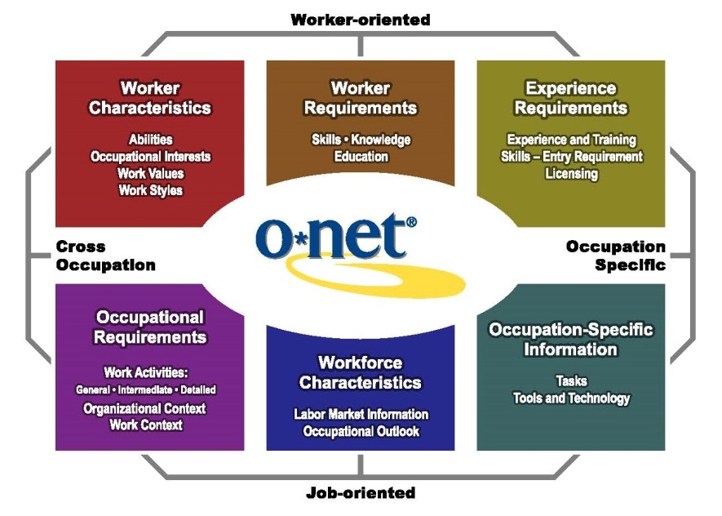

The descriptors and rating scales for O*NET data were developed through extensive research, drawing primarily from job analysis in industrial/organizational psychology and human resource management (Peterson et al., 1995). The descriptors in the O*NET Program are meant to be comprehensive. The primary sources of data are job incumbents and occupation experts. The SOC system is used as the basis for classifying occupations. The use of questionnaires and rating scales reflects the most widely accepted approach to job analyses conducted across settings, occupations, or positions (Guion, 2011). The scales used for the O*NET ratings are Importance, Level, and Frequency. Each descriptor in the O*NET questionnaires may use one or more scales. For example, the O*NET Work Activities Descriptor—Monitoring and Controlling Resources is rated on both a 5-point Importance scale and a 7-point Level scale. For the complete set of O*NET questionnaires, which include O*NET descriptors, see Appendix G.

Appendix Exhibit B-2 summarizes the number of descriptors and scales in the O*NET Data Collection Program questionnaires. Descriptors are identified from O*NET Content Model domains. Data are collected by means of 239 descriptors that include 400 scales (e.g., Importance, Level, and Frequency). To collect ratings for the Abilities and Skills domains, trained occupational analysts review updated information (e.g., Tasks, Generalized Work Activities) provided by job incumbents.[1] No data collection is planned for the Workforce Characteristics domain. Information for it is provided through links to the employment, wage, and long-term projections databases produced by the U.S. Bureau of Labor Statistics (BLS), the state employment security agencies, and other agencies.

Appendix Exhibit B-2. O*NET Data Collection Program Questionnaires

|  |  |  |  |  |
| --- | --- | --- | --- | --- |
| O*NET Data Collection Program Questionnaire | Number of Descriptors | Number of Scales per Descriptor | Total Number of Scales | Data Source |
| Skills | 35 | 2 | 70 | Analysts |
| Knowledge | 33 | 2 | 66 | Job incumbents |
| Work Stylesa | 16 | 1 | 16 | Job incumbents |
| Education and Traininga | 5 | 1 | 5 | Job incumbents |
| Generalized Work Activities | 41 | 2 | 82 | Job incumbents |
| Work Context | 57 | 1 | 57 | Job incumbents |
| Abilities | 52 | 2 | 104 | Analysts |
| Tasksb | Varies | 2 | Varies | Job incumbents |
| Total (not including Tasks) | 239 | NA | 400 | NA |

Notes: Occupation experts use the same questionnaires as job incumbents for those occupations whose data collection is by the Occupation Expert Method. NA = not applicable.

a The Knowledge Questionnaire packet also contains the Work Styles Questionnaire and the Education and Training Questionnaire.

b All job incumbents are asked to complete a Task Questionnaire in addition to the domain questionnaire.

#### Versions of the O*NET Database

The first version of the O*NET database released to the public was O*NET 98. The O*NET 98 database contained 306 descriptors and 684 scales. A review of O*NET 98–specific scales and descriptors during the preparation for pretest data collection led to some consolidation and refinement of descriptors and scales to reduce burden on the public and to increase employee response rate.[2]

The O*NET 98 database was first replaced with the O*NET 3.1 database and has been updated 21 times as new data have been collected and analyzed. The current database,[3] O*NET version 25.1, contains the same descriptors used in O*NET 98; however, the occupations have been restructured and coded to encompass the most detailed level of the 2018 SOC, with more occupational specificity added as needed. Research is ongoing to identify additional new and emerging occupations in high-growth industries. New occupations emerge because of changes in technology, society, law, business practices, and markets. As these new and emerging occupations are identified and their data are collected, they will be integrated into the O*NET-SOC occupation classification and database.

O*NET 25.1 has a Web-based accessing application, O*NET OnLine, which is available to the public at no cost at <https://online.onetcenter.org>/. An electronic version of the 25.1database can be downloaded at <https://www.onetcenter.org/>. The data can also be accessed/incorporated via O*NET Web Services. (See <https://services.onetcenter.org>.) The O*NET 25.1 database has been restructured to incorporate improvements made to the O*NET data collection instruments and is the structure currently being offered to developers.

Data in the O*NET database include the mean ratings on each of the items (or descriptors) in the O*NET questionnaires. Ratings have been standardized to facilitate interpretation and comparison across occupations. In addition to mean rating data on Level and Importance for various questionnaire items, text information is also included on occupational definitions, descriptor definitions, scale anchors, and task descriptions.

1. For a discussion of the preferred data source, see Section A.3.1.
2. See *Revision of O*NET data collection instruments*, available at <https://www.onetcenter.org/reports/Data_append.html>.
3. O*NET 25.0 was the 21st complete update of the database. O*NET 25.1 is the 41st partial update of the database.