Form ETA-9035 & 9035E
Labor Condition Application for Nonimmigrant Workers
H-1B, H1-B1 and E-3 Visas

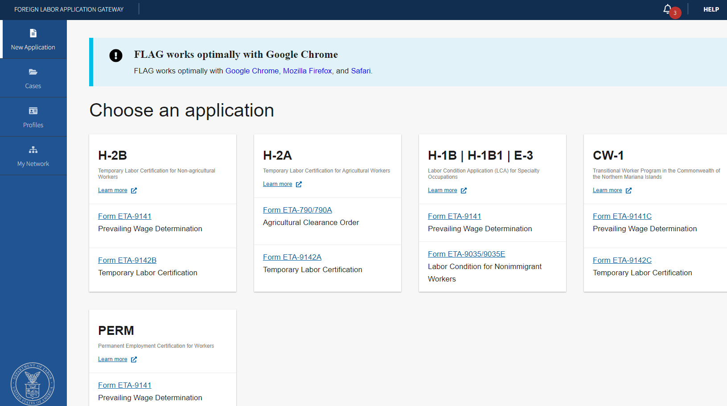

Figure 1: Home Screen to choose an application for Form ETA-9035/9035E

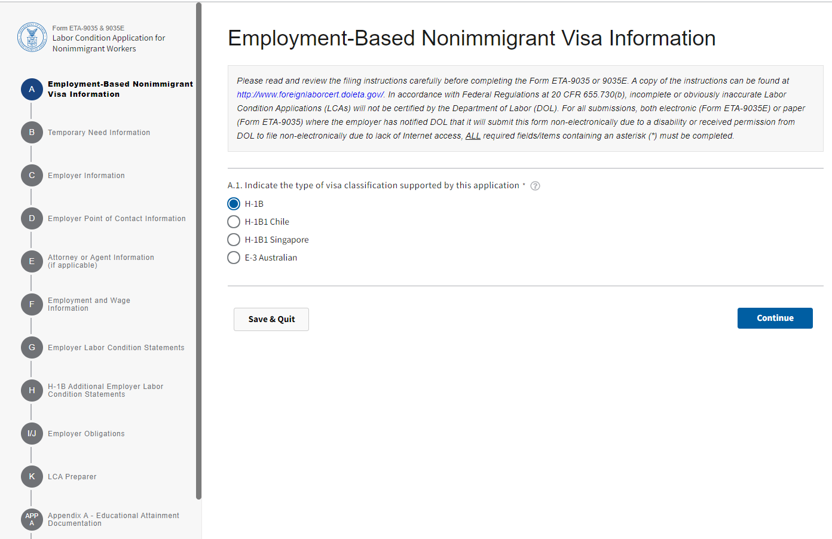
Figure 2: Section A –Employment Based Nonimmigrant Visa Information (Section A.1)

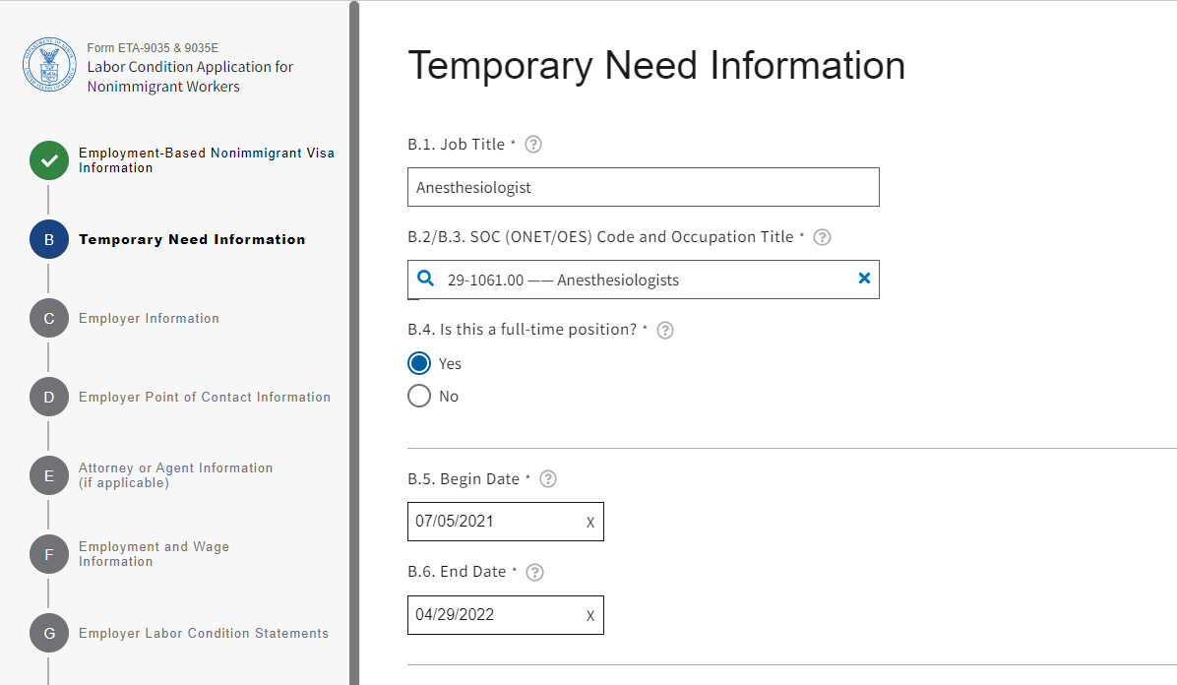
Figure 3: Section B –Temporary Need Information (Section B.1 through B.6)

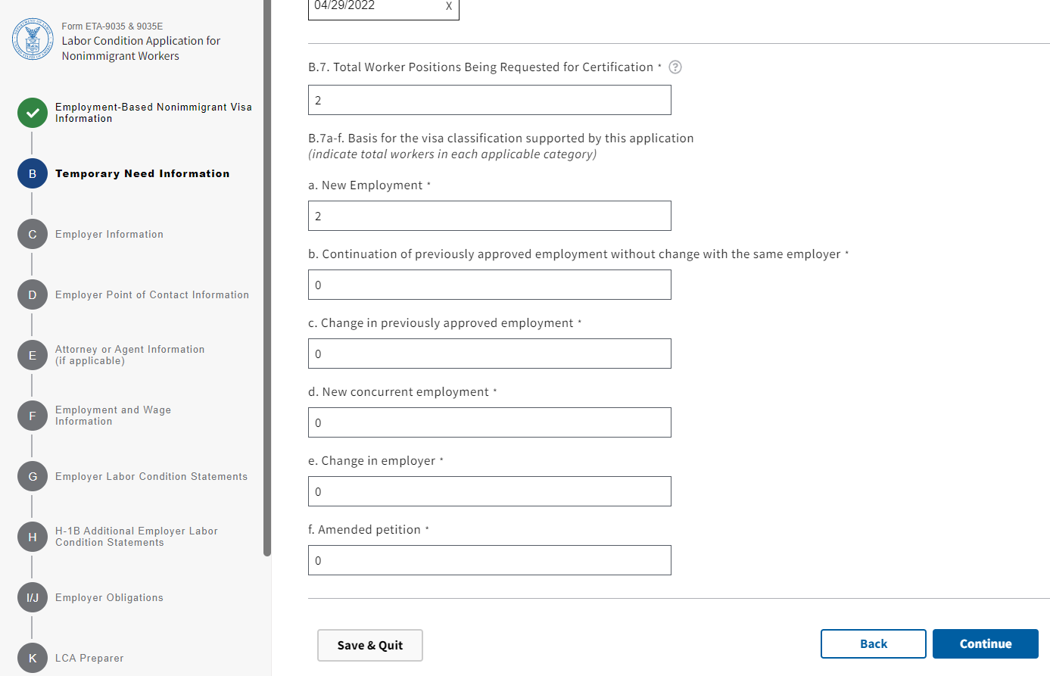
Figure 4: Section B –Temporary Need Information (Section B.7a through B.7f)

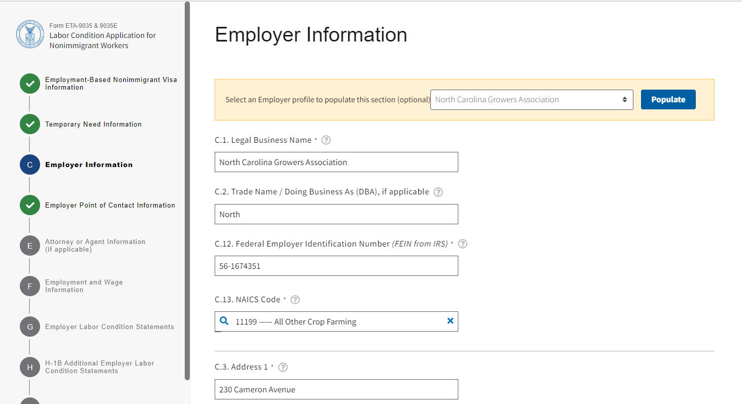

Figure 5: Section C –Employer Information (Section C.1 through C.3)

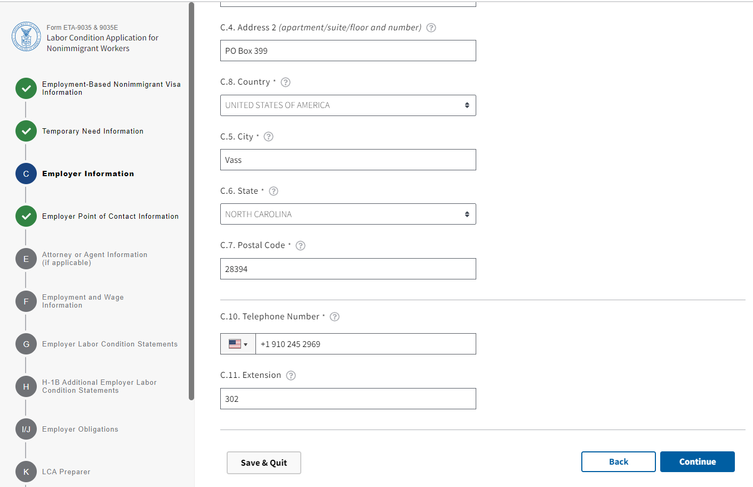
Figure 6: Section C –Employer Information (Section C.4 through C.11)

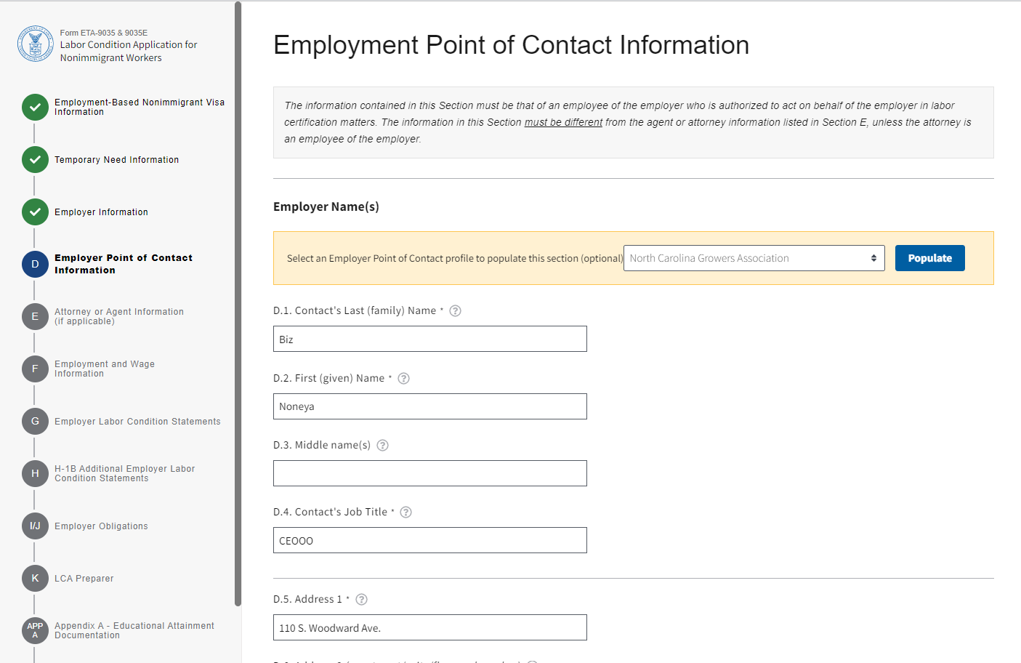
Figure 7: Section D – Employer Point of Contact Information (Section D.1 through D.5)

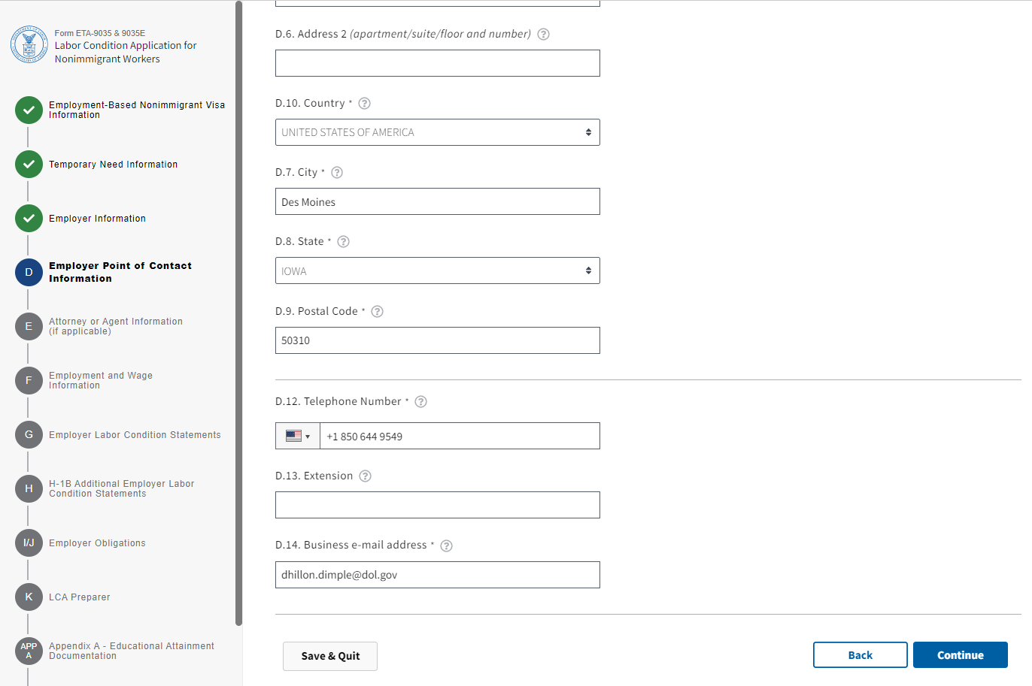

Figure 8: Section D – Employer Point of Contact Information (Section D.6 through D.14)

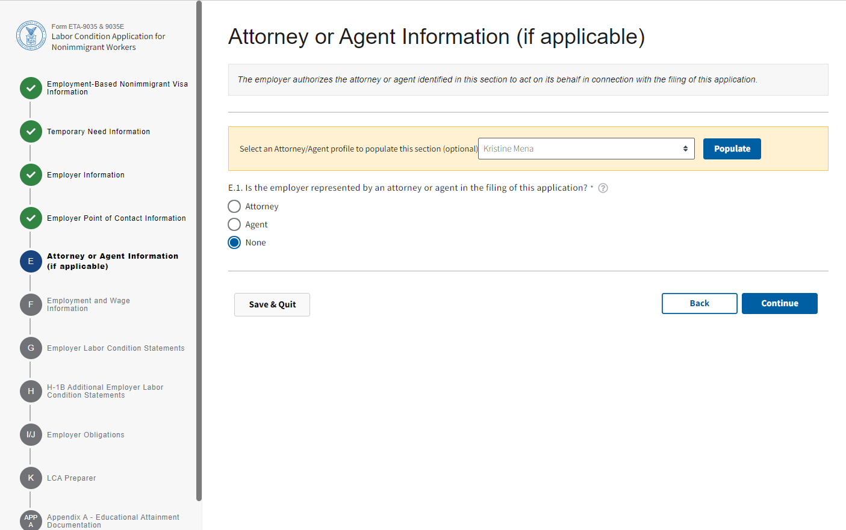

Figure 9: Section E – Attorney or Agent Information (if applicable)(Section D.6 through D.14)

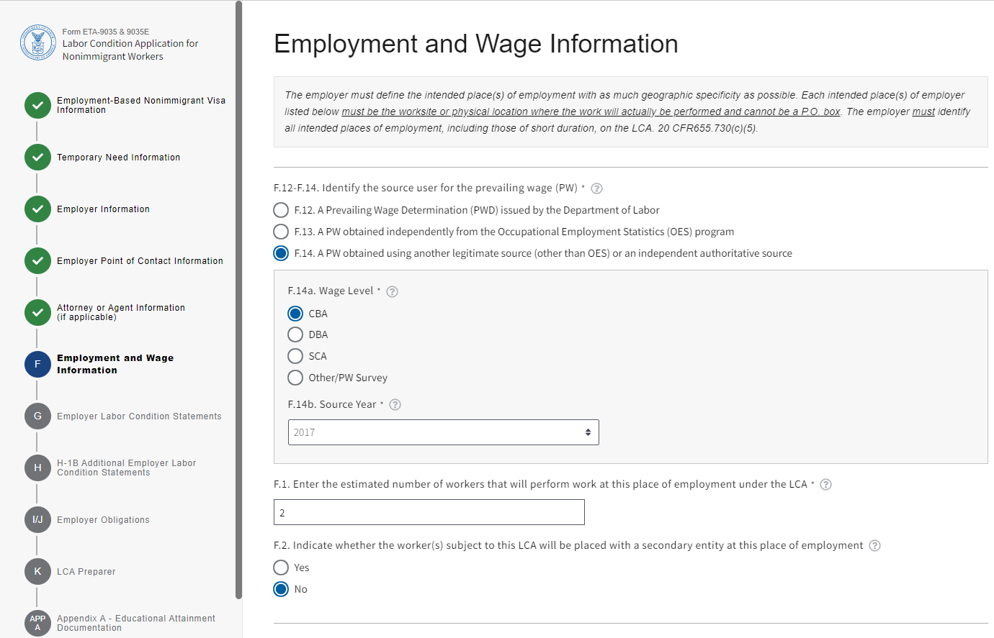
Figure 10: Section F – Employment and Wage Information (Section F.12 through F.2)

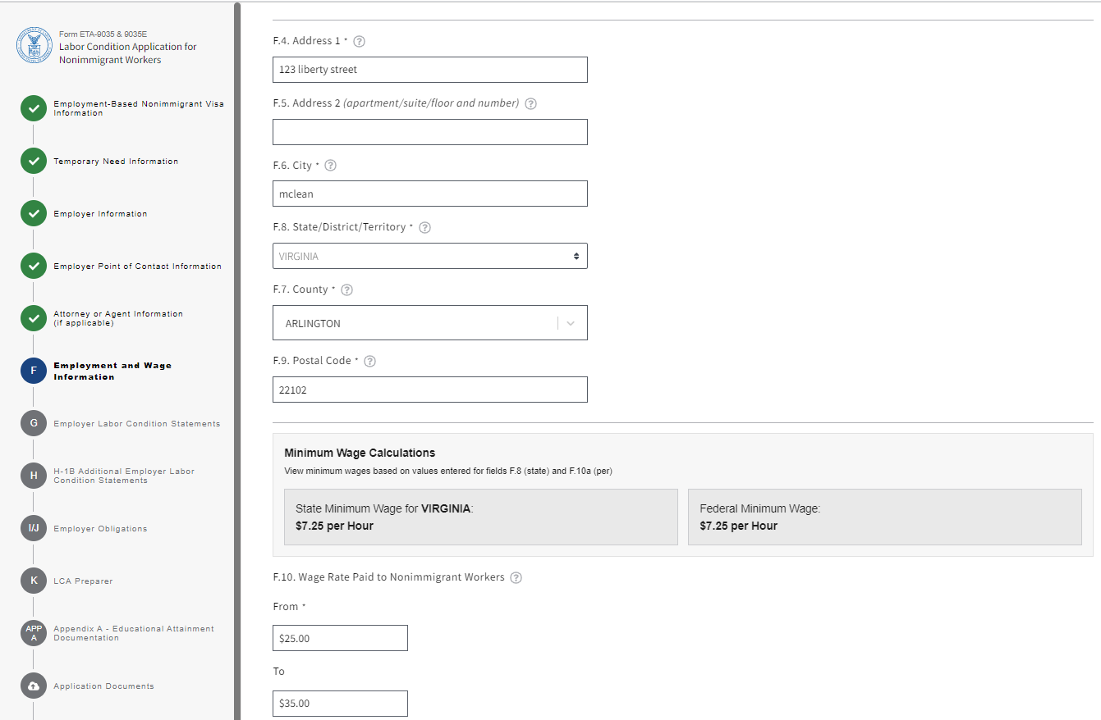

Figure 11: Section F – Employment and Wage Information (Section F.4 through F.10)

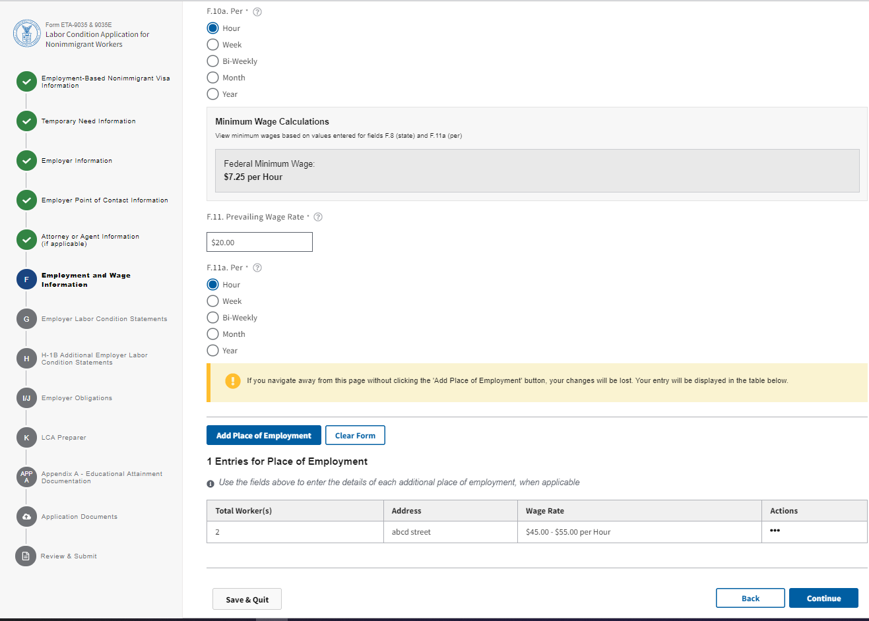

Figure 12: Section F – Employment and Wage Information (Section F.10a through F.11a)

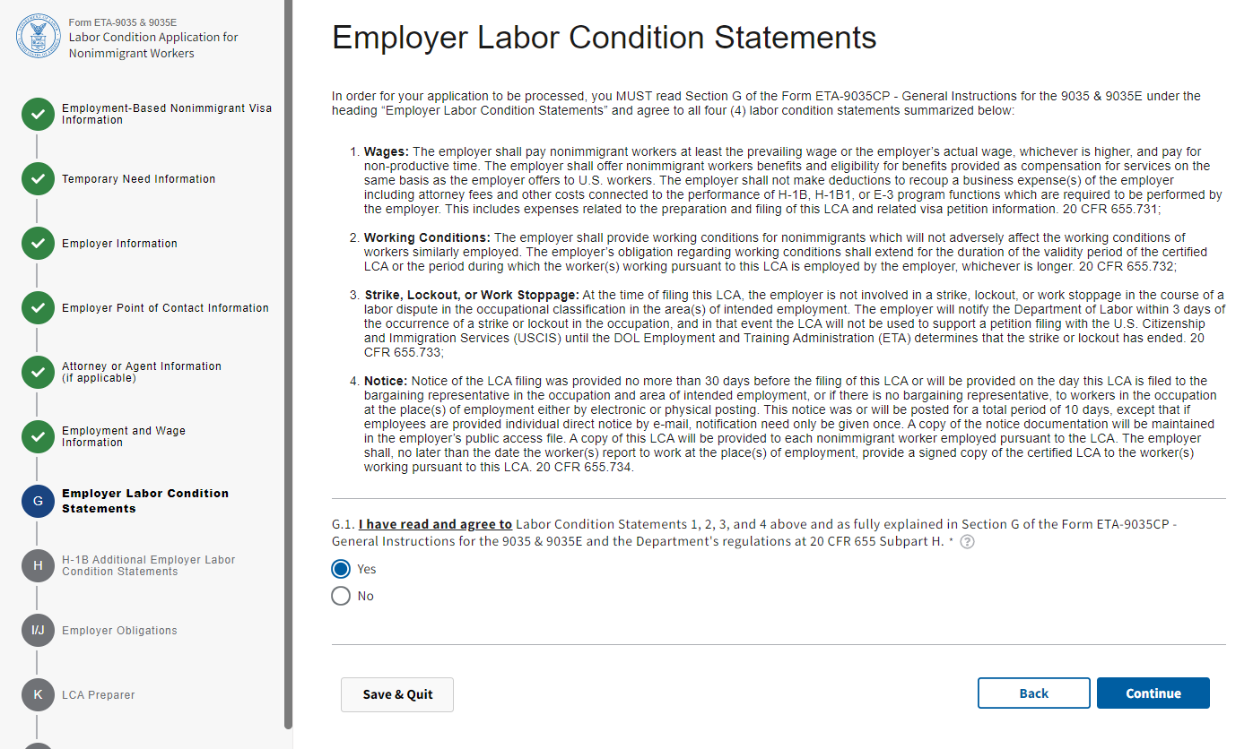

Figure 13: Section G – Employment Labor Condition Statements (Section G.1)

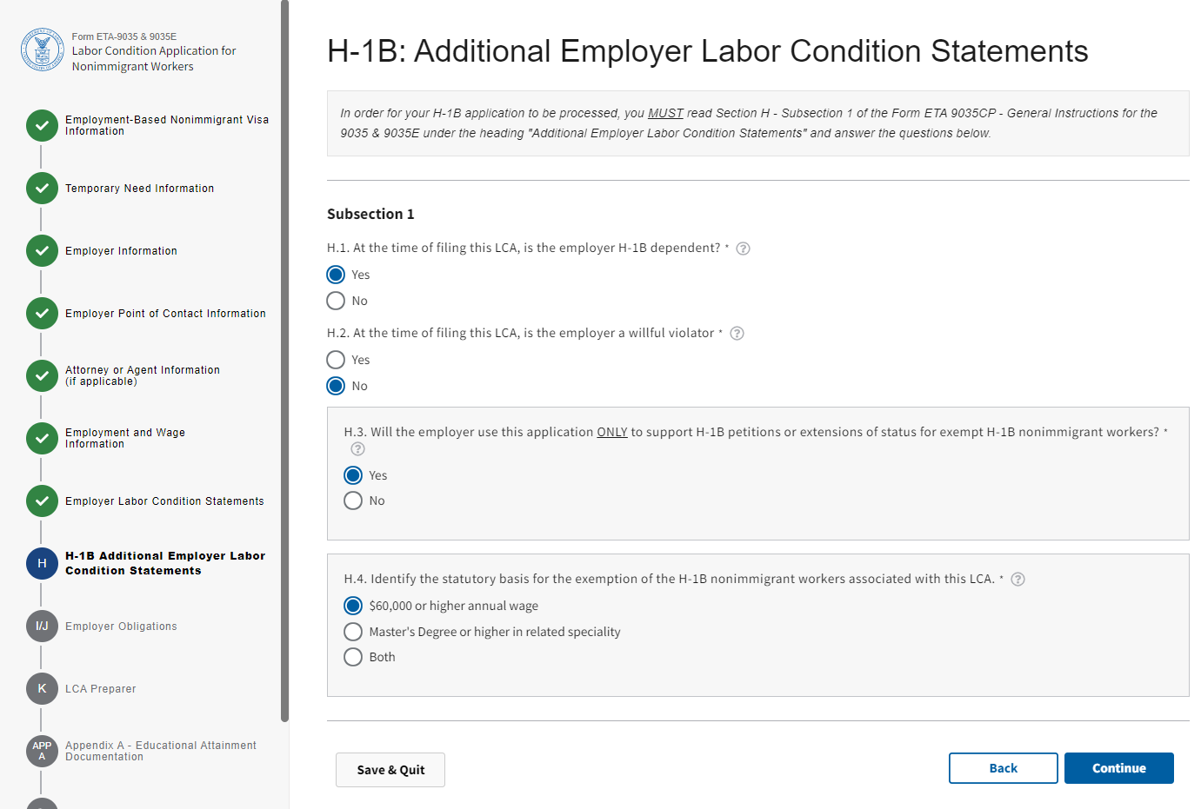

Figure 14: Section H: H-1B Additional Employer labor Condition Statements (Section H.1 through H.4)

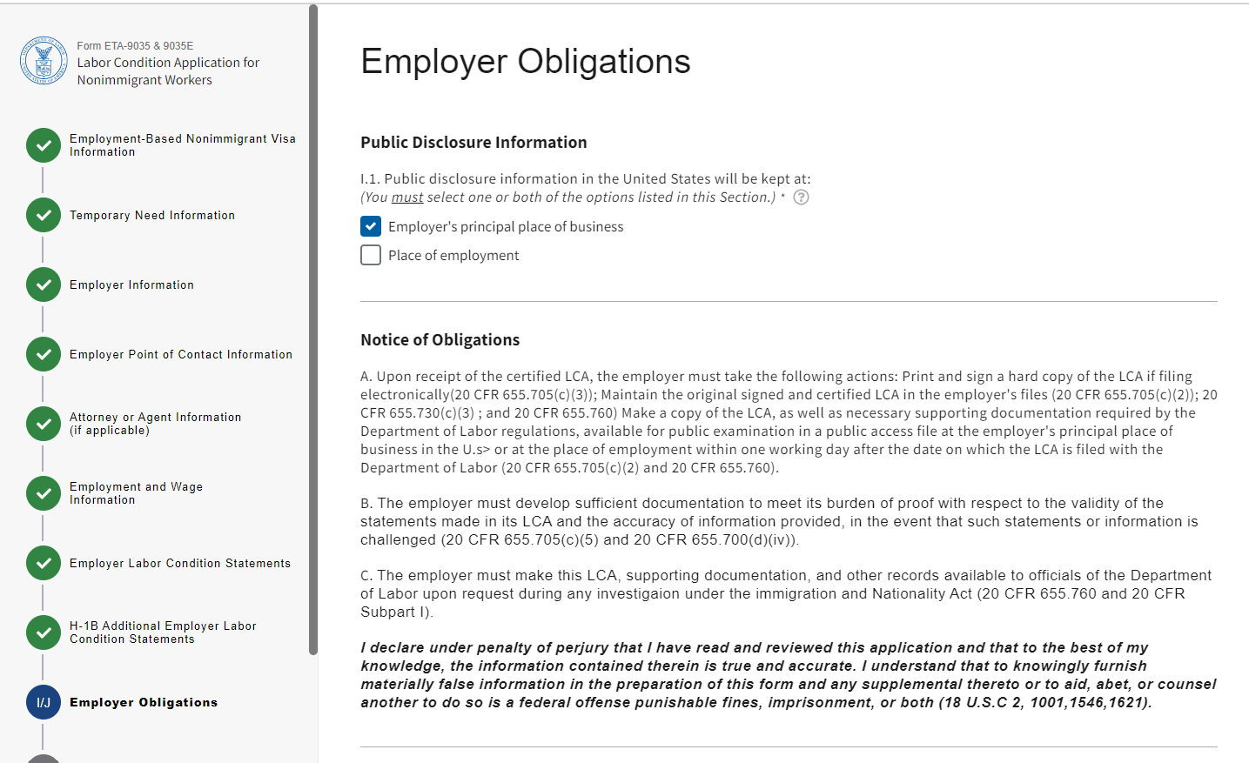

Figure 15: Section I/J: Employer Obligations (Section I.1)

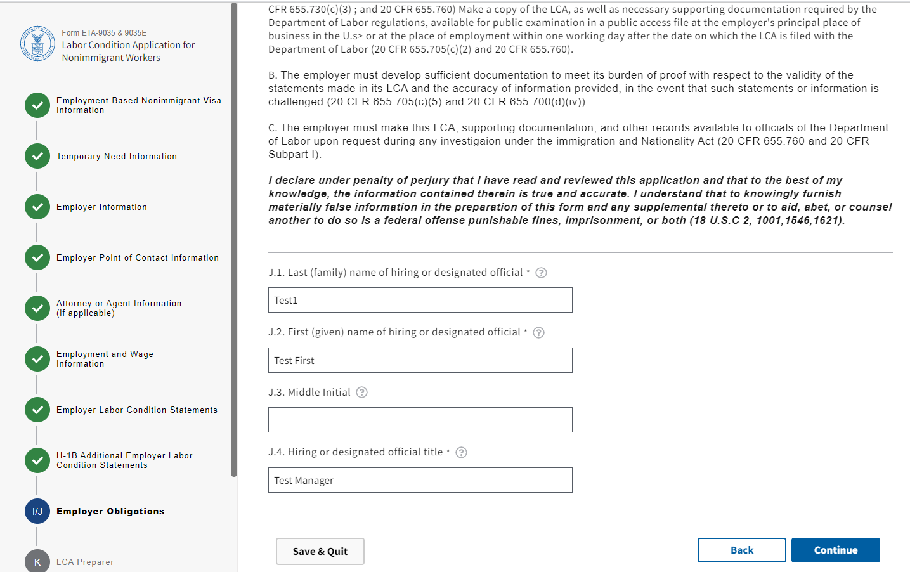

Figure 16: Section I/J: Employer Obligations (Section J.1 through J.4)

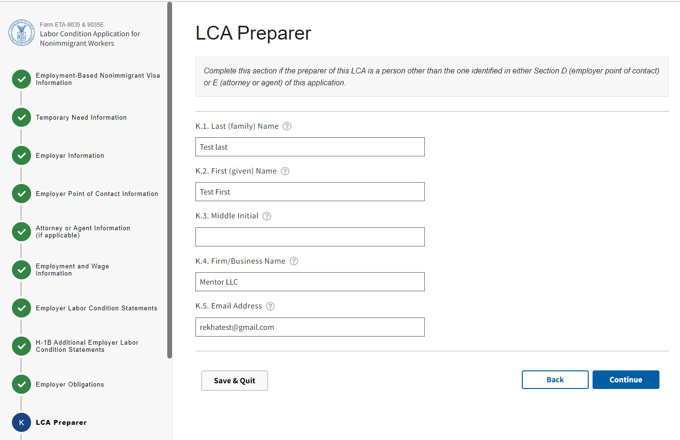

Figure 17: Section K: LCA Preparer (Section K.1 through K.5)

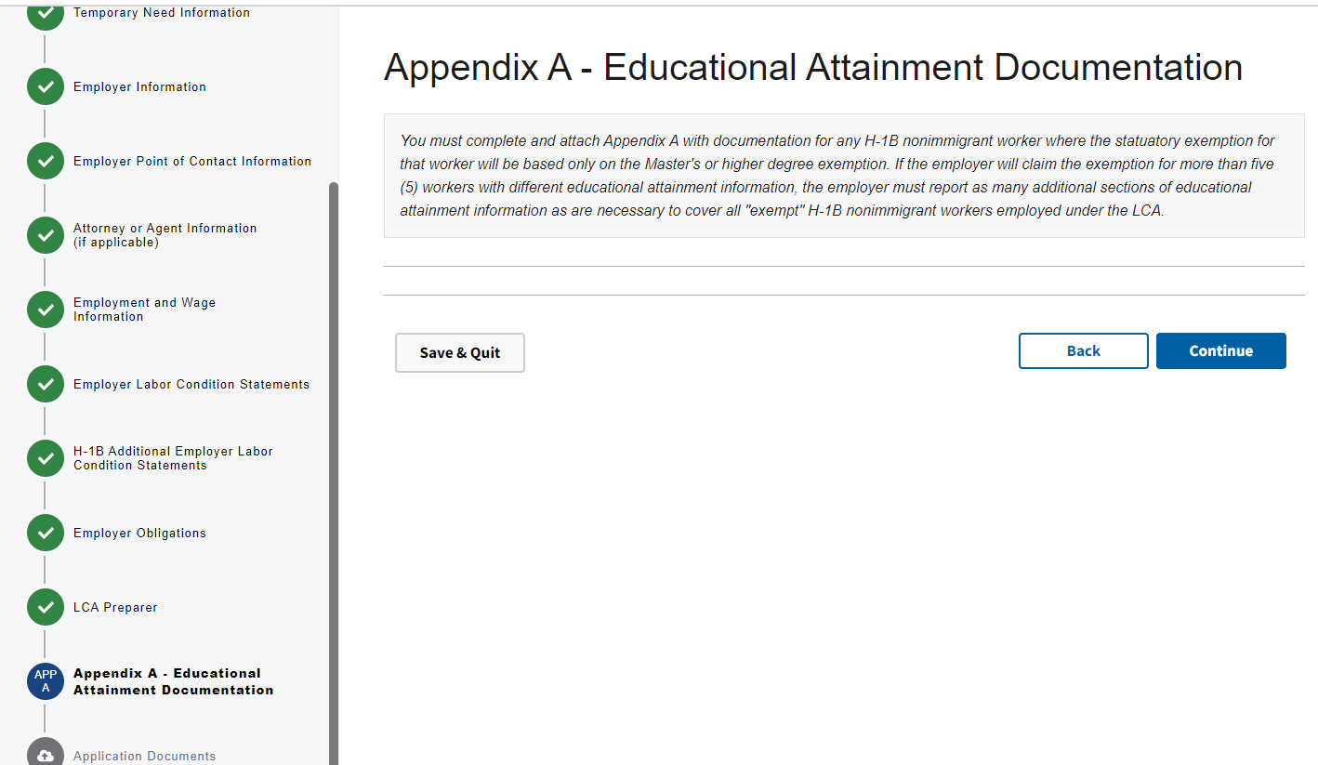
Figure 18: Appendix A – Educational Attainment Documentation

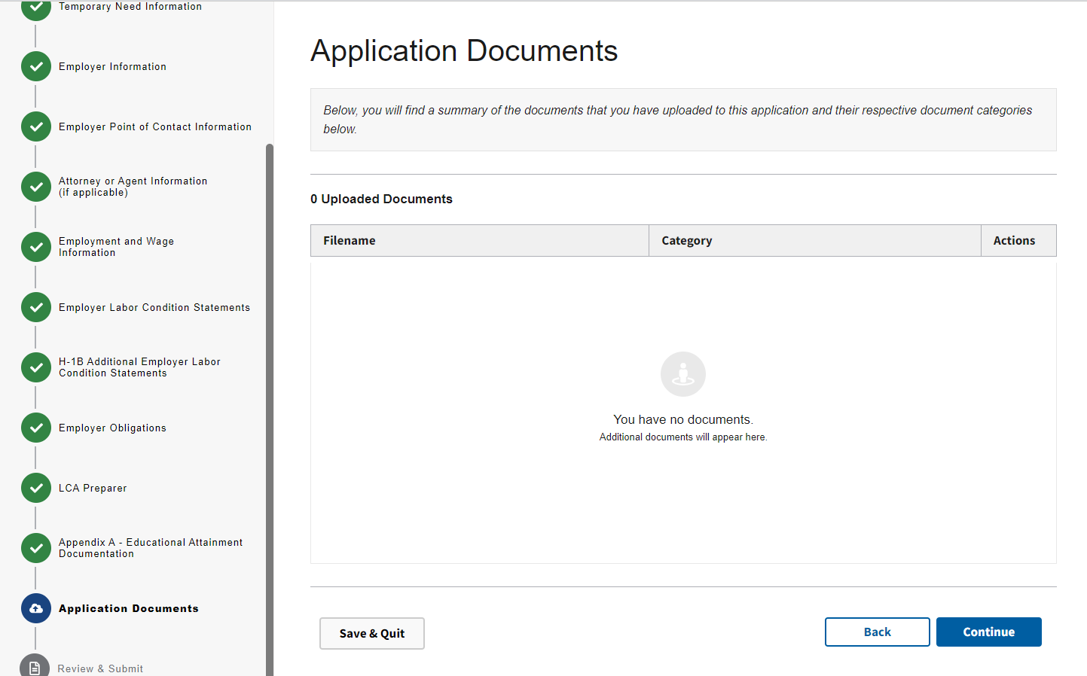

Figure 19: Application Documents

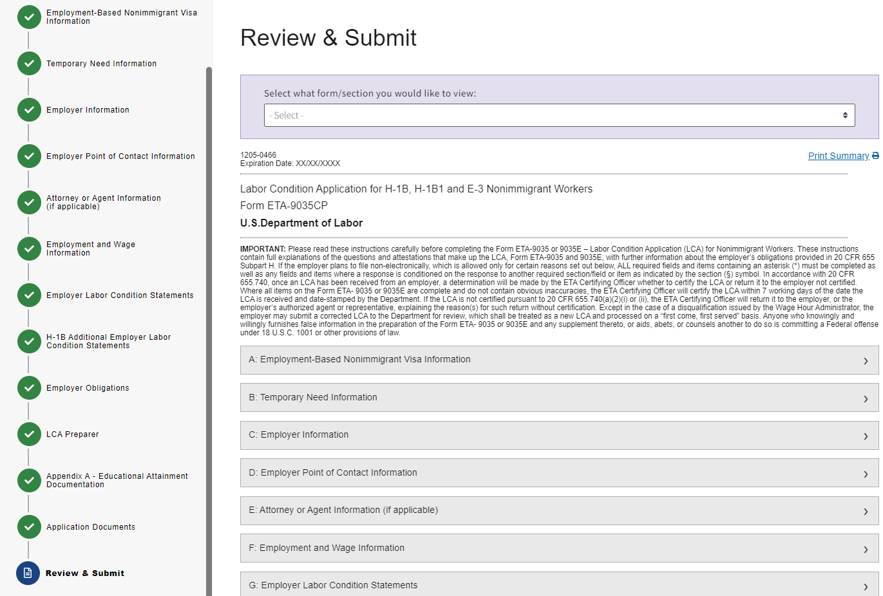

Figure 20: Review and Submit

Figure 21: Review and Submit (Continued)

Form ETA-9035 &9035E: Case Generated PDF Version
(Page 1 of 6)
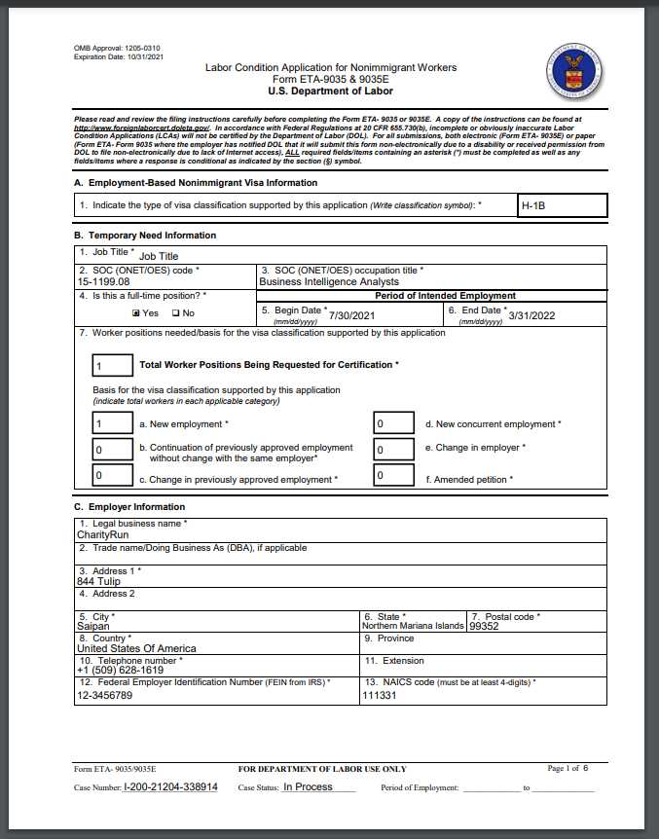

Form ETA-9035 &9035E: Case Generated PDF Version
(Page 2 of 6)
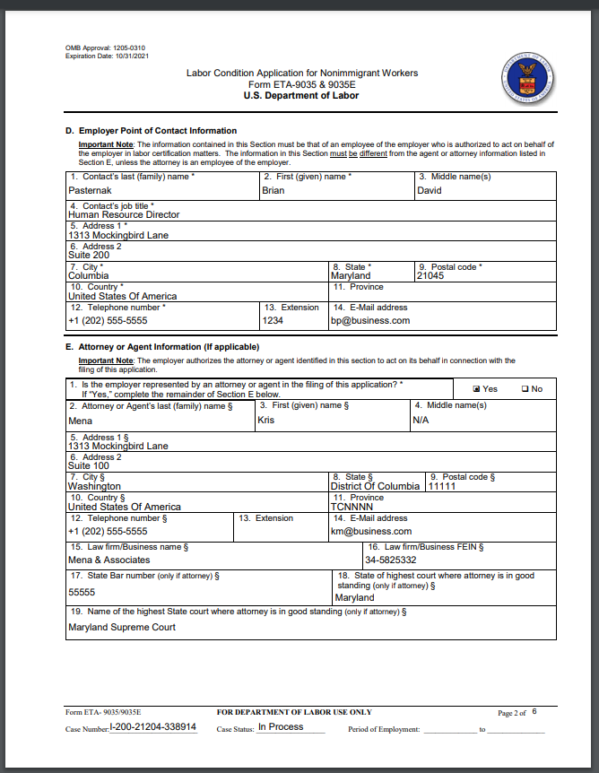

Form ETA-9035 &9035E: Case Generated PDF Version
(Page 3 of 6)
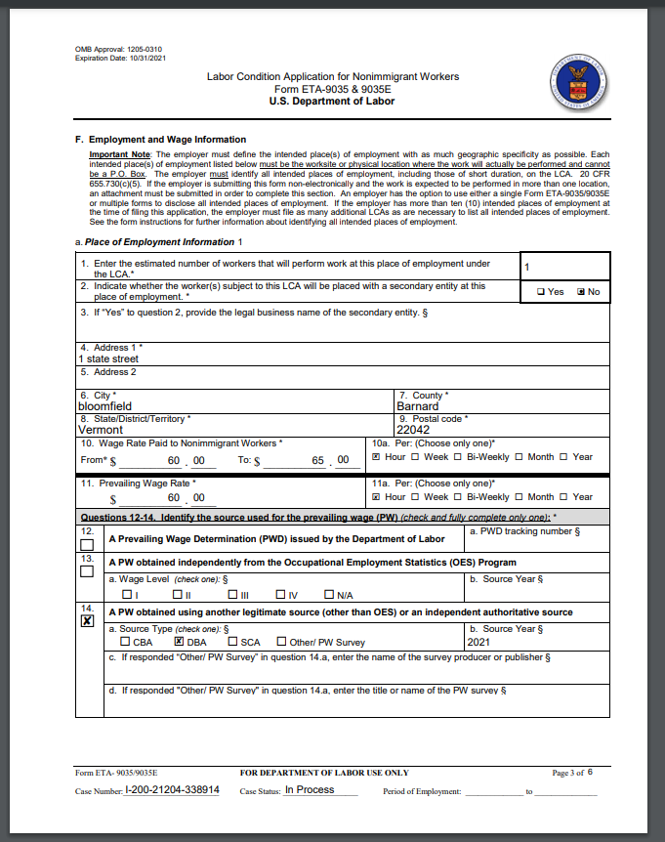

Form ETA-9035 &9035E: Case Generated PDF Version
(Page 4 of 6)

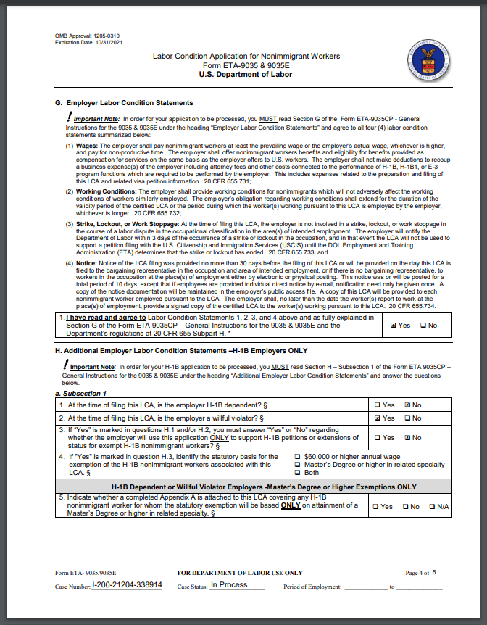

Form ETA-9035 &9035E: Case Generated PDF Version
(Page 5 of 6)

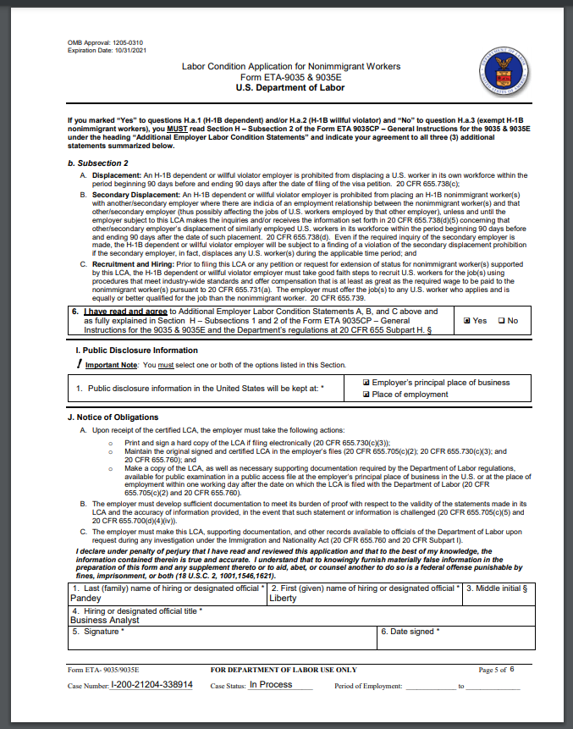

Form ETA-9035 &9035E: Case Generated PDF Version
(Page 6 of 6)

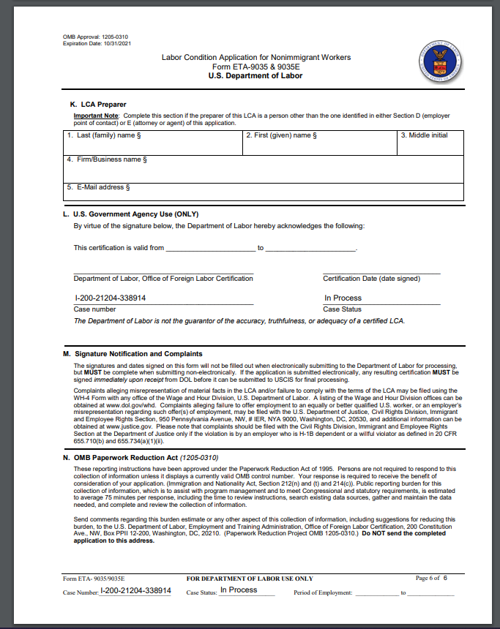

Form ETA-9035 & 9035E – Appendix A
Labor Condition Application for Nonimmigrant Workers
