Form ETA-9142C
CW-1 Application for Temporary Labor Certification

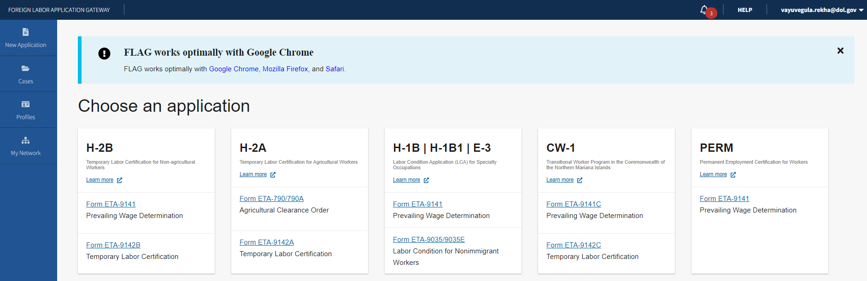

Figure 1: Home Page: New Application for CW-1 Form ETA-9142C TLC

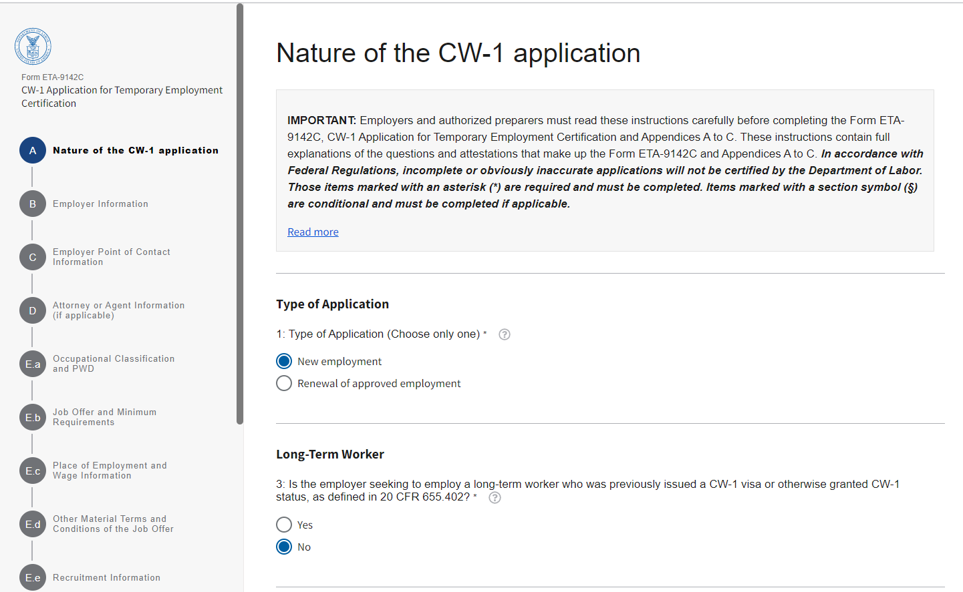

Figure 2: Section A: Nature of the CW-1 application (Section A.1 through A.3)

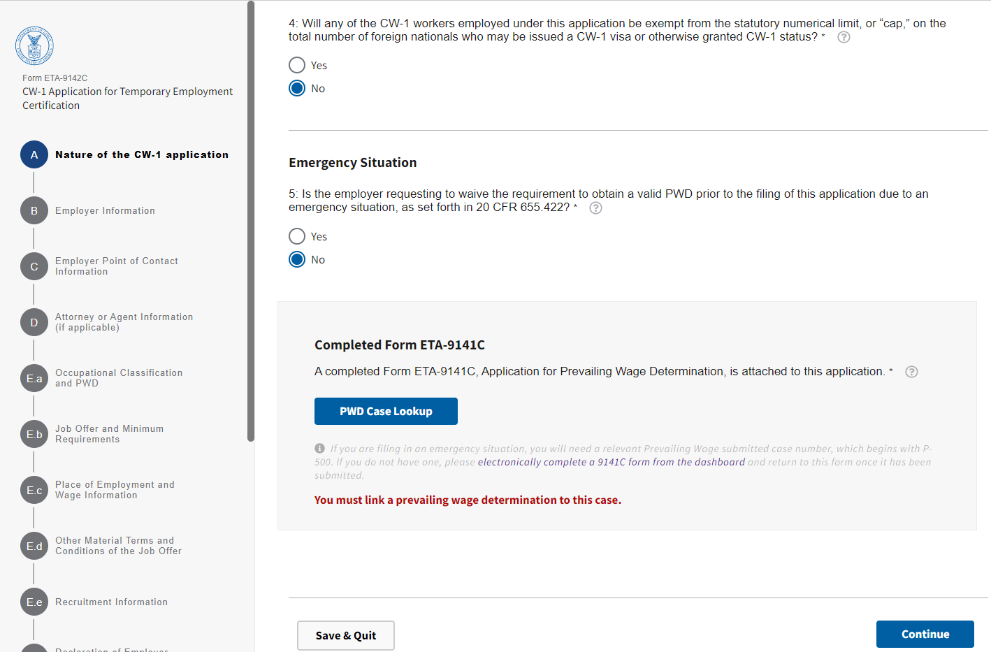

Figure 3: Section A: Nature of the CW-1 application (Section A.4 and A.5)

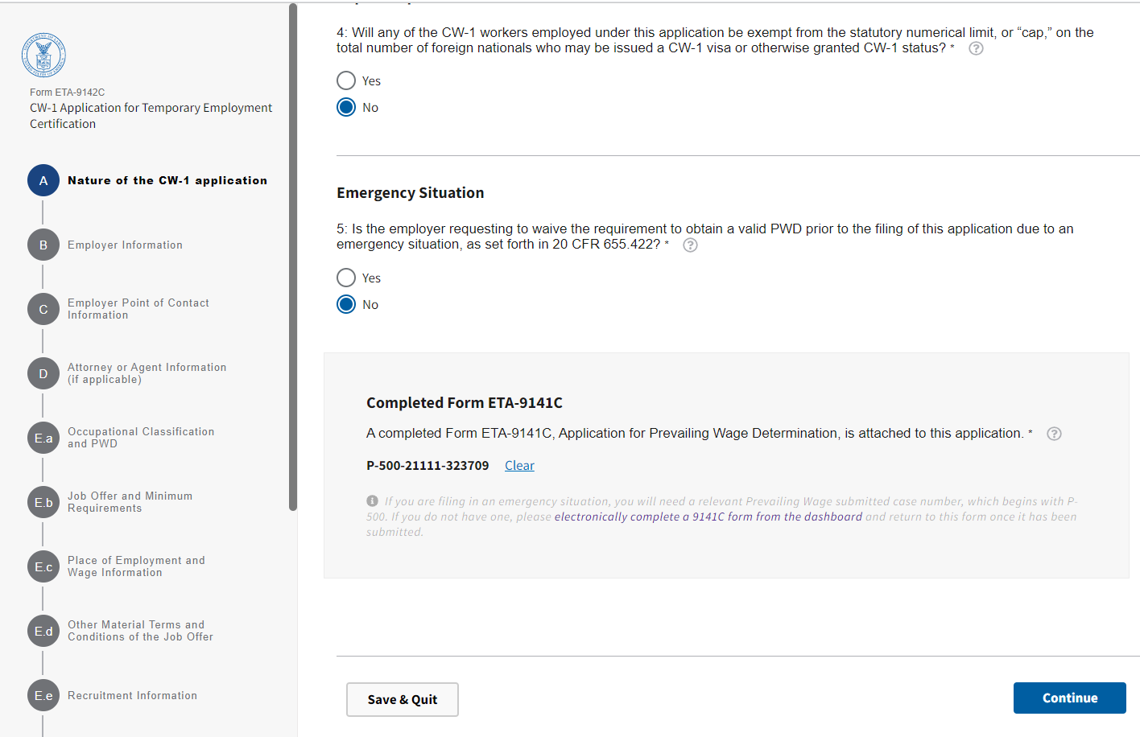

Figure 4: Section A: Completed Form ETA-9141C attached

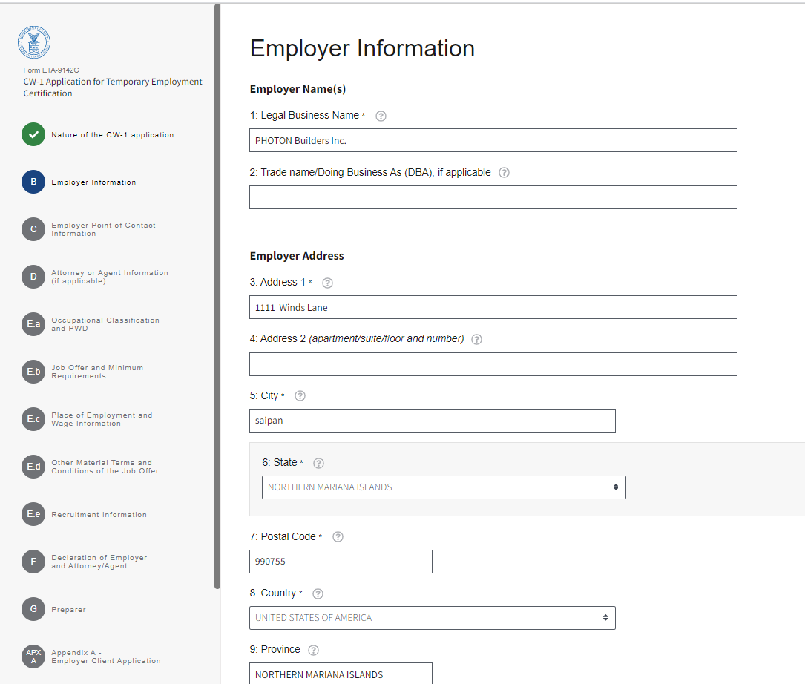

Figure 5: Section B: Employer Information (Section B.1 through B.9)

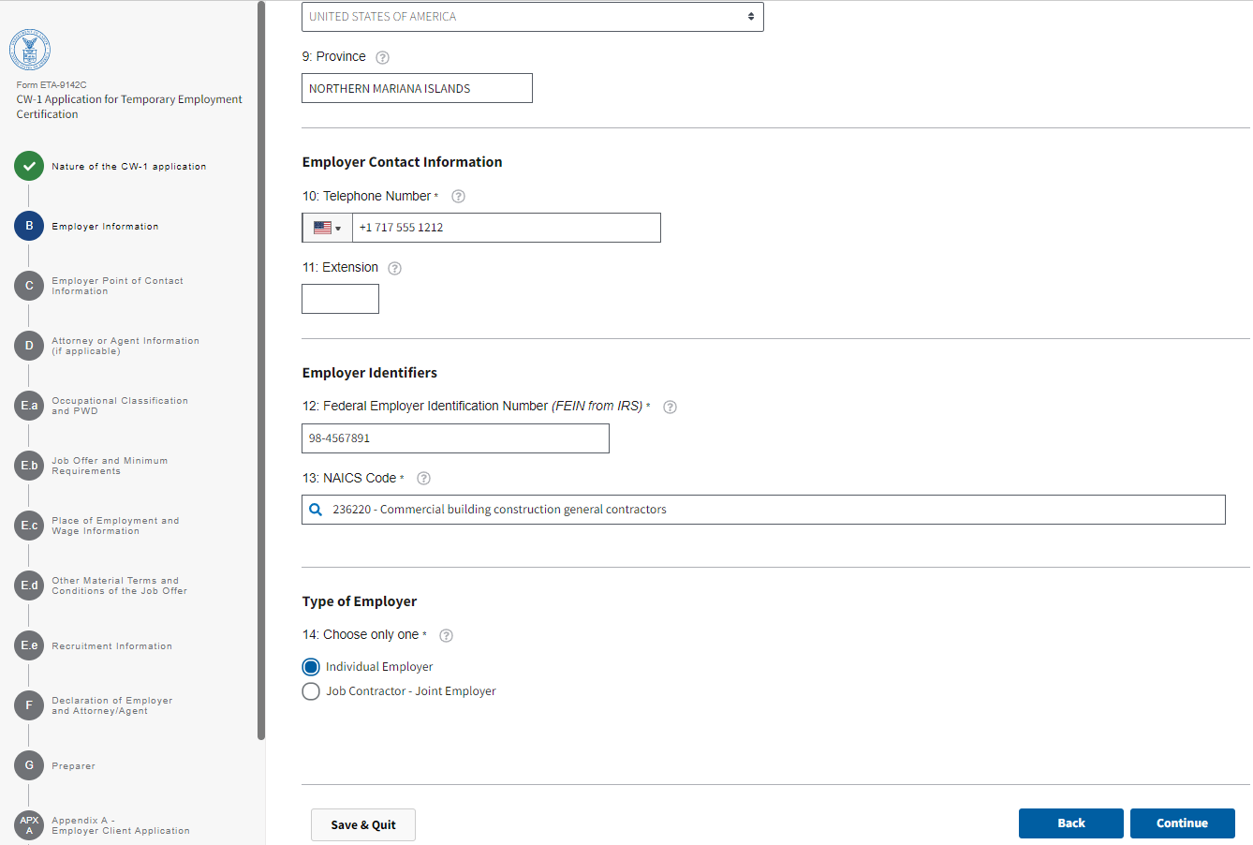

Figure 6: Section B: Employer Information (Section B.10 through B.14)

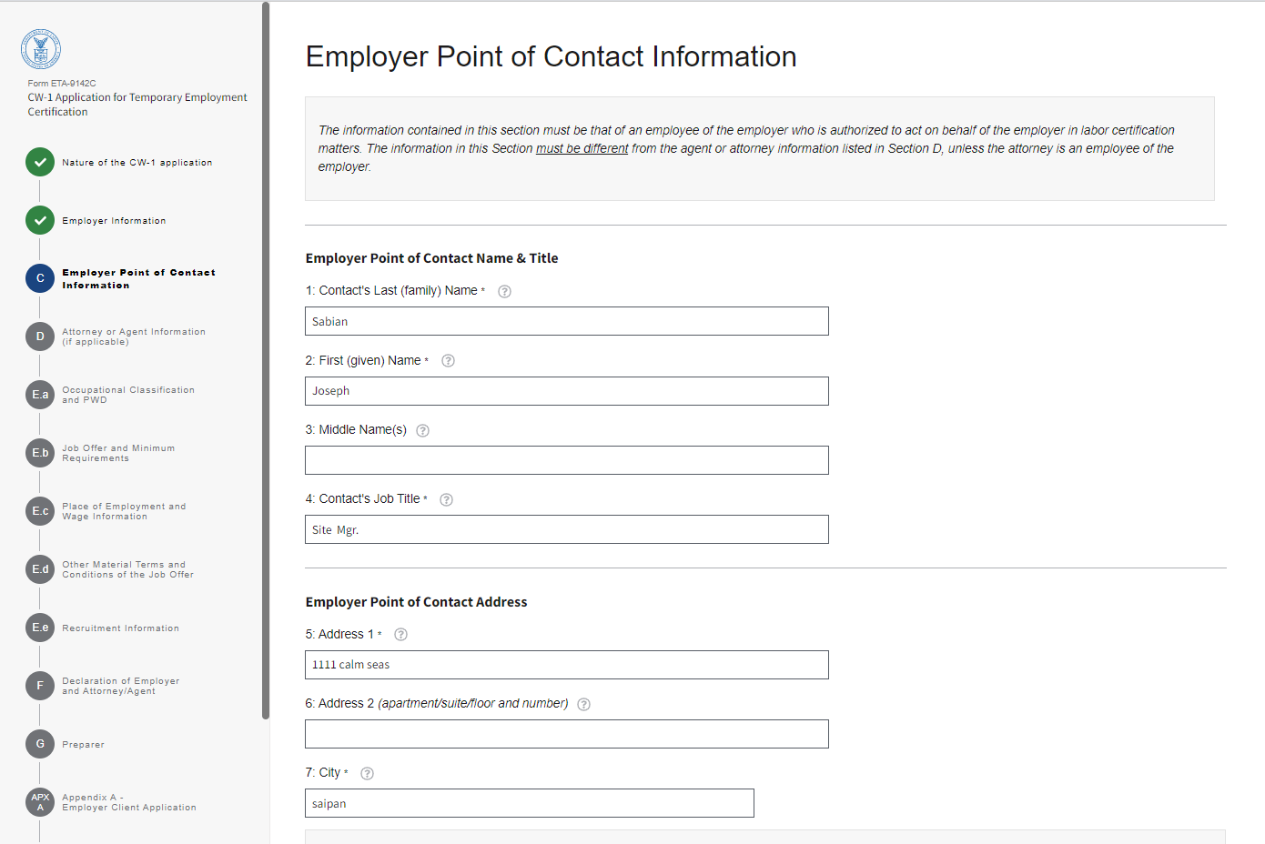

Figure 7: Section C: Employer Point of Contact Information (Section C.1 through C.7)

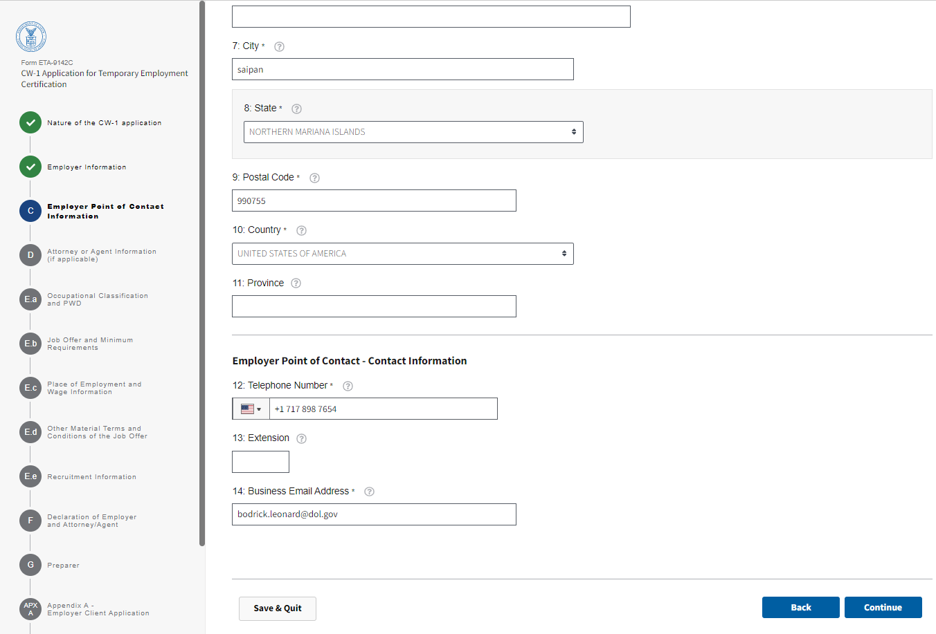
Figure 8: Section C: Employer Point of Contact Information (Section C.8 through C.14)

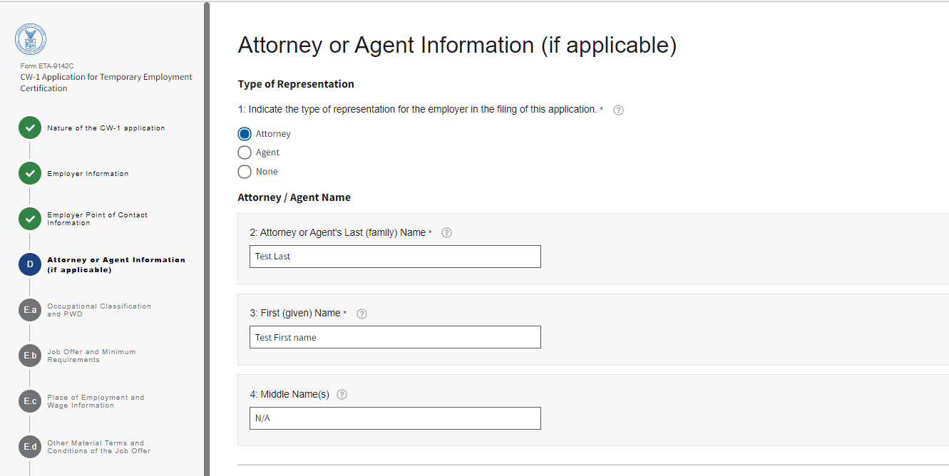
Figure 9: Section D: Attorney or Agent Information (if applicable) (Section D.1 through D.4)

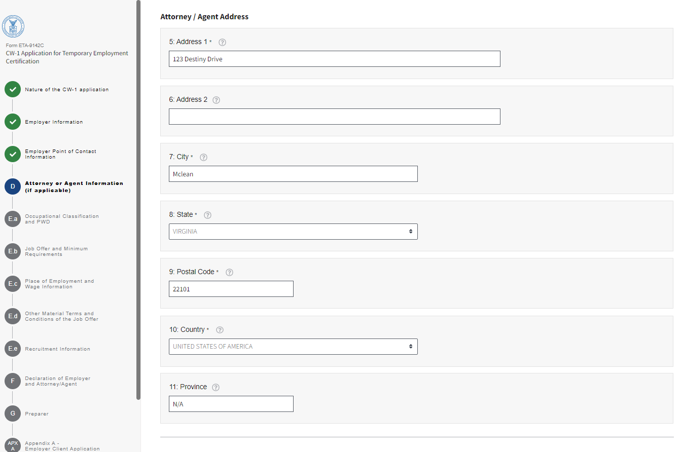

Figure 10: Section D: Attorney or Agent Information (if applicable) (Section D.5 through D.11)

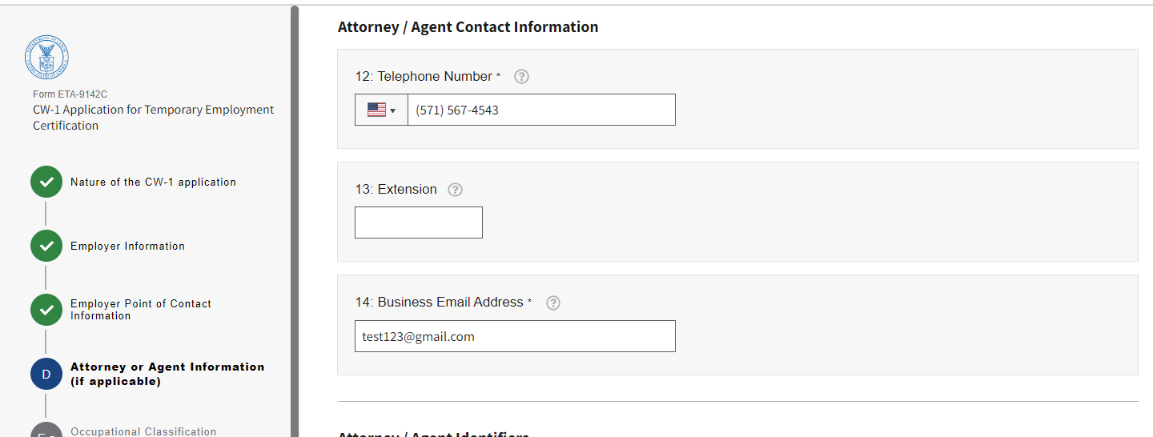

Figure 11: Section D: Attorney or Agent Information (if applicable) (Section D.12 through D.14)

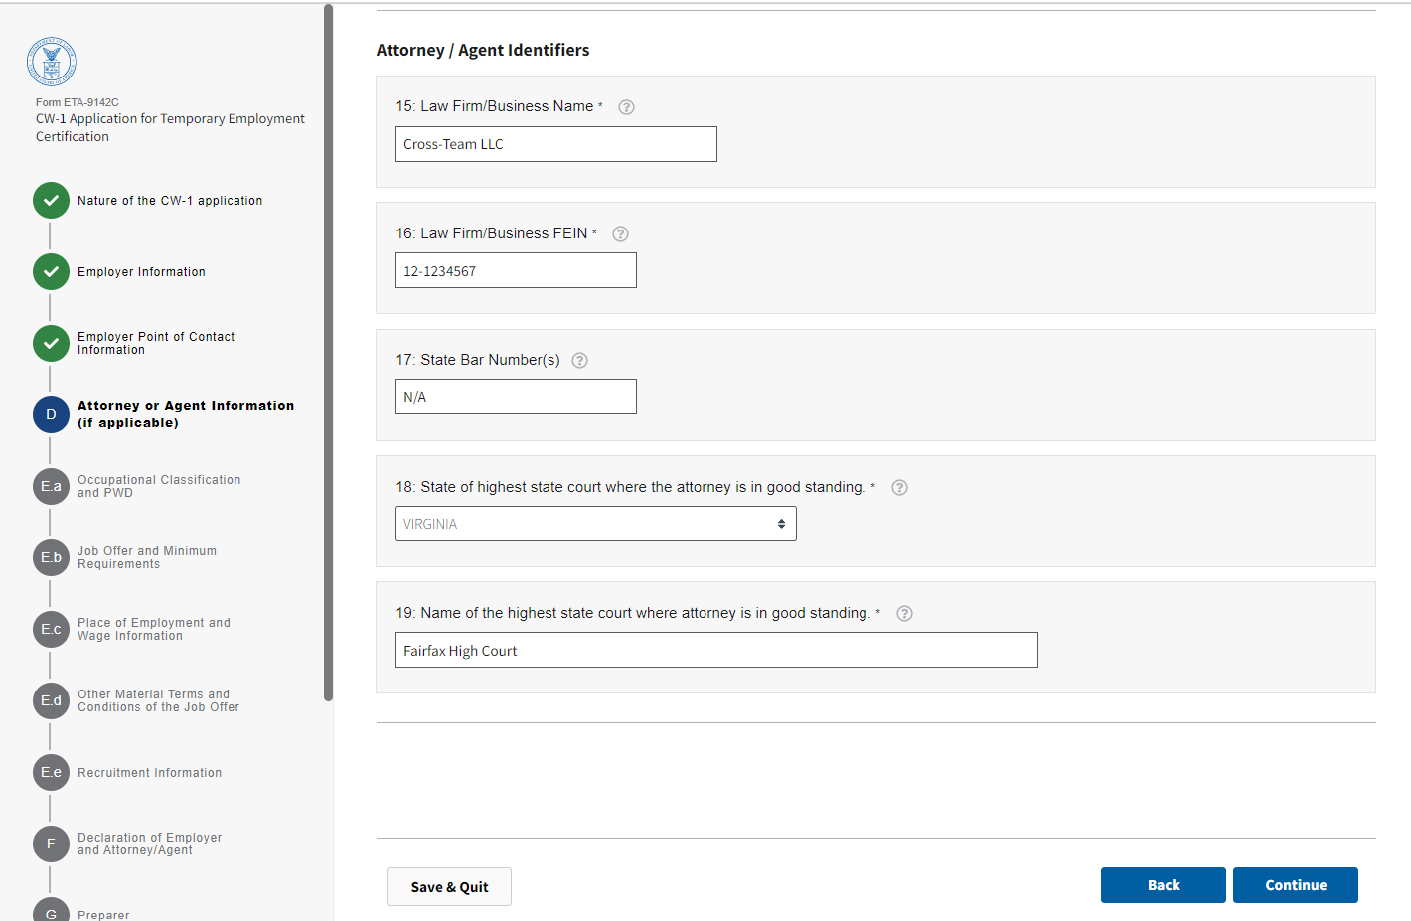

Figure 12: Section D: Attorney or Agent Information (if applicable) (Section D.15 through D.19)

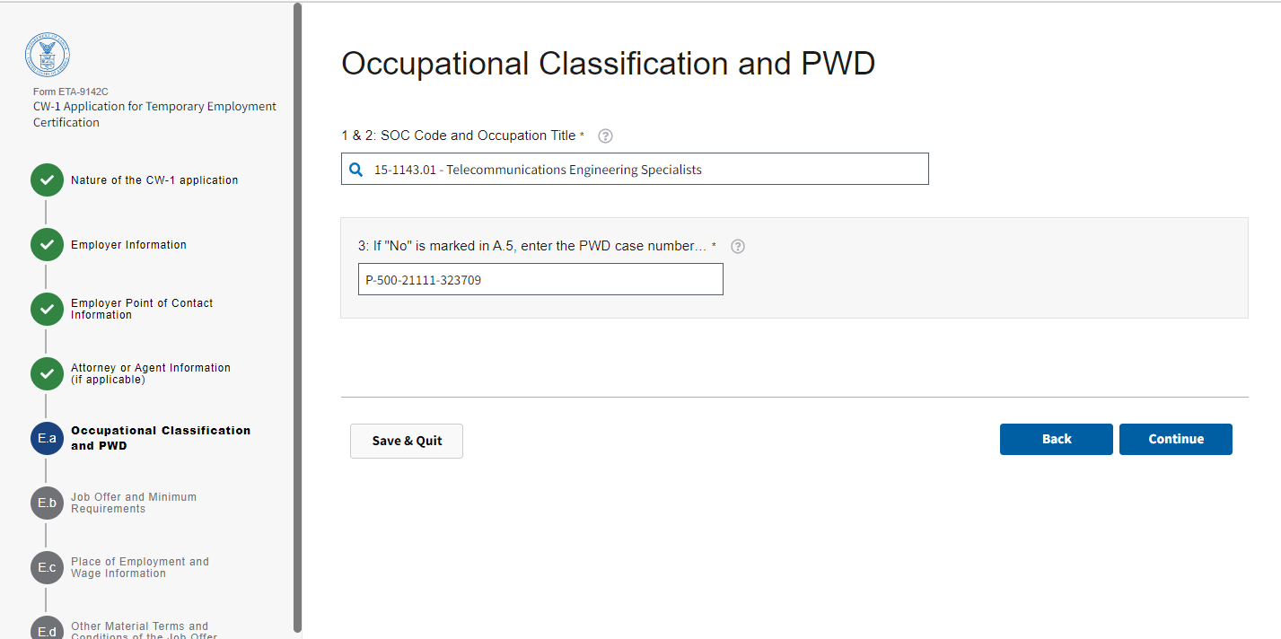

Figure 13: Section E.a: Occupational Classification and PWD (Section E.a.1 through E.a.3)

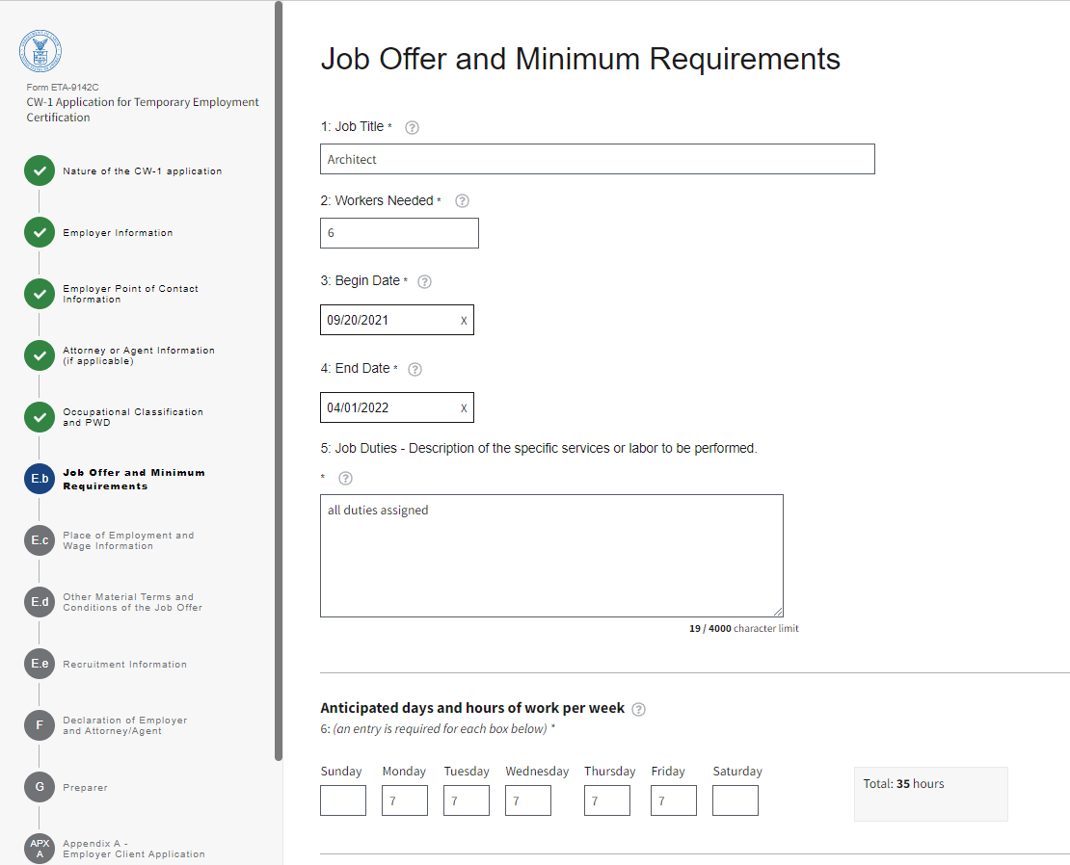

Figure 14: Section E.b: Job Offer and Minimum Requirements (Section E.b.1 through E.b.6)

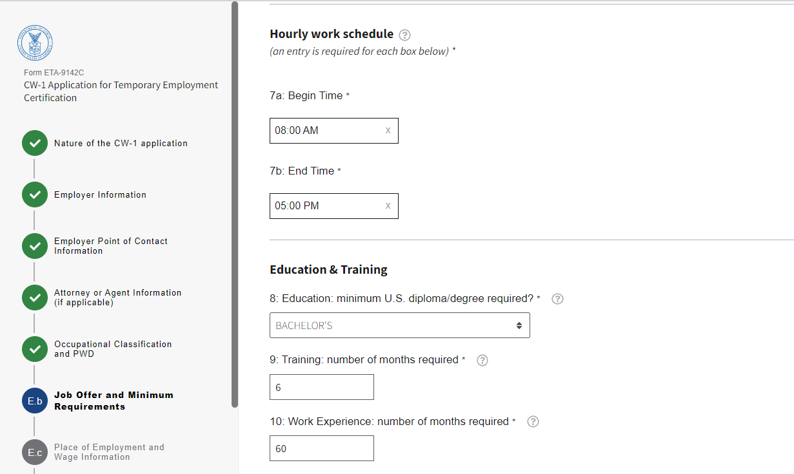

Figure 15: Section E.b: Job Offer and Minimum Requirements (Section E.b.7 through E.b.10)

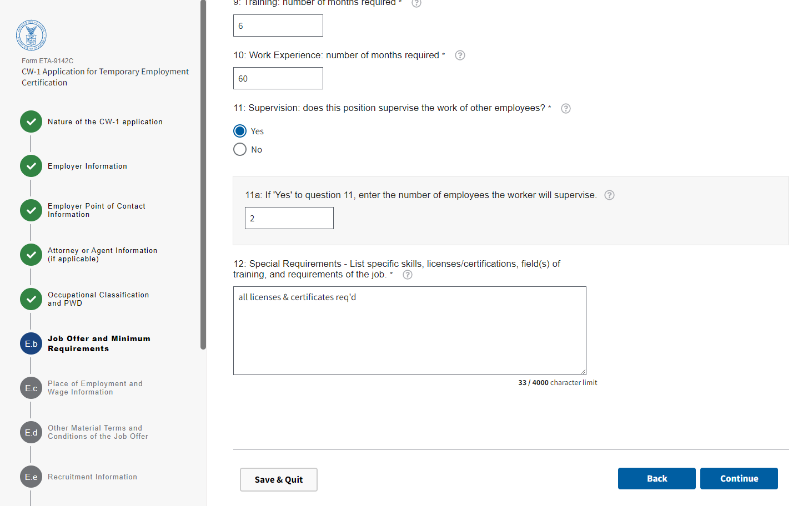

Figure 16: Section E.b: Job Offer and Minimum Requirements (Section E.b.11 and E.b.12)

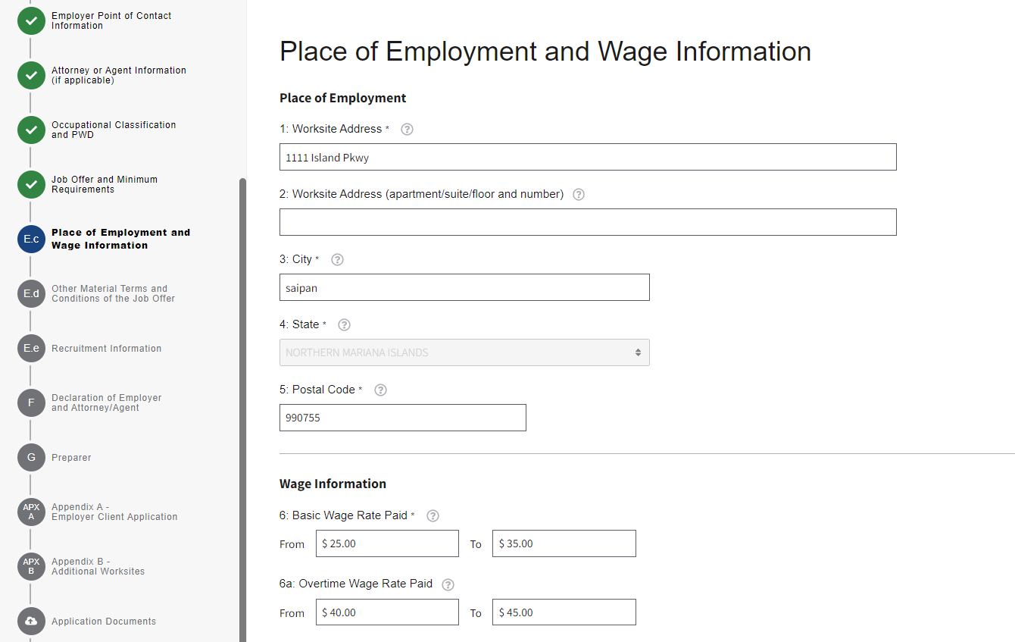

Figure 17: Section E.c: Place of Employment and Wage Information (Section E.C.1 through E.c.6a)

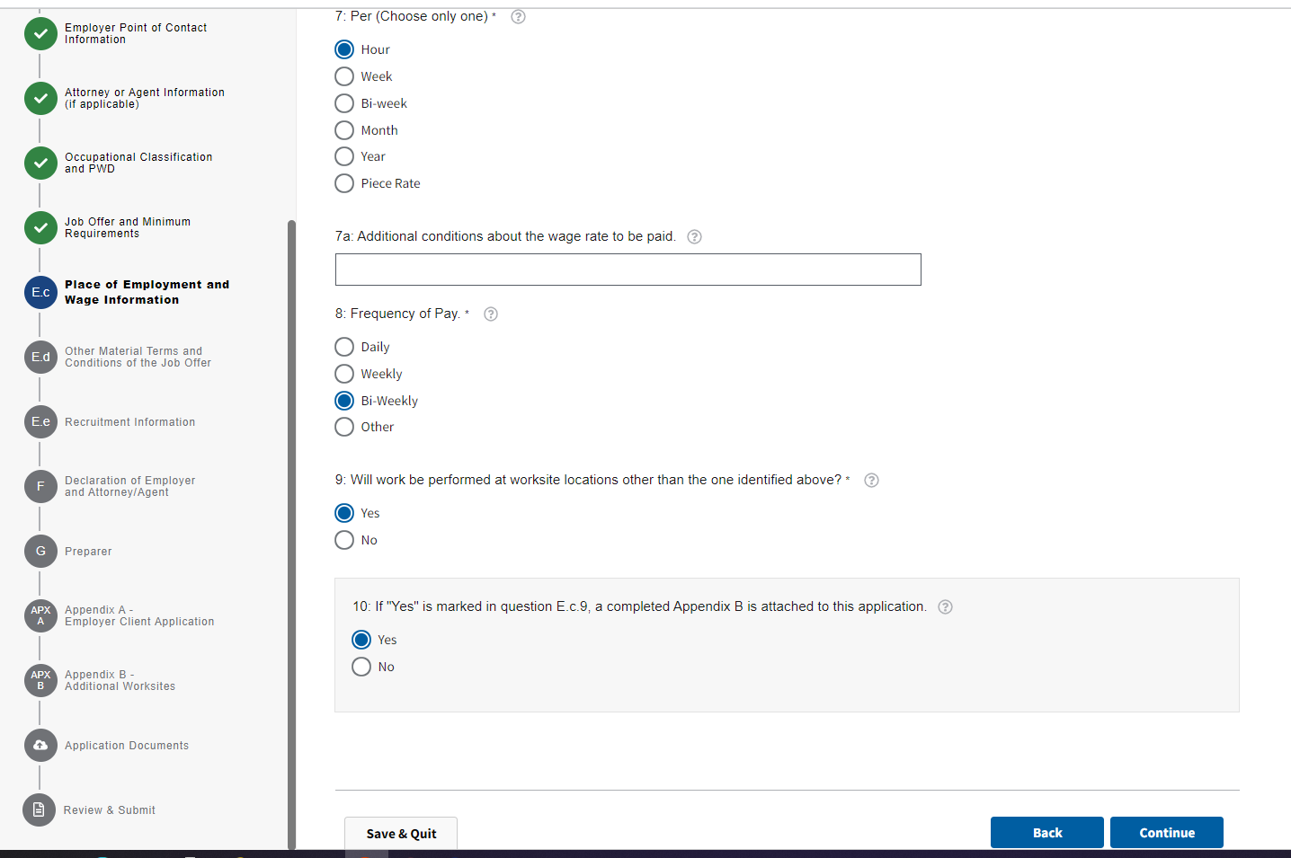

Figure 18: Section E.c: Place of Employment and Wage Information (Section E.C.7 through E.c.10)

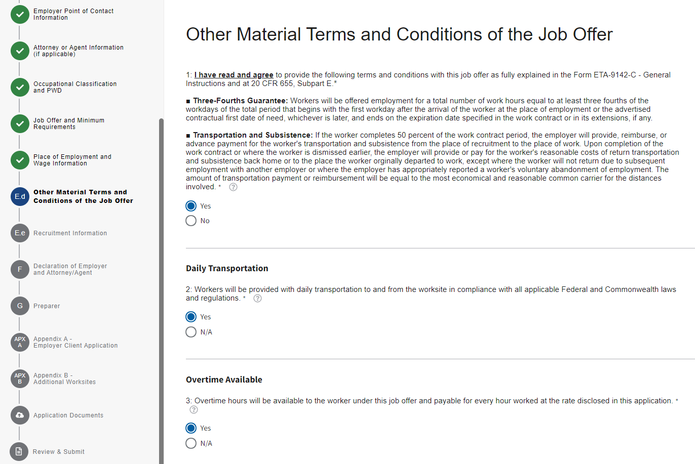

Figure 19: Section E.d: Other Material Terms and Conditions of the Job Offer (Section E.d.1 through E.d.3)

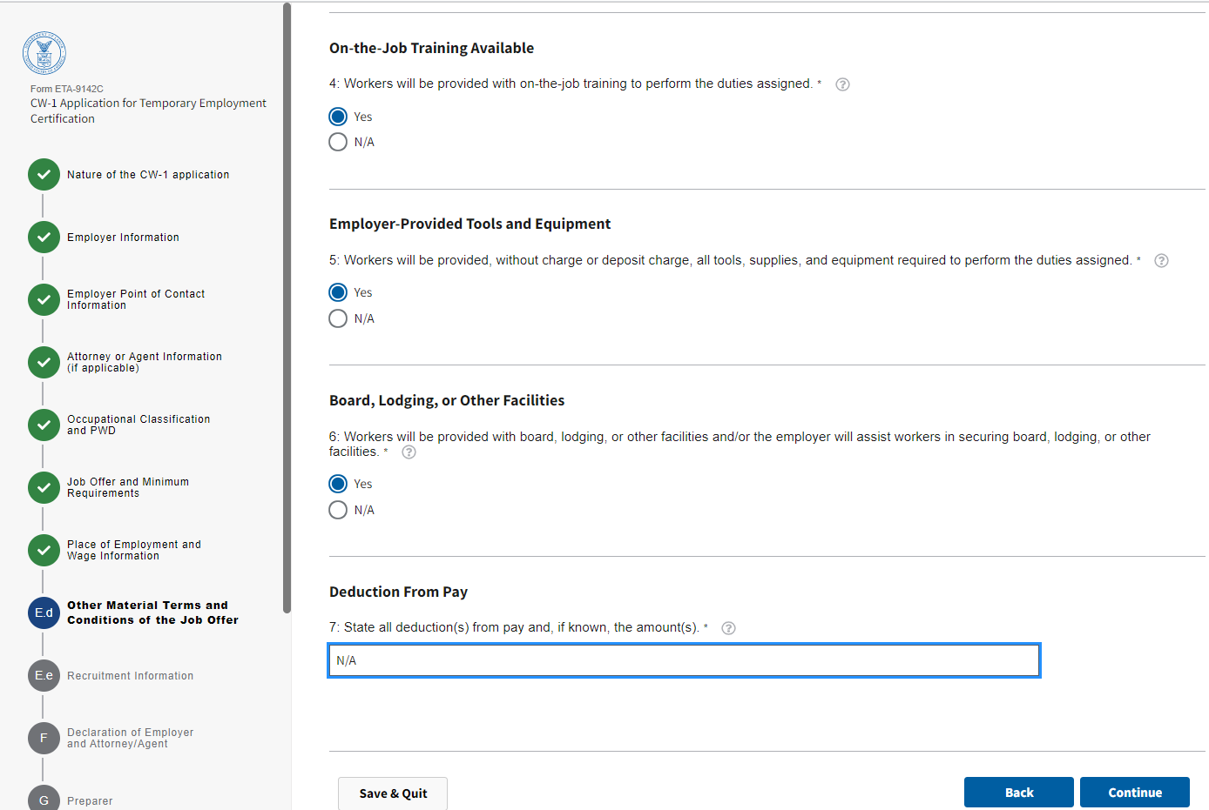

Figure 20: Section E.d: Other Material Terms and Conditions of the Job Offer (Section E.d.4 through E.d.7)

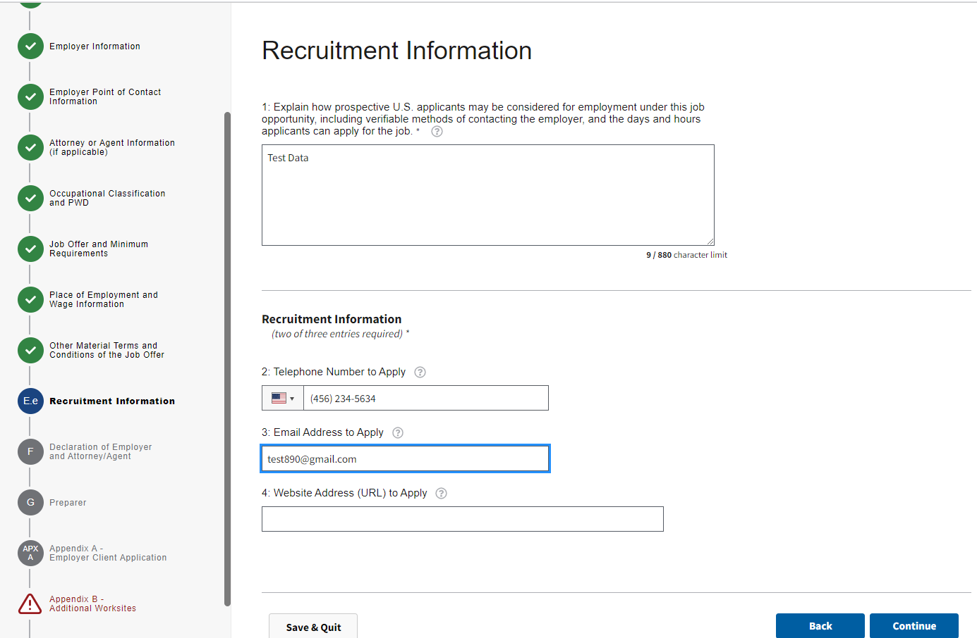

Figure 21: Section E.e: Recruitment Information (Section E.e.1 through E.e.4)

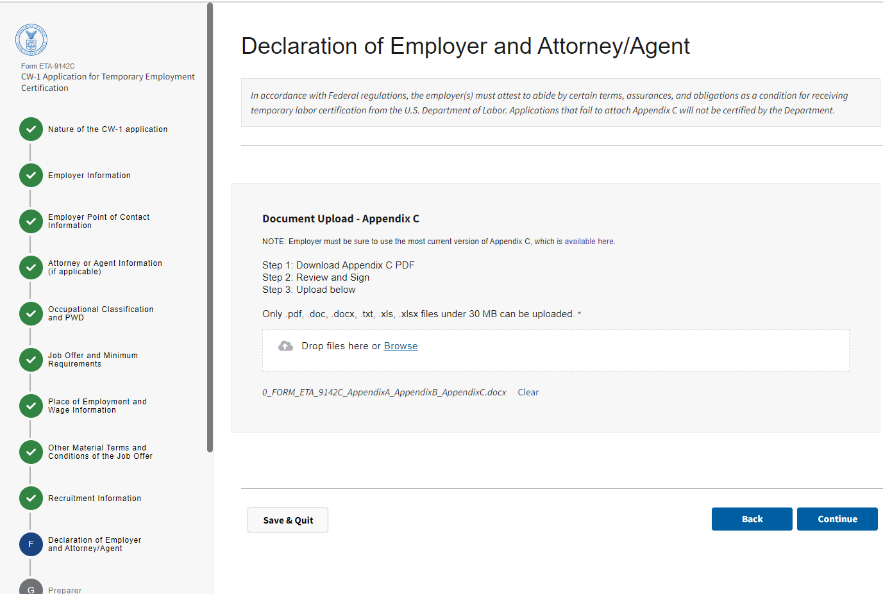
Figure 22: Section F: Declaration of Employer and Attorney/Agent

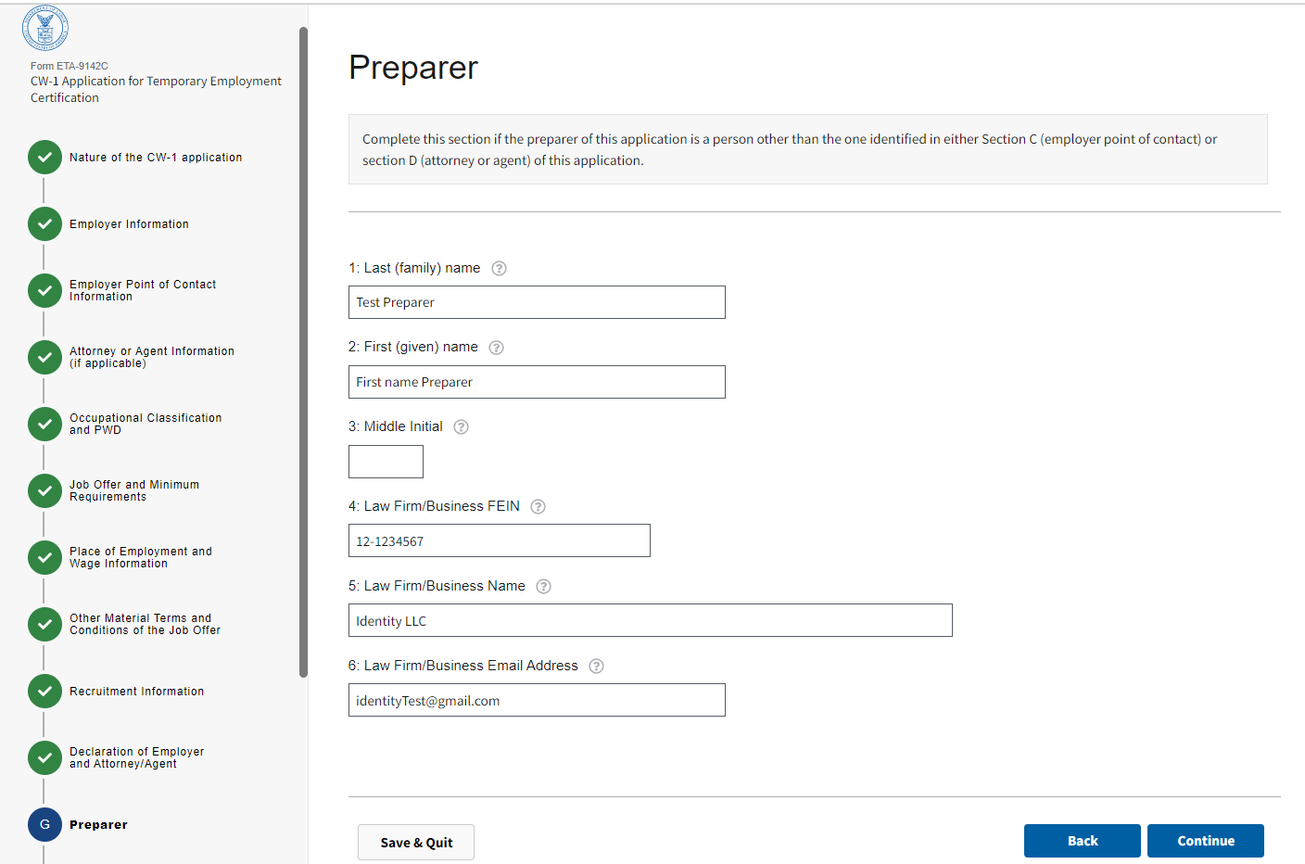

Figure 23: Section G: Preparer (Sections G.1 through G.6)

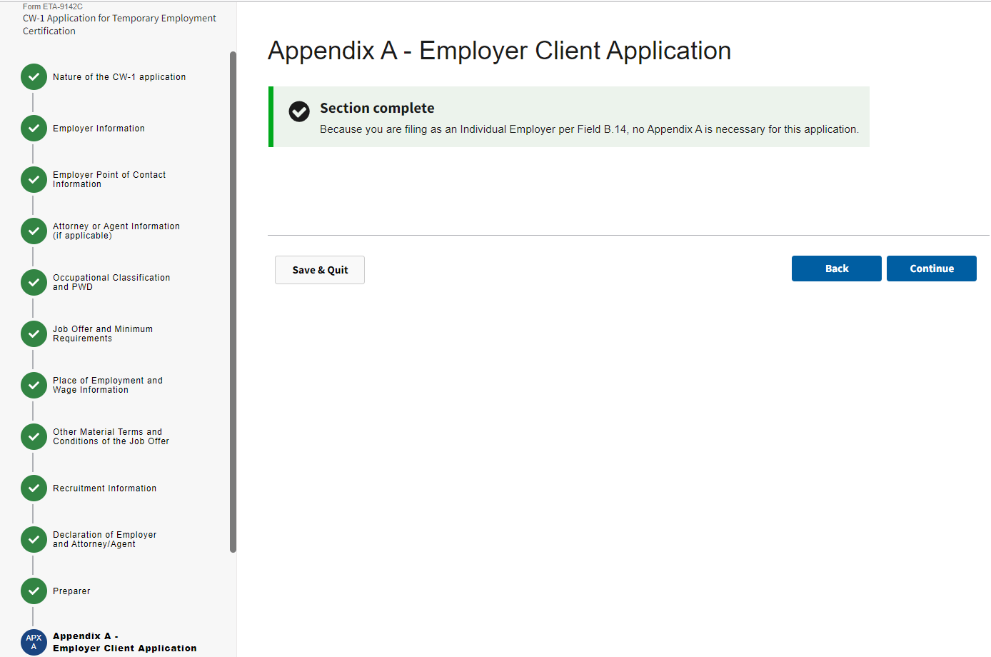

Figure 24: Appendix A – Employer Client Application

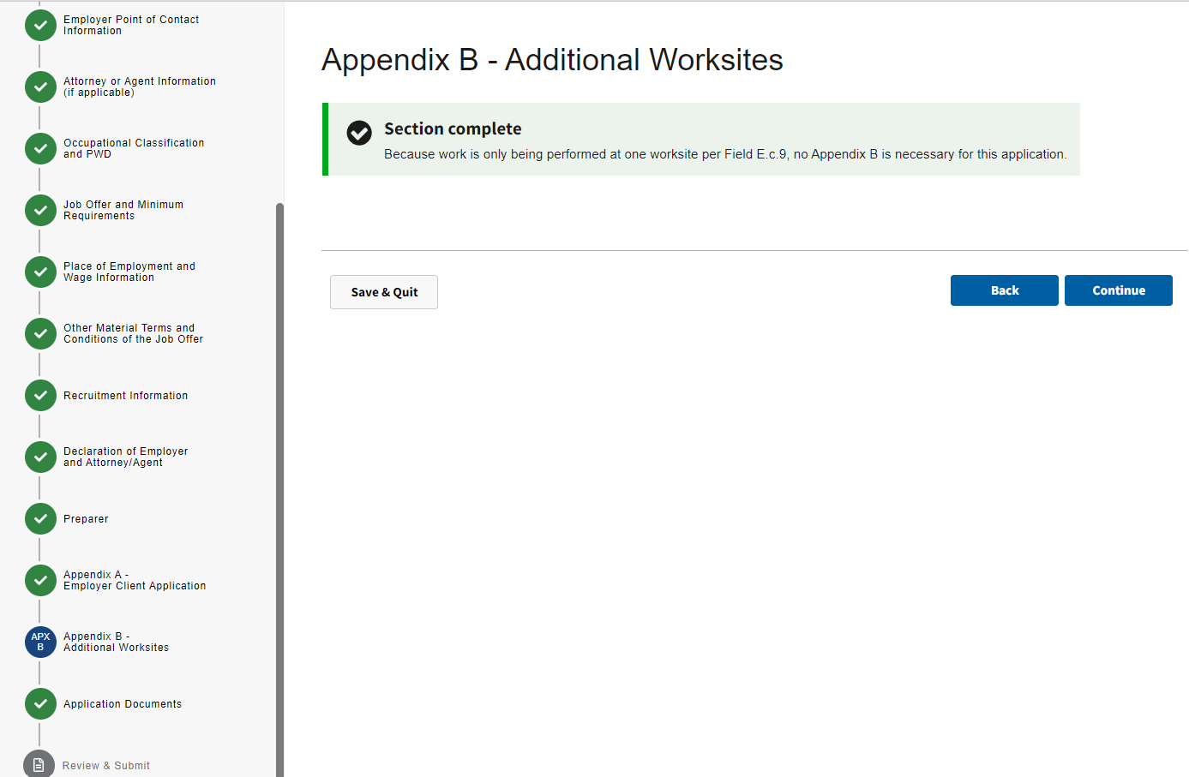

Figure 25: Appendix B - Additional worksites

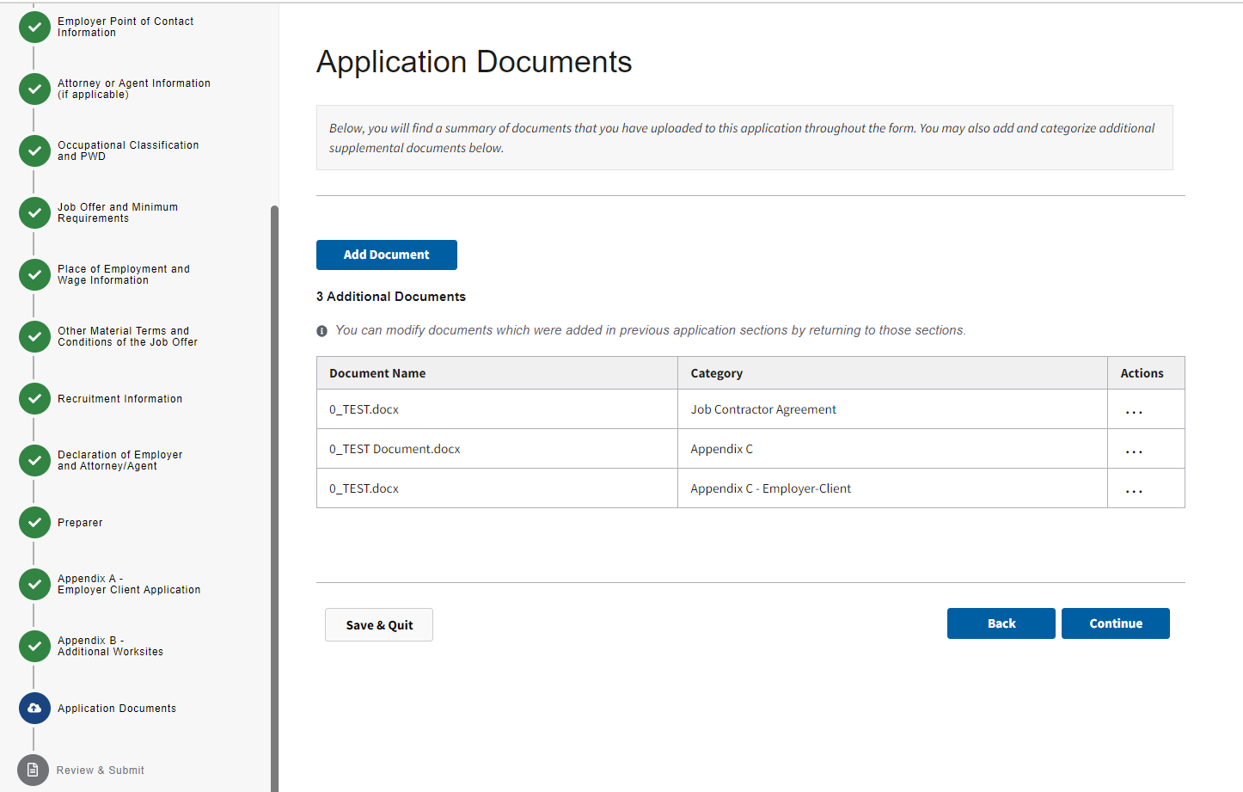

Figure 26: Application Documents

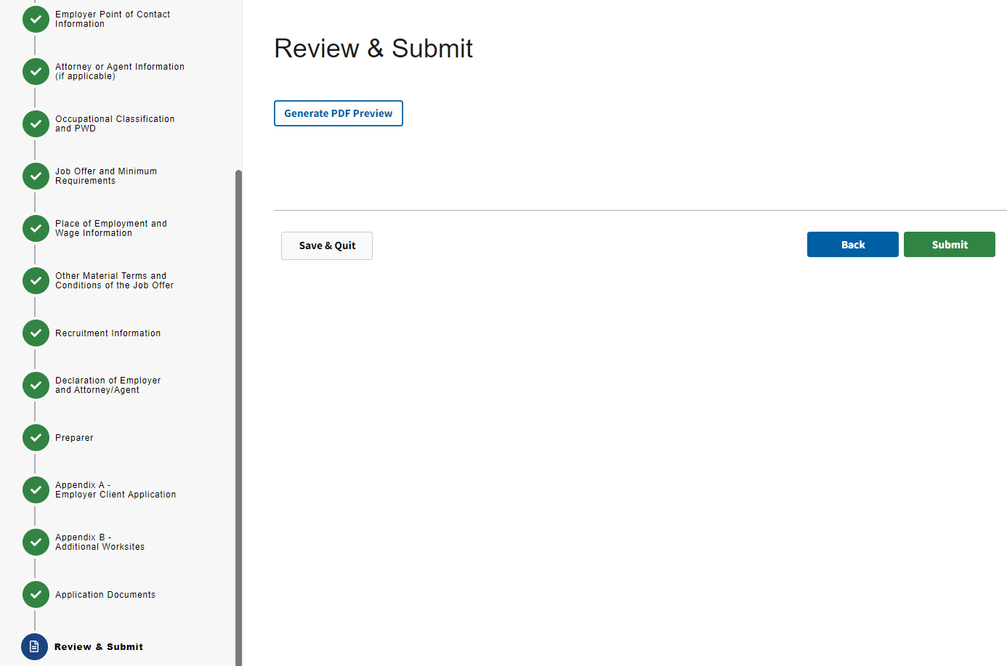

Figure 26: Review and Submit

Case PDF (Page 1 of 5)
Case Prep Generated PDF View:
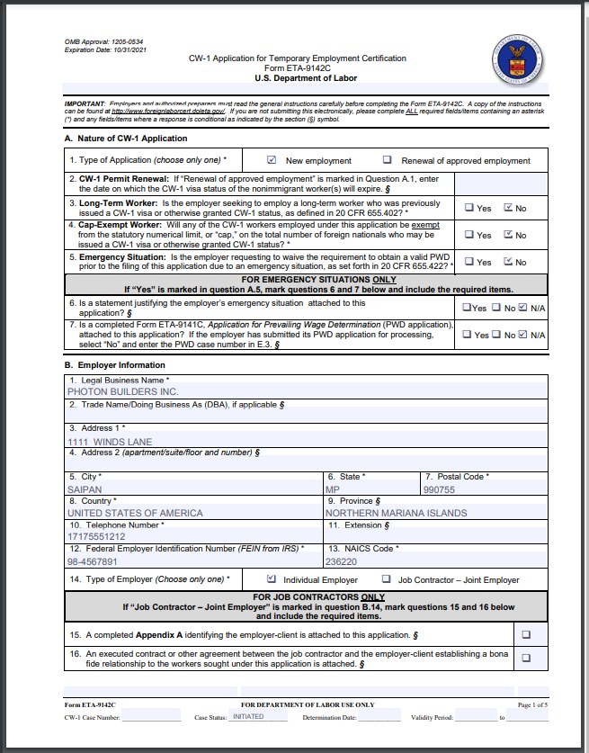

Case PDF (Page 2 of 5)
Case Prep Generated PDF View:
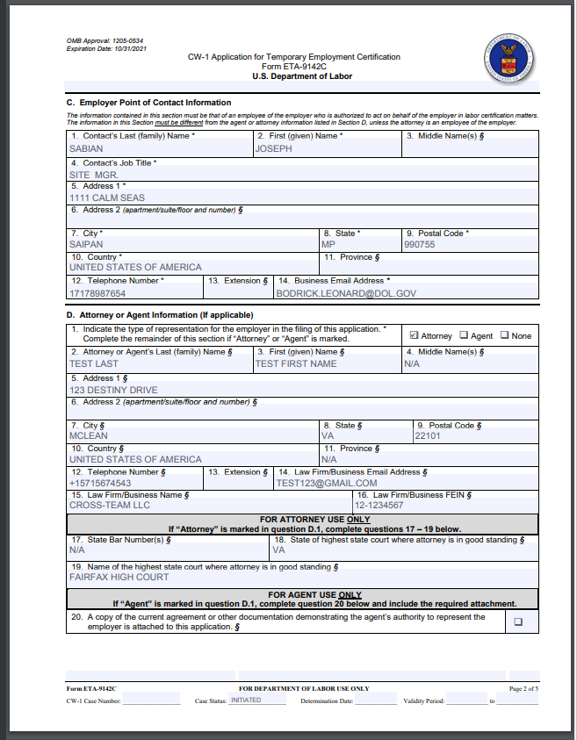

Case PDF (Page 3 of 5)
Case Prep Generated PDF View:
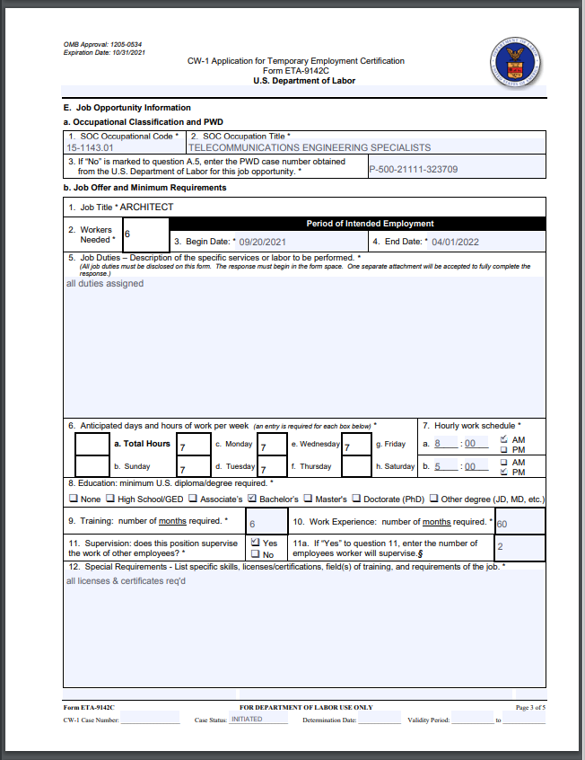

Case PDF (Page 4 of 5)
Case Prep Generated PDF View:
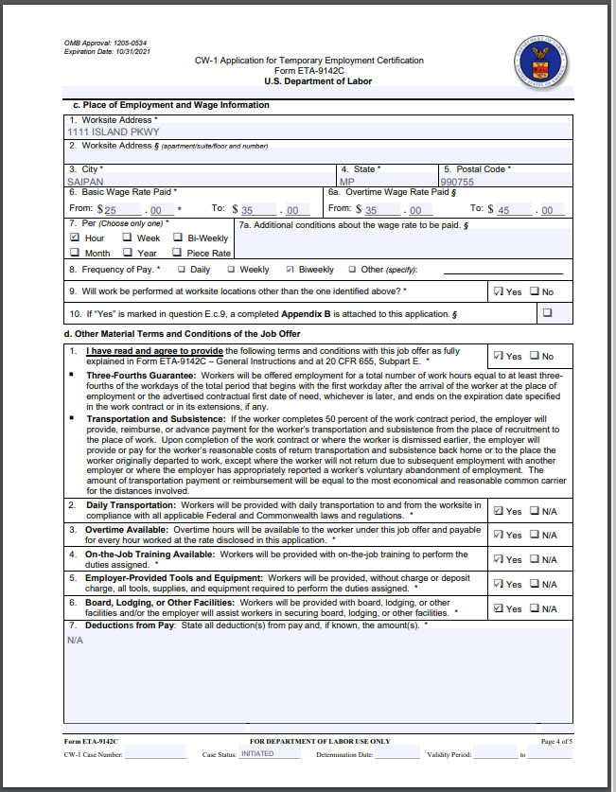

Case PDF (Page 5 of 5)
Case Prep Generated PDF View:
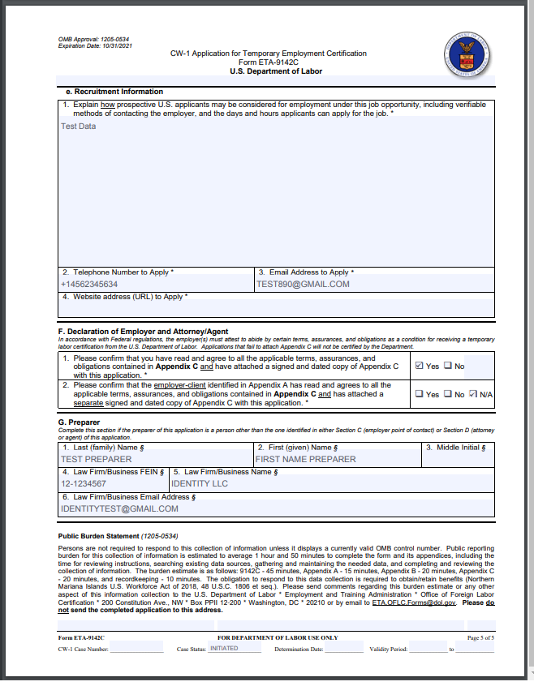

Form ETA-9142C – Appendix A
CW-1 Application for Temporary Employment Certification

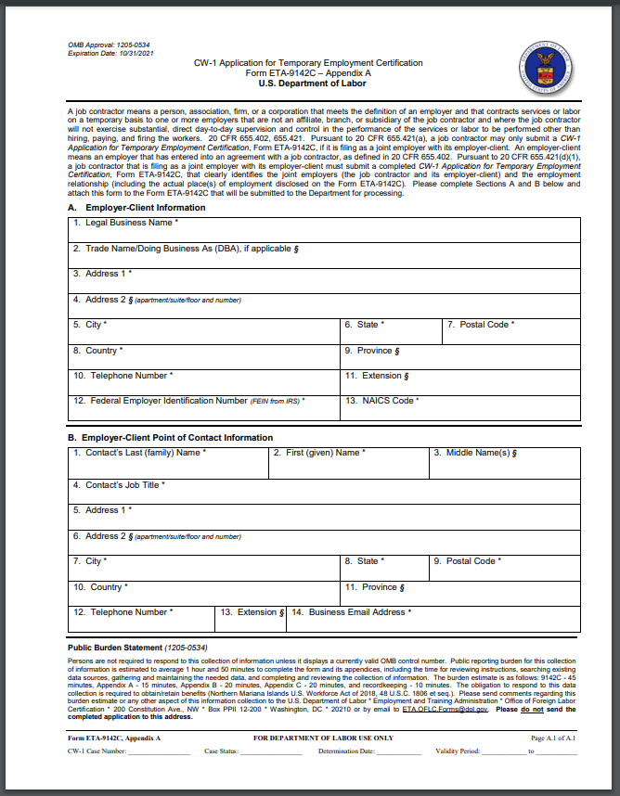

Form ETA-9142C - Appendix B
CW-1 Application for Temporary Employment Certification

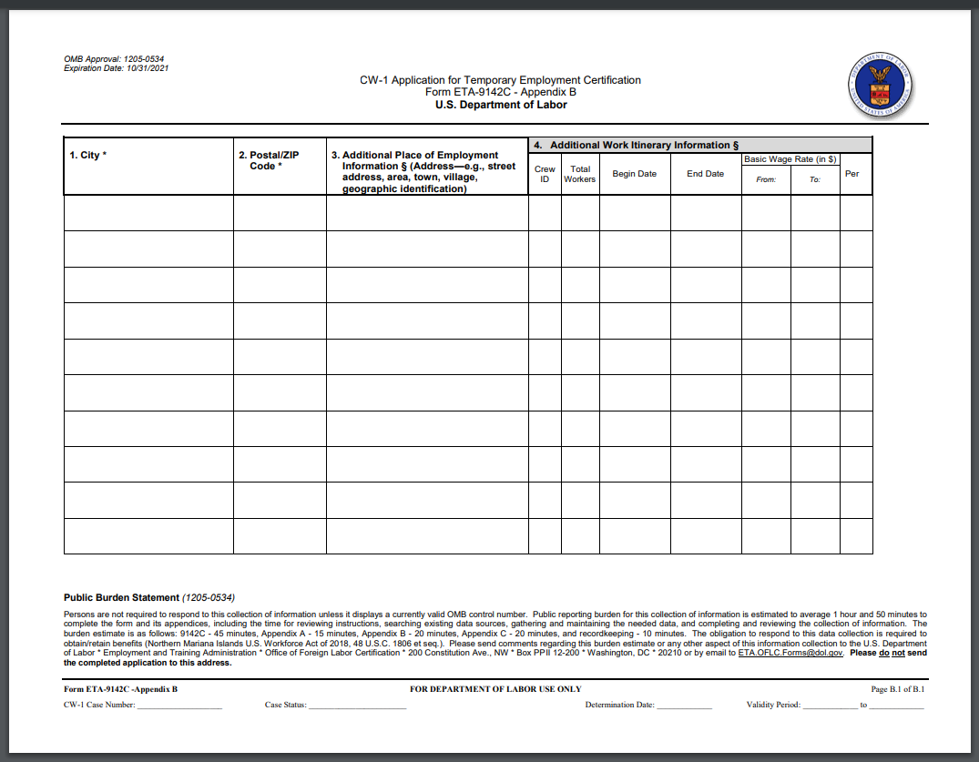

Form ETA-9142C – Appendix C
CW-1 Application for Temporary Employment Certification 