NOTE TO REVIEWER

FROM: David Talan, Chief
Division of Administrative Statistics and Labor Turnover

SUBJECT: Non-substantive Change Request for OMB Clearance of the QCEW Business Supplement (QBS)

The Quarterly Census of Employment and Wages Program (QCEW) of the Bureau of Labor Statistics (BLS) is requesting a non-substantive change request to allow the program to conduct targeted follow up to a limited number of respondents to the 2021 U.S. Business Response Survey to the Coronavirus Pandemic. This follow up is intended to clarify their responses to Question 3 of the survey that went into the field on July 28, 2021. This survey was collected under the QCEW Business Supplement (OMB control number 1220-0198).

Question 3 asks respondents to specify what percent of employees currently telework in various amounts. About 20% of respondents to Question 3 are reporting zero in all three categories.

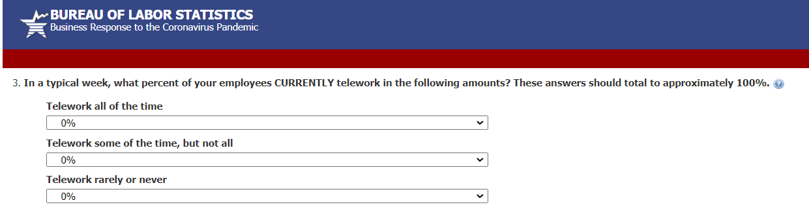

BLS has researched this response pattern by matching responses to this question with responses to the prior year’s Business Response Survey and using Occupational Employment and Wage Statistics data. This research indicates a pattern consistent with these respondents intending to report that they have no telework at this location. The correct response would have been to select 100% in the ‘Telework rarely or never category.’

BLS wishes to follow up with respondents to ask them whether there is any telework at their business location. This follow up would allow BLS to correct responses for those respondents that answer the follow up request. It could also inform imputation strategy for the remaining responses if a high percentage of respondents indicate there is no telework at their establishment, as is expected. The email and the website option were developed in consultation with BLS’ Office of Survey Methods Research which concurs with this approach.

BLS would send one email to respondents, asking for a clarification to their response. The respondents would be directed to a BLS website where they would answer one Yes or No question about telework and provide their WebID from the email, their name, and email address for linking.

QCEW estimates that it will take respondents approximately 30 seconds to answer one follow up question. If the program solicits approximately 14,000 respondents, that would equate to approximately 116.67 burden hours. Solicitation will take place via email, so there will be no additional printing or postage costs associated with this change

Please contact Emily Thomas at Thomas.emily@bls.gov or (856) 534-4729 if there are any questions concerning this request.

Attachment 1 – Email Template
Attachment 2 – Website for clarification request

Attachment 1 - Email Template

Subject: Business Response to the Coronavirus Pandemic

Dear Employer,

You recently completed the U.S. Business Response Survey to the Coronavirus Pandemic. Thank you for your time and your response. We are following up to make sure we have a clear understanding of the information you took the time to provide. To do this we are asking you to answer one follow-up question about whether any employees at your business currently telework.

It will take about 30 seconds to go to our website and answer this one question. Without this information, we may be unable to use the data you took the time to provide.
Please go to our secure website to clarify your response: https://data.bls.gov/forms/ars.htm?/respondents/ars/home.htm
WEB ID 1: 012345678901
This survey is approved with O.M.B. No. 1220-0198, in cooperation with the U.S. Department of Labor.
Thank you,
U.S. Department of Labor
Bureau of Labor Statistics

How do I know this email is from the United States Bureau of Labor Statistics?
Links in this email will start with https:// and contain 'bls.gov.' Your browser will also display a padlock icon to let you know a site is secure.

The Bureau of Labor Statistics (BLS) is committed to the responsible treatment of confidential information and takes rigorous security measures to protect confidential information in its possession. This email contains confidential information. If you believe you are not the intended recipient of this message, please notify the sender and delete this email without disclosing, copying, or further disseminating its contents.

Attachment 2 – Website for clarification request

