NATIONAL CENTER FOR EDUCATION STATISTICS NATIONAL ASSESSMENT OF EDUCATIONAL PROGRESS

National Assessment of Educational Progress (NAEP)2022
Materials Update #1

Appendix J1

2022 Student Questionnaires

OMB# 1850-0928 v.23



June 2021

Appendix J1 provides updated student survey questionnaires to be used in NAEP 2022. The change tables indicate any revisions that have been made to the previous versions of the SQs. Please note, the change tables compare the 2022 items to the 2019 versions of the items. No changes to the items have been made since OMB# 1850-0928 v.22. If further revisions are required, they will be submitted in this Appendix in Amendment #2 by August 2021.

Table of Contents
Student Questionnaires
Student Login Screen 3
Appendix J1-1: Summary of Changes Operational Grade 4 (CORE) 4
Appendix J1-2: Operational Grade 4 (CORE) 9
Appendix J1-3: Summary of Changes Operational Grade 8 (CORE) 13
Appendix J1-4: Operational Grade 8 (CORE) 19
Appendix J1-5: Summary of Changes Operational Grade 4 (Mathematics) 26
Appendix J1-6: Operational Grade 4 (Mathematics) 31
Appendix J1-7: Summary of Changes Operational Grade 8 (Mathematics) 35
Appendix J1-8: Operational Grade 8 (Mathematics) 41
Appendix J1-9: Summary of Changes Operational Grade 4 (Reading) 47
Appendix J1-10: Operational Grade 4 (Reading) 51
Appendix J1-11: Summary of Changes Operational Grade 8 (Reading) 56
Appendix J1-12: Operational Grade 8 (Reading) 61
Appendix J1-13: Summary of Operational Grade 8 Civics 67
Appendix J1-14: Operational Grade 8 Civics 74
Appendix J1-15: Summary of Operational Grade 8 U.S. History 80
Appendix J1-16: Operational Grade 8 U.S. History 87
Appendix J1-17: Summary of Operational Grade 4 Debrief 92
Appendix J1-18: Operational Grade 4 Debrief 93
Appendix J1-19: Summary of Operational Grade 8 Debrief 94
Appendix J1-20: Operational Grade 8 Debrief 95
Appendix J1-21: Operational Grade 4 COVID-19 Student Items (ELA) 96
Appendix J1-22: Operational Grade 8 COVID-19 Student Items (ELA) 99
Appendix J1-23: Operational Grade 4 COVID-19 Student Items (Math) 102
Appendix J1-24: Operational Grade 8 COVID-19 Student Items (Math) 105
Appendix J1-25: Operational Grade 8 COVID-19 Student Items (Civics) 108
Appendix J1-26: Operational Grade 8 COVID-19 Student Items (U.S. History) 111

Student Login Screen
The student login screens will have the updated OMB expiration dates added in Amendment #2 in August 2021.

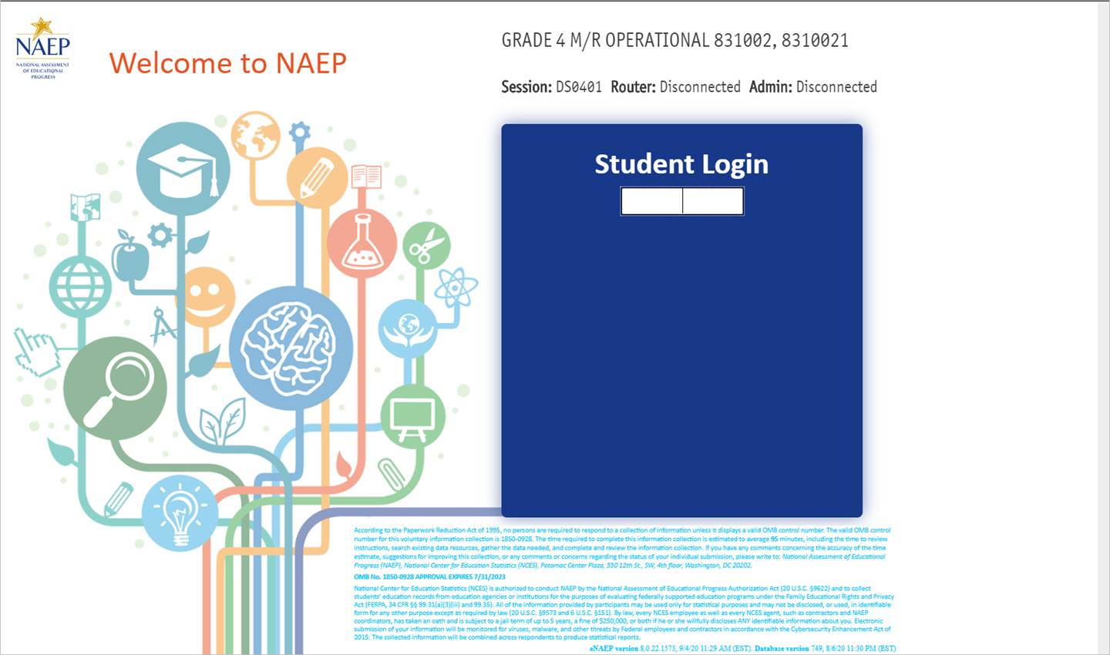

Appendix J1-1: Summary of Changes Operational Grade 4 (CORE)
2022 Operational Grade 4 Core Student

Previous item | 2022 item | D/A/ R/NC+ | Rationale
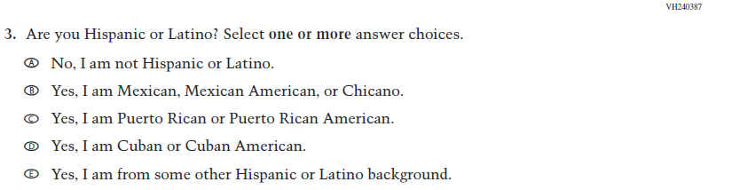  (2019 Grade 4) | 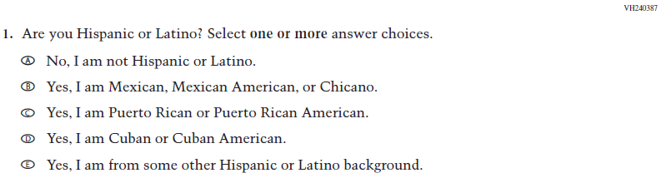  Issue: Race/Ethnicity | NC | N/A
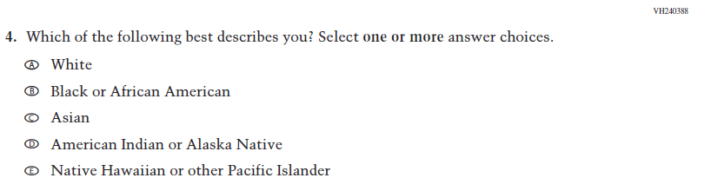  (2019 Grade 4) | 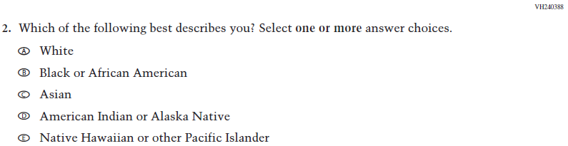  Issue: Race/Ethnicity | NC | N/A
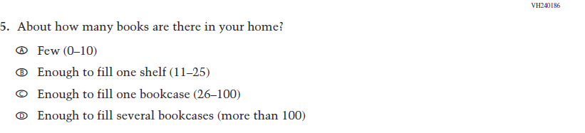  (2019 Grade 4) | 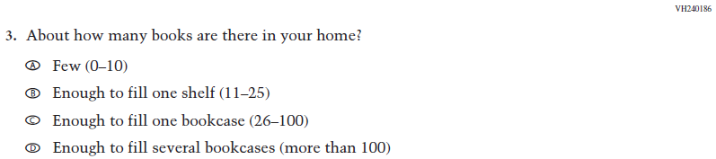  Issue: Socioeconomic Status | NC | N/A

2022 Operational Grade 4 Core Student
Previous item | 2022 item | D/A/ R/NC+ | Rationale
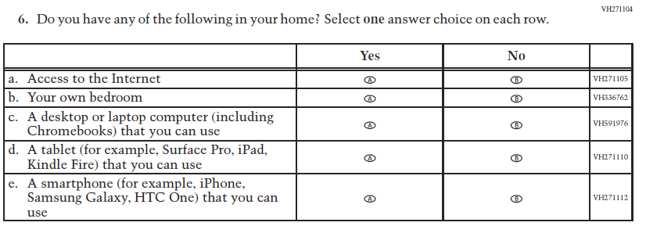  (2019 Grade 4) | 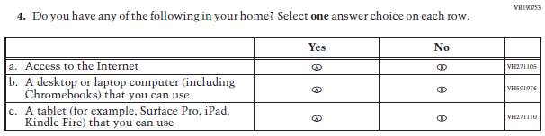  Issue: Socioeconomic Status | R | To keep student burden low, sub-items b and e were dropped.
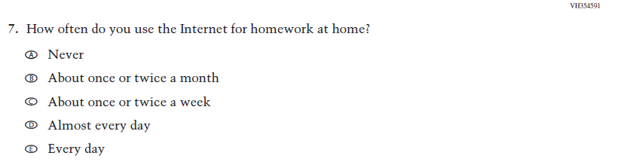  (2019 Grade 4) | N/A | D | To keep student burden low, this item was dropped.
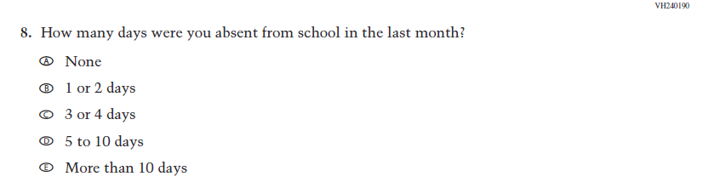  (2019 Grade 4) | 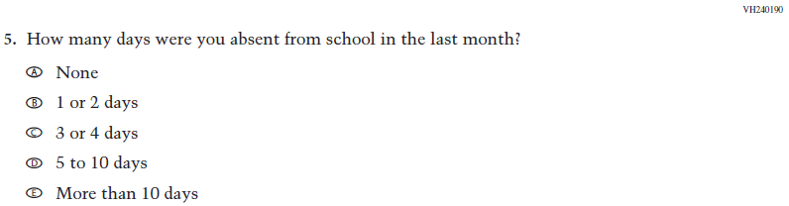  Issue: School Climate | NC | N/A
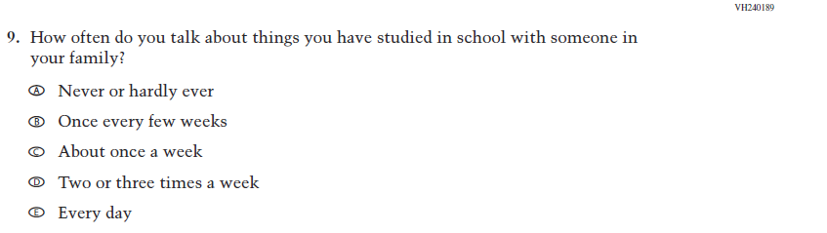  (2019 Grade 4) | N/A | D | To keep student burden low, this item was dropped.

2022 Operational Grade 4 Core Student

Previous item | 2022 item | D/A/ R/NC+ | Rationale
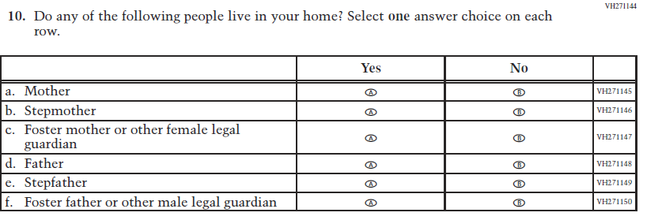  (2019 Grade 4) | 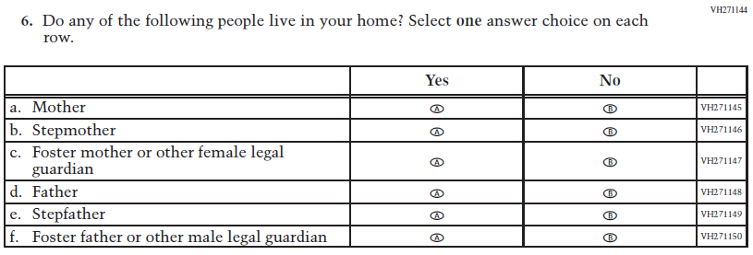  Issue: Socioeconomic Status | NC | N/A
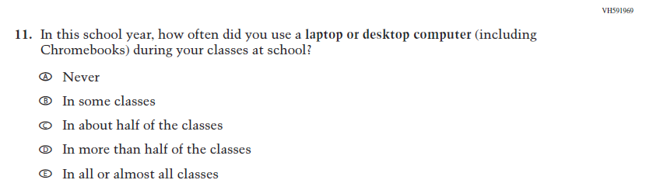  (2019 Grade 4) | 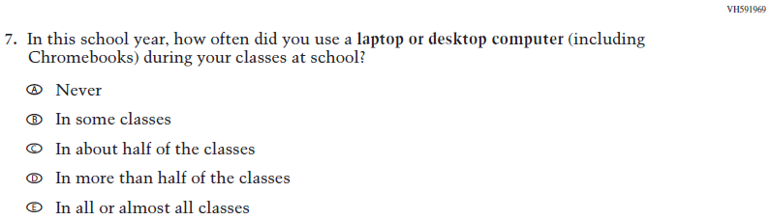  Issue: Technology Use | NC | N/A
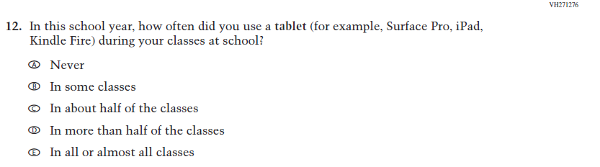  (2019 Grade 4) | N/A | D | To keep student burden low, this item was dropped.

2022 Operational Grade 4 Core Student

Previous item | 2022 item | D/A/ R/NC+ | Rationale
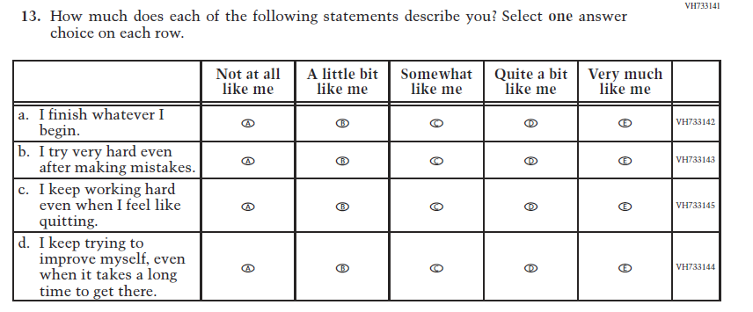  (2019 Grade 4) | N/A | D | To keep student burden low, this item was dropped.
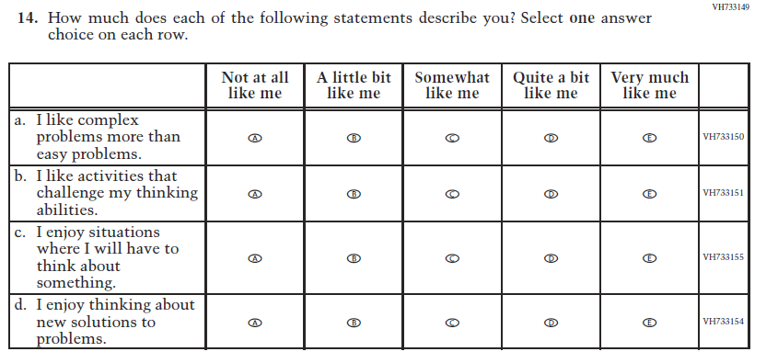  (2019 Grade 4) | 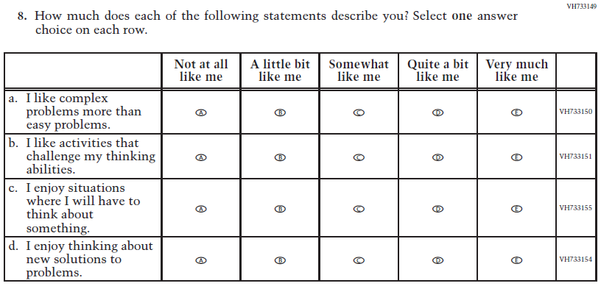  Issue: Desire for Learning | NC | N/A
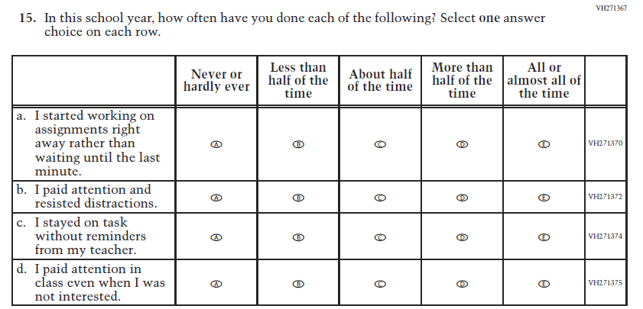  (2019 Grade 4) | 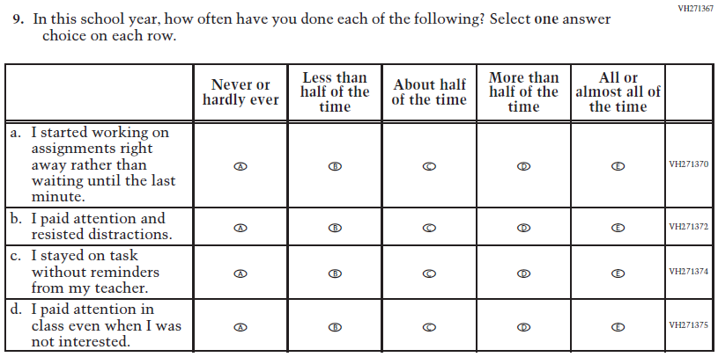  Issue: Grit | NC | N/A
2022 Operational Grade 4 Core Student
Previous item | 2022 item | D/A/ R/NC+ | Rationale
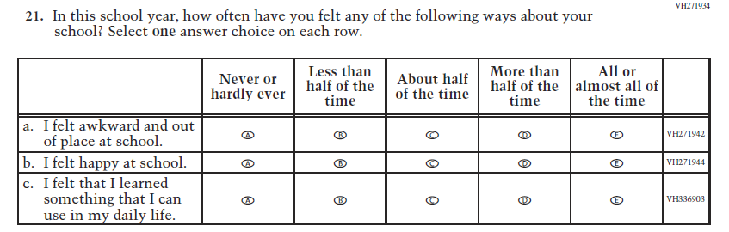  (2019 Grade 4) | N/A | D | To keep student burden low, this item was dropped.

Appendix J1-2: Operational Grade 4 (CORE)
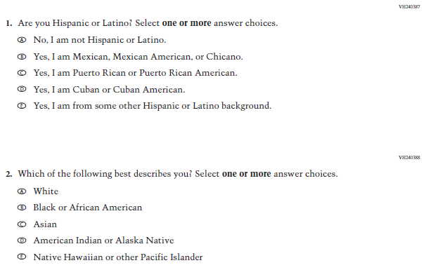
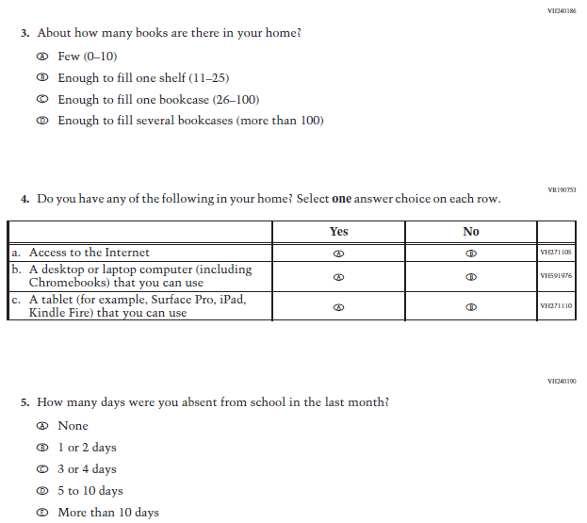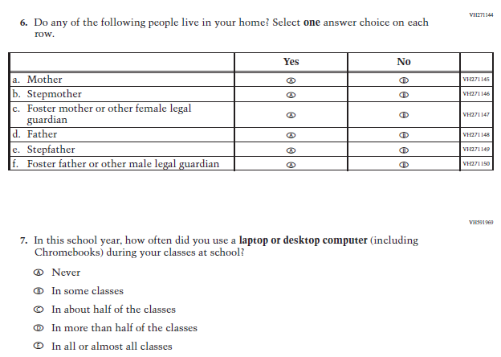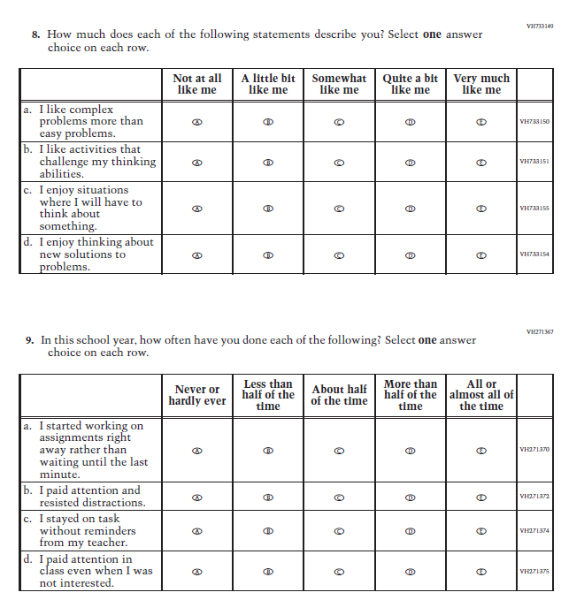

Appendix J1-3: Summary of Changes Operational Grade 8 (CORE)
2022 Operational Grade 8 Core Student

Previous item | 2022 item | D/A/ R/NC+ | Rationale
(2019 Grade 8) | 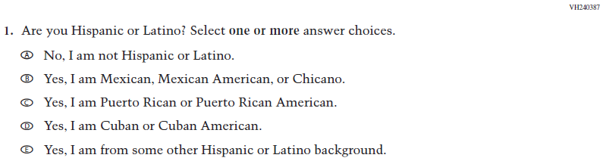  Issue: Race/Ethnicity | NC | N/A
(2019 Grade 8) | 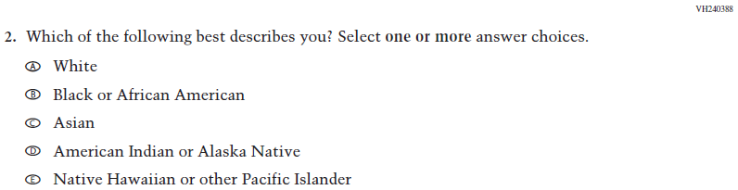  Issue: Race/Ethnicity | NC | N/A
(2019 Grade 8) | 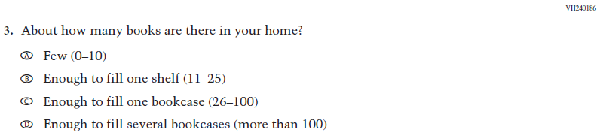  Issue: Socioeconomic Status | NC | N/A

2022 Operational Grade 8 Core Student

Previous item | 2022 item | D/A/ R/NC+ | Rationale
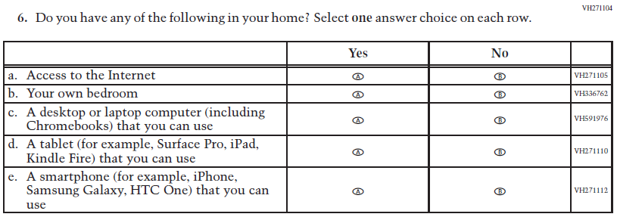  (2019 Grade 8) | 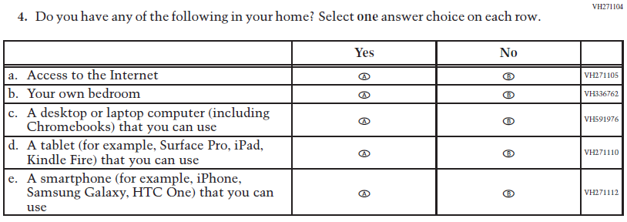  Issue: Socioeconomic Status | NC | N/A
(2019 Grade 8) | 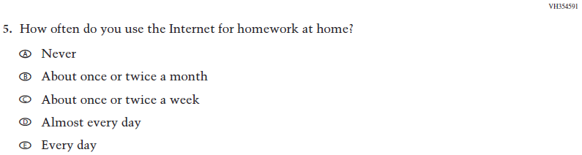  Issue: Technology Use | NC | N/A
(2019 Grade 8) | 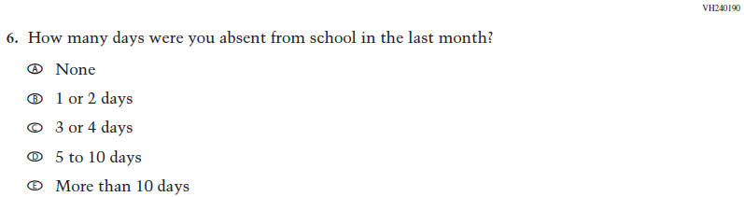  Issue: School Climate | NC | N/A
(2019 Grade 8) | 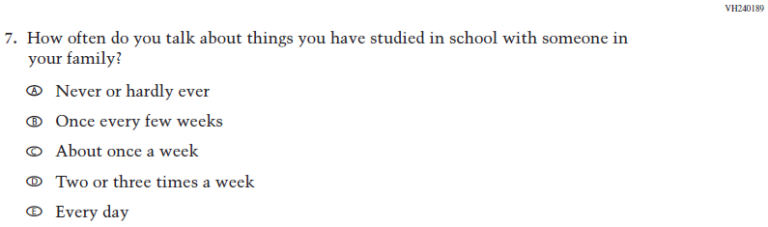  Issue: Socioeconomic Status | NC | N/A

2022 Operational Grade 8 Core Student

Previous item | 2022 item | D/A/ R/NC+ | Rationale
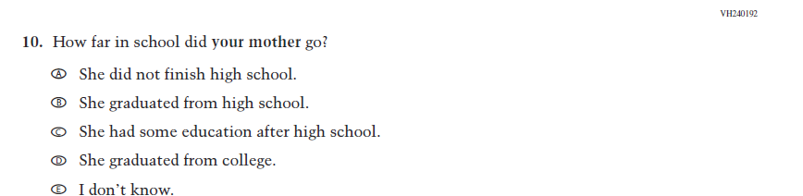  (2019 Grade 8) | 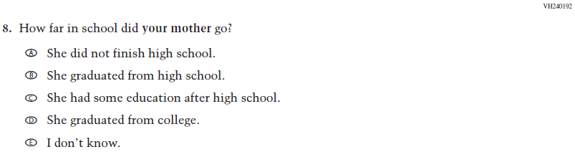  Issue: Socioeconomic Status | NC | N/A
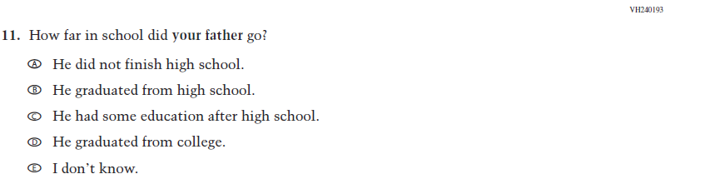  (2019 Grade 8) | 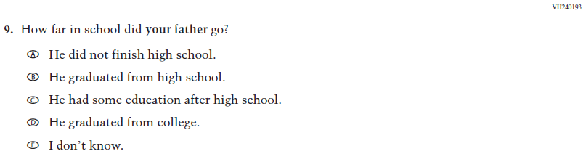  Issue: Socioeconomic Status | NC | N/A
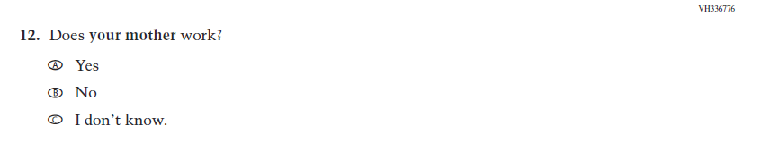  (2019 Grade 8) | 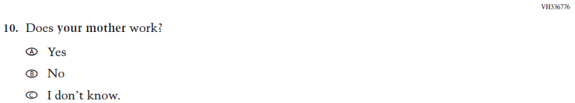  Issue: Socioeconomic Status | NC | N/A
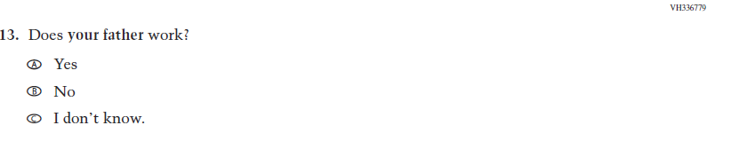  (2019 Grade 8) | 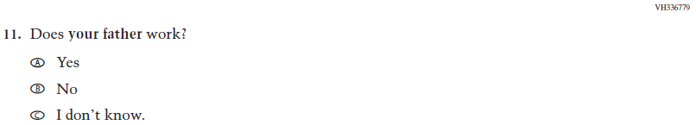  Issue: Socioeconomic Status | NC | N/A

2022 Operational Grade 8 Core Student

Previous item | 2022 item | D/A/ R/NC+ | Rationale
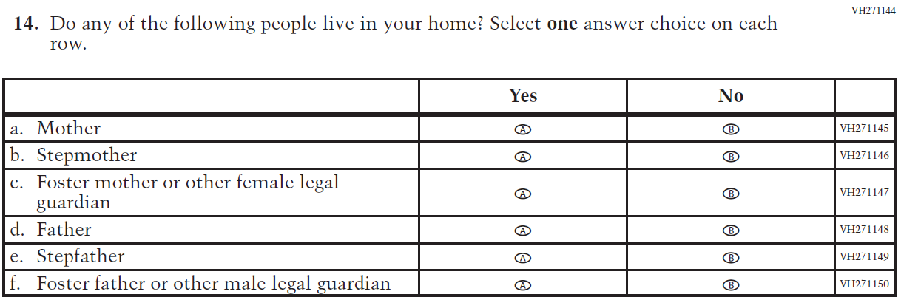  (2019 Grade 8) | 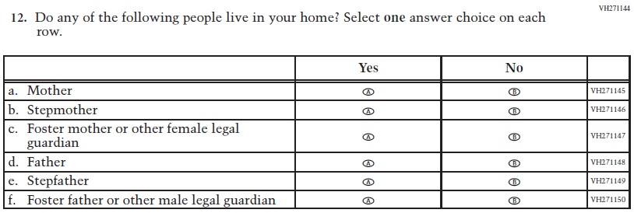  Issue: Socioeconomic Status | NC | N/A
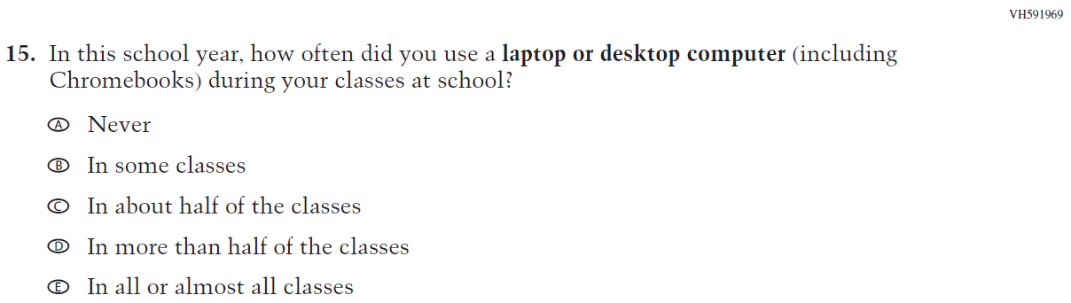  (2019 Grade 8) | 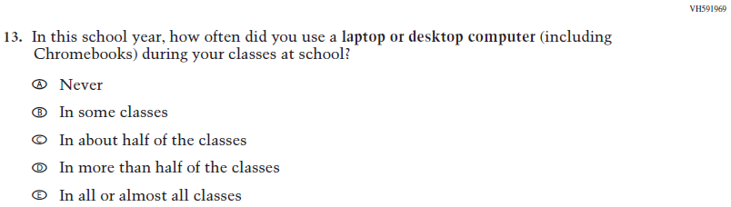  Issue: Technology Use | NC | N/A
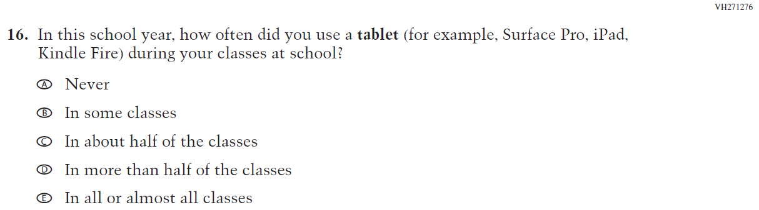  (2019 Grade 8) | 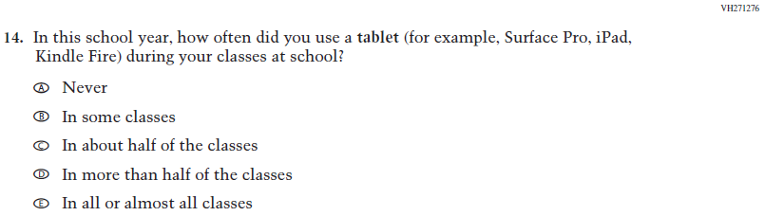  Issue: Technology Use | NC | N/A
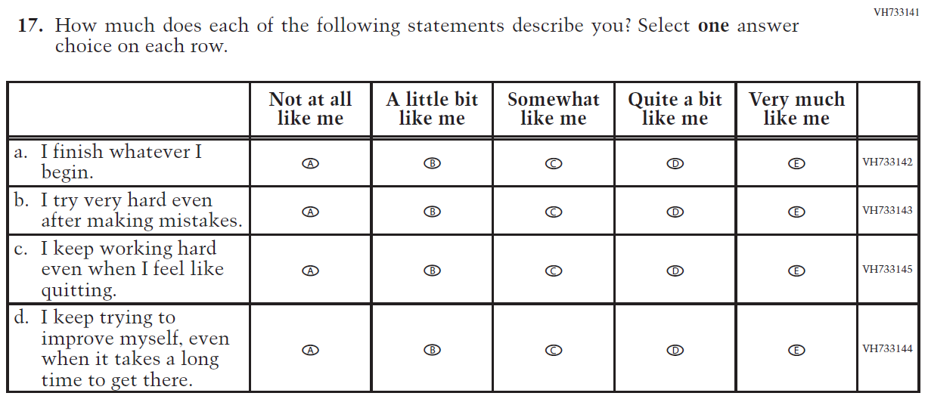  (2019 Grade 8) | 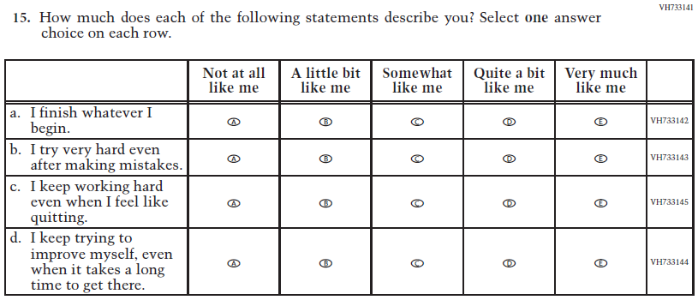  Issue: Grit | NC | N/A
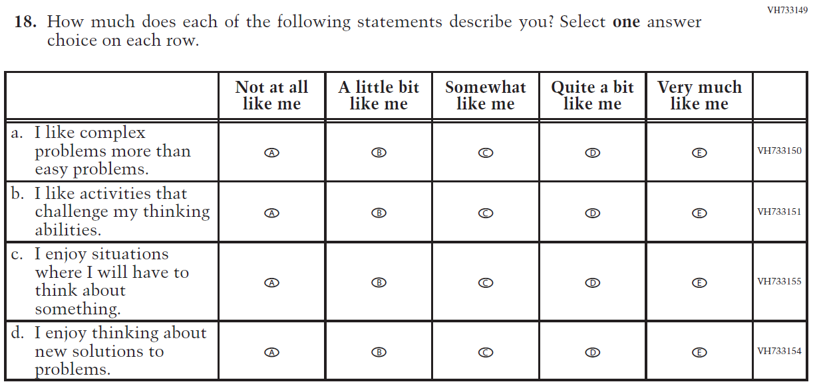  (2019 Grade 8) | 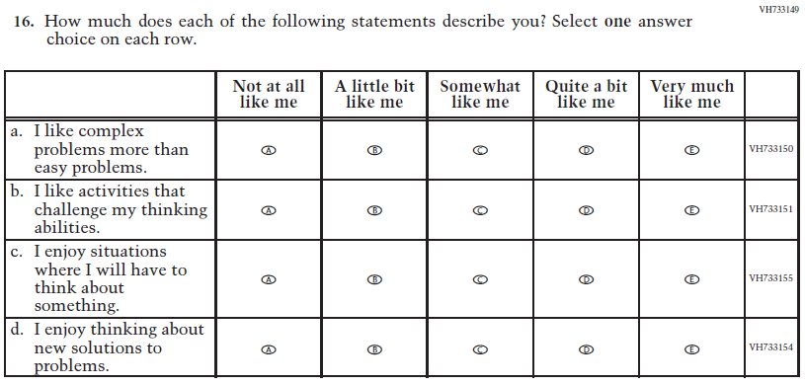  Issue: Desire for Learning | NC | N/A
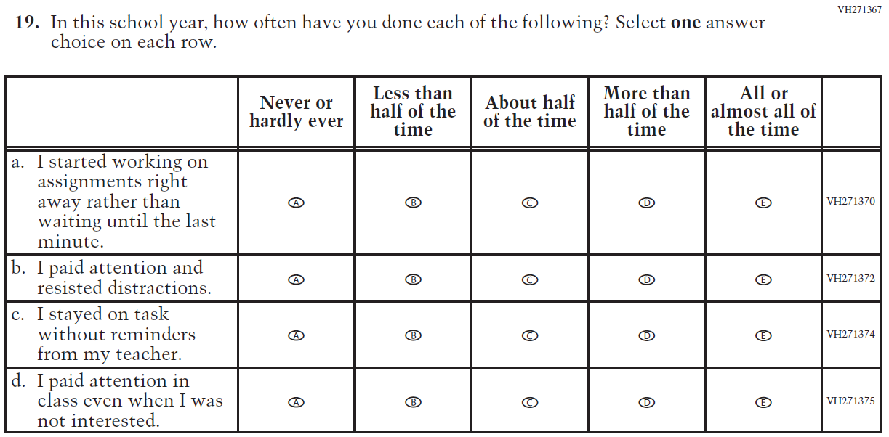  (2019 Grade 8) | 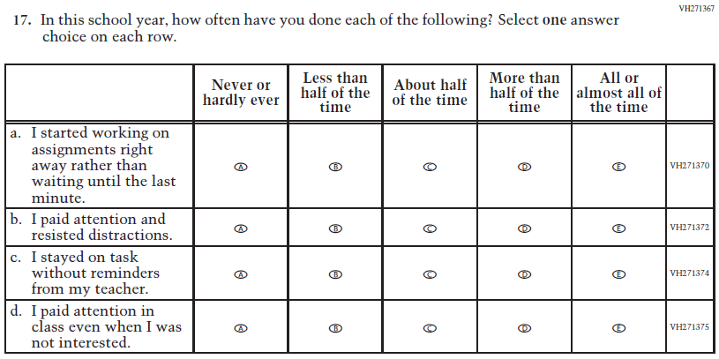  Issue: Grit | NC | N/A
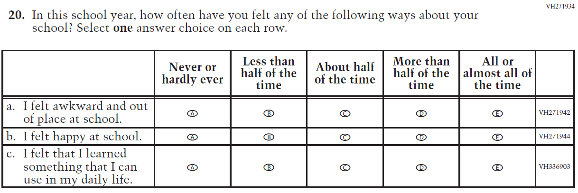  (2019 Grade 8) | N/A | D | To keep student burden low, this item was dropped.
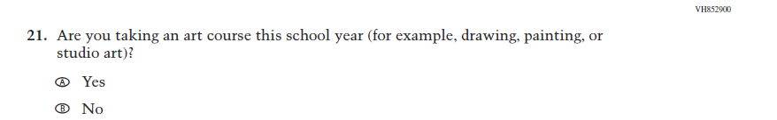  (2019 Grade 8) | 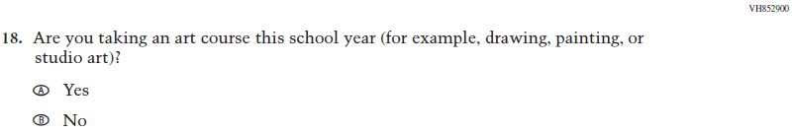  Issue: Educational Experiences | NC | N/A

Appendix J1-4: Operational Grade 8 (CORE)
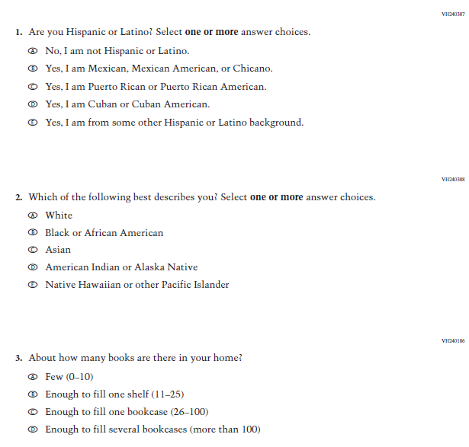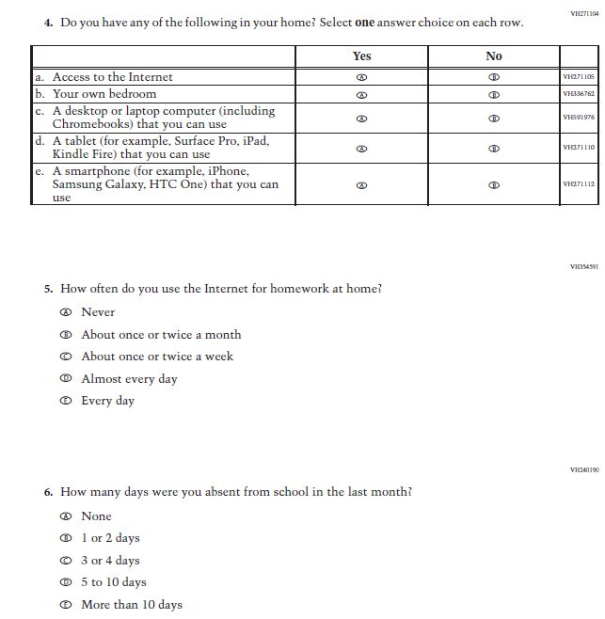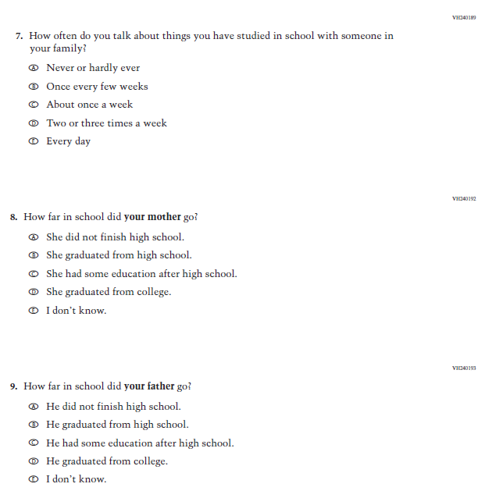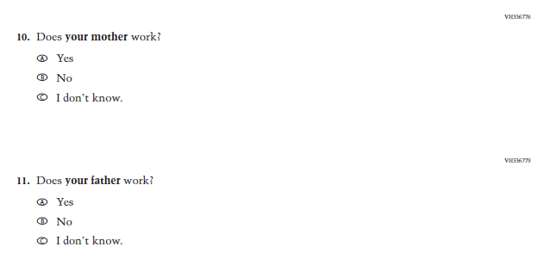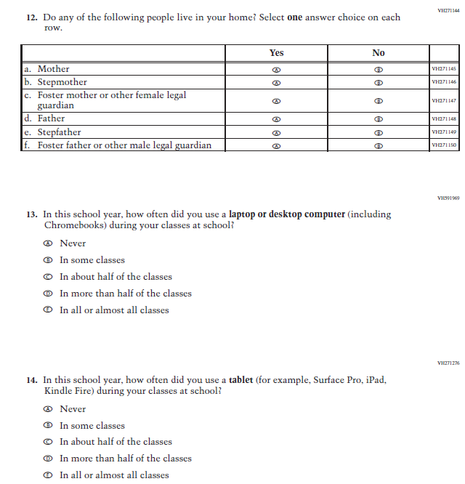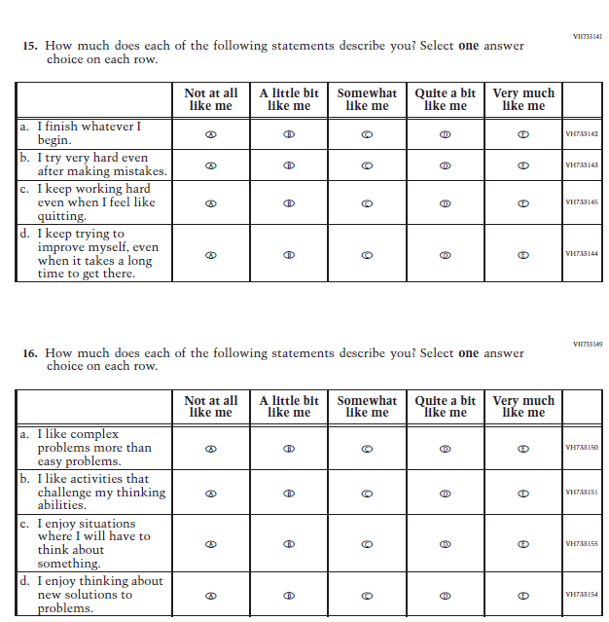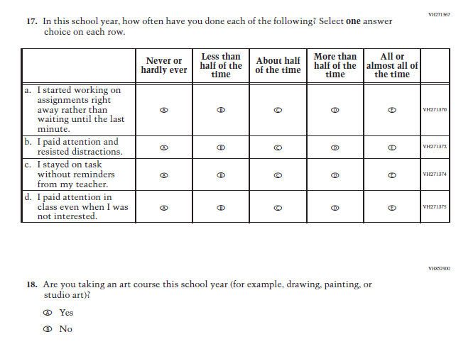

Appendix J1-5: Summary of Changes Operational Grade 4 (Mathematics)
2022 Operational Grade 4 Mathematics Student

Previous item | 2022 item | D/A/ R/NC+ | Rationale
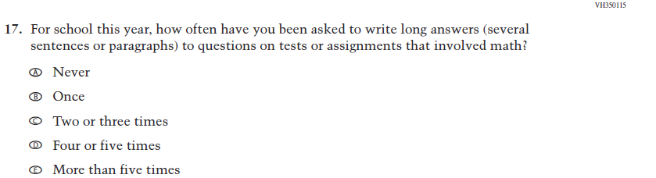  (2019 Grade 4) | 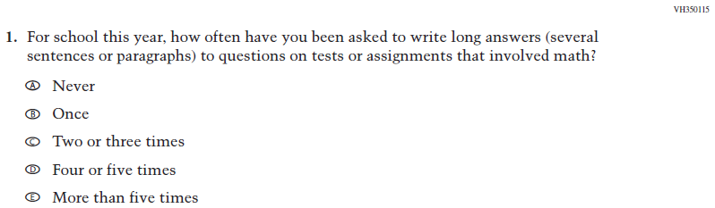  Issue: Organization of Instruction | NC | N/A
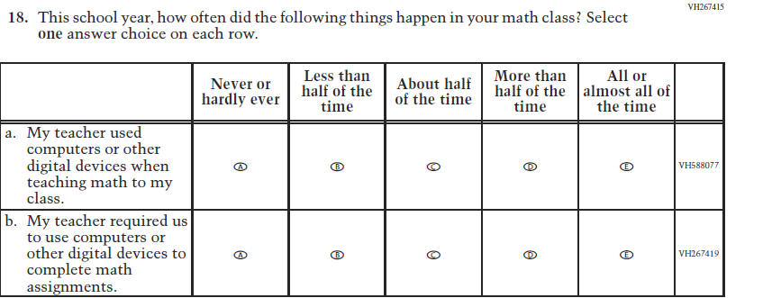  (2019 Grade 4) | 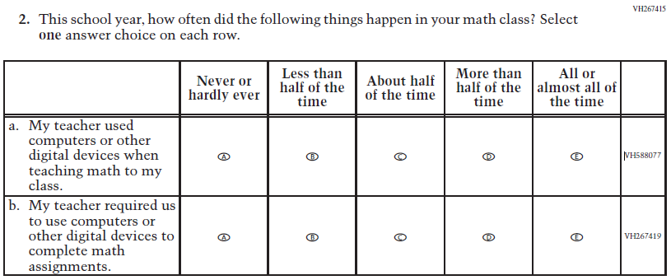  Issue: Resources for Learning and Instruction | NC | N/A
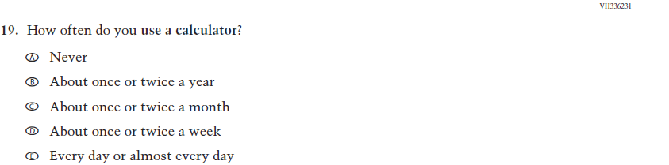  (2019 Grade 4) | 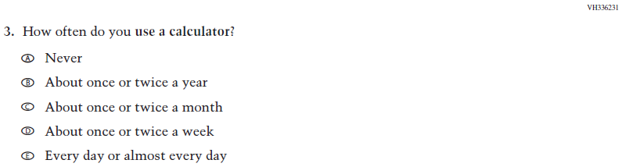  Issue: Resources for Learning and Instruction | NC | N/A
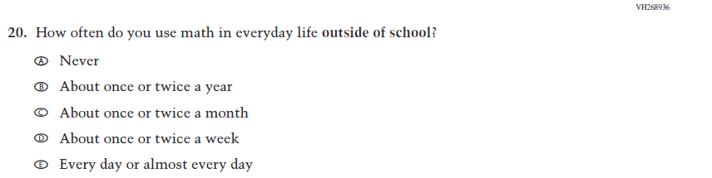  (2019 Grade 4) | 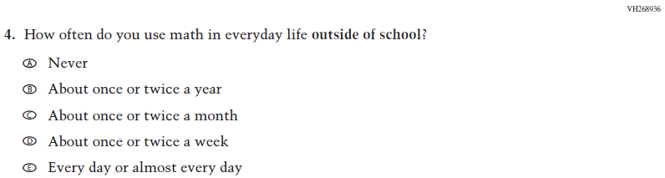  Issue: Resources for Learning and Instruction | NC | N/A
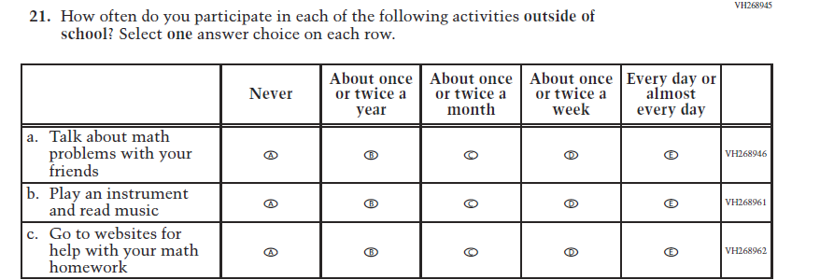  (2019 Grade 4) | 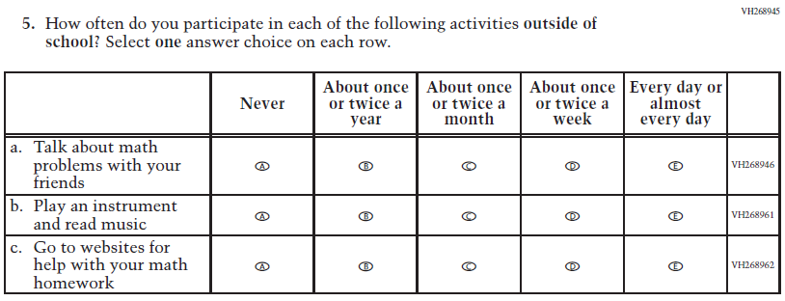  Issue: Resources for Learning and Instruction | NC | N/A
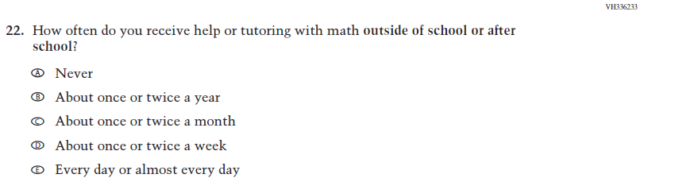  (2019 Grade 4) | 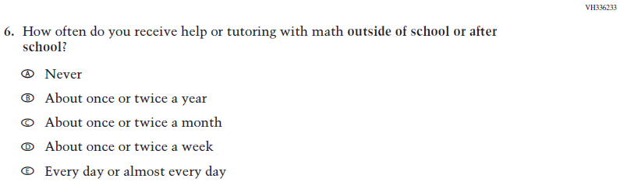  Issue: Resources for Learning and Instruction | NC | N/A
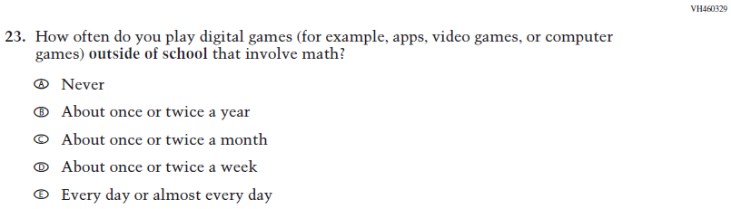  (2019 Grade 4) | 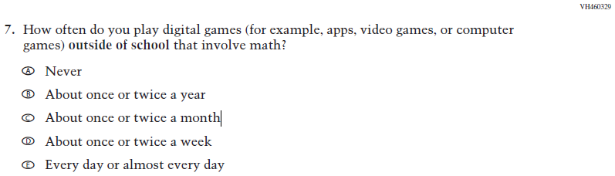  Issue: Resources for Learning and Instruction | NC | N/A

2022 Operational Grade 4 Mathematics Student

Previous item | 2022 item | D/A/ R/NC+ | Rationale
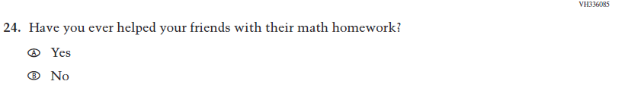  (2019 Grade 4) | N/A | D | To keep student burden low, this item was dropped.
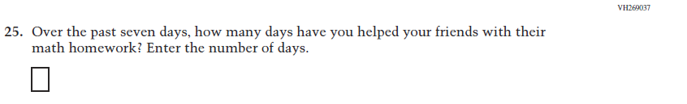  (2019 Grade 4) | N/A | D | To keep student burden low, this item was dropped.
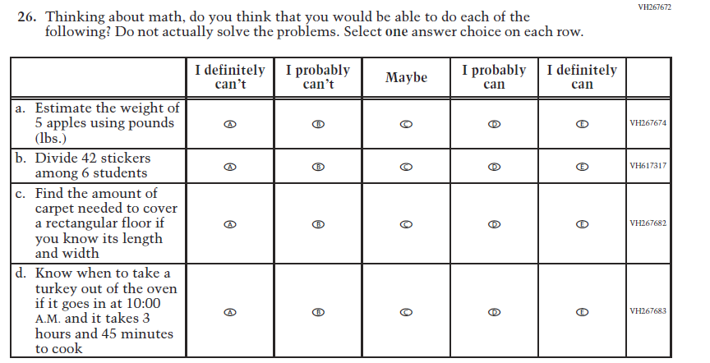  (2019 Grade 4) | 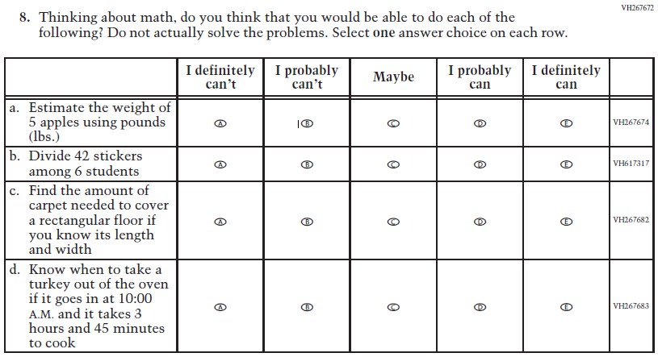  Issue: Student Factors | NC | N/A

2022 Operational Grade 4 Mathematics Student

Previous item | 2022 item | D/A/ R/NC+ | Rationale
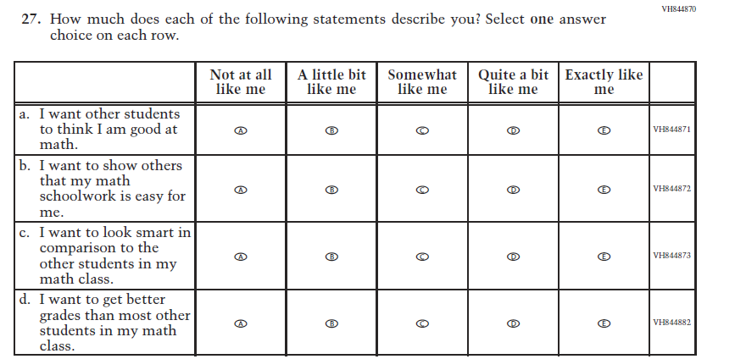  (2019 Grade 4) | N/A | D | To keep student burden low, this item was dropped.
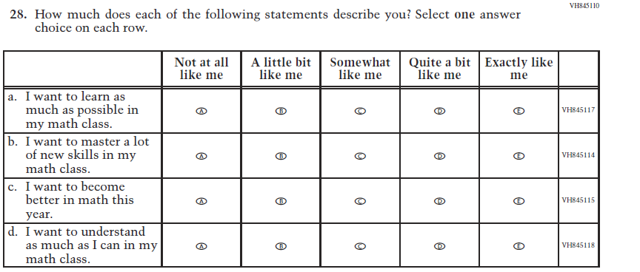  (2019 Grade 4) | 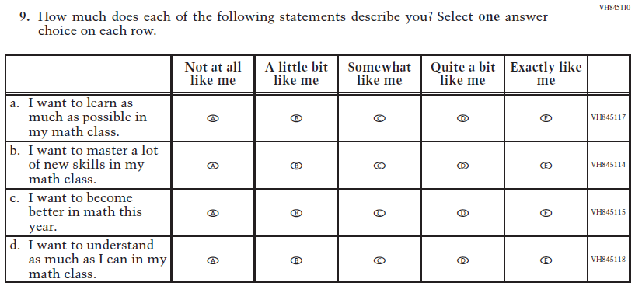  Issue: Student Factors | NC | N/A

2022 Operational Grade 4 Mathematics Student

Previous item | 2022 item | D/A/ R/NC+ | Rationale
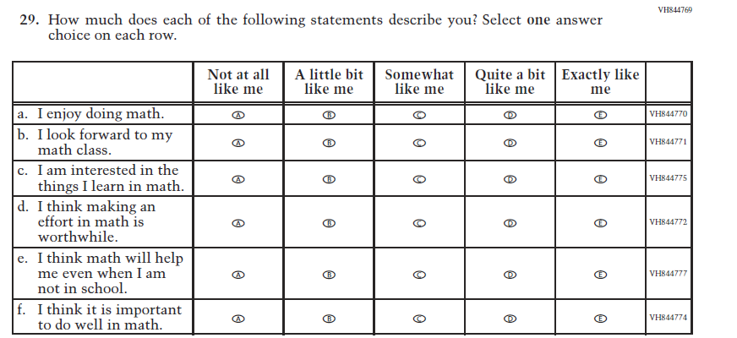  (2019 Grade 4) | 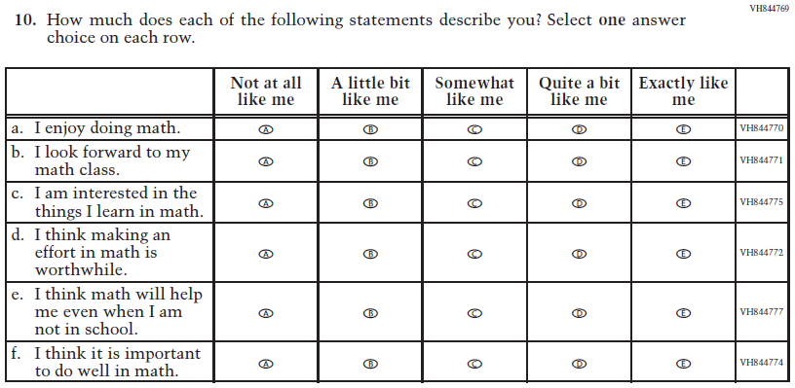  Issue: Student Factors | NC | N/A

Appendix J1-6: Operational Grade 4 (Mathematics)
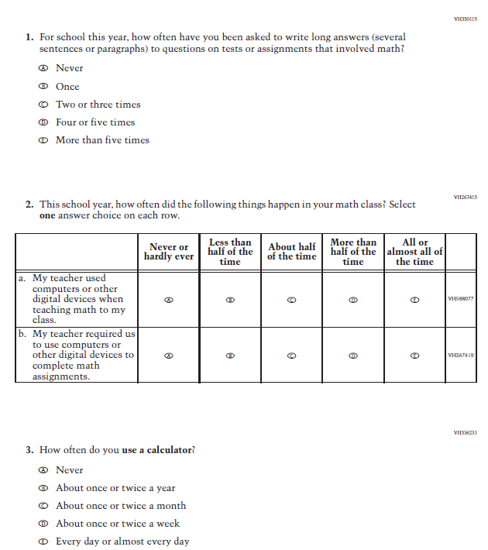

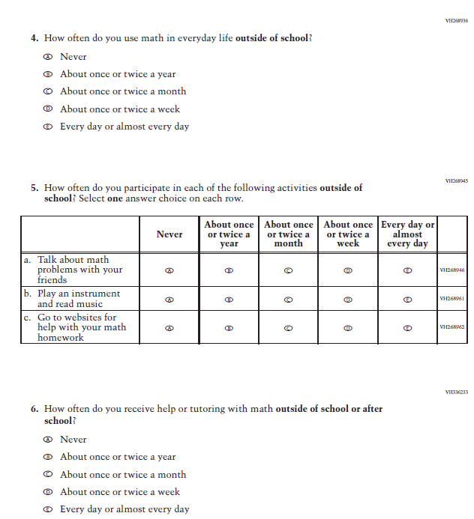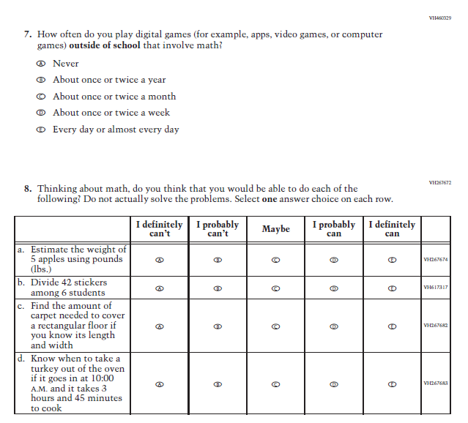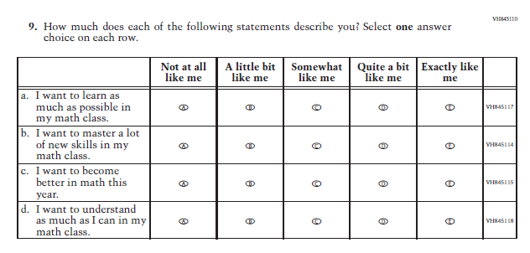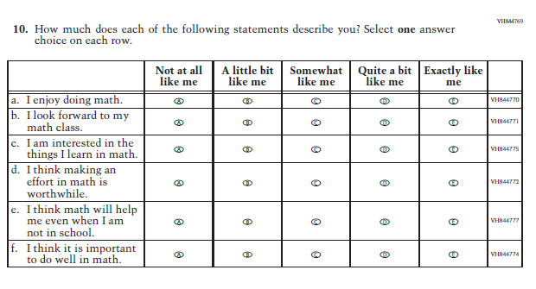

Appendix J1-7: Summary of Changes Operational Grade 8 (Mathematics)
2022 Operational Grade 8 Mathematics Student

Previous item | 2022 item | D/A/ R/NC+ | Rationale
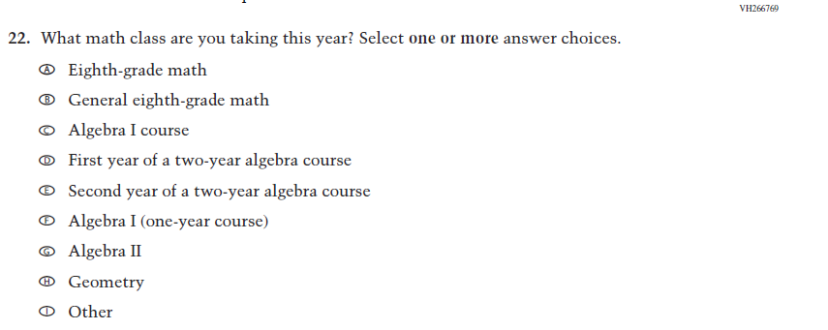  (2019 Grade 8) | 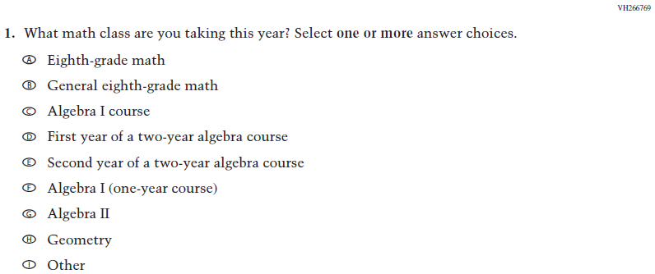  Issue: Organization of Instruction | NC | N/A
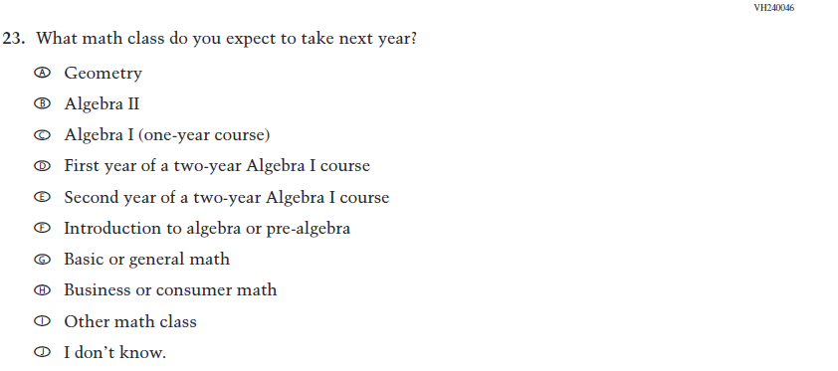  (2019 Grade 8) | 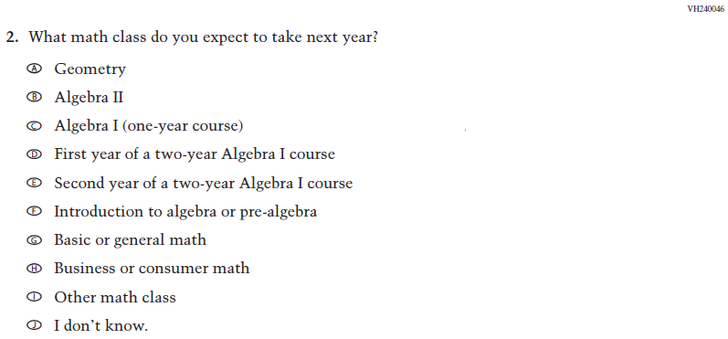  Issue: Organization of Instruction | NC | N/A
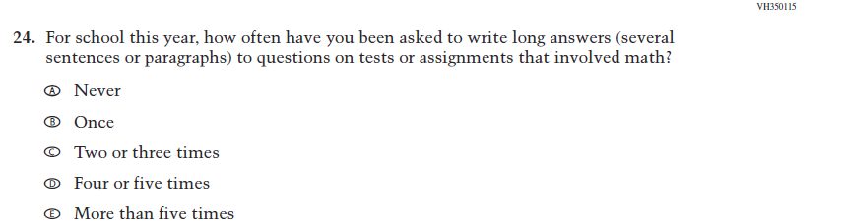  (2019 Grade 8) | 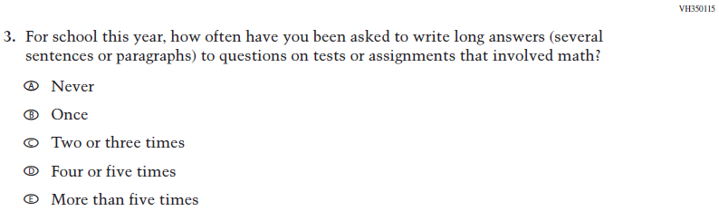  Issue: Organization of Instruction | NC | N/A

2022 Operational Grade 8 Mathematics Student
Previous item | 2022 item | D/A/ R/NC+ | Rationale
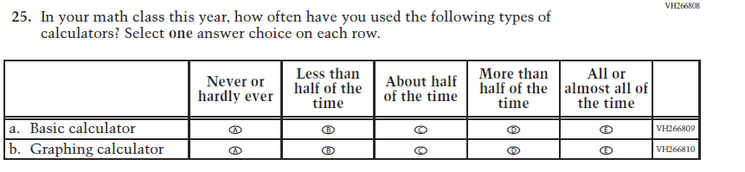  (2019 Grade 8) | 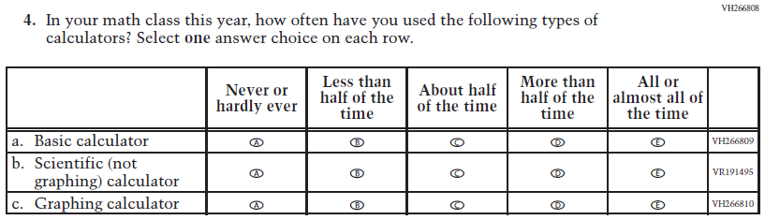  Issue: Resources for Learning and Instruction | A: sub-item “b”  NC for SL and sub-items “a” and “c” | The “Scientific (not graphing) calculator” sub-item was dropped previously due to an oversight and is being reinstated to capture calculator features in mathematics as students progress from K to 12.
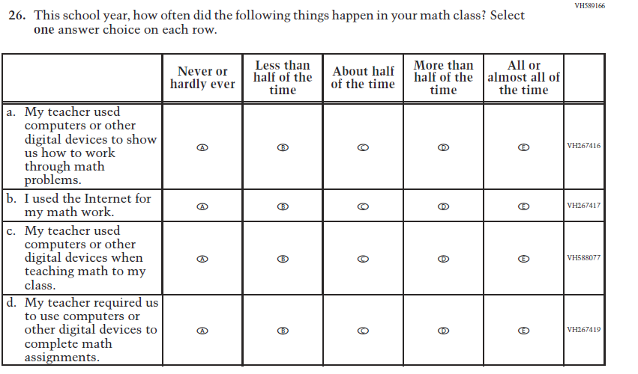  (2019 Grade 8) | 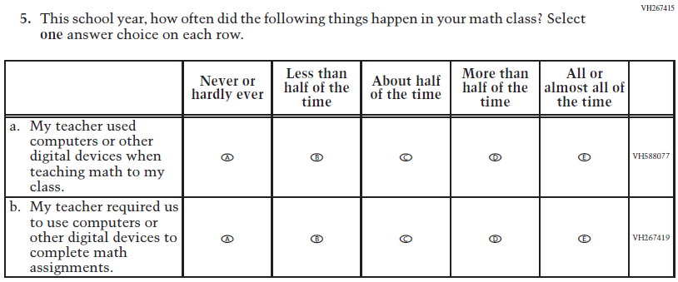  Issue: Resources for Learning and Instruction | R | To keep student burden low, sub-items a and b were dropped.

2022 Operational Grade 8 Mathematics Student
Previous item | 2022 item | D/A/ R/NC+ | Rationale
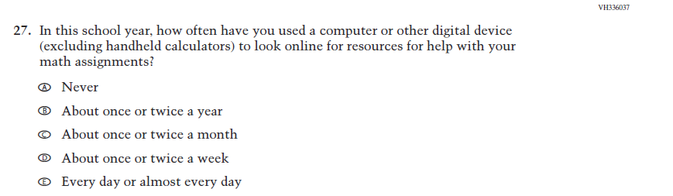  (2019 Grade 8) | N/A | D | To keep student burden low, this item has been dropped.
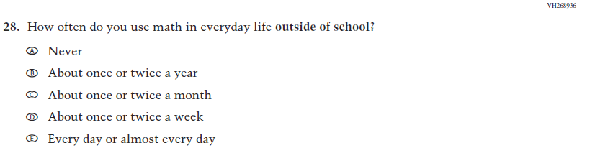  (2019 Grade 8) | 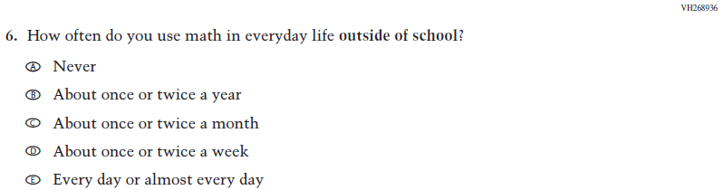  Issue: Resources for Learning and Instruction | NC | N/A
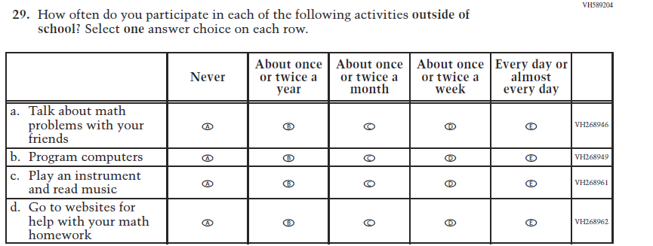  (2019 Grade 8) | 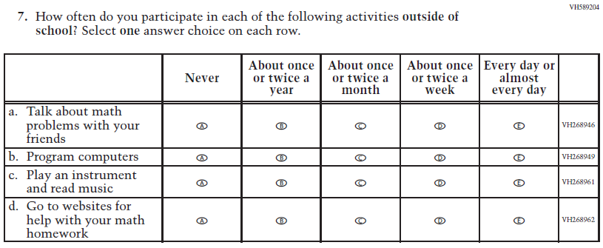  Issue: Resources for Learning and Instruction | NC | N/A
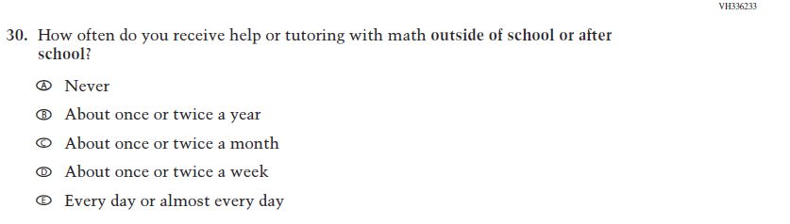  (2019 Grade 8) | 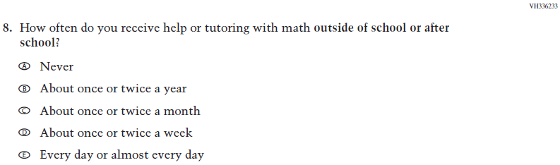  Issue: Resources for Learning and Instruction | NC | N/A

2022 Operational Grade 8 Mathematics Student
Previous item | 2022 item | D/A/ R/NC+ | Rationale
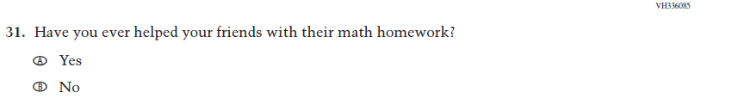  (2019 Grade 8) | N/A | D | To keep student burden low, this item was dropped.
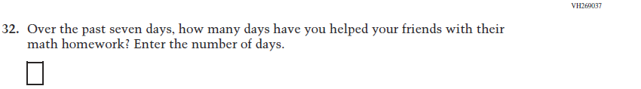  (2019 Grade 8) | N/A | D | To keep student burden low, this item was dropped.
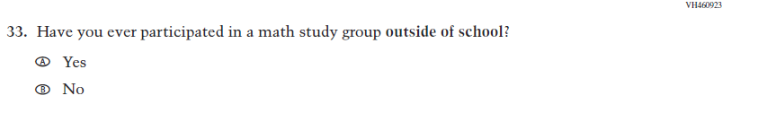  (2019 Grade 8) | N/A | D | To keep student burden low, this item was dropped.
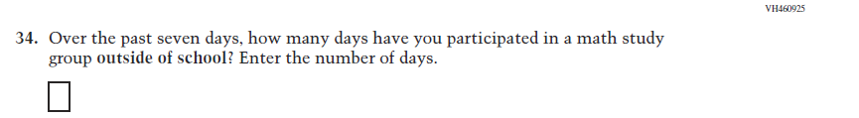  (2019 Grade 8) | N/A | D | To keep student burden low, this item was dropped.
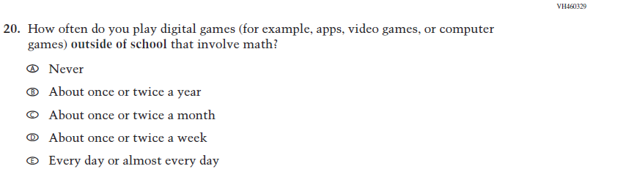  (2019 Grade 8) | 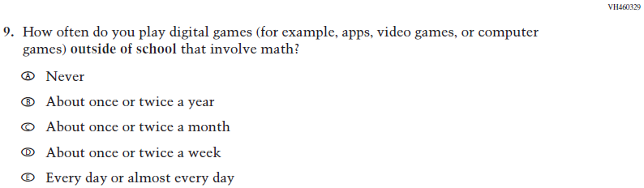  Issue: Resources for Learning and Instruction | NC | N/A
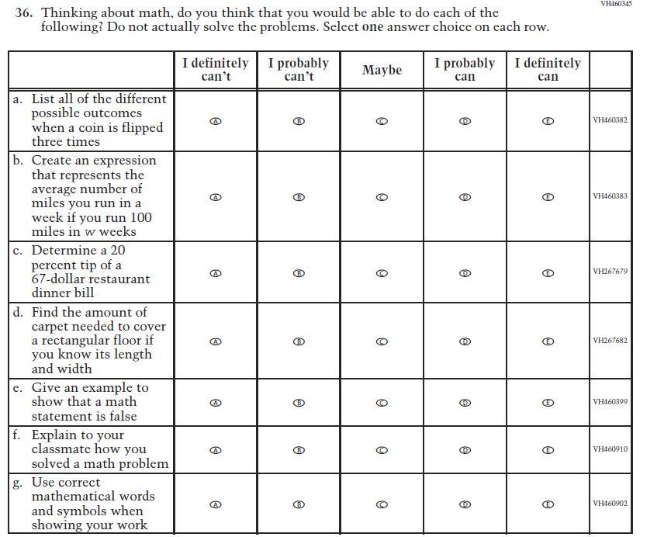  (2019 Grade 8) | 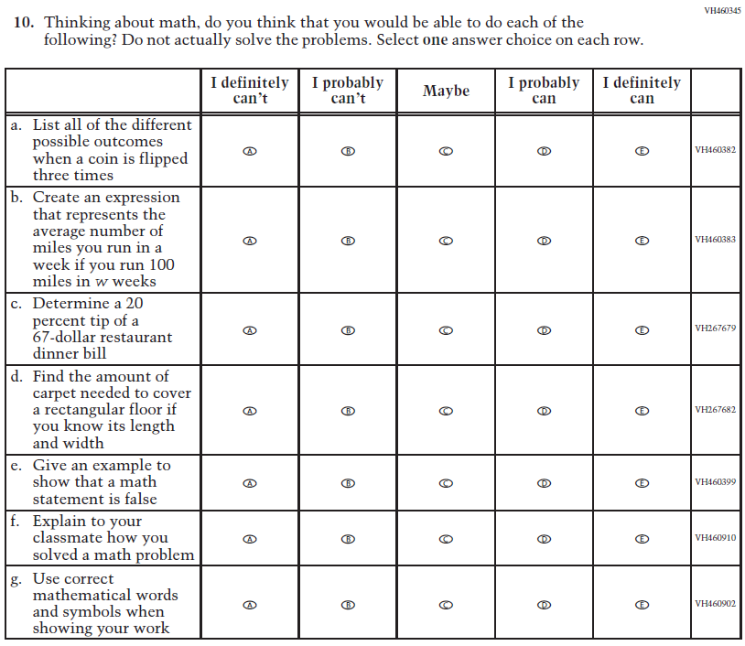  Issue: Student factors | NC | N/A
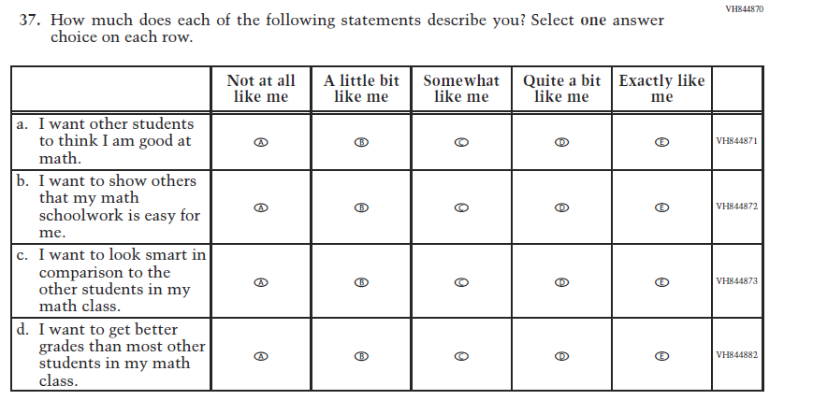  (2019 Grade 8) | N/A | D | To keep student burden low, this item was dropped.
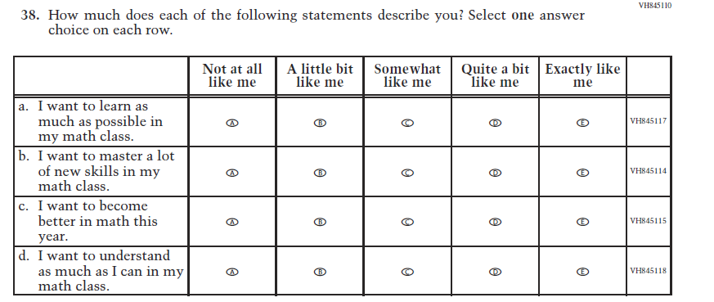  (2019 Grade 8) | 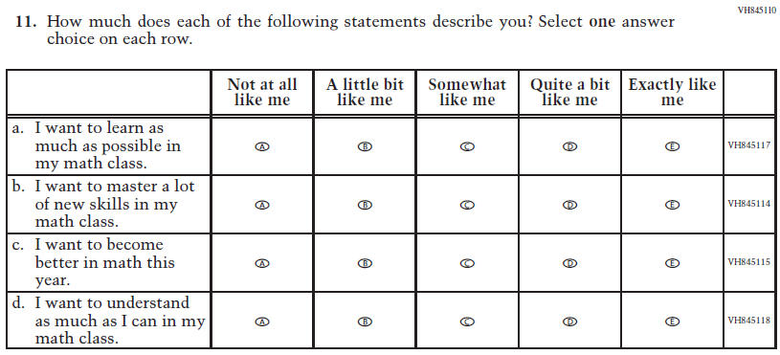  Issue: Student factors | NC | N/A
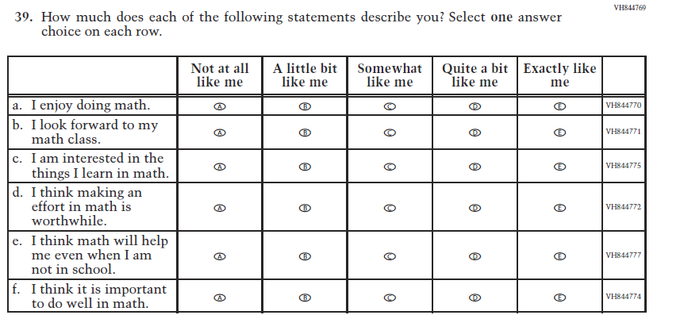  (2019 Grade 8) | 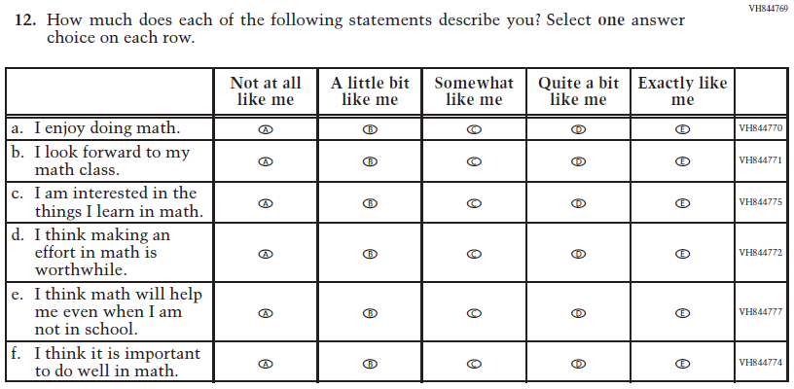  Issue: Student Factors | NC | N/A
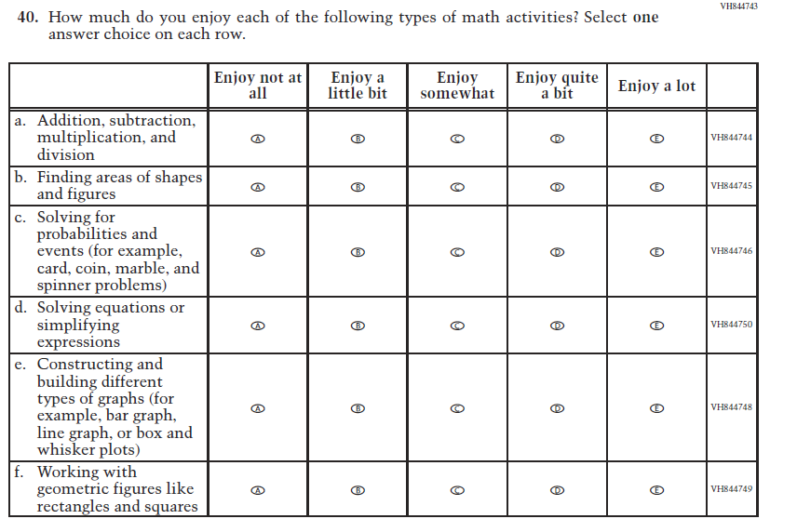  (2019 Grade 8) | 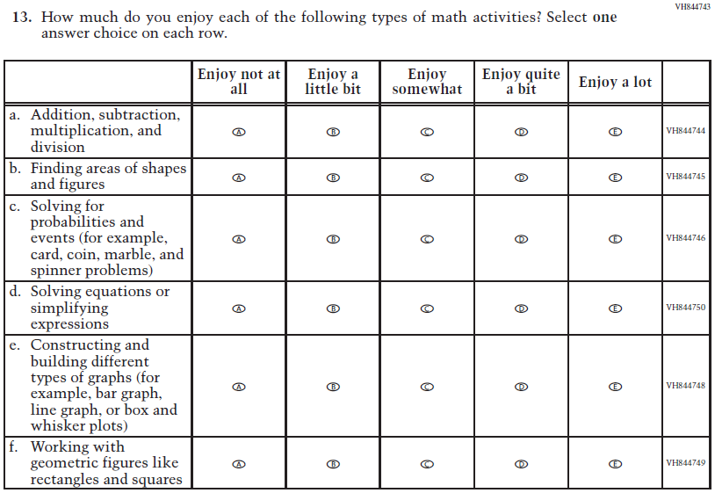  Issue: Student Factors | NC | N/A

Appendix J1-8: Operational Grade 8 (Mathematics)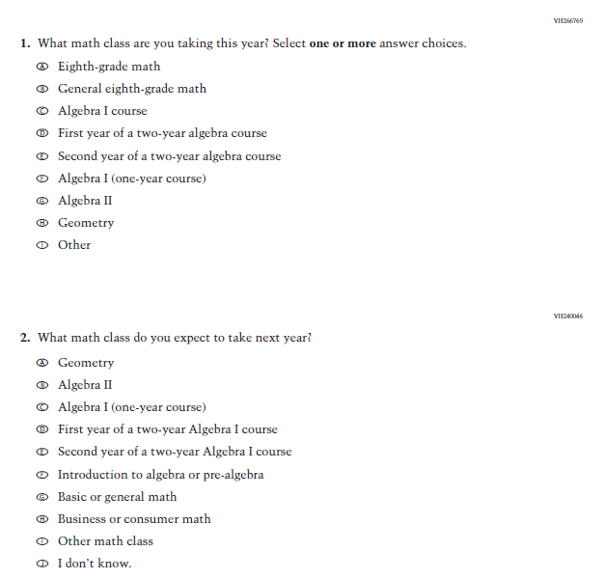
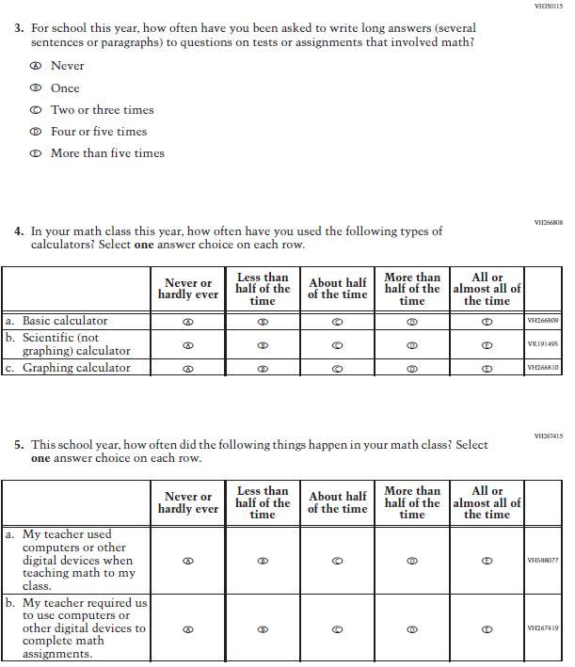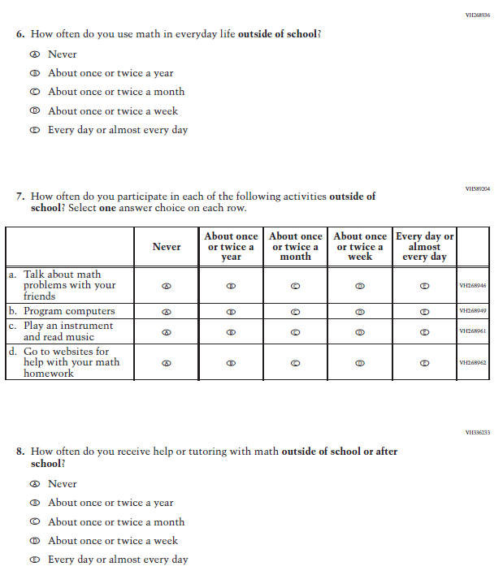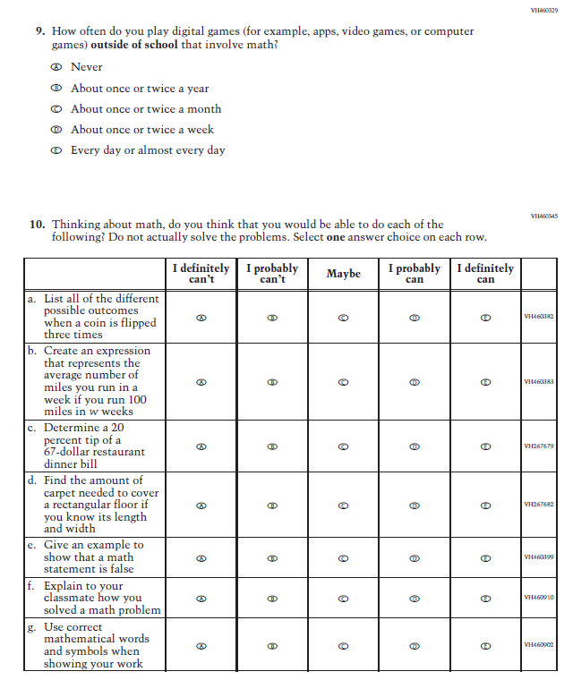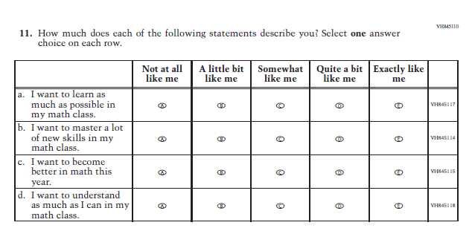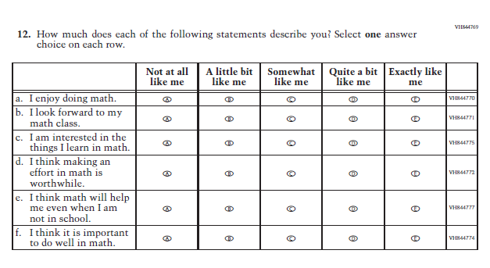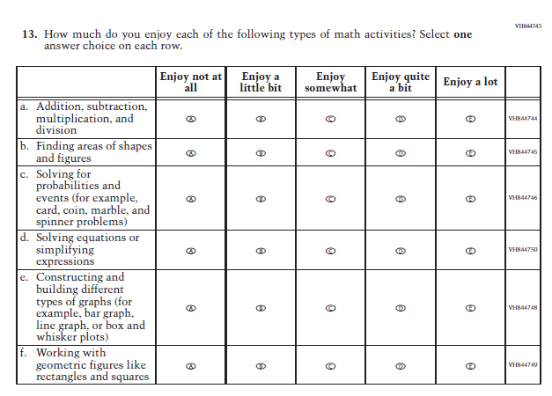

Appendix J1-9: Summary of Changes Operational Grade 4 (Reading)
2022 Operational Grade 4 Reading Student

Previous item | 2022 item | D/A/ R/NC+ | Rationale
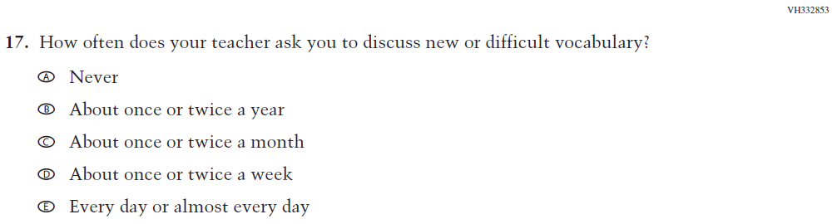  (2019 Grade 4) | 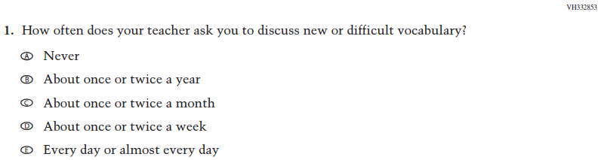  Issue: Organization of Instruction | NC | N/A
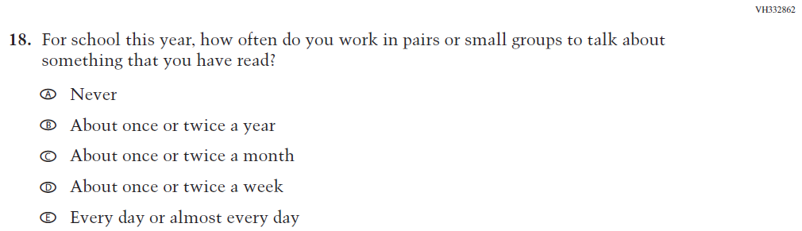  (2019 Grade 4) | 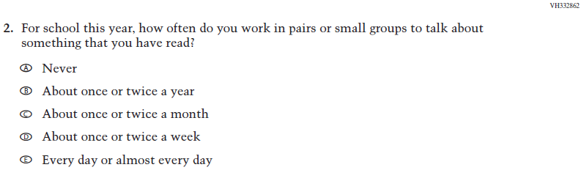  Issue: Organization of Instruction | NC | N/A
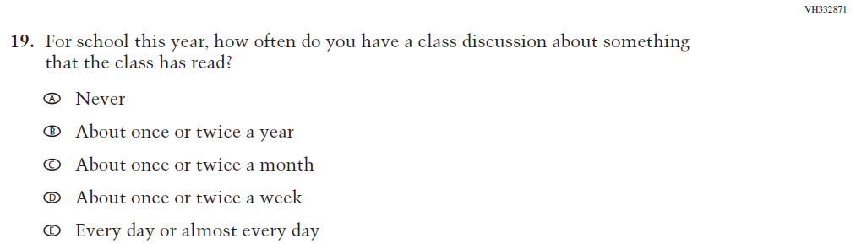  (2019 Grade 4) | 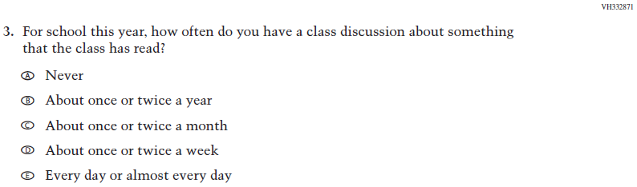  Issue: Organization of Instruction | NC | N/A
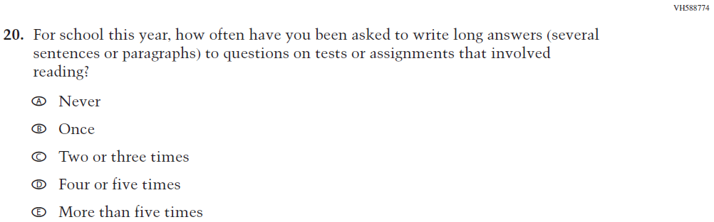  (2019 Grade 4) | 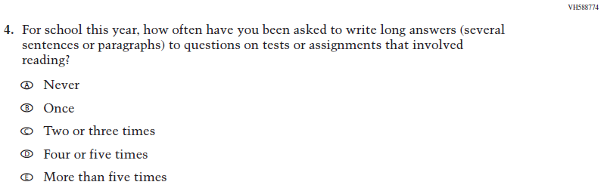  Issue: Organization of Instruction | NC | N/A
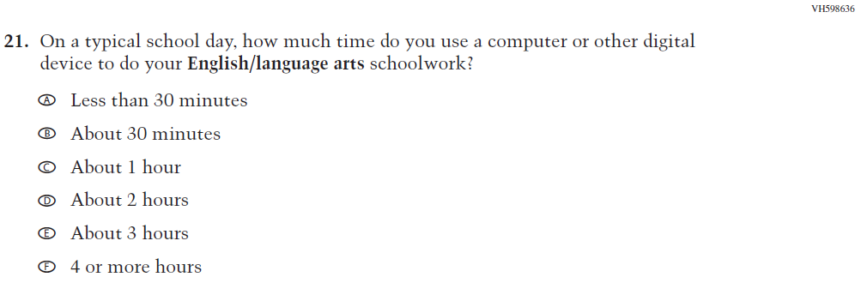  (2019 Grade 4) | N/A | D | To keep student burden low, this item was dropped.
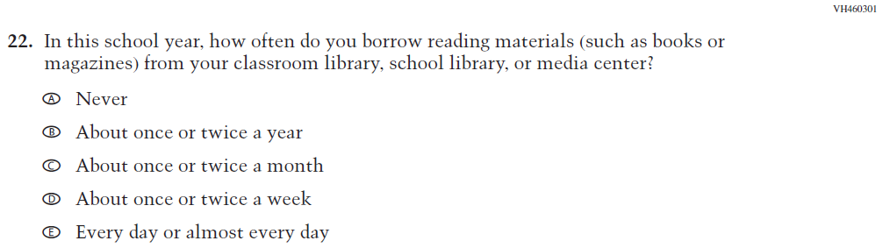  (2019 Grade 4) | 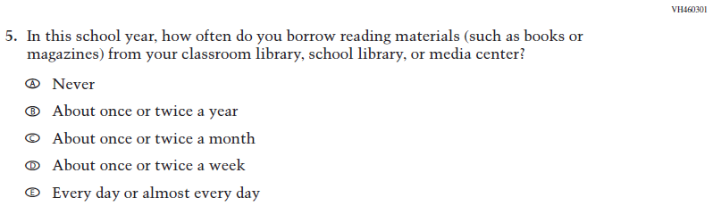  Issue: Resources for Learning and Instruction | NC | N/A
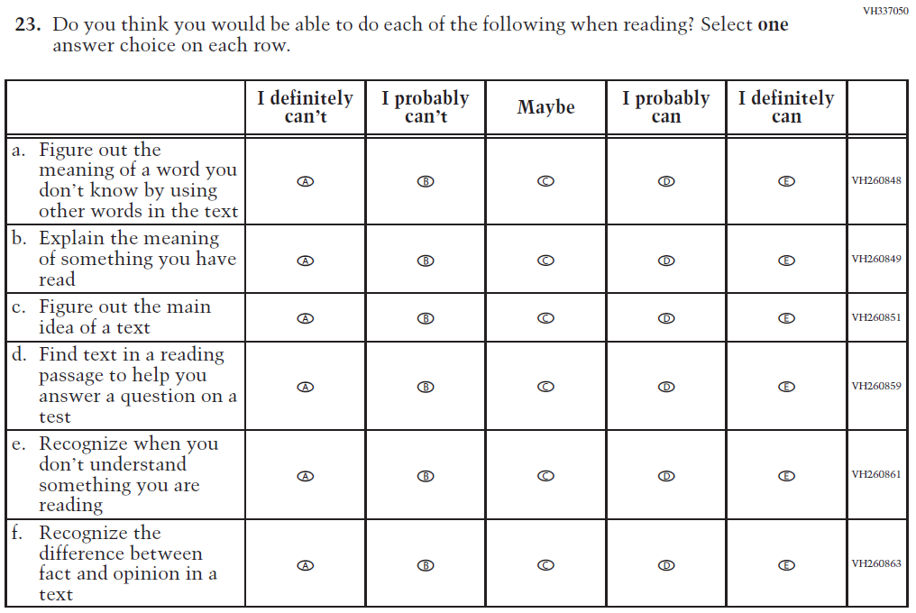  (2019 Grade 4) | 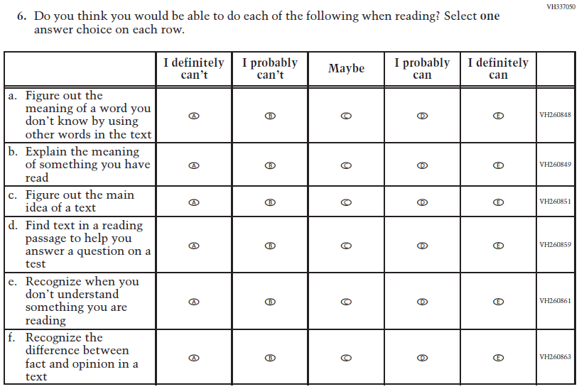  Issue: Student Factors | NC | N/A
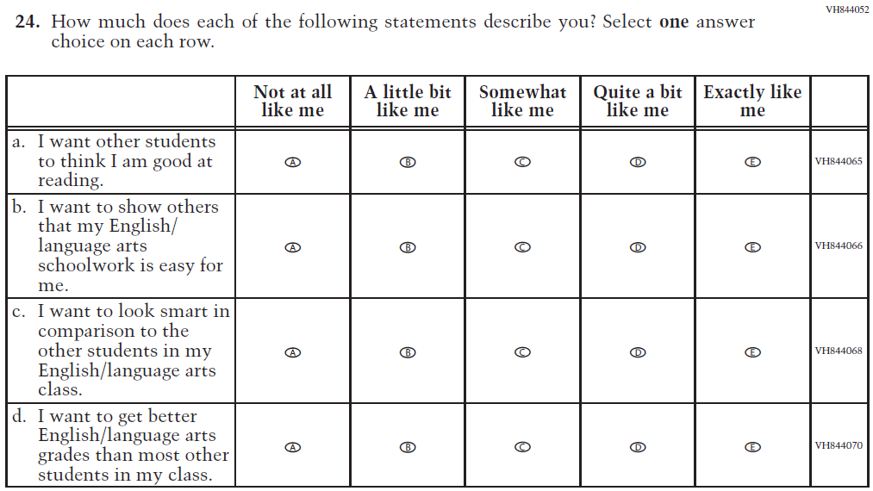  (2019 Grade 4) | N/A | D | To keep student burden low, this item was dropped.
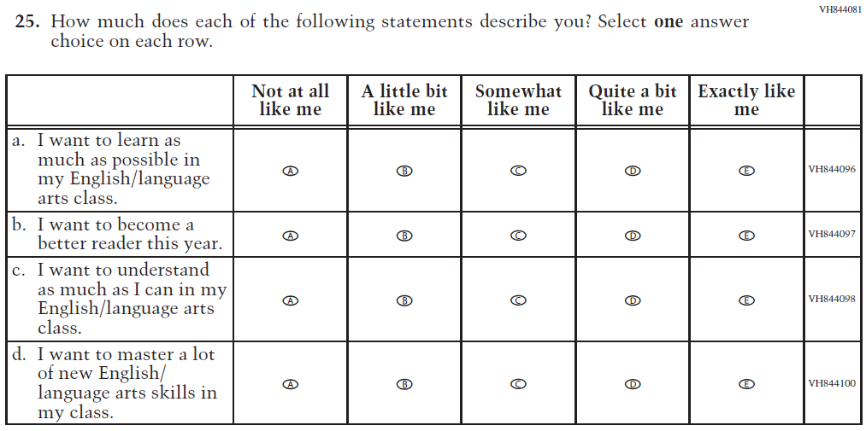  (2019 Grade 4) | 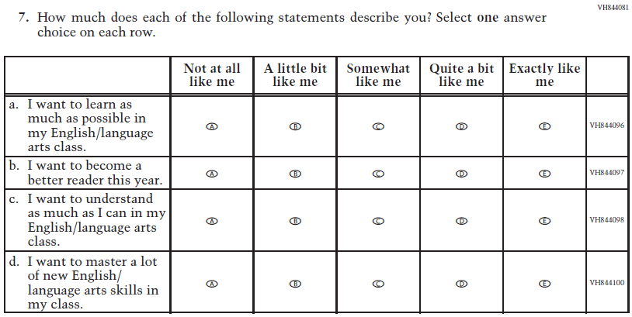  Issue: Student Factors | NC | N/A
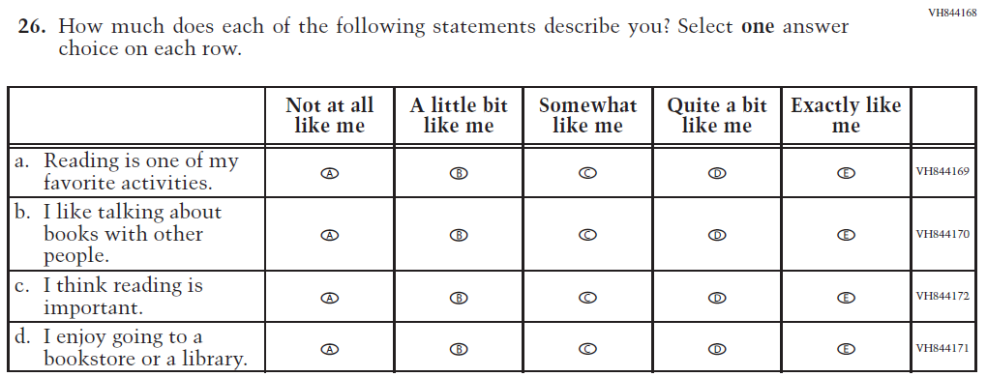(2019 Grade 4) | 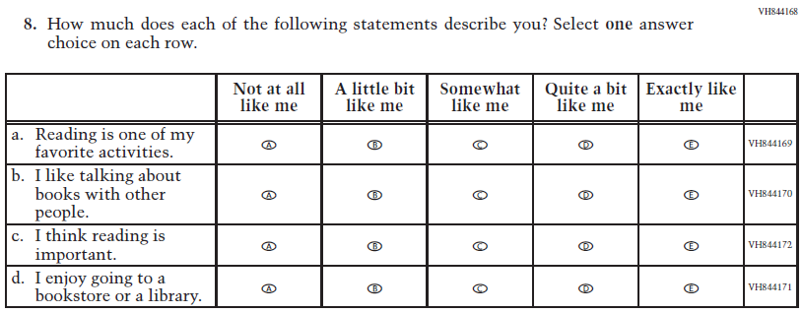Issue: Student Factors | NC | N/A
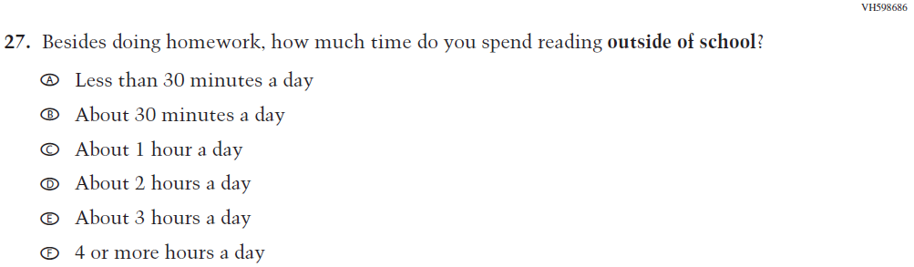  (2019 Grade 4) | 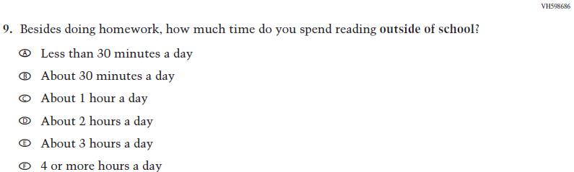  Issue: Student Factors | NC | N/A
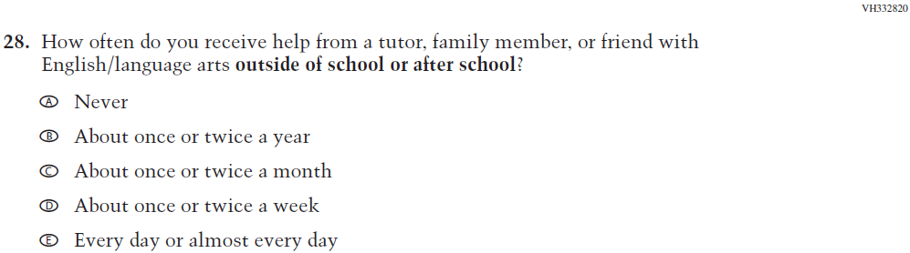  (2019 Grade 4) | 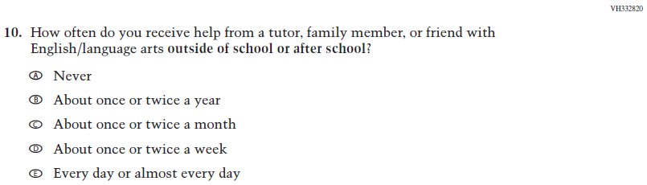  Issue: Resources for Learning and Instruction | NC | N/A
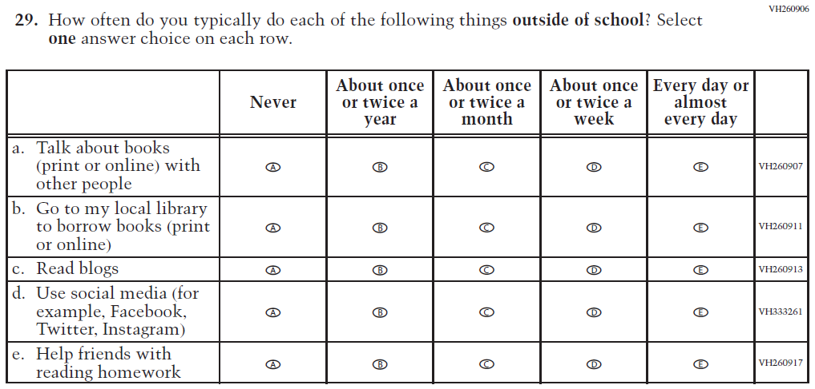  (2019 Grade 4) | 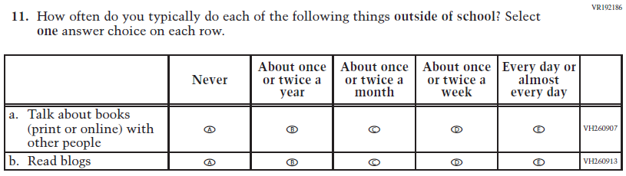  Issue: Student Factors | R | To keep student burden low, sub-items b, d, and e were dropped.

Appendix J1-10: Operational Grade 4 (Reading)
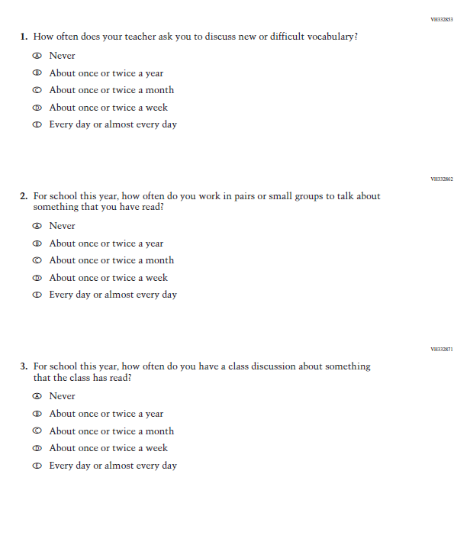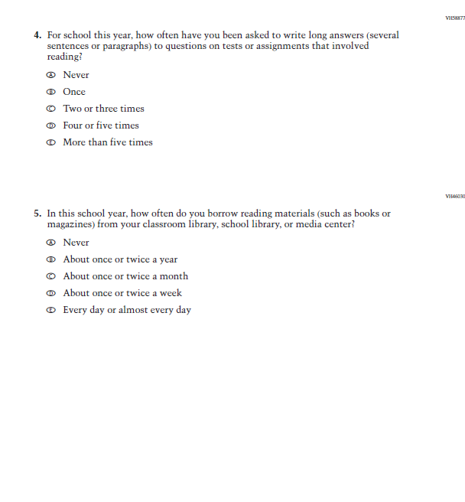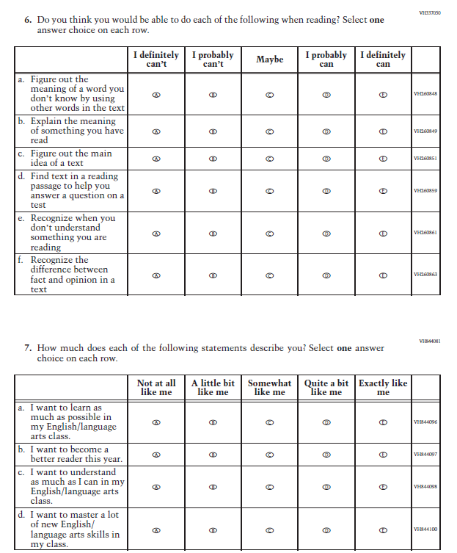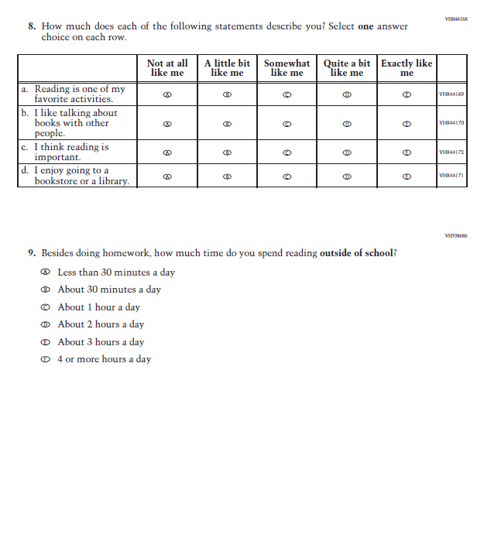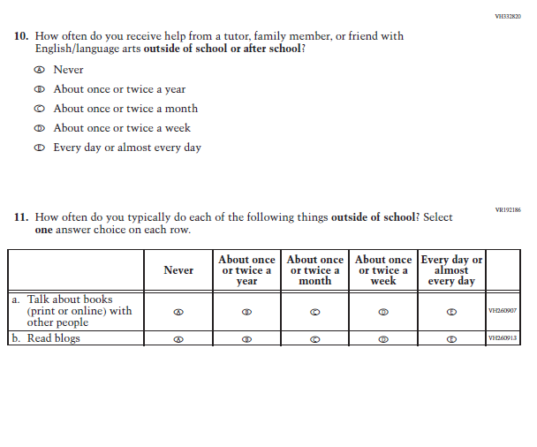

Appendix J1-11: Summary of Changes Operational Grade 8 (Reading)
2022 Operational Grade 8 Reading Student

Previous item | 2022 item | D/A/ R/NC+ | Rationale
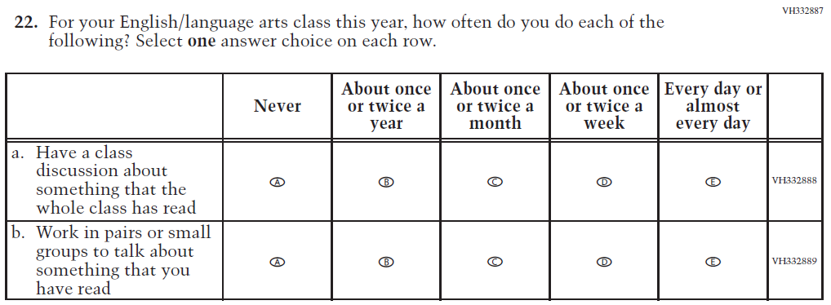  (2019 Grade 8) | 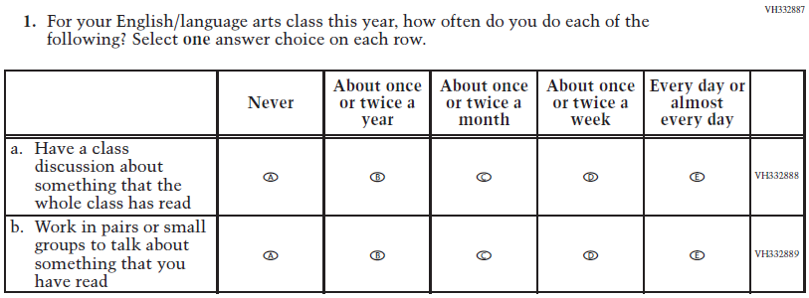  Issue: Organization of Instruction | NC | N/A
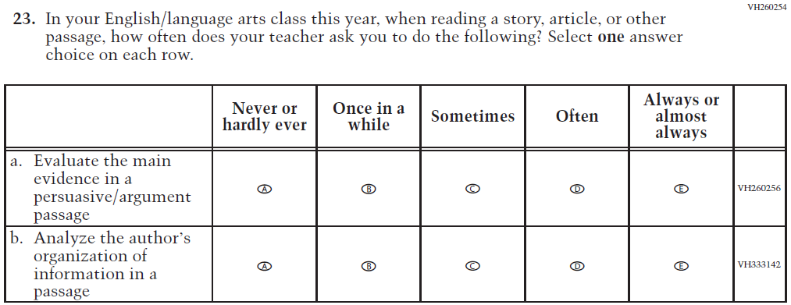  (2019 Grade 8) | 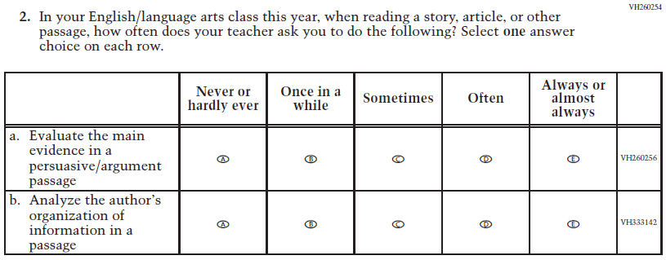  Issue: Organization of Instruction | NC | N/A
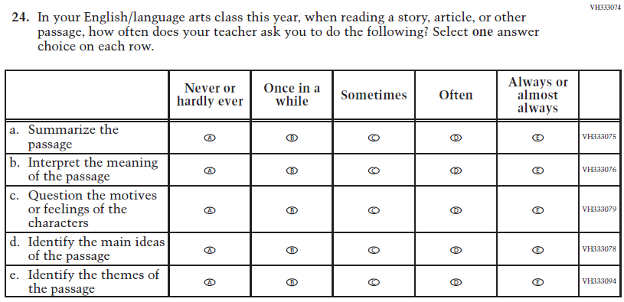  (2019 Grade 8) | 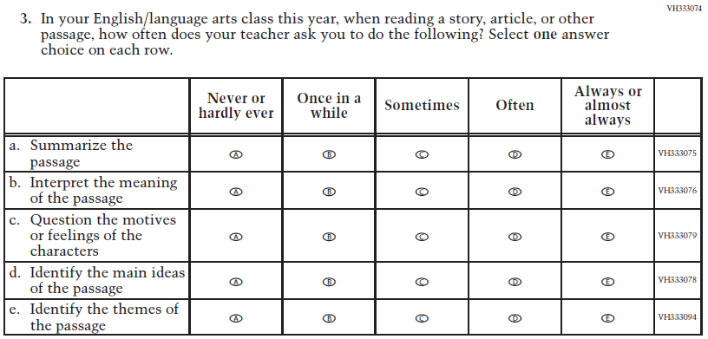  Issue: Organization of Instruction | NC | N/A
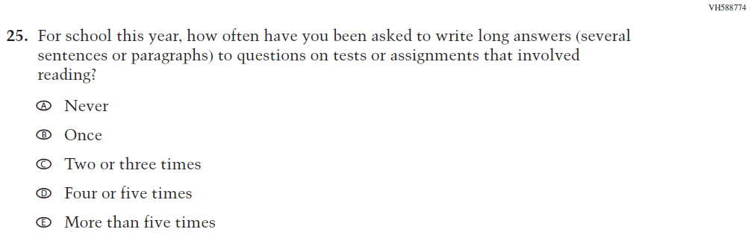  (2019 Grade 8) | 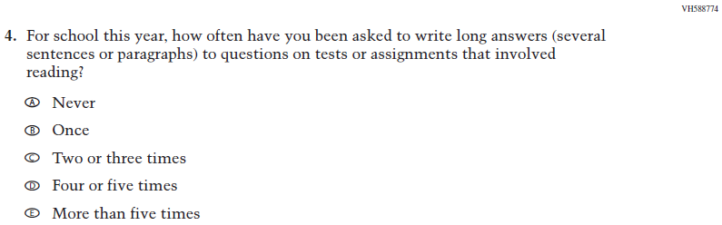  Issue: Organization of Instruction | NC | N/A
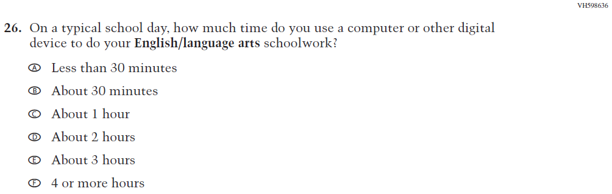  (2019 Grade 8) | N/A | D | To keep student burden low, this item was dropped.
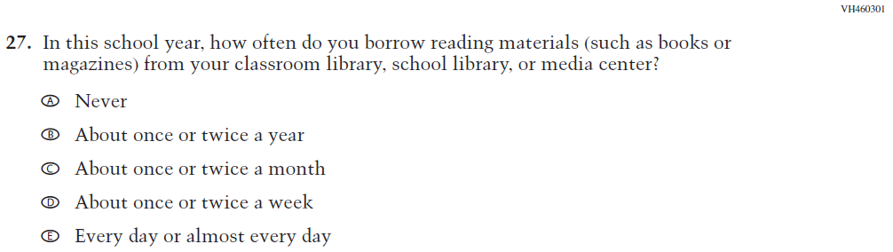  (2019 Grade 8) | N/A | D | To keep student burden low, this item was dropped.
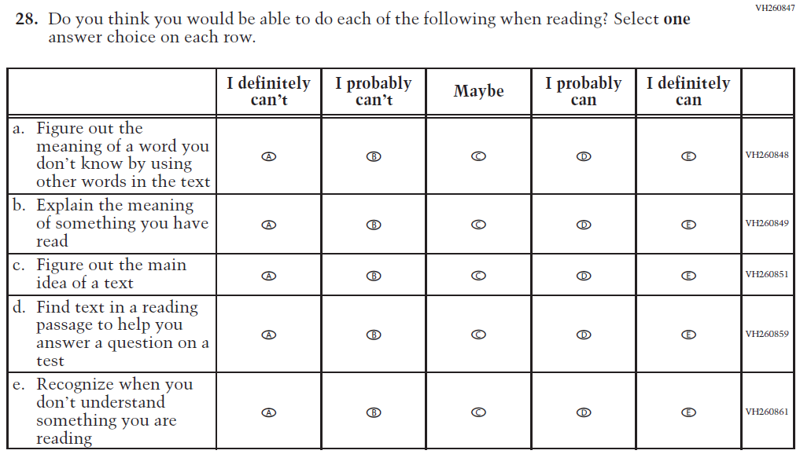  (2019 Grade 8) | 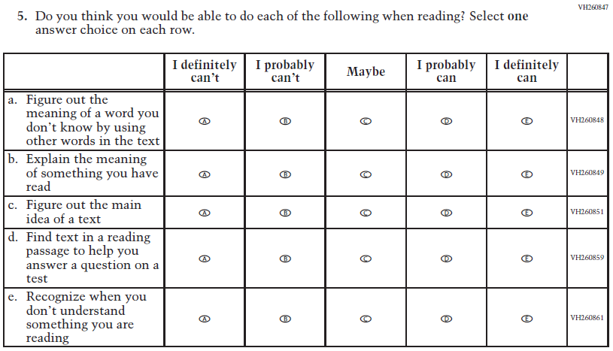  Issue: Student Factors | NC | N/A
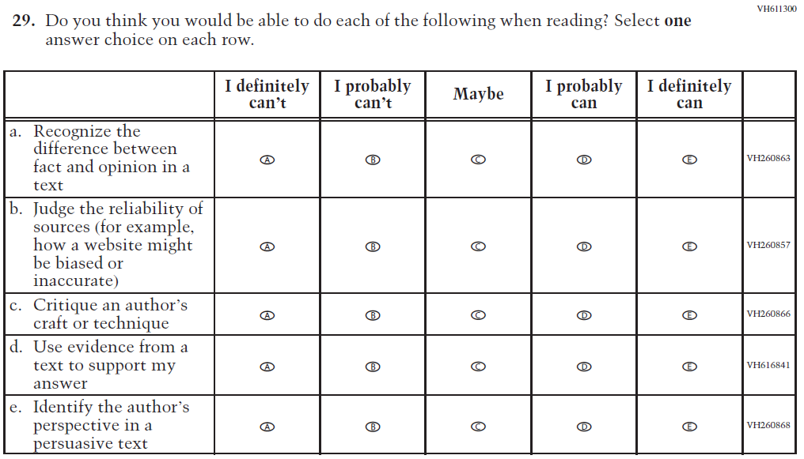  (2019 Grade 8) | 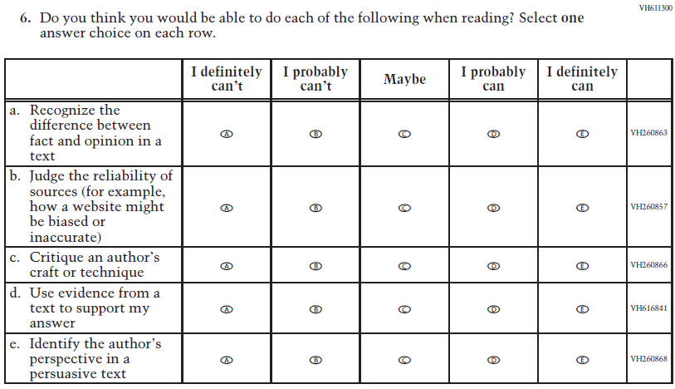  Issue: Student Factors | NC | N/A
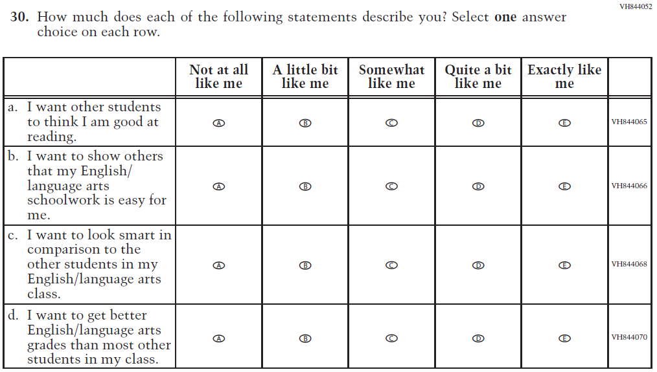  (2019 Grade 8) | N/A | D | To keep student burden low, this item was dropped.
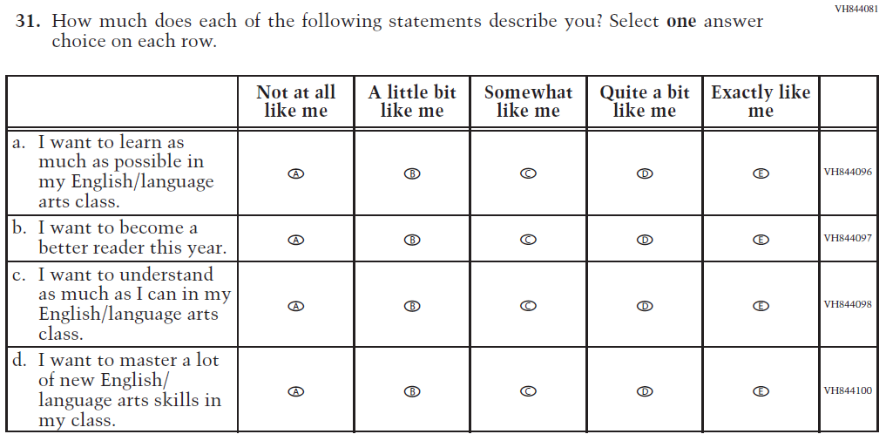  (2019 Grade 8) | 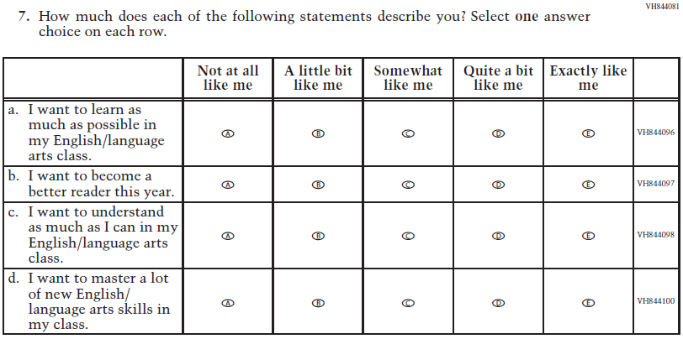  Issue: Student Factors | NC | N/A
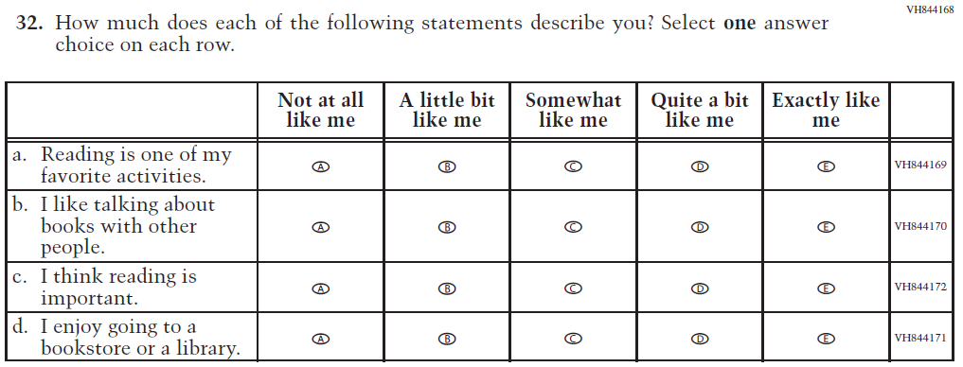(2019 Grade 8) | 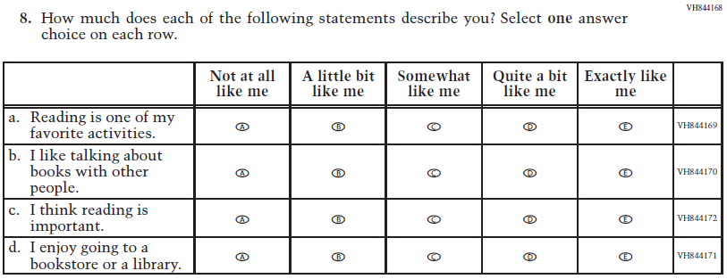  Issue: Student Factors | NC | N/A
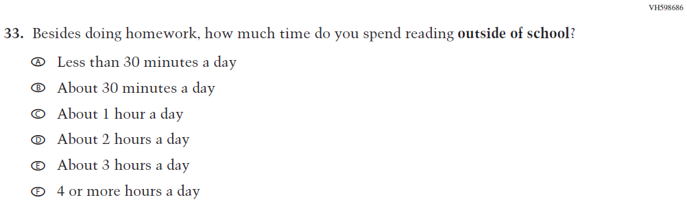  (2019 Grade 8) | 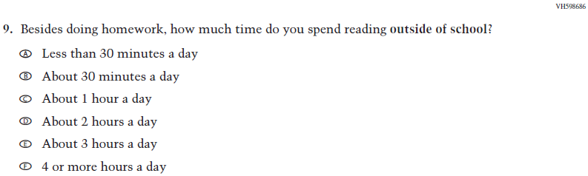  Issue: Student Factors | NC | N/A
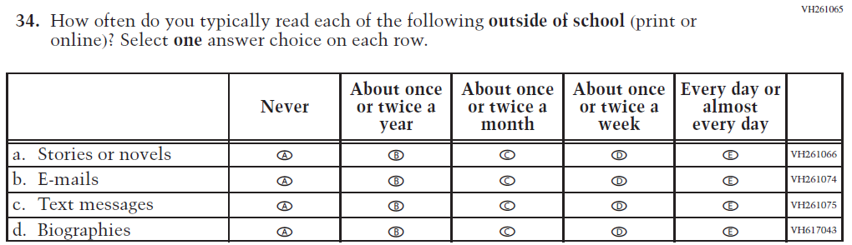  (2019 Grade 8) | 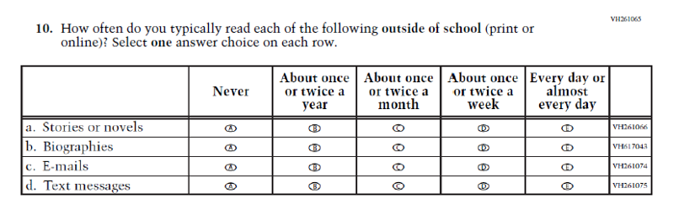  Issue: Student Factors | R | The order of sub-items b, c, and d was revised.
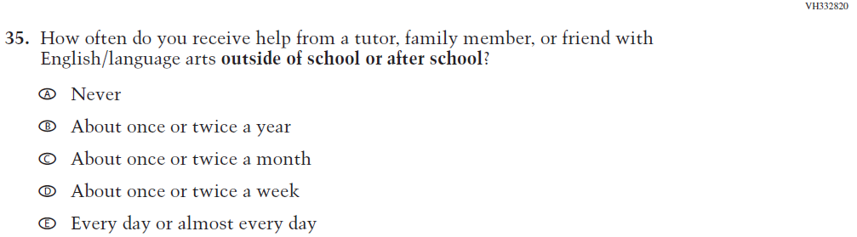  (2019 Grade 8) | 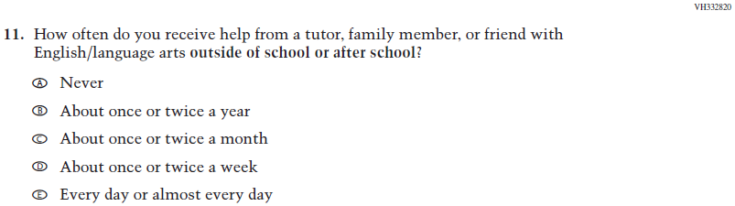  Issue: Resources for Learning and Instruction | NC | N/A
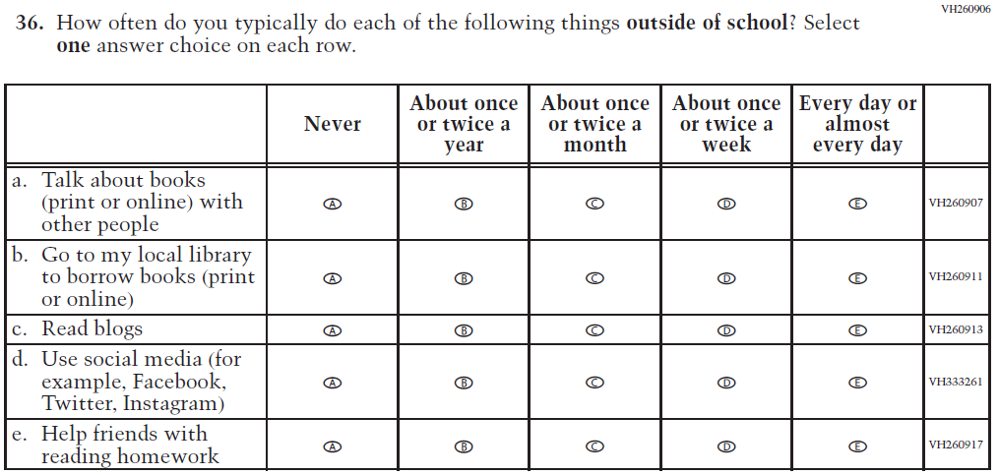  (2019 Grade 8) | 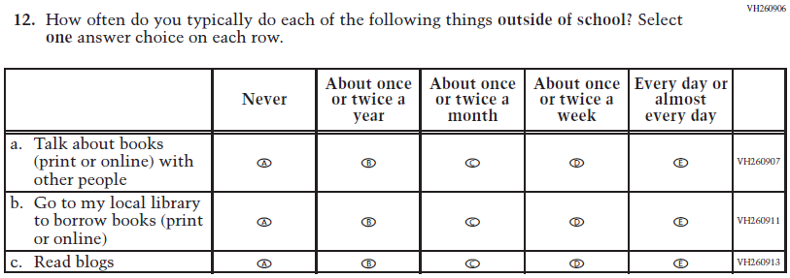  Issue: Student Factors | R | To keep student burden low, sub-items d and e were dropped.

Appendix J1-12: Operational Grade 8 (Reading)
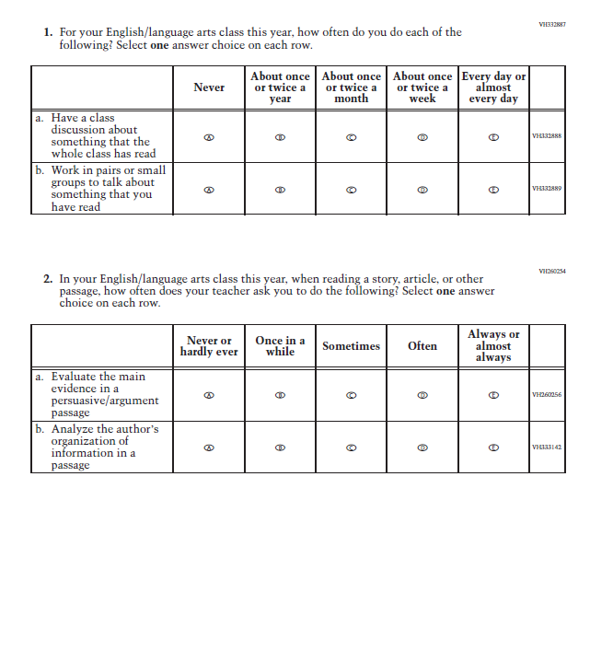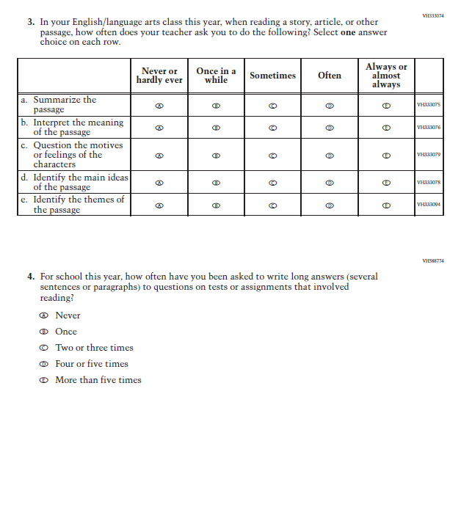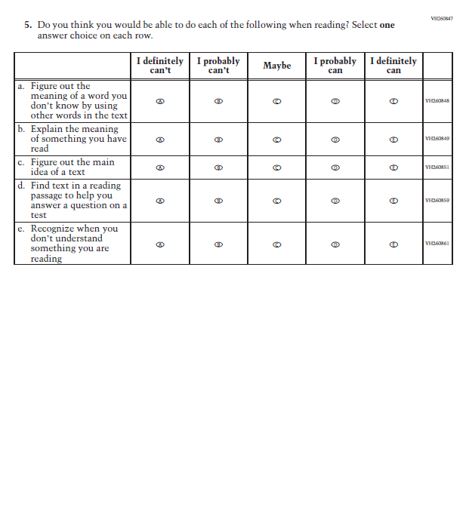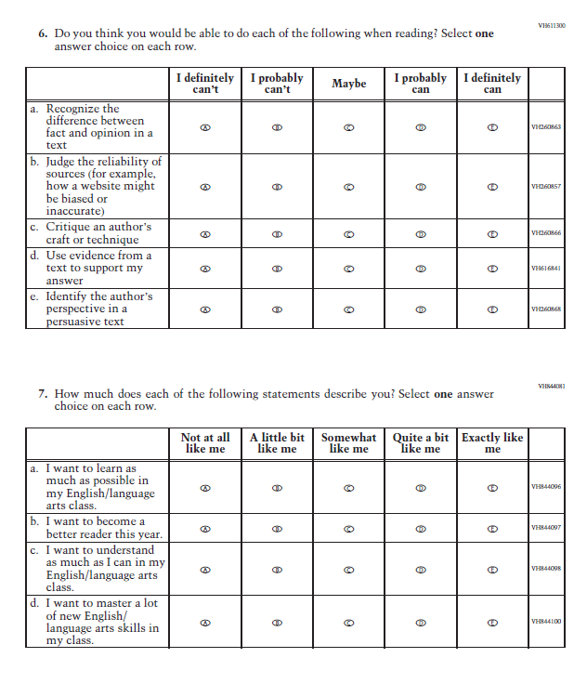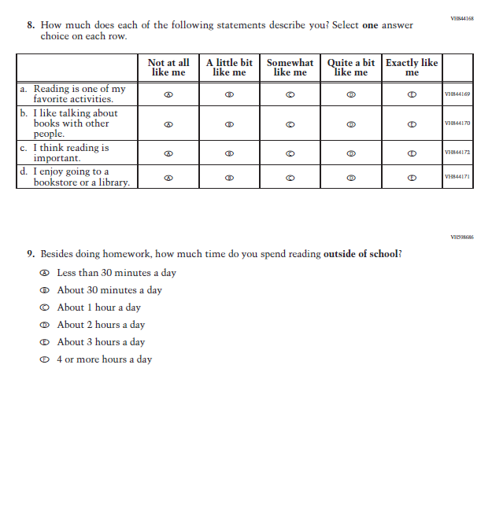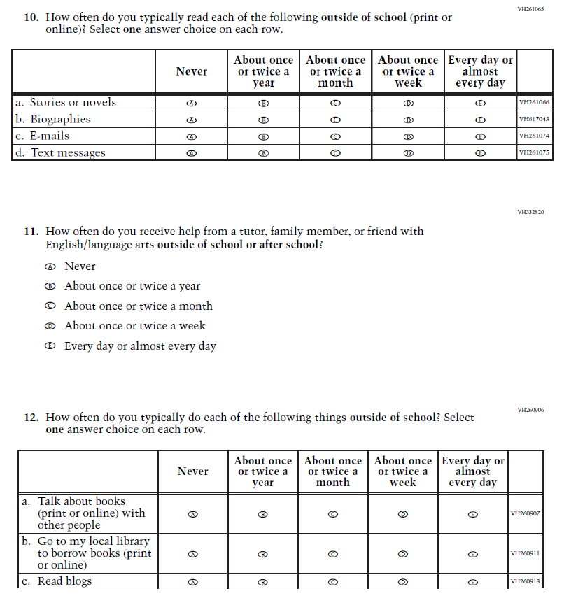

Appendix J1-13: Summary of Operational Grade 8 Civics
2022 Operational Grade 8 Civics Student
Previous item | 2022 item | D/A/ R/NC+ | Rationale
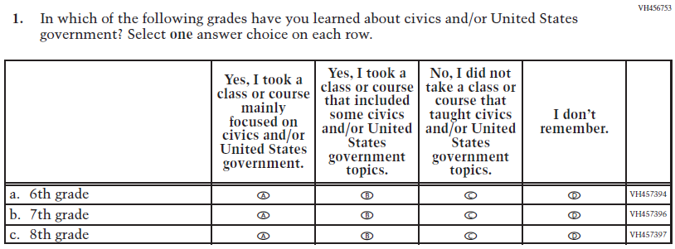  (2018 Grade 8) | 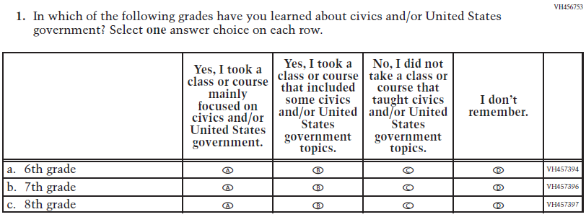  Issue: Organization of Instruction | NC | N/A
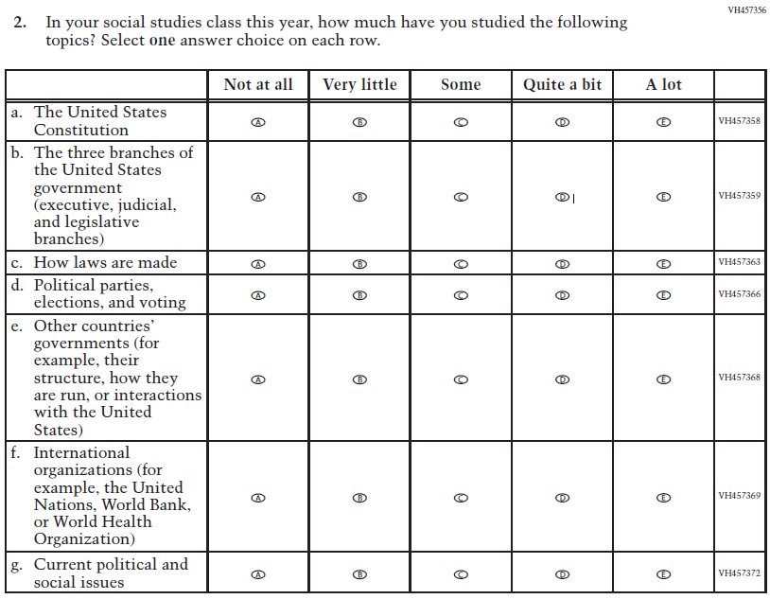  (2018 Grade 8) | 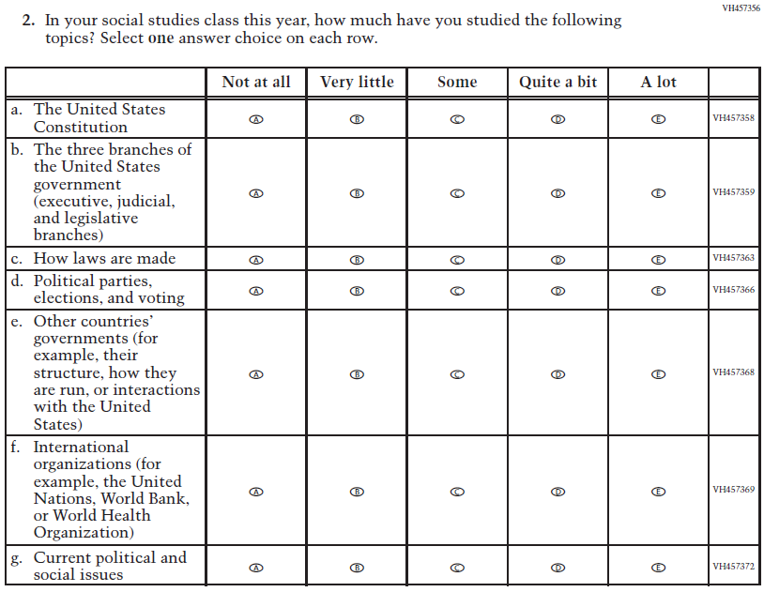  Issue: Organization of Instruction | NC | N/A
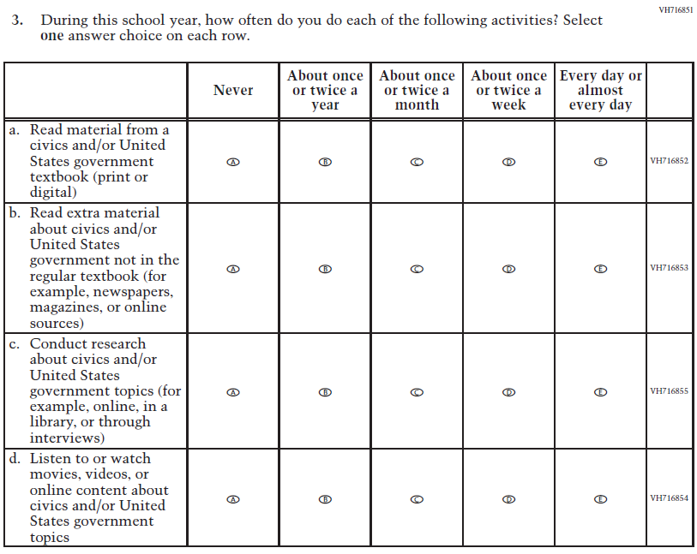  (2018 Grade 8) | N/A | D | To keep student burden low, this item was dropped.
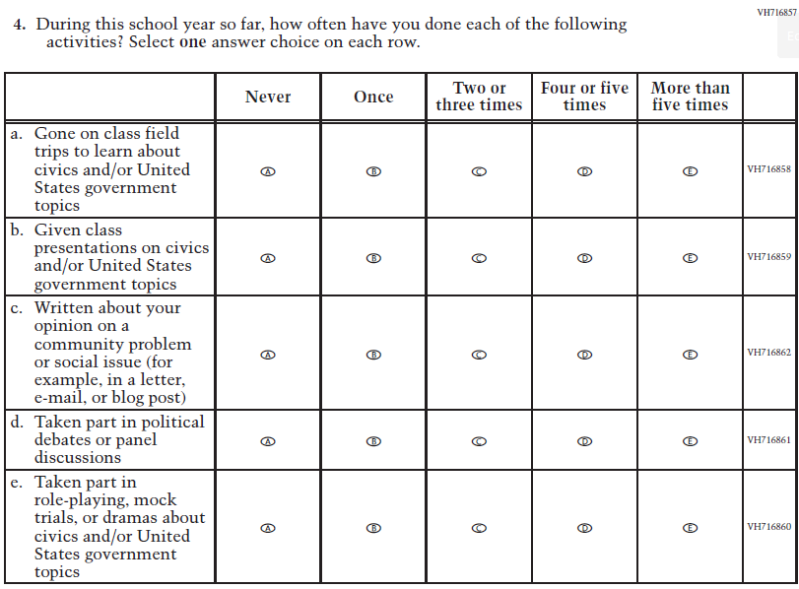  (2018 Grade 8) | N/A | D | To keep student burden low, this item was dropped.
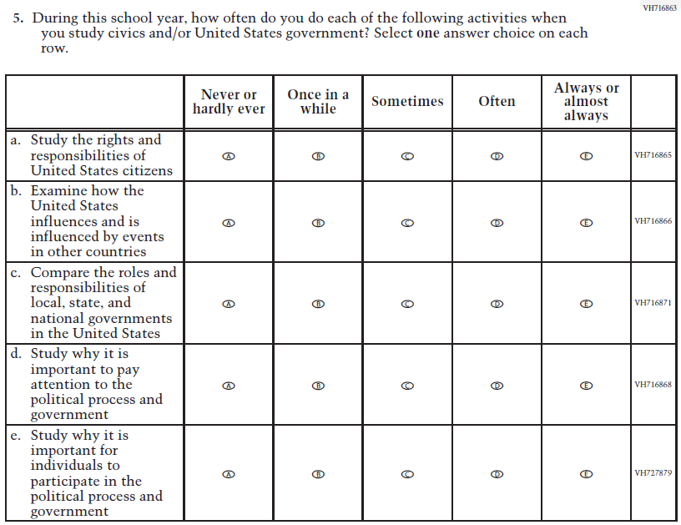  (2018 Grade 8) | 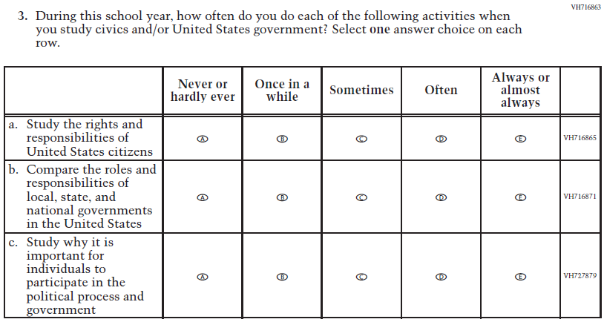  Issue: Organization of Instruction | R | To keep student burden low, sub-items b and d were dropped.
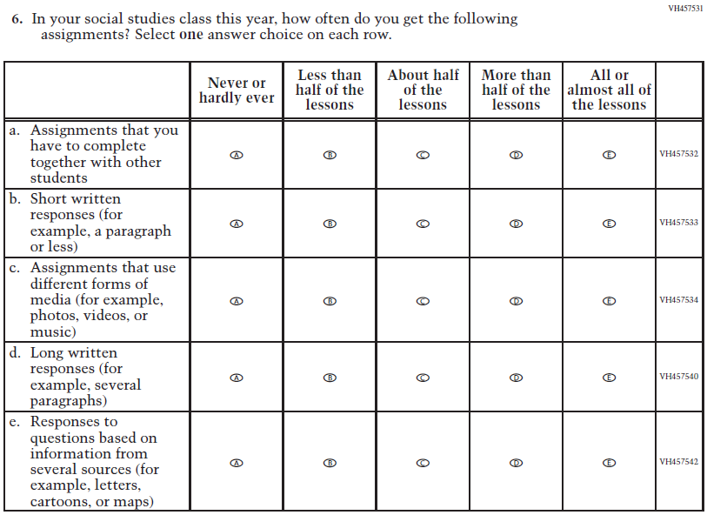  (2018 Grade 8) | 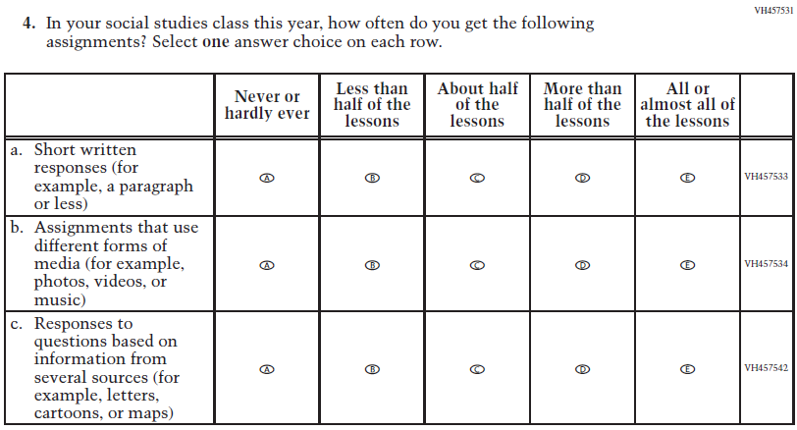  Issue: Organization of Instruction | R | To keep student burden low, sub-items a and d were dropped.
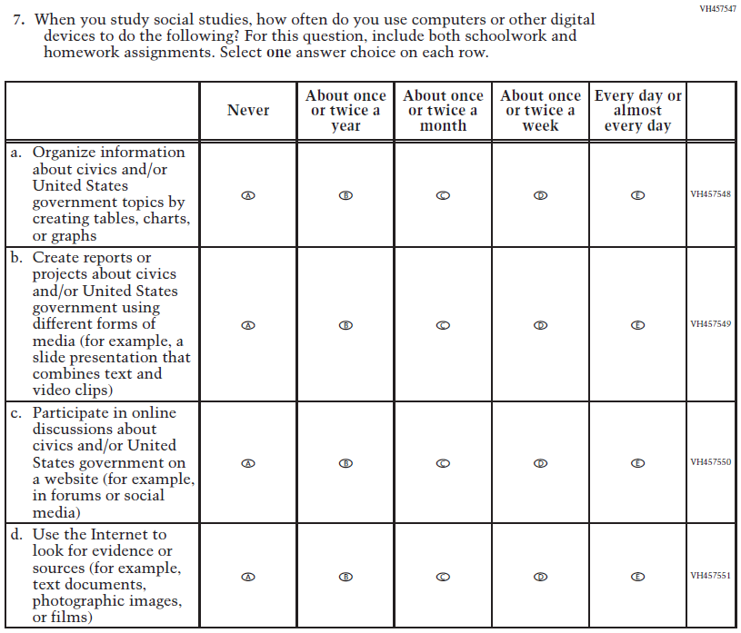  (2018 Grade 8) | 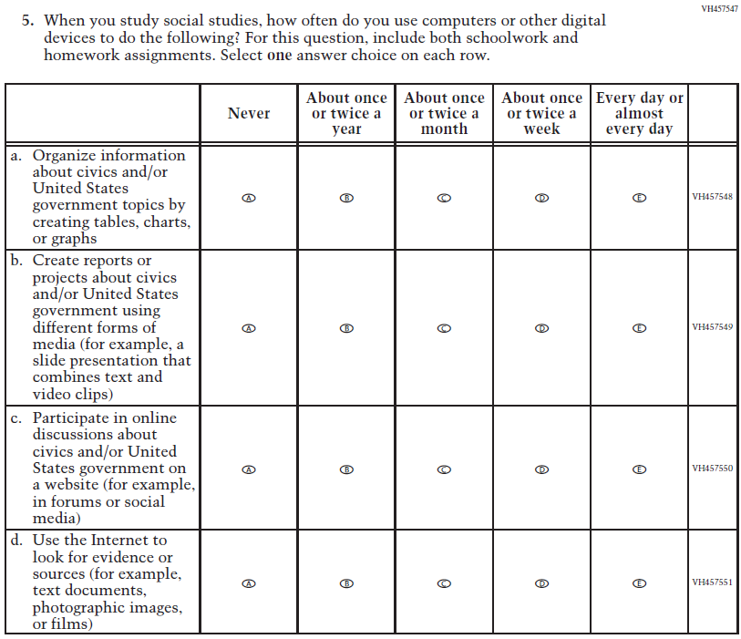  Issue: Organization of Instruction | NC | N/A
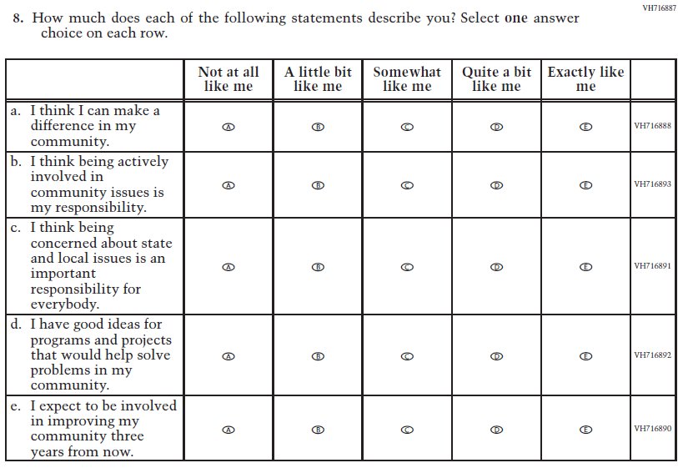  (2018 Grade 8) | 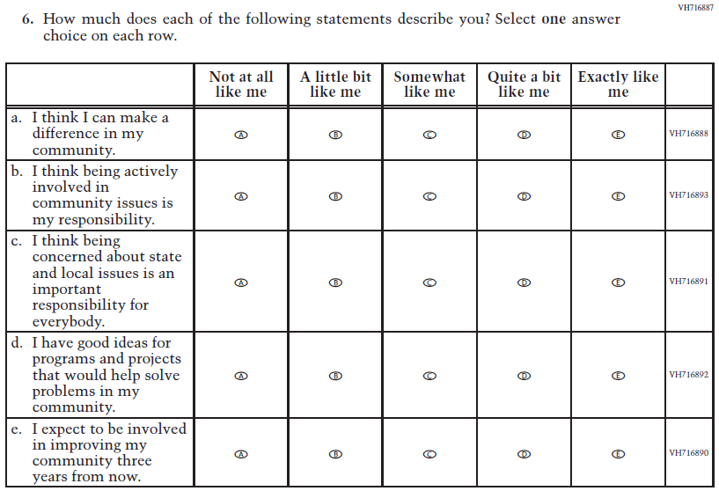  Issue: Student Factors | NC | N/A
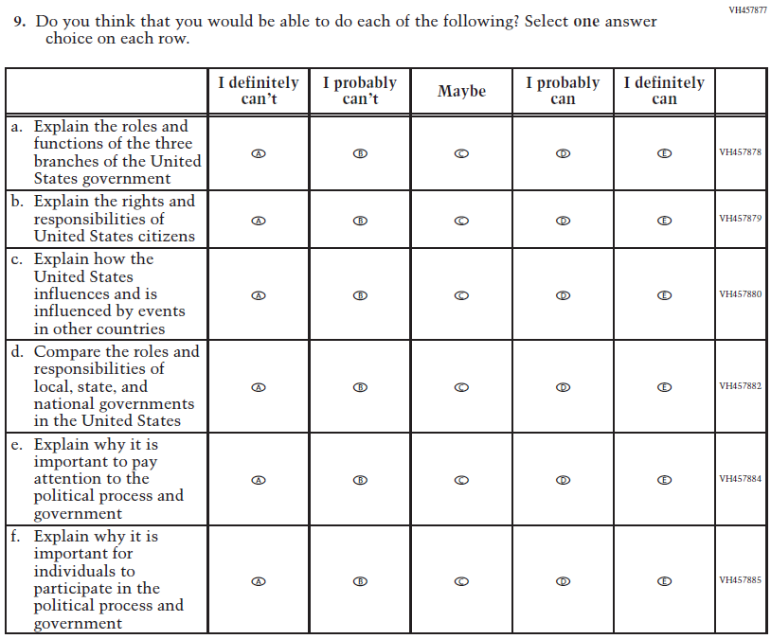  (2018 Grade 8) | 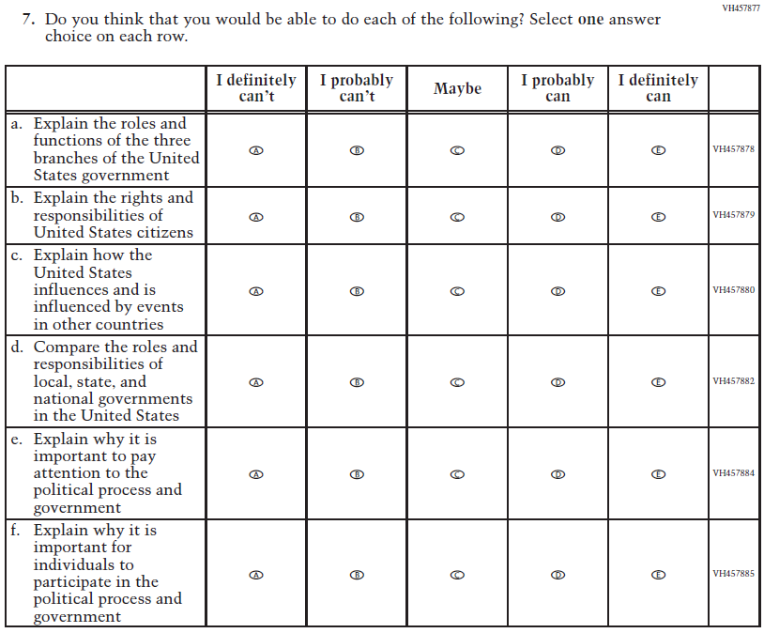  Issue: Student Factors | NC | N/A
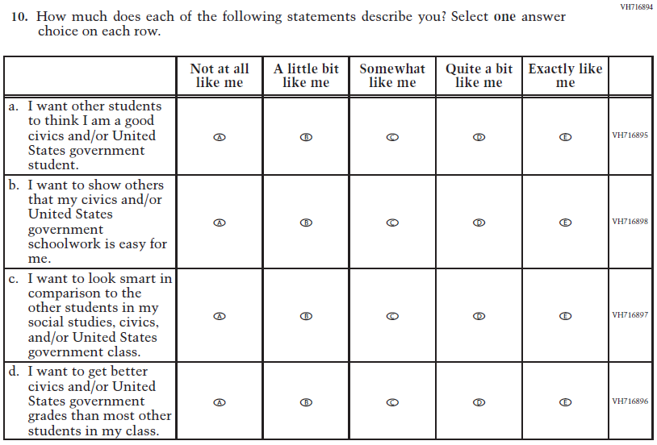  (2018 Grade 8) | N/A | D | To keep student burden low, this item was dropped.
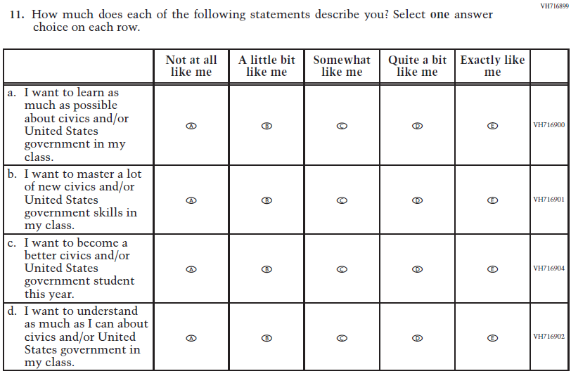  (2018 Grade 8) | 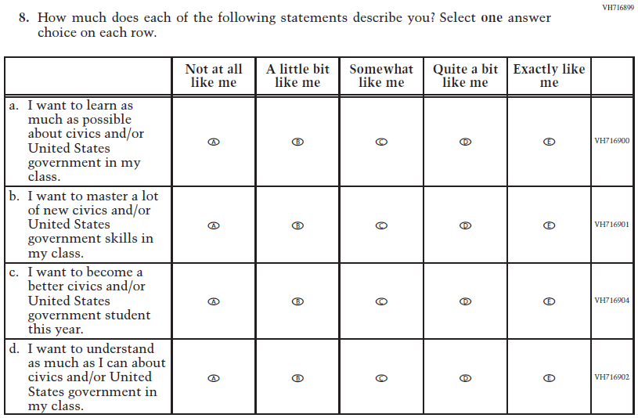  Issue: Student Factors | NC | N/A
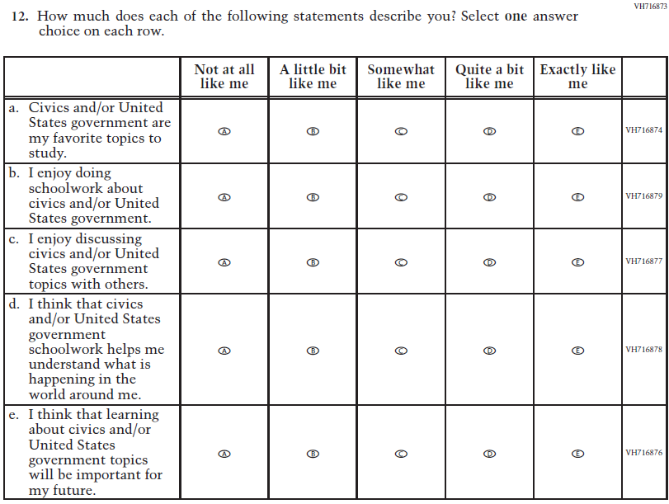  (2018 Grade 8) | 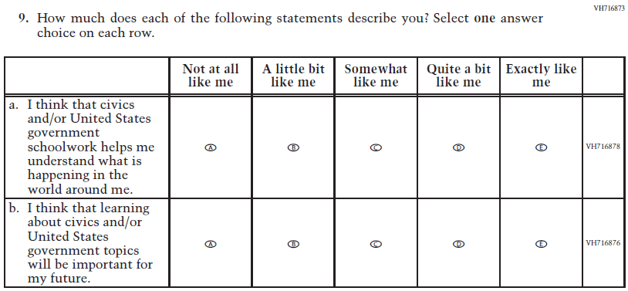  Issue: Student Factors | R | To keep student burden low, sub-items a, b, and c were dropped.
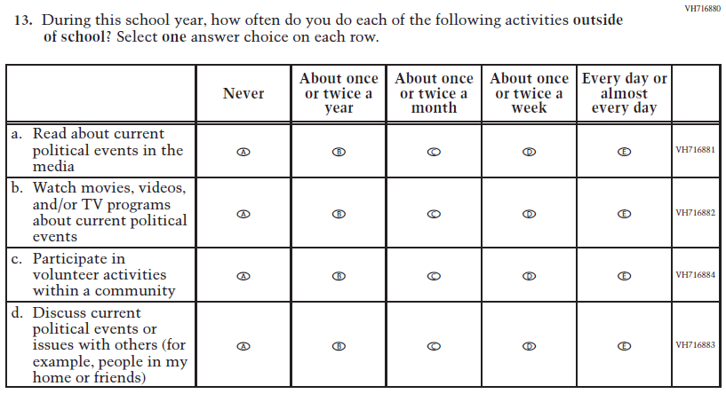  (2018 Grade 8) | 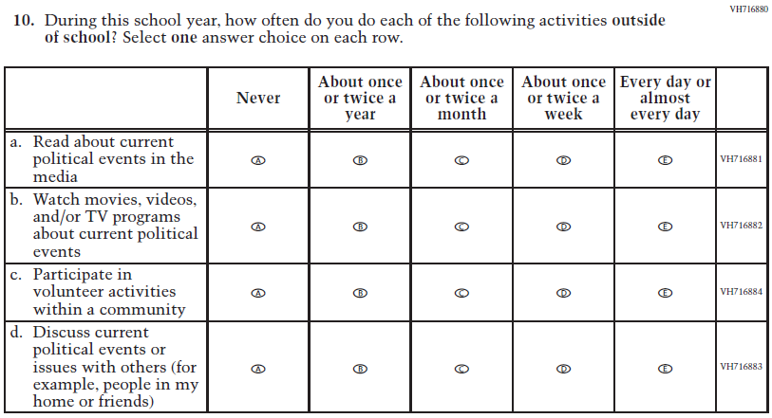  Issue: Student Factors | NC | N/A
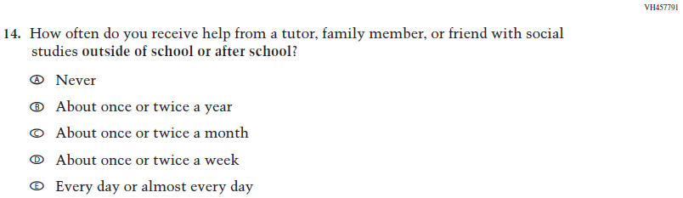  (2018 Grade 8) | 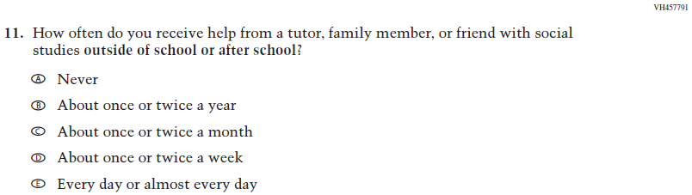  Issue: Resources for Learning and Instruction | NC | N/A
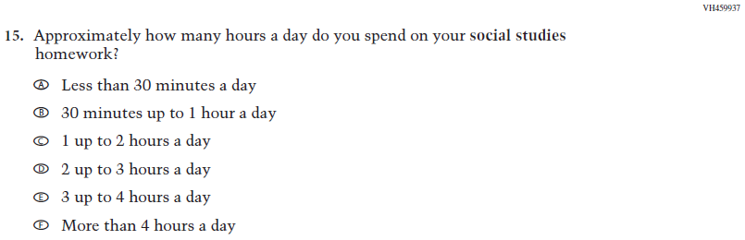  (2018 Grade 8) | N/A | D | To keep student burden low, this item was dropped.

Appendix J1-14: Operational Grade 8 Civics
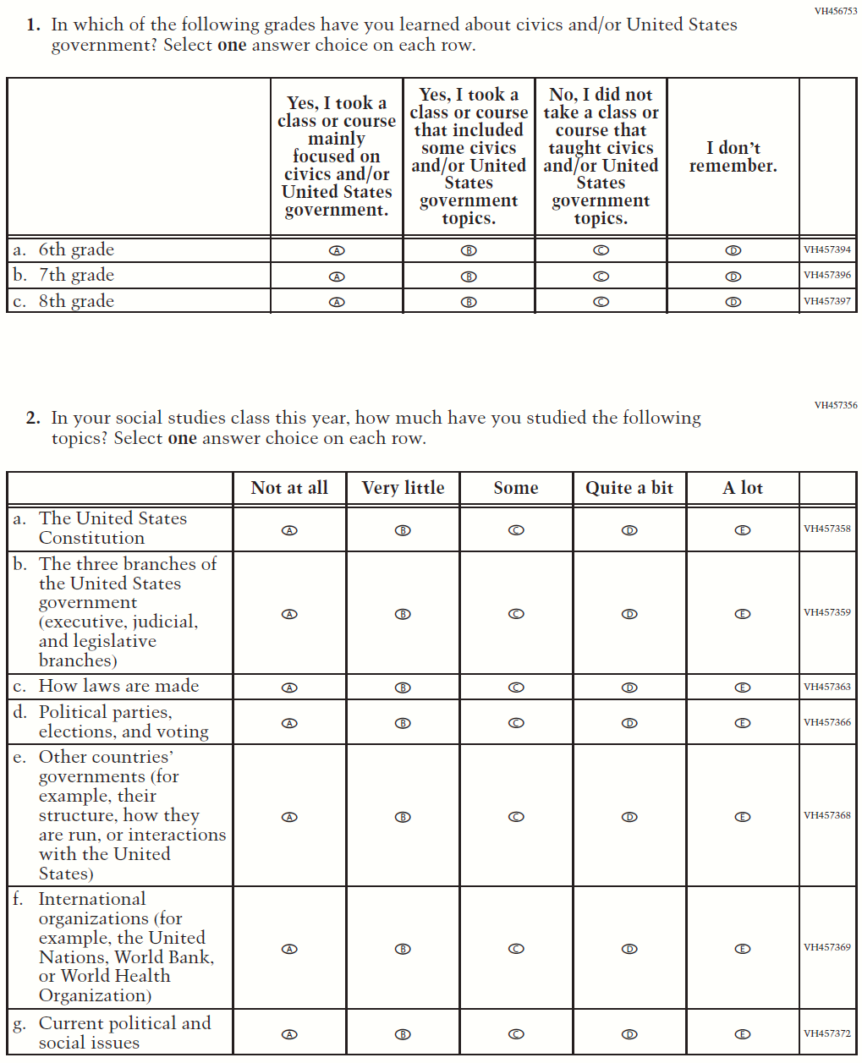
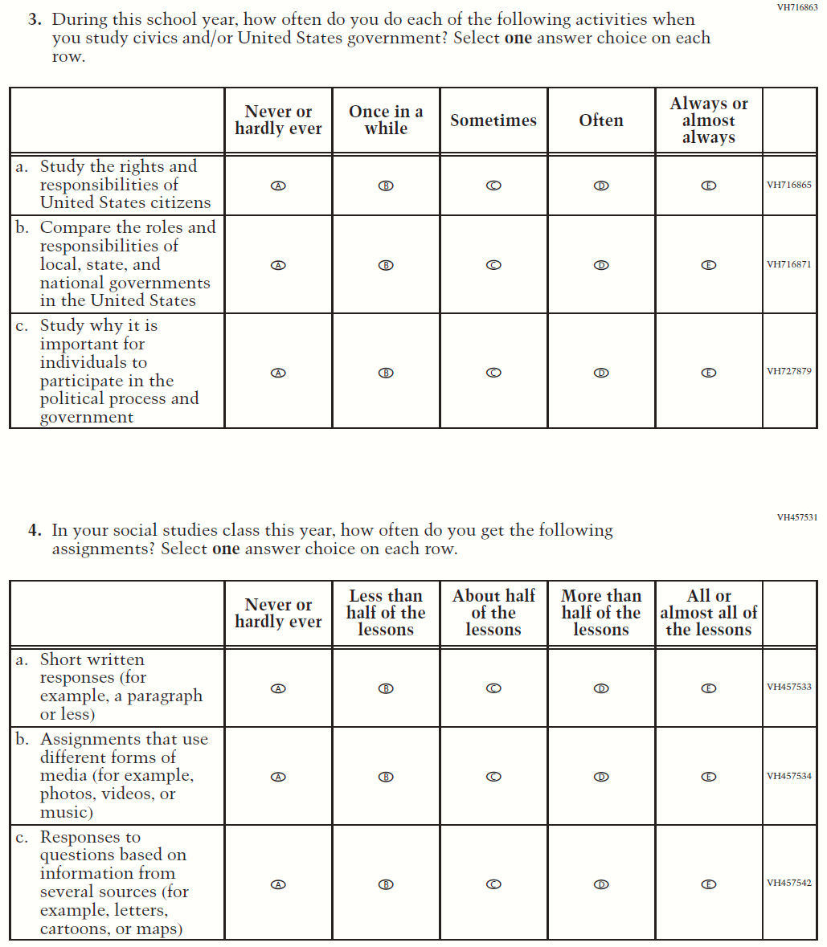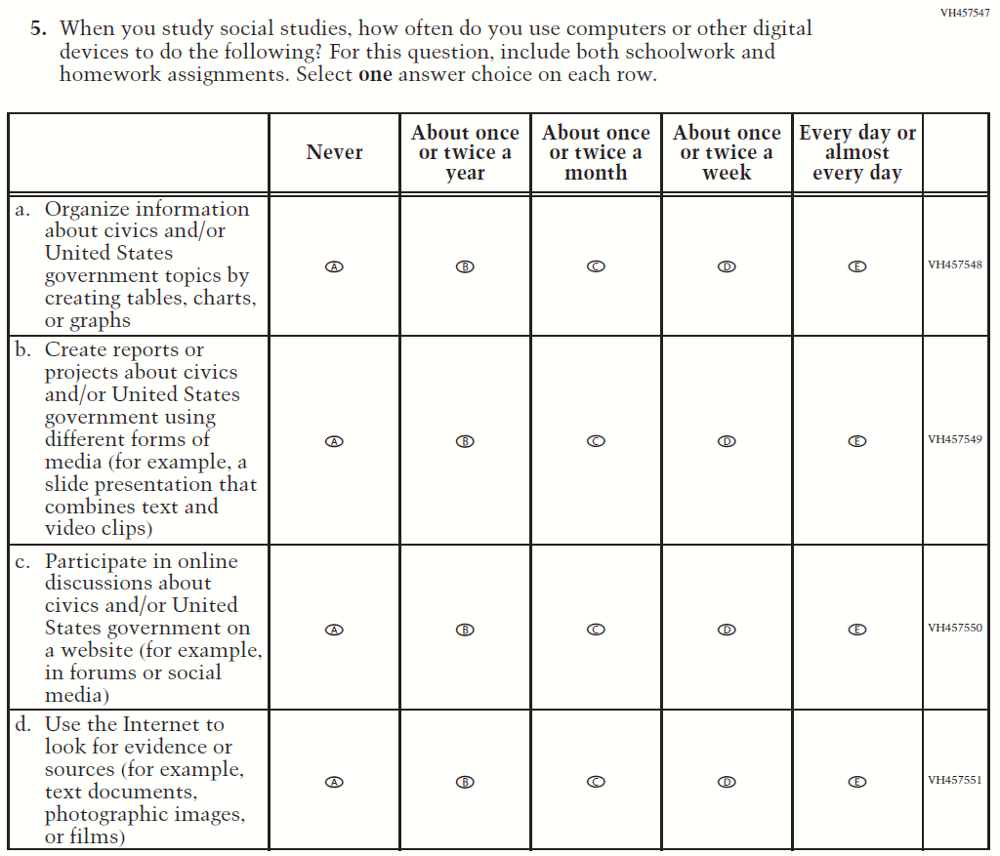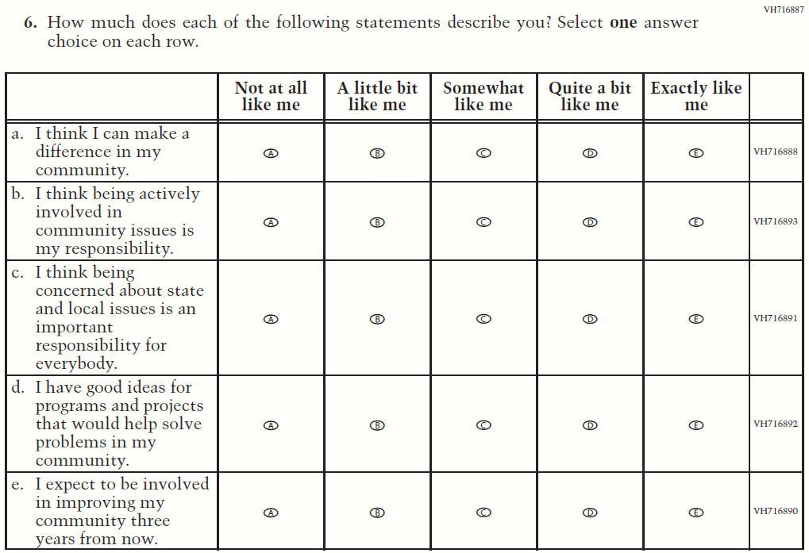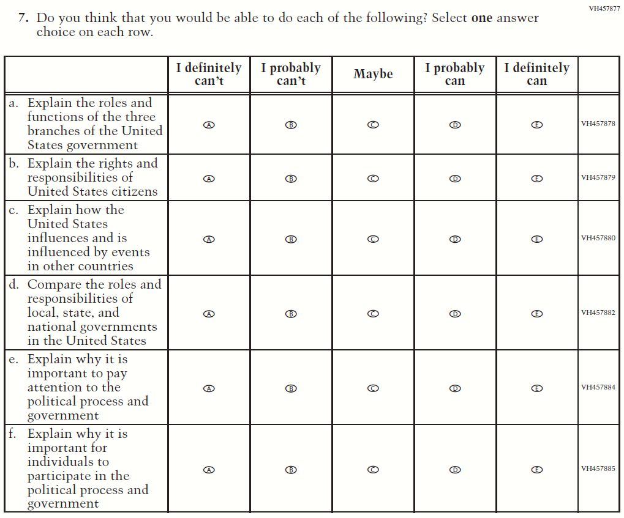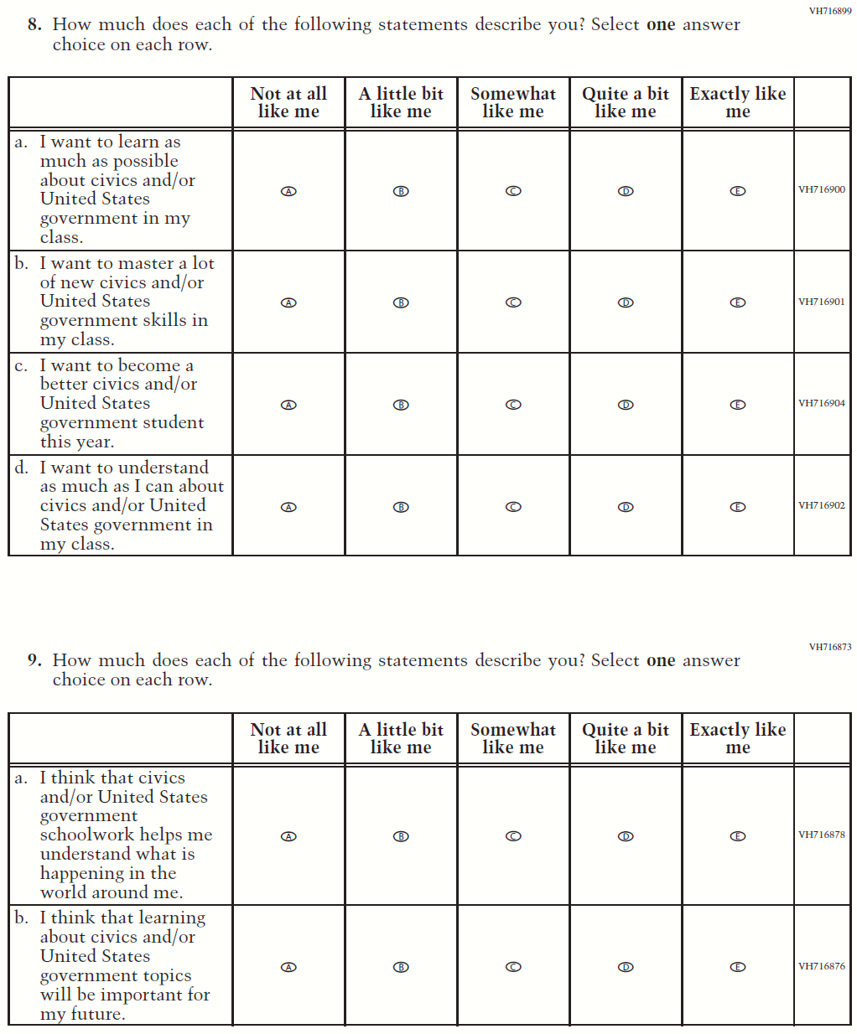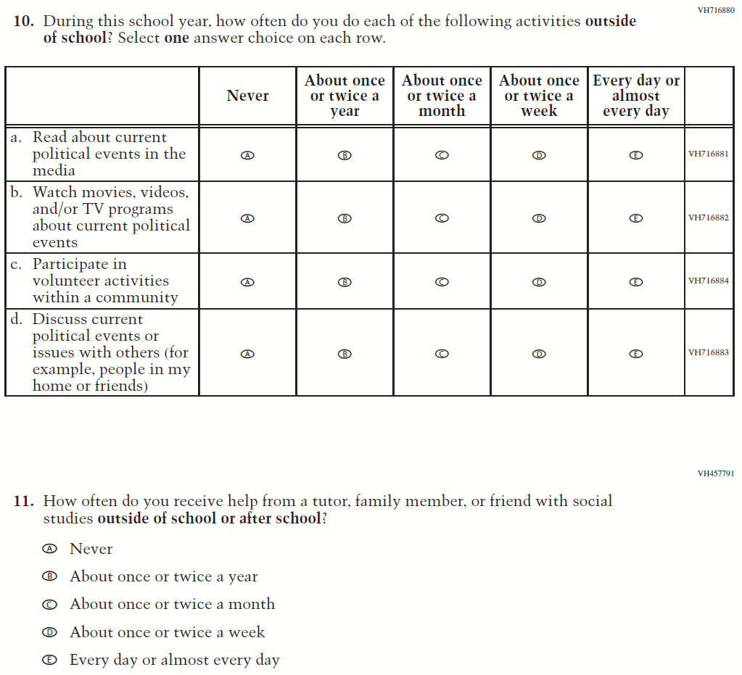

Appendix J1-15: Summary of Operational Grade 8 U.S. History
2022 Operational Grade 8 U.S. History Student
Previous item | 2022 item | D/A/ R/NC+ | Rationale
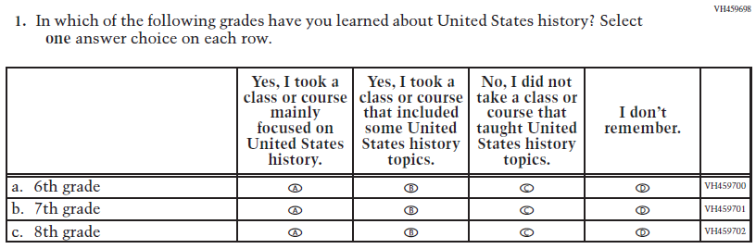  (2018 Grade 8) | 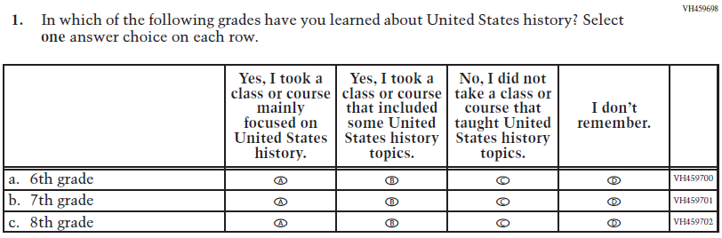  Issue: Organization of Instruction | NC | N/A
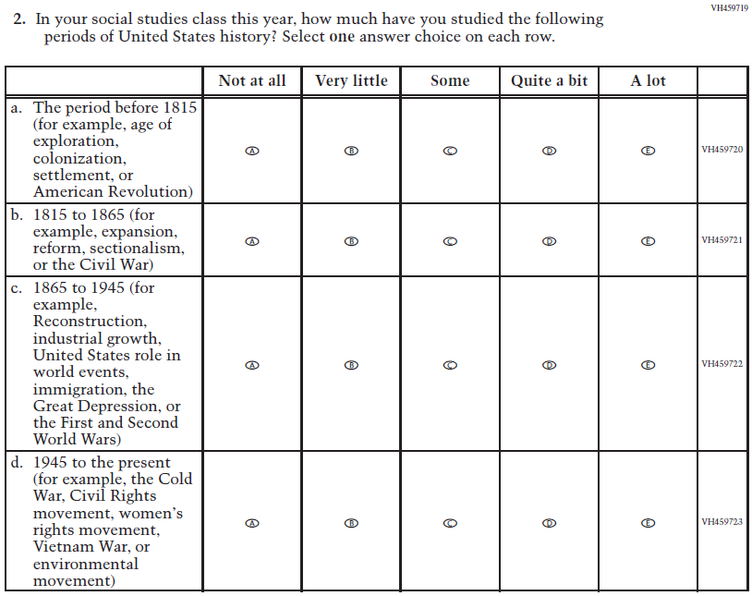  (2018 Grade 8) | 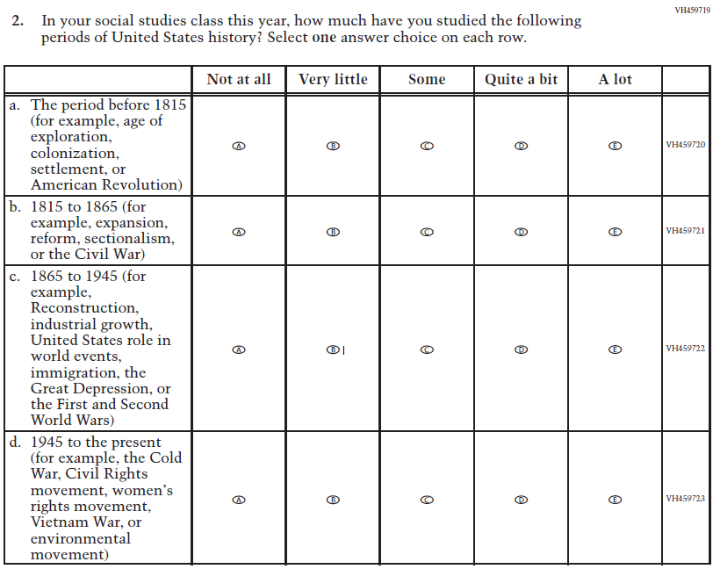  Issue: Organization of Instruction | NC | N/A
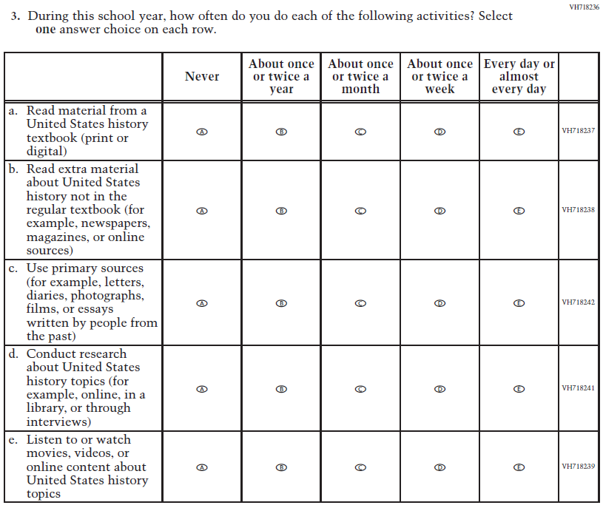  (2018 Grade 8) | N/A | D | To keep student burden low, this item was dropped.
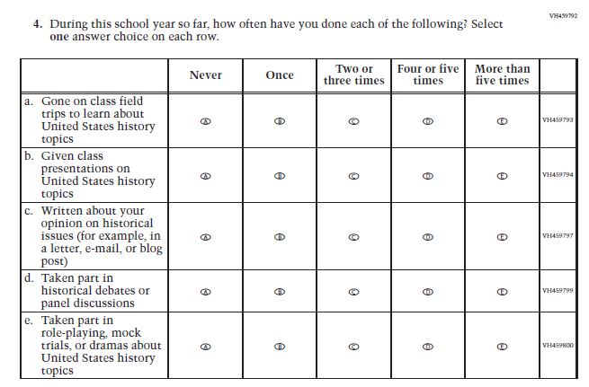  (2018 Grade 8) | N/A | D | To keep student burden low, this item was dropped.
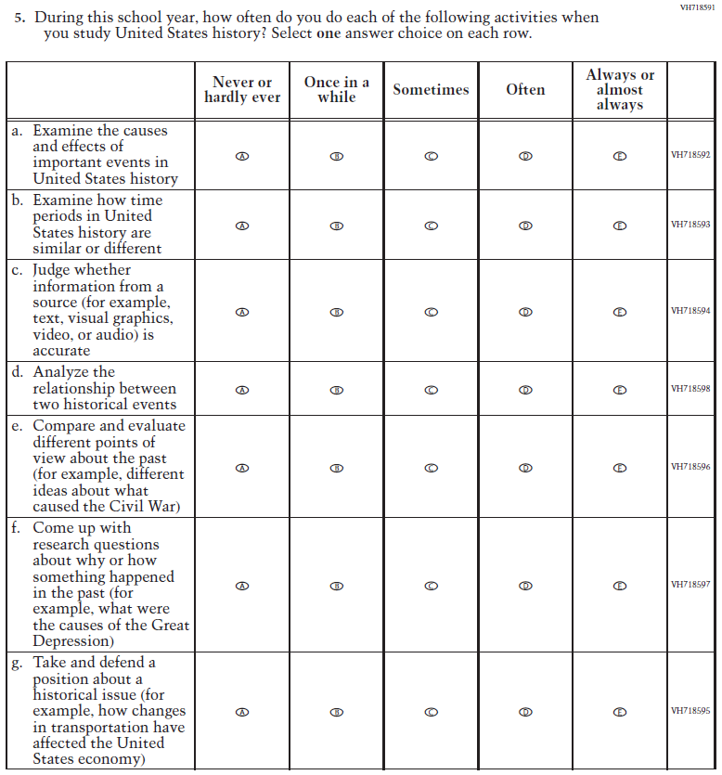  (2018 Grade 8) | 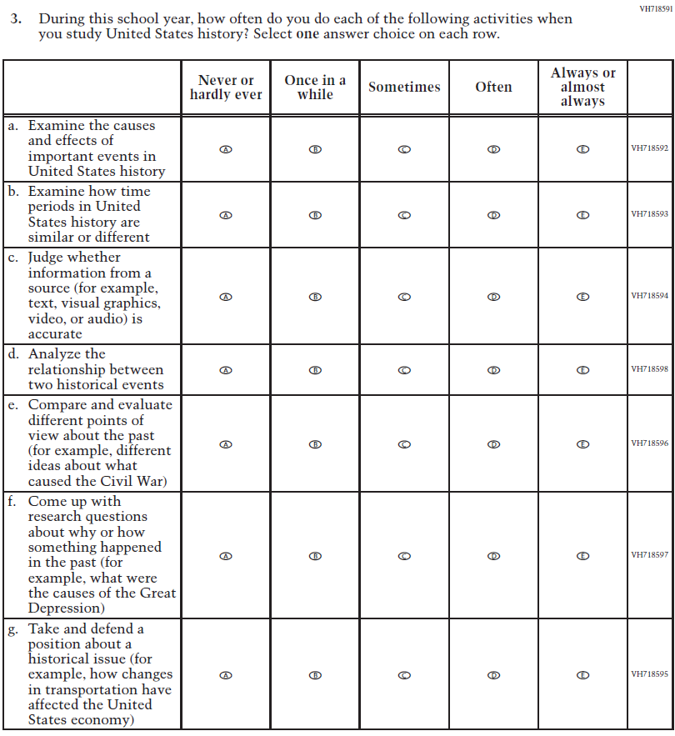  Issue: Organization of Instruction | NC | N/A
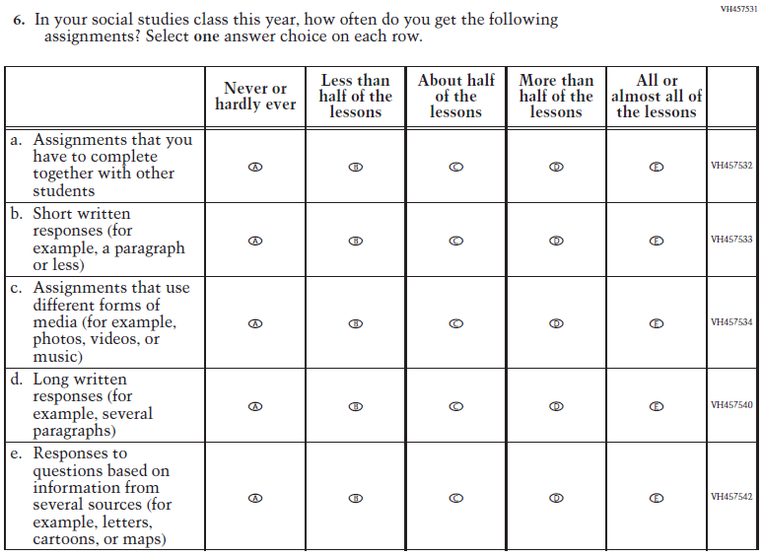  (2018 Grade 8) | 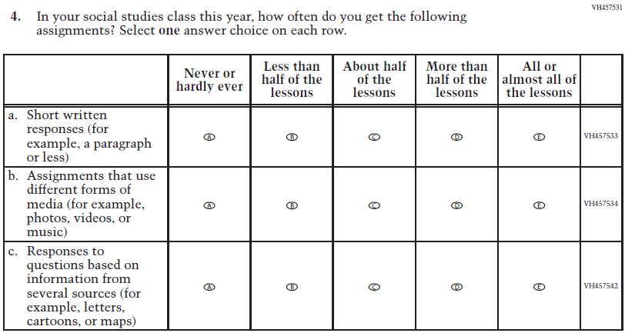  Issue: Organization of Instruction | R | To keep student burden low, sub-items a and d were dropped.
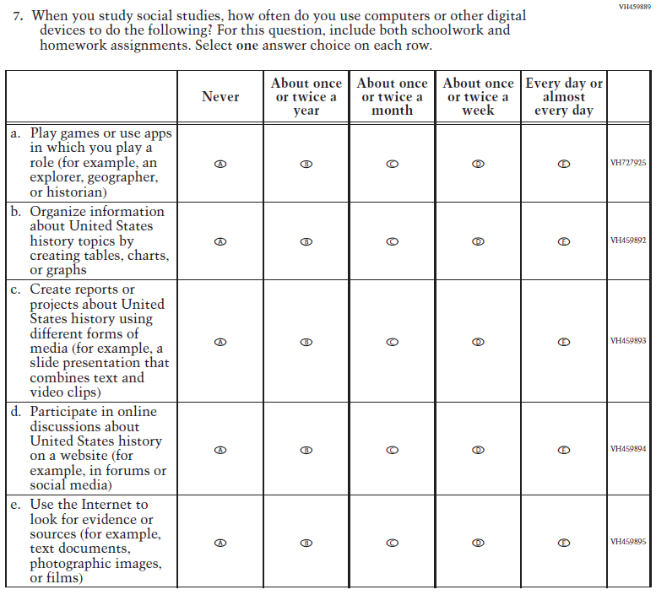(2018 Grade 8) | N/A | D | To keep student burden low, this item was dropped.
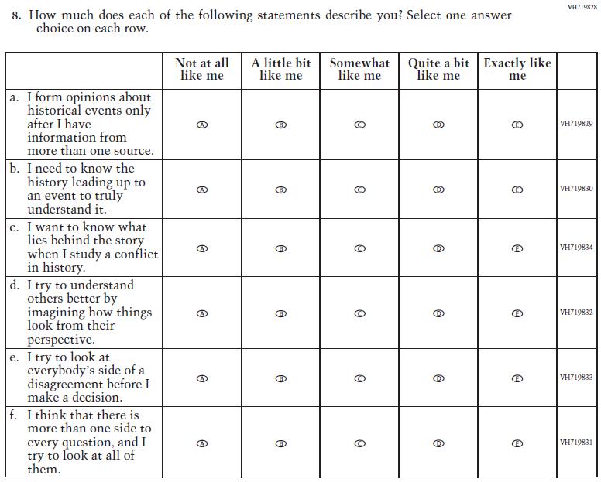  (2018 Grade 8) | 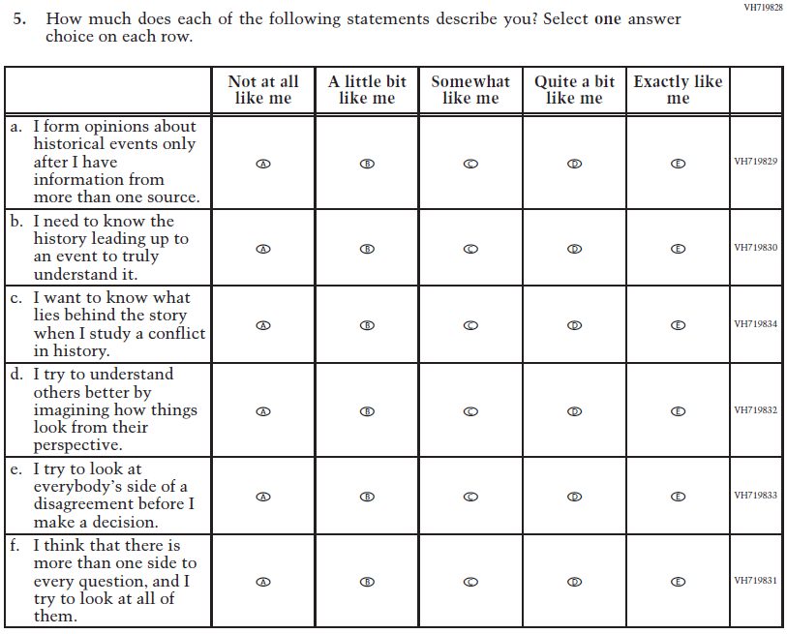  Issue: Student Factors | NC | N/A
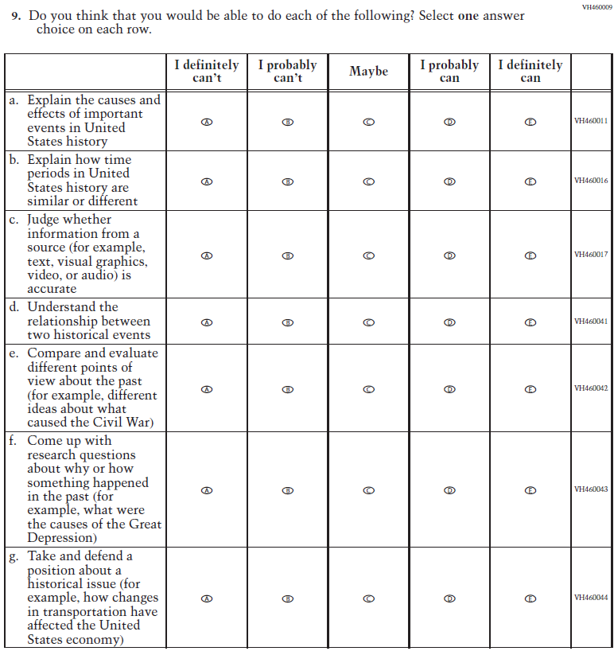  (2018 Grade 8) | 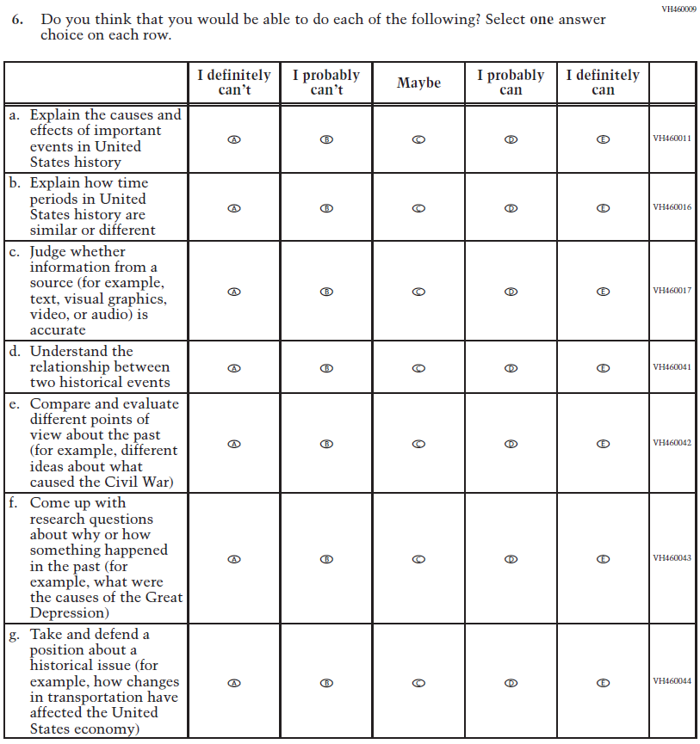  Issue: Student Factors | NC | N/A
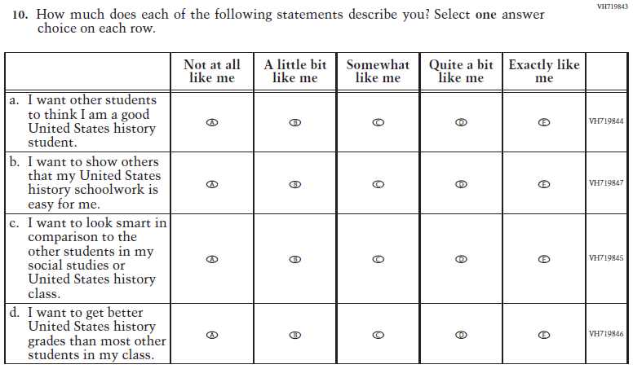  (2018 Grade 8) | N/A | D | To keep student burden low, this item was dropped.
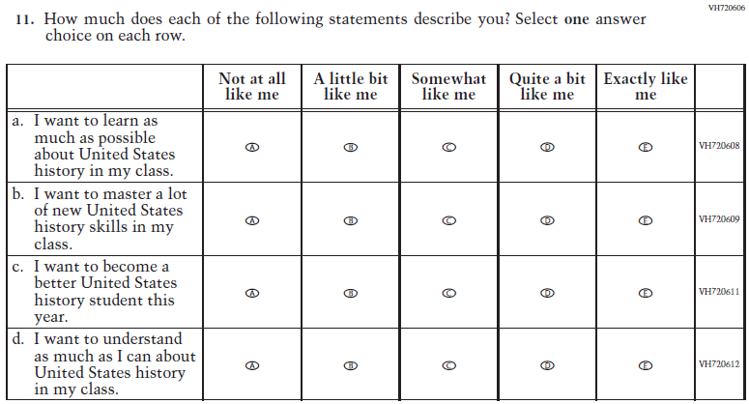  (2018 Grade 8) | 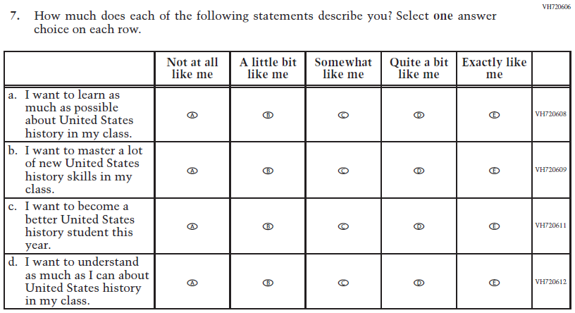  Issue: Student Factors | NC | N/A
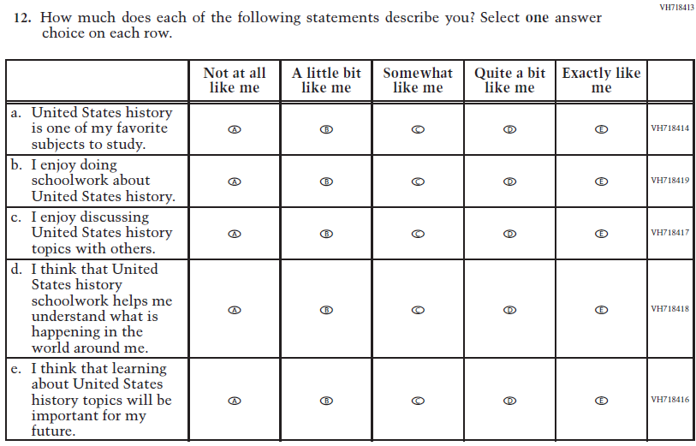  (2018 Grade 8) | N/A | D | To keep student burden low, this item was dropped.
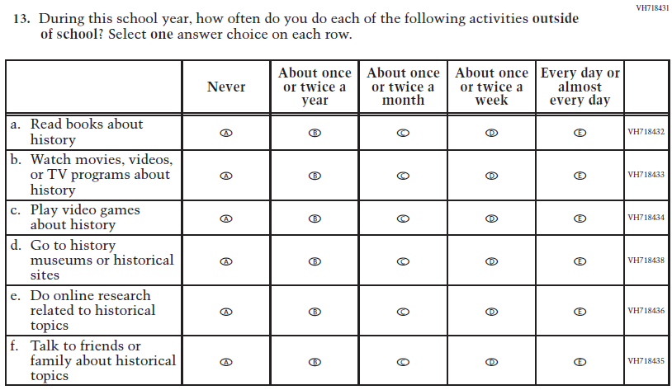  (2018 Grade 8) | 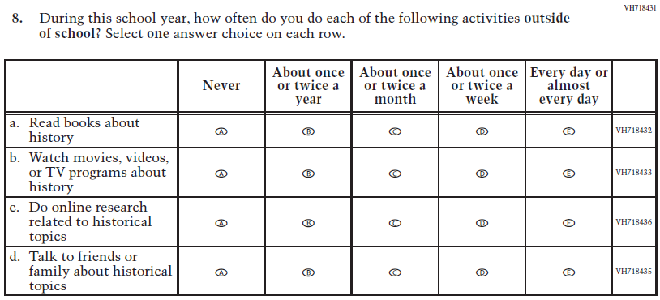  Issue: Student Factors | R | To keep student burden low, sub-items c and d were dropped.
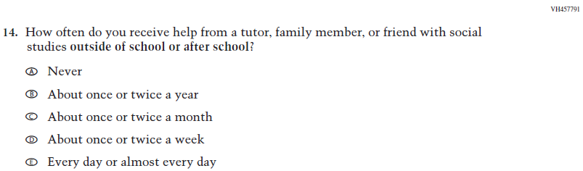  (2018 Grade 8) | 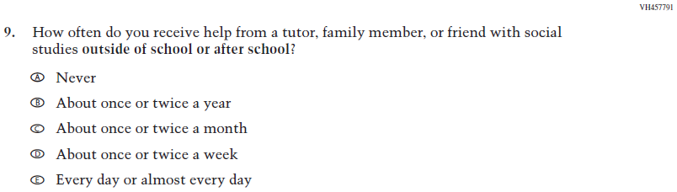  Issue: Resources for Learning and Instruction | NC | N/A
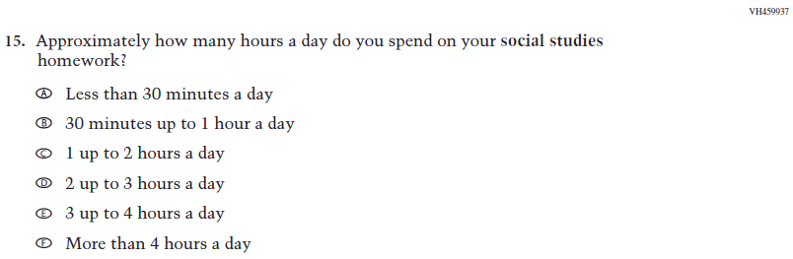  (2018 Grade 8) | N/A | D | To keep student burden low, this item was dropped.

Appendix J1-16: Operational Grade 8 U.S. History
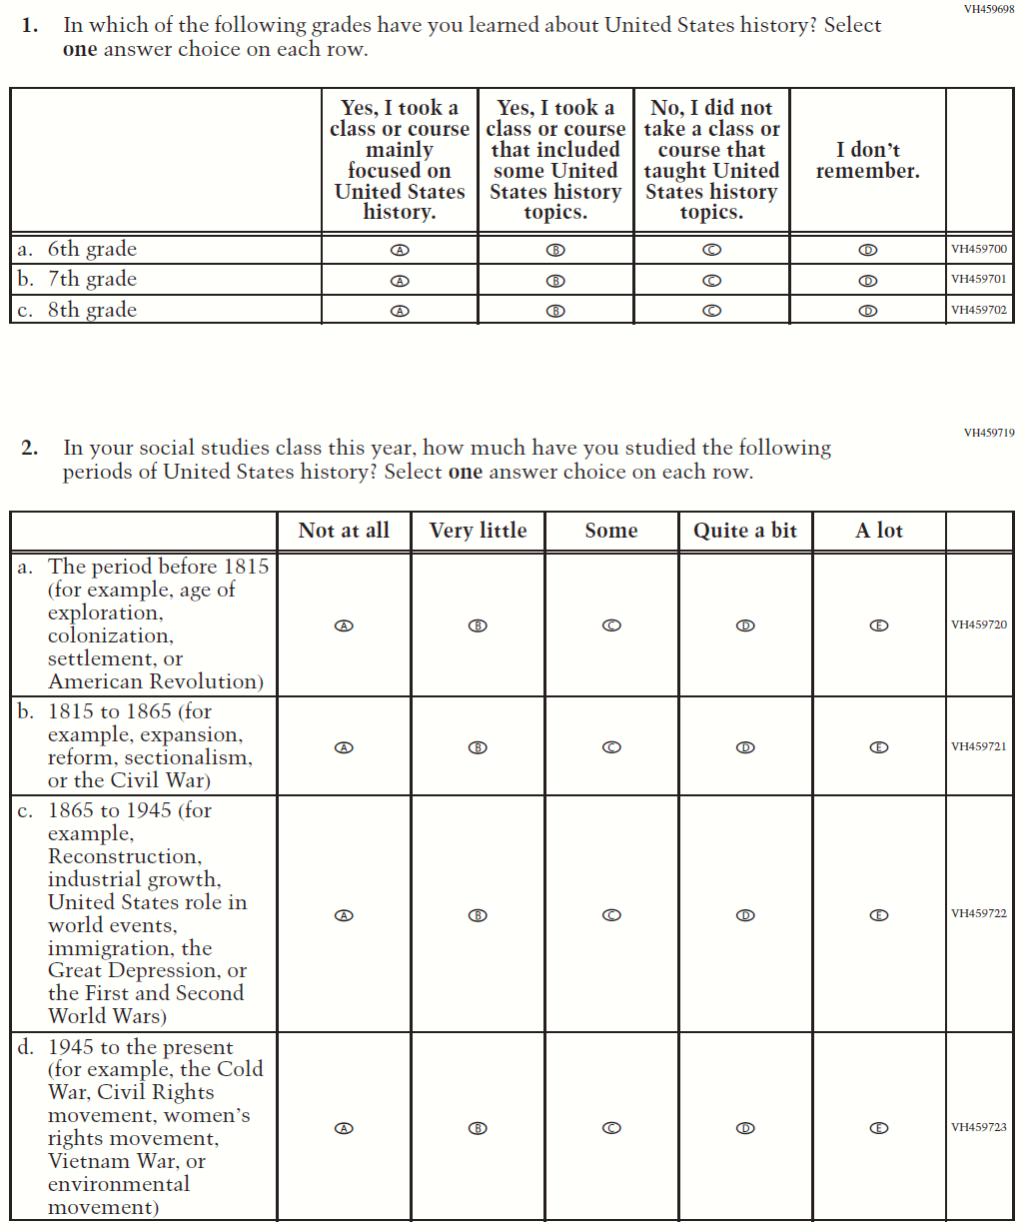
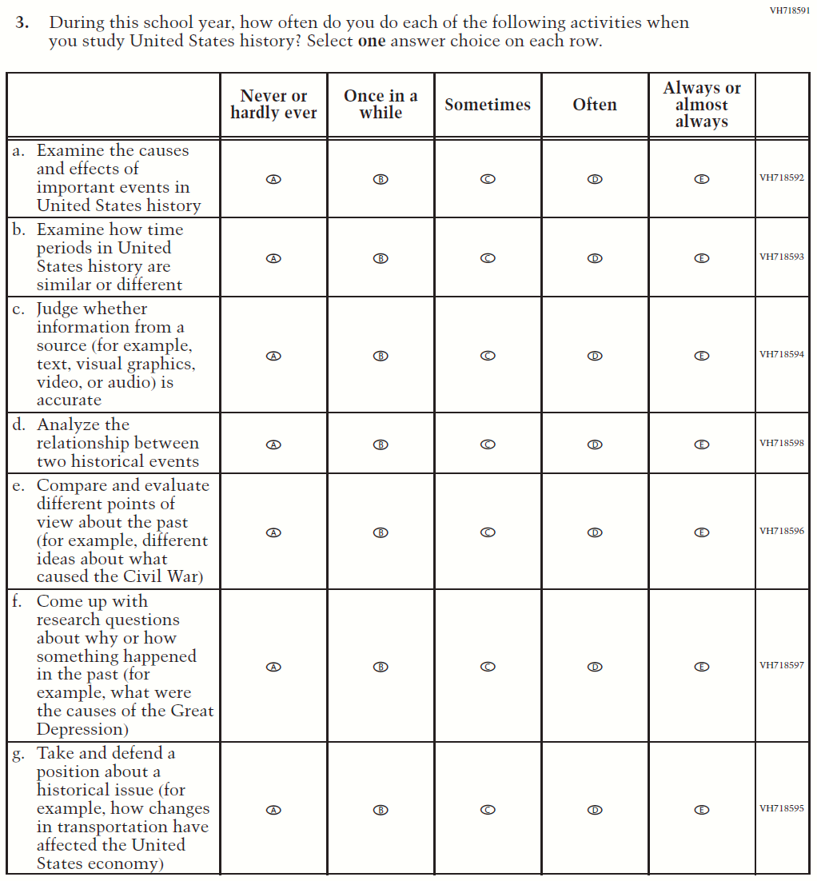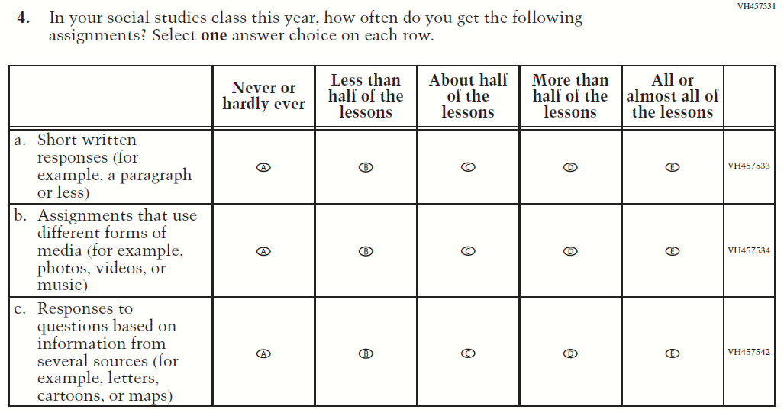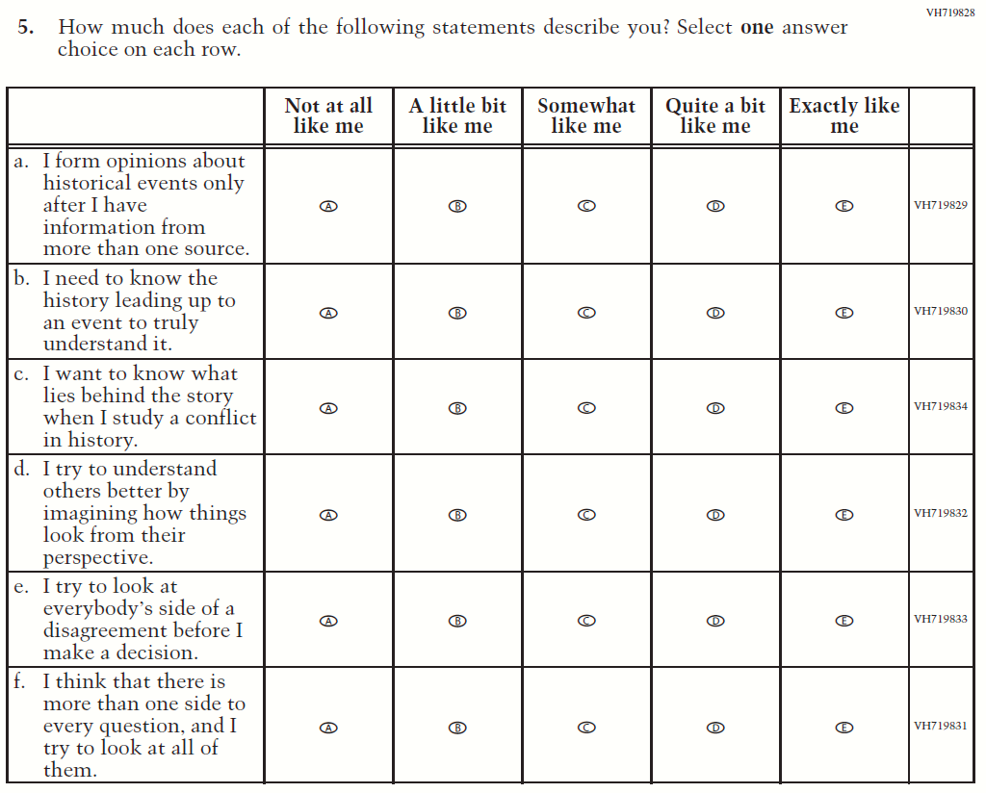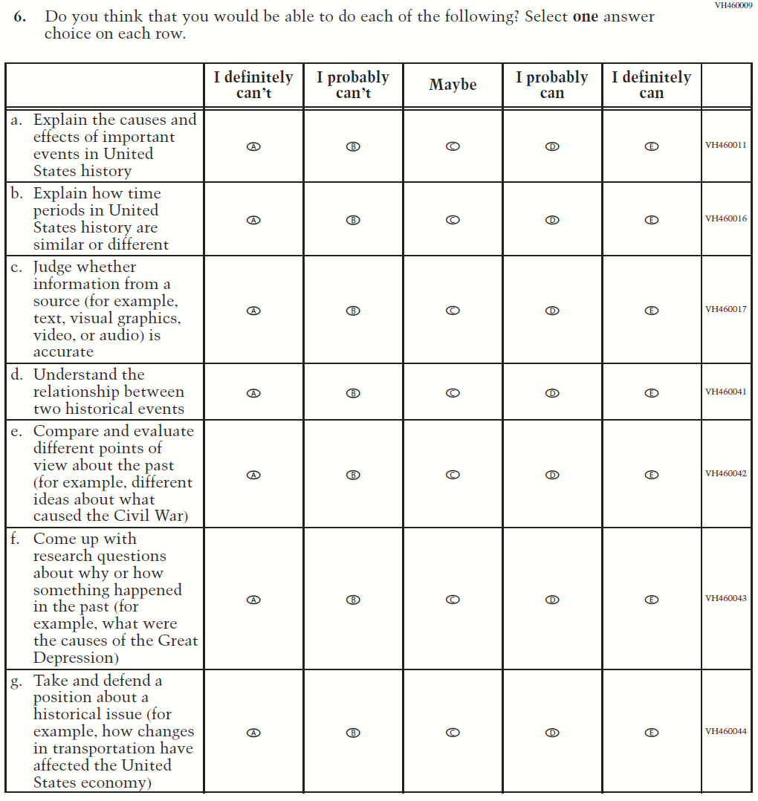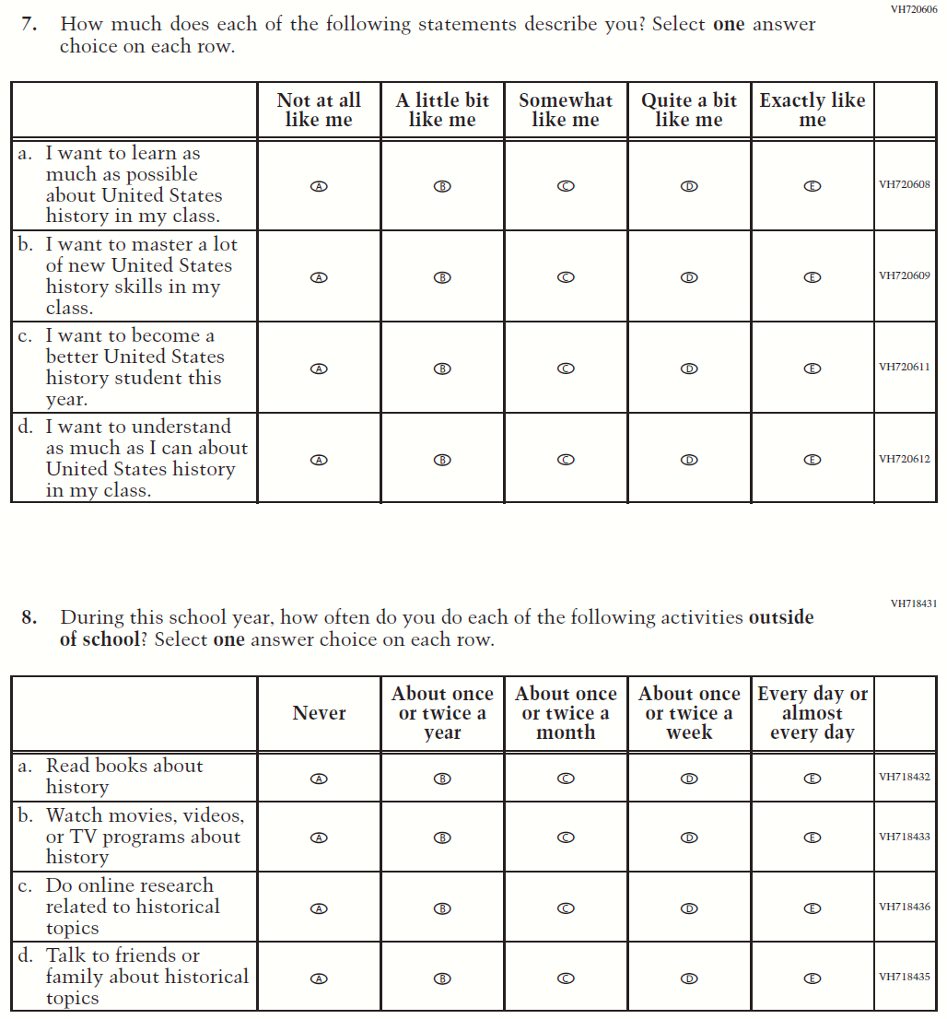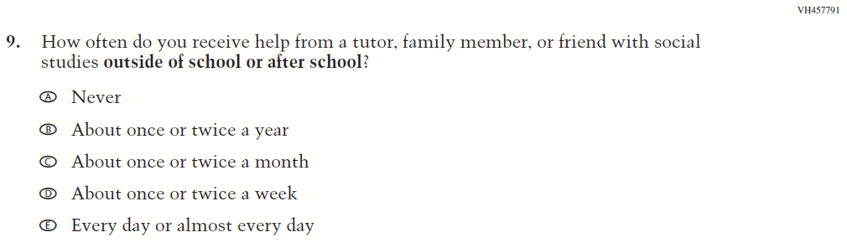

Appendix J1-17: Summary of Operational Grade 4 Debrief

2022 Operational Grade 4 Debrief Student

Previous item | 2022 item | D/A/ R/NC+ | Rationale
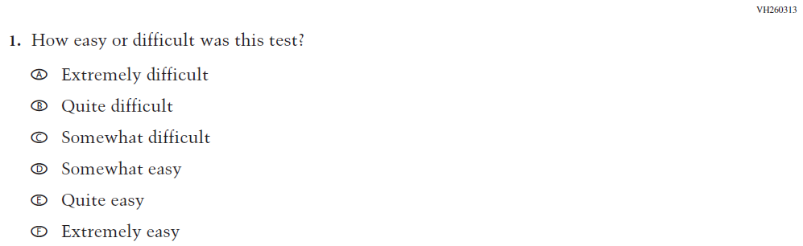  (2019 Grade 4, 8, and 12) | N/A | D | To keep student burden low, this item was dropped.
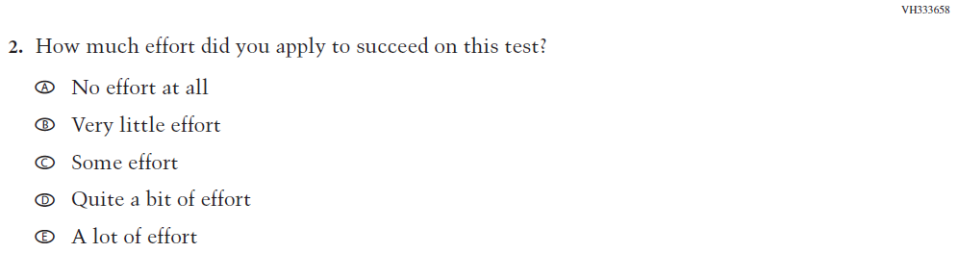  (2019 Grade 4, 8, and 12) | 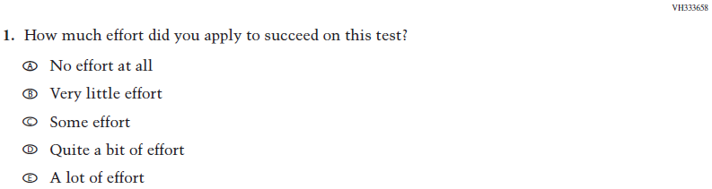  Issue: Debrief | NC | N/A

Appendix J1-18: Operational Grade 4 Debrief
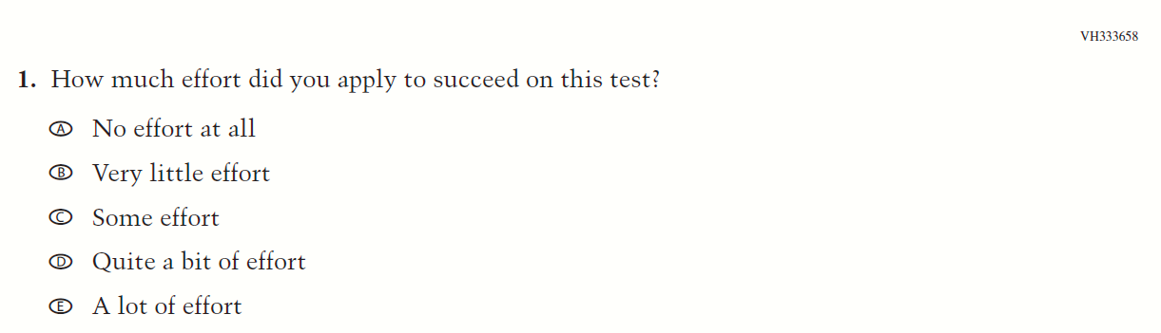

Appendix J1-19: Summary of Operational Grade 8 Debrief
2022 Operational Grade 8 Debrief Student

Previous item | 2022 item | D/A/ R/NC+ | Rationale
(2019 Grade 4, 8, and 12) | Issue: Debrief | NC | N/A
(2019 Grade 4, 8, and 12) | Issue: Debrief | NC | N/A

Appendix J1-20: Operational Grade 8 Debrief
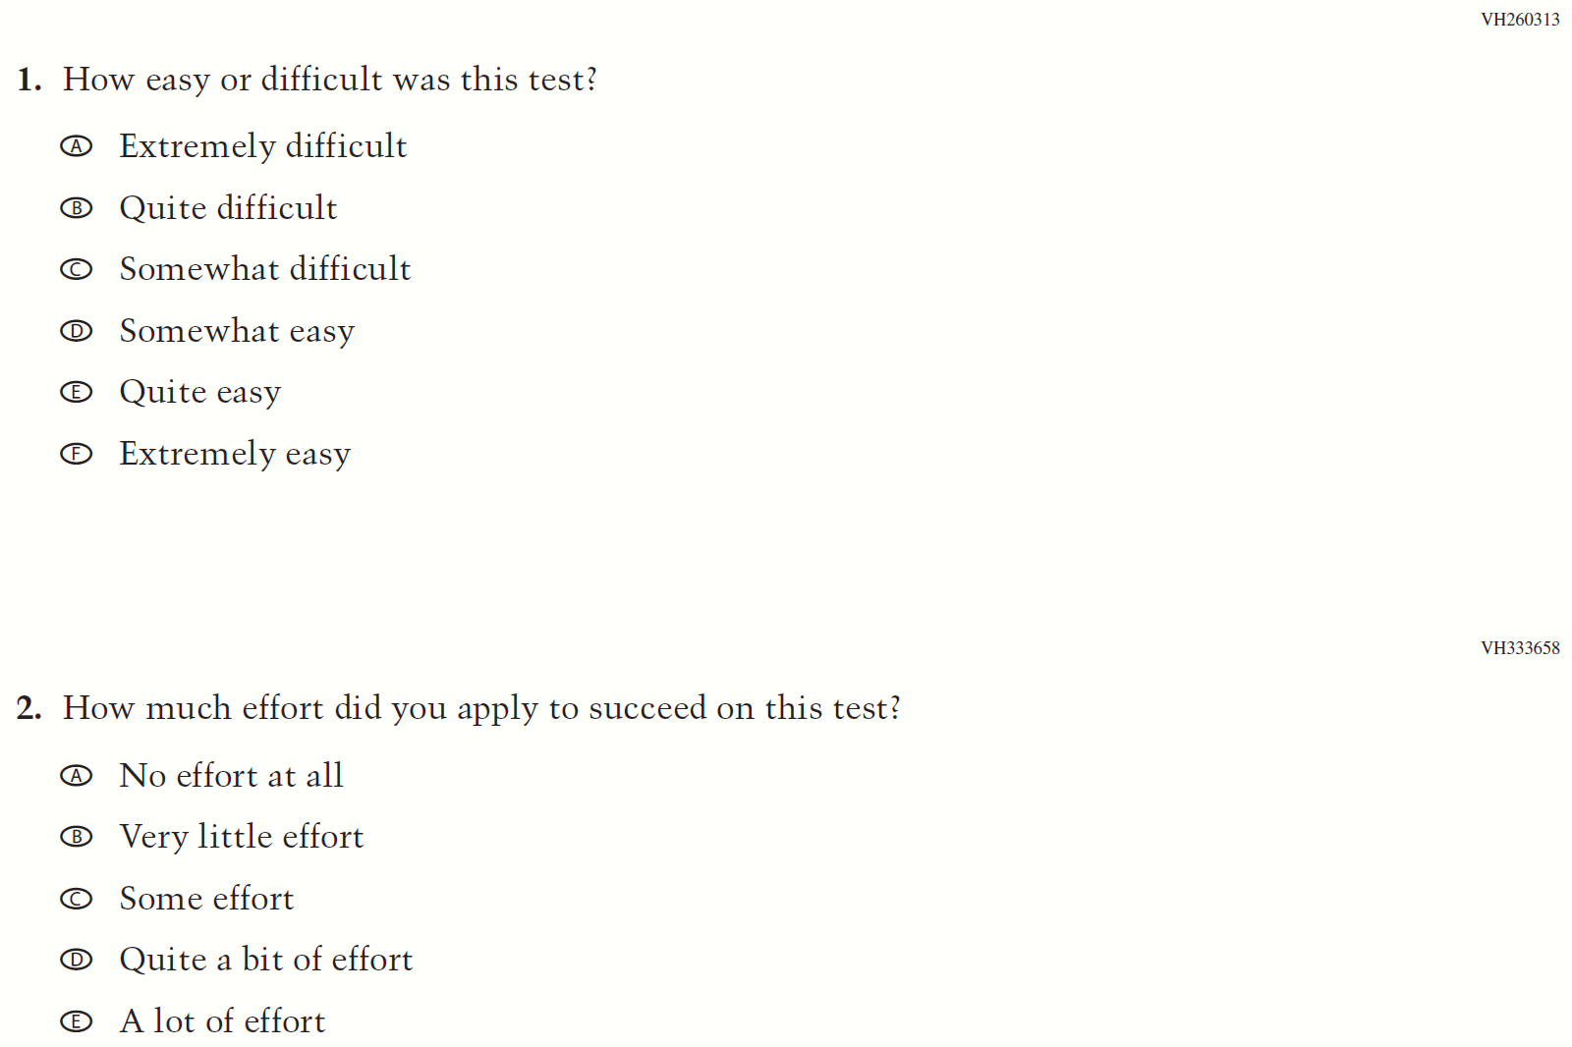

Appendix J1-21: Operational Grade 4 COVID-19 Student Items (ELA)
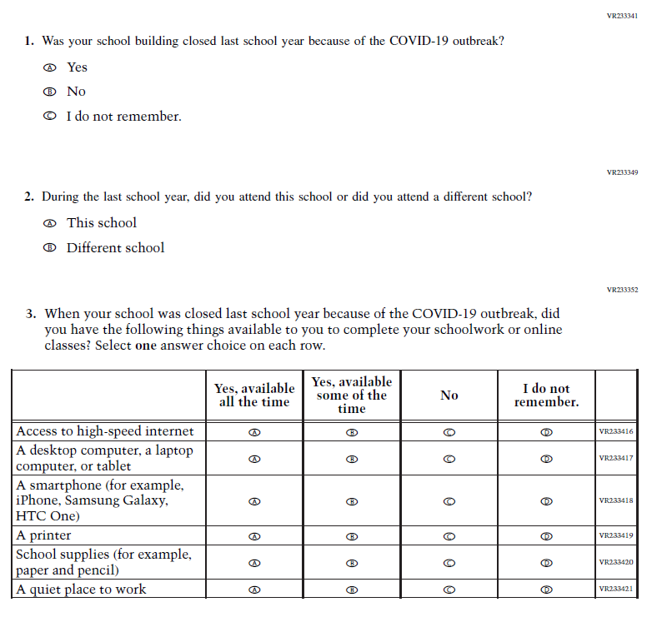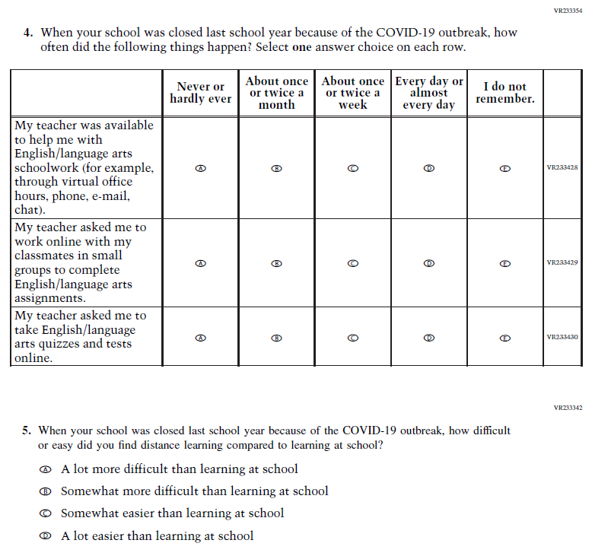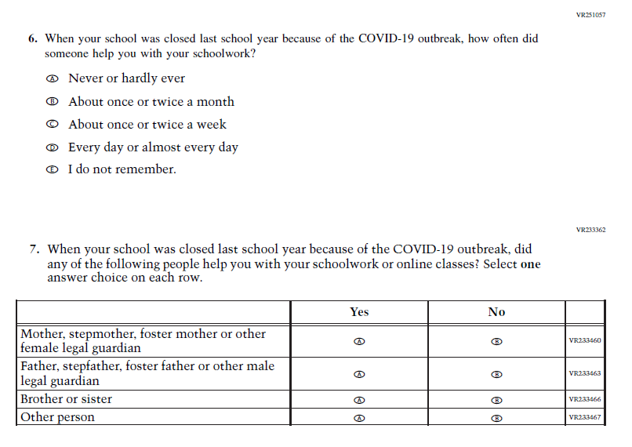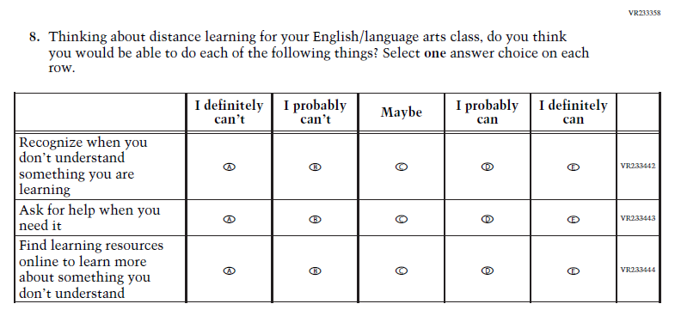

Appendix J1-22: Operational Grade 8 COVID-19 Student Items (ELA)
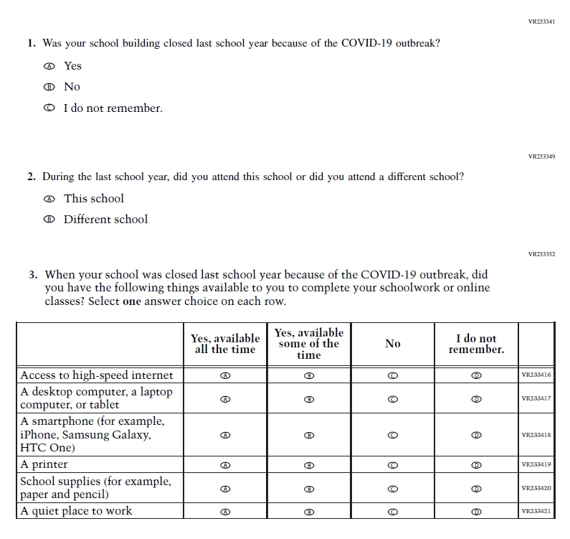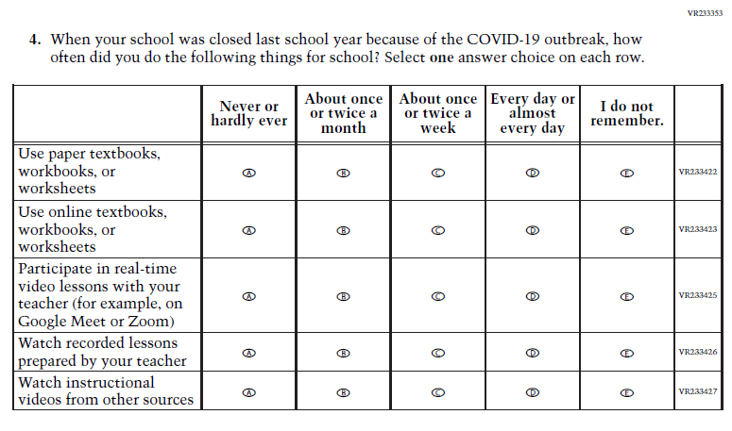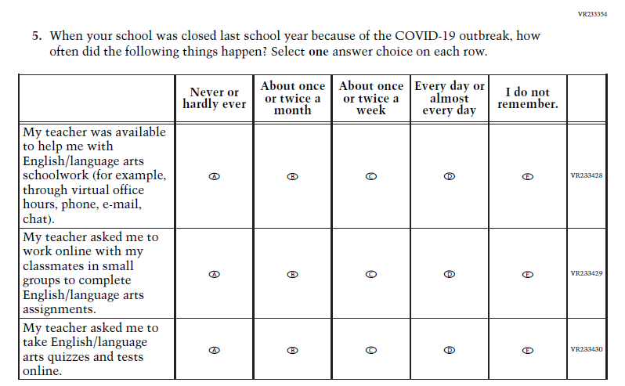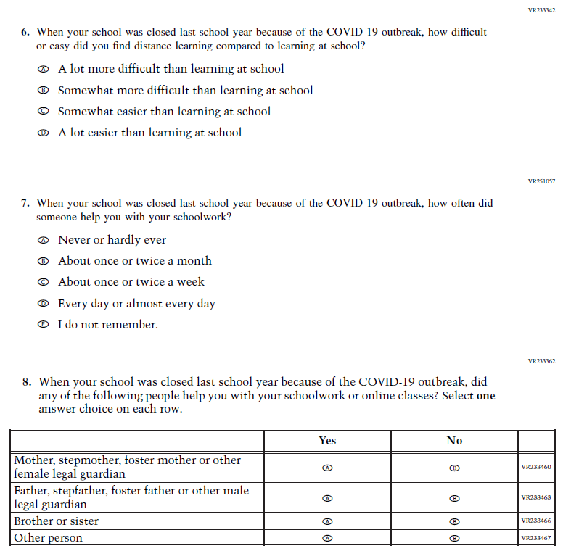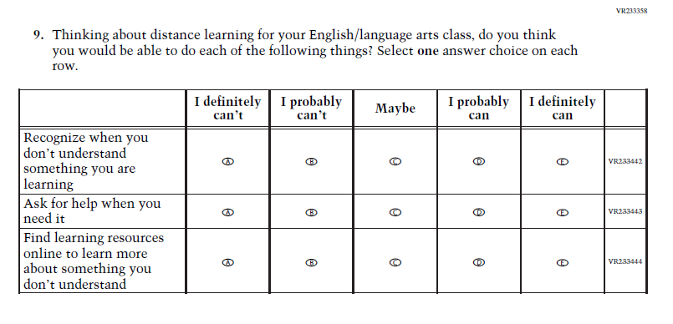

Appendix J1-23: Operational Grade 4 COVID-19 Student Items (Math)
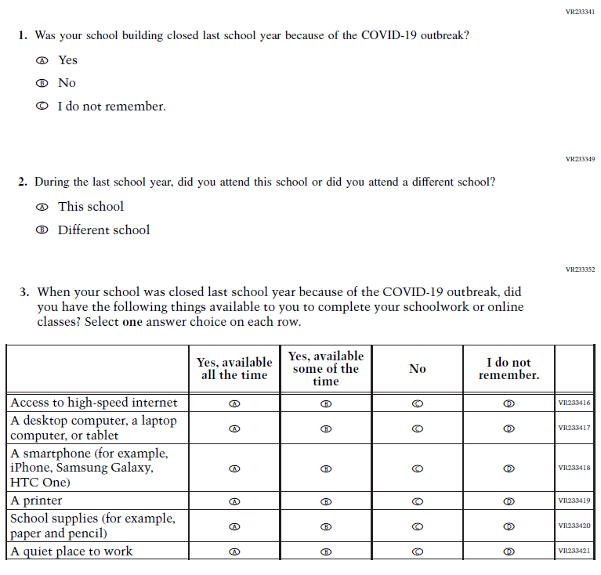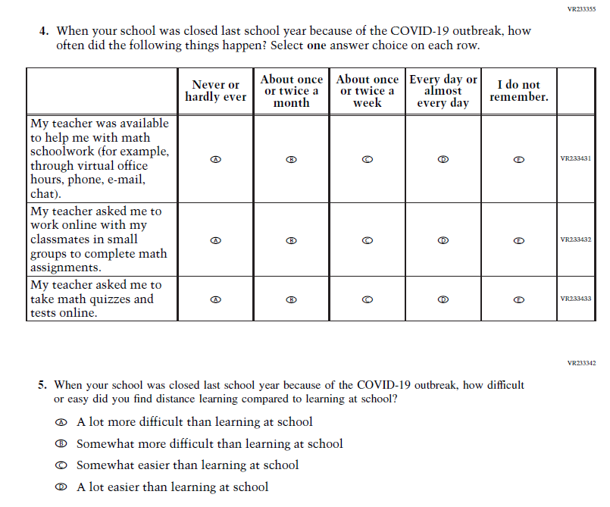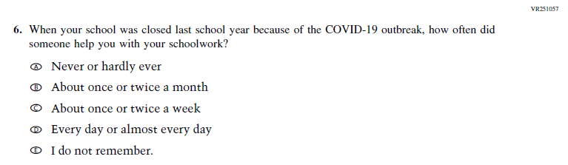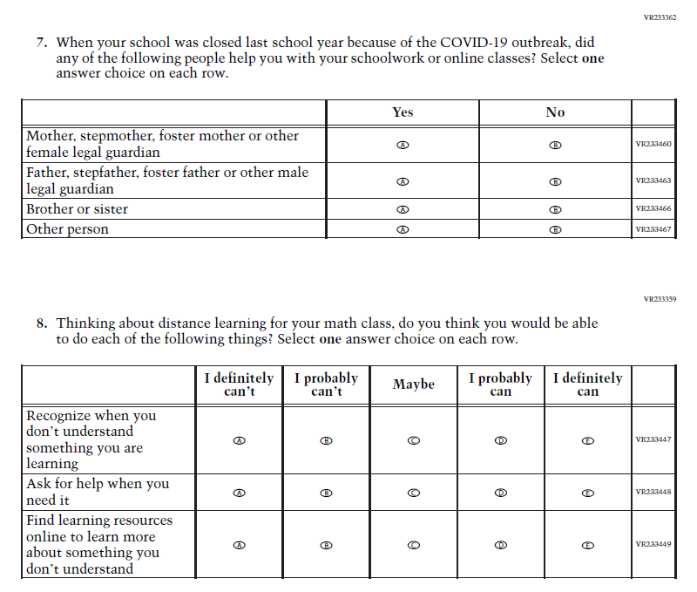

Appendix J1-24: Operational Grade 8 COVID-19 Student Items (Math)
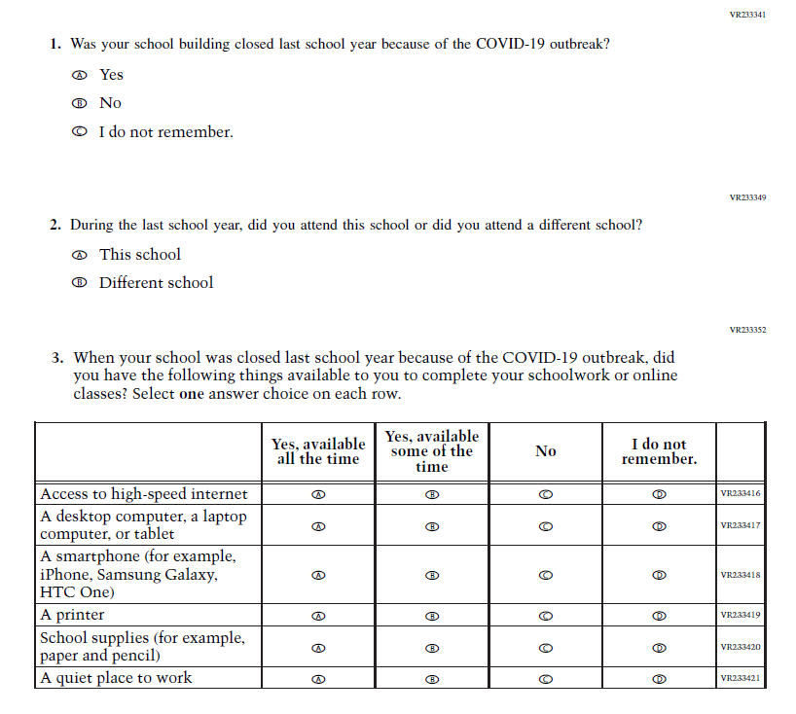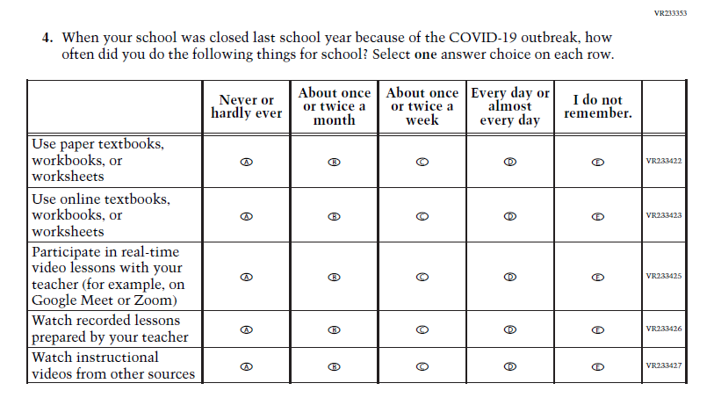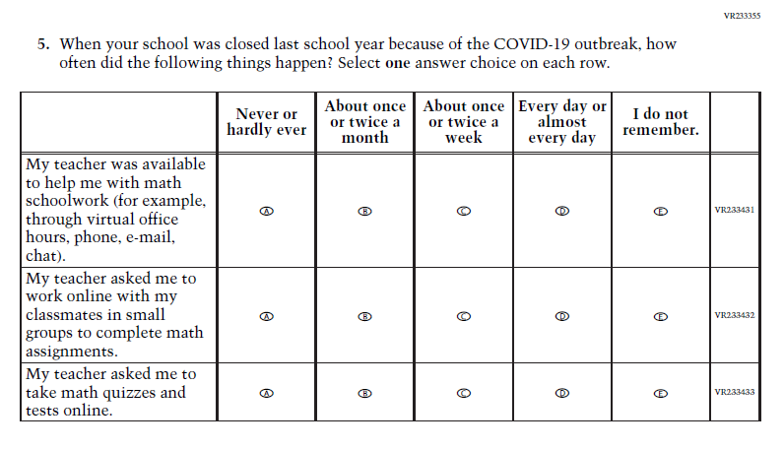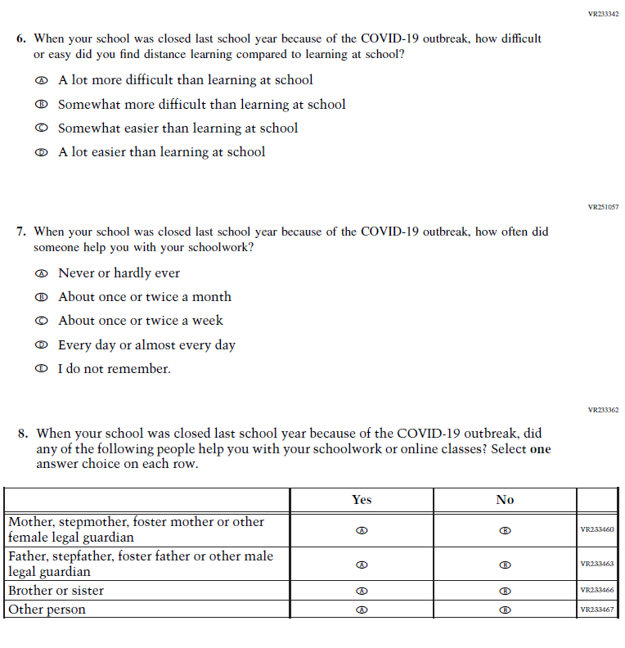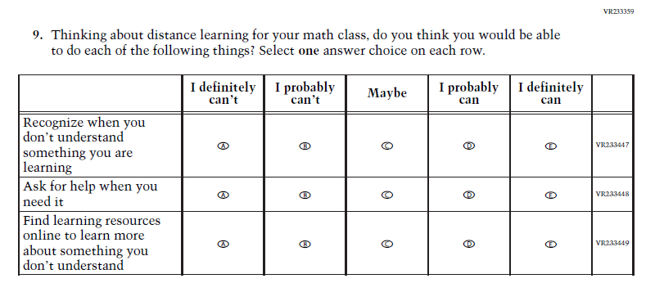

Appendix J1-25: Operational Grade 8 COVID-19 Student Items (Civics)
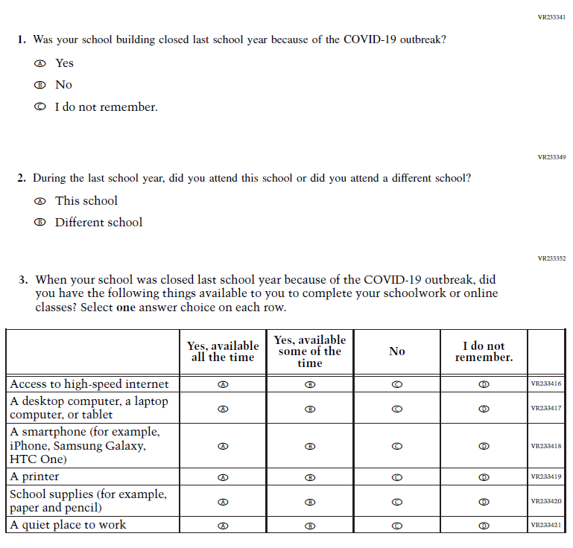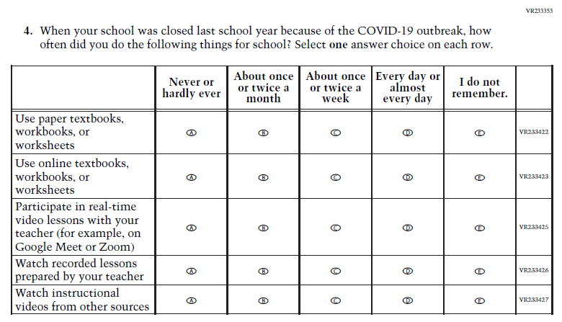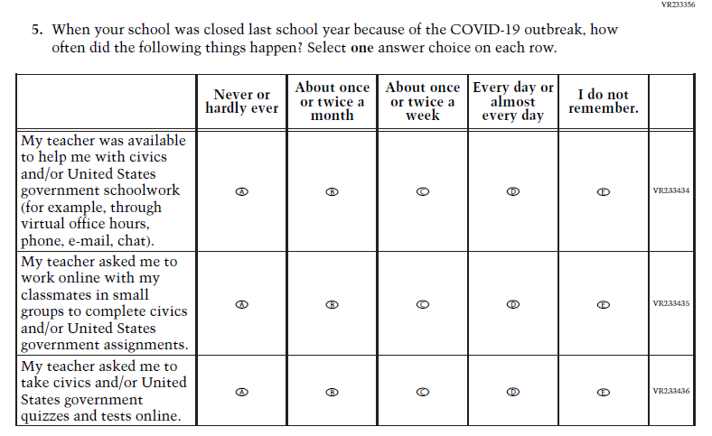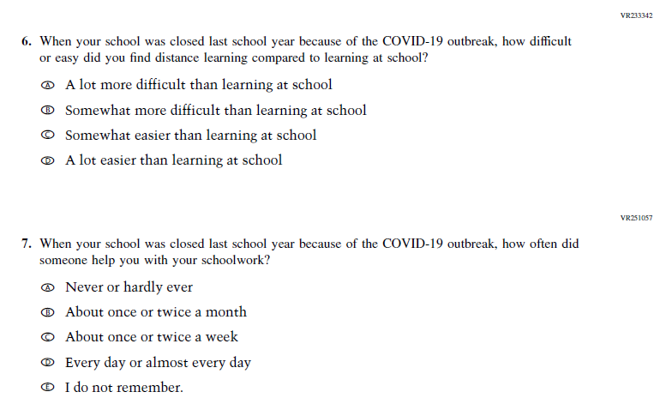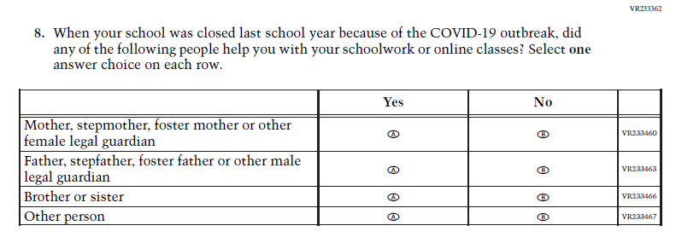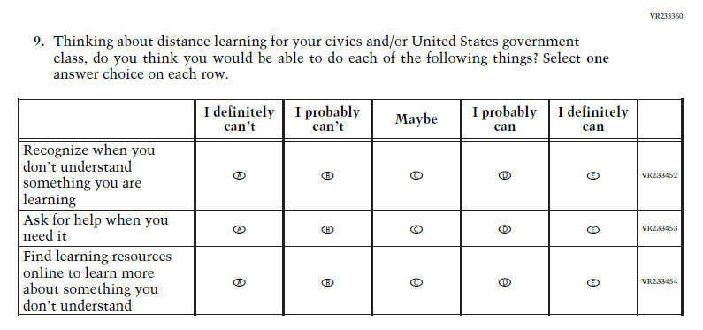

Appendix J1-26: Operational Grade 8 COVID-19 Student Items (U.S. History)
