NATIONAL CENTER FOR EDUCATION STATISTICS NATIONAL ASSESSMENT OF EDUCATIONAL PROGRESS

National Assessment of Educational Progress (NAEP)
2022 Materials Update #1

Appendix J3

2022 School Questionnaires

OMB# 1850-0928 v.23

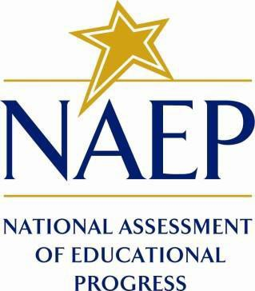

June 2021

Appendix J3 provides updated school survey questionnaires to be used in NAEP 2022. The change tables indicate any revisions that have been made to the previous versions of the SQs. If further revisions are required, they will be submitted in this Appendix in Amendment #2 by August 2021.
Table of Contents
School Questionnaires
NAEPq School Login 3
Appendix J3-1: Summary of Changes Operational Grade 4 CORE 4
Appendix J3-2: Operational Grade 4 CORE 13
Appendix J3-3: Summary of Changes Operational Grade 8 CORE 24
Appendix J3-4: Operational Grade 8 CORE 33
Appendix J3-4: Summary of Changes Operational Grade 4 and 8 Charter School 44
Appendix J3-6: Operational Grade 4 and 8 Charter School 46
Appendix J3-7: Summary of Changes Operational Grade 4 Mathematics 48
Appendix J3-8: Operational Grade 4 Mathematics 51
Appendix J3-9: Summary of Changes Operational Grade 8 Mathematics 54
Appendix J3-10: Operational Grade 8 Mathematics 57
Appendix J3-11: Summary of Changes Operational Grade 4 Reading 61
Appendix J3-12: Operational Grade 4 Reading 64
Appendix J3-13: Summary of Changes Operational Grade 8 Reading 68
Appendix J3-14: Operational Grade 8 Reading 72
Appendix J3-15: Summary of Operational Grade 8 Social Studies School Items 76
Appendix J3-16: Operational Grade 8 Social Studies School Items 79
Appendix J3-17: Summary of Operational Grade 4 COVID-19 School Items 82
Appendix J3-18: Operational Grade 4 COVID-19 School Items 88
Appendix J3-19: Summary of Operational Grade 8 COVID-19 School Items 96
Appendix J3-20: Operational Grade 8 COVID-19 School Items 102

NAEPq School Login

The school login screens will have the updated OMB expiration dates added in Amendment #2 in August 2021.

School Administrator Questionnaire Login Screen
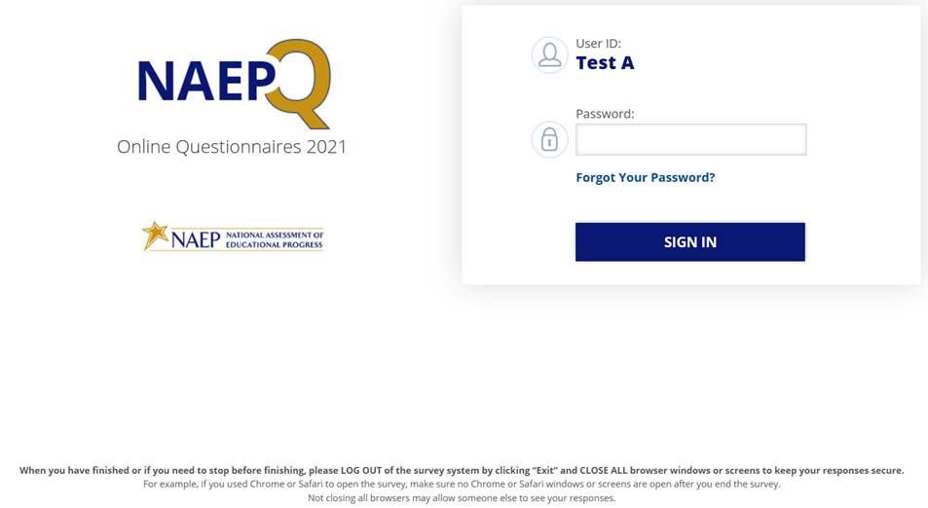
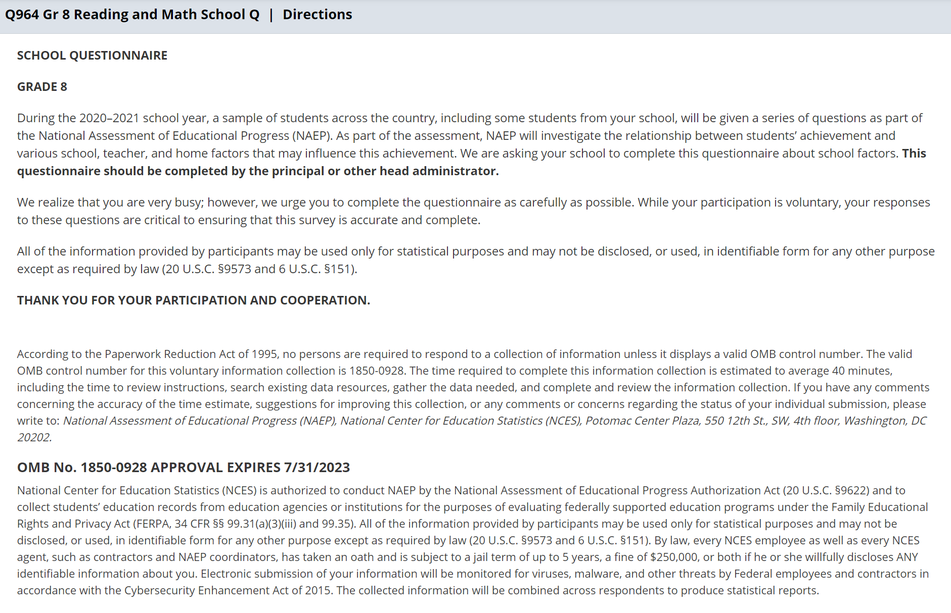

Appendix J3-1: Summary of Changes Operational Grade 4 CORE
2022 Operational Grade 4 Core School

Previous item | 2022 item | D/A/ R/NC+ | Rationale
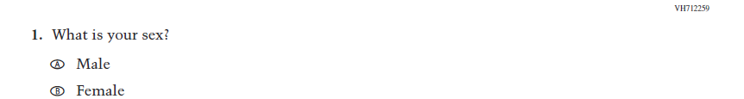  (2021 Grade 4) | 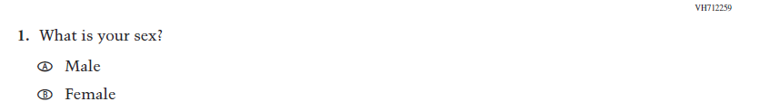  Issue: Gender | NC | N/A
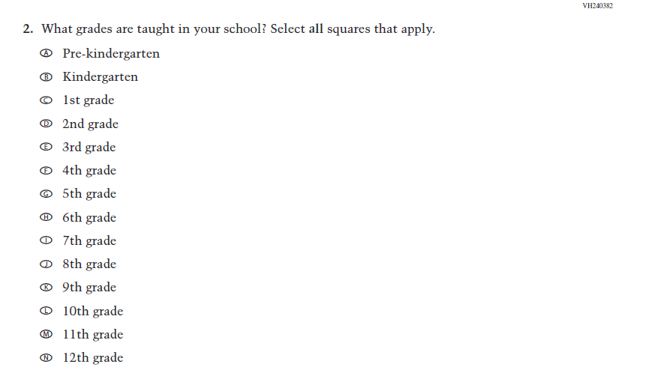  (2021 Grade 4) | 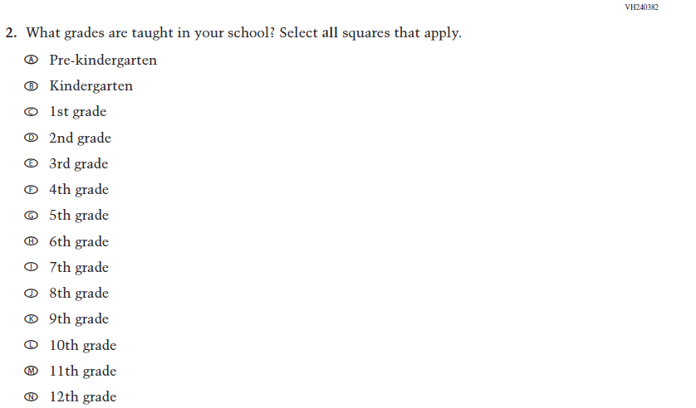  Issue: School Climate | NC | N/A
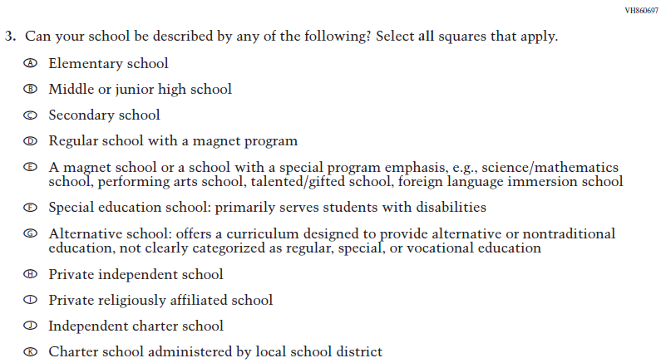  (2021 Grade 4) | Issue: School Climate | NC | N/A
2022 Operational Grade 4 Core School

Previous item | 2022 item | D/A/ R/NC+ | Rationale
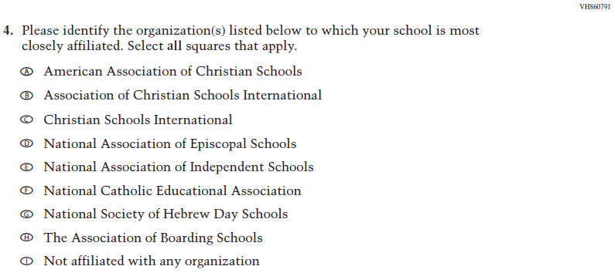  (2021 Grade 4) | Issue: School Climate | NC | N/A
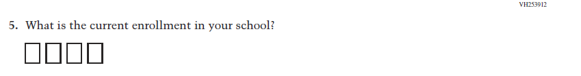  (2021 Grade 4) | 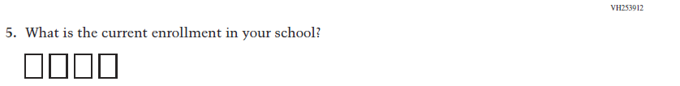  Issue: School Climate | NC | N/A
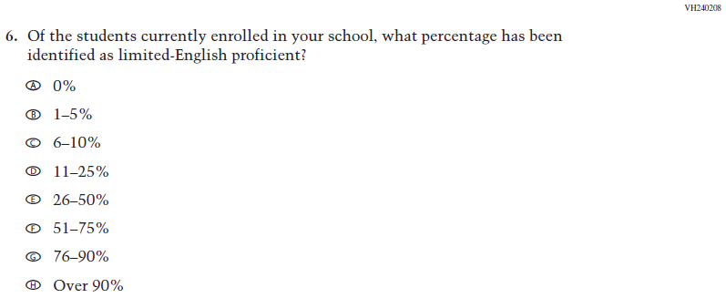  (2021 Grade 4) | Issue: School Climate | NC | N/A
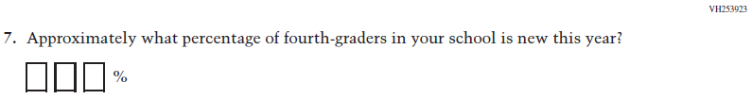  (2021 Grade 4) | Issue: School Climate | NC | N/A

2022 Operational Grade 4 Core School

Previous item | 2022 item | D/A/ R/NC+ | Rationale
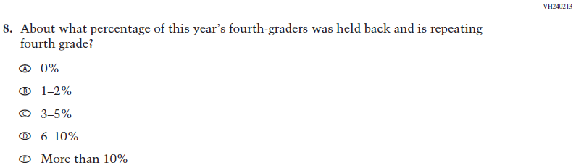  (2021 Grade 4) | Issue: School Climate | NC | N/A
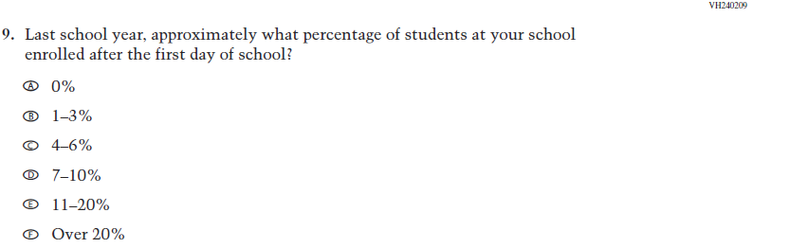  (2021 Grade 4) | Issue: School Climate | NC | N/A
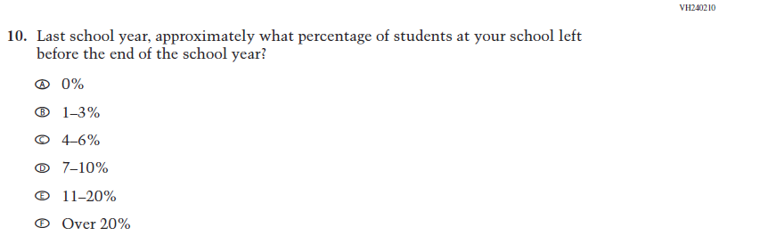  (2021 Grade 4) | Issue: School Climate | NC | N/A
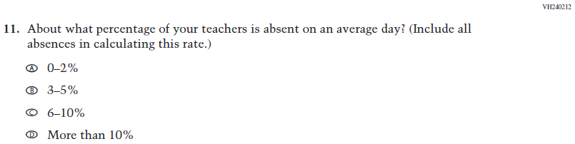  (2021 Grade 4) | Issue: School Climate | NC | N/A

2022 Operational Grade 4 Core School

Previous item | 2022 item | D/A/ R/NC+ | Rationale
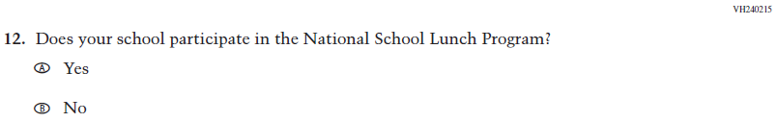  (2021 Grade 4) | Issue: Socioeconomic Status | NC | N/A
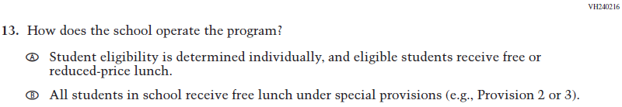  (2021 Grade 4) | Issue: Socioeconomic Status | NC | N/A
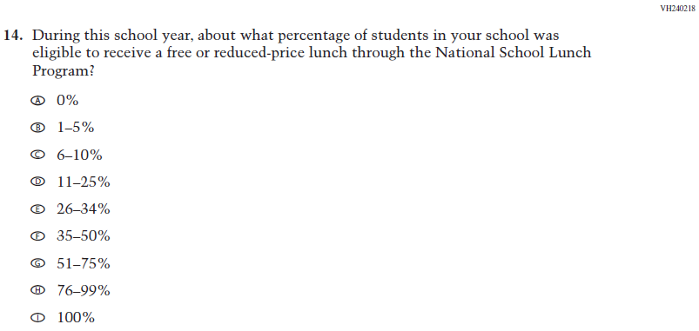  (2021 Grade 4) | Issue: Socioeconomic Status | NC | N/A
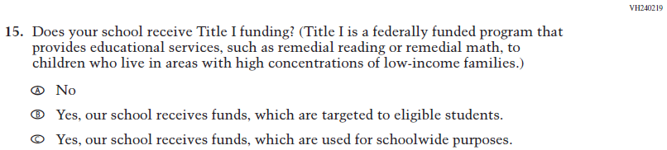  (2021 Grade 4) | Issue: Socioeconomic Status | NC | N/A
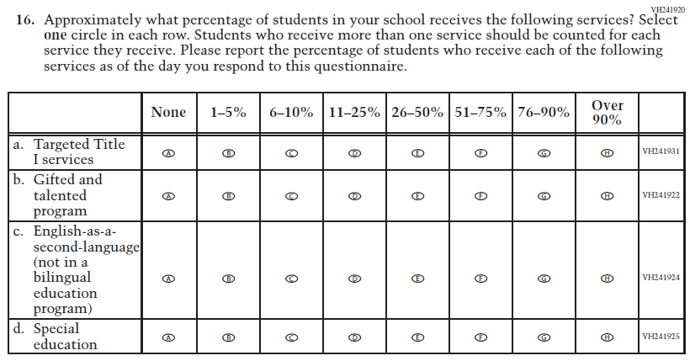  (2021 Grade 4) | Issue: School Climate | NC | N/A
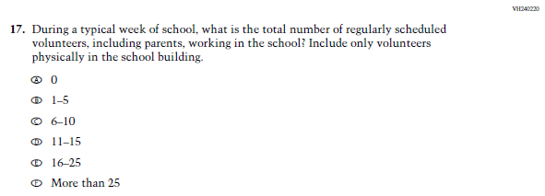  (2021 Grade 4) | Issue: School Climate | NC | N/A
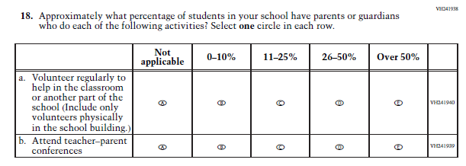  (2021 Grade 4) | Issue: School Climate | NC | N/A
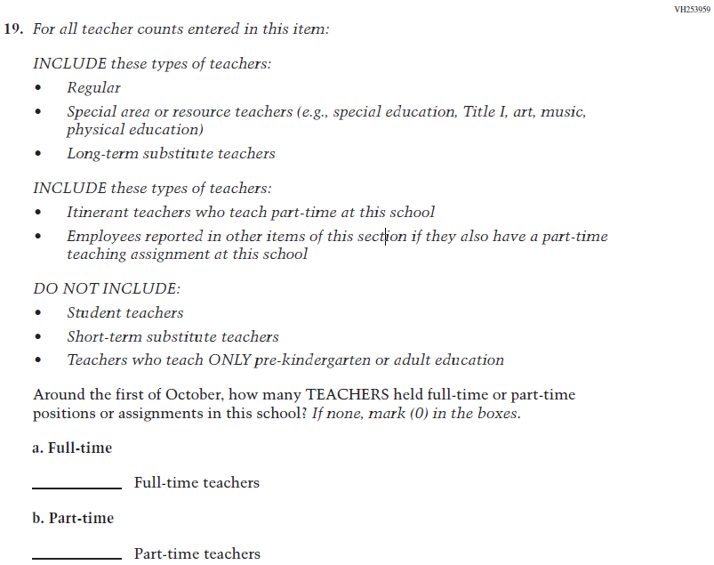  (2021 Grade 4) | Issue: School Climate | NC | N/A
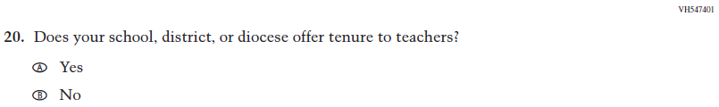  (2021 Grade 4) | Issue: School Climate | NC | N/A

2022 Operational Grade 4 Core School

Previous item | 2022 item | D/A/ R/NC+ | Rationale
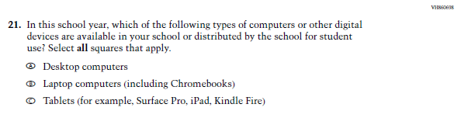  (2021 Grade 4) | Issue: Technology Use | NC | N/A
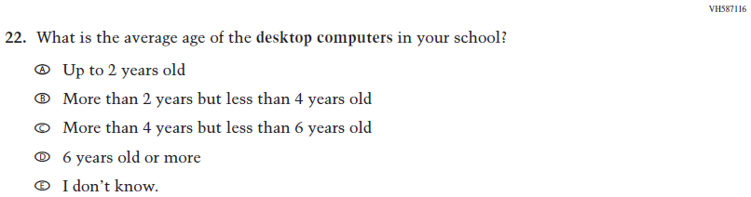  (2021 Grade 4) | Issue: Technology Use | NC | N/A
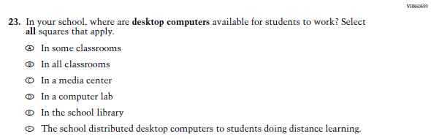  (2021 Grade 4) | Issue: Technology Use | NC | N/A
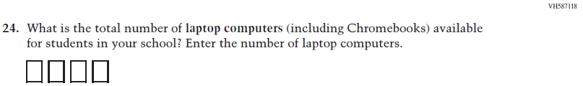  (2021 Grade 4) | Issue: Technology Use | NC | N/A
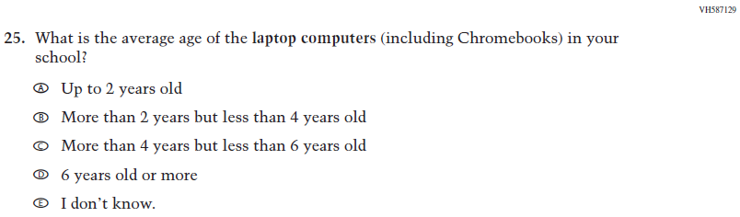  (2021 Grade 4) | Issue: Technology Use | NC | N/A
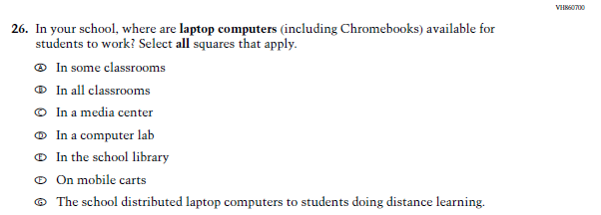  (2021 Grade 4) | Issue: Technology Use | NC | N/A
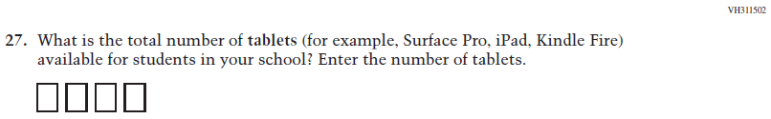  (2021 Grade 4) | Issue: Technology Use | NC | N/A
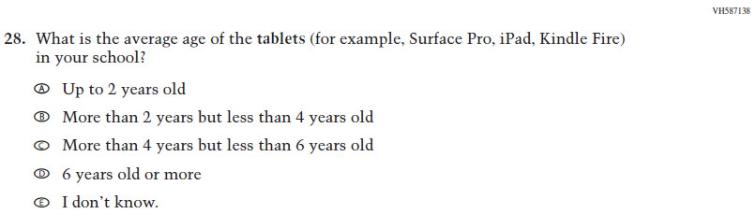  (2021 Grade 4) | Issue: Technology Use | NC | N/A
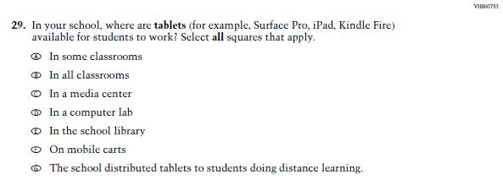  (2021 Grade 4) | Issue: Technology Use | NC | N/A
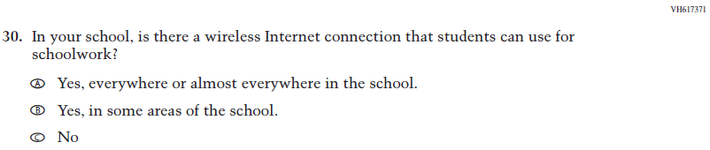  (2021 Grade 4) | Issue: Technology Use | NC | N/A

Appendix J3-2: Operational Grade 4 CORE
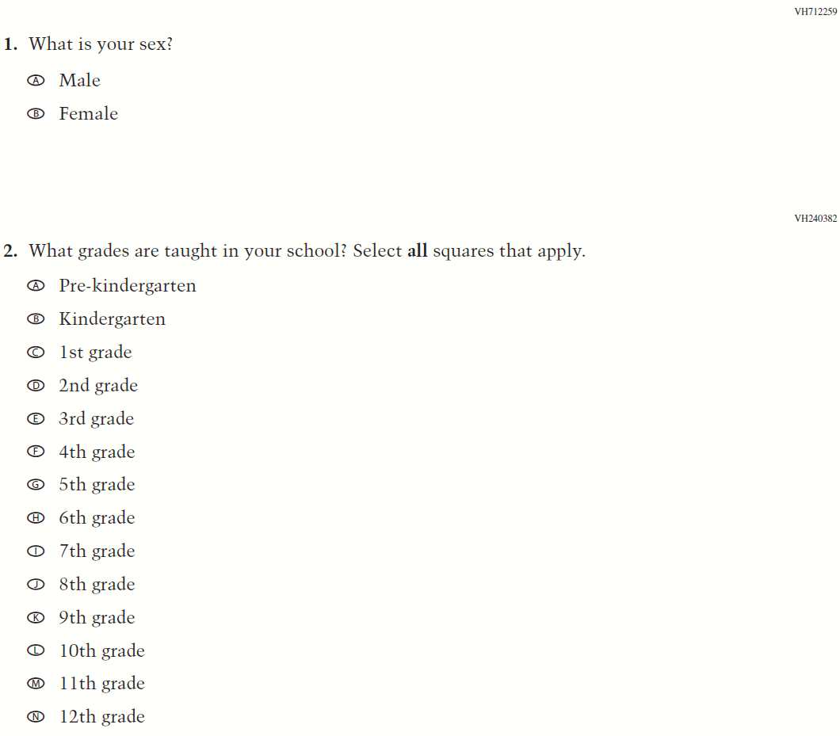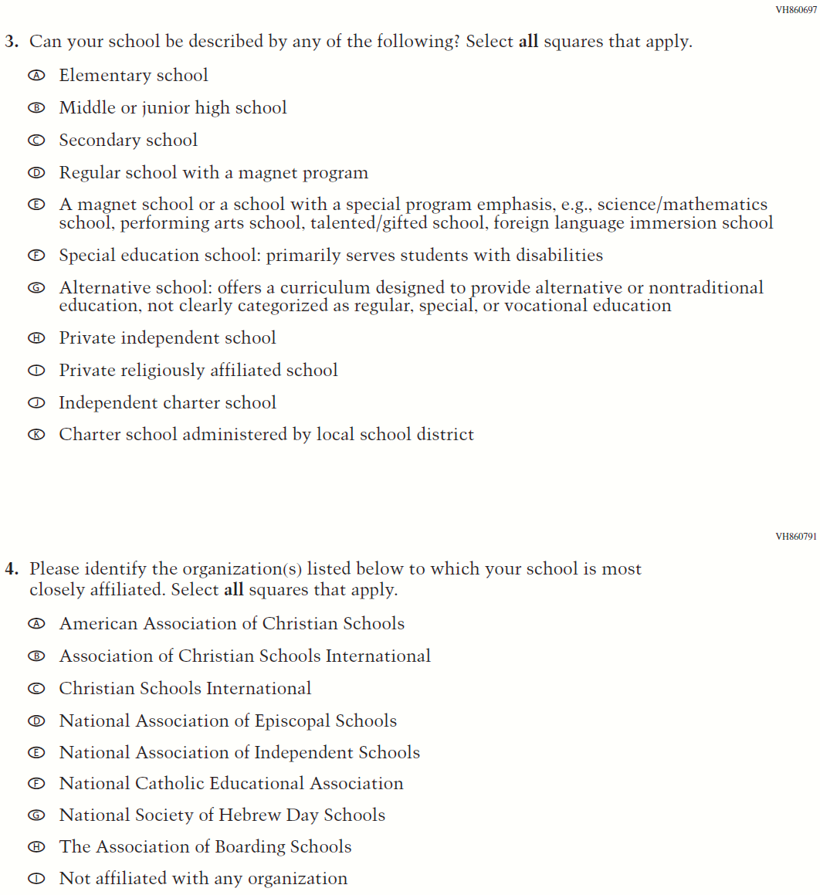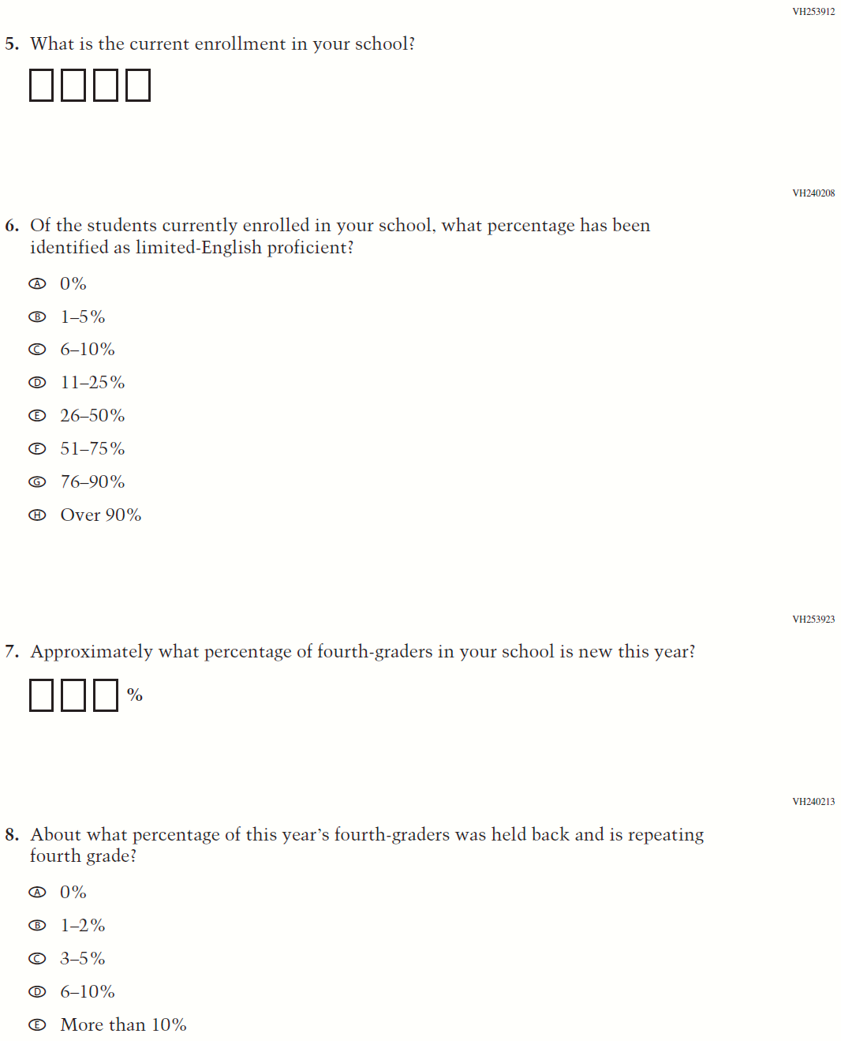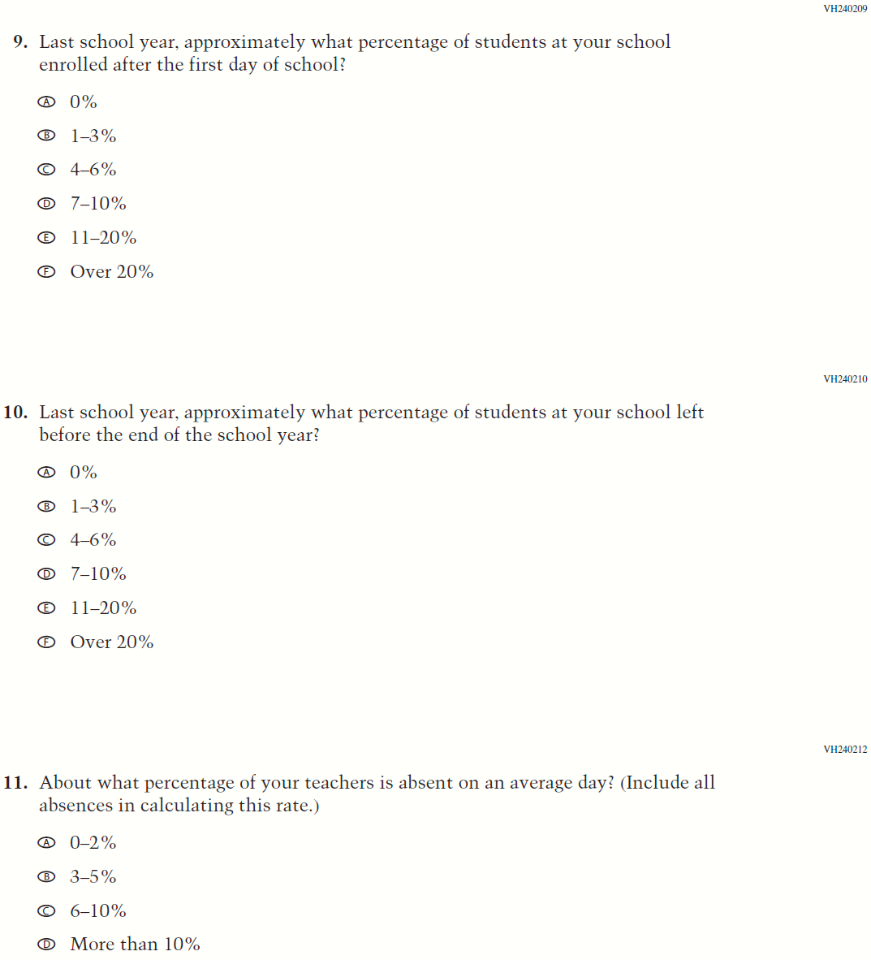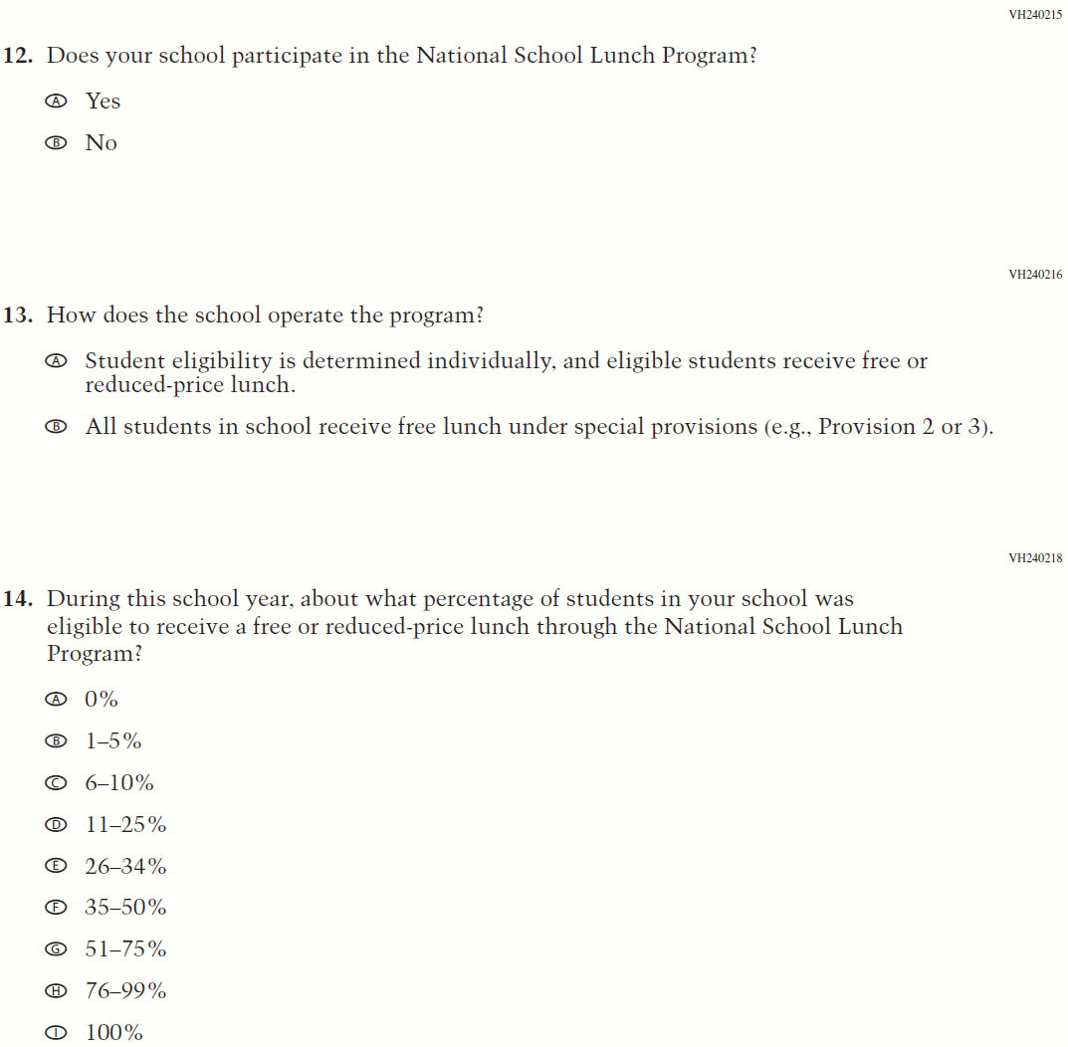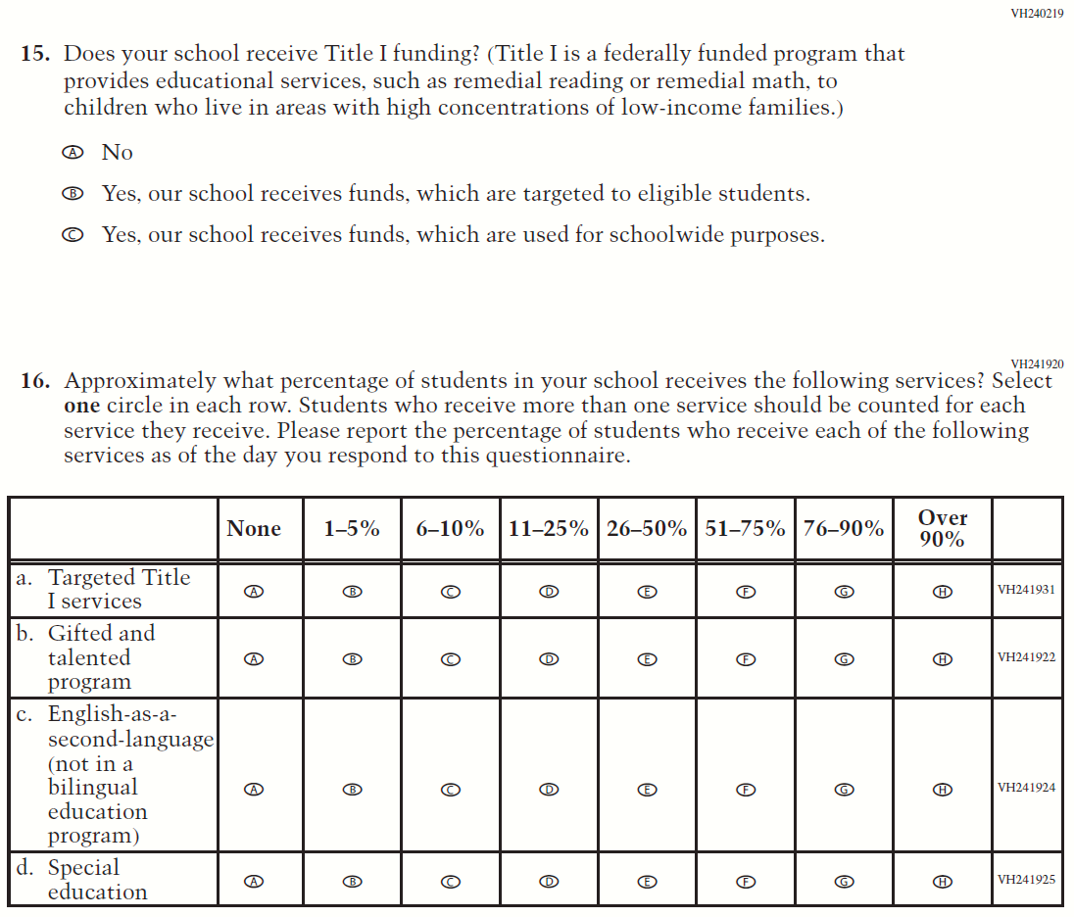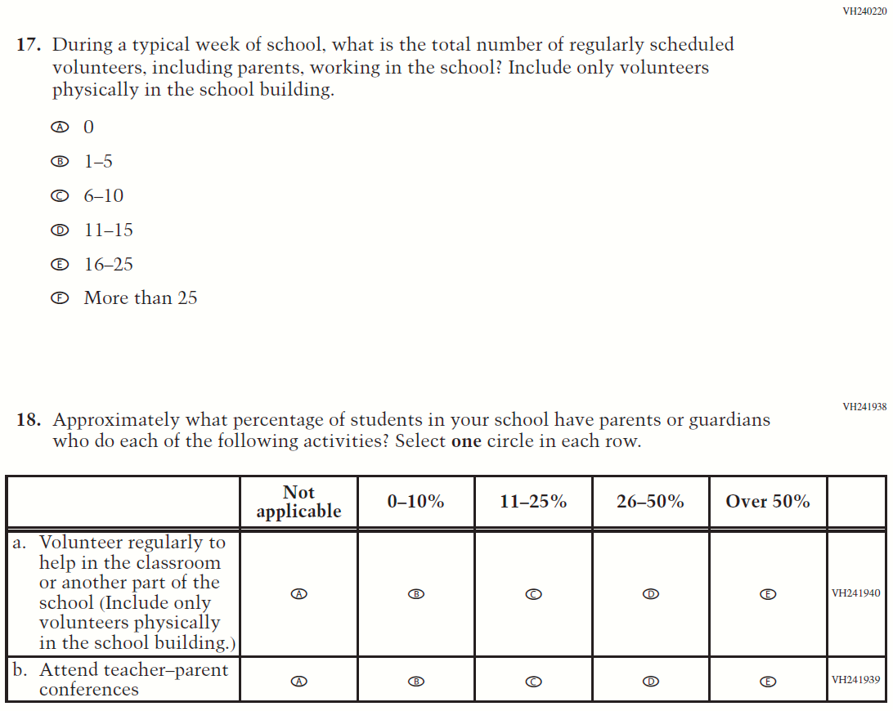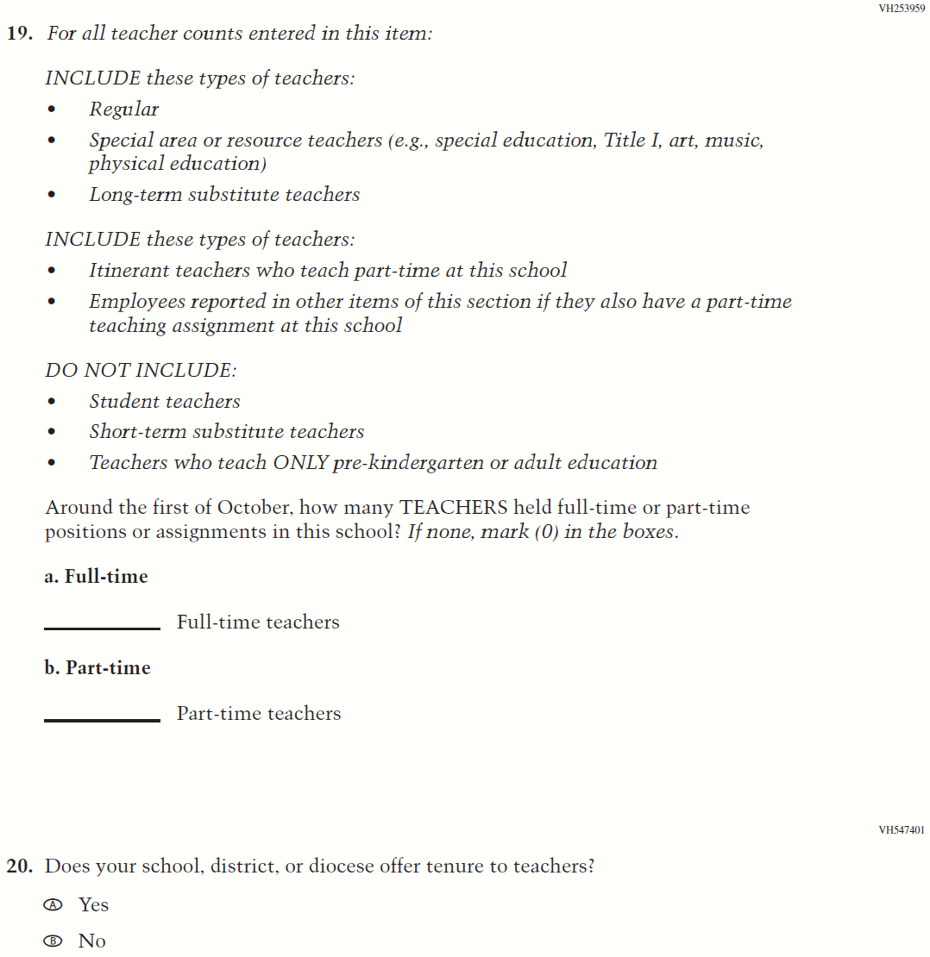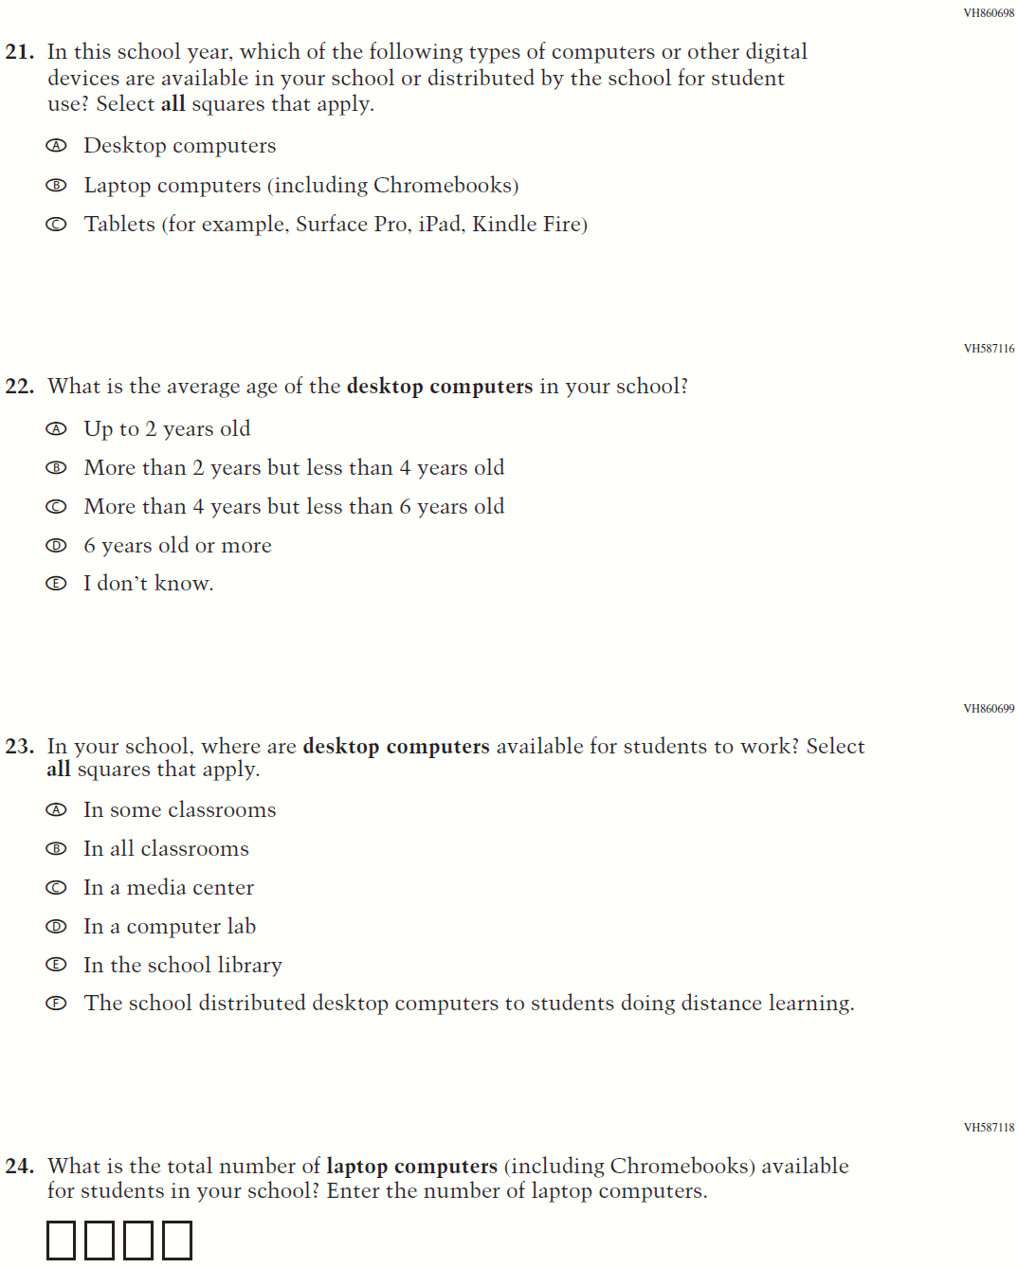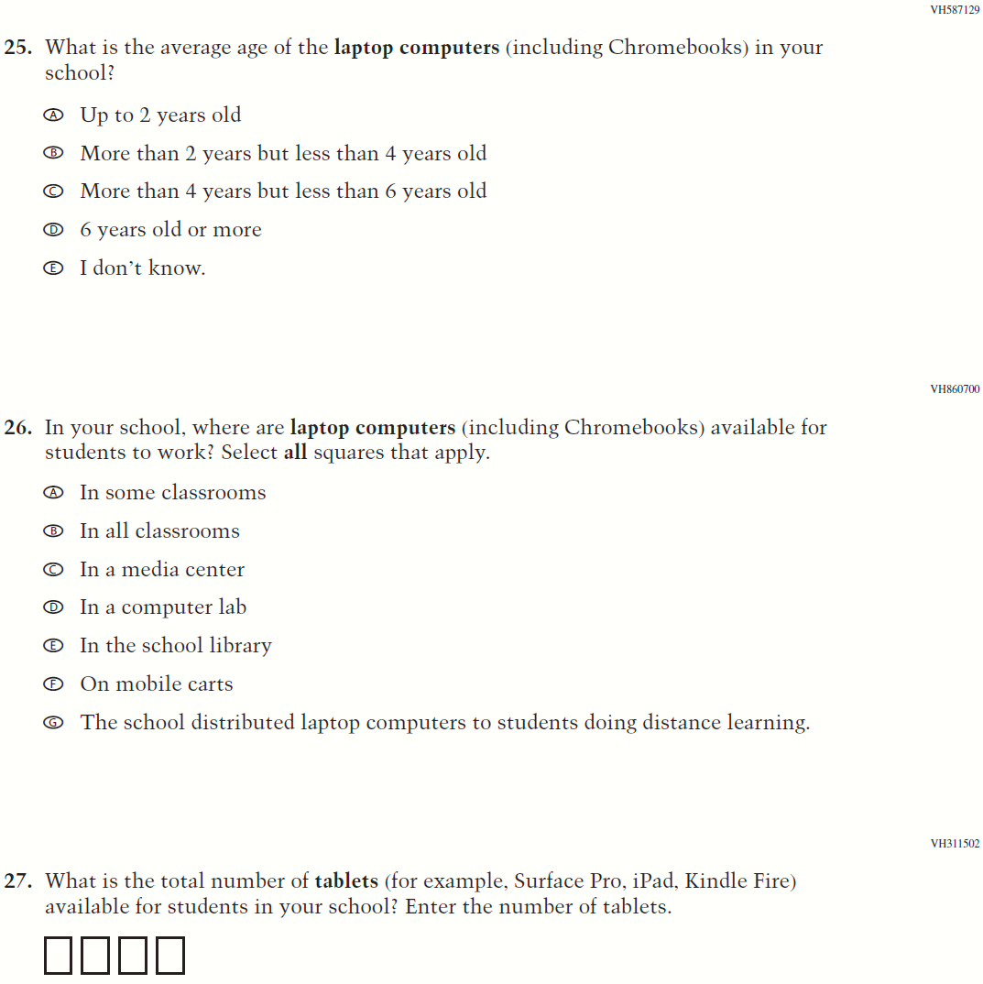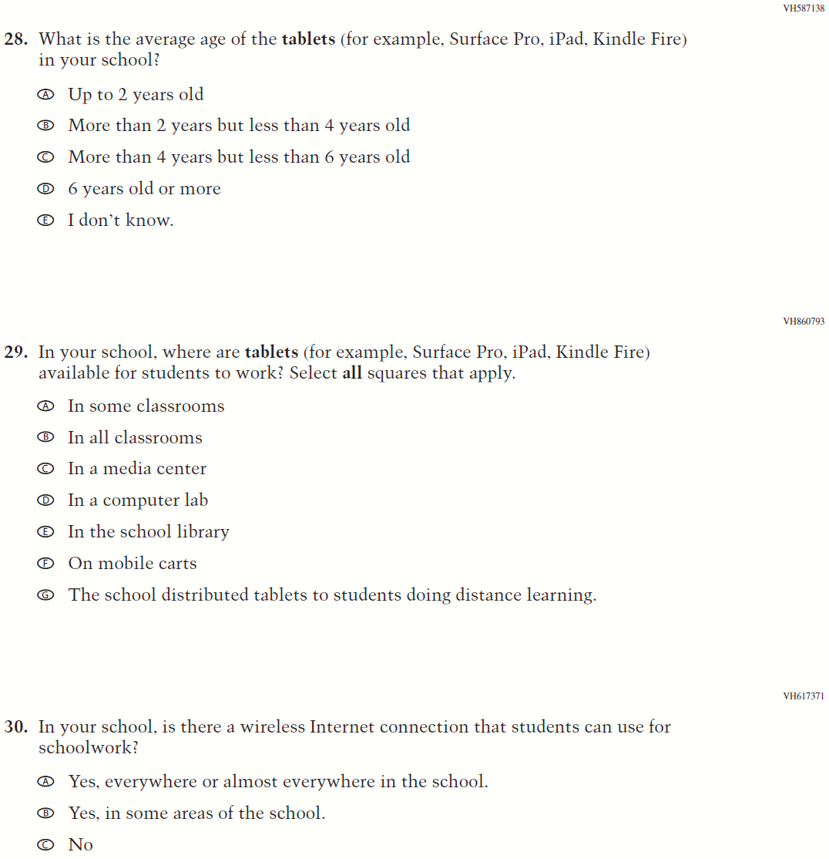

Appendix J3-3: Summary of Changes Operational Grade 8 CORE
2022 Operational Grade 8 Core School

Previous item | 2022 item | D/A/ R/NC+ | Rationale
(2021 Grade 8) | Issue: Gender | NC | N/A
(2021 Grade 8) | Issue: School Climate | NC | N/A
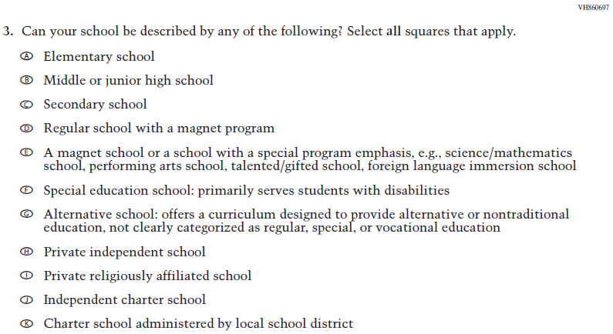  (2021 Grade 8) | Issue: School Climate | NC | N/A
2022 Operational Grade 8 Core School

Previous item | 2022 item | D/A/ R/NC+ | Rationale
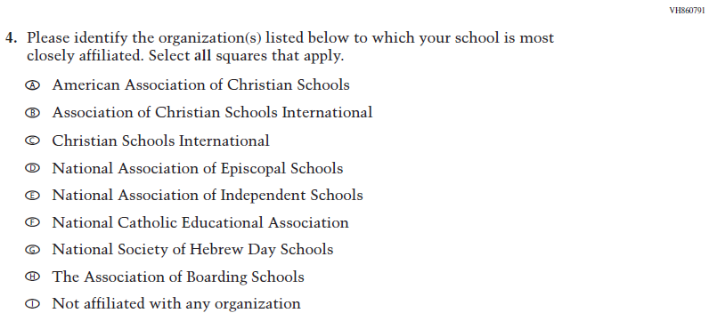  (2021 Grade 8) | Issue: School Climate | NC | N/A
(2021 Grade 8) | Issue: School Climate | NC | N/A
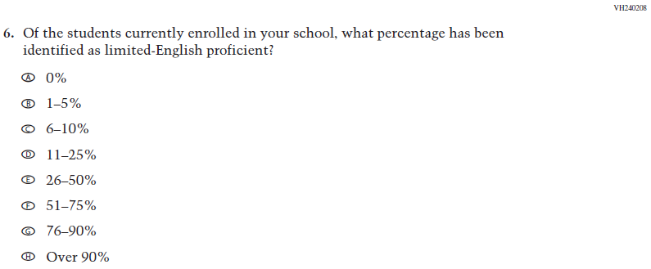  (2021 Grade 8) | Issue: School Climate | NC | N/A
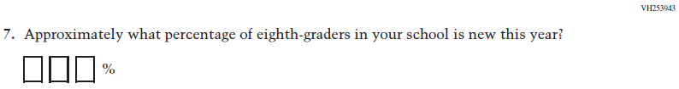  (2021 Grade 8) | Issue: School Climate | NC | N/A

2022 Operational Grade 8 Core School

Previous item | 2022 item | D/A/ R/NC+ | Rationale
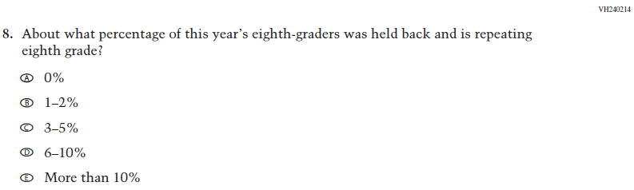  (2021 Grade 8) | Issue: School Climate | NC | N/A
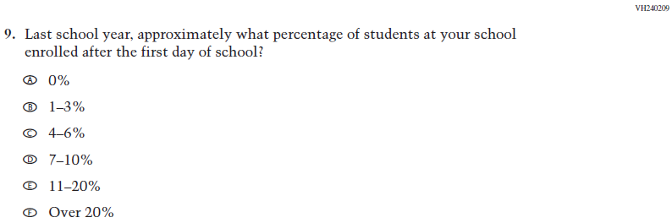  (2021 Grade 8) | Issue: School Climate | NC | N/A
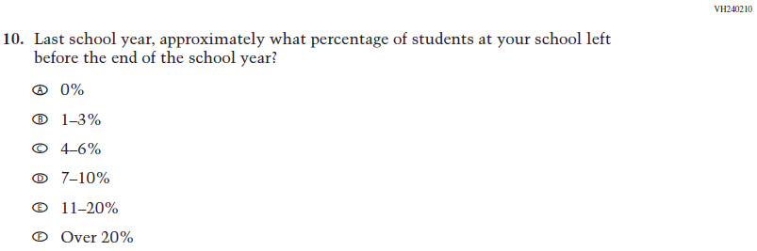  (2021 Grade 8) | Issue: School Climate | NC | N/A

2022 Operational Grade 8 Core School

Previous item | 2022 item | D/A/ R/NC+ | Rationale
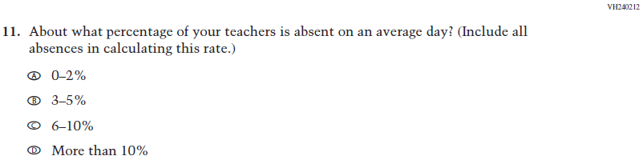  (2021 Grade 8) | Issue: School Climate | NC | N/A
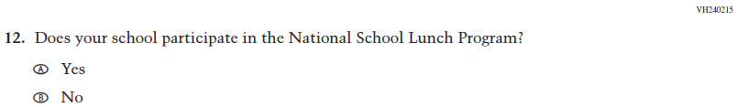  (2021 Grade 8) | Issue: Socioeconomic Status | NC | N/A
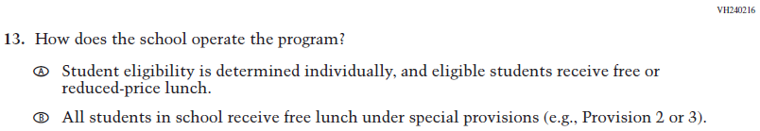  (2021 Grade 8) | Issue: Socioeconomic Status | NC | N/A
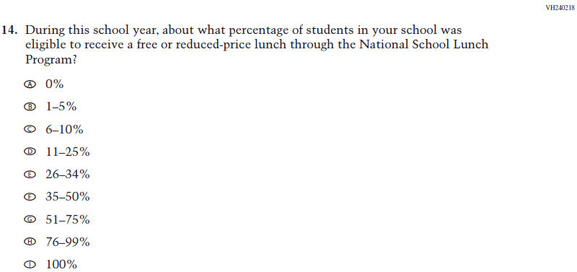  (2021 Grade 8) | Issue: Socioeconomic Status | NC | N/A
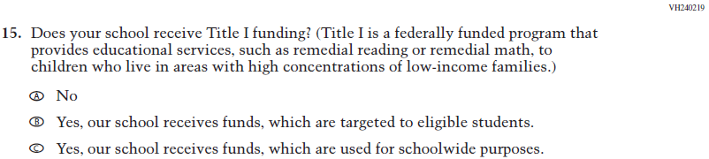  (2021 Grade 8) | Issue: Socioeconomic Status | NC | N/A
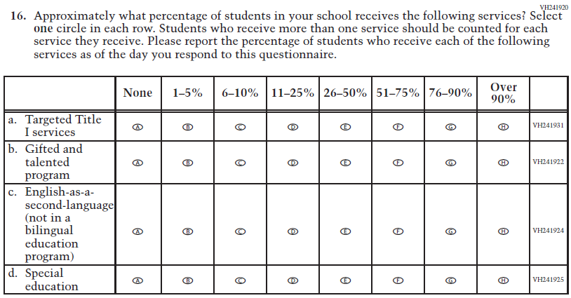  (2021 Grade 8) | Issue: School Climate | NC | N/A
(2021 Grade 8) | Issue: School Climate | NC | N/A
(2021 Grade 8) | Issue: School Climate | NC | N/A
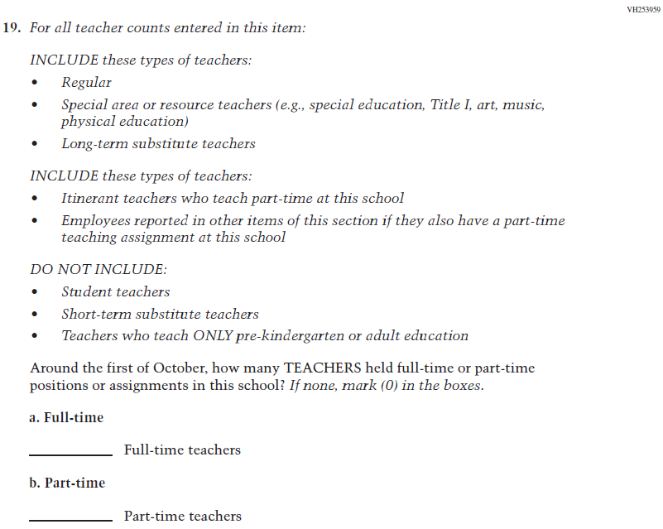  (2021 Grade 8) | Issue: School Climate | NC | N/A
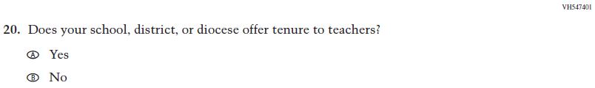  (2021 Grade 8) | Issue: School Climate | NC | N/A

2022 Operational Grade 8 Core School

Previous item | 2022 item | D/A/ R/NC+ | Rationale
(2021 Grade 8) | Issue: Technology Use | NC | N/A
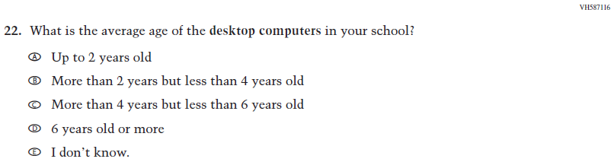  (2021 Grade 8) | Issue: Technology Use | NC | N/A
(2021 Grade 8) | Issue: Technology Use | NC | N/A
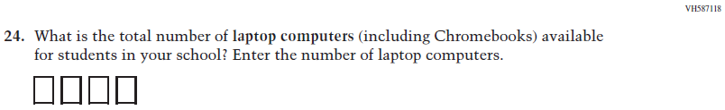  (2021 Grade 8) | Issue: Technology Use | NC | N/A
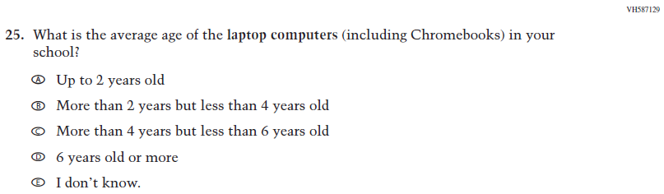  (2021 Grade 8) | Issue: Technology Use | NC | N/A
(2021 Grade 8) | Issue: Technology Use | NC | N/A
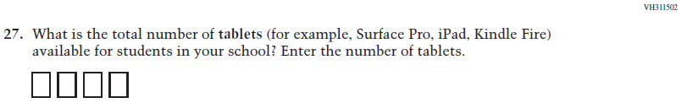  (2021 Grade 8) | Issue: Technology Use | NC | N/A

2022 Operational Grade 8 Core School

Previous item | 2022 item | D/A/ R/NC+ | Rationale
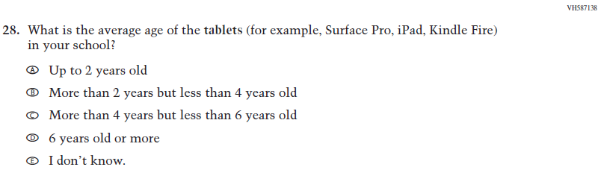  (2021 Grade 8) | Issue: Technology Use | NC | N/A
(2021 Grade 8) | Issue: Technology Use | NC | N/A
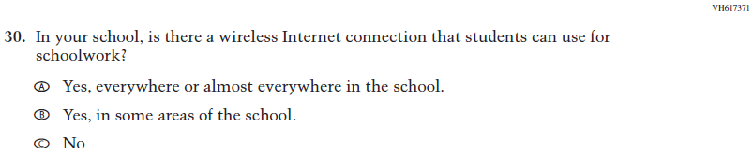  (2021 Grade 8) | Issue: Technology Use | NC | N/A

Appendix J3-4: Operational Grade 8 CORE
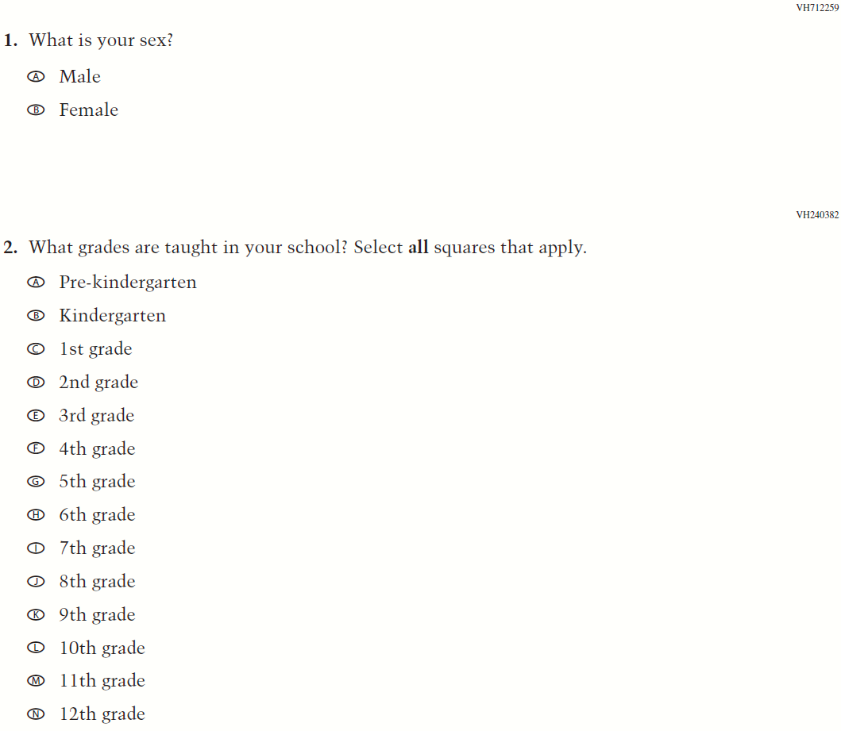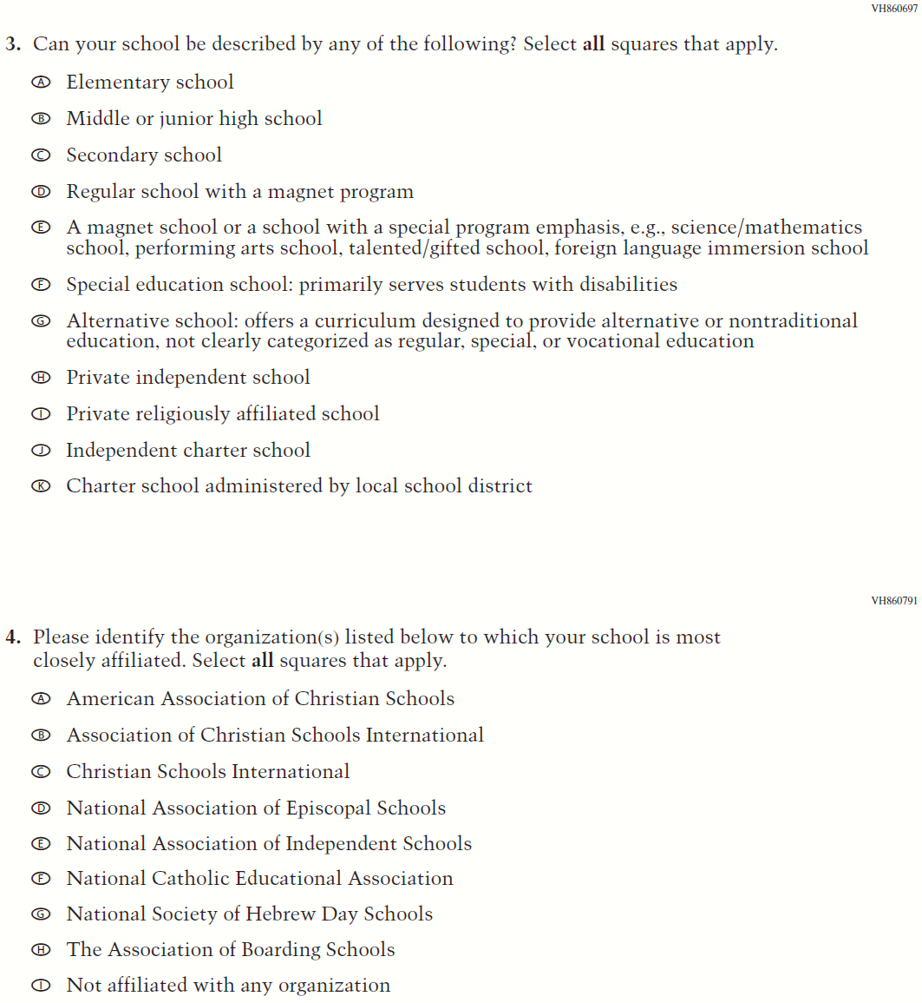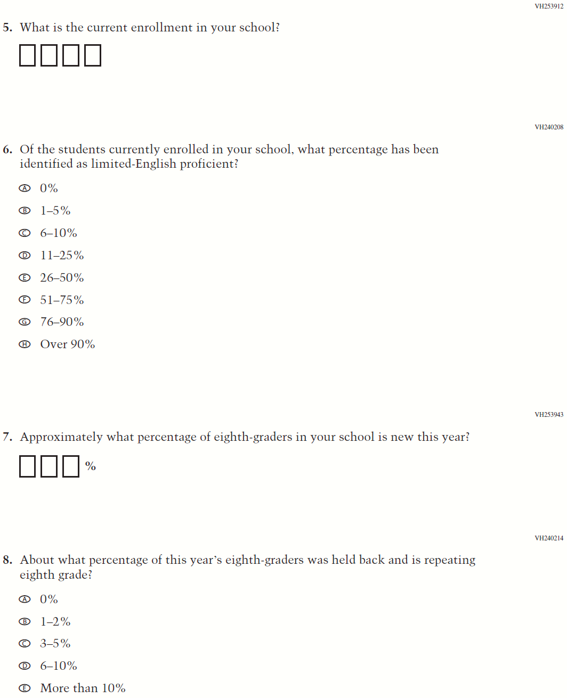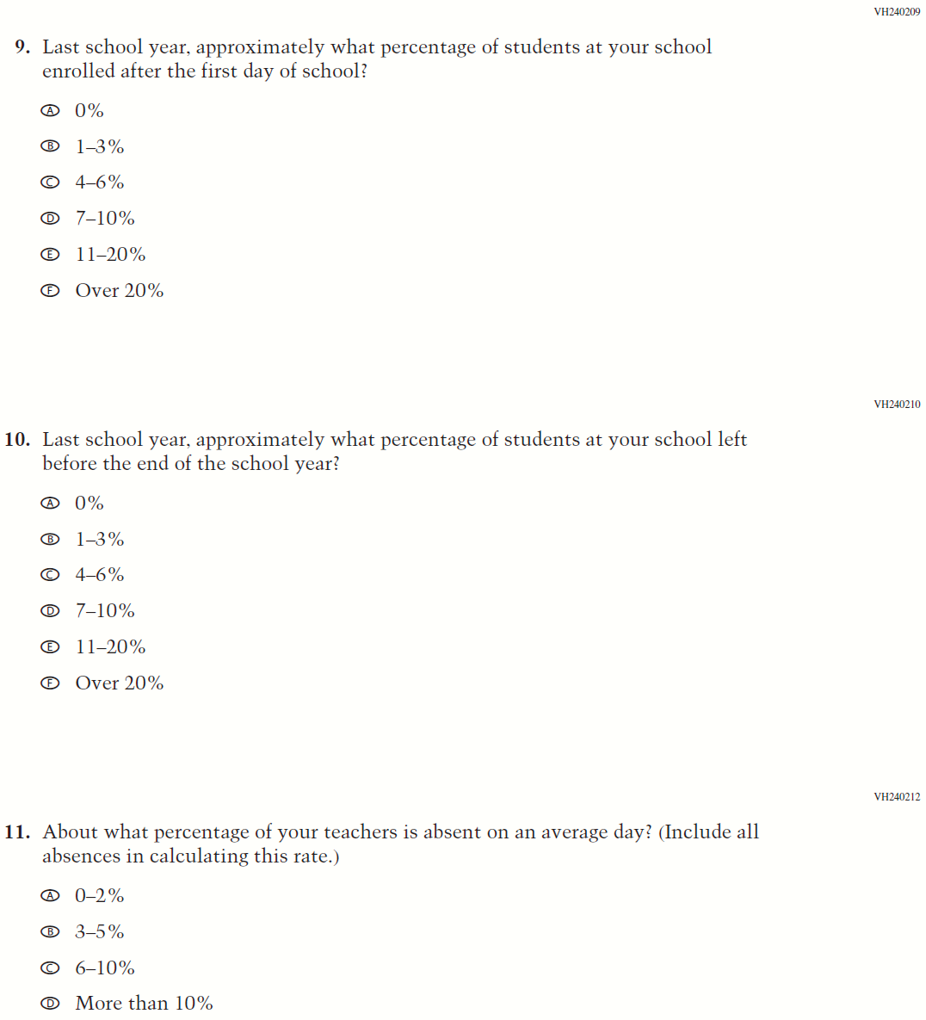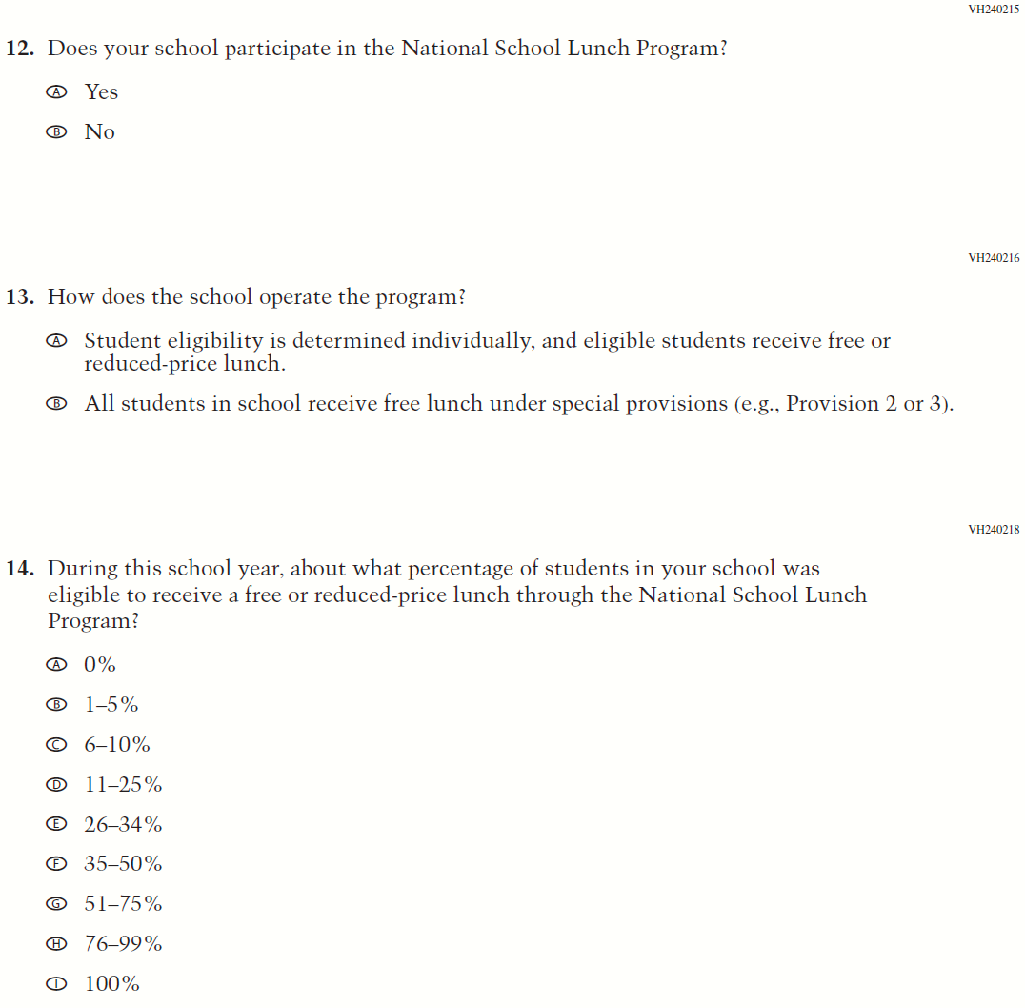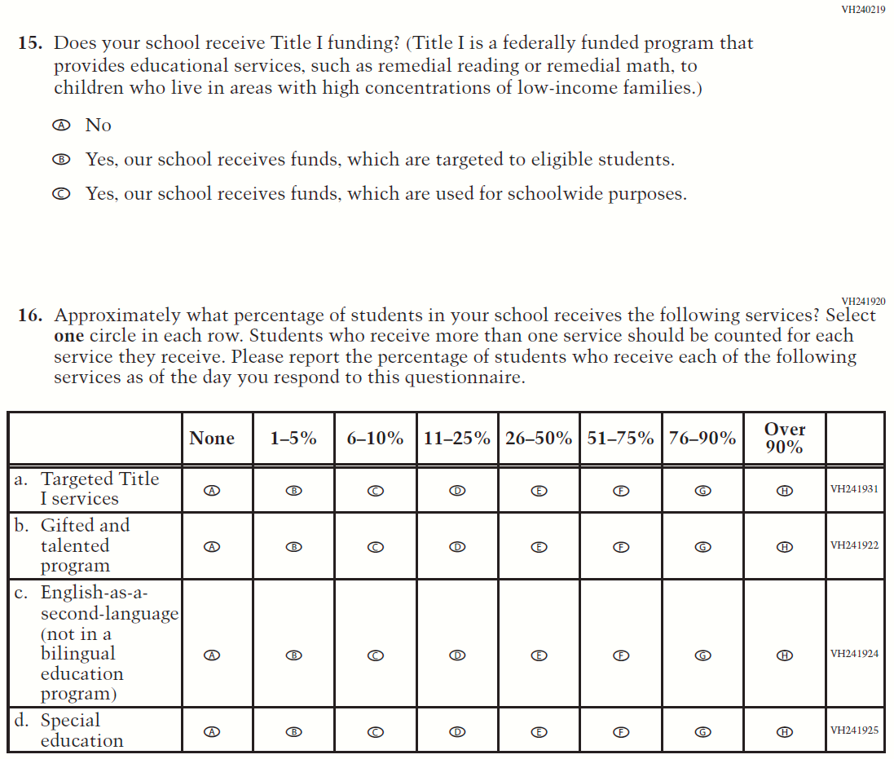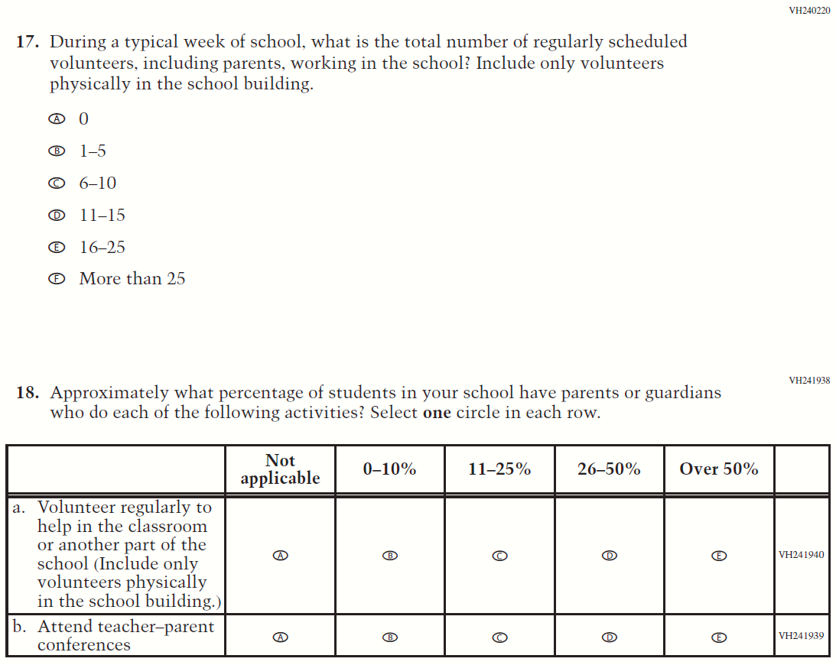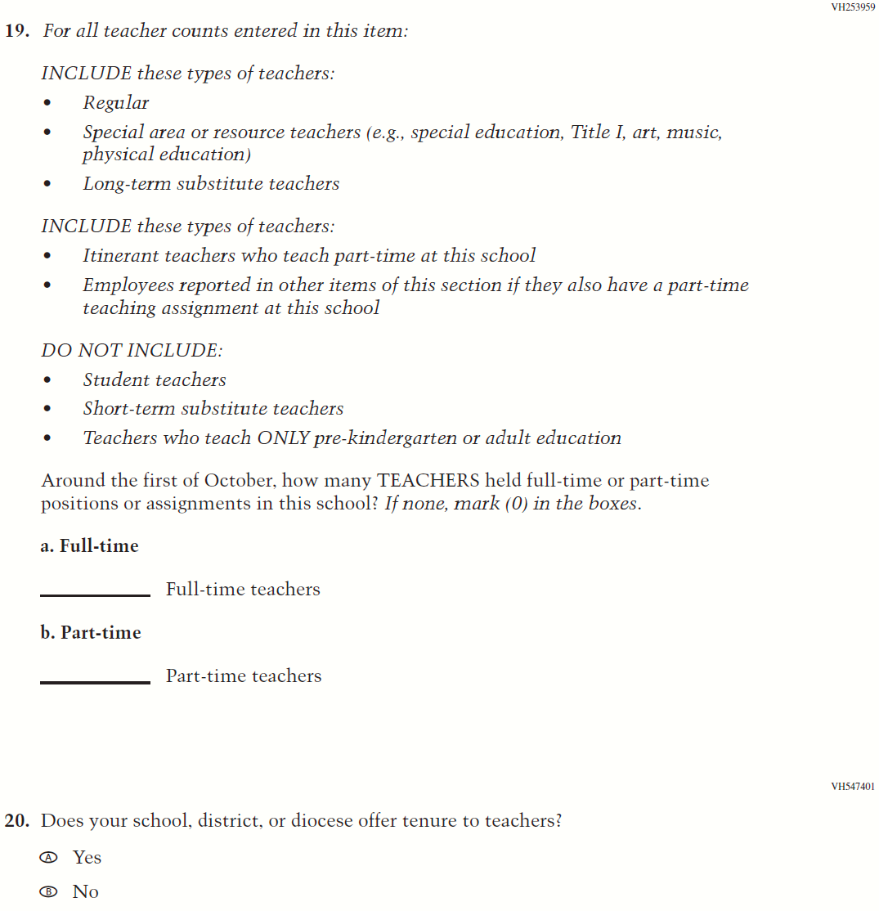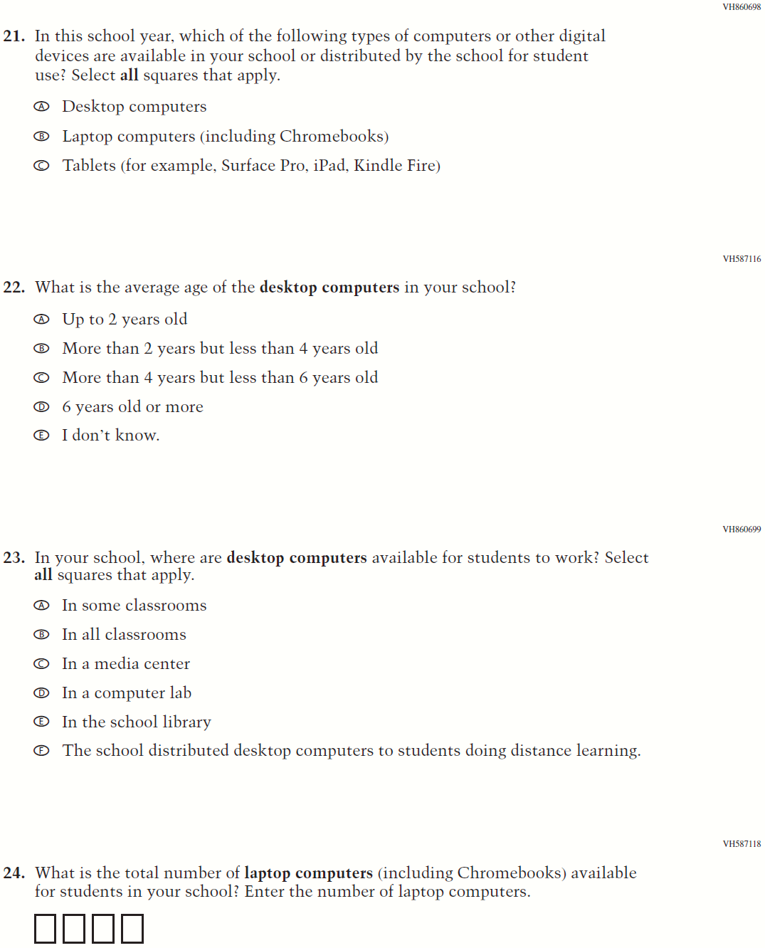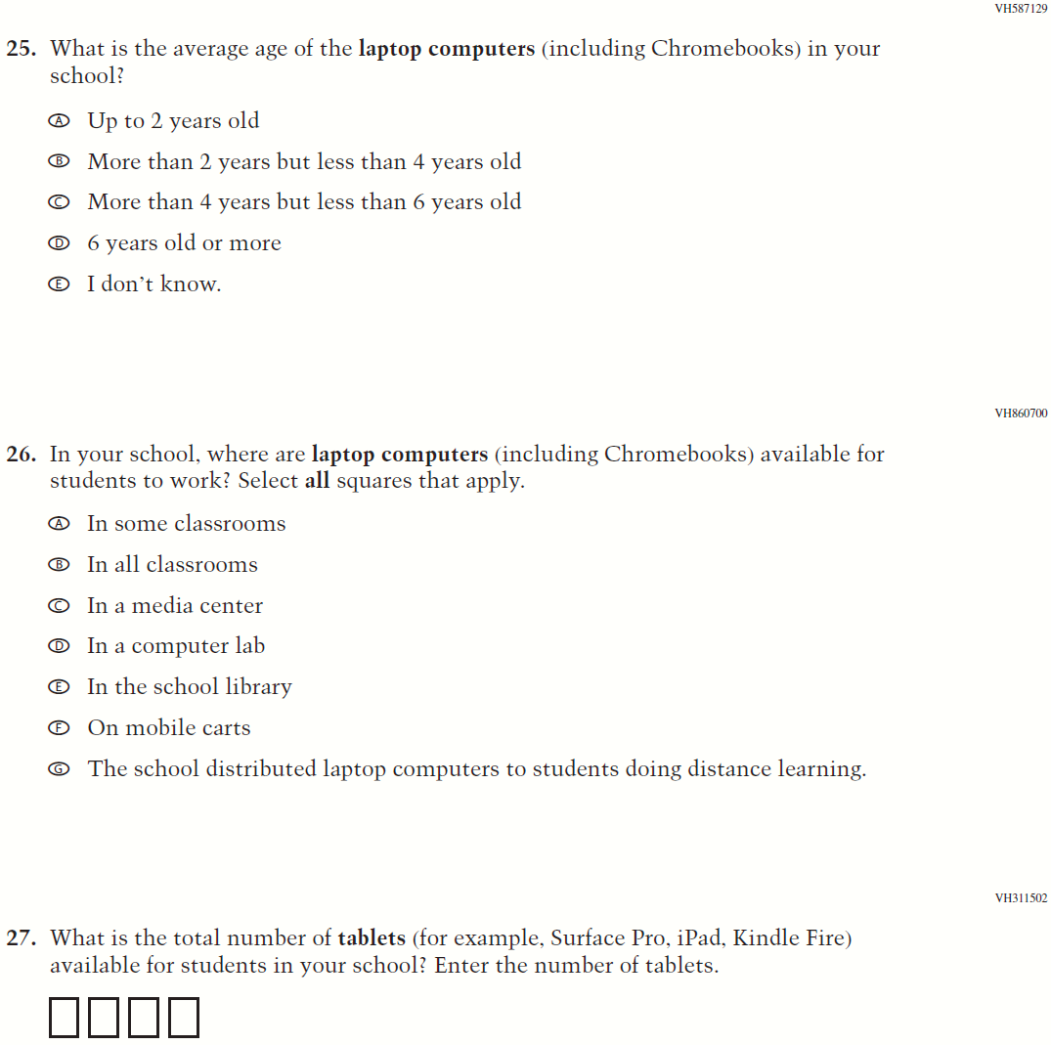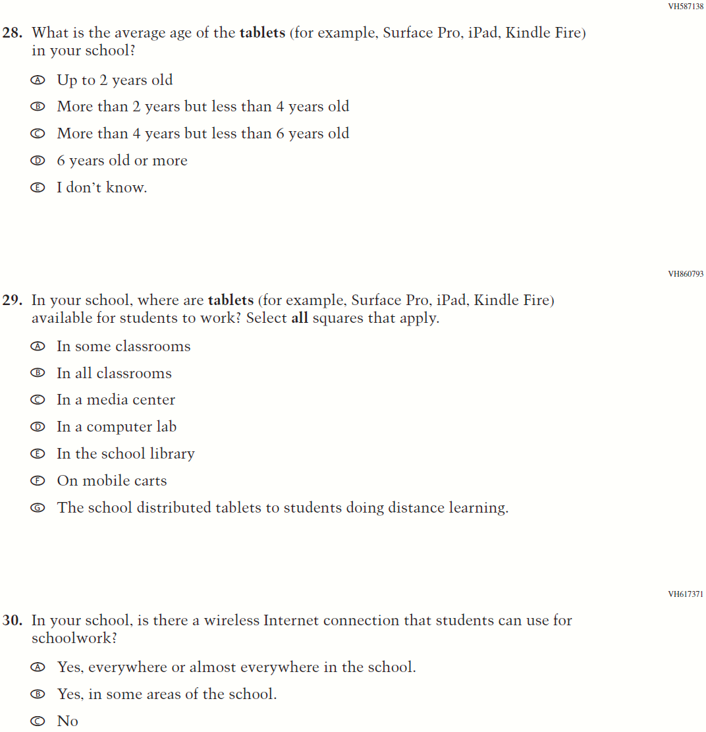

Appendix J3-4: Summary of Changes Operational Grade 4 and 8 Charter School
2022 Operational Grade 4 and 8 Charter School

Previous item | 2022 item | D/A/ R/NC+ | Rationale
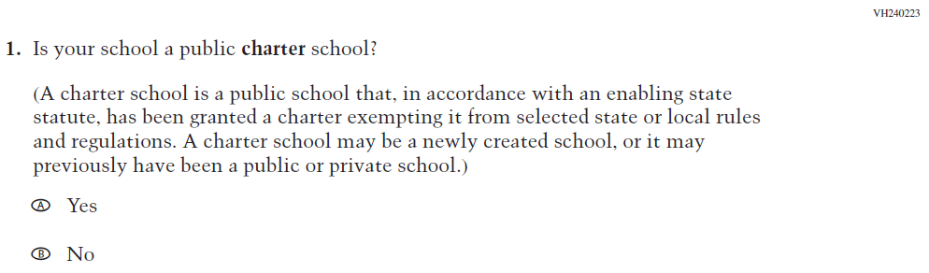  (2021 Grade 4, 8, and 12) | 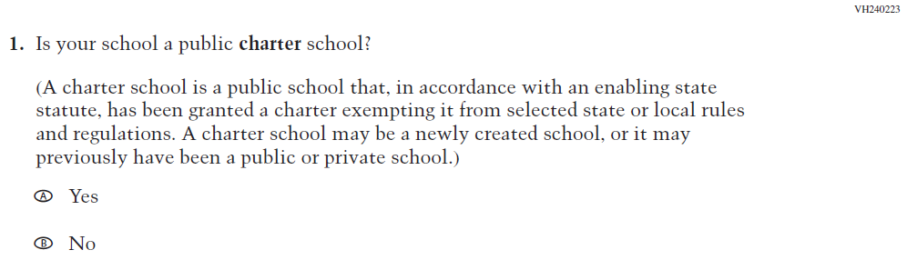  Issue: School Climate | NC | N/A
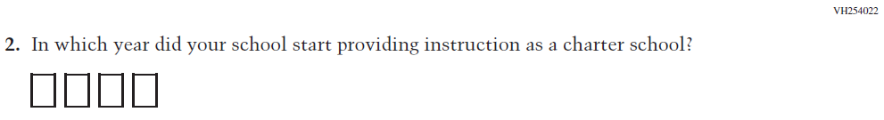  (2021 Grade 4, 8, and 12) | 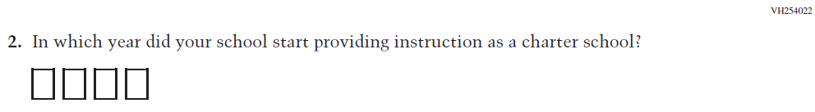  Issue: School Climate | NC | N/A
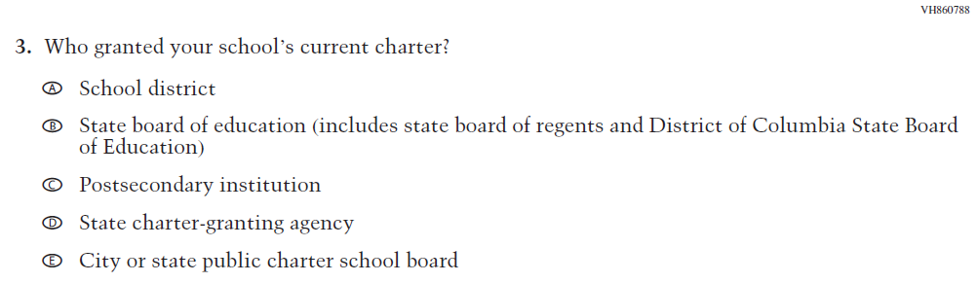  (2021 Grade 4, 8, and 12) | Issue: School Climate | NC | N/A
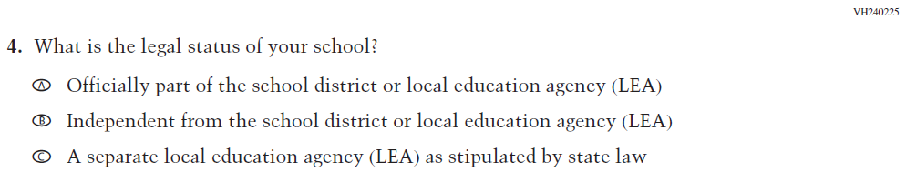  (2021 Grade 4, 8, and 12) | 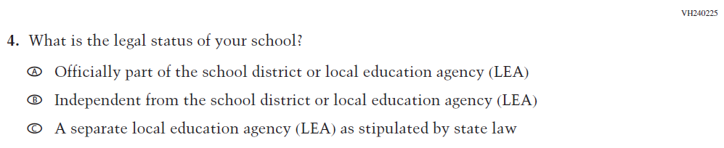  Issue: School Climate | NC | N/A

2022 Operational Grade 4 and 8 Charter School

Previous item | 2022 item | D/A/ R/NC+ | Rationale
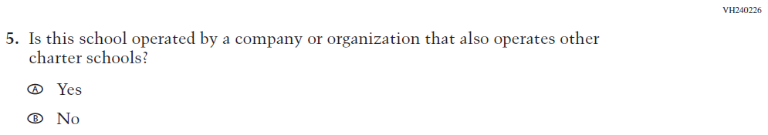  (2021 Grade 4, 8, and 12) | 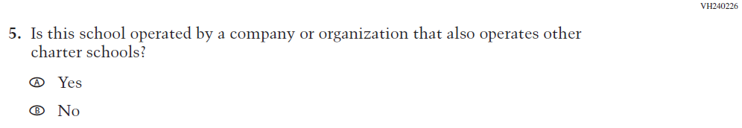  Issue: School Climate | NC | N/A
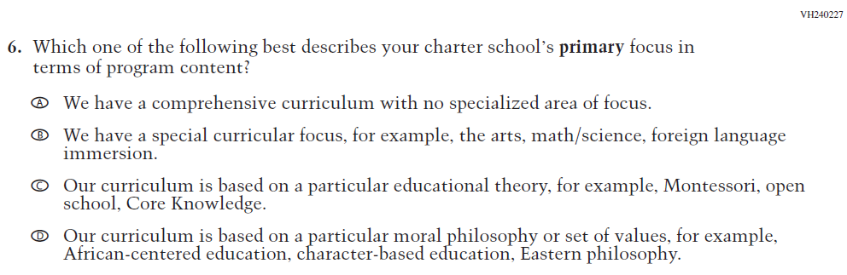  (2021 Grade 4, 8, and 12) | 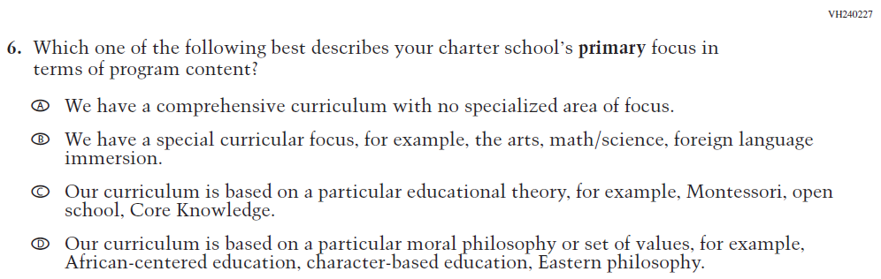  Issue: School Climate | NC | N/A
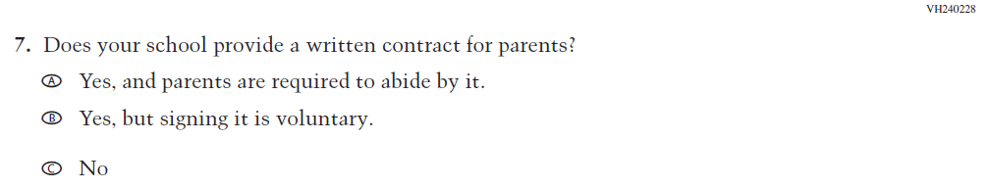  (2021 Grade 4, 8, and 12) | 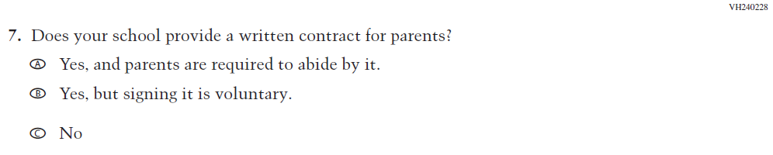  Issue: School Climate | NC | N/A
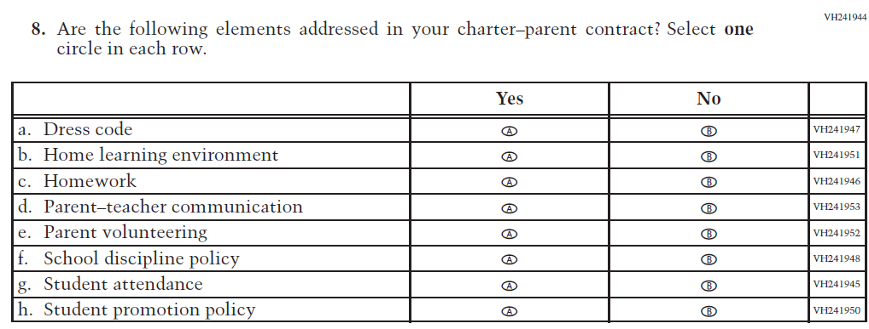  (2021 Grade 4, 8, and 12) | Issue: School Climate | NC | N/A

Appendix J3-6: Operational Grade 4 and 8 Charter School
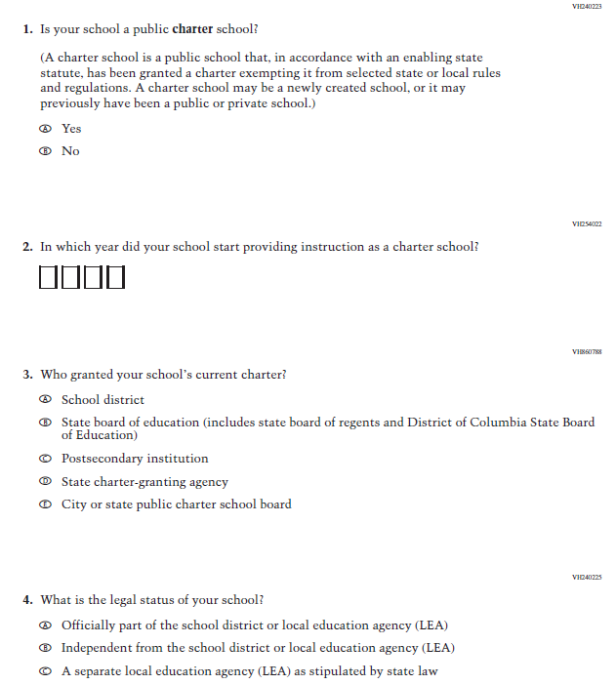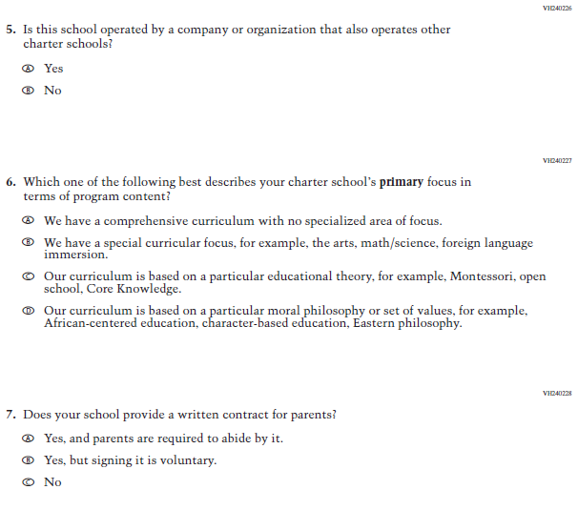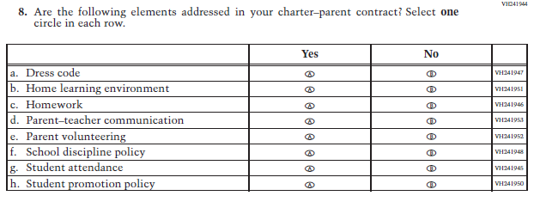

Appendix J3-7: Summary of Changes Operational Grade 4 Mathematics
2022 Operational Grade 4 Mathematics School

Previous item | 2022 item | D/A/ R/NC+ | Rationale
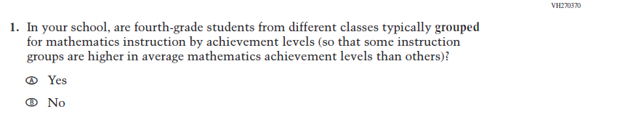  (2021 Grade 4) | Issue: Resources for Learning and Instruction | NC | N/A
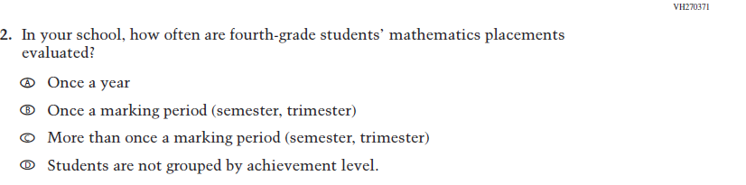  (2021 Grade 4) | Issue: Organization of Instruction | NC | N/A
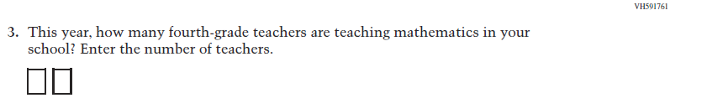  (2021 Grade 4) | Issue: Resources for Learning and Instruction | NC | N/A
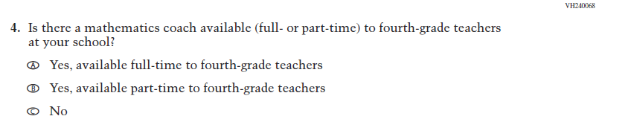  (2021 Grade 4) | Issue: Resources for Learning and Instruction | NC | N/A

2022 Operational Grade 4 Mathematics School

Previous item | 2022 item | D/A/ R/NC+ | Rationale
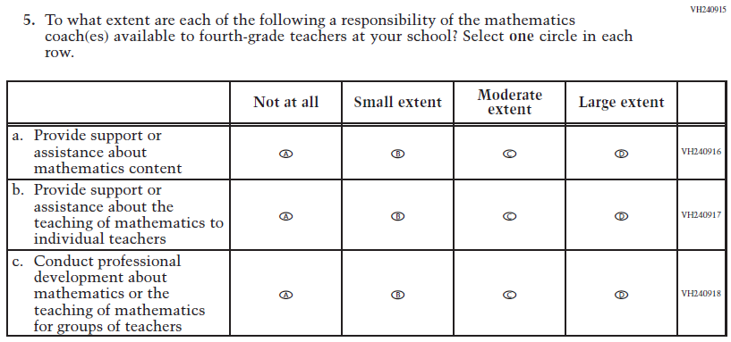  (2021 Grade 4) | Issue: Resources for Learning and Instruction | NC | N/A
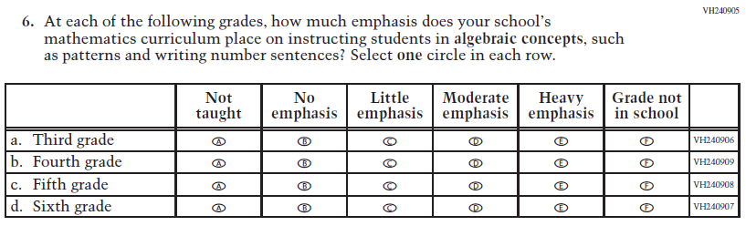  (2021 Grade 4) | Issue: Organization of Instruction | NC | N/A
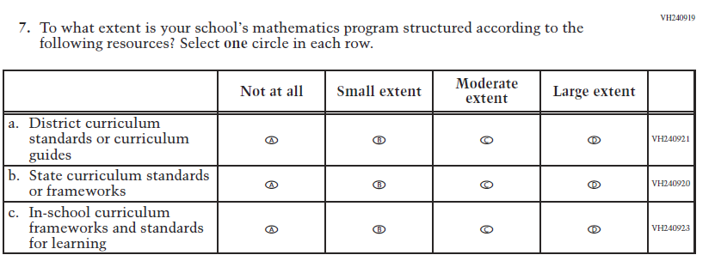  (2021 Grade 4) | Issue: Organization of Instruction | NC | N/A

2022 Operational Grade 4 Mathematics School

Previous item | 2022 item | D/A/ R/NC+ | Rationale
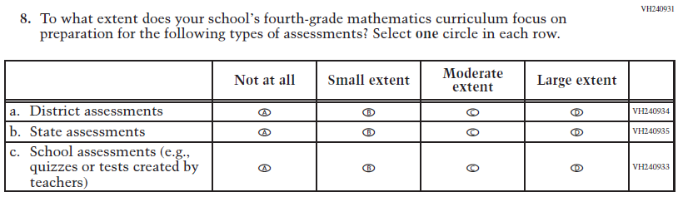  (2021 Grade 4) | Issue: Organization of Instruction | NC | N/A
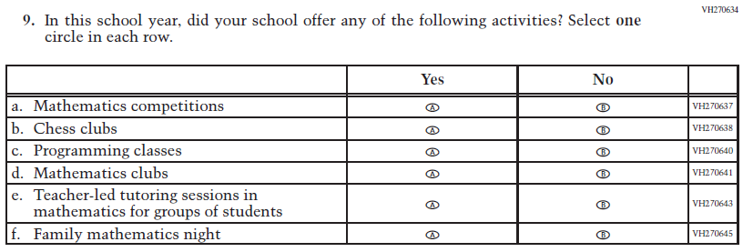  (2021 Grade 4) | Issue: Resources for Learning and Instruction | NC | N/A

Appendix J3-8: Operational Grade 4 Mathematics
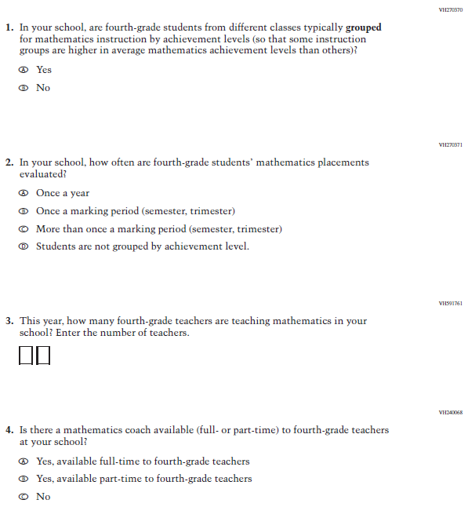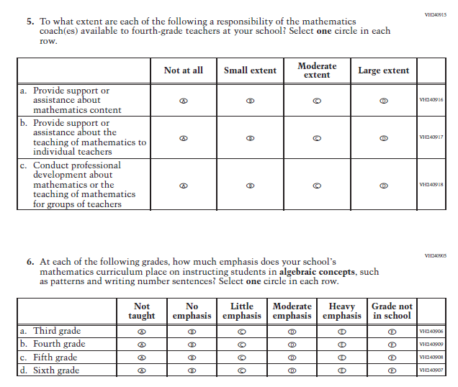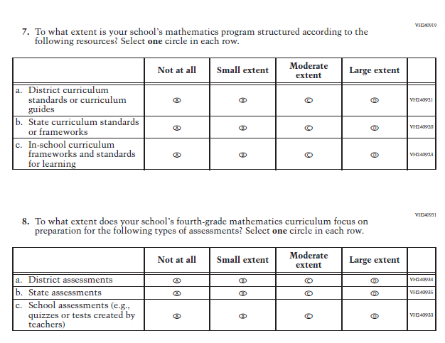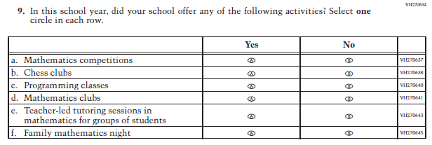

Appendix J3-9: Summary of Changes Operational Grade 8 Mathematics
2022 Operational Grade 8 Mathematics School

Previous item | 2022 item | D/A/ R/NC+ | Rationale
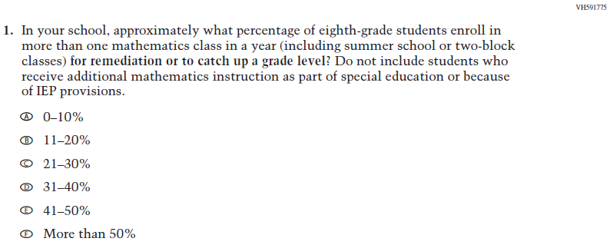  (2021 Grade 8) | Issue: Organization of Instruction | NC | N/A
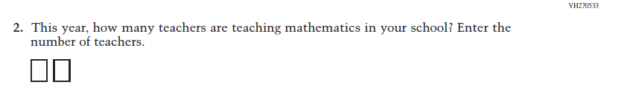  (2021 Grade 8) | Issue: Resources for Learning and Instruction | NC | N/A
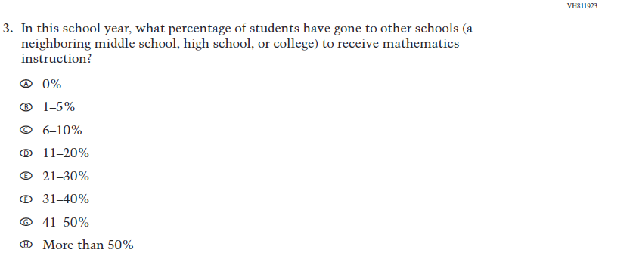  (2021 Grade 8) | Issue: Resources for Learning and Instruction | NC | N/A
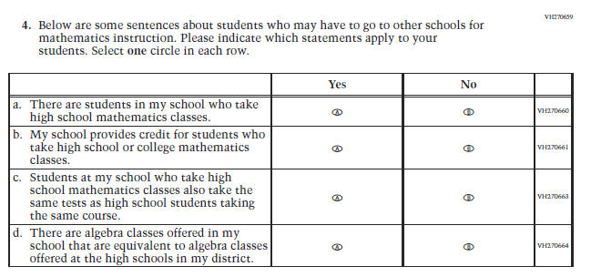(2021 Grade 8) | Issue: Resources for Learning and Instruction | NC | N/A
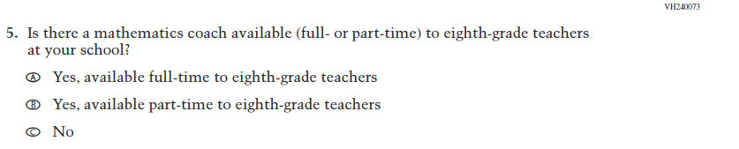  (2021 Grade 8) | Issue: Resources for Learning and Instruction | NC | N/A
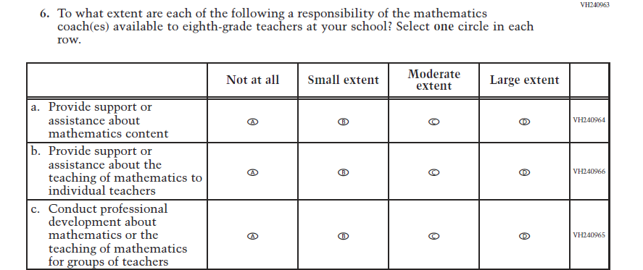  (2021 Grade 8) | Issue: Resources for Learning and Instruction | NC | N/A
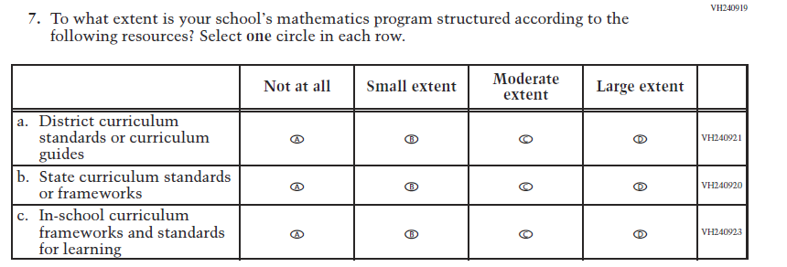  (2021 Grade 8) | Issue: Organization of instruction | NC | N/A
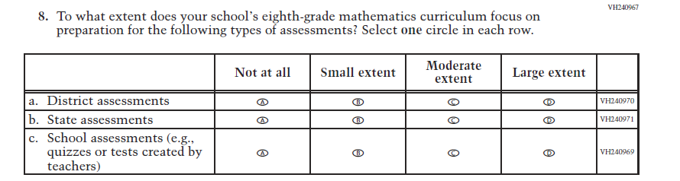  (2021 Grade 8) | Issue: Organization of instruction | NC | N/A
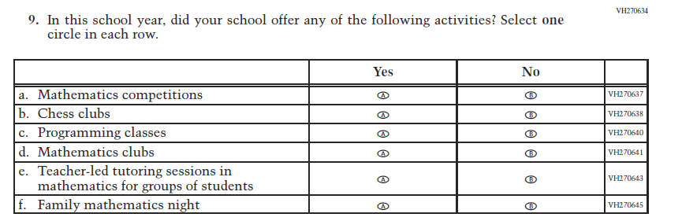  (2021 Grade 8) | Issue: Resources for Learning and Instruction | NC | N/A

Appendix J3-10: Operational Grade 8 Mathematics
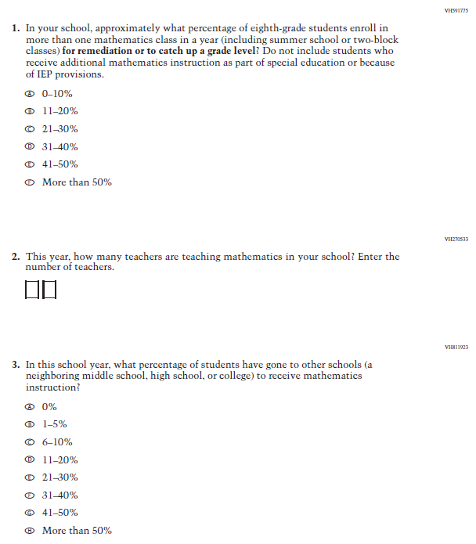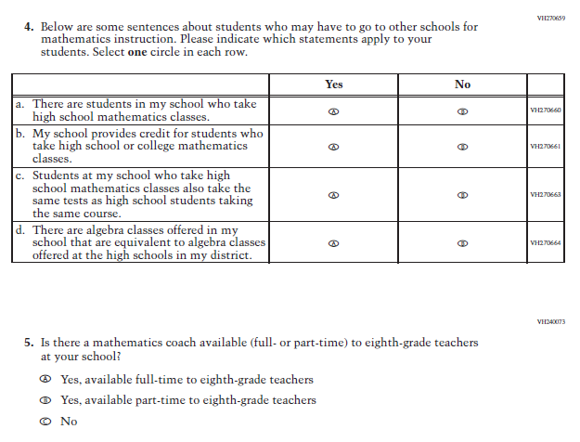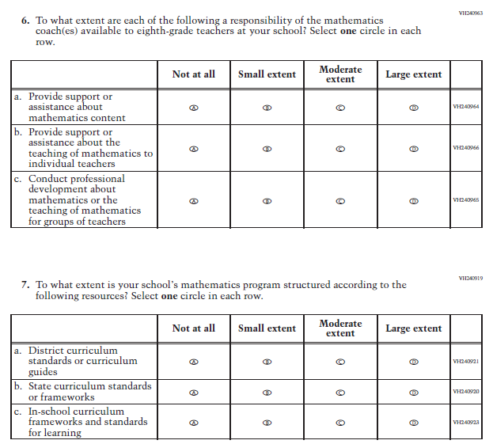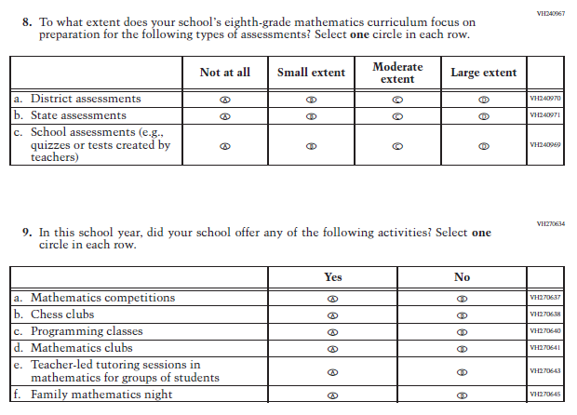

Appendix J3-11: Summary of Changes Operational Grade 4 Reading
2022 Operational Grade 4 Reading School

Previous item | 2022 item | D/A/ R/NC+ | Rationale
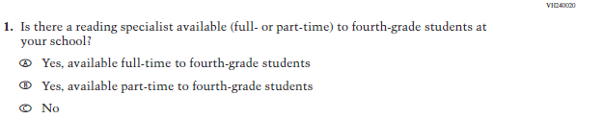  (2021 Grade 4) | Issue: Resources for Learning and Instruction | NC | N/A
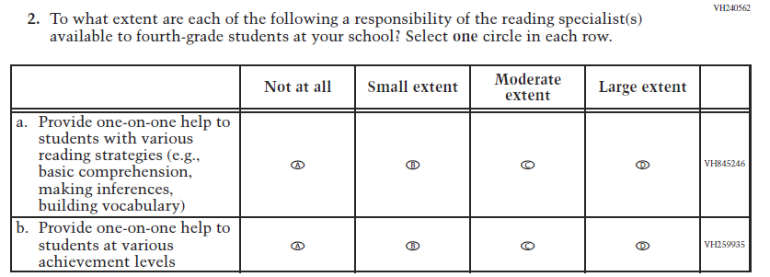  (2021 Grade 4) | Issue: Resources for Learning and Instruction | NC | N/A
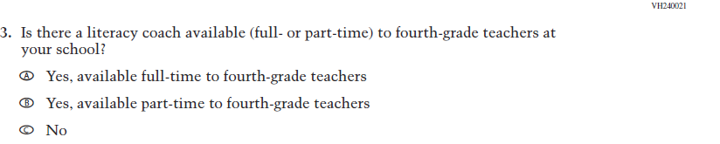  (2021 Grade 4) | Issue: Resources for Learning and Instruction | NC | N/A

2022 Operational Grade 4 Reading School

Previous item | 2022 item | D/A/ R/NC+ | Rationale
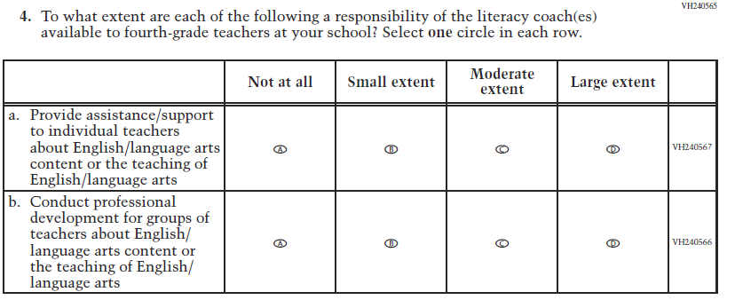  (2021 Grade 4) | Issue: Resources for Learning and Instruction | NC | N/A
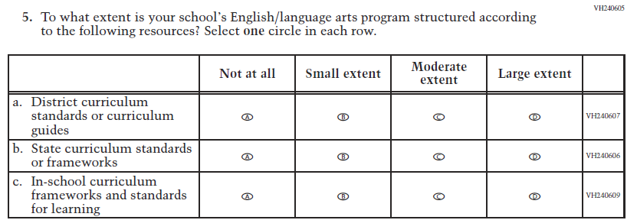  (2021 Grade 4) | Issue: Organization of Instruction | NC | N/A
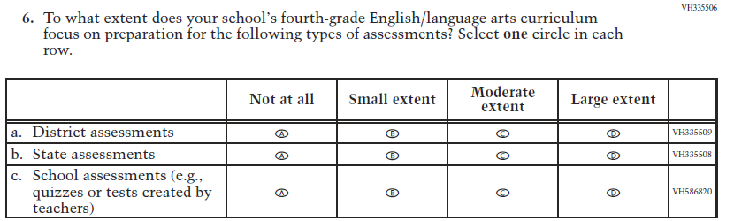  (2021 Grade 4) | Issue: Organization of Instruction | NC | N/A

2022 Operational Grade 4 Reading School

Previous item | 2022 item | D/A/ R/NC+ | Rationale
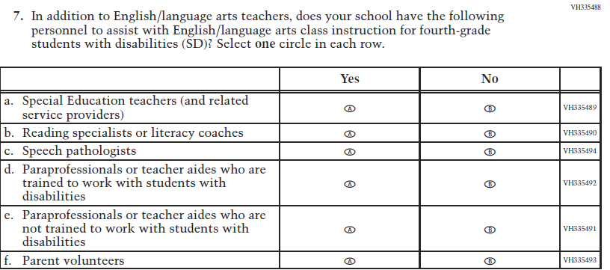  (2021 Grade 4) | Issue: Resources for Learning and Instruction | NC | N/A
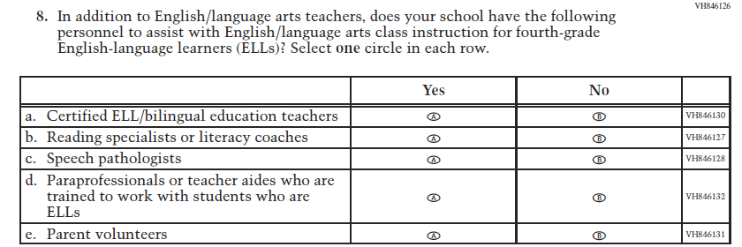  (2021 Grade 4) | Issue: Resources for Learning and Instruction | NC | N/A
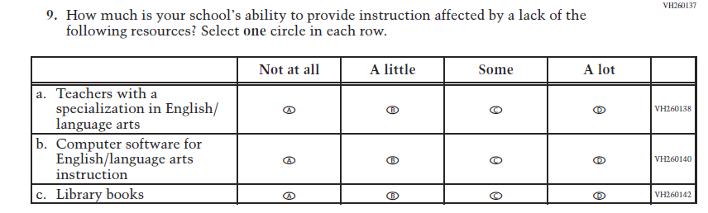  (2021 Grade 8) | Issue: Resources for Learning and Instruction | NC | N/A

Appendix J3-12: Operational Grade 4 Reading
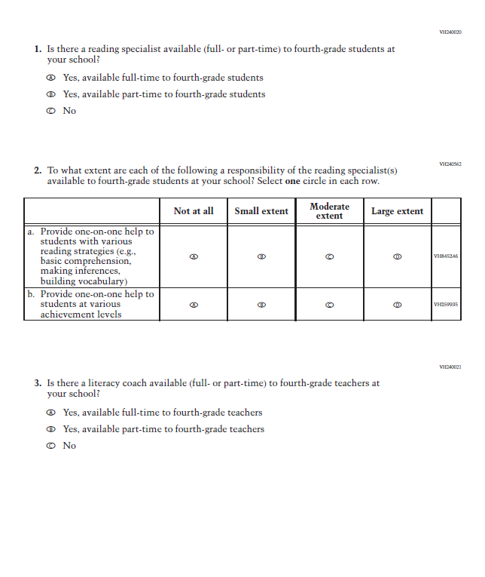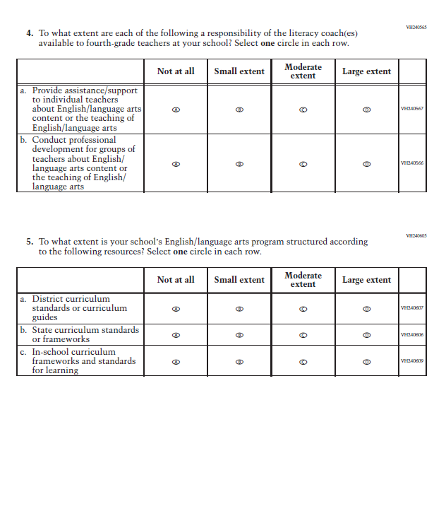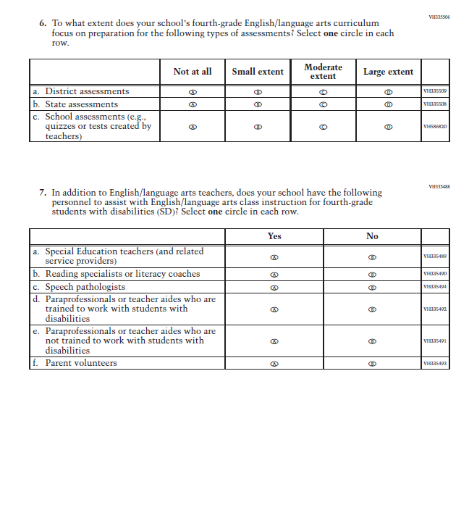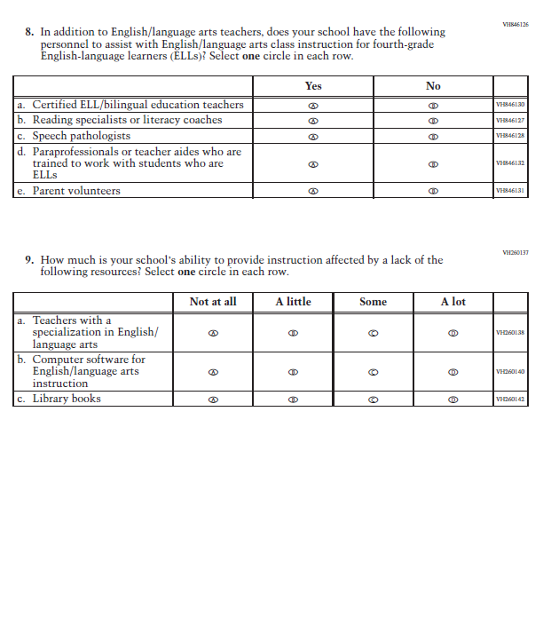

Appendix J3-13: Summary of Changes Operational Grade 8 Reading
2022 Operational Grade 8 Reading School

Previous item | 2022 item | D/A/ R/NC+ | Rationale
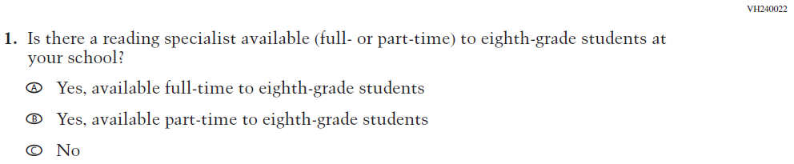  (2021 Grade 8) | Issue: Resources for Learning and Instruction | NC | N/A
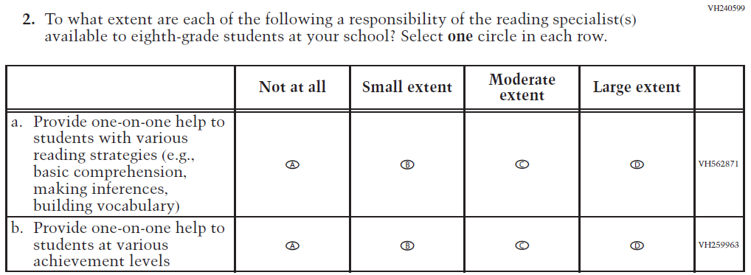  (2021 Grade 8) | Issue: Resources for Learning and Instruction | NC | N/A

2022 Operational Grade 8 Reading School

Previous item | 2022 item | D/A/ R/NC+ | Rationale
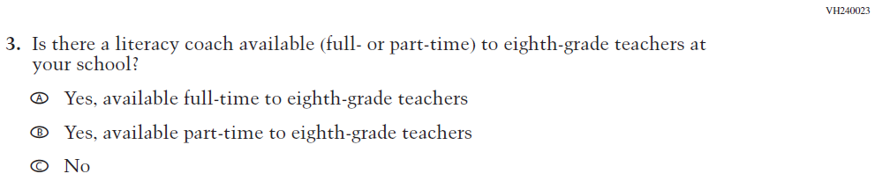  (2021 Grade 8) | Issue: Resources for Learning and Instruction | NC | N/A
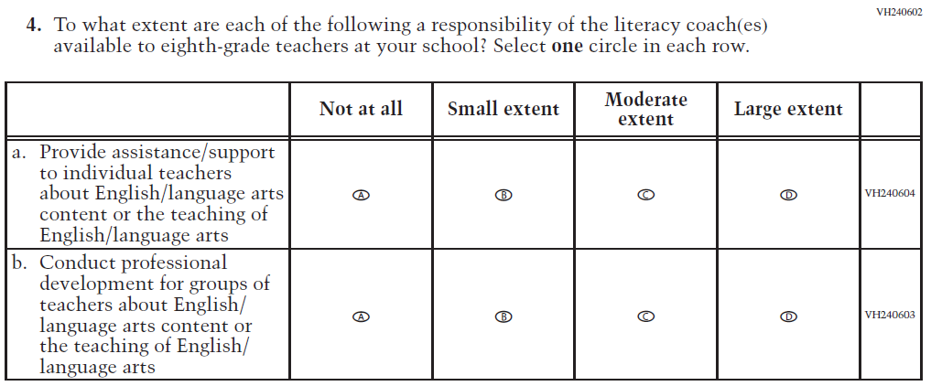  (2021 Grade 8) | Issue: Resources for Learning and Instruction | NC | N/A
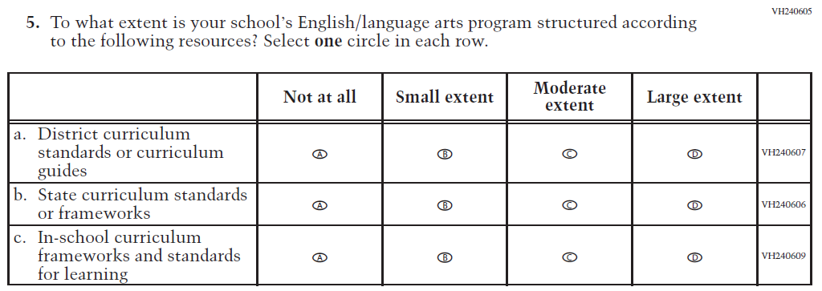  (2021 Grade 8) | Issue: Organization of Instruction | NC | N/A

2022 Operational Grade 8 Reading School

Previous item | 2022 item | D/A/ R/NC+ | Rationale
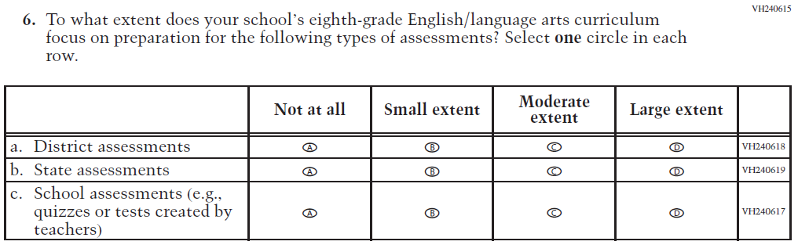  (2021 Grade 8) | Issue: Organization of Instruction | NC | N/A
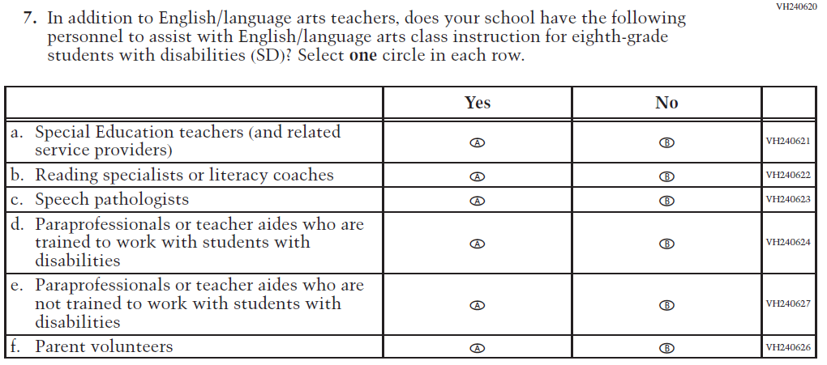  (2021 Grade 8) | Issue: Resources for Learning and Instruction | NC | N/A

2022 Operational Grade 8 Reading School

Previous item | 2022 item | D/A/ R/NC+ | Rationale
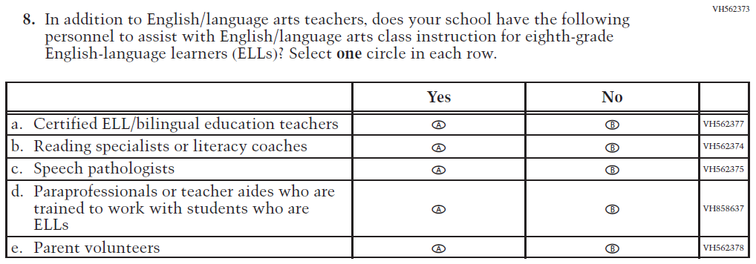  (2021 Grade 8) | Issue: Resources for Learning and Instruction | NC | N/A
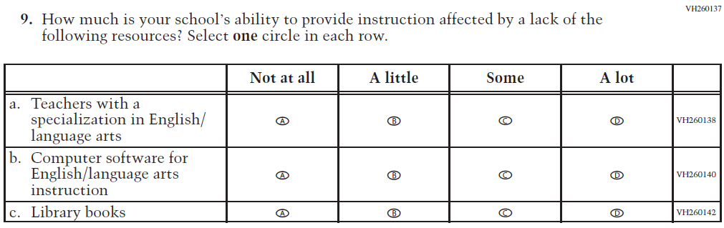  (2021 Grade 8) | Issue: Resources for Learning and Instruction | NC | N/A

Appendix J3-14: Operational Grade 8 Reading
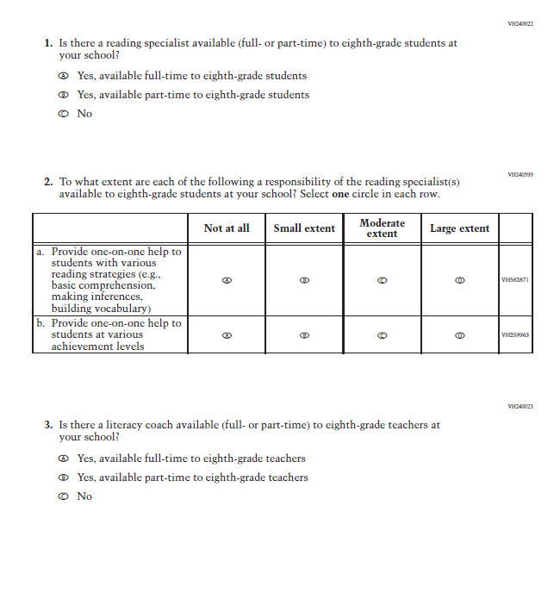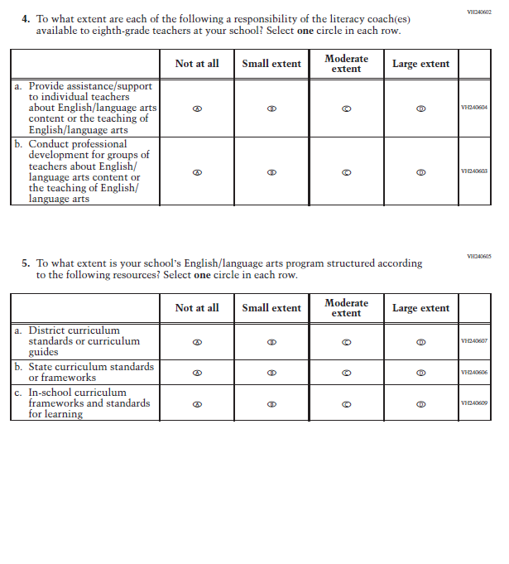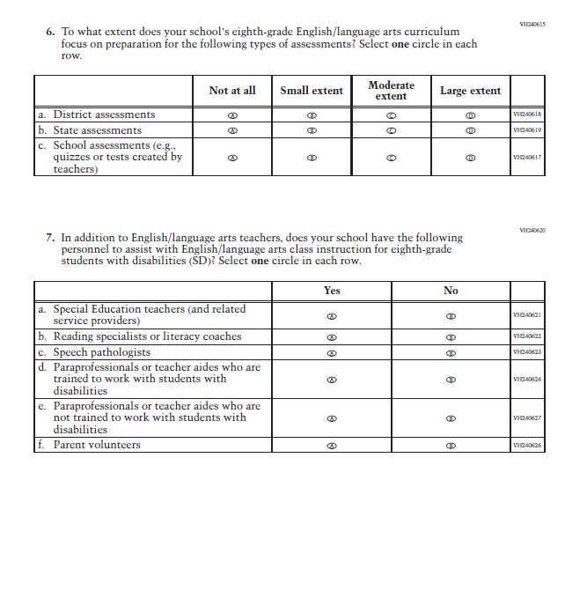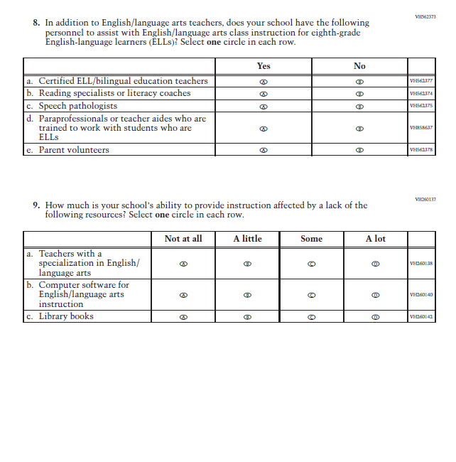

Appendix J3-15: Summary of Operational Grade 8 Social Studies School Items
2022 Operational Grade 8 Social Studies School
Previous item | 2022 item | D/A/ R/NC+ | Rationale
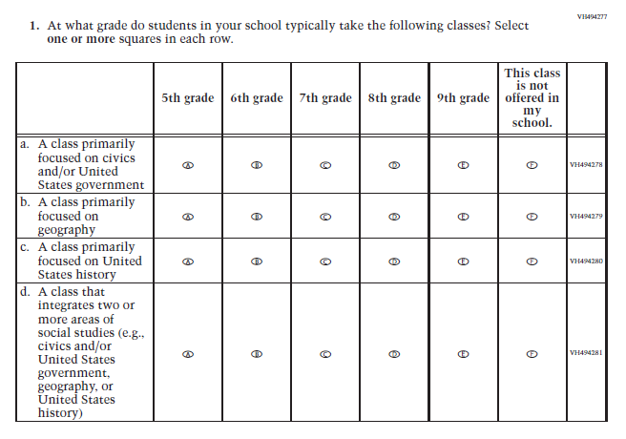  (2018 Grade 8) | Issue: Organization of Instruction | NC | N/A
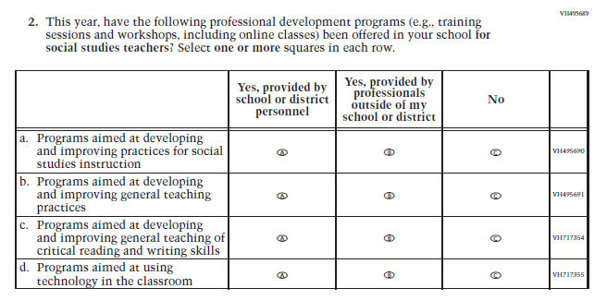  (2018 Grade 8) | Issue: Teacher Preparation | NC | N/A
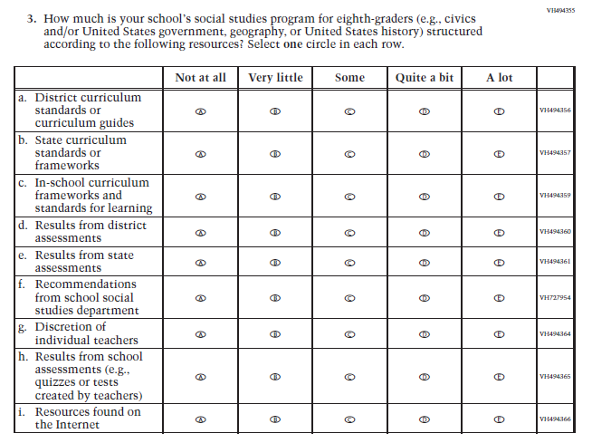  (2018 Grade 8) | Issue: Organization of Instruction | NC | N/A
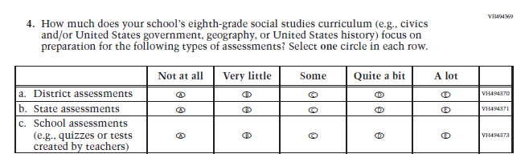  (2018 Grade 8) | Issue: Organization of Instruction | NC | N/A
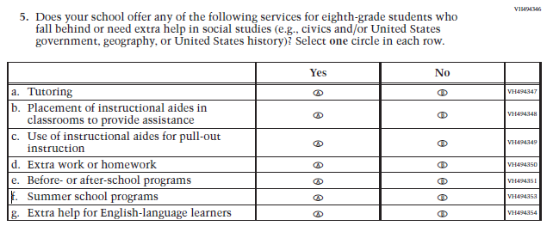  (2018 Grade 8) | Issue: Resources for Learning and Instruction | NC | N/A
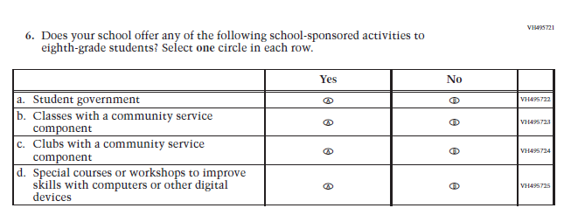  (2018 Grade 8) | Issue: Student Factors | NC | N/A

Appendix J3-16: Operational Grade 8 Social Studies School Items
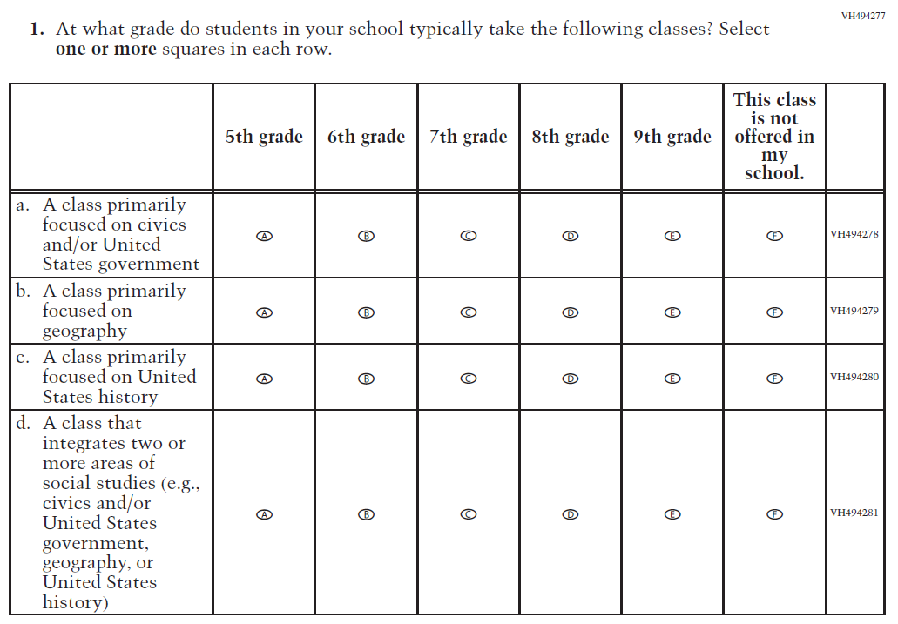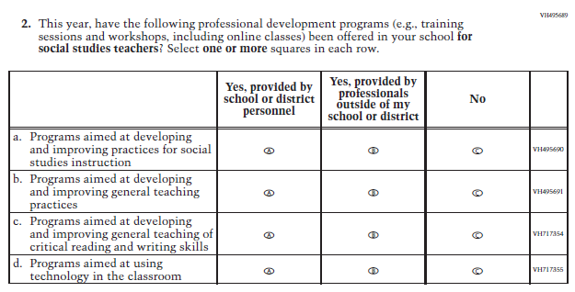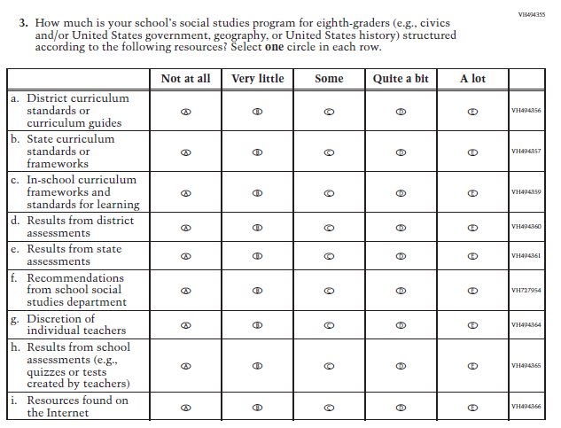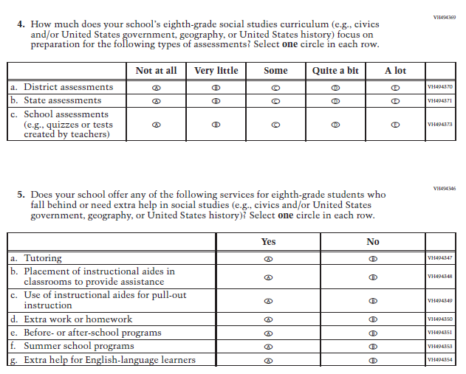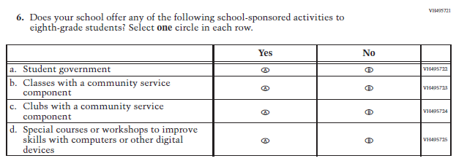

Appendix J3-17: Summary of Operational Grade 4 COVID-19 School Items
2022 Operational Grade 4 COVID-19 School Items
Previous item | 2022 item | D/A/R/NC+ | Rationale
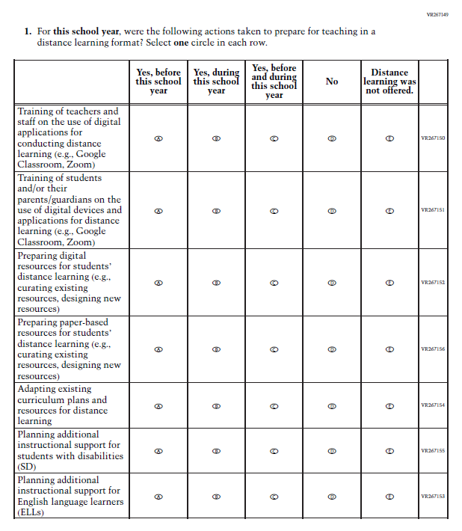  (2021 Grade 4) | Issue: Resources for Learning and Instruction | NC | N/A

2022 Operational Grade 4 COVID-19 School Items
Previous item | 2022 item | D/A/R/NC+ | Rationale
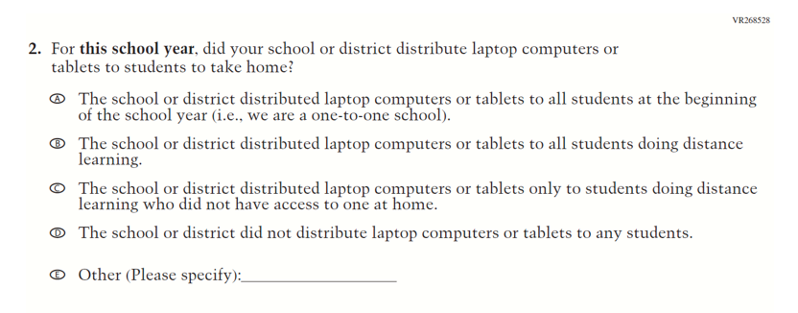  (2021 Grade 4) | Issue: Technology Use and Access | NC | N/A
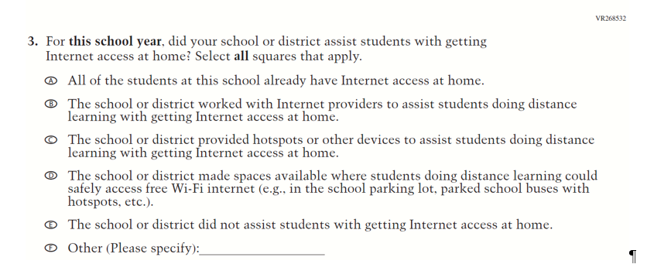  (2021 Grade 4) | Issue: Technology Use and Access | NC | N/A

2022 Operational Grade 4 COVID-19 School Items
Previous item | 2022 item | D/A/R/NC+ | Rationale
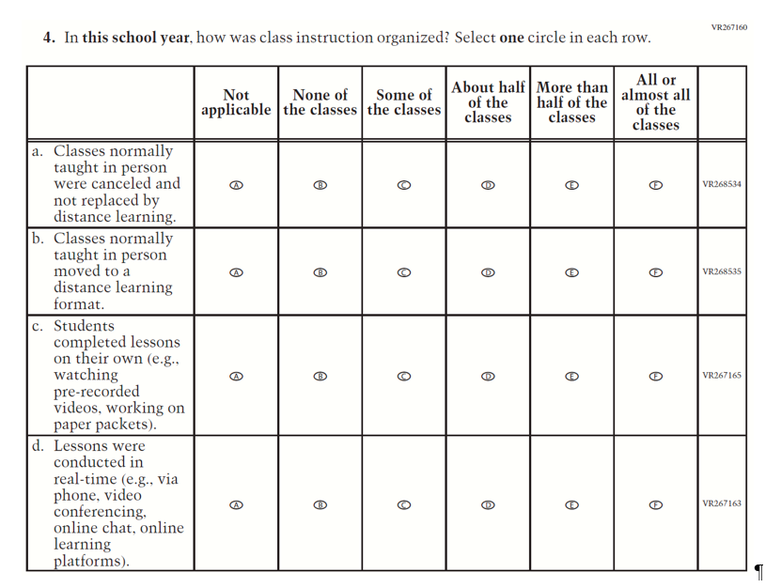  (2021 Grade 4) | Issue: Organization of Instruction | NC | N/A

2022 Operational Grade 4 COVID-19 School Items
Previous item | 2022 item | D/A/R/NC+ | Rationale
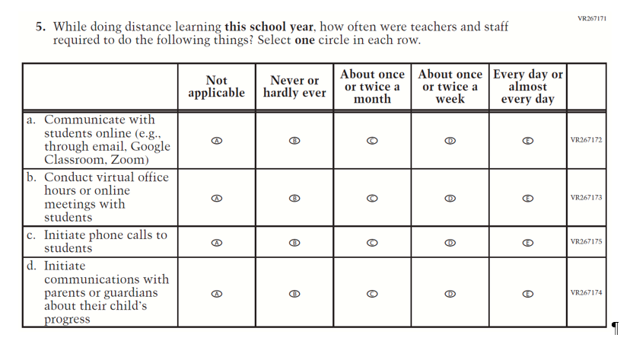  (2021 Grade 4) | Issue: Resources for Learning and Instruction | NC | N/A
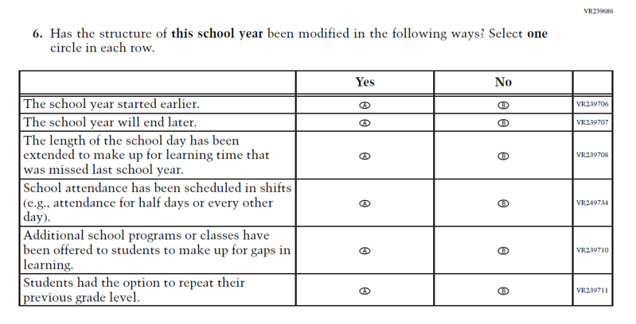  (2021 Grade 4) | Issue: Organization of Instruction | NC | N/A

2022 Operational Grade 4 COVID-19 School Items
Previous item | 2022 item | D/A/R/NC+ | Rationale
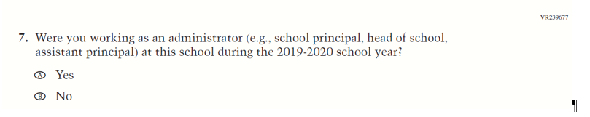  (2021 Grade 4) | 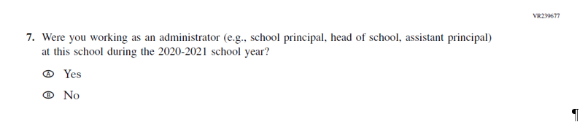  Issue: Organization of Instruction | R | This item has been updated to reference the correct academic year for the 2022 administration.
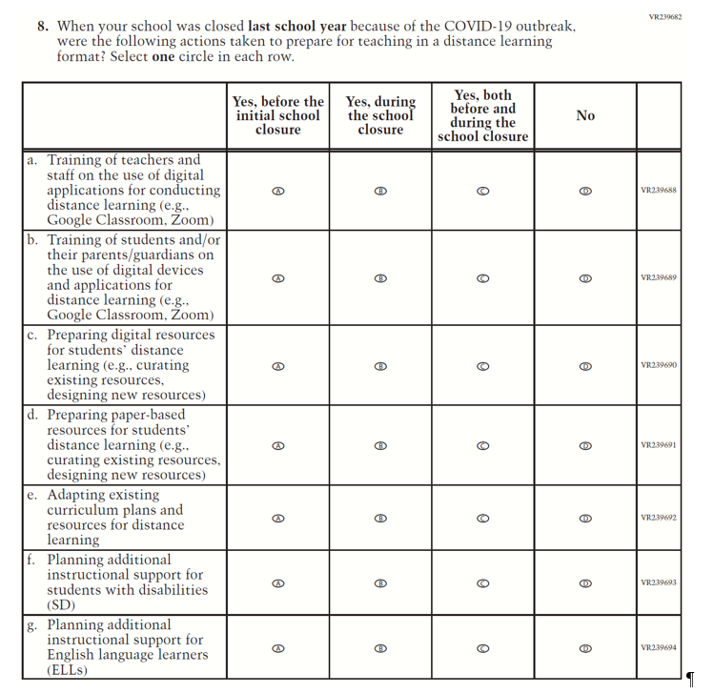  (2021 Grade 4) | Issue: Resources for Learning and Instruction | NC | N/A

2022 Operational Grade 4 COVID-19 School Items
Previous item | 2022 item | D/A/R/NC+ | Rationale
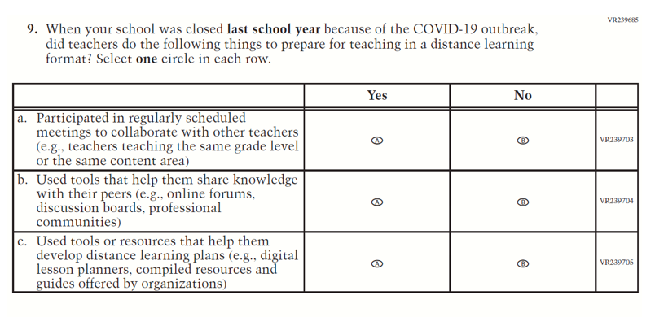  (2021 Grade 4) | Issue: Resources for Learning and Instruction | NC | N/A
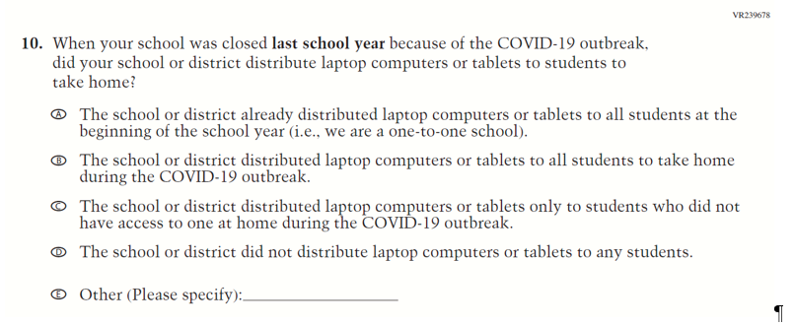  (2021 Grade 4) | Issue: Technology Use and Access | NC | N/A

2022 Operational Grade 4 COVID-19 School Items
Previous item | 2022 item | D/A/R/NC+ | Rationale
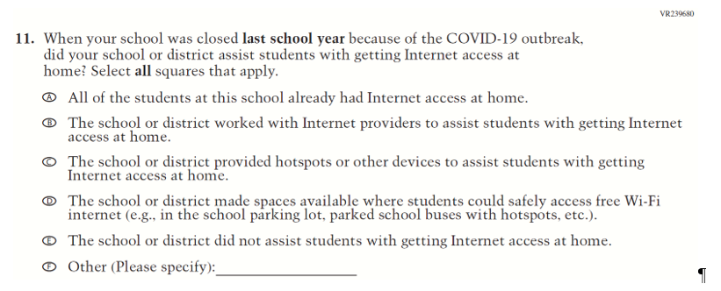  (2021 Grade 4) | Issue: Technology Use and Access | NC | N/A
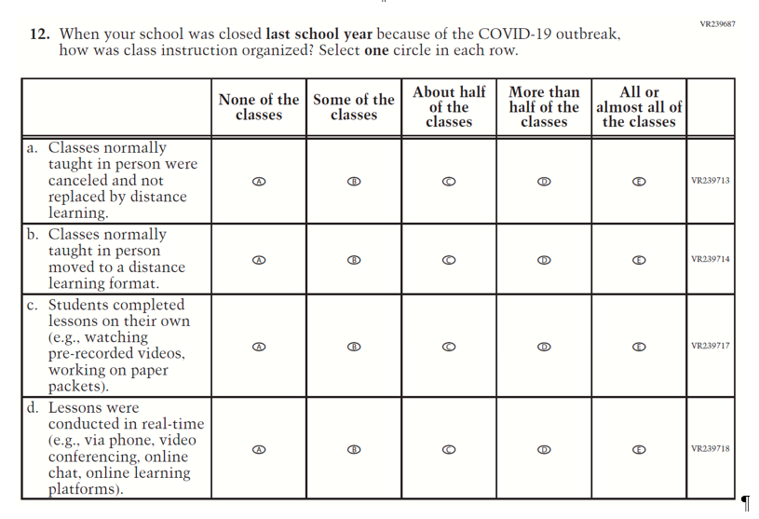  (2021 Grade 4) | Issue: Organization of Instruction | NC | N/A

2022 Operational Grade 4 COVID-19 School Items
Previous item | 2022 item | D/A/R/NC+ | Rationale
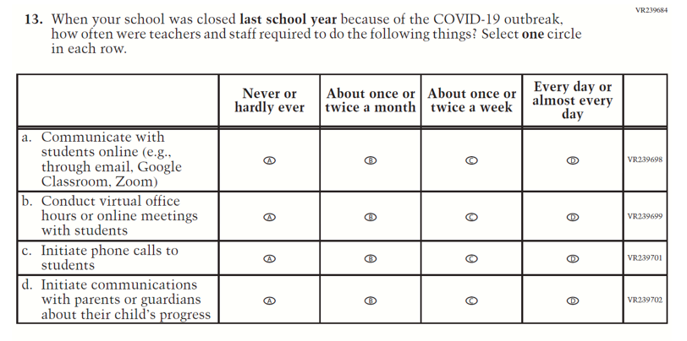  (2021 Grade 4) | Issue: Resources for Learning and Instruction | NC | N/A
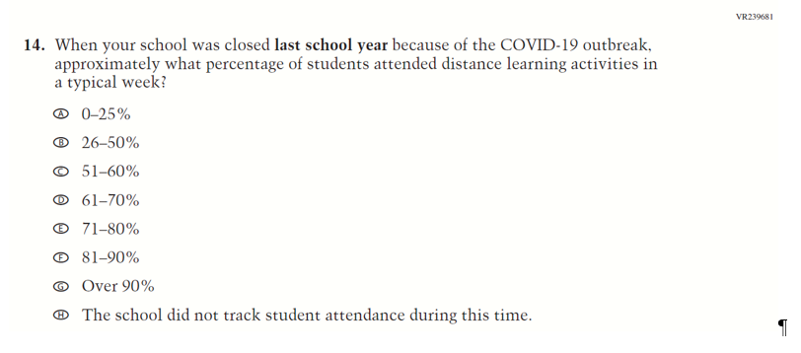  (2021 Grade 4) | Issue: Resources for Learning and Instruction | NC | N/A

Appendix J3-18: Operational Grade 4 COVID-19 School Items
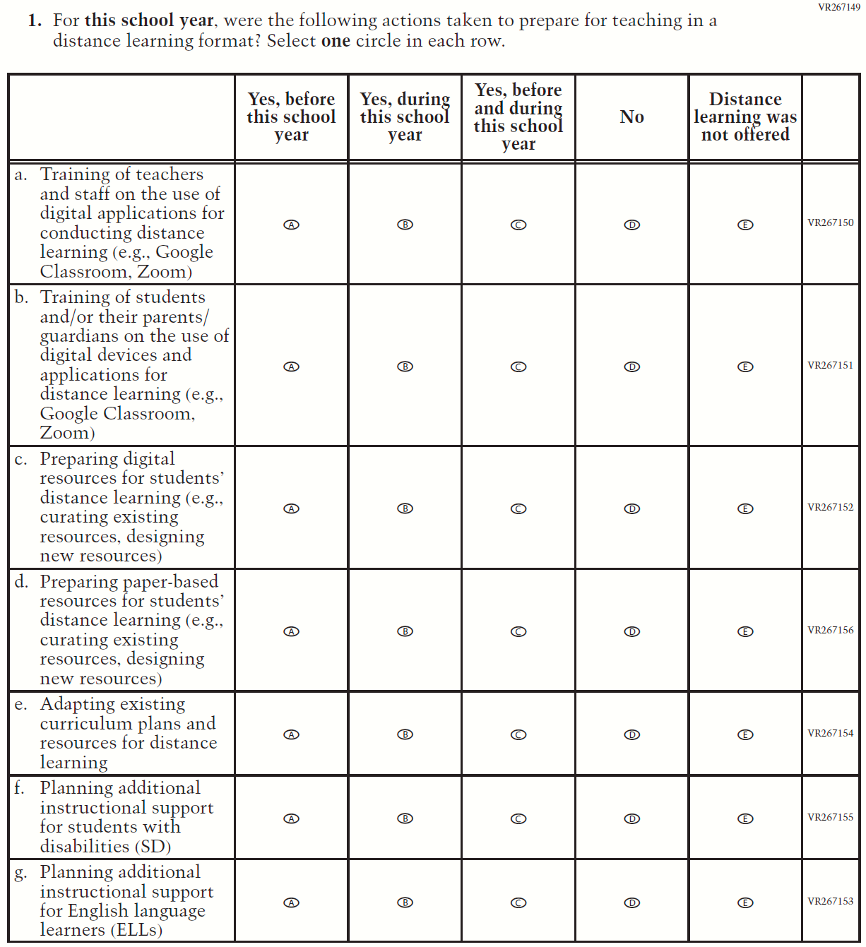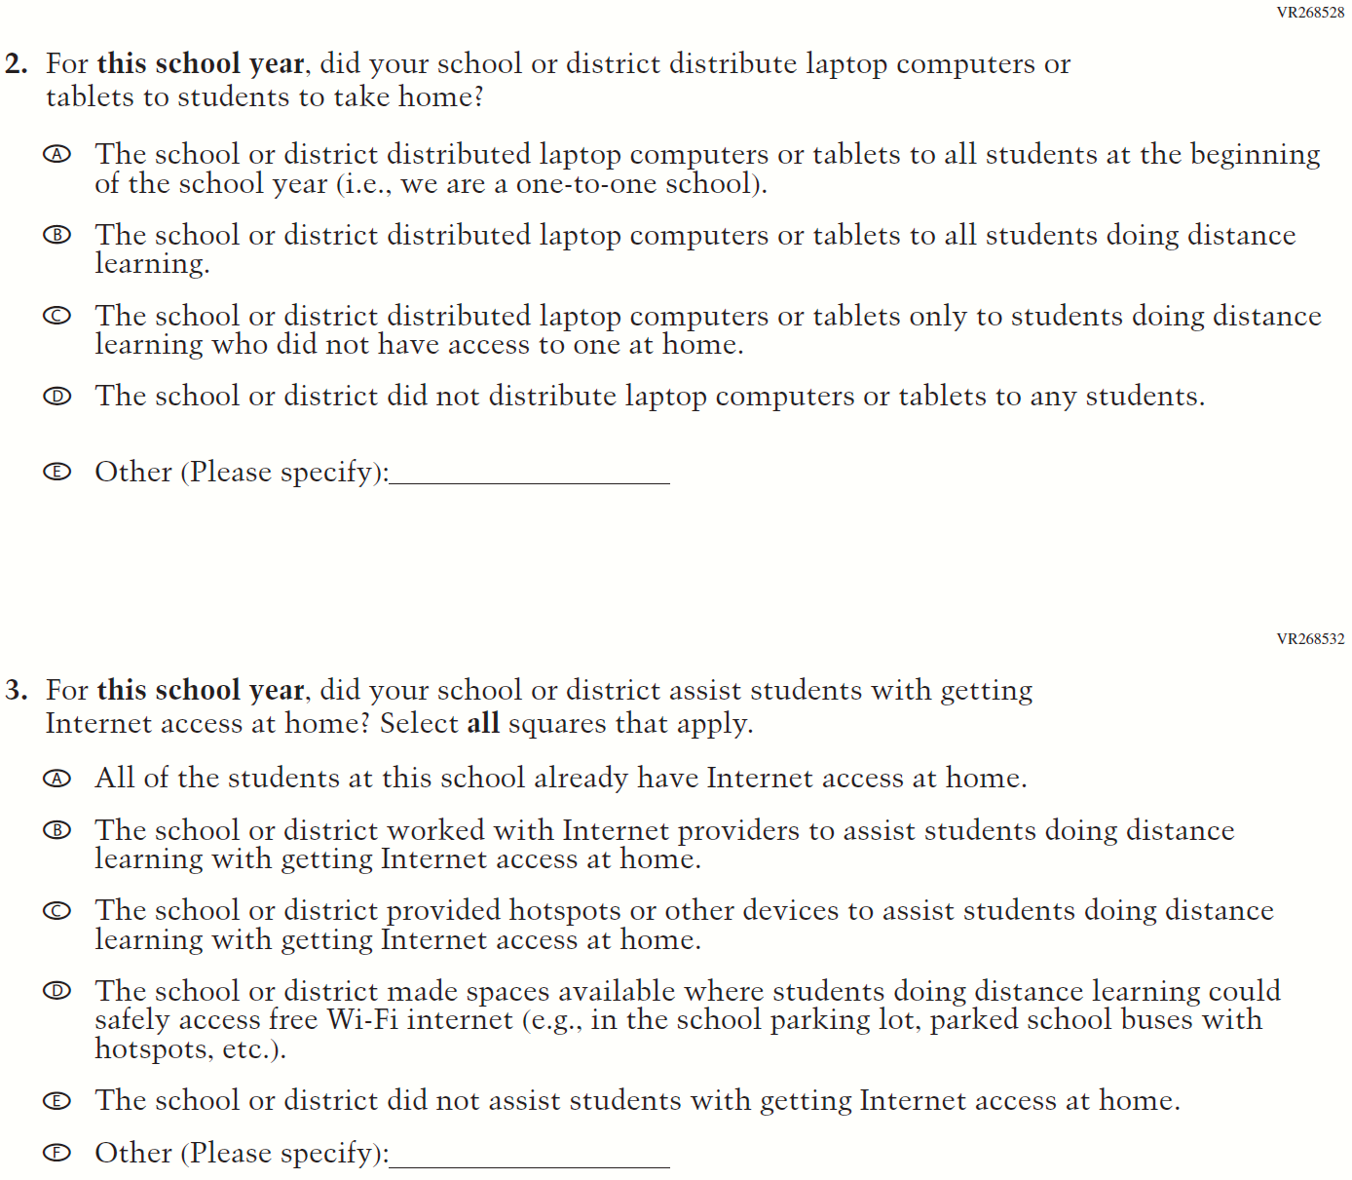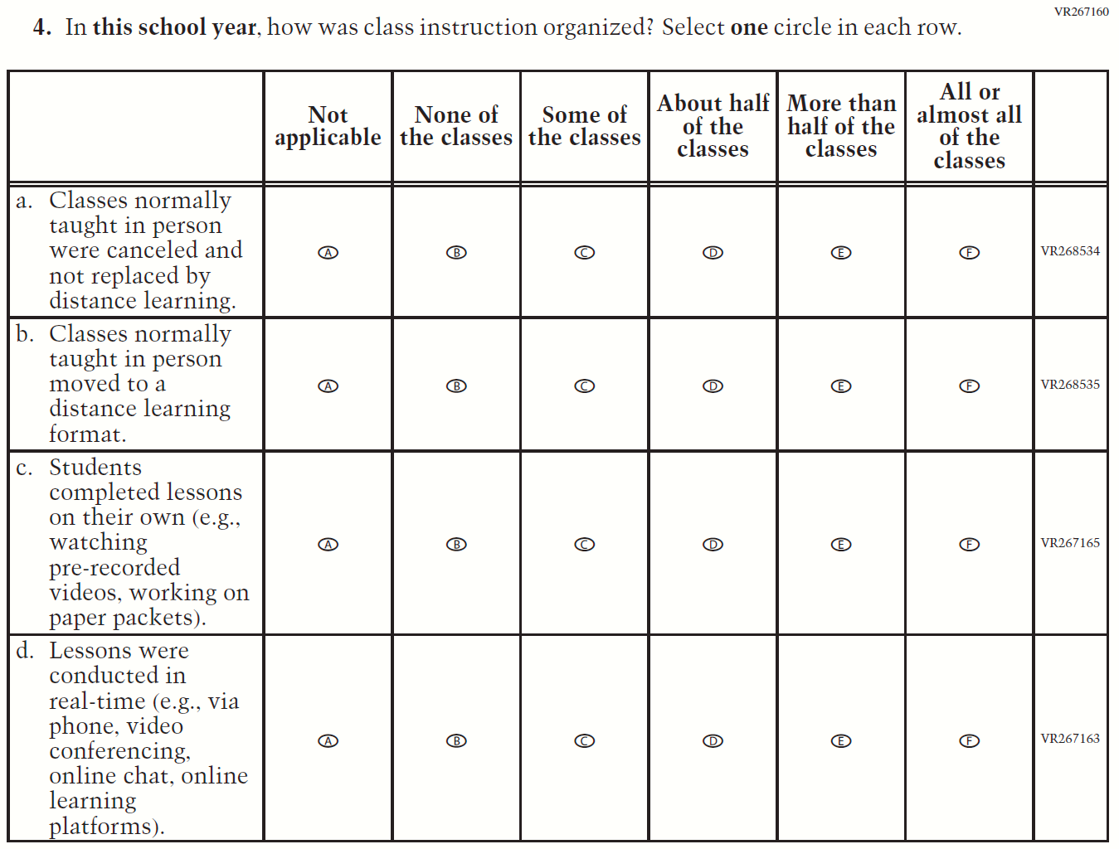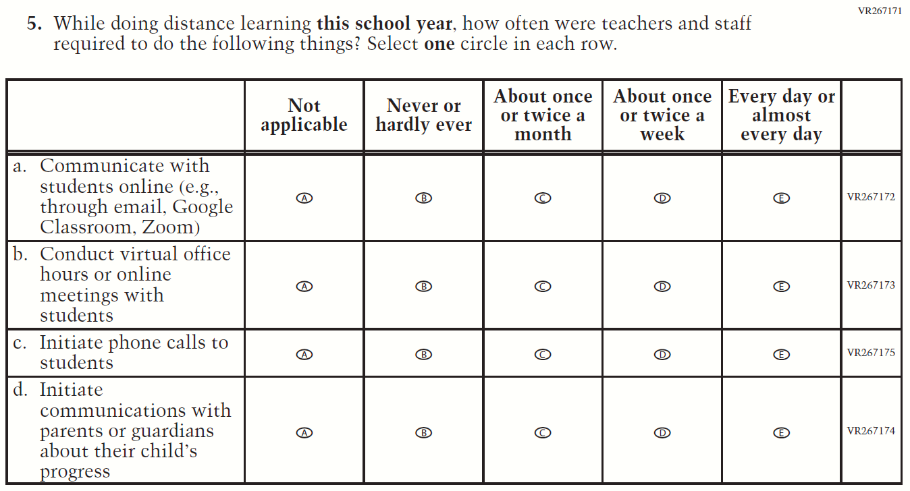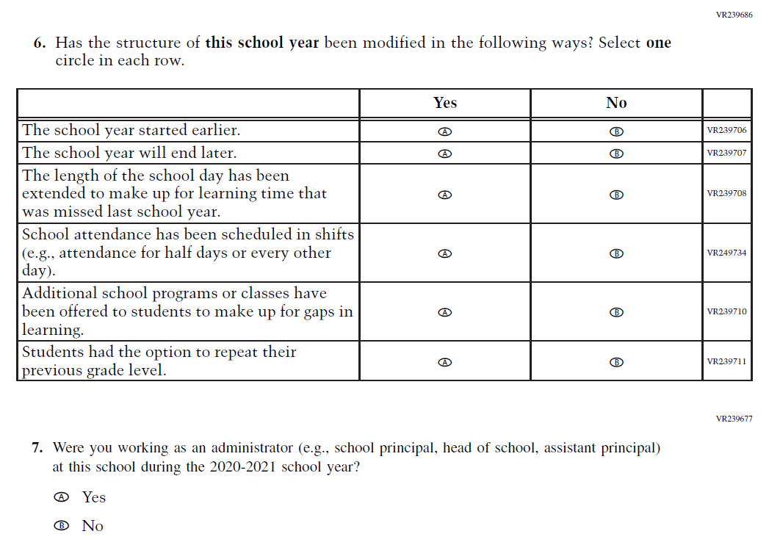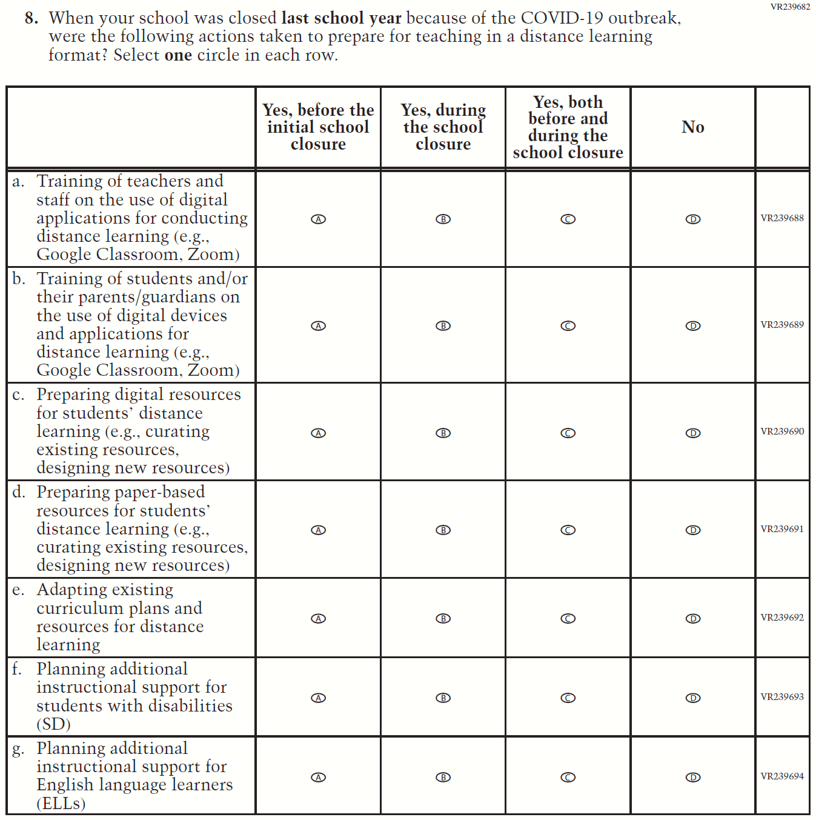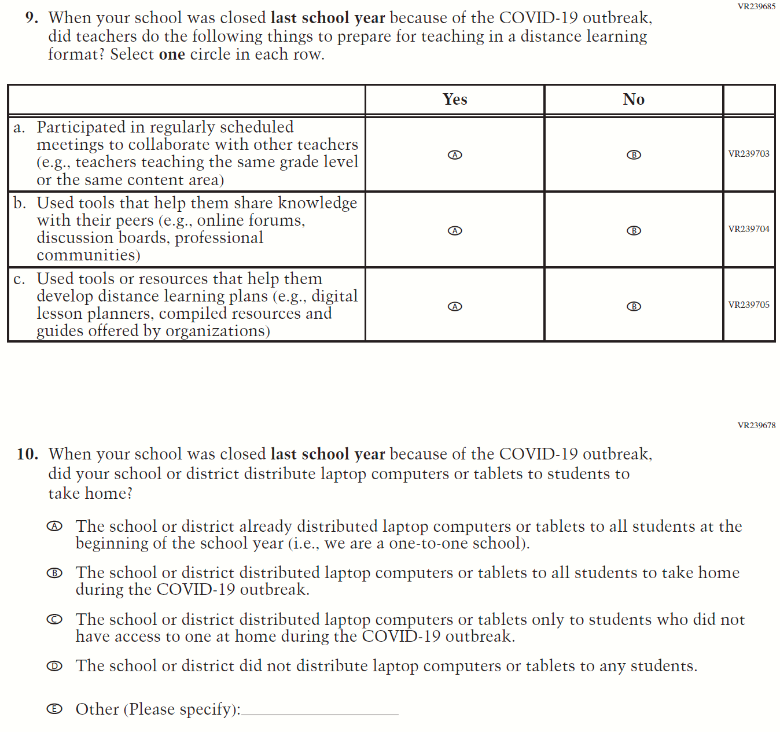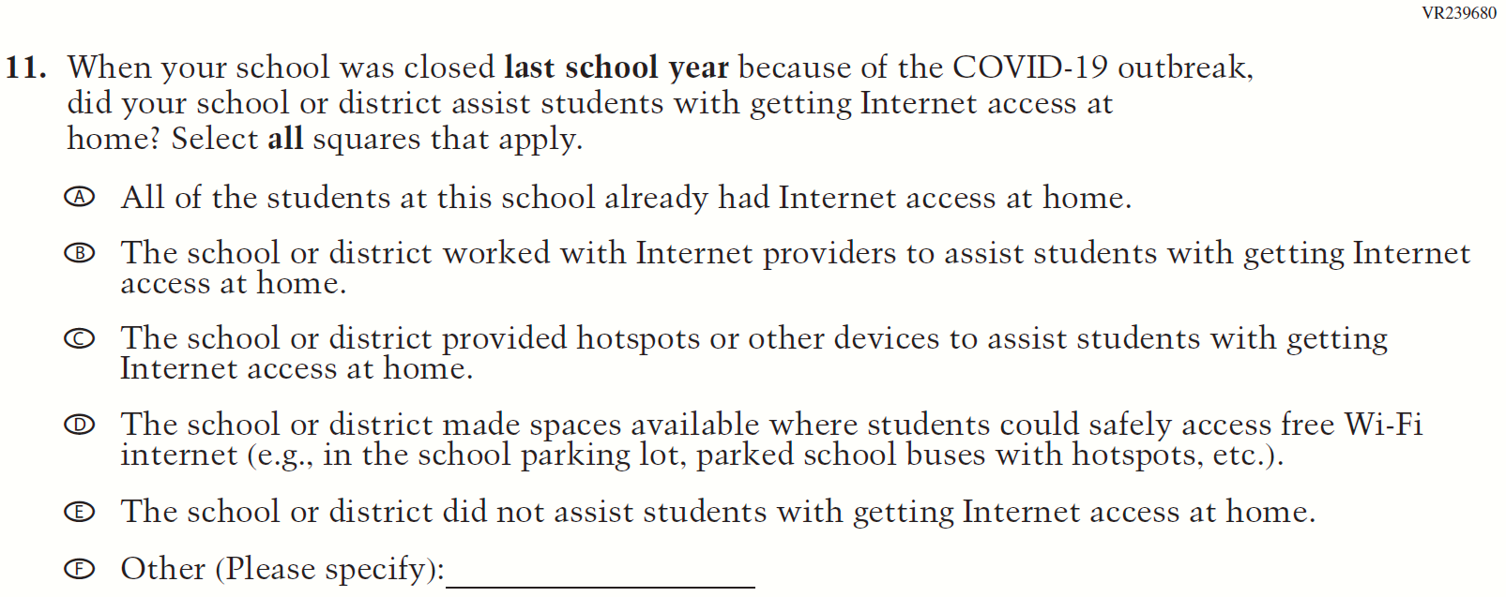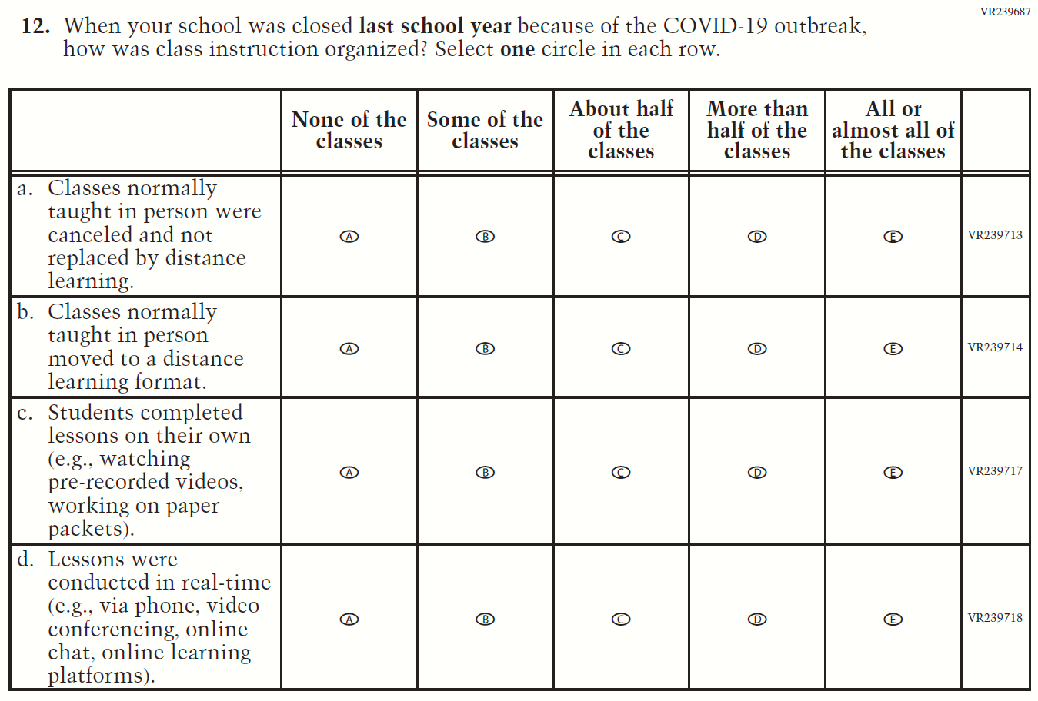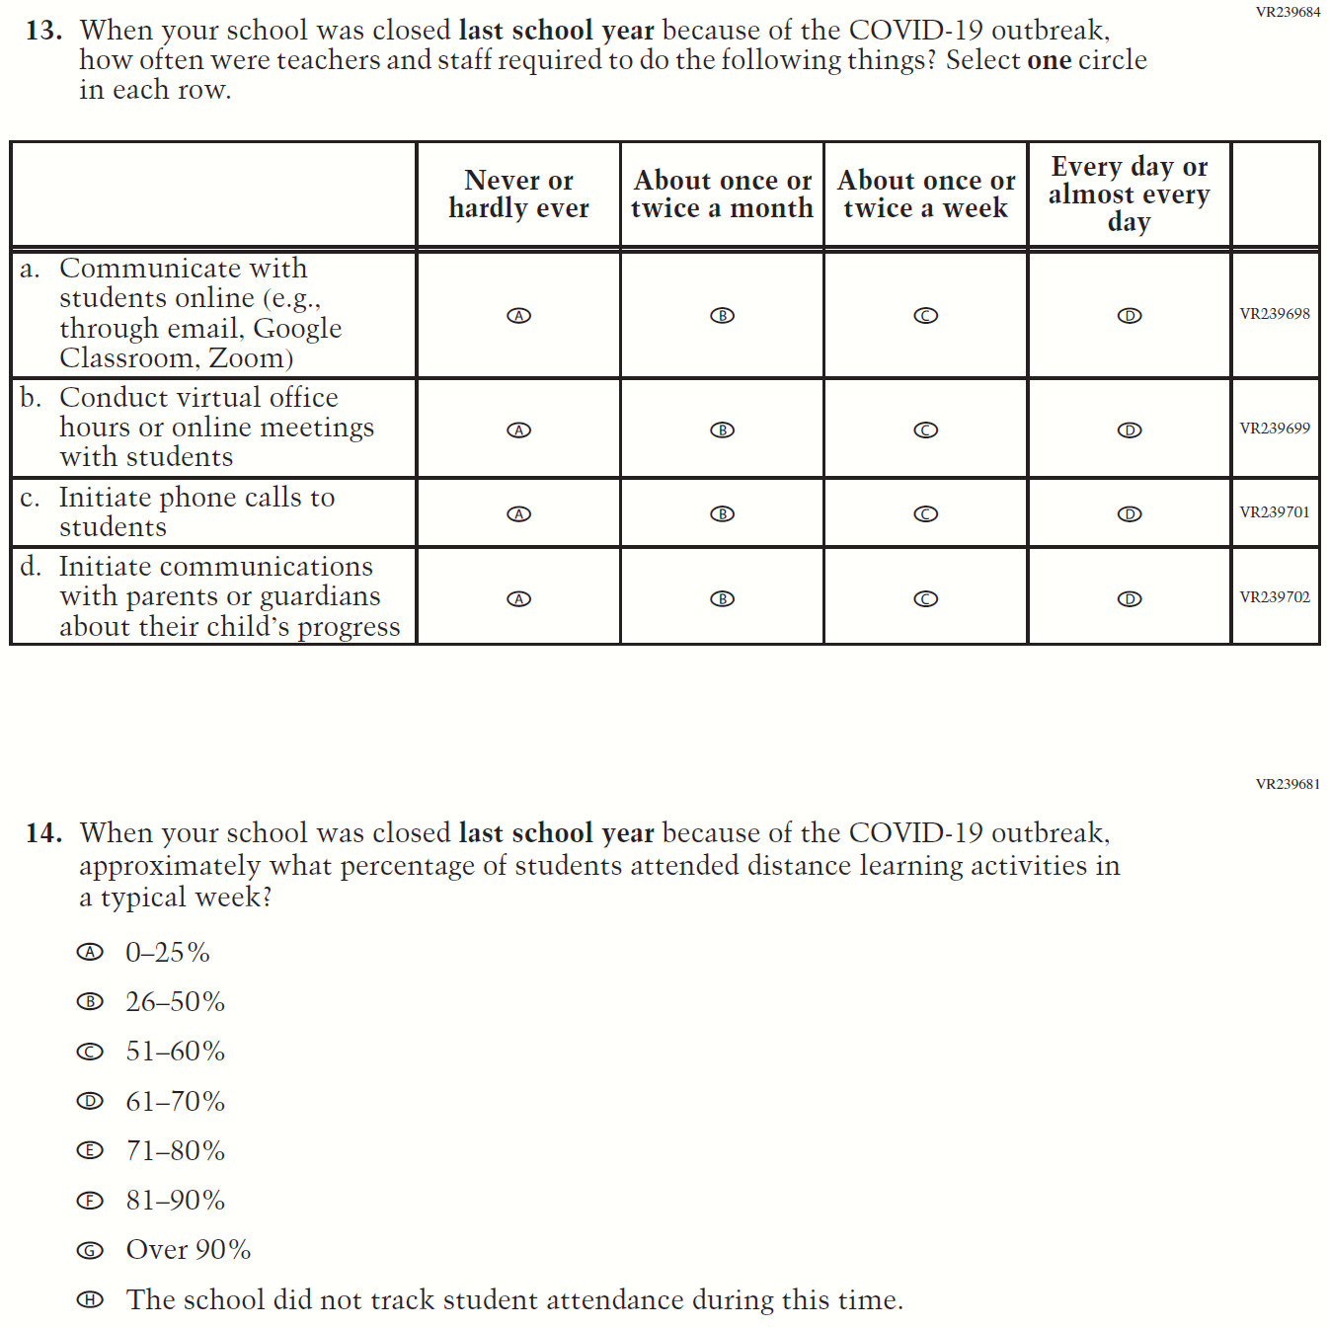

Appendix J3-19: Summary of Operational Grade 8 COVID-19 School Items
2022 Operational Grade 8 COVID-19 School Items
Previous item | 2022 item | D/A/R/NC+ | Rationale
(2021 Grade 8) | Issue: Resources for Learning and Instruction | NC | N/A

2022 Operational Grade 8 COVID-19 School Items
Previous item | 2022 item | D/A/R/NC+ | Rationale
(2021 Grade 8) | Issue: Technology Use and Access | NC | N/A
(2021 Grade 8) | Issue: Technology Use and Access | NC | N/A

2022 Operational Grade 8 COVID-19 School Items
Previous item | 2022 item | D/A/R/NC+ | Rationale
(2021 Grade 8) | Issue: Organization of Instruction | NC | N/A

2022 Operational Grade 8 COVID-19 School Items
Previous item | 2022 item | D/A/R/NC+ | Rationale
(2021 Grade 8) | Issue: Resources for Learning and Instruction | NC | N/A
(2021 Grade 8) | Issue: Organization of Instruction | NC | N/A

2022 Operational Grade 8 COVID-19 School Items
Previous item | 2022 item | D/A/R/NC+ | Rationale
(2021 Grade 8) | Issue: Organization of Instruction | R | This item has been updated to reference the correct academic year for the 2022 administration.
(2021 Grade 8) | Issue: Resources for Learning and Instruction | NC | N/A

2022 Operational Grade 8 COVID-19 School Items
Previous item | 2022 item | D/A/R/NC+ | Rationale
(2021 Grade 8) | Issue: Resources for Learning and Instruction | NC | N/A
(2021 Grade 8) | Issue: Technology Use and Access | NC | N/A

2022 Operational Grade 8 COVID-19 School Items
Previous item | 2022 item | D/A/R/NC+ | Rationale
(2021 Grade 8) | Issue: Technology Use and Access | NC | N/A
(2021 Grade 8) | Issue: Organization of Instruction | NC | N/A

2022 Operational Grade 8 COVID-19 School Items
Previous item | 2022 item | D/A/R/NC+ | Rationale
(2021 Grade 8) | Issue: Resources for Learning and Instruction | NC | N/A
(2021 Grade 8) | Issue: Resources for Learning and Instruction | NC | N/A

Appendix J3-20: Operational Grade 8 COVID-19 School Items
