CDX Landing Page for Section 5 Submissions:

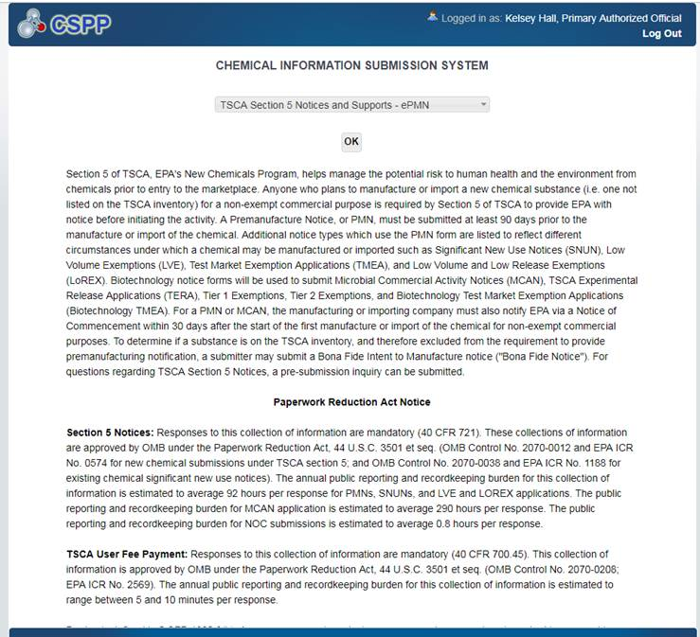
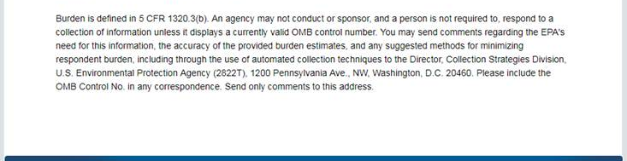

CDX Landing Page for Section 6 Submissions:

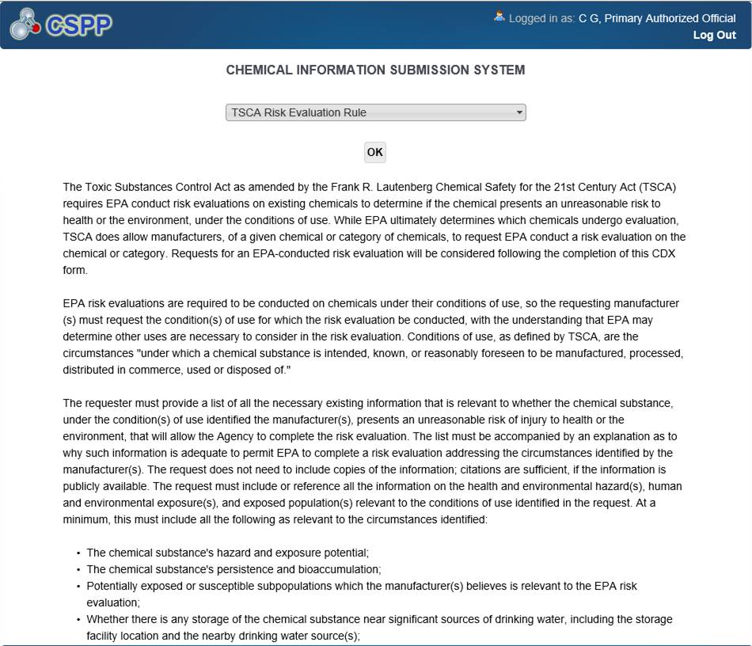

Continued on next page (Scroll down on screen).
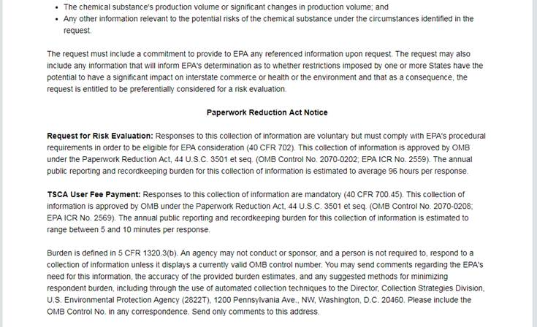

CDX New Payment Widget for Section 5 and 6 Submissions:

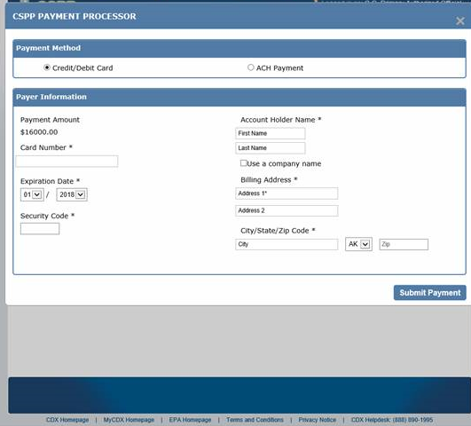

Section 5 Fees Certification Screen – New for Exemption Submissions:

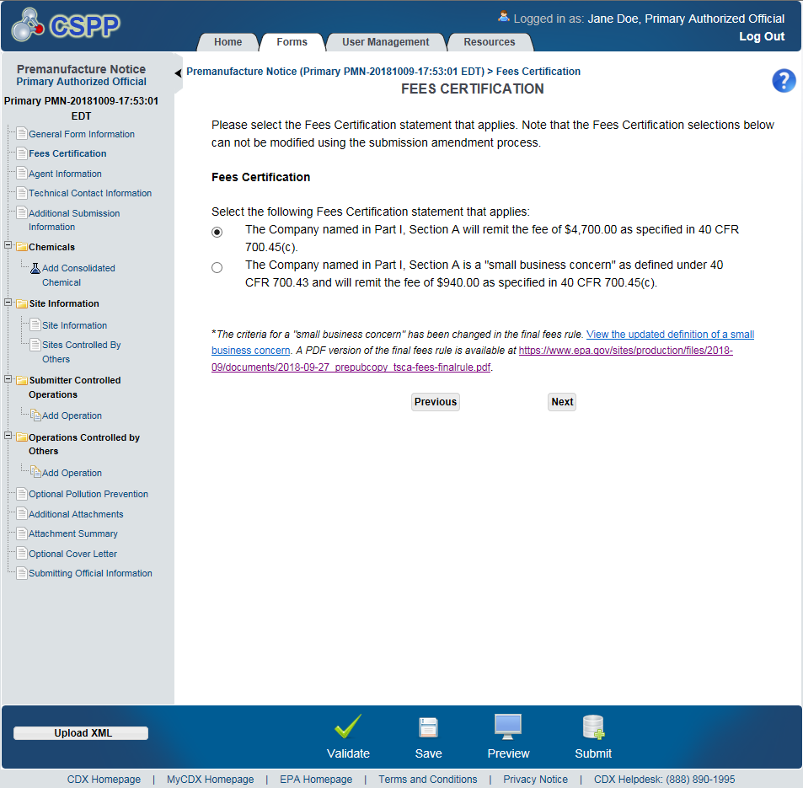

Section 5 Fees Certification Screen – New for TMEA Exemptions:

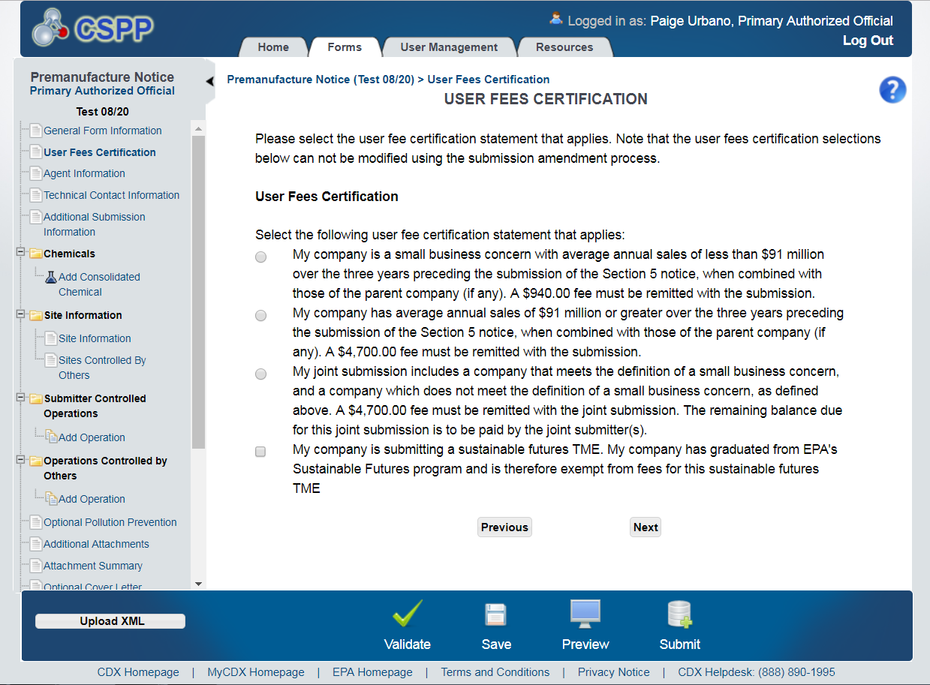

Section 6 Fees Certification Screen – New for Manufacturer Requests:

