Supporting Statement A
Transit COVID-19 Response Program
OMB Number 2132- 0581

ABSTRACT:

In accordance with the Paperwork Reduction Act (PRA) of 1995, the Federal Transit Administration (FTA) is requesting Office of Management and Budget (OMB) 3-year approval of an extension without change for a currently approved collection, previously authorized under emergency approval. FTA is collecting monthly data related to impacts from the coronavirus disease 2019 (COVID-19) on public transportation agencies, including transit workforce counts; transit service levels; counts of COVID-19 positives, fatalities, recoveries, and unvaccinated employees; whether or not a transit agency has implemented the U.S. Centers for Disease Control and Prevention (CDC) Order and Transportation Security Administration (TSA) Security Directive requiring workers and passengers to wear masks; and whether or not the agency has used FTA funds to support vaccine access services. FTA uses this data to inform FTA’s COVID-19 response and recovery actions, including monitoring of safety measures and impacts, development of technical assistance and safety advisories, monitoring use of FTA grant funds to address COVID-19 considerations, and monitoring compliance with Federal requirements.

FTA began this information collection in April 2021 under OMB emergency approval. On June 24, 2021, FTA issued a 60-day Federal Register Notice requesting the extension of the approved information collection. This subsequent 30-day Federal Register Notice requesting public comments follows OMB's normal PRA clearance process. There have been no substantive changes to the information collection application and associated data since the initial request. FTA is requesting information collection approval for up to three years.

1. Explain the circumstances that make the collection of information necessary. Identify any legal or administrative requirements that necessitate the collection.
The collection of this information is necessary for FTA to provide risk-based guidance and support for transit industry COVID-19 recovery efforts. In addition, the collected information assists FTA in assessing compliance with a CDC Order and TSA Security Directive mandating masks on public transit. This information collection is essential to FTA’s safety oversight and grant-making roles—both critical to the Agency’s mission of improving public transportation for America's communities. Disruptions in acquiring this information may hinder Federal efforts regarding emergency funding and assessing the impacts of COVID-19 on the transit industry and thereby increase the risk associated with COVID-19 to transit systems, workers, and passengers.

COVID-19 poses significant risk to the Nation’s communities and transit providers. Although some transit providers have suspended service and a greater number have reduced service, throughout the COVID-19 public health emergency, transit agencies across the country continue to provide millions of trips to lifeline services, including transporting healthcare personnel and other essential workers on the front line of the Nation’s COVID-19 response. Transit agencies also offer additional essential services to support communities during the public health emergency, such as meal delivery and Wi-Fi access in underserved areas, and offer a range of vaccine access services. Accordingly, the Cybersecurity and Infrastructure Security Agency designates transit workers as essential critical infrastructure workers.
Transit agencies and other stakeholders have expressed concerns about the risk of COVID-19 to the transit industry and, along with FTA, have taken steps to address these concerns. Numerous transit agencies have implemented mitigations to limit the transmission of SARS-CoV-2, the virus that causes COVID-19, among their workers and within their systems. Despite these efforts, frontline transit workers remain at high risk for work-related exposure to SARS-CoV-2 because their work-related duties must be performed on-site and involve being in close proximity (<6 feet) to the public or to coworkers. In addition, many transit workers fall within racial and socioeconomic demographics that are at increased risk of getting sick and dying from COVID-19.
On January 29, 2021, CDC issued an Order requiring the wearing of masks by travelers, including on public transportation, to prevent spread of the virus that causes COVID-19. CDC’s Order implemented Presidential Executive Order 13998. Pursuant to the CDC Order, transportation operators must require that all persons wear masks when boarding, disembarking, and for the duration of travel, with certain exemptions. Operators of transportation hubs, which include bus terminals and subway stations, must require all persons wear a mask when entering or on the premises of a transportation hub. As of its June 10, 2021 announcement, CDC is not enforcing the wearing of masks by persons while outdoors on transportation vehicles or while outdoors in transportation hubs. TSA issued a Security Directive on February 1, 2021 that implements the CDC Order. On August 20, 2021, TSA extended the Security Directive through January 18, 2022 to curb the spread of COVID-19. This information collection allows FTA to assess compliance with these Federal mask mandates.

FTA’s information collection captures the number of transit workers that may still not be vaccinated. The communities served by transit agencies continue to rely on them to provide critical transportation services every day—including transportation to vaccination sites. This information collection allows FTA to monitor the number of transit workers that have reported that they have been vaccinated and captures information on transit agencies’ efforts to support vaccine access for their communities—both critical data points to support FTA response activity. According to data from the CDC, 70 percent of adult Americans had received at least one vaccination shot on August 2, 2021. Continued concern regarding vaccine access and hesitancy among transit workers and the U.S. public presents challenges to increasing this percentage further.
New, more transmissible variants of the virus have recently emerged, including the B.1.617.2 (Delta) variant. Between June 30, 2021 and July 31, 2021, after five months of decreasing trends in COVID-19 cases and hospitalizations, data show that cases increased by over 500 percent and hospitalizations increased by over 160 percent. In light of the Delta variant and increased spread and hospitalizations, CDC reversed its May 2021 recommendation that fully vaccinated individuals did not need to wear masks indoors and now recommends that all Americans in areas of surging COVID-19 transmission should wear masks while indoors, regardless of their vaccination status.

Authority

FTA’s authority to collect this information is derived from 49 U.S.C § 5334.

The American Rescue Plan Act of 2021 (ARP), enacted on March 11, 2021, includes $30.5 billion in Federal funding to support the nation’s public transportation systems as they continue to respond to the COVID-19 pandemic and support vaccination of the U.S. population

Since April 2020, FTA also allocated $25 billion in emergency relief funding to the U.S. transit industry through the Coronavirus Aid, Relief and Economic Security (CARES) Act (P.L. 116–136) and another $14 billion provided through the Coronavirus Response and Relief Supplemental Appropriations Act of 2021 (CRRSAA) (P.L.116-260). Funding through ARP and CRRSAA, like the CARES Act, is at 100-percent Federal share with no local match required.

In addition, for Fiscal Year 2020, FTA apportioned over $12.5 billion in funding authorized under the Fixing America's Surface Transportation Act (FAST Act) (P.L. 114-94) and the Further Consolidated Appropriations Act, 2020 (P. L. 116-94).

2. Indicate how, by whom, and for what purpose the information is to be used. Except for a new collection, indicate the actual use the agency has made of the information received from the current collection.

FTA will collect this information via an online fillable application. The purpose of this data collection is to enable FTA to provide risk-based guidance and support for the transit industry’s COVID-19 recovery efforts.

FTA will require applicable FTA grant recipients to report data on three topics and submit updates monthly:
- Transit Worker Counts: Total number of transit operators, other frontline essential personnel, and other workers during the reporting period. This data is not currently available to the Federal Government for all required reporters. This information is critical to identifying the number of transit workers supporting transportation for essential workers across the country. The information may become necessary to inform the distribution of vaccine doses based on risk to the transit workforce.
- COVID-19 Impacts on Transit Agency Service Levels: Yes or no responses to indicate if the agency suspended service, reduced service, or operated at normal levels during the reporting period. This data is not currently available to the Federal Government for all required reporters. This information is critical to understanding agency-level COVID-19 impacts and continued risk to transit agencies’ capability to provide transportation to support essential services in communities across the country, including transportation to vaccination sites.
- COVID-19 Impacts on Transit Workforce: Cumulative counts of transit worker COVID-19 positives, fatalities, recoveries, and unvaccinated employees during the reporting period, to the extent the grant recipient is able to compile such information consistent with applicable privacy laws, and yes or no responses on whether the agency is requiring workers to be vaccinated, whether the agency has implemented the CDC Order and TSA Security Directive requiring workers and passengers to wear masks, and whether the agency has used FTA funds to support vaccine access services and which vaccine services the agency provides. This data is not currently available to the Federal Government. This information is critical to understanding agency-level COVID-19 risk to transit workers and passengers, and the follow-on effects of worker shortages on operational capacity. This information will help inform policy and guidance regarding COVID-19 recovery efforts in transit with consideration for the health and safety of transit workers and passengers.

Since the collection began under the emergency approval in April 2021, FTA has used this information to monitor COVID-19 impacts on the transit industry, inform FTA policy and funding decisions to support COVID-19 recovery in the U.S. public transportation industry, monitor transit systems’ compliance with Federal mask requirements, and support COVID-19 vaccine access efforts.
3. Describe whether, and to what extent, the collection of information involves the use of automated, electronic, mechanical, or other technological collection techniques or other forms of information technology.

FTA will collect this information via a fillable online electronic application. To reduce the burden on reporters, the application leverages FTA’s existing Transit Integrated Appian Development (TrIAD) platform, the same platform that hosts FTA’s National Transit Database. Applicable users access the COVID-19 online application using their existing login credentials.

4. Describe efforts to identify duplication. Show specifically why any similar information already available cannot be used or modified for use for the purposes described in Item 2 above.

This is an extension of a previously approved information collection approved under emergency clearance. The specific information requested is unique to this situation and the transit industry. The information is not publicly available elsewhere. Though FTA has other approved information collections under the PRA that collects select aspects of service levels, this data cannot be used for the purpose of this information collection as it is retrospective and does not provide the contemporaneous information needed for this purpose.

5. If the collection of information involves small businesses or other small entities, describe the methods used to minimize burden.

This information collection has been designed to minimize the burden on all respondents. Each data point will be a single entry, with the option of clicking a single button to indicate no change from the previous reporting period.

Recipients may use funding provided at 100-percent Federal share with no local match through the CARES Act, CRRSAA, and the ARP Act of 2021 to cover costs related to this collection.

6. Describe the consequence to Federal program or policy activities if the collection is not conducted or is conducted less frequently, as well as any technical or legal obstacles to reducing burden.

Without approval to collect this information on a monthly basis, FTA will be ill-equipped to provide risk-based guidance and support for the COVID-19 response and recovery efforts of the transit industry. As the COVID-19 public health emergency evolves, guidance from CDC and other public health entities is expected to change, and States and transit agencies may adjust their vaccination approaches in response. Delays or reduced frequency in acquiring this information may hinder Federal action to support COVID-19 response and recovery in the transit industry. Delays or reduced reporting frequency may also impact FTA’s efforts to assess compliance with recent Federal mask mandates and to monitor voluntary industry support for vaccine access, all of which may increase the risk associated with COVID-19 to transit systems, workers, and passengers.
7. Explain any special circumstances that would cause an information collection to be conducted in a manner inconsistent with OMB guidelines 5 CFR 1320.6:

FTA is collecting this information to enable rapid Federal response to a quickly evolving public health emergency and the assessment of compliance with new Federal mask requirements and support for vaccine access. Quarterly updates of this data will not provide FTA with an understanding of the present transit operational realities sufficient to inform its activities to support the transit industry’s COVID-19 recovery efforts. In order to make risk-based decisions to aid in the vaccine distribution efforts, FTA must have access to up-to-date data. Monthly information collection balances the need for up-to-date information and the potential burden placed on respondents.

There is no required written response and no requirement for respondents to submit documentation or retain records beyond what is already required by FTA.

This is not a statistical data collection; it is a fillable electronic online application that leverages FTA’s existing TrIAD platform, the same platform that hosts FTA’s National Transit Database.

This information collection does not require respondents to submit proprietary information.

Respondents may use funding provided at 100-percent Federal share with no local match through the CARES Act, CRRSAA, and the ARP Act of 2021 to cover costs related to this collection.

8. Provide information on the PRA Federal Register Notice that solicited public comments on the information collection prior to this submission. Summarize the public comments received in response to that notice and describe the actions taken by the agency in response to those comments. Describe the efforts to consult with persons outside the agency to obtain their views on the availability of data, frequency of collection, the clarity of instructions and recordkeeping, disclosure, or reporting format (if any), and on the data elements to be recorded, disclosed, or reported.

On June 24, 2021 (Vol. 86 No. 119), FTA issued a 60-day Federal Register Notice for the three year approval under the PRA. FTA did not receive any comments in response to this 60-day Federal Register Notice.

The 60-day Federal Register Notice summarized the eight comments received in response to its initial request for emergency OMB approval in March 2021. Five respondents noted concerns with providing data on the number of vaccinated workers. FTA clarified that while it expects all respondent agencies to collect and submit COVID-19 data for all transit workers, if an agency or its contractor is prohibited by State or local laws from collecting data on whether their employees have been vaccinated, the respondent should not include these workers in the “Number of Workers Not Vaccinated” field. Further, the form allows agencies to leave this form blank in such a situation.

Two respondents noted concerns with collecting information on worker COVID-19 cases, recoveries, and fatalities. FTA clarified that agencies should submit COVID-19 data, to the extent that they are able to compile such information, for all workers (employees and contractors) that support the operation of the agency. FTA encouraged agencies to report data based on their current knowledge and understanding of the COVID-19 impacts on their organization.

Two respondents noted concerns with the feasibility of collecting and reporting, and the level of effort required to collect and report required data points. In an effort to reduce the burden on reporters, FTA has leveraged its existing Transit Integrated Appian Development Platform, the platform that hosts the National Transit Database, to facilitate reporting through an online application. FTA also has made available a Recurring Form Template, which was developed to assist Section 5311 recipients with collecting data on behalf of their subrecipients in support of the Transit COVID-19 Response Program Information Collection online application. The template includes the same fields and options as the Recurring Form in the online application.

One respondent requested clarification on how FTA will handle late reports. FTA explained that respondents may submit and/or revise their responses at any time in either the Baseline Form or the Recurring Form to address errors or if updated data becomes available.

One respondent requested the exclusion of Section 5311 subrecipients from the reporting requirement. FTA clarified that the reporting requirement is a condition of FTA funding assistance.

One respondent requested a 30-day extension of the comment period for the notice of request for emergency OMB approval. FTA noted that respondents will have the opportunity to provide written comments to the 60-day and 30-day notices.

To further communicate and provide outreach to stakeholders, FTA has established a team within its Office of Transit Safety and Oversight to provide technical assistance and answer questions from respondents regarding this collection. FTA has held four webinars to help different respondent groups answer the questions in the online application and has made these recordings publicly available. FTA has also published a user manual, fact sheets, demonstration videos, and a data collection template. Further, FTA assists respondents with any issues or questions related to the information collection through the FTASystemSafety@dot.gov email box.

These stakeholder outreach and technical assistance efforts have been successful. FTA has worked with respondents to process over 430 questions/issues and also reached out to respondents to close over 100 validation issues. After the first four months of data collection, the industry has a submission compliance rate of over 99 percent.

A 30-Day Federal Register Notice was published on September 23, 2021 Vol. 86 No. 182 (pages 52945-52947).

9. Explain any decisions to provide payments or gifts to respondents, other than remuneration of contractors or grantees.

FTA will not provide payments or gifts.

10. Describe any assurance of confidentiality provided to respondents and the basis for assurance in statute, regulation, or agency policy.

FTA offers no assurance of confidentiality. However, responses will not include personally identifying information. FTA will aggregate responses for purposes of vaccine planning and distribution and other COVID-19 response and recovery activities.

11. Provide additional justification for any questions of a sensitive nature, such as sexual behavior and attitudes, religious beliefs, and other matters that are commonly considered private.

FTA will not ask questions of a sensitive nature.

12. Provide estimates of the hour burden of the collection of information.

Estimated Total Respondents: 2,390 Comprised of 943 (Section 5307 respondents), 52 (Rural-Section 5311 respondents), 128 (Tribal-Section 5311 respondents), and 1267 (Section 5310 respondents)
Estimated Total Responses: 28,680
Estimated Total Burden Hours: 10,356
Estimated Total Cost: $1,222,008
Frequency: Monthly
This information collection will apply to recipients and subrecipients of FTA funds under the Urbanized Area Formula Funding program (49 U.S.C. § 5307) and/or the Formula Grants for Rural Areas program (49 U.S.C. § 5311) that operate transit systems or pass through funds to subrecipients that operate transit systems. Recipients of FTA funds under the Enhanced Mobility of Seniors and Individuals with Disabilities program (49 U.S.C. § 5310) may be asked to provide this information on a voluntary basis in the future.
FTA anticipates the total annualized burden to the transit industry, assuming forms are submitted every month for one year, to be 10,356 hours, and the total annualized cost to the transit industry to be $1,222,008.
Section 5307 Public Transportation Agencies = 943 Total Respondents
FTA intends to continue its request for monthly responses from approximately 943 transit agencies. On average, we expect each transit agency to spend approximately 10 minutes responding to monthly collection.
943 x 10 minutes (monthly) = 9,430 minutes (monthly) = 157 hours (rounded)
As FTA plans to collect information for a 12-month period, the total burden will be as follows:
157 hours x 12 months = 1,884 annual burden hours (rounded)
FTA estimates the total annualized cost to Section 5307 transit agencies to be $222,312.

This estimate is based on the mean hourly wage of a General and Operations Manager. The mean hourly pay for a General and Operations Manager is $59 (rounded), multiplied by 2 to account for benefits plus other overhead costs such as rent, utilities, and office equipment, for a fully-loaded hourly wage of $118.

$118 x 1,884 hours = $222,312
Section 5311 Rural Public Transportation Providers
FTA intends to continue its request for monthly responses from all recipients of Section 5311 grants that provide funds to 1,300 rural public transportation providers. Fifty-two (52) Section 5311 recipients will be required to respond to the information collection on behalf of the 1,300 rural public transportation providers.
On average, a Section 5311 recipient will provide responses on behalf of 25 Section 5311 subrecipients. We expect Section 5311 recipients and associated rural public transportation providers to spend approximately 16 minutes per subrecipient to respond to each monthly collection. The 16-minute estimate covers the capture of information from the subrecipient and the entering of information into the form by the recipient.
52 x 25 x 16 minutes (monthly) = 20,800 minutes (monthly) = 347 hours (rounded)
As FTA plans to collect information for a 12-month period, the total burden will be as follows:
347 hours x 12 months = 4,164 hours
FTA estimates the total annualized cost to 5311 recipients and subrecipients to be $491,352.

This estimate is based on the mean hourly wage of a General and Operations Manager. The mean hourly pay for a General and Operations Manager is $59 (rounded), multiplied by 2 to account for benefits plus other overhead costs such as rent, utilities, and office equipment, for a fully-loaded hourly wage of $118.

$118 x 4,164 hours = $491,352
Section 5311 Tribal Transit Providers
FTA intends to continue its request for responses from all Section 5311 recipient tribal transit providers. One-hundred and twenty-eight (128) tribal transit providers will be required to respond directly to the information collection. On average, we expect each tribal transit agency to spend approximately 10 minutes responding to each monthly collection.
128 x 10 minutes (monthly) = 1,280 minutes (monthly) = 21 hours (rounded)
As FTA plans to collect information for a 12-month period, the total burden will be as follows:
21 hours x 12 months = 252 hours
FTA estimates the total annualized cost to Section 5311 tribal transit providers to be $29,736.

This estimate is based on the mean hourly wage of a General and Operations Manager. The mean hourly pay for a General and Operations Manager is $59 (rounded), multiplied by 2 to account for benefits plus other overhead costs such as rent, utilities, and office equipment, for a fully-loaded hourly wage of $118.

$118 x 252 hours = $29,736
Section 5310 Providers (FUTURE VOLUNTARY COLLECTION)
FTA may request voluntary responses from all recipients of Section 5310 grants that cover approximately 1,267 Section 5310 subrecipients. Section 5310 recipients will report data on behalf of their Section 5310 subrecipients.

We expect the information collection to take Section 5310 recipients approximately 16 minutes per subrecipient to respond to each monthly collection. The 16-minute estimate covers the capture of information from the subrecipient and entering the information into the form by the recipient.
1,267 x 16 minutes (monthly) = 20,272 minutes (monthly) = 338 hours (rounded)
As FTA plans to collect information for a 12-month period, the total burden will be as follows:
338 hours x 12 months = 4,056 hours
FTA estimates the total annualized cost to 5310 agencies to be as high as $478,608.

This estimate is based on the mean hourly wage of a General and Operations Manager. The mean hourly pay for a General and Operations Manager is $59 (rounded), multiplied by 2 to account for benefits plus other overhead costs such as rent, utilities, and office equipment, for a fully-loaded hourly wage of $118.

$118 x 4,056 hours = $478,608

Summary (Annual numbers) | Reporting | Recordkeeping
Section 5307 Agencies
# of Respondents | 943 | —
# of Responses per respondent | 12
Time per response | 10 min.
Total # of responses | 11,316
Total burden (hours) | 1,884
Section 5311 Rural Agencies
# of Respondents | 52 | —
# of Responses per respondent | 12
Time per response | 400 min.
Total # of responses | 624
Total burden (hours) | 4,164
Section 5311 Tribal Agencies
# of Respondents | 128 | —
# of Responses per respondent | 12
Time per response | 10 min.
Total # of responses | 1,536
Total burden (hours) | 252
Section 5310 Agencies (VOLUNTARY)
# of Respondents | 1,267 | —
# of Responses per respondent | 12
Time per response | 16 min.
Total # of responses | 15,204
Total burden (hours) | 4,056

13. Provide an estimate for the total annual cost burden to respondents or record keepers resulting from the collection of information.

As this collection will be fully online, there is no additional cost burden to respondents.

14. Provide estimates of annualized costs to the Federal government. Also, provide a description of the method used to estimate cost, which should include quantification of hours, operational expenses (such as equipment, overhead, printing, and support staff), and any other expense that would not have been incurred without this collection of information.

The total estimated annualized cost to the Federal Government is $370,600. This is based on administering the collection monthly for a 12-month period.

FTA anticipates that one agency employee at the GS-14-1 level ($103 per hour including 75 percent overhead costs) will provide project management support. FTA anticipates the effort will take the individual approximately 8 hours per collection.

25($103 x 8 hours) = $20,600

FTA estimates that it will use contractor support resources to conduct ongoing validation and analysis of the collected information. FTA estimates the cost of these support services to be approximately $350,000.

15. Explain the reasons for any program changes or adjustments.
This is an extension of a previously approved information collection approved under emergency clearance. FTA has not applied any substantive changes or adjustments from the initial assumptions of the emergency approval.

16. For collections of information whose results will be published, outline plans for tabulation and publication. Address any complex analytical techniques that will be used. Provide the time schedule for the entire project, including beginning and ending dates of the collection of information, completion of report, publication dates, and other actions.

To ensure transparency for respondents, FTA provides a summary of key data points collected monthly on its website as part of its Spotlight Newsletter.
17. If seeking approval to not display the expiration date for OMB approval of the information collection, explain the reasons why display would be inappropriate.

FTA is not seeking such approval and will include all appropriate OMB information on the fillable application.

18. Explain each exception to the topics of the certification statement identified in “Certification for Paperwork Reduction Act Submissions.”

There are no exceptions.

Data Collection Format
The application will use two data collection formats to collect COVID-19 information from respondents:
- Baseline Request - (one-time) used to capture historical data on service reductions and suspensions during the COVID-19 public health emergency.
- Recurring Request - will be submitted monthly to capture data on:
  - Service levels
  - Worker counts
  - Worker positives
  - Worker fatalities
  - Worker recoveries
  - Worker vaccinations
  - Compliance with Federal face mask mandates
  - Support for vaccine access

The application will have the required PRA Statement and contain links to key terms and associated policies. FTA has also published a user manual that provides reporting instructions and guidance. A sample screenshot of the application is provided below followed by the list of questions.
Initial Log-in Screen with the PRA Statement
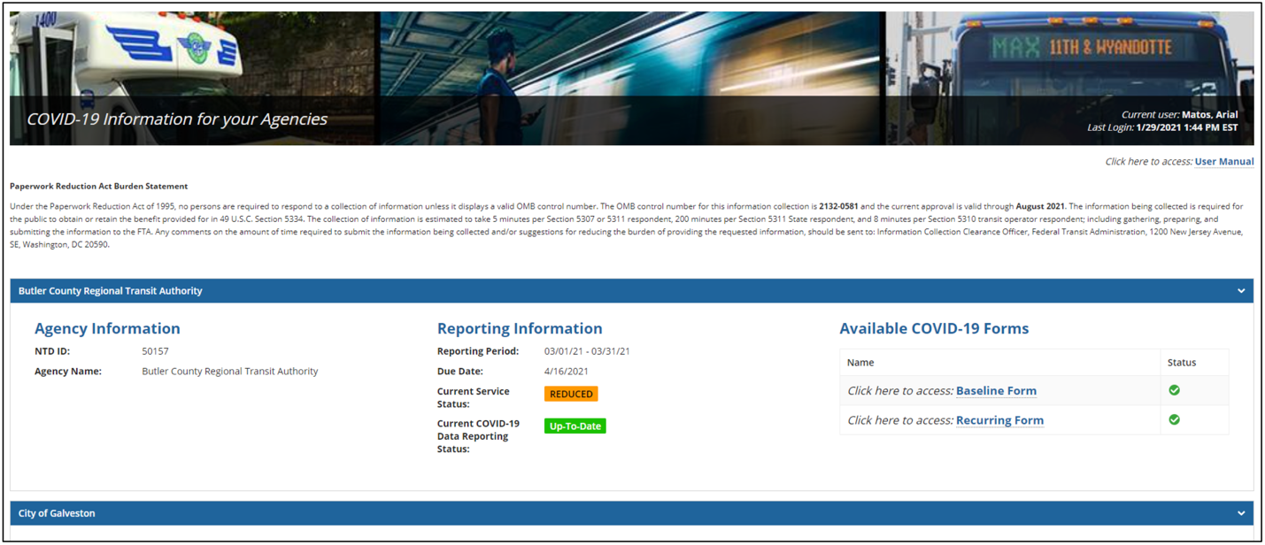

Baseline Submission
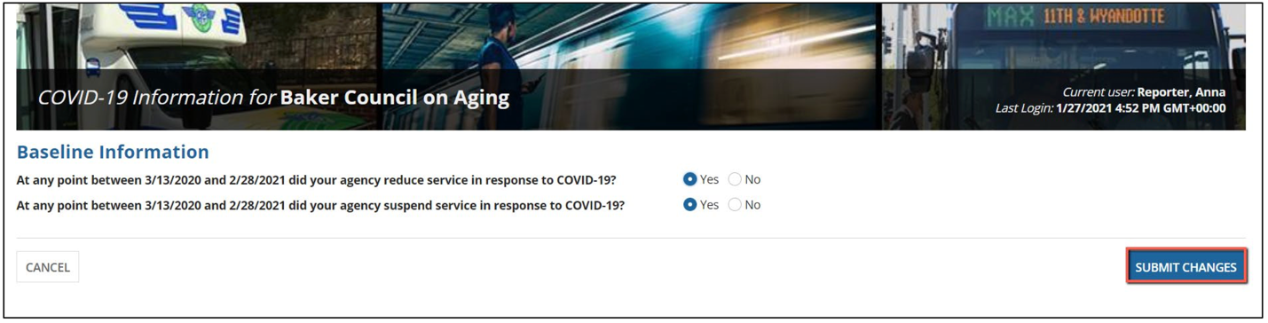
Recurring Submission
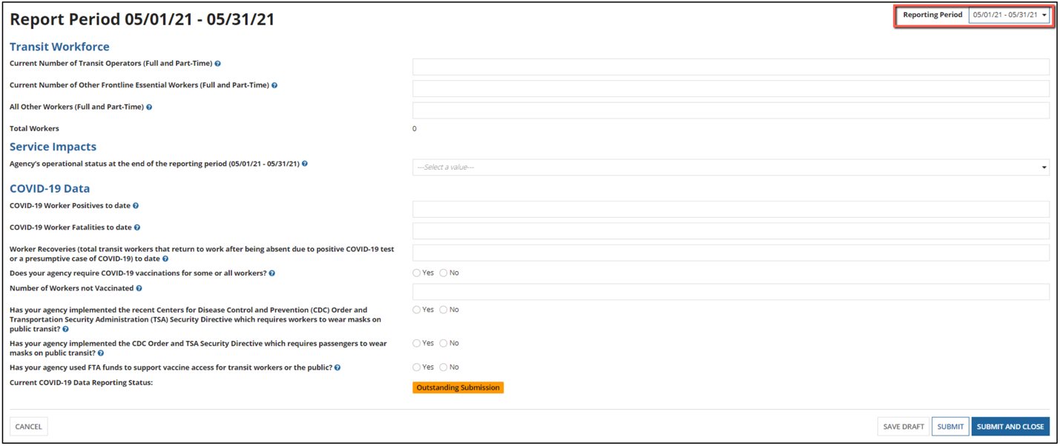
COVID-19 Baseline Questions
- At any point between 3/13/2020 and 2/1/2021 did your agency reduce service in response to COVID-19? Yes or No
- At any point between 3/13/2020 and 2/1/2021 did your agency suspend service in response to COVID-19? Yes or No
Recurring Submission Questions
Transit Workforce
- Current Number of Transit Operators (Full and Part-Time)
- Current Number of Other Frontline Essential Workers (Full and Part-Time)
- All Other Workers (Full and Part-Time)
Service Impacts
- Agency’s operational status at the end of the monthly period (Normal, Reduced, or Suspended)
COVID-19 Data
- COVID-19 Worker Positives to date
- COVID-19 Worker Fatalities to date
- Worker Recoveries (total transit workers that return to work after being absent due to positive COVID-19 test or presumptive case of COVID-19) to date
- Does your agency require COVID-19 vaccinations for some or all workers? Yes or No
- Number of workers not vaccinated
- Has your agency implemented the recent Centers for Disease Control and Prevention (CDC) Order and Transportation Security Administration (TSA) Security Directive which require workers to wear masks on public transit? Yes or No
- Has your agency implemented the CDC Order and TSA Security Directive which require passengers to wear masks on public transit? Yes or No
- Has your agency used FTA funds to support vaccine access for transit workers or the public? Yes or No

https://www.cdc.gov/quarantine/pdf/Mask-Order-CDC_GMTF_01-29-21-p.pdf
https://www.tsa.gov/sites/default/files/sd-1582_84-21-01.pdf
https://www.tsa.gov/news/press/releases/2021/08/20/tsa-extends-face-mask-requirement-through-january-18-2022
https://covidactnow.org
Based on Occupation 11-1021, BLS Occupational Employment Statistics, May 2019. See https://www.bls.gov/oes/current/oes_nat.htm - 11-0000.
U.S. Department of Health and Human Services, Guidelines for Regulatory Impact Analysis, Table 4.2, Constructing Default Estimates of the Value of Time, 2016. See https://aspe.hhs.gov/system/files/pdf/242926/HHS_RIAGuidance.pdf.
Based on Occupation 11-1021, BLS Occupational Employment Statistics, May 2019. See https://www.bls.gov/oes/current/oes_nat.htm - 11-0000.
U.S. Department of Health and Human Services, Guidelines for Regulatory Impact Analysis, Table 4.2, Constructing Default Estimates of the Value of Time, 2016. See https://aspe.hhs.gov/system/files/pdf/242926/HHS_RIAGuidance.pdf.
Based on Occupation 11-1021, BLS Occupational Employment Statistics, May 2019. See https://www.bls.gov/oes/current/oes_nat.htm - 11-0000.
U.S. Department of Health and Human Services, Guidelines for Regulatory Impact Analysis, Table 4.2, Constructing Default Estimates of the Value of Time, 2016. See https://aspe.hhs.gov/system/files/pdf/242926/HHS_RIAGuidance.pdf.
Based on Occupation 11-1021, BLS Occupational Employment Statistics, May 2019. See https://www.bls.gov/oes/current/oes_nat.htm - 11-0000.
U.S. Department of Health and Human Services, Guidelines for Regulatory Impact Analysis, Table 4.2, Constructing Default Estimates of the Value of Time, 2016. See https://aspe.hhs.gov/system/files/pdf/242926/HHS_RIAGuidance.pdf.
https://www.opm.gov/policy-data-oversight/pay-leave/salaries-wages/salary-tables/pdf/2021/DCB_h.pdf
https://www.transit.dot.gov/sites/fta.dot.gov/files/2021-07/COVID-19-Information-Collection-Online-Application-User-Guide-v2-1.pdf

