GENERAL INFORMATION SHEET
CLAIM FOR GOVERNMENT MEDALLION FOR PLACEMENT IN A PRIVATE CEMETERY
RESPONDENT BURDEN - Public reporting burden for this collection of information is estimated to average 15 minutes per response, including the time for reviewing instructions, searching existing data sources, gathering and maintaining the data needed, and completing and reviewing the collection of information. VA cannot conduct or sponsor a collection of information unless it has a valid OMB number. Your response is voluntary, however, your response is required to obtain benefits. Send comments regarding this burden estimate or any other aspect of this collection of information, including suggestions for reducing this burden to the VA Clearance Officer (005R1B), 810 Vermont Avenue, NW, Washington, DC 20420. Please DO NOT send applications for benefits to this address.

PRIVACY ACT - VA considers the responses you submit confidential (38 U.S.C. 5701). VA may only disclose this information outside the VA if the disclosure is authorized under the Privacy Act, including the routine uses identified in the VA system of records, 48VA40B, published in the Federal Register. VA considers the requested information relevant and necessary to determine maximum benefits under the law.
BENEFIT PROVIDED - MEDALLION (Only for eligible deceased Veterans who served in the Armed Forces on or after April 6, 1917, regardless of their date of death)
Furnished upon receipt of claim for affixing to an existing privately-purchased headstone or marker placed at the gravesite of an eligible deceased Veteran who is buried in a private or local Government cemetery. The medallion is made of bronze and available in three sizes: Large, Medium, Small. Each medallion is inscribed with the word VETERAN across the top and the Branch of Service at the bottom (see Note in Block 11 of the claim for further information). An eligible deceased Veteran may receive a Government furnished headstone or marker, or a medallion, but not both. If requesting a headstone or marker, please use the VA Form 40-1330, Claim for Standard Government Headstone or Marker.
Shown below are the three medallions with the actual dimensions (+/- 1/32") for width and height.
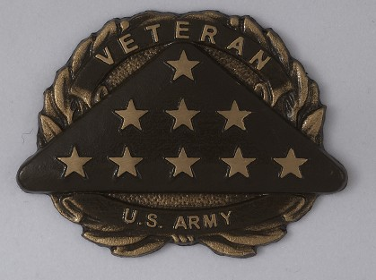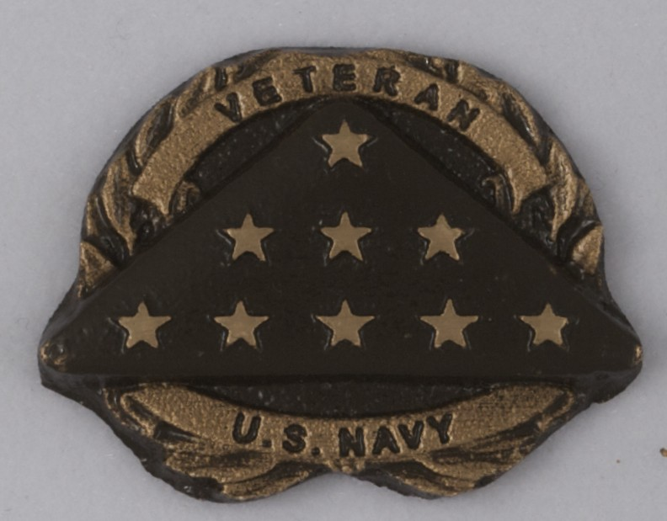

Large Medallion Dimensions: 6 3/8" W, 4 3/4" H, 1/2" D
Medium Medallion Dimensions: 3 3/4" W, 2 7/8" H, 1/4" D

Small Medallion Dimensions: 2" W, 1 1/2" H, 1/3" D

WHO IS ELIGIBLE - Any deceased Veteran discharged under honorable conditions, who served in the Armed Forces on or after April 6, 1917, and is buried in a private cemetery in a grave marked with a privately purchased headstone or marker. Any Servicemember of the Armed Forces of the United States who served on or after April 6, 1917, and died on active duty and is buried in a private cemetery in a grave marked with a privately purchased headstone or marker. Please attach a copy of the deceased Veteran's discharge certificate (DD Form 214 or equivalent) or a copy of other official document(s) establishing qualifying military service. If you are unable to locate copies of military records, apply anyway, as VA will attempt to obtain records necessary to make an eligibility determination. Do not send original documents; they will not be returned. Service after September 7, 1980, must be for a minimum of 24 months continuous active duty or be completed under special circumstances, e.g., death on active duty. Persons who have only limited active duty service for training while in the National Guard or Reserves are not eligible unless there are special circumstances, e.g., death while on active duty, or as a result of training. Reservists and National Guard members who, at time of death, were entitled to retired pay, or would have been entitled, but for being under the age of 60, are eligible; please submit a copy of the Reserve Retirement Eligibility Benefits Letter with the claim. Reservists called to active duty other than training and National Guard members who are Federalized and who serve for the period called are eligible.
WHO CAN APPLY - An "applicant" for a Medallion may be any of the following:
- A decedent's family member, which includes the decedent's spouse or individual who was in a legal union as defined in 38 CFR 3.1702(b)(1)(ii) with the decedent; a child, parent, or sibling of the decedent, whether biological, adopted, or step relation; and any lineal or collateral descendant of the decedent;
- A personal representative, defined as a family member or other individual who has identified himself or herself as the person responsible for making decisions concerning the interment of the remains of or memorialization of a deceased individual;
- A representative of a Congressionally-chartered Veterans Service Organization;
- An individual employed by the relevant state, tribal organization, or local government whose official responsibilities include serving veterans and families of veterans, such as a state or county veterans service officer; or
- Any individual who is responsible, under the laws of the relevant state or locality, for the disposition of the unclaimed remains of the decedent or for other matters relating to the interment or memorialization of the decedent.
PRESIDENTIAL MEMORIAL CERTIFICATE - A Presidential Memorial Certificate (PMC) is an engraved paper certificate, signed by the current sitting president, to honor the memory of Veterans discharged under other than dishonorable conditions. If the Veteran is eligible for a headstone, marker, or medallion, one PMC will automatically be provided unless otherwise specified. Additional PMCs may be requested by indicating how many in block 18 of this form.

HOW TO SUBMIT A CLAIM

FAX VA Form 40-1330M and supporting documents to: 1-800-455-7143.
IMPORTANT: If faxing more than one claim - fax each claim package (claim plus supporting documents) individually (disconnect the call and redial for each submission).
MAIL claims to: Memorial Products Service (41B)

Department of Veterans Affairs 5109 Russell Road
Quantico, VA 22134-3903

A VA medallion may be furnished only upon receipt of a fully completed and signed claim with required supporting documentation.
SIGNATURES REQUIRED - The claimant signs in block 19; the cemetery or other responsible official in block 24. If there is no official on duty at the cemetery, the signature of the person responsible for the property listed in block 23 is required. Entries of "None," "Not Applicable," or "NA" will not be accepted.
ASSISTANCE NEEDED - If assistance is needed to complete this claim, you may contact our Applicant Assistance Unit toll free at: 1-800-697-6947, or via e-mail at mps.headstones@va.gov. If additional assistance is needed to complete this claim, contact the nearest VA Regional Office, national cemetery, or a local Veterans' organization. No fee should be paid in connection with the preparation of this claim. For more information regarding medallion eligibility, affixing procedures, and sizes, visit our website at www.cem.va.gov.
DELIVERY - The medallion is shipped without charge to the name/address designated in Block 21 of the claim. The Government is not responsible for costs associated with affixing the medallion to the privately purchased headstone or marker. Appropriate affixing adhesives, hardware and instructions are provided with the medallion.
CAUTION - To avoid delays in the production and delivery of the medallion, please check carefully to be sure you have accurately furnished all required information and documents before faxing or mailing the claim. The Government is not responsible for costs associated with affixing the medallion to the privately purchased headstone or marker. Medallions furnished remain the property of the United States Government and may not be used for any purpose other than to be affixed to the privately purchased headstone or marker of an eligible deceased Veteran buried in a private or local Government cemetery.

DETACH AND RETAIN THIS GENERAL INFORMATION SHEET FOR YOUR RECORDS.

VA FORM JUL 2021
40-1330M ALL PREVIOUS VERSIONS OF THIS FORM ARE OBSOLETE


Department of Veterans Affairs National Cemetery Administration Memorial Products Service

To: MEMORIAL PRODUCTS SERVICE (41B)
Fax Number: 1-800-455-7143
From:
Sender's Phone Number:
Sender's Fax Number:
Total No. of Pages (including cover sheet):
This optional fax cover sheet is provided for your convenience. The 1-800-455-7143 fax line is dedicated to the transmission of applications for headstones or markers, medallions, commemorative plaque, and urn. Applications for other Government Benefits will not be accepted. If you prefer, you may mail your application and supporting documents to the address below:
Memorial Products Service (41B) Department of Veterans Affairs 5109 Russell Road
Quantico, VA 22134-3903
Please select the benefit you are applying for (Check one): HEADSTONE OR MARKER
MEDALLION

Include all supporting documents with this application (i.e., DD Form 214 or equivalent discharge documents). If you do not have the documents, please submit your claim and VA will request documents for you. Please note, this may result in a longer processing time.
To submit multiple application packages: Fax one application package (application plus supporting documents) at a time. You must disconnect the call and redial between each application package. Faxing several applications without redialing between each one will delay the processing of your applications.


Form approved, OMB No. 2900-0222 Expiration Date: Jul.. 31, 2024 Respondent Burden: 15 minutes
 |  |  |  |  |  | CLAIM FOR GOVERNMENT MEDALLION FOR PLACEMENT IN A PRIVATE CEMETERY
IMPORTANT: Please read the General Information Sheet before completing this claim. Type or print clearly all information except for signatures. Illegible printing could result in incorrect delivery of the medallion. Failure to complete each block may result in delayed processing. PLEASE INCLUDE MILITARY DISCHARGE DOCUMENTS. |  |  |  |  |  |  |  |  |  |  |  |  |  |  | 1. DID VA PREVIOUSLY DETERMINE ELIGIBILITY FOR BURIAL AT A VA NATIONAL CEMETERY?  YES NO UNSURE
2. NAME OF DECEASED VETERAN |  |  |  |  |  |  |  |  |  |  |  |  |  |  | 3. THERE MUST BE A SET HEADSTONE,
MAUSOLEUM, OR CRYPT IN PLACE TO AFFIX
THE MEDALLION. IS THE GRAVE CURRENTLY
FIRST (Or Initial) |  |  | MIDDLE (Or Initial) |  |  |  |  | LAST |  |  |  |  | SUFFIX
 |  |  |  |  |  |  |  |  |  |  |  |  |  |  | MARKED? |  | YES |  | NO
4. RACE OR ETHNICITY (You may select more than one. Information will be used for statistical purposes only.) |  |  |  |  |  |  |  |  |  |  |  |  |  |  | 5. SEX (Information will be used for statistical purposes only.)  MALE FEMALE |  |  |  |  | 6. AGE AT TIME
ASIAN OR ASIAN AMERICAN |  |  |  |  | NATIVE HAWAIIAN OR OTHER PACIFIC ISLANDER |  |  |  |  |  |  |  |  |  |  |  |  |  |  | OF DEATH
AMERICAN INDIAN OR ALASKA NATIVE |  |  |  |  | WHITE
BLACK OR AFRICAN AMERICAN |  |  |  |  | NOT HISPANIC OR LATINO
HISPANIC OR LATINO
VETERAN'S SERVICE AND IDENTIFYING INFORMATION (Use numbers only, e.g., 05-15-1941)
7. VETERAN'S SOCIAL SECURITY NO. OR SERVICE NO.  SSN: SVC. NO.: |  |  |  |  |  |  |  |  |  | 8. PLACE OF BIRTH (City and State or Country)
 |  |  |  |  |  |  |  |  |  | PERIODS OF ACTIVE MILITARY DUTY
9A. DATE OF BIRTH |  |  |  | 9B. DATE OF DEATH |  |  |  |  |  | 10A. DATE(S) ENTERED |  |  |  |  |  | 10B. DATE(S) SEPARATED
MONTH | DAY | YEAR |  | MONTH | DAY |  |  |  | YEAR | MONTH |  | DAY |  | YEAR |  | MONTH |  | DAY |  |  | YEAR
11. BRANCH OF SERVICE (BOS) (Check applicable box(es)) NOTE: If one BOS is selected, it will be spelled out on the medallion, i.e. U.S. ARMY, U.S. AIR FORCE, etc. If more than one BOS is selected, they will be abbreviated on the medallion, i.e. USA, USAF, USN, USMC, USCG, etc.
ARMY MARINE CORPS COAST GUARD MERCHANT MARINE NAVY AIR FORCE ARMY AIR FORCES (WW II) OTHER (USAAC, WAAC, etc.) (Specify)
12. MEDALLION SIZE REQUESTED (Check one) (Refer to general information sheet for exact sizes)
LARGE (M5) MEDIUM (M3) SMALL (M1)
13. ARE YOU:  FAMILY MEMBER (Specify relationship)  PERSONAL REPRESENTATIVE (Person responsible for decisions  concerning burial of decedent; include written authorization) |  |  |  |  |  |  |  |  |  | VETERANS SERVICE OFFICER FUNERAL HOME MANAGEMENT  (that received the unclaimed remains) |  |  |  |  |  | CEMETERY MANAGEMENT  (where the unclaimed remains are buried)
14. NAME AND MAILING ADDRESS OF CLAIMANT  (No., Street, City, State, and ZIP Code) |  |  |  |  |  |  | 15. DAYTIME PHONE NO. OF CLAIMANT |  |  |  | 16. E-MAIL ADDRESS (Optional)
17. I WOULD LIKE A PRESIDENTIAL MEMORIAL CERTIFICATE?  YES NO |  |  |  |  |  |  |  |  |  |  | 18. IF "YES" HOW MANY?
CERTIFICATION: By signing below I certify the medallion will be affixed to a privately purchased headstone or marker in the cemetery listed in Block 23 at no expense to the Government, and that I (or the party listed in Block 21) have agreed to accept delivery, and all information entered on this claim is true and correct to the best of my knowledge. I also certify, to the best of my knowledge, that the decedent has never committed a serious crime, such as murder or other offense that could have resulted in imprisonment for life, has never been convicted of a serious crime, and has never been convicted of a sexual offense for which the Veteran was sentenced to a minimum of life imprisonment.
PENALTY: The law provides severe penalties, which include fine or imprisonment, or both, for the willful submission of any statement or evidence of a material fact, knowing it to be false or for the fraudulent acceptance of any benefit to which you are not entitled.
19. SIGNATURE OF CLAIMANT |  |  |  |  |  |  |  |  |  |  | 20. DATE (MM/DD/YYYY)
21. NAME AND DELIVERY ADDRESS FOR MEDALLION (No., Street, City, State, and ZIP Code); (If same as applicant, please enter SAME) |  |  |  |  |  |  | 22. DAYTIME PHONE NO.  (Include Area Code) |  |  |  | 23. NAME AND ADDRESS OF CEMETERY WHERE PRIVATELY PURCHASED HEADSTONE IS IN PLACE OR A MAUSOLEUM, OR CRYPT TO AFFIX THE MEDALLION MARKER OF THE DECEASED VETERAN IS LOCATED (No., Street, City, State, and ZIP Code)
CERTIFICATION: By signing below I certify the size medallion indicated above is permitted in the cemetery.
24. SIGNATURE OF CEMETERY OFFICIAL |  |  |  |  |  |  |  |  |  |  | 25. DATE (MM/DD/YYYY)

VA FORM JUL 2021
40-1330M ALL PREVIOUS VERSIONS OF THIS FORM ARE OBSOLETE

