**FCC FORM 655: HEARING AID COMPATIBLITY STATUS REPORTING**

**INSTRUCTIONS FOR DEVICE MANUFACTURERS**

**Contents**

I. Purpose 2

II. Who Must File An FCC Form 655 Status Report? 2

III. Access to Electronic Filing System for FCC Form 655 2

A. Obtaining an FCC Registration Number (FRN) 2

B. Accessing the Hearing Aid Compatibility Reporting Site 2

IV. Instructions for Completing the FCC Form 655 Status Report 2

A. *De Minimis* Exception 3

B. Company Information 4

C. Handset Model Information 5

C1. Fields for Handset Model Information 5

C2. Editing and Deleting Handset Model Information 8

D. Consumer Outreach 8

V. Certifying, Submitting, Updating, and Printing Filed FCC Form 655 Status Reports 10

VI. FCC Notice Required by the Paperwork Reduction Act of 1995 11

**Figures in Appendix**

Figure 1 Register and Receive an FCC Registration Number ....…………...…………………..12

Figure 2 Login Page …………………………………………………………………………….13

Figure 3 License Manager Page ..……………………………………………………………….14

Figure 4 My Applications Page -- Summary ..………………………………………………….15

Figure 5 Company Information Page 1 ...……………………………………………………….16

Figure 6 Company Information Page 2 ...……………………………………………………….17

Figure 7 Handset Model Information Page 1 ...…………………………………………………18

Figure 8 Handset Model Information Page 2a ...………………………………………………..19

Figure 9 Handset Model Information Page 2b ...………………………………………………..20

Figure 10 Handset Model Information Page 3 ...………………………………………………..21

Figure 11 Handset Model Information Page 4a .………………………………………………..22

Figure 12 Handset Model Information Page 4b ….……………………………………………..23 Figure 13 Report Summary for Handset Information Section …...……………………………..24

Figure 14 Edit the Handset Information ...……………………………………………………...25

Figure 15 Consumer Outreach Page 1 ...………………………………………………………..26

Figure 16 Consumer Outreach Page 2 ...………………………………………………………..27

Figure 17 Certification Page ...………………………………………………………………….28

Figure 18 Confirmation Page ...…………………………………………………………………29

Figure 19 My Applications Page -- Saved Report ..…………………………………………….30 Figure 20 My Applications Page -- Submitted Report ...……………………………………….31

**I. PURPOSE**

The Federal Communications Commission (FCC) requires that certain digital mobile handset manufacturers electronically file FCC Form 655 reporting their compliance with the Commission’s wireless hearing aid compatibility requirements. The Hearing Aid Compatibility Status Report is required to be filed by July 31 of each calendar year using the same electronic system Service Providers use to file FCC Form 855. *See* 47 CFR § 20.19(i)(1). The use of the Commission’s electronic filing system ensures that each Device Manufacturer’s status report includes all of the required information in a consistent format, facilitates filing subsequent reports, and facilitates the FCC’s compilation of data. The electronic system also provides the public with improved access to review the filed status reports.

**II. WHO MUST FILE AN FCC FORM 655 STATUS REPORT?**

Certain manufacturers of wireless handsets are required to annually file an FCC Form 655 status report indicating their compliance with the Commission’s hearing aid compatibility requirements. Specifically, this reporting requirement applies to manufacturers of wireless handsets used in the delivery of digital mobile service in the United States to the extent that the handsets offer terrestrial mobile service that enables two-way real-time voice communications among members of the public or a substantial portion of the public, including both interconnected and non-interconnected VoIP services, and such service is provided over frequencies in the 614 MHz to 6 GHz bands. *See* 47 CFR § 20.19(a). Entities meeting this definition are referred to herein as Device Manufacturers.

**III. ACCESS TO ELECTRONIC FILING SYSTEM FOR FCC FORM 655**

**A. Obtaining an FCC Registration Number (FRN)**

In order to access the electronic filing system for Hearing Aid Compatibility, each Device Manufacturer must use its FCC Registration Number (FRN). A Device Manufacture may choose to obtain a new FRN for the purpose of filing its Hearing Aid Compatibility Status Report or it may use an existing FRN that is assigned to it. If an agent files status reports for multiple Device Manufacturers, the agent should obtain a separate FRN for each Device Manufacturer. The same FRN can be used for the Device Manufacturer’s future filings. FRNs can be obtained at <https://apps.fcc.gov/coresWeb/publicHome.do> (*see* **Figure 1**).

**B. Accessing the Hearing Aid Compatibility Reporting Site**

The reporting site can be accessed at <https://www.fcc.gov/filing-hearing-aid-compatibility-reports-and-certifications>. This web page contains a link to the License Manager Login page (*see* **Figure 2**) in the FCC’s Universal Licensing System (ULS). The Login page can also be accessed through the *FCC Forms* page (<http://www.fcc.gov/formpage.html>) on the main FCC website. After login, click “*My Reports*,” then “*File Hearing Aid Compatibility Status Report (655) or Certifications (855)*” on the left panel to start filing your report (*see* **Figure 3**). If you want to update a submitted or saved report, click the “HAC Submitted” or “Saved” link (*see* **Figure 4**). If you do not see the “*My Reports”* link, that means you have already submitted a report for the current filing window. You must then click the “HAC Submitted” link from the “My Applications” summary page to update your report. This mechanism is installed to prevent a Device Manufacturer from submitting two reports for the same filing period (i.e., submitting a new report rather than amending the existing report).

**IV. INSTRUCTIONS FOR COMPLETING THE FCC FORM 655 STATUS REPORT**

Each year Device Manufacturers must electronically file Hearing Aid Compatibility Status Reports using FCC Form 655 by July 31. The reports provide information for the preceding year – July 1 through June 30. When July 31 falls on a weekend or holiday, the report is due on the next business day. The electronic filing system is designed to be user-friendly with many illustrative texts and information icons. If you are a returning filer, i.e., you filed a report using the electronic filing system in a previous filing period, the system will allow you to pre-fill certain information from your previous report to the current report, update and add any necessary information. Because the electronic FCC Form 655 interface periodically changes, you must review the accuracy of all copied or pre-filled information, and update and/or complete any missing information.

You should provide the requested information for the Device Manufacturer. You can edit the Device Manufacturer information while in this section (*see* **Figure 5** and **Figure 6**). You also can come back to edit the Device Manufacturer information when you are on the Report Summary screen (after initiating the Handset Model Information section) by clicking the edit icon ( ) to the left of the company name (*see* **Figure 13**). Letters, numbers, and common punctuation characters may be used to enter your information. The system will accept the following characters: , . ' _ - ( ) ? ! @ [ ] : ; # " $ | / &. However, common word processing software will often embed hidden characters that convey additional information, typically about formatting, and are considered “invalid characters” by the electronic version of the form. Invalid characters are detected by our data entry system when copying text from word processing software into a data entry field. These characters may appear as a square or other symbol such as + ~ * etc. Instead of copying information from word processing software, one alternative is to copy that information from a basic text editor that does not embed hidden characters. Windows Notepad is one example of a basic text editor. Another alternative is to delete the text and re-key the information directly into the data entry field.

**Company Information**: If you are a returning Device Manufacturer, click “Copy Company Information from previous submission.” The system will load your previously submitted company information (*see* **Figure 5**). If you are a new Device Manufacturer click “Continue” at the bottom of the page and go to the company information section and fill in the requested information (*see* **Figure 5** and **Figure 6**).

**A. *De Minimis* Exception**

The *de minimis* exception for Device Manufacturers applies to Device Manufacturers that offer between zero and five handset models in an air interface in the United States (*see* **Figure 6**).

* Device Manufacturers that offer two or fewer handset models in an air interface:
  + Device Manufacturers that offer two or fewer handset models in an air interface in the United States are under most circumstances exempt from requirements to offer hearing aid-compatible handsets over that air interface. A Device Manufacturer that qualifies for this exception is still subject to the annual reporting requirements. *See* 47 CFR § 20.19(e), (i).
  + Answer the question: “For the reporting period, have you only been offering two or fewer handset models in an air interface in the United States?” A handset is a device used in delivery of covered services that contains a built-in speaker and is typically held to the ear in any of its ordinary uses. “Typically” encompasses any intended or anticipated ordinary use and does not mean “usually” or “most often.”
  + Answer the question: “For the reporting period, have you had more than 750 employees for at least two years, been offering handsets over an air interface for at least two years, and been offering one or two handset models over that air interface in the United States for at least two years?” For purposes of this question, employees of a parent, subsidiary, or affiliate company under common ownership or control with a Device Manufacturer are considered employees of the Device Manufacturer.
  + If you answer “Yes” to the first question above and “No” to the second question above, you qualify for the *de minimis* exception and are not required to offer hearing aid-compatible handsets. You are, however, still subject to the annual reporting requirements. The system will use the above answers to take you directly to the Consumer Outreach section after you finish the Company Information section. If you answer “Yes” to the first question above and “Yes” to the second question above, then you must offer at least one hearing aid-compatible handset model in that air interface and complete the rest of this report demonstrating compliance with the FCC’s wireless hearing aid compatibility requirements. *See* 47 CFR § 20.19(e)(1)(i)-(ii)
* Device Manufacturers that only offer three, four, or five handset models in an air interface:
  + Device Manufacturers that offer three handset models in an air interface must offer at least one hearing aid-compatible handset model in that air interface. Device Manufacturers that offer four or five handset models in an air interface must offer at least two hearing aid-compatible handset models in that air interface. Device Manufacturers covered by these provisions must complete the rest of this report demonstrating compliance with the FCC’s wireless hearing aid compatibility requirements. *See* 47 CFR § 20.19(e)(2)-(3).
  + Answer the question: “For the reporting period, did you only offer three handset models in an air interface or four or five handset models in an air interface?”
* Device Manufacturers that offer more than five handset models in an air interface do not qualify for the *de minimis* exception.

**B. Company Information**

* Company Information: You should provide the company name for the reporting Device Manufacturer. If the reporting Device Manufacturer also has a “Doing Business As (dba)” name, include both the company name and the dba name in the Company Name box. The format can be “Company Name dba Doing Business As Name.”
* Brand Name(s) Included: You should provide the brand names under which the Device Manufacturer is offering handsets. For example, if the Device Manufacturer offers all handsets under one brand name *ABC* (most likely the manufacturer’s name), enter *ABC* in the box. If the Device Manufacturer offers handsets under two brand names *ABC* and *XYZ*, enter *ABC* and *XYZ* in two different boxes. This can happen when one manufacturer acquired another manufacturer and decided to keep both brand names. If the Device Manufacturer has more than five brand names, enter the first four names separately in the first four boxes, and enter all the remaining names in the last box using format “DEF/GHI/LMN.”
* Address: You should provide the company address for the reporting Device Manufacturer. If the Device Manufacturer is a non-U.S. company, please use your U.S. business office address for filing purposes. If the Device Manufacturer does not have a U.S. business office address, please use your U.S. agent’s address.
* Contact Information: You should provide the name, 10-digit U.S. phone number, 10-digit U.S. FAX number, and e-mail address of the contact person for the reporting Device Manufacture. If the Device Manufacturer is a non-U.S. company, please use the contact person’s U.S. business contact information for filing purposes. If the contact person’s does not have U.S. business office, please use the Device Manufacturer’s U.S. agent’s contact information. All fields are required except the U.S. FAX number. If the contact person does not have a U.S. FAX number, leave the field blank.
* Filing Agent: If the status report is being filed by an agent (such as a law firm) in the U.S. on behalf of a Device Manufacturer, select “Yes” and provide the name, address, and contact information for the agent as well.

**C. Handset Model Information**

You must complete a separate Handset Model Information screen submission for each handset model you offered in the United States that counts as a unique model for hearing aid compatibility purposes. A handset is a device used in delivery of covered services that contains a built-in speaker and is typically held to the ear in any of its ordinary uses. “Typically” encompasses any intended or anticipated ordinary use, and does not mean “usually” or “most often.” If you marketed the same model under more than one name, all of the names must be reported as part of the same model.

For purposes of compliance with the hearing aid compatibility deployment requirements, two handsets marketed as separate models must be counted as a single model if they do not differ in form, features, or capabilities (for example, if they differ only in being marketed through different service providers or in cosmetic respects such as color). A difference in hearing aid compatibility rating under a pre-2019 ANSI Standard is considered a difference in form, features, or capabilities.

For example, Device Manufacturer X markets two models, the TalkMaster X1 and the Talk2Me, that are indistinguishable in form, features, and capabilities. It also produces another model, the TalkMaster X2, that offers different features from the TalkMaster X1. All of these models are certified under the same FCC ID number. The Device Manufacturer must report the TalkMaster X1 and the Talk2Me on the same Handset Model Information screen submission, and the TalkMaster X2 on a separate Handset Model Information screen submission.

**C1. Fields for Handset Model Information**

Specific attributes of a handset model need to be entered in this section. These attributes include handset maker, handset model name, air interfaces and frequency bands used by the handset model, hearing aid compatibility ratings, etc. Once you complete the information required for one handset model, you can add information for another handset model or continue to the next section on consumer outreach information if you have completed information for all handset models.

If you have filed a report using the electronic filing system in a previous filing period, the system will pre-fill your report with certain handset model information that you reported in your most recent filing. Because the electronic FCC Form 655 interface periodically changes, you must review the accuracy of all pre-filled information for each handset model, and update and/or complete any missing information about previously submitted handset models. For example, you will be required either to enter a new Ending Available Date that is within the current reporting period or to delete the handset model if you did not offer it during the current reporting period. In addition, you may be prompted to enter a corrected FCC ID if the FCC ID that you previously reported is invalid or not granted. You must also review the attributes of each handset model (e.g., air interfaces and frequency bands, etc.) to make any other necessary corrections to the pre-filled information.

**HANDSET MAKER:** This is the manufacturer of the handset (*see* **Figure 7**).

* If the Handset Maker name is in the dropdown list in the Handset Maker box, select it from the list.
* If the Handset Maker is not on the list, select “Other” at the bottom of the list and enter the name in the box to the right of the Handset Maker box.

**HANDSET MODEL:** Select “No” if you marketed the Handset Model under only one name, “Yes” if you marketed the Handset Model under multiple names (*see* **Figure 7**).

* If “No” is selected:
  + Provide the Handset Model name either by selecting a name from the dropdown list in the Handset Model name box or by selecting “Other” from the dropdown list and entering a new Handset Model name in the box to the right of the Handset Model name box.
  + Provide the associated FCC ID(s) for the Handset Model in the FCC ID boxes. If there is one FCC ID associated with the Handset Model, enter it in the first FCC ID box. If there are multiple FCC IDs associated with the Handset Model, enter each FCC ID in a separate FCC ID box. The system sometimes automatically pre-fills one or more FCC IDs if they are available. You can over-write or delete a pre-filled FCC ID if it is not correct or not relevant (*see* **Figure 8**).
  + If the system does not accept the entered FCC ID(s) because it is either invalid (such as mistyped) or not granted by the FCC, please check your FCC ID(s) for the Handset Model. If you cannot immediately find the correct FCC ID(s) for this model, you may delete the model temporarily and continue to fill out the Handset Model Information section with another handset model. You must return to this section and add the deleted handset model with the correct FCC ID(s) before certifying and filing your report.
* If “Yes” is selected:
  + Provide the first name for the Handset Model, either by selecting a name from the dropdown list in the Handset Model name box or by selecting “Other” from the dropdown list and entering a new Handset Model name in the box to the right of the Handset Model name box.
  + Provide the associated FCC ID(s) for this Handset Model name in the FCC ID boxes. If there is one FCC ID associated with this Handset Model name, enter it in the first FCC ID box. If there are multiple FCC IDs associated with this Handset Model name, enter each FCC ID in a separate FCC ID box. The system sometimes automatically pre-fills one or more FCC IDs if they are available. You can over-write or delete a pre-filled FCC ID if it is not correct or not relevant.
  + Click “Add Another Handset Model Name” to add another marketing Handset Model name and associated FCC ID(s).
  + Repeat until all marketing Handset Model names have been entered (*see* **Figure 9**).
* If you initially select “Yes” and later need to remove Handset Model names, you can do that by choosing the edit icon () for the handset model on the Report Summary screen (appears after finishing each Handset Model Information submission) and selecting the delete icon () for the unneeded Handset Model name(s) on the Handset Model Information Summary screen (*see* **Figure 13**).
* If you initially select “No” and later need to add Handset Model names, you can do that by choosing the edit icon () for the handset on the Report Summary screen (appears after finishing each Handset Model Information submission) and selecting the “Add Another Handset Model Name” button on the Handset Model Information Summary screen (*see* **Figure 13**).

**AIR INTERFACES/FREQUENCY BANDS:** Select the air interface technology and corresponding frequency band(s) for each air interface that can be used by this handset model for voice communications. Include all air interfaces over which the handset model is capable of being operated for voice communications, including any air interface or frequency band that may not currently have hearing aid compatibility deployment requirements (*see* **Figure 10**). A handset is considered capable of voice communication over an air interface or frequency band if it could be made capable of voice communication through the use of software, whether or not that software is currently commercially available and whether or not that software is pre-installed by the device manufacturer or service provider, or at their direction.

**DATES:** Enter “Starting Available Date” and “Ending Available Date” in the relevant boxes in the “MM/YY” format. For example, April 2021 should be entered as 04/21, not 04/2021 or 4/21. If this handset is still being offered as of the end of the reporting period, enter the ending month of the reporting period as the ending available date. The current reporting period will be listed at the top of the screen for your reference (*see* **Figure 10**).

**ANSI STANDARD UTILIZED FOR CERTIFICATION:** Select the “2005,” “2006,” “2007,” “2011,” or “2019” button to indicate which version of the ANSI C63.19 standard was used during the certification process (*see* **Figure 11 and Figure 12**).

**For ANSI C63.19 versions prior to the 2019 version:**

**M-RATING (*see*** **Figure 11):**

* Select “No” if the handset model has not received an M-Rating certification.
* Select “Yes” if the handset model has received an M-Rating certification.
  + Select the appropriate rating from the dropdown list in the M-Rating box.
  + Provide the M-Rating Certification Date in the format MM/DD/YY.
  + If either M3 or M4 is selected in the M-Rating box for a handset model with the GSM air interface and 1900 MHz frequency band box selected in the AIR INTERFACES/FREQUENCY BANDS section, then answer the question: “Did this handset meet the criteria for an M3 rating for operations over GSM at 1900 MHz by enabling the user optionally to reduce the maximum power at which the handset will operate by no more than 2.5 decibels, except for emergency calls to 911?” If this question is *not* applicable to the particular handset, it does not appear in the electronic version of Form 655. However, it still appears on the printed version under each listed handset, whether GSM, CDMA, or WCDMA, etc., is selected. Please ignore the question on the printed version of the report under the listed handsets.

**T-RATING (*see*** **Figure 11):**

* Select “No” if the handset model has not received a T-Rating certification.
* Select “Yes” if the handset model has received a T-Rating certification.
  + Select the appropriate rating from the dropdown list in the T-Rating box.
  + Provide the T-Rating Certification Date in the format MM/DD/YY.

**For ANSI C63.19 version 2019 (*see*** **Figure 12):**

* Has the handset model received a hearing-aid compatibility certification?
* Answer “Yes” or “No” and if you answer “Yes” provide the certification date in mm/dd/yy format.

**REMARKS:** Provide any remarks or comments concerning the handset model (*see* **Figure 11 and Figure 12**).

**C2. Editing and Deleting Handset Model Information**

As you complete the information required for each handset model, the system will take you to the Report Summary screen for the Handset Model Information section (*see* **Figure 13**), where the company name and other basic information such as the handset maker name, handset model name(s), and FCC ID(s) for each submitted handset model will be on display. From this screen, you can:

* Edit Company Information by clicking the edit icon () to the left of the company name on the upper left corner of the screen (*see* **Figure 13**).
* Edit the Handset Model Information for a specific handset model by clicking the edit icon () for the handset model in the right-most column of the table showing the individual handset models reported. The system allows you to edit the Handset Model name(s) and FCC ID(s) (*see* **Figure 13**).
  + However, if the Handset Maker name needs to be changed, you need to return to the Report Summary screen (*see* **Figure 13**), delete the handset model by clicking the delete icon (), and add the handset model back by selecting “Report New Handset Model” at the bottom of the screen (at which point you will be able to select the correct Handset Maker).
* Delete a handset model or a duplicated handset model by clicking the delete icon () in the right-most column of the table showing the individual handset models reported (*see* **Figure 13**).
* Continue to the Consumer Outreach section by selecting “Continue” at the bottom of the screen.

**D. Consumer Outreach**

**PRODUCT LABELING AND DISCLOSURE:** Provide the requested information for the reporting Device Manufacturer (*see* **Figure 15**).

* Package label information (*see* 47 CFR § 20.19(f)(1)):
  + A hearing aid-compatible handset’s package label must expressly state that the handset is hearing aid-compatible and must quantify the handset’s volume control capability if the handset is certified using the 2019 ANSI Standard.
  + Answer the question: “Does the package label for all hearing aid-compatible handset models state that the handset is hearing aid-compatible?” Answer “Yes” or “No.” If you answer “No,” then provide an explanation in the popup text box below.
  + Answer the question: “If the handset model is certified using the 2019 ANSI Standard, does the package label for the handset model provide the actual conversational gain for the handset with a hearing aid and, if the handset model has different ratings for different covered air interfaces or frequency bands the lowest rating assigned to the handset for any covered air interface or frequency band?” Answer “Yes” or “No.” If you answer “No,” then provide an explanation in the popup text box below.
  + Answer the question: “If the handset model is certified using the 2019 ANSI Standard, does the package label for the handset model provide the actual conversational gain for the handset without a hearing aid?” Answer “Yes” or “No.” If you answer “No,” then provide an explanation in the popup text box below.
* Package inserts and user manuals (*see* 47 CFR § 20.19(f)(2)):
  + A hearing aid-compatible handset’s package insert or user manual must include the following information: (1) that the handset is hearing aid-compatible; (2) the ANSI standard used to determine the hearing aid compatibility of the handset model’s air interfaces and frequency bands; (3) if using the 2011 ANSI Standard or an earlier version of the standard, the lowest hearing aid compatibility rating assigned to any of the covered air interfaces or frequency bands; (4) the air interfaces or frequency bands on handsets that are not certified to be hearing aid-compatible, if applicable, or have been determined to be hearing aid-compatible under special testing circumstances; and (5) if a handset model was not certified as hearing aid-compatible over all of its air interfaces or frequency bands, a prescribed disclosure notifying consumers of this fact and that they should test the handset thoroughly and in different locations. In addition, package inserts and user manuals for hearing aid-compatible handsets must include an explanation of the ANSI rating system as well as an explanation of a handset’s volume control capabilities. Further, if an air interface has been determined to be hearing aid-compatible under special testing circumstances, the package insert or user manual must disclose this information to consumers and explain how this affects the use and operation of the handset.
  + Answer the question: “Do all hearing aid-compatible handset models include the required package insert or user manual with all the required information and disclosures?” Answer “Yes” or “No.” If you answer “No,” then provide an explanation in the popup text box below.

**PUBLIC WEBSITE:** Provide the requested information for the reporting Device Manufacturer (*see* **Figure 15**).

* Public website (*see* 47 CFR § 20.19(h)(1)):
  + Device Manufacturers that operate publicly-accessible websites must make available on their websites a list of all hearing aid-compatible models currently offered, the ANSI standard used to evaluate hearing aid compatibility, the ratings of those models under the relevant ANSI standard, if applicable, and an explanation of the rating system.
  + Answer the question: “Does your company maintain a public website describing all hearing aid-compatible models currently offered, the ANSI standard used to evaluate hearing aid compatibility, the ratings of those models under the relevant ANSI standard, if applicable, and an explanation of the rating system?”
  + Answer “Yes” if you maintain such a website and provide the website address. One website address is sufficient if the information is clearly accessible from that web page, even if there are multiple sub-pages. If you do not maintain a website with this information, answer “No” and explain (e.g., the reporting Device Manufacturer does not maintain any public website) (*see* **Figure 15**).

**CONSUMER OUTREACH:** Provide information on the Device Manufacturer’s outreach efforts with regard to hearing aid compatibility within the reporting period (*see* **Figure 16**).

**HEARING AID COMPATIBILITY TESTING:** Enter the number of handset models that were tested for hearing aid compatibility during the reporting period. You need not include models that have not received certification from the FCC (*see* **Figure 16**).

**REPORT REMARKS**: Add any other information that you may choose to provide (*see* **Figure 16**).

**V. CERTIFYING, SUBMITTING, UPDATING, AND PRINTING FILED FCC FORM 655 STATUS REPORTS**

**Certifying and Submitting Your Report**: Upon finishing the Consumer Outreach Information section, you need to certify your report by selecting the “Certify Filing” button at the bottom of the Consumer Outreach Information Screen (*see* **Figure 16**). On the Certification screen, you must provide your name and title. You must then submit your report by selecting the “Submit Filing” button at the bottom of the Certification screen (*see* **Figure 17**). The system will then provide you with a Filing Confirmation Number. **Please write down this confirmation number for your future reference** (*see* **Figure 18**). You must **submit** your report on or before the filing deadline. Failure to submit your report in a timely manner may trigger FCC enforcement action.

**Saving without Submitting Your Report**: You can stop at any time while completing your report by selecting the “Quit Application” button at the top-right corner of the screen (*see* **Figure 7**). Whenever you select “Quit Application,” your report will be saved and put into the “Saved” category (*see* **Figure 4**). A “Saved” report is not considered to be a “HAC Submitted” report. You must remember to **submit** your report on or before the filing deadline. To submit a saved report, you must update the report, certify it, and submit it.

If you are accidentally timed out by the system, your report will be placed in the “Saved” category. You will need to re-login to the system and update your report (see below on updating a saved report).

**Updating Your Report**: You can update your saved or submitted report at any time before the filing deadline. However, you **cannot** update your report once the deadline has passed. To update your report, you need to access the electronic FCC Form 655 and go to the “Saved” category if you have a saved report or the “HAC Submitted” category if you have a submitted report (*see* **Figure 4**). After clicking on the appropriate link to your report (either “*Not Assigned*” or a File No.), select “Continue” or “Update” to update your saved or submitted report (*see* **Figure 19** or **Figure 20**). The system will take you directly to the Report Summary screen (*see* **Figure 13**). From there, you can update your report. After completing your update, you must submit your report again in order for it to be considered “HAC Submitted.” A submitted report that has been opened for updating but not re-submitted will be placed in the “Saved” category and not the “HAC Submitted” category.

FCC Form 655 Hearing Aid Compatibility Status Reports always have a purpose code of “HA.” Knowing this will help you find your Hearing Aid Compatibility Status Report.

**Printing Your Report**: When you are on the Filing Confirmation screen, you can view your report by clicking the “Print Report” button () at the top of the screen (*see* **Figure 18**). The system will generate a PDF file that contains all the information you have entered into your report as well as the FRN you used for filing the report.

**VI. FCC NOTICE REQUIRED BY THE PAPERWORK REDUCTION ACT OF 1995**

We have estimated that each response to this collection of information will take, on average, two and a half (2.5) hours. Our estimate includes the time to read the instructions, look through existing records, gather and maintain the required data, enter the data in the Form 655 on-line template, and submit it electronically. If you have any comments on this estimate, or how we can improve the collection and reduce the burden it causes you, please write the Federal Communications Commission, AMD-PERM, Washington, D.C. 20554, Paperwork Reduction Project (3060-0999). We also will accept your comments via the Internet if you send them to PRA@fcc.gov. DO NOT SEND COMPLETED FCC FORM 655 TO THIS ADDRESS.

Remember – You are not required to respond to a collection of information sponsored by the Federal government, and the government may not conduct or sponsor this collection, unless it displays a currently valid Office of Management and Budget (OMB) control number. This collection has been assigned an OMB control number of 3060-0999.

Device Manufacturers failing to file FCC Form 655 Status Reports in a timely fashion may be subject to penalties under the Communications Act, including Sections 502 and 503(b).

THE FOREGOING NOTICE IS REQUIRED BY THE PAPERWORK REDUCTION ACT OF 1995, PUBLIC LAW 104-13, OCTOBER 1, 1995, 44 U.S.C. SECTION 3507.

APPENDIX

Figure 1 Register and Receive an FCC Registration Number

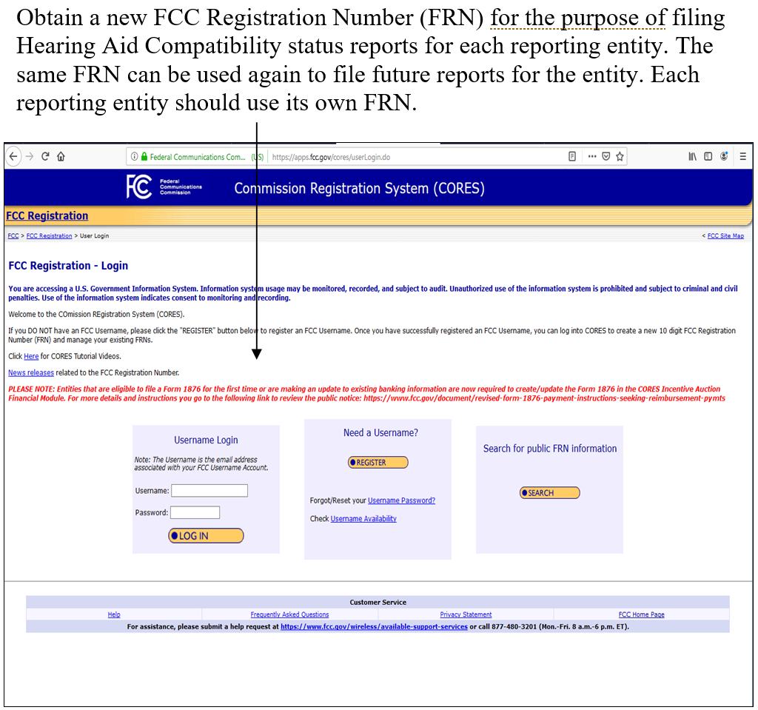

Figure 2 Login Page

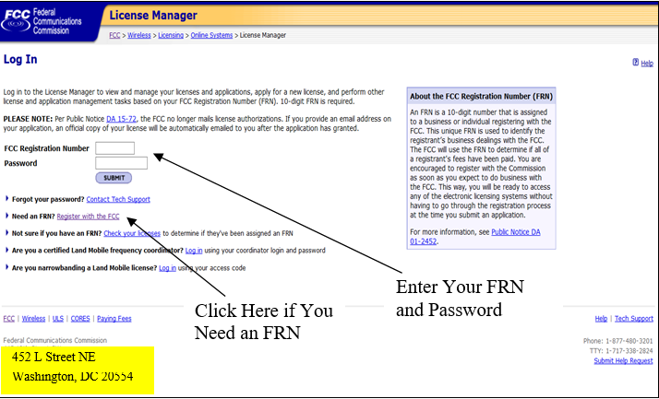

**Figure 3 License Manager Page**

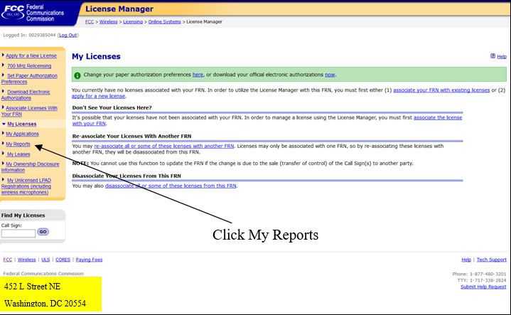

Figure 4 My Applications Page -- Summary

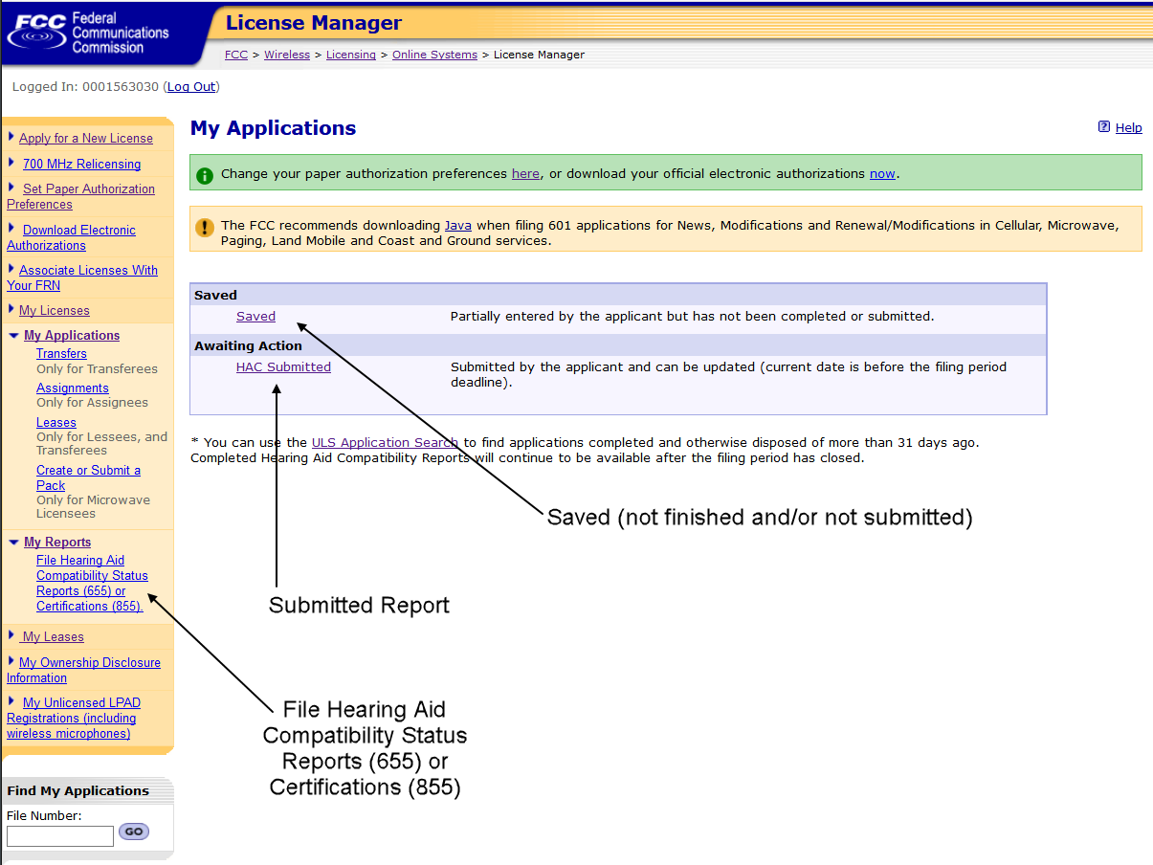

Figure 5 Company Information Page 1

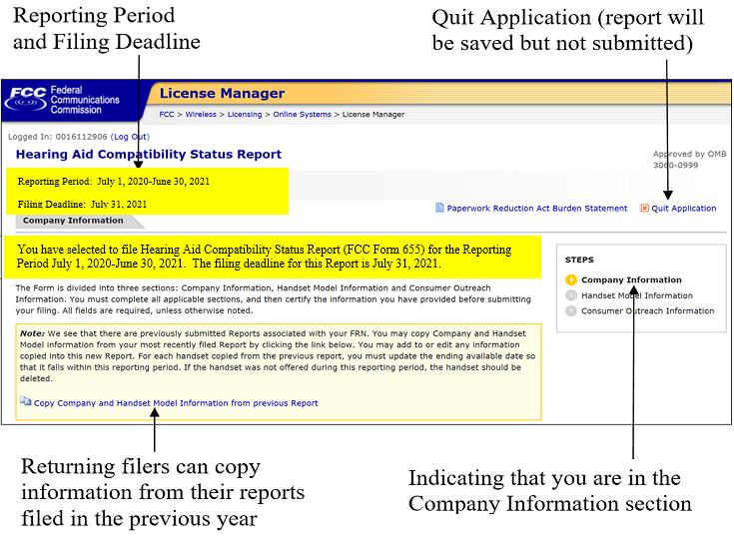

Figure 6 Company Information Page 2

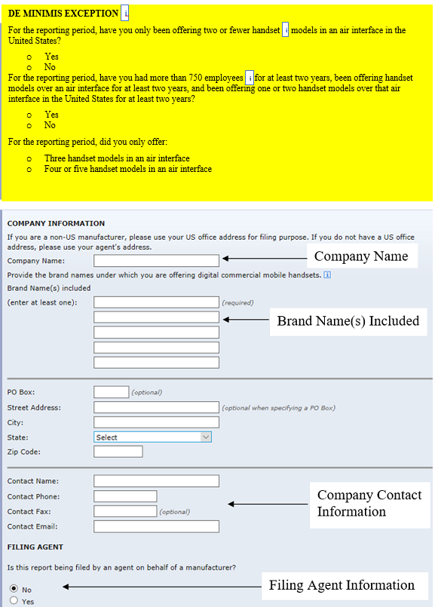

Figure 7 Handset Model Information Page 1

(Handset Maker / Handset Model)

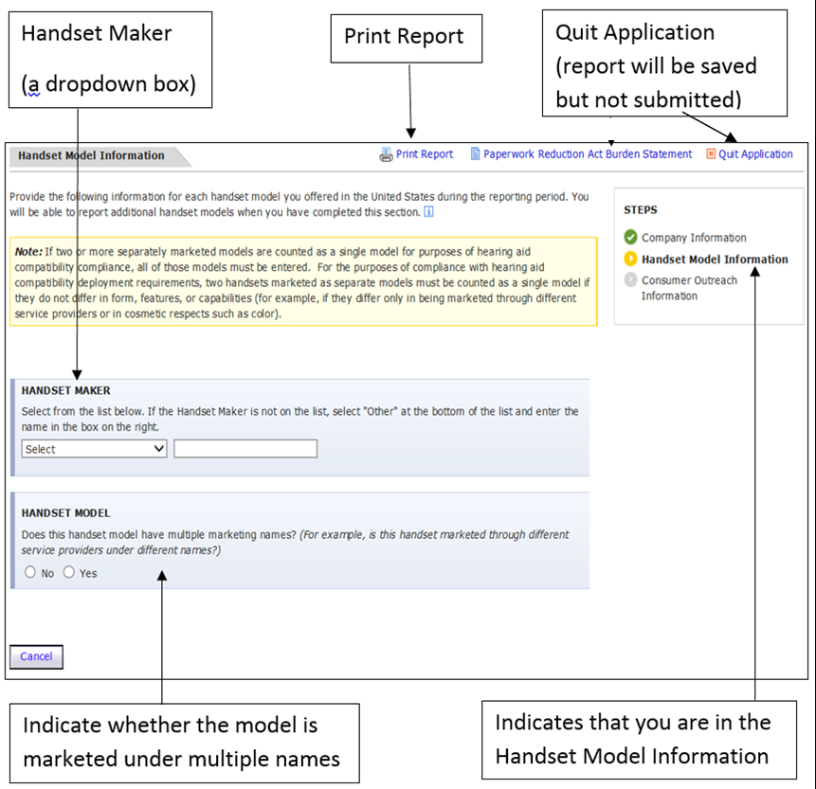

Figure 8 Handset Model Information Page 2a

(Single Handset Model Name / FCC ID)

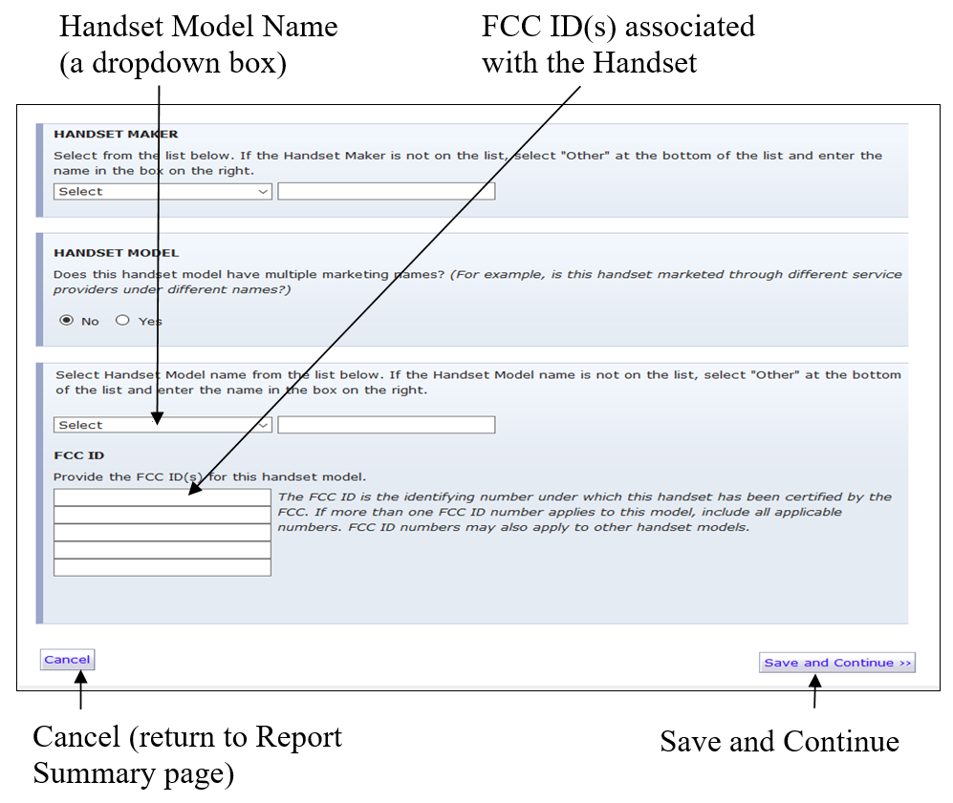

Figure 9 Handset Model Information Page 2b

(Multiple Handset Model Names / FCC ID)

­­­­­

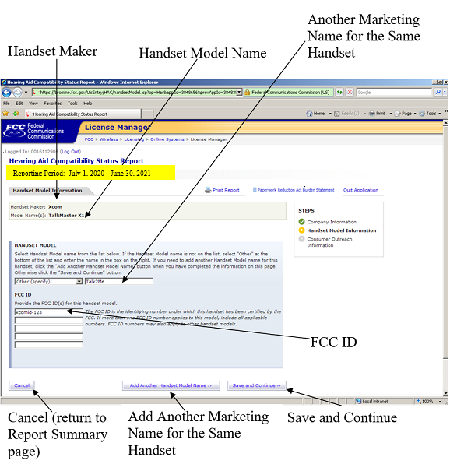

Figure 10 Handset Model Information Page 3

(Air Interfaces / Frequency Bands)

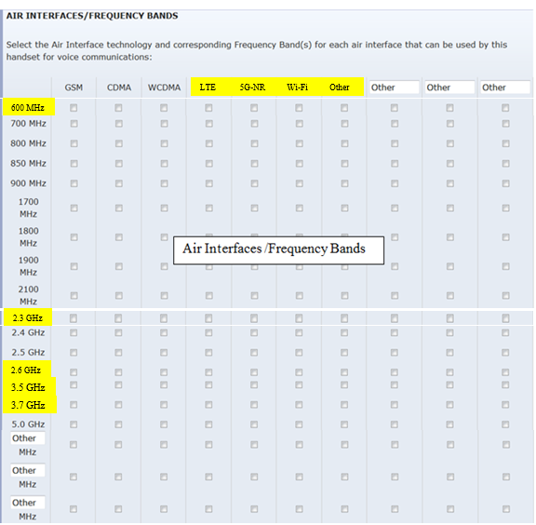

Figure 11 Handset Model Information Page 4a

(Hearing Aid Compatibility Ratings under a pre-2019 ANSI C63.19 Standard)

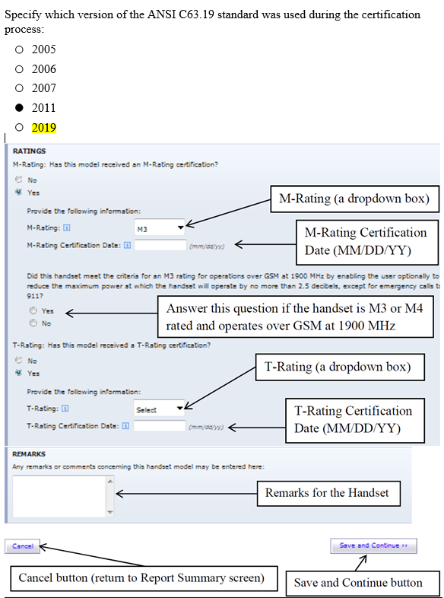

Figure 12 Handset Model Information Page 4b

(Hearing Aid Compatibility Certification under the 2019 ANSI C63.19 Standard)

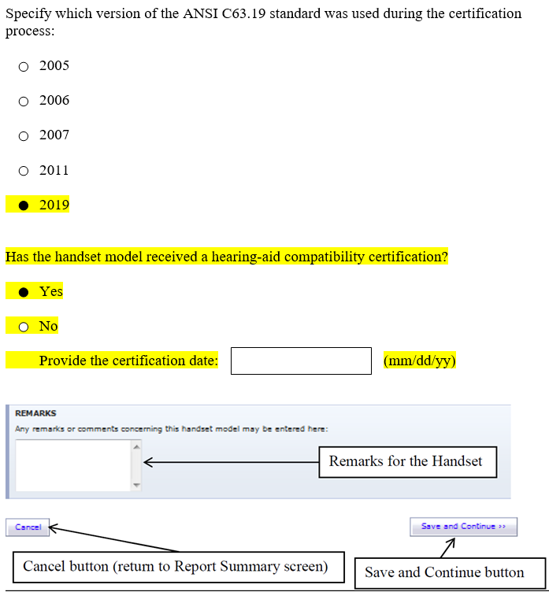

**Figure 13 Report Summary for Handset Information Section**

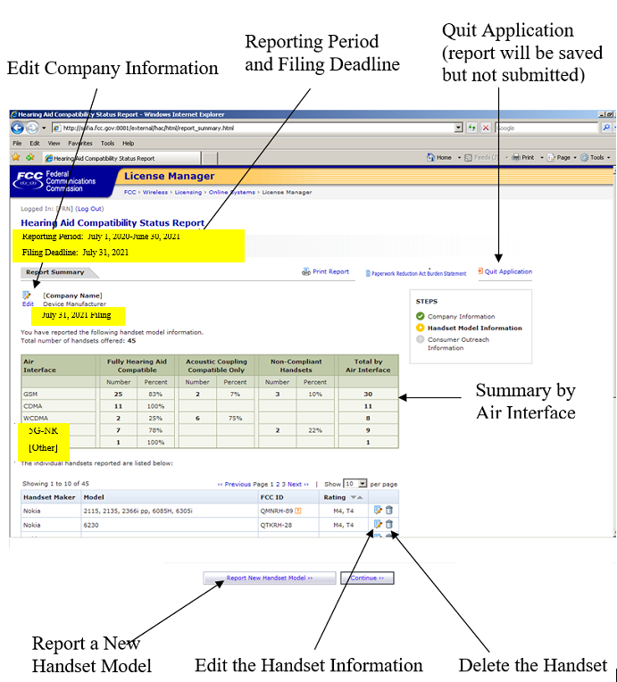

Figure 14 Edit the Handset Information

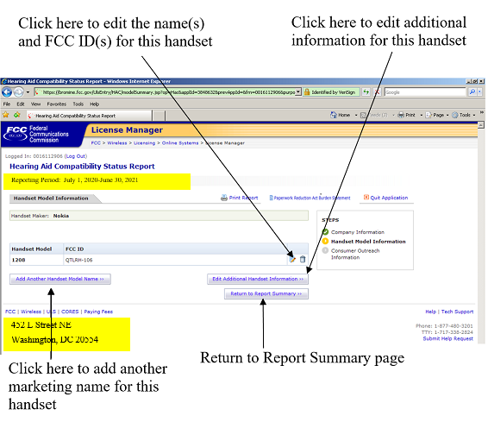

Figure 15 Consumer Outreach Page 1

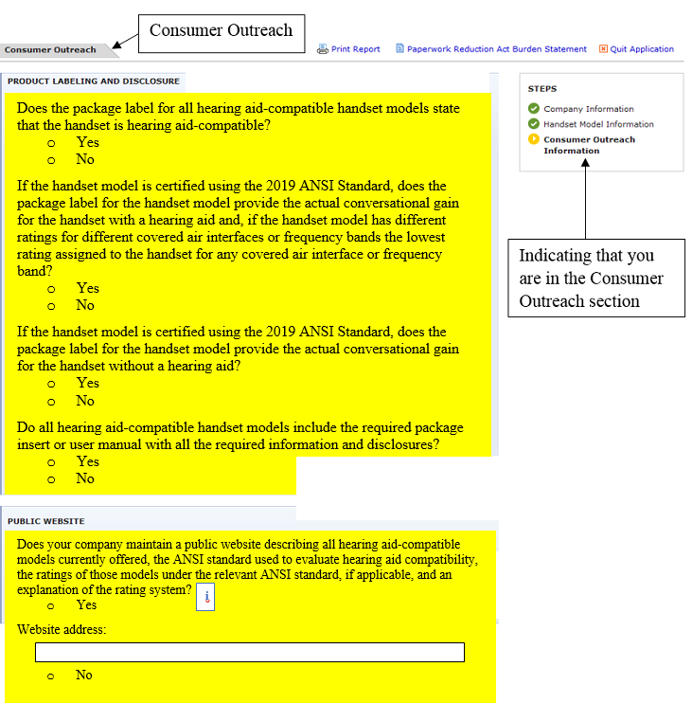

Figure 16 Consumer Outreach Page 2



Figure 17 Certification Page

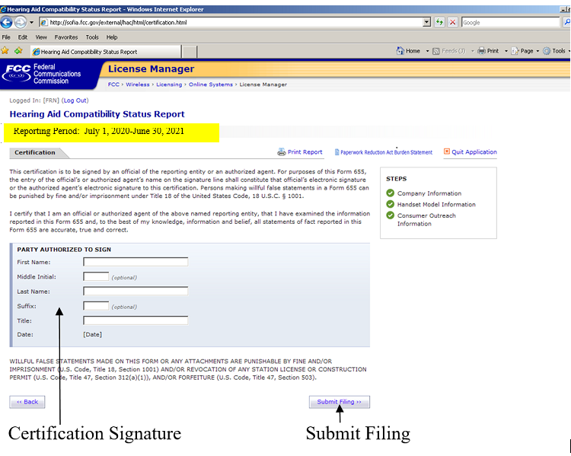

Figure 18 Confirmation Page

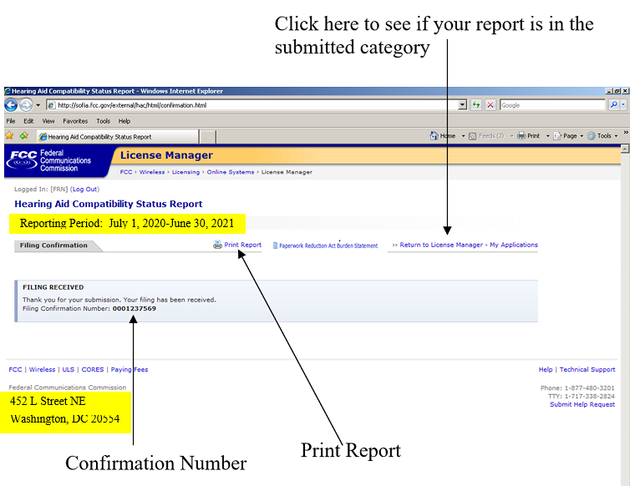

Figure 19 My Applications Page -- Saved Report

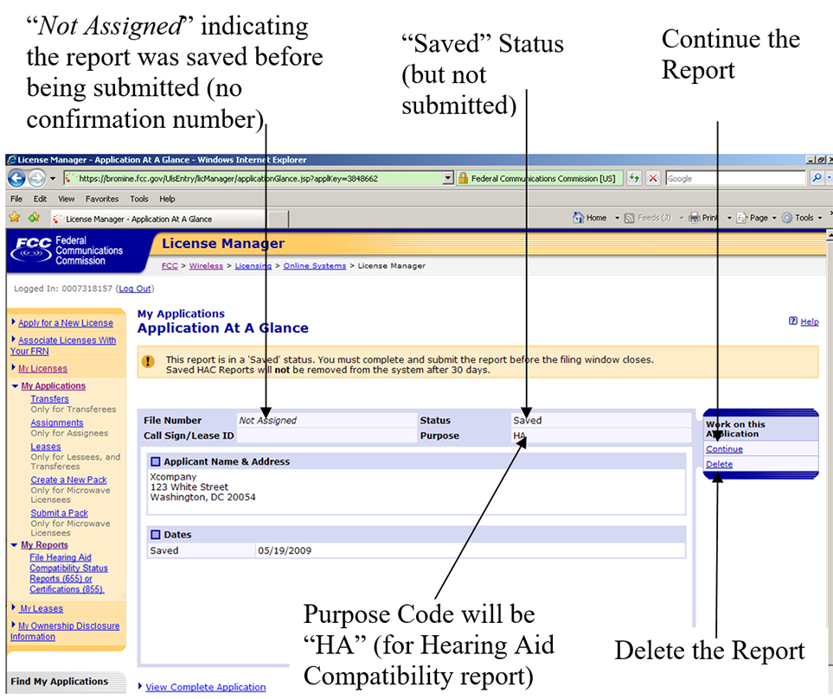

Figure 20 My Applications Page -- Submitted Report

