**Generic Information Collection Plan for the Collection of Qualitative Feedback on Bureau Service Delivery**

**No Material/Nonsubstantive Change Request**

The Consumer Financial Protection Bureau requests that OMB approves the “*Consumer Response Intake Form*” information collection (OMB Control No. 3170-0011) to incorporate a field to collect email address information into the Consumer Response Intake Form.

Currently, first party consumer submission (i.e. complaints submitted on behalf of oneself) do not require email address data for submission to the Bureau. The Bureau will now require email address data as part of respondents’ submissions.

The additional field would appear as follows:

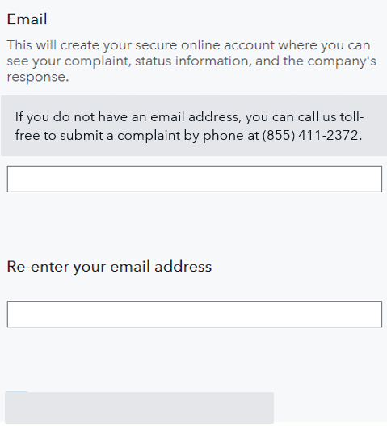

Previously, respondents could opt-out of providing email address data. Upon approval, these fields will be mandatory for any submission of the Consumer Response Intake Form. The email address will be stored at the Bureau only to facilitate customers to retrieve their own complaint data and will not be used by the Bureau for any other purpose.

The Bureau considers an email address to be "basic identifying information" under the meaning of 5 CFR 1320.3(h)(1) and, thus, collection of it is generally not subject to the requirements of the PRA. However, since this proposed change will amend an approved form, we are submitting this nonsubstantive change request.

If approved, this proposed revision would be reflected in the previously approved Consumer Response Intake Form.