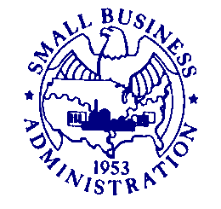
U.S. Small Business Administration
Washington, DC 20416

August 11, 2021

Susan Minson
SBA Desk Officer
Office of Management and Budget

Dear Ms. Minson:

Pursuant to the Office of Management and Budget (OMB) procedures in 5 CFR Part 1320,
SBA requests emergency review of revisions to the collection of information for the COVID-19 EIDL Loan Program (COVID EIDL). This information collection (OMB Control Number 3245-0406) is currently approved until November 30, 2023. This request for emergency processing, includes a request for waiver of the requirement to publish the 60-day and 30-day public comment notices in the Federal Register.

In order to simplify and streamline the process for applicants, SBA has consolidated Forms 3501 (COVID-19 Economic Injury Disaster Loan Application), 3502 (Economic Injury Disaster Loan Supporting Information), and 3503 (Self-Certification for Verification of Eligible Entity for Economic Injury Disaster Loan) into one form. This will reduce the burden on applicants as they will only need to enter certain information once. SBA also added questions related to entity type and types of business activity to assist applicants and SBA in determining eligibility. Further, SBA revised the questions related to the calculation of economic injury for clarity and to aid in automating the review process. These amendments and others will simplify the program requirements for the COVID EIDL, expand the number of entities that will be eligible for loans under the program, and increase the flow of funds to businesses and nonprofit organizations that still need relief from the COVID -19 pandemic

Many small businesses continue to face diminished operations and concerns of potential impact of the Delta COVID variant. With the end of the Paycheck Protection Program and the exhaustion of the Restaurant Revitalization Fund, the COVID-EIDL program is now the primary remaining resource for supporting small businesses back to stabilized operations. However, the deadline to apply for COVID EIDL loans is December 31, 2021. Due to that looming deadline, plus the ongoing critical need for financial assistance, SBA is requesting that OMB review and approve the revised information collection under the emergency procedures set forth in 5 CFR 1320.13 by August 18, 2021.

Sincerely,
Dianna Seaborn
Dianna Seaborn, Director
Office of Financial Assistance

