OMB No.

Dear Sir/Madam,
The United States Department of Agriculture’s National Agricultural Statistics Service recently requested your response to the 2022 Census of Agriculture. If you’ve already completed it, thank you. If not, there’s still time. Please complete the census today. Your response is vital.
Filling out the census online is easy:
- Type the following web address in your internet browser:
www.agcounts.usda.gov
- Enter your survey code on the homepage:
<<Survey code>>

Your individual responses are kept confidential, as required by federal law (Title V, Subtitle A, Public Law 107–347). If you have questions or difficulty completing the form, please call toll-free (888) 424-7828.

We thank you for your time, effort, and unwavering commitment to U.S. agriculture.

Sincerely,
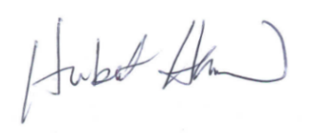
Hubert Hamer
Administrator, National Agricultural Statistics Service
United States Department of Agriculture

Responding online is convenient and secure.

To complete your survey online:

- Go to www.agcounts.usda.gov
- Enter the survey code: <<Survey code>>
- Select CONTINUE.
- Verify the contact information is correct and select ADDRESS VERIFIED – START SURVEY, or make corrections by selecting MAKE CORRECTIONS.
  - If you made Operation, Operator, or Contact Information corrections, select SAVE CHANGES – START SURVEY
- Complete the census through the Conclusion section and select SUBMIT SURVEY

You will receive a confirmation code and can choose to view your completed questionnaire. Using the options provided by your browser, you can copy, save, or print your form.

