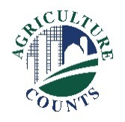
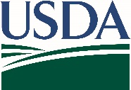
United States Department of Agriculture
National Agricultural Statistics Service
Eastern Mountain Regional Field Office
SAMPLE COVER LETTER – ALL SURVEYS IN THIS INFORMATION COLLECTION REQUEST WILL HAVE A SIMILAR LETTER WITH INFORMATION FOR THE SELECTED SURVEY SIGNED BY THE APPROPRITE PERSON.
August 27, 2021
What should I do next?
Complete your survey in one of the following ways:
Online at www.agcounts.usda.gov beginning on August 27. Online reporting is fast, cost-effective, and secure. All you need is the 17-digit survey code on the enclosed form to begin.

By mail or fax. Complete the survey questionnaire and mail it back in the return envelope provided or fax it to 855-270-2708.

Why am I getting this letter?

Enclosed is your September 2021 Turkeys Raised Survey. Please complete the questionnaire at your earliest convenience. Your information is important. Turkey producers, processors, retailers, analysts, agribusinesses, and others use the data from the Turkeys Raised survey to gain up-to-date inventory information and make critical decisions about production and marketing strategies. This September report provides data users with a preliminary estimate of turkeys being raised in the current calendar year.

If we do not hear from you by Tuesday, September 07, 2021, we will contact you to arrange a telephone interview.

The information you provide will be used for statistical purposes only. In accordance with federal law, your responses will be kept confidential and will not be disclosed in identifiable form. We will publish the survey findings in the Turkeys Raised Report, to be released Friday, September 24, 2021 at 3:00 PM ET.

Thank you for participating and for your support of our programs and U.S. agriculture. If you have any questions, please feel free to contact us at 1-800-928-5277.

Enclosure
Place a state or regional graph or highlight here

Sincerely,
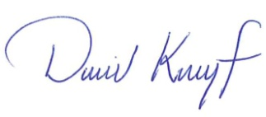
David Knopf
Director, Eastern Mountain Regional Field Office
U.S. Department of Agriculture
National Agricultural Statistics Service

PO Box 1120 Louisville, Kentucky 40201-1120
www.nass.usda.gov
USDA is an equal opportunity provider, employer, and lender.

