**United States Department of Agriculture**

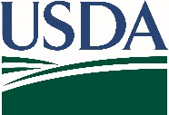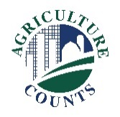

National Agricultural Statistics Service

DRAFT

December 20XX

**What should I do next?**

Complete your survey in one of the following ways:

**Online** at [agcounts.usda.gov](http://www.agcounts.usda.gov). Online reporting is fast, easy, and secure.All you need is the unique survey code on the enclosed form to begin.

By **mail or fax**. Complete the questionnaire and mail it back in the envelope provided or fax it to (855) 415-3687.

**Why am I getting this letter?**

You have been selected to participate in the Commercial Floriculture Survey. Your information is important. It will help document changes in the floriculture industry and enable us to develop up-to-date industry data for you. Please complete your questionnaire online or by mail at your earliest convenience. To protect the health of producers, partners, and employees, NASS has suspended in-person data collection until further notice.

**What will this data be used for?**

Growers, buyers, government agencies and others can use the data to identify state and national trends, make plans, and determine the industry’s impact on farm income and the economy.

If we do not hear from you by Monday, February XX, 20XX, we may contact you to arrange a telephone interview.

Your response is protected by federal law (Title V, Subtitle A, Public Law 107-347), which ensures that your individual identity and answers are kept confidential. We will publish the survey results in the *Floriculture Crops* report on May XX, 20XX. The report will be available at nass.usda.gov/Publications.

Thank you for participating and for your support of our programs and U.S. agriculture. If you have any questions, please contact us at (888) 424-7828.

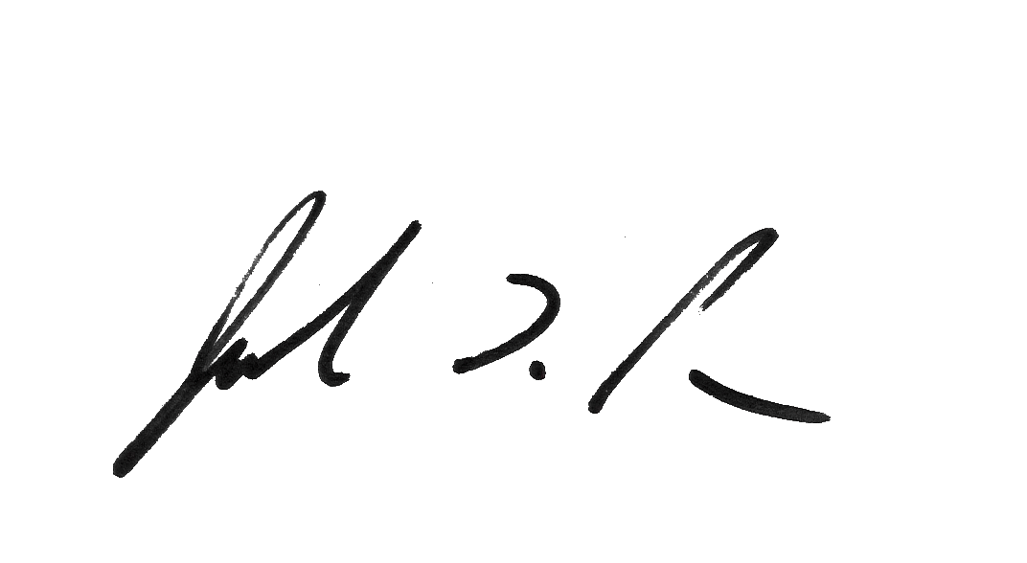

Sincerely,

Joseph L. Parsons

Chair, Agricultural Statistics Board

Enclosure