**Appendix D.4   
Screenshots of State Agency Child Nutrition Director Survey: Summer 2022**

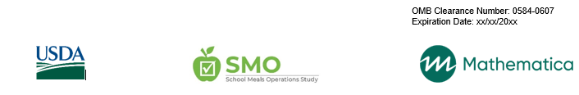

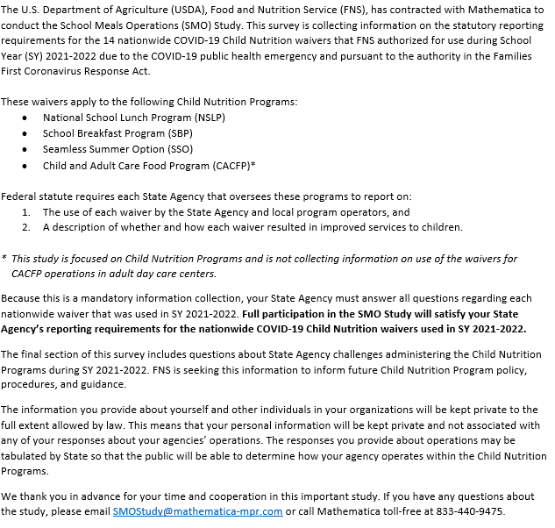

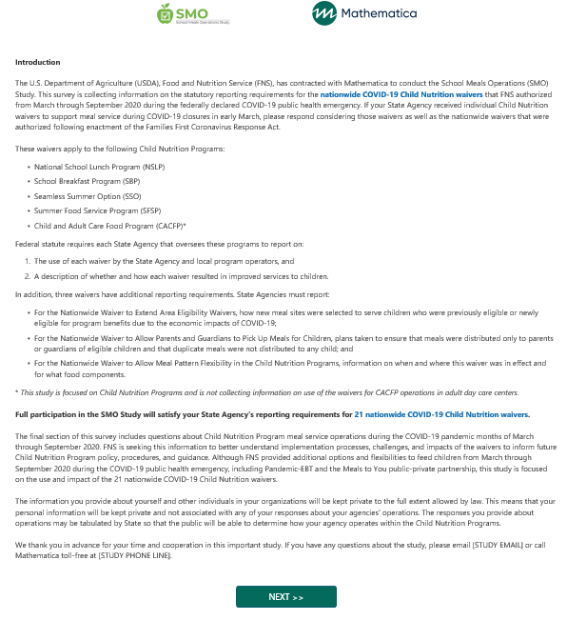

**14 nationwide COVID-19 Child Nutrition waivers.**



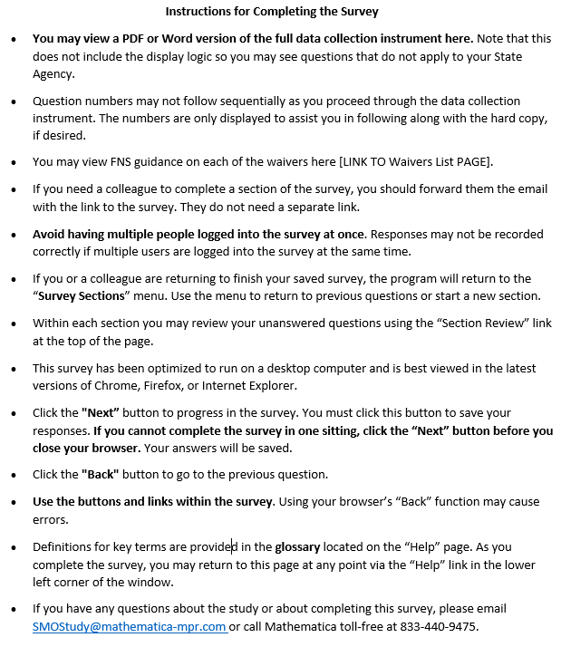



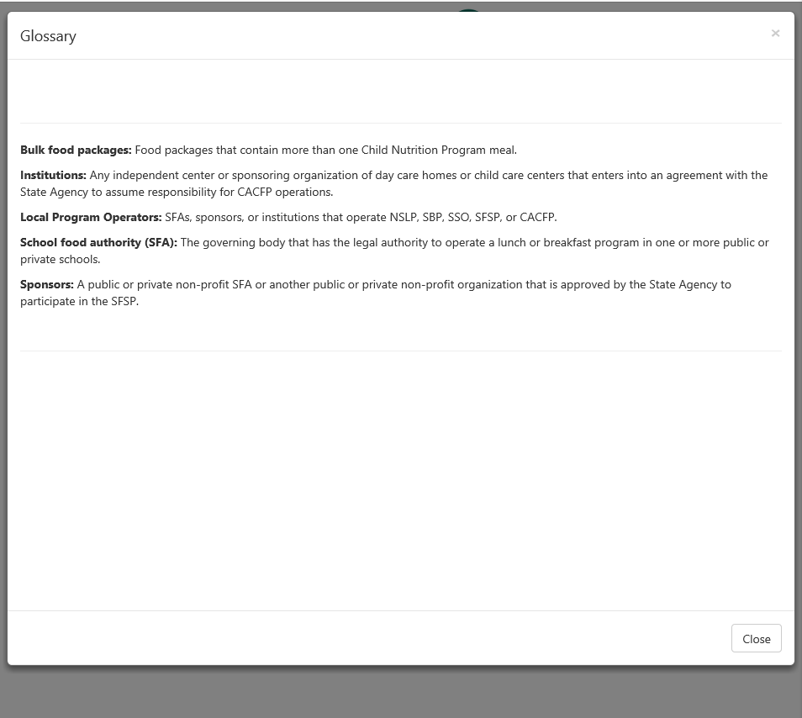

items that could be used for multiple meals or portion sizes.

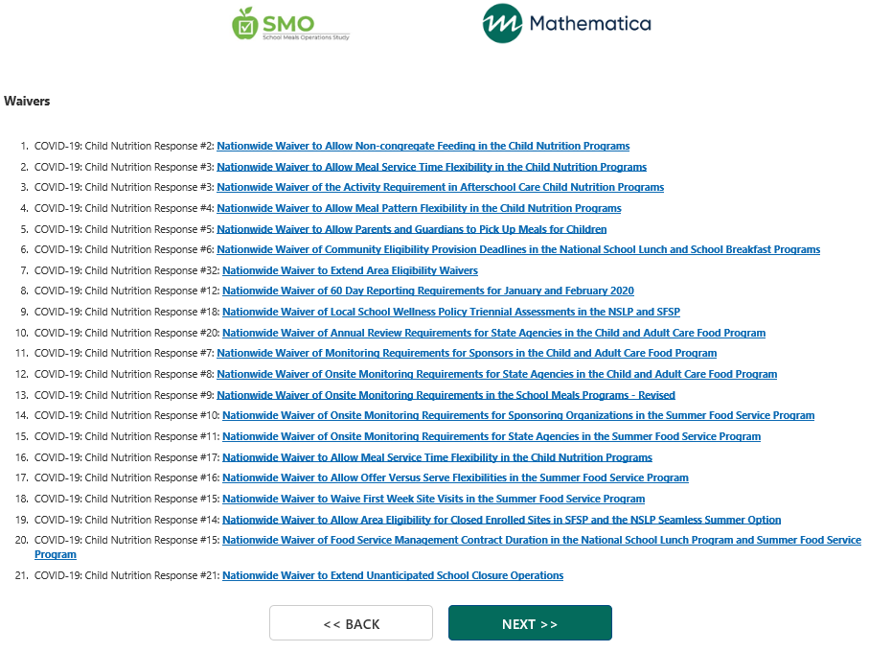

**This data collection is focused on the reporting requirements associated with the following nationwide waivers authorized for use in SY 2021-20222:**

1. [Nationwide Waiver to Allow the Seamless Summer Option](https://www.fns.usda.gov/cn/child-nutrition-response-85) (Response 85)  
   Allows SFSP and Seamless Summer Option operations through June 30, 2022.
2. [Nationwide Waiver to Allow Summer Food Service Program Reimbursement Rates](https://www.fns.usda.gov/cn/child-nutrition-response-86) (Response 86)  
   Allows school food authorities to claim NSLP SSO meals and snacks at the SFSP reimbursement rates.
3. [Nationwide Waiver to Allow Non-Congregate Meal Service](https://www.fns.usda.gov/cn/child-nutrition-response-87)(Response 87)  
   Allows meals to be served in non-group settings to support social distancing.
4. [Nationwide Waiver of Meal Times Requirements](https://www.fns.usda.gov/cn/child-nutrition-response-88) (Response 88)  
   Allows meals to be served to kids outside traditional times to maximize flexibility for meal pick-up.
5. [Nationwide Waiver to Allow Parents and Guardians to Pick Up Meals for Children](https://www.fns.usda.gov/cn/child-nutrition-response-89) (Response 89)  
   Allows parents/guardians to pick-up meals and bring them home to their children.
6. [Nationwide Waiver to Allow Specific School Meal Pattern Flexibility](https://www.fns.usda.gov/cn/child-nutrition-response-90) (Response 90)  
   Provides the flexibility to serve meals that do not meet specified meal pattern requirements when needed.
7. [Nationwide Waiver to Allow Specific Meal Pattern Flexibility in the Child and Adult Care Food Program](https://www.fns.usda.gov/cn/child-nutrition-response-91) (Response 91)  
   Provides the flexibility to serve meals that do not meet specified meal pattern requirements when needed.
8. [Nationwide Waiver to Allow Offer Versus Serve Flexibility for Senior High Schools](https://www.fns.usda.gov/cn/child-nutrition-response-92)(Response 92)  
   Provides the flexibility to serve meals without using offer versus serve in senior high schools.
9. [Nationwide Waiver of Area Eligibility in the Afterschool Programs and for Family Day Care Home Providers](https://www.fns.usda.gov/cn/child-nutrition-response-93) (Response 93)  
   Allows schools and at-risk afterschool care centers, regardless of their location, to claim all National School Lunch Program Afterschool Snack Service and Child and Adult Care Food Program At-risk Afterschool Program meals and snacks at the free rate.
10. [Nationwide Waiver of Onsite Monitoring Requirements in the School Meal Programs – Revised – EXTENSION 3](https://www.fns.usda.gov/cn/child-nutrition-response-94) (Response 94)  
    Provides flexibilities for certain monitoring and review requirements for school meals programs.
11. [Nationwide Waiver of Onsite Monitoring Requirements for State Agencies in the Child and Adult Care Food Program – EXTENSION 3](https://www.fns.usda.gov/cn/child-nutrition-response-95) (Response 95)  
    Provides flexibilities for certain monitoring and review requirements for school meals programs.
12. [Nationwide Waiver of Onsite Monitoring Requirements for Sponsors in the Child and Adult Care Food Program – EXTENSION](https://www.fns.usda.gov/cn/child-nutrition-response-96)(Response 96)  
    Provides flexibilities for certain monitoring and review requirements for sponsors participating in CACFP.
13. [Nationwide Waiver to Provide Flexibility for School Meal Programs Administrative Reviews of School Food Authorities Operating Only the Seamless Summer Option in School Year (SY) 2021-2022](https://www.fns.usda.gov/cn/child-nutrition-response-97) (Response 97)  
    Provides flexibilities for State agencies conducting administrative reviews of school food authorities operating only the SSO.
14. [Nationwide Waiver of Local School Wellness Policy Triennial Assessments in the National School Lunch and School Breakfast Programs](https://www.fns.usda.gov/cn/covid19-child-nutrition-response-98) (Response 98)  
    Provides a new first triennial assessment deadline of June 30, 2022.

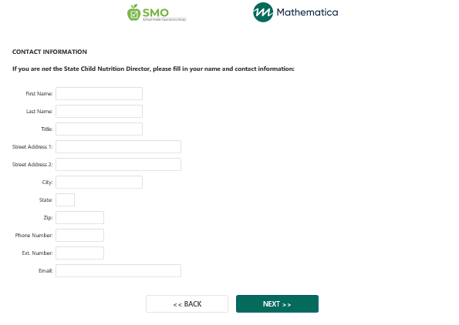

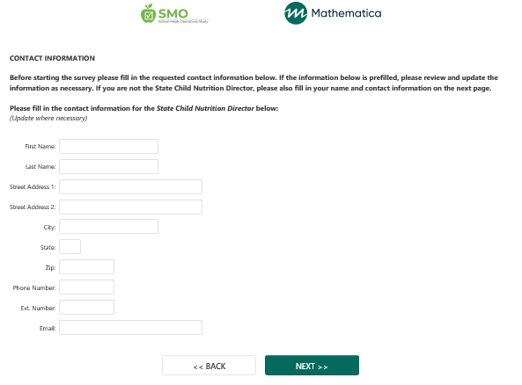

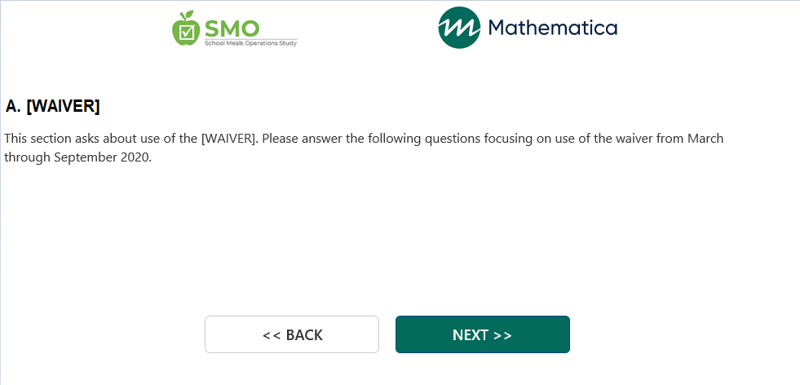

**during SY 2021-2022.**

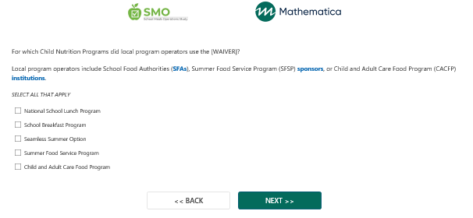

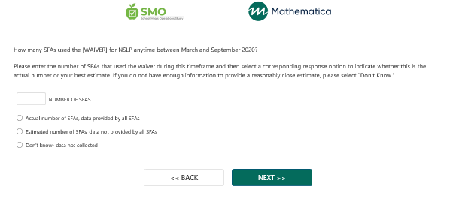

**during SY 2021-2022.**

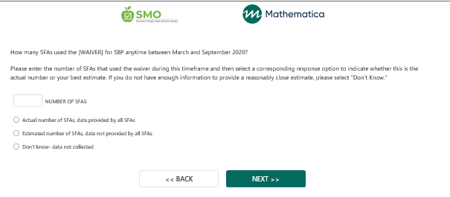

**during SY 2021-2022.**

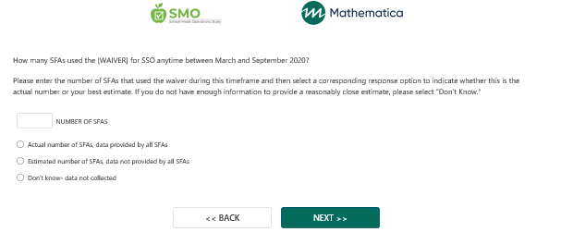

**during SY 2021-2022.**

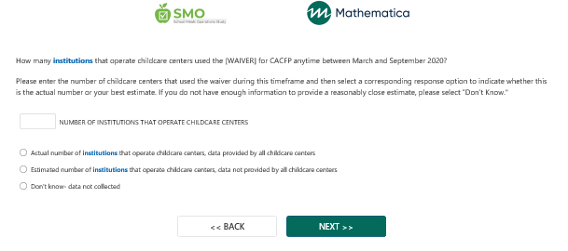

**during SY 2021-2022.**

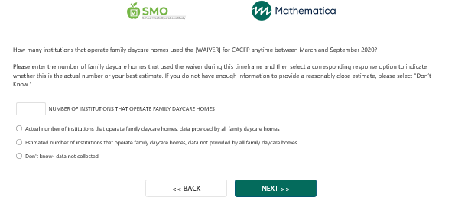

**during SY 2021-2022.**

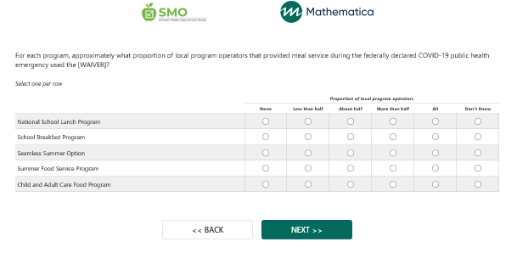

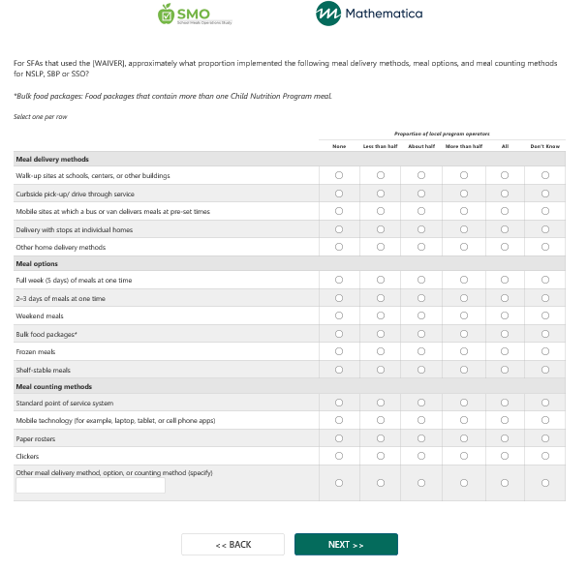

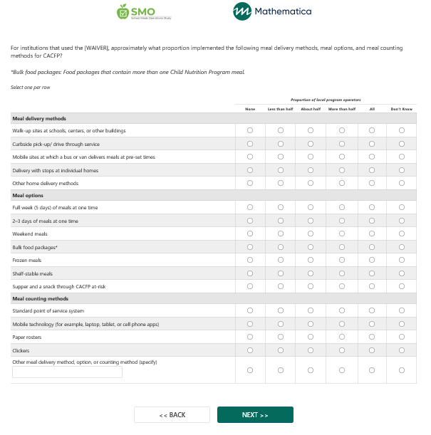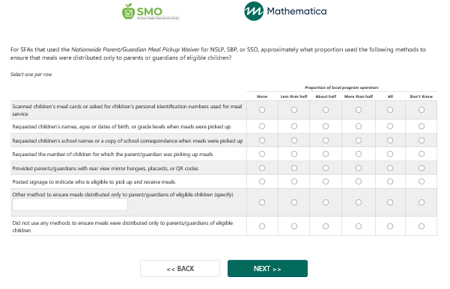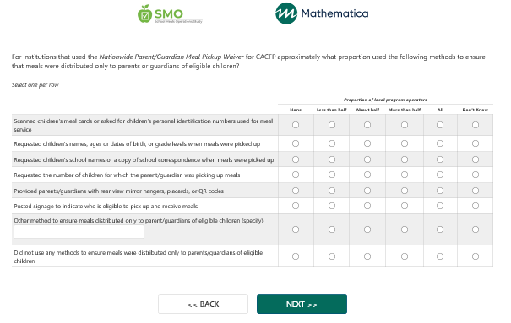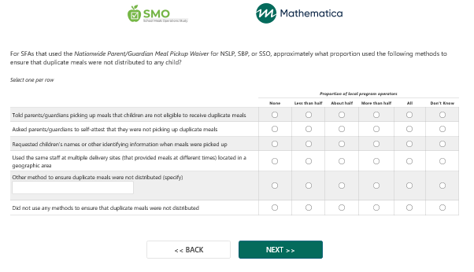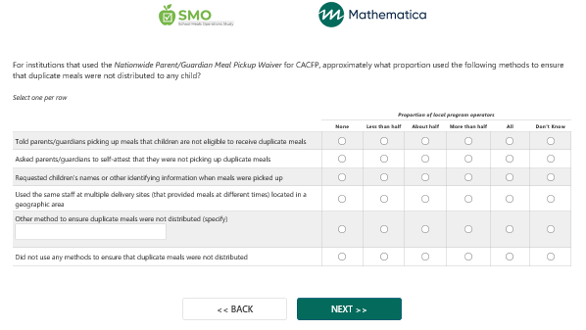

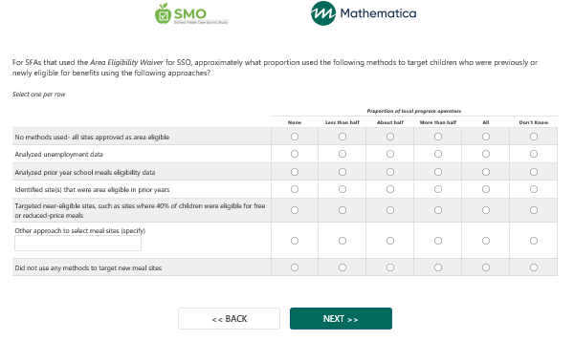

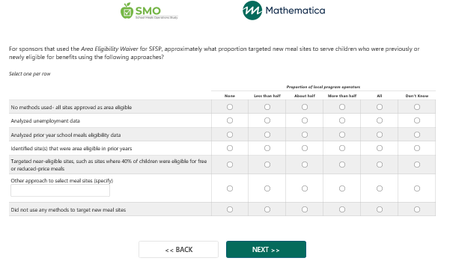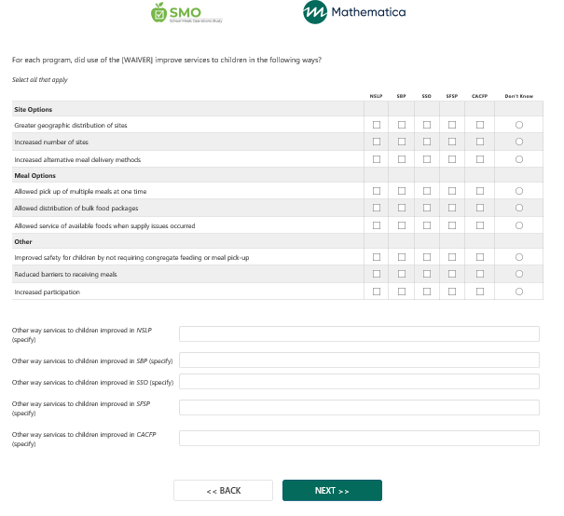

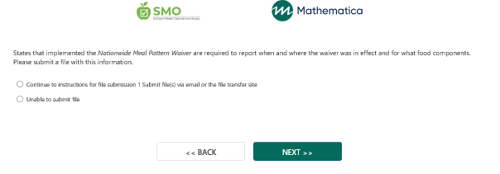

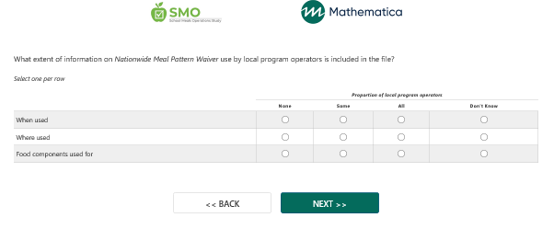

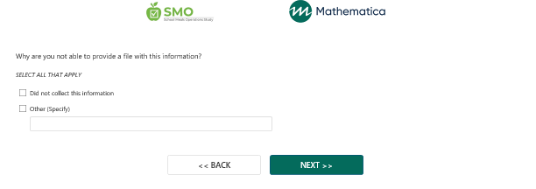

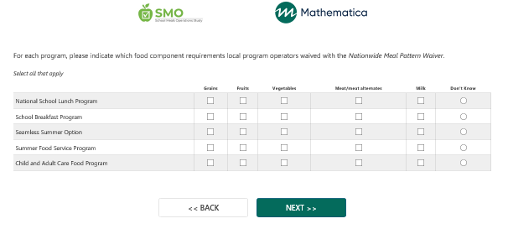

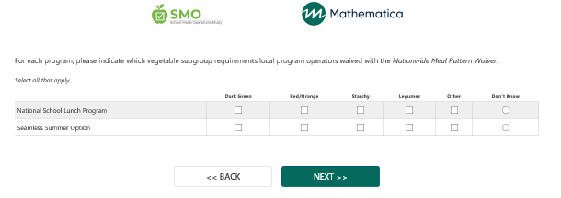

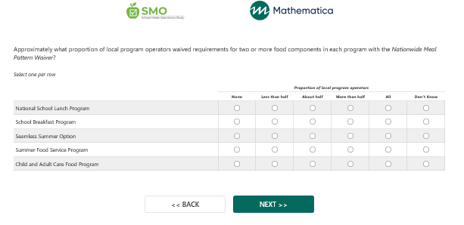

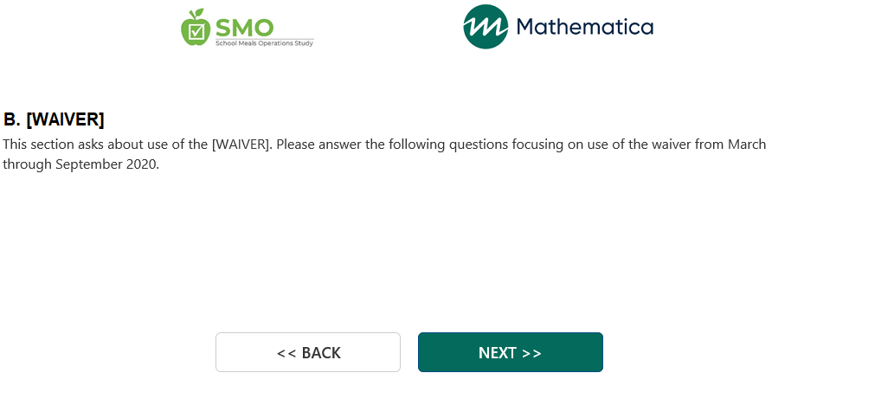

during SY 2021-2022.



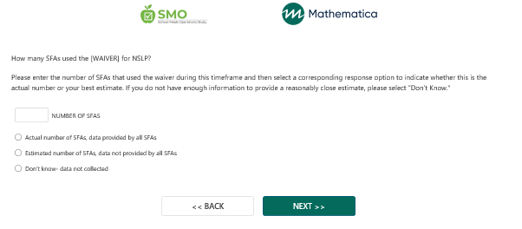

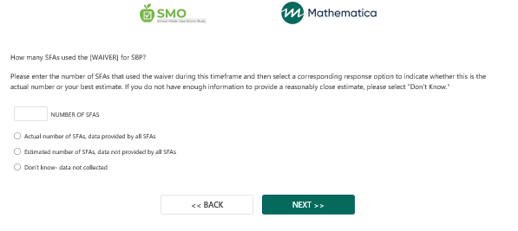

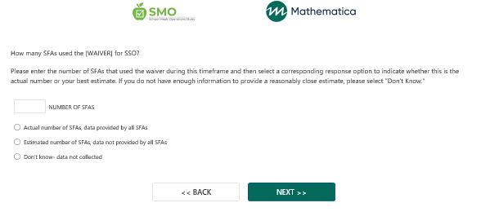

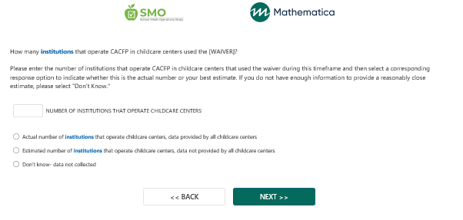

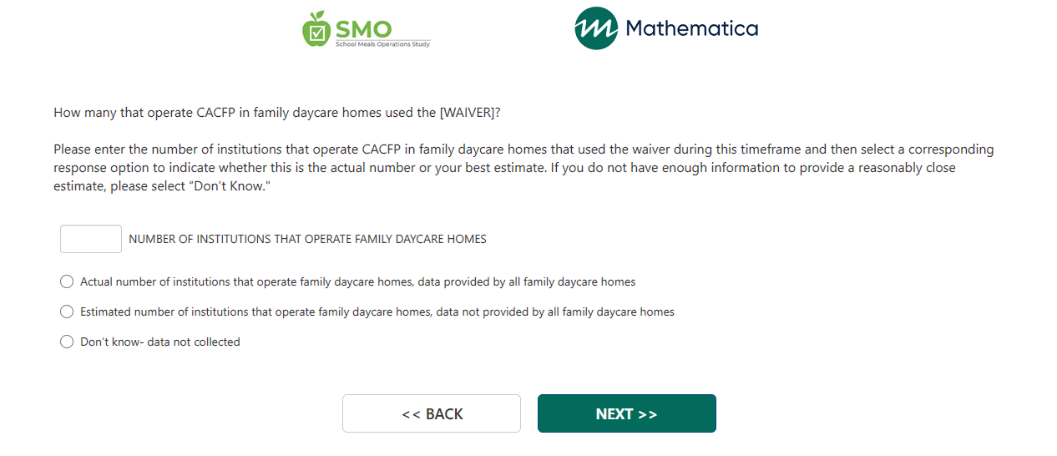

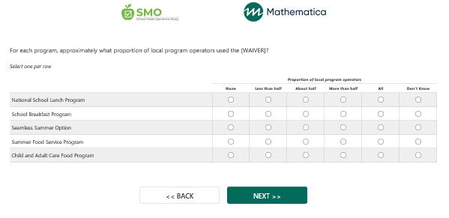

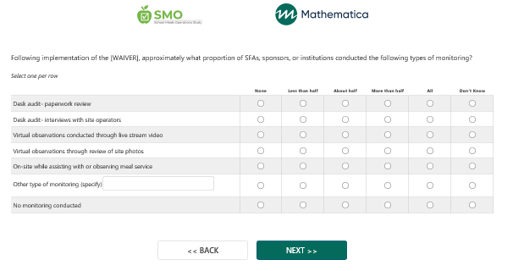

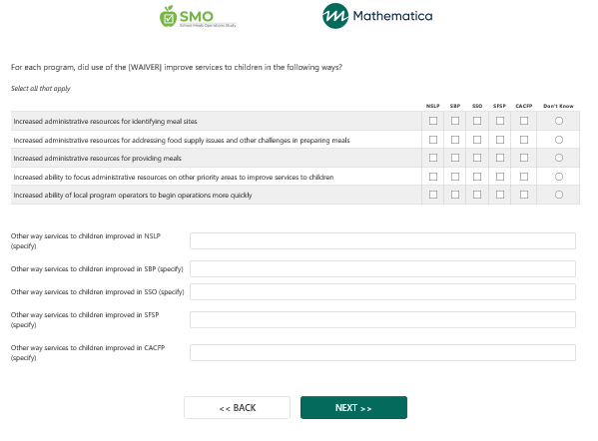

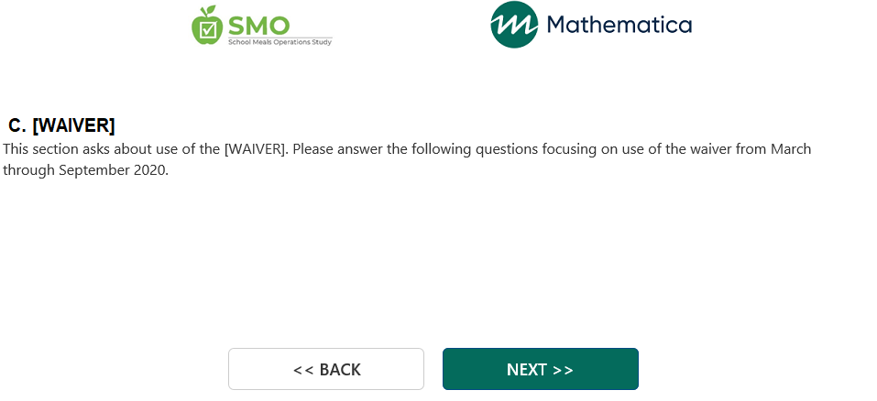

during SY 2021-2022.

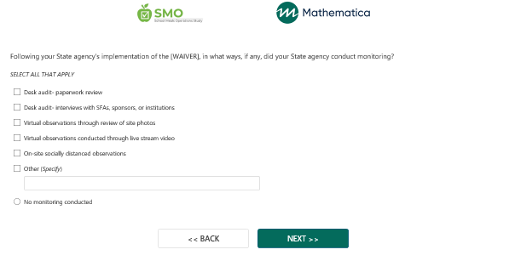

/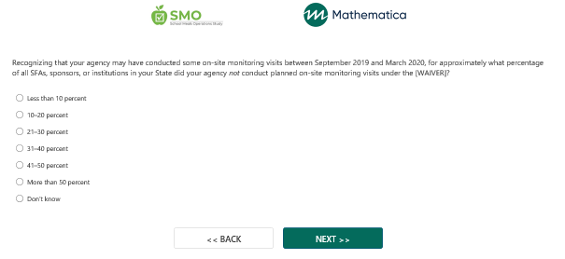

During SY 2021-2022, for approximately what percentage of all SFAs in your State did your agency conduct administrative reviews using the *Administrative Reviews of School Food Authorities Operating Only the Seamless Summer Option Waiver*?

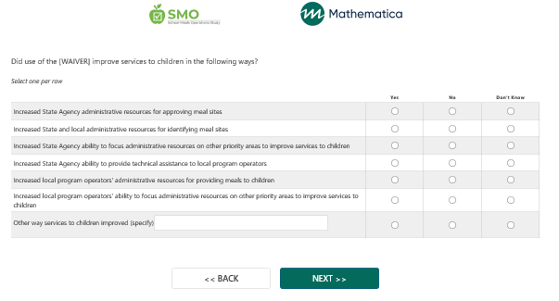

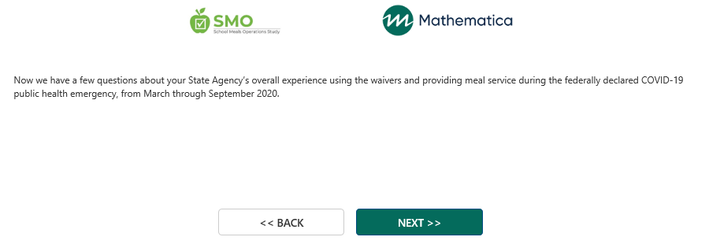

**operational and financial challenges that your State Agency experienced administering Child Nutrition Programs** during SY 2021-2022**.**

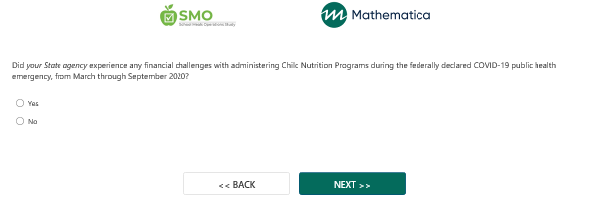

**SY 2021-2022?**

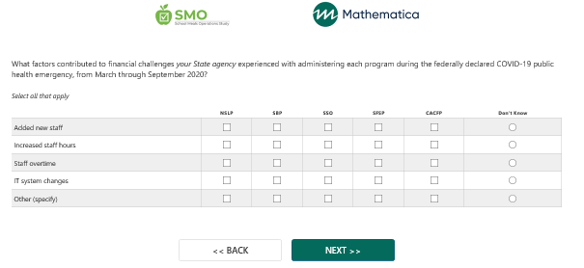

**SY 2021-2022?**

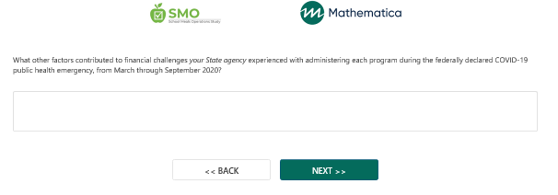

**SY 2021-2022?**

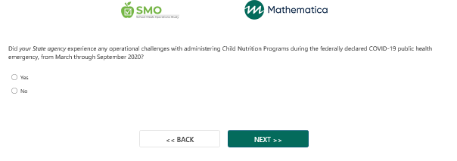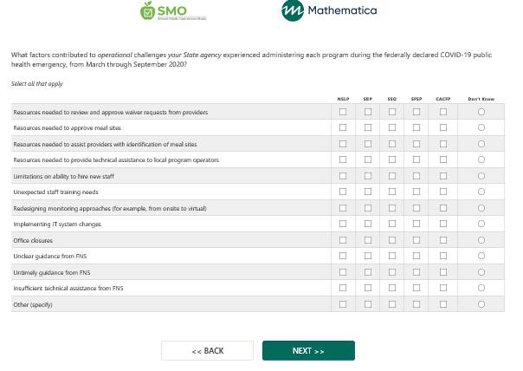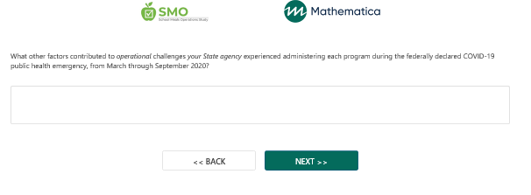

**SY 2021-2022?**

**SY 2021-2022?**

**SY 2021-2022?**

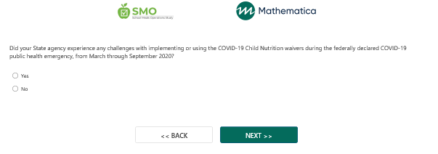

**SY 2021-2022?**

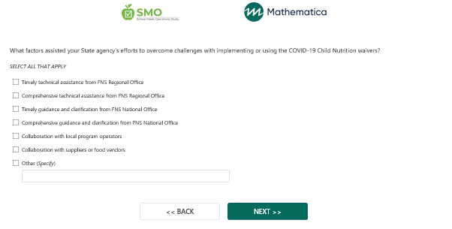

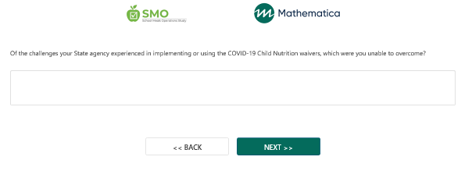

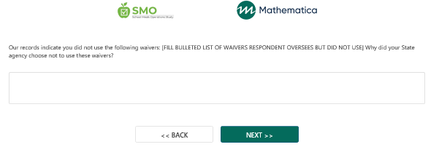

**Is there anything else FNS should know about use or impacts of the nationwide COVID-19 Child Nutrition waivers during SY 2021-2022?**

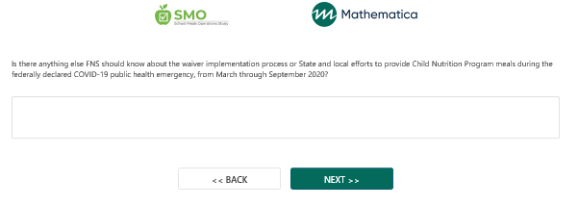

**State and local efforts to provide Child Nutrition Program meals during SY 2021-2022?**

