Eliminated Questions and Support Emails:
Eliminating Item 5B. Interplant transfers:
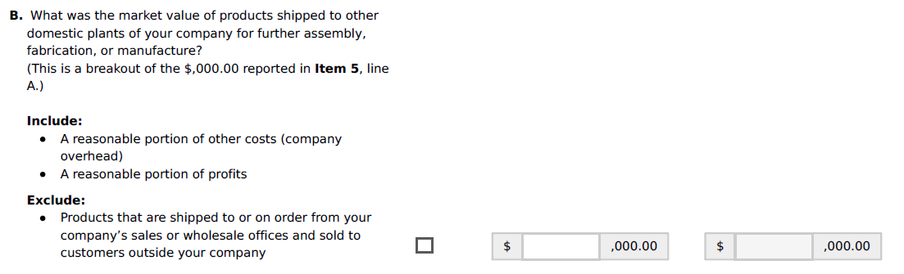

Eliminating the Production Workers Sum (highlighted) and 7B the Average:
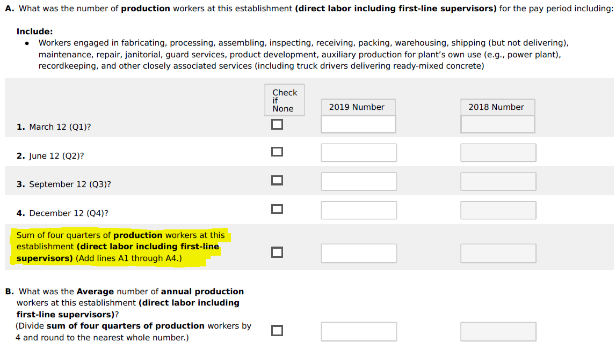

This section contains selected comments and support related to the removal of this content from emails received:
Sent: Sunday, March 22, 2020 6:27 PM
Subject: RE: Manufacturing Interplant Transfers - FRB

I reached out to the usual characters around here to see if anyone used the interplant transfers. One person said “no” and the others haven’t replied. I gave them a deadline of noon Monday. So if you haven’t heard otherwise from me by then, it’s safe to assume we don’t use those data.

Thanks again, and sorry for the delay.

Sent: Friday, March 13, 2020 2:42 PM
Subject: RE: Manufacturing Interplant Transfers - BEA

BEA does not use this data item, so we will not be affected by the removal.

Thanks,

Sent: Friday, March 20, 2020 4:57 PM
Subject: RE: Manufacturing Interplant Transfers - BLS
Thank you for reaching out to us and apologies for not getting back to you sooner on this. The PPI program has no plans to use the information from the question so not publishing it will have no adverse effect on us.

Thank you again for reaching out,

