Attachment IV: IDES Introductory/Login Page
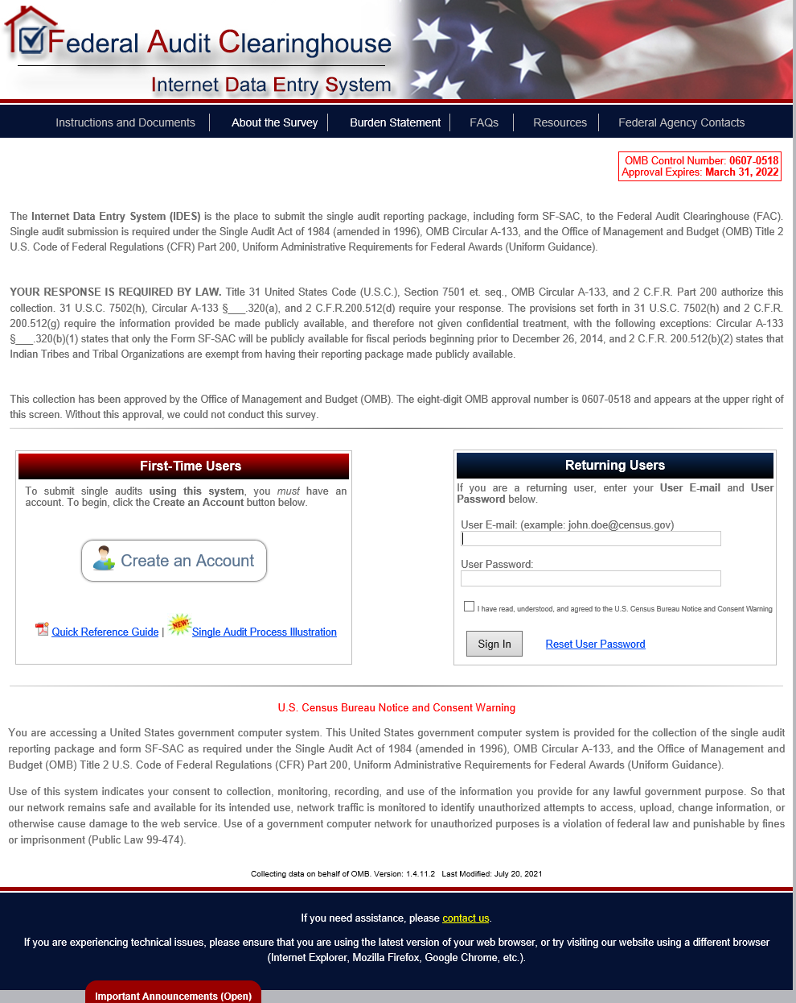

Clicking “About the Survey”
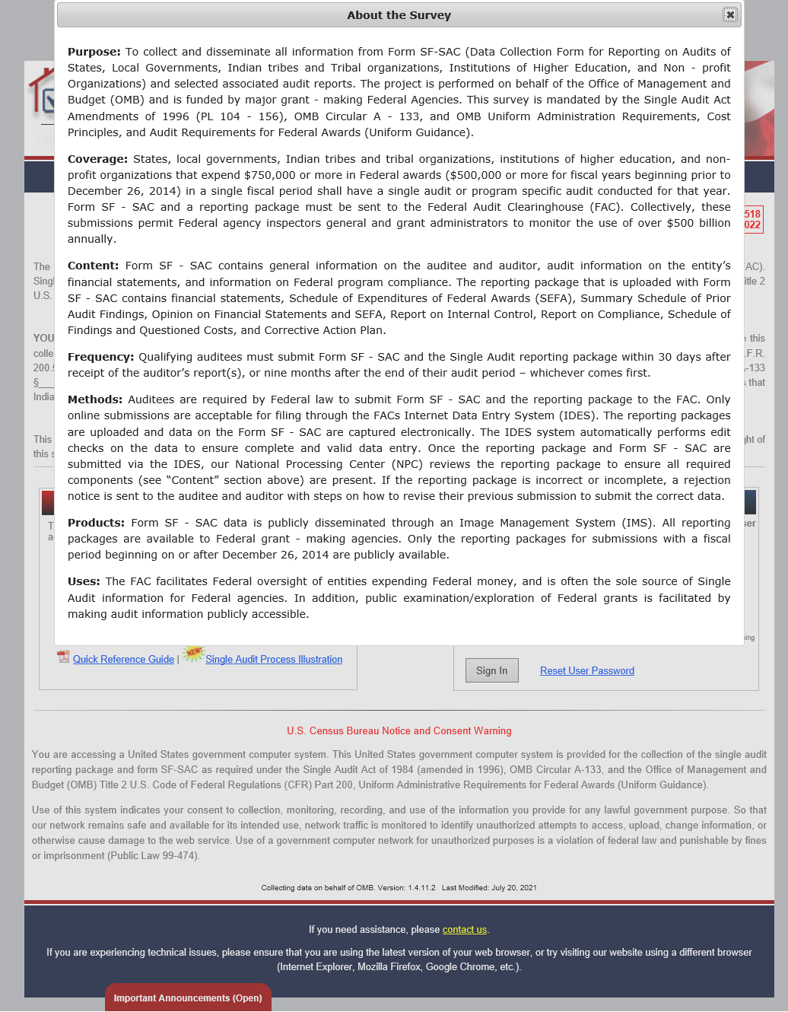

Clicking “Burden Statement”
