U.S. Census Bureau
Non-Substantive Change Request
Manufacturers’ Shipments, Inventories and Orders (M3) Survey (0607-0008)

The Manufacturers’ Shipments, Inventories and Orders (M3) Survey has been conducted monthly by the U.S. Census Bureau since 1957. The Advance Report on Durable Goods, Manufacturers’ Shipments, Inventories and Orders is an advance snapshot of manufacturing in the U.S. and includes shipments, new orders, unfilled orders, and inventories estimates only for the durable goods sector. It is available about 18 working days after each month. Currently, there is no similar advance report for non-durable goods. The M3 survey also produces the Full Report on Manufacturers’ Shipments, Inventories and Orders. This report details information on the durable goods industries and includes the non-durable goods industries. In addition, the Full Report captures late receipts, and is available about 23 working days after each month.

In the last request for Office of Management and Budget (OMB) review of the M3 survey (approved March 3, 2021), the Census Bureau outlined its plan to publish an Advance Total Manufacturing estimate at the same time as the Advance Report on Durable Goods. The advance total manufacturing estimate will include the durable, as well as non-durable goods sectors. OMB asked the Census Bureau to submit a memo of exemption to Statistical Policy Directive No. 3 and a non-substantive change request to detail our plans to publish Advance Total Manufacturing estimate at the same time as the Advance Report on Durable Goods. The exemption was granted on September 15, 2021. The Census Bureau is now requesting a non-substantive change to be able to release Advance Total Manufacturing shipments and inventories data at the same time with the Advance Report on Durable Goods Manufacturers’ Shipments, Inventories and Orders.

Consistent with the current Advance Report on Durable Goods Manufacturers’ Shipments, Inventories and Orders, we propose the same 8:30 a.m. release time and schedule. We will release the report electronically through the Census website.

Beginning with the release of September 2021 data on October 27, 2021, the U.S. Census Bureau will be accelerating the non-durable manufacturing industries data together with durable goods industries in an advance high-level total manufacturing estimates for shipments and inventories. This additional data release will provide data users with early access to total manufacturing estimates, giving an early snapshot of the direction of this critical indicator. The advance total manufacturing statistics for shipments and inventories will be released at the same time as the Advance Report on Durable Goods Manufacturers’ Shipments, Inventories and Orders. Sample tables are shown below.

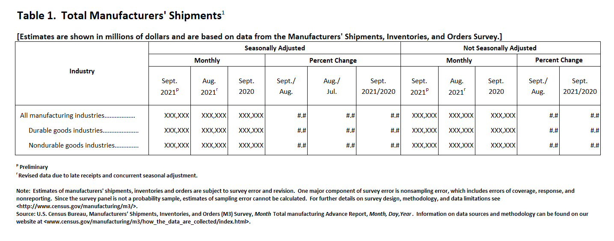
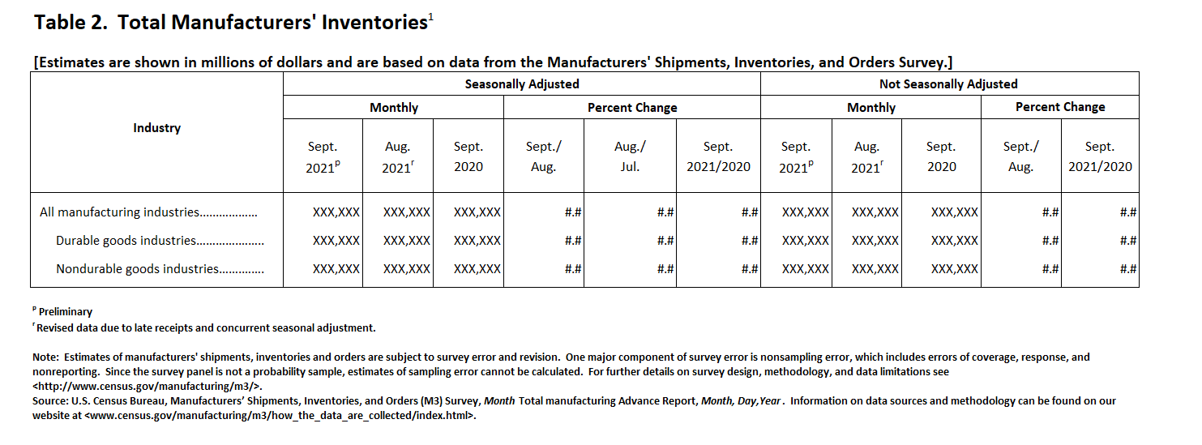

Advance Total manufacturing shipments and inventories estimates will be made available on a seasonally adjusted basis as well as a not seasonally adjusted basis on the M3 website at 8:30 a.m. under the “Advance Report Highlights” at U.S. Census Bureau Manufacturers’ Shipments, Inventories, and Orders website at the same time with the Advance Report on Durable Goods Manufacturers’ Shipments, Inventories and Orders.

The Census Bureau will collect feedback from stakeholders and data users to determine the usefulness of the data as well as review recommended changes or updates. This information will assist Census in providing data users with more timely and accurate data on manufacturing sector, a major component of the economy.

