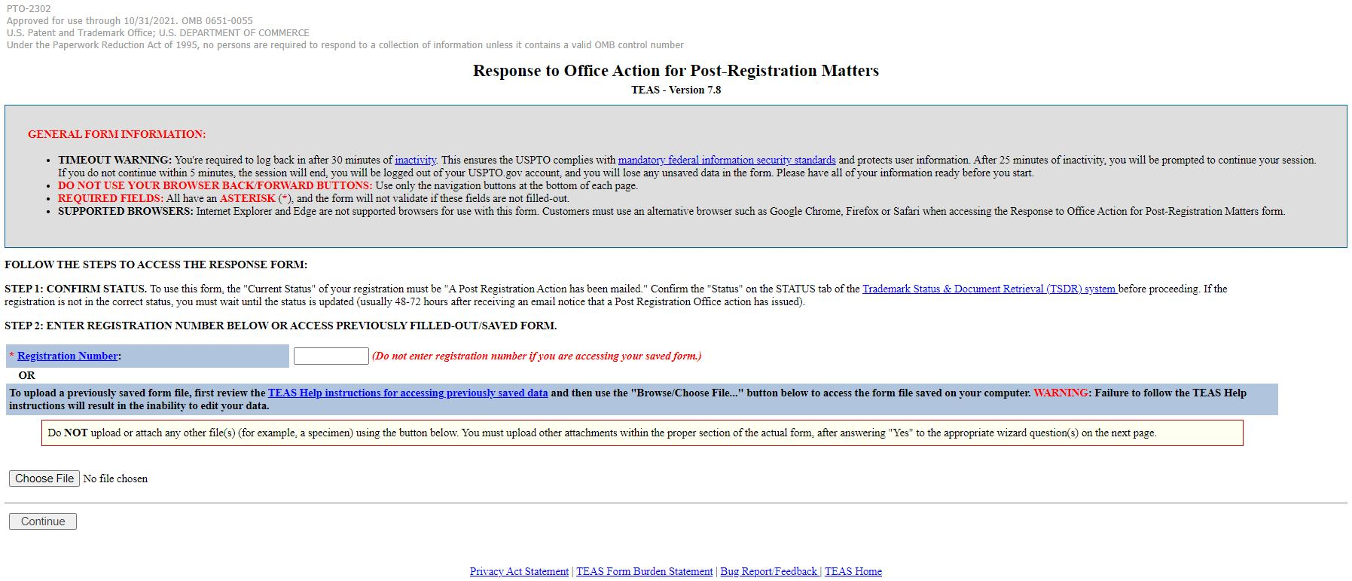
xx/xx/xx20

PRA Burden Statement
A Federal agency may not conduct or sponsor, and a person is not required to respond to, nor shall a person be subject to a penalty for failure to comply with an information collection subject to the requirements of the Paperwork Reduction Act of 1995, unless the information collection has a valid OMB Control Number. The OMB Control Number for this information collection is 0651-0055. Public burden for this form is estimated to average 45 minutes per response, including the time for reviewing instructions, searching existing data sources, gathering and maintaining the data needed, and completing and reviewing the information collection. Send comments regarding this burden estimate or any other aspect of this information collection, including suggestions for reducing this burden to the Office of the Chief Administrative Officer, United States Patent and Trademark Office, P.O. Box 1450, Alexandria, VA 22313-1450 or email InformationCollection@uspto.gov.

Privacy Act Statement
The USPTO collects this information under authority of 35 U.S.C. 2(b)(2). The information you provide will be used to process your applications and submissions related to trademark registration. The information in this system of records is used to manage name, citizenship, domicile, email address, postal address, and telephone number of the trademark applicant, registrant, and applicant’s or registrant’s legal or other authorized representative(s), an attorney’s law firm or company affiliation and professional licensing information, and other information pertaining to an applicant’s or registrant’s activities in connection with the applied-for or registered mark. The information is protected from disclosure to third parties in accordance with the Privacy Act. However, routine uses of this information may include disclosure to the following: the public; certain foreign entities, professional organizations or associations, audit or oversight controls; law enforcement; non-federal personnel working for the agency; record and informational inquiries; coordinators of data breach response; litigation actions; Department of Justice; Office of Personnel Management; Congressional inquiries; the National Archives and Records Administration; and Office of Management and Budget. If you do not furnish the requested information, the U.S. Patent and Trademark Office may not be able to process and/or examine your submission, which may result in termination of proceedings or abandonment of the application for trademark registration. The applicable Privacy Act System of Records Notice for this information request is COMMERCE/USPTO-26, Trademarks Application and Registration Records: Federal Register vol. 85 February 18, 2020, p 8847, available at https:// www.govinfo.gov/content/pkg/FR-2020-02-18/pdf/2020-03068.pdf.

