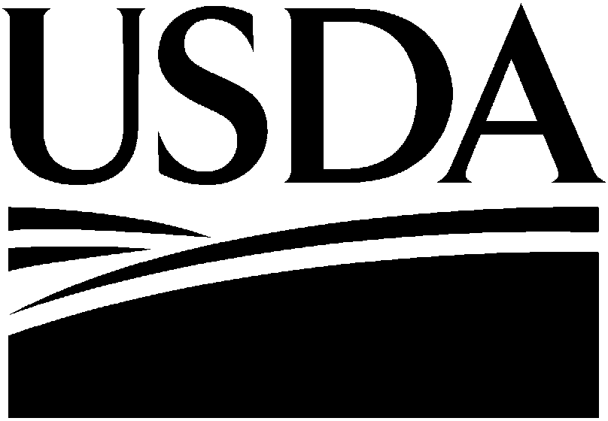
REQUEST FOR EXEMPTION
OF SELECT AGENTS AND TOXINS FOR AN INVESTIGATIONAL PRODUCT (APHIS/CDC FORM 5)

FORM APPROVED OMB NO. 0579-0213
OMB NO. 0920-0576 EXP DATE XX/XX/2020

Read all instructions carefully before submitting the form to either APHIS Agriculture Select Agent Services or CDC Division of Select Agents and Toxins, through the Federal Select Agent Program electronic information system or email. Instructions are available at https://www.selectagents.gov/form5.html

Animal and Plant Health Inspection Service Agriculture Select Agent Services
4700 River Road Unit 2, Mailstop 22, Cubicle 1A07
Riverdale, MD 20737
FAX: 301-734-3652
E-mail: AgSAS@aphis.usda.gov
Centers for Disease Control and Prevention Division of Select Agents and Toxins
1600 Clifton Road NE, Mailstop H-21-7
Atlanta, GA 30329
FAX: 404-718-2096
E-mail: lrsat@cdc.gov

SECTION 1 – TO BE COMPLETED FOR INVESTIGATIONAL PRODUCT EXEMPTION
1. Entity name:

2. Entity address (NOT a post office address): |  | 3. City: | 4. State: | 5. Zip code:
6. Applicant  First: MI: Last: |  | 7. Title:
8. Telephone #: |  | 9. E-mail address:
10. FDA IND/INAD/IDE number: | 11. FDA product name: | 12. This product has been approved for Phase I clinical trials by FDA: □ No □ Yes
13. Date of the IND/INAD/IDE application submitted to FDA including the name of the FDA center and review office FDA Center/Review Office: Date:
14. USDA veterinarian product code number: | 15. USDA veterinarian product name: | 16. This product has been tested and approved for field trials by USDA: □ No □ Yes
17. Investigational product (Give select agent name and characterization):
18. Federal act that authorizes investigational use of this product:
19. Provide a detailed justification to request an exemption for the use of an investigational product that is, bears, or contains select agents or toxins (attach additional sheets if necessary):
I hereby certify that the information contained on this form is true and correct to the best of my knowledge. I understand that if I knowingly provide a false statement on any part of this form, or its attachments, I may be subject to criminal fines and/or imprisonment. I further understand that violations of 7 CFR Part 331, 9 CFR Part 121, or 42 CFR Part 73 may result in civil or criminal penalties, including imprisonment. For exemption requests that involve the investigational product that is, bears, or contains select agents or toxin, I authorize FDA to confirm for APHIS or CDC the existence and status of the IND, INAD, or IDE, and agree that such confirmation will not violate FDA's information disclosure regulations, the Federal Food, Drug, and Cosmetic Act, or the Trade Secrets Act (18 U.S.C. § 1905).
Signature of Investigational Product Exemption Applicant: Date:
Public reporting burden: Public reporting burden of this collection of information is estimated to average 30 minutes per response, including the time for reviewing instructions, searching existing data sources, gathering and maintaining the data needed, and completing and reviewing the collection of information. An agency may not conduct or sponsor, and a person is not required to respond to a collection of information unless it displays a currently valid OMB control number. Send comments regarding this burden estimate or any other aspect of this collection of information, including suggestions for reducing this burden to CDC/ATSDR Reports Clearance Officer; 1600 Clifton Road NE, MS D-74, Atlanta, Georgia 30329; ATTN: PRA (0920-0576).

