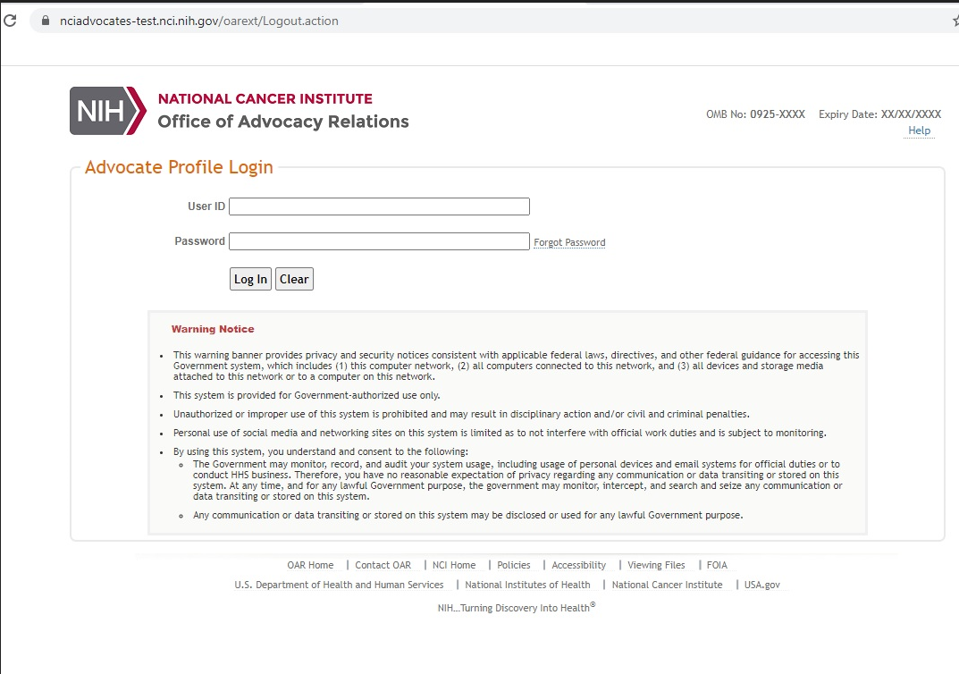

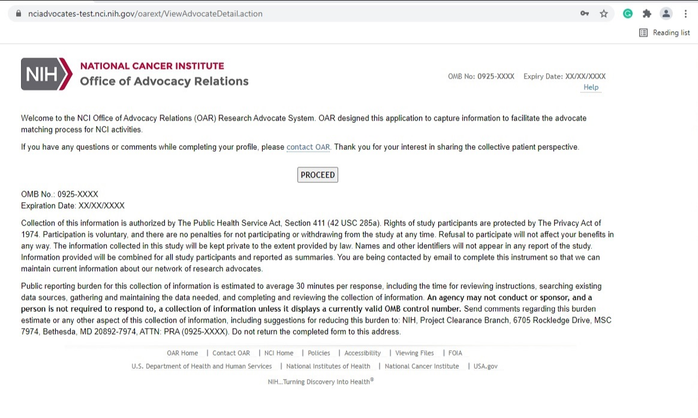
Advocate Profile (Page 1)

Advocate Profile (Page 2)

Advocate Profile (Page 3)

Advocate Profile (Page 4)
Advocate Profile (Page 4 continued)
Program Staff Request (Page 1)

Program Staff Request (Page 2)
Program Staff Request (Page 3)

