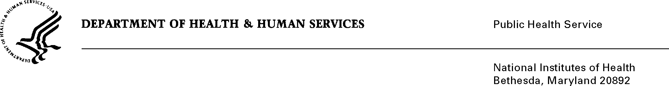

DATE: September 23, 2021

TO: Office of Management and Budget (OMB)
Matt Eliseo, Desk Officer

FROM: Mikia P. Currie
Chief, Project Clearance Branch

SUBJECT: Non-material/Non-substantive change request for:
Generic Clearance for NIH Citizen Science and Crowdsourcing Projects (NIH)
(OMB #0925-0766, Expiration Date 4/30/2023)

This is a request for OMB to approve a non-material/non-substantive change to the, “Generic Clearance for NIH Citizen Science and Crowdsourcing Projects (NIH)” to clarify the types of information collections that may be submitted under the Generic IC (sub-studies).

NIH would like to clarify the definition of existing resources and identify the mode to collect such information. The SSA states, “Projects may include requests to identify and/or describe extramural research, research tools, or existing resources and further defines citizen science as, “… a form of open collaboration where the public can participate actively in the scientific process through methods that include asking research questions, collecting, and analyzing data, interpreting results, or engaging in problem solving.” Generic ICs under this clearance might include applications and registrations needed to access/request data however, it would not allow for programs to submit data.

The applications or registrations may ask the requestor’s credentials and a description of the proposed use of the data.

This non-substantive request does not change the purpose or objectives of this generic, nor change the overall burden to the public.

Your full consideration is appreciated.

