Attachment A: Eligibility and Registration Form

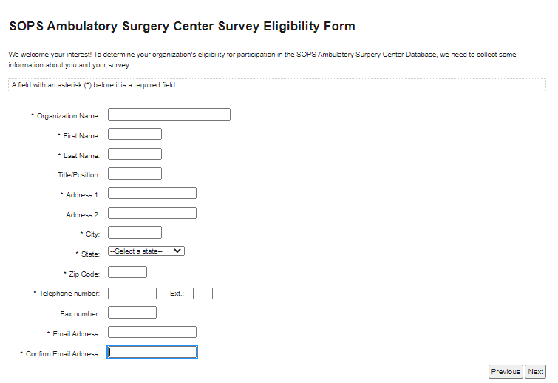

SOPS Ambulatory Surgery Center Survey Eligibility Form
If the registration information is incorrect, please click on the "Previous" button below and update your information.
Confirm your registration information
Organization Name:
Email:
First Name:
Last Name:
Address 1:
Address 2:
City:
State:
Zip:
Telephone:
Fax:

SOPS Ambulatory Surgery Center Survey Eligibility Form

Account registered.
An email message has been sent to [Email].
To ACTIVATE your account please follow the link emailed to you, Thank you!

