Figure 1: Submit Data Use Agreement (DUA) and Link DUA to Ambulatory Surgery Center(s)
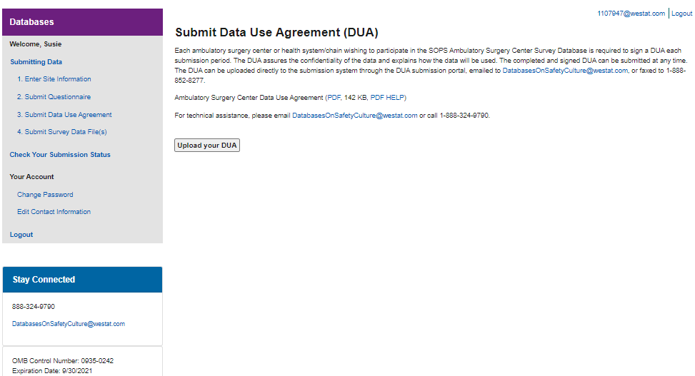

Figure 1: Submit Data Use Agreement (DUA) and Link DUA to Ambulatory Surgery Center(s), continued
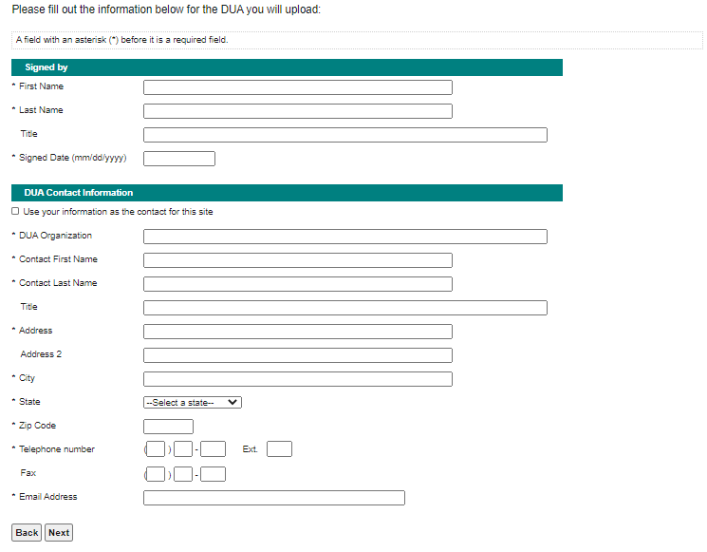

Figure 1: Submit Data Use Agreement (DUA) and Link DUA to Ambulatory Surgery Center(s), continued
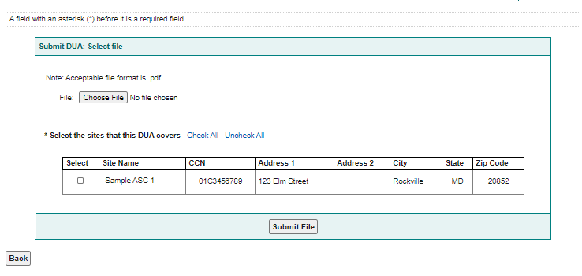

Figure 2: Submit Questionnaire and Link Questionnaire to Ambulatory Surgery Center(s)

Figure 2: Submit Questionnaire and Link Questionnaire to Ambulatory Surgery Center(s), continued
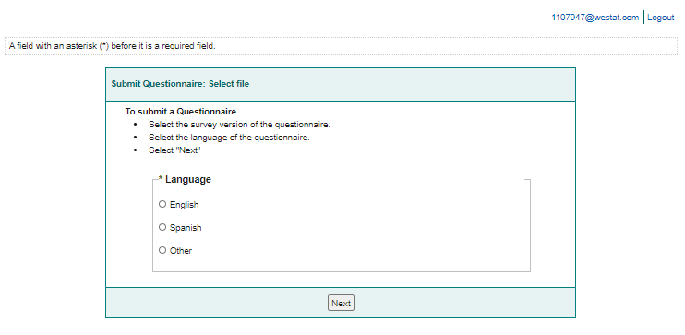

Figure 2: Submit Questionnaire and Link Questionnaire to Ambulatory Surgery Center(s), continued
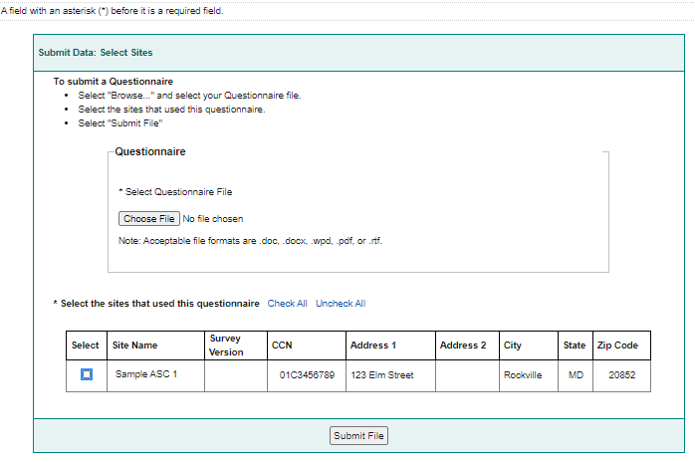

Figure 3: Upload Data for Each Participating Ambulatory Surgery Center
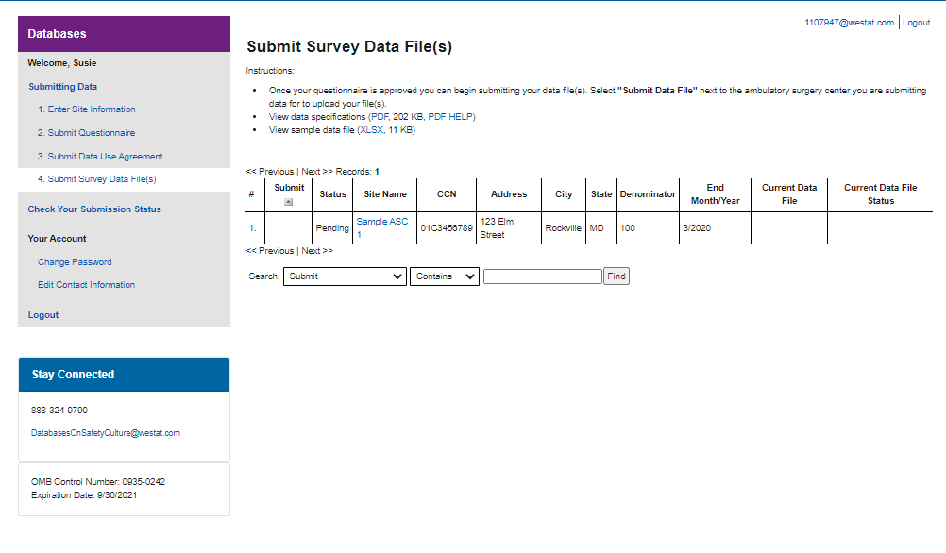

Figure 3: Upload Data for Each Participating Ambulatory Surgery Center (continued)
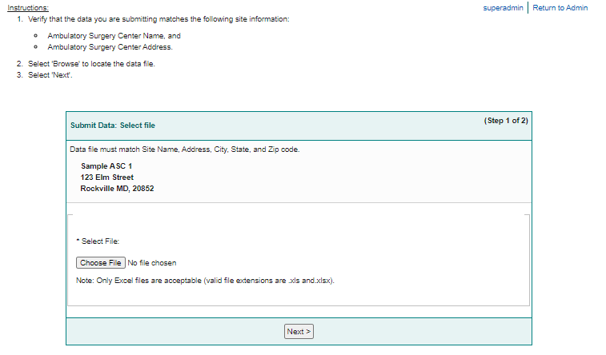

Figure 3: Upload Data for Each Participating Ambulatory Surgery Center (continued)
