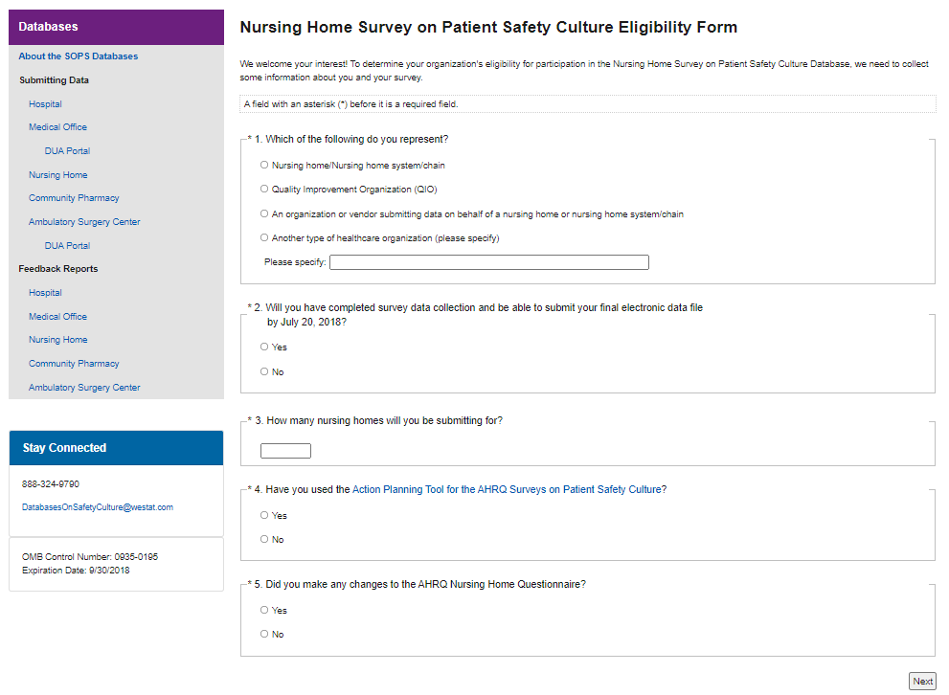
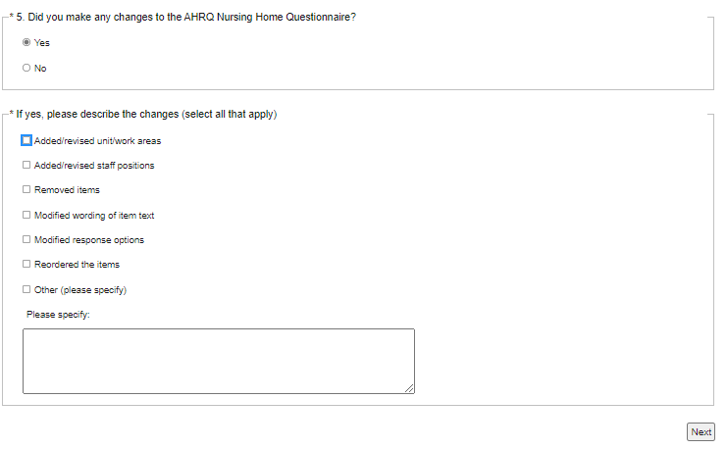
Attachment A: Nursing Home Eligibility and Registration Form
by September 21, 2022?

- Yes
- No

Public reporting burden for this collection of information is estimated to average 3 minutes per response, the estimated time required to complete the survey. An agency may not conduct or sponsor, and a person is not required to respond to, a collection of information unless it displays a currently valid OMB control number. Send comments regarding this burden estimate or any other aspect of this collection of information, including suggestions for reducing this burden, to: AHRQ Reports Clearance Officer Attention: PRA, Paperwork Reduction Project (0935-XXXX) AHRQ, 5600 Fishers Lane #7, Rockville, MD 20857.

Attachment A: Nursing Home Eligibility and Registration Form (continued)

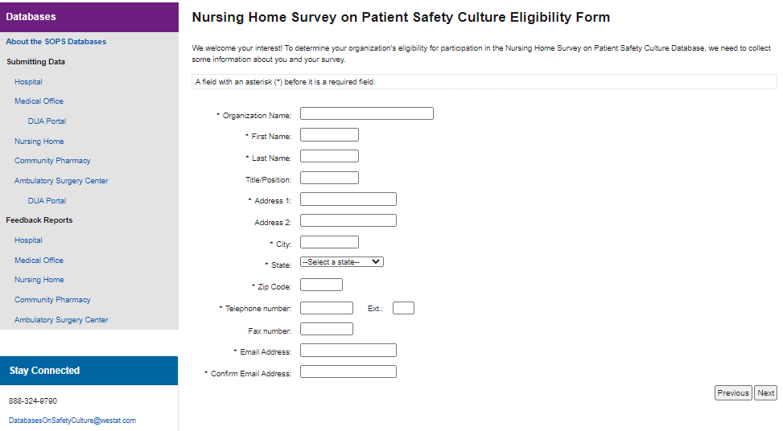

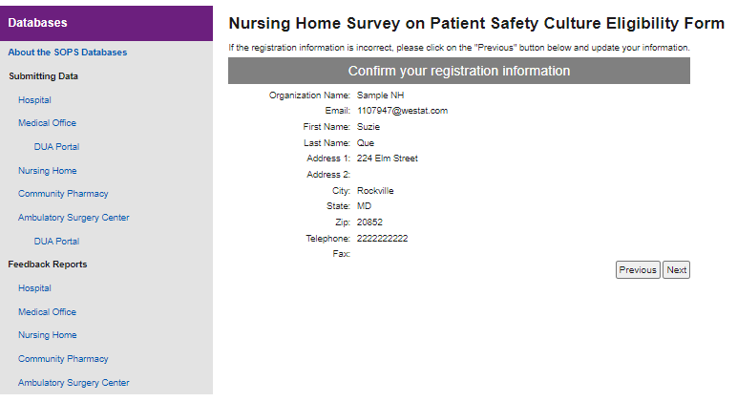

Attachment A: Nursing Home Eligibility and Registration Form (continued)
