APPENDIX W
AIAN FACES 2019 FALL 2021 SPECIAL RESPONDENT MATERIALS

This page has been left blank for double-sided copying.

AIAN FACES 2019 FALL 2021 SPECIAL PARENT-TEACHER
FREQUENTLY ASKED QUESTIONS (FAQS)

This page has been left blank for double-sided copying.

FREQUENTLY ASKED QUESTIONS ABOUT THE AMERICAN INDIAN AND ALASKA NATIVE HEAD START FAMILY AND CHILD EXPERIENCES SURVEY (AIAN FACES)
FOR TEACHERS AND PARENTS OF CHILDREN SELECTED FOR THE STUDY
- What is AIAN FACES about?
AIAN FACES 2019 is the second national study of children and families served by Head Start programs in American Indian and Alaska Native communities. AIAN FACES will help us learn more about children and families in Region XI Head Start programs and the services Head Start provides to them. It will allow Head Start to better serve the needs of children and families attending programs in Native communities. New study activities have been added for fall 2021 and spring 2022 to look at child, family, and teacher well-being 18-months into the COVID-19 pandemic.
- Who is conducting the study?
The U.S. Department of Health and Human Services, Administration for Children and Families, sponsors the study. The study is being conducted by Mathematica, a respected, independent research organization whose studies of Head Start and other early childhood and education programs have been used to improve services to children and families for 50 years. Mathematica is working with directors of Head Start programs in AIAN communities, Office of Head Start leadership and other federal staff, and child development researchers to make sure that the study meets the needs of Region XI Head Start programs.
- When will the study take place?
Parents and teachers will be asked to participate in fall 2021 and spring 2022.
- Will anyone visit programs to collect data?
No. All data collection will be remote. Parent surveys will be available on the web or over the telephone, and teacher surveys via the web or on paper.
- Will taking part in the study affect the Head Start services the child and family receive?
No. Taking part in the AIAN FACES study, or declining to participate will not affect any Head Start services the child or family receives.
- How did you pick classrooms and children for the study?
Classrooms were randomly picked from all classrooms in this Head Start center. Children in those selected classrooms were then randomly picked and, along with their parents, were invited to be in the study. Only children whose parents gave permission are in the study.
- What will you ask teachers to do?
In fall 2021 and spring 2022, we will ask teachers who have children participating in AIAN FACES in their classrooms to complete a brief form. This form will ask questions about the behavior and skills of each child in AIAN FACES. It will also ask if a child has been diagnosed with a disability by a professional, what services or Individualized Education Plans (IEPs) are in place, or if there are any special concerns the teacher has about each child in AIAN FACES. Each form will take about 10 minutes to complete. Teachers can fill out the forms online or on paper. Teachers will receive a $10 gift card for every form they complete. We will also ask teachers to fill out a survey about their well-being 18 months into the COVID-19 pandemic. The survey will take about 10 minutes. In the spring, we will ask teachers to complete a survey about their training and background, classroom activities, and the Head Start program. The survey will take about 35 minutes. Teachers can fill out the survey online or on paper.
- Do parents need to do anything besides signing the consent?
On the consent forms, parents should include their email address, phone number, and mailing address so we can contact them about filling out the parent survey.
- What will you ask parents to do?
We will ask parents to fill out a survey in fall 2021 and spring 2022. Parents may fill out the survey online or answer the questions over the phone. Each will last about 35 minutes. In both the fall and spring, parents will be mailed a $30 gift card after they finish the survey.
- Is there a phone number or email parents and teachers can use if they have questions?
Parents and teachers can call Sara Skidmore, the survey director, at 800-xxx-xxxx, toll-free, to ask questions. Parents and teachers can also email the AIAN FACES study team at AIANFACES@mathematica-mpr.com.
- How will my privacy be protected?
Mathematica agrees to protect the privacy of all study participants to the extent permitted by law. All staff working on the study are required to sign a privacy agreement. The information we collect will be electronically and securely stored at the Mathematica offices, and will not be shared with anyone outside of the study team. Your survey responses will be stripped of any identifying features of you and your family and will be securely shared only with qualified individuals for additional learning purposes to better understand the strengths and needs of children and families served by Region XI Head Start. Teachers’ individual responses will not be shared with anyone at the program, including supervisors.
We have also obtained a Certificate of Confidentiality from the National Institutes of Health. The Certificate helps us protect your privacy. This means no one can force the study team to give out information that identifies you, even in court. However, we may need to share your information if it shows a serious threat to you or to others, including reporting to authorities when required by law. The U.S. Department of Health and Human Services (DHHS) may ask for data for an audit or evaluation. If they do, we will need to provide it. However, only DHHS staff involved in the review will see it.
The referenced collection of information is voluntary. Information will be kept private. An agency may not conduct or sponsor, and a person is not required to respond to, a collection of information unless it displays a currently valid OMB control number. The OMB control number for this collection is 0970-0151 and it expires XX/XX/XXXX.

This page has been left blank for double-sided copying.

AIAN FACES 2019 FALL 2021 SPECIAL PARENT BROCHURE
This page has been left blank for double-sided copying.

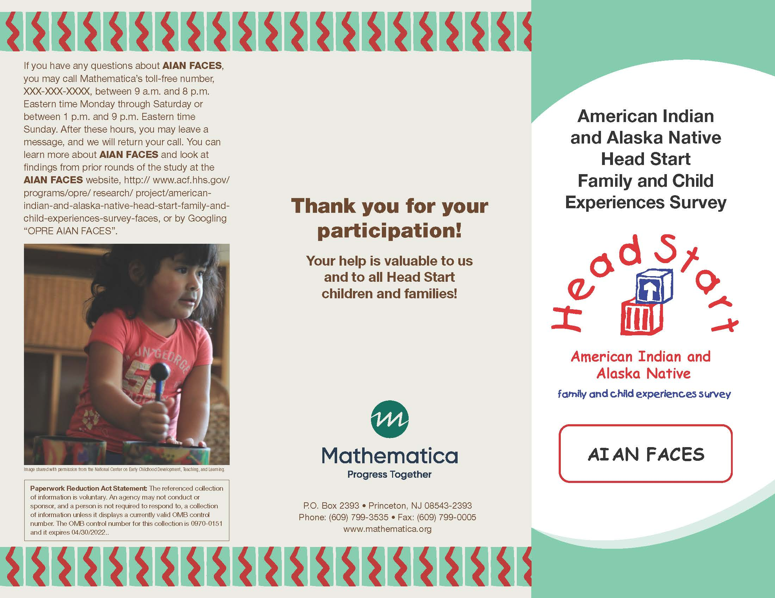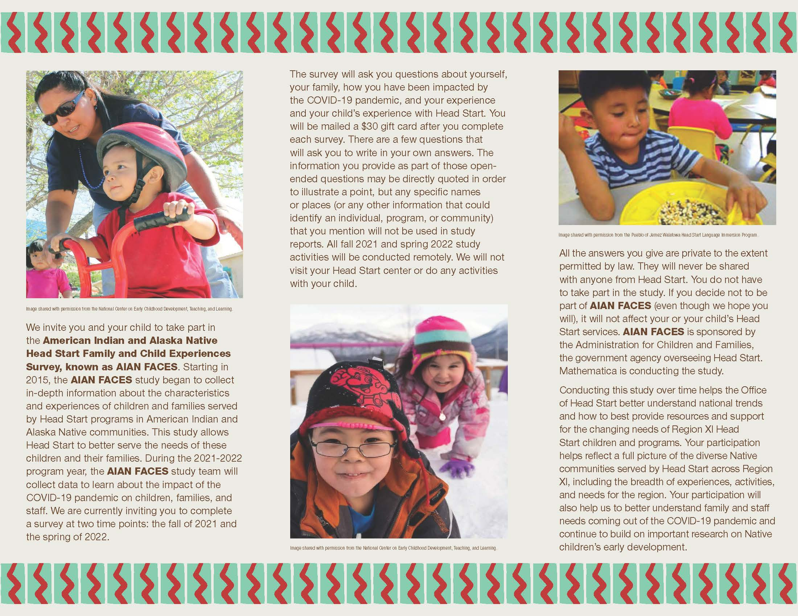

AIAN FACES 2019 FALL 2021 SPECIAL PARENT SURVEY INVITATION EMAIL
This page has been left blank for double-sided copying.

TO: [RESPONDENT EMAIL ADDRESS]
FROM: AIAN FACES STUDY TEAM
SUBJECT: AIAN FACES STUDY INVITATION
AIAN FACES: IMPORTANT PARENT SURVEY
Dear [First name] [Last name],
- Thank you for taking part in the American Indian and Alaska Native Head Start Family and Child Experiences Survey (AIAN FACES). This email serves as confirmation that you have provided consent for your child to participate in the study. Below is a link to a blank copy of the consent form that you completed. The study is funded by the Administration for Children and Families, U.S. Department of Health and Human Services.
- The study focuses on children’s development, family involvement, and program quality to identify strategies for improving Head Start. It is very important because it will help the Office of Head Start (OHS) understand the unique needs of Head Start families 18 months into the COVID-19 pandemic.
- Mathematica, an independent research firm, is conducting the study. Mathematica has worked with directors of Head Start programs in AIAN communities, the OHS leadership and other federal staff, and child development researchers to make sure it meets the unique needs of Region XI Head Start programs.
We invite you to be a part of this study by filling out a survey about you, your family, and your child. The survey will take about 35 minutes to finish. After you finish the survey, we will send you a $30 gift card to thank you for your participation. You can complete the survey online or by phone. To complete the survey by phone, or if you need to complete the survey in a language other than English, please call 800-xxx-xxxx toll-free.
We encourage you to complete the survey online at:
[UNIQUE SURVEY LINK]

Please finish the survey as soon as you can. Here are some points to keep in mind:
- Taking part in AIAN FACES is up to you. There is no penalty if you decide not to participate. Taking part in the study, or deciding not to participate, will not affect any Head Start services you or your child receive. There are no risks from taking part in the study. However, you may be asked a few sensitive questions. You may choose not to answer those questions or any questions.
- Study results will only be reported for groups. Study results will never be reported in a way that identifies you, your child, any other individuals in your family, or your child’s Head Start program.
- There are a few short answer questions in this survey. The information you provide as part of these questions may be directly quoted in order to illustrate a point, but no specific names or places (or any other information that could identify an individual, program, or community) that you mention will be used in study reports.
- No one from your Head Start program will see or hear your individual responses, and your name and your program’s name will not be shared with the OHS or in any reports. We are, however, required by law to identify participants if they tell us something that suggests that they are very likely to harm themselves, that they are planning to hurt another person or child, or that someone is likely to harm them.
- In the future, survey responses from the study (with nothing identifying individuals, programs, or communities) may be securely shared with qualified individuals for additional learning purposes to better understand the strengths and needs of children and families in Region XI Head Start and the programs that serve them.
If you have questions about AIAN FACES, please call Sara Skidmore, the survey director, at 800-xxx-xxxx. This call is toll-free. You can also email us at AIANFACES@mathematica-mpr.com. To learn more about AIAN FACES, visit the study website at https://www.acf.hhs.gov/opre/research/ project/american-indian-and-alaska-native-head-start-family-and-child-experiences-survey-faces or Google “OPRE AIAN FACES”.
Thanks again for taking part in AIAN FACES.
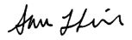
Sincerely,

Sara Skidmore
AIAN FACES Survey Director

The referenced collection of information is voluntary. Information will be kept private. An agency may not conduct or sponsor, and a person is not required to respond to, a collection of information unless it displays a currently valid OMB control number. The OMB control number for this collection is 0970-0151 and it expires XX/XX/XXXX.

AIAN FACES 2019 FALL 2021 SPECIAL PARENT SURVEY INVITATION LETTER

This page has been left blank for double-sided copying.
Sara Skidmore  AIAN FACES Survey Director | 1100 First Street, NE, 12th Floor  Washington, DC 20002  Phone: 202-484-5273  Fax: 202-863-1763  www.mathematica-mpr.com
[DATE]
[PARENT NAME]
[PARENT ADDRESS]

Dear [PARENT]:
Thank you for taking part in the American Indian and Alaska Native Head Start Family and Child Experiences Survey (AIAN FACES).
A few things you should know about the study:
- The purpose of AIAN FACES is to provide details about the characteristics, experiences, and development of children and families whom Region XI Head Start programs serve.
- The information collected this year will help Head Start improve its services to children and families in Region XI Head Start programs, and is especially important because it will help the Office of Head Start (OHS) understand the unique needs of Region XI Head Start families 18 months into the COVID-19 pandemic.
- The study is funded by the Administration for Children and Families, U.S. Department of Health and Human Services.
- Mathematica, an independent research firm, is conducting the study. Mathematica has worked with directors of Head Start programs in AIAN communities, OHS leadership and other federal staff, and child development researchers to help make sure it meets the unique needs of Region XI Head Start programs.
As part of this study, we invite you to fill out a survey about you and your child. The survey will take about 35 minutes to finish. After you finish the survey, we will send you a $30 gift card to thank you for your participation. You can complete the survey over the phone or online. To complete the survey by phone, or if you need to complete the survey in a language other than English, please call 800-xxx-xxxx toll-free.
We encourage you to complete the survey online at:
[WEBSITE].

Use the log-in ID and password shown.
LOG-IN ID: [LOG-IN ID]
PASSWORD: [PASSWORD]
Please finish the survey as soon as you can. Here are some points to keep in mind:
- Taking part in AIAN FACES is up to you. There is no penalty if you decide not to participate. Taking part in the study, or deciding not to participate, will not affect any Head Start services you or your child receive. There are no risks from taking part in the study. However, you may be asked a few sensitive questions. You may choose not to answer those questions or any questions.
- Study results will only be reported for groups. Study results will never be reported in a way that identifies you, your child, any other individuals in your family, or your child’s Head Start program.
- There are a few short answer questions in this survey. The information you provide as part of these questions may be directly quoted in order to illustrate a point, but no specific names or places (or any other information that could identify an individual, program, or community) that you mention will be omitted from study reports.
- No one from your Head Start program will see or hear your individual responses, and your name and your program’s name will not be shared with the OHS or in any reports. We are, however, required by law to identify participants if they tell us something that suggests that they are very likely to harm themselves, that they are planning to hurt another person or child, or that someone is likely to harm them.
- In the future, survey responses from the study (with nothing identifying individuals, programs, or communities) may be securely shared with qualified individuals for additional learning purposes to better understand the strengths and needs of children and families in Region XI Head Start and the programs that serve them.
If you have questions about AIAN FACES, please call Sara Skidmore, the survey director, at 800-xxx-xxxx. This call is toll-free. You can also email us at AIANFACES@mathematica-mpr.com. To learn more about AIAN FACES, visit the study website at https://www.acf.hhs.gov/opre/research/ project/american-indian-and-alaska-native-head-start-family-and-child-experiences-survey-faces or Google “OPRE AIAN FACES”.
Thanks again for taking part in AIAN FACES.
Sincerely,

Sara Skidmore
AIAN FACES Survey Director
The referenced collection of information is voluntary. Information will be kept private. An agency may not conduct or sponsor, and a person is not required to respond to, a collection of information unless it displays a currently valid OMB control number. The OMB control number for this collection is 0970-0151 and it expires XX/XX/XXXX.
Paperwork Reduction Act Statement: The referenced collection of information is voluntary. An agency may not conduct or sponsor, and a person is not required to respond to, a collection of information unless it displays a currently valid OMB control number. The OMB control number for this collection is 0970-0151 and it expires XX/XX/XXXX.
Paperwork Reduction Act Statement: The referenced collection of information is voluntary. An agency may not conduct or sponsor, and a person is not required to respond to, a collection of information unless it displays a currently valid OMB control number. The OMB control number for this collection is 0970-0151 and it expires XX/XX/XXXX.
Paperwork Reduction Act Statement: The referenced collection of information is voluntary. An agency may not conduct or sponsor, and a person is not required to respond to, a collection of information unless it displays a currently valid OMB control number. The OMB control number for this collection is 0970-0151 and it expires XX/XX/XXXX.

AIAN FACES 2019 FALL 2021 SPECIAL PARENT SURVEY REMINDER EMAIL

This page has been left blank for double-sided copying.

TO: [PARENT]
FROM: AIAN FACES STUDY TEAM
SUBJECT: AIAN FACES STUDY REMINDER
Dear [First name] [Last name],
Recently, we invited you to complete a survey online or by phone about you, your family and your child for the American Indian and Alaska Native Head Start Family and Child Experiences Survey (AIAN FACES). The survey will take about 35 minutes to finish. After you finish the survey we, will send you a $30 gift card to thank you for your participation. To complete it by phone, or if you need to complete the survey in a language other than English, please call 800-xxx-xxxx toll-free.
As a reminder:
- The purpose of AIAN FACES is to provide details about the characteristics, experiences, and development of children and families whom Region XI Head Start programs serve.
- The information collected this year will help Head Start improve its services to children and families in Region XI Head Start programs, and is especially important because it will help the Office of Head Start (OHS) understand the unique needs of Region XI Head Start families 18-months into the COVID-19 pandemic.
- The study is funded by the Administration for Children and Families, U.S. Department of Health and Human Services.
- Mathematica, an independent research firm, is conducting the study. Mathematica has worked with directors of Head Start programs in AIAN communities, OHS leadership, and child development researchers to help make sure it meets the unique needs of Region XI Head Start programs.

We encourage you to complete the survey online at:
[UNIQUE SURVEY LINK]
We hope you will finish the survey as soon as you can. Here are some points to keep in mind:
- Taking part in AIAN FACES is up to you. There is no penalty if you decide not to participate. Taking part in the study, or deciding not to participate, will not affect any Head Start services you or your child receive. There are no risks from taking part in the study. However, you may be asked a few sensitive questions. You may choose not to answer those questions or any questions.
- Study results will only be reported for groups. Study results will never be reported in a way that identifies you, your child, any other individuals in your family, or your child’s Head Start program.
- There are a few short answer questions in this survey. The information you provide as part of these questions may be directly quoted in order to illustrate a point, but no specific names or places (or any other information that could identify an individual, program, or community) that you mention will be omitted from study reports.
- No one from your Head Start program will see or hear your individual responses, and your name and your program’s name will not be shared with the OHS or in any reports. We are, however, required by law to identify participants if they tell us something that suggests that they are very likely to harm themselves, that they are planning to hurt another person or child, or that someone is likely to harm them.
- In the future, survey responses from the study (with nothing identifying individuals, programs, or communities) may be securely shared with qualified individuals for additional learning purposes to better understand the strengths and needs of children and families in Region XI Head Start and the programs that serve them.
If you have questions about AIAN FACES, please call Sara Skidmore, the survey director, at 800-xxx-xxxx. This call is toll-free. You can also email us at AIANFACES@mathematica-mpr.com. To learn more about AIAN FACES, visit the study website at https://www.acf.hhs.gov/opre/research/ project/american-indian-and-alaska-native-head-start-family-and-child-experiences-survey-faces or Google “OPRE AIAN FACES”.
Thanks again for taking part in AIAN FACES.
Sincerely,
Sara Skidmore
AIAN FACES Survey Director
The referenced collection of information is voluntary. Information will be kept private. An agency may not conduct or sponsor, and a person is not required to respond to, a collection of information unless it displays a currently valid OMB control number. The OMB control number for this collection is 0970-0151 and it expires XX/XX/XXXX.
Paperwork Reduction Act Statement: The referenced collection of information is voluntary. An agency may not conduct or sponsor, and a person is not required to respond to, a collection of information unless it displays a currently valid OMB control number. The OMB control number for this collection is 0970-0151 and it expires XX/XX/XXXX.
Paperwork Reduction Act Statement: The referenced collection of information is voluntary. An agency may not conduct or sponsor, and a person is not required to respond to, a collection of information unless it displays a currently valid OMB control number. The OMB control number for this collection is 0970-0151 and it expires XX/XX/XXXX.
Paperwork Reduction Act Statement: The referenced collection of information is voluntary. An agency may not conduct or sponsor, and a person is not required to respond to, a collection of information unless it displays a currently valid OMB control number. The OMB control number for this collection is 0970-0151 and it expires XX/XX/XXXX.

AIAN FACES 2019 FALL 2021 SPECIAL PARENT SURVEY REMINDER LETTER

This page has been left blank for double-sided copying.

Sara Skidmore  AIAN FACES Survey Director | 1100 First Street, NE, 12th Floor  Washington, DC 20002  Phone: 202-484-5273  Fax: 202-863-1763  www.mathematica-mpr.com
[DATE]
[PARENT NAME]
[PARENT ADDRESS]

Dear [PARENT]:
Recently, we invited you to complete a survey online or by phone about you and your child for the American Indian and Alaska Native Head Start Family and Child Experiences Survey (AIAN FACES). The survey will take about 35 minutes to finish. After you finish the survey, we will send you a $30 gift card to thank you for your participation. To complete it by phone, or if you need to complete the survey in a language other than English, please call 800-xxx-xxxx toll-free.
As a reminder:
- The purpose of AIAN FACES is to provide details about the characteristics, experiences, and development of children and families whom Region XI Head Start programs serve. The information collected will help Head Start improve its services to children and families in Region XI Head Start programs.
- The information collected this year is especially important because it will help the Office of Head Start (OHS) understand the unique needs of Region XI Head Start families 18-months into the COVID-19 pandemic.
- The study is funded by the Administration for Children and Families, U.S. Department of Health and Human Services.
- Mathematica, an independent research firm, is conducting the study. Mathematica has worked with directors of Head Start programs in AIAN communities, OHS leadership, and child development researchers to help make sure it meets the unique needs of Region XI Head Start programs.
We encourage you to complete the survey online at:
[WEBSITE].

Use the log-in ID and password shown.
LOG-IN ID: [LOG-IN ID]
PASSWORD: [PASSWORD]
We hope you will complete the survey as soon as you can. Here are some points to keep in mind:
- Taking part in AIAN FACES is up to you. There is no penalty if you decide not to participate. Taking part in the study, or deciding not to participate, will not affect any Head Start services you or your child receive. There are no risks from taking part in the study. However, you may be asked a few sensitive questions. You may choose not to answer those questions or any questions.
- Study results will only be reported for groups. Study results will never be reported in a way that identifies you, your child, any other individuals in your family, or your child’s Head Start program.
- There are a few short answer questions in this survey. The information you provide as part of these questions may be directly quoted in order to illustrate a point, but nospecific names or places (or any other information that could identify an individual, program, or community) that you mention will be omitted from study reports.
- No one from your Head Start program will see or hear your individual responses, and your name and your program’s name will not be shared with the OHS or in any reports. We are, however, required by law to identify participants if they tell us something that suggests that they are very likely to harm themselves, that they are planning to hurt another person or child, or that someone is likely to harm them.
- In the future, survey responses from the study (with nothing identifying individuals, programs, or communities) may be securely shared with qualified individuals for additional learning purposes to better understand the strengths and needs of children and families in Region XI Head Start and the programs that serve them.
If you have questions about AIAN FACES, please call Sara Skidmore, the survey director, at 800-xxx-xxxx. This call is toll-free. You can also email us at AIANFACES@mathematica-mpr.com. To learn more about AIAN FACES, visit the study website at https://www.acf.hhs.gov/opre/research/ project/american-indian-and-alaska-native-head-start-family-and-child-experiences-survey-faces or Google “OPRE AIAN FACES”.
Thanks again for taking part in AIAN FACES.
Sincerely,

Sara Skidmore
AIAN FACES Survey Director

The referenced collection of information is voluntary. Information will be kept private. An agency may not conduct or sponsor, and a person is not required to respond to, a collection of information unless it displays a currently valid OMB control number. The OMB control number for this collection is 0970-0151 and it expires XX/XX/XXXX.

AIAN FACES 2019 FALL 2021 SPECIAL TEACHER SURVEY AND TEACHER CHILD REPORT INVITATION LETTER

This page has been left blank for double-sided copying.

Sara Skidmore  AIAN FACES Survey Director | 1100 First Street, NE, 12th Floor  Washington, DC 20002  Phone: 202-484-5273  Fax : 202-863-1763  www.mathematica-mpr.com
[DATE]
Dear [TEACHER]:
Welcome to the American Indian and Alaska Native (AIAN) Head Start Family and Child Experiences Survey, known as AIAN FACES. [ENTER PROGRAM NAME] has been selected to take part in this important study.
A few things you should know about the study:
- In 2015, AIAN FACES was the first study to collect descriptive information on children’s skills and the experiences of families attending Head Start in Region XI to help inform policies and practices. The study is being conducted again to provide details about the characteristics, experiences, and development of children and families whom Region XI AIAN Head Start programs serve.
- The information collected this year will help Head Start improve its services to children and families in Region XI Head Start programs, and is especially important because it will help the Office of Head Start (OHS) understand the unique needs of Region XI Head Start families 18-months into the COVID-19 pandemic. The Administration for Children and Families, part of the U.S. Department of Health and Human Services, funds the study.
- Mathematica, an independent research company, is conducting AIAN FACES. Mathematica worked with a group of directors and leaders of Head Start programs in AIAN communities, federal officials, and early childhood researchers with experience with Native communities to design the study and to guide how the study is being carried out.
This fall, we are asking about 800 3- and 4-year-old children’s families as well as 90 teachers from 22 Head Start programs to take part in AIAN FACES. We are excited about the study and hope you will be too. As one of only 90 teachers taking part, your help is vital to the study’s success.
In fall 2021 and spring 2022, we will ask children whose parents have agreed to take part in the study to take a short survey. Your program director has selected [OSC NAME] to work with us. [OSC NAME] will help us gain consent from the parents of children who were chosen to take part in the study.
We are asking you to complete a short form, the Teacher Child Report (TCR), for each child participating in AIAN FACES in your class. The form asks about the skills, behaviors, and approaches to learning that you have seen these children use. Each form should only take about 10 minutes to finish. As a thank you, we will send you a $10 gift card for each TCR form you complete and return.
In addition to completing the TCRs, we are also asking you to complete a short survey this fall 2021. It should take about 10 minutes to complete. The survey will ask about your well-being 18-months into the COVID-19 pandemic. If you have access to the internet, we think you will find it convenient to complete these forms and survey online. If you do not have internet access or prefer to fill out the forms or the survey on paper, you may use the paper copies enclosed. Please return them in the pre-paid envelope provided.
In spring 2022, we will ask you, your program director, and your center director to each fill out a short survey. Your survey will ask about children’s classroom activities, the materials used in the classroom, Native culture and language experiences that happen in the classroom, and the ways that you involve and interact with children’s parents. It will also ask about your feelings, and your education and training.
Here are some points to keep in mind:
- Taking part in AIAN FACES is voluntary. You do not have to take part in this study. If you choose to take part in the study but then decide you want to leave the study at any point, that is okay.
- Study results will only be reported for groups. No one from your Head Start program, including your supervisors, will see or hear your individual responses, and your name and your program’s name will not be shared with the OHS or in any reports.
- There are a few short answer questions in this survey. The information you provide as part of these questions may be directly quoted in order to illustrate a point, but no specific names or places (or any other information that could identify an individual, program, or community) that you mention will be used in study reports.
- In the future, survey responses from the study (with nothing identifying individuals, programs, or communities) may be securely shared with qualified individuals for additional learning purposes to better understand the strengths and needs of children and families in Region XI Head Start and the programs that serve them.
- We have a Certificate of Confidentiality from the National Institutes of Health. The Certificate helps us protect your privacy. This means no one can force the study team to give out information that identifies you, even in court. However, we may need to share your information if it shows a serious threat to you or to others, including reporting to authorities when required by law.
- The U.S. Department of Health and Human Services (DHHS) may ask for data for an audit or evaluation. If they do, we will need to provide it. However, only DHHS staff involved in the review will see it.
If you choose to fill out the survey and TCRs online, please use the log-in ID and password below. The website, your log-in ID and password are secure and will not be shared with anyone. All information you provide will be kept private to the extent permitted by law. Only selected members of the study team will see your responses. Using the log-in ID and password ensures that your responses will be protected.
We encourage you to complete the survey and TCRs online at:
[WEBSITE].

Use the log-in ID and password shown.
LOG-IN ID: [LOG-IN ID]
PASSWORD: [PASSWORD]

We have enclosed a list of frequently asked questions and some helpful tips for completing your teacher survey and TCRs online. Mathematica staff will be happy to answer any questions about AIAN FACES and to assist you in any way. You can contact Sara Skidmore, the survey director, toll-free at 800-xxx-xxxx or email us at AIANFACES@mathematica-mpr.com. To learn more about AIAN FACES, visit the study website at https://www.acf.hhs.gov/opre/research/project/american-indian-and-alaska-native-head-start-family-and-child-experiences-survey-faces or Google “OPRE AIAN FACES”. Thank you in advance for your help with this important study.
Sincerely,
Sara Skidmore
AIAN FACES Survey Director

The referenced collection of information is voluntary. Information will be kept private. An agency may not conduct or sponsor, and a person is not required to respond to, a collection of information unless it displays a currently valid OMB control number. The OMB control number for this collection is 0970-0151 and it expires XX/XX/XXXX.
Paperwork Reduction Act Statement: The referenced collection of information is voluntary. An agency may not conduct or sponsor, and a person is not required to respond to, a collection of information unless it displays a currently valid OMB control number. The OMB control number for this collection is 0970-0151 and it expires XX/XX/XXXX.
Paperwork Reduction Act Statement: The referenced collection of information is voluntary. An agency may not conduct or sponsor, and a person is not required to respond to, a collection of information unless it displays a currently valid OMB control number. The OMB control number for this collection is 0970-0151 and it expires XX/XX/XXXX.
Paperwork Reduction Act Statement: The referenced collection of information is voluntary. An agency may not conduct or sponsor, and a person is not required to respond to, a collection of information unless it displays a currently valid OMB control number. The OMB control number for this collection is 0970-0151 and it expires XX/XX/XXXX.

This page has been left blank for double-sided copying.

AIAN FACES 2019 FALL 2021 SPECIAL TEACHER SURVEY AND TEACHER CHILD REPORT REMINDER EMAIL

This page has been left blank for double-sided copying.

TO: [RESPONDENT EMAIL ADDRESS]
FROM: AIAN FACES STUDY TEAM
SUBJECT: AIAN FACES STUDY REMINDER
Dear [TEACHER FNAME TEACHER LNAME]:
A few weeks ago, you were invited to complete a Teacher Child Report (TCR) for each child participating in American Indian and Alaska Native Head Start Family and Child Experiences Survey (AIAN FACES) in your class. Each TCR should take only about 10 minutes to complete. You were also invited to complete a 10-minute teacher survey. According to our records, you have [IF TEACHER SURVEY NOT COMPLETE: not completed the Teacher Survey and have] [XX] TCRs left to complete.
As a reminder:
- The purpose of AIAN FACES is to provide details about the children and families whom Region XI Head Start programs serve.
- The information collected this year will help Head Start improve its services to children and families in Region XI Head Start programs, and is especially important because it will help the Office of Head Start (OHS) understand the unique needs of Region XI Head Start families 18 months into the COVID-19 pandemic.
- The study is funded by the Administration for Children and Families, U.S. Department of Health and Human Services.
- Mathematica, an independent research firm, is conducting the study.
As a thank you, when you have completed all of your TCRs, we will send you a $10 gift card for each TCR you completed.
We encourage you to complete the survey and TCRs online at:
[UNIQUE SURVEY LINK]

If you have questions about AIAN FACES or you prefer to complete the TCRs on paper, please call Sara Skidmore, the survey director, toll-free at 800-xxx-xxxx. To learn more about AIAN FACES, visit the AIAN FACES website at http://www.acf.hhs.gov/programs/opre/research/project/american-indian-and-alaska-native-head-start-family-and-child-experiences-survey-faces or Google “OPRE AIAN FACES ”.
Sincerely,

Sara Skidmore
AIAN FACES Survey Director
The referenced collection of information is voluntary. Information will be kept private. An agency may not conduct or sponsor, and a person is not required to respond to, a collection of information unless it displays a currently valid OMB control number. The OMB control number for this collection is 0970-0151 and it expires XX/XX/XXXX.

