Proposed EARN Project Description:
Perspectives of Jobseekers with Disabilities: The Impact of Employer Messaging

Questionnaire of Job Applicants Regarding Employer Online Outreach and Recruitment of People with Disabilities

Approach

Study objectives
- To understand applicants’ perspectives of how employer messaging in the online outreach process impacts key outcomes related to recruiting people with disabilities;
- To use the information we collect about the perspectives of people with disabilities to create tools and resources that help employers improve their online messaging.

Research questions
- What online job search strategies do jobseekers with disabilities use when job searching?
- How are the different online messaging approaches that employers use perceived by jobseekers with disabilities?
- What messaging strategies are most likely to positively motivate a person with a disability to:
  - Apply for a position
  - Self-identify as a person with a disability during the application (pre-offer) process?

Potential collaborating organizations:
We propose to access our sample through organizations with direct connections to jobseekers, such as the DirectEmployers Job Board, ODEP’s Workforce Recruitment Program, Disability IN’s Next Gen Leaders Initiatives, the American Association of Persons with Disabilities Summer Internship Program, and community employment programs such as OurAbility, Getting Hired and Disability Solutions. Concepts, EARN’s subcontractor, will also work to promote among relevant groups on LinkedIn.

Participant recruitment
We will work with organizations to reach jobseekers with disabilities to be study participants. Inclusion criteria for the study will be: Adults (18+ years old) with disabilities (identified using a health condition/disability screener) who have looked online for a new position in the last two years.

Research Methods:
The draft text of our proposed questionnaire and related informed consent statement are below. The questionnaire will be an online questionnaire in Qualtrics.

Proposed Questionnaire Content: Respondent Consent and Question Text

Perspectives of Jobseekers with Disabilities:
The Impact of Employer Messaging

Online Consent Statement
QUESTIONNAIRE PURPOSE: You are invited to take part in a research study designed to better understand the perspectives of individuals with disabilities/health conditions during the job search process. Specifically, we will ask questions about: (1) The approaches you use for finding jobs and (2) What information is important to you in evaluating whether an employer is disability-inclusive. The results will be used to develop tools and resources to help employers attract and recruit applicants with disabilities more effectively.
WHO SHOULD COMPLETE THIS QUESTIONNAIRE: Participants should be adults with disabilities (18 years or older) who either are currently searching for a job or have engaged in a job search online within the last two years.
ABOUT THE QUESTIONNAIRE: The questionnaire should take 15 minutes. Your questionnaire responses will be anonymous and reporting of results will be done in aggregate form only and we anticipate that your participation in this questionnaire presents no greater risk than everyday use of the Internet. There are no direct benefits to you. If you participate, you can skip any question or stop the questionnaire at any time.
TO THANK YOU: Participants who complete the questionnaire can choose to be entered in a drawing for a $25 gift card (chance of winning is 1 out of 20). You will be redirected to another form to enter the drawing, so your contact information will not be linked to your questionnaire responses.
The U.S. Department of Labor Office of Disability Employment Policy is funding this study. This document does not necessarily reflect the views or policies of the U.S. Department of Labor, nor does mention of trade names, commercial products, or organizations imply endorsement by the U.S. Government.
The main researcher conducting this study is Sarah von Schrader, Associate Director of Research at Cornell University’s Yang-Tan Institute on Employment and Disability. Please feel free to ask questions at any point during the process. If you have questions later, you may contact Sarah von Schrader (sv282@cornell.edu, 607-254-8088). If you have any questions or concerns regarding your rights as a subject in this study, you may contact the Institutional Review Board (IRB) for Human Participants at 607-255-5138 or access their website at http://www.irb.cornell.edu. You may also report your concerns or complaints anonymously through Ethicspoint online at www.hotline.cornell.edu or by calling toll free at 1-866-293-3077. Ethicspoint is an independent organization that serves as a liaison between the University and the person bringing the complaint so that anonymity can be ensured.
If you are 18 years old or older and consent to participate in the study, please click the next button to begin the questionnaire.
- NEXT

Questionnaire Part 1: Demographics
This questionnaire focuses on understanding the experiences of individuals with disabilities and/or chronic health conditions who have searched online for work in the past two years.
For this questionnaire, a "person with a disability and/or chronic health condition" includes, but is not limited to, individuals with a physical or cognitive impairment, mental health condition, chronic health condition (such as heart disease or diabetes), or a vision or hearing impairment.

Screener Items
(Screener Item 1): Have you searched online for work in the past two years?
- Yes
- No
(Screener Item 2): Do you have a disability and/or chronic health condition, as defined above?
- Yes
- No
[If respondent answers “no” to either item they will be sent to the end of the questionnaire]

Demographic Questions
Do you have an obvious disability? In other words, do you believe that people can tell that you have a disability and/or chronic health condition without you telling them?
- Always
- Often
- Sometimes
- Rarely
- Never
Have you ever been employed (i.e., worked for pay at a job or business)?
- Yes
- No
Are you currently employed?
- Yes
- No

What type(s) of jobs have you looked for recently? (Select all that apply)
- Management, business, and financial occupations
- Computer, engineering, and science occupations
- Education, legal, community service, arts, and media occupations
- Healthcare practitioners and technical occupations
- Healthcare support occupations
- Protective service occupations
- Food preparation and serving related occupations
- Building and grounds cleaning, and maintenance occupations
- Personal care and service occupations
- Sales and related occupations
- Office and administrative support occupations
- Natural resources, construction, and maintenance occupations
- Production, transportation, and material moving occupations
- Other occupation, please describe_______________
What is your gender?
- Female
- Male
- Non-binary
- Prefer to self-describe: _______________________________
- Prefer not to say
What is your age?
- 18-24
- 25-34
- 35-44
- 45-54
- 55-64
- 65-74
- 75 or over
What is your race?
- White
- Black/African American
- Native American or Alaskan Native
- Asian
- Native Hawaiian or Other Pacific Islander
- Some other race
- Multi-racial
Are you of Hispanic, Latino, or Spanish origin?
- Yes
- No
What is your highest educational level completed?
- 8th grade or less
- Some high school, but no diploma or GED
- High school graduate or GED certificate
- Technical, trade, or vocational school
- Some college, but less than a 4-year degree (including 2 year Associate Degree)
- College graduate (BS, BA, or other 4-year degree)
- Master's, doctoral, or professional degree

Questionnaire Part 2: Job Search Strategy
How often do you use the following approaches when job searching? | Always | Often | Sometimes | Rarely | Never
- Searching on job posting websites (e.g., Indeed.com, Monster.com, Craigslist.com, etc.)
- Searching for open positions on disability-specific job posting websites (e.g., AAPD Career Center, abilityJOBS, AbilityLinks)
- Going directly to a specific company's online career webpage(s)
- Searching for open positions on social media platforms (e.g., LinkedIn, Facebook)
- Attending online career fairs
- Working with a recruiter/headhunter
- Other (please specify)

How often do you have a specific company in mind when you are searching for job openings online?
- Always
- Often
- Sometimes
- Rarely
- Never

How often do you use the following approaches to decide whether to apply for a job at a specific company? | Always | Often | Sometimes | Rarely | Never
- Going directly to the company’s online career webpage(s).
Note: A company’s career webpage lists job openings and may share information about the company with jobseekers.
- Searching for the company on social media platforms (e.g. LinkedIn, Facebook)
- Looking specifically for the company’s online disability career page
- Using outside websites (e.g., Glassdoor) to understand how current employees feel about working at the company (e.g. workplace culture)
- Other (please specify)

How often do you look for a company’s disability-inclusive messaging when making the decision to apply to that company?
- Always
- Often
- Sometimes
- Rarely
- Never

Questionnaire Part 3: Self-Identifying as a Person with a Disability
Some employers are required to invite applicants and newly hired employees to voluntarily identify as a person with a disability. This is called self-identification and it helps the employer keep track of their success in recruiting and hiring people with disabilities. An example form is presented below.

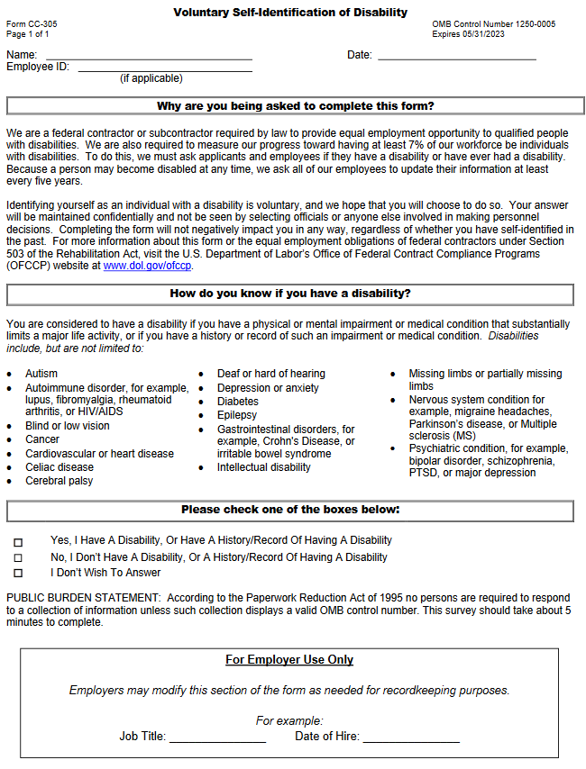

In your recent job applications, have you been asked to complete a self-identification form?
- Yes, always
- Yes, sometimes
- No, I have not been asked to complete a self-identification form
- No, I have not applied for any jobs
- I do not remember
[If respondent answers “Yes, always” or “Yes, sometimes”]
In your recent job applications, did you check the box to self-identify as a person with a disability?
- Always
- Sometimes
- Never
[If respondent answers “No, I have not been asked to complete a self-identification form” or “No, I have not applied for any jobs” or “I don’t remember”]
If you were asked to complete a self-identification form, would you check the box to self-identify as a person with a disability?
- Yes
- No
- It depends
[If respondent answered “yes” to “Are you currently employed” OR “Have you ever been employed” above]
In your current or most recent job, were you asked to complete a self-identification form?
- Yes
- No
- Unsure
[If respondent answered “yes” to “were you asked to complete a self-identification form” above]
In your current or most recent job, did you check the box to self-identify as a person with a disability?
- Yes
- No
- Unsure
[If respondent answered “yes” to “Did you check the box to self-identify” above]
At what point did you check the box to self-identify as a person with a disability? (Please select all that apply)
- Before the job offer
- After the job offer, but before starting the job
- After starting the job

Questionnaire Part 4: Career Webpages
Companies design the career pages on their websites to appeal to potential applicants. Some companies include items on their career webpages that can signal that their company is disability inclusive.
Consider the following elements that could be included on a company’s career webpage(s).
To what extent does each element of a company career page increase your interest in applying for a job with a company? | To a great extent | Somewhat | Very Little | Not at All
- Diversity and inclusion statements/information that includes disability
- Videos or pictures of employees with disabilities
- List of awards received for disability inclusion efforts
- A testimonial from an employee with a disability
- A disability-focused Employee Resource Group
- Description(s) of flexible work arrangements ((e.g., work from home options, work schedule flexibility, and time off options)
- Description(s) of work-life balance programs (e.g., parental leave, education support, counseling, and health and wellness opportunities)
- Clear explanation of the accommodations request process for applicants (e.g., availability of accommodations for the application process, whom to contact, etc.)
- Description of disability-focused hiring programs (e.g., affirmative action or other targeted hiring programs)
- Description of partnerships with disability employment organizations (e.g., state vocational rehabilitation, job placement providers, job coaching services, etc.)
- List of disability-focused recruitment sources (e.g., disability job-posting boards, job fairs, etc.)
- Other (please specify)

Please choose the three most important things from this list that a company can include on their career page to increase your likelihood of self-identifying as a person with a disability?
- Diversity and inclusion statements/information that includes disability
- Videos or pictures of employees with disabilities
- Awards received for disability inclusion efforts
- A testimonial from an employee with a disability
- A disability-focused Employee Resource Group
- Flexible work arrangements
- Work-life balance programs
- Clear accommodations request process for applicants
- Disability-focused hiring programs
- Partnerships with disability employment organizations
- Disability-focused recruitment sources

What else can employers do to increase your likelihood of self-identifying as a person with a disability? ______________________________________________________________________________
_______________________________________________________________________________

Questionnaire Part 5: Job Postings
Consider the following elements that could be included in a company’s job postings.
To what extent does each element of a company career page increase your interest in applying for a job with a company? | To a great extent | Somewhat | Very Little | Not at All
- Diversity and inclusion statements/information that includes disability
- Awards received for disability inclusion efforts
- Flexible work arrangements (e.g., work from home options, work schedule flexibility, and time off options)
- Work-life balance programs (e.g., parental leave, education support, counseling, and health and wellness opportunities)
- Clear accommodations request process for applicants (e.g., availability of accommodations for the application process, whom to contact, etc.)
- Other (please specify)

Questionnaire Part 6: COVID
Have you searched for a job since the COVID pandemic began (March 2020)?
- Yes
- No
Have your job search efforts been impacted in any way by the COVID pandemic?
- Yes
- No
[If yes, to job search efforts been impacted in any way by the COVID pandemic]
Please explain how your job search efforts have been impacted by the COVID pandemic (open-ended)
____________________________________________

Thank you for completing our questionnaire! If you would like to be entered in a drawing for a $25 gift card, please enter your name and email on the next screen. When you select “next” you will leave this questionnaire and enter a new form to enter the drawing. Your name and email will not be linked to your questionnaire results.

