TIF FORM TABLE OF CHANGES
1652-0044 DHS TRIP
 | Original Text | Changed Text | Reason for Changes
1 | Department of Homeland Security Traveler Redress Inquiry Program (DHS TRIP)  Thank you for contacting the Department of Homeland Security Traveler Redress Inquiry Program (DHS TRIP). DHS TRIP is a single point of contact for U.S and non-U.S citizens who have inquiries or seek resolution regarding difficulties they experience during their travel while undergoing screening at transportation hubs, such as airports and train stations, or while crossing U.S. borders. If you wish to apply, you must complete a Traveler Inquiry Form and provide certain required documentation. Your application can be e-mailed or mailed to DHS TRIP. E-mailed applications may be processed more quickly than mailed applications. Below are details regarding submitting a DHS TRIP application.  If your concern relates solely to a belief that your personal information has been misused or that your civil rights have been violated, you may skip to Section II of this form.  While you may apply via email or surface mail, submitting an electronic application at www.dhs.gov/TRIP may be significantly faster.  Submitting the DHS TRIP Application:  1. On Behalf of Another Person: DHS TRIP requires a DHS Form 590, Authorization to Release Information to Another Person, which permits DHS TRIP to communicate with and provide information to someone other than the traveler, including someone serving as a representative for the traveler. U.S. privacy laws prohibit any discussion about this case absent the traveler’s express written consent. To authorize DHS to release information about the traveler to a third party, the traveler must complete and return the DHS Form 590. The G-28 is not used by this program. To obtain a copy of this form please visit http://www.dhs.gov/step-2-how-use-dhs-trip  2. Family or Group Applying for Redress: DHS TRIP cannot accept family or group applications for any reason. Each individual that is seeking redress must submit a separate application along with a copy of a valid, unexpired travel document, e.g., passport. If the applicant is a minor (i.e., a child under age 18), a parent or guardian may apply on his/her behalf; however, the information provided in the application must be specific to the child seeking redress. Each redress requestor may also apply online by visiting www.dhs.gov/TRIP. A parent/guardian is not required to complete a DHS Form 590.  3. Required Documents: The traveler applying for redress must attest under penalty of perjury that the facts stated in the application for redress are true and correct. The applicant must sign the document to continue with the application; it cannot be signed on behalf of someone unless the application is for a minor. In addition, our program requires the submission of at least one government issued photograph bearing travel document. In each document, DHS TRIP must be able to discern your facial features, and the information must be legible. It is strongly recommended that travelers submit a copy of a passport since it is required for international travel. Please note that our program does not accept expired travel documents. If the application is for a minor, parents or guardians may submit a copy of the minor’s birth certificate if no driver’s license or state-issued identification card is available. Do not send the original document. Please note that the provision of the identity document is a program requirement that DHS TRIP cannot waive.  4. Privacy Issue: If the traveler only selects the Privacy box in Section II, no documents are required; however, having documents will significantly accelerate the process if further review is needed.  5. Civil Rights and Civil Liberties Issue: If the traveler wishes to make a civil rights and civil liberties complaint, he/she may use the following link to learn more about the DHS Office for Civil Rights and Civil Liberties (CRCL) or use the CRCL Complaint Tool to file a complaint. http://www.dhs.gov/xlibrary/assets/crcl-complaint-submission-form-english.pdf. CRCL investigates allegations that DHS employees, programs or activities have violated a civil right or civil liberty, including, but not limited to: discrimination based on race, religion, national origin, gender or disability; abusive or coercive questioning; and unreasonable searches and seizures.  E-mailing Instructions  Please e-mail the completed form and copies of identity documents to: TRIP@dhs.gov. Submitting documents electronically will accelerate the process.  Mailing Instructions  Please mail the completed form and copies of identity documents to:  DHS Traveler Redress Inquiry Program (TRIP) 601 South 12th Street, TSA-901, Arlington, VA 20598-6901. | Thank you for contacting the Department of Homeland Security Traveler Redress Inquiry Program (DHS TRIP). DHS TRIP is a single point of contact for U.S and non-U.S citizens who have inquiries or seek resolution regarding difficulties they experience during their travel while undergoing screening at transportation hubs, such as airports and train stations, or while crossing U.S. borders. If you wish to apply, you must complete a Traveler Inquiry Form and provide certain required documentation. Your application can be e-mailed or mailed to DHS TRIP. E-mailed applications may be processed more quickly than mailed applications. Below are details regarding submitting a DHS TRIP application.  If your concern relates solely to a belief that your personal information has been misused or that your civil rights have been violated, you may skip to Section II of this form.  While you may apply via email or surface mail, submitting an electronic application at www.DHS-TRIP.tsa.dhs.gov may be significantly faster.  Submitting the DHS TRIP Application:  - On Behalf of Another Person: DHS TRIP requires a DHS Form 590, Authorization to Release Information to Another Person, which permits DHS TRIP to communicate with and provide information to someone other than the traveler, including someone serving as a representative for the traveler. U.S. privacy laws prohibit any discussion about this case absent the traveler’s express written consent. To authorize DHS to release information about the traveler to a third party, the traveler must complete and return the DHS Form 590. The G-28 is not used by this program. To obtain a copy of this form please visit http://www.dhs.gov/step-2-how-use-dhs-trip.  - Family or Group Applying for Redress: DHS TRIP cannot accept family or group applications for any reason. Each individual that is seeking redress must submit a separate application along with a copy of a valid, unexpired travel document, e.g., passport. If the applicant is a minor (i.e., a child under age 18), a parent or guardian may apply on his/her behalf; however, the information provided in the application must be specific to the child seeking redress. Each redress requestor may also apply online by visiting www.DHS-TRIP.tsa.dhs.gov. A parent/guardian is not required to complete a DHS Form 590.  - Required Documents: The traveler applying for redress must attest under penalty of perjury that the facts stated in the application for redress are true and correct. The applicant must sign the document to continue with the application; it cannot be signed on behalf of someone unless the application is for a minor. In addition, our program requires the submission of at least one government issued photograph bearing travel document. In each document, DHS TRIP must be able to discern your facial features, and the information must be legible. It is strongly recommended that travelers submit a copy of a passport since it is required for international travel. Please note that our program does not accept expired travel documents. If the application is for a minor, parents or guardians may submit a copy of the minor’s birth certificate if no driver’s license or state-issued identification card is available. Do not send the original document. Please note that the provision of the identity document is a program requirement that DHS TRIP cannot waive.  - Privacy Issue: If the traveler only selects the Privacy box in Section II, no documents are required; however, having documents will significantly accelerate the process if further review is needed.  - Civil Rights and Civil Liberties Issue: If the traveler wishes to make a civil rights and civil liberties complaint, he/she may use the following link to learn more about the DHS Office for Civil Rights and Civil Liberties (CRCL) or use the CRCL Complaint Tool to file a complaint. http://www.dhs.gov/xlibrary/assets/crcl-complaint-submission-form-english.pdf. CRCL investigates allegations that DHS employees, programs or activities have violated a civil right or civil liberty, including, but not limited to discrimination based on race, religion, national origin, gender or disability; abusive or coercive questioning; and unreasonable searches and seizures.  E-mailing Instructions  Please e-mail the completed form and copies of identity documents to: TRIP@tsa.dhs.gov Submitting documents electronically will accelerate the process.  Mailing Instructions  Please mail the completed form and copies of identity documents to:  DHS Traveler Redress Inquiry Program (TRIP) 6595 Springfield Center Drive, TSA-901 Springfield, Virginia 20598-6901. | Edited to update to the new system link, email address, and mailing address.
2 | INCIDENTS RELATED TO PORTS OF ENTRY, IMMIGRATION, CUSTOMS, OR BORDER PATROL:  Please check ALL scenarios that describe your travel experience (required):  I was referred for secondary screening when clearing U.S. Customs and Border Protection.  I was denied entry into the United States.  My Electronic System for Travel Authorization (ESTA) application was denied.  I am a foreign student or exchange visitor who is unable to travel due to my status.  I was given an information sheet by a CBP Officer.  Other (Please explain in Section III: Incident Details) | INCIDENTS RELATED TO PORTS OF ENTRY, IMMIGRATION, CUSTOMS, OR BORDER PATROL:  Please check ALL scenarios that describe your travel experience (required):  I was referred for secondary screening when clearing U.S. Customs and Border Protection.  I was denied entry into the United States.  My Electronic System for Travel Authorization (ESTA) application was denied.  I am a foreign student or exchange visitor who is unable to travel.  I was given an information sheet by a CBP Officer.  I got an “X” at the kiosk (APC or Global Entry).  My Electronic Visa Update System (EVUS) enrollment was unsuccessful.  My Global Entry Application was denied.  Other (Please explain in Section III: Incident Details) | Removed “due to my status” from option:  I am a foreign student or exchange visitor who is unable to travel due to my status..  Added options based on feedback from CBP and ICE:  I got an “X” at the kiosk (APC or Global Entry).  My Electronic Visa Update System (EVUS) enrollment was unsuccessful.  My Global Entry Application was denied.
3 | IV. Personal Information (Required)  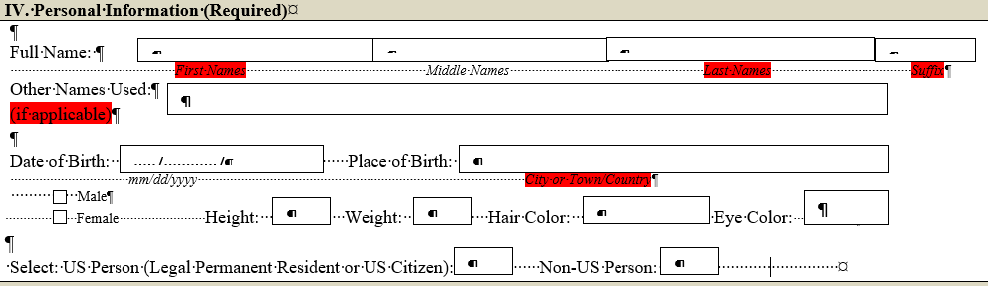 | 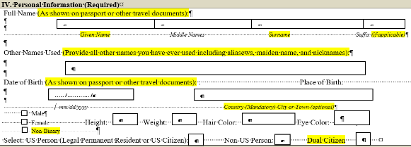 | To follow ICAO standards change Full Name options to "Given Name & Surnames"  Change Full Name to Full Name (As shown in your passport or other travel documents)  Change Other Names Used to Other Names Used (Provide all other names you have ever used including aliases, maiden names, and nicknames)  Change Suffix to Suffix (if applicable)  Change Date of Birth to Date of Birth (as shown on your passport or other travel document)  Change Place of Birth Country Mandatory with City/Town Optional  Change Gender Options to be Male, Female, and Non-Binary  Change US Person to add a check box for Dual Citizenship - should be able to upload both passports with application
4 | Contact Information  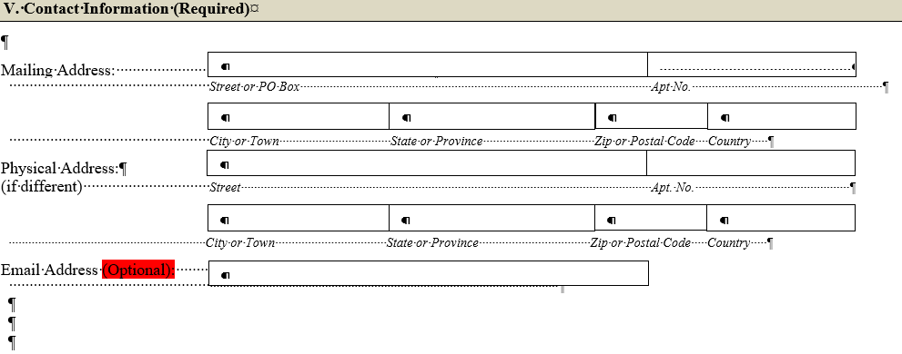 | 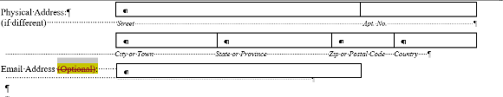 | Change Email Address (Optional) to Email Address (Required)
5 | VI. Attorney/Representative Information  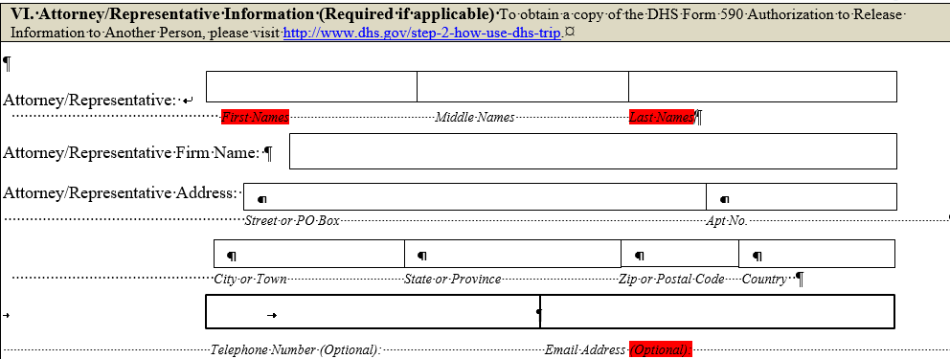 | 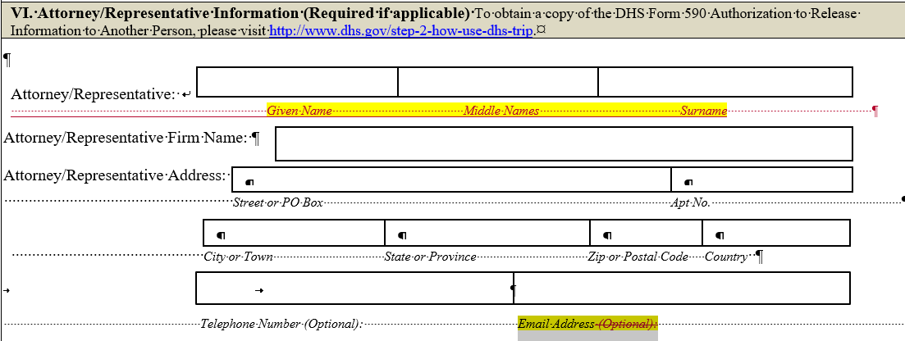 | To follow ICAO standards change Full Name options to "Given Name & Surnames"  Change Email Address (Optional) to Email Address (Required)
6 | Identification Documents  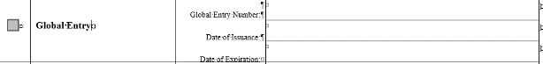 | 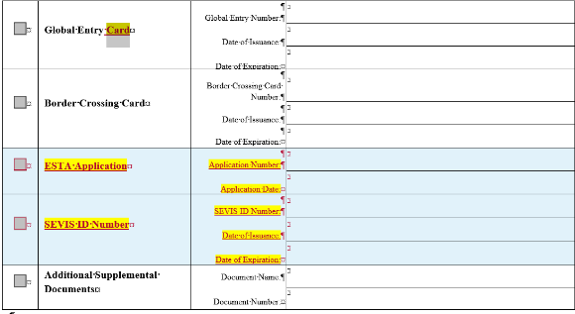 | Update Global Entry to Global Entry Card  Add ESTA Application Number  Add SEVIS ID Number

Highlighted red - deleted in changed text
Highlighted yellow - new language added in changed text.

