Early Childhood Longitudinal Study, Kindergarten Class of 2023-24 (ECLS-K:2024)

Kindergarten and First-Grade Field Test Data Collection, National Sampling, and National Recruitment

OMB# 1850-0750 v.24

Attachment A-2
National Study Recruitment Respondent Materials

National Center for Education Statistics
U.S. Department of Education

August 2021
revised November 2021
revised December 2021

NCES is currently preparing materials for focus groups to be held in early 2022 that will test and evaluate different communication and recruitment materials for use in future ECLS-K:2024 study rounds. The materials being tested will be abbreviated and more concise versions of the materials presented here. If, upon evaluation of the findings of those focus groups, NCES believes that the benefits to revised contact materials is sufficiently substantial to motivate an immediate change, we may submit a change request (OMB 1850-0750 v.25) in May 2022 to revise those materials in time for them to be used in the K-1 field test and/or national school and district recruitment.

Table of Contents
Section Page
State Recruitment Letter National Study 1
ECLS-K:2024 Study Overview National Study 3
School District Recruitment Letter National Study 7
School District Nonresponse Letter National Study 10
School Recruitment Letter National Study 12
Recruitment Follow-up Letter for Pending/Refusal Schools National Study 14
Recruitment Email Template for Difficult-to-Reach Principals National Study 16
Recruitment Email Template School Staff Considering Participation National Study 18
Recruitment Email Template Follow-up to Address Concerns National Study 20
Recruitment Email Template Follow-up after Cooperation Achieved National Study 21
Follow-up Letter for Participating but Difficult to Contact Schools National Study 22
Spring Email for School Coordinators National Study 24
School Coordinator Responsibilities Checklist National Study 26
Summer Email for School Coordinators National Study 29
Study Letterhead National Study 30

State Recruitment Letter
National Study
[DATE]
[TITLE] [NAME FIRST] [NAME LAST]
[STATE AGENCY NAME]
[ADDRESS 1]
[CITY], [STATE] [ZIP CODE]

Dear [TITLE] [NAME LAST]:
[This is a follow-up to the letter you received from me in {MONTH} that described a new effort sponsored by the U.S. Department of Education. The Department is/The U.S. Department of Education is] preparing to work with a new cohort of elementary-aged students for a national education research study called the Early Childhood Longitudinal Study, Kindergarten Class of 2023-24 (ECLS-K:2024). Your state contains schools sampled for the study. Children who are attending kindergarten during the 2023-24 school year, as well as their teachers and parents, will be asked to participate. The enclosed Study Overview provides more details about what is involved for the participants.

The ECLS-K:2024 is the fourth cohort in the series of early childhood longitudinal studies that make up the ECLS program. For more than 20 years, the ECLS program has helped educators, families, researchers, and policymakers better understand and improve children’s knowledge and skills from birth through elementary school. For more details about the ECLS program, visit nces.ed.gov/ecls.

District and school contact for the ECLS-K:2024 will begin in August 2022. Data collection will include one-on-one child assessments conducted by trained ECLS-K:2024 staff and self-administered web surveys completed by school administrators, teachers, and parents of sampled children. Current plans are for the study activities to take place during the selected children’s kindergarten (fall 2023 and spring 2024), first-grade (spring 2025), third-grade (spring 2027), and fifth-grade (spring 2029) years.

While participation in the ECLS-K:2024 is voluntary, your support of the study, as well as active encouragement of district and school participation in your state, is invaluable as we work to obtain a representative sample of schools across the country. Without the participation of the selected schools, the data we collect may not represent the experiences of the nation as a whole, resulting in incomplete information about students and the changing landscape of the education system in the United States. This can lead to misleading research conclusions and misinformed policy decisions.

The ECLS-K:2024 is conducted by the National Center for Education Statistics (NCES), within the U.S. Department of Education’s Institute of Education Sciences (IES). NCES is working with Westat, a U.S.-based research organization, to conduct the study. Additional specific ECLS-K:2024 information is available on the ECLS website, MyECLS.ed.gov. If you have questions or need assistance, please call 1-855-898-2018 or email ECLS@westat.com. You may also reach the ECLS Study Director, Jill McCarroll, at 202-304-2920 or jill.mccarroll@ed.gov.

Thank you for your time and support.
Sincerely,

[Name]
[Commissioner or other title]
National Center for Education Statistics, Institute of Education Sciences
U.S. Department of Education

cc: State Testing Coordinator, State Early Childhood Education Coordinator

Enclosure:
ECLS-K:2024 Study Overview

The National Center for Education Statistics (NCES) is authorized to conduct the Early Childhood Longitudinal Study (ECLS) by the Education Sciences Reform Act of 2002 (ESRA 2002, 20 U.S.C. §9543). The data are being collected for NCES by Westat, a U.S.–based research organization. All of the information you provide may be used only for statistical purposes and may not be disclosed, or used, in identifiable form for any other purpose except as required by law (20 U.S.C. §9573 and 6 U.S.C. §151). The collected information will be combined across respondents to produce statistical reports.

ECLS-K:2024 Study Overview
National Study
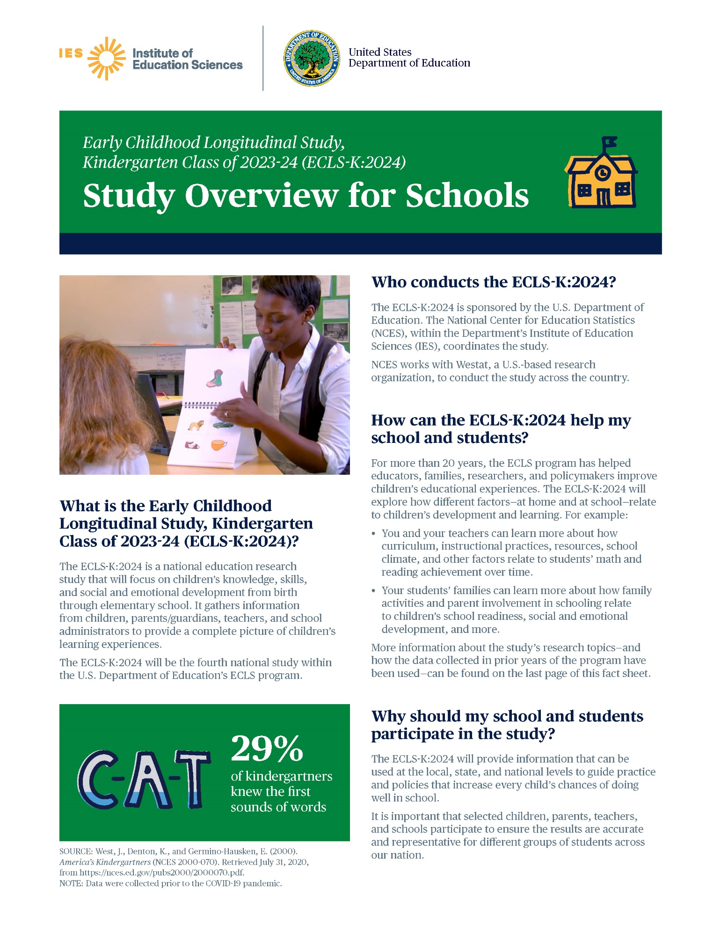
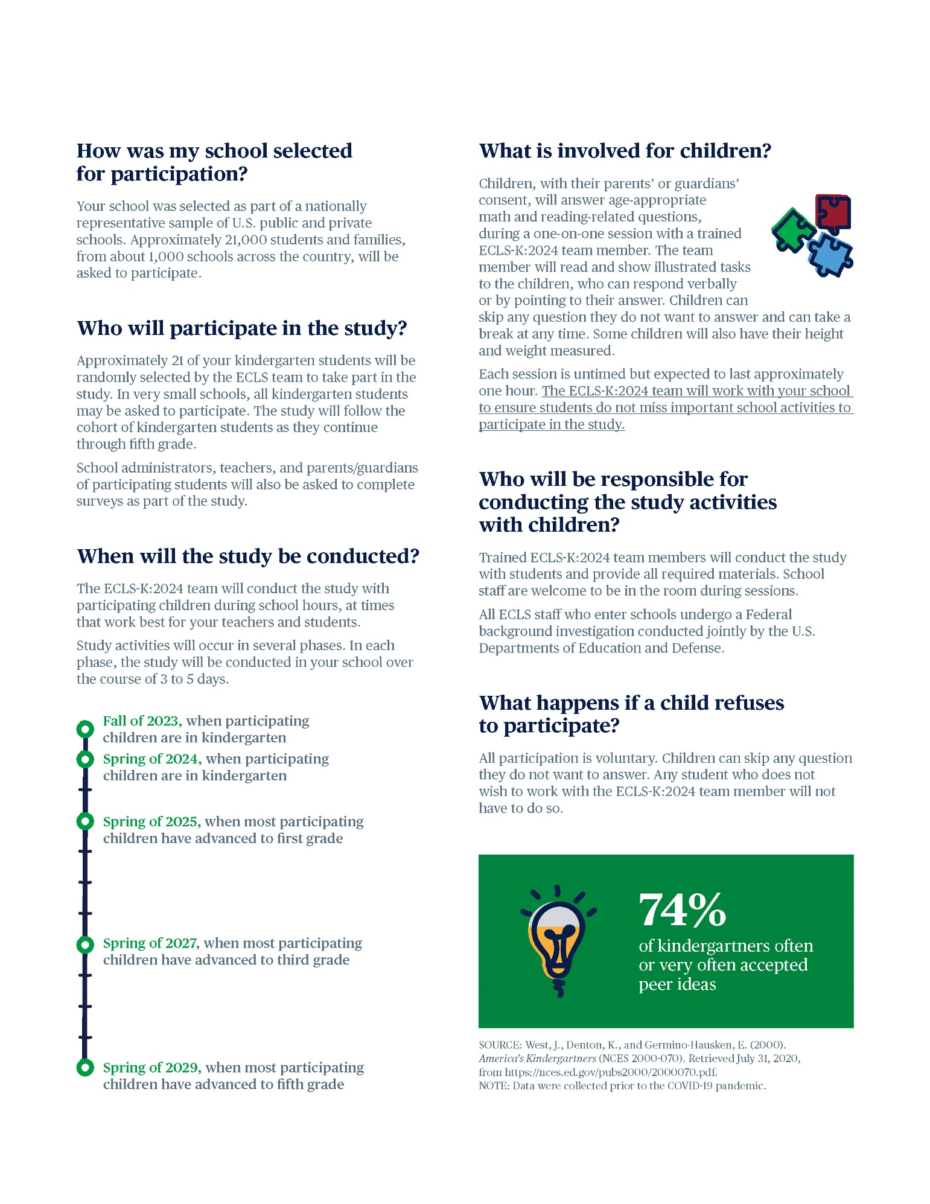
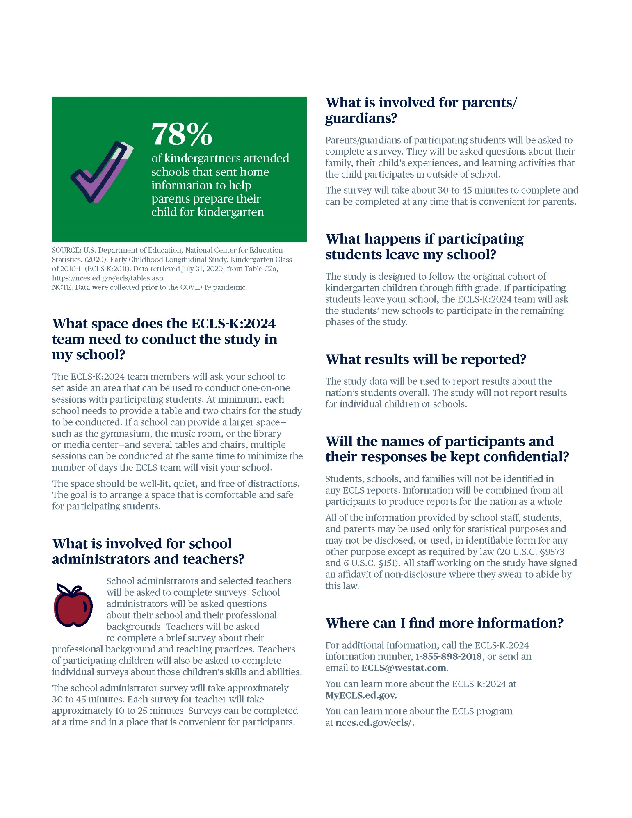

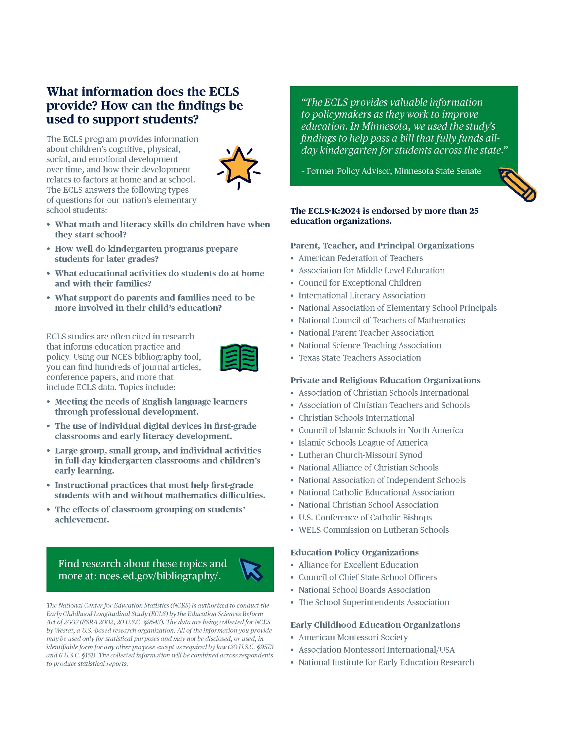

School District Recruitment Letter
National Study
[DATE]
[TITLE] [NAME FIRST] [NAME LAST]
[TITLE/DEPARTMENT]
[SCHOOL DISTRICT]
[ADDRESS 1]
[CITY], [STATE] [ZIP CODE]

Dear [TITLE] [NAME LAST]:

The U.S. Department of Education is preparing to work with a new cohort of elementary-aged students for a national education research study called the Early Childhood Longitudinal Study, Kindergarten Class of 2023-24 (ECLS-K:2024). This study will help improve educational experiences and outcomes for all students in the United States. The enclosed Study Overview provides more details about the study and what is involved for the participants.

The ECLS-K:2024 is the fourth cohort in the series of early childhood longitudinal studies that make up the ECLS research program. For more than 20 years, the ECLS program has helped educators, families, researchers, and policymakers better understand and improve children’s knowledge and skills from birth through elementary school. For more details about the ECLS program, visit nces.ed.gov/ecls.

The ECLS-K:2024 study activities will begin in the 2023-24 school year, collecting data on approximately 21,000 kindergartners in 1,000 schools nationwide. Data collection will include one-on-one child assessments conducted by trained ECLS-K:2024 staff and self-administered web surveys completed by school administrators, teachers, and parents of sampled children. Current plans are for the study activities to take place during the selected children’s kindergarten (fall 2023 and spring 2024), first-grade (spring 2025), third-grade (spring 2027), and fifth-grade (spring 2029) years.

Some schools in your district have been randomly selected to participate in the ECLS-K:2024, and I am writing to ask for your district’s support of the study and the selected schools’ participation. While the study is voluntary, by permitting our staff to contact selected schools in your district to discuss participation and encouraging those schools to participate, you will help ensure a successful data collection. Without the participation of the schools in your districts, the data we collect may not represent the experiences of your district, resulting in incomplete information about students and the changing landscape of the education system in the United States. This can lead to misleading research conclusions and misinformed policy decisions.

Study staff will be contacting you soon to discuss the participation of the selected schools in your district, as well as any special approval processes that may be required, such as research applications or district-specific consent forms. <To help ensure that our study clearance request packages are properly developed and submitted for your district’s formal review process, I am reaching out to ask you to designate a staff person who can serve as our central point of contact.>

The following school(s) in your district will be contacted to discuss participation. If allowed by your district, these schools, as well as school staff, teachers, and parents will be provided with monetary tokens of appreciation in recognition of the time spent participating in the study.
<LIST SAMPLED SCHOOLS>

The ECLS-K:2024 is conducted by the National Center for Education Statistics (NCES), within the U.S. Department of Education’s Institute of Education Sciences (IES). NCES is working with Westat, a U.S.-based research organization, to conduct this voluntary study. Additional study-specific information is available on the ECLS-K:2024 website, MyECLS.ed.gov.

If you have questions or need assistance, please call 1-855-898-2018 or email ECLS@westat.com. You may also reach the ECLS Study Director, Jill McCarroll, at 202-304-2920 or jill.mccarroll@ed.gov.

Thank you for your time and for supporting this important national education research study.

Sincerely,

[Name]
[Commissioner or other title]
National Center for Education Statistics, Institute of Education Sciences
U.S. Department of Education

Enclosure:
ECLS-K:2024 Study Overview

The National Center for Education Statistics (NCES) was established in 1867 to collect and provide to Congress and the public information on the condition of the education system in the United States. NCES, part of the U.S. Department of Education’s Institute of Education Sciences (IES), is the sole Federal statistical agency responsible for meeting Congressional mandates to collect, analyze, and report information on the condition of education in the United States.

NCES needs the support of all involved in the education process to complete the studies it conducts related to Congressional mandates for information about education in the country as a whole. The longitudinal studies including those in the ECLS program collect nationally representative data from students and from their families, teachers, schools, and school systems. These data provide rich information that can be used to study how students’ backgrounds and school experiences are related to education and life outcomes. The studies are comprehensive in approach, covering an expansive array of research and policy issues central to the future of education.

NCES has produced some of the most widely used and cited longitudinal studies on education in the United States. All data collections conducted by NCES are reviewed and approved by the Federal Office of Management and Budget (OMB) to ensure minimal burden on the part of the public and to prevent duplicate data collections by multiple Federal agencies. NCES data are used not only by government agencies but also by policy institutes and researchers at leading universities from across the country. NCES also produces resources for teachers and families. For example, the nces.ed.gov/nceskids website is a resource to learn more about education in the United States and to play fun educational games

ECLS-K:2024 Tokens of Appreciation

Current plans are for the study activities to occur in the fall of 2023 and spring of 2024, when the selected children are in kindergarten. Subsequent data collection activities are planned for spring 2025, spring 2027, and spring 2029. If district policy permits, each school community will receive the following to recognize the time spent participating in the ECLS-K:2024:
- Each school will receive $300 at the conclusion of every spring phase of data collection.
- School administrators will receive $25 during every spring data collection phase to thank them for completing a school administrator survey .
- School coordinators, who will act as liaisons between the school and the study, will receive $65 in the fall of 2023. They will also receive $35 in the spring of 2024, as well as in each of the future spring phases.
- Teachers will be asked to complete surveys in every study phase. In each phase, they will receive $20 for a survey they complete about themselves and $7 for each survey they complete for participating students.
- School administrators, school coordinators, and teachers will receive a Certificate of Contribution from the U.S. Department of Education.
- For schools with explicit parent consent for children’s participation and that have obtained 100 percent returned forms, regardless of whether consent is provided, the study will also sponsor a food event at the school.
- In every study phase, participating families will receive <a $15 prepaid Mastercard® and> a pad of sticky notes with the U.S. Department of Education logo as a thank you for completing the web survey.

The National Center for Education Statistics (NCES) is authorized to conduct the Early Childhood Longitudinal Study (ECLS) by the Education Sciences Reform Act of 2002 (ESRA 2002, 20 U.S.C. §9543). The data are being collected for NCES by Westat, a U.S.-based research organization. All of the information you provide may be used only for statistical purposes and may not be disclosed, or used, in identifiable form for any other purpose except as required by law (20 U.S.C. §9573 and 6 U.S.C. §151). The collected information will be combined across respondents to produce statistical reports.

School District Nonresponse Letter
National Study
[DATE]
[TITLE] [NAME FIRST] [NAME LAST]
[TITLE/DEPARTMENT]
[SCHOOL DISTRICT]
[ADDRESS 1]
[CITY], [STATE] [ZIP CODE]
Dear [TITLE] [NAME LAST]:
We recently contacted your district about the U.S. Department of Education’s Early Childhood Longitudinal Study, Kindergarten Class of 2023-24 (ECLS-K:2024). I am contacting you again to consider lending your support to the study and allowing your district’s sampled schools to participate.
About the ECLS research program: Over its rich 20-year history, the ECLS program’s studies have been important sources of data for researchers and policymakers to use in order to address key issues related to children’s development and learning including literacy in the home; school support of families; the teaching of reading and mathematics; and the associations between physical exercise, childhood obesity, and well-being. Researchers using ECLS data have published their findings widely in scientific journals and the popular press has reported on these findings. The results from these research studies are available for districts, schools, and the general public to read about on the ECLS program’s website, nces.ed.gov/ecls.
<INSERT INFOGRAPHIC HERE: EITHER USE OF TECHNOLOGY, SCHOOL SUPPORT OF FAMILIES, AND/OR MATERIALS SENT HOME.>
Why it is important to participate: We need the support of all involved in the education process to collect nationally representative data from children and from their families, teachers, and schools. In this new ECLS study, which focuses on the kindergarten class of 2023-24, data will be collected on policy-related areas not fully covered in or that have emerged since the previous ECLS program studies. We will not be able to understand the current experiences and skills of children without a sample of schools that includes a diverse group of children and teachers in the United States today. This can lead to misleading research conclusions and misinformed policy decisions.
What is involved for the selected schools, staff, and families:
- The ECLS-K:2024 study activities will begin in the 2023-24 school year, collecting data on approximately 21,000 kindergartners in 1,000 schools nationwide. Data collection will include one-on-one child assessments and self-administered surveys completed by school administrators, teachers, and parents of sampled children. Current plans are for the study activities to take place during the selected children’s kindergarten (fall 2023 and spring 2024), first-grade (spring 2025), third-grade (spring 2027), and fifth-grade (spring 2029) years.
- Age-appropriate and engaging assessments in <mathematics and reading/mathematics, reading, and executive function> will be conducted by trained ECLS-K:2024 staff with a sample of approximately 21 kindergartners in each school. <Children’s height and weight will also be measured.>The child sessions will be scheduled at a time convenient for the school. Most children will be out of the classroom for about 1 hour. Teachers do not need to be present during the sessions and we will work with them to minimize classroom disruptions.
- School administrators will be asked to complete web surveys about their background and the school environment. Teachers of the participating children will be asked to complete web surveys about their background, the school environment, their classrooms, and skills of the sampled children. If allowed by district policy, school administrators and teachers will receive a monetary token of appreciation as a recognition of their time and effort. They, along with school coordinators, will also receive a Certificate of Contribution from the U.S. Department of Education.
- For schools that require explicit parent consent for children’s participation and that have obtained 100 percent returned forms, regardless of whether consent is provided, the study will also sponsor a food event at the school.
- Parents of the sampled children will be asked to complete a web survey about their child’s home environment, health, early care and education, and skills. Parents will receive <a $15 prepaid Mastercard® and> a pad of sticky notes with the U.S. Department of Education logo for their time.
The ECLS-K:2024 is conducted by the National Center for Education Statistics (NCES), within the U.S. Department of Education’s Institute of Education Sciences (IES). NCES is working with Westat, a U.S.-based research organization, to conduct this voluntary study.
A Westat representative of the ECLS-K:2024 will call you soon to discuss your decision. For additional information, please reach out to the ECLS-K:2024 team at ECLS@westat.com or 1-855-898-2018, or visit the ECLS-K:2024 website at MyECLS.ed.gov. To contact the ECLS Study Director, Jill McCarroll, please call 202-304-2920 or email jill.mccarroll@ed.gov. Thank you for your time and consideration.
Sincerely,

[Name]
[Commissioner or other title]
National Center for Education Statistics, Institute of Education Sciences
U.S. Department of Education

Enclosure:
ECLS-K:2024 Study Overview

The National Center for Education Statistics (NCES) is authorized to conduct the Early Childhood Longitudinal Study (ECLS) by the Education Sciences Reform Act of 2002 (ESRA 2002, 20 U.S.C. §9543). The data are being collected for NCES by Westat, a U.S.-based research organization. All of the information you provide may be used only for statistical purposes and may not be disclosed, or used, in identifiable form for any other purpose except as required by law (20 U.S.C. §9573 and 6 U.S.C. §151). The collected information will be combined across respondents to produce statistical reports.

School Recruitment Letter
National Study
<Date>

<Addressee’s Name
School
Address
Address 2
City, State, ZIP>

Dear <School Administrator>:
Your school has been chosen by the U.S. Department of Education to participate in the upcoming Early Childhood Longitudinal Study, Kindergarten Class of (2023-24 (ECLS-K:2024). <<District approver’s name> at your district’s office/Your district office>has been notified about this study and is aware that you are being contacted and asked to participate. The enclosed Study Overview provides more details about the study and what is involved for the participants.

The ECLS-K:2024 is the fourth cohort in the series of early childhood longitudinal studies that make up the ECLS program. For more than 20 years, the ECLS program has helped educators, families, researchers, and policymakers better understand and improve children’s knowledge and skills from birth through elementary school. For more details about the ECLS program, visit nces.ed.gov/ecls.

I encourage you and your school to participate in the ECLS-K:2024. The study is voluntary, but the selected schools, students, and families need to be included to ensure that the study outcomes are regionally, culturally, and socioeconomically represented.
- The ECLS-K:2024 study activities will begin in the 2023-24 school year, collecting data on approximately 21,000 kindergartners in 1,000 schools nationwide. Data collection will include one-on-one child assessments and self-administered surveys completed by school administrators, teachers, and parents of sampled children. Current plans are for the study activities to take place during the selected children’s kindergarten (fall 2023 and spring 2024), first-grade (spring 2025), third-grade (spring 2027), and fifth-grade (spring 2029) years.
- Age-appropriate and engaging assessments in <mathematics and reading/mathematics, reading, and executive function> will be conducted by trained ECLS-K:2024 staff with a sample of approximately 21 kindergartners in each school. <Children’s height and weight will also be measured.> The child sessions will be scheduled at a time convenient for the school. Each session is untimed but is expected to take about an hour for most children. Your teachers will not need to take time away from their students for study activities and we will work with them to minimize classroom disruptions.
- You, as well as the parents and teachers, will be asked to complete web surveys.
- <For your time and effort, we will provide you, your school, the school’s coordinator to the study, <and>teachers<, and parents> a monetary token of appreciation. More details are provided on the back of this letter.>

The ECLS is conducted by the National Center for Education Statistics (NCES), within the U.S. Department of Education’s Institute of Education Sciences (IES). We have partnered with Westat, a U.S.-based research organization, to carry out the study in participating schools. A study representative will contact you about the study within the next few days. In the meantime, if you have any questions, please call the ECLS team at 1-855-898-2018 or send an email to ECLS@westat.com. Additional specific study information is available on the ECLS-K:2024 website, MyECLS.ed.gov.

Thank you for our support of this important study!
Sincerely,
[Name]
[Commissioner or other title]
National Center for Education Statistics, Institute of Education Sciences
U.S. Department of Education
Current plans are for the study activities to occur in the fall of 2023 and spring of 2024, when the selected children are in kindergarten. Subsequent data collection activities are planned for spring 2025, spring 2027, and spring 2029.

Your school community will receive the following to recognize the time spent participating in the study:
- Each school will receive $300 at the conclusion of every spring phase of data collection.
- School administrators will receive $25 during every spring data collection phase to thank them for completing a school administrator survey.
- School coordinators, who will act as liaisons between the school and the study, will receive $65 in the fall of 2023. They will also receive $35 in the spring of 2024, as well as in each of the future spring phases.
- Teachers will be asked to complete surveys in every study phase. In each phase, they will receive $20 for a survey they complete about themselves and $7 for each survey they complete for participating students.>
- School administrators, school coordinators, and teachers will <also> receive a Certificate of Contribution from the U.S. Department of Education.
- For schools with explicit parent consent for children’s participation and that have obtained 100 percent returned forms, regardless of whether consent is provided, the study will also sponsor a food event at the school.
- In every study phase, participating families will receive <a $15 prepaid Mastercard® and> a pad of sticky notes with the U.S. Department of Education logo as a thank you for completing the web survey.

The National Center for Education Statistics (NCES) is authorized to conduct the Early Childhood Longitudinal Study (ECLS) by the Education Sciences Reform Act of 2002 (ESRA 2002, 20 U.S.C. §9543). The data are being collected for NCES by Westat, a U.S.-based research organization. All of the information you provide may be used only for statistical purposes and may not be disclosed, or used, in identifiable form for any other purpose except as required by law (20 U.S.C. §9573 and 6 U.S.C. §151). The collected information will be combined across respondents to produce statistical reports.

Recruitment Follow-up Letter for Pending/Refusal Schools
National Study
[DATE]
[TITLE] [NAME FIRST] [NAME LAST]
[TITLE/DEPARTMENT]
[SCHOOL DISTRICT]
[ADDRESS 1]
[CITY], [STATE] [ZIP CODE]

Dear [TITLE] [NAME LAST]:

We recently contacted your school about the U.S. Department of Education’s Early Childhood Longitudinal Study, Kindergarten Class of 2023-24 (ECLS-K:2024). I am contacting you again to consider lending your support to the study and allowing your school to participate.

About the ECLS research program: Over its rich 20-year history, the ECLS program’s studies have been important sources of data for researchers and policymakers to use in order to address key issues related to children’s development and learning including literacy in the home; school support for families; the teaching of reading and mathematics; and the associations between physical exercise, childhood obesity, and well-being. Researchers using ECLS data have published their findings widely in scientific journals and the popular press has reported on these findings. The results from these studies are available for districts, schools, and the general public to read about on the ECLS program’s website, nces.ed.gov/ecls.

<INSERT INFOGRAPHIC HERE: EITHER USE OF TECHNOLOGY, SCHOOL SUPPORT OF FAMILIES, AND/OR MATERIALS SENT HOME.>

Why it is important to participate: We need the support of all involved in the education process to collect nationally representative data from students and from their families, teachers, and schools. In this new ECLS cohort study, which focuses on the kindergarten class of 2023-24, data will be collected on policy-related areas not fully covered in or that have emerged since the previous ECLS program studies. We will not be able to understand the current experiences and skills of children without a sample of schools that includes a diverse group of children and teachers in the United States today. This can lead to misleading research conclusions and misinformed policy decisions. The enclosed Study Overview provides more details about the study and what is involved for the participants.

What is involved for the selected schools, staff, and families:
- The ECLS-K:2024 study activities will begin in the 2023-24 school year, collecting data on approximately 21,000 kindergartners in 1,000 schools nationwide. Data collection will include one-on-one child assessments and self-administered web surveys completed by school administrators, teachers, and parents of sampled children. Current plans are for the study activities to take place during the selected children’s kindergarten (fall 2023 and spring 2024), first-grade (spring 2025), third-grade (spring 2027), and fifth-grade (spring 2029) years.
- Age-appropriate and engaging assessments in <mathematics and reading/mathematics, reading, and executive function> will be conducted by trained ECLS-K:2024 staff with a sample of approximately 21 kindergartners in each school. <Children’s height and weight will also be measured.> The child sessions will be scheduled at a time convenient for the school. Most children will be out of the classroom for about 1 hour. Teachers do not need to be present during the sessions and we will work with them to minimize classroom disruptions.
- School administrators will be asked to complete web surveys about their background and the school environment. Teachers of the participating children will be asked to complete web surveys about their background, the school environment, their classrooms, and skills of the sampled children. If allowed by district policy, school administrators and teachers will receive a monetary token of appreciation as a recognition of their time and effort. They, along with school coordinators, will also receive a Certificate of Contribution from the U.S. Department of Education. For schools that require explicit parent consent for children’s participation and that have obtained 100 percent returned forms, regardless of whether consent is provided, the study will also sponsor a food event (such as a pizza or ice cream party) at the school.
- Parents of the sampled children will be asked to complete a web survey about their child’s home environment, health, early care and education, and skills. Parents will receive <a $15 prepaid Mastercard® and> a pad of sticky notes with the U.S. Department of Education logo for their time.

The ECLS-K:2024 is conducted by the National Center for Education Statistics (NCES), within the U.S. Department of Education’s Institute of Education Sciences (IES). NCES is working with Westat, a U.S.-based research organization, to conduct this voluntary study. A Westat representative of the ECLS-K:2024 will call you soon to discuss your decision. For additional information, please reach out to the ECLS-K:2024 team at ECLS@westat.com or 1-855-898-2018, or visit the ECLS-K:2024 study website at MyECLS.ed.gov. Thank you for your time and consideration.

Sincerely,

[Name]
[Commissioner or other title]
National Center for Education Statistics, Institute of Education Sciences
U.S. Department of Education

Enclosure:
ECLS-K:2024 Study Overview

The National Center for Education Statistics (NCES) is authorized to conduct the Early Childhood Longitudinal Study (ECLS) by the Education Sciences Reform Act of 2002 (ESRA 2002, 20 U.S.C. §9543). The data are being collected for NCES by Westat, a U.S.-based research organization. All of the information you provide may be used only for statistical purposes and may not be disclosed, or used, in identifiable form for any other purpose except as required by law (20 U.S.C. §9573 and 6 U.S.C. §151). The collected information will be combined across respondents to produce statistical reports.

Recruitment Email Template for Difficult-to-Reach Principals
National Study

SUBJECT: Participation in the U.S. Department of Education’s ECLS

Dear [SCHOOL ADMIN NAME]:

My name is [RECRUITER NAME] and I have recently been trying to reach you to discuss the U.S. Department of Education’s Early Childhood Longitudinal Study, Kindergarten Class of 2023-24 (ECLS-K:2024). [Your [SECRETARY / ADMINISTRATIVE ASSISTANT / RECEPTIONIST] has been very gracious in receiving my calls and suggested I use email to contact you.] [IF DISTRICT APPROVAL OBTAINED: I spoke with [NAME], [TITLE] of [DISTRICT/DIOCESE NAME], about your school’s selection for the ECLS-K:2024. [He/She] approved my contacting you directly.]

Why is it Important for My School to Participate?
- Your school was selected because of a variety of factors, including geographic location, school size, and the makeup of the school population you serve.
- We need representation from all types of schools in the United States―public schools, religiously-affiliated private schools, and private schools without religious affiliation.

What is Involved for the Selected Schools, Staff, and Families?
- The ECLS-K:2024 study activities will begin in the 2023-24 school year. Data collection will include one-on-one child assessments and self-administered web surveys completed by school administrators, teachers, and parents of sampled children. Current plans are for the study activities to take place during the selected children’s kindergarten (fall 2023 and spring 2024), first-grade (spring 2025), third-grade (spring 2027), and fifth-grade (spring 2029) years.
- Engaging, age-appropriate assessments in <mathematics and reading/mathematics, reading, and executive function> will be conducted by trained ECLS-K:2024 staff. <Children’s height and weight will also be measured.> Each child session is untimed but should take about 1 hour for most children.
- The study will provide all materials for the school visits. Teachers do not need to be present and we will work with them to minimize disruptions to their classrooms.
- In the spring phases of the study, you are asked to complete a web survey on school characteristics and your background. In the fall and spring phases, the teachers are asked to complete web surveys about their experiences, classroom characteristics, and the selected children. Parents of sampled children are asked to complete web surveys about their household and the child in each phase of the study.
What Else Should I Know about the Study?
- [IF INCENTIVES ARE ALLOWED:] There is no monetary cost involved―in fact, the school, the school’s coordinator to the study, teachers, and parents will all receive a monetary token of appreciation for participation.
- School, child, teacher, and parent names will not be published in any reports nor will individual child assessment scores be reported.
- All ECLS-K:2024 staff who enter schools undergo a Federal background investigation conducted jointly by the U.S. Departments of Education and Defense and have signed a pledge of confidentiality.
What is the Next Step?
Please identify a convenient time when we can discuss your ECLS-K:2024 participation. If you would rather appoint another staff member to serve as the contact, I would be glad to work with that person to make arrangements.

Need More Information about the Study?
Refer to the attached ECLS Study Overview or visit the study website, MyECLS. If you have questions, please feel free to contact me directly.

Sincerely,
[NAME], ECLS-K:2024 Representative
[PHONE NUMBER]

One reason why the ECLS-K:2024 is so important? It helps us understand more about schools, teachers, and students across the United States.
<INSERT INFOGRAPHIC HERE: EITHER USE OF TECHNOLOGY, SCHOOL SUPPORT OF FAMILIES, AND/OR MATERIALS SENT HOME.>

Attachment
ECLS Study Overview
The ECLS-K:2024 is conducted by the National Center for Education Statistics (NCES), within the U.S. Department of Education’s Institute of Education Sciences (IES).
The National Center for Education Statistics (NCES) is authorized to conduct the Early Childhood Longitudinal Study (ECLS) by the Education Sciences Reform Act of 2002 (ESRA 2002, 20 U.S.C. §9543). The data are being collected for NCES by Westat, a U.S.-based research organization. All of the information you provide may be used only for statistical purposes and may not be disclosed, or used, in identifiable form for any other purpose except as required by law (20 U.S.C. §9573 and 6 U.S.C. §151). The collected information will be combined across respondents to produce statistical reports.

Recruitment Email Template School Staff Considering Participation
National Study
SUBJECT: Participation in the U.S. Department of Education’s ECLS

Dear [SCHOOL ADMIN NAME]:
Thank you for taking your valuable time to speak with me today concerning the participation of [SCHOOL NAME] in the U.S. Department of Education’s Early Childhood Longitudinal Study, Kindergarten Class of 2023-24 (ECLS-K:2024). As you will be speaking with [your teachers / your board] about the study, I am including a brief overview of what is involved as well as attaching an ECLS Study Overview for you to pass along. As we discussed, your staff’s time involvement is limited, but their support is vital.

Why is it Important for My School to Participate?
- Your school was selected because of a variety of factors, including geographic location, school size, and the makeup of the school population you serve.
• We need representation from all types of schools in the United States―public, religiously-affiliated private schools, and private schools without religious affiliation.

What is Involved for the Selected Schools, Staff, and Families?
- The ECLS-K:2024 study activities will begin in the 2023-24 school year. Data collection will include one-on-one child assessments and self-administered web surveys completed by school administrators, teachers, and parents of sampled children. Current plans are for the study activities to take place during the selected children’s kindergarten (fall 2023 and spring 2024), first-grade (spring 2025), third-grade (spring 2027), and fifth-grade (spring 2029) years.
- Engaging, age-appropriate assessments in <mathematics and reading/mathematics, reading, and executive function> will be conducted by trained ECLS-K:2024 staff. <Children’s height and weight will also be measured.> Each child session is untimed but should take about 1 hour for most children.
- The study will provide all materials for the school visits. Teachers do not need to be present and we will work with them to minimize disruptions to their classrooms.
- In the spring phases of the study, the school administrator is asked to complete a web survey on school characteristics and his or her background. In the fall and spring phases, the teachers are asked to complete web surveys about their experiences, classroom characteristics, and the selected children. Parents of sampled children are asked to complete web surveys about their household and the child in each phase of the study.

What Else Should I Know about the Study?
- [IF INCENTIVES ARE ALLOWED:] There is no monetary cost involved―in fact, the school, the school’s coordinator to the study, teachers, and parents will all receive a monetary token of appreciation for participation.
- School, child, teacher, and parent names will not be published in any reports nor will individual child assessment scores be reported.
- All ECLS-K:2024 staff who enter schools undergo a Federal background investigation conducted jointly by the U.S. Departments of Education and Defense and have signed a pledge of confidentiality.
Need More Information about the Study?
Refer to the attached ECLS Study Overview or visit the study website, MyECLS. If you have questions, please feel free to contact me directly.

What is the Next Step?
I will contact you on [DATE] to obtain additional school information, including the contact information for the person you designate to help with study arrangements.

Sincerely,
[NAME], ECLS-K:2024 Representative
[PHONE NUMBER]

One reason why the ECLS-K:2024 is so important? It helps us understand more about schools, teachers, and students across the United States.
<INSERT INFOGRAPHIC HERE: EITHER USE OF TECHNOLOGY, SCHOOL SUPPORT OF FAMILIES, AND/OR MATERIALS SENT HOME.>

Attachment
ECLS Study Overview
The ECLS-K:2024 is conducted by the National Center for Education Statistics (NCES), within the U.S. Department of Education’s Institute of Education Sciences (IES).
The National Center for Education Statistics (NCES) is authorized to conduct the Early Childhood Longitudinal Study (ECLS) by the Education Sciences Reform Act of 2002 (ESRA 2002, 20 U.S.C. §9543). The data are being collected for NCES by Westat, a U.S.-based research organization. All of the information you provide may be used only for statistical purposes and may not be disclosed, or used, in identifiable form for any other purpose except as required by law (20 U.S.C. §9573 and 6 U.S.C. §151). The collected information will be combined across respondents to produce statistical reports.

Recruitment Email Template Follow-up to Address Concerns
National Study
SUBJECT: Participation in the U.S. Department of Education’s ECLS

Dear [SCHOOL ADMIN NAME]:

Thank you so much for taking the time to speak with me today. I am writing to summarize some of the details of our discussion and to provide more information about [CONCERN].

[DETAILED RESPONSE TO CONCERN]

For more than 20 years, the ECLS program has helped educators, families, researchers, and policymakers better understand and improve children’s knowledge and skills from birth through elementary school. This is [SCHOOL NAME]’s opportunity to contribute to the interests of the broader educational community, while also contributing to research that can help your particular school, teachers, and students.

One reason why the ECLS-K:2024 is so important? It helps us understand more about schools, teachers, and students across the United States.
<INSERT INFOGRAPHIC HERE: EITHER USE OF TECHNOLOGY, SCHOOL SUPPORT OF FAMILIES, AND/OR MATERIALS SENT HOME.>

Please visit the study website MyECLS for more information or contact me with any questions you may have. I will call you again in a few days and look forward to working with you.

Sincerely,
[NAME], ECLS-K:2024 Representative
[PHONE NUMBER]

The ECLS-K:2024 is conducted by the National Center for Education Statistics (NCES), within the U.S. Department of Education’s Institute of Education Sciences (IES).

The National Center for Education Statistics (NCES) is authorized to conduct the Early Childhood Longitudinal Study (ECLS) by the Education Sciences Reform Act of 2002 (ESRA 2002, 20 U.S.C. §9543). The data are being collected for NCES by Westat, a U.S.-based research organization. All of the information you provide may be used only for statistical purposes and may not be disclosed, or used, in identifiable form for any other purpose except as required by law (20 U.S.C. §9573 and 6 U.S.C. §151). The collected information will be combined across respondents to produce stTo atistical reports.

Recruitment Email Template Follow-up after Cooperation Achieved
National Study
SUBJECT: Participation in the U.S. Department of Education’s ECLS

Dear [SCHOOL ADMIN NAME]:

Thank you for taking your valuable time to speak with me today concerning the participation of [SCHOOL NAME] in the U.S. Department of Education’s Early Childhood Longitudinal Study, Kindergarten Class of 2023-24 (ECLS-K:2024). I am so pleased that your school will assist us in gathering important information that will be used to improve education for our nation’s students. As we discussed, your staff’s time involvement is limited, but their support is vital. To summarize our discussion today:

[SUMMARY OF DISCUSSION]

I look forward to working with you and your staff. I will contact [SCHOOL COORDINATOR NAME] on [DATE OR TIMEFRAME] to discuss the fall study activities and to make preliminary arrangements. In the meantime, please feel free to contact me with questions, or visit the study website MyECLS for more information about next steps.

Sincerely,
[NAME], ECLS-K:2024 Representative
[PHONE NUMBER]

The ECLS-K:2024 is conducted by the National Center for Education Statistics (NCES), within the U.S. Department of Education’s Institute of Education Sciences (IES).
The National Center for Education Statistics (NCES) is authorized to conduct the Early Childhood Longitudinal Study (ECLS) by the Education Sciences Reform Act of 2002 (ESRA 2002, 20 U.S.C. §9543). The data are being collected for NCES by Westat, a U.S.-based research organization. All of the information you provide may be used only for statistical purposes and may not be disclosed, or used, in identifiable form for any other purpose except as required by law (20 U.S.C. §9573 and 6 U.S.C. §151). The collected information will be combined across respondents to produce statistical reports.

Follow-up Letter for Participating but Difficult to Contact Schools
National Study

[DATE]
[TITLE] [NAME FIRST] [NAME LAST],
[TITLE/DEPARTMENT]
[SCHOOL DISTRICT]
[ADDRESS 1]
[CITY], [STATE] [ZIP CODE]

Dear [TITLE] [NAME LAST]:
We recently contacted you about the U.S. Department of Education’s Early Childhood Longitudinal Study, Kindergarten Class of 2023-24 (ECLS-K:2024). As the ECLS-K:2024 Project Director for Westat, the U.S.-based research organization conducting this study on behalf of the National Center for Education Statistics (NCES), I want to thank you for agreeing to participate in the ECLS-K:2024.

As the data collection period draws closer, it is critical that we <confirm the ECLS-K:2024 visit dates for your school / receive the child list for sampling>. Your school represents hundreds of other schools in the U.S. that have a student body like yours. As a reminder:
- We will schedule the fall school visit at a time convenient for your school, between August and December 2023. Local ECLS staff will administer each child’s session. Most children will be out of the classroom about 1 hour. We will work with your school staff to schedule the child sessions at convenient times to minimize the amount of class time that children will miss. Teachers do not need to be present and we will work with them to minimize classroom disruptions. The burden on your school staff is minimal.
- <In recognition of the school staff’s time and effort, your school will receive $300 for participating. You will receive $25 for completing the spring school survey. Your school’s ECLS school coordinator, who will act as a liaison between your school and the study, will receive $65 in the fall and $35 in the spring. Teachers will receive $20 for completing the teacher background survey and an additional $7 for each survey about a study child they complete in the fall and spring.> School administrators, school coordinators, and teachers will <also> receive a Certificate of Contribution from the U.S. Department of Education. < For schools that require explicit parent consent for children’s participation and that have obtained 100 percent returned forms, regardless of whether consent is provided, the study will also sponsor a food event at the school.> Parents asked to complete the survey will receive <a $15 prepaid Mastercard® and> a pad of sticky notes with the U.S. Department of Education logo.
The ECLS-K:2024 team wants to make your school’s participation as easy and efficient as possible. We are available to help review your calendar to find a time to visit your school to conduct the study activities and can aid in compiling and submitting the child list that we need in order to sample students for the study. Please reach out to your ECLS-K:2024 representative, <team leader name>, at <email address>. You can also contact the ECLS-K:2024 team at 1-855-898-2018 or ECLS@westat.com with any questions. There are detailed tips for completing the study activities on the ECLS-K:2024 website, MyECLS.ed.gov.

Thank you for your time and consideration.

Sincerely,

Elizabeth Bissett
Project Director, ECLS-K:2024
Westat

One reason why the ECLS-K:2024 is so important? It helps us understand more about schools, teachers, and students across the United States.
<INSERT INFOGRAPHIC HERE: EITHER USE OF TECHNOLOGY, SCHOOL SUPPORT OF FAMILIES, AND/OR MATERIALS SENT HOME.>

The National Center for Education Statistics (NCES) is authorized to conduct the Early Childhood Longitudinal Study (ECLS) by the Education Sciences Reform Act of 2002 (ESRA 2002, 20 U.S.C. §9543). The data are being collected for NCES by Westat, a U.S.-based research organization. All of the information you provide may be used only for statistical purposes and may not be disclosed, or used, in identifiable form for any other purpose except as required by law (20 U.S.C. §9573 and 6 U.S.C. §151). The collected information will be combined across respondents to produce statistical reports.

Spring Email for School Coordinators
National Study
SUBJECT: Participation in the U.S. Department of Education’s ECLS

Dear <SC NAME>:

As you may be aware, <SCHOOL NAME> is participating in the U.S. Department of Education’s Early Childhood Longitudinal Study, Kindergarten Class of 2023-24 (ECLS-K:2024) and you have been named to serve as the school’s liaison with the ECLS staff who will work with your school. For over 20 years, the ECLS program’s studies have been important sources of data to address key issues including those related to children’s development and learning including literacy in the home; the teaching of reading and mathematics; and the associations between physical exercise, childhood obesity, and well-being.

The ECLS-K:2024 study activities will begin in the 2023-24 school year. Data collection will include one-on-one child assessments and self-administered web surveys completed by school administrators, teachers, and parents of sampled children. Current plans are for the study activities to take place during the selected children’s kindergarten (fall 2023 and spring 2024), first-grade (spring 2025), third-grade (spring 2027), and fifth-grade (spring 2029) years.

What Will You be Asked to Do?
- At the beginning of the 2023-24 school year, you will be asked to provide a list of kindergarten children at your school. From this list, the ECLS-K:2024 team will select children to participate in the study.
- Once the children are selected for the study, an ECLS-K:2024 representative will call you to discuss the study activities that need completion prior to our visit to your school, including the most efficient method of contacting parents and gaining consent for their child’s participation, working with teachers to invite them to complete web surveys, and the logistics for the visit to your school.
- We will work with you to schedule the child sessions at convenient times to minimize the amount of class time that children miss. The sessions are conducted by trained ECLS-K:2024 staff, so there is nothing that you or their teachers need to do to administer them. You will be asked to provide logistical support during the days ECLS staff are visiting your school.
- You may be asked to follow-up with teachers and parents to ask them to complete their web surveys.
- <To thank you for your help, you will receive $65 this fall and $35 in each spring phase of the study.> You will <also> receive a Certificate of Contribution from the U.S. Department of Education. <For schools that return 100 percent of their parental consent forms, regardless of whether consent is provided, the study will also sponsor a food event (such as a pizza or ice cream party) at the school.>

Need More Information about the Study?
- Refer to the attached ECLS Study Overview and School Coordinator Responsibilities Checklist.
- The study website MyECLS contains more details about the study and additional findings from previous ECLS studies.
Questions or Need Help?
- The U.S. Department of Education is working with Westat, a U.S.-based research organization, to conduct the study. Please contact the ECLS-K:2024 team at ECLS@westat.com or by calling 1-855-898-2018.
Thank you and have a wonderful summer,
The ECLS-K:2024 Project Staff

Attachments
ECLS Study Overview
School Coordinator Responsibilities Checklist
The ECLS-K:2024 is conducted by the National Center for Education Statistics (NCES), within the U.S. Department of Education’s Institute of Education Sciences (IES).
The National Center for Education Statistics (NCES) is authorized to conduct the Early Childhood Longitudinal Study (ECLS) by the Education Sciences Reform Act of 2002 (ESRA 2002, 20 U.S.C. §9543). The data are being collected for NCES by Westat, a U.S.-based research organization. All of the information you provide may be used only for statistical purposes and may not be disclosed, or used, in identifiable form for any other purpose except as required by law (20 U.S.C. §9573 and 6 U.S.C. §151). The collected information will be combined across respondents to produce statistical reports.

School Coordinator Responsibilities Checklist
National Study
U.S. Department of Education
Early Childhood Longitudinal Study, Kindergarten Class of 2023-24 (ECLS-K:2024)
School Coordinator Responsibilities Checklist – Fall 2023
Overview

As the school coordinator, your efforts and support are crucial to the success of the ECLS-K:2024. Thank you in advance for your help preparing for this important study!

In late August or early September 2023, you will be responsible for:

- Preparing and submitting the child list to MyECLS.ed.gov.
The child list should include all kindergarten students in your school, including those in transitional kindergartens and pre-first grade classrooms. Include each child’s month and year of birth, grade, sex, ethnicity, and race. The list will be used by ECLS staff to select the children, their parents, and teachers to participate in the ECLS-K:2024. Please submit this list electronically; instructions are posted on the MyECLS.ed.gov website on the “Submit Child List” page. It is very important that the list is prepared carefully and accurately.

- Determining consent requirements and updating MyECLS.ed.gov.
There are two types of parental consent used for the ECLS-K:2024: implicit consent and explicit consent. Details about consent are displayed on the “School Information” page of the MyECLS website. The Parent Portal on the MyECLS website allows parents to provide consent electronically for their children to participate. The ECLS team can also provide paper consent forms as necessary. Please confirm which type of consent is required for child participation in the ECLS-K:2024 in your school and how paper consent forms (if being used for any parents in your school) will be distributed; we will update MyECLS with the consent requirements.

Leading up to the visit to your school, you will be responsible for:

- Collecting and confirming child and teacher information.
After the children are selected for participation, you will receive an email when the Child Tracking Form is available to download from the MyECLS website. This form allows you to compile child and teacher information in advance of the study activities call with an ECLS-K:2024 representative.

- Participating in a study activities call with an ECLS-K:2024 representative.
The ECLS-K:2024 representative assigned to your school will contact you to go over the status of the preliminary tasks, discuss child and teacher participation, and work with you to arrange logistics for the school visit such as arranging a room for the child sessions and determining where ECLS-K:2024 staff will park when they arrive at the school. The representative can field any questions you may have about any of the ECLS-K:2024 procedures.

- Receiving and checking the ECLS-K:2024 study activities package.
You will receive a FedEx package with the following materials:
- Parent packets,
- Teacher packets, and
- A cover letter with a list of included materials.
The parent and teacher materials include welcome letters with instructions for using the MyECLS website to complete study activities, informational fact sheets, and the monetary tokens of appreciation for parents and teachers (if allowed by the school and district). Parent packets will also contain unique PINs to access the MyECLS website. (The PINs for teachers will be emailed to them directly.) If your school has chosen to use paper consent forms, the parent packets will also contain a consent form. Please ensure that there are parent and teacher envelopes for each selected child.

- Notifying parents and teachers and distributing survey information.
You are responsible for distributing the parent and teacher packets that will be included in the study activities package. In the event that a parent or teacher refuses to participate, be sure to let the ECLS-K:2024 representative know.

You will receive email templates for you to send to selected school staff and parents to notify them about the ECLS-K:2024. When emailing school administrators, teachers, and parents, please help us to maintain confidentiality by not revealing the names of study participants. We encourage you to send individual emails or, if you choose to send a group email, please be sure to blind-copy recipients so that they cannot see the names and email addresses of others included on the message.

- Encouraging consent and participation from parents and school staff and updating status on MyECLS.ed.gov.
The success of the study relies on children, parents, teachers, and the school administrator. Please encourage them to participate and notify the ECLS-K:2024 representative as soon as possible about any problems affecting participation in your school. You can check the completion of surveys on the School, Teacher, and Parent Information pages in the MyECLS website.

It is also very important that you update consent information on the Parent Information page of the website, particularly for parents providing consent through the return of paper forms. The ECLS-K:2024 representative assigned to your school will follow up with you on consent progress prior to and on the school visit days.

Please check the MyECLS website regularly throughout the study period to determine which parents and teachers need prompting to complete their surveys.

- Reserving space for the child sessions.
Three to five study team members will need approximately 3 consecutive days to assess all participating students. Please reserve space for the ECLS-K:2024 team to conduct the sessions with children. The sessions can take place in one large room with separate tables or in smaller rooms that accommodate only one or two pairs of ECLS study staff member and child. The space should be well-lit, quiet, free of distractions, and have two chairs and a table for each member of the study team. The goal is to arrange a space that is comfortable and safe for participating children. Internet access is not required.

On the ECLS school visit days, you will be responsible for:

- Working with the ECLS-K:2024 team and providing support, as needed.
Please plan to meet with the ECLS-K:2024 team before the first child session each day the ECLS study team is in your school in order to walk through the plan for the day. Show the reserved location to the team and make sure that they are introduced to all relevant staff members and, if possible, to the children involved in the study. You should also make sure that the procedure for getting children to and from class is clear. As the school coordinator, you are asked to assist the team as needed and help resolve any unforeseen issues. If you are unable to meet with the team on any of the school visit days, please designate an alternate staff member to take your place. Please deliver to the ECLS-K:2024 representative any paper parent consent forms that you have collected.

- Debriefing with the ECLS-K:2024 representative and returning completed paper surveys.
At the end of each day ECLS-K:2024 staff are in your school, please plan to meet with the study representative for 5-10 minutes to debrief about the day’s sessions. The ECLS-K:2024 representative will provide you with any paper surveys that have been requested for you to distribute to teachers. Please return any surveys that were completed on paper by teachers.

After the school visit, you will be responsible for:

- Storing the tracking forms and ECLS-K:2024 team materials in the storage envelope until June 30, 2024.
Please securely store the Child Tracking Form, Child Information Sheet, and Child Sign-out sheets until June 30, 2024 in the red storage envelope provided by the ECLS-K:2024 representative. After that date, the materials should be shredded.

Thank you for your help with the ECLS-K:2024 study activities!

The National Center for Education Statistics (NCES) is authorized to conduct the Early Childhood Longitudinal Study (ECLS) by the Education Sciences Reform Act of 2002 (ESRA 2002, 20 U.S.C. §9543). The data are being collected for NCES by Westat, a U.S.-based research organization. All of the information you provide may be used only for statistical purposes and may not be disclosed, or used, in identifiable form for any other purpose except as required by law (20 U.S.C. §9573 and 6 U.S.C. §151). The collected information will be combined across respondents to produce statistical reports.

Summer Email for School Coordinators
National Study
SUBJECT: Upcoming ECLS-K:2024 Study Activities in Your School

Dear <SC NAME>:

Thank you again for agreeing to take part in the U.S. Department of Education’s important study, the Early Childhood Longitudinal Study, Kindergarten Class of 2023-24 (ECLS-K:2024).

We look forward to visiting your school on <ASSESSMENT START DATE> through <ASSESSMENT END DATE> to complete the planned study activities. If for any reason these dates no longer work for your school, please contact us at 1-855-898-2018 or ECLS@westat.com.

What’s Next?
- At the beginning of the 2023-24 school year, you will receive an email inviting you to log in to the study website, MyECLS, and provide a list of all of the kindergarten children in your school so that we can select children to participate in the study.
- We plan to contact you on <PREASSESSMENT CALL DATE> to discuss the study arrangements in more detail, including the most efficient method of contacting parents and gaining consent for their child’s participation, working with teachers who were identified during sampling to invite them to the study and to complete their web surveys, and school visit logistics.

To thank you for your help, you will receive <$65 this fall and $35 next spring as well as> a Certificate of Contribution from the U.S. Department of Education. <For schools that require explicit parent consent for children’s participation and that have obtained 100 percent returned forms, regardless of whether consent is provided, the study will also sponsor a food event (such as a pizza or ice cream party) at the school.>

Need More Information about the Study?
- Refer to the attached ECLS Study Overview and School Coordinator Responsibilities Checklist.
- Feel free to contact the ECLS-K:2024 team at ECLS@westat.com or 1-855-898-2018 or visit the ECLS-K:2024 website at MyECLS.

We look forward to working with you and your school!
Thank you and have a wonderful rest of your summer,
The ECLS-K:2024 Team
Attachments
ECLS Study Overview
School Coordinator Responsibilities Checklist

The ECLS-K:2024 is conducted by the National Center for Education Statistics (NCES), within the U.S. Department of Education’s Institute of Education Sciences (IES).
The National Center for Education Statistics (NCES) is authorized to conduct the Early Childhood Longitudinal Study (ECLS) by the Education Sciences Reform Act of 2002 (ESRA 2002, 20 U.S.C. §9543). The data are being collected for NCES by Westat, a U.S.-based research organization. All of the information you provide may be used only for statistical purposes and may not be disclosed, or used, in identifiable form for any other purpose except as required by law (20 U.S.C. §9573 and 6 U.S.C. §151). The collected information will be combined across respondents to produce statistical reports.

Study Letterhead
National Study

