School Pulse Panel

OMB# 1850-0963 v.5

Appendix A – Communication Materials

National Center for Education Statistics (NCES)
U.S. Department of Education

August 2021
revised September 2021

Appendix A – Communication Materials

Advance E-mail to School, September, Responded to summer

Subject: Action requested: 2021-22 school reopening plans, providing <September> information by <date>

<insert name>:

Thank you for your participation in the brief, summer survey for the School Pulse Panel study. The data you provided have already been valuable for increasing our understanding of how schools are responding to rapidly changing threats from the COVID-19 pandemic.

As a reminder, we need your continued participation in the monthly data collections. The School Pulse Panel’s <September> survey will open on <MM/DD/YY>. Please be on the lookout for an email that includes a link to the survey. You will have two weeks to complete the survey.

The survey will take approximately 2-3 hours to complete. If necessary, you can save your responses and return to the survey later. We encourage you to work with other school staff, such as special education coordinators and district staff, to complete the survey; you can do so by sharing the survey link with them. Some questions may best be answered by central data office staff and having help with completing the survey will greatly reduce the burden on school staff. Your school will be compensated up to $5,000 for continued participation throughout the year.

Additional Information About the School Pulse Panel

The information you provide is essential to understanding the continued impact of the COVID-19 pandemic on K-12 education.

The School Pulse Panel is distinct from other studies in that it will provide information every month during the 2021-22 school year on the status of the reopening and operating of schools within the United States. This monthly collection will build a real-time picture of reopening progress across the United States. With each new variant and subsequent increase in COVID-19 cases, it becomes ever more imperative that we collect real-time data on how schools are experiencing these changes and the adaptations they are making to ensure the health, safety, and well-being of their students and staff. Your participation helps to ensure that the needs of your school and schools like yours will be considered in future policy and funding discussions.

To learn more about the School Pulse Panel, visit www.census.gov/schoolpulse.

Schools will be compensated up to $5,000 for regularly participating throughout the year. Compensation will be sent to the school districts in the form of a debit card, which in turn will be distributed to participating schools. Money will be added to the card quarterly with a payment for each monthly survey your school completes during that quarter. School participation is voluntary.

From September 2021 continuing through August 2022, you will be asked to provide information about school reopening efforts, virus spread mitigation strategies, services offered for students and staff, and technology use. New items may be rotated in on a quarterly basis. Instructions will be provided as part of the survey.

The School Pulse Panel is sponsored by the U.S. Department of Education’s National Center for Education Statistics (NCES). NCES is a division within the Institute of Education Sciences. If you have any questions about the study, contact the U.S. Census Bureau at 1-844-868-3661 or via e-mail at addp.school.pulse.panel@census.gov. The Census Bureau is collecting the data for NCES.

Thank you for your participation.

Sincerely,

Christopher Chapman
Associate Commissioner
National Center for Education Statistics (NCES)
U.S. Department of Education
NCES is authorized to conduct this survey by the Education Sciences Reform Act of 2002 (ESRA 2002, 20 U.S.C. §9543). All of the information schools provide may be used only for statistical purposes and may not be disclosed, or used, in identifiable form for any other purpose except as required by law (20 U.S.C. §9573 and 6 U.S.C. §151). Reports of the findings from the survey will not identify participating Local Education Agencies (LEAs), schools, or staff. Individual responses will be combined with those from other participants to produce summary statistics and reports.

E-mail to School, September, Responded to summer

Subject: Action requested: 2021-22 school reopening plans, providing <September> information by <date>

<insert name>:

Thank you for your participation in the brief, summer survey for the School Pulse Panel study. The data you provided have already been valuable for increasing our understanding of how schools are responding to rapidly changing threats from the COVID-19 pandemic.

As a reminder, we need your continued participation in the monthly data collections. The School Pulse Panel’s <September> survey is open and ready for you to enter your information.

To get started, click the link below.

Please complete the <September> survey by <MM/DD/YY>.

Respond now at [INSERT LINK]

The survey will take approximately 2-3 hours to complete. If necessary, you can save your responses and return to the survey later. We encourage you to work with other school staff, such as special education coordinators and district staff, to complete the survey; you can do so by sharing the survey link with them. Some questions may best be answered by central data office staff and having help with completing the survey will greatly reduce the burden on school staff. Your school will be compensated up to $5,000 for continued participation throughout the year.

Additional Information About the School Pulse Panel

The information you provide is essential to understanding the continued impact of the COVID-19 pandemic on K-12 education.

The School Pulse Panel is distinct from other studies in that it will provide information every month during the 2021-22 school year on the status of the reopening and operating of schools within the United States. This monthly collection will build a real-time picture of reopening progress across the United States. With each new variant and subsequent increase in COVID-19 cases, it becomes ever more imperative that we collect real-time data on how schools are experiencing these changes and the adaptations they are making to ensure the health, safety, and well-being of their students and staff. Your participation helps to ensure that the needs of your school and schools like yours will be considered in future policy and funding discussions.

To learn more about the School Pulse Panel, visit www.census.gov/schoolpulse.

Schools will be compensated up to $5,000 for regularly participating throughout the year. Compensation will be sent to the school districts in the form of a debit card, which in turn will be distributed to participating schools. Money will be added to the card quarterly with a payment for each monthly survey your school completes during that quarter. School participation is voluntary.

From September 2021 continuing through August 2022, you will be asked to provide information about school reopening efforts, virus spread mitigation strategies, services offered for students and staff, and technology use. New items may be rotated in on a quarterly basis. Instructions will be provided as part of the survey.

This study is in support of the recent Executive Order on Supporting the Reopening and Continuing Operation of Schools and Early Childhood Education Providers. and is sponsored by the U.S. Department of Education’s National Center for Education Statistics (NCES). NCES is a division within the Institute of Education Sciences. If you have any questions about the study, contact the U.S. Census Bureau at 1-844-868-3661 or via e-mail at addp.school.pulse.panel@census.gov. The Census Bureau is collecting the data for NCES.

Thank you for your participation.

Sincerely,

Christopher Chapman
Associate Commissioner
National Center for Education Statistics (NCES)
U.S. Department of Education
NCES is authorized to conduct this survey by the Education Sciences Reform Act of 2002 (ESRA 2002, 20 U.S.C. §9543). All of the information schools provide may be used only for statistical purposes and may not be disclosed, or used, in identifiable form for any other purpose except as required by law (20 U.S.C. §9573 and 6 U.S.C. §151). Reports of the findings from the survey will not identify participating Local Education Agencies (LEAs), schools, or staff. Individual responses will be combined with those from other participants to produce summary statistics and reports.

Advance E-mail to School, September, not invited to summer

Subject: Action requested: 2021-22 school reopening plans, please complete by <date>

Dear <insert name>:
Every student in America deserves a high-quality education in a safe environment. This promise, which was already out of reach for too many, has been further threatened by the COVID-19 pandemic.
We are asking you and your school to participate in a study sponsored by the U.S. Department of Education. The study is the School Pulse Panel, and the information you provide is essential to understanding the continued impact of the COVID-19 pandemic on K-12 education – especially as new variants and challenges emerge.
The School Pulse Panel is distinct from other studies in that it will provide information every month during the 2021-22 school year on the status of the reopening and operating of schools within the United States. The data you provide each month will help to build a real-time picture of reopening progress across the United States and enhance our understanding of the experiences of students and educators in dealing with the rapidly evolving pandemic. Your participation helps to ensure that the needs of your school and schools like yours will be considered in future policy and funding discussions. Every month, information will be provided on a data dashboard posted on the U.S. Department of Education’s National Center for Education Statistics website.
Your Involvement and Compensation
From September 2021 continuing through August 2022, you will be asked to provide information about school reopening efforts, virus spread mitigation strategies, services offered for students and staff, and technology use. Total time to complete the survey is expected to be 2-3 hours each month. We recognize this is a large request of school staff; we strongly encourage you to work with other school and district staff to help complete the survey. Identifying and working with staff members who are best positioned to answer various parts of the survey will greatly reduce your burden. For example, some questions related to enrollment may be best answered by central data office staff. You can share the survey with other staff members by providing them with link below. If necessary, you can save your responses and return to the survey. Instructions will be provided as part of the survey.

Schools will be compensated up to $5,000 for regularly participating throughout the year. Compensation will be sent to the school districts in the form of a debit card, which in turn will be distributed to participating schools. Money will be added to the card quarterly with a payment for each monthly survey your school completes during that quarter. School participation is voluntary.
The School Pulse Panel’s <September> survey will open on <MM/DD/YY>. Please be on the lookout for an email that includes a link to the survey. You will have two weeks to complete the survey.

Additional Information About the School Pulse Panel
To learn more about the School Pulse Panel, visit www.census.gov/schoolpulse.
This study is in support of the recent Executive Order on Supporting the Reopening and Continuing Operation of Schools and Early Childhood Education Providers. The School Pulse Panel is sponsored by the U.S. Department of Education’s National Center for Education Statistics (NCES). NCES is a division within the Institute of Education Sciences.
The survey was designed by NCES in coordination with several agencies, including the Centers for Disease Control and Prevention, and is an information collection effort conducted at the federal level to understand the impact of COVID-19 on education. Please be assured that reports of the survey findings will not identify schools or districts by name. Individual responses will be combined with those from other participants to produce summary statistics and reports. Data collected will be used for statistical purposes only.
If you have any questions about the study, contact the U.S. Census Bureau at 1-844-868-3661 or via e-mail at addp.school.pulse.panel@census.gov. The Census Bureau is collecting the data for NCES.
Thank you for your participation.
Sincerely,
Christopher Chapman
Associate Commissioner
National Center for Education Statistics (NCES)
U.S. Department of Education
NCES is authorized to conduct this survey by the Education Sciences Reform Act of 2002 (ESRA 2002, 20 U.S.C. §9543). All of the information schools provide may be used only for statistical purposes and may not be disclosed, or used, in identifiable form for any other purpose except as required by law (20 U.S.C. §9573 and 6 U.S.C. §151). Reports of the findings from the survey will not identify participating Local Education Agencies (LEAs), schools, or staff. Individual responses will be combined with those from other participants to produce summary statistics and reports.

E-mail to School, September, not invited to summer

Subject: Action requested: 2021-22 school reopening plans, please complete by <date>

Dear <insert name>:
Every student in America deserves a high-quality education in a safe environment. This promise, which was already out of reach for too many, has been further threatened by the COVID-19 pandemic.
We are asking you and your school to participate in a study sponsored by the U.S. Department of Education. The study is the School Pulse Panel, and the information you provide is essential to understanding the continued impact of the COVID-19 pandemic on K-12 education – especially as new variants and challenges emerge.
The School Pulse Panel is distinct from other studies in that it will provide information every month during the 2021-22 school year on the status of the reopening and operating of schools within the United States. The data you provide each month will help to build a real-time picture of reopening progress across the United States and enhance our understanding of the experiences of students and educators in dealing with the rapidly evolving pandemic. Your participation helps to ensure that the needs of your school and schools like yours will be considered in future policy and funding discussions. Every month, information will be provided on a data dashboard posted on the U.S. Department of Education’s National Center for Education Statistics website.
Your Involvement and Compensation
From September 2021 continuing through August 2022, you will be asked to provide information about school reopening efforts, virus spread mitigation strategies, services offered for students and staff, and technology use. Total time to complete the survey is expected to be 2-3 hours each month. We recognize this is a large request of school staff; we strongly encourage you to work with other school and district staff to help complete the survey. Identifying and working with staff members who are best positioned to answer various parts of the survey will greatly reduce your burden. For example, some questions related to enrollment may be best answered by central data office staff. You can share the survey with other staff members by providing them with link below. If necessary, you can save your responses and return to the survey. Instructions will be provided as part of the survey.

Schools will be compensated up to $5,000 for regularly participating throughout the year. Compensation will be sent to the school districts in the form of a debit card, which in turn will be distributed to participating schools. Money will be added to the card quarterly with a payment for each monthly survey your school completes during that quarter. School participation is voluntary. You will have two weeks to complete the survey.
To get started, click the link below.
Please complete the <September> survey by <MM/DD/YY>.
Respond now at [INSERT LINK]

Additional Information About the School Pulse Panel
To learn more about the School Pulse Panel, visit www.census.gov/schoolpulse.
This study is in support of the recent Executive Order on Supporting the Reopening and Continuing Operation of Schools and Early Childhood Education Providers. The School Pulse Panel is sponsored by the U.S. Department of Education’s National Center for Education Statistics (NCES). NCES is a division within the Institute of Education Sciences.
The survey was designed by NCES in coordination with several agencies, including the Centers for Disease Control and Prevention, and is an information collection effort conducted at the federal level to understand the impact of COVID-19 on education. Please be assured that reports of the survey findings will not identify schools or districts by name. Individual responses will be combined with those from other participants to produce summary statistics and reports. Data collected will be used for statistical purposes only.
If you have any questions about the study, contact the U.S. Census Bureau at 1-844-868-3661 or via e-mail at addp.school.pulse.panel@census.gov. The Census Bureau is collecting the data for NCES.
Thank you for your participation.
Sincerely,
Christopher Chapman
Associate Commissioner
National Center for Education Statistics (NCES)
U.S. Department of Education
NCES is authorized to conduct this survey by the Education Sciences Reform Act of 2002 (ESRA 2002, 20 U.S.C. §9543). All of the information schools provide may be used only for statistical purposes and may not be disclosed, or used, in identifiable form for any other purpose except as required by law (20 U.S.C. §9573 and 6 U.S.C. §151). Reports of the findings from the survey will not identify participating Local Education Agencies (LEAs), schools, or staff. Individual responses will be combined with those from other participants to produce summary statistics and reports.

E-mail to School, September Reminder 1

Subject: Action requested: 2021-22 school reopening plans; please complete the <September> survey by <MM/DD/YY>

<insert name>:

This is a reminder to please complete the School Pulse Panel <September> survey by MM/DD/YY. As new COVID-19 variants emerge, the answers you provide will be an invaluable resource for increasing our understanding of how schools are responding to these threats in real time. Your participation helps to ensure that the experiences and needs of your school and schools like yours are considered in future policy and funding discussions.

We anticipate that the survey will take 2-3 hours to complete. The burden of survey completion can be greatly reduced by identifying and working with other school and district staff members who are best positioned to complete various parts of the survey. The survey can be shared with other staff members using the link provided below. By participating in each monthly survey throughout the year, your school will be compensated up to $5,000. School participation is voluntary.

To get started, click the link below.

Respond now at [INSERT LINK]
Additional Information About the School Pulse Panel

As a reminder, you and your school agreed to participate in the School Pulse Panel, sponsored by the U.S. Department of Education. The information you provide is essential to understanding the continued impact of the COVID-19 pandemic on K-12 education. We have communicated with your district about your school’s opportunity to participate.

To learn more about the School Pulse Panel, visit www.census.gov/schoolpulse.

The School Pulse Panel is sponsored by the U.S. Department of Education’s National Center for Education Statistics (NCES). NCES is a division within the Institute of Education Sciences. If you have any questions about the study, contact the U.S. Census Bureau at 1-844-868-3661 or via e-mail at addp.school.pulse.panel@census.gov. The Census Bureau is collecting the data for NCES.

Thank you for your participation.

Sincerely,

Christopher Chapman
Associate Commissioner
National Center for Education Statistics (NCES)
U.S. Department of Education
NCES is authorized to conduct this survey by the Education Sciences Reform Act of 2002 (ESRA 2002, 20 U.S.C. §9543). All of the information schools provide may be used only for statistical purposes and may not be disclosed, or used, in identifiable form for any other purpose except as required by law (20 U.S.C. §9573 and 6 U.S.C. §151). Reports of the findings from the survey will not identify participating Local Education Agencies (LEAs), schools, or staff. Individual responses will be combined with those from other participants to produce summary statistics and reports.

E-mail to School, September Reminder 2

Subject: Action requested: 2021-22 school reopening plans; please complete the <September> survey by <MM/DD/YY>

<insert name>:

We are seeking your participation in the School Pulse Panel survey. During these challenging times, we appreciate your time and effort. Your participation in this survey will provide a real-time picture of how schools are continuing to serve their students and support their staff in the midst of the ongoing and rapidly changing COVID-19 pandemic. Your participation helps to ensure that future policy and funding decisions are based the most accurate representation of the experiences and needs of schools like yours during this time.

Please complete the <September> survey by MM/DD/YY. The survey will take approximately 2-3 hours to complete. The burden of survey completion can be greatly reduced by identifying and working with other school and district staff members who are best positioned to complete various parts of the survey. The survey can be shared with other staff members using the link provided below. By participating in each monthly survey throughout the year, your school will be compensated up to $5,000. School participation is voluntary.

To get started, click the link below.

Respond now at [INSERT LINK]

Additional Information About the School Pulse Panel

As a reminder, you and your school were randomly selected to participate in the School Pulse Panel, sponsored by the U.S. Department of Education. The information you provide is essential to understanding the continued impact of the COVID-19 pandemic on K-12 education. Your school represents many other schools with similar characteristics.

To learn more about the School Pulse Panel, visit www.census.gov/schoolpulse.

The School Pulse Panel is sponsored by the U.S. Department of Education’s National Center for Education Statistics (NCES). NCES is a division within the Institute of Education Sciences. If you have any questions about the study, contact the U.S. Census Bureau at 1-844-868-3661 or via e-mail at addp.school.pulse.panel@census.gov. The Census Bureau is collecting the data for NCES.

Thank you for your participation.

Sincerely,

Christopher Chapman
Associate Commissioner
National Center for Education Statistics (NCES)
U.S. Department of Education

NCES is authorized to conduct this survey by the Education Sciences Reform Act of 2002 (ESRA 2002, 20 U.S.C. §9543). All of the information schools provide may be used only for statistical purposes and may not be disclosed, or used, in identifiable form for any other purpose except as required by law (20 U.S.C. §9573 and 6 U.S.C. §151). Reports of the findings from the survey will not identify participating Local Education Agencies (LEAs), schools, or staff. Individual responses will be combined with those from other participants to produce summary statistics and reports.

E-mail to School, September Reminder 3

Subject: Action requested: 2021-22 school reopening plans; please complete the <September> survey by <MM/DD/YY>

<insert name>:

This is a final reminder to please complete <September> survey by <MM/DD/YY>. In order to develop a comprehensive picture of how schools are responding to ongoing challenges presented by COVID-19, it is crucial that we collect these data each month. By collecting data monthly, we will be better able to understand how schools are continually adapting their practices to best serve their students and support their staff as new variants and challenges emerge.

The survey will take approximately 2-3 hours to complete. The burden of survey completion can be greatly reduced by identifying and working with other school and district staff members who are best positioned to complete various parts of the survey. The survey can be shared with other staff members using the link provided below. By participating in each monthly survey throughout the year, your school will be compensated up to $5,000. School participation is voluntary.

To get started, click the link below.

Respond now at [INSERT LINK]

Additional Information About the School Pulse Panel

As a reminder, you and your school agreed to participate in the School Pulse Panel, sponsored by the U.S. Department of Education. We have communicated with your district about your school’s opportunity to participate.

To learn more about the School Pulse Panel, visit www.census.gov/schoolpulse.

The School Pulse Panel is sponsored by the U.S. Department of Education’s National Center for Education Statistics (NCES). NCES is a division within the Institute of Education Sciences. If you have any questions about the study, contact the U.S. Census Bureau at 1-844-868-3661 or via e-mail at addp.school.pulse.panel@census.gov. The Census Bureau is collecting the data for NCES.

Thank you for your participation.

Sincerely,

Christopher Chapman
Associate Commissioner
National Center for Education Statistics (NCES)
U.S. Department of Education

October Advance Letter
(Variations of this letter will be sent depending on whether they can accept incentives or not)
[Date]

Dear Principal,

The Covid-19 pandemic continues to impact K-12 education in the United States. It is critical for the Department of Education, Centers for Disease Control (CDC) and other Federal agencies to have accurate and up to date information on the operating status of schools. We have selected a small number of schools to represent all schools in the United States as part of a carefully selected panel. Your school was selected to participate in this important panel. Each month during the 2021-22 school year, you will be asked to provide information on the operating status and COVID-19 related protocols at your school.

On October 12th, the US Census Bureau will send you an email invitation (sender: ADDP.School.Pulse.Panel@census.gov) to participate in the School Pulse Panel. To learn more about the School Pulse Panel, visit www.census.gov/schoolpulse.

What Is Involved?
Within the email invitation that you receive is a link to the October survey, which asks about your school’s response to the pandemic, including reopening status, virus spread mitigation strategies, services offered for students and staff, and technology use. This email will be sent to:

[principal email address]

If this is the incorrect email address, please contact the School Pulse Panel staff at 1-844-868-3661 to provide the correct email address.

Participating schools will be compensated up to $5,000 for the year if each survey is completed. Total time to complete the survey is expected to be 2-3 hours each month. You are encouraged to work with district staff to complete the survey. Working with your district will greatly reduce the time it takes to complete the survey. On the back of this letter are specific instructions for accessing and completing the survey. Participation is voluntary.

What’s Next?
After completing the October survey, you will receive a new survey monthly, through August 2022. You will receive the next survey in an email on Tuesday, November 9. Each survey will focus on various aspects of your school’s response to the pandemic.

If you have any questions about the study, contact the U.S. Census Bureau at 1-844-868-3661 or via e-mail at addp.school.pulse.panel@census.gov. The Census Bureau is collecting the data for NCES.

Thank you for your participation.

Sincerely,

Christopher Chapman
Associate Commissioner
National Center for Education Statistics (NCES)
U.S. Department of Education

Additional Information About Participating in the School Pulse Panel

This study is in support of the recent Executive Order on Supporting the Reopening and Continuing Operation of Schools and Early Childhood Education Providers. The School Pulse Panel is sponsored by the U.S. Department of Education’s National Center for Education Statistics (NCES). NCES is a center within the Institute of Education Sciences.

Accessing the Survey
You can access the survey using the unique link that will be emailed to you. The survey does not need to be completed in one sitting. You will have two weeks to complete the survey.

The following is a non-exhaustive list of topics covered in this survey:

- instructional mode offered,
- enrollment counts of subgroups of students using various instructional modes,
- pandemic-related learning needs,
- safe and healthy school mitigation strategies,
- mental health services,
- use of technology, and
- information on staffing.

Completing the Survey
You may not be the most appropriate person to answer every question related to each of these topics. For some topics, such as enrollment and attendance, staff at the district level may be in a better position to respond. You are free (and encouraged) to send the survey link to members of your school and/or district staff to ease the burden of completion. Please note that when other staff members access the survey, they will be brought to the introduction page; when you send the link to others, be sure to include which specific questions you want them to answer. These questions are numbered and can be easily accessed using the table of contents, found at the top of each survey page.

Compensation
The school will be offered up to a total reimbursement of $5,000 for participation in the study over the course of 12 months (this includes September 2021 through August 2022). The reimbursement will be paid out quarterly to the district in the form of a debit card and will be prorated to include the dollar amount that reflects the number of months of participation for that quarter. More information on the delivery of the debit card will come in November.

Other Important Information
All participation is voluntary. There are no penalties for not participating in the study. However, each school in the School Pulse Panel sample was selected to represent schools with similar characteristics, therefore your participation is critical. Please be assured that by federal mandate we are required to protect the responses of all schools included in our survey. Individual responses will be combined with those from other participants to produce summary statistics and reports.

Questions?
If you have any questions about the study, contact the U.S. Census Bureau at 1-844-868-3661 or via e-mail at addp.school.pulse.panel@census.gov. The Census Bureau is collecting the data for NCES.

NCES is authorized to conduct this survey by the American Rescue Plan Act of 2021 (ARP 2021; Sec. 2010) and the Education Sciences Reform Act of 2002 (ESRA 2002, 20 U.S.C. §9543). All of the information schools provide may be used only for statistical purposes and may not be disclosed, or used, in identifiable form for any other purpose except as required by law (20 U.S.C. §9573 and 6 U.S.C. §151). Reports of the findings from the survey will not identify participating Local Education Agencies (LEAs), schools, or staff. Individual responses will be combined with those from other participants to produce summary statistics and reports.

November Tote Bags – Participated and allowed to receive incentives

Dear Principal,

On behalf of the Department of Education, I want to thank you for your participation in the School Pulse Panel so far. Your school is one a of small number of schools that are providing a monthly snapshot of the operational status of schools during the 2021-22 school year. I have included a tote bag as a token of appreciation for your continued participation in the panel.

On November 9th, the US Census Bureau will send you an email invitation (sender: ADDP.School.Pulse.Panel@census.gov) to participate in the November collection of the School Pulse Panel. For more about the School Pulse Panel, visit www.census.gov/schoolpulse.

Thank you again for helping to ensure that policy makers at the Department of Education, Centers for Disease Control, and other Federal agencies have accurate, timely data to drive policy decisions and to inform resource allocations to assist with school reopening efforts.

If you have any questions about the study, contact the U.S. Census Bureau at 1-844-868-3661 or via e-mail at addp.school.pulse.panel@census.gov. The Census Bureau is collecting the data for NCES.

Thank you for your participation.

Sincerely,

Christopher Chapman
Associate Commissioner
National Center for Education Statistics (NCES)
U.S. Department of Education

NCES is authorized to conduct this survey by the American Rescue Plan Act of 2021 (ARP 2021; Sec. 2010) and the Education Sciences Reform Act of 2002 (ESRA 2002, 20 U.S.C. §9543). All of the information schools provide may be used only for statistical purposes and may not be disclosed, or used, in identifiable form for any other purpose except as required by law (20 U.S.C. §9573 and 6 U.S.C. §151). Reports of the findings from the survey will not identify participating Local Education Agencies (LEAs), schools, or staff. Individual responses will be combined with those from other participants to produce summary statistics and reports.

November Tote Bags – Non-responding schools and can accept incentives

Date

Dear Principal,

Recently, we sent you an invitation to join the U.S. Department of Education’s School Pulse Panel. We have selected Your school as part of a small number of schools to participate in this important panel. The panel provides a monthly snapshot of school operating status and COVID-19 safety measures that is used to help determine Federal policy to support schools during this difficult time.

We will be sending the next survey to {email} on November 9th. Please respond to ensure that your school and students have a voice in public policy as we navigate the challenges posed by COVID-19.

To learn more about the School Pulse Panel, visit www.census.gov/schoolpulse.

If you do not receive the email on November 9th, please contact the School Pulse Panel staff at 1-844-868-3661.
Please complete this survey as soon as possible.

Participating schools will be compensated up to $5,000 for the year if each survey is completed. Total time to complete the survey is expected to be 2-3 hours each month. You are encouraged to work with district staff to complete the survey. Working with your district will greatly reduce the time it takes to complete the survey. On the back of this letter are specific instructions for accessing and completing the survey. Participation is voluntary.

What’s Next?
After completing the November survey, you will receive a new survey monthly, through August 2022. Each survey will focus on various aspects of your school’s response to the pandemic.

If you have any questions about the study, contact the U.S. Census Bureau at 1-844-868-3661 or via e-mail at addp.school.pulse.panel@census.gov. The Census Bureau is collecting the data for NCES.

As an additional token of our appreciation, I have included a tote bag with this letter. Thank you for your participation.

Sincerely,

Christopher Chapman
Associate Commissioner
National Center for Education Statistics (NCES)
U.S. Department of Education

Additional Information About Participating in the School Pulse Panel

This study is in support of the recent Executive Order on Supporting the Reopening and Continuing Operation of Schools and Early Childhood Education Providers. The School Pulse Panel is sponsored by the U.S. Department of Education’s National Center for Education Statistics (NCES). NCES is a center within the Institute of Education Sciences.

Accessing the Survey
You can access the survey using the unique link that will be emailed to you. The survey does not need to be completed in one sitting. You will have two weeks to complete the survey.

The following is a non-exhaustive list of topics covered in this survey:

- instructional mode offered,
- enrollment counts of subgroups of students using various instructional modes,
- pandemic-related learning needs,
- safe and healthy school mitigation strategies,
- mental health services,
- use of technology, and
- information on staffing.

Completing the Survey
You may not be the most appropriate person to answer every question related to each of these topics. For some topics, such as enrollment and attendance, staff at the district level may be in a better position to respond. You are free (and encouraged) to send the survey link to members of your school and/or district staff to ease the burden of completion. Please note that when other staff members access the survey, they will be brought to the introduction page; when you send the link to others, be sure to include which specific questions you want them to answer. These questions are numbered and can be easily accessed using the table of contents, found at the top of each survey page.

Compensation
The school will be offered up to a total reimbursement of $5,000 for participation in the study over the course of 12 months (this includes September 2021 through August 2022). The reimbursement will be paid out quarterly to the district in the form of a debit card and will be prorated to include the dollar amount that reflects the number of months of participation for that quarter. More information on the delivery of the debit card will come in November.

Other Important Information
All participation is voluntary. There are no penalties for not participating in the study. However, each school in the School Pulse Panel sample was selected to represent schools with similar characteristics, therefore your participation is critical. Please be assured that by federal mandate we are required to protect the responses of all schools included in our survey. Individual responses will be combined with those from other participants to produce summary statistics and reports.

Questions?
If you have any questions about the study, contact the U.S. Census Bureau at 1-844-868-3661 or via e-mail at addp.school.pulse.panel@census.gov. The Census Bureau is collecting the data for NCES.

NCES is authorized to conduct this survey by the American Rescue Plan Act of 2021 (ARP 2021; Sec. 2010) and the Education Sciences Reform Act of 2002 (ESRA 2002, 20 U.S.C. §9543). All of the information schools provide may be used only for statistical purposes and may not be disclosed, or used, in identifiable form for any other purpose except as required by law (20 U.S.C. §9573 and 6 U.S.C. §151). Reports of the findings from the survey will not identify participating Local Education Agencies (LEAs), schools, or staff. Individual responses will be combined with those from other participants to produce summary statistics and reports.

School Pulse Panel FAQ/Brochure

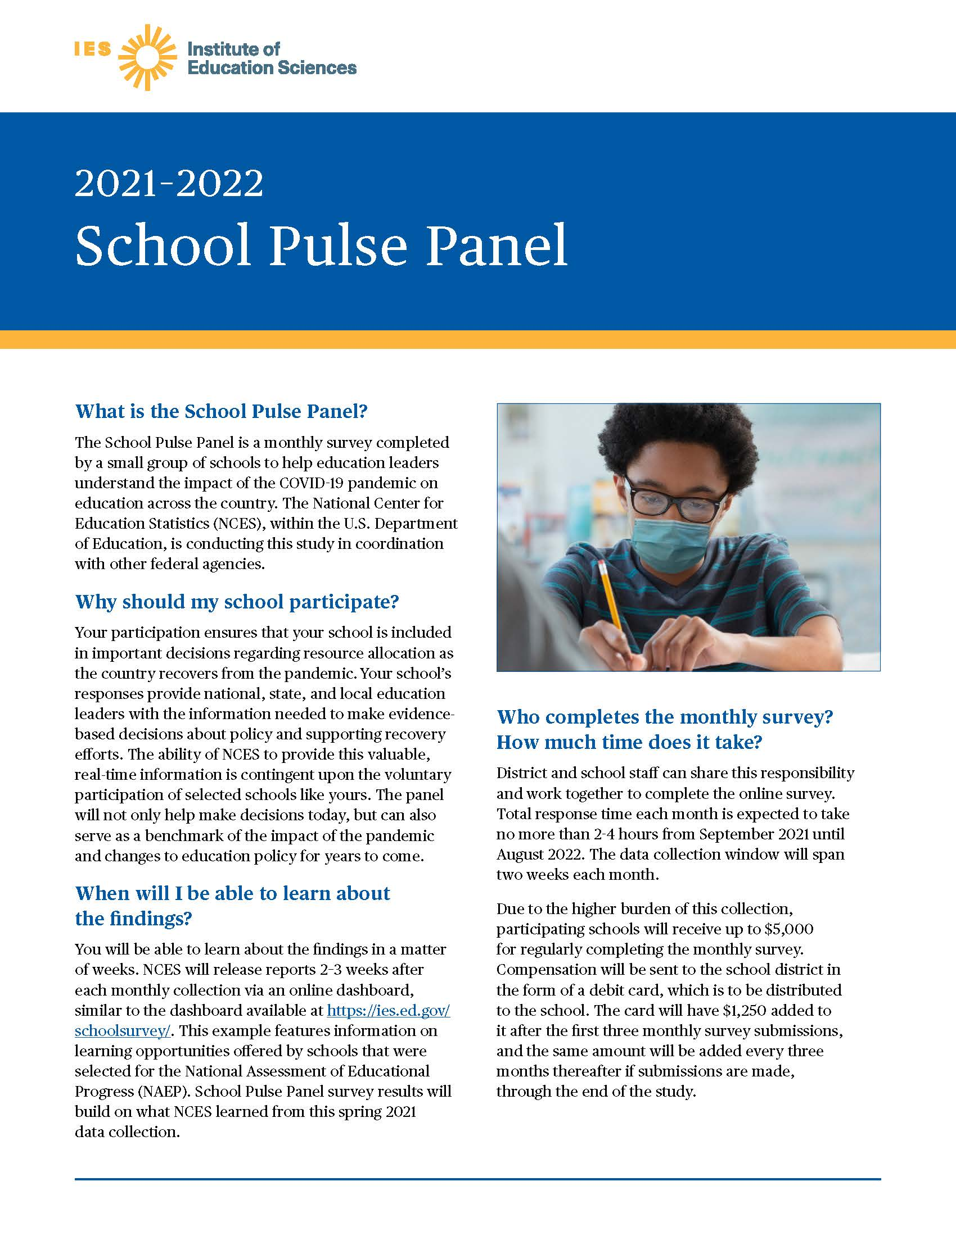
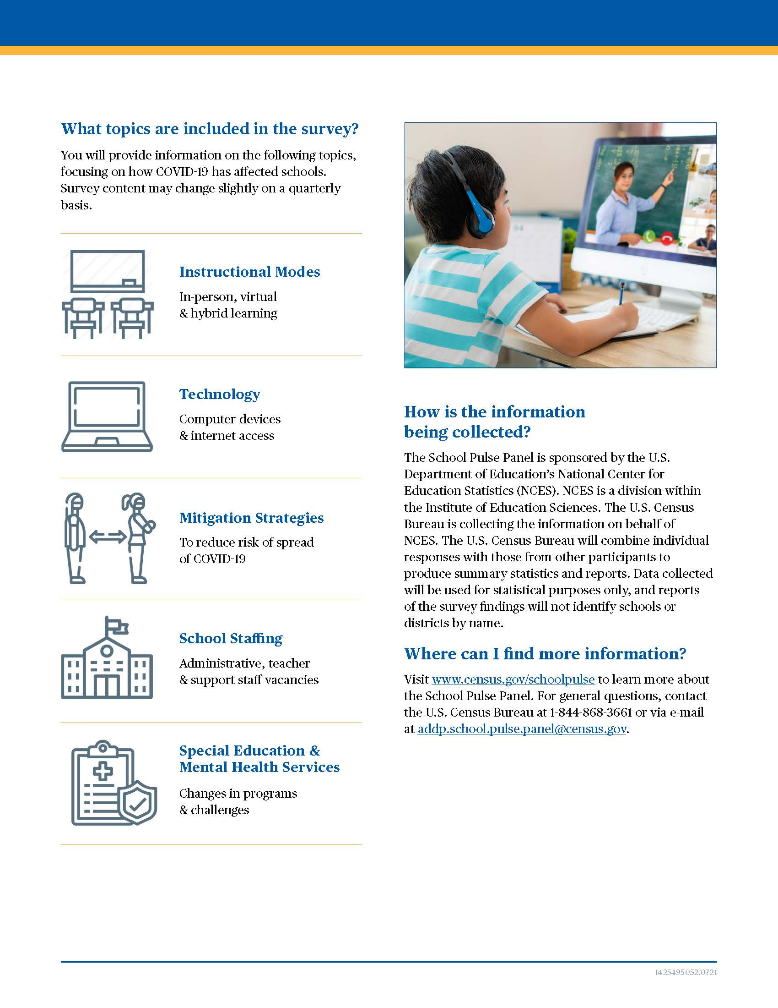

Web Instrument Log-in Screenshot

Note: These pages will be updated upon complete of user acceptance testing of the instrument which is happening now. The text will remain the same, with the following exceptions:
- The time estimate for the information collection will be updated to 2-3 hours
- The OMB control number and expiry date will be updated upon emergency clearance

