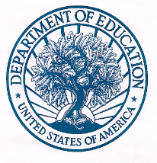
UNITED STATES DEPARTMENT OF EDUCATION

Dear Comprehensive Center Director,
I am writing to request your assistance with the Congressionally mandated study we are conducting pertaining to the implementation of the Comprehensive Centers program. In partnership with (contractor), we are collecting surveys/interviews of Comprehensive Centers grantees and their stakeholders to understand the implementation of the program from 2019-present.
Attached to this letter, you will find an email from (contractor) asking you to participate in a survey/interview in May 2022. The purpose of the study is to provide the Institute of Education Sciences (IES) of the U.S. Department of Education with information about assistance and services your Center offers, challenges and successes in implementing your program, technical assistance recipients you serve, and your partnership with your Regional Educational Laboratory. Findings will help IES improve the program and identify commonly used strategies.
Thank you for your cooperation with this effort. If you have any questions about the study, please contact Allan Porowski, study director, at (e-mail address) or (phone).

Sincerely,
[Insert Danielle’s electronic signature and title here]

U.S. Department of Education

Cc: Comprehensive Center Technical Assistance recipient
Regional Educational Laboratory Director

