Middle Grades Longitudinal Study of 2017-18 (MGLS:2017) Main Study First Follow-up (MS2) Data Collection

OMB# 1850-0911 v.26

Appendices A-S
Contact Materials

Appendices MS2-A1 through MS2-C8
and MS2B-A through MS2B-S2

National Center for Education Statistics
U.S. Department of Education
Institute of Education Sciences
Washington, DC

August 2019
revised March 2020

Legend:

MS2 MGLS:2017 Main Study First Follow-up
MS2 prefix material to be used across all stages of MS2
MS2B prefix materials to be used during the fall 2019 MS2 tracking and recruitment activities

Table of Contents
Contents

Appendix MS2-A1. MGLS:2017 Brochure Text and Flyer, “Quick Facts about MGLS:2017” (formerly Appendix MS1-H; approved) 4
Appendix MS2-A2. “Quick Facts about MGLS:2017” – Spanish Translation (formerly Appendix MS1-H1) 6
Appendix MS2-B1. MGLS:2017 Recruitment Website Text (formerly MS1-J1; approved) 7
Appendix MS2-C1. Summary of Mathematics Assessment (formerly Appendix MS1-K; approved) 17
Appendix MS2-C2. Summary of Reading Assessment (formerly Appendix MS1-K; approved) 18
Appendix MS2-C3. Summary of Executive Function Assessments (formerly Appendix MS1-M; approved) 19
Appendix MS2-C4. Summary of Student Survey (formerly Appendix MS1-N; approved) 20
Appendix MS2-C5. Summary of Parent Survey (formerly Appendix MS1-O; approved) 21
Appendix MS2-C6. Summary of Mathematics Teacher Survey (formerly Appendix MS1-P; approved) 22
Appendix MS2-C7. Summary of Special Education Teacher Survey (formerly Appendix MS1-Q; approved) 23
Appendix MS2-C8. Summary of School Administrator Survey (formerly Appendix MS1-R; approved) 24
Appendix MS2B-A. MGLS:2017 Base Year School Letter (approved) 25
Appendix MS2B-B. MGLS:2017 Enrollment Update Instructions (approved) 26
Appendix MS2B-C. MGLS:2017 Enrollment Update Form (approved) 27
Appendix MS2B-D. MGLS:2017 Reminder Email for Enrollment Update (approved) 28
Appendix MS2B-E. MGLS:2017 District Letter: Newly Identified Schools in Study District (Destination & Transfer; approved) 29
Appendix MS2B-F. MGLS:2017 District Letter: Newly Identified Schools in Non-Study District (Destination) that have four or more students (approved) 31
Appendix MS2B-G. MGLS:2017 School Letter: Newly Identified Schools (Destination - four or more students; approved) 33
Appendix MS2B-G1. MGLS:2017 School Letter: Newly Identified Schools (Transfer - fewer than four students; approved) 34
Appendix MS2B-H1. District Notification and Recruitment Letter (Augmentation School; approved) 35
Appendix MS2B-H2. District Notification and Recruitment Letter (Base Year NonParticipating School; approved) 36
Appendix MS2B-I1. School Recruitment Letter (Augmentation School; approved) 38
Appendix MS2B-I2. School Recruitment Letter (Base Year NonParticipating School; approved) 39
Appendix MS2B-J. MGLS:2017 Student Rostering Materials (Augmentation & Base Year Nonparticipating Schools; approved) 40
Appendix MS2B-K. MGLS:2017 School FAQs Text (approved) 42
Appendix MS2B-L. MGLS:2017 Study Announcement: Letter to Parents from Schools (approved) 45
Appendix MS2B-M. MGLS:2017 Panel Maintenance Letter (approved) 46
Appendix MS2B-N. MGLS:2017 Panel Maintenance Email (approved) 47
Appendix MS2B-O. MGLS:2017 Panel Maintenance Webpage Contents (approved) 48
(The information provided to respondents on the login screen is shown in Appendix MS2-B1) 48
Appendix MS2B-P. MGLS:2017 Panel Maintenance Hardcopy (approved) 50
Appendix MS2B-Q1. Parent Permission Letter – Implicit (modified) 52
Appendix MS2B-Q1a. Parent Permission Letter – Implicit – Spanish (modified) 54
Appendix MS2B-Q2. Parent Permission Letter – Explicit (modified) 57
Appendix MS2B-Q2a. Flyer – Explicit (approved) 59
Appendix MS2B-Q2b. Parent Permission Letter – Explicit – Spanish (modified) 60
Appendix MS2B-Q3. Parent Notification Letter (modified) 62
Appendix MS2B-Q3a. Parent Notification Letter – Spanish (modified) 63
Appendix MS2B-Q4. School Coordinator Letter (sent with parent letter/permission forms mailing) (approved) 65
Appendix MS2B-Q5. SC Responsibility Checklist (approved) 66
Appendix MS2B-Q6. Student Assent Form (approved) 67
Appendix MS2B-Q7a. In-School Student Video Script (approved) 68
Appendix MS2B-Q7b. Out-of-School Student Instructions (approved) 69
Appendix MS2B-Q8. MGLS:2017 School Thank You Letter (approved) 71
Appendix MS2B-R1. Parent and Out-of-School Student Data Collection – Parent Letter Initial (modified) 72
Appendix MS2B-R1a. Parent and Out-of-School Student Data Collection – Parent Letter Initial – Spanish (modified) 74
Appendix MS2B-R2. Parent and Out-of-School Student Data Collection – Reminder (modified) 76
Appendix MS2B-R3. Out-of-school Data Collection – Student Letter (modified) 78
Appendix MS2B-R4. Out-of-school Data Collection – Student Letter Reminder (modified) 79
Appendix MS2B-R5. Hybrid Out-of-School Data Collection – Student Postcard (modified) 80
Appendix MS2B-R6. Hybrid Out-of-school Data Collection – Student Letter (modified) 81
Appendix MS2B-R7. Hybrid Out-of-school Data Collection – Student Letter Reminder (modified) 82
Appendix MS2B-R8a. Parent Data Collection – Additional Reminder Letter (approved) 83
Appendix MS2B-R8b. Parent Data Collection – Reminder Postcard (approved) 84
Appendix MS2B-R8c. Parent Data Collection – Abbreviated Survey Postcard (approved) 86
Appendix MS2B-R8c1. Parent Data Collection – Abbreviated Survey Postcard – Spanish (approved) 88
Appendix MS2B-R8d. Parent Data Collection – Mini Survey Letter (approved) 90
Appendix MS2B-R8d1. Parent Data Collection – Mini Survey Letter – Spanish (approved) 91
Appendix MS2B-R8e. Parent Data Collection – Final Reminder Letter (approved) 92
Appendix MS2B-R8f. MGLS:2017 Parent FAQs Text – In-School Participation (approved) 93
Appendix MS2B-R8f1. MGLS:2017 Parent FAQs Text – In-School Participation – Spanish (approved) 95
Appendix MS2B-R8g. MGLS:2017 Parent FAQs Text – Out-of-School Participation (modified) 97
Appendix MS2B-R8g1. MGLS:2017 Parent FAQs Text – Out-of-School Participation – Spanish (modified) 99
Appendix MS2B-R9. Out-of-School Data Collection: Sorry I Missed You Card (approved) 101
Appendix MS2B-R10. Out-of-School Data collection: Incentive Receipt (approved) 102
Appendix MS2B-S1a. Staff Data Collection Letters – Administrator (approved) 103
Appendix MS2B-S1b. Staff Data Collection Letters – Teacher (approved) 104
Appendix MS2B-S2. Teacher Reminder Postcard (approved) 105

Appendix MS2-A1. MGLS:2017 Brochure Text and Flyer, “Quick Facts about MGLS:2017” (formerly Appendix MS1-H; approved)
MGLS:2017 Brochure Text – Main Study

COVER
Middle Grades Longitudinal Study of 2017-18 (MGLS:2017)
Education quote: “Education is not preparation for life; education is life itself." ~John Dewey
Study conducted by: National Center for Education Statistics of U.S. Department of Education
Data collection by: RTI International

INTERIOR
The Study
The Middle Grades Longitudinal Study of 2017-18 (MGLS:2017) will be the first study to follow a nationally-representative sample of students as they enter and move through the middle grades (grades 6 and 8).

MGLS:2017
The Middle Grades Longitudinal Study of 2017-2018 (MGLS:2017) will follow a cohort of students as they progress through the middle grade years, making the transition from elementary school and preparing for the transition into high school. The goals of the study are to assess students’ mathematics and reading skills, their other (noncognitive) skills important to learning, their socioemotional well-being, and to collect from the students, their families, and their schools data on family and school factors that may encourage success during these important years of education.

Your Participation
As part of the MGLS:2017, you are one of approximately 800 schools, about 20,000 students, or about 3,600 teachers selected to participate across the United States. MGLS:2017 will be conducted in early 2018. Your participation is essential to the success of the study.

What Will Be Included?
- Mathematics and reading skills
- Executive function development
- Socioemotional wellbeing
- Peer experiences
- Classroom characteristics and students’ learning
- Services to students with disabilities
- Family characteristics and students’ success

BACK
For More Information
If you have questions about MGLS:2017 or would like more information, please contact the study. Its success depends on you!
Phone number: 855-500-1432
E-mail address: mgls@rti.org
Website: https://surveys.nces.ed.gov/MGLS/

MGLS:2017 Flyer Text – Main Study

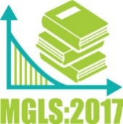
Quick Facts about the
Middle Grades Longitudinal Study of 2017-18
(MGLS:2017)

- MGLS:2017 is a research study that will help educators, policymakers, and researchers learn about growth in math and reading as well as family and school factors that encourage success during the important, yet generally understudied, middle grade years.
- The study is longitudinal and follows a cohort of students from grade six through eight to fully understand the student middle grade experience.
- The MGLS:2017 student sessions will involve up to 40 randomly selected students at a given school and will take about 90 minutes to complete.
- Students will provide data to the study through answering math and reading questions and playing executive function “brain games” along with some survey questions. These items are different from the standardized tests administered to students by states and school districts.
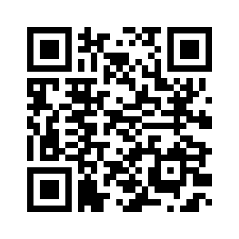
- Participation of each selected student is very important to the study but is not required.
- This is not a high stakes test! Students’ responses will not be reported to schools and do not affect student grades. They do however contribute to an understanding of middle grades students and can help in the planning of better educational services for them.
Scan MGLS:2017 QR code
HERE for more information

Appendix MS2-A2. “Quick Facts about MGLS:2017” – Spanish Translation (formerly Appendix MS1-H1)
Datos Breves sobre
el Estudio Longitudinal de los Grados Intermedios de 2017-18
(MGLS:2017)

- MGLS:2017 es un estudio que les permitirá a los educadores, legisladores e investigadores conocer más sobre el desarrollo de las habilidades en matemáticas y lectura, así como también los factores familiares y escolares que pueden fomentar el éxito durante los importantes años escolares intermedios, generalmente poco estudiados.
- Es un estudio longitudinal y sigue a un mismo grupo de estudiantes desde que están en sexto grado hasta el octavo grado, para entender en su totalidad la experiencia del estudiante durante los grados intermedios.

- Las sesiones de evaluación de los estudiantes de MGLS:2017 se conformarán por un máximo de 40 estudiantes seleccionados al azar de una escuela determinada y tomarán 90 minutos completarlas.

- Los estudiantes proporcionarán datos al estudio respondiendo preguntas de matemáticas y lectura, y jugando juegos de función ejecutiva (“juegos de destreza mental”), junto con algunas preguntas de una encuesta. Estas actividades son diferentes a las pruebas estandarizadas administradas a los estudiantes por los estados y distritos escolares.

- La participación de cada estudiante seleccionado es muy importante para el estudio, pero no es obligatoria.
- ¡Esto no es una prueba con serias consecuencias! Las respuestas de los estudiantes no serán reportadas a las escuelas y por lo tanto no afectarán sus calificaciones. Pero, sin embargo, contribuyen a un mejor entendimiento de los estudiantes de los grados intermedios y pueden ayudar al momento de planificar mejores servicios educativos para ellos.
Escanee el Código QR MGLS:2017
aquí para mayor información

Appendix MS2-B1. MGLS:2017 Recruitment Website Text (formerly MS1-J1; approved)

The recruitment website is used to provide information to school district and school staff, parents, and the public about the study. The website also serves as a portal to securely upload student roster (Appendix MS2B-J) and enrollment status information (Appendix MS2B-B), provide address updates for panel maintenance (Appendix MS2B-O), complete the parent questionnaire and out of school student session (Appendix MS2B-R1), and complete school staff questionnaires (Appendices MS2B-S1a and MS2B-S1b). A screenshot of the study homepage and several other pages in the website are provided here as examples. Additional content proposed for the Main Study recruitment and data collection website is reflected in the text provided in this appendix.

The study home page
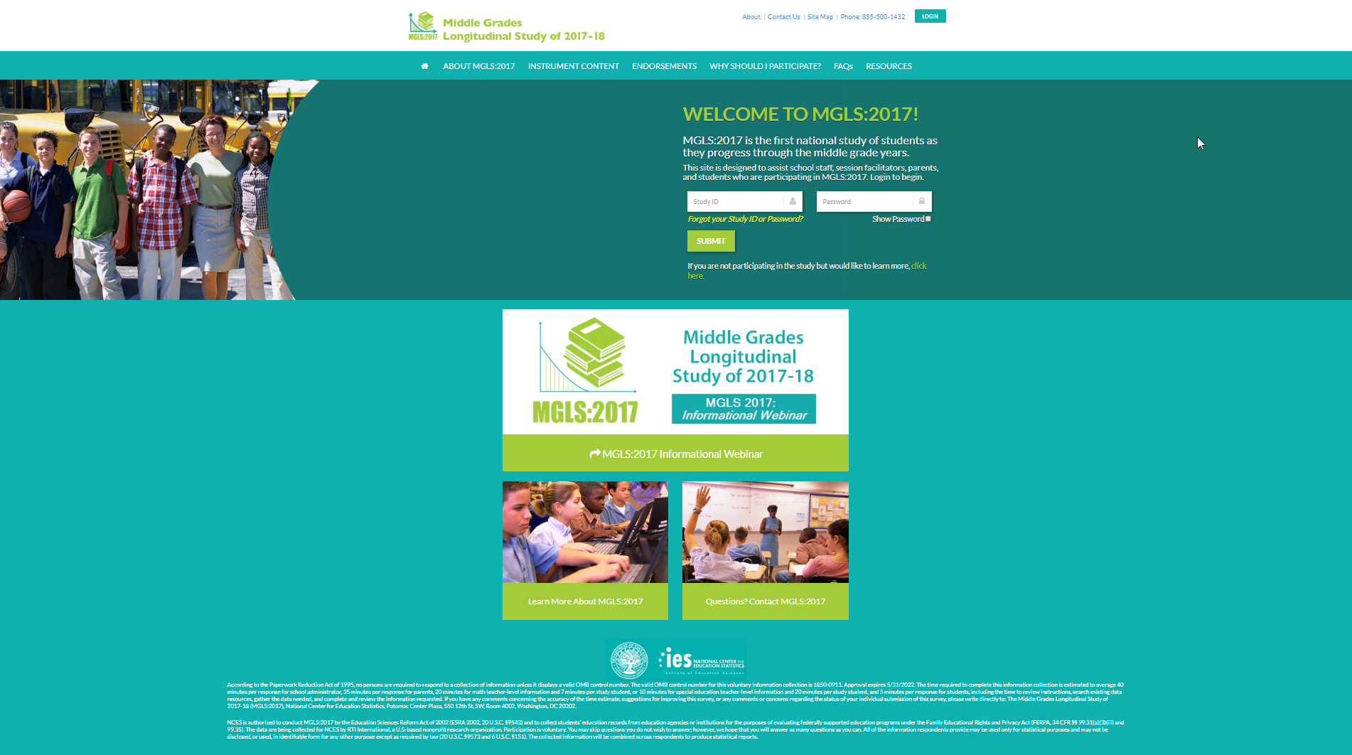

<MGLS:2017 study phone number will appear in header on every page>
<Login box will appear in header on every page><MGLS:2017 StudyID><Password>
Welcome to MGLS:2017! MGLS:2017 is the first national study of students as they progress through the middle grade years.
This site is designed to assist school staff, session facilitators, parents, and students who are participating in MGLS:2017. Login to begin.
If you are not participating in the study but would like to learn more, click here
Login <study id><password>
< link to Home page>
<link to About MGLS:2017>
<link to Content>
<link to Endorsements>
<Link to Why Should I Participate?>
<link to FAQs>
<link to Resources>
<link to Learn More About MGLS:2017 in footer>
<link to MGLS:2017 Brochure>
Questions? Contact MGLS <Study phone number> <study email address>
NCES is authorized to conduct the MGLS:2017 by the Education Sciences Reform Act of 2002 (ESRA 2002, 20 U.S.C. §9543), and to collect students’ education records from educational agencies or institutions for the purpose of evaluating federally supported education programs under the Family Educational Rights and Privacy Act (FERPA, 34 CFR §§ 99.31(a)(3)(iii) and 99.35). The data are being collected for NCES by RTI International, a U.S.-based nonprofit research organization. Participation is voluntary. You may skip questions you do not wish to answer; however, we hope that you will answer as many questions as you can. All of the information you provide may be used only for statistical purposes and may not be disclosed, or used, in identifiable form, for any other purpose except as required by law (20 U.S.C. §9573 and 6 U.S.C. §151). The collected information will be combined across respondents to produce statistical records.
According to the Paperwork Reduction Act of 1995, no persons are required to respond to a collection of information unless it displays a valid OMB control number. The valid OMB control number for this voluntary information collection is 1850-0911. Approval expires M/D/2022. The time required to complete this information collection is estimated to average 40 minutes per response for school administrator, 35 minutes per response for parents, 20 minutes for math teacher-level information and 7 minutes per study student, or 10 minutes for special education teacher-level information and 20 minutes per study student, and up to 90 minutes for students, including the time to review instructions, gather the data needed, and complete and review the information collection. If you have any comments concerning the accuracy of the time estimate, suggestions for improving this survey, or any comments or concerns regarding the status of your individual submission of this survey, please write directly to: The Middle Grades Longitudinal Study of 2017-18(MGLS:2017), National Center for Education Statistics, Potomac Center Plaza, 550 12th St., SW, Room 4002, Washington, DC 20202.

Please note: Above is a screenshot of the active website.
- The website will be updated so that the most recent legal language, as shown in the text above, is reflected.
- When the abbreviated instruments become available to respondents near the end of data collection as described in Part B, median burden estimates will be updated (School administrator: 20 minutes; Parent: 20 minutes).
- The OMB expiration date will be updated so that it always reflects the most recent expiration date.
- The burden estimate for students will be updated to 90 minutes.

About MGLS:2017

The Middle Grades Longitudinal Study of 2017-18 (MGLS:2017) is a new, unprecedented national study of middle grade students being conducted by the National Center for Education Statistics (NCES), part of the U.S. Department of Education. RTI International is carrying out the MGLS:2017 data collection on behalf of NCES.
MGLS:2017 will gather information about the development and learning that occur during students’ middle-grade years, or grades 6 through 8. In particular, it will identify school, individual, social, and contextual factors that predict future student success.
Sample and Data Collection Schedule:

The Operational Field Test occurred in early 2017 with a sample of about 1,200 students in sixth grade from about 50 schools. Follow-up data collections occurred in the spring of 2018, when most students were in the seventh grade.

The Main Study took place in the spring of 2018 and a sample of about 17,000 students in sixth grade from about 570 schools participated. A planned follow-up with students, parents, and school staff will occur in the spring of 2020. In preparation for the 2019-20 follow-up, the study will sample additional schools and eighth-grade students to ensure the study results are nationally representative. Administrative records may be collected in fall 2021.
What is involved for participants of MGLS:2017?

What is involved for students? Students will complete a math and reading assessment and complete two computerized games to assess executive function skills, or skills that help a person to organize and act on information. Students will also provide height and weight measurements and complete a student survey. The student session will take approximately 90 minutes and will be completed in schools on Chromebooks, tablet-like computers with touchscreen capability and an attached keyboard.
What is involved for school administrators? School administrators will be asked to complete the approximately 40-minute school administrator web-based survey about the school and the school environment.
What is involved for math teachers? Math teachers of students selected for the study will complete the math teacher survey about their background and classroom characteristics (approximately 20 minutes), as well as answer questions about the skills and abilities of specific students in the study (about 7 minutes per student).
What is involved for special education teachers? Special education teachers/providers for students selected to participate in the study with an Individualized Education Program (IEP) will be asked to complete the special education teacher survey about their background and special education services provided (about 10 minutes), as well as answer questions about the skills and abilities of specific students in the study (approximately 20 minutes per student).
What is involved for parents? Parents of each sampled student will complete the parent survey or a telephone interview. The questionnaire will take about 35 minutes to complete.
What is the purpose of the MGLS:2017?

MGLS:2017 will help researchers and policymakers learn about student growth in math and reading as well as family and school factors that encourage success during the important, yet generally understudied, middle grade years.
How Will the Data be Used?
MGLS:2017 data, which will be available to the public, will allow researchers, educators, policymakers and members of the public to examine student development and achievement through this important stage of students’ education career. More generally, MGLS:2017 data will allow researchers to examine family and schooling factors related to students’ achievement. The study will capture changes in young people’s lives and their connections with communities, schools, teachers, families, parents, and peers, including:
- Academic (especially in math and reading), social, and interpersonal growth;
- Transitions from elementary school and preparations for transitions into high school;
- School connectedness, belongingness, and engagement;
- Characteristics of schools and their relationship to student outcomes; and
- School support of students with disabilities, and outcomes for those students.
Organizations Conducting and Collecting MGLS:2017 Data:
MGLS:2017 is conducted by the National Center for Education Statistics (NCES), the primary federal statistical agency for collecting and analyzing data related to education in the United States. NCES is part of the Institute of Education Sciences of the U.S. Department of Education. NCES is authorized to conduct MGLS:2017 by the Education Sciences Reform Act of 2002 (ESRA 2002, 20 U.S.C. §9543) and to collect students’ education records from education agencies or institutions for the purposes of evaluating federally supported education programs under the Family Educational Rights and Privacy Act (FERPA, 34 CFR §§ 99.31(a)(3)(iii) and 99.35).
The data are being collected for NCES by RTI International, a U.S.-based nonprofit research organization.
Confidentiality:
The Middle Grades Longitudinal Study of 2017-18 (MGLS:2017) is conducted by the National Center for Education Statistics (NCES). Under contract with NCES, RTI International, a U.S.-based nonprofit research organization, administers MGLS:2017 on behalf of NCES. NCES is authorized to conduct MGLS:2017 by the Education Sciences Reform Act of 2002 (ESRA 2002, 20 U.S.C. §9543) and to collect students’ education records from education agencies and institutions for the purposes of evaluating federally supported education programs under the Family Educational Rights and Privacy Act (FERPA, 34 CFR §§ 99.31(a)(3)(iii) and 99.35). All of the information you provide may be used only for statistical purposes and may not be disclosed, or used, in identifiable form for any other purpose except as required by law (20 U.S.C. §9573 and 6 U.S.C. §151).
All RTI project staff have signed confidentiality agreements and affidavits of nondisclosure and are prohibited by law from using the obtained information for any purposes other than this research study.
You may review the Confidentiality Agreements and Affidavit of Nondisclosure statements (pdf, 81KB) that are signed by project staff.

Instrument Content:
A key goal of the study is to provide researchers and policymakers with the information they need to better understand the school and non-school influences associated with mathematics and reading success, socioemotional health, and positive life development during the middle-grade years and beyond.

Select an instrument to learn more about its content
< A graphic box will be displayed listing each instrument. Clicking on the box brings up the content page, which is found in appendix MS1-K to R.>

Endorsements
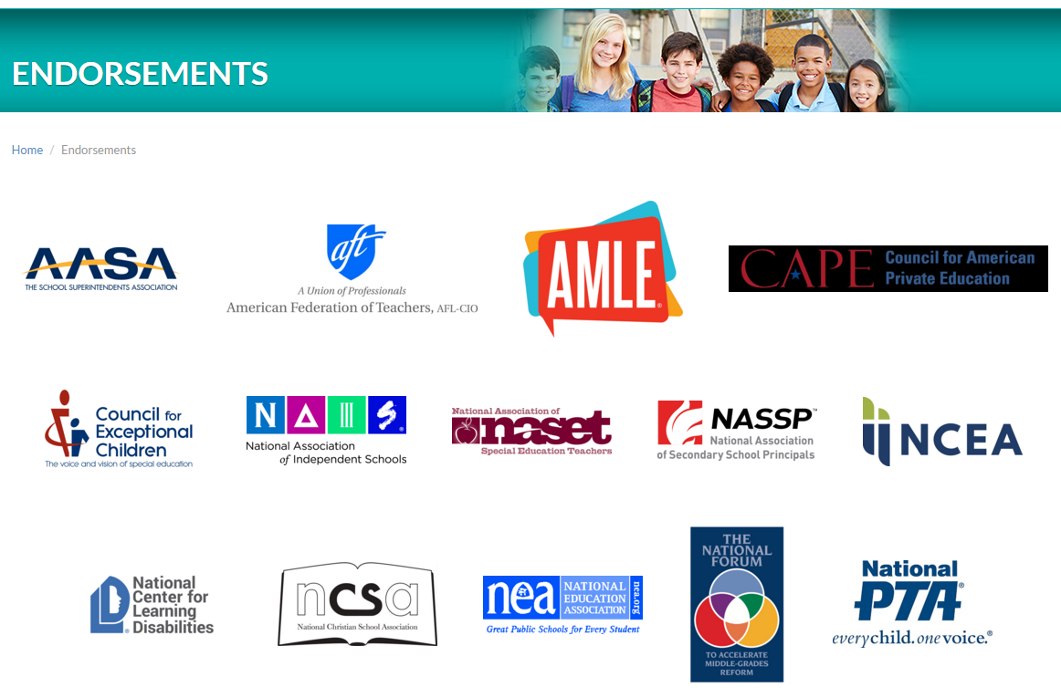
Why Should I Participate?
You are uniquely positioned to provide the much-needed information integral to the success of this comprehensive study of students as they enter and move through the middle grades. The study’s success hinges on being able to provide crucial national information on these students’ learning and contexts for development. Your participation will help ensure the study captures the diverse and unique experiences of students as they progress across the middle grade years.

Schools provide essential information on contexts for learning.

Teachers (mathematics teachers and special education teachers/providers) have the opportunity to provide crucial information about instructional practices, planning, classroom characteristics, classroom climate, as well as individualized information about their students in the study in terms of social skills, classroom behaviors, and learning supports.

Parents contribute vital information on the home learning environment, students’ school experiences, their own involvement in their child’s learning, and characteristics about the household.

Students will have the opportunity to let us know about their school experiences, activities, and their educational aspirations. To contribute to the understanding of learning and development across the middle grade years, the study also collects invaluable information about students’ reading, math, and executive function, which includes skills that help them organize and act on information.
Frequently Asked Questions
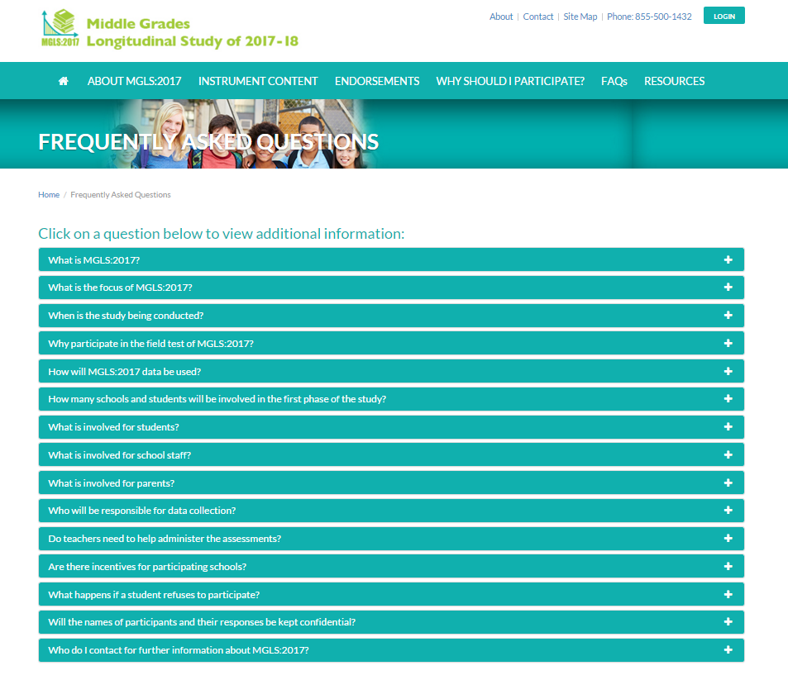
<Frequently Asked Questions: The FAQ text is provided in Appendix MS2B-K.>

Resources
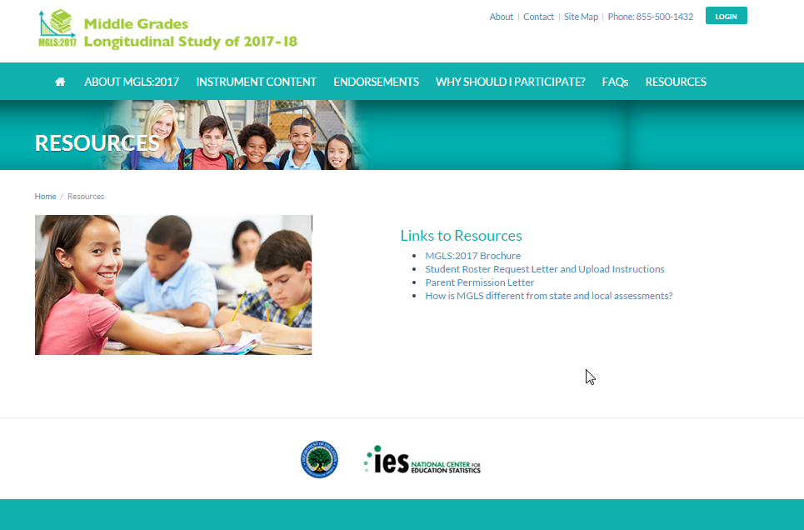

<The resources page provides links to files in Appendices MS2B-I, MS2B-J (with upload instructions on the next page), and MS2B-Q.>

Contact
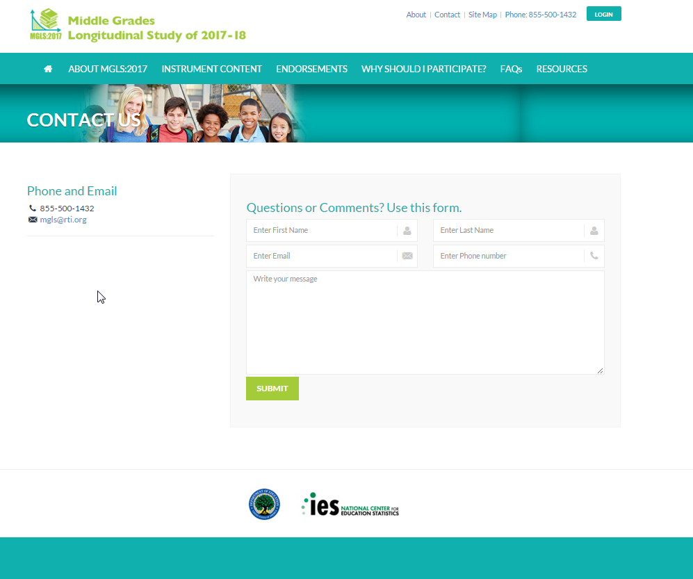

Main Study text
Questions or Comments? Use this form.
MGLS:2017- after login
Student Roster Upload (Augmentation Schools)
Welcome!
Your participation in the Middle Grades Longitudinal Study of 2017-18 is very important.
MGLS:2017 data will allow researchers, educators, and policymakers to examine family and educational factors related to students’ achievement. Please complete the tasks in the list below with a green arrow next to them. You will receive $50 for completing this activity and another $100 after all data collection activities for the school year are completed.
Request for Initial Roster – Step 1

Thank you for providing your school’s student roster. If you need assistance, please contact the Help Desk at 1-855-500-1432 or mgls@rti.org. Please complete the following steps:
- Provide your contact information <name>, <e-mail address>, <telephone number>, <school name>
- Download the Student Roster Template
  - Save the Student Roster Template on your computer
- Prepare the Student Roster Template
  - List all students in Grade 8
  - For each student, please enter the following information:
Student information
    - District/School Student ID number
    - Student’s name (First, Middle, Last, Suffix)
    - Grade
    - Date of birth (MM/DD/YY)
    - Sex (M/F)
    - Race/ethnicity
    - ELL Status
  - Please use the corresponding “Upload” button to upload the completed Student Roster Template
- Finalize Student Roster Template
  - Once steps 1 through 4 above have been completed, please click the button below to finalize your school’s Student Roster Template.

Student Sample and Request for Additional Information – Step 2

Stage 1 – Review your school’s list of sampled students
Please review the sampled student list and, if any information is missing and/or in need of correction, proceed to “Stage 2” below, otherwise proceed to “Stage 3.”

Stage 2 – Update student information
If any information associated with your sampled students was noticed to be incomplete (such as missing date of birth) and/or an error in “stage 1”, please follow the steps below.
- Download list of Sampled Students (Excel spreadsheet file)
  - Save the template on your computer
- Prepare Sampled Student File (downloaded in Step 1)
  - For each sampled student, add any missing information (parent contacts, teacher information, etc.)
- Upload the completed Sampled Student File
  - Please use the corresponding “Upload” button to upload the completed template.
- Finalize Sampled Student Template
  - Once steps 1 through 3 above have been completed, please click the “Finalize” button below to finalize your school’s Sampled Student Template.
Stage 3 – Provide additional information for sampled students
Below are instructions for providing the parent contact information and student math and special education teacher/provider information after the student sample has been selected if you are unable to provide this information for the entire student enrollment list. Please note, this action can only be completed after the student enrollment list has been uploaded and you have been notified that the student sample has been selected at your school.
- Click on the link “Additional Information” to download an Excel spreadsheet.
- Save the Excel spreadsheet to your computer.
- Student information will be pre-filled for all students selected to participate in MGLS:2017.
- Prepare your document containing the requested information:
  - Student enrollment status in 2017-18
- Student was enrolled in grade 6 at this school: Y/N
  - For all students who were enrolled in grade 6 at this school, please provide the following:
- Parent contact information
- Parent’s name (first and last name)
- Parent’s mailing address (street, city, state, zip)
- Parent’s email address
- Parent’s home phone number
- Parent’s cell phone number
  - Math/Special Education Teacher/Provider Information (associated with each student)
- Student’s math teacher (first and last name)
- Student’s math teacher’s email address
- Student’s math course name
- Student’s math course period/section
- Student’s special education teacher/provider (first and last name, if applicable)
- Student’s special education teacher’s/provider’s email address (if applicable)
- When you have added all of the requested enrollment status, parent, and teacher information to the Excel spreadsheet, go to the file menu in Excel and click save.
- Go back to the MGLS:2017 website and click the corresponding BROWSE button.
- Find the location where you saved the Excel spreadsheet containing the student information and click open. This will automatically start the upload process.
- When a completed file has been uploaded, click the FINALIZE button at the bottom of the webpage.
- Call 855-500-1432 if you need assistance.
Conditional screen for users attempting to upload using the Chrome browser:
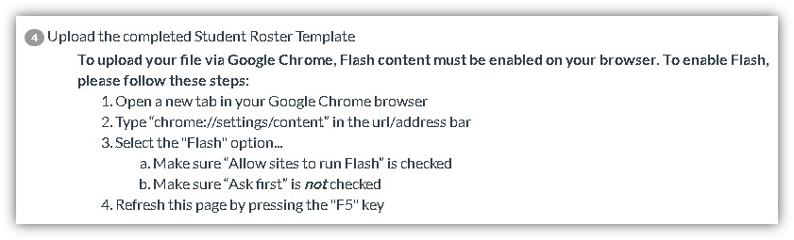

Appendix MS2-C1. Summary of Mathematics Assessment (formerly Appendix MS1-K; approved)

 | Direct Mathematics Assessment
Approximate length  Goal for Main Study | 30 minutes (part of 90-minute student session)
Mode of administration | Computerized administration using Chromebooks, tablet-like computers with touchscreen capability and an attached keyboard, that will be brought in to the school by the study
Key constructs (bullets represent learning progression) | Number System  - finding common factors and multiples  - comparing fractions  - applying basic operations with fractions and integers to word problems  - using basic operations  - representing and understanding rational numbers in multiple forms  - understanding the relative size of irrational numbers  Proportional Relationships  - extending students’ understanding of the number system  - multiplying and dividing fractions and multiplicative thinking  - understanding basic concepts of ratio, rate and proportional relationships  - using rational numbers to solve problems and understand slope and functions  Expressions and Equations  - understanding the use of expressions beginning with letter representations of a single number  - applying knowledge of rational numbers and operations to solve equations  - constructing equations and inequalities to solve real-world problems  - recognizing different types of notation (such as square root)  - reasoning with equalities and inequalities  - solving and representing linear equations and inequalities  Functions  - understanding the definition of a function  - comparing functions represented in different ways  - distinguishing between linear and nonlinear functions  - comparing and creating representations of different functions  - understanding of functions to context

Appendix MS2-C2. Summary of Reading Assessment (formerly Appendix MS1-K; approved)
 | Direct Reading Assessment
Approximate length  Goal for Main Study | 25 minutes (part of 90-minute student session)
Mode of administration | Two-stage, computerized assessment using Chromebooks, tablet-like computers with touchscreen capability and an attached keyboard, that will be brought in to the school by the study
Key constructs | Word Recognition & Decoding  Students read words (e.g., elect), pronounceable nonwords (e.g., clort) and pseudohomophones (e.g., brane) and decide whether the stimulus is a word, not a real word, or sounds exactly like a real word.  Vocabulary  A single target word is presented and the student decides which of provided three words goes with the target word. Correct answers are either synonyms (e.g., data - information) or meaning associates (e.g., thermal - heat).  Morphological Awareness  The student completes a sentence by choosing from three words derived from the same root word (e.g., She is good at many sports, but her _______ is basketball: specialty, specialize, specialist). The target words vary in difficulty based on the frequency of the derived forms (i.e., lower frequency derivations are more difficult).  Sentence Processing  The student completes sentences of increasing length and syntactic complexity by choosing from three choices (e.g., Shouting in a voice louder than her friend Cindy's, Tonya asked Joe to unlock the door, but ______ didn’t respond: he, she, they). In this task, frequent words used in everyday language are used in the sentences to decrease the influence of vocabulary knowledge in this task. Consequently, the focus is on understanding of sentence syntax and meaning (rather than word meaning).  Efficiency of Basic Reading Comprehension (MAZE task)  Students read short passages containing sentences that are completed using a forced-choice cloze task (e.g., Agriculture meant that people stayed in one place to grow their baskets / crops / rings.). These passages are between 250-300 words in length and have Flesch-Kinkaid Grade Level estimates of grades 6 and 7. Students in this block will read approximately 3 paragraphs in this way. This task is timed such that students are given 3 minutes to complete a passage and its corresponding items, making it a measure of efficiency as well as basic comprehension.  Reading Comprehension  Students answer questions about the passage they read while doing the MAZE task. The passage presented in the MAZE task will be presented again with the correct completions for the items presented in the MAZE task. The passage will appear on the same screen as the questions. Easier questions will be selected for this skill-based block.

Appendix MS2-C3. Summary of Executive Function Assessments (formerly Appendix MS1-M; approved)

 | Direct Executive Function Assessment
Approximate length  Goal for Main Study | 10 minutes, 2 measures (part of 90-minute student session)
Mode of administration | Computerized administration using Chromebooks, tablet-like computers with touchscreen capability and an attached keyboard, that will be brought in to the school by the study
Key constructs | Working memory (N-back task)  Working memory is considered a strong measure of reasoning ability and involves keeping information active in primary memory while acting on it in relation to other information, such as keeping a list of words in memory and then ordering the words alphabetically or by categories. The n-back tasks are measures of working memory often used in research, particularly in neuroscience studies that look at the regions of the brain activated by different types of working memory (that is memory for verbal, symbolic, and spatial information).  Cognitive flexibility (Hearts and Flowers task)  Shifting involves flexibility in thinking and moving between rules, tasks, or mental states. With shifting, each mental set may involve several task rules. Several regions of the brain (cortex and the prefrontal cortex) show increased activation when participants respond to measures of shifting. The Hearts and Flowers task (Dots task) includes a congruent condition, an incongruent condition, and a mixed condition. The task calls on working memory and inhibitory control as students remember the rule and decide whether to inhibit a prepotent response. The mixed condition measures shifting (or cognitive flexibility) as the task shifts between the congruent and incongruent condition.  Inhibitory control (Hearts and Flowers task)  Involves the ability to stop ongoing thoughts or actions, particularly prepotent responses. Development of inhibitory control occurs rapidly in early childhood and advances more slowly during adolescence. The Hearts and Flowers task provides information on inhibitory control (in addition to cognitive flexibility or shifting) in the incongruent condition.

Appendix MS2-C4. Summary of Student Survey (formerly Appendix MS1-N; approved)

 | Student Survey
Approximate length  Goal for Main Study | 20 minutes (part of 90-minute student session)
Mode of administration | Computerized administration using Chromebooks, tablet-like computers with touchscreen capability and an attached keyboard, that will be brought in to the school by the study
Key constructs | Demographics  School experiences  - Student perspective of teacher support  - Perceptions of school climate (e.g., safety and rule fairness)  - Academic culture (e.g., high standards and expectations)  - Problems at school (e.g., student misconduct and bullying)  Activities  - Time use-structured activities: student employment; participating in activities (sports, clubs, etc.)  - Time use-unstructured or unsupervised activities (e.g., watching television, doing homework, or being with friends)  - Technology activities  Health  - Physical well-being  Peers  - Perception of peer social support  - Peer victimization  - Perception of peer values (importance of education, engagement in risky behaviors, peer pressure)  - Belongingness (a sense of belonging in school)  - Risk-taking (students’ sensation seeking behaviors)  “Tell us about Yourself”  - Academic engagement (e.g., persistence)  - Identity formation (interests of students (“sparks”); ethnic identity; perceived social status)  - Socioemotional well-being  Home Life  - Parent-child relationships (autonomy-granting, disclosure)  - Community perspectives  Future  - Aspirations and expectations (educational, career/life goals)

Appendix MS2-C5. Summary of Parent Survey (formerly Appendix MS1-O; approved)

 | Parent Survey
Approximate length  Goal for Main Study | 35 minutes
Mode of administration | Web-based administration accessible by individualized link, with a telephone-based interview option available.
Key constructs | Introduction  - Student demographics  Family Roster  - Family demographics  - Household composition  Family and Parent Background  - Language (student uses most, family primary language)  - Parent education  Home Life  - Parent-child relationship—monitoring/disclosure  - Risk-taking and risky behaviors (i.e. students’ sensation seeking behaviors and parents’ report of students’ deviant behaviors)  - Community perspectives (poverty, crime, victimization)  Child’s School Experiences  - Parent contact/communication with school  - Disciplinary actions taken by school  - Grade progression (retention, early promotion)  - ESL participation  - Student free- and reduced-price lunch eligibility  Child Health and Well-Being  - Health and physical well-being  - IEP and Disability Details  Employment and Income  - Parent occupation  - Family income  - Family assets  Mobility  - Mobility (number of school changes)  Parent Involvement  - Conversation about math courses  - Conversation about going to college  - Conversation about jobs or careers  - Academic expectations

Appendix MS2-C6. Summary of Mathematics Teacher Survey (formerly Appendix MS1-P; approved)

 | Mathematics Teacher Survey
Approximate length  Goal for Main Study | 20 minutes for teacher background and classroom characteristics; 7minutes per student report
Mode of administration | Web-based administration accessible by individualized link.
Key constructs | Teacher background and classroom characteristics  Student and Classroom Characteristics  - Class size (number of students)  - Course type  - Heterogeneity in math ability  - Classroom climate (e.g., misbehavior)  Classroom Mathematics Instruction  - Curriculum used  - Opportunities to learn (length of course)  - Content covered in course (Common Core & practice standards)  - Instructional practice/pedagogy  - Availability and use of classroom resources  Views on Teaching and School Environment  - Instruction in self-contained classrooms or departmentalized  - Factors for determining math course (take a test, prerequisite)  - Teacher efficacy  - Instructional leadership  - Academic culture (high standards and expectations)  - Teaching climate  Teacher Background  - Education and degree (courses in math and math education)  - Years of experience  - Certification  - Demographic information  Teacher provided information on individual students  Mathematical Thinking  - Math class performance  Social Skills  - Approaches to learning  - Externalizing behaviors  - Social skills and positive behavior  Classroom Behaviors  - Academic engagement (behavioral and cognitive)  - Attendance  Student and Classroom Information  - Math support services (tutoring, pull-out, instruction frequency)

Appendix MS2-C7. Summary of Special Education Teacher Survey (formerly Appendix MS1-Q; approved)

 | Special Education Teacher/Provider Survey
Approximate length  Goal for Main Study | 10 minutes for background; 20 minutes per student report
Mode of administration | Web-based administration accessible by individualized link.
Key constructs | Teacher background  Teacher Assignment or Position  - Teaching Assignment or Position  - Instruction and instructional environment  Teacher Background and Education  - Demographic information  - Experiences and Training  Teacher Experience  - Years of experience  Teacher provided information on specific students  Student Grade and IEP Status  - Student Grade and IEP status  Student’s Disability and Services  - Primary disability  - Special education and related services  Student’s Instruction and Instructional Environment  - Instruction and instructional environment  Communication About Student  - Communication with general education teacher  Student Goals, Performance, and Expectations  - IEP goals and evaluation  - Teacher’s expectations for student  - Academic & life skills

Appendix MS2-C8. Summary of School Administrator Survey (formerly Appendix MS1-R; approved)

 | School Administrator Survey
Approximate length  Goal for Main Study | 40 minutes
Mode of administration | Web-based administration accessible by individualized link.
Key constructs | School Characteristics  - School characteristics (e.g., average daily attendance, tuition)  - Student population (e.g., percent IEP, percent ELL/LEP)  - Providing additional support for struggling students (tutoring, extra assistance, pull-out, homework assistance)  Services and Supports for Students with Disabilities  - IEP/Disability-School services and programs  School Programs and Practices  - Courses offered  - Subject-specific academic tracking practices (order/progression of courses)  - School extended learning opportunities: additional instruction time, Gifted and Talented, International Baccalaureate  - Assisting students with transitions from elementary to middle grades; from middle grades to high school  - Health services (e.g., sex education classes)  School Environment  - Problems at school: absenteeism, student mobility, student misconduct, bullying  - School-level security (police officer on site, security officer on site, teachers supervise hallways during transition)  - Community perspectives (poverty, crime, victimization)  School’s Teachers  - School’s teachers: number, preparation  School Administrator Background  - Demographic information  - Years of experience

Appendix MS2B-A. MGLS:2017 Base Year School Letter (approved)
<date>
Go to https://surveys.nces.ed.gov/mgls/
Select “Student Enrollment Form”
Enter your Study ID: <ID fill>
Enter your Password: <psswrd fill>

<List Provider name>
<school name>
<address>
<city> <state> <zip>

Dear <School Coordinator>:

Thank you for your school’s continued support for the Middle Grades Longitudinal Study of 2017-18 (MGLS:2017). Your principal has designated you as the School Coordinator for MGLS:2017, and you play an invaluable role in assisting with the study. Project staff will call you in the next several days to begin the logistical planning which includes setting a session date, location, and discussing any accommodations your students may need.
Please begin to verify the enrollment status of the students at your school who participated in MGLS:2017 during the 2017-18 school year. This may also include MGLS:2017 students that have recently transferred to your school. Because data collection will occur in winter/spring 2020, it is imperative that we maintain current enrollment records. Next steps:
- Read the instructions for completing the task included with this letter.
- Log into the study website by using your Study ID and Password located in the top right corner of this letter.
- Please complete this task via the study website within three weeks of receiving this letter.
If district/school policy allows, you will receive two incentive checks for your assistance in this vital research. You will receive $50 for completing this activity and another $100 after all data collection activities for the school year are completed. In addition, your school will receive a $400 check or $400 in goods/services for participating.
MGLS:2017 is a comprehensive longitudinal study that follows a cohort of students as they progress through the middle grade years, making the transition from elementary school and preparing for the transition into high school. MGLS:2017 data will allow researchers, educators, and policymakers to examine student development and achievement as well as family and school factors related to their success. MGLS:2017 is conducted by the National Center for Education Statistics (NCES) at the U.S. Department of Education and is being administered by RTI International on behalf of NCES.
We are grateful for your time and assistance, which are critical to the success of the study. If you have any questions, please contact the MGLS:2017 help desk at 855-500-1432 or by email at mgls@rti.org. Thank you for your continued support of MGLS:2017!

Sincerely,

Dan Pratt, Project Director

Enclosures:
Enrollment Status Instructions
Frequently Asked Questions (FAQs) sheet

NCES is authorized to conduct MGLS:2017 by the Education Sciences Reform Act of 2002 (ESRA 2002, 20 U.S.C. §9543) and to collect students’ education records from education agencies or institutions for the purposes of evaluating federally supported education programs under the Family Educational Rights and Privacy Act (FERPA, 34 CFR §§ 99.31(a)(3)(iii) and 99.35). The data are being collected for NCES by RTI International, a U.S.-based nonprofit research organization. All of the information schools provide may be used only for statistical purposes and may not be disclosed, or used, in identifiable form for any other purpose except as required by law (20 U.S.C. §9573 and 6 U.S.C. §151). The collected information will be combined across respondents to produce statistical reports.

Appendix MS2B-B. MGLS:2017 Enrollment Update Instructions (approved)
Instructions for Student Enrollment Verification
If you need assistance, please contact us at 1-855-500-1432 or mgls@rti.org

- Go to the MGLS:2017 website at https://surveys.nces.ed.gov/mgls/

- Enter your Study ID + Password (located on top right corner of your List Provider letter). You will be prompted to change your password the first time you log on.

- For added security, there is an additional 2-factor authentication step. After entering your Study ID and Password, a 6-digit code will be sent via email to the designated list provider we have on file.

- The 6-digit code is time sensitive and must be entered within 15 minutes into the verification code prompt box.

- Click on the link “Student Enrollment Update” which lists all students selected for MGLS:2017.

- Step 1: Review the list of students and select yes/no for whether they are still enrolled at your school and indicate their current grade. When you have completed this task for ALL students, press SUBMIT and you will receive a message that says ‘Success!’

- Step 2: You will see two lists: (1) Students currently enrolled, and (2) Students no longer enrolled. For each student click on the ‘Select’ button. Please fill out the ‘Student Detail Form’ for every student on both lists. You will be asked to provide the following:

Currently Enrolled Students:
Math teacher and special education teacher provider
Confirm or provide contact information for student and parent(s)
Address, phone, email

Students no longer enrolled:
Last date of attendance
Reason for leaving (select from dropdown menu)
If transfer, provide name/address of new school (if known)
Last known contact information for student/parent

- Click the ‘Update’ button when finished entering information for each student. You will receive the message: Success! The data you submitted has been saved.

- Complete this task for all students remaining on the lists. You will see ‘Updated’ in the status column for each student.

- You will receive $50 for completing this activity and another $100 after all data collection activities for the school year are completed.

Appendix MS2B-C. MGLS:2017 Enrollment Update Form (approved)
ENROLLMENT UPDATE FORM

 |  |  | If enrolled: |  |  | If no longer enrolled: |  |  |  |  |  | For all students
 |  |  |  |  |  |  | Reason for leaving school attended in spring 2018 | If transferred (Option A, B, C selected on previous question):
Student Name | Study ID | Still Enrolled? | Current Grade | Math teacher contact information and section | Special education teacher/provider contact information (If applicable) | Last Date of Attendance | A. Transferred to school inside district  B. Transferred to school outside district  C. Graduated and moved on to next grade level school in district  D. Early graduate  E. Home schooled  F. Other (please specify)  G. Don't know | Current School Name | Current School City | Current School State | Don't know | Student's Current/ Last Known Address | City | State | Zip | Student's Home Phone | Student's Cell Phone | Mother's Name | Mother's Address (if different from student) | Mother's Home Phone | Mother's Cell Phone | Mother's Email | Father's Name | Father's Address (if different from student) | Father's Home Phone | Father's Cell Phone | Father's Email

Appendix MS2B-D. MGLS:2017 Reminder Email for Enrollment Update (approved)
<<Sample Maintenance Enrollment Update Email, Group 1: Schools that have not changed their password or initiated the process yet>>

Dear <LIST PROVIDER/SCHOOL COORDINATOR>:
Select students from your school participated in the Middle Grades Longitudinal Study of 2017-18 (MGLS:2017) conducted by the National Center for Education Statistics (NCES), part of the U.S. Department of Education. We recently sent you a letter asking you to verify the current enrollment status of these students. You will receive $50 for your assistance. If you have already completed this information, we thank you! If not, please do so at your earliest convenience.
Please visit the website below and use the Study ID and Password provided to access the enrollment list. You will be prompted to change your password the first time you log in. For added security you will also receive a code via email to copy/paste into the verification code box. If you have any questions, please use the ‘Contact Us’ button on the website or call us at 855-500-1432.
https://surveys.nces.ed.gov/mgls/
Enter your Study ID: <ID fill>
Enter your Password: <psswrd fill>
Select “Student Enrollment Update”

Thank you in advance for your help with this important effort!

Dan Pratt
Project Director
Middle Grades Longitudinal Study of 2017-18
<<Sample Maintenance Enrollment Update Email, Group 2: Schools that have started to update the form, have changed their password, but have not “submitted” their updated form yet>>
Dear <LIST PROVIDER/SCHOOL COORDINATOR>
Our records indicate you have started the enrollment update task for students selected for the Middle Grades Longitudinal Study of 2017-2018 (MGLS:2017) conducted by the National Center for Education Statistics (NCES), part of the U.S. Department of Education. We thank you for beginning this update. You will receive $50 for your assistance.
Please go to our website at https://surveys.nces.ed.gov/mgls and log in with your Study ID <ID fill> and the password you created. Click on “Student Enrollment Update Form’ to resume the task. If you have any questions, please use the ‘Contact Us’ button on the website or call us at 855-500-1432. We greatly appreciate your continued support of this vital research. We look forward to working with your students and staff on this vital research.
Thank you in advance for your help with this important effort!

Dan Pratt
Project Director
Middle Grades Longitudinal Study of 2017-18

Appendix MS2B-E. MGLS:2017 District Letter: Newly Identified Schools in Study District (Destination & Transfer; approved)
«dist_contact_name»
The middle grades can be a time of turmoil or a time of triumph. We know that with all hands on deck our young adolescents can thrive.
https://blog.ed.gov/2011/11/middle-grades-matter/

«dist_entity_name»
«dist_address»
«dist_citystzip»

Dear «dist_contact_name»:

Thank you for your continued support of the Middle Grades Longitudinal Study of 2017-18 (MGLS:2017). Until now, middle grades have been noticeably absent from national studies, creating a gap in information needed to answer important questions pertaining to the growth of young adolescents and how we can impact their academic and social success. To meet this need, the National Center for Education Statistics (NCES), part of the U.S. Department of Education, is conducting MGLS:2017.
In preparation for the next round of MGLS:2017, we recently learned that «stuCnt» student(s) who were attending participating schools in your district during the 2017-18 school year are now attending other schools in your district. As a longitudinal study, the success of MGLS:2017 lies with the continued participation of all students initially selected for the study. The newly identified school(s) and the original participating schools are as follows:
<<School 1>> <<# students>>
<<School2>> <<# students>>

It’s possible that additional schools may be identified if other study students transfer within your district. <<IF 4 OR MORE STUDENTS: I am writing to notify you of our plans to contact the school(s) to confirm the student’s enrollment in the 2019-2020 school year and to discuss upcoming data collection. The data collection will occur on a date the school(s) select(s) between January and June of 2020 and administrative records may be collected in fall 2021.>> <<IF FEWER THAN 4 STUDENTS: I am writing to notify you of our plans to contact the school(s) to confirm the student’s enrollment and contact information in the 2019-2020 school year so that we may contact the student to participate outside of school. We will also request contact information for the school administrator and the math and special education teachers of participating students to complete a brief web survey. In addition, administrative records may be collected in fall 2021.>> <<IF HYBRID: I am writing to notify you of our plans to contact the school(s) to confirm these student’s enrollment in the 2019-2020 school year and to discuss upcoming plans. In the school(s) to which 4 or more students transferred, we will plan in school data collection that will occur on a date the school(s) select(s) between January and June of 2020. In the school(s) to which fewer than 4 students have transferred, we will confirm the student’s enrollment and current contact information so that we can contact students to participate outside of school. We will also request contact information for the school administrator and the math and special education teachers of participating students to complete a brief web survey. In addition, administrative records may be collected in fall 2021.>>

Benefits associated with your district’s participation:
- Data sets that can be used for grant writing and school improvement efforts.
- Incentives

 | <<Schools with 4 or more students | <<Schools with 1-3 students
School | $400 | $0 (no in-school data collection)
School Coordinator | $100 | $0 (no school coordinator)
Enrollment List Provider | $50 | $50
Students | A 2-hour community service certificate, a pencil, and earbuds | Students may choose between a 45-minute session for $20 plus a 2-hour community service certificate, or a 75-minute session for $20 plus a 3-hour community service certificate and a donation of $20 to Save the Children’s special fund to help kids affected by the COVID-19 outbreak.
Math and Special Education Teachers | $20 web survey & $7 per student report plus a certificate of participation | $20 web survey & $7 per student report plus a certificate of participation

Next Step:
- <<IF 4 OR MORE STUDENTS, OR HYBRID: A representative from RTI International will call to answer any questions you may have.>> Please support your school(s) participation in this study. It is extremely important to have the participation of all the sampled schools in this research because each represents the broad diversity of schools across the nation. Without their participation, the validity of the national estimates will be impaired. Your endorsement will have an immense impact on the success of this study.

Enclosed you will find a brochure describing the study and a copy of the MGLS:2017 Frequently Asked Questions (FAQs). For additional details please visit the MGLS:2017 study website: https://surveys.nces.ed.gov/mgls.
We look forward to working with your school(s) to make MGLS:2017 a success. Should you have any questions, please call the MGLS:2017 toll-free information number, 1-855-500-1432, or send an e-mail to or mgls@rti.org. Thank you for your support.

Sincerely,

<<NCES Official’s Name and Title>>

NCES is authorized to conduct MGLS:2017 by the Education Sciences Reform Act of 2002 (ESRA 2002, 20 U.S.C. §9543) and to collect students’ education records from education agencies or institutions for the purposes of evaluating federally supported education programs under the Family Educational Rights and Privacy Act (FERPA, 34 CFR §§ 99.31(a)(3)(iii) and 99.35). The data are being collected for NCES by RTI International, a U.S.-based nonprofit research organization. All of the information schools provide may be used only for statistical purposes and may not be disclosed, or used, in identifiable form for any other purpose except as required by law (20 U.S.C. §9573 and 6 U.S.C. §151). The collected information will be combined across respondents to produce statistical reports.

Enclosures
MGLS:2017 brochure
Frequently Asked Questions (FAQs) sheet

Appendix MS2B-F. MGLS:2017 District Letter: Newly Identified Schools in Non-Study District (Destination) that have four or more students (approved)

«dist_contact_name»
The middle grades can be a time of turmoil or a time of triumph. We know that with all hands on deck our young adolescents can thrive.
https://blog.ed.gov/2011/11/middle-grades-matter/

«dist_entity_name»
«dist_address»
«dist_citystzip»

Dear «dist_contact_name»:

Until now, middle grades have been noticeably absent from national studies, creating a gap in information needed to answer important questions pertaining to the growth of young adolescents and how we can impact their academic and social success. To meet this need, the National Center for Education Statistics (NCES), part of the U.S. Department of Education, is conducting the Middle Grades Longitudinal Study of 2017-18 (MGLS:2017).
In preparation for the next round of MGLS:2017, we recently learned that «stuCnt» student(s) who were attending participating schools in another district during the 2017-18 school year are now attending other schools in your district. It’s possible that additional schools may be identified if other study students transfer within your district. As a longitudinal study, the success of MGLS:2017 lies with the continued participation of all students initially selected for the study.

<<IF 4 OR MORE STUDENTS: I am writing to notify you of our plans to contact the school(s) to confirm the student’s enrollment in the 2019-2020 school year and to discuss upcoming data collection. The data collection will occur on a date the school(s) select(s) between January and June of 2020 and administrative records may be collected in fall 2021.>> << IF FEWER THAN 4 STUDENTS: I am writing to notify you of our plans to contact the school(s) to confirm the student’s enrollment and contact information in the 2019-2020 school year so that we may contact the student to participate outside of school. We will also request contact information for the school administrator and the math and special education teachers of participating students to complete a brief web survey. In addition, administrative records may be collected in fall 2021.>> <<IF HYBRID: I am writing to notify you of our plans to contact the school(s) to confirm these student’s enrollment in the 2019-2020 school year and to discuss upcoming plans. In the school(s) to which 4 or more students transferred, we will plan in school data collection that will occur on a date the school(s) select(s) between January and June of 2020. In the school(s) to which fewer than 4 students have transferred, we will confirm the student’s enrollment and current contact information so that we can contact students to participate outside of school. We will also request contact information for the school administrator and the math and special education teachers of participating students to complete a brief web survey. In addition, administrative records may be collected in fall 2021.>>

Benefits associated with your district’s participation:
- Data sets that can be used for grant writing and school improvement efforts.
- Incentives

 | <<Schools with 4 or more students | <<Schools with 1-3 students
School | $400 | $0 (no in-school data collection)
School Coordinator | $100 | $0 (no school coordinator)
List Provider | $50 | $50
Students | A 2-hour community service certificate, a pencil, and earbuds | Students may choose between a 45-minute session for $20 plus a 2-hour community service certificate, or a 75-minute session for $20 plus a 3-hour community service certificate and a donation of $20 to Save the Children’s special fund to help kids affected by COVID-19.
Math and Special Education Teachers | $20 web survey & $7 per student report plus a certificate of participation | $20 web survey & $7 per student report plus a certificate of participation

Next Step:
- <<IF 4 OR MORE STUDENTS, OR HYBRID: A representative from RTI International will call to answer any questions you may have.>> Please support your school(s) participation in this study. It is extremely important to have the participation of all the sampled schools in this research because each represents the broad diversity of schools across the nation. Without their participation, the validity of the national estimates will be impaired. Your endorsement will have an immense impact on the success of this study.

Enclosed you will find a brochure describing the study and a copy of the MGLS:2017 Frequently Asked Questions (FAQs). For additional details please visit the MGLS:2017 study website: https://surveys.nces.ed.gov/mgls.
We look forward to working with your school(s) to make MGLS:2017 a success. Should you have any questions, please call the MGLS:2017 toll-free information number, 1-855-500-1432, or send an e-mail to or mgls@rti.org. Thank you for your support.

Sincerely,

<<NCES Official’s Name and Title>>

NCES is authorized to conduct MGLS:2017 by the Education Sciences Reform Act of 2002 (ESRA 2002, 20 U.S.C. §9543) and to collect students’ education records from education agencies or institutions for the purposes of evaluating federally supported education programs under the Family Educational Rights and Privacy Act (FERPA, 34 CFR §§ 99.31(a)(3)(iii) and 99.35). The data are being collected for NCES by RTI International, a U.S.-based nonprofit research organization. All of the information schools provide may be used only for statistical purposes and may not be disclosed, or used, in identifiable form for any other purpose except as required by law (20 U.S.C. §9573 and 6 U.S.C. §151). The collected information will be combined across respondents to produce statistical reports.

Enclosures
MGLS:2017 brochure
Frequently Asked Questions (FAQs) sheet

Appendix MS2B-G. MGLS:2017 School Letter: Newly Identified Schools (Destination - four or more students; approved)
<Title><fname><lname> <date>
<schoolname>
<address>
Genuine community involvement is a fundamental component of successful schools for young adolescents.
http://www.amle.org/AboutAMLE/ThisWeBelieve/tabid/121/Default.aspx#122516-the-16-characteristics
<city>, <state> <zip>

Dear Principal,

Until now, middle grades have been noticeably absent from national studies, creating a gap in information needed to answer important questions pertaining to the growth of young adolescents and how we can impact their academic and social success. To meet this need, the National Center for Education Statistics (NCES), part of the U.S. Department of Education, is conducting the Middle Grades Longitudinal Study of 2017-18 (MGLS:2017).
During the 2017-18 school year, approximately 570 middle-grade schools participated in the Middle Grade Longitudinal Study of 2017 (MGLS:2017). In preparation for the next round of MGLS:2017, we recently learned that «stuCnt» students who were attending participating schools during the 2017-18 school year are now in your school. I am writing to request the opportunity to work with <#> students at your school for this upcoming data collection of the MGLS:2017 first follow-up. As a longitudinal study, the success of MGLS:2017 lies with the continued participation of all students initially selected for the study.
Study Overview:
- Your school selects a day between January and June of 2020 for the 90-minute student session.
- Project staff will provide all equipment and the Internet connectivity to run the student session.
- Students will respond to survey questions, math and reading, and executive function. They will also provide height and weight measurements.
- Math teachers, the administrator, and one parent for each student will receive a survey invitation.
- If district/school policy permits, your school will receive a $400 check or $400 in goods/services for participating, the school coordinator will receive $50 to thank them for the enrollment update and $100 for the data collection logistics.
- Student administrative records may be collected in fall 2021.

Next Steps:
- A representative from RTI International will call to answer any questions you may have, and
- Obtain the name(s) of your designated school coordinator.
- The school coordinator will serve as the liaison between your school and the research staff and coordinate all data collection activities.

<<Fill: The study has earned the support of <Superintendent’s Name>. >>Enclosed you will find a brochure describing the study and a copy of the MGLS:2017 Frequently Asked Questions (FAQs). For additional details please visit the MGLS:2017 study website: https://surveys.nces.ed.gov/mgls. Your participation is important to advance the quality of education for our country’s middle-grade students.
We look forward to working with your school to make MGLS:2017 a success. Should you have any questions, please call the MGLS:2017 toll-free information number, 1-855-500-1432, or send an e-mail to or mgls@rti.org. Thank you for your support.
Sincerely,
<<NCES Official’s Name and Title>>
NCES is authorized to conduct MGLS:2017 by the Education Sciences Reform Act of 2002 (ESRA 2002, 20 U.S.C. §9543) and to collect students’ education records from education agencies or institutions for the purposes of evaluating federally supported education programs under the Family Educational Rights and Privacy Act (FERPA, 34 CFR §§ 99.31(a)(3)(iii) and 99.35). The data are being collected for NCES by RTI International, a U.S.-based nonprofit research organization. All of the information schools provide may be used only for statistical purposes and may not be disclosed, or used, in identifiable form for any other purpose except as required by law (20 U.S.C. §9573 and 6 U.S.C. §151). The collected information will be combined across respondents to produce statistical reports.

Enclosures: MGLS:2017 brochure; Frequently Asked Questions (FAQs) sheet

Appendix MS2B-G1. MGLS:2017 School Letter: Newly Identified Schools (Transfer - fewer than four students; approved)

<Title><fname><lname> <date>
<schoolname>
<address>
Genuine community involvement is a fundamental component of successful schools for young adolescents.
http://www.amle.org/AboutAMLE/ThisWeBelieve/tabid/121/Default.aspx#122516-the-16-characteristics
<city>, <state> <zip>

Dear Principal,

Until now, middle grades have been noticeably absent from national studies, creating a gap in information needed to answer important questions pertaining to the growth of young adolescents and how we can impact their academic and social success. To meet this need, the National Center for Education Statistics (NCES), part of the U.S. Department of Education, is conducting the Middle Grades Longitudinal Study of 2017-18 (MGLS:2017).
During the 2017-18 school year, approximately 570 middle-grade schools participated in the Middle Grade Longitudinal Study of 2017 (MGLS:2017). In preparation for the next round of MGLS:2017, we recently learned that «stuCnt» students who were attending participating schools during the 2017-18 school year are now in your school. I am writing to let you know that we will be contacting you to ask that you confirm these students’ enrollment in the 2019-2020 school year. In the winter/spring, we will ask the math and special education teachers of participating students as well as the school administrator to complete online questionnaires. As a longitudinal study, the success of MGLS:2017 lies with the continued participation of all students initially selected for the study.
Study Overview:
- Math teachers and special education teachers of the participating students, the administrator, and one parent for each student will receive a survey invitation.
- If district/school policy permits, the math and special education teacher of the participating students will receive $20 for completing a web survey and $7 per student report.
- A school coordinator will receive $50 to thank them for confirming the enrollment status of the students.
- Student administrative records may be collected in fall 2021.

Next Steps:
- A representative from RTI International will call to answer any questions you may have, and
- Obtain the name(s) of your designated school coordinator.

<<Fill: The study has earned the support of <Superintendent’s Name>. >>Enclosed you will find a brochure describing the study and a copy of the MGLS:2017 Frequently Asked Questions (FAQs). For additional details please visit the MGLS:2017 study website: https://surveys.nces.ed.gov/mgls. Your participation is important to advance the quality of education for our country’s middle-grade students.
We look forward to working with your school to make MGLS:2017 a success. Should you have any questions, please call the MGLS:2017 toll-free information number, 1-855-500-1432, or send an e-mail to or mgls@rti.org. Thank you for your support.
Sincerely,
<Signature>
NCES is authorized to conduct MGLS:2017 by the Education Sciences Reform Act of 2002 (ESRA 2002, 20 U.S.C. §9543) and to collect students’ education records from education agencies or institutions for the purposes of evaluating federally supported education programs under the Family Educational Rights and Privacy Act (FERPA, 34 CFR §§ 99.31(a)(3)(iii) and 99.35). The data are being collected for NCES by RTI International, a U.S.-based nonprofit research organization. All of the information schools provide may be used only for statistical purposes and may not be disclosed, or used, in identifiable form for any other purpose except as required by law (20 U.S.C. §9573 and 6 U.S.C. §151). The collected information will be combined across respondents to produce statistical reports.

Enclosures: MGLS:2017 brochure; Frequently Asked Questions (FAQs) sheet

Appendix MS2B-H1. District Notification and Recruitment Letter (Augmentation School; approved)
<<Superintendent’s Name>>, Superintendent
The middle grades can be a time of turmoil or a time of triumph. We know that with all hands on deck our young adolescents can thrive.
https://blog.ed.gov/2011/11/middle-grades-matter/

<<District>>
<<Address>>
<<City, State Zip>>

Dear <<Name>>:
Until now, middle grades have been noticeably absent from national studies, creating a gap in information needed to answer important questions pertaining to the growth of young adolescents and how we can impact their academic and social success. To meet this need, the National Center for Education Statistics (NCES), part of the U.S. Department of Education, is conducting the Middle Grades Longitudinal Study of 2017-18 (MGLS:2017). One or more schools in your district have been randomly selected to represent the U.S. middle-grades experience in this important research study.
Participation is an opportunity for schools, parents, and school staff to share their experiences and opinions which can shape the future of education. The study will give policymakers and educators information they need to improve the middle-grades experience for ALL students. During the 2017-18 school year, approximately 570 middle-grade schools participated in MGLS:2017. In preparation for the 2019-20 follow-up, the study has sampled additional schools to ensure that study results are nationally representative. In addition to the 2019-20 data collection, we may also collect administrative records information in fall 2021.
Benefits associated with your district’s participation:
- Schools may select from a menu of incentive options for schools, school coordinators, teachers, and students. If district/school policy permits, each school will receive a $400 check or $400 in goods/services for participating, and each school coordinator will receive $150.
- Data sets that can be used for grant writing and school improvement efforts.
- Participating students earn a certificate for 2 hours of community service from the U.S. Department of Education.
Next Step:
- A representative from RTI International will call to answer any questions you may have. Support your school(s) participation in this study. It is extremely important to have the participation of all the sampled schools in this research because each represents the broad diversity of schools across the nation. Without their participation, the validity of the national estimates will be impaired. Your endorsement will have an immense impact on the success of this study.

School and student participation is voluntary, but we anticipate your district and all selected schools will partner with us in this extremely important study and ultimately contribute to the success of middle grades students. Enclosed you will find an MGLS:2017 brochure that further explains the study and a sheet of Frequently Asked Questions (FAQs). Should you have any questions, please call the MGLS:2017 information line at 855-500-1432, or send an email to mgls@rti.org.
We look forward to working with your schools and thank you for your support.
Sincerely,

<<NCES Official’s Name and Title>>

NCES is authorized to conduct MGLS:2017 by the Education Sciences Reform Act of 2002 (ESRA 2002, 20 U.S.C. §9543) and to collect students’ education records from education agencies or institutions for the purposes of evaluating federally supported education programs under the Family Educational Rights and Privacy Act (FERPA, 34 CFR §§ 99.31(a)(3)(iii) and 99.35). The data are being collected for NCES by RTI International, a U.S.-based nonprofit research organization. All of the information schools provide may be used only for statistical purposes and may not be disclosed, or used, in identifiable form for any other purpose except as required by law (20 U.S.C. §9573 and 6 U.S.C. §151). The collected information will be combined across respondents to produce statistical reports.
cc: District Testing Coordinator
Director of Research
Enclosures: MGLS:2017 brochure
Frequently Asked Questions (FAQs) sheet; State Endorsement Letter if provided

Appendix MS2B-H2. District Notification and Recruitment Letter (Base Year NonParticipating School; approved)
<<Superintendent’s Name>>
Superintendent
The middle grades can be a time of turmoil or a time of triumph. We know that with all hands on deck our young adolescents can thrive.
https://blog.ed.gov/2011/11/middle-grades-matter/

<<District>>
<<Address>>
<<City, State Zip>>

Dear <<Name>>:
Until now, middle grades have been noticeably absent from national studies, creating a gap in information needed to answer important questions pertaining to the growth of young adolescents and how we can impact their academic and social success. To meet this need, the National Center for Education Statistics (NCES), part of the U.S. Department of Education, is conducting the Middle Grades Longitudinal Study of 2017-18 (MGLS:2017).
One or more schools in your district were asked, but unable, to participate in the 2017-18 school year. We are writing to ask these same schools to participate in the follow-up study in the winter/spring 2020.
Participation is an opportunity for schools, parents, and school staff to share their experiences and opinions which can shape the future of education. The study will give policymakers and educators information they need to improve the middle-grades experience for ALL students. During the 2017-18 school year, approximately 570 middle-grade schools participated in MGLS:2017. In preparation for the 2019-20 follow-up, the study is asking schools that were unable to participate in the study’s first year to participate in 2019-20 to ensure that study results are nationally representative. In addition to the 2019-20 data collection, we may also collect administrative records information in fall 2021.
Benefits associated with your district’s participation:
- Schools may select from a menu of incentive options for schools, school coordinators, teachers, and students. If district/school policy permits, each school will receive a $400 check or $400 in goods/services for participating, and each school coordinator will receive $150.
- Data sets that can be used for grant writing and school improvement efforts.
- Participating students earn a certificate for 2 hours of community service from the U.S. Department of Education.
Next Step:
- A representative from RTI International will call to answer any questions you may have. Support your school(s) participation in this study. It is extremely important to have the participation of all the sampled schools in this research because each represents the broad diversity of schools across the nation. Without their participation, the validity of the national estimates will be impaired. Your endorsement will have an immense impact on the success of this study.

School and student participation is voluntary, but we anticipate your district and all selected schools will partner with us in this extremely important study and ultimately contribute to the success of middle grades students. Enclosed you will find an MGLS:2017 brochure that further explains the study and a sheet of Frequently Asked Questions (FAQs). Should you have any questions, please call the MGLS:2017 information line at 855-500-1432, or send an email to mgls@rti.org.
We look forward to working with your schools and thank you for your support.
Sincerely,

<<NCES Official’s Name and Title>>

NCES is authorized to conduct MGLS:2017 by the Education Sciences Reform Act of 2002 (ESRA 2002, 20 U.S.C. §9543) and to collect students’ education records from education agencies or institutions for the purposes of evaluating federally supported education programs under the Family Educational Rights and Privacy Act (FERPA, 34 CFR §§ 99.31(a)(3)(iii) and 99.35). The data are being collected for NCES by RTI International, a U.S.-based nonprofit research organization. All of the information schools provide may be used only for statistical purposes and may not be disclosed, or used, in identifiable form for any other purpose except as required by law (20 U.S.C. §9573 and 6 U.S.C. §151). The collected information will be combined across respondents to produce statistical reports.

cc: District Testing Coordinator
Director of Research
Enclosures:
MGLS:2017 brochure
Frequently Asked Questions (FAQs) sheet; State Endorsement Letter if provided

Appendix MS2B-I1. School Recruitment Letter (Augmentation School; approved)
Title><fname><lname> <date>
<schoolname>
Genuine community involvement is a fundamental component of successful schools for young adolescents.
http://www.amle.org/AboutAMLE/ThisWeBelieve/tabid/121/Default.aspx#122516-the-16-characteristics
<address>
<city>, <state> <zip>

Dear Principal,

Until now, middle grades have been noticeably absent from national studies, creating a gap in information needed to answer important questions pertaining to the growth of young adolescents and how we can impact their academic and social success. To meet this need, the National Center for Education Statistics (NCES), part of the U.S. Department of Education, is conducting the Middle Grades Longitudinal Study of 2017-18 (MGLS:2017).
During the 2017-18 school year, approximately 570 middle-grade schools participated in the Middle Grade Longitudinal Study of 2017 (MGLS:2017). In preparation for the 2019-20 follow up, the study has sampled additional schools to ensure that study results are nationally representative. Your school is one of a limited number of schools around the country randomly selected to participate in this groundbreaking study.
Study Overview:
- Your school selects a day between January and June of 2020 for the 90-minute student session.
- Project staff will provide all equipment and the Internet connectivity to run the student session.
- On average, 35 randomly selected 8th grade students in each school will respond to survey questions, math and reading, and executive function. They will also provide height and weight measurements.
- Math teachers, the administrator, and one parent for each student will receive a survey invitation.
- If district/school policy permits, your school will receive a $400 check or $400 in goods/services for participating, the list provider will receive $50 to thank them for providing the enrollment information, and the school coordinator will receive $100 for help with the data collection logistics.
- Student administrative records may be collected in fall 2021.

Next Steps:
- A representative from RTI International will call to answer any questions you may have, and
- Obtain the name(s) of your designated school coordinator and list provider.
- The list provider will upload your 8th grade roster so we can randomly select about 35 students to participate. If your school is small, we may select all of your 8th graders to participate.
- The school coordinator will serve as the liaison between your school and the research staff and coordinate all data collection activities.

<<FILL: The study has earned the support of <Insert Superintendent name>.>> School and student participation is voluntary, but we anticipate that your school will partner with us in this extremely important study and ultimately contribute to the success of ALL middle-grades students. Enclosed you will find a brochure describing the study and a copy of the MGLS:2017 Frequently Asked Questions (FAQs). For additional details please visit the MGLS:2017 study website: https://surveys.nces.ed.gov/mgls.
We look forward to working with your school to make MGLS:2017 a success. Should you have any questions, please call the MGLS:2017 toll-free information number, 1-855-500-1432, or send an e-mail to or mgls@rti.org. Thank you for your support.
Sincerely,
<<NCES Official’s Name and Title>>

NCES is authorized to conduct MGLS:2017 by the Education Sciences Reform Act of 2002 (ESRA 2002, 20 U.S.C. §9543) and to collect students’ education records from education agencies or institutions for the purposes of evaluating federally supported education programs under the Family Educational Rights and Privacy Act (FERPA, 34 CFR §§ 99.31(a)(3)(iii) and 99.35). The data are being collected for NCES by RTI International, a U.S.-based nonprofit research organization. All of the information schools provide may be used only for statistical purposes and may not be disclosed, or used, in identifiable form for any other purpose except as required by law (20 U.S.C. §9573 and 6 U.S.C. §151). The collected information will be combined across respondents to produce statistical reports.

Enclosures: MGLS:2017 brochure; Frequently Asked Questions (FAQs) sheet

Appendix MS2B-I2. School Recruitment Letter (Base Year NonParticipating School; approved)
<Title><fname><lname> <date>
<schoolname>
<address>
Genuine community involvement is a fundamental component of successful schools for young adolescents.
http://www.amle.org/AboutAMLE/ThisWeBelieve/tabid/121/Default.aspx#122516-the-16-characteristics
<city>, <state> <zip>

Dear Principal,

Until now, middle grades have been noticeably absent from national studies, creating a gap in information needed to answer important questions pertaining to the growth of young adolescents and how we can impact their academic and social success. To meet this need, the National Center for Education Statistics (NCES), part of the U.S. Department of Education, is conducting the Middle Grades Longitudinal Study of 2017-18 (MGLS:2017).
During the 2017-18 school year, approximately 570 middle-grade schools participated in the Middle Grade Longitudinal Study of 2017 (MGLS:2017). In preparation for the 2019-20 follow up, we are asking schools that were unable to participate in the study’s first year to participate in the follow-up study to ensure that study results are nationally representative.
Study Overview:
- Your school selects a day between January and June of 2020 for the 90-minute student session.
- Project staff will provide all equipment and the Internet connectivity to run the student session.
- On average, 35 randomly selected 8th grade students in each school will respond to survey questions, math and reading, and executive function. They will also provide height and weight measurements.
- Math teachers, the administrator, and one parent for each student will receive a survey invitation.
- If district/school policy permits, your school will receive a $400 check or $400 in goods/services for participating, the list provider will receive $50 to thank them for providing the enrollment information, and the school coordinator will receive $100 for help with the data collection logistics.
- Student administrative records may be collected in fall 2021.

Next Steps:
- A representative from RTI International will call to answer any questions you may have, and
- Obtain the name(s) of your designated school coordinator and list provider.
- The list provider will upload your 8th grade roster so we can randomly select about 35 students to participate. If your school is small, we may select all of your 8th graders to participate.
- The school coordinator will serve as the liaison between your school and the research staff and coordinate all data collection activities.

<<FILL: The study has earned the support of <Insert Superintendent name>.>> School and student participation is voluntary, but we anticipate that your school will partner with us in this extremely important study and ultimately contribute to the success of ALL middle-grades students. Enclosed you will find a brochure describing the study and a copy of the MGLS:2017 Frequently Asked Questions (FAQs). For additional details please visit the MGLS:2017 study website: https://surveys.nces.ed.gov/mgls.
We look forward to working with your school to make MGLS:2017 a success. Should you have any questions, please call the MGLS:2017 toll-free information number, 1-855-500-1432, or send an e-mail to or mgls@rti.org. Thank you for your support.
Sincerely,
<<NCES Official’s Name and Title>>
NCES is authorized to conduct MGLS:2017 by the Education Sciences Reform Act of 2002 (ESRA 2002, 20 U.S.C. §9543) and to collect students’ education records from education agencies or institutions for the purposes of evaluating federally supported education programs under the Family Educational Rights and Privacy Act (FERPA, 34 CFR §§ 99.31(a)(3)(iii) and 99.35). The data are being collected for NCES by RTI International, a U.S.-based nonprofit research organization. All of the information schools provide may be used only for statistical purposes and may not be disclosed, or used, in identifiable form for any other purpose except as required by law (20 U.S.C. §9573 and 6 U.S.C. §151). The collected information will be combined across respondents to produce statistical reports.

Enclosures: MGLS:2017 brochure; Frequently Asked Questions (FAQs) sheet

Appendix MS2B-J. MGLS:2017 Student Rostering Materials (Augmentation & Base Year Nonparticipating Schools; approved)
Request for Student Roster Information from Schools
<<Date>>
<<Title>> <<Name First>> <<Name Last>>
<<Title/Department>>
<<State District>>
<<Address>>
<<City>>, <<State>> <<Zip code>>

Dear <<School Coordinator Name>>:

Thank you again for participating in the Middle Grades Longitudinal Study of 2017-18 (MGLS:2017). Your participation is critical to the success of the study. Not all students in your school will be asked to participate. We will be selecting a sample. In order to select the sample, we are requesting a complete roster of all students currently enrolled in eighth grade. Please include in your enrollment list all students with an IEP who are enrolled at your school, even if they may spend time at another school. These students may take academic or non-academic classes; or they may be in a “school within a school,” or a school co-located with your school.

You will receive $50 as a token of our appreciation for preparing this roster. The roster should include key characteristics about each student for sampling purposes. The MGLS:2017 roster data request conforms fully to the requirements of the Family Educational Rights and Privacy Act of 1974 (FERPA) (20 U.S.C. §1232g; 34 CFR Part 99). For the purposes of this collection of data, FERPA permits education agencies and institutions to disclose personally identifiable information from students’ education records, without consent, to authorized representatives of the Secretary of Education in connection with an evaluation of federally supported education programs (34 CFR §§ 99.31(a)(3)(iii) and 99.35). Student data are subject to strict protections that are adhered to by NCES and its contractor organizations. Roster information will be securely destroyed when no longer needed for the purposes specified in 34 CFR §99.35.

The key characteristics of interest include:
- Name
- District/School Student identification number
- Date of birth
- Current grade level
- Sex
- Race/ethnicity
- ELL status

Once we have drawn a student sample, we will ask you to provide additional information on selected students. This information is critical:
- Students’ enrollment status in 2017-18
- Students’ parent and/or guardians contact information
- Students’ math teacher(s)
- Students’ special education teacher/provider (if applicable)
- Parent contact information
  - Name (last, first)
  - Parent Street address, City, State, Zip
  - Home phone number
  - Cell phone number
  - E-mail address
- Student’s Math Teacher Name (last, first)
- Student’s Math Teacher Email Address
- Student’s Math Course Name
- Student’s Math Course Period/Section
- Student’s Special Education Teacher(s)/Provider(s) (list all if applicable)
- Student’s Special Education Teacher(s)/Provider(s) email address

We have developed a form to provide guidance for preparing the student roster. You may access and submit the form via the study website. To access the form, please go to https://surveys.nces.ed.gov/mgls and enter user ID: xxxxxxxx and password: xxxxxxxx. To protect the students’ data, you will be asked to change your password to something only you know after the initial login.

The sample of students will be selected in the next few weeks, but in order to select the sample we first need the student roster with key characteristics from you. In the next few days, a study representative from RTI International, which is administering MGLS:2017 on behalf of NCES, will contact you to discuss the best way of obtaining student roster information. Although we have provided a roster form for you, we are happy to collect this information in a different format if that is more convenient to you. This could be electronically or through a paper-and-pencil form. If at any time you should have questions about the study, please do not hesitate to contact me at 855-500-1432 or mgls@rti.org.

Thank you for your time and participation in this unprecedented study.

Sincerely,

Dan Pratt, Project Director

NCES is authorized to conduct MGLS:2017 by the Education Sciences Reform Act of 2002 (ESRA 2002, 20 U.S.C. §9543) and to collect students’ education records from education agencies or institutions for the purposes of evaluating federally supported education programs under the Family Educational Rights and Privacy Act (FERPA, 34 CFR §§ 99.31(a)(3)(iii) and 99.35). The data are being collected for NCES by RTI International, a U.S.-based nonprofit research organization. All of the information schools provide may be used only for statistical purposes and may not be disclosed, or used, in identifiable form for any other purpose except as required by law (20 U.S.C. §9573 and 6 U.S.C. §151). The collected information will be combined across respondents to produce statistical reports.

Appendix MS2B-K. MGLS:2017 School FAQs Text (approved)
MGLS:2017 FAQs – Main Study

MGLS Letterhead

Middle Grades Longitudinal Study of 2017-18 (MGLS:2017) –– Frequently Asked Questions (FAQs)

What is MGLS:2017?
The Middle Grades Longitudinal Study of 2017-18 (MGLS:2017) is a new, unprecedented study of middle grade students being conducted by the National Center for Education Statistics (NCES), part of the U.S. Department of Education. RTI International is carrying out the MGLS:2017 data collection on behalf of NCES.

What is the focus of MGLS:2017?
The study follows a cohort of students as they progress through the middle grade years, making the transition from elementary school and preparing for the transition into high school. The goals of the study are to assess students’ mathematics and reading skills, executive function, and socioemotional well-being, and to collect data on family and school factors that may encourage success during these important, yet generally understudied, years of education.

When is the study being conducted?
MGLS:2017 began in early 2018 with students in sixth grade. The planned follow-up with the same students will occur in the winter/spring of 2020. The study will select additional eighth-grade students to participate in the study in advance of the 2020 data collection. These students will only participate in one round of data collection. In fall of 2021, student administrative records may be collected.

Why is MGLS:2017 important?
MGLS:2017 will help educators, researchers, policymakers, and members of the public to learn about student growth in math and reading as well as family and school factors that encourage success during the middle grade years. The data collected will provide a rich, descriptive picture of the experiences and lives of young adolescents during this critical time and will permit researchers to examine associations between contextual factors and student outcomes. Because mathematics and literacy skills are important for preparing students for high school and are linked with later education and career opportunities, the study is placing a focus on instruction and student growth in these areas.

Why participate in MGLS:2017?
Over the past two decades, education policy has become more data driven with a recognition of the importance of reliable and systematically collected information at the federal, state, and local levels. MGLS:2017 will provide, for the first time, national data for a longitudinal cohort that can be used to examine various aspects and components of middle grades education, as well as evidence about the effectiveness of middle grades programs and practices.

How will my school benefit from participating in MGLS:2017?
The value to you of participating in MGLS:2017 includes extrinsic benefits, such as monetary incentives, but the true value is an intrinsic one. It is your opportunity as a dedicated supporter and advocate of the middle grades to positively contribute to the success of middle grades education for our current and future principals, teachers, students, and parents. The benefits of participation in MGLS:2017 include: Excitement—the feeling of being part of the first national longitudinal study of the middle grades by the U.S. Department of Education; Contribution—you can take pride in knowing that you are making a positive contribution to the field of middle grades education; and Understanding— if enough of your school’s students participate in the study, your school will receive a report showing how your students compare with students attending schools nationwide, as well as comparisons between your students and those at schools similar to yours on selected dimensions, such as public/private.
How will MGLS:2017 data be used?
MGLS:2017 data, which will be available to the public, will allow researchers, educators, policymakers and members of the public to examine student development and achievement through this important stage of students’ education career. More generally, MGLS:2017 data will allow researchers to examine family and schooling factors related to students’ achievement. The study will capture changes in young people’s lives and their connections with communities, schools, teachers, families, parents, and peers, including:
- Academic (especially in math and reading), social, and interpersonal growth;
- Transitions from elementary school and preparations for transitions into high school;
- School connectedness, belongingness, and engagement;
- Characteristics of schools and their relationship to student outcomes; and
- School support of students with disabilities, and outcomes for those students.
How many schools and students will be involved in MGLS:2017?
MGLS:2017 involves a nationally representative sample of about 20,000 students enrolled in grade 6 during the 2017-18 school year from about 800 public and private schools. Approximately 570 schools participated in the spring 2018 data collection and will be asked to participate again in the spring of 2020. To supplement the sample, an additional ~250 schools and ~6,000 eighth-grade students will be selected to participate in a single round of data collection in the spring of 2020.
What is involved for students?
Students complete a direct-assessment of their math, reading, and other skills important to learning. Each student will also be asked to complete a survey about his or her school, social, and home experiences, and provide height and weight measurements. The student session will take about 90 minutes.
What is involved for school staff?
A school administrator will be asked to complete an approximately 40-minute web-based questionnaire about the school and the school environment. The math teachers of students selected for the study will complete web-based questionnaires about their background and classroom characteristics (approximately 20 minutes), as well as answer questions about the skills and abilities of specific students in the study (about 7minutes per student). The special education teacher/provider for selected students with an Individualized Education Program (IEP) will be asked to complete web-based questionnaires about their background and the special education services they provide (about 10 minutes), as well as answer questions about the skills and abilities of specific students in the study (approximately 20 minutes per student).
What is involved for parents or guardians?
One parent or guardian of each selected student will complete a questionnaire via a web survey or a telephone interview. The questionnaire will take about 35 minutes to complete.
Who will be responsible for the student data collection?
Trained MGLS:2017 staff will facilitate the completion of the student assessments and questionnaires and provide all required materials. Schools will only be asked to designate a school contact to assist MGLS:2017 staff with in-school assessment arrangements.
Do teachers need to help administer the assessments?
No, trained MGLS:2017 staff will visit the school, bringing all required materials for administering the assessments. Exceptions will be made for students with IEP accommodations that may require the assistance of school personnel (e.g., if a student works one-on-one with an aide).
Why are height and weight data collected in MGLS:2017?
Height and weight measurements are important in understanding physical growth, puberty status, and obesity status at this important time of growth for adolescents. By collecting this data, we will be able to better understand how physical growth patterns affect student learning and socioemotional well-being.
Are there incentives for participating schools?
MGLS:2017 recognizes the demands placed on schools from many sources throughout the school year, and will give a modest incentive to schools that agree to help. MGLS:2017 will also provide $100 for a school coordinator to serve as the central point of contact and manage the data collection at each school and will provide $50 to the list provider to thank them for providing the enrollment information. Participating teachers will receive $20 for their completed teacher survey and $7 for each of their completed individual student forms.
What happens if a student or staff member refuses to participate?
All participation is voluntary. There are no penalties for not participating in the study. When completing the questionnaires, respondents can skip any question they do not want to answer. If individuals or schools are hesitant to be a part of the study, please reach out to MGLS:2017 staff so we can address any concerns you may have.

What happens if a student is absent the day of the session?
Absent students will have a chance to participate via the web. The parents of these students will receive a letter and email encouraging him/her to prompt the student to go to the web address and complete the online session. The online session will take about 45 minutes to complete and will involve reading and math problems as well as a survey. Each participating student will receive a certificate for 2 hours of community service from the U.S. Department of Education as a token of appreciation.
Will the names of participants and their responses be kept confidential?
NCES is authorized to conduct MGLS:2017 by the Education Sciences Reform Act of 2002 (ESRA 2002, 20 U.S.C. §9543) and to collect students’ education records from education agencies or institutions for the purposes of evaluating federally supported education programs under the Family Educational Rights and Privacy Act (FERPA, 34 CFR §§ 99.31(a)(3)(iii) and 99.35). The data are being collected for NCES by RTI International, a U.S.-based nonprofit research organization. All of the information schools provide may be used only for statistical purposes and may not be disclosed, or used, in identifiable form for any other purpose except as required by law (20 U.S.C. §9573 and 6 U.S.C. §151). The collected information will be combined across respondents to produce statistical reports.

All field staff and other staff working on the study have signed an affidavit of non-disclosure where they swear to abide by this law. Field staff have also undergone a criminal background check as a condition of employment.
Who do I contact for further information about MGLS:2017?
For additional information, call the toll-free MGLS:2017 information number, 855-500-1432, or send an email to mgls@rti.org. You may also learn more about the study and education research focused on students in the middle grades by visiting the MGLS:2017 website at https://surveys.nces.ed.gov/MGLS/.

Appendix MS2B-L. MGLS:2017 Study Announcement: Letter to Parents from Schools (approved)
<date>
<schoolname>
These are the pivotal years, where we make or break a student, where we turn them on or off.
https://blog.ed.gov/2011/11/middle-grades-matter/

<address>
<city>, <state> <zip>

Dear Parent or Guardian,

Until now, there have been zero national studies of middle grades in the United States. This school year, our school will contribute to a greater understanding of the middle grades experience, by participating in the Middle Grades Longitudinal Study of 2017 (MGLS:2017), conducted by the National Center for Education Statistics (NCES), part of the U.S. Department of Education. This study will explore academic and social growth in middle school and how students connect with teachers, friends, family, and their environment.

By collecting information on the lives of students both inside and outside of the classroom, the study will be able to learn what helps students succeed. This is important for parents, teachers, and policymakers who want to know how to best prepare students for high school, later education, and career opportunities.

Your child <<FILL BASED OFF IF SAMPLE HAS BEEN DRAWN: may be/has been>> selected to take part in this study during the 2019-20 school year>>. <<FILL IN-SCHOOL: In the winter/spring of 2020 selected students will be invited to participate in a 90-minute student session. A trained session facilitator will visit the school to conduct the student session on Chromebooks. FILL OUT-OF-SCHOOL: In the winter/spring of 2020 selected students will be invited to participate in an online student session.>> One parent or guardian of each selected student will also be asked to participate by completing an online survey or telephone interview. Later, in fall 2021, student administrative records may be collected.

Please watch for additional materials, including permission forms, that <<FILL BASED OFF IF SAMPLE HAS BEEN DRAWN: may/will>> be sent home with your child or mailed to you this spring. All participation is voluntary and there are no penalties for not participating in the study. However, <<SCHOOL NAME>> believes the study is important and encourages parents to consider taking part.

For additional details please visit the MGLS:2017 study website: https://surveys.nces.ed.gov/mgls.
We look forward to supporting this important study. Should you have any questions, please feel free to contact <<SCHOOL CONTACT>> or contact the study by using the ‘Contact Us’ form on the study website or sending an e-mail to mgls@rti.org.

Sincerely,

<<School Official’s Name and Title>>

NCES is authorized to conduct MGLS:2017 by the Education Sciences Reform Act of 2002 (ESRA 2002, 20 U.S.C. §9543) and to collect students’ education records from education agencies or institutions for the purposes of evaluating federally supported education programs under the Family Educational Rights and Privacy Act (FERPA, 34 CFR §§ 99.31(a)(3)(iii) and 99.35). The data are being collected for NCES by RTI International, a U.S.-based nonprofit research organization. All of the information schools and students provide may be used only for statistical purposes and may not be disclosed, or used, in identifiable form for any other purpose except as required by law (20 U.S.C. §9573 and 6 U.S.C. §151). The collected information will be combined across respondents to produce statistical reports.

Appendix MS2B-M. MGLS:2017 Panel Maintenance Letter (approved)
PLEASE NOTE: This letter will be stapled to the front of the Contact Information Update Form (MS2B-P).

Go to: https://surveys.nces.ed.gov/mgls
Study ID: <ID fill>
Password: <psswrd fill>

<date>

<name>
<address>
<city> <state> <zip>

Dear <name>:
In the spring of 2018, <student’s name> <<IF PARTICIPATED SAY: participated; IF NONRESPONDENT SAY: was selected to participate>> in the Middle Grades Longitudinal Study of 2017-18 (MGLS:2017). This important research, conducted by the National Center for Education Statistics (NCES), part of the U.S. Department of Education, follows a cohort of students as they progress through the middle grade years, making the transition from elementary school and preparing for the transition into high school.
As we prepare for the next phase of MGLS:2017, which will take place in the winter/spring of 2020, we are updating our contact information for selected students. We hope that you can take just 5 minutes to update <student’s name> contact information and current school information. The success of this national longitudinal study depends on having the most up-to-date contact information for all of the students and parents involved in MGLS:2017. Please visit our secure website and use the study ID provided above to update your contact information. <<IF REMINDER: If you prefer, you may also complete and return the enclosed address update form.>> Once the information is updated and received, we will send you a $10 check as a token of our appreciation.

MGLS:2017 is being administered by RTI International for the National Center for Education Statistics (NCES), part of the U.S. Department of Education. If you have any questions about MGLS:2017 or about updating your contact information, please call the MGLS:2017 Help Desk at 1-855-500-1432. You may also send us an e-mail at mglsparent@rti.org.
We thank you in advance for your help and greatly appreciate your continued support of this important research!

Sincerely,

James L. Woodworth
NCES Commissioner
<<NCES Official’s Name and Title>>
NCES is authorized to conduct MGLS:2017 by the Education Sciences Reform Act of 2002 (ESRA 2002, 20 U.S.C. §9543) and to collect students’ education records from education agencies or institutions for the purposes of evaluating federally supported education programs under the Family Educational Rights and Privacy Act (FERPA, 34 CFR §§ 99.31(a)(3)(iii) and 99.35). The data are being collected for NCES by RTI International, a U.S.-based nonprofit research organization. All of the information you provide may be used only for statistical purposes and may not be disclosed, or used, in identifiable form for any other purpose except as required by law (20 U.S.C. §9573 and 6 U.S.C. §151). The collected information will be combined across respondents to produce statistical reports.

Enclosures
<<IF REMINDER: Address update form>>

Appendix MS2B-N. MGLS:2017 Panel Maintenance Email (approved)

<<Sample Maintenance Email to Parents that have not updated within a week after the letter>>

Subject: MGLS:2017 – Information Update Requested
Dear <NAME>:

In the spring of 2018, your son or daughter <<IF PARTICIPATED SAY: participated; IF NONRESPONDENT SAY: was selected to participate>> in the Middle Grades Longitudinal Study of 2017-18 (MGLS:2017). MGLS:2017 is conducted by the National Center for Education Statistics (NCES), part of the U.S. Department of Education. Recently, we sent a letter asking for your help in verifying your child’s contact information. If you have already completed this update, we thank you!

If you have not yet had an opportunity, please spend about 5 minutes to update this information, after which you will receive $10 as a token of our appreciation.

We greatly appreciate your help with this critical effort. One of the most powerful aspects of MGLS:2017 is that it is longitudinal. Our ability to assess the progress of students over time will help educators better understand what leads to student growth and success across the middle grade years.

Please visit the web address below and use the study ID and password provided to update your student’s contact information. If you have any questions or encounter any difficulty, please call the MGLS:2017 Help Desk, toll-free, at 855-500-1432.

Go to: https://surveys.nces.ed.gov/mgls/
Study ID: <ID fill>
Password: <psswrd fill>

Thank you for your continued participation in this important study. We look forward to hearing from you!

Sincerely,

James L. Woodworth
NCES Commissioner

NCES is authorized to conduct MGLS:2017 by the Education Sciences Reform Act of 2002 (ESRA 2002, 20 U.S.C. §9543). The data are being collected for NCES by RTI International, a U.S.-based nonprofit research organization. All of the information you provide may be used only for statistical purposes and may not be disclosed, or used, in identifiable form for any other purpose except as required by law (20 U.S.C. §9573 and 6 U.S.C. §151).

Appendix MS2B-O. MGLS:2017 Panel Maintenance Webpage Contents (approved)

(The information provided to respondents on the login screen is shown in Appendix MS2-B1)
Middle Grades Longitudinal Study of 2017-18 (MGLS:2017)
Address Update Information
Thank you for your interest and continued participation in the Middle Grades Longitudinal Study of 2017-18 (MGLS:2017). We are preparing for the follow-up study to take place in the winter/spring of 2020 and need to verify some information with you about your child who was in sixth grade during the 2017-18 school year. Once you complete this form and submit, you will receive a $10 check as a token of our appreciation.
- Will <studentname> be attending <schoolname> in the spring of 2020?
- Yes <<Skip to question 4>>
- No <<Continue to question 2>>

- What school will <studentfname> be attending in spring 2020?
School Name: ________________________________
City: ___________________________________________
State:_________________________

- What is the reason for leaving <schoolname>?
- Transferred to a new school
- Left to be home schooled
- Graduated and moved on to the next school (e.g. middle school or junior high school).
- Don’t know

- If the contact information is correct, please check the box below. If the contact information is not correct, please provide updated information on the right.
Parent or Guardian 1
«parent1panelinfo»
Check here if this information is correct & no changes are needed |  |  | OR make corrections below:
 | «parentname» | Name:
 | «parentaddr» | Address:
 | «parentcity» | City
 | «parentstate» | State
 | «parentzip» | ZIP
 | «parenthphone» | Home phone:
 | «parentwphone» | Work phone:
 | «parentcphone» | Cell phone:
 | <parentemail> | Primary email:
 | <parentemail2> | Alternate email:
Check here if this is the student’s primary address _____________________ ________________________

Parent or Guardian 2
«parent2panelinfo»

Check here if this information is correct & no changes are needed |  |  |  | OR make corrections below:
 | «parent2name» |  | Name:
 | «parent2addr» |  | Address:
 | «parent2city» |  | City
 | «parent2state» |  | State
 | «parent2zip» |  | ZIP
 | «parent2hphone» |  | Home phone:
 | «parent2wphone» |  | Work phone:
 | «parent2cphone» |  | Cell phone:
 | <parent2email> |  | Primary email:
 | <parent2email2> |  | Alternate email:
Check here if this is the student’s primary address

- Is there a relative or friend, who does not live in this household, who will always know where you are if you move? Please provide the name, address, and phone number of that person below. We will only contact this person if we cannot locate you for the next interview.
Name:
Address:
City
State
ZIP
Home phone:
Work phone:
Cell phone:

- May we send a text message to the cell phone number listed on the first page when data collection is about to begin? (Please note: standard text message rates apply)
- Yes
- No

NOTE: The next question will only be displayed if the “yes” box under number 6 is checked. It will not be displayed if “no” is checked or nothing is checked.

Cell phone provider (e.g. AT&T, Verizon): _______________________________
We ask for the cell phone service provider to format the text message we send

- You’re finished! The last thing we need to know is where you want us to send the $10 check for completing this activity. If the address below is right, press Next. If this address below is not right, please fix it, and then press Next. If you do not want to receive this check, please click the box below, and then press Next to continue.

Name: <<_________________>> >>
Street address1: <<___________________>>
Street address2: <<___________________>>
City: <<___________________>>
State: <<___________________>>
Zip code: <<___________________>>

□ I do not want to receive any money for completing this survey.

Thank you in advance for making MGLS:2017 a success!

Appendix MS2B-P. MGLS:2017 Panel Maintenance Hardcopy (approved)
Middle Grades Longitudinal Study of 2017-18
Contact Information Update Form

Please confirm or update your contact information so that we can reach you when the next round of data collection begins in Spring of 2020.

Please complete this form and return in the enclosed Business Reply Envelope, even if no edits are needed. You will receive $10 as a token of our appreciation for your assistance.

If you prefer, you can complete this form by logging into our secure website at https://surveys.nces.ed.gov/mgls/
Enter Study ID <parentID> and Password: <parentpw>
1) | Will <studentname> be attending <schoolname> in the spring of 2020?  Yes Please skip to question 4.  No Please continue to question 2.
2) | What school will <studentfname> be attending in spring 2020?  School Name: __________________________________  City: ________________________________  State: _______________________________
3) | What is the reason for leaving <schoolname>?  Transferred to a new school  Left to be home schooled  Graduated and moved on to the next school (e.g. middle school or junior high school)  Don’t know

4) | Parent/Guardian 1: If the contact information is correct, please check the box below.  If the contact information is not correct, please provide updated information on the right.
contact information for <parent1>

Check here if this information is correct  & no changes are needed | OR make corrections below:
<parentname> | Name:
<parentaddress> | Address:
<parentcity>, <parentstate> <parentzip>
<parenthomephone> | Home phone: | ( ) —
<parentworkphone> | Work phone: | ( ) —
<parentcellphone> | Cell phone: | ( ) —
<parentemail1> | Primary E-mail:
<parentemail2> | Alternate E-mail:
Check here if this is the student’s primary address

Form continues on back
5) | Parent/Guardian 2: If the contact information is correct, please check the box below.  If the contact information is not correct, please provide updated information on the right.
contact information for <PARENT2>

Check here if this information is correct  & no changes are needed | OR make corrections below:
<parent2name> | Name:
<parent2address> | Address:
<parent2city>, <parent2state> <parent2zip>
<parent2homephone> | Home phone: | ( ) —
<parent2workphone> | Work phone: | ( ) —
<parent2cellphone> | Cell phone: | ( ) —
<parent2email1> | Primary E-mail:
<parent2email2> | Alternate E-mail:
Check here if this is the student’s primary address

6) | May we send a text message to the cell phone number listed on the first page when data collection is about to begin?  Yes  No
 | Cell phone provider (e.g., AT&T, Verizon):
 | We ask for the cell phone service provider to format the text message we send. (Please note: standard text message rates apply)

7) | Is there a relative or friend, who does not live in this household, who will always know where you are if you move? Please provide name, address, and phone number of that person below. We will only contact this person if we cannot locate you for the next interview.
Name:
Address:
 | ^{City} ^{State} ^{ZIP}
Home phone: | ( ) —
Work phone: | ( ) —
Cell phone: | ( ) —

8) | You’re finished! The last thing we need to know is where you want us to send the $10 check for completing this form.
Name:
Address:
^{City} ^{State} ^{ZIP}

Please return this completed form in the enclosed Business Reply Envelope. Thank you for helping to make MGLS:2017 a success!

Appendix MS2B-Q1. Parent Permission Letter – Implicit (modified)
MGLS:2017 Child Permission Form - Implicit Permission - Main Study

Dear Parent or Guardian,

Your school is participating in the Middle Grades Longitudinal Study of 2017-18 (MGLS:2017), conducted by the National Center for Education Statistics (NCES), part of the U.S. Department of Education. MGLS:2017 gives you and your child the rare opportunity to share your experiences and opinions to help improve education for your child and children in the future. We are writing now about your child’s participation, and you will receive a separate invitation for you to participate as well.
WHO: <<IF MS1/AUG/REF SCHOOL: About 35 students from your child’s school will participate.>> <<IF TRANSFER/DESTINATION SCHOOL: Selected students who were sixth-grade students in 2017-2018 will participate>>. About 20,000 students from across the country will be participating.
WHAT: Students will complete a survey about themselves and their experiences, answer some math and reading questions, and play some “brain games”. They will also provide height and weight measurements, which are important to understanding the growth and development of adolescents. The student session will be conducted on Chromebook computers supplied by the study, and participation is voluntary. Later, in fall 2021, student administrative records may be collected.
WHEN: Your student’s school will choose a convenient day and time between January and June 2020 for students to spend <<FILL>> minutes in the MGLS:2017 student session. <<IF HYBRID SCHOOL: Students will be asked to complete another <<FILL>> minutes outside of school>>.
WHERE: The school will choose the best location for the session, typically a classroom or media center.
WHY: The study will help us learn more about students’ growth during the middle grades and ways we can support them. Together, this information will help us learn how to give all middle grades students the experiences and skills they need to thrive in these critical years of education.
Your child will receive a 2-hour community service certificate, a pencil, and a pair of earbuds as a “thank you” for participating. <<IF PART OF THE SESSION WILL BE COMPLETED OUTSIDE OF SCHOOL: Students who complete all or part of their session outside of school also will receive a $20 gift card as a token of our appreciation.>>
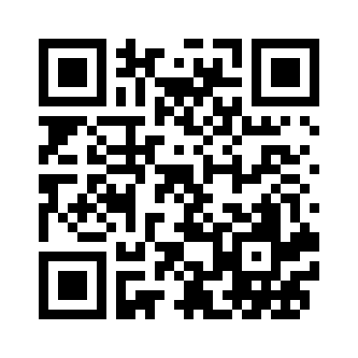
To learn more: Visit the study website at https://surveys.nces.ed.gov/MGLS/ or scan the QR code below. If you have questions, please call us at (855) 500-1432 or send an email to mglssurvey@rti.org.
Thank you for taking the time to learn about this important study and how you can help.
You only need to return the attached form if you do not want your child to participate.
Scan MGLS:2017
QR code HERE
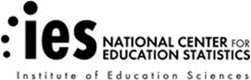
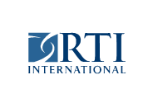

IMPORTANT: This is not a test, and it is not graded. We follow very strict laws to protect personal information and any data collected. All information collected is securely maintained. All reports will use aggregate information for all students who participate; no names will be published in the data files or reports.

NCES is authorized to conduct MGLS:2017 by the Education Sciences Reform Act of 2002 (ESRA 2002, 20 U.S.C. §9543) and to collect students’ education records from education agencies or institutions for the purposes of evaluating federally supported education programs under the Family Educational Rights and Privacy Act (FERPA, 34 CFR §§ 99.31(a)(3)(iii) and 99.35). The data are being collected for NCES by RTI International, a U.S.-based nonprofit research organization. All of the information you and your child provide may be used only for statistical purposes and may not be disclosed, or used, in identifiable form for any other purpose except as required by law (20 U.S.C. §9573 and 6 U.S.C. §151). The collected information will be combined across respondents to produce statistical reports.

Parent/Guardian Implicit Permission Form – MGLS:2017

Your child has been asked to participate in a study of student learning called the Middle Grades Longitudinal Study of 2017-18 (MGLS:2017). Student data will be collected in a <<fill>>-minute session during the school day. The student session will be led by a team of researchers from RTI International, on behalf of the National Center for Education Statistics (NCES).

If you give permission for your child to participate in MGLS:2017 YOU DO NOT NEED TO RETURN THIS FORM. Please keep this copy for your records.

If you do not give permission for your child to participate in MGLS:2017, please check the box below, and sign and return this form to your child’s school as soon as possible.

No, I do not give permission for my child to participate in the Middle Grades Longitudinal Study of 2017-18.

____________________________________________Date of signature: _____/_____/______
(Signature of parent or guardian)

Please Print:
Student name: __________________________________________

School name: ____________________________________________

Parent name: ____________________________________________

Parent telephone: ________________________________________

Parent email: _____________________________________________

Parent home address: ________________________________________________________________________________________________________ Street address City State Zip

FOR OFFICE USE ONLY:
Student ID: ________________________________________________

Appendix MS2B-Q1a. Parent Permission Letter – Implicit – Spanish (modified)
MGLS:2017 Formulario de consentimiento para la participación de su hijo(a) – Consentimiento implícito - Estudio principal

Estimado(a) padre, madre o guardián legal,

Su escuela está participando en el Estudio Longitudinal de los Grados Intermedios de 2017-18 (MGLS:2017) que lleva a cabo el Centro Nacional para Estadísticas de Educación (NCES por sus siglas en inglés), que es parte del Departamento de Educación de los Estados Unidos. MGLS:2017 les brinda a usted y a su hijo(a) la rara oportunidad de compartir sus experiencias y opiniones para ayudar a mejorar la educación de su hijo(a) y de otros muchachos en el futuro. Esta carta es una invitación para que su hijo(a) participe en el estudio. Más adelante usted recibirá una carta por separado invitándole a participar en el estudio también.

QUIÉN: <<IF MS1/AUG/REF SCHOOL: Participarán aproximadamente 35 estudiantes de la escuela de su hijo(a). >> <<IF TRANSFER/DESTINATION SCHOOL: Participarán estudiantes seleccionados que estaban en 6º grado en 2017-2018.>>. Estarán participando aproximadamente 20,000 estudiantes de todo el país.

QUÉ: Los estudiantes completarán una encuesta sobre ellos mismos y sus experiencias, contestarán algunas preguntas de matemáticas y lectura y jugarán algunos “juegos de destreza mental”. También proporcionarán información sobre su peso y talla, medidas que son importantes para entender el crecimiento y desarrollo de los adolescentes. La sesión con los estudiantes se llevará a cabo usando computadoras Chromebook provistas para el estudio y la participación de los estudiantes en el estudio es voluntaria. Más adelante, en el otoño de 2021, tal vez se recopilen los registros administrativos de los estudiantes.

CUÁNDO: La escuela de su hijo(a) elegirá la fecha y hora más conveniente entre enero y junio 2020 para que los estudiantes pasen <<FILL>> minutos en la sesión de estudiantes de MGLS:2017. <<IF HYBRID SCHOOL: Se les pedirá a los estudiantes que completen otra sesión de <<FILL>> minutos fuera de la escuela>>.

DÓNDE: La escuela elegirá la ubicación más conveniente para las sesiones con los estudiantes. Ésta podría ser un salón de clases o centro de computación.

POR QUÉ: El estudio nos ayudará a entender el crecimiento de los estudiantes durante los grados intermedios y las maneras en que nosotros podamos apoyarlos. Esta información nos ayudará a entender cómo darle al estudiante de los grados intermedios las experiencias y habilidades necesarias para ser exitoso en estos años tan importantes de su vida académica.

Su hijo(a) recibirá un certificado por 2 horas de servicio comunitario, un lápiz y un par de audífonos como muestra de nuestro agradecimiento por su participación. <<IF PART OF THE SESSION WILL BE COMPLETED OUTSIDE OF SCHOOL: Los estudiantes que completen la sesión, o parte de ella, fuera de la escuela recibirán adicionalmente una tarjeta de regalo de $20 como muestra de nuestro agradecimiento.>>

Para mayor información: Visite el sitio electrónico del estudio en https://surveys.nces.ed.gov/MGLS/ o escanee el código QR que aparece abajo. Si tiene preguntas, por favor comuníquese con nosotros al (855) 500-1432 o vía correo electrónico al mglssurvey@rti.org.
Gracias por dedicar tiempo para informarse sobre este estudio y la manera en que usted puede contribuir.
Usted solamente necesita devolver el formulario anexo si usted no desea que su hijo(a) participe.
Escanee el código MGLS:2017
aquí

IMPORTANTE: Esto no es un examen y tampoco se califica. Seguimos leyes muy estrictas para proteger la información personal y cualquier dato que se obtenga. Toda la información que se recopile se mantiene de manera segura. Todos los reportes usarán información agregada de todos los estudiantes que participen; no se publicará ningún nombre en los archivos de datos ni en los reportes.
NCES está autorizado a hacer el estudio MGLS:2017 por el Acta de Reforma de las Ciencias de la Educación de 2002 (ESRA 2002, 20 U.S.C. §9543) y a obtener récords educativos de los estudiantes de agencias o instituciones educativas para propósitos de evaluación de programas de educación con fondos federales, bajo la Ley de Derechos Educativos y Privacidad Familiar (FERPA, 34 CFR §§ 99.31(a)(3)(iii) and 99.35). RTI International, una organización sin fines de lucro que realiza estudios y está basada en los Estados Unidos, está recopilando los datos para NCES. Toda la información que usted y su hijo(a) proporcionen podrá usarse solamente para propósitos estadísticos y no podrá divulgarse ni usarse de manera que permita identificar a los participantes para ningún otro propósito, salvo que lo requiera la ley (20 U.S.C. §9573 y 6 U.S.C. §151). La información obtenida se combinará con la de los demás participantes para producir reportes estadísticos.

Formulario de permiso implícito para padres/tutor o guardián legal – MGLS:2017

Le hemos pedido a su hijo(a) que participe en un estudio sobre el aprendizaje de los estudiantes llamado Estudio Longitudinal de los Grados Intermedios de 2017-18 (MGLS:2017 por sus siglas en inglés). Los datos de los estudiantes se obtendrán en una sesión de <<fill>> minutos durante el día escolar. La sesión de los estudiantes será dirigida por un equipo de investigadores de RTI International a nombre del Centro Nacional para Estadísticas de Educación (NCES por sus siglas en inglés).

Si usted da su permiso para que su hijo(a) participe en MGLS:2017, NO NECESITA DEVOLVER ESTE FORMULARIO. Por favor guarde esta copia para sus registros.

Si usted no da su permiso para que su hijo(a) participe en MGLS:2017, por favor marque el cuadrito que está a continuación, firme y devuelva este formulario a la escuela de su hijo(a) lo más pronto posible.

No, no doy permiso para que mi hijo(a) participe en el Estudio Longitudinal de los Grados Intermedios de
2017-18.

____________________________________________ ___________ Fecha en que firma _______/_______/____________
(Firma del padre, madre, tutor o guardián legal)

Por favor escriba en letra de imprenta:

Nombre del estudiante: _________________________

Nombre de la escuela: _________________________

Nombre del padre o madre: __________________________

Teléfono del padre o madre: _________________________________________
Correo electrónico del padre o madre: ______________________________________________
Dirección del padre o madre:
______________________________________________________________________________________________________ Calle y número Ciudad Estado Código Postal

FOR OFFICE USE ONLY:
Student ID: ________________________________________________

Appendix MS2B-Q2. Parent Permission Letter – Explicit (modified)
MGLS:2017 Child Permission Form - Explicit Permission - Main Study
Please read, sign, and return the attached form to your child’s school.

Dear Parent or Guardian,

Your school is participating in the Middle Grades Longitudinal Study of 2017-18 (MGLS:2017), conducted by the National Center for Education Statistics (NCES), part of the U.S. Department of Education. MGLS:2017 gives you and your child the rare opportunity to share your experiences and opinions to help improve education for your child and children in the future. We are writing now about your child’s participation, and you will receive a separate invitation for you to participate as well.
WHO: <<IF MS1/AUG/REF SCHOOL: About 35 students from your child’s school will participate.>> <<IF TRANSFER/DESTINATION SCHOOL: Selected students who were sixth-grade students in 2017-2018 will participate. >> About 20,000 students from across the country will be participating.
WHAT: Students will complete a survey about themselves and their experiences, answer some math and reading questions, and play some “brain games”. They will also provide height and weight measurements, which are important to understanding the growth and development of adolescents. The student session will be conducted on Chromebook computers supplied by the study, and participation is voluntary. Later, in fall 2021, student administrative records may be collected.
WHEN: Your student’s school will choose a convenient day and time between January and June 2020 for students to spend <<FILL>> minutes in the MGLS:2017 student session. << IF HYBRID SCHOOL: Students will be asked to complete another <<FILL>> minutes outside of school.>>
WHERE: The school will choose the best location for the session, typically a classroom or media center.
WHY: The study will help us learn more about students’ growth during the middle grades and ways we can support them. Together, this information will help us learn how to give all middle grades students the experiences and skills they need to thrive in these critical years of education.
Your child will receive a 2-hour community service certificate, a pencil, and a pair of earbuds as a “thank you” for participating. <<IF PART OF THE SESSION WILL BE COMPLETED OUTSIDE OF SCHOOL: Students who complete all or part of their session outside of school also will receive a $20 gift card as a token of our appreciation.>>
To learn more: Visit the study website at https://surveys.nces.ed.gov/MGLS/ or scan the QR code below. If you have questions, please call us at (855) 500-1432 or send an email to mglssurvey@rti.org.
Please complete and return the form to your child’s school to let us know if you agree to your child participating in MGLS:2017. OR you may also text <<unique number>> to <<#####>> to indicate your permission or login to the study website to provide permission at https://surveys.nces.ed.gov/mgls/ and enter Study ID: <<parentID>> and password: <<password>>.
Scan MGLS:2017
QR code HERE
Thank you for taking the time to learn about this important study and how you can help.

IMPORTANT: This is not a test, and it is not graded. We follow very strict laws to protect personal information and any data collected. All information collected is securely maintained. All reports will use aggregate information for all students who participate; no names will be published in the data files or reports.

NCES is authorized to conduct MGLS:2017 by the Education Sciences Reform Act of 2002 (ESRA 2002, 20 U.S.C. §9543) and to collect students’ education records from education agencies or institutions for the purposes of evaluating federally supported education programs under the Family Educational Rights and Privacy Act (FERPA, 34 CFR §§ 99.31(a)(3)(iii) and 99.35). The data are being collected for NCES by RTI International, a U.S.-based nonprofit research organization. All of the information you and your child provide may be used only for statistical purposes and may not be disclosed, or used, in identifiable form for any other purpose except as required by law (20 U.S.C. §9573 and 6 U.S.C. §151). The collected information will be combined across respondents to produce statistical reports.

Parent/Guardian Explicit Permission Form – MGLS:2017

Your child has been asked to participate in a study of student learning called the Middle Grades Longitudinal Study of 2017-18 (MGLS:2017). Student data will be collected in a <<fill>>-minute session during the school day. The student session will be led by a team of researchers from RTI International, on behalf of the National Center for Education Statistics (NCES).

PLEASE CHECK ONE:

Yes, I give permission for my child to participate in MGLS:2017.

No, I do not give permission for my child to participate in MGLS:2017.

PLEASE SIGN YOUR NAME BELOW:

_____________________________________________________ Date of signature: _____/_______/_______
(Signature of parent or guardian)

PLEASE PRINT:
Student name: _____________________________________________
School name: ______________________________________________
Parent name: ______________________________________________
Parent telephone: _________________________________________
Parent email: ______________________________________________
Parent home address: ___________________________________________________________________________________________________ Street address City State Zip

FOR OFFICE USE ONLY:
Student ID: ________________________________________________

Appendix MS2B-Q2a. Flyer – Explicit (approved)

NATIONAL CENTER FOR EDUCATION STATISTICS/U.S DEPARTMENT OF EDUCATION
MIDDLE GRADES LONGITUDINAL STUDY of 2017-18


<<PIZZA PARTY!/GIFT CERTIFICATE!>>

<<A food event will be held for/A $3 gift certificate to the school cafeteria will be given to>> ALL students whose parent/guardian returns a completed Middle Grades Longitudinal Study of 2017-18 (MGLS:2017) permission form! <<The party will be held at your child’s school/The certificate will be given out>> on or about the day the session will be held.

What’s the study about?

- Selected students spend approximately 90 minutes on a computer answering questions about themselves, completing math and reading items, and playing a “brain game”. Height and weight measurements will be collected during the session.
Why should my child participate?

- This is an exciting and unique chance to provide your opinion, input, and experiences about middle grades education. We are collecting information from students and their parents, teachers, and administrators to find out what you think is working well and what is not working well. The input we receive could help to improve education for students now and in the future.
What are the benefits of participation?

- Excitement – the feeling of being part of one of the largest national longitudinal studies of the middle grades by the U.S. Department of Education and the National Center for Education Statistics (NCES).
- Contribution – you can take pride in knowing that you are making a positive contribution to the field of middle grades education.
- Tokens of Appreciation– as a thank you for participating, your child will be given a pair of earbuds and a pencil used during the session. He/She will also receive a certificate for 2 community service hours.

Please complete the enclosed permission form and return it to <<Fill>> in the return envelope today!

Appendix MS2B-Q2b. Parent Permission Letter – Explicit – Spanish (modified)
MGLS:2017 Formulario de consentimiento para la participación de su hijo(a)- Consentimiento explícito – Estudio principal
Por favor lea, firme y devuelva a la escuela de su hijo(a) el formulario adjunto.

Estimado(a) padre, madre o guardián legal,

Su escuela está participando en el Estudio Longitudinal de los Grados Intermedios de 2017-18 (MGLS:2017) que lleva a cabo el Centro Nacional para Estadísticas de Educación (NCES por sus siglas en inglés), que es parte del Departamento de Educación de los Estados Unidos. MGLS:2017 les brinda a usted y a su hijo(a) la rara oportunidad de compartir sus experiencias y opiniones para ayudar a mejorar la educación de su hijo(a) y de otros muchachos en el futuro. Esta carta es una invitación para que su hijo(a) participe en el estudio. Más adelante usted recibirá una carta por separado invitándole a participar en el estudio también.

QUIÉN: <<IF MS1/AUG/REF SCHOOL: Participarán aproximadamente 35 estudiantes de la escuela de su hijo(a).>> <<IF TRANSFER/DESTINATION SCHOOL: Participarán estudiantes seleccionados que estaban en 6º grado en 2017-2018.>>. Estarán participando aproximadamente 20,000 estudiantes de todo el país.

QUÉ: Los estudiantes completarán una encuesta sobre ellos mismos y sus experiencias, contestarán algunas preguntas de matemáticas y lectura y jugarán algunos “juegos de destreza mental”. También proporcionarán información sobre su peso y talla, medidas que son importantes para entender el crecimiento y desarrollo de los adolescentes. La sesión con los estudiantes se llevará a cabo usando computadoras Chromebook provistas para el estudio y la participación de los estudiantes en el estudio es voluntaria. Más adelante, en el otoño de 2021, tal vez se recopilen los registros administrativos de los estudiantes.

CUÁNDO: La escuela de su hijo(a) elegirá la fecha y hora más conveniente entre enero y junio 2020 para que los estudiantes pasen <<FILL>> minutos en la sesión de estudiantes de MGLS:2017. <<IF HYBRID SCHOOL: Se les pedirá a los estudiantes que completen otra sesión de <<FILL>> minutos fuera de la escuela>>.

DÓNDE: La escuela elegirá la ubicación más conveniente para las sesiones con los estudiantes. Ésta podría ser un salón de clases o centro de computación.

POR QUÉ: El estudio nos ayudará a entender el crecimiento de los estudiantes durante los grados intermedios y las maneras en que nosotros podamos apoyarlos. Esta información nos ayudará a entender cómo darle al estudiante de los grados intermedios las experiencias y habilidades necesarias para ser exitoso en estos años tan importantes de su vida académica.

Su hijo(a) recibirá un certificado por 2 horas de servicio comunitario, un lápiz y un par de audífonos como muestra de nuestro agradecimiento por su participación. <<IF PART OF THE SESSION WILL BE COMPLETED OUTSIDE OF SCHOOL: Los estudiantes que completen la sesión, o parte de ella, fuera de la escuela, recibirán adicionalmente una tarjeta de regalo de $20 como muestra de nuestro agradecimiento.>>

Para mayor información: Visite el sitio electrónico del estudio en https://surveys.nces.ed.gov/MGLS/ o escanee el código QR que aparece abajo. Si tiene preguntas, por favor comuníquese con nosotros al (855) 500-1432 o vía correo electrónico al mglssurvey@rti.org.

Por favor complete y devuelva el formulario a la escuela para hacernos saber que usted autoriza a su hijo(a) participar en el estudio MGLS:2017. O, si lo prefiere, también puede enviarnos un mensaje de texto con el número <<unique number>> al <<#####>> para indicar que usted autoriza a su hijo(a) a participar. También puede dar su permiso entrando a la página electrónica del estudio: https://surveys.nces.ed.gov/mgls/ e ingrese su Study ID (número de identificación del estudio): <<parentID>> y su password (contraseña): <<password>>.
Escanee el código MGLS:2017
aquí

Gracias por dedicar tiempo para informarse sobre este estudio y la manera en que usted puede contribuir.

IMPORTANTE: Esto no es un examen y tampoco se califica. Seguimos leyes muy estrictas para proteger la información personal y cualquier dato que se obtenga. Toda la información que se recopile se mantiene de manera segura. Todos los reportes usarán información agregada de todos los estudiantes que participen; no se publicará ningún nombre en los archivos de datos ni en los reportes.
NCES está autorizado a hacer el estudio MGLS:2017 por el Acta de Reforma de las Ciencias de la Educación de 2002 (ESRA 2002, 20 U.S.C. §9543) y a obtener récords educativos de los estudiantes de agencias o instituciones educativas para propósitos de evaluación de programas de educación con fondos federales, bajo la Ley de Derechos Educativos y Privacidad Familiar (FERPA, 34 CFR §§ 99.31(a)(3)(iii) and 99.35). RTI International, una organización sin fines de lucro que realiza estudios y está basada en los Estados Unidos, está recopilando los datos para NCES. Toda la información que usted y su hijo(a) proporcionen podrá usarse solamente para propósitos estadísticos y no podrá divulgarse ni usarse de manera que permita identificar a los participantes para ningún otro propósito, salvo que lo requiera la ley (20 U.S.C. §9573 y 6 U.S.C. §151). La información obtenida se combinará con la de los demás participantes para producir reportes estadísticos.

Appendix MS2B-Q3. Parent Notification Letter (modified)

Dear Parent or Guardian,

Your school is participating in the Middle Grades Longitudinal Study of 2017-18 (MGLS:2017), conducted by the National Center for Education Statistics (NCES), part of the U.S. Department of Education. MGLS:2017 gives you and your child the rare opportunity to share your experiences and opinions to help improve education for your child and children in the future. We are writing now about your child’s participation, and you will receive a separate invitation for you to participate as well.
WHO: <<IF MS1/AUG/REF SCHOOL: About 35 students from your child’s school will participate.>> <<IF TRANSFER/DESTINATION SCHOOL: Selected students who were sixth-grade students in 2017-2018 will participate.>> About 20,000 students from across the country will be participating.
WHAT: Students will complete a survey about themselves and their experiences, answer some math and reading questions, and play some “brain games”. They will also provide height and weight measurements, which are important to understanding the growth and development of adolescents. The student session will be conducted on Chromebook computers supplied by the study, and participation is voluntary. Later, in fall 2021, student administrative records may be collected.
WHEN: Your student’s school will choose a convenient day and time between January and June 2020 for students to spend <FILL> minutes in the MGLS:2017 student session. <<IF HYBRID SCHOOL: Students will be asked to complete another <<FILL>> minutes outside of school>>.
WHERE: The school will choose the best location for the session, typically a classroom or media center.
WHY: The study will help us learn more about students’ growth during the middle grades and ways we can support them. Together, this information will help us learn how to give all middle grades students the experiences and skills they need to thrive in these critical years of education.
Your child will receive a 2-hour community service certificate, a pencil, and a pair of earbuds as a “thank you” for participating. <<IF PART OF THE SESSION WILL BE COMPLETED OUTSIDE OF SCHOOL: Students who complete all or part of their session outside of school also will receive a $20 gift card as a token of our appreciation.>>
To learn more: Visit the study website at https://surveys.nces.ed.gov/MGLS/ or scan the QR code. If you have questions, please call us at (855) 500-1432 or send an email to mglssurvey@rti.org.
Thank you for taking the time to learn about this important study and how you can help.
Scan MGLS:2017
QR code HERE

IMPORTANT: This is not a test, and it is not graded. We follow very strict laws to protect personal information and any data collected. All information collected is securely maintained. All reports will use aggregate information for all students who participate; no names will be published in the data files or reports.

NCES is authorized to conduct MGLS:2017 by the Education Sciences Reform Act of 2002 (ESRA 2002, 20 U.S.C. §9543) and to collect students’ education records from education agencies or institutions for the purposes of evaluating federally supported education programs under the Family Educational Rights and Privacy Act (FERPA, 34 CFR §§ 99.31(a)(3)(iii) and 99.35). The data are being collected for NCES by RTI International, a U.S.-based nonprofit research organization. All of the information you and your child provide may be used only for statistical purposes and may not be disclosed, or used, in identifiable form for any other purpose except as required by law (20 U.S.C. §9573 and 6 U.S.C. §151). The collected information will be combined across respondents to produce statistical reports.

Appendix MS2B-Q3a. Parent Notification Letter – Spanish (modified)
MGLS:2017 Formulario de consentimiento para la participación de su hijo(a)- Notificación – Estudio principal

Estimado(a) padre, madre o guardián legal,

Su escuela está participando en el Estudio Longitudinal de los Grados Intermedios de 2017-18 (MGLS:2017) que lleva a cabo el Centro Nacional para Estadísticas de Educación (NCES por sus siglas en inglés), que es parte del Departamento de Educación de los Estados Unidos. MGLS:2017 les brinda a usted y a su hijo(a) la rara oportunidad de compartir sus experiencias y opiniones para ayudar a mejorar la educación de su hijo(a) y de otros muchachos en el futuro. Esta carta es una invitación para que su hijo(a) participe en el estudio. Más adelante usted recibirá una carta por separado invitándole a participar en el estudio también.

QUIÉN: <<IF MS1/AUG/REF SCHOOL: Participarán aproximadamente 35 estudiantes de la escuela de su hijo(a).>> <<IF TRANSFER/DESTINATION SCHOOL: Participarán estudiantes seleccionados que estaban en 6º grado en 2017-2018>>. Estarán participando aproximadamente 20,000 estudiantes de todo el país.

QUÉ: Los estudiantes completarán una encuesta sobre ellos mismos y sus experiencias, contestarán algunas preguntas de matemáticas y lectura y jugarán algunos “juegos de destreza mental”. También proporcionarán información sobre su peso y talla, medidas que son importantes para entender el crecimiento y desarrollo de los adolescentes. La sesión con los estudiantes se llevará a cabo usando computadoras Chromebook provistas para el estudio y la participación de los estudiantes en el estudio es voluntaria. Más adelante, en el otoño de 2021, tal vez se recopilen los registros administrativos de los estudiantes.

CUÁNDO: La escuela de su hijo(a) elegirá la fecha y hora más conveniente entre enero y junio 2020 para que los estudiantes pasen <<FILL>> minutos en la sesión de estudiantes de MGLS:2017. <<IF HYBRID SCHOOL: Se les pedirá a los estudiantes que completen otra sesión de <<FILL>> minutos fuera de la escuela>>.

DÓNDE: La escuela elegirá la ubicación más conveniente para las sesiones con los estudiantes. Ésta podría ser un salón de clases o centro de computación.

POR QUÉ: El estudio nos ayudará a entender el crecimiento de los estudiantes durante los grados intermedios y las maneras en que nosotros podamos apoyarlos. Esta información nos ayudará a entender cómo darle al estudiante de los grados intermedios las experiencias y habilidades necesarias para ser exitoso en estos años tan importantes de su vida académica.

Su hijo(a) recibirá un certificado por 2 horas de servicio comunitario, un lápiz y un par de audífonos como muestra de nuestro agradecimiento por su participación. <<IF PART OF THE SESSION WILL BE COMPLETED OUTSIDE OF SCHOOL: Los estudiantes que completen la sesión fuera de la escuela recibirán adicionalmente una tarjeta de regalo de $20 como muestra de nuestro agradecimiento por su participación.>>

Para mayor información: Visite el sitio electrónico del estudio en https://surveys.nces.ed.gov/MGLS/ o escanee el código QR. Si tiene preguntas, por favor comuníquese con nosotros al (855) 500-1432 o vía correo electrónico al mglssurvey@rti.org.

Gracias por dedicar tiempo para informarse sobre este estudio y la manera en que usted puede contribuir.
Escanee el código MGLS:2017
aquí

IMPORTANTE: Esto no es un examen y tampoco se califica. Seguimos leyes muy estrictas para proteger la información personal y cualquier dato que se obtenga. Toda la información que se recopile se mantiene de manera segura. Todos los reportes usarán información agregada de todos los estudiantes que participen; no se publicará ningún nombre en los archivos de datos ni en los reportes.
NCES está autorizado a hacer el estudio MGLS:2017 por el Acta de Reforma de las Ciencias de la Educación de 2002 (ESRA 2002, 20 U.S.C. §9543) y a obtener récords educativos de los estudiantes de agencias o instituciones educativas para propósitos de evaluación de programas de educación con fondos federales, bajo la Ley de Derechos Educativos y Privacidad Familiar (FERPA, 34 CFR §§ 99.31(a)(3)(iii) and 99.35). RTI International, una organización sin fines de lucro que realiza estudios y está basada en los Estados Unidos, está recopilando los datos para NCES. Toda la información que usted y su hijo(a) proporcionen podrá usarse solamente para propósitos estadísticos y no podrá divulgarse ni usarse de manera que permita identificar a los participantes para ningún otro propósito, salvo que lo requiera la ley (20 U.S.C. §9573 y 6 U.S.C. §151). La información obtenida se combinará con la de los demás participantes para producir reportes estadísticos.

Appendix MS2B-Q4. School Coordinator Letter (sent with parent letter/permission forms mailing) (approved)
<<Date>>
«entityname»
«entityaddress»
«entitycitystzip»

Dear «contactname»:
Thank you for your school’s participation in the Middle Grades Longitudinal Study of 2017-18 (MGLS:2017) and for all you have done to prepare for the data collection thus far. We look forward to coming to your school on «test_date_1» to conduct the student session(s).
In this mailing, we have provided a student tracking form (STF) which lists the students selected to participate at your school and parental permission materials for each selected student. In anticipation of the in-school session, we ask that you:
- distribute the parental <<notification letters/permission forms>> to the students listed on the STF; and
- work with RTI’s session facilitator (SF) to finalize the logistics of the session(s), determine the eligibility of the students listed on the STF to participate in the study, and discuss any accommodations that may be needed for specific students with IEPs and/or disabilities.
We have also provided a checklist for you to use to help you with organizing these tasks.
<<IF INCENTIVE ALLOWED: As a token of our appreciation for your time and effort with MGLS:2017, a check for $100 will be mailed to you after all student sessions have been completed at the school. Your school will also receive $400.>>
RTI’s session facilitator (SF) will contact you in the next few days to confirm the session logistics and to assist you in completing the activities listed above. Should you have questions in the meantime, you may contact us at 1-855-500-1432 or mgls@rti.org.
Thank you again for serving as the school coordinator and for your help to make MGLS:2017 successful at your school.
Sincerely,
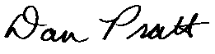
Dan Pratt
Project Director, Middle Grades Longitudinal Study of 2017-18

The National Center for Education Statistics (NCES) is authorized to conduct MGLS:2017 by the Education Sciences Reform Act of 2002 (ESRA 2002, 20 U.S.C. §9543) and to collect students’ education records from education agencies or institutions for the purposes of evaluating federally supported education programs under the Family Educational Rights and Privacy Act (FERPA, 34 CFR §§ 99.31(a)(3)(iii) and 99.35). The data are being collected for NCES by RTI International, a U.S.-based nonprofit research organization. All of the information provided by schools may be used only for statistical purposes and may not be disclosed, or used, in identifiable form for any other purpose except as required by law (20 U.S.C. §9573 and 6 U.S.C. §151). The collected information will be combined across respondents to produce statistical reports.

Appendix MS2B-Q5. SC Responsibility Checklist (approved)
Timeframe | Item | Who | Complete
 | Review MGLS:2017 FAQ and brochure
 | Review student roster information and choose date/person to complete the upload
 | Upload student roster information
 | Upload parent and teacher information
 | Send home permission forms
 | Finalize date for MGLS:2017 student session
Principal and SC share info about MGLS:2017 with staff (importance, date of parent permission form distribution, student session date/time, teacher
participation and incentives)
Choose date for pre-session visit and meet with MGLS
Session Facilitator
 | Review student list to determine eligibility, enrollment status, English language status, and any student accommodations that are needed
Choose location for student session and height/weight
station
Create plan for getting students to and from the
student session
 | Choose location for storage of Chromebooks
Contact parents of students who refused consent or didn’t return a permission form (if explicit consent is
required) OR give parent contacting information to the
MGLS Session Facilitator as appropriate
Assist MGLS team on session day as appropriate/needed (locating missing students, monitoring the session, assisting with
accommodations, etc.)

Appendix MS2B-Q6. Student Assent Form (approved)
<<TO BE DISTRIBUTED IF SCHOOL REQUIRES HARDCOPY STUDENT ASSENT>>
Middle Grades Longitudinal Study of 2017-18 (MGLS:2017)
Student Assent Form

You are being asked to participate in a study called the Middle Grades Longitudinal Study of 2017-18 (MGLS:2017). This study is conducted by the National Center for Education Statistics (NCES), part of the U.S. Department of Education.
Your participation in MGLS:2017 is voluntary, and all of the information you provide may be used only for statistical purposes and may not be disclosed, or used, in identifiable form, for any other purpose except as required by law (20 U.S.C. §9573 and 6 U.S.C. §151). Each student who participates will receive a certificate for two hours of community service and you may keep the ear buds and pencil you use for this session.
Please check only one option below to indicate your decision to participate in the study.

Yes, I will participate in MGLS:2017.

No, I will not participate in MGLS:2017.

PRINT your name here:
__________________________________________________________________

SIGN your name here:
__________________________________________________________________

Date: _______/_______/____________

FOR OFFICE USE ONLY:
Student ID: ________________________________________________
School name: ________________________________________________

Appendix MS2B-Q7a. In-School Student Video Script (approved)
Welcome to the Middle Grades Longitudinal Study of 2017-18. The study is also called MGLS:2017 for short. MGLS:2017 is a research study conducted by the U.S. Department of Education. We thank you for participating today.
MGLS:2017 is the first national study to learn about the experiences of students in grades six through eight. The study will help us understand what students learn during these grades, and about your experiences with your peers, teachers, school, and family.

You will use the computer to answer some questions about yourself, complete math and reading problems and to play two brain games. We will also measure your height and weight, which is important to understanding growth and development. The whole process will take approximately 90 minutes. After we finish today, we will give you a small gift to thank you for your participation.

When you answer the questions, you will move through each section a little differently. When you answer questions about yourself, you will be able to go back to previous questions if you need to review or change an answer. During the math section, you will only be able to go back to the last problem you completed. When you play the brain game or complete the reading section, you will not be able to go backwards. If you skip a question, you may see a box pop up on some items to ask if you want to consider answering the question.

If you want to have an item read out loud to you, you may click this icon <<show icon>>.

The information and answers you give today will not be shared with your parents, teachers, or school. The collected information will be combined across respondents to produce statistical reports and neither your name nor your school’s name will be identified in these reports. Participation in MGLS:2017 is voluntary, but also very important. You may skip any item you do not know or do not want to answer.

On this computer, you do not have a mouse. Instead you can use the track pad like this <<DEMONSTRATE THE CHROMEBOOK AND USE OF THE TRACK PAD>> and you can touch the screen to select answers or to make the text larger or smaller like this <<DEMONSTRATE HOW TO DRAG THE CURSOR AROUND. DRAG YOUR THUMB AND FOREFINGER APART TO ZOOM IN AND THEN PINCH YOUR THUMB AND FOREFINGER TOGETHER TO ZOOM OUT>>. To move from screen to screen, you should press NEXT to save your answer and move on to the next item.

The scratch paper next to your computer has graph paper on one side and is blank on the other side. <<DEMONSTRATE PAPER AND SHOW BOTH SIDES>>. If you need more scratch paper, please raise your hand.

You each received a card with a user ID and password. The password letters are case sensitive, so please type these carefully. Please enter the ID and password now. This should take you to the “Welcome” screen where you will see additional instructions. When you are asked to go to the measurement station, log out from your Chromebook and please bring your card with you.

If you need help or have any questions, please raise your hand.

Thank you for participating in MGLS:2017. Press next to begin.

Appendix MS2B-Q7b. Out-of-School Student Instructions (modified)
Note: Students will log into the session via the login screen shown in Appendix MS2-B1 then be led through the following three screens before starting the student survey.

Out of School Administration student survey instructions:

Screen 1:
Welcome to the Middle Grades Longitudinal Study of 2017-18 or MGLS:2017. We thank you for participating today!
Your answers to the following math, reading and other questions will help us understand what students learn during grades six through eight, and about your experiences with your peers, teachers, school, and family.

Press NEXT to continue.
[The Next button is immediately available.]

Screen 2:
This session will take approximately <75/45> minutes.
Instructions:
- Put your internet browser in full screen mode. You might need to press F11 on your keyboard or Command + Shift + F on a Mac.
- Use the NEXT and PREVIOUS buttons to navigate through the survey
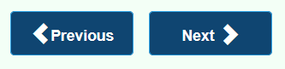
- When you answer questions about yourself, you will be able to go back to previous questions if you need to review or change an answer.
- In some sections, like the reading section, you will not be able to go back. In other sections, like the math section, you can only go back to the last problem you completed.

- If you want to have an item read out loud to you, click this icon 
- You can see additional help for a question by clicking this icon 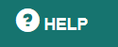
- When you are all done you will see a screen that says “Congratulations.” When you see that screen, close your browser.
- If you need help or have any questions, please call 855-500-1432 or e-mail mgls@rti.org.

Press NEXT to continue.

Screen 3:

The information and answers you give today will not be shared with your parents, teachers, or school. The collected information will be combined across respondents to produce statistical reports and neither your name nor your school’s name will be identified in these reports. Participation in MGLS:2017 is voluntary, but also very important. You may skip any question you do not know or do not want to answer. Please do the best that you can. This is not a test and you will not be graded on how you answer the questions.

Thank you for participating in MGLS:2017. Press start to begin.

Appendix MS2B-Q8. MGLS:2017 School Thank You Letter (approved)

<<DATE>>

<<School name>>
<<Address 1>>
<<Address 2}
<<City, state, zip>>

Dear <<Principal>>:

We are writing to thank you and your school for your participation in the Middle Grades Longitudinal Study of 2017-18 (MGLS:2017) this spring. We particularly would like to thank <<you/School Coordinator name>> for working with us to coordinate the student sessions and ensure the study’s success at your school. <<if applicable: We have enclosed <incentive> as a token of our appreciation for the school’s participation.>>

We may come back in <<year>> to request administrative records for students in the study. Thank you for partnering with MGLS:2017 to make the study a success. We wish you a wonderful summer.

Sincerely,

James L. Woodworth
NCES Commissioner

Appendix MS2B-R1. Parent and Out-of-School Student Data Collection – Parent Letter Initial (modified)

<DATE>
These are the pivotal years, where we make or break a student, where we turn them on or off.
https://blog.ed.gov/2011/11/middle-grades-matter/

<parentname>
<address>
<city, state zip>

Dear <Parent or Guardian>,

<<IF STUDENT WAS SELECTED IN BASE YEAR: We are thrilled that the follow-up survey for the Middle Grades Longitudinal Study of 2017-18 (MGLS:2017) is underway. During the 2017-2018 school year, <student name> <IF PARTICIPATED SAY: participated; IF NONRESPONDENT SAY: was selected to participate> in MGLS:2017.>> <<IF STUDENT IS SELECTED IN 2019-2020: We are thrilled that your child’s school is participating in the Middle Grades Longitudinal Study of 2017-18 (MGLS:2017).>>
[IF IN ‘TEMPORARY OUT OF SCHOOL’ GROUP: Your child’s school was scheduled to participate in Spring 2020. You may have already received a letter explaining this. Due to the high number of temporary school closings across the nation, we’d like to invite your child to participate online.]
Here at the National Center for Education Statistics (NCES) in the U.S. Department of Education, we are reaching out to schools, students, parents, teachers, and school administrators to better understand the experiences of students in grades 6-8. The study is helping us learn more about how educators and parents can support student learning and success. The information that is provided will contribute to improving education for students now and in the future.
[IF STUDENT IS PARTICIPATING OUT OF SCHOOL: <<FULL OOS: Students will be asked to take a survey and answer math and reading questions and may choose between a 45- or 75-minute session. Students who complete the 45-minute session will receive $20 and a 2-hour community service certificate. Those who complete the 75-minute session will receive $20 and a 3-hour community service certificate and, for the extra time with this survey, we will make an additional donation of $20 to Save the Children’s special fund to help kids affected by the COVID-19 outbreak.>>]

Participation is easy! Please give your child the enclosed envelope so that he/she can participate. The envelope contains the information needed to log in to the computer to complete the session.]
<<IF PARENT HAS NOT ALREADY PARTICIPATED: Parents and guardian: We would greatly appreciate it if the person most knowledgeable about <student_firstname>’s school and home life would complete a <##>-minute online survey for the study. Please use the following information to log in:
Web Address: surveys.nces.ed.gov/MGLS/
Parent Study ID: <XXXXXXXX>
Parent Password: <XXXXXXXX><PW_ind>>.

When that person completes the survey, we will send them a check for <<$incentive>>.

As the parent or guardian of your middle grades student, you provide an important and unique point of view. Only you can tell us about your child’s home learning environment, your child’s school experiences, and your involvement in their learning. We need your input for MGLS:2017 so the study can represent the experiences of all middle grades students across the U.S.>>

To learn more, please visit the study website at https://surveys.nces.ed.gov/mgls/. You may also call the study hotline at (855) 500-1432 or send an email to mglsparent@rti.org. Thank you for supporting education by participating in this important study!

Sincerely,

James L. Woodworth
NCES Commissioner

Enclosures: Brochure, Parent FAQs, Flyer

IMPORTANT: This is not a test, and it is not graded. We follow very strict laws to protect personal information and any data collected. All information collected is securely maintained. All reports will use aggregate information for all students who participate; no names will be published in the data files or reports.

NCES is authorized to conduct MGLS:2017 by the Education Sciences Reform Act of 2002 (ESRA 2002, 20 U.S.C. §9543) and to collect students’ education records from education agencies or institutions for the purposes of evaluating federally supported education programs under the Family Educational Rights and Privacy Act (FERPA, 34 CFR §§ 99.31(a)(3)(iii) and 99.35). The data are being collected for NCES by RTI International, a U.S.-based nonprofit research organization. All of the information you and your child provide may be used only for statistical purposes and may not be disclosed, or used, in identifiable form for any other purpose except as required by law (20 U.S.C. §9573 and 6 U.S.C. §151). The collected information will be combined across respondents to produce statistical reports.

Appendix MS2B-R1a. Parent and Out-of-School Student Data Collection – Parent Letter Initial – Spanish (modified)

<DATE>
Estos son años cruciales, años en los que construimos el éxito o el fracaso de un estudiante, años en los que lo entusiasmamos o lo desencantamos.
https://blog.ed.gov/2011/11/middle-grades-matter/

<parentname>
<address>
<city, state zip>

Estimado(a) padre, madre o guardián legal,

<<IF STUDENT WAS SELECTED IN BASE YEAR: Nos complace informarle que la ronda de seguimiento al Estudio Longitudinal de los Grados Intermedios de 2017-18 (MGLS:2017) ya está en marcha. Durante el año escolar 2017-2018 <student name> <IF PARTICIPATED SAY: participó; IF NONRESPONDENT SAY: fue seleccionado(a) para participar> en MGLS:2017>> <<IF STUDENT IS SELECTED IN 2019-2020: Nos complace informarle que la escuela de su hijo(a) está participando en el Estudio Longitudinal de los Grados Intermedios de 2017-18 .>> Aquí en el Centro Nacional para Estadísticas de Educación (NCES por sus siglas en inglés) que pertenece al Departamento de Educación de los Estados Unidos, estamos contactando a las escuelas, estudiantes, padres de familia, profesores y administradores escolares para lograr un mejor entendimiento de las experiencias de los estudiantes que cursan entre el 6⁰ y el 8⁰ grado. El estudio nos ayuda a aprender más cómo los educadores y padres de familia pueden apoyar el aprendizaje y el éxito de los estudiantes. La información proporcionada contribuirá a mejorar la educación de los estudiantes ahora y en el futuro.
[IF IN ‘TEMPORARY OUT OF SCHOOL’ GROUP: La escuela de su hijo(a) estaba programada para participar en la primavera de 2020. Es posible que ya haya recibido una carta explicando esto. Debido a la gran cantidad de cierres temporales de escuelas a través el país, nos gustaría invitar a su hijo(a) a participar en línea.]

[IF STUDENT IS PARTICIPATING OUT OF SCHOOL: <<FULL OOS: Se les pedirá a los estudiantes que realicen una encuesta y respondan preguntas de matemáticas y lectura y pueden escoger entre una sesión de 45 o 75 minutos. Los estudiantes que completen una sesión de 45 minutos recibirán $20 y un certificado de servicio comunitario de dos horas. Los que completen una sesión de 75 minutos recibirán $20 y un certificado de servicio comunitario de tres horas más, por su tiempo extra con esta encuesta, haremos una donación adicional de $20 a la organización Save the Children para ayudar a los necesitados niños afectados por debido a la pandemia del COVID-19.>>

¡Es muy fácil participar! Por favor entregue a su hijo(a) el sobre incluido para que él/ella pueda participar. El sobre contiene la información necesaria para ingresar en la computadora y completar la sesión.
<<IF PARENT HAS NOT ALREADY PARTICIPATED: Padres, madres y guardianes legales: Les agradeceríamos mucho si la persona que está mejor informada sobre la vida de <student_firstname> en la escuela y en el hogar pudiera completar una encuesta del estudio que dura <##>-minutos en Internet. Por favor usen la siguiente información para ingresar a la encuesta:
Sitio Web: surveys.nces.ed.gov/MGLS/
ID del Padre/Madre: <XXXXXXXX>
Password (Contraseña) del Padre/Madre: <XXXXXXXX><PW_ind>>.

Cuando esa persona haya completado la encuesta, le enviaremos un cheque por <<$incentive>>.

Como padre, madre, o guardián legal de un estudiante de grados intermedios, usted tiene una perspectiva única y muy importante. Solamente usted puede hablar del ambiente de aprendizaje de su hijo(a) en casa, de las experiencias de su hijo(a) en la escuela y de la participación de usted en el aprendizaje de su hijo(a). Necesitamos conocer sus puntos de vista en MGLS:2017 para que nuestro estudio represente las experiencias de todos los estudiantes de los grados intermedios en el país. >>
Para mayor información: Por favor visite el sitio electrónico del estudio en https://surveys.nces.ed.gov/MGLS/. Si tiene preguntas, por favor comuníquese con nosotros al (855) 500-1432 o vía correo electrónico al mglssurvey@rti.org. ¡Muchas gracias por el apoyo que usted brinda a la educación al participar en este importante estudio!

Atentamente,
James L. Woodworth
Comisionado de NCES

Anexo: Folleto, Preguntas más frecuentes de los padres (FAQs), Volantes

IMPORTANTE: Esto no es un examen y tampoco se califica. Seguimos leyes muy estrictas para proteger la información personal y cualquier dato que se obtenga. Toda la información que se recopile se mantiene de manera segura. Todos los reportes usarán información agregada de todos los estudiantes que participen; no se publicará ningún nombre en los archivos de datos ni en los reportes.
NCES está autorizado a hacer el estudio MGLS:2017 por el Acta de Reforma de las Ciencias de la Educación de 2002 (ESRA 2002, 20 U.S.C. §9543) y a obtener récords educativos de los estudiantes de agencias o instituciones educativas para propósitos de evaluación de programas de educación con fondos federales, bajo la Ley de Derechos Educativos y Privacidad Familiar (FERPA, 34 CFR §§ 99.31(a)(3)(iii) and 99.35). RTI International, una organización sin fines de lucro que realiza estudios y está basada en los Estados Unidos, está recopilando los datos para NCES. Toda la información que usted y su hijo(a) proporcionen podrá usarse solamente para propósitos estadísticos y no podrá divulgarse ni usarse de manera que permita identificar a los participantes para ningún otro propósito, salvo que lo requiera la ley (20 U.S.C. §9573 y 6 U.S.C. §151). La información obtenida se combinará con la de los demás participantes para producir reportes estadísticos.

Appendix MS2B-R2. Parent and Out-of-School Student Data Collection – Reminder (modified)
<<PARENT NAME>> <<DATE>>
<<ADDR1>>
<<ADDR2>>
MGLS:2017 is the first national study to look at the middle grades experience.

<<CITY, STATE ZIP>>
Dear <<Parent or Guardian Name>>:
<<IF CHILD ONLY: Recently, we sent a letter asking you/your child/ you and your child to participate in the MGLS:2017. This is an opportunity for your child to share his/her middle school experiences and help improve education for all students.>> <<IF PARENT ALREADY PARTICIPATED, ADD: You have already provided valuable information for this study and we thank you for your participation.>> <<IF PARENT AND CHILD NEEDED: Recently, we sent a letter asking you/your child/ you and your child to participate in the MGLS:2017. This is an opportunity for you and your child to share your middle school experiences and opinions and help improve education for all students.>> <<IF WE’VE ALREADY REACHED OUT TO THE PARENT AND ARE ADDING THE CHILD TO THE OUT-OF-SCHOOL DATA COLLECTION: You were recently contacted to share your experiences and opinions about the middle school experience, and we would also like to ask <<child name>> to share his/her experience.>>
The U.S. Department of Education’s National Center for Education Statistics (NCES) is conducting the Middle Grades Longitudinal Study of 2017-18 (MGLS:2017). We want to hear from you <<both>> about what works for you with the middle school experience and what doesn’t work. We are listening!
<<OOS STUDENT DATA COLLECTION: Participation is easy! Please give your child the enclosed envelope so that he/she can participate. The envelope contains the information needed to log in to the computer to complete the session. Your student may choose between a 45- or 75-minute session. In return, we will send your child $20 and a 2-hour community service certificate for completing the 45-minute session or those completing the 75-minute session will receive $20 plus a 3-hour community service certificate, and, for the extra time with this survey, we will make a donation of $20 to Save the Children’s special fund to help kids affected by COVID-19.>>
<<IF PARENT HAS NOT ALREADY PARTICIPATED: Parents and guardians: It is not too late to participate in this exciting study that schools, students, parents, teachers, and school administrators are participating in nationwide. Your contributions will help improve education now and in the future. Please consider completing this <##>-minute survey.
Please use the following information to log in:
Web Address: surveys.nces.ed.gov/MGLS/
Parent Study ID: <XXXXXXXX>
Parent Password: <XXXXXXXX><PW_ind>>.

When that person completes the survey, we will send them a check for <<$incentive>>.>>

If you have questions, please call (855) 500-1432 or email us at mglsparent@rti.org. You can also get more information on our website https://surveys.nces.ed.gov/MGLS/.
We thank you in advance for your cooperation in this important research.
Sincerely,

James L. Woodworth
NCES Commissioner

IMPORTANT: This is not a test, and it is not graded. We follow very strict laws to protect personal information and any data collected. All information collected is securely maintained. All reports will use aggregate information for all students who participate; no names will be published in the data files or reports.

NCES is authorized to conduct MGLS:2017 by the Education Sciences Reform Act of 2002 (ESRA 2002, 20 U.S.C. §9543) and to collect students’ education records from education agencies or institutions for the purposes of evaluating federally supported education programs under the Family Educational Rights and Privacy Act (FERPA, 34 CFR §§ 99.31(a)(3)(iii) and 99.35). The data are being collected for NCES by RTI International, a U.S.-based nonprofit research organization. All of the information you and your child provide may be used only for statistical purposes and may not be disclosed, or used, in identifiable form for any other purpose except as required by law (20 U.S.C. §9573 and 6 U.S.C. §151). The collected information will be combined across respondents to produce statistical reports.

Appendix MS2B-R3. Out-of-school Data Collection – Student Letter (modified)
<DATE>

<STUDENT NAME> Web Address: https://surveys.nces.ed.gov/mgls/
<ADDR1> Student Study ID: <XXXXXXXX>
<CITY STATE ZIP> Student Password: <XXXXXXXX><PW_ind>

Dear <Student Name>:
YOU can make a difference!

Congratulations! You have been selected to share your middle school experiences and opinions. Your input will help to improve education for students now and in the future.
The Middle Grades Longitudinal Study of 2017-18 (MGLS:2017) is conducted by the National Center for Education Statistics (NCES), part of the U.S. Department of Education. We are asking for your participation in this important research.
This is your chance to provide information that could lead to important changes in education.
Your participation is voluntary, but we can’t do this without you. The study will include a short survey and math and reading questions. Your answers will never be shared with your parents, teachers, or school staff.
To participate, please use the web link and the unique student study ID and password provided above. You will have the choice between:
- a 45-minute session for $20 plus a certificate for 2 hours of community service from the U.S. Department of Education, or
- a 75-minute session for $20 plus a certificate for 3 hours of community service from the U.S. Department of Education and, for taking extra time, a donation of $20 to Save the Children’s special fund to help kids affected by COVID-19.
RTI International will collect the information for MGLS:2017 on behalf of NCES. Participation is easy and we really value your responses! The enclosed brochure provides more information about the study. If you have questions, please call (855) 500-1432 or email us at mglssurvey@rti.org.
‘Believe you can and you’re halfway there’
-Theodore Roosevelt-
We thank you in advance for sharing your voice.
Sincerely,

James L. Woodworth
NCES Commissioner

IMPORTANT: This is not a test, and it is not graded. We follow very strict laws to protect personal information and any data collected. All information collected is securely maintained. All reports will use aggregate information for all students who participate; no names will be published in the data files or reports.

NCES is authorized to conduct MGLS:2017 by the Education Sciences Reform Act of 2002 (ESRA 2002, 20 U.S.C. §9543) and to collect students’ education records from education agencies or institutions for the purposes of evaluating federally supported education programs under the Family Educational Rights and Privacy Act (FERPA, 34 CFR §§ 99.31(a)(3)(iii) and 99.35). The data are being collected for NCES by RTI International, a U.S.-based nonprofit research organization. All of the information you provide may be used only for statistical purposes and may not be disclosed, or used, in identifiable form for any other purpose except as required by law (20 U.S.C. §9573 and 6 U.S.C. §151). The collected information will be combined across respondents to produce statistical reports.

Appendix MS2B-R4. Out-of-school Data Collection – Student Letter Reminder (modified)
<DATE>

<STUDENT NAME> Web Address: https://surveys.nces.ed.gov/mgls
<ADDR1> Student Study ID: <XXXXXXXX>
<CITY STATE ZIP> Student Password: <XXXXXXXX><PW_ind>

Dear <Student Name>:
We recently sent you information about your participation in an exciting new study, the Middle Grades Longitudinal Study of 2017-18 or MGLS:2017 and we didn’t want you to miss out on an opportunity to have your voice be heard. All you have to do is answer a short survey and math and reading questions. You can choose to spend 45 minutes and receive $20 plus a 2-hour community service certificate from the U.S. Department of Education, or you can spend 75 minutes and receive $20 plus a 3-hour community service certificate from the U.S. Department of Education, and, for taking the extra time, we will make a $20 donation to Save the Children’s special fund to help kids affected by COVID-19. We would really appreciate it if you would share your middle school experiences and opinions to help improve education for you and other students.
MGLS:2017 is conducted by the National Center for Education Statistics (NCES), part of the U.S. Department of Education, and RTI International is collecting the data for the study. We are asking your participation in this important research.
It is your decision to participate or not, but we hope that you will decide to join fellow students and take part. We will never share your responses with your parents, teachers, or school staff. Participation is easy! Just use the web link and the unique student study ID and password provided above.
If you have any questions, please call (855) 500-1432 or email us at mglssurvey@rti.org. You can also get more information on our website: https://surveys.nces.ed.gov/mgls.

Thank you so much for sharing your voice.
Sincerely,

James L. Woodworth
NCES Commissioner

IMPORTANT: This is not a test, and it is not graded. We follow very strict laws to protect personal information and any data collected. All information collected is securely maintained. All reports will use aggregate information for all students who participate; no names will be published in the data files or reports.

NCES is authorized to conduct MGLS:2017 by the Education Sciences Reform Act of 2002 (ESRA 2002, 20 U.S.C. §9543) and to collect students’ education records from education agencies or institutions for the purposes of evaluating federally supported education programs under the Family Educational Rights and Privacy Act (FERPA, 34 CFR §§ 99.31(a)(3)(iii) and 99.35). The data are being collected for NCES by RTI International, a U.S.-based nonprofit research organization. All of the information you provide may be used only for statistical purposes and may not be disclosed, or used, in identifiable form for any other purpose except as required by law (20 U.S.C. §9573 and 6 U.S.C. §151). The collected information will be combined across respondents to produce statistical reports.

Appendix MS2B-R5. Hybrid Out-of-School Data Collection – Student Postcard (modified)

Thank you for your participation today. Please complete the rest of the session on your computer. You can log in at:

Web Address: surveys.nces.ed.gov/mgls/
Student Study ID: <XXXXXXXX>
Student Password: <XXXXXXXX><PW_ind>

When you have finished, we will send you a 2-hour community service certificate and $20.

Appendix MS2B-R6. Hybrid Out-of-school Data Collection – Student Letter (modified)
<DATE>

<STUDENT NAME> Web Address: surveys.nces.ed.gov/mgls/
<ADDR1> Student Study ID: <XXXXXXXX>
<CITY STATE ZIP> Student Password: <XXXXXXXX><PW_ind>

Dear <Student Name>:
YOU can make a difference!

Thank you for participating in the first part of the Middle Grades Longitudinal Study of 2017-18 (MGLS:17) at your school. You are helping to improve education for students now and in the future.
Please take <##> minutes to complete the rest of the session. Your participation is voluntary, but we can’t do this without you. Your answers will never be shared with your parents, teachers, or school staff. We will send you a 2-hour community service certificate plus $20 after you have completed the session. To participate, please use the web link and ID and password above.
We value and appreciate your input! The enclosed brochure provides more information about the study. If you have questions, please call (855) 500-1432 or email us at mglssurvey@rti.org.
We thank you in advance for sharing your voice.
Scan MGLS:2017
QR code HERE
Sincerely,

James L. Woodworth
NCES Commissioner

IMPORTANT: This is not a test, and it is not graded. We follow very strict laws to protect personal information and any data collected. All information collected is securely maintained. All reports will use aggregate information for all students who participate; no names will be published in the data files or reports.

The National Center for Education Statistics (NCES) is authorized to conduct MGLS:2017 by the Education Sciences Reform Act of 2002 (ESRA 2002, 20 U.S.C. §9543) and to collect students’ education records from education agencies or institutions for the purposes of evaluating federally supported education programs under the Family Educational Rights and Privacy Act (FERPA, 34 CFR §§ 99.31(a)(3)(iii) and 99.35). The data are being collected for NCES by RTI International, a U.S.-based nonprofit research organization. All of the information you provide may be used only for statistical purposes and may not be disclosed, or used, in identifiable form for any other purpose except as required by law (20 U.S.C. §9573 and 6 U.S.C. §151). The collected information will be combined across respondents to produce statistical reports.

Appendix MS2B-R7. Hybrid Out-of-school Data Collection – Student Letter Reminder (modified)
<DATE>

<STUDENT NAME> Web Address: surveys.nces.ed.gov/mgls/
<ADDR1> Student Study ID: <XXXXXXXX>
<CITY STATE ZIP> Student Password: <XXXXXXXX><PW_ind>

Dear <Student Name>:
YOU can make a difference!

Thank you again for completing the first part of the Middle Grades Longitudinal Study of 2017-18 (MGLS:17) at your school! As a reminder, we would still like you to log in and complete the rest of the session, which should take about <###> minutes. Participating is easy and will earn you $20 and a 2-hour community service certificate.
The information you need to login is provided above.
NCES has asked RTI International to collect the information for MGLS:17. We hope that you will participate in this important research. We value and appreciate your input! The enclosed brochure provides more information about the study. If you have questions, please call (855) 500-1432 or email us at mglssurvey@rti.org.
We thank you in advance for sharing your voice.
Sincerely,
Scan MGLS:2017
QR code HERE

James L. Woodworth
NCES Commissioner

IMPORTANT: This is not a test, and it is not graded. We follow very strict laws to protect personal information and any data collected. All information collected is securely maintained. All reports will use aggregate information for all students who participate; no names will be published in the data files or reports.

The National Center for Education Statistics (NCES) is authorized to conduct MGLS:2017 by the Education Sciences Reform Act of 2002 (ESRA 2002, 20 U.S.C. §9543) and to collect students’ education records from education agencies or institutions for the purposes of evaluating federally supported education programs under the Family Educational Rights and Privacy Act (FERPA, 34 CFR §§ 99.31(a)(3)(iii) and 99.35). The data are being collected for NCES by RTI International, a U.S.-based nonprofit research organization. All of the information you provide may be used only for statistical purposes and may not be disclosed, or used, in identifiable form for any other purpose except as required by law (20 U.S.C. §9573 and 6 U.S.C. §151). The collected information will be combined across respondents to produce statistical reports.

Appendix MS2B-R8a. Parent Data Collection – Additional Reminder Letter (approved)

<DATE>

<parentname>
<address>
<city, state zip>

Dear <Parent or Guardian>,
Besides looking at student growth in math and reading, MGLS:2017 will study how students connect with teachers, peers, family, and their environment. By collecting information on the lives of students both inside and outside of the classroom, we will be able to learn what helps students succeed. This is important for parents, teachers, and policymakers who want to know how to best prepare students for high school, later education, and career opportunities.

Why IS MGLS:2017 IMPORTANT?

Please complete the parent/guardian survey for the Middle Grades Longitudinal Study of 2017-2018 (MGLS:2017). We need your help to learn more about «stufname»’s home and school life.

As a token of our appreciation for being a part of the study, when you finish the survey either online or over the phone, you will receive a check for $<<INC_AMT>>.

To complete the survey online, go to our secure website:
https://surveys.nces.ed.gov/mgls/
Study ID: xxxxxxxx
Password: xxxxxxxx

For more information, please visit the study website at https://surveys.nces.ed.gov/mgls/. You may also call the study hotline at (855) 500-1432 or send an email to mglsparent@rti.org. Thank you for supporting education by participating in this important study.

Sincerely,

James L. Woodworth
NCES Commissioner

Enclosures: Brochure, Quick Facts
The National Center for Education Statistics (NCES) is authorized to conduct MGLS:2017 by the Education Sciences Reform Act of 2002 (ESRA 2002, 20 U.S.C. §9543) and to collect students’ education records from education agencies or institutions for the purposes of evaluating federally supported education programs under the Family Educational Rights and Privacy Act (FERPA, 34 CFR §§ 99.31(a)(3)(iii) and 99.35). The data are being collected for NCES by RTI International, a U.S.-based nonprofit research organization. All of the information you and your child provide may be used only for statistical purposes and may not be disclosed, or used, in identifiable form for any other purpose except as required by law (20 U.S.C. §9573 and 6 U.S.C. §151). The collected information will be combined across respondents to produce statistical reports.

Appendix MS2B-R8b. Parent Data Collection – Reminder Postcard (approved)
Front of postcard:
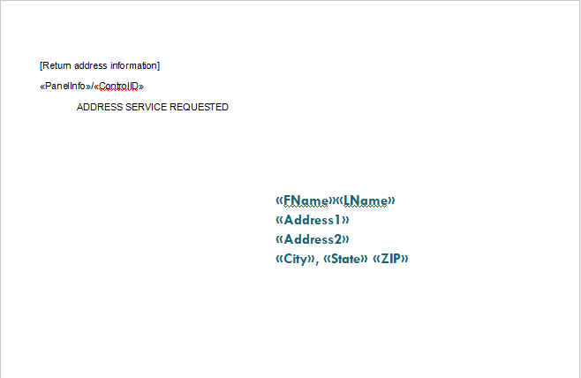

Back of postcard:
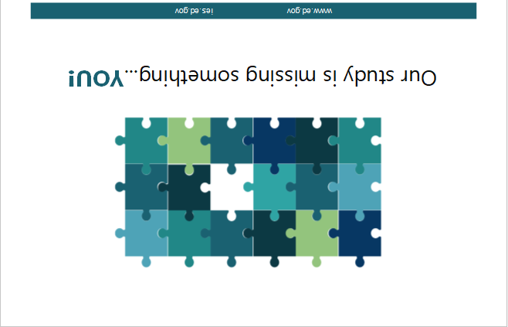

Inside of postcard:

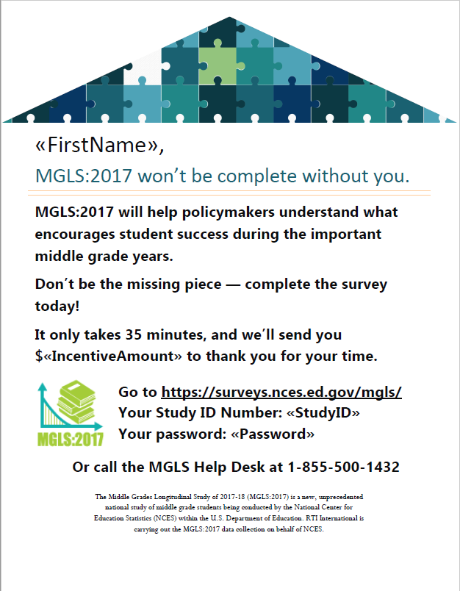

Appendix MS2B-R8c. Parent Data Collection – Abbreviated Survey Postcard (approved)
Front of postcard:

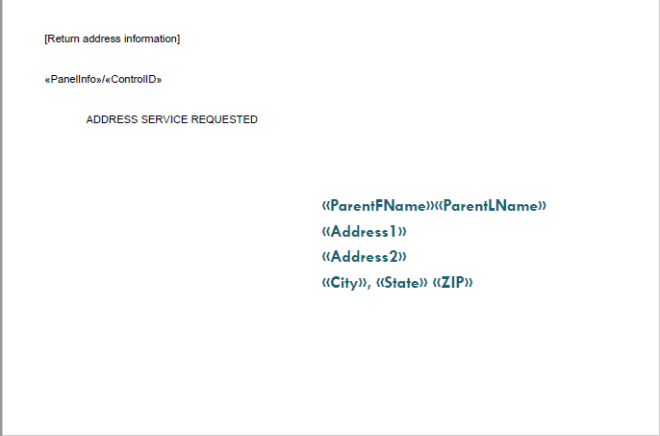

Back of postcard:

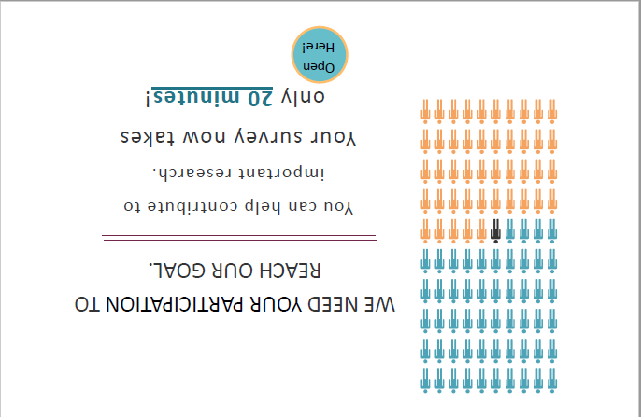

Inside of postcard:

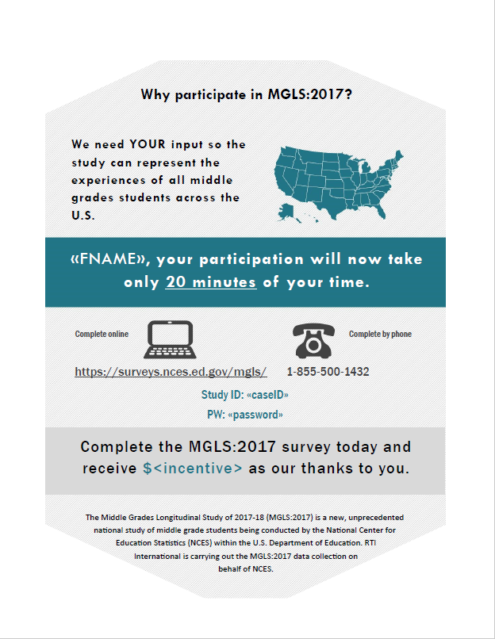

Appendix MS2B-R8c1. Parent Data Collection – Abbreviated Survey Postcard – Spanish (approved)
Front of postcard:

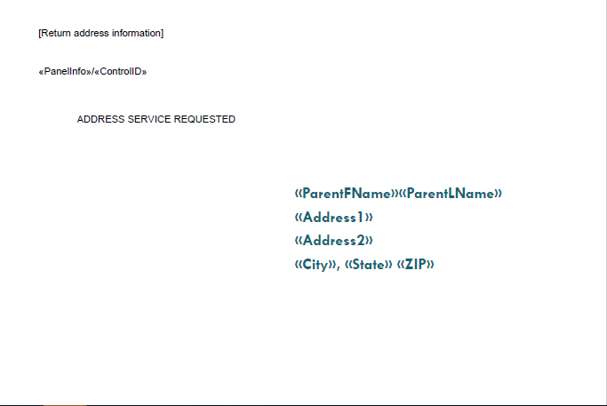

Back of postcard:
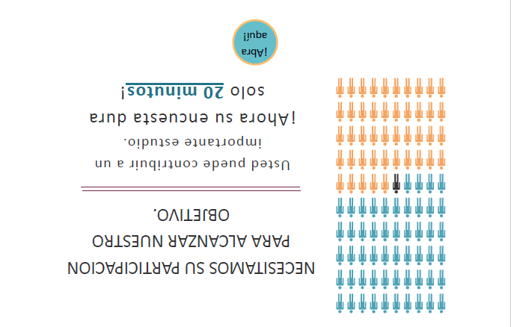

Inside of postcard:

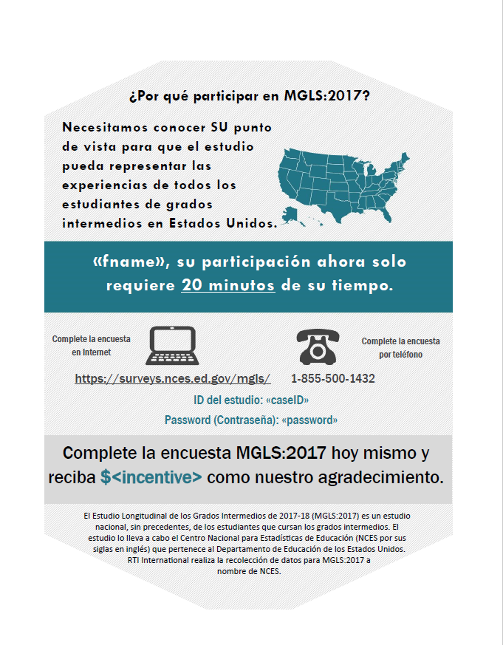

Appendix MS2B-R8d. Parent Data Collection – Mini Survey Letter (approved)
PLEASE NOTE: This letter will be stapled to the front of the Mini Survey.
<DATE>
<parentname>
<address>
<city, state zip>
Study ID: «parentID»
Password: «passwd»

Dear <Parent or Guardian>:

There is still time for you to participate in the Middle Grades Longitudinal Study of 2017-18 (MGLS:2017)! Data collection is ending soon, and we really need your help to learn about «studentFName»’s educational experiences. The information you provide will help improve education for students now and in the future. If you have already completed the survey, thank you for your participation.
Enclosed is a shortened version of the parent survey for your convenience.

To complete the survey and receive a check for $<incentive>, you have a few options:

- You may log-in to our secure website at https://surveys.nces.gov/mgls/ using the study ID and password provided above.
- You may call us toll-free at 1-855-500-1432 to complete over the phone.
- If you prefer, you may use the enclosed paper form and return it in the postage-paid envelope provided.


Please take about a few minutes to fill out this brief questionnaire and return it in the enclosed envelope by <DATE> to receive $<incentive>.

Complete this survey today!

Thank you in advance for making MGLS:2017 a success!
Sincerely,

James L. Woodworth
NCES Commissioner
The National Center for Education Statistics (NCES) is authorized to conduct the MGLS:2017 by the Education Sciences Reform Act of 2002 (ESRA 2002, 20 U.S.C. §9543), and to collect students’ education records from educational agencies or institutions for the purpose of evaluating federally supported education programs under the Family Educational Rights and Privacy Act (FERPA, 34 CFR §§ 99.31(a)(3)(iii) and 99.35). The data are being collected for NCES by RTI International, a U.S.-based nonprofit research organization. Participation is voluntary. You may skip questions you do not wish to answer; however, we hope that you will answer as many questions as you can. All of the information you provide may be used only for statistical purposes and may not be disclosed, or used, in identifiable form, for any other purpose except as required by law (20 U.S.C. §9573 and 6 U.S.C. §151). The collected information will be combined across respondents to produce statistical records.
According to the Paperwork Reduction Act of 1995, no persons are required to respond to a collection of information unless it displays a valid OMB control number. The valid OMB control number for this voluntary information collection is 1850-0911. Approval expires M/D/2022. The time required to complete this information collection is estimated to average 20 minutes for the electronic form or 5 minutes for the paper form, including the time to review instructions, gather the data needed, and complete and review the information collection. If you have any comments concerning the accuracy of the time estimate, suggestions for improving this survey, or any comments or concerns regarding the status of your individual submission of this survey, please write directly to: The Middle Grades Longitudinal Study of 2017-18 (MGLS:2017), National Center for Education Statistics, Potomac Center Plaza, 550 12th St., SW, Room 4002, Washington, DC 20202.

Appendix MS2B-R8d1. Parent Data Collection – Mini Survey Letter – Spanish (approved)
PLEASE NOTE: This letter will be stapled to the front of the Mini Survey.

<DATE>
<parentname>
ID del estudio (número de identificación del estudio): «parentID»
Password (contraseña): «passwd»

<address>
<city, state zip>

Estimado(a) « Parent or Guardian »:

Todavía tiene tiempo de participar en el Estudio Longitudinal de los Grados Intermedios de 2017-18 (MGLS:2017, por sus siglas en inglés). Ya está por terminar la recolección de datos y realmente necesitamos su ayuda para conocer las experiencias educativas de <<student Name>>. La información que usted proporcione nos ayudará a mejorar la educación para los estudiantes ahora y en el futuro. Si usted ya completó la encuesta, muchas gracias por su participación.

Para su conveniencia, junto con esta carta le estamos enviando una versión abreviada de la encuesta para padres.

Para completar este cuestionario y recibir un cheque for $<incentive> usted tiene diferentes opciones:

- Puede ingresar a nuestro sitio electrónico seguro en https://surveys.nces.ed.gov/mgls/ usando el ID del estudio y la contraseña que aparecen más arriba.
- Puede llamarnos al número gratuito 1-855-500-1432 para completar la encuesta por teléfono.
- Si prefiere, puede usar el cuestionario impreso adjunto y devolverlo en el sobre prepagado que le estamos enviando.

Por favor tome unos minutos para completar este breve cuestionario y devolverlo en el sobre adjunto antes del <DATE> para recibir $<incentive>.

¡Gracias de antemano por hacer de MGLS:2017 todo un éxito!
¡Complete esta encuesta hoy!
Atentamente,

James L. Woodworth
Comisionado de NCES

Anexo: Encuesta para padres
NCES está autorizado a hacer el estudio MGLS:2017 por el Acta de Reforma de las Ciencias de la Educación de 2002 (ESRA 2002, 20 U.S.C. §9543) y a obtener récords educativos de los estudiantes de agencias o instituciones educativas para propósitos de evaluación de programas de educación con fondos federales, bajo la Ley de Derechos Educativos y Privacidad Familiar (FERPA, 34 CFR §§ 99.31(a)(3)(iii) and 99.35). RTI International, una organización sin fines de lucro que realiza estudios y está basada en los Estados Unidos, está recopilando los datos para NCES. Toda la información que usted proporcione podrá usarse solamente para propósitos estadísticos y no podrá divulgarse ni usarse de manera que permita identificar a los participantes para ningún otro propósito, salvo que lo requiera la ley (20 U.S.C. §9573 y 6 U.S.C. §151). La información obtenida se combinará con la de los demás participantes para producir reportes estadísticos..

De conformidad con la Ley de Reducción del Papeleo de 1995 no se puede pedir a ninguna persona que responda a un pedido de información a menos que éste cuente con un número de control de OMB válido (Office of Management and Budget por sus siglas en inglés). El número de control de OMB válido para este pedido de recolección de información voluntaria es 1850-0911. La aprobación expira el DD/MM/2022. El tiempo requerido para completar esta recolección de información es en promedio 5 minutos incluyendo el tiempo para revisar las instrucciones, reunir la información necesaria y completar y revisar la información solicitada. Si usted tiene algún comentario concerniente a la precisión del tiempo estimado, sugerencias para mejorar la encuesta, o cualquier comentario relacionado al estatus del envío de su información por favor escriba directamente a: The Middle Grades Longitudinal Study of 2017-18 (MGLS:2017), National Center for Education Statistics, Potomac Center Plaza, 550 12th St, SW, Room 4002, Washington, DC 20202.

Appendix MS2B-R8e. Parent Data Collection – Final Reminder Letter (approved)

The survey takes only <##> minutes and you will receive $<INC>!
Survey ends on: <DATE>

<DATE>
<parentname>
<address>
<city, state zip>

Dear Parent or Guardian of <<Child Name>>,

Please help the Middle Grades Longitudinal Study of 2017-18 (MGLS:2017) succeed by completing our parent survey. The information you provide will help to shape education policy for the middle grades for years to come. Don’t wait! Your chance to participate ends on <DATE>.
As a token of our appreciation for being a part of the study, when you finish the survey either online or over the phone, you will receive a check for <<$INC_AMT>>.
To access the parent survey, please log into:
Study website: https://surveys.nces.ed.gov/mgls
Study ID: <xxxxxxxx>
Password: <xxxxxxxx>

Completing the 20-minute survey is voluntary and there are no penalties for not participating. You may also skip any question you do not want to answer if you choose to participate. For more information, please visit the study website at https://surveys.nces.ed.gov/mgls/. If you have questions or prefer to complete the survey over the phone, please call us toll-free at 855-500-1432. You may also reach us by email at mglsparent@rti.org. Thank you for supporting education by participating in this important study.

Sincerely,

James L. Woodworth
NCES Commissioner

The National Center for Education Statistics (NCES) is authorized to conduct MGLS:2017 by the Education Sciences Reform Act of 2002 (ESRA 2002, 20 U.S.C. §9543) and to collect students’ education records from education agencies or institutions for the purposes of evaluating federally supported education programs under the Family Educational Rights and Privacy Act (FERPA, 34 CFR §§ 99.31(a)(3)(iii) and 99.35). The data are being collected for NCES by RTI International, a U.S.-based nonprofit research organization. All of the information you provide may be used only for statistical purposes and may not be disclosed, or used, in identifiable form for any other purpose except as required by law (20 U.S.C. §9573 and 6 U.S.C. §151). The collected information will be combined across respondents to produce statistical reports.

Appendix MS2B-R8f. MGLS:2017 Parent FAQs Text – In-School Participation (approved)

MGLS:2017 Parent FAQs – Main Study

MGLS Letterhead

Middle Grades Longitudinal Study of 2017-18 (MGLS:2017) –– Frequently Asked Questions (FAQs)

What is MGLS:2017?
The Middle Grades Longitudinal Study of 2017-18 (MGLS:2017) is the first national study of middle grade students. It is being conducted by the National Center for Education Statistics (NCES), part of the U.S. Department of Education. RTI International is carrying out the MGLS:2017 data collection on behalf of NCES.
What is the focus of MGLS:2017?
The study follows students as they progress through the middle grade years, making the transition from elementary school and preparing for the transition into high school. The goals of the study are to assess students’ mathematics and reading skills, executive function, and socioemotional well-being, and to collect data on family and school factors that may encourage success during these important, yet generally understudied, years of education.

When is the study being conducted?
MGLS:2017 began in early 2018 with about 17,000 selected sixth grade students in nearly 570 schools across the country. A follow-up data collection will occur in the spring of 2020. The study will select additional eighth-grade students to participate in the study in advance of the 2020 data collection. These students will only participate in one round of data collection. In fall of 2021, student administrative records may be collected.

Why is MGLS:2017 important?
MGLS:2017 is the first national study to look at several important parts of the middle grades experience. The study will examine growth in math and reading as students move through grades 6 to 8. It also explores how students connect with teachers, peers, family, and their environment. By collecting information on the lives of students both inside and outside of the classroom, we will be able to learn what helps students succeed. This is important for parents, teachers, policymakers, and members of the general public who want to know how to best prepare students for high school, later education, and career opportunities.

Why participate in MGLS:2017?
As the parent or guardian of your middle grades student, you provide an important and unique point of view. Only you can tell us about your child’s home learning environment, your child’s school experiences, and your involvement in their learning. We need your input for MGLS:2017 so the study can represent the experiences of all middle grades students across the U.S.
How will MGLS:2017 data be used?
Information collected through MGLS:2017 will allow researchers, educators, policymakers and members of the public to examine student development and achievement through this important time in students’ lives. It will allow researchers to examine family and schooling factors related to students’ achievement, and will reflect changes in young people’s lives and their connections with communities, schools, teachers, families, parents, and peers, including:
- Academic (especially in math and reading), social, and interpersonal growth;
- Transitions from elementary school and preparations for transitions into high school;
- School connectedness, belongingness, and engagement;
- Characteristics of schools and their relationship to student outcomes; and
- School support of students with disabilities, and outcomes for those students.
How many schools and students will be involved in MGLS:2017?
Already about 17,000 sixth grade students from about 570 public and private schools participated in spring of 2018 and about 20,000 students and 800 schools are expected to participate in the 2019-2020 school year.
What is involved for students?
Students will complete a session made up of math and reading questions and one or more computerized games to assess executive function skills, or skills that help a person to organize and act on information. Students will also provide height and weight measurements and complete a student survey. The student session will take about 90 minutes and will be completed in schools on Chromebooks, tablet-like computers with touchscreen capability and an attached keyboard. Students will be given a pair of earbuds and a pencil used during the assessment to take home plus a certificate for 2 hours of service from the U.S. Department of Education.
What is involved for parents or guardians?
One parent or guardian of each selected student will complete a questionnaire via a web survey or a telephone interview. The questionnaire will take about 35 minutes to complete.
Why are height and weight data collected in MGLS:2017?
Height and weight measurements are important in understanding physical growth, puberty status, and obesity status at this important time of growth for adolescents. By collecting these data, we will be able to better understand how physical growth patterns affect student learning and socioemotional well-being.
What happens if a student refuses to participate?
All participation is voluntary. There are no penalties for not participating in the study. When completing the questionnaires, respondents can skip any question they do not want to answer. If individuals or schools are hesitant to be a part of the study, please reach out to MGLS:2017 staff so we can address any concerns you may have.
My child has a disability and is not in a general education setting. Do I still need to participate?
This study is interested in learning how all students learn and grow in this age range. Even if your child is not able to participate in the school session, we invite you to participate in the survey.
Will the names of participants and their responses be kept confidential?
All of the information provided by schools, staff, students, and parents may be used only for statistical purposes and may not be disclosed, or used, in identifiable form for any other purpose except as required by law (20 U.S.C. §9573 and 6 U.S.C. §151). All field staff and other staff working on the study have signed an affidavit of non-disclosure where they swear to abide by this law. Field staff have also undergone a criminal background check as a condition of employment. The collected information will be combined across respondents to produce statistical reports.
NCES is authorized to conduct MGLS:2017 by the Education Sciences Reform Act of 2002 (ESRA 2002, 20 U.S.C. §9543) and to collect students’ education records from education agencies or institutions for the purposes of evaluating federally supported education programs under the Family Educational Rights and Privacy Act (FERPA, 34 CFR §§ 99.31(a)(3)(iii) and 99.35).
Who do I contact for further information about MGLS:2017?
For additional information, call the MGLS:2017 Help Desk toll-free at 855-500-1432, or send an email to mglsparent@rti.org. You may also learn more about the study and education research focused on students in the middle grades by visiting the MGLS:2017 website at https://surveys.nces.ed.gov/MGLS/ or by scanning the QR code.
Scan MGLS:2017
QR code HERE

Appendix MS2B-R8f1. MGLS:2017 Parent FAQs Text – In-School Participation – Spanish (approved)
MGLS:2017 Preguntas Frecuentes de los Padres (FAQs) – Estudio Principal

MGLS Letterhead

Estudio Longitudinal de los Grados Intermedios de 2017-18 (MGLS:2017) ---Preguntas Frecuentes (FAQs)

¿Qué es MGLS:2017?
El Estudio Longitudinal de los Grados Intermedios de 2017-18 (MGLS:2017) es el primer estudio a nivel nacional de estudiantes que cursan los grados intermedios. El estudio es llevado a cabo por el Centro Nacional para Estadísticas de Educación (NCES por sus siglas en inglés) que es parte del Departamento de Educación de los Estados Unidos. RTI Internacional se encarga de la recolección de datos a nombre de NCES para MGLS:2017.

¿Cuál es el objetivo de MGLS:2017?
El estudio sigue a los estudiantes a medida que avanzan por los años escolares intermedios, haciendo la transición de la escuela elemental y preparándose para la escuela secundaria o superior. Los objetivos del estudio son evaluar las habilidades de los estudiantes en matemáticas y lectura, funciones ejecutivas y bienestar socio-emocional y reunir información sobre factores familiares y escolares que fomenten el éxito durante estos importantes, aunque poco estudiados, años de educación.

¿Cuándo se realizará el estudio?
MGLS:2017 empezó a principios de 2018 con aproximadamente 17,000 estudiantes de 6º grado seleccionados en cerca de 570 escuelas de todo el país. La ronda de seguimiento para recolección de datos ocurrirá durante la primavera de 2020. El estudio seleccionará más estudiantes de octavo grado para que participen en el estudio antes de la recolección de datos de 2020. Estos estudiantes participarán en una sola ronda de recolección de datos. En el otoño de 2021 tal vez se obtengan récords administrativos de los estudiantes.

¿Por qué es importante MGLS:2017?
MGLS:2017 es el primer estudio a nivel nacional que analiza varios aspectos importantes de las experiencias en los grados intermedios. El estudio examinará el crecimiento en matemáticas y lectura a medida que los estudiantes transitan de 6º a 8º grado. También explora cómo los estudiantes interactúan con maestros, compañeros, familiares y su ambiente. Al reunir información sobre la vida de los estudiantes dentro y fuera del salón de clases podremos tener una imagen más precisa de los factores que contribuyen al éxito de los estudiantes. Esto es importante para los padres de familia, los profesores, y los legisladores, así como también miembros del público en general, que desean saber cómo preparar mejor a los estudiantes para la educación superior y sus carreras profesionales.

¿Por qué participar en MGLS 2017?
Como padre, guardián legal o tutor de un estudiante de grados intermedios, usted posee un importante y único punto de vista. Solamente usted puede darnos información sobre el ambiente de aprendizaje en casa para su hijo(a), las experiencias escolares de su hijo(a) y la participación de usted en el proceso de aprendizaje de su hijo(a). Necesitamos conocer su punto de vista para que el estudio pueda representar las experiencias de todos los estudiantes de grados intermedios en Estados Unidos.

¿Cómo se utilizarán los datos de MGLS 2017?
La información que se reúna en MGLS:2017 permitirá a los investigadores, educadores, legisladores y miembros del público en general examinar el desarrollo de los estudiantes y sus logros a lo largo de estos importantes años en la vida de los estudiantes. Permitirá a los investigadores examinar los factores familiares y escolares relacionados con los logros de los estudiantes y reflejará los cambios en la vida de los jóvenes y sus relaciones con la comunidad, escuela, profesores, familiares, padres, y compañeros, incluyendo:

- Crecimiento académico (especialmente en matemáticas y lectura), social e interpersonal
- Transición de la escuela elemental y preparación para la educación superior
- Conexión con la escuela, sentido de pertenencia y compromiso
- Características de las escuelas y su relación con los resultados obtenidos por los estudiantes y
- Apoyo escolar para estudiantes con discapacidades y resultados de esos estudiantes

¿Cuántas escuelas y estudiantes participarán en MGLS:2017
Ya participaron aproximadamente 17,000 estudiantes de 6º grado en unas 570 escuelas públicas y privadas de todo el país en la primavera de 2018 y se espera que aproximadamente 20,000 estudiantes y 800 escuelas participen en el año escolar 2019-2020.

¿Qué deben hacer los estudiantes?
Los estudiantes completarán una sesión que incluye preguntas de matemáticas y lectura y uno o más de juegos computarizados para evaluar habilidades de funcionamiento ejecutivo, o habilidades que le permitan a una persona organizar y actuar usando información. Se medirá la talla y el peso de los estudiantes y ellos también completarán una encuesta. La sesión de estudiantes tomará aproximadamente 90 minutos para completarse en la escuela. Los estudiantes usarán Chromebooks, que son computadoras parecidas a una tableta, con pantalla táctil y teclado. Se les dará a los estudiantes un par de audífonos y un lápiz que habrán usado durante la evaluación para llevarse a la casa, así como un certificado por 2 horas de servicio comunitario del Departamento de Educación de los Estados Unidos.

¿Qué implica para los padres de familia?
Uno de los padres o guardianes legales de cada estudiante seleccionado completará un cuestionario en Internet o por teléfono. Completar el cuestionario tomará aproximadamente 35 minutos.

¿Por qué se obtienen medidas de peso y talla en MGLS:2017?
Las medidas de peso y talla son importantes para entender el crecimiento físico, el estado de pubertad y el estado de obesidad en este importante tiempo del crecimiento de adolescentes. Al reunir estos datos nosotros podremos entender mejor de qué manera los patrones de crecimiento físico afectan el aprendizaje y el bienestar socioemocional de los estudiantes.

¿Qué pasa si un estudiante rechaza participar en el estudio?
Toda participación es voluntaria. No hay penalización alguna por no participar en el estudio. Al completar los cuestionarios los participantes pueden omitir cualquier pregunta que no deseen contestar. Si un participante o una escuela tienen dudas sobre participar o no, por favor contacte al personal de MGLS:2017 para poder responder a sus preguntas o preocupaciones.

Mi hijo(a) tiene una discapacidad y no está en un ambiente de educación general, ¿aun así necesito participar?
Este estudio está interesado en conocer cómo aprenden y crecen todos los estudiantes en este rango de edad. Aun si su hijo(a) no puede participar en la sesión en la escuela, lo invitamos a que usted participe en la encuesta.

¿Se mantendrán en confidencialidad los nombres y las respuestas de los estudiantes?
Toda la información proporcionada por las escuelas, personal, estudiantes y padres de familia podrá usarse solamente para propósitos estadísticos y no podrá divulgarse ni usarse de manera que permita identificar a los participantes para ningún otro propósito, salvo que lo requiera la ley (20 U.S.C. §9573 and 6 U.S.C. §151). Todo el personal de campo y otro personal adscrito al estudio ha firmado una declaración de no divulgación en la que han jurado acatar esta ley. El personal de campo también ha pasado por un chequeo de antecedentes criminales como condición para obtener el empleo. La información reunida será combinada entre todos los participantes para producir reportes estadísticos.

NCES está autorizado a hacer el estudio MGLS:2017 por el Acta de Reforma de las Ciencias de Educación de 2002 (ESRA 2002, 20 U.S.C. §9543) y a obtener expedientes escolares de los estudiantes, de agencias o instituciones educativas con el propósito de evaluar programas educativos que cuentan con apoyo a nivel federal bajo la Ley de Derechos Educativos y Privacidad Familiar (FERPA, 34 CFR §§ 99.31(a)(3)(iii) y 99.35).

¿A quién puedo contactar para obtener información adicional de MGLS:2017?
Para más información, comuníquese a la Línea de Ayuda de MGLS:2017 gratis al 855-500-1432 o envíe un correo electrónico a mglsparent@rti.org. Para mayor información sobre este estudio y sobre investigaciones en educación especializada en estudiantes en los grados intermedios visite el sitio electrónico de MGLS:2017 en https://surveys.nces.ed.gov/MGLS/ o escanee el código QR del estudio que aparece a la derecha.
Escanee el Código QR MGLS:2017 aquí

Appendix MS2B-R8g. MGLS:2017 Parent FAQs Text – Out-of-School Participation (modified)
MGLS:2017 Parent FAQs – Main Study

MGLS Letterhead

Middle Grades Longitudinal Study of 2017-18 (MGLS:2017) –– Frequently Asked Questions (FAQs)

What is MGLS:2017?
The Middle Grades Longitudinal Study of 2017-18 (MGLS:2017) is the first national study of middle grade students. It is being conducted by the National Center for Education Statistics (NCES), part of the U.S. Department of Education. RTI International is carrying out the MGLS:2017 data collection on behalf of NCES.
What is the focus of MGLS:2017?
The study follows students as they progress through the middle grade years, making the transition from elementary school and preparing for the transition into high school. The goals of the study are to assess students’ mathematics and reading skills, executive function, and socioemotional well-being, and to collect data on family and school factors that may encourage success during these important, yet generally understudied, years of education.

When is the study being conducted?
MGLS:2017 began in early 2018 with about 17,000 selected sixth grade students in nearly 570 schools across the country. A follow-up data collection will occur in the spring of 2020. The study will select additional eighth-grade students to participate in the study in advance of the 2020 data collection. These students will only participate in one round of data collection. In fall of 2021, student administrative records may be collected.

Why is MGLS:2017 important?
MGLS:2017 is the first national study to look at several important parts of the middle grades experience. The study will examine growth in math and reading as students move through grades 6 to 8. It also explores how students connect with teachers, peers, family, and their environment. By collecting information on the lives of students both inside and outside of the classroom, we will be able to learn what helps students succeed. This is important for parents, teachers, policymakers, and members of the general public who want to know how to best prepare students for high school, later education, and career opportunities.

Why participate in MGLS:2017?
As the parent or guardian of your middle grades student, you provide an important and unique point of view. Only you can tell us about your child’s home learning environment, your child’s school experiences, and your involvement in their learning. We need your input for MGLS:2017 so the study can represent the experiences of all middle grades students across the U.S.
How will MGLS:2017 data be used?
Information collected through MGLS:2017 will allow researchers, educators, policymakers and members of the public to examine student development and achievement through this important time in students’ lives. It will allow researchers to examine family and schooling factors related to students’ achievement, and will reflect changes in young people’s lives and their connections with communities, schools, teachers, families, parents, and peers, including:
- Academic (especially in math and reading), social, and interpersonal growth;
- Transitions from elementary school and preparations for transitions into high school;
- School connectedness, belongingness, and engagement;
- Characteristics of schools and their relationship to student outcomes; and
- School support of students with disabilities, and outcomes for those students.
How many schools and students will be involved in MGLS:2017?
Already about 17,000 sixth grade students from about 570 public and private schools participated in spring of 2018 and about 20,000 students and 800 schools are expected to participate in the 2019-2020 school year.

What is involved for students?
Students will complete an online session made up of reading and math problems as well as a survey. Students who complete the 45-minute survey and math and reading items will receive $20 and a 2-hour community service certificate. Those who complete the 75-minute survey and math and reading items will receive $20 and a 3-hour community service certificate and, for their extra time with this survey, we will make a donation of $20 to the Save the Children’s special fund to help kids affected by COVID-19.
What is involved for parents or guardians?
One parent or guardian of each selected student will complete a questionnaire via a web survey or a telephone interview. The questionnaire will take about 35 minutes to complete.

We do not have a computer/Internet in our home. How can my child participate?
If you do not have a computer or Internet at home, we encourage you to find a place that has computers for the public to use. For example, many local libraries have computers that anyone can use. Your child may also be able to complete the session at school during his or her free time.
Will the names of participants and their responses be kept confidential?
All of the information provided by schools, staff, students, and parents may be used only for statistical purposes and may not be disclosed, or used, in identifiable form for any other purpose except as required by law (20 U.S.C. §9573 and 6 U.S.C. §151). All field staff and other staff working on the study have signed an affidavit of non-disclosure where they swear to abide by this law. Field staff have also undergone a criminal background check as a condition of employment. The collected information will be combined across respondents to produce statistical reports.
NCES is authorized to conduct MGLS:2017 by the Education Sciences Reform Act of 2002 (ESRA 2002, 20 U.S.C. §9543) and to collect students’ education records from education agencies or institutions for the purposes of evaluating federally supported education programs under the Family Educational Rights and Privacy Act (FERPA, 34 CFR §§ 99.31(a)(3)(iii) and 99.35).
Who do I contact for further information about MGLS:2017?
For additional information, call the MGLS:2017 Help Desk toll-free at 855-500-1432, or send an email to mglsparent@rti.org. You may also learn more about the study and education research focused on students in the middle grades by visiting the MGLS:2017 website at https://surveys.nces.ed.gov/MGLS/ or by scanning the QR code.
Scan MGLS:2017
QR code HERE

Appendix MS2B-R8g1. MGLS:2017 Parent FAQs Text – Out-of-School Participation – Spanish (modified)
MGLS:2017 Preguntas Frecuentes de los Padres (FAQs) – Estudio Principal

MGLS Letterhead

Estudio Longitudinal de los Grados Intermedios de 2017-18 (MGLS:2017) ---Preguntas Frecuentes (FAQs).

¿Qué es MGLS:2017?
El Estudio Longitudinal de los Grados Intermedios de 2017-18 (MGLS:2017) es el primer estudio a nivel nacional de estudiantes que cursan los grados intermedios. El estudio es llevado a cabo por el Centro Nacional para Estadísticas de Educación (NCES por sus siglas en inglés) que es parte del Departamento de Educación de los Estados Unidos. RTI Internacional se encarga de la recolección de datos a nombre de NCES para MGLS 2017.

¿Cuál es el objetivo de MGLS:2017?
El estudio sigue a los estudiantes a medida que avanzan por los años escolares intermedios, haciendo la transición de la escuela elemental y preparándose para la escuela secundaria o superior. Los objetivos del estudio son evaluar las habilidades de los estudiantes en matemáticas y lectura, funciones ejecutivas y bienestar socio-emocional y reunir información sobre factores familiares y escolares que fomenten el éxito durante estos importantes, aunque poco estudiados, años de educación.

¿Cuándo se realizará el estudio?
MGLS:2017 empezó a principios de 2018 con aproximadamente 17,000 estudiantes de 6º grado seleccionados en cerca de 570 escuelas de todo el país. La ronda de seguimiento para recolección de datos ocurrirá durante la primavera de 2020. El estudio seleccionará más estudiantes de octavo grado para que participen en el estudio antes de la recolección de datos de 2020. Estos estudiantes participarán en una sola ronda de recolección de datos. En el otoño de 2021 tal vez se obtengan récords administrativos de los estudiantes.

¿Por qué es importante MGLS:2017?
MGLS:2017 es el primer estudio a nivel nacional que analiza varios aspectos importantes de las experiencias en los grados intermedios. El estudio examinará el crecimiento en matemáticas y lectura a medida que los estudiantes transitan de 6º a 8º grado. También explora cómo los estudiantes interactúan con maestros, compañeros, familiares y su ambiente. Al reunir información sobre la vida de los estudiantes dentro y fuera del salón de clases podremos tener una imagen más precisa de los factores que contribuyen al éxito de los estudiantes. Esto es importante para los padres de familia, los profesores, y los legisladores, así como también miembros del público en general, que desean saber cómo preparar mejor a los estudiantes para la educación superior y sus carreras profesionales.

¿Por qué participar en MGLS:2017?
Como padre, guardián legal o tutor de un estudiante de grados intermedios, usted posee un importante y único punto de vista. Solamente usted puede darnos información sobre el ambiente de aprendizaje en casa para su hijo(a), las experiencias escolares de su hijo(a) y la participación de usted en el proceso de aprendizaje de su hijo(a). Necesitamos conocer su punto de vista para que el estudio pueda representar las experiencias de todos los estudiantes de grados intermedios en Estados Unidos.

¿Cómo se utilizarán los datos de MGLS:2017?
La información que se reúna en MGLS:2017 permitirá a los investigadores, educadores, legisladores y miembros del público en general examinar el desarrollo de los estudiantes y sus logros a lo largo de estos importantes años en la vida de los estudiantes. Permitirá a los investigadores examinar los factores familiares y escolares relacionados con los logros de los estudiantes y reflejará los cambios en la vida de los jóvenes y sus relaciones con la comunidad, escuela, profesores, familiares, padres, y compañeros, incluyendo:
- Crecimiento académico (especialmente en matemáticas y lectura), social e interpersonal
- Transición de la escuela elemental y preparación para la educación superior
- Conexión con la escuela, sentido de pertenencia y compromiso
- Características de las escuelas y su relación con los resultados obtenidos por los estudiantes y
- Apoyo escolar para estudiantes con discapacidades y resultados de esos estudiantes

¿Cuántas escuelas y estudiantes participarán en MGLS:2017
Ya participaron aproximadamente 17,000 estudiantes de 6º grado en unas 570 escuelas públicas y privadas de todo el país en la primavera de 2018 y se espera que aproximadamente 20,000 estudiantes y 800 escuelas participen en el año escolar 2019-2020.

¿Qué deben hacer los estudiantes?
Los estudiantes completarán una sesión en Internet que incluye preguntas de matemáticas y lectura y una encuesta. Los estudiantes que completen una sesión de 45 minutos recibirán $20 y un certificado de servicio comunitario de dos horas. Los que completen una sesión de 75 minutos recibirán $20 y un certificado de servicio comunitario de tres horas más, por su tiempo extra con esta encuesta, haremos una donación adicional de $20 a la organización Save the Children para ayudar a los niños afectados por la pandemia del COVID-19.

¿Qué implica para los padres de familia?
Uno de los padres o guardianes legales de cada estudiante seleccionado completará un cuestionario en Internet o por teléfono. Completar el cuestionario tomará aproximadamente 35 minutos.

Nosotros no tenemos computadora/internet en casa. ¿Cómo puede participar mi hijo(a)?
Si usted no tiene computadora o acceso a Internet en casa, le sugerimos que localice un lugar que tenga computadoras para uso público. Por ejemplo, muchas bibliotecas locales tienen computadoras que cualquiera puede usar. Su hijo(a) también podría completar la sesión en la escuela durante su tiempo libre.

¿Se mantendrán en confidencialidad los nombres y las respuestas de los estudiantes?
Toda la información proporcionada por las escuelas, personal, estudiantes y padres de familia podrá usarse solamente para propósitos estadísticos y no podrá divulgarse ni usarse de manera que permita identificar a los participantes para ningún otro propósito, salvo que lo requiera la ley (20 U.S.C. §9573 and 6 U.S.C. §151). Todo el personal de campo y otro personal adscrito al estudio ha firmado una declaración de no divulgación en la que han jurado acatar esta ley. El personal de campo también ha pasado por un chequeo de antecedentes criminales como condición para obtener el empleo. La información reunida será combinada entre todos los participantes para producir reportes estadísticos.

NCES está autorizado a hacer el estudio MGLS:2017 por el Acta de Reforma de las Ciencias de Educación de 2002 (ESRA 2002, 20 U.S.C. §9543) y a obtener expedientes escolares de los estudiantes, de agencias o instituciones educativas con el propósito de evaluar programas educativos que cuentan con apoyo a nivel federal bajo la Ley de Derechos Educativos y Privacidad Familiar (FERPA, 34 CFR §§ 99.31(a)(3)(iii) y 99.35).

¿A quién puedo contactar para obtener información adicional de MGLS:2017?
Para más información, comuníquese a la Línea de Ayuda de MGLS:2017 gratis al 855-500-1432, o envíe un correo electrónico a mglsparent@rti.org. Para mayor información sobre este estudio y sobre investigaciones en educación especializada en estudiantes en los grados intermedios visite el sitio electrónico de MGLS:2017 en https://surveys.nces.ed.gov/MGLS/ o escanee el código QR del estudio que aparece a la derecha.
Escanee el Código QR MGLS:2017 aquí

Appendix MS2B-R9. Out-of-School Data Collection: Sorry I Missed You Card (approved)



RTI International
Research Triangle Park, NC 27709

Sorry I Missed You…

Appendix MS2B-R10. Out-of-School Data collection: Incentive Receipt (approved)

Interview Incentive Receipt
National Center for Education Statistics (NCES)
and
RTI International
Thank you for participating in the Middle Grades Longitudinal Study of 2017-18 (MGLS:2017)
In appreciation of your participation in this important study, you are eligible to receive $______.
Since protecting your information is important to us, your name will not be entered on this form. However, the interviewer must sign and date this form to certify you received (or declined) the incentive.

___________________________________ _________ __ __ __ __ __ __ __ __
Interviewer Date Study ID
□ Accepted Incentive □ Declined Incentive

Appendix MS2B-S1a. Staff Data Collection Letters – Administrator (approved)

<<Date>>

Administrator Login Credentials
https://surveys.nces.ed.gov/mgls/
*Click on “Admin login”
Study ID: «caseID»
Password: «passwd»

«adminname»
«schoolname»
«addr1» «addr2»
«citystzip»

Thank you for participating in the Middle Grades Longitudinal Study of 2017-18 (MGLS:2017)! Please use the login credentials provided above to complete your administrator survey. By participating, you are contributing to a better understanding of factors that affect academic and social growth, health, and positive development during the middle grade years (grades 6 through 8).
Your responses will provide essential information about academic policies and programs, activities and curriculum in the school, and other school related experiences that impact student learning. It should take about 40 minutes to complete the survey.
If there is someone at your school more knowledgeable about the students, teachers, programs, and services at your school, please provide him or her with this letter and enclosed information so that he or she may complete the survey for your school.

The middle grades can be a time of turmoil or a time of triumph. We know that with all hands on deck our young adolescents can thrive.
Call or email anytime if you have any questions:
Phone: 855-500-1432
Email: mglsstaff@rti.org
Thank you for doing all you can to make this important research study a success.

Sincerely,

<<NCES Official’s Name and Title>>

The National Center for Education Statistics (NCES) is authorized to conduct MGLS:2017 by the Education Sciences Reform Act of 2002 (ESRA 2002, 20 U.S.C. §9543) and to collect students’ education records from education agencies or institutions for the purposes of evaluating federally supported education programs under the Family Educational Rights and Privacy Act (FERPA, 34 CFR §§ 99.31(a)(3)(iii) and 99.35). The data are being collected for NCES by RTI International, a U.S.-based nonprofit research organization. All of the information schools provide may be used only for statistical purposes and may not be disclosed, or used, in identifiable form for any other purpose except as required by law (20 U.S.C. §9573 and 6 U.S.C. §151). The collected information will be combined across respondents to produce statistical reports.

https://blog.ed.gov/2011/11/middle-grades-matter/

Appendix MS2B-S1b. Staff Data Collection Letters – Teacher (approved)

<<DATE>>
<<TEACHER NAME>>

https://surveys.nces.ed.gov/mgls/
Study ID: «ID»
Password: «password»
<<SCHOOL NAME>>
<<ADDR1>>
<<ADDR2>>
<<CITY STATE ZIP>>
Dear <<TEACHER NAME>>,
We are grateful for your school’s participation in the U.S. Department of Education’s Middle Grades Longitudinal Study of 2017-18. You are receiving this invitation to participate in a teacher survey because a student you teach is part of MGLS:2017. Please use the login credentials provided above to complete your teacher survey.
Your participation is voluntary and very important to the success of this study. As a <<MATH or SPECIAL EDUCATION>> teacher at <<SCHOOL NAME>>, you can provide essential information about academic policies and programs, activities and curriculum in the classroom, and other school related experiences that impact student learning. <<FOR MATH TEACHERS ONLY: The survey will include several general questions about your background and experiences at school and in the classroom (about 20 minutes), as well as questions about specific students that are part of the study (about 7 minutes per student).>> <<FOR SPECIAL EDUCATION TEACHERS ONLY: The survey will include several general questions about your background and the special education services you provide at the school (about 10 minutes), as well as questions about specific students that are part of the study (about 20 minutes per student).>>

The middle grades can be a time of turmoil or a time of triumph. We know that with all hands on deck our young adolescents can thrive.
As a token of our appreciation, you will receive $20 for answering the questions about your background, plus $7 per student questionnaire.
Learn more about this crucially important study by visiting our website at https://surveys.nces.ed.gov/mgls/. Feel free to call 855-500-1432 or email mglsstaff@rti.org with any questions you might have.
Thank you for the role you play to make this important research study a success.

Sincerely,

<<NCES Official’s Name and Title>>

The National Center for Education Statistics (NCES) is authorized to conduct MGLS:2017 by the Education Sciences Reform Act of 2002 (ESRA 2002, 20 U.S.C. §9543) and to collect students’ education records from education agencies or institutions for the purposes of evaluating federally supported education programs under the Family Educational Rights and Privacy Act (FERPA, 34 CFR §§ 99.31(a)(3)(iii) and 99.35). The data are being collected for NCES by RTI International, a U.S.-based nonprofit research organization. All of the information schools provide may be used only for statistical purposes and may not be disclosed, or used, in identifiable form for any other purpose except as required by law (20 U.S.C. §9573 and 6 U.S.C. §151). The collected information will be combined across respondents to produce statistical reports.

https://blog.ed.gov/2011/11/middle-grades-matter/

Appendix MS2B-S2. Teacher Reminder Postcard (approved)

